EXAMINATION OF POTENCY OF ASPERGILLUS NIGER TOXIN

BY

AKINNUGBA RASAQ BABATUNDE
HND/23/SLT/FT/0340

A PROJECT SUBMITTED TO THE DEPARTMENT OF SCIENCE LABORATORY TECHNOLOGY, INSTITUTE OF APPLIED SCIENCES, KWARA STATE POLYTECHNIC, ILORIN

IN PARTIAL FULFILMENT OF THE REQUIREMENTS OF THE AWARD OF HIGHER NATIONAL DIPLOMA (HND) IN SCIENCE LABORATORY TECHNOLOGY (SLT), MICROBIOLOGY UNIT

JULY, 2025
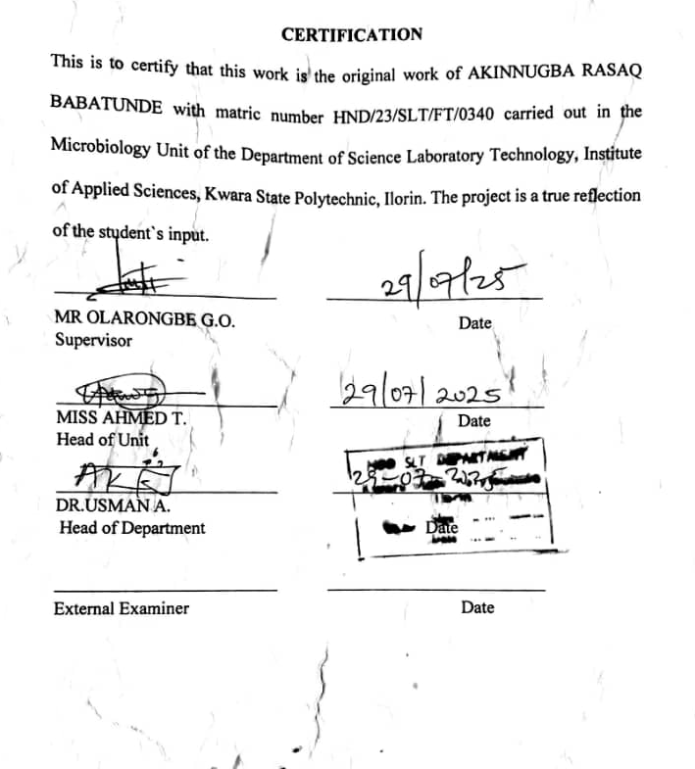

DEDICATION
I dedicate this work to the Lord Almighty, the creator of heaven and the earth, and to my beloved parents, Mr. and Mrs. Akinnugba, whose love, prayers, sacrifices, and unwavering belief in me have been my greatest source of strength and inspiration.

ACKNOWLEDGEMENTS
I would like to express my sincere gratitude to everyone who contributed to the successful completion of this project. First and foremost, my deepest appreciation goes to my dear parents, Mr. and Mrs. Akinnugba, for their unwavering love, steadfast support, and constant encouragement throughout my academic journey. Their belief in my potential has been a foundational pillar of my success. I am profoundly grateful to all my lecturers for their dedication and for imparting valuable knowledge throughout my years of study. I am especially thankful to my project supervisor, Mr. Olarongbe, whose exceptional mentorship, insightful feedback, and tireless support played a vital role in shaping and completing this work. Furthermore, I extend my heartfelt thanks to my friends and peers for their encouragement, collaborative spirit, and thoughtful contributions. Their discussions and support were truly beneficial and greatly appreciated. To all who have been a part of this journey in one way or another thank you.

TABLE OF CONTENTS

TITLE PAGE -------------------------------------------------------------------------- i
CERTIFICATION ---------------------------------------------------------------------ii
DEDICATION ------------------------------------------------------------------------iii
ACKNOWLEDGEMENTS ---------------------------------------------------------iv
TABLE OF CONTENTS ------------------------------------------------------------vii
LIST OF TABLES --------------------------------------------------------------------viii
LIST OF FIGURES -------------------------------------------------------------------viii
ABSTRACT ------------------------------------------------------------------------------ix
CHAPTER ONE
1.0 Introduction -----------------------------------------------------------------------3
1.1 Literature Review----------------------------------------------------------------11
1.2 Problem Statement---------------------------------------------------------------11
1.3 Justification of Study------------------------------------------------------------12
1.4 Aims and Objective--------------------------------------------------------------13

CHAPTER TWO
2.0 Materials and Methods ---------------------------------------------------------14
2.1 Samples Collection and Location ---------------------------------------------14
2.2 Sterilization of Equipment and Environment -------------------------------14
2.3 Media Preparation for fungal isolation ---------------------------------------14
2.3.1 Sample Preparation and Culturing ------------------------------------------16
2.3.2 Morphological Characteristics of Isolates -----------------------------------17
2.4 Toxin production ----------------------------------------------------------------17
2.4.1 Toxin Extraction ----------------------------------------------------------------17
2.4.2 Preparation of various toxin Concentrations----------------------------------17
2.5 Experimental Animals and Grouping--------------------------------------------19
2.5.1 Toxin Administration -----------------------------------------------------------19
2.5.2 Dissection and Post-Mortem Examination-----------------------------------19
CHAPTER THREE
3.0 Results
3.1 Characterization and Identification of Fungal Isolate --------------------- 20
3.2 Daily Observation During Toxin Administration for four days ------------21
3.3 Post-Mortem Gross Pathological Findings-----------------------------------25
CHAPTER FOUR
4.0 Discussion and Conclusion
4.1 Discussion -----------------------------------------------------------------------28
4.2 Conclusion -----------------------------------------------------------------------29
4.2 Recommendation --------------------------------------------------------------- 30
REFERENCES -------------------------------------------------------------------------31

LIST OF TABLES
Table 1: Identification of Fungal Isolate after culturing
Table 2: Daily Observation During Toxin Administration for four days
Table 3: Post-Mortem Gross Pathological Findings
LIST OF FIGURES
Figure 1: Colonies on PDA
Figure 2: Microscopic view of Aspergillus niger
Figure 3: Cumulative frequency chart for 100% conc. Red rat
Figure 4: Cumulative frequency chart for 80% conc. Red rat
Figure 5: Cumulative frequency chart for 60% conc. Red rat
Figure 6: Cumulative frequency chart for 50% conc. Red rat
Figure 7: Showing Total Weight Loss After Toxin Exposure

ABSTRACT
This study investigated the potency of toxins produced by Aspergillus niger using a combination of microbiological and toxicological methods. Aspergillus niger was isolated from contaminated food samples and identified based on cultural and microscopic characteristics. The fungal isolate was cultivated in Potato dextrose broth for 3-5 days to promote mycotoxin production, after which crude extracts were obtained through solvent extraction. Toxicity evaluation was carried out using Wistar rats divided into four groups, each receiving graded doses of the toxin extract, with one control group. Observations included behavioral changes, physiological responses, and post-mortem organ examination. The results showed dose-dependent signs of toxicity such as lethargy, reduced feed intake, weight loss, and mortality, with gross pathological changes including kidney discoloration, intestinal blockage, and liver pallor in high-dose groups. These findings confirm the acute toxicity of crude A. niger metabolites and highlight the potential public health risks associated with fungal contamination in poorly stored food products giving relevance to the need for improved food safety practices, early mycotoxin detection, and regulatory interventions to minimize exposure risks.

Keywords: Aspergillus niger, mycotoxins, toxicity, crude extract, food safety, Wistarra

CHAPTER ONE
1.0 INTRODUCTION
Aspergillus niger a filamentous, saprophytic fungus ubiquitously present in diverse environments including soil, decaying vegetation, stored food products, and indoor air, particularly in regions with high humidity and poor ventilation. It belongs to the black aspergilli group and is among the most commonly encountered species of the genus Aspergillus. While it is renowned for its industrial applications in producing citric acid, gluconic acid, and various enzymes such as amylases and proteases, Aspergillus niger also possesses a detrimental effect by produce harmful secondary metabolites, notably ochratoxin A (OTA), fumonisin B2, and citrinin (Kumar et al., 2023; Mahato et al., 2023). These mycotoxins are of significant concern due to their association with a range of toxicological effects. OTA is particularly known for its nephrotoxic, immunosuppressive, and carcinogenic properties, and has been classified as a Group 2B possible human carcinogen by the International Agency for Research on Cancer (IARC, 2023). Fumonisin B2 disrupts sphingolipid metabolism and is implicated in hepatotoxic and neurotoxic effects. Though citrinin is more commonly associated with Penicillium species, it has also been identified in certain A. niger strains under conducive conditions, further amplifying the potential health risks (Mahato et al., 2023). Human exposure to A. niger toxins can occur through ingestion of contaminated food, inhalation of airborne spores, or contact with mold-infested environments. These exposures can lead to chronic health problems, particularly in vulnerable populations such as children, the elderly, and immunocompromised individuals. Inhalation of spores in occupational or residential settings has been associated with allergic reactions, respiratory irritation, and in severe cases, invasive pulmonary aspergillosis (Fekete et al., 2022). Moreover, the resilience of A. niger spores and their ability to persist under harsh conditions make them a frequent contaminant in water-damaged buildings and improperly stored agricultural products. Another major concern is the stability of these toxins during food processing and storage. Mycotoxins like OTA are resistant to conventional heat treatments, making their removal through cooking or drying largely ineffective. This stability, combined with insufficient monitoring and control in many developing countries, exacerbates the risk of dietary exposure to these toxins. As a result, A. niger contamination not only poses a health risk but also carries significant economic implications due to crop losses, food recalls, and international trade restrictions. Although A. niger has long been studied for its industrial capabilities, there remains a considerable knowledge gap in understanding the toxicological implications of its mycotoxins, particularly in vivo. Existing research has predominantly focused on in vitro detection and food safety monitoring, leaving the physiological and morphological effects of these toxins in biological systems underexplored.
  - LITERATURE REVIEW
Several studies have demonstrated the toxigenic potential of Aspergillus niger, particularly its ability to produce harmful secondary metabolites under favorable conditions. These toxins, notably ochratoxin A (OTA), citrinin, and fumonisin B2 (FB2), are commonly associated with contamination of a variety of agricultural products including cereals, spices, dried fruits, coffee, and fermented goods. Researchers have increasingly turned their attention to these metabolites due to their heat stability, structural complexity, and persistence even after food processing. One of the most studied mycotoxins associated with A. niger is ochratoxin A. Structurally composed of a dihydroisocoumarin moiety linked to L-phenylalanine, OTA is known for its high chemical stability and lipophilicity, which facilitate its accumulation in lipid-rich organs, notably the kidney and liver. Cao et al. (2022) conducted a comprehensive survey of OTA-contaminated food samples across multiple West African countries and found widespread contamination in dried fruits, coffee, and maize. Their findings revealed that over 65% of tested samples contained OTA concentrations above the European Commission’s maximum residue levels, especially in open-market grains stored under humid conditions. Kumar et al. (2023) confirmed similar results in India, reporting OTA presence in over 52% of maize and groundnut samples collected from rural warehouses. These findings suggest that OTA contamination is not limited to one geography, and its prevalence aligns with climatic and post-harvest handling conditions. Toxicologically, OTA exhibits potent nephrotoxic and hepatotoxic properties. Milicevic et al. (2021) showed that repeated dietary exposure to OTA in rats resulted in proximal tubular degeneration, mitochondrial swelling, and increased levels of kidney biomarkers such as creatinine and urea. OTA’s carcinogenic potential has also been confirmed in rodent studies, leading the International Agency for Research on Cancer (IARC) to classify it as a Group 2B carcinogen possibly carcinogenic to humans. Zhang et al. (2021) added to this evidence by demonstrating OTA-induced oxidative stress and DNA damage in renal epithelial cells via upregulation of p53 and downregulation of antioxidant enzymes such as superoxide dismutase. Beyond nephrotoxicity, OTA impairs immune responses by inhibiting macrophage activity and cytokine production, weakening the body’s defense against opportunistic infections (Mahato et al., 2023). Citrinin is another mycotoxin associated with A. niger, also traditionally linked with Penicillium citrinum and Monascus species. Under specific stress conditions such as nitrogen deficiency, oxidative imbalance, or acidic pH A. niger has been observed to express citrinin biosynthetic gene clusters. Mahato et al. (2023) showed that nutrient-limited and high-sugar culture environments enhanced citrinin expression in A. niger isolates from fermented maize and cassava. Chemically, citrinin is a polyketide toxin with relatively low molecular weight and moderate thermal stability. It acts primarily by disrupting mitochondrial function, increasing reactive oxygen species (ROS), and triggering apoptotic cascades. Hassan et al. (2022) demonstrated in vitro that citrinin causes mitochondrial depolarization and caspase-3 activation in hepatocyte cell lines. In vivo, long-term citrinin exposure has been linked to renal inflammation, glomerular shrinkage, and immune suppression. The prevalence of citrinin in food products is often underreported due to limitations in detection sensitivity. However, recent studies have made progress. In a 2021 study, Emmanuel et al. identified citrinin residues in 40% of commercial rice samples stored for over six months in Nigerian markets. These residues were particularly concentrated in damp sacks and storage containers, affirming citrinin’s survival in high-moisture environments. Co-contamination with OTA is of growing concern, as several studies have demonstrated enhanced toxicity when the two toxins occur together. Zhang et al. (2021) reported that citrinin and OTA jointly increase ROS production and mitochondrial DNA damage more significantly than either compound alone. Fumonisin B2 (FB2), structurally analogous to the more widely studied fumonisin B1, is a mycotoxin that A. niger has increasingly been recognized to produce. Originally attributed to Fusarium verticillioides, FB2 is now frequently detected in food matrices colonized by A. niger. Fox et al. (2023) investigated this in dried fruits and raisins exposed to A. niger fermentation and observed measurable levels of FB2 that correlated with storage time and moisture content. FB2’s mode of toxicity is centered on the inhibition of ceramide synthase, a key enzyme in the sphingolipid biosynthesis pathway. Disruption of this pathway leads to membrane instability, cell apoptosis, and compromised neurological development. Righetti et al. (2021) described FB2-induced hepatotoxicity in animal models, noting fatty liver changes, fibrosis, and disruption of bile flow. While FB2 is not as thoroughly regulated as FB1, its inclusion in total fumonisin burden assessments is increasingly recommended by food safety authorities. Recent epidemiological data have suggested associations between chronic fumonisin exposure and esophageal cancer in populations with high maize consumption. EFSA (2022) reported an increase in such cases in regions of South America and sub-Saharan Africa where dried maize products serve as dietary staples and are often stored in poor conditions. Furthermore, Hussain et al. (2021) found FB2 contamination in 36% of spice samples collected from local vendors in Pakistan. They linked these results to A. niger presence, as confirmed by molecular and culture-based techniques.
The ability of A. niger to simultaneously produce multiple mycotoxins under stress has been a focal point of recent research. Co-occurrence of OTA, citrinin, and FB2 has been documented in stored cereals, processed cassava, and dried pepper samples from Nigeria, India, and Bangladesh (Mahato et al., 2023). Co-exposure to these toxins presents a more significant health risk than previously understood. Synergistic toxicity has been demonstrated in multiple animal and cell-based models. In a study by Zhang et al. (2021), mice exposed to both OTA and citrinin displayed elevated blood urea nitrogen (BUN), liver enzyme imbalances, and oxidative stress markers compared to controls. Histological analysis revealed glomerular fibrosis, lipid peroxidation, and hepatocellular necrosis. These findings confirm that the combined toxic effect surpasses additive toxicity and warrants urgent regulatory review. Hussain et al. (2021) also evaluated the genotoxic effects of co-exposure in human lymphocyte cultures and found higher frequencies of chromosomal aberrations and DNA strand breaks than those caused by individual toxins. The increasing occurrence of such co-contamination in informal food markets where grains, spices, and nuts are often kept unrefrigerated and without packaging has raised alarm within public health communities. The health risks posed by these mycotoxins are not limited to dietary routes alone. Occupational exposure is another route of concern. Agricultural workers, grain processors, and warehouse handlers often inhale A. niger spores and mycotoxin-laden dust particles. Baldin and Valdes (2020) linked prolonged airborne exposure to allergic rhinitis, asthma-like symptoms, and hypersensitivity pneumonitis in food processing employees. Immunocompromised individuals, such as transplant patients and those with uncontrolled diabetes, are particularly vulnerable to invasive fungal infections. Though A. niger is less virulent than A. fumigatus, it can still cause pulmonary and otic infections, especially when conidia are inhaled in high loads.
The accurate detection and quantification of mycotoxins produced by Aspergillus niger, are essential in ensuring food safety, preventing human and animal exposure, and complying with international regulatory standards. These secondary metabolites pose considerable challenges due to their structural complexity, stability under processing conditions, and tendency to co-occur in contaminated substrates. Therefore, reliable, sensitive, and accessible analytical methods are necessary for effective surveillance and control. Among established techniques, chromatographic methods remain the cornerstone for mycotoxin detection. High-Performance Liquid Chromatography (HPLC), when paired with detectors like fluorescence (FLD) or mass spectrometry (MS), provides high sensitivity and accuracy. In particular, Liquid Chromatography-Tandem Mass Spectrometry (LC-MS/MS) has become the method of choice in multi-mycotoxin analysis, capable of detecting low concentrations of OTA and fumonisin B2 even in complex matrices such as coffee, cereals, and dried fruits (Righetti et al., 2021). Kumar et al. (2023) demonstrated that LC-MS/MS could detect OTA in maize samples contaminated by A. niger at levels surpassing permissible limits, thus underscoring its regulatory value. Despite its analytical advantages, LC-MS/MS is expensive, requires trained personnel, and may not be readily available in low-income settings. In such environments, Thin-Layer Chromatography (TLC) remains a viable alternative for preliminary screening. TLC is widely recognized for its cost-effectiveness, simplicity, and ability to detect multiple compounds with limited instrumentation. Hussain et al. (2021) successfully applied TLC to identify fumonisin B2 in spice samples, highlighting its utility in rural and decentralized settings. Immunological methods, particularly Enzyme-Linked Immunosorbent Assays (ELISA), offer rapid, user-friendly, and scalable options for mycotoxin screening. ELISA kits are designed with antibodies specific to OTA or fumonisins and can be applied to a wide range of agricultural commodities. These kits have been adopted in the food industry for quality control and in government surveillance programs due to their throughput capacity and quick turnaround. Mahato et al. (2023) emphasized ELISA's role in detecting co-contamination in maize, revealing both its practicality and reliability in routine testing. Molecular techniques have further revolutionized detection strategies by targeting mycotoxin biosynthetic genes. Polymerase Chain Reaction (PCR) and real-time quantitative PCR (qPCR) allow not only the identification of A. niger but also the assessment of its toxigenic potential through the detection of gene clusters such as otaA, fum1, and pks. Zhang et al. (2021) demonstrated that qPCR results correlated positively with LC-MS/MS quantification of OTA in contaminated coffee beans, indicating that molecular assays can serve as predictive tools for early detection, even before mycotoxins accumulate to toxic levels. Emerging tools like biosensors, aptamer-based detection, and solid-phase cytometry are under development to provide faster and field-deployable detection systems. Biosensors, in particular, use biological recognition elements—such as antibodies or nucleic acid aptamers—attached to transducers to convert the toxin-binding event into a measurable signal. These systems promise high sensitivity and minimal sample preparation, but their application remains limited by validation, stability, and cost (EFSA, 2022). Solid-phase cytometry is also being explored for rapid detection of viable mycotoxigenic fungi and their metabolites in air and food samples, although standardization is still underway. Challenges in detection persist, including matrix interference, false negatives due to masked mycotoxins, and the need for multi-residue capabilities. Masked mycotoxins modified forms that escape conventional detection but revert to active forms in the digestive tract complicate risk assessments and often evade routine screening (Escrivá et al., 2022). Thus, integrating multiple methods—such as combining ELISA for screening with LC-MS/MS for confirmation offers a more comprehensive approach to mycotoxin surveillance. Aspergillus niger is not only a widespread spoilage organism but also a potent producer of multiple mycotoxins with serious health implications. These toxins OTA, citrinin, and FB2 exhibit individual and combined toxicity affecting the kidneys, liver, immune system, and nervous system. Their resilience to food processing, widespread prevalence in warm, humid environments, and increasing occurrence in co-contaminated foods make them a pressing concern. Advances in detection technology have improved monitoring, but challenges remain in under-resourced settings. As food systems face mounting pressures from climate change and population growth, understanding and managing the risks associated with A. niger mycotoxins is more urgent than ever.
1.2 PROBLEM STATEMENT
Although the industrial advantages of Aspergillus niger are well-established, its ability to produce hazardous secondary metabolites like ochratoxin A (OTA), fumonisin B2, and citrinin presents a significant public health risk. These toxins are associated with nephrotoxicity, hepatotoxicity, immunosuppression, and potential carcinogenic effects, but their in vivo impacts are not thoroughly investigated. While many studies have concentrated on identifying A. niger contamination in food and environmental samples, few have examined the toxicological effects of its metabolites using biological systems. The absence of in vivo data hampers a thorough risk assessment, especially in areas with high exposure due to inadequate food storage practices and weak regulatory frameworks. Lacking a clear understanding of the physiological and morphological impacts of these toxins makes it challenging to implement effective health guidelines and preventive measures.
1.3 JUSTIFICATION OF THE STUDY
Aspergillus niger is widely found in food and environmental substrates, especially in tropical and subtropical regions, where it can produce harmful mycotoxins such as ochratoxin A (OTA), citrinin, and fumonisin B2 (FB2). These toxins are difficult to detect, persist through food processing, and commonly contaminate staples like maize, groundnuts, and dried fruits. In many developing countries, poor storage conditions, limited awareness, and weak regulations increase the risk of contamination and prolonged exposure. While previous studies have focused on purified toxins under laboratory conditions, such approaches may not reflect the complex interactions and cumulative effects found in naturally contaminated foods. This study addresses that gap by assessing the toxicity of crude A. niger extracts using experimental animal models mimicking real-world exposure in low-resource settings. The findings are expected to provide practical insights for food safety authorities and support public health interventions aimed at reducing mycotoxin-related risks.

1.5 Aims and Objective of the Research
This study aims to examine the potency of its toxins through laboratory analysis and experimental testing.
Objectives are:
- To isolate and identify Aspergillus niger from environmental samples.
- To induce toxin production in the isolated strain and confirm its presence using standard biochemical and analytical techniques.
- To evaluate the potency of the produced toxin through controlled exposure in experimental animals (rats) by assessing physiological, and morphological changes.

CHAPTER TWO
2.0 MATERIALS AND METHOD
2.1 Sample Collection
Cashew was obtained from kwara state polytechnic, yankari axis, Ilorin, Nigeria and placed in a sterile container and taken to the laboratory.
2.2 Sterilization of Equipment and Environment
The working surface area was sterilized with cotton wool soaked in 70% ethanol and all the glass wear such as conical flask, beaker, and test tubes, were also sterilized by first washing and cleaning with 70% ethanol, then autoclaved (Mishra et al., 2022)
  - Media Preparation for Fungal Isolation
- Potato Dextrose Agar (PDA) preparation
Thirty-nine (39) gram of PDA powder was weighed and dispensed in a conical flask and 1000ml of distilled was added according to manufacturer instruction and it was gently stirred. The mixture was heated to allow total dissolution of the potato dextrose agar. It was then corked with cotton wool and aluminum foil and was sterilized in an autoclave at 121°C for 15 minutes to ensure sterility. After sterilization, the medium was allowed to cool to about 45°c and 1g of streptomycin powder (antibiotics) was weighed into 10ml of distilled water to make a stock solution. Then, 1ml of the stock solution was added to the PDA aseptically to inhibit bacterial growth. The medium was mixed well and dispensed into four (4) sterile Petri dish and allow to solidify
- Potato Dextrose Broth (PDB)
Twenty-nine (24) gram of PDB powder was weighed and dispensed in a conical flask and 1000ml of distilled was added according to manufacturer instruction and it was gently stirred. The mixture was heated to allow total dissolution of the potato dextrose broth. It was then corked with cotton wool and aluminum foil and was sterilized in an autoclave at 121°C for 15 minutes to ensure sterility. After sterilization, the medium was allowed to cool to about 45°c and one drop of streptomycin stock solution (antibiotics) was added to the PDB aseptically to inhibit bacterial growth. The medium was mixed thoroughly (Zhang et al., 2021).
2.3.1 Sample Preparation and culturing
According to kurmal et al., 2023 the rotten cashew was rinsed with distilled water and the decayed part was homogenized in 10ml of sterile distilled water using a sterile inoculating loop and thoroughly agitated for some minute to ensure even mixing to give 10⁻² dilution, further dilution were made up to 10⁻³ then 0.5mL from appropriate dilutions were plated on Potato Dextrose Agar (PDA) supplemented with 0.01% streptomycin to inhibit bacterial growth. Plates were incubated at 28–30°C for 3 to 5 days.

2.3.2 Morphological Characteristics of Isolates
Growing fungal colonies with typical Aspergillus niger morphology (Dark brown to black color with a cottony texture) were sub cultured on a fresh prepared PDA to obtain pure culture. Once purified, the isolate were maintained by transferring them onto sterile PDA slants, which were then sealed and stored at 4⁰c for further analysis. These were incubated under the same conditions for 3 to 5 days (Deshmukh et al., 2021).
The fungal colonies was described as they appear on the media, the colonial morphology include: colour, texture, shape, hyphae. The isolate were also examined for microscopic identification using lactophenol cotton blue stain Lactophenol Cotton Blue Stain
A drop of lactophenol stain was placed on a clean glass slide, and a speck of fungal growth was placed to make a smear and covered with a coverslip. The slide was observed under the microscope at x40 magnification. The presence of long, smooth conidiophores terminating in globose vesicles with biseriate phialides and chains of black conidia confirmed the identity of Aspergillus niger (Fox et al., 2023).

  - Toxin production
The pure colonies from PDA plate was put into the agar flask filled with 150ml of PDB and the flasks was placed on a rotary shaker and agitated continuously for 3 days to enhance metabolite production, then left at room temperature undisturbed for 7days (Mahato et al., 2023)
2.4.1 Toxin Extraction
The liquid was poured into six (6) test tubes fill till ¾ of each tube, the tubes was then subjected to centrifugation and spin at 4000–6000 rpm for 10–15 minutes. After spinning, a clear liquid on top which is the (supernatant) was carefully pour into another clean test tubes and the solid layer at the bottom which is the fungal biomass was discarded.
2.4.2 Preparation of various toxin Concentrations
The crude toxin filtrate, regarded as the 100% concentration, was diluted using sterile distilled water to obtain lower concentrations of the toxin. Each prepared concentration was measured into a sterile test tube as follows:
100% concentration: 5 mL of undiluted crude toxin.
80% concentration: 4 mL of crude toxin mixed with 1 mL of sterile distilled water.
60% concentration: 3 mL of crude toxin mixed with 2 mL of sterile distilled water.
50% concentration: 2.5 mL of crude toxin mixed with 2.5 mL of sterile distilled water. All mixtures were thoroughly homogenized and stored in labeled test tubes for experimental use.
2.5 Experimental Animals and Grouping
Four healthy albino rats of the same age with different body mass were selected for the study. The rats were housed in a clean, well-ventilated cage and allowed a 3-day adaptation period with unrestricted access to feed and clean drinking water. The rats were grouped based on the concentration of toxins to be administered. Each rat was marked with a distinct colour as follows:
RED – 100% concentration
BLUE – 80% concentration
GREEN – 60% concentration
BLACK – 50% concentrations
The color marking was maintained throughout the experiment for accurate tracking and observation.
2.5.1 Toxin Administration
0.5 mL of the prepared toxin concentration was administered orally to each rat using a sterile syringe for 3days. After administration the rats were observed daily for a period of 4 days for signs of change in physical appearance, behavior, feeding pattern, and body weight. Daily parameters such as body weight, activeness, feeding, behavior, physical appearance (fur condition, eye retraction) were observed and recorded.
2.5.2 Dissection and Post-Mortem Examination
At the end of the four days close observation , rats were dissected, and organs (liver, kidney, intestine, lung and heart) were examined macroscopically for any abnormalities

CHAPTER THREE
RESULTS
3.0 characteristics and identification of fungal isolates
3.1 Table 1
Identification of Fungal Isolate after culturing
Cultural feature on PDA | Microscopic characteristics
Initially white, rapidly turning dark brown  Powdery colonies  Rapid growth rate | Long smooth, unbranched stalk arising from hyphae  Large globose (spherical) structure  Small rough- walled, black spherical spores formed in chains

Figure 1: showing colonies on PDA Figure 2: showing microscopic view

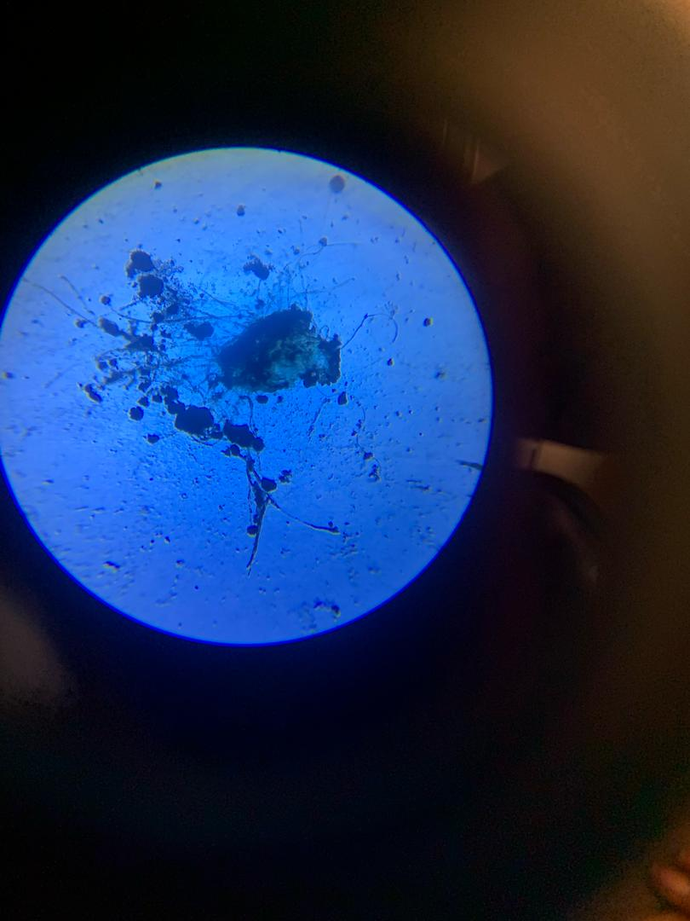
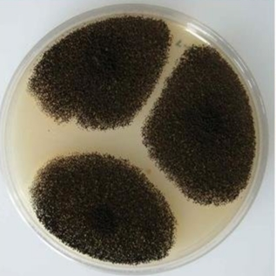

3.2 Table 2:
Daily Observation During Toxin Administration for four days
Rat ID | Physical appearance | Behavior | locomotion | Feeding | Respiratory signs | Eyes and nose
Red  Blue  Green  Black | Normal  Normal  Normal  Normal | Sedentary  Active  Active  Active | Dormant  Normal  Normal  Normal | Normal  Normal  Normal  Normal | Palpitation  Normal  Normal  Normal | Normal  Normal  Normal  Normal
Red  Blue  Green  Black | Normal  Normal  Normal  Death | Sedentary  Less active  Active | Dormant  Slow  Normal | Normal  Normal  Normal | Palpitation  Palpitation  Normal | Normal  Normal  Normal
Red  Blue  Green  Black | Normal  Death  Swollen fur  Death | Sedentary  Less active | Dormant  Slow | Not eating  Less eating | Palpitation  palpitation | Discharge  Discharge
Red  Blue  Green  Black | Death  Death  Swollen fur  Death | Inactive | Paralyzed | Not eating | Palpitation | Discharge

Key:
Red – 100%
Blue – 80%
Green – 60%
Black – 50%

Figure 3: Cumulative frequency chart for 100% conc. Red rat

Figure 4: Cumulative frequency chart for 80% conc Blue rat

Figure 5: Cumulative frequency chart for 60% conc Green rat

Figure 6: Cumulative frequency chart for 50% conc Black rat

Key:
Normal/Active (1), Less active (2), Sedentary (2.5), Dormant (3), Not eating/Less eating (3.5), Palpitation (4), Swollen fur (4.5), Discharge (5), Paralysis (5.5), Death (6).

Figure 7: Showing Total Weight Loss After Toxin Exposure

Table 3:
3.3 Post-Mortem Gross Pathological Findings of green rat
Organ observed | Control rat | Green rat (80%)
Heart  Intestine  Kidney  Liver | Normal appearance  No inflammation  Normal firm with smooth surface  Reddish brown | Dark colorations of veins connecting to the heart  Blocked intestine with two color discoloration  Damaged kidney compared to control in appearance  Slight discoloration

CHAPTER FOUR
4.0 Discussion and Conclusion
4.1 Discussion
This study assessed the toxicity of crude Aspergillus niger extract in Wistar rats, providing information into the potential health hazards posed by fungal contamination of food products. The findings demonstrated a clear dose-dependent response in both behavioral and physiological parameters, emphasizing the biological potency of A. niger secondary metabolites, even in their unrefined form.
From table [3] it shows that rats exposed to the fungal extract, particularly in the medium and high-dose groups, displayed progressive signs of systemic toxicity. These included reduced activity, inappetence, fur roughness, respiratory difficulty, and lead to mortality. The onset of such symptoms as early as the second day of exposure indicates rapid absorption and systemic distribution of toxic compounds present in the extract. These symptoms are consistent with known effects of A. niger mycotoxins such as ochratoxin A (OTA), fumonisin B2, and citrinin, all of which are associated with nephrotoxicity, hepatotoxicity, and immunosuppression (Cao et al., 2022; Mahato et al., 2023). The rapid decline and subsequent death of rats in the high-dose group (BLACK and BLUE rats), and the visible signs of neurotoxicity and weakness in others (e.g., the GREEN rat), support the hypothesis that crude A. niger extracts can cause acute toxicity. Notable features such as paralyzed movement, irregular heart rate, and discharges from the eyes and nose are consistent with previous reports on fumonisin-related cardiotoxicity and OTA-induced systemic effects (Righetti et al., 2021; Zhang et al., 2021). These findings are significant given that the extract used was not purified, suggesting high potency in the natural metabolic output of the fungus.
Post-mortem examination from table 4 revealed gross pathological changes such as liver pallor, kidney discoloration, blocked intestines, and cardiac tissue damage in exposed animals. These pathological alterations suggest functional impairment of key detoxifying and circulatory organs. The observed liver and kidney changes correlate with the biochemical targets of OTA and citrinin, both of which accumulate in renal and hepatic tissues, leading to oxidative stress, mitochondrial dysfunction, and cellular necrosis (Milicevic et al., 2021; Hassan et al., 2022). The presence of intestinal blockage and darkened cardiac tissue in high-dose rats also indicates gastrointestinal stasis and compromised cardiovascular function, potentially driven by toxin-induced vasoconstriction or hemorrhage. The pale appearance of the liver and the shrunken kidneys in some groups also reflect chronic stress on these organs due to metabolic overload or failure in detoxifying circulating mycotoxins. In line with these findings, several studies have reported that OTA and citrinin have additive or synergistic effects, especially in inducing nephropathy and altering electrolyte balance (Zhang et al., 2021).
Importantly, these effects were observed despite the crude nature of the toxin, without isolation or purification of specific components. This reveals a significant limitation of the present study while the effects of the crude extract were clear, the individual contributions of specific mycotoxins (e.g., OTA, FB2, citrinin) could not be independently evaluated. Nevertheless, the observed biological effects are consistent with those reported in studies using purified toxin preparations, suggesting that even the raw metabolite complex poses substantial toxicological risks. These findings have important public health implications, particularly in regions where food is often stored under suboptimal conditions conducive to fungal proliferation. The results strongly support the need for strict post-harvest handling, routine mycotoxin screening, and public awareness programs. Additionally, the study highlight the need for affordable detection tools and better enforcement of safety standards to limit human and animal exposure to A. niger toxins. the results provide compelling evidence of the harmful effects of Aspergillus niger toxins when consumed, even in their crude form. They support previous studies linking A. niger to severe organ damage and highlight the relevance of this fungus in food safety risk assessments.

4.2 Conclusion
This study investigate the toxicological effects of crude Aspergillus niger extract in Wistar rats to evaluate its potency and health implications. The findings revealed a dose-dependent toxic response, with marked behavioral, physiological, and organ-related abnormalities in exposed animals. Rats administered higher concentrations of the extract exhibited lethargy, reduced feeding, fur roughening, and mortality. Gross pathological changes such as pale liver, discolored kidneys, and blocked intestines were observed in toxin-treated groups, across all doses. These results support earlier scientific reports on the nephrotoxic, hepatotoxic, and immunosuppressive nature of A. niger mycotoxins, including ochratoxin A, citrinin, and fumonisin B2. Notably, the study employed the crude form of the fungal extract without isolating individual mycotoxins, yet the symptoms observed were profound. This highlights the inherent toxicity of A. niger metabolites even without purification or enhancement. The implications of these findings are significant, particularly in regions where food preservation, storage hygiene, and mycotoxin surveillance are not of standard.
4.3 Recommendations
- Adopting proper drying and storage techniques to prevent A. niger growth and subsequent mycotoxin production.
- Agricultural produce, particularly cereals, nuts, and dried fruits, should be routinely tested for A. niger mycotoxins using affordable and sensitive techniques, even at the community level.
- Educational programs should be launched to raise awareness about fungal contamination and its health implications, especially in rural and semi-urban communities.
- Future studies should focus on isolating and characterizing individual A. niger mycotoxins to better understand their specific toxic mechanisms. Dose-response studies using purified toxins would provide a clearer toxicological profile.

REFRENCES
Baldin, C., & Valdes, I. D. (2020). Occupational exposure to fungal bioaerosols: Health risks and prevention strategies. International Journal of Environmental Research and Public Health, 17(12), 4452. https://doi.org/10.3390/ijerph17124452

Cao, X., Li, P., Liu, X., & Zhang, Q. (2022). Occurrence of ochratoxin A in food and feed: A review of analytical methods, contamination status, and control strategies. Toxins, 14(2), 94. https://doi.org/10.3390/toxins14020094

European Food Safety Authority (EFSA). (2022). Scientific opinion on the risks to human and animal health related to the presence of fumonisins in food and feed. EFSA Journal, 20(3), e07098. https://doi.org/10.2903/j.efsa.2022.7098

Emmanuel, I. O., Usman, H. A., & Salawu, R. A. (2022). Occurrence and identification of black aspergilli in maize samples from Nigerian open markets. Journal of Mycology and Plant Pathology, 52(2), 87–94.

Escrivá, L., Font, G., & Manyes, L. (2022). Binders as detoxifying agents of mycotoxins in animal feed: A review. Toxins, 14(1), 44. https://doi.org/10.3390/toxins14010044

EFSA Panel on Contaminants in the Food Chain (CONTAM). (2022). Approaches to the risk assessment of chemical mixtures in food. EFSA Journal, 20(2), e07063. https://doi.org/10.2903/j.efsa.2022.7063

Fekete, C., Gyurkovics, A., & Nagy, G. (2022). Clinical relevance of black aspergilli in invasive fungal infections. Medical Mycology, 60(5), myac014. https://doi.org/10.1093/mmy/myac014

Hussain, S., Anwar, J., & Bhatti, I. A. (2021). Detection of fumonisins in red chili using thin-layer chromatography. Journal of Food Safety, 41(2), e12865. https://doi.org/10.1111/jfs.12865

Hassan, M. A., Sulaiman, R. A., & Tijani, A. A. (2021). Mycological analysis of groundnut and melon seeds from household storage: A public health concern. African Journal of Food Science, 15(8), 267–274. https://doi.org/10.5897/AJFS2021.2101

Kumar, A., Kushwaha, R., & Gautam, P. (2023). Mycotoxins and food safety: Recent advances in detection and control. Frontiers in Microbiology, 14, 1190325. https://doi.org/10.3389/fmicb.2023.1190325

Kumar, M., Rawal, N., Thakur, M., & Sharma, A. (2023). Occurrence, toxicity and mitigation strategies of ochratoxin A in food: A review. Environmental Research, 219, 114906. https://doi.org/10.1016/j.envres.2022.114906

Kumar, A., Singh, P., & Verma, R. (2023). Ochratoxin A and fumonisin B2 production in Aspergillus niger: A food safety concern. International Journal of Food Microbiology, 384, 109915. https://doi.org/10.1016/j.ijfoodmicro.2023.109915

Khalil, M. I., Umar, I. M., & Olaleye, T. A. (2022). Morphological and molecular identification of fungi associated with maize in Nigeria. African Journal of Microbiological Research, 16(4), 101–110.

Kumar, A., Singh, P., & Verma, R. (2023). Ochratoxin A and fumonisin B2 production in Aspergillus niger: A food safety concern. International Journal of Food Microbiology, 384, 109915. https://doi.org/10.1016/j.ijfoodmicro.2023.109915

Mahato, D. K., Gupta, A., Pandhi, S., & Sharma, B. (2023). Mycotoxins in food and feed: Occurrence, detection, and control strategies. Frontiers in Microbiology, 14, 1089642. https://doi.org/10.3389/fmicb.2023.1089642

Molla, M., Adeoye, A. O., & Yakubu, M. E. (2021). Spectrum of fungal agents in otomycosis among patients attending tertiary hospital in North-Central Nigeria. Nigerian Journal of Medical Mycology, 17(1), 22–28.

Mahato, D. K., Lee, K. E., & Kang, S. C. (2023). Co-occurrence and toxicological interactions of multiple mycotoxins in food and feed. Food and Chemical Toxicology, 170, 113559. https://doi.org/10.1016/j.fct.2023.113559

Mahato, D. K., Lee, K. E., & Kang, S. C. (2023). Co-occurrence and toxicological interactions of multiple mycotoxins in food and feed. Food and Chemical Toxicology, 170, 113559. https://doi.org/10.1016/j.fct.2023.113559

Mahato, D. K., Lee, K. E., Kamle, M., Devi, S., Dewangan, H. K., Kumar, P., & Kang, S. G. (2023). Citrinin and its health effects: An overview and recent updates. Toxicon, 225, 106022. https://doi.org/10.1016/j.toxicon.2023.106022
Milicevic, D. R., Jurisic, V. B., & Mandic, A. I. (2021). Ochratoxin A in foodstuffs: Recent insights into toxicity, detection, and regulation. Food and Chemical Toxicology, 153, 112254. https://doi.org/10.1016/j.fct.2021.112254

Ogbonna, D. N., Okafor, F. C., & Umeh, E. U. (2021). Occurrence of fungi and aflatoxins in stored food grains. Journal of Environmental Health Research, 31(2), 145–153.

Righetti, L., Dall’Asta, C., & Galaverna, G. (2021). Fumonisins: Chemistry, occurrence, toxicology, and methods of analysis. World Mycotoxin Journal, 14(1), 5–24. https://doi.org/10.3920/WMJ2020.2557

Righetti, L., Galaverna, G., & Dall’Asta, C. (2021). Innovation in mycotoxin detection: From the laboratory to the field. Analytical and Bioanalytical Chemistry, 413(1), 97–113. https://doi.org/10.1007/s00216-020-03063-w

World Health Organization (WHO). (2022). Mycotoxins: Health impacts and control strategies. Geneva: WHO. https://www. Kumar, A., Singh, P., & Verma, R. (2023). Ochratoxin A and fumonisin B2 production in Aspergillus niger: A food safety concern. International Journal of Food Microbiology, 384, 109915.

Zain, M. E. (2011). Impact of mycotoxins on humans and animals. Journal of Saudi Chemical Society, 15(2), 129–144. https://doi.org/10.1016/j.jscs.2010.06.006

Zhang, X., Wang, S., Zhou, Y., & Tang, H. (2021). Molecular detection and quantification of Aspergillus niger and ochratoxin A production genes in coffee beans using qPCR. Journal of Applied Microbiology, 130(6), 1942–1953. https://doi.org/10.1111/jam.149

Zhang, Q., Liu, X., Wang, Y., & Zhou, H. (2021). Synergistic toxicity of ochratoxin A and citrinin: Evidence from in vitro and in vivo studies. Toxicology Letters, 348, 1–9. https://doi.org/10.1016/j.toxlet.2021.04.002

