FACIAL RECOGNITION AND SMART CARD BASED EXAMINATION IMPERSONATION DETECTION, USING CONVOLUTIONAL NEURAL NETWORK

PRESENTED BY

OLOYEDE AYUBA OLAMIDE
HND/22/COM/FT/455

SUBMITTED TO THE DEPARTMENT OF COMPUTER SCIENCE, KWARA STATE POLYTECHNIC, ILORIN, KWARA STATE.

IN PARTIAL FULFILMENT OF THE REQUIREMENTS FOR THE
AWARD OF HIGHER NATIONAL DIPLOMA IN COMPUTER SCIENCE.

JULY, 2025.

CERTIFICATION
This is to certify that Oloyede Ayuba Olamide Matric no: HND/22/COM/FT/455 has satisfactorily carried out his project under my instructions and direct supervision. I hereby declare that he has conducted himself with diligence, honesty and sobriety on the project.

...................................................... .......................................
Mrs Ibirinoye-Abdulkareem, S.B Sign and Date
(Project Supervisor)

................................................... ........................................
Mr Saka Sign and Date
Project Coordinator

……………………………… ……………………………
Mr F.S Oyedepo Sign and Date
Head of the Department

…………………………….. ……………………………
External Examiner Sign and Date

DEDICATION
I dedicate this project report to the most beloved creator, the Almighty God. To my beloved parents and family for their endless prayers, love, and support throughout my academic journey.
Also, to my friends and colleagues who encouraged and stood by me during the course of this project, your presence and support mean the world to me.

ACKNOWLEDGEMENT
First and foremost, I give all glory to God for the grace, wisdom, and perseverance to complete this project successfully.
I would like to express my heartfelt gratitude to my project supervisor, Mrs Ibirinoye-Abdulkareem, S.B for her invaluable guidance, support, and expertise throughout this project. Her constructive feedback, patience, and encouragement helped me navigate the challenges of this research and produce a quality output.
I appreciate the opportunity to work under her supervision and benefit from her vast knowledge and experience on my project. Her insightful comments and suggestions significantly improved the quality of this project, and I am grateful for her dedication and commitment to my academic success.
I would like to appreciate the Head of Department (Mr F.S Oyedepo) and all lecturers in the department of computer science for their unwavering support and impactful knowledge throughout my study.
I would also like to thank my parents Mr & Mrs Oloyede, also to my family, friends and peers for their support, encouragement, and understanding throughout this project. Their contributions, whether big or small are gratefully acknowledged.
Finally, I acknowledge Kwara State Polytechnic for providing the resources and facilities that enabled me to complete this project. Thank you!

TABLE OF CONTENT
Title page
Certification
Dedication
Acknowledgement
Table of Content
Abstract
Chapter One
1.0 Introduction
1.1 Background to the study
1.2 Statement of the problem
1.3 Aim and objectives of the study
1.4 Significance of the study
1.5 Scope of the study
1.6 Organization of the report
Chapter Two
2.0 Literature Review
2.1 Review of Related Literature
2.2 Review of Related Concepts
2.2.1 Overview of Facial Recognition
2.2.2 Overview of Neural Networks
2.2.3 Smart Card Technology
2.2.4 Examination Security
2.2.5 Facial Recognition and Smart Card-Based Examination Impersonation Recognition
Chapter Three
3.0 Research Methodology and Analysis of the Existing System
3. 1 Research Methodology
3.2 Analysis of the Existing System
3.3 Problems of the Existing System
3.4 Description of the proposed system
3.5 Advantages of the proposed system
Chapter Four
4.0 Design, Implementation and Documentation of the System
4.1 Design of the System
4.1.1 Output Design
4.1.2 Input Design
4.1.3 Procedure Design
4.2 Implementation of the System
4.2.1 Hardware Requirements
4.3 Maintaining the System
Chapter Five
5.0 Summary, Conclusion and Recommendation
5.1 Summary
5.2 Conclusion
5.3 Recommendation
Reference
ABSTRACT
Examination malpractice, particularly impersonation, remains a significant threat to the credibility and integrity of academic evaluations. Traditional methods of student verification—such as manual ID checks and biometric fingerprint scanning—often fall short due to issues like human error, hygiene concerns, and limited scalability.
This project proposes the design and implementation of a dual-layer verification system that combines facial recognition technology with smart card authentication, powered by neural network algorithms. The facial recognition system utilizes deep learning to accurately detect and match student facial features against stored data, while the smart card provides an additional layer of identity confirmation by storing encrypted candidate information.
The system was developed using tools like OpenCV and MySQL and evaluated in a simulated examination environment. Results show that the proposed system significantly reduces impersonation risks, enhances verification accuracy, and increases overall efficiency in examination security processes.
This research contributes a scalable and secure solution to the persistent problem of impersonation in academic institutions and provides a foundation for future enhancements through multi-biometric integration.

CHAPTER ONE
GENERAL INTRODUCTION
  - BACKGROUND TO THE STUDY
Examinations play a crucial role in assessing students' knowledge and skills. However, the prevalence of impersonation undermines the credibility of these assessments. Traditional verification methods, such as manual ID checks, are prone to human error and fraud. Advances in technology, particularly in neural networks and facial recognition, offer an opportunity to develop robust systems to combat examination malpractice (Lathaet al., 2024).
Examination impersonation according to Mamun (2023) involves a person fraudulently sitting for an exam on behalf of another. This malpractice compromises academic standards and devalues qualifications. Previous attempts to address this problem, such as biometric systems and invigilator-led verification, have shown limited success due to scalability and reliability issues. With the advent of neural networks and their ability to process complex patterns, there is potential to create more effective solutions.
Impersonation not only undermines the trustworthiness of examination outcomes but also erodes the value of merit-based systems in academic institutions. The lack of robust authentication methods has allowed impersonators to exploit loopholes in the verification processes, often with dire consequences for institutions’ reputations. Existing methods, such as fingerprint scanning and manual ID checks, face challenges including hygiene concerns, time inefficiency, and ease of forgery (Vivian&Ise, 2020).
Anuradhaet al., (2018) asserted that the evolution of artificial intelligence, particularly in facial recognition and neural network technologies, provides a promising avenue for tackling these challenges. Facial recognition offers non-intrusive, fast, and accurate candidate identification, while neural networks enhance its robustness by adapting to varying conditions such as lighting and facial orientation. Coupled with smart card authentication, these technologies can create a secure, scalable, and user-friendly solution for examination verification systems.
Educational institutions, particularly those operating at scale, require solutions that are both technologically advanced and cost-effective. The integration of neural networks into examination security frameworks is not only a response to existing problems but also a proactive measure to future-proof these systems. Authentication has consistently been the biggest difficulty during exams. Verifying candidates' test eligibility is a difficult process that takes time after typical candidate screening (Garko& Ahmad, 2017).
Face recognition is one of the few biometric methods that possess the merits of both high accuracy and low intrusiveness. It has the accuracy of a physiological approach without being obtrusive. Over past few decades, many face recognition techniques have been proposed, motivated by the increased number of real-world applications requiring human face recognition. The importance of automatic face recognition is much better with numerous variations of images of the same face due to changes in the parameters such as pose, illumination, expression, motion, facial hair, glasses, and background (Siyakaet al., 2020).
There are two types of system, which help automatically in establishment of identity of a person:
- Authentication (verification) systems
- ii. An identification systems
In a verification system, a person desired to be identified submits an identity claim to the system, usually via a magnetic stripe card, login name, smart card, and so on, and the system either rejects or accepts the submitted claim of identity (Am I who I claim I am?). In an identification system, the system establishes a subject’s identity (or fails if the subject is not enrolled in the system database) without the subject’s having to claim an identity (Who am I?) (Udoh & Essien, 2024).
This project focuses on designing and implementing a system that integrates these technologies to ensure accurate candidate verification. The researchers believe that the fear of being suspected and scan for true identity before or during examination will mitigate examination impersonation by students.
  - STATEMENT OF THE PROBLEM
Despite the National Policy on Education's emphasis on exams, examination malpractice has continued to be a serious concern for education professionals. It appears that examination fraud has not been adequately tackled in institutions in Nigeria. Examination malpractice has a variety of detrimental effects. The Ministry of Education, Science, and Technology as well as the Nigeria Universities Commission (NUC) have made attempts to stop students from impersonating other people during exams, although the practice persists. The majority of the time, a student who is registered to write the exams is replaced by an examination candidate or a person who is not registered as a candidate for a certain course. While some students report the loss of the identity cards at the point of checking into the examination hall, the candidate is still permitted to sit for exams even without an identity card having a face on it.The presentation of fake clearance and identification cards is just one of the obvious issues with this way of authenticating a student for entry to the exam rooms. Due to the test's unethical practices and the basic flaws in the manual paperbased clearing process, academic stakeholders must look for other methods of authenticating students for examination. Therefore, the goal of this project is to develop a facial recognition and smart card based examination impersonation detection system.
  - AIM AND OBJECTIVES OF THE STUDY
The aim of this project is to develop a facial recognition and smart card-based examination impersonation detection system using neural networks. The objectives are to:
- design a facial recognition-based system for students’ identification in an exam hall;
- integrate smart card technology for secure authentication;
- evaluate the system’s effectiveness in real-world examination scenarios using Neural networks; and
- analyze the limitations of existing examination verification methods.
  - SIGNIFICANCE OF THE STUDY
This project is significant in addressing a critical issue in the education sector. By enhancing the integrity of examination processes, the proposed system will:
- Prevent impersonation and other malpractices.
- Restore confidence in academic assessments.
- Provide a scalable solution for institutions globally.
- Contribute to the broader field of secure identity verification systems.

  - SCOPE OF THE STUDY
Thisproject focuses on the development and implementation of a neural network-based facial recognition system integrated with smart card authentication. It is limited to the context of academic examinations and does not cover other forms of identity verification. The system’s performance will be evaluated within controlled examination environments.
1.6 ORGANIZATION OF THE REPORT
The project write-up is organized into five distinct chapters. Chapter one covers general introduction, which contains introduction to the project topic, statement of the problem, aim and objectives of the study, significance of the study, scope of the study and organization of the report. Chapter two covers the literature review, which contains review of related past works, overview of artificial intelligence, description facial recognition, smart card and other related concepts. Chapter three explains the project methodology which includes analysis of existing system, problems of the existing system, the description of the proposed system and advantages of proposed system. Chapter four explains the design, implementation and documentation of the system which contain system designed output design, input design, database design, procedure design, implementation of the system hardware and software support and documentation of the new system installation procedure, operating the system and system maintenance. Lastly, chapter five explains the summary of the research, recommendations, and conclusion.

CHAPTER TWO
LITERATURE REVIEW
2.1 REVIEW OF RELATED LITERATURE
Latha (2024) worked on preventing impersonation in exams through face recognition technology. The system uses cutting-edge facial recognition algorithms and student photo databases to verify the identification of test takers. Face recognition techniques was utilized to authenticate the student's identity in real-time. The technology confirmed that the registered student who was physically there was the approved test-taker by photographing and analyzing the student's facial features. After scanning, the algorithm divides students into two sets: verified students belong in one set and unverified students in another. Before the test, every student's picture is safely stored in the system's database. To confirm a student's identification during a test, the system takes pictures of them in real-time and compares them to images that they have already registered. Any discrepancies or potential instances of impersonation are flagged for immediate investigation by exam proctors or administrators. The Student Face identification System, which includes facial identification and photo verification during exams, provides a reliable solution for assuring examination integrity and combating academic fraud. Using modern technology, the system delivers effective authentication procedures while also facilitating efficient examination administration operations.
Mamun (2023) developed an authentication system for exam halls using face biometrics. The paper aims to overcome the existing challenges by leveraging the unique characteristics of an individual's face for authentication purposes. The enrolment stage and the verification of identities phase are the system's two primary parts. Each exam participant's face characteristics are photographed and safely saved in a database throughout the enrolment step. High-resolution cameras are used in this procedure to take several pictures of the participant's face from different perspectives. The positioning of facial characteristics and particular contours of the face are then extracted from these photos via processing and analysis. In the authentication phase, when an individual enters the exam hall, their face is captured by the cameras installed at strategic locations. The captured image is compared with the enrolled images stored in the database. Advanced algorithms are employed to perform a comprehensive analysis of the facial features, ensuring accurate identification and authentication of the individual. If a match is found, the system grants access to the exam hall; otherwise, it denies entry and alerts the invigilators about the potential unauthorized presence.
Udeh and Essien (2024) designed and developed a biometric capturing system for preventing impersonation in examinations in tertiary institutions in Akwa Ibom state. The study comprised two stages: the fabrication of the biometric device and the development of the biometric application software to drive the fabricated biometric device. The list of software components comprised the Windows Operating System, MySQL, a database for storing captured data concerning the students, PHP programming Language, and so on for the development of software applications used in driving the fabricated biometric capturing system. The perception reliability indices were analyzed using mean and standard deviation. Items with a mean score of 3.50 and above were considered agreeable, while those with a mean value of less than 3.49 were rejected based on the rating of items on the decision rule. Findings reveal that the development of a Biometric capturing system for the prevention of examination impersonation was reliable.
Vivian and Ise (2020)implemented a face recognition service model for student identity verification using deep neural network and support vector machine. Theresearchers developed a face recognition web service model for student identity verification using Deep Neural Network (DNN) and Support Vector Machine (SVM). The aim is to mitigate examination impersonation by simple face scan using mobile phone and also to make such a model accessible and re-usable for seamless integration with any kind of student identity verification project.
Idemudiaet al., (2018)developed a smart approach of e-exam assessment method using face recognition to address identity theft and cheating. In the research, the new approach of using facial recognition was introduced as an enhanced verification for e-Exam’s candidates. Early warning was produced to inform any suspicious movement through the system. The system generated web Application Programming Interface (API) authentication, image, and video with feature extraction matching action. The proposed technique has been presented to experts in addition to 29 students as respondent and to study the effect and the benefit of such system in e-Exam environment.
Prince (2023) developed a neural network face biometrics system for impersonation detection in an examination. The construction of a software system to identify impersonators while being examined is the main focus of the paper. The system is built with Deep Convolutional Neutral Network (DCNN) biometric technology, which is based on identifying a person's face traits, and Model View Controller (MVC) image processing approach. MySQL was used as the database, and Python was used to implement it. Data was gathered through primary and secondary sources, and the face biometric dataset will be purchased online. The research resulted in the development of an impersonation detection system during examination for students at Federal Polytechnic, Auchi, in order to establish an environment conducive to free and fair examination.
Garko and Ahmad (2017) designed and modeled a student verification system in an examination in Nigeria using biometric fingerprint technology. The paper proposed a system that will help in identifying and verifying student during examinations with a view of minimizing exams malpractice. The introduction of fingerprint-based exam verification system in the paper helped to easily identify students that registered for a particular course and can easily identify students that are eligible to enter the exam hall. Each student’s information will be saved in the database which will help the staff to carry out their verification and identification exercise efficiently and is more secured. However, for student to be verified using the system they should make sure they have registered for all the courses they supposed to take during a particular session and they must have 75% of attendance for him/her to be eligible to sit for the exam. Prototyping software development methodology was adopted in this paper; Visual Basic 6.0 was used to design the interfaces and Mysql was used as the back-end. Finally, only the verified students are allowed to sit for the exam. The output from the system shows that, the proposed framework is more secured, more efficient, and has better performance when compared with the manual system of students‟ verification.
2.2 REVIEW OF RELATED CONCEPTS
2.2.1 Overview of Facial Recognition
Facial recognition is a biometric technology that uses algorithms to identify or verify an individual by analyzing their facial features. The system captures an image or video of a face, maps its unique geometry, and compares it against a database of stored facial data. Key aspects analyzed include the distance between the eyes, the shape of the cheekbones, the width of the nose, and the jawline. Modern facial recognition systems use artificial intelligence and deep learning techniques to improve accuracy and adapt to variations such as lighting, angles, and facial expressions.
This technology has found applications in various fields, including law enforcement, security, healthcare, and retail. For instance, it is used in surveillance systems to identify suspects, in smartphones for authentication, and in airports to streamline passenger verification. Despite its widespread use, facial recognition raises concerns about privacy and the potential for misuse. Ethical considerations and regulatory frameworks are essential to ensure responsible implementation.
Advancements in artificial intelligence have significantly enhanced the capabilities of facial recognition systems, enabling real-time processing and improved accuracy. However, challenges such as bias in datasets and vulnerability to spoofing attacks still exist. Researchers are continuously working to address these issues and make facial recognition more robust and equitable (Fayyoumi&Zarrad, 2019).
2.2.2 Overview of Neural Networks
Neural networks are a subset of machine learning inspired by the human brain's structure and function. Composed of layers of interconnected nodes or neurons, these systems process data through weights and biases to learn patterns and make predictions. Neural networks are the foundation of many AI applications, including image recognition, natural language processing, and autonomous systems.
The architecture of a neural network typically includes an input layer, one or more hidden layers, and an output layer. Each layer transforms the data using activation functions and passes the results to the next layer. Backpropagation, a method for adjusting weights based on errors, enables the network to learn over time. Deep neural networks, with multiple hidden layers, have demonstrated remarkable success in handling complex tasks like speech recognition and medical diagnosis.
Despite their capabilities, neural networks face challenges such as high computational requirements and the need for large amounts of labeled data. Moreover, they often operate as "black boxes," making it difficult to interpret their decision-making process. Ongoing research aims to enhance the transparency, efficiency, and applicability of neural networks across various domains (Prince et al., 2023).
2.2.3 Smart Card Technology
Smart card technology involves the use of pocket-sized cards embedded with integrated circuits capable of processing and storing data securely. These cards are widely used in areas such as banking, healthcare, and identity verification. A smart card may store sensitive information, including personal identification, cryptographic keys, or transaction records, making it an essential tool for secure communication.
The technology offers significant advantages over traditional magnetic stripe cards, including enhanced security features like encryption and authentication protocols. Smart cards are resistant to tampering and cloning, which reduces the risk of fraud. They can also facilitate multi-factor authentication by working alongside PINs, passwords, or biometric systems, thereby improving security.
Despite their benefits, the implementation of smart card technology requires significant investment in infrastructure and systems. Compatibility and interoperability issues can also pose challenges, particularly in global applications. Nevertheless, advancements in this field are continually enhancing the usability and security of smart card solutions (Garko & Ahmad, 2017).
Top of Form

2.2.4 Examination Security
Examination security is critical for maintaining the integrity of academic and professional assessment processes. It involves measures to prevent cheating, impersonation, and unauthorized access to exam materials. Traditional methods include strict supervision, secure exam storage, and candidate verification through IDs or entry passes. However, as technology advances, digital examinations necessitate more sophisticated security measures.
Biometric systems, such as fingerprint or facial recognition, are increasingly employed to authenticate candidates and eliminate impersonation. Similarly, secure online platforms use encryption and real-time monitoring to detect anomalies during tests. Other measures include time-restricted access, randomized question sets, and AI-powered proctoring systems capable of identifying suspicious behavior.
Despite these efforts, examination security remains a challenging domain due to evolving fraud tactics. Regular updates to security protocols and investment in advanced technologies are essential. Moreover, fostering a culture of academic integrity through awareness and ethical training can complement technological measures (Vivian & Ise, 2020).
2.2.5 Facial Recognition and Smart Card-Based Exam Impersonation Recognition
Combining facial recognition and smart card technology offers a robust solution for preventing exam impersonation and enhancing examination security. Facial recognition ensures that the individual taking the exam matches the registered candidate by analyzing their facial features. Smart cards add an additional layer of security by storing the candidate's biometric and identification data, which can be verified during the exam.
This dual approach minimizes the risk of fraud by addressing weaknesses in standalone systems. Facial recognition can prevent impersonators who might otherwise use forged IDs, while smart cards ensure that the correct identity information is readily available. The integration of these technologies also facilitates seamless authentication, reducing delays and improving the overall examination experience.
Implementing such a system requires significant investment in hardware, software, and training. Challenges like ensuring data privacy, maintaining system accuracy under diverse conditions, and integrating with existing infrastructure must be addressed. However, the combination of these technologies holds significant potential to revolutionize examination security, setting new standards for integrity and trust in assessment processes (Siyakaet al., 2020).

CHAPTER THREE
RESEARCH METHODOLOGY AND ANALYSIS OF THE EXISTING SYSTEM
3.1 RESEARCH METHODOLOGY
In this project, a student identity verification face recognition service model was proposed. The model is aimed at identifying suspected cases of impersonation during examination exercise. Although the service can also be used for full scale student identity verification before entering the examination hall.
This project adopted an iterative waterfall design model which was used to identify the biometric application software that was developed to serve as an interface between the server and the facial recognition system as shown in the figure below:
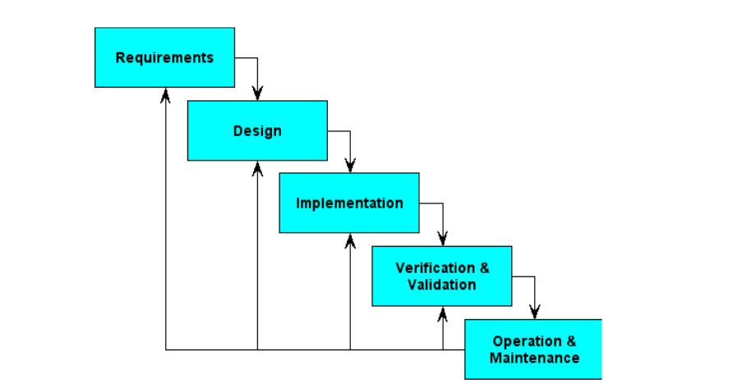
Figure 3.1: The Iterative Waterfall Model Source: Walia, (2022)
The iterative waterfall model of software at Bell Laboratory is proposed in a series of short Plan-to-Study-Act (PDSA), cycles for quality improvement. Software development is broken down into large numbers of iterations, where each iteration is a complete development loop resulting in a release of executable software and it allows for improvement and changes to be made at each stage of the development process.
Materials and Methods
Face Recognition
Generally, face recognition could be described as a four steps processes as shown in figure 3.2 below. These are:
- Face Detection: Locating one or more faces in the image and mark with a bounding box.
- Face Alignment: Normalizing the face to be consistent with the database, such as geometry and photometrics.
- Feature Extraction: Extracting features from the face that can be used for the recognition task.
- Face Recognition: Performing match of the face against one or more known faces in a database.
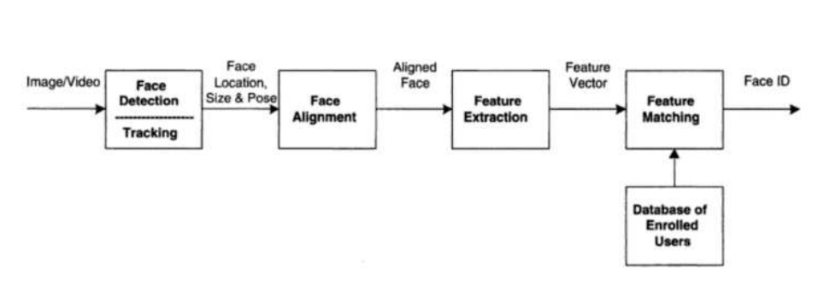
Figure 3.2: Face Recognition Process Source: Adam, (2021)
In this project the face recognition pipeline was built using OpenCV implementation of Neural Network (NN). Basically, a standard Neural Network (NN) consists of many simple, connected processors called neurons, each producing a sequence of real-valued activations. Figure 3.3 depicts a neural network with three layer.
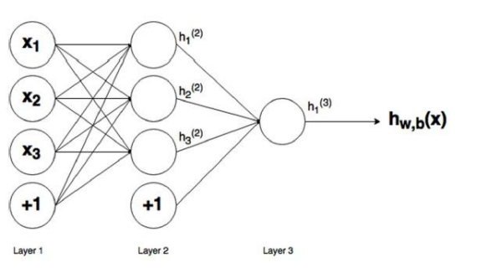
Figure 3.3: A Three Layer Neural Network Source: Thomas, (2017)
3.2 ANALYSIS OF THE EXISTING SYSTEM
Traditional examination verification methods heavily rely on manual processes and invigilator oversight. These methods are not only prone to human error but also susceptible to manipulation and fraudulent activities. The process of manually verifying candidate identities often results in delays and inefficiencies, especially in large-scale examination settings. Biometric systems, such as fingerprint recognition, have been introduced in some contexts but face significant challenges in terms of hygiene concerns, particularly in a post-pandemic era. Additionally, these systems require physical contact and often lack the scalability needed for institutions with high student populations.
Another drawback of existing systems is their inability to provide real-time detection and verification of candidates. This results in a reactive rather than proactive approach to combating impersonation. The dependence on standalone systems, without the integration of modern technologies such as neural networks and multi-factor authentication, limits their effectiveness in addressing sophisticated impersonation tactics. The growing sophistication of fraud necessitates an advanced, automated, and scalable solution that can ensure examination integrity in diverse operational environments. Traditional systems rely on manual ID checks and invigilator oversight, which are prone to errors and manipulation. Biometric systems, such as fingerprint scanners, face scalability challenges and are susceptible to hygiene concerns, especially in the post-pandemic era. These limitations necessitate a more robust and automated solution.
3.3 PROBLEMS OF THE EXISTING SYSTEM
Existing student verification system during exams primarily rely on manual method. The problems faced by the existing system are:
- High susceptibility to human error.
- Vulnerability to fraud and manipulation.
- Scalability and reliability issues in biometric systems.
- Lack of real-time detection and verification.
3.4 DESCRIPTION OF THE PROPOSED SYSTEM
The proposed system integrates facial recognition technology and smart card authentication to verify candidates. The neural network processes facial images captured by cameras and matches them against stored data. The smart card ensures the candidate’s presence and provides additional security by storing encrypted identity information. The system operates in real-time, ensuring quick and accurate verification.

3.5 ADVANTAGES OF THE PROPOSED SYSTEM
Advantages of the proposed system are:
- Enhanced security through dual-factor authentication.
- Real-time detection of impersonation attempts.
- Scalability for large examination centers.
- Reduced reliance on manual verification.
- Improved fairness and integrity in examinations.

CHAPTER FOUR
DESIGN, IMPLEMENTATION AND DOCUMENTATION OF THE SYSTEM
4.1 DESIGN OF THE SYSTEM
This is the computation of the particulars of a new system and the determination of what the new system would be and the function it is to perform. This may involve changing from one system to another or modifying the existing system operation.
The most challenging phase of the system life cycle is the change from manual operation to a faster and more accurate one; system design stage covers the technical specifications that will be employed in the implementation of the new system in order to modify the previous system. Some factors are put in consideration. These factors include input design, output design, the database and procedure designs and other documentation.
4.1.1 OUTPUT DESIGN
This incorporates the objectives of solving the existing system problems and challenges. The outputs extracted from the system are displayed in the screenshot images below:
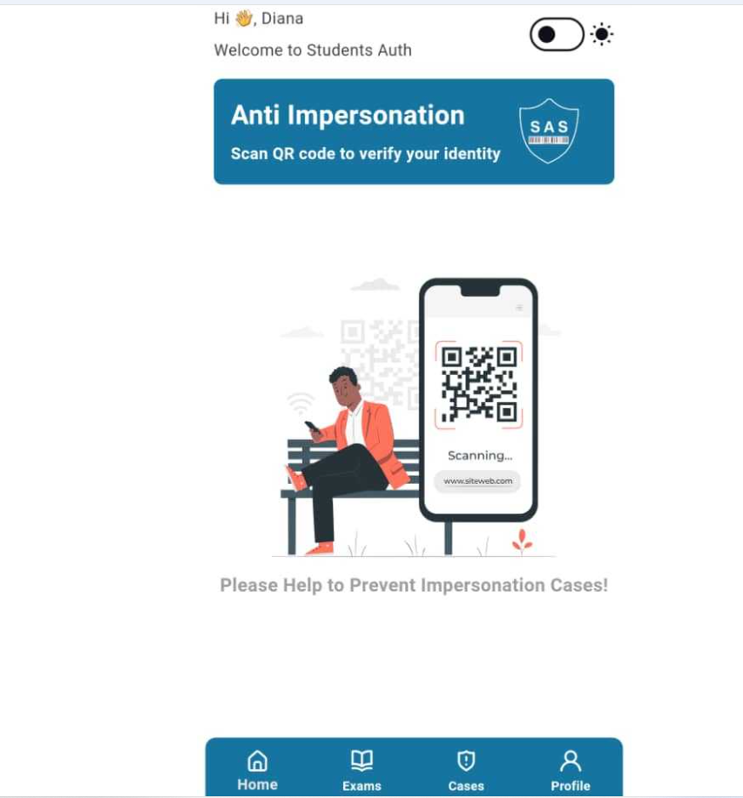
Figure 4.1: The Main Menu of the System
The figure 4.1 above is the main interface of the system. There are some clickable menus below to navigate to various places on the system. These include Home, Exams, Cases and Profile.
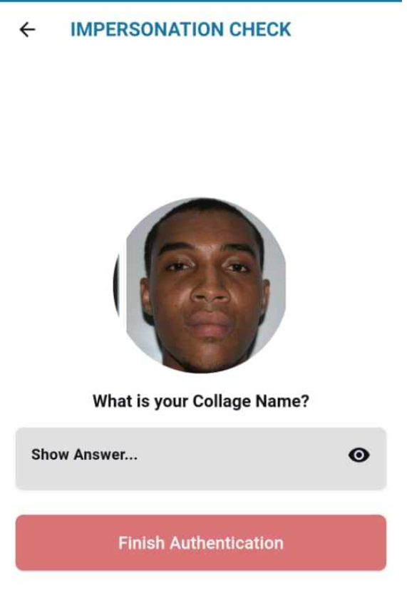
Figure 4.2: The Impersonation Check Interface
The image above shows the impersonation check page. A student who is yet to be verified will stand in front of the system, the system will have to capture his/her face to authenticate its eligibility for that particular exam.

Figure 4.3: The Authentication Confirmation Page
This image above is the authentication page. After a student is confirmed to be who he said he is then a page pops up to confirm its authentication. It is include in this page student name, Matric number, phone number and email.

4.1.2 INPUT DESIGN
The input to implement this hardware is obtained from the facial recognition and smart card-based impersonation detection system materials purchased from the market. The researchers are expected to couple and install the system. They can achieve this by coupling these materials together. These materials are shown below:

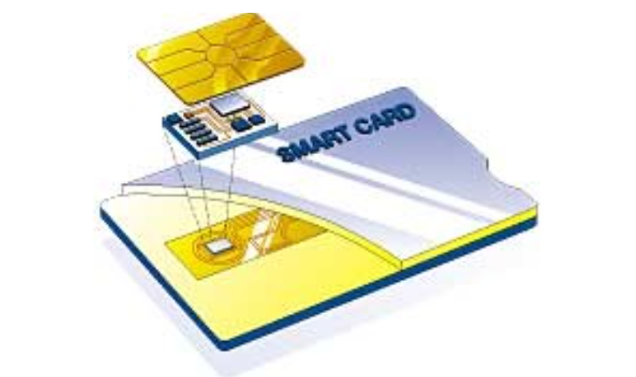
Figure 4.4: Smart Card
The image above is a sample of the smart card to be used on the system, each student has his or her own smart card for authentication.
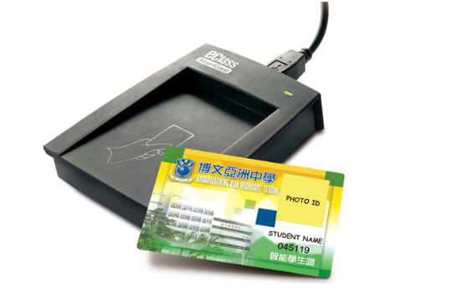
Figure 4.5: A Smart Card Reader
This is the smart card reader used in the system. When a student card is inserted it displays the details of the students indicating the authenticity of the said students.
4.1.4 PROCEDURE DESIGN
These are the steps involved in unifying the whole process to produce the desired output. It involves implementation of the system which starts from the original input lessons to the output that is the implemented system. This allows the processing of user information and result to be possible. Display unit is provided to help user with some information.
4.2 IMPLEMENTATION OF THE SYSTEM
This entails the choice of the programming language employed to implement the system which should-be suitable for facial recognition and smart card-based impersonation detection system. The system is designed for the use of higher institution of learning which should serve as an assistant. It is also expected to be used in conjunction with the admistrator.
4.2.1 HARDWARE REQUIREMENTS
i. The Microcontroller
ii. Andruino Uno
iii. Power Box
iv. Smart Card
- LCD Screen
- Facial and Card Reader
4.3 MAINTAINING THE SYSTEM
The system maintenance refers to making modification to an already existing system without necessarily changing from the beginning. System maintenance includes modification of the system to meet-up with certain requirements of the users. In this course, additional features can be added, errors corrected, ambiguous materials replaced to eliminate confusions and unnecessary features removed.
Maintaining this system can be done by a technician or an expert. Any future modification can be by replacing some parts that has fault and re-install the system.

CHAPTER FIVE
SUMMARY, CONCLUSION AND RECOMMENDATIONS
5.1 SUMMARY
Summary
Examination impersonation has long been a persistent issue undermining the credibility of academic assessments. Traditional methods, including manual ID verification and biometric systems, have failed to fully address this challenge due to issues such as human error, hygiene concerns, and limited scalability. The emergence of neural networks and facial recognition technologies presents a groundbreaking opportunity to tackle this problem with precision and efficiency.
This project introduces a Facial Recognition and Smart Card-Based Examination Impersonation Detection System designed to ensure secure and fair examination environments. This system leverages the adaptive learning capabilities of neural networks, enabling accurate facial recognition even in challenging conditions such as varying lighting and facial orientations. Coupled with smart card authentication, the system provides a dual-layer security mechanism to prevent impersonation and other malpractices.
By addressing the limitations of existing systems, this project highlights the potential of integrating advanced technologies into examination security frameworks. The proposed system not only enhances the integrity of academic assessments but also serves as a scalable and cost-effective solution for institutions worldwide. Its implementation represents a significant step toward maintaining trust and fairness in educational evaluations.
5.2 CONCLUSION
The proposed system addresses critical gaps in examination security by providing an effective solution to impersonation. By integrating facial recognition and smart card technologies with neural networks, the system offers real-time verification and dual-factor authentication to ensure the authenticity of candidates. This approach not only enhances examination integrity but also sets a benchmark for academic institutions worldwide.
  - RECOMMENDATIONS
Based on the findings of this research, the following were recommended:
- Educational institutions should prioritize the adoption of this technology to strengthen examination processes and prevent malpractices.
- Further research should explore the incorporation of additional biometric features, such as iris or voice recognition, to enhance the system's robustness.
- The scalability of the system can be expanded to include broader identity verification applications beyond academic settings, such as in professional certifications and corporate testing environments. proposed system addresses critical gaps in examination security by providing an effective solution to impersonation.
- It is recommended that educational institutions adopt this technology to enhance the credibility of their assessment processes. Further research could explore the integration of additional biometric features and the adaptation of the system for broader identity verification applications.

REFERENCES
Anuradha, S. G., Kavya, B., Akshatha, S., Jyothi, K & Ashalatha, G. (2018). Automated Face Detection & Recognition for Detecting Impersonation of Candidate in Examination System, International Journal of Scientific & Engineering Research. Vol. 7, Issue: 3. Pp. 149-150. DOI: 10.33136/ijser.8976
Idemudia, S. Rohani, M. F., Siraj, M. & Othman, S. H. (2018). A Smart Approach of E-Exam Assessment Method Using Face Recognition to Address Identity Theft and Cheating, International Journal of Computer Science and Information Security (IJCSIS). Vol. 14, Issue: 10. Pp.123-124. DOI: 10.22146/ijccs.3764
Latha, M. P., Swathi, C., Sathvikai, G. K., Mukesh, D. S. & Raj, M. B. (2024). Preventing Impersonation in Exams through Face Recognition Technology, International Research Journal on Advanced Engineering and Management. Vol. 2, Issue: 9. Pp. 23-25. https://doi.org/10.47392/IRJAEM.2024.0441 e
Mamun A. M. (2023). Authentication System for Exam Halls Using Face Biometrics, Open Access Journal of Data Science & Artificial Intelligence. Vol. 1, Issue: 1. Pp. 12-13. DOI: 10.23880/oajda-16000101
Musambo, K. & Phiri, J. (2021). Student Facial Authentication Model based on OpenCV’s Object Detection Method and QR Code for Zambian Higher Institutions of Learning, (IJACSA) International Journal of Advanced Computer Science and Applications. Vol. 9, Issue: 5. Pp. 88-89. doi: https://doi.org/10.32628/CSEIT2063225
Siyaka, H. O., Owolabi, O. & Hashim, B. I. (2020). An Examination Conduct Mechanism for Nigeria Based on Modified Convolutional Neural Networks Algorithm Authentication Scheme, Journal of Behavioral Informatics. Vol. 6. Issue: 1. Pp. 122-123.
Udoh, O. & Nseabasi, P. Essien, N. P. (2024). Development of a Biometric Capturing System for Preventing Impersonation in Examinations in Tertiary Institutions in Akwa Ibom State, Asia-Africa Journal of Recent Scientific Research. Vol. 4, Issue: 1. Pp. 67-69. doi:10.5281/zenodo.1234567
Vivian, N. I. & Ise, O. A. (2020). Face Recognition Service Model for Student Identity Verification Using Deep Neural Network and Support Vector Machine (SVM), International Journal of Scientific Research in Computer Science, Engineering and Information Technology. Vol. 11, Issue: 4. Pp. 2456-2457 doi: https://doi.org/10.32628/CSEIT2063225 11
Walia, W. & Jain, J. (2019). Acceptability of Biometric Security Systems, Radio Frequency Identification Technology, Pacific journal of science and technology. Vol 6: 7 (1). Pp. 14 – 15. Medwin Publishers
Wang, Y., Huang, J., Su, C. & Li, H. (2018). Furnace Thermal Efficiency Modeling using an Improved Convolution Neural Network Based on Parameter-Adaptive Mnemonic Enhancement Optimization, Applied Thermal Engineering. Vol. 3, Issue: 2. Pp. 35-37. https://doi.org/10.1016/j.applthermaleng.2018.12.048
Yang, S., and Verbauwhede I. (2020). A Real Time, Memory Efficient Fingerprint Verification System. In: Proc. IEEE International Conference on Acoustics,Speech and Signal Processing. Vol 5. Pp. 189 – 192.

