MEDICAL IMAGE COMPRESSION USING HUFFMAN TECHNIQUES

By

ENITAN ISAAC OLUWASEUN
HND/23/COM/FT/0236

A Project Submitted to the Department of Computer Science, Institute of Information and Communication Technology, Kwara State Polytechnic, Ilorin

In Partial Fulfillment of the Requirements for the Award of Higher National Diploma (HND) in Computer Science

June, 2025

CERTIFICATION
This is to certify that this project research was carried out by ENITAN, Isaac Oluwaseun
with Matriculation Number HND/23/COM/FT/0236, has been read and approved as meeting part of the requirements for the award of Higher National Diploma (HND) in Computer Science.

………………………….. ………………………….
MR. OLAJIDE A.T. Date
Project Supervisor

………………………….. ………………………….
MR. OYEDEPO F. S Date
Head of Department

………………………….. ………………………….
External Examiner Date

DEDICATION
This project is dedicated to the creator of the earth and universe, the Almighty God. It is also dedicated to my parents for their moral and financial support.

ACKNOWLEDGEMENT
Praises and thanks to be God, the Almighty, for his showers of blessings through my research work to complete the research successfully.
I would like to express my deep sincere gratitude to my project Supervisor in person of MR. OLAJIDE for giving me the opportunity to do this research and providing invaluable guidance throughout this research. Her dynamism, vision, sincerity and motivation have deeply inspired me. She has taught me the methodology to carry out the research and to present the research works as clearly as possible. It was a great privilege and honour to work and under her guidance, I am extremely grateful for what she has offered me. Special thanks to H.O.D of the department (Mr. Oyedepo F. S.) and other members of staff of the department of Computer Science for their support always.
My regards go to my siblings for their immersed contribution towards the success of this study. In conclusion my sincere appreciation goes to my friends for their love and care and maximum cooperation towards my academic success.

TABLE OF CONTENTS
Title Page i
Certification ii
Dedication iii
Acknowledgements iv
Abstract v
Table of Content vi
CHAPTER ONE: GENERAL INTRODUCTION
  - Background to the Study 1
  - Statement of the Problem 3
  - Aim and Objectives of the Study 3
  - Significance of the Study 4
  - Scope of the Study 5
  - Organization of the Report 5
CHAPTER TWO: LITERATURE REVIEW
2.1 Review of Related Works 7
2.2 Review of General Text 11
CHAPTER THREE: RESEARCH METHODOLOGY AND ANALYSIS
  - Research Methodology 17
  - Analysis of the Existing System 17
  - Problems of the Existing System 18
  - Description of the Proposed System 18
  - Advantages of the proposed system 19
CHAPTER FOUR: DESIGN, IMPLEMENTATION AND DOCUMENTATION OF THE SYSTEM
  - Design of the System 20
    - Output Design 20
    - Input Design 24
    - Database Design 26
    - Procedure Design 27
  - Implementation of the System 27
    - Choice of Programming Language 28
    - Hardware Support 28
    - Software Support 29
  - Documentation of the System 29
    - Program Documentation 30
    - Maintaining the System 30
CHAPTER FIVE: SUMMARY, CONCLUSION AND RECOMMENDATION
  - Summary 31
  - Conclusion 31
  - Recommendation 32
References 33
System Flowchart / Program Flowchart of the Existing System
Source Program Listings

ABSTRACT
A medical picture is worth more than thousand words, is a common saying. What an image can communicate cannot be expressed through words. Medical Images play an indispensable role in representing vital information and needs to be saved for further use or can be transmitted over a medium. In order to have efficient utilization of disk space and transmission rate, images need to be compressed. Medical Image compression is the technique of reducing the file size of a medical image without compromising with the image quality at an acceptable level. This reduction in file size saves disk/memory space and allows faster transmission of images over a medium. Image compression is been used from a long time and many algorithms have been devised. In this project we have converted an image into an array using Delphi image control tool. Image control can be used to display a graphical image Icon (ICO), Bitmap (BMP), Metafile (WMF), GIF, JPEG, and so on, then lossless algorithm is used to implement the coding method that removes redundant codes from the image and compresses a BMP image file (especially grayscale image) and it is successfully reconstructed. This reconstructed image is an exact representation of the original because it is lossless compression technique. This Program can also be applied on other kind of Red Green and Blue (RGB) images (BMP, JPEF, Gif, and tiff) but it gives some color quality loss after reconstruction .Compression ratio for grayscale image is better compared to other standard methods. The system was developed using Visual C# and MySQL as the database.

CHAPTER ONE
GENERAL INTRODUCTION
1.1 BACKGROUND TO THE STUDY
An image is an object that records the information about visual perception of the human being like two dimensional image, three dimensional images, etc. An image processing is any type of the signal processing for which input is simply the image and the output is the characteristics of the image. Image compression is the technique which is used to compress the images in the form of reduction of the storage space and in cost. Biomedical images are the technique to capture the images from the human being for the clinical purpose. Biomedical images have persistent to advance across a wide range of applications from diagnostics to tailored therapy to mechanistic understanding of biological processes (Ajibola, 2020).
Rachmawati et al., (2021) define compression as “reducing the quantity of data used to represent a file, image or video content without excessively reducing the quality of the original data”. An Improve Medical Image compression refers to the reduction of the digital data to store or transmit images with less rate of distortion. Medical Image compression means the reduction of the quantity of graphical data required to represent a digital image. It involves reducing the size of pictures files, while retaining necessary information.
Medical Image compression is an application of data compression that encodes the original image with few bits. The objective of Medical Image compression is to reduce the redundancy of the image and to store or transmit data in an efficient form. The main goal of such system is to reduce the storage quantity as much as possible, and the decoded image displayed in the monitor can be similar to the original image as much as can be (Mathur, et al., 2019). Image compression refers to the reduction of the digital data to store or transmit images with less rate of distortion. Image compression means the reduction of the quantity of graphical data required to represent a digital image. It involves reducing the size of pictures files, while retaining necessary information (Al-Rababah, 2020). Biomedical images are the technique to capture the images from the human being for the clinical purpose. Biomedical images have persistent to advance across a wide range of applications from diagnostics to tailored therapy to mechanistic understanding of biological processes (Rajan, 2019).
Medical Image compression is a type of data compression applied to digital images, to reduce their cost for storage or transmission. Algorithms may take advantage of visual perception and the statistical properties of image data to provide superior results compared with generic compression methods (Srinivasan, 2019).
Lempel Ziv Welch (LZW) is an image compression based algorithm, which is lossless in nature and incorporated as the standard of the consultative committee on International telegraphy and telephony, which is implemented in a research paper. Lempel-Ziv-Welch (LZW) is a universal lossless data compression algorithm created by Abraham Lempel, Jacob Ziv, and Terry Welch. It was published by Welch in 1984 as an improved implementation of the LZ78 algorithm published by Lempel and Ziv in 1978. The algorithm is designed to be fast to implement but is not usually optimal because it performs only limited analysis of the data (Abhishek, 2021).
The main goal of this medical image compression technique is to achieve a highly compressed medical data of patients without mortifying the perceptual quality and robust against transmission errors. The widely acceptable compression method is lossless compression. The medical compression technique is based on the optimization approach.

1.2 STATEMENT OF THE PROBLEM
Images play an important role in providing detailed information of human/object, fractures and other information issues related to different images. However these images face major challenges due to the size of graphical image data sets during transmission and storage. For instance each MRI and CT image requires an average of 5 to 12 Mbytes and a single X-ray may require as much as 24 Mbytes. This occupies larger bandwidth and time for its transmission, increasing the cost. For this reason this project aim to develop a medical image compression with low file size.
1.3 AIM AND OBJECTIVES
The aim of this project is to develop an improve medical image compression using Lempel Ziv Welch Algorithm (LZW). The objectives are to:-
- store and transmit image in an efficient form;
- develop a system that maintain medical image quality and the total amount of digital storage required (Megabyte or MByte);
- implement a system that reduce the quantity of graphical data required to represent a digital medical image; and
- reduce the size of medical pictures files, while retaining necessary information.
1.4 SIGNIFICANCE OF THE STUDY
The significance of this project is to achieve a highly compressed graphical image or object without mortifying the perceptual quality and robust against transmission errors. This project seeks to reduce the number of bits used to store or transmit information; it encompasses a wide variety of software and hardware compression techniques. For effective compression, the resultant stream of image will be smaller than the original image size.

1.5 SCOPE OF THE STUDY
This project is centered on system application for graphical medical image compression using Lempel Ziev Welch (LZW) which is an algorithm suitable for image compression technique.
1.6 ORGANIZATION OF REPORT
The project write-up is organized into five chapters. Chapter one covers general introduction which contains introduction to the research topic, statement of the problem, aim and objectives, significance of the study, scope and limitation, organization of the report and definition of technical terms used. Chapter two covers literature review, which contains review of general text and discussions of issues related to the application of case filling. Chapter three explains the project methodology which includes method of data collection, analysis of existing system, problems of the existing system, and the description of the proposed system, advantages of proposed system and design and implementation techniques used. Chapter four explains the design, implementation and documentation of the system which contain system design – output design, input design, database design and procedure design, implementation of the system – hardware and software support and documentation of the new system – installation procedure, operating the system and system maintenance. Lastly, chapter five explains the summary of the research, recommendations and conclusion.

CHAPTER TWO
LITERATURE REVIEW
2.1 REVIEW OF RELATED WORKS
Mathur, Loonker and Saxena (2019) proposed a lossless huffman coding technique for image compression and reconstruction using binary tree. They converted an image into an array using Delphi image control tool. Image control can be used to display a graphical image - Icon (ICO), Bitmap (BMP), Metafile (WMF), GIF, JPEG, and so on, then an algorithm is created in Delphi to implement Huffman coding method that removes redundant codes from the image and compresses a BMP image file (especially grayscale image) and it is successfully reconstructed. This reconstructed image is an exact representation of the original because it is lossless compression technique. This Program can also be applied on other kind of RGB images (BMP, JPEF, Gif, and tiff) but it gives some color quality loss after reconstruction .Compression ratio for grayscale image is better as compared to other standard methods.
Jilani and Sattar (2020) implemented a fuzzy neural networks based EZW image compression system. A fuzzy optimization design based on neural networks is presented as a new method of image processing. The combination system adopts a new fuzzy neuron network (FNN) which can appropriately adjust input and output values, and increase robustness, stability and working speed of the network by achieving high compression ratio. Artificial Neural Network has been applied to many problems in image processing and has demonstrated their superiority over classical methods when dealing with noisy or incomplete data for image compression applications.
Thakur et al., (2019) designed an image compression algorithm using matlab. The paper gives the idea of recent developments in the field of image security and improvements in image security. Images are used in many applications and to provide image security using image encryption and authentication. Image encryption techniques scramble the pixels of the image and decrease the correlation among the pixels, such that the encrypted image cannot be accessed by unauthorized user. The study proposed a method for encrypting the sender’s messages using new algorithm called chaotic encryption method. The key was used for encrypting and decrypting the messages which are transmitted between two sides. Chaotic encryption technique is the new way of cryptography. Emphasizing the image security, this paper is to design the enhanced secure algorithm which uses chaotic encryption method to ensure improved security and reliability.
Jassim and Qassim (2021) developed five modulus methods for image compression. In the paper a novel approaches of image compression based on a new method that has been created for image compression which is called Five Modulus Method (FMM). The new method consists of converting each pixel value in an 8x8 block into a multiple of 5 for each of the R, G and B arrays. After that, the new values could be divided by 5 to get new values which are 6-bit length for each pixel and it is less in storage space than the original value which is 8-bits. Also, a new protocol for compression of the new values as a stream of bits has been presented that gives the opportunity to store and transfer the new compressed image easily.
Rachmawati et al., (2019) proposed a least combination of huffman coding compression algorithm and least significant Bit method for image hiding. Significant Bit method can be used to hide image data into another image, but it need 8 bytes of data to store 1 bit of data, therefore, to store an image with red, green and blue channel. It would require 24 times the size of the image itself.
To solve the size problem in hiding data, we implement and experiment with huffman coding compression algorithm to reduce the size of the image data needed in C#. Their experimental results are as follows. First, the less colour value variation, Huffman Coding algorithm will give a better compressed size. Second, the average file size change in this research is 29.17%.
2.2 REVIEW OF RELATED CONCEPTS
2.2.1 Digital Image
Digital image is a rectangular array of dots, or pixels, arranged in m rows and n columns. A digital image is represented by a two-dimensional array of pixels, which are arranged in rows and columns. Hence, a digital image can be presented as M×N. A Grey-scale image, also referred to as a monochrome image contains the values ranging from 0 to 255, where 0 is black, 255 is white and values in between are shades of grey. In color images, each pixel of the array is constructed by combining three different channels (RGB) which are R=red, G=green and B=blue. Each channel represents a value from 0 to 255. In digital image, each pixel is stored in three bytes, while in a Grey image is represented by only one byte. Therefore, color images take three times the size of Gray images (Rajakumar and Arivoli, 2019).
2.1.2 Image Compression
Image compression can be bifurcated as lossy and lossless compression. Lossy compression as the name implies results in loss of some information. The compressed image is similar to the original uncompressed image but not identical to the previous as in the process of compression some information regarding the image has been lost. They are generally suited for photographs. The most common example of lossy compression is JPEG. Lossless compression compresses the image by encoding all the information from the original file, so when the image is decompressed, it will be exactly identical to the original image. Examples of lossless image compression are PNG and GIF. (GIF only allows 8-bit images.)When to use a certain image compression format really depends on what is being compressed (Navpreet and Prabhpreet, 2018).
2.2.3 Image Compression Model
Image compression system is composed of two distinct functional components: an encoder and a decoder. The encoder performs the complementary operation of compression, and the decoder performs the complementary operation of decompression. Both compression and decompression operations can be performed in software, as in the case in web browsers and many commercial image editing programs, or in a combination of hardware and firmware, as in commercial DVD players. A codec is a device or program that is capable of both encoding and decoding. Input image f(x, y) is fed into the encoder, which creates a compressed representation of the input. This representation is stored for latter use, or transmitted for storage and use at a remote location. When the compressed representation is presentation is presented to its complementary decoder, a reconstructed output image f^(x, y) is generated. In general, f^(x,y) may or may not be a replica of f(x, y). If it is, the compression system is called error free, lossless or information preserving. If not, the reconstructed output image is distorted and the compression system is referred to as lossy (Yi-Fei and Wooi, 2020).

2.2.4 Image Compression Algorithms
Image compression can be lossy or lossless. Lossless compression is sometimes preferred for artificial images such as technical drawings, icons or comics. This is because lossy compression methods, especially when used at low bit rates, introduce compression artifacts. Lossless compression methods may also be preferred for high value content, such as medical imagery or image scans made for archival purposes. Lossy methods are especially suitable for natural images such as photos in applications where minor (sometimes imperceptible) loss of fidelity is acceptable to achieve a substantial reduction in bit rate (Yi-Fei and Wooi, 2020).
Various Lossy Compression Methods are:
1. Cartesian Perceptual Compression: Also known as CPC
2. DjVu
3. Fractal compression
4. HAM, hardware compression of color information used in Amiga computers
5. ICER, used by the Mars Rovers: related to JPEG 2000 in its use of wavelets
6. JPEG
7. JPEG 2000, JPEG's successor format that uses wavelets.
8. JBIG2
9. PGF, Progressive Graphics File (lossless or lossy compression) Wavelet compression.
Various Loss-Less Compression Method are:
1. Run-length encoding – used as default method in PCX and as one of possible in BMP, TGA, TIFF
2. Entropy coding
3. Adaptive dictionary algorithms such as LZW – used in GIF and TIFF
4. Deflation – used in PNG, MNG and TIFF.
5. Lempel Zielv Welch algorithm
The steps involved in compressing and decompressing of image are:
1. Specifying the Rate (bits available) and Distortion (tolerable error) parameters for the target image.
2. Dividing the image data into various classes, based on their importance.
3. Dividing the available bit budget among these classes, such that the distortion is a minimum.
4. Quantize each class separately using the bit allocation information derived in step 3.
5. Encode each class separately using an entropy coder and write to the file.
6. Reconstructing the image from the compressed data is usually a faster process than compression. The steps involved are step 7 to step 9.
7. Read in the quantized data from the file, using an entropy decoder. (Reverse of step 5).
8. Dequantized the data. (Reverse of step 4).
9. Rebuild the image. (Reverse of step 2).
2.2.5 Overview LZW Compression Algorithm
LZW (Lempel Ziv Welch) image compression is based algorithm, which is lossless in nature and incorporated as the standard of the consultative committee on International telegraphy and telephony, which is implemented in this paper. Lempel-Ziv-Welch (LZW) is a universal lossless data compression algorithm created by Abraham Lempel, Jacob Ziv, and Terry Welch. It was published by Welch in 1984 as an improved implementation of the LZ78 algorithm published by Lempel and Ziv in 1978. The algorithm is designed to be fast to implement but is not usually optimal because it performs only limited analysis of the data (Abhishek, 2020).
CHAPTER THREE
RESEARCH METHODOLOGY AND ANALYSIS OF THE EXISTING SYSTEM
3.1 RESEARCH METHODOLOGY
The project will adopt the Agile and Prototype Software development methodologies that will be comprised of four main phases of the system development life cycle (SDLC).
Agile Development is the methodology that accommodates changes and frequent adaption to alternative designs and revised models. The prototype methodology is a great methodology for the project because it will provide users with the sample system, so users will be aware of the real system and if there is a need for changes then it can be done. This project shall be based on iterative development stages. These stages include planning, analysis, design and implementation.
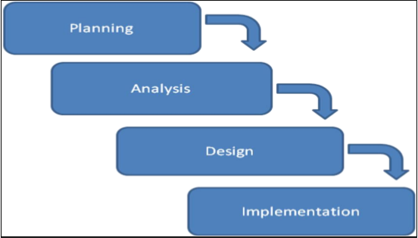
Figure 3.1: System Development Prototype (www.tutorialspoint.com/sdlc/sdlcmodel.htm).
The figure 3.1 above shows the main stages of the system development life cycle towards the development of the prototype.
The system was developed using the following Method:
i. Visual C# for implementation
ii. MYSQL for database management.
In the design of this project work, a high level programming language was used in order to achieve a good end. Before design, the front and backend of a design must be known, therefore visual C# is the programming language used for the implementation of the design, and the interface of the project work was designed using visual C #, MySQL a relational database system was used for the database in the implementation. The togetherness of this platforms result in a good front and backend objectives.
3.1.1 Algorithm Adopted: Lempel Ziev Welch (LZW) Compression Algorithm
1. Initial table with initial character strings
2. P=first input character
3. WHILE not end of input stream
4. C=next input character
5. IF P+C is in the string table
6. P=P+C
7. ELSE
8. output the code for P
9. add P+C to the string table
10. P=C
11. END WHILE
12. output code for P
Lempel Ziv Welch Algorithm Source: (Mamta, 2019)
How Lempel Ziv Welch Algorithm Works for Image Compression
The Lempel-Ziv-Welch (LZW) algorithm is a popular compression technique used for various types of data, including text, and can be adapted for image compression as well. Here's a simplified explanation of how LZW works for image the compression:
- Dictionary Initialization: LZW starts with an initial dictionary that typically contains all possible symbols that can occur in the data being compressed. For image compression, each pixel value (or a combination of pixel values, depending on the color depth and encoding) can be considered as a symbol.
- Sliding Window Encoding: LZW reads the image data in a sliding window manner. It starts by encoding the first symbol it encounters. Then it expands the window until it finds a sequence that is not in the dictionary.
- Dictionary Population: Whenever LZW encounters a sequence that is not in the dictionary, it adds that sequence to the dictionary. This allows LZW to reference longer sequences with shorter codes, thereby achieving compression.
- Code Output: Instead of outputting the actual pixel values, LZW outputs the corresponding codes from the dictionary. These codes represent sequences of pixel values.
- Compression: LZW repeats the above steps for the entire image, gradually building up the dictionary as it encounters new sequences. The output of this process is a compressed representation of the image, consisting of a series of codes from the dictionary.
- Decompression: To decompress the image, the receiver initializes a dictionary with the same symbols as the sender's dictionary. It then reads the series of codes from the compressed data and reconstructs the original image by looking up the corresponding sequences in the dictionary.
The main Compression
- LZW achieves compression by replacing repeated sequences of symbols with shorter codes.
- The effectiveness of LZW compression depends on the redundancy and repetitiveness of the input data. In images, areas of uniform color or patterns tend to compress well, while noisy or highly detailed areas may not compress as much.
- LZW is a lossless compression algorithm, meaning that the decompressed data is identical to the original input data.
- It's important to optimize the dictionary size and update frequency to balance compression efficiency and computational complexity.
3.2 ANALYSIS OF THE EXISTING SYSTEM
The existing system has been uncompressed image, it is image with its actual size and shape it is usually very bold and clear but usually occupies much space because of its un-adjustable and uncompressed system. It is a non-destructive format, therefore any changes made such as cropping or adjustments can be undone and the image reverted back to its original state.
3.3 PROBLEMS OF THE EXISTING SYSTEM
The problems of the existing image compression system are enumerated below:
1. It requires larger storage capacity
2. Not recommended for use when sending to printing labs or similar due to incompatibilities and the nature of the file type
3. Most website and online images galleries do not support its uploading
4. Contribute to insufficient bandwidth of network and storage of memory device.
3.4 DESCRIPTION OF THE PROPOSED SYSTEM
The proposed system is useful in reducing the storage, transmission and width requirements of medical images. If the image is compressed by 8:1 compression without any perceptual distortion, the capacity of storage increases eight times. This project allows user to reduce the number of bits used to store or transmit information. It encompasses a wide variety of software and hardware compression techniques. For effective compression, the resultant stream of image will be smaller than the original image size, it is a type of data compression applied to digital images, to reduce their cost for storage or transmission.
  - ADVANTAGES OF THE PROPOSED SYSTEM
The proposed system has the following advantages:
1. It highly compresses medical data of patients without modifying the perceptual quality
2. It reduces the storage, transmission and width requirements of medical images
3. It stores and transmits data in an efficient form
4. It maintains the rate of digital image data transfer or data rate (Megabit per second or Mb/s)
5. It maintains image quality and the total amount of digital storage required or data capacity (Megabyte or MByte).
6. It reduces the quantity of graphical data required to represent a digital image.

CHAPTER FOUR
DESIGN AND IMPLEMENTATION OF THE SYSTEM
4.1 DESIGN OF THE SYSTEM
This is the computation of the particulars of a new system and the determination of what the new system would be and the function it is to perform. This may involve changing from one system to another or modifying the existing system operation. The most challenging phase of the system life cycle is the change from manual operation to a faster and more accurate one; system design stage covers the technical specifications that will be employed in the implementation of the new system in order to modify the previous system. Some factors are put in consideration. These factors include input design, output design, definitions file and procedure designs and other documentation.
4.1.1 OUTPUT DESIGN
This incorporates the objectives of solving the existing system problems and challenges. This involves the structuring of the desired information and also to enhance efficient and effective automated image compression system. Things taken into consideration in determining the output are represented below:
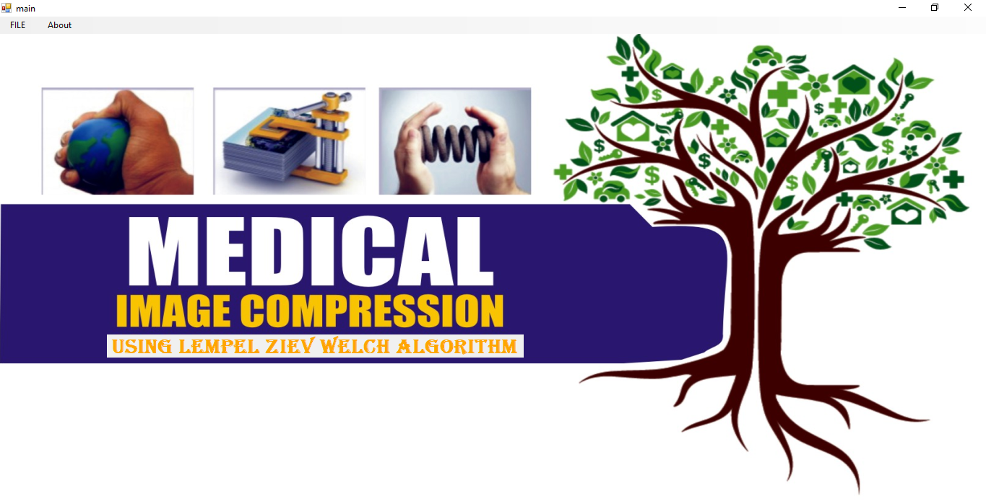
Figure 4.1: Main Menu Interface
This interface above shows the main menu of the system, it contains some menu which can be clicked to navigate to another pages on the system.
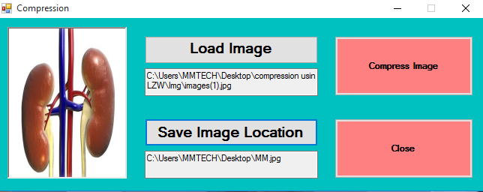
Figure 4.2 Compressor Interface
This is the page where Image can be upload and compressed, a sample of an image to be compressed is on the interface.

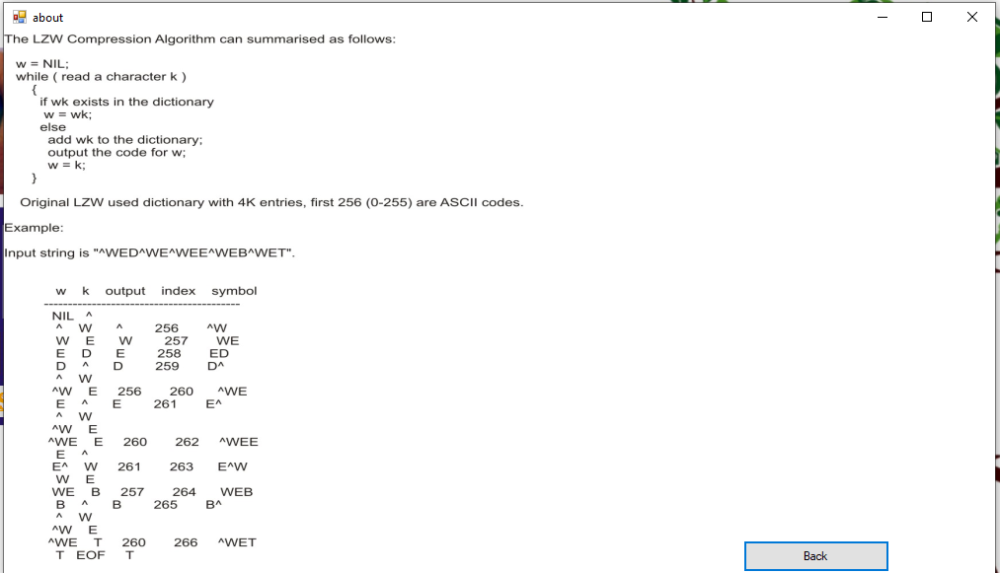
Figure 4.3: About Lempel Ziev Welch Page
This is the interface that shows about the Lempel Ziev Welch algorithm.
4.1.2 INPUT DESIGN
The input to run this software is obtained from image compression system administrator. He can achieve this by typing via the keyboard or browsing image.
To the questions set by the administrator. It can serve as the various input layouts from the various modules first from the collection of data and module then from the assessment module and input from user respectively.
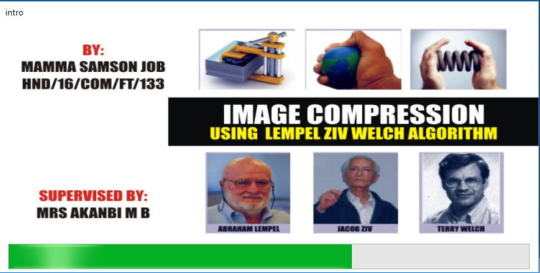
Mrs. ABDULRAHMAN

SALMAN O. HASSANAT
HND/21/COM/FT/154

Figure 4.4: Splash Screen Interface
This page tells brief introduction about the project, this include the topic of the project, the student details carrying out the project as well as the supervisor of the project.
4.1.3 DATABASE DESIGN
The input file is processed against the output file to produce the required output and the" various file layout (designs) has already been given in the various pages, under the input design and the output design for the various modules respectively.
Table 4.1: Image Table
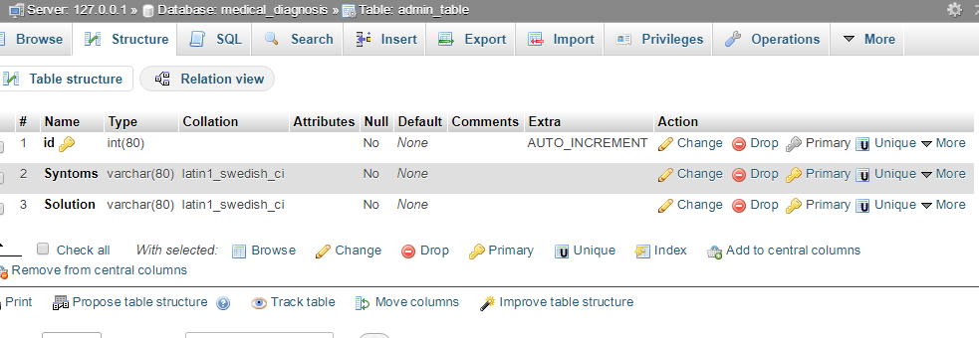
Image
Compressed
4.1.4 PROCEDURE DESIGN
These are the steps involved in unifying the whole process to produce the desired output. It involves computer procedures which start from the original input lessons to the output result file. This allows the processing of the information and result to be possible. Menu is provided to aid user in the processing of the output file.
4.2 IMPLEMENTATION OF THE SYSTEM
This entails the choice of the programming language employed to implement the software which should-be suitable for Image Compression System. The software is designed to reduce the size of some data by lowering the number of bits used in its formation
4.2.1 HARDWARE REQUIREMENT
Minimum of Microcomputer Pentium IV- Intel 1.5 GHZ processor, 1.0 GB RAM, 40GB Hard disk, 14” VGA Monitor Windows XP or higher, Enhanced keyboard, mouse and pad.
4.2.2 SOFTWARE REQUIREMENT
i. Windows Operating system such Windows 7, Windows 8, Windows 10 etc.
ii. Visual Studio 2010 (Enterprise Edition which allows the Programmer to run all the necessary Data, which has been supplied.
4.3 DOCUMENTATION OF THE SYSTEM
After the program has been well tested with input that the output has already been known, the next is to install the software in to the computer system for use.
The process of installing are been stated below
- Insert the CD into the system through the CD-ROM after the computer is switch on
- Locate the CD drive directory in my computer and click it to open
- After open, locate setup.exe, and then click to install the program by following the necessary step in installing the program.
- Ensure full installing of the software for effective operation of the system.
After the program has been fully install. The next thing is to locate the package install to put it into operation, to locate the package for expiration purpose the following step are to be taking .
- Click on start menu from task bar. Then select all program
- From the display sub option, select by locating the software installed named Information to load the software.
4.3.1 PROGRAM DOCUMENTATION
The program is packaged for use in any system irrespective of either it runs Visual Studio Application or not. After developing a program in Visual Studio, there is a facility provided in Microsoft Visual Studio suite called “Package and Deployment Wizard” that is used in Visual studio application packaging and deployment.
The Image Compression is packaged into an installable setup that can be run from any system.
4.3.2 OPERATING THE SYSTEM
To operate the system, the following algorithm must be followed:-
- Switch the system on
- Allow it to boot
- Click on start menu
- Select the package name “Image Compression” and wait for the application to load.
- From the list of menu that appears on the application main page, user can
- Select any one to navigate and carry the operation of the menu item.
4.3.2 MAINTAINING THE SYSTEM
The system maintenance refers to making modification to an already existing application/program without necessarily re-writing everything from start. Program maintenance of a program includes modification of the program to meet-up with certain requirements of the users. In this course, additional features can be added, errors corrected, ambiguous interfaces redesigned to eliminate confusions and unnecessary features removed.
Maintaining this program can be done in a Visual Studio environment. Any future modification can be by re-running the program source code in a Visual Studio environment making necessary changes and updates and recompile the application into an upgrade version of the existing version of the mini word processing application. Further versions of this program can be named following their year of release or it can be given a different version number.
4.3.3 PROCEDURE DESIGN
The procedure design refers to the construct of the whole program i.e. how each section functions individually and collectively as a whole to make up the whole execution of the program work/operate according to specification.
The system contains menus, each menu having different forms and they are control by modules.

CHAPTER FIVE
SUMMARY, CONLCUSION AND RECOMMENDATIONS
5.1 SUMMARY
Medical Image compression is an application of data compression that encodes the original image with few bits. The objective of medical image compression is to reduce the redundancy of the image and to store or transmit data in an efficient form. The main goal of such system is to reduce the storage quantity as much as possible, and the decoded image displayed in the monitor can be similar to the original image.
5.2 CONCLUSION
Compression is a technique to reduce the size of some data by lowering the number of bits used in its formation. In other words, we can say compression means reduction of size of data by changing it to a format which requires fewer bits than the original format. The main goal of Medical Image compression technique is to achieve a highly compressed data of patients without mortifying the perceptual quality and robust against transmission errors. Images play an important role in providing detailed information of patient injuries, fractures and other critical issues related to different disease and discomfort. However these images face major challenges due to the size of image data sets during transmission and storage.
Based on the findings of this research it is concluded that Medical Image compression seeks to reduce the number of bits used to store or transmit information. It encompasses a wide variety of software and hardware compression techniques.

5.3 RECOMMENDATIONS
Based on the findings of the study, the researcher recommends the following;
Approved health institutions such as: hospitals, primary health centers, medical laboratories etc to further encourage medical Medical Image compression techniques in order to enhance easy and effective transferring of medical data if need be.
Medical Image compression technique is recommended in order to achieve a highly compressed Image data without mortifying the perceptual quality and robust against transmission inaccuracy.
More research should be conducted on the usefulness and effect of Medical Image compression techniques.

REFERENCES
Ajibola, K. (2020). Image Compression Algorithms, International Journal of Computer and Information. Vol. 2. Issue: 1. IOP Publishing. Pp. 21-45.
Abhishek, A. (2021). Image Compression using Lossless Huffman Coding Technique. Journal of King Saud University Computer and Information Sciences, Vol. 2, Issue: 4. Pp. 23-24. https://doi.org/10.1016/j.tra.2011.06.110
Al-Rabaha, A. (2019). Lossless Huffman Coding Technique for Image Compression and Reconstruction using Binary Trees, International Journal of Computer Technology and Applications, Vol. 3, Issue: 1. Pp. 76 – 79. DOI: 10.5897/AJBM10.1549
Dharanidharan, S., Kumaar, M. & Kumar, D. (2020). Modified International Data Encryption Algorithm using in Medical Image compression Techniques, IJESIT. Vol. 16. Lagos: Malthouse Press Limited. Pp. 186-191.
Firas, A., Jassim, K. & Hind, E. (2020) Five Modulus Method for Medical Image Compression, International Journal of Electric and Electronic Engineering, Vol.3, Issue: 5. Pp. 19 – 28. Doi: 10.34545/2018.8115676
Jagadish, H. Pujar, R., Lohit, M. & Kadlaskar, B. (2021). A New Lossless Method of Medical Image compression and Decompression using Huffman Coding Techniques, JATIT. Vol. 2. Pp. 18-22. Doi: 10.26599/Bdma.2018.8115505
Jassim, F., A. & Qassim, H., E. (2020). Five Modulus Method for image Compression, An International Journal (SIPIJ.) Vol.3, Issue: 5, pp. 45-46. DOI : 10.5121/sipij.2012.3502.
Jilani, A. & Sattar, A. (2020). A Fuzzy Neural Networks based EZW Image Compression System, International Journal of Computer Applications. Vol. 2, Issue: 9, Pp. 23-25. https://doi.org/10.1016/j.tra.2011.06.110
Mathur, M., K., Loonker, S. & Saxena. D. (2021). Lossless Huffman Coding Technique for Image Compression and Reconstruction Using Binary Tree, International Journal Computer Technological Application, Vol. 3, Issue: 1, Pp. 76-79. Doi: 11.66899/Bdma.2019.8115323
Mridul, K., Mathur, S., & Dheeraj, S. (2019). Lossless Huffman Coding Technique for Medical Image compression And Reconstruction Using Binary Trees, International Journal of Communication Technology, Vol. 2. Pp. 11-12. Doi: 10.34545/2018.8115676
Navpreet, A. & Prabhpreet, P. (2018). Image Compression using Hoofman Coding Technique, International Journal of Electrical & Electronics Engineering (IJEEE). Iop Publishing. Vol. 1, Issue: 1. Pp. 2-3.
Padmaja, A. & Chandrasekhar, B. (2021). Literature Review of Medical Image Compression Algorithm, Report Series Research in Management. Pp. 4-5.
Rachmawati, D. Amalia, A. & Surya, J. (2018). Combination of Huffman Coding Compression Algorithm and Least Significant Bit Method for Image Hiding, International Conference on Computing and Applied Informatics. Vol. 1, Issue:1. Pp. 4-5.
Rajakumar K. & Arivoli T., (2021). Implementation of Multi-wavelet Transform Coding for Lossless Medical Image Compression , Institute of Electrical and Electronic Engineering (IEEE). Vol. 6. Pp. 634-637.
Sonal, V., Dinesh, K. (2020). A Study of Various Medical Image Compression Techniques, Literature Review of Medical Image Compression Algorithm, Pp. 4-6. https://doi.org/11.1016/j.tra.2015.06.010
Thakur, A., Kumar, R., Bath, A. & Sharma, J. (2019). Design of Image Compression Algorithm Using Matlab, International Journal of Electrical & Electronics Engineering (IJEEE), Vol. 1, Issue: 1. Pp. 11-13.
Yi-Fei, T. & Wooi-Nee T. (2019) Medical Image Compression Technique Utilizing Reference Points Coding with Threshold Values, International Journal of Electrical & Electronics Engineering (IJEEE). Vol. 3, Issue: 2. Pp. 21-23.

APPENDICES: PASSWORD
Appendix 1: Password Confirmation

Return
CLOSE DATABASE
CLOSE DATABASE
MAIN MENU
IS USERNAME AND PASSWORD CORRECT ?
ENTER USERNAME AND PASSWORD
OPEN DATABASE
START
N
Y

Appendix 2: Main menu
RETURN
COMPRESS
START
DISPLAY MAIN MENU ITEMS
SELECT COMPRESSION OPTION
Is it compression
Yes
No

Appendix 3: New Compressed Image
START

OPEN DATABASE

BROWSE IMAGE LOCATION

ENTER IMAGE FOLDER NAME

IS IMAGE NAME VALID?
NO

YES
COMPRESS IMAGE

SAVE TO DATABASE

RETURN
CLOSE DATABASE

Appendix 4: Source Code
using System;
using System.Collections.Generic;
using System.ComponentModel;
using System.Data;
using System.Drawing;
using System.Linq;
using System.Text;
using System.Windows.Forms;
using System.Drawing.Imaging;

namespace compression
{
public partial class Form1 : Form
{
Image myImage;
public Form1()
{
InitializeComponent();
}

private void button1_Click(object sender, EventArgs e)
{
// pictureBox1.Visible = true;

OpenFileDialog openfil = new OpenFileDialog();
openfil.Filter = ".images file(*.jpg)|*.JPG";
if (openfil.ShowDialog() == DialogResult.OK)
{
string showopen = openfil.FileName.ToString();
textBox1.Text = showopen;
pictureBox1.ImageLocation = showopen;
//Image myImage = showopen;
}
}

private void button2_Click(object sender, EventArgs e)
{
try
{
pictureBox2.ImageLocation = @"C:\Users\Desktop\m.jpg";
pictureBox2.SizeMode = PictureBoxSizeMode.Normal;
pictureBox1.SizeMode = PictureBoxSizeMode.Normal;

string path = textBox2.Text;
pictureBox2.Image.Save(path + @"\" + Name + ".jpg");
//MessageBox.Show("Successful");
}
catch (NullReferenceException) { }

}

public static void SaveJpeg(string path, Image img, int quality)
{
try
{

