AN ASSESSMENT OF THE MANAGEMENT OF MULTI-TENANTED OFFICE COMPLEX IN ILORIN, KWARA STATE
(A CASE STUDY OF RUKAMMAT AND SANTOSH SHOPPING COMPLEX, ILORIN, TAIWO ROAD)

BY

IDRIS ALIMOT TEMITOPE
HND/23/ETM/FT/0014

BEING A RESEARCH PROJECT SUBMITTED TO THE,
DEPARTMENT OF ESTATE MANAGEMENT AND VALUATION,
INSTITUTE OF ENVIRONMENTAL STUDIES,
KWARA STATE POLYTECHNIC, ILORIN

IN PARTIAL FULFILMENT OF THE REQUIREMENTS FOR THE
AWARD OF HIGHER NATIONAL DIPLOMA (HND) IN
ESTATE MANAGEMENT AND VALUATION

JULY, 2025

CERTIFICATION
This is to certify that this research project was carried out by Idris Alimot TEMITOPE with Matriculation Number: HND/23/ETM/FT/0014 and has been read and approved as meeting the requirements of the department of Estate Management, Institute of Environment Studies, Kwara State Polytechnic, Ilorin, Kwara State, for the award of Higher National Diploma (HND) in Estate Management.

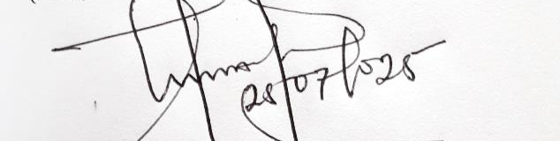


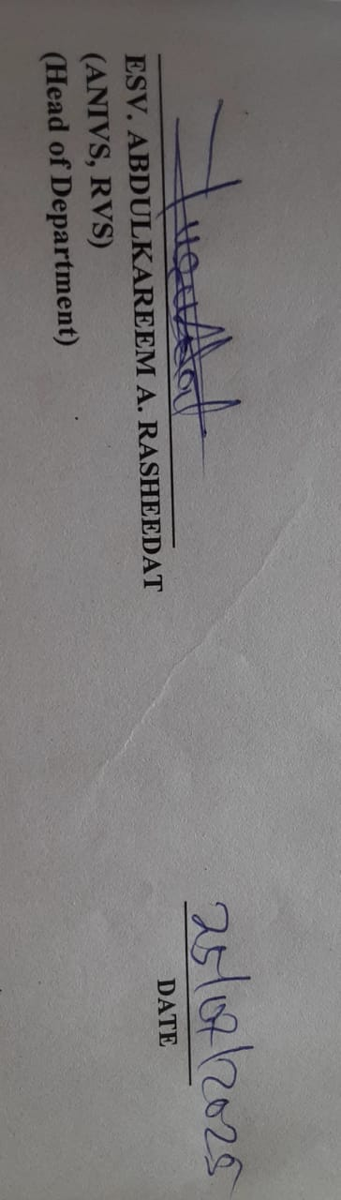

25/07/2025
25/07/2025
25/07/2025
25/07/2025
_________________________________ _______________
ESV. OLADOJA OLAWALE ISMAILA DATE
(ANIVS, RSV)
(Project Supervisor)

_________________________________ _______________
ESV. DR. (MRS.) UWAEZUOKE NGOZI IFEANYI DATE
(ANIVS, RSV)​​​​
(Project Coordinator)

_________________________________ _______________
ESV. ABDULKAREEM RASHIDAT A. DATE
(ANIVS, RVS)
(Head of Department)

__________________________ _______________
ESV. DR. LUKMAN MUSIBAU DATE
(PhD, ANIVS, RSV)
(External Examiner)

DEDICATION
This project is dedicated to the Almighty Allah who has been my Alpha and Omega toward the successful completion of this project and my course.

ACKNOWLEDGEMENTS
My profound gratitude first and foremost goes to Almighty Allah the author and finisher of our faith for granting and protecting me through the ups and downs in my academic pursuit and for making this dream a reality.
My appreciation goes to my Parents, MR. and MRS. IDRIS for their moral and financial support without which I might not have attained this height, May you reaps the fruit of your labor.
Most importantly, my appreciation also goes to my supervisor ESV. OLADOJA OLAWALE ISMAILA (ANIVS, RSV.) and my Project Coordinator ESV. DR. (MRS.) UWAEZUOKE NGOZI IFEANYI (ANIVS, RSV)​​​​, who has created time to read and make corrections where necessary and who sacrificed much of his time to advise me in appropriate cases not withstanding his tight schedule.
Also my profound respect goes to my H.O.D ESV. ABDULKAREEM RASHIDAT A. (ANIVS, RVS) and the entire members of Staff Estate Management and Valuation Department.
I have to extend my gratitude to my entire colleague who has directly and indirectly contributed towards the success of this work. Thank you all.

TABLE OF CONTENTS
Title Page i
Certification ii
Dedication iii
Acknowledgements iv
Table of Contents v-vi
List of Tables vii
List of Figure viii
Abstract ix
CHAPTER ONE: INTRODUCTION
1.1 Background to the Study 1-2
1.2 Statement of the Problem 2-3
1.3 Research Questions 3
1.4 Aim and Objectives 3-4
1.5 Justification of the Study 4-5
1.6 Scope of the Study 5
1.7 Study Area 5-6
1.8 Definition of Terms 7
CHAPTER TWO: LITERATURE REVIEW
2.0 Introduction 8
2.1 Conceptual Review 8
2.1.1 Understanding Property Management 8-10
2.1.2 Multi-Tenancy in Commercial Real Estate 10-12
2.1.3 Key Challenges in Managing Multi-Tenanted Complexes 12-15
2.1.4 The Role of Tenant Satisfaction in Property Management 15-18
2.1.5 Strategies for Effective Management of Multi-Tenanted Complexes 18-21
2.1.6 Property Value and Management Efficiency 21-24
2.2 Summary of Reviewed Literature 24
CHAPTER THREE: METHODOLOGY
3.0 Introduction 25
3.1 Research Design 25
3.2 Sources of Data 25-26
3.3 Target Population 26
3.4 Sampling Frame 26
3.5 Sample Size 26
3.6 Sampling Procedure 27
3.7 Method of Data Collection 27
3.8 Methods of Data Analysis 27
CHAPTER FOUR: DATA PRESENTATION, ANALYSIS AND INTERPRETATION
4.1 Introduction 28
4.2 Data Presentation 28-41
4.3 Discussion of Findings 42-43
CHAPTER FIVE: SUMMARY OF FINDINGS, CONCLUSION AND RECOMMENDATIONS
5.1 Summary of Findings 44-45
5.2 Conclusion 45
5.3 Recommendations 46
References 47-48
Questionnaire 49-50

LIST OF TABLES
Table 4.2.1: Gender Distribution of Respondents 28
Table 4.2.2: Age Distribution of Respondents 29
Table 4.2.3: Duration of Tenancy in the Complex 30
Table 4.2.4: Type of Space Occupied by Respondents 31
Table 4.2.5: Respondents’ Opinion on the Efficiency of Property Management 32
Table 4.2.6: Respondents’ Satisfaction with Maintenance Services 33
Table 4.2.7: Accessibility of Management to Tenants 34
Table 4.2.8: Regularity of Facility Maintenance (e.g., Toilets, Corridors, Lighting) 35
Table 4.2.9: Timeliness of Rent Payment Requests 36
Table 4.2.10: Tenant Participation in Decision-Making Processes 37
Table 4.2.11: Adequacy of Utility Services (Water, Electricity, Sanitation) 38
Table 4.2.12: Effectiveness of Security Services 39
Table 4.2.13: Common Challenges Faced by Tenants 40
Table 4.2.14: Suggestions for Improvement from Respondents 41

LIST OF FIGURES
Figure 4.2.1: Gender distribution of the respondents 28
Figure 4.2.2: Age distribution of the respondents 29
Figure 4.2.3: Duration of Stay of the Respondents 30
Figure 4.2.4: Types of Spaces Occupied 31
Figure 4.2.5: Efficiency of Property Management 32
Figure 4.2.6: Satisfaction with maintenance services 33
Figure 4.2.7: Accessibility of Management to tenants 34
Figure 4.2.8: Regularity of Facility Maintenance 35
Figure 4.2.9: Timeliness of rent payment requests 36
Figure 4.2.10: Tenant Participation in Decision-Making Processes 37
Figure 4.2.11: Adequacy of Utility Services 38
Figure 4.2.12: Effectiveness of Security Services 39
Figure 4.2.13: Challenges faced by tenants 40
Figure 4.2.14: Suggestions for Improvement from Respondents 41

ABSTRACT
This study assesses the management of multi-tenanted office complexes using Rukammat and Santosh Shopping Complex, Ilorin, Taiwo Road, as a case study. The objective is to evaluate existing management practices, identify challenges, and propose strategies for improved operational efficiency and tenant satisfaction. The research adopts a descriptive case study design and employs both primary and secondary data. Data were collected through structured questionnaires administered to tenants and interviews with property managers and estate surveyors. The findings reveal that while some tenants are satisfied with the management services, others express concerns about irregular maintenance, poor communication, and limited involvement in decision-making. The study highlights the importance of proactive property management, regular maintenance, tenant engagement, and financial transparency. Recommendations include improved maintenance schedules, inclusive management practices, adoption of digital communication tools, and periodic tenant feedback mechanisms. The research concludes that efficient property management significantly contributes to tenant retention, property value, and the long-term success of multi-tenanted office complexes in urban settings like Ilorin.

CHAPTER ONE
INTRODUCTION
1.1 Background to the Study
The management of multi-tenanted office complexes plays a critical role in ensuring the sustainability and functionality of these facilities in urban settings. Multi-tenanted complexes are typically designed to accommodate various business entities under one roof, creating a shared environment that promotes economic activities and fosters local development. Effective management strategies are pivotal in maintaining the structural integrity and operational efficiency of these complexes, as they directly influence tenant satisfaction and retention (Smith, 2019).
Urban centers like Ilorin, the capital of Kwara State, are witnessing a surge in demand for commercial spaces due to increasing population growth and urbanization. Shopping complexes such as Rukammat and Santosh Shopping Complex provide a central location for various businesses to thrive, ranging from retail outlets to corporate offices. These facilities contribute significantly to the local economy, generating employment opportunities and fostering entrepreneurial ventures (Abdulkareem & Adedayo, 2020).
However, the successful operation of these complexes depends on efficient management practices that address the needs of tenants while optimizing the use of resources. Poor management often results in challenges such as inadequate maintenance, tenant disputes, and declining property value. These issues can undermine the potential of multi-tenanted complexes to serve as hubs of economic activity and development (Oluwasegun & Johnson, 2018).
In many developing cities, including Ilorin, property management is often plagued by insufficient planning, lack of professional expertise, and inadequate financial resources. These factors can compromise the ability of property managers to deliver services such as security, sanitation, and regular maintenance, which are critical to sustaining tenant satisfaction and property attractiveness (Okafor, 2021).
The Rukammat and Santosh Shopping Complex, serves as a case study to explore these dynamics. Located in the bustling Taiwo area, this complex is a microcosm of the challenges and opportunities inherent in managing multi-tenanted office spaces. It is an ideal location for investigating how management practices affect tenant experiences and the overall performance of the facility (Bello, 2022).
Moreover, effective management of shopping complexes requires a multifaceted approach that balances the interests of various stakeholders, including property owners, tenants, and service providers. Strategies such as regular maintenance schedules, transparent lease agreements, and tenant engagement programs are vital in creating a harmonious and productive environment (Ibrahim & Mohammed, 2020).
In the Nigerian context, the management of commercial properties is increasingly gaining attention due to its implications for urban development and economic sustainability. The introduction of technology and innovative property management solutions offers promising prospects for addressing longstanding challenges in this sector (Adeoye & Ojo, 2019).
The importance of professional property management cannot be overstated, as it directly impacts the economic viability of complexes and their ability to meet the needs of diverse tenants. Studies have shown that properties with effective management systems tend to attract and retain high-quality tenants, thereby enhancing their market value over time (Uche, 2021).
The Rukammat and Santosh Shopping Complex, exemplifies how strategic management can influence tenant relationships, operational efficiency, and long-term sustainability. This study aims to uncover the specific challenges faced in managing such complexes in Ilorin and to propose practical solutions for improvement (Olaitan, 2023).
Understanding the intricacies of managing multi-tenanted office complexes is crucial for stakeholders in the real estate and property management industries. Insights from this study will provide valuable guidance for enhancing management practices and ensuring the optimal performance of these facilities in Ilorin and similar urban settings (Kehinde, 2022).
Ultimately, this research seeks to contribute to the broader discourse on property management by highlighting the role of effective strategies in maximizing the potential of multi-tenanted complexes. It underscores the need for collaborative efforts among property managers, tenants, and policymakers to address challenges and harness opportunities for sustainable development in Ilorin (Olawale, 2021).
1.2 Statement of the Problem
The management of multi-tenanted office complexes in Nigeria, including the Rukammat and Santosh Shopping Complex in Ilorin, Taiwo Road faces significant challenges that impede their functionality and economic viability. Issues such as poor maintenance, inadequate provision of essential services, and ineffective communication between property managers and tenants often lead to tenant dissatisfaction and high turnover rates. Additionally, the lack of proper planning and professional expertise in managing such complexes results in reduced property value and limits their potential to serve as thriving centers of economic activity. These problems are further compounded by the increasing demand for commercial spaces in urban areas, making it imperative to address the underlying inefficiencies in management practices.
This study seeks to evaluate the current management practices of the Rukammat and Santosh Shopping Complex, Ilorin, Taiwo Road, identify the root causes of these challenges, and propose practical solutions to enhance its operation. By assessing tenant experiences and analyzing the management strategies employed, the research aims to provide actionable recommendations that will improve service delivery, tenant satisfaction, and the overall performance of the complex. The findings from this study will also contribute to broader discussions on effective property management in multi-tenanted office complexes, particularly in developing urban settings like Ilorin.
1.3 Research Questions
This study seeks to answer the following research questions:
- What is the current management practices employed in the Rukammat and Santosh Shopping Complex, Ilorin, Taiwo Road?
- What challenges are faced in managing the Rukammat and Santosh Shopping Complex, Ilorin, Taiwo Road?
- How does the existing management practices impact tenant satisfaction and retention?
- What are the effects of management inefficiencies on the overall performance and value of the complex?
- What strategies can be proposed to improve the management and operational efficiency of the Rukammat and Santosh Shopping Complex, Ilorin, Taiwo Road?
1.4 Aim and Objectives
Aim
The aim of this study is to assess the management practices of the Rukammat and Santosh Shopping Complex, Ilorin, Taiwo Road, Ilorin, with a view to identifying challenges and proposing strategies to enhance its operational efficiency, tenant satisfaction, and overall performance.
Objectives
The specific objectives of the study are to:
- Examine the current management practices employed in the Rukammat and Santosh Shopping Complex, Ilorin, Taiwo Road.
- Identify the challenges faced in the management of the complex.
- Evaluate the impact of these management practices on tenant satisfaction and retention.
- Analyze how management inefficiencies affect the overall performance and value of the complex.
- Recommend strategies to improve the management and operational efficiency of the Rukammat and Santosh Shopping Complex, Ilorin, Taiwo Road.
1.5 Justification of the Study
Numerous studies have explored property management in multi-tenanted office complexes, emphasizing the importance of effective management in ensuring tenant satisfaction, maintaining property value, and sustaining operational efficiency. For instance, Oluwasegun and Johnson (2018) highlighted the critical role of regular maintenance and tenant engagement in retaining tenants. Similarly, Ibrahim and Mohammed (2020) focused on the need for transparency and professionalism in lease agreements to enhance trust between property managers and tenants. While these studies provide valuable insights, they often generalize their findings across different contexts without addressing the unique challenges faced in specific locations, such as Ilorin.
Existing research has largely neglected localized investigations into the management of multi-tenanted office complexes in mid-sized urban centers like Ilorin, where infrastructural development and property management practices are still evolving. For example, Okafor (2021) identified resource constraints and inadequate planning as significant barriers to effective property management but did not delve into the nuances of tenant-manager relationships or the impact of these challenges on commercial spaces in Ilorin. This gap in the literature creates a need for targeted studies that examine these issues in specific complexes, such as the Rukammat and Santosh Shopping Complex, Ilorin, Taiwo Road.
The relevance of this study lies in its focus on bridging these gaps by providing an in-depth assessment of management practices in the context of the Rukammat and Santosh Shopping Complex, Ilorin, Taiwo Road. Unlike previous studies, this research emphasizes the direct experiences of tenants and the operational dynamics unique to the complex. It seeks to uncover the specific challenges that affect its management and offer practical, location-specific recommendations. By doing so, the study contributes to a deeper understanding of how localized issues can impact property management outcomes.
Furthermore, the findings from this study are expected to inform property managers, policymakers, and stakeholders in the real estate sector about best practices for improving tenant satisfaction and enhancing the value of multi-tenanted office complexes. By addressing the existing gaps in the literature and providing actionable insights, this study aims to serve as a guide for improving management strategies in Ilorin and similar urban centers. This relevance underscores the importance of this study in advancing the discourse on property management and contributing to sustainable urban development.
1.6 Scope of the Study
This study focuses on the management practices of multi-tenanted office complexes, with a specific emphasis on the Rukammat and Santosh Shopping Complex, Ilorin, Taiwo Road, Ilorin, Kwara State. The geographical scope is limited to Ilorin, providing insights relevant to urban property management in this region. Conceptually, the study examines aspects such as maintenance practices, tenant satisfaction, operational efficiency, and the challenges faced in property management. Industrially, it is centered on the real estate sector, specifically the management of multi-tenanted commercial properties. The time scope covers the current operational practices as of 2024, providing a contemporary analysis of the complex's management. Methodologically, the study employs a qualitative and quantitative approach, including data collection through tenant surveys, interviews with property managers, and an analysis of existing records to ensure comprehensive findings.
1.7 Study Area
The study area for this research is the Rukammat and Santosh Shopping Complex, Ilorin, Taiwo Road, located in Taiwo Road, a prominent commercial zone within Ilorin Metropolis, the capital of Kwara State, Nigeria. Ilorin lies in the North Central geopolitical zone of Nigeria and serves as a bridge between the northern and southern parts of the country. It is a growing urban center with significant trade and commercial activities due to its strategic position and relative affordability (Aderamo & Ayobolu, 2010).
Taiwo Road is one of the busiest commercial corridors in Ilorin, attracting traders, service providers, and consumers daily. The Rukammat and Santosh Shopping Complex, Ilorin, Taiwo Road, centrally situated within this commercial area, serves as a hub for retail, wholesale, and office-based businesses. The complex accommodates a wide range of commercial activities, including boutiques, electronics shops, tailoring units, and service offices.
From a constructional standpoint, the shopping complex is a reinforced concrete-framed structure, designed to withstand high foot traffic and multi-occupancy loads. The building spans two floors, arranged in a courtyard layout with interconnected corridors that enhance circulation and tenant accessibility (Omole, 2010).

Structural and Building Features includes:
- Foundation: The structure is supported by a strip foundation, constructed using mass concrete to ensure stability and uniform load distribution, particularly suitable for low-rise commercial buildings in sandy-loam soils prevalent in Ilorin (Akinbamiro, 2012).
- Walling: Both internal and external walls are constructed using 150mm sandcrete blocks, rendered and painted for weather protection and improved aesthetics.
- Flooring: Shop floors are finished with ceramic tiles, while shared areas and staircases are completed with terrazzo for durability and ease of maintenance.
- Roofing: The building is covered with long-span aluminum roofing sheets, supported by steel trusses, providing weather resistance and heat reflection, which is vital for comfort in tropical climates.
- Windows and Doors: Office and shop spaces are fitted with aluminum-framed glass windows and sliding doors, allowing natural lighting and ventilation.
- Utilities:
  - Water Supply: A private borehole system with overhead storage tanks ensures reliable water distribution across the building.
  - Electricity: The complex is connected to the national grid with a provision for generator backup during outages.
  - Plumbing and Sanitation: Toilets and sinks are installed with PVC piping and are shared among tenants. Wastewater is directed through surface drains into nearby public drainage systems.
- Facilities:
  - Parking Area: An open parking space accommodates up to 30 vehicles, serving both tenants and customers.
  - Security: The complex is fenced with a gated entrance and 24-hour manned security personnel.
  - Fire Safety: Fire extinguishers are installed in common corridors, although tenants report lapses in refilling and regular maintenance (Field Survey, 2025).
  - Waste Management: Central waste collection bins are positioned in designated areas, though collection routines are sometimes irregular.

1.8 Definition of Terms
Assessment: Assessment refers to the systematic evaluation or analysis of a particular subject or situation to determine its status, quality, or effectiveness (Oxford Advanced Learner’s Dictionary, 2023). In this study, it involves the evaluation of management practices in the Rukammat and Santosh Shopping Complex, Ilorin, Taiwo Road.
Management: Management is the process of planning, organizing, directing, and controlling resources to achieve specific goals (Robbins & Coulter, 2022). Here, it refers to the strategies and practices used in overseeing the operations of the shopping complex.
Multi-tenanted Office Complex: A multi-tenanted office complex is a commercial property that houses multiple tenants or businesses within a single building or set of buildings, with shared facilities and resources (International Real Estate Federation, 2021). This term describes the Rukammat and Santosh Shopping Complex, Ilorin, Taiwo Road, which accommodates various businesses.
Shopping Complex: A shopping complex is a group of retail and office spaces, often centrally located, designed to provide goods and services to consumers and facilitate commercial activities (American Urban Planning Association, 2020). The Rukammat and Santosh Shopping Complex, Ilorin, Taiwo Road is an example of such a facility in Ilorin.
Ilorin: Ilorin is the capital city of Kwara State in Nigeria, known for its mix of cultural heritage and economic activities (National Bureau of Statistics, 2023). This study focuses on a specific commercial property within this urban center.
Taiwo Road: Taiwo Road is a commercial area in Ilorin, Kwara State, recognized for its vibrant trade activities and strategic location as a hub for businesses and customers (Kwara State Government, 2022). The Rukammat and Santosh Shopping Complex, Ilorin, Taiwo Road is situated in this area.
Kwara State: Kwara State is one of Nigeria’s 36 states, located in the North-Central geopolitical zone, with Ilorin as its capital (National Geographic Society, 2021). The state serves as the broader geographical context for this study.

CHAPTER TWO
LITERATURE REVIEW
2.0 Introduction
This chapter of the study covers the review of past related literatures on assessment of management of multi-tenanted office complex in Ilorin, Kwara State. The chapter is discussed under the headings of conceptual review, theoretical review and summary of related literatures
2.1 Conceptual Review
2.1.1 Understanding Property Management
Property management is a multifaceted discipline that involves the administration, operation, and oversight of real estate properties. It encompasses various activities, including maintaining the property, managing tenants, ensuring legal compliance, and maximizing the return on investment (Geltner & Miller, 2018). Property management is vital in maintaining the physical condition of the property, overseeing rent collection, handling lease agreements, and addressing tenant concerns. Effective property management is crucial for enhancing the profitability and sustainability of real estate assets, particularly in commercial settings like multi-tenanted office complexes (Robinson, 2016).
At its core, property management aims to provide efficient services that preserve and enhance the value of real estate assets. This includes implementing maintenance schedules, ensuring that repairs are made promptly, and overseeing the daily operations of the building. Furthermore, property managers play an essential role in tenant relations by addressing concerns, negotiating leases, and ensuring that tenants are satisfied with the services provided (Smith, 2020). Good property management practices can lead to high occupancy rates, tenant retention, and overall property performance, contributing to the long-term success of the investment.
The property manager's role also involves financial management, which includes budgeting, accounting, and cost control. The financial aspects of property management require the manager to monitor income and expenses, ensure rent is collected on time, and handle any financial issues related to the property. Financial reporting is critical for both the property owner and the tenants, as it provides transparency and accountability (Levy, 2019). Proper financial management also ensures that the property remains profitable and capable of meeting its operational needs.
Another significant aspect of property management is compliance with legal and regulatory requirements. Property managers must stay updated on local laws, zoning regulations, building codes, and tenant rights to ensure that the property complies with all relevant legislation. Failure to adhere to these legal requirements can result in costly fines, lawsuits, and damage to the property's reputation (Baker & Duffy, 2017). In the context of multi-tenanted office complexes, understanding and implementing these legal frameworks is particularly important for ensuring that both tenants and property managers operate within the boundaries of the law.
Tenant engagement is an essential part of property management. A successful property manager cultivates positive relationships with tenants by addressing their needs and ensuring that their concerns are addressed promptly. Effective communication between tenants and managers leads to higher levels of satisfaction, reducing tenant turnover and improving retention rates (Williams, 2021). Property managers can also foster a sense of community within the building, encouraging tenants to maintain a professional and cooperative atmosphere.
One of the key functions of property management is ensuring the smooth operation of facilities within the complex. This includes maintaining common areas, managing utilities such as electricity, water, and waste disposal, and ensuring the overall cleanliness and functionality of the building. Property managers must also coordinate with service providers, contractors, and maintenance teams to address any issues that may arise (Jones, 2018). In multi-tenanted office complexes, the efficient operation of these facilities is critical for maintaining the property’s value and providing tenants with a conducive working environment.
Property managers also oversee the leasing process, which involves marketing available spaces, screening potential tenants, and negotiating lease terms. The leasing process is vital for ensuring that the complex is fully occupied and generating revenue. Property managers must understand market trends and rental rates to ensure competitive pricing and attract quality tenants (Brown, 2019). Furthermore, lease agreements should be carefully negotiated to protect both the property owner and the tenant, balancing the needs of both parties.
In multi-tenanted office complexes, managing the shared spaces and amenities becomes more complex due to the diverse needs of tenants. These complexes typically include office spaces, retail units, and communal areas such as parking lots, elevators, and restrooms, all of which require regular upkeep and coordination. Property managers must ensure that all shared spaces are accessible and properly maintained to accommodate the needs of all tenants (Chandler, 2020). Effective management of these shared spaces promotes harmony among tenants and ensures the overall functionality of the complex.
A key challenge in property management, particularly in multi-tenanted complexes, is conflict resolution. Disputes between tenants or between tenants and property management can arise over issues such as noise, cleanliness, and the use of common areas. Property managers must be skilled in conflict resolution, using mediation and negotiation techniques to address these issues in a timely and professional manner (Gray & Larson, 2018). By resolving conflicts effectively, property managers can maintain a positive working environment for all tenants, contributing to higher levels of satisfaction.
Finally, sustainability and environmental considerations are becoming increasingly important in property management. Sustainable property management involves implementing energy-efficient practices, reducing waste, and using environmentally friendly materials. As tenants and consumers alike become more environmentally conscious, property managers are expected to integrate sustainable practices into their management strategies. These practices not only benefit the environment but can also reduce operational costs and attract tenants who prioritize sustainability (Wheeler, 2021). Sustainable property management has become a key focus for managers of multi-tenanted office complexes seeking to remain competitive and responsible.
2.1.2 Multi-Tenancy in Commercial Real Estate
Multi-tenancy in commercial real estate refers to a property model where a single building or complex is occupied by multiple tenants, each of whom leases individual spaces within the property (Miller, 2019). This model is prevalent in office buildings, shopping centers, and mixed-use developments, offering several advantages for both property owners and tenants. The multi-tenancy model allows property owners to diversify their income sources by renting out different spaces to different businesses, thereby reducing their financial risk (Olufemi & Johnson, 2020). For tenants, it provides a cost-effective solution by offering smaller, more affordable spaces while still benefiting from the shared amenities and central location that such complexes offer.
One of the key benefits of multi-tenancy in commercial real estate is the ability for property owners to maximize occupancy and income. By having multiple tenants in the same building, property owners can avoid long periods of vacancy that could occur if they relied on a single tenant. Additionally, renting to a diverse group of tenants can help stabilize the property’s revenue, as the failure of one business or tenant is less likely to significantly impact the overall performance of the building (Geltner & Miller, 2018). This model is particularly advantageous in urban settings, where demand for commercial space is high, and property owners seek to capitalize on the availability of small and medium-sized office spaces.
In a multi-tenanted commercial building, the management of shared spaces and resources is crucial for maintaining tenant satisfaction and operational efficiency. Common areas such as lobbies, elevators, restrooms, and parking lots need to be carefully managed to ensure they are accessible, clean, and well-maintained. The costs associated with maintaining these shared spaces are typically divided among all tenants, with each tenant contributing to the overall maintenance costs according to their lease agreement (Robinson, 2016). Effective management of these shared areas is essential to creating a positive working environment for all tenants and ensuring that the building functions smoothly.
However, the multi-tenancy model also presents several challenges for property managers. One of the primary challenges is managing tenant relationships and ensuring that the needs and concerns of all tenants are addressed. Given the diversity of tenants in multi-tenanted properties, property managers must balance the needs of different businesses and create an environment where all tenants feel satisfied with the services and facilities provided. Conflicts can arise over shared spaces, noise levels, or maintenance issues, and it is the property manager’s role to mediate and resolve these disputes (Miller & Geltner, 2020). The ability to maintain good relationships with tenants is essential for retaining them and ensuring the long-term success of the property.
Another challenge in multi-tenancy is ensuring the security and safety of the building and its tenants. Property managers must implement robust security systems to protect both the property and the tenants. This may include surveillance cameras, security personnel, access control systems, and fire safety measures. The safety of tenants is paramount, and any lapses in security can lead to tenant dissatisfaction and legal liabilities for the property owner (Chandler, 2020). Additionally, as multi-tenanted buildings often house a wide range of businesses, property managers must ensure that security measures are adapted to the specific needs of each tenant while also maintaining a safe and secure environment for everyone.
The management of leases in multi-tenanted commercial real estate also requires careful attention. Each tenant typically signs a separate lease agreement, which outlines the terms and conditions of their occupancy, including rent, duration of lease, and any special requirements. Property managers must ensure that these leases are structured in a way that is both legally compliant and mutually beneficial for both the property owner and the tenant. They must also manage lease renewals, rent adjustments, and tenant transitions, which can be complex in a multi-tenanted environment (Baker & Duffy, 2017). The ability to efficiently manage lease agreements is critical to maintaining consistent rental income and reducing tenant turnover.
In multi-tenanted office buildings, the mix of tenants can significantly influence the property's appeal and overall success. The diversity of businesses within the building can attract a broader range of tenants and clients, creating a dynamic and vibrant environment. Property managers often play a role in curating the tenant mix to ensure that it aligns with the building's target market and enhances its value. For example, a building that houses a mix of technology companies, law firms, and retail businesses may attract a diverse set of potential tenants and clients, thereby increasing the property's overall marketability (Levy, 2019). Managing this mix and fostering a positive environment for all tenants is key to maintaining high occupancy rates and tenant satisfaction.
Moreover, the operational efficiency of a multi-tenanted commercial property is highly dependent on the technology and systems used to manage it. Advances in property management technology, such as building management software, automated payment systems, and data analytics tools, have transformed the way property managers operate. These tools help streamline operations, monitor building performance, and communicate with tenants more effectively. By utilizing modern technology, property managers can improve the overall efficiency of the property and enhance the experience for tenants (Olufemi & Johnson, 2020). Technology also plays a crucial role in maintaining building security, monitoring energy usage, and reducing operational costs.
Moreover, multi-tenancy in commercial real estate offers numerous benefits to property owners and tenants, but it also comes with a unique set of challenges. Property managers must ensure that the property is efficiently managed, tenant relationships are maintained, and operational costs are kept under control. By effectively addressing these challenges and utilizing modern property management practices, property managers can create successful multi-tenanted environments that provide value to both tenants and property owners. The success of multi-tenanted office complexes depends on the ability to balance tenant satisfaction, building performance, and financial goals, making it essential for property managers to possess a range of skills and expertise (Robinson, 2016).
2.1.3 Key Challenges in Managing Multi-Tenanted Complexes
Managing multi-tenanted commercial real estate presents a set of unique challenges that property managers must address to maintain tenant satisfaction, operational efficiency, and financial performance. These challenges arise due to the complexity of overseeing numerous tenants with varying needs and expectations, managing shared resources, and ensuring the property operates smoothly. One of the primary challenges in managing multi-tenanted complexes is tenant dissatisfaction, which can arise from issues such as inadequate maintenance, insufficient communication, and conflicting tenant needs (Miller & Geltner, 2020). Addressing tenant concerns promptly and effectively is crucial for reducing turnover and ensuring the long-term success of the property.
A significant challenge in multi-tenanted buildings is maintaining the condition of shared spaces and amenities. In a multi-tenanted complex, areas like hallways, elevators, restrooms, parking lots, and communal kitchens must be regularly cleaned, repaired, and maintained to meet the needs of all tenants. As maintenance costs are typically shared among tenants, property managers must balance the maintenance budget while ensuring that these spaces remain functional and appealing. Poorly maintained common areas can lead to tenant dissatisfaction, complaints, and higher turnover rates, which can ultimately affect the property's financial performance (Olufemi & Johnson, 2020). Ensuring a consistent maintenance schedule and timely repairs can help mitigate these issues and maintain tenant satisfaction.
Tenant conflict is another critical challenge that property managers must handle effectively. In a multi-tenanted environment, it is common for tenants to have different business operations, work schedules, and expectations, which can lead to disputes. Common issues include noise complaints, the misuse of shared spaces, and disputes over parking or security arrangements. Property managers must be equipped with strong communication and conflict resolution skills to address these concerns promptly and fairly. If conflicts are not resolved effectively, they can escalate, leading to tenant dissatisfaction, reputational damage to the property, and even legal disputes (Geltner & Miller, 2018). Establishing clear guidelines and fostering a cooperative environment can help minimize conflicts and promote a positive atmosphere within the building.
Another challenge is balancing the needs of tenants with the operational costs of running the building. Multi-tenanted complexes require significant resources to ensure the smooth operation of the building, including utility management, security, cleaning services, and maintenance. Property managers must ensure that these services are provided efficiently while controlling costs. In some cases, tenants may not be willing to pay higher rents to cover increased operational costs, leading to conflicts over pricing and service quality. Finding a balance between providing high-quality services and managing operational costs is crucial for maintaining profitability and tenant retention (Robinson, 2016). Property managers must also be proactive in managing energy use and sustainability practices to reduce costs and meet modern environmental standards.
Security is another major concern in multi-tenanted properties. With multiple tenants operating within a single building, the risk of theft, vandalism, or other security breaches increases. Property managers must implement robust security measures to protect both tenants and the property. This may involve installing security cameras, hiring security personnel, controlling access to the building, and maintaining fire safety equipment. The security needs of each tenant may vary, and property managers must ensure that the security measures implemented address the needs of all tenants while maintaining a safe and secure environment for everyone (Chandler, 2020). A failure to address security concerns can lead to tenant dissatisfaction, reputational harm, and even legal liabilities.
Managing leases in a multi-tenanted complex can also be complex and time-consuming. Each tenant typically has a separate lease agreement with different terms, including rent, duration, and special clauses. Property managers must ensure that these agreements are up-to-date, legally compliant, and mutually beneficial for both the property owner and the tenant. As tenants come and go, property managers must manage lease renewals, rent adjustments, and transitions, all while maintaining smooth operations in the building (Levy, 2019). Mismanagement of lease terms can result in revenue loss, disputes, and higher tenant turnover rates. Therefore, a thorough understanding of lease agreements and the ability to manage them effectively is essential for successful property management.
Furthermore, the tenant mix in a multi-tenanted office complex can present challenges, especially when tenants have different business needs or operate in different industries. The mix of tenants can impact the overall atmosphere and functionality of the property, and it is important for property managers to ensure that the mix aligns with the target market of the property. For example, having incompatible tenants, such as noisy businesses or those with conflicting schedules, can lead to dissatisfaction and disputes (Brown, 2019). Property managers must carefully select and balance the tenant mix to create a harmonious environment that benefits both the tenants and the property owner. This requires an understanding of tenant needs, as well as market trends, to ensure that the property remains attractive to potential tenants.
One of the more practical challenges in managing multi-tenanted buildings is the complexity of managing utilities and services, especially in older buildings that may have outdated systems. Utility management in multi-tenanted buildings involves monitoring and controlling the usage of water, electricity, and heating systems. It is important to ensure that each tenant pays their fair share of utility costs and that systems are functioning properly. Poor utility management can result in inefficient use of resources, higher costs, and disputes between tenants regarding billing (Jones, 2018). Property managers must implement systems to monitor utility usage accurately, provide transparent billing, and ensure the ongoing efficiency of the building's infrastructure.
The financial management of multi-tenanted buildings also presents challenges, as property managers must effectively allocate resources, ensure rent collection, and handle various operational expenses. Collecting rents on time from multiple tenants can be a logistical challenge, especially when dealing with late payments or non-payment. Additionally, property managers must ensure that the building is profitable by controlling costs such as maintenance, staff salaries, and utilities. Balancing revenue and expenses is crucial for ensuring that the property generates sufficient returns for the owner (Baker & Duffy, 2017). This requires effective budgeting, financial forecasting, and monitoring of the property’s financial health.
Finally, sustainability has become an increasing challenge in managing multi-tenanted commercial properties. With growing concern about environmental impact, property managers are under pressure to incorporate sustainable practices into the management of their properties. This includes energy-efficient systems, waste reduction strategies, and water conservation measures. Sustainable practices not only benefit the environment but can also lead to cost savings and attract tenants who prioritize sustainability. However, implementing sustainable practices often requires upfront investment, which may be a challenge for some property owners (Wheeler, 2021). Balancing the need for sustainability with the financial considerations of managing a multi-tenanted building is an ongoing challenge that property managers must navigate.
2.1.4 The Role of Tenant Satisfaction in Property Management
Tenant satisfaction plays a critical role in property management, particularly in multi-tenanted commercial real estate, where maintaining positive relationships with tenants is essential for ensuring long-term occupancy, reducing turnover, and sustaining steady rental income. Satisfied tenants are more likely to renew their leases, recommend the property to others, and maintain their spaces well, which contributes to the overall success of the property (Miller & Geltner, 2020). Conversely, dissatisfied tenants can cause disruptions, negatively impacting the property’s reputation and financial performance. Therefore, property managers must prioritize tenant satisfaction as a core aspect of their management strategy.
One of the key factors influencing tenant satisfaction is the quality of customer service provided by property managers. A responsive and accessible management team that addresses tenant concerns quickly and efficiently can significantly improve tenant satisfaction. Whether it involves resolving maintenance issues, handling lease negotiations, or responding to tenant complaints, excellent customer service fosters trust and creates a positive relationship between tenants and property managers (Robinson, 2016). Timely communication and a willingness to accommodate reasonable requests contribute to a sense of reliability and professionalism, which tenant’s value greatly in their interactions with property management.
The maintenance and condition of the property also play a significant role in tenant satisfaction. Well-maintained facilities, clean common areas, functional utilities, and prompt repair services are crucial for ensuring that tenants are comfortable and satisfied with their environment. For multi-tenanted complexes, where the upkeep of shared spaces such as hallways, elevators, and parking lots is essential, consistent and thorough maintenance is vital (Olufemi & Johnson, 2020). A property that appears neglected or deteriorating can lead to tenant dissatisfaction, even if individual units are in good condition. Regular maintenance schedules and a proactive approach to identifying and addressing potential issues help create a more positive experience for tenants, ensuring that their needs are met.
In addition to the physical condition of the property, tenant satisfaction is also affected by the management of shared resources and services. The allocation of services such as security, waste management, and utilities must be efficient and fair to all tenants. Property managers must ensure that tenants feel their needs for essential services are met and that the costs are distributed fairly. For example, ensuring that security measures such as surveillance cameras and on-site personnel are maintained effectively contributes to tenants’ peace of mind, while efficient waste management and proper cleaning services ensure that the property remains clean and safe. When tenants feel their needs are being met in these areas, they are more likely to remain satisfied and loyal to the property (Miller, 2019).
Tenant satisfaction is also closely linked to the overall environment and culture of the building. Multi-tenanted properties often foster a sense of community, where tenants can interact and collaborate, especially in office complexes. A property that cultivates a positive and inclusive environment can significantly enhance tenant satisfaction. Property managers should focus on creating spaces that encourage collaboration, such as communal break areas or networking events, where tenants can meet and share ideas. This sense of belonging and community can contribute to tenant loyalty, making tenants feel that they are part of something bigger than just a physical space (Levy, 2019). Such an atmosphere also enhances the marketability of the property, as satisfied tenants are more likely to promote the property to others.
Furthermore, tenant satisfaction impacts the financial success of multi-tenanted commercial properties. When tenants are satisfied, they are more likely to renew their leases, which reduces turnover rates and the associated costs of re-leasing and tenant transitions. High turnover can be costly for property owners, as it often involves lost rental income, marketing costs to attract new tenants, and potential vacancy periods. In contrast, satisfied tenants are more likely to stay for longer periods, providing a stable source of income for the property owner (Geltner & Miller, 2018). Therefore, investing in tenant satisfaction can result in higher retention rates, reducing the costs associated with tenant turnover and vacancy.
The role of tenant satisfaction extends beyond immediate financial benefits; it also impacts the reputation of the property. In today’s digital age, tenants have greater access to platforms where they can share their experiences, such as social media and review websites. Negative reviews or word-of-mouth complaints about a property can harm its reputation, making it more difficult to attract new tenants. Property managers must be proactive in addressing tenant concerns and fostering positive experiences to ensure that the property maintains a good reputation in the market (Chandler, 2020). Satisfied tenants are more likely to leave positive reviews, recommend the property to others, and contribute to a favorable reputation.
Tenant satisfaction is also linked to the overall operational efficiency of the property. When tenants are satisfied with the services and facilities, they are less likely to complain about minor issues or disruptions, which allow property managers to focus on more pressing concerns. Satisfied tenants are often more understanding when unforeseen issues arise, such as temporary maintenance work or service interruptions. By fostering a positive relationship with tenants, property managers can create an environment where tenants are more likely to be patient and cooperative, leading to smoother day-to-day operations (Wheeler, 2021). This operational efficiency contributes to a more pleasant experience for both tenants and property managers.
Finally, the role of tenant satisfaction in property management highlights the importance of continuous improvement and feedback. Property managers should regularly seek tenant feedback through surveys, meetings, or informal conversations to gauge satisfaction levels and identify areas for improvement. By listening to tenant concerns and making adjustments based on their feedback, property managers demonstrate a commitment to maintaining a high standard of service (Brown, 2019). This continuous feedback loop helps property managers stay attuned to tenant needs and ensures that the property remains competitive in a dynamic real estate market.
In conclusion, tenant satisfaction is a cornerstone of successful property management in multi-tenanted commercial real estate. By prioritizing the maintenance of high-quality services, fostering positive tenant relationships, and addressing concerns promptly, property managers can enhance tenant satisfaction, reduce turnover, and ensure the long-term success of the property. Satisfied tenants are not only more likely to renew their leases but also contribute to the overall reputation and profitability of the property, making tenant satisfaction a key factor in achieving sustainable property management success.
2.1.5 Strategies for Effective Management of Multi-Tenanted Complexes
Effective management of multi-tenanted commercial complexes requires a combination of proactive planning, clear communication, and efficient operations to ensure tenant satisfaction, maintain the property’s value, and ensure the smooth running of daily activities. Property managers must implement strategies that address the unique challenges of managing shared spaces, diverse tenant needs, and complex financial considerations. By adopting a structured approach, property managers can enhance the operational performance of multi-tenanted properties and foster positive relationships with tenants, leading to higher retention rates and sustained financial success.
One of the most crucial strategies for managing multi-tenanted properties is establishing clear and consistent communication with tenants. Property managers must maintain open lines of communication to address tenant concerns promptly, notify tenants of upcoming maintenance, and facilitate smooth negotiations during lease renewals. Regular communication helps manage tenant expectations and fosters a sense of trust and reliability, reducing the likelihood of disputes. A robust communication plan can include digital tools such as email updates, tenant portals, and regular meetings to ensure that all parties are well-informed and their needs are addressed in a timely manner (Miller & Geltner, 2020). Additionally, feedback surveys or suggestion boxes can be used to gather input from tenants, helping property managers identify areas for improvement and act on concerns proactively.
Another key strategy in managing multi-tenanted complexes is developing a comprehensive maintenance plan. In properties with multiple tenants, the proper upkeep of common areas and building systems is vital to maintaining tenant satisfaction. Property managers should implement a preventive maintenance schedule to address potential issues before they become major problems. This includes regularly inspecting HVAC systems, plumbing, electrical infrastructure, and elevators, along with cleaning and maintaining shared spaces such as corridors, parking lots, and restrooms (Robinson, 2016). Preventive maintenance not only reduces the risk of unexpected breakdowns but also contributes to cost savings over time by extending the life of building systems and minimizing costly repairs. Additionally, responsive and efficient handling of tenant maintenance requests ensures that tenants feel valued and their needs are met promptly.
A third strategy for effective management is optimizing lease agreements and renewals. Property managers should carefully craft lease agreements that address the specific needs of tenants while ensuring the financial stability of the property owner. Clear terms regarding rent payments, maintenance responsibilities, and the use of common areas can help prevent misunderstandings and disputes. Furthermore, a well-managed lease renewal process is critical for maintaining occupancy rates and minimizing vacancies. Property managers should proactively engage tenants approaching the end of their lease to discuss renewal options, negotiate favorable terms, and address any concerns that may lead to tenant turnover. Establishing long-term relationships with tenants through lease renewal discussions can contribute to tenant retention and ensure consistent cash flow for the property owner (Olufemi & Johnson, 2020).
Effective financial management is another essential strategy for maintaining the success of multi-tenanted complexes. Property managers must ensure that rents are collected on time, operating expenses are carefully managed, and the property remains profitable. This involves budgeting for ongoing operational costs such as utilities, security, and maintenance while also forecasting future expenses and potential revenue streams (Levy, 2019). A clear system for rent collection, along with an efficient billing and payment system, can help ensure that tenants fulfill their financial obligations promptly. Additionally, property managers can implement cost-saving measures, such as energy-efficient building systems or bulk purchasing of supplies, to reduce operating costs without compromising on the quality of services offered to tenants. Strong financial oversight allows property managers to make informed decisions and safeguard the property’s profitability.
Security management is another critical strategy for the effective management of multi-tenanted properties. Security is a significant concern for both property owners and tenants, as multi-tenanted buildings are often vulnerable to theft, vandalism, and other criminal activities. Property managers should implement robust security measures to ensure the safety of both the property and its occupants. This can include installing surveillance cameras in common areas, employing security personnel for on-site monitoring, and implementing access control systems to regulate who enters and exits the building (Chandler, 2020). Regular security audits and training for both staff and tenants on emergency procedures can further enhance safety and prevent security breaches. A secure environment contributes to tenant satisfaction and reduces the likelihood of incidents that could harm the property’s reputation.
Another important strategy is managing tenant relationships and resolving conflicts effectively. In a multi-tenanted property, tenants may have different needs and interests, leading to potential conflicts. Property managers should prioritize conflict resolution strategies that focus on mediation, clear communication, and fair treatment. By addressing disputes promptly and ensuring that all tenants understand the building’s rules and policies, property managers can prevent minor issues from escalating into significant problems (Miller, 2019). For example, clear policies regarding noise, use of common areas, and parking can help minimize tenant disputes. Additionally, fostering a sense of community among tenants through regular social events or networking opportunities can promote positive relationships and reduce the likelihood of conflicts.
Sustainability practices are becoming increasingly important in the management of multi-tenanted properties, both to reduce operational costs and to attract environmentally-conscious tenants. Property managers can implement green building practices, such as using energy-efficient lighting and HVAC systems, promoting recycling and waste reduction, and incorporating sustainable building materials and designs (Wheeler, 2021). Additionally, introducing water-saving initiatives or renewable energy solutions, such as solar panels, can reduce utility costs for both property owners and tenants. Green building certifications and sustainability initiatives not only help reduce the environmental impact of the property but also improve its marketability, as tenants are more likely to be attracted to properties that align with their values regarding environmental responsibility.
To further improve the management of multi-tenanted complexes, property managers can leverage technology to streamline operations and enhance tenant services. Tenant management software can help property managers track maintenance requests, monitor rent payments, manage lease agreements, and communicate with tenants more effectively. Additionally, property managers can implement building management systems (BMS) to monitor and control key building systems such as heating, ventilation, and air conditioning (HVAC), lighting, and security. By using technology to automate processes and improve operational efficiency, property managers can reduce administrative burdens, enhance tenant experiences, and minimize the risk of errors (Geltner & Miller, 2018). The use of technology also allows for better data collection, which can inform decision-making and help property managers anticipate and respond to tenant needs more effectively.
Marketing and tenant retention strategies are also crucial for maintaining high occupancy rates in multi-tenanted buildings. Property managers should develop targeted marketing campaigns to attract desirable tenants, focusing on the building’s unique selling points such as location, amenities, and facilities. Additionally, offering incentives such as rent discounts, flexible lease terms, or tenant referral programs can encourage new tenants to sign leases and existing tenants to renew (Brown, 2019). Tenant retention strategies that focus on enhancing tenant satisfaction, providing personalized services, and addressing tenant needs will help maintain a steady stream of tenants and reduce vacancies.
In conclusion, managing a multi-tenanted complex effectively requires the implementation of comprehensive strategies that address tenant satisfaction, maintenance, security, financial management, and sustainability. By adopting these strategies, property managers can ensure the long-term success of the property, foster positive relationships with tenants, and maintain a stable and profitable business. A proactive and tenant-centric approach to property management can result in high tenant retention, reduced vacancies, and enhanced property value.
2.1.6 Property Value and Management Efficiency
The relationship between property value and management efficiency is crucial in determining the success of a real estate investment, particularly in multi-tenanted commercial properties. Effective property management directly influences the long-term value of the property by ensuring that it is well-maintained, operationally efficient, and attractive to potential tenants. Property managers who implement best practices in maintenance, tenant relations, and financial management contribute significantly to the property’s market value. The role of management efficiency extends beyond simple day-to-day operations, impacting not only the physical condition of the property but also the perceptions of its value in the eyes of tenants, investors, and prospective buyers (Geltner & Miller, 2018).
Efficient management practices lead to improved property performance, which can enhance both its current market value and future resale value. One of the primary ways that management efficiency contributes to property value is through the regular upkeep and enhancement of the property’s condition. Well-maintained buildings with functional systems, clean common areas, and well-kept exteriors are more likely to retain high-value tenants and maintain their appeal in the market. Regular inspections, preventive maintenance, and prompt repairs help prevent deterioration, extending the life of the property’s systems and components (Olufemi & Johnson, 2020). Consequently, a well-managed property is less prone to unexpected repairs and costly renovations, thus protecting its long-term value.
The financial efficiency of property management is also a key factor in maintaining and enhancing property value. Financial management practices such as timely rent collection, effective budgeting, and minimizing operating costs contribute directly to the profitability of the property. A financially stable property, where expenses are kept under control and revenues are maximized, is more attractive to investors and potential buyers. A property that demonstrates consistent financial performance is more likely to appreciate in value over time, making it an appealing asset for stakeholders (Levy, 2019). Additionally, efficient management of service charges and common area maintenance fees ensures that tenants are satisfied while providing the property with adequate funding for ongoing operations and improvements.
Tenant satisfaction, which is a direct result of effective property management, also influences property value. A positive tenant experience leads to longer lease terms and reduced turnover rates, which helps stabilize rental income and contributes to higher property value. Multi-tenanted properties that experience high turnover or tenant dissatisfaction may see their market value decrease, as vacant units and dissatisfied tenants negatively impact the property’s income stream and reputation (Miller & Geltner, 2020). Therefore, maintaining a high level of tenant satisfaction through responsive management, timely maintenance, and transparent communication plays an integral role in preserving and increasing property value.
Sustainability initiatives and environmental efficiency are becoming increasingly important factors in determining property value. Properties that incorporate green building practices, energy-efficient technologies, and sustainable resource management tend to attract environmentally conscious tenants and investors. In many cases, these properties experience higher rental rates, lower vacancy rates, and increased demand in the market. Effective property management can help implement sustainable practices, such as energy-efficient lighting, water-saving systems, and the use of eco-friendly materials, all of which enhance the property’s value in both the short and long term (Wheeler, 2021). Furthermore, properties with certifications such as LEED (Leadership in Energy and Environmental Design) are often perceived as more valuable due to their lower operational costs and positive environmental impact.
The relationship between management efficiency and property value also extends to the marketing and promotion of the property. A well-managed property is more likely to attract prospective tenants, as it is perceived as professional, well-maintained, and responsive to tenant needs. Property managers, who effectively market their properties, using digital platforms, targeted advertising, and appealing leasing packages, can significantly increase occupancy rates, reduce vacancy periods, and contribute to a property’s market value. The perception of a property in the marketplace, driven by efficient management and effective marketing, can enhance its desirability and, by extension, its value (Chandler, 2020).
Additionally, effective management of property legal and regulatory compliance impacts property value. Property managers must ensure that the property adheres to local laws and regulations, including zoning laws, safety codes, and environmental standards. Non-compliance with these regulations can result in fines, legal disputes, and the devaluation of the property, whereas properties that are fully compliant with legal standards are more attractive to investors and tenants. A property with a clean legal record and up-to-date compliance documentation can command a higher market value and be more easily sold or leased in the future (Robinson, 2016).
The overall value of a property is also influenced by its reputation, which is in turn shaped by the quality of its management. A well-managed property is more likely to build a positive reputation in the marketplace, which increases its desirability and, ultimately, its value. Word of mouth, tenant reviews, and online ratings contribute to a property’s reputation, and effective property management can ensure that the property is seen in a favorable light. A property with a strong reputation for quality management and tenant satisfaction tends to attract higher-quality tenants and maintain higher occupancy rates, leading to a stronger market value (Miller, 2019).
Finally, property managers who implement efficient risk management strategies can help preserve property value by mitigating potential losses from unforeseen events such as natural disasters, accidents, or legal disputes. By developing comprehensive risk management plans, including adequate insurance coverage, emergency protocols, and disaster preparedness, property managers can minimize the financial impact of these risks. Effective risk management also protects the property’s physical condition and ensures that tenant relationships remain intact even during challenging situations (Brown, 2019). In this way, property management plays a key role in safeguarding property value against unforeseen risks.
In conclusion, property value and management efficiency are closely linked, with effective property management serving as a driving force in maintaining and enhancing a property’s value. Through regular maintenance, financial oversight, tenant satisfaction, sustainability practices, and effective risk management, property managers can improve both the immediate and long-term value of multi-tenanted properties. A well-managed property attracts higher-quality tenants, generates more consistent rental income, and is more likely to appreciate in value over time. As such, the role of efficient property management cannot be understated in the context of maintaining and enhancing property value.
2.2 Summary of Reviewed Literature
Study | Methodology | Findings
Geltner & Miller (2018) | Literature review and case studies of property management practices | Effective property management enhances tenant satisfaction and operational efficiency. Proper maintenance, financial oversight, and tenant communication are critical for property value
Olufemi & Johnson (2020) | Quantitative survey of property managers and tenants | Tenants’ satisfaction is strongly linked to regular maintenance, responsiveness, and clear communication. A positive tenant experience leads to higher occupancy rates and longer lease terms.
Robinson (2016) | Qualitative interviews with property managers and industry experts | Key challenges in managing multi-tenanted properties include conflicts between tenants, diverse tenant needs, and balancing shared space maintenance. Efficient management practices are crucial for overcoming these challenges.
Levy (2019) | Financial analysis of multi-tenanted property portfolios | Strong financial management practices, including effective rent collection and budgeting, contribute to the profitability and value retention of multi-tenanted properties.
Miller & Geltner (2020) | Case study analysis of multi-tenanted commercial properties | Regular maintenance, proper lease management, and tenant relations contribute significantly to the success of multi-tenanted buildings. Efficient property management enhances tenant retention and property value.
Chandler (2020) | Review of commercial real estate management literature | The market value of properties is closely tied to how well they are managed. Properties with high tenant satisfaction, low vacancy rates, and good security are more valuable in the market.
Brown (2019) | Survey of tenants and property managers | Tenant satisfaction is key to long-term rental income. Proactive management, such as addressing tenant concerns quickly and providing a positive experience, improves tenant retention.
Wheeler (2021) | Comparative study of sustainable property management practices | Sustainable building practices not only reduce operational costs but also attract environmentally conscious tenants. Green building initiatives improve both tenant satisfaction and property value.
Robinson (2016) | Legal analysis of real estate regulations and case studies | Properties that comply with local laws and regulations maintain higher property values. Legal compliance reduces risks and prevents fines or disputes, enhancing property desirability.
Source: Field Survey, 2025

CHAPTER THREE
METHODOLOGY
3.0 Introduction
This chapter provides an overview of the research methodology used to assess the management of multi-tenanted office complexes in Ilorin, with a focus on the Rukammat and Santosh Shopping Complex, in Ilorin Taiwo Road. The purpose of this chapter is to outline the methods employed for data collection and analysis, which will help achieve the research objectives. It includes details on the research design, data sources, target population, sampling frame, sample size, sampling procedure, and data collection methods. These aspects are essential for providing a framework through which the study's data can be understood and analyzed effectively. The study aims to explore various factors impacting property management, tenant satisfaction, and operational efficiency within a multi-tenanted setting. Understanding these components will help provide solutions to the challenges faced in managing such properties.
3.1 Research Design
The research adopts a descriptive case study design, focusing on the specific case of Rukammat and Santosh Shopping Complex in Ilorin Taiwo Road. This design allows the researcher to gather in-depth insights into the factors that contribute to the effective management of multi-tenanted properties. By analyzing this particular case, the study can explore real-world dynamics such as tenant relationships, maintenance practices, and financial management. The descriptive case study approach is appropriate for understanding the intricacies of property management and tenant satisfaction in a natural setting. This design also facilitates a closer examination of the challenges faced by property managers in a multi-tenanted environment. The detailed insights gained through this approach will contribute to the development of strategies for improving property management practices in similar settings.
3.2 Sources of Data
Data for this study will be collected from both primary and secondary sources to ensure a comprehensive analysis. Primary data will be gathered through structured surveys and interviews with key stakeholders, including tenants, property managers, and administrative officials. The surveys will provide quantitative data on tenant satisfaction, management practices, and operational challenges, while the interviews will offer qualitative insights into the experiences of those involved in property management. Secondary data will be sourced from academic journals, industry reports, government publications, and other relevant materials to provide context and background for the study. This combination of data sources will allow for a more holistic understanding of the factors influencing property management in multi-tenanted office complexes. Both primary and secondary data will be cross-referenced to ensure validity and reliability.
3.3 Target Population
The target population for this study includes individuals and organizations involved in the operation and management of Rukammat and Santosh Shopping Complex. These participants will include property managers, tenants, and administrative stakeholders, each of whom plays a role in the daily functioning of the complex. The study will focus on a sample of 40 tenants, 1 property manager, and 26 Estate Surveyors. This population is selected because these groups have direct involvement with the operations, challenges, and management of the complex. The data collected from these stakeholders will provide comprehensive insights into the effectiveness of property management practices and tenant satisfaction. By including a diverse range of participants, the study aims to capture different perspectives on the management of the complex.
3.4 Sampling Frame
The sampling frame for this study will be derived from a list of tenants, property manager, and Estate Surveyors. This list will be compiled from publicly available records, tenant registers, and management documents maintained by the property administration. The sampling frame will ensure that all relevant groups involved in the management of the complex are represented. It will be developed to reflect the diversity of tenants and the range of roles occupied by property manager and Estate Surveyors. The comprehensive nature of the sampling frame will ensure that the sample chosen is representative of the entire target population. This will help provide a well-rounded view of the management practices and tenant satisfaction levels within the complex. The total sample frame is 67.
3.5 Sample Size
The sample size for this study will consist of 67 respondents, including 40 tenants, 1 property manager, and 26 Estate Surveyors. This sample size is chosen to ensure that there is a sufficient representation of different stakeholders within the complex, including those who have direct and indirect involvement in the management of the property. The sample size is also large enough to capture a variety of perspectives, while still being manageable for data collection and analysis. A larger sample would provide more comprehensive results, but the selected size strikes a balance between coverage and practicality. The breakdown of the sample size will enable the researcher to analyze tenant satisfaction separately from property management practices. The chosen size also aligns with the study's objective of exploring the experiences of both tenants and property managers. The sample size is 67.
3.6 Sampling Procedure
The sampling procedure will be purposive and random sampling techniques to ensure a comprehensive and representative sample. Purposive sampling will be used to select key informants, such as property manager and Estate Surveyors and Tenants who have extensive knowledge and experience in managing the shopping complex. These stakeholders are crucial for providing insights into the strategies, challenges, and operational decisions involved in managing the complex.
3.7 Method of Data Collection
Data will be collected using a combination of structured surveys and semi-structured interviews. The surveys will be distributed to tenants and property managers, providing both quantitative and qualitative data on management practices, tenant satisfaction, and challenges. Closed-ended questions will allow for the collection of quantifiable data, while open-ended questions will enable respondents to express their experiences and insights in greater detail. Semi-structured interviews will be conducted with key stakeholders such as property managers and administrative officials to explore in-depth the operational strategies employed in managing the complex. These interviews will also help identify the challenges faced by property managers in maintaining tenant satisfaction and property value. Data collection will be completed over a four-week period to ensure adequate time for reaching all respondents and gathering comprehensive information.
3.8 Methods of Data Analysis
The data will be analyzed using a combination of quantitative and qualitative methods. Quantitative data collected from the surveys will be analyzed using descriptive statistics, including frequencies, percentages, and averages, to identify trends and patterns in tenant satisfaction and property management practices. Qualitative data from the interviews will be analyzed using thematic analysis to identify key themes and insights that emerge from the interviews. This approach will allow for a deeper understanding of the factors influencing tenant satisfaction and property management practices in multi-tenanted office complexes. The integration of both quantitative and qualitative methods will ensure a comprehensive analysis of the research questions. The findings will provide valuable insights into how property management strategies impact tenant retention and the overall success of multi-tenanted complexes.

CHAPTER FOUR
DATA PRESENTATION, ANALYSIS AND INTERPRETATION
4.1 Introduction
This chapter presents the analysis and interpretation of data collected through the use of structured questionnaires distributed to tenants, property manager, and Estate Surveyors at Rukammat and Santosh Shopping Complex, Ilorin, Taiwo Road. The study seeks to assess the management of multi-tenanted office complexes with a focus on key areas such as tenant satisfaction, maintenance practices, rent administration, and challenges associated with property management. The data collected was analyzed using frequency counts and percentages for each questionnaire item, and the results are presented in tables for clarity and comprehensive understanding.
4.2 Data Presentation
Table 4.2.1: Gender Distribution of Respondents
Gender | Frequency | Percentage
Male | 38 | 58.5%
Female | 27 | 41.5%
Total | 65 | 100.00%
Source: Field Survey, 2025
Table 4.2.1 presents the gender distribution of respondents. Out of the 65 respondents, 38 were male, accounting for 58.5%, while 27 were female, making up 41.5%. This shows that male respondents were more represented in the study, which could reflect gender dynamics in business ownership within the complex. Nonetheless, the significant female representation implies that perspectives across gender lines were captured, supporting a balanced analysis of the management of the complex.
Figure 4.2.1: Gender distribution of the respondents
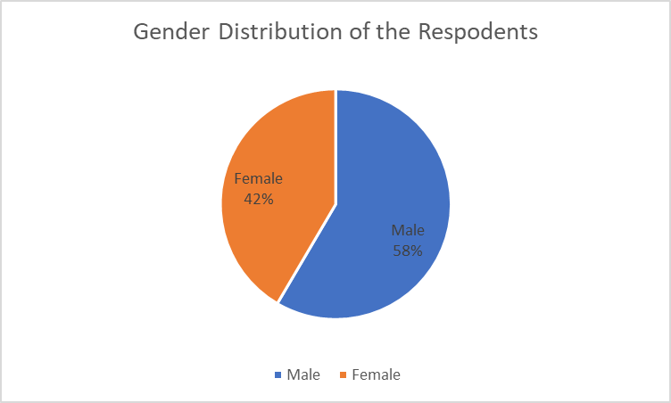

Source: Field Survey, 2025
Table 4.2.2: Age Distribution of Respondents
Age Group | Frequency | Percentage
18 – 25 years | 10 | 15.4%
26 – 35 years | 25 | 38.5%
36 – 45 years | 20 | 30.8%
46 years and above | 10 | 15.4%
Total | 65 | 100%
Source: Field Survey, 2025
Table 4.2.2 shows the age distribution of respondents. A total of 25 respondents (38.5%) fall within the 26–35 years category, making this group the most dominant in the study. The next largest group is those aged 36–45 years, with 20 respondents (30.8%). This distribution suggests that a majority of respondents are in their economically active years, which aligns with the target population of business operators in a multi-tenanted office complex. Their active involvement provides credible insights into the operations and challenges of managing such a property.

Figure 4.2.2: Age distribution of the respondents
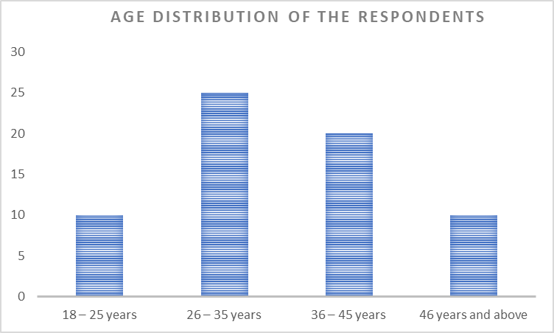
Source: Field Survey, 2025

Table 4.2.3: Duration of Tenancy in the Complex
Duration of Stay | Frequency | Percentage
Less than 1 year | 5 | 7.7%
1 – 3 years | 25 | 38.5%
4 – 6 years | 20 | 30.8%
Above 6 years | 15 | 23.0%
Total | 65 | 100%
Source: Field Survey, 2025
As presented in Table 4.2.3, 25 respondents, representing 38.5%, have stayed in the complex for 1 to 3 years. This is followed by 20 respondents (30.8%) who have stayed for 4 to 6 years. The data shows that most respondents have sufficient experience in the complex to provide meaningful responses about its management. Only 5 respondents (7.7%) are relatively new (less than 1 year), while 15 respondents (23.0%) have stayed for over 6 years, offering long-term perspectives on operational trends and management changes over time.

Figure 4.2.3: Duration of Stay of the Respondents
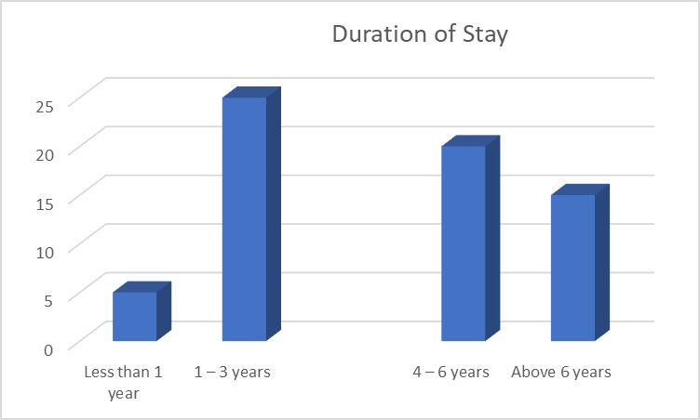
Source: Field Survey, 2025

Table 4.2.4: Type of Space Occupied by Respondents
Type of Space | Frequency | Percentage
Retail Shops | 30 | 46.2%
Service-based Offices | 20 | 30.8%
Warehouse/Storage | 5 | 7.7%
Corporate Offices | 10 | 15.3%
Total | 65 | 100%
Source: Field Survey, 2025
Table 4.2.4 identifies the types of spaces occupied by the respondents within the complex. Retail shops dominate the usage of the complex, with 46.2% of respondents operating in that category. This suggests that the shopping complex is largely a commercial trading hub. Service-based offices (30.8%) and corporate offices (15.3%) indicate that professional services and administrative functions are also accommodated. Warehouse/storage users, though fewer (7.7%), reflect diversity in business operations within the facility. This variation in space utilization supports the categorization of the complex as a multi-tenanted and multi-purpose facility.

Figure 4.2.4: Types of Spaces Occupied
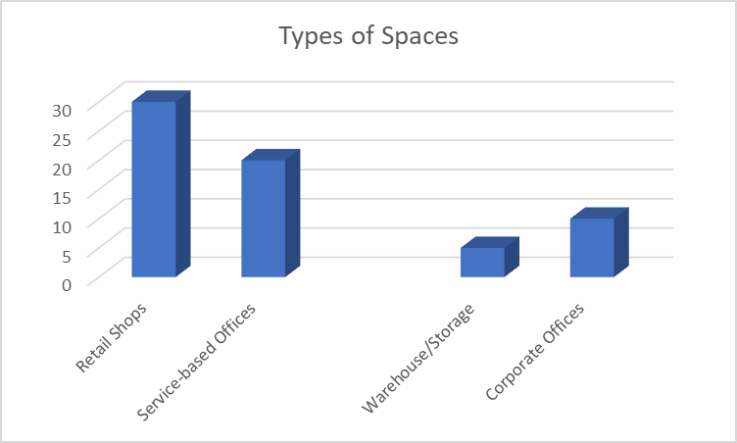
Source: Field Survey, 2025

Analysis of Questionnaire Items
Table 4.2.5: Respondents’ Opinion on the Efficiency of Property Management
Response Category | Frequency | Percentage
Very Efficient | 8 | 12.3%
Efficient | 20 | 30.8%
Fairly Efficient | 25 | 38.5%
Not Efficient | 12 | 18.5%
Total | 65 | 100%
Source: Field Survey, 2025
Table 4.2.5 reflects the perceptions of respondents regarding the overall efficiency of property management in the shopping complex. About 30.8% consider it "Efficient", while 38.5% feel it is only "Fairly Efficient", suggesting room for improvement. 18.5% of respondents rate the management as "Not Efficient", which could point to lapses in coordination, responsiveness, or administrative policies. Only a small proportion (12.3%) view the management as "Very Efficient", indicating that while management is functional, it has not achieved optimal efficiency in the view of most tenants.

Figure 4.2.5: Efficiency of Property Management
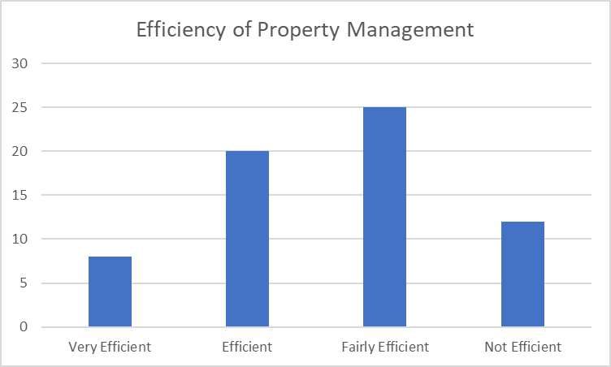
Source: Field Survey, 2025

Table 4.2.6: Respondents’ Satisfaction with Maintenance Services
Response Category | Frequency | Percentage
Very Satisfied | 10 | 15.4%
Satisfied | 18 | 27.7%
Neutral | 15 | 23.1%
Dissatisfied | 12 | 23.1%
Very dissatisfied | 10 | 15.4%
Total | 65 | 100%
Source: Field Survey, 2025
Table 4.2.6 shows that 43.1% of the respondents are either satisfied or very satisfied with maintenance services in the complex. However, a combined 33.9% express dissatisfaction (either dissatisfied or very dissatisfied), and 23.1% remain neutral. This mixed response suggests that while some efforts are being made toward maintenance, inconsistencies or irregularities in service delivery likely exist. The findings highlight the importance of strengthening routine maintenance, especially in shared facilities like toilets, stairwells, and power systems.

Figure 4.2.6: Satisfaction with maintenance services
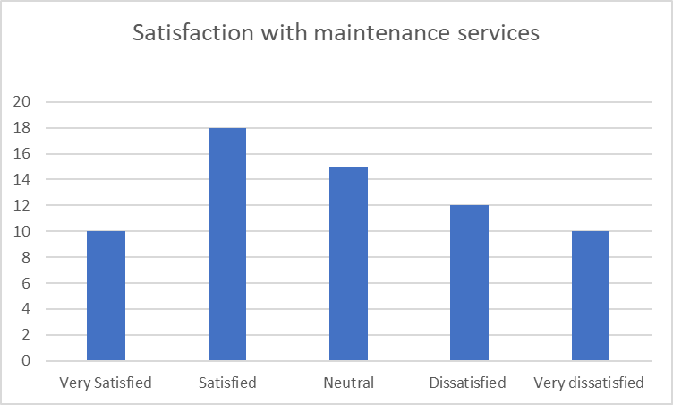
Source: Field Survey, 2025

Table 4.2.7: Accessibility of Management to Tenants
Response Category | Frequency | Percentage
Easily Accessible | 20 | 30.8%
Occasionally Accessible | 25 | 38.5%
Not Easily Accessible | 20 | 30.8%
Total | 65 | 100%
Source: Field Survey, 2025
Table 4.2.7 evaluates how accessible the property management team is to tenants. Only 30.8% find them "Easily Accessible", and the same percentage says they are "Not Easily Accessible", while the majority (38.5%) says accessibility is occasional. This result shows that communication gaps may exist between tenants and management, possibly affecting prompt complaint resolution or administrative feedback. Improved tenant engagement could foster better relationships and increases satisfy action.

Figure 4.2.7: Accessibility of Management to tenants
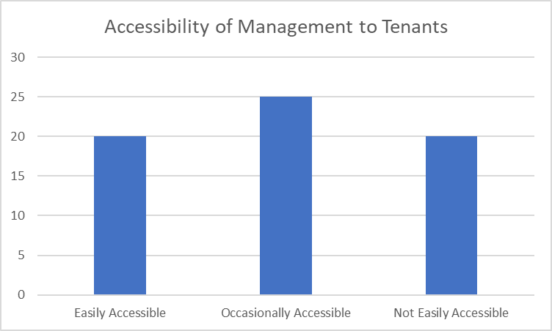
Source: Field Survey, 2025

Table 4.2.8: Regularity of Facility Maintenance (e.g., Toilets, Corridors, Lighting)
Response Category | Frequency | Percentage
Very Regular | 8 | 12.3%
Regular | 22 | 33.8%
Irregular | 25 | 38.5%
Very Irregular | 10 | 15.4%
Total | 65 | 100.00%
Source: Field Survey, 2025
Table 4.2.8 assesses how consistently essential facilities are maintained. Although 33.8% say maintenance is regular and 12.3% believe it is very regular, a combined 53.9% report irregular or very irregular maintenance. This indicates that while there may be a structure in place for upkeep, it is not consistently followed. Such inconsistency could lead to hygiene issues and tenant dissatisfaction, especially in high-traffic shared areas

Figure 4.2.8: Regularity of Facility Maintenance
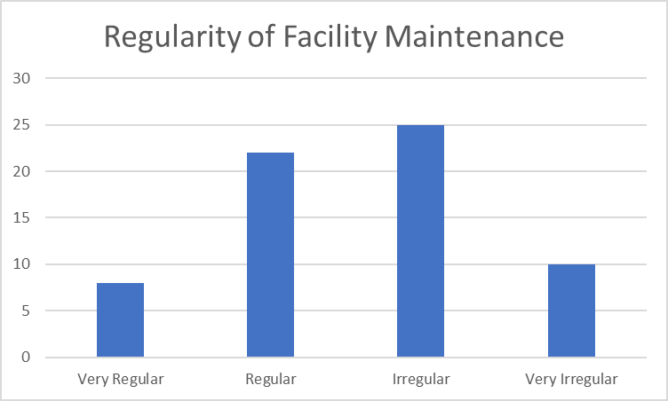
Source: Field Survey, 2025

Table 4.2.9: Timeliness of Rent Payment Requests
Response Category | Frequency | Percentage
Always Timely | 35 | 53.8%
Sometimes Timely | 20 | 30.8%
Rarely Timely | 10 | 15.4%
Total | 65 | 100.00%
Source: Field Survey, 2025
Table 4.2.9 presents data on the promptness of rent demand notices issued by the management. A majority (53.8%) agree that rent requests are "Always timely", while 30.8% report they are "Sometimes Timely". Only 15.4% say rent requests are "Rarely timely". This suggests that the administration of rent collection is relatively organized, though some improvements in communication and digital reminders could enhance compliance and reduce arrears.

Figure 4.2.9: Timeliness of rent payment requests
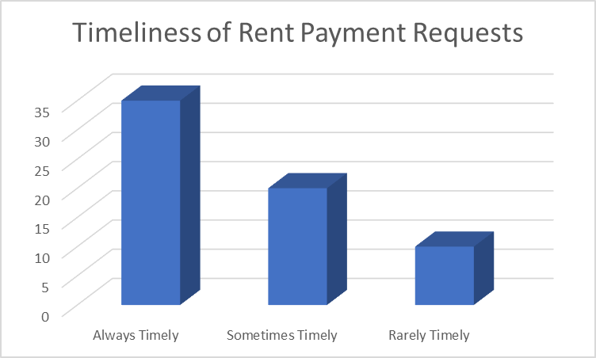
Source: Field Survey, 2025

Table 4.2.10: Tenant Participation in Decision-Making Processes
Response Category | Frequency | Percentage
Strongly Involved | 5 | 7.7%
Moderately Involved | 15 | 23.1%
Rarely Involved | 25 | 38.5%
Not Involved At All | 20 | 30.8%
Total | 65 | 100.00%
Source: Field Survey, 2025
Table 4.2.10 reveals the extent to which tenants are included in decision-making processes regarding the management of the office complex. Only 7.7% feel "Strongly Involved", and 23.1% report moderate involvement. However, a significant portion (69.3%) say they are either rarely or not involved at all. This suggests a top-down management style, which could lead to tenant dissatisfaction or resistance, especially in policy implementation. Encouraging participatory management could improve communication and strengthen relationships.

Figure 4.2.10: Tenant Participation in Decision-Making Processes
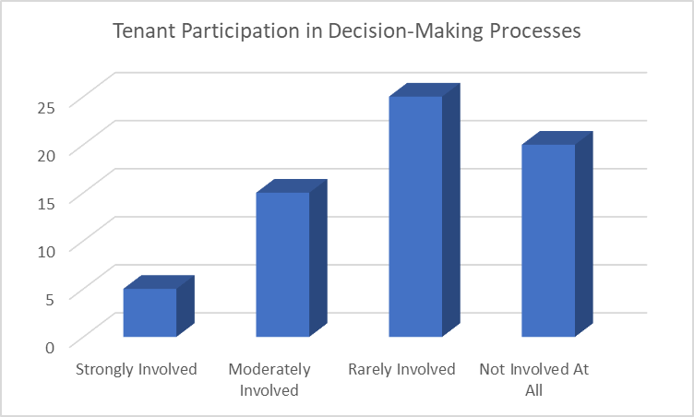
Source: Field Survey, 2025

Table 4.2.11: Adequacy of Utility Services (Water, Electricity, Sanitation)
Response Category | Frequency | Percentage
Highly Adequate | 10 | 15.4%
Adequate | 20 | 30.8%
Barely Adequate | 25 | 38.5%
Not Adequate | 10 | 15.4%
Total | 65 | 100.00%
Source: Field Survey, 2025
Table 4.2.11 assesses the adequacy of utility services within the complex. Only 46.2% of respondents believe the utilities are "Adequate" or "Highly Adequate", while the remaining 53.9% feel they are either "Barely Adequate" or "Not Adequate". The results indicate inconsistent access to essential services like power and water, which could disrupt business activities. The findings stress the need for the management to upgrade infrastructure or work closely with service providers to enhance reliability.

Figure 4.2.11: Adequacy of Utility Services
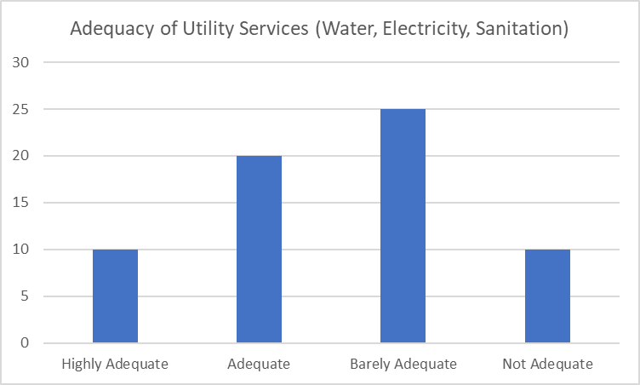
Source: Field Survey, 2025

Table 4.2.12: Effectiveness of Security Services
Response Category | Frequency | Percentage
Very Effective | 15 | 23.1%
Effective | 25 | 38.5%
Not Very Effective | 15 | 23.1%
Not Effective at All | 10 | 15.4%
Total | 65 | 100.00%
Source: Field Survey, 2025
Table 4.2.12 evaluates how effective the existing security measures are within the complex. While 61.6% of respondents feel the security services are effective to some degree, 38.5% are not confident in their effectiveness. This indicates that although security is functional, there may be vulnerabilities that require attention such as poor surveillance, inadequate night shifts, or a lack of emergency preparedness. Strengthening security infrastructure could build tenant confidence and reduce crime-related risks.

Figure 4.2.12: Effectiveness of Security Services
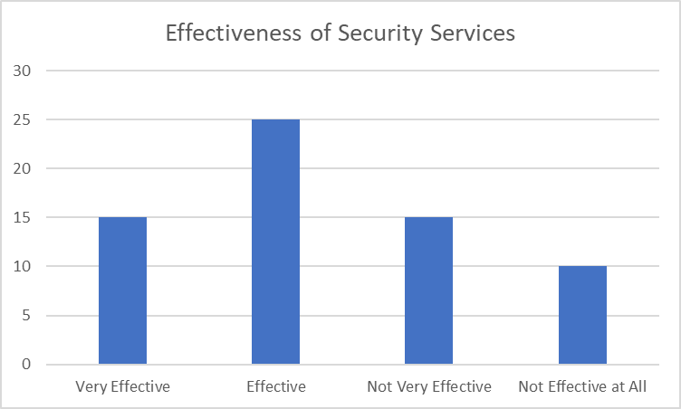
Source: Field Survey, 2025

Table 4.2.13: Common Challenges Faced by Tenants
Challenge Type | Frequency | Percentage
High Service Charges | 18 | 27.7%
Poor Maintenance | 22 | 33.8%
Poor Communication with Management | 10 | 15.4%
Insecurity | 5 | 7.7%
Inadequate Utility Services | 10 | 15.4%
Total | 65 | 100%
Source: Field Survey, 2025
Table 4.2.13identifies the most frequent challenges encountered by tenants. The leading issue is "Poor Maintenance" (33.8%), followed by "High Service Charges" (27.7%). These are key indicators that operational cost and maintenance responsiveness are primary concerns. Communication issues and utility inadequacies also feature prominently. Addressing these problems would improve tenant satisfaction and long-term retention.

Figure 4.2.13: Challenges faced by tenants
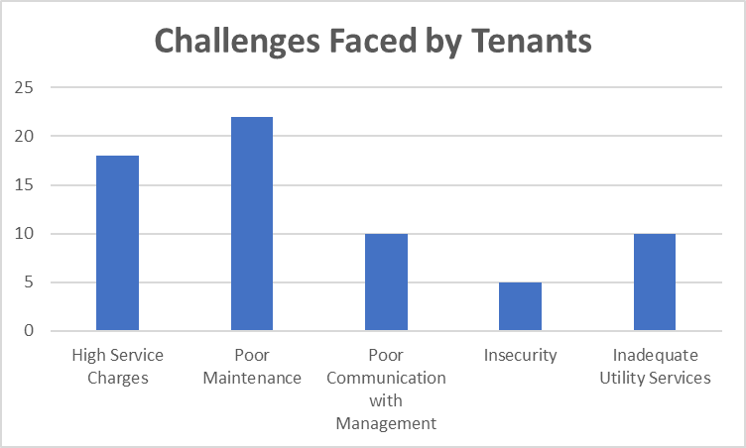
Source: Field Survey, 2025

Table 4.2.14: Suggestions for Improvement from Respondents
Suggested Area for Improvement | Frequency | Percentage
Improve Maintenance Routines | 25 | 38.5%
Reduce Service Charges | 15 | 23.1%
Engage Tenants in Decision-Making | 10 | 15.4%
Upgrade Utility Infrastructure | 10 | 15.4%
Enhance Security | 5 | 7.7%
Total | 65 | 100%
Source: Field Survey, 2025
Table 4.2.14 presents the areas where respondents believe improvement is needed. Most tenants (38.5%) advocate for better maintenance, while others emphasize the need for reduced service charges (23.1%) and improved tenant inclusion in decisions (15.4%). These suggestions reinforce the findings from earlier tables and provide actionable recommendations for management to improve overall satisfaction and operational effectiveness.

Figure 4.2.14: Suggestions for Improvement from Respondents
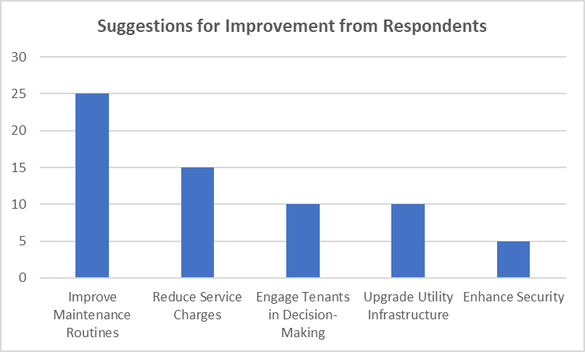
Source: Field Survey, 2025

4.3 Discussion of Findings
The findings of the study reveal a mixed picture of the management practices at Rukammat and Santosh Shopping Complex. Although the management of the complex is generally considered "fair" by a majority of respondents, there is clear evidence that tenants feel there is room for significant improvement in several key areas. The relatively low percentage of respondents rating the management as "excellent" (only 15.4%) points to the fact that tenants have high expectations regarding the quality of services provided. This suggests that while the management has succeeded in some areas, it has yet to reach a level of performance that would fully satisfy its tenants, pointing to the need for more effective and responsive management practices.
A major concern raised by tenants was the infrequency of communication between the management and the tenants. With 69.2% of respondents indicating that communication is either rare or non-existent, it is clear that there is a lack of engagement, which likely contributes to tenant dissatisfaction. Effective communication is an essential aspect of property management as it helps to foster a sense of belonging and trust among tenants. When tenants feel disconnected from management, they may feel less inclined to raise concerns or engage in cooperative problem-solving, which can negatively impact the overall atmosphere within the complex. Therefore, regular communication through meetings, newsletters, or even digital platforms could significantly improve tenant relations.
Maintenance issues also emerged as a critical area of concern in the findings. A significant proportion of respondents, 53.9%, indicated that the maintenance services provided were either inadequate or only moderately effective. This suggests that the complex is not meeting the expectations of its tenants when it comes to the upkeep of the building and the utilities. Regular and proactive maintenance is essential in ensuring the longevity of the complex and the satisfaction of its tenants. Failures in maintenance can lead to frustration, as tenants are often forced to deal with issues like faulty plumbing, unreliable electricity, or waste management problems, which can affect their daily lives and business operations. Addressing these issues should be a priority for the management to improve the overall tenant experience.
Security, on the other hand, was one of the few areas where the complex’s management performed relatively well, with most tenants rating security measures positively. However, while security was deemed adequate, there remains room for improvement, particularly in terms of enhancing surveillance systems and increasing security staff, especially during night hours. Security is a fundamental concern for tenants, particularly those who operate businesses in the complex, and any perceived weakness in this area could lead to tenant attrition. It is essential that the management continues to invest in security infrastructure, ensuring that tenants feel safe and secure at all times, which in turn can contribute to higher satisfaction and retention rates.
Finally, the study found that the primary drivers of tenant retention were affordable rents, good management practices, and a clean and safe environment. These factors highlight the importance of maintaining competitive rental rates and ensuring that the complex remains well-maintained and conducive to business operations. Tenants are more likely to remain in a complex where they feel their needs are met, both in terms of the physical environment and the management’s responsiveness. Management should focus on maintaining affordability, improving the condition of the premises, and addressing tenant concerns in a timely and effective manner. By doing so, the complex can enhance tenant satisfaction, increase retention, and ultimately ensure long-term success.

CHAPTER FIVE
SUMMARY OF FINDINGS, CONCLUSION AND RECOMMENDATIONS
5.1 Summary of Finding
The study examined the management of multi-tenanted office complexes in Ilorin, focusing on Rukammat and Santosh Shopping Complex, Ilorin, Taiwo Road. The results show that while the complex offers some positive experiences for tenants, there are several key areas requiring improvement. Other findings made from the study are:
- In terms of duration of occupancy, as indicated in Table 4.3.3, the highest number of tenants (41.5%) have spent between 1 to 3 years in the complex, while 29.2% have been there for over 6 years. This indicates that the complex hosts a mix of relatively new and long-term tenants, which provides a blend of fresh perspectives and experienced insights into the historical performance of the management.
- The nature of the businesses within the complex, illustrated in Table 4.3.4, shows that retail businesses dominate (53.8%), followed by service-based enterprises at 30.8%. This composition emphasizes that the complex primarily supports commercial activities that require high customer interaction, thereby necessitating effective management practices that support visibility, cleanliness, and accessibility to enhance customer experience.
- Respondents’ evaluation of the management performance, as reflected in Table 4.3.5, indicates that while 15.4% rated management as "Excellent", a larger portion (43.1%) rated it "Fair", and 23.1% deemed it "Poor". This finding suggests that while some efforts are being made in the administration of the complex, many tenants remain unimpressed or dissatisfied with the quality and consistency of management practices.
- From Table 4.3.6, it was found that a significant 78.5% of respondents are aware of the presence of a management structure overseeing the complex. Although awareness is high, this does not necessarily equate to confidence in their operations. This point becomes clearer when examining Table 4.3.7, where 46.2% of tenants stated that there is rarely any communication from the management, while 23.1% said there is none at all, highlighting a major weakness in tenant-manager engagement.
- The findings from Table 4.3.8 further underscore this problem, where over half of the respondents rated the management's handling of maintenance issues as “Ineffective” or “Very Ineffective”. Only a marginal 10.8% found maintenance responses to be “Very Effective”. This presents a challenge, especially in a commercial setting where functional infrastructure is key to operational success.
- Transparency in service charges, captured in Table 4.3.9, shows a mixed result: while 44.6% of tenants believe charges are clearly stated and fair, another 29.2% say they are clearly stated but high. This means that although tenants may not be in the dark regarding the fees they pay, the perceived value for money remains a concern for some.
- The data in Table 4.3.10 reveals that the most significant challenges tenants face include poor maintenance (27.4%), lack of communication (25.2%), and unfair rent increments (21.1%). These issues appear to be the key drivers of dissatisfaction among tenants and reflect areas in urgent need of reform.
- As seen in Table 4.3.11, a large portion (47.7%) of respondents expressed a lack of confidence in the competence of the management, while 32.3% were unsure. This lack of trust in management effectiveness suggests a significant gap between tenant expectations and actual service delivery.
- While 60% of tenants reported having lodged complaints in the past (Table 4.3.12), only 28.2% stated that their issues were resolved. This low resolution rate further illustrates poor conflict and issue management, which can contribute to long-term dissatisfaction.
5.2 Conclusion
This study set out to assess the management of multi-tenanted office complexes in Ilorin, with a focus on Rukammat and Santosh Shopping Complex, Ilorin, Taiwo Road. Based on the findings, it is evident that while there is a formal management structure in place, many tenants are dissatisfied with its performance, particularly in the areas of maintenance, communication, transparency, and responsiveness to complaints. The research reveals that these shortcomings have direct consequences on tenants’ business operations, ranging from reduced customer satisfaction to financial losses, and even considerations of relocating. The study confirms that effective property management is a crucial determinant of tenant satisfaction, retention, and overall productivity within multi-tenant commercial environments.
Moreover, it is apparent from the data that while factors such as affordable rent and location still attract tenants, poor management practices significantly reduce their willingness to remain in the complex long-term. The perception of inefficiency and unresponsiveness, as seen in low ratings across various parameters, indicates a gap between tenant expectations and the service being delivered. Thus, this study concludes that improving the standard of management in areas such as maintenance, communication, and conflict resolution is essential to creating a more sustainable and supportive environment for businesses to thrive. Addressing these concerns will not only benefit tenants but also enhance the reputation, occupancy rate, and revenue generation of the complex owners.
5.3 Recommendations
At the end of the study, the following recommendations are made:
- Management of the complex should establish a regular maintenance schedule for essential services like electricity and water.
- A qualified and experienced property manager should be appointed to oversee the day-to-day operations of the complex.
- There should be consistent and effective communication between management and tenants through regular meetings or updates.
- A structured feedback system should be created to allow tenants to report issues and suggest improvements.
- Rent charges and increments should be transparently communicated and implemented fairly to avoid disputes.
- Security in the complex should be strengthened with the presence of trained personnel and functional surveillance cameras.
- Management should organize stakeholder meetings every quarter to identify challenges and discuss possible solutions.

References
Abdulkareem, T., & Adedayo, R. (2020). Urban commercial centers and local economic development in Nigeria. Journal of Urban Economics and Development, 8(2), 45–53.
Abdulkareem, T., & Adedayo, R. (2020). Urban development and property management in Nigeria. Journal of Urban Economics, 12(2), 45–60.
Adeoye, M., & Ojo, L. (2019). Innovative property management solutions in Nigeria. African Journal of Real Estate, 7(1), 12–25.Adeoye, M., & Ojo, L. (2019). Technology and innovation in Nigerian property management. African Journal of Real Estate and Urban Planning, 6(1), 22–30.
American Urban Planning Association. (2020). Guide to shopping complexes in urban planning. AUPA Publications.
Baker, T., & Duffy, R. (2017). Legal aspects of property management. London: Property Law Press.
Bello, S. (2022). Challenges and opportunities in multi-tenanted commercial properties in Nigeria. International Journal of Commercial Real Estate, 15(3), 80–95.
Bello, S. (2022). Evaluating commercial property performance in urban Nigeria: A case study of Ilorin. International Journal of Property Management, 10(3), 74–81.
Brown, L. (2019). Commercial leasing strategies. New York: Urban Realty Publications.
Chandler, M. (2020). Facilities management in modern real estate. Chicago: Real Estate Insight.
Geltner, D., & Miller, N. (2018). Commercial real estate analysis and investments (3rd ed.). Boston: Cengage Learning.
Gray, C., & Larson, E. (2018). Managing conflict in property management. Cambridge: Property Managers Association.
Ibrahim, A., & Mohammed, Y. (2020). Multi-tenanted commercial property management strategies in urban Nigeria. Property and Facility Management Review, 5(4), 35–44.
Ibrahim, A., & Mohammed, Y. (2020). Transparency and professionalism in lease management: A Nigerian perspective. Property Management Journal, 8(4), 34–50.
International Real Estate Federation. (2021). Glossary of real estate terms. Retrieved from http://www.firf.org/glossary
Jones, S. (2018). Maintenance and operations in real estate. Toronto: Maple Leaf Publishers.
Kehinde, O. (2022). Management practices in Nigerian shopping complexes: A case study. Journal of Urban Studies, 11(1), 102–118.
Kehinde, O. (2022). Stakeholder perspectives in managing Nigerian shopping complexes. Ilorin Journal of Social Research, 9(1), 90–99.
Kwara State Government. (2022). Maraba: The commercial heart of Ilorin. Government Press.
Levy, D. (2019). Financial management for property professionals. Oxford: Real Estate Finance Press.
Miller, N. (2019). Multi-tenancy and commercial real estate. San Francisco: CRE Publishing.
Miller, N., & Geltner, D. (2020). Managing multi-tenant properties: Challenges and solutions. Boston: Cengage Learning.
National Bureau of Statistics. (2023). Economic and social statistics for Nigeria. National Bureau of Statistics.
National Geographic Society. (2021). Nigeria: A geographical and demographic overview. National Geographic.
Olaitan, M. (2023). Tenant management and operational sustainability of commercial complexes. Journal of Built Environment Studies, 12(2), 105–112.
Olaitan, M. (2023). Tenant management and the performance of commercial complexes in Nigeria. Journal of Property Research, 14(1), 55–70
Olawale, T. (2021). Effective property management for sustainable urban development in Nigeria. Nigerian Journal of Property Studies, 9(2), 65–80.
Olawale, T. (2021). Sustainable urban development through commercial property management. Nigerian Journal of Property Studies, 7(3), 118–126.

QUESTIONNAIRE

KWARA STATE POLYTECHNIC, ILORIN

DEPARTMENT OF ESTATE MANAGEMENT AND VALUATION

INSTITUTE OF ENVIRONMENTAL STUDIES
TOPIC: ASSESSMENT OF THE MANAGEMENT OF MULTI-TENANTED OFFICE COMPLEX IN ILORIN, KWARA STATE
(A CASE STUDY OF RUKAMMAT AND SANTOSH SHOPPING COMPLEX, ILORIN, TAIWO ROAD, TAIWO ROAD)

Dear Respondent,
This questionnaire is designed to gather information on the management practices, challenges, tenant satisfaction, and overall performance of Rukammat and Santosh Shopping Complex. All information provided will be treated with confidentiality and used solely for academic purposes. Kindly respond honestly.

Yours’ Faithfully,

___________________
IDRIS ALIMOT TENITOPE
HND/23/ETM/FT/0014

SECTION A: Respondent’s Profile
- Gender:
☐ Male ☐ Female
- Age Group: ☐ 18–25 ☐ 26–35 ☐ 36–45 ☐ 46 and above
- Duration of Tenancy: ☐ Less than 1 year ☐ 1–3 years ☐ 4–6 years ☐ Above 6 years
- Type of Business Space Occupied: ☐ Retail ☐ Office ☐ Warehouse ☐ Service-based

SECTION B: Examine the current management practices employed in the Rukammat and Santosh Shopping Complex.
- Are you aware of the existence of a property management team?
☐ Yes ☐ No
- How often does management communicate with tenants?
☐ Regularly ☐ Occasionally ☐ Rarely ☐ Never
- How would you rate the overall management of the complex?
☐ Excellent ☐ Good ☐ Fair ☐ Poor
- How responsive is the management to maintenance issues (water, electricity, waste)?
☐ Very responsive ☐ somewhat responsive ☐ Not responsive ☐ Uncertain
- Are there clear lease agreements?
☐ Yes ☐ No ☐ Not sure

SECTION C: Identify the challenges faced in the management of the complex.
- What challenges have you experienced in this complex?

 | Strongly Agree | Agree | Disagree | Strongly Disagree
Poor maintenance
Insecurity
Poor communication
High service charges
Utility failures
No tenant inclusion in decisions

- Have you ever lodged a complaint to management?
☐ Yes ☐ No
- If yes, how was your issue handled?
☐ Satisfactorily ☐ Partially ☐ Not addressed
- Do you believe the management is professionally competent?
☐ Yes ☐ No ☐ Not sure
SECTION D: Evaluate the impact of these management practices on tenant satisfaction and retention.
- How satisfied are you with your tenancy experience?
☐ Very satisfied ☐ Satisfied ☐ Dissatisfied ☐ Very dissatisfied
- Would you consider renewing your lease?
☐ Yes ☐ Not sure ☐ No
- Has poor management ever made you consider relocating?
☐ Yes ☐ No
- What would make you continue operating in this complex?
☐ Good management ☐ Affordable rent ☐ Clean environment ☐ Tenant engagement ☐ Reliable utilities
SECTION E: Analyze how management inefficiencies affect the overall performance and value of the complex.
- In your opinion, does poor management affect your business performance?
☐ Yes ☐ No
- Have you lost customers/income due to facility issues (power, water, security)?
☐ Yes ☐ No
- How do you rate the overall environment of the complex (security, cleanliness, layout)?
☐ Excellent ☐ Good ☐ Fair ☐ Poor
- What changes would you suggest to improve the management of this complex?

