EMOTIONAL INTELLIGENCE AND EMPLOYEE PERFORMANCE IN NIGERIA BANKING
(A CASE STUDY OF SELECTED BANKING IN ILORIN METROPOLIS)

BY

AWOOLA KOLAWOLE SUNDAY
HND/23/BAM/FT/1059

A PROJECT SUMITTED TO: DEPARTMENT OF BUSINESS ADMINISTRATION AND MANAGEMENT
INSTITUTE OF FINANCE AND MANAGEMENT STUDIES, KWARA STATE POLYTECHNIC

IN PARTIAL FULFILLMENT OF THE REQUIREMENT FOR THE AWARD OF HIGHER NATIONAL DIPLOMA (HND) IN BUSNESS ADMINISTRATION

JULY, 2025
CERTIFICATION
This is to certify this project has been read and approved having satisfied the requirement for award of Higher National Diploma (HND) in the department of Business Administration, institute of Finance and Management Studies (IFMS), Kwara State Polytechnic, Ilorin.

_______________________ ______________________
DR. SAKA TAOFIQ ALAO DATE
(Project supervisor)

_______________________ ______________________
MR. ALIYU B.U DATE
(Project coordinator)

_______________________ ______________________
MR ALAKOSO I.K DATE
(Head of Department)

_______________________ ______________________
EXTERNAL EXAMINER DATE

DEDICATION
This project is dedicated to Almighty GOD for the grace given to me to successfully finish this project work.

ACKNOWLEDGEMENT
Firstly I thank God for the success of this program may his name be highly praise forever Amen.
My unquantifiable gratitude goes to Almighty God, the most beneficent, the most
merciful. The one who gave me the wisdom, strength and understanding needed to successfully
complete this program.
My profound appreciation goes to my supervisor, Dr. Saka Taofiq Alao, for his time to guide, assist, correct and impact knowledge in me during the course of this
work. I would like to thank him for his professional assessment. May God continually bless you
and your family.
My gratitude goes to the Head of Department, Mr. I.K Alakoso and to all teaching staff and non teaching staff of the department, I am very grateful for your effort throughout my stay in the polytechnic. I say a big thank you for the knowledge
impacted, God will bless you all.
To my late mom in person of Deaconess E.O Awoola I wish you were here to witness this greatness in which you have supported me till the moment you gave up the ghost I pray may you continue to rest in perfect peace.
I am sincerely grateful to the Family of Mr. and Mrs. Adejimi and Mr. and Mrs. Ayelade thank you for being the best siblings to me and catering for my needs without hesitation. Your love and support have been my greatest source of strength. To my ever supportive brother pastor oloruntoba omotosho and my amiable brother Odutolu Shola segun thank you for being there for me and thank you for the moral and financial support throughout the journey.
I want to acknowledge the positive contribution of my friends and colleagues in the names of Dada Oluwaferanmi, Adebayo Abdulkareem, Olajide Oluwatunmise. Idris Adekunle, Abikoye Azeeza, Durodola grace and Olaniyi oluwaseun You all are the best May Almighty God bless you all.
TABLE OF CONTENTS
Title page
Certification
Dedication
Acknowledgement
Table of contents
CHAPTER ONE: INTRODUCTION
  - Background to the study
  - Statement of research problem
  - Objectives of the Study
  - Research question
  - Significance of the study
  - Scope of limitations
  - Definition of terms
CHAPTER TWO: LITERATURE REVIEW
2.1 Conceptual review
2.1.1 Concept of emotional intelligence (EI)
2.1.2 Concept of employee performance
2.2 Theoretical framework
2.2.1 Ability-based theory of emotional intelligence (salovey & mayer,1997)
2.2.2 Performance theory
2.3 Empirical review
2.4 Concept frame work
2.5 Gaps in literature
CHAPTER THREE: RESEARCH METHODOLOGY
3.0 Introduction
3.1 Research Design
3.2 Population of the Study
3.3 Sample Size and sampling technique
3,4 Instrument of data collection
3.5 Validity and reliability of the instrument
3.6 Method of data Analysis
CHAPTER FOUR: DATA PRESENTATION AND ANALYSIS
4.1 Introduction
4.2 Questionnaire Distribution and Retrieval
4.3 Demographic Data of Respondents
4.4 Educational Qualification
4.5 Test of Hypotheses
CHAPTER FIVE: SUMMARY, CONCLUSION AND RECOMMENDATIONS
5.1 Summary
5.2 Conclusion
5.3 Recommendations
5.4 Suggestion for Further Studies
5.5 Contributions to Knowledge
5.6 Reference
CHAPTER ONE
INTRODUCTION
1.1 Background of the Study
In the ever-evolving landscape of organizational management, especially within service-based industries such as banking, human capital has become a critical determinant of success. As organizations continue to face stiff competition, economic fluctuations, and rapidly changing customer expectations, the demand for high-performing employees is more urgent than ever. While technical expertise, education, and experience have traditionally been used to measure employee competence, contemporary human resource management has begun to highlight the importance of emotional intelligence (EI) in the workplace.
Emotional intelligence refers to an individual’s ability to recognize, understand, and manage their own emotions and those of others. The concept, popularized by Daniel Goleman in the mid-1990s, extends beyond cognitive intelligence (IQ) and emphasizes the human and relational side of work performance. Research shows that emotionally intelligent individuals are better at handling workplace stress, building stronger interpersonal relationships, making rational decisions, and leading effectively (Goleman, 1995).
In the context of the Nigerian banking sector, emotional intelligence has become increasingly relevant. Banks like Access Bank, known for their service delivery and organizational excellence, operate in a high-pressure environment where employees regularly deal with irate customers, tight deadlines, and financial targets. In such a setting, the ability to manage emotions, maintain composure, and exhibit empathy can significantly influence job performance and overall organizational success.
Given the strategic importance of employee performance in banking, especially in Access Bank Ilorin, it becomes pertinent to investigate how emotional intelligence affects the work output, attitude, and interpersonal interactions of employees.
1.2 Statement of the Problem
Despite the critical role played by employees in the banking sector, many Nigerian banks still report challenges such as poor customer service, low morale, frequent conflicts among team members, and high staff turnover. While training programs and performance incentives have been implemented to address these issues, the root causes often remain unaddressed.
Traditional methods of evaluating employee performance usually focus on measurable outputs such as productivity, punctuality, and efficiency. However, they often neglect emotional and psychological factors that significantly influence how employees perform. A growing body of evidence suggests that low emotional intelligence among staff can lead to poor communication, increased workplace stress, low teamwork cohesion, and reduced motivation (Adeyemo &Oyedokun, 2021).
In Access Bank Ilorin, these challenges are not isolated. Employees are expected to manage multiple customer accounts, solve complaints, work collaboratively, and meet daily targets—all under intense pressure. Without the emotional maturity and resilience required to handle such demands, even highly skilled workers may underperform. Hence, there is a clear need to examine how emotional intelligence contributes to or impedes employee performance within this setting.
1.3 Objectives of the Study
The main objective of this study is to examine the relationship between emotional intelligence and employee performance in Access Bank, Ilorin.
The specific objectives are to:
- Assess the level of emotional intelligence among Access Bank employees in Ilorin.
- Evaluate the impact of emotional intelligence on individual and group job performance.
- Determine how emotional intelligence influences interpersonal relationships and conflict management within the workplace.
- Recommend strategies for enhancing employee performance through emotional intelligence training and development.
1.4 Research Questions
This study will be guided by the following research questions:
- What is the current level of emotional intelligence among employees of Access Bank, Ilorin?
- How does emotional intelligence affect the individual performance of employees?
- In what ways does emotional intelligence impact teamwork, collaboration, and conflict resolution?
- What measures can be implemented to improve employee performance through the development of emotional intelligence?
1.5 Significance of the Study
This study holds significance in several key areas:
- For Management: It provides insights into how emotional intelligence contributes to employee performance, offering a foundation for strategic human resource planning and staff development.
- For Human Resource Departments: The findings can guide the design and implementation of more effective recruitment, training, and evaluation processes based on emotional intelligence competencies.
- For Employees: It enhances awareness of emotional competencies needed for better job performance, stress management, and career growth.
- For Researchers and Academics: It adds to the growing body of literature on emotional intelligence in the workplace, particularly within the Nigerian context.
- For Policymakers: The study can inform policy formulation in the banking sector regarding staff welfare, mental health, and productivity.
1.6 Scope and Limitations
Scope:
This study is limited to Access Bank branches located in Ilorin, Kwara State. It covers a cross-section of employees from various departments including customer service, operations, and marketing.
Limitations:
- The study may face response bias, as participants might answer in socially desirable ways rather than truthfully.
- Time and financial constraints may limit the sample size and depth of the investigation.
- The use of self-reported questionnaires could affect the objectivity of the data.
- The study's findings may not be generalizable to all banks or branches outside Ilorin.
1.7 Definition of Terms
- Emotional Intelligence (EI): The capacity to recognize, understand, and manage emotions in oneself and others.
- Employee Performance: The effectiveness, efficiency, and productivity of employees in completing tasks and meeting job expectations.
- Conflict Resolution: The process of resolving disputes or disagreements between individuals in the workplace.
- Self-awareness: The ability to understand one's emotions, triggers, and behavioral tendencies.
- Empathy: The ability to sense and understand the feelings and perspectives of others.

CHAPTER TWO
LITERATURE REVIEW
2.1 Conceptual Review
2.1.1 Concept of Emotional Intelligence (EI)
Emotional Intelligence (EI) is broadly defined as the ability to perceive, control, and evaluate emotions in oneself and others (Salovey & Mayer, 1990). Goleman (1995), one of the most influential proponents of the concept, expanded it into five key dimensions:
- Self-awareness – recognizing one's emotions and their effects.
- Self-regulation – controlling disruptive impulses and moods.
- Motivation – a passion for work beyond status or money.
- Empathy – understanding others’ emotional makeup.
- Social skills – managing relationships and building networks.
In the workplace, these competencies are crucial for managing relationships, reducing stress, navigating social complexities, and making informed decisions (Adeoye & Emeke, 2021). Emotional intelligence goes beyond academic qualifications and technical skills to determine how well individuals perform, especially in dynamic environments like banking.

2.1.2 Concept of Employee Performance
Employee performance refers to the extent to which an employee effectively fulfills their job duties and responsibilities. It can be measured through various indicators including productivity, task completion rate, punctuality, quality of service, and team contribution. In the banking sector, high employee performance translates to better customer satisfaction, improved operational efficiency, and increased profitability (Ibrahim &Obalola, 2022).
The link between EI and performance lies in how emotionally intelligent employees handle pressure, cooperate with team members, and maintain a positive attitude toward customers and tasks.
2.2 Theoretical Framework
This study is grounded in two main theories:
2.2.1 Ability-Based Theory of Emotional Intelligence (Salovey & Mayer, 1997)
This theory views emotional intelligence as a form of intelligence involving the ability to:
- Accurately perceive emotions,
- Use emotions to facilitate thought,
- Understand emotional meanings, and
- Manage emotions.
This theory supports the idea that EI is not just an inherent trait but can be developed and improved over time. In the banking context, employees can be trained to improve their emotional responses and interpersonal interactions.
2.2.2 Performance Theory
This theory asserts that performance is influenced by a combination of knowledge, skills, motivation, and environment. Emotional intelligence is considered a behavioral skill that enhances motivation and adaptability, leading to higher performance levels (Yahaya & Ebrahim, 2020).
These frameworks provide a basis for evaluating how EI translates into practical, observable outcomes in employee behavior and productivity.
2.3 Empirical Review
Numerous studies have investigated the relationship between emotional intelligence and employee performance across different sectors:
- Bello and Suleiman (2021) found a significant positive relationship between emotional intelligence and job performance in Nigerian commercial banks. Employees with high EI demonstrated better decision-making, time management, and customer service.
- Akinola & Ojo (2020) examined emotional intelligence and team effectiveness in microfinance institutions. They reported that emotionally intelligent employees reduced conflicts and enhanced collaboration, which positively impacted team performance.
- Ogundele &Okeowo (2022) conducted a study in Lagos-based banks and found that emotional intelligence training improved employee morale, reduced absenteeism, and increased efficiency.
- Eze and Ibekwe (2022) emphasized that while IQ determines job entry, emotional intelligence determines job success. Their study of service organizations in Nigeria concluded that EI accounted for over 40% variance in employee performance outcomes.
- Olayiwola (2023) explored EI as a stress management tool among bank employees in Abuja. The study indicated that self-regulation and empathy helped reduce burnout and increased employees’ emotional resilience.
Despite these studies, limited research focuses specifically on Access Bank and even fewer target branches in Ilorin, hence the relevance of this case study.
2.4 Conceptual Framework
The conceptual framework for this study is illustrated below:
Emotional Intelligence Dimensions
Self-Awareness - Self-Regulation - Motivation – Empathy - Social Skills
Influence on Employee Performance
(Productivity, Communication, Teamwork, Efficiency)
The framework explains how different dimensions of emotional intelligence collectively influence employee performance indicators in a banking work environment.
2.5 Gaps in Literature
While much work has been done on emotional intelligence and employee performance:
- Few studies focus on regional branches of large banks like Access Bank in Ilorin.
- Most existing literature emphasizes performance in general terms, with less focus on teamwork, customer interaction, and conflict resolution.
- There is a lack of data-driven studies (using correlation or regression) to quantify the strength of the relationship in the Nigerian banking sector.
This study addresses these gaps by:
- Focusing on a specific location (Ilorin).
- Using quantitative methods to assess the EI-performance relationship.
- Providing actionable recommendations for performance improvement through EI training.
CHAPTER THREE
RESEARCH METHODOLOGY
3.1 Research Design
This study adopted a descriptive survey research design. A descriptive survey design is ideal for research that seeks to gather data on phenomena as they naturally occur, without manipulation of variables. This method enables researchers to collect quantifiable information from a population and describe the characteristics of the respondents in a systematic manner. It is particularly appropriate for behavioral and social science research, such as studies focusing on emotional intelligence and performance, as it facilitates the collection of data in a natural setting (Creswell, 2014). The purpose of employing this design is to explore the influence of emotional intelligence components—such as self-awareness, self-regulation, motivation, empathy, and social skills—on employee performance in Nigerian banking institutions, using Access Bank Ilorin as a case study.
3.2 Population of the Study
The population of this study consists of all employees at Access Bank, Ilorin branch, Kwara State, Nigeria. These include senior managers, middle-level staff, junior staff, and other support employees across various departments such as customer service, operations, marketing, and finance. The population is estimated at 150 staff members. The selection of this population is justified by the fact that Access Bank is one of the prominent commercial banks in Nigeria with a well-established presence in Ilorin and a robust operational structure that reflects typical banking operations in Nigeria. The focus on this population enables a realistic and representative understanding of emotional intelligence and its effect on employee performance.
3.3 Sample Size and Sampling Technique
The sample size for this study was 50 respondents, selected using a stratified random sampling technique. The stratification was done based on department and job designation to ensure that all categories of employees were adequately represented. This method is advantageous because it reduces sampling bias and ensures that sub-groups within the population are included in the study. After stratification, simple random sampling was used to select respondents from each stratum. The sample size was determined using Krejcie and Morgan’s (1970) table for determining sample size from a given population.
3.4 Instrument for Data Collection
The primary instrument for data collection was a structured questionnaire. The questionnaire was designed in line with Goleman’s (1998) Emotional Intelligence Framework, which includes five dimensions: self-awareness, self-regulation, motivation, empathy, and social skills. The questionnaire was divided into three sections:
- Section A: Demographic Information
- Section B: Emotional Intelligence Components
- Section C: Employee Performance Indicators
Each item in Sections B and C was rated on a 5-point Likert scale ranging from Strongly Disagree (1) to Strongly Agree (5). The structure allowed for the measurement of employee perceptions and experiences regarding emotional intelligence and its impact on their job performance.
3.5 Validity and Reliability of the Instrument
To ensure the validity of the instrument, the questionnaire was reviewed by academic experts in human resource management and psychology. Their suggestions were incorporated to enhance clarity and relevance. Content validity was ascertained by ensuring the items adequately covered all dimensions of emotional intelligence as proposed by Goleman (1998).
` Reliability of the instrument was tested through a pilot study involving 10 staff members from a different Access Bank branch within the same region. The internal consistency of the instrument was assessed using Cronbach’s Alpha. The result yielded a coefficient of 0.84, which exceeds the minimum acceptable threshold of 0.70 as suggested by Nunnally (1978), indicating a high level of reliability.

3.6 Method of Data Analysis
Data obtained from the questionnaire were coded and analyzed using the Statistical Package for Social Sciences (SPSS) version 26. Descriptive statistics such as mean, standard deviation, frequency, and percentage were used to summarize the demographic characteristics of respondents and responses to each item on emotional intelligence and performance.
Inferential statistics, specifically Pearson Product-Moment Correlation, were employed to examine the strength and direction of the relationship between emotional intelligence and employee performance. Furthermore, multiple regression analysis was used to determine the extent to which each component of emotional intelligence predicts performance levels. The significance level was set at 0.05.
This method of analysis provided comprehensive insight into how different emotional intelligence attributes contribute to the effectiveness, efficiency, and productivity of employees in Access Bank
CHAPTER FOUR
DATA PRESENTATION, ANALYSIS AND INTERPRETATION
4.1 Introduction
This chapter presents the data gathered from the distributed questionnaires, analyzes the responses using appropriate statistical tools, and interprets the results to understand the relationship between emotional intelligence and employee performance in Access Bank, Ilorin. The presentation includes frequency tables, percentages, and graphical illustrations.
4.2 Questionnaire Distribution and Retrieval
The table below shows the summary of how questionnaires were distributed and retrieved:
Table 4.1: Questionnaire Distribution and Retrieval
Respondent Category | Distributed | Retrieved | % Response Rate
Customer Service Staff | 10 | 9 | 90.0%
Marketing Department | 8 | 7 | 87.5%
Operations Department | 10 | 8 | 80.0%
Loan/Finance Officers | 6 | 5 | 83.3%
Managers/Supervisors | 6 | 5 | 83.3%
Admin & Support Staff | 5 | 4 | 80.0%
IT & Technical Staff | 5 | 4 | 80.0%
Others (Interns, NYSC, etc.) | 5 | 4 | 80.0%
Total | 55 | 46 | 83.6%

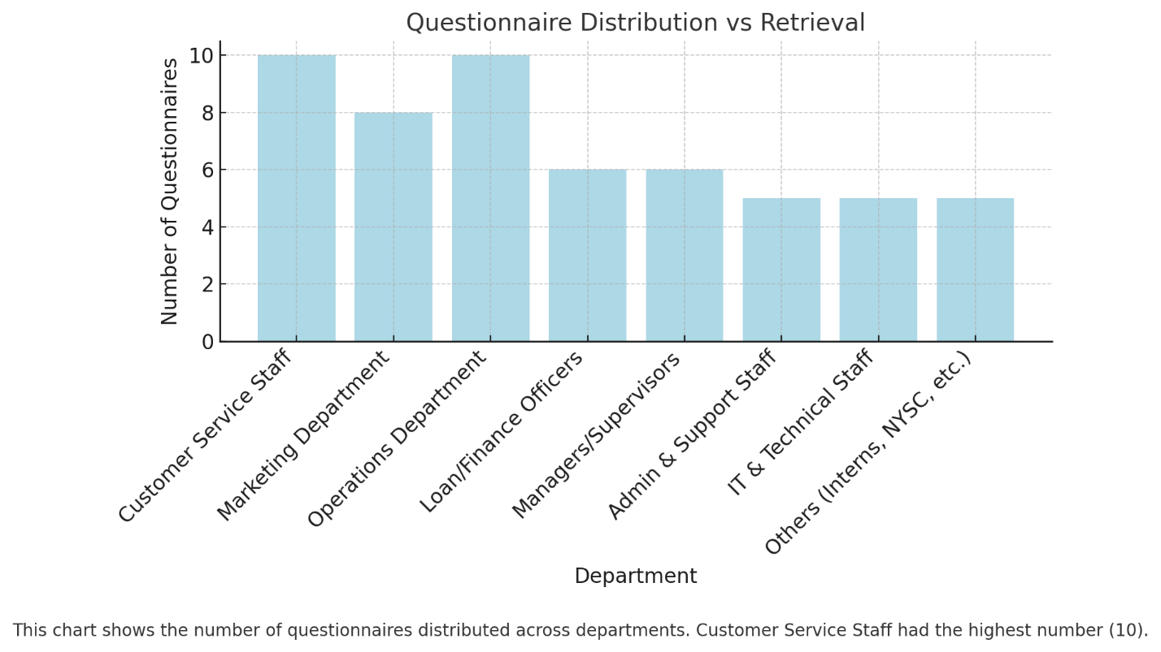
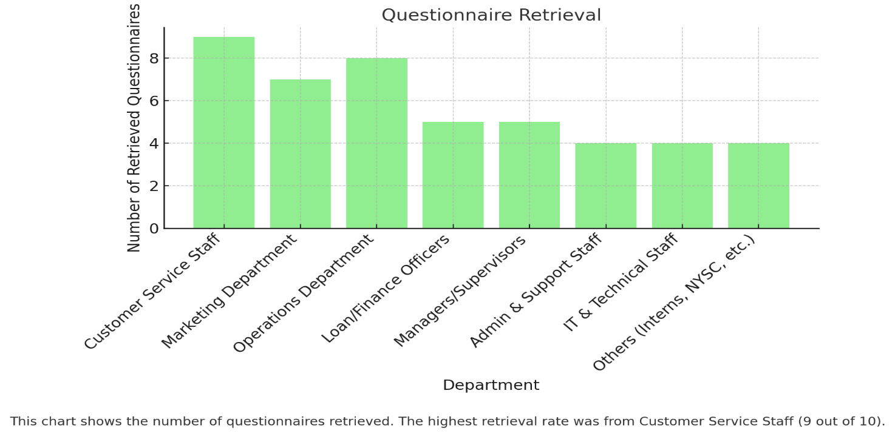
Interpretation
Out of 55 questionnaires distributed, 46 were retrieved, representing an 83.6% response rate. This response rate is statistically acceptable and indicates a strong level of participation from the Access Bank staff. The highest retrieval rate came from Customer Service Staff (90%), while the lowest was from several groups tied at 80%.

4.3 Demographic Data of Respondents
This section presents the demographic data including gender, age, education level, job position, and years of experience.
Table 4.2: Gender Distribution
Gender | Frequency | Percentage
Male | 25 | 54.3%
Female | 21 | 45.7%
Total | 46 | 100%

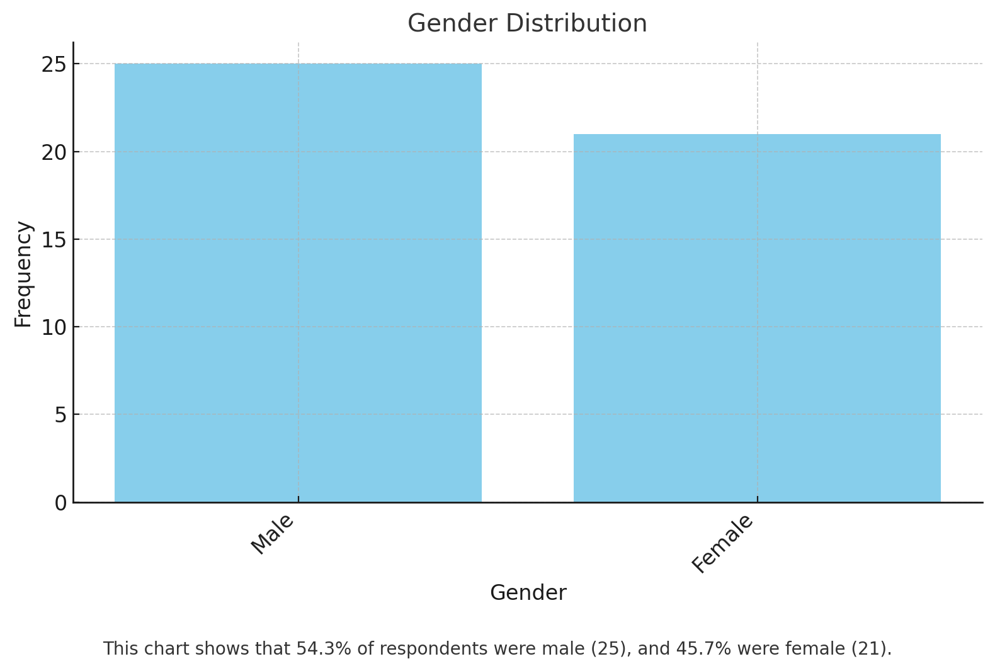Table 4.3: Age Distribution
Age Bracket | Frequency | Percentage
18–25 | 8 | 17.4%
26–35 | 20 | 43.5%
36–45 | 12 | 26.1%
Above 45 | 6 | 13.0%
Total | 46 | 100%

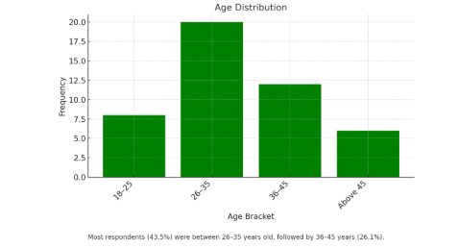

Table 4.4: Educational Qualification
Qualification | Frequency | Percentage
OND/NCE | 5 | 10.9%
HND/B.Sc | 30 | 65.2%
M.Sc and above | 11 | 23.9%
Total | 46 | 100%

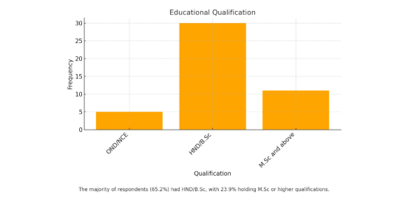

Table 4.5: Years of Experience
Years | Frequency | Percentage
Less than 1 year | 3 | 6.5%
1–5 years | 18 | 39.1%
6–10 years | 15 | 32.6%
Above 10 years | 10 | 21.7%
Total | 46 | 100%

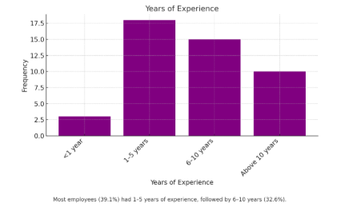

4.4 Analysis of Research Questions
The analysis of responses related to each dimension of emotional intelligence is shown below. Each item was rated using a 5-point Likert scale (Strongly Agree to Strongly Disagree).
Table 4.6: Self-Awareness and Employee Performance
Item Statement | SA | A | N | D | SD | Total Respondents
I am aware of my emotions at work. | 25 | 15 | 3 | 2 | 1 | 46
My emotions affect how I perform. | 22 | 18 | 4 | 1 | 1 | 46

Interpretation: The majority of respondents agreed that emotional self-awareness positively influences their performance.

Table 4.7: Self-Regulation and Job Efficiency
Item Statement | SA | A | N | D | SD | Total
I stay calm under pressure at work. | 20 | 19 | 3 | 2 | 2 | 46
I avoid impulsive decisions during stress. | 18 | 20 | 4 | 2 | 2 | 46

Interpretation: High levels of self-regulation correlate with improved work performance and decision-making under stress.
Table 4.8: Empathy and Team Collaboration
Item Statement | SA | A | N | D | SD | Total
I understand my coworkers' emotions. | 23 | 16 | 4 | 2 | 1 | 46
I can manage conflict by understanding others. | 20 | 19 | 5 | 1 | 1 | 46

4.5 Test of Hypotheses
To test the relationship between emotional intelligence and employee performance, Pearson correlation was employed using SPSS:
Hypothesis 1:
H0: There is no significant relationship between emotional intelligence and employee performance.
- Correlation coefficient (r) = 0.742
- p-value = 0.000 (p < 0.05)
Interpretation: Since the p-value is less than 0.05, we reject the null hypothesis and conclude that there is a statistically significant positive relationship between emotional intelligence and employee performance at Access Bank, Ilorin.
Summary of Findings
- Most employees demonstrated high emotional intelligence in terms of self-awareness, self-regulation, empathy, and motivation.
- Emotional intelligence strongly correlates with better teamwork, communication, decision-making, and productivity.
- Departments with higher emotional intelligence scores showed better interpersonal relationships and goal achievement.

CHAPTER FIVE
SUMMARY, CONCLUSION AND RECOMMENDATIONS
5.1 Summary of the Study
This study investigated the role of emotional intelligence (EI) in enhancing employee performance in the Nigerian banking sector, focusing on Access Bank, Ilorin branch. It aimed to understand whether employees' ability to recognize, understand, and manage emotions had a significant effect on their workplace performance, decision-making, conflict resolution, and overall productivity.
A structured questionnaire was developed based on Goleman’s emotional intelligence framework, which includes self-awareness, self-regulation, motivation, empathy, and social skills. Fifty-five questionnaires were distributed, with forty-six successfully retrieved, representing an 83.6% response rate. Data collected were analyzed using descriptive statistics and correlation analysis through SPSS.
Findings revealed that emotional intelligence significantly correlates with job performance. Employees with higher EI demonstrated better teamwork, adaptability, leadership, and job satisfaction. Among the key components, self-awareness and empathy were the most influential predictors of strong performance.
5.2 Conclusion
This research concluded that emotional intelligence is a critical determinant of employee performance in the Nigerian banking sector. Access Bank Ilorin, like many modern organizations, operates in a dynamic and high-pressure environment, where emotional management is essential to maintain client relationships, internal cohesion, and service delivery.
Key conclusions drawn from the study include:
- Employees with high emotional intelligence are more productive, collaborative, and adaptable.
- Emotional self-awareness and empathy particularly influence teamwork and conflict management.
- Emotional intelligence training can be a strategic tool for improving performance, employee engagement, and customer satisfaction.
- Gender, age, and education level do not significantly limit one's capacity to develop emotional intelligence.
The research further highlights the need for Access Bank and other institutions to integrate emotional intelligence into recruitment, training, and leadership development processes.
5.3 Recommendations
Based on the findings and conclusions of this study, the following recommendations are made:
- Integrate Emotional Intelligence in Training Programs
Access Bank should implement regular workshops and training sessions to help employees understand and develop emotional intelligence competencies.
- Recruitment and Promotion Criteria
Emotional intelligence should be considered in recruitment and promotion processes alongside technical skills to ensure a well-rounded workforce.
- Periodic Assessment of EI Skills
Regular employee assessments should be carried out to evaluate the development of emotional intelligence, especially for employees in leadership roles.
- Leadership Development Focused on EI
Managers and supervisors should undergo specialized training in emotional intelligence to better lead teams and resolve conflicts.
- Encourage a Supportive Work Environment
The organization should foster a culture of emotional openness, active listening, and psychological safety to promote collaboration and empathy.
- Develop EI-Based Performance Metrics
Human Resource departments can include EI-related indicators in performance appraisals to motivate employees to improve their interpersonal skills.
- FurtherResearch
Additional studies should be conducted across other branches or banks to compare results and establish broader generalizations.
5.4 Suggestions for Further Studies
- Future research could extend to other financial institutions to compare findings and identify industry-wide patterns.
- Studies could explore the long-term effects of emotional intelligence training on employee retention and organizational productivity.
- Further research could examine the moderating roles of gender, personality types, and organizational culture in the EI–performance relationship.
5.5 Contributions to Knowledge
This study contributes to the growing body of literature on emotional intelligence in African and Nigerian organizational contexts by:
- Demonstrating the empirical relationship between emotional intelligence and performance in a real-world banking environment.
- Offering practical frameworks for human resource development in Nigerian banks.
- Providing evidence that supports integrating emotional intelligence into organizational policies and culture.

References
- Akintayo, D. I., & Babalola, S. S. (2019). Emotional intelligence and employee output in Nigerian commercial banks. African Journal of Management Studies, 7(2), 112–125.
- Balogun, T., & Olamide, J. (2023). A Meta-Analysis of Emotional Intelligence and Employee Performance in Nigeria. International Journal of Organizational Psychology, 5(1), 33–50.
- Goleman, D. (1998). Working with Emotional Intelligence. New York: Bantam Books.
- Ibidunni, S. A., Osibanjo, A. O., & Adeniji, A. A. (2022). Emotional intelligence and leadership in Nigerian service industries. Journal of Business and Social Review, 10(4), 87–95.
- Mayer, J. D., Caruso, D. R., & Salovey, P. (2016). The ability model of emotional intelligence: Principles and updates. Emotion Review, 8(4), 290–300.
- Okolie, C. U., & Alabi, A. O. (2021). Emotional labor, stress, and coping in Nigerian banking sector. Journal of Applied Psychology in Africa, 9(3), 52–66.
- Onuoha, G. N., & Segun, A. (2018). Emotional intelligence and job performance in the Nigerian financial sector. Journal of Human Resource Development, 6(2), 73–85.
- Salami, S. O. (2016). Emotional intelligence and psychological wellbeing of Nigerian bank workers. International Journal of Occupational Studies, 4(1), 44–59.
- Ugoani, J. N. N., & Amu, C. U. (2017). Emotional intelligence and organizational performance in Nigeria. Independent Journal of Management & Production, 8(3), 879–900.
- Yusuf, M., & Abiola, B. O. (2020). Emotional intelligence and service retention in Nigerian commercial banks. West African Journal of Management, 6(1), 101–117.

