

EFFECTS OF Syzygium aromaticum (CLOVES) AQUEOUS EXTRACT ON PAROXETINE -INDUCED DYSFUNCTIONAL RATS
By:

ADENIRAN OYINDAMOLA ERITOSIN

HND/23/SLT/FT/0895

SUBMITTED TO THE DEPARTMENT OF SCIENCE LABORATORY TECHNOLOGY
(BIOCHEMISTRY UNIT)
INSTITUTE OF APPLIED SCIENCES (IAS), KWARA STATE POLYTECHNIC, ILORIN, KWARA STATE, NIGERIA.
IN PARTIAL FULFILLMENT OF THE REQUIREMENTS FOR THE AWARD OF
HIGHER NATIONAL DIPLOMA (HND)
IN SCIENCE LABORATORY TECHNOLOGY
SUPERVISED BY
MR. ALLI, A. O.
JULY, 2025.
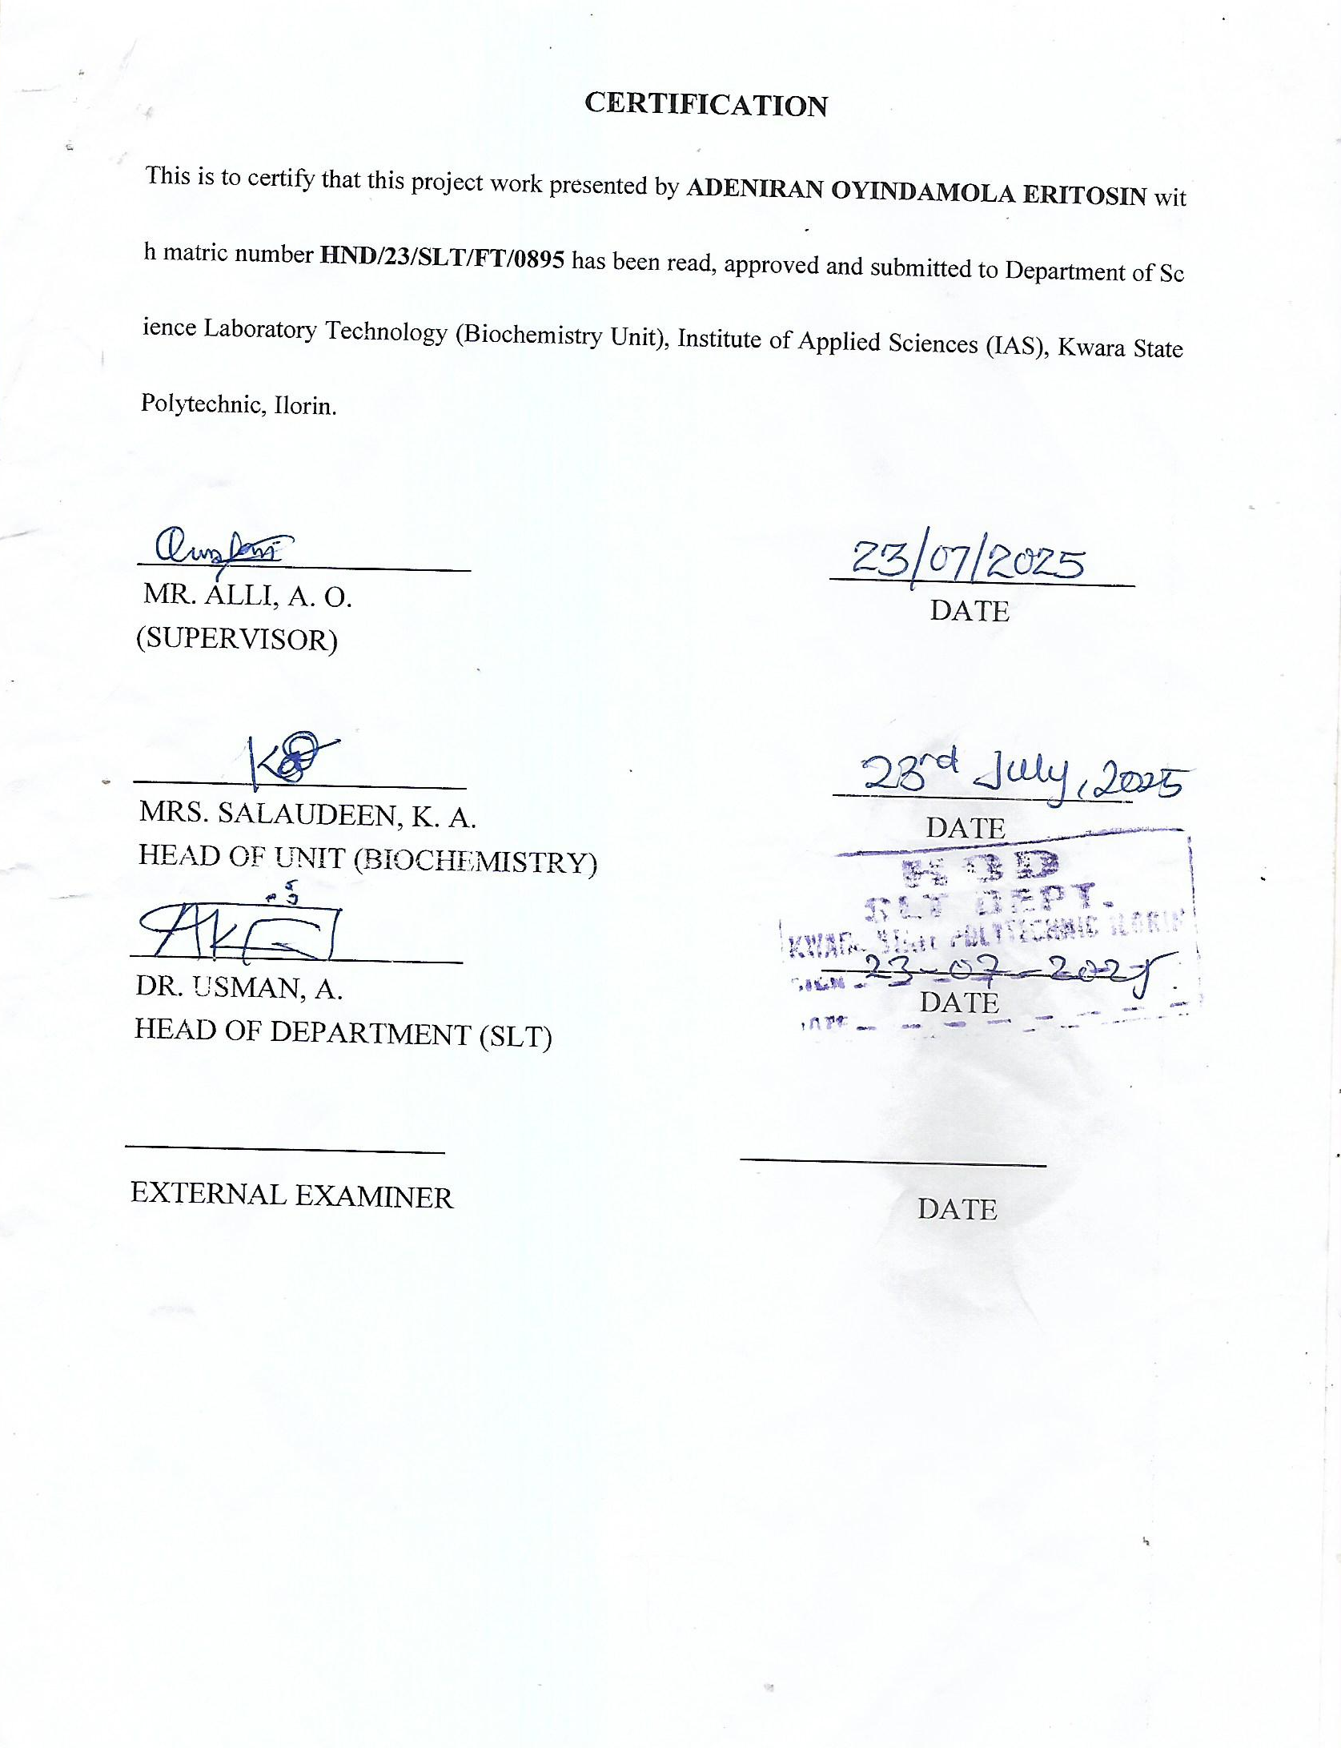

DEDICATION
I Dedicate this project to God Almighty, and to my parent and siblings who has helped me so far, the source of my strength, my sustainer and my provider, the author and the finisher of my faith.

ACKNOWLEDGEMENT
My deepest gratitude to almighty God for his overwhelming love over me throughout my stay in school and my research completion
This Project would not have been possible without God sent supervisor, Mr Alli, A.O God bless you sir.
l want to appreciate my HOD in person of Dr Usman, A. for his advice and encouragement.
Also,my gratitude also goes to my HOU in person of Mrs Salaudeen K.A.
My appreciation goes to my Parents Mr and late (Mrs) Adeniran, My Grandparents Chief Aduloju, Mrs. Ogunware D.A and Mrs. Popoola A.J who has effortlessly been a support to me, May God continue to bless you abundantly all days of your life. I will also love to convey my heartfelt gratitude to Honourable Fajolu A.O who has always been supportive financially and emotionally, I pray may God answer all your heart desires.
I will not cease to acknowledge and extend my gratitude to my aunt Mrs Ogidan Olufunke, My Step Mum Adeniran Adenike, My Best Friend Ajayi Micheal, and my Guardian Mr Paul Oshaji and everyone who took part of this journey for their respective immense support all through the year. It is to them this dissertation is dedicated.
Last but by no means the least, to my Siblings Miss Adeniran M.O, Olaolu, Richard, Tosin, Pemisire and Victor for their on-the-spot support all through the years of my academic pursuit. God bless you all tremendously.

ABSTRACT
Erectile dysfunction (ED) is a prevalent side effect associated with long-term use of selective serotonin re-uptake inhibitors (SSRIs) such as paroxetine, mainly due to the disruption of nitric oxide (NO) signaling and upregulation of phosphodiesterase-5 (PDE5) and arginase activities. Due to the limitations of current erectile dysfunction treatments, this study investigated the effects of Syzygium aromaticum aqueous extract on paroxetine-induced erectile dysfunction in male Wistar rats as a safer, plant-based alternative. Twenty-five rats were randomly divided into five groups: normal control, paroxetine-induced untreated, paroxetine plus sildenafil (50 mg/kg), paroxetine plus Syzygium aromaticum aqueous extract at 200 mg/kg, and 400 mg/kg. Paroxetine administration (10 mg/kg orally for 21 days) significantly (p < 0.05) increased PDE5 activity (42.7 ± 2.8 U/L vs. 28.5 ± 2.1 U/L in control), arginase activity (8.4 ± 0.7 mg/dL vs. 6.2 ± 0.5 mg/dL), and reduced penile nitric oxide concentration (24.8 ± 2.6 µmol/L vs. 45.6 ± 3.4 µmol/L), indicating impaired erectile function. Treatment with 400 mg/kg Syzygium aromaticum extract significantly (p < 0.05) reduced PDE5 and arginase activities and, respectively, while increasing nitric oxide concentration compared to the paroxetine-only group. Additionally, paroxetine elevated total cholesterol (5.86 ± 0.27 mmol/L), triglycerides (2.83 ± 0.16 mmol/L), and LDL cholesterol (2.62 ± 0.14 mmol/L), while decreasing HDL cholesterol (0.89 ± 0.08 mmol/L). Syzygium aromaticum extract at 400 mg/kg normalized these values close to control levels, with total cholesterol at 3.78 ± 0.21 mmol/L, triglycerides at 1.44 ± 0.11 mmol/L, LDL at 1.36 ± 0.12 mmol/L, and HDL at 1.62 ± 0.10 mmol/L. These findings highlight Syzygium aromaticum as a promising natural therapeutic agent capable of mitigating paroxetine-induced erectile dysfunction through modulation of PDE5 and arginase activities, enhancement of NO bioavailability, and lipid profile improvement.

LIST OF FIGURES
Figures Title Page
Figure 2.1 Pathophysiology of Erectile Dysfunction 10
Figure 2.4 Treatment of Erectile Dysfunction 17
Figure 4.1 Penile Organ-Body Ratios of Paroxetine-Induced 29
Dysfunctional Rats Administered Syzygium
aromatic Extract (SAAE)
Figure 4.2 Nitric Oxide Levels of Paroxetine-Induced Dysfunctional 30
Rats Administered Syzygium aromatic Extract (SAAE)
Figure 4.3 The phosphodiesterase Activity of Paroxetine-Induced 31
Dysfunctional Rats Administered Syzygium aromatic Extract (SAAE)
Figure 4.4 The Arginase Activity of Paroxetine-Induced 31
Dysfunctional Rats Administered Syzygium aromatic Extract (SAAE)

Figure 4.5 Creatinine Kinase Activity of Paroxetine-Induced 32
Dysfunctional Rats Administered Syzygium aromatic Extract (SAAE)

LIST OF TABLES
Table Title Page
Table 4.1 Phytochemical Screening of Syzygium aromaticum Aqueous Extract 28
Table 4.2 Serum Lipid Profile of Paroxetine-Induced Dysfunctional Rats 33
Administered Syzygium aromatic Extract

TABLE OF CONTENT

CERTIFICATION Error! Bookmark not defined.
DEDICATION Error! Bookmark not defined.
ACKNOWLEDGEMENT Error! Bookmark not defined.
ABSTRACT V
LIST OF FIGURES VII
LIST OF TABLES VIII
TABLE OF CONTENT IX
CHAPTER ONE 12
1.0 INTRODUCTION 12
1.1 Background of the Study 12
1.2 Justification for the Study 13
1.3 Problem Statement 14
1.4 Significance of the Study 15
1.5 Objectives of the Study 16
CHAPTER TWO 17
2.0 LITERATURE REVIEW 17
2.1 Erectile Dysfunction 17
2.2 Epidemiology of Erectile Dysfunction 18
2.3 Pathophysiology of Erectile Dysfunction 20
2.3.1 Phosphodiesterase 5 22
2.3.2 Arginase 24
2.3.3 Nitric oxide 25
2.3.4 Creatinine Kinase 27
2.4 Treatment of Erectile Dysfunction 28
2.4.1 Limitations of Current Erectile Dysfunction Treatment 30
2.5 Syzygium aromaticum 31
2.5.1 Bioactive Components of Syzygium aromaticum 33
CHAPTER THREE 35
3.0 MATERIALS AND METHODS 35
3.1 Materials 35
3.1.1 Plant Materials 35
3.1.2 Experimental Animal 35
3.1.3 Reagents and Kits 35
3.2 Methods 35
3.2.1 Preparation of Clove Extract 35
3.2.2 Experimental Design 36
3.2.3 Induction of Erectile Dysfunction 36
3.2.4 Determination of Body-Organ Weight Ratio 36
3.2.5 Determination of Phosphodiesterase 5 Activity 37
3.2.6 Determination of Penile Nitric Oxide Concentrations 37
3.2.7 Arginase Activity 37
3.2.8 Creatine Kinase (CK) Activity Assay 38
3.2.9 Lipid Profile 38
3.2.9.1 Serum Total Cholesterol Concentration 38
3.2.9.2 Triglycerides concentration 39
3.2.9.3 Serum High Density Lipoprotein-Cholesterol Concentration 39
3.2.9.4 Serum Low Density Lipoprotein-Cholesterol Concentration 40
3.2.9.5 Atherogenic Index Error! Bookmark not defined.
3.2.10 Statistical Analysis 40
CHAPTER FOUR 41
4.0 RESULTS 41
4.1 Percentage Yield of the Extract 41
4.2 Phytochemical Screening of Syzygium aromaticum Aqueous Extract 41
4.3 Penile Organ-Body Ratios 42
4.4 Nitric Oxide Concentration 43
4.5 In vivo Enzyme Assays 43
4.5.1 Phosphodiesterase 5 43
4.5.2 Arginase 44
4.5.3 Creatinine Kinase 45
4.6 Serum Lipid Profile 46
CHAPTER FIVE 48
5.0 DISCUSSION, CONCLUSION AND RECOMMENDATION 48
5.1 Discussion 48
5.2 Conclusion 50
5.3 Recommendation 51
REFERENCES 52

CHAPTER ONE

1.0 INTRODUCTION

Background of the Study
Erectile dysfunction (ED) is a common male sexual disease, and the definition of chronic failure to achieve or maintain an erection sufficient for healthy sexual life Abdel-Kader et al., 2021). Vascular status and aging remain dominant physiological etiologies, but increasing evidence points toward pharmacological etiologies, particularly antidepressants like paroxetine, as significant etiologies. Paroxetine, an SSRI, is usually used to cure depression and anxiety but has been associated with adverse sexual side effects such as low libido, delayed ejaculation, and impaired erectile function (Odetayo & Olayaki, 2023). These are mostly due to the blocking of serotonergic and dopaminergic, and nitric oxide, mechanisms that play significant roles in sexual arousal and penile erection (Besong et al., 2023; Odetayo & Olayaki, 2023).
As a result of these limitations, less side-effect-prone natural products are in greater demand. Among such plants is Syzygium aromaticum (clove), a plant with a long history of use in traditional medicine among various cultures for its medicinal, as well as aphrodisiac properties. Recent pharmacological studies have shown that S. aromaticum contains bioactive compounds such as eugenol and flavonoids with antioxidant, androgenic, and nitric oxide-stimulating activities (Adedayo et al., 2021). These mechanisms were believed to support sexual function by maintaining testicular tissues, increasing testosterone levels, and increasing penile tissue vasodilation (Ajiboye et al., 2018; Abdel-Kader et al., 2021).
Though aphrodisiac activity of S. aromaticum has been demonstrated in intact animal models, very few scientific interests have been focused on its effectiveness against drug-induced sexual dysfunction, including paroxetine-induced sexual dysfunction. Other studies have indicated that antioxidants from medicinal plants can reverse the oxidative stress and hormonal imbalance caused by SSRIs and restore normal sexual behavior in rats (Adedayo et al., 2021; Kpomah et al., 2024). It is a strong rationale for investigating the aqueous extract of S. aromaticum in the therapy of paroxetine-induced erectile dysfunction. Such research is important to its validation as a therapeutic agent and to the development of alternative interventions, particularly where access to mainstream pharmacological interventions is limited.

1.2 Justification for the Study
Sexual dysfunction is a prevalent side effect of selective serotonin re-uptake inhibitors (SSRIs), particularly paroxetine, that adversely affects sexual desire, erection, and ejaculation (Odetayo & Olayaki, 2023). While one of the most effective medications for depression and anxiety disorders, long-term treatment has been linked with heavy impairment of male sexual function by disruption of hormonal control and nitric oxide-dependent vasodilation processes (Besong et al., 2023; Odetayo & Olayaki, 2023). These effects not only decrease the quality of life but also threaten medication compliance in patients taking SSRIs. Pharmacologic treatments for erectile dysfunction, such as phosphodiesterase type 5 inhibitors, have no effect in all and may be cardiotoxic in certain populations (Odetayo & Olayaki, 2023). It has prompted the search for other safe, accessible, and affordable therapies.
Medicinal herbs have been used traditionally to enhance sexual function from ancient times in many systems of traditional medicine. Syzygium aromaticum (clove) is among them, which is known for its widespread availability and traditional use as an aphrodisiac. Its bioactive constituents such as eugenol, flavonoids, and sterols have been documented with antioxidant, anti-inflammatory, and androgenic activities that have the potential to be beneficial in the rehabilitation of sexual performance (Ajiboye et al., 2018; Abdel-Kader et al., 2021). However, despite numerous investigations that have described S. aromaticum's pro-sexual activity in healthy rodents, evidence of its action in models of pharmacologically induced sexual dysfunction, and in models specifically representing clinical conditions such as SSRI-induced sexual dysfunction, is extremely meager.

1.3 Problem Statement
Sexual dysfunction, particularly erectile dysfunction (ED), is an upsetting and troubling side effect seen in patients under treatment with selective serotonin re-uptake inhibitors (SSRIs) such as paroxetine. Paroxetine, useful in treating various psychological disorders, has been consistently reported to suppress sexual desire, decrease testosterone levels, delay ejaculation, and interfere with erection by suppressing dopaminergic and nitric oxide signaling pathways (Besong et al., 2023; Odetayo & Olayaki, 2023). This poses a double clinical challenge: while the underlying psychiatric disorder is alleviated, the consequent sexual dysfunction can cause negative impact on the patient's quality of life, marital relationship, and adherence to treatment.
Although drug therapies such as sildenafil are a possibility, they are not always effective for sexual dysfunction caused by SSRI and may have contraindications in certain groups of patients. Moreover, these man-made drugs are not always accessible or affordable in resource-poor environments. Thus, interest is growing in the treatment of sexual dysfunction using natural products, e.g., medicinal plants, with fewer side effects and lower cost. Syzygium aromaticum (clove) has been classically used as an aphrodisiac and is also known to possess antioxidant, anti-inflammatory, and androgen-stimulating activity (Ajiboye et al., 2018; Abdel-Kader et al., 2021). However, the majority of studies that have been performed to date have focused on its effect in normal animals or on non-specific models of sexual disorder, without first-hand analysis of its effectiveness against SSRI-induced sexual disorder.
The absence of scientific evidence on the putative therapeutic action of S. aromaticum against paroxetine-induced erectile dysfunction is a critical knowledge gap. In the absence of targeted research, its clinical usefulness in controlling antidepressant-induced sexual side effects can only be speculative. Thus, there is a need to examine the possibility of using aqueous extract of S. aromaticum is able to reverse the sexual impairments induced by paroxetine and identify the mechanisms underlying. The current research will provide valuable evidence to enable the safe and effective administration of S. aromaticum as a substitute or adjunct treatment for SSRI-induced erectile dysfunction.

1.4 Significance of the Study
The present study involves a significant interface between male reproductive health and mental health drug therapy. While SSRIs such as paroxetine are crucial for depression and anxiety management, they often cause sexual side effects such as ED, reduced libido, and delayed ejaculation (Besong et al., 2023; Odetayo & Olayaki, 2023). These adverse effects can exert a significant detrimental effect on quality of life, discourage treatment compliance, and increase emotional distress, especially in male patients of reproductive age.
The significance of this study is that it examines Syzygium aromaticum, a prevalent medicinal herb with traditional aphrodisiac and healing claims. Previous studies suggest that S. aromaticum contains pharmacologically active compounds such as eugenol and flavonoids with antioxidant, androgenic, and nitric oxide-enhancing activities (Ajiboye et al., 2018; Abdel-Kader et al., 2021). Such effects can be directly directed against the oxidative stress and hormonal imbalance caused by paroxetine, reversing or slowing drug-induced sexual dysfunction.
By studying the aqueous extract of S. aromaticum within a paroxetine-induced rat model, this study provides evidence for its possible therapeutic application based on science. This discovery is particularly beneficial for the people in low-resource communities, where conventional ED treatments are normally unattainable because of exorbitant cost or contraindications. In addition, the study may be used as a basis for developing safer and cheaper phytotherapeutic treatments to manage SSRI-induced sexual dysfunction.

1.5 Objectives of the Study

The overall aim of this study was to evaluate the therapeutic effects of aqueous extract of Syzygium aromaticum on erectile dysfunction induced by paroxetine in male Wistar rats. The specific objectives of the study were to:
- prepare aqueous extract of S. aromaticum;
- induce erectile dysfunction in Wistar rats using paroxetine administration;
- administer the induced rats with S. aromaticum extract;
- assess the penile organ-body ratio, and enzymatic biomarkers of erectile dysfunction (PDE 5 and Arginase) in the penile organs of experimental rats;
- examine the penile nitric oxide and protein levels of the experimental rats;
- investigate creatinine kinase activity in serum of the animals;
- carryout lipid profile assessment on serum of the experimental rats.

CHAPTER TWO

2.0 LITERATURE REVIEW

2.1 Erectile Dysfunction
Erectile dysfunction (ED) is the repeated or persistent inability to attain or maintain a penile erection sufficient for satisfactory sexual performance (Kaltsas et al., 2024; Feng et al., 2025). It is a prevalent disorder that has been found to afflict an estimated 150 million men worldwide and is projected to affect over 300 million men by 2025. While its incidence increases with age, ED can also be observed among the young population due to multifactorial etiologies, which include vascular diseases, endocrine diseases, neurological diseases, psychiatric diseases, and the use of certain pharmacological medications (Kaltsas et al., 2024; Saikia et al., 2024).
The penile erection physiology is a complex process involving neural, vascular, and endocrine interaction. Nitric oxide (NO) is a key mediator that induces relaxation of corpus cavernosum smooth muscle through stimulation of the guanylate cyclase-cGMP pathway, thus enabling flow of blood into the penile tissue (Mobley et al., 2017; Elekofehinti et al., 2024). Testosterone also plays an important role via its capacity to enhance libido, preserve erectile tissue health, and regulate the expression of nitric oxide synthase (NOS), which is essential for NO synthesis (Kaltsas et al., 2024; Ademosun et al., 2019).
Oxidative stress is also strongly implicated in the pathophysiology of ED. Elevated reactive oxygen species (ROS) such as superoxide anions reduce the bioavailability of NO by forming peroxynitrite, thus inhibiting vasodilation and leading to endothelial dysfunction. Chronic oxidative damage also impairs penile architecture, promotes fibrosis, and reduces sensitivity to endogenous vasodilators (Ademosun et al., 2019; Kassan et al., 2013). This emphasizes the role of antioxidant defense mechanisms, such as superoxide dismutase (SOD) and glutathione peroxidase, in maintaining normal erectile function (Kaltsas et al., 2024).
Pharmacological therapies, particularly selective serotonin reuptake inhibitors (SSRIs) like paroxetine, can also induce erectile dysfunction. Paroxetine is used for depression and anxiety disorders but is strongly associated with undesirable sexual effects, including delayed ejaculation, anorgasmia, and decreased erectile function. These actions are mainly the result of increased serotonergic activity that suppresses dopaminergic and NO-mediated pathways, in addition to reductions in testosterone levels (Muritala & Bewaji, 2021; Stefan et al., 2020). Experiments using animal models have shown that paroxetine decreases testicular weight, serum testosterone, and penile NO levels, testifying to its negative action on sexual function (Ademosun et al., 2019; Elekofehinti et al., 2024).
Because of the limitations of conventional therapies and their potential contraindications in patients with cardiovascular or psychiatric comorbidities, recent research has leaned towards the exploration of herbal remedies. These natural alternatives are often gifted with antioxidant, androgenic, and NO-modulatory properties, offering a multimodal approach to the management of ED. Medicinal plants such as Carpolobia lutea and Syzygium aromaticum have also demonstrated promising results in experimental models via testosterone level enhancement, NO synthesis, and reversal of SSRI-induced dysfunction (Elekofehinti et al., 2024; Saikia et al., 2024).

2.2 Epidemiology of Erectile Dysfunction
Erectile dysfunction (ED) is a universal disorder among men across all adult age groups, with risk increasing very rapidly with increasing age and with chronic comorbidity. Recent meta-analysis of over 20 countries has recently reported the universal prevalence of ED as between 20% and over 50%, depending on population being studied and diagnostic criteria used (Goldstein et al., 2020). Prevalence rises from approximately 10% for men below the age of 40 years to more than 60% among men above 70 years (Dilixiati et al., 2024). This is associated not only with age but also with the cumulative vascular, endocrine, and neurological deficits.
Age is consistently identified as the most significant non-modifiable risk factor for ED. The Massachusetts Male Aging Study and subsequent global replications have shown a strong age gradient in ED incidence. For example, Svennersten and Reus (2024) reported that more than half of men over 60 exhibit moderate-to-severe forms of ED. Similarly, Dutch general population estimates reflect an annual incidence of 2.3 per 1,000 in men aged 40-49, rising to over 50 per 1,000 in men ≥70 years (Gebeyehu et al., 2023). This has implications for the cumulative effect of aging on endothelial function and hormonal control, both important predictors of erectile capability.
Comorbidities such as diabetes mellitus, hypertension, cardiovascular disease, obesity, and chronic kidney disease also increase ED risk and severity. A Saudi Arabian cross-sectional study found diabetic men had 72% higher prevalence of ED compared to their non-diabetic counterparts (Al-Qahtani et al., 2025). In the same vein, a systematic review undertaken by Ziapour et al. (2024) emphasized the observation that ED is more prevalent in cardiovascular risk factor-positive men, particularly those with reduced ejection fraction or systemic endothelial dysfunction. The relationship between ED and these chronic conditions is bidirectional, with ED serving as an early predictor of systemic vascular pathology.
Socioeconomic and psychological determinants are also crucial in ED epidemiology. Psychosocial distress, depression, low educational levels, and restricted healthcare access are associated with higher rates of undiagnosed and untreated ED, particularly in low- and middle-income countries. A recent Tanzanian population-based survey found the prevalence of ED was 28.1%, with higher prevalence in men with low income and not being engaged in regular physical activity (Leyaro et al., 2020). Besides, sexual dysfunction is stigmatized and hence underreported, limiting accuracy in data in the majority of regions.
Future trends suggest that ED prevalence will continue to rise as the world witnesses an increase in lifestyle disorders and aging populations. Public health interventions, thus, must target early diagnosis, management of comorbidities, and sensitization programs to desensitize the sexual health discourse.

2.3 Pathophysiology of Erectile Dysfunction
Erectile dysfunction (ED) is actually a penile hemodynamic, neural integrative, and hormonal disorder. At the core of the erectile process is relaxation of corpus cavernosum smooth muscle that is NO-mediated, activating guanylate cyclase to increase cyclic guanosine monophosphate (cGMP), leading to vasodilation and penile engorgement (Zhu et al., 2025). Disruption of any aspect of this signaling cascade, endothelial, neurogenic, or hormonal, can impair erectile response. Endothelium integrity is essential since it is one of the main sources of NO (Figure 2.1). Endothelial dysfunction, which results primarily from systemic disease or oxidative stress, is thus central to the development of ED (Salvio et al., 2021).
Oxidative stress is a key factor in ED pathogenesis by inducing the build-up of reactive oxygen species (ROS) that consume NO, cause vasoconstriction, inflammation, and tissue remodeling. This oxidation imbalance is common in diabetic, obese, and hypertensive conditions and leads to endothelial injury, increased vascular tone, and disturbed cavernosal blood flow (Rastrelli et al., 2025).
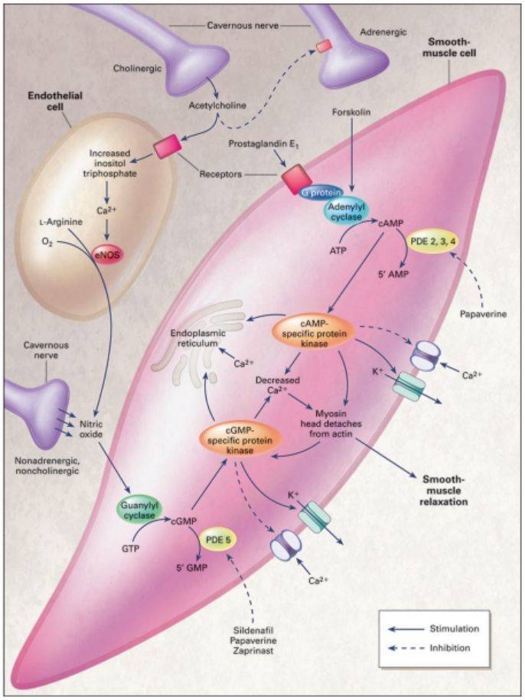
Figure 2.1: Pathophysiology of Erectile Dysfunction
Source: Roushias & Ossei-Gerning (2018)
Chronic exposure to ROS also induces accumulation of collagen in corpus cavernosum, causing fibrosis and penile tissue loss of elasticity (Ziapour et al., 2024). Malondialdehyde and decreased superoxide dismutase activity have been reported as biomarkers for oxidative damage in ED (Alrumaihi et al., 2024).
Testosterone plays a critical role in erectile function. It affects libido, penile tissue structure, and NOS enzyme expression. Androgen deficiency has been associated with impaired NO bioavailability and dysfunctional penile vasodilation. Low levels of testosterone are also the cause of increased oxidative stress and lowered PDE5 inhibitor sensitivity (Woo et al., 2021). Clinical evidence reports that testosterone replacement is capable of recovering erectile function in hypogonadal men through enhanced NOS function and vascular reactivity (Saikia et al., 2024).
Pharmacologically-induced ED, especially from selective serotonin reuptake inhibitors (SSRIs) like paroxetine, is more and more a clinical concern. SSRIs also alter central serotonergic mechanisms that damage sexual desire and orgasmic function. Additionally, they suppress dopaminergic and NO signaling in erectile tissue. Paroxetine downregulates testosterone production and suppresses NOS activity in penile tissue to induce ED (Alrumaihi et al., 2024; Xie et al., 2025).

2.3.1 Phosphodiesterase 5
Phosphodiesterase type 5 (PDE5) plays a central role in the regulation of penile erection by controlling intracellular levels of cyclic guanosine monophosphate (cGMP), a key second messenger involved in smooth muscle relaxation. During sexual stimulation, nitric oxide (NO) is released from nonadrenergic noncholinergic neurons and endothelial cells in the corpora cavernosa. NO activates soluble guanylyl cyclase, leading to the conversion of guanosine triphosphate (GTP) into cGMP, which then induces relaxation of the cavernosal smooth muscles and facilitates blood engorgement in the penis (Kaltsas et al., 2025; Saikia et al., 2022).
PDE5, a cGMP-specific enzyme, hydrolyzes cGMP into its inactive form 5’-GMP, thereby terminating the vasodilatory signal. Overexpression or heightened activity of PDE5 reduces cGMP bioavailability, resulting in sustained cavernosal contraction and difficulty maintaining an erection (Zachariou et al., 2025). The pharmacological inhibition of PDE5 maintains elevated cGMP levels in penile tissue, promoting prolonged smooth muscle relaxation and improved erectile function. This mechanism underlies the clinical utility of PDE5 inhibitors, such as sildenafil, tadalafil, and vardenafil, which have revolutionized the treatment of erectile dysfunction (Nik-Ahd & Shindel, 2022).
Beyond erectile tissue, PDE5 is expressed in other vascular beds, and its dysregulation has been implicated in systemic vascular diseases, including pulmonary hypertension and diabetic vasculopathies. These associations emphasize the broader physiological significance of the NO–cGMP–PDE5 axis (Campolo et al., 2020). Moreover, recent findings suggest that certain pathological conditions such as diabetes and endothelial dysfunction upregulate PDE5 expression, potentially contributing to treatment resistance among ED patients (Crescioli & Paronetto, 2024).
Emerging research also points to the therapeutic versatility of PDE5 inhibitors beyond urology. Their antioxidative, anti-inflammatory, and proangiogenic effects have shown potential in the management of benign prostatic hyperplasia, cardiovascular diseases, and even certain neurodegenerative conditions (Kaltsas et al., 2025; Zachariou et al., 2025). However, long-term safety, drug interactions, and individual variations in response remain areas requiring continued investigation.
In the context of paroxetine-induced erectile dysfunction, PDE5 inhibition may offer a potential strategy to counter the SSRI-induced suppression of NO signaling. Since SSRIs like paroxetine downregulate NOS activity and testosterone levels, which in turn lowers cGMP synthesis, restoring cGMP via PDE5 blockade may help normalize erectile response (Ismail & El-Sakka, 2024).

2.3.2 Arginase
Arginase is a manganese-containing enzyme that catalyzes the hydrolysis of L-arginine into urea and ornithine. Although this reaction is part of the urea cycle in the liver, arginase is also expressed in extrahepatic tissues, including the penile corpus cavernosum, where it has significant implications for erectile physiology. Importantly, L-arginine is a shared substrate for both arginase and nitric oxide synthase (NOS), the latter of which converts L-arginine to nitric oxide (NO), a critical mediator of penile erection. Therefore, increased arginase activity can competitively reduce the availability of L-arginine for NO synthesis, thereby impairing endothelial function and cavernosal smooth muscle relaxation (Sağır et al., 2025; Alrumaihi et al., 2024).
In the context of erectile dysfunction (ED), elevated arginase activity has been observed in several pathological states, including diabetes, hypertension, and aging. This upregulation leads to reduced NO production, endothelial dysfunction, and diminished vasodilation of the penile arteries (Zhu et al., 2025). Experimental models have demonstrated that inhibition of arginase activity restores L-arginine availability, enhances NO bioavailability, and improves erectile response in both animal and human studies (Wang et al., 2025). This indicates that arginase acts as a negative regulator of NO signaling in penile tissue, with direct consequences on erectile capacity.
Arginase exists in two isoforms—arginase I, which is cytosolic, and arginase II, which is mitochondrial. Both isoforms are expressed in cavernosal tissue, with arginase II particularly implicated in age-related and diabetes-induced erectile dysfunction (Sangiorgi et al., 2021). Increased expression of arginase II has been shown to impair endothelial NOS activity and promote oxidative stress, leading to fibrosis and structural deterioration of cavernosal smooth muscle (Oyovwi & Atere, 2024). Notably, this mechanism overlaps with the pathways influenced by phosphodiesterase-5 (PDE5), underscoring the interconnectedness of NO bioavailability, oxidative injury, and enzymatic regulation in the pathogenesis of ED.
Pharmacological agents or plant-derived compounds that inhibit arginase activity have shown promise in restoring erectile function. For instance, certain polyphenols and flavonoids found in Syzygium aromaticum and other medicinal plants possess arginase-inhibitory effects, which may account for their vasodilatory and aphrodisiac properties (Alrumaihi et al., 2024; Wang et al., 2025). Targeting arginase not only boosts NO levels but also limits pro-fibrotic and inflammatory pathways, making it a compelling therapeutic target for drug development and phytotherapy in ED management.

2.3.3 Nitric oxide
Nitric oxide (NO) is a pivotal signaling molecule in the physiology of penile erection, playing a central role in smooth muscle relaxation within the corpus cavernosum. It is synthesized from the amino acid L-arginine by nitric oxide synthase (NOS), primarily the neuronal (nNOS) and endothelial (eNOS) isoforms. Upon sexual stimulation, NO is released from nonadrenergic, noncholinergic nerve terminals and endothelial cells into the smooth muscle tissue of the penis. This triggers the activation of soluble guanylate cyclase (sGC), which catalyzes the conversion of guanosine triphosphate (GTP) to cyclic guanosine monophosphate (cGMP), a key second messenger that mediates smooth muscle relaxation and vasodilation (Kaltsas et al., 2024; Oyovwi & Atere, 2024).
The increase in cGMP levels reduces intracellular calcium concentrations, resulting in the relaxation of the trabecular smooth muscles and dilation of penile arterioles. This physiological cascade facilitates rapid blood influx into the corpus cavernosum and compression of subtunical venules, thereby sustaining erection (Wang & Chung, 2025; Oyovwi & Atere, 2024). A deficiency in NO bioavailability, whether due to reduced NOS activity, substrate limitation (L-arginine), or increased oxidative degradation, leads to insufficient smooth muscle relaxation and subsequent erectile dysfunction (Zhu et al., 2025; Sangiorgi et al., 2021).
Multiple pathophysiological conditions including diabetes, atherosclerosis, hypertension, and aging are associated with diminished NO signaling. In these states, endothelial dysfunction impairs eNOS function, while elevated reactive oxygen species (ROS) such as superoxide anions rapidly scavenge NO, forming peroxynitrite, a reactive nitrogen species that further exacerbates vascular injury (Kaltsas et al., 2024; Oyovwi & Atere, 2024). Consequently, NO deficiency is now recognized as one of the core molecular mechanisms underlying both organic and psychogenic forms of erectile dysfunction.
Furthermore, the activity of NOS is tightly regulated by cofactors and intracellular conditions. For example, tetrahydrobiopterin (BH4) is a crucial NOS cofactor, and its depletion leads to uncoupling of NOS, resulting in the generation of superoxide instead of NO. In addition, asymmetric dimethylarginine (ADMA), an endogenous inhibitor of NOS, is elevated in many disease states and negatively impacts NO synthesis (Tarcan et al., 2022). These biochemical disruptions compromise cavernosal vasodilation and are linked with reduced responsiveness to phosphodiesterase-5 inhibitors (PDE5is).
Therapeutic strategies targeting the NO pathway, such as L-arginine supplementation, NO donors, and herbal agents with NOS-modulating properties, are being actively explored for ED treatment. Recent studies suggest that combining L-arginine with antioxidants or PDE5 inhibitors may synergistically enhance erectile function, particularly in patients with endothelial dysfunction or SSRI-induced ED (Tian et al., 2023; Oyovwi & Atere, 2024).

2.3.4 Creatinine Kinase
Creatine kinase (CK) is a critical enzyme involved in cellular energy homeostasis, catalyzing the reversible conversion of creatine and adenosine triphosphate (ATP) into phosphocreatine and adenosine diphosphate (ADP). This reaction forms a vital energy reservoir in tissues with high and fluctuating energy demands, including the smooth muscles of the corpus cavernosum (Kim et al., 2001; Salehiyeh et al., 2024). In the erectile process, CK contributes to the rapid regeneration of ATP, enabling sustained contraction and relaxation of smooth muscle cells during penile tumescence and detumescence.
In erectile tissues, especially during erection, the energy requirement is elevated due to the mechanical and biochemical workload of vasodilation and smooth muscle modulation. CK is localized in penile smooth muscle, where it ensures an immediate supply of high-energy phosphates for myosin ATPase activity and calcium reuptake by sarcoplasmic reticulum ATPases—essential for smooth muscle contraction and relaxation cycles (Lee et al., 2014; Giri et al., 2024). Altered CK activity has been implicated in erectile dysfunction (ED), especially when associated with systemic metabolic disorders like diabetes, which impair ATP synthesis and phosphocreatine buffering (Nguyen et al., 2024).
Experimental studies demonstrate that CK levels and function are compromised in erectile tissues under oxidative stress and hypoxic conditions, leading to impaired energy metabolism. A study by Hersch et al. (2004) showed that hypoxia-induced dysfunction in corpus cavernosum tissue was associated with altered CK activity and decreased energy availability. Similarly, reduced CK activity has been linked to diminished cavernosal smooth muscle contractility and decreased erectile response in aging or disease states (Salehiyeh et al., 2024).
The measurement of CK isoenzymes (e.g., CK-MM in muscle) can also serve as a biomarker for muscular integrity and stress in experimental models of ED. For instance, a 2024 study assessing the effect of testosterone-boosting herbal compounds reported improvements in erectile parameters alongside elevated CK levels, suggesting enhanced muscular energy turnover in penile tissue (Obalana et al., 2024).

2.4 Treatment of Erectile Dysfunction
The treatment of erectile dysfunction (ED) has evolved significantly over the past two decades, encompassing both pharmacological and non-pharmacological approaches tailored to the patient's etiology, comorbidities, and preferences. The cornerstone of pharmacological therapy remains the use of phosphodiesterase type 5 inhibitors (PDE5is), such as sildenafil, tadalafil, vardenafil, and avanafil. These agents enhance the nitric oxide–cGMP pathway (Figure 2.2), promoting relaxation of cavernosal smooth muscle and improving penile blood flow during sexual stimulation (Nik-Ahd & Shindel, 2022; Kaltsas et al., 2024). PDE5is are effective in approximately 70–80% of patients, although their efficacy may be reduced in individuals with severe endothelial dysfunction, diabetes, or those using SSRIs (Zhu et al., 2025).
Testosterone replacement therapy (TRT) is another cornerstone in ED management, particularly in men with confirmed hypogonadism. Low testosterone levels negatively affect libido, penile tissue architecture, and nitric oxide synthase expression. Studies show that TRT improves sexual desire and may enhance responsiveness to PDE5is in men with borderline testosterone levels (Paschou et al., 2024; Rastrelli et al., 2025). However, TRT is contraindicated in certain patients, including those with prostate cancer, and must be carefully monitored due to potential adverse effects.
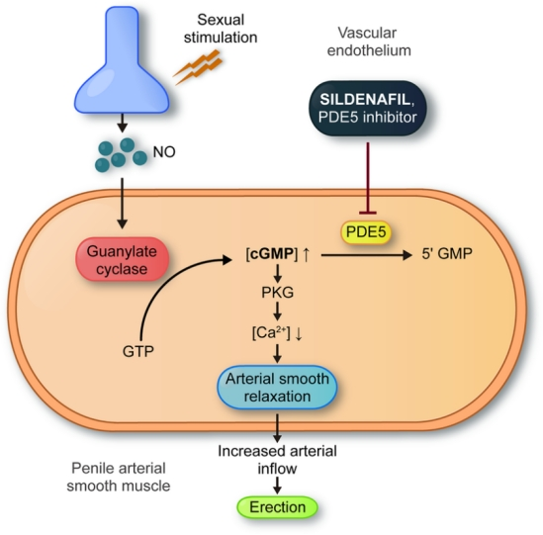
Figure 2.2: Treatment of Erectile Dysfunction
Source: Roushias & Ossei-Gerning (2018)
In parallel with pharmacological options, non-pharmacological interventions have gained attention for their holistic and complementary benefits. Lifestyle modifications such as regular physical activity, weight loss, smoking cessation, and adherence to Mediterranean or DASH diets are associated with improved erectile function and reduced vascular inflammation (Bonarska et al., 2025; Vardi et al., 2022). Exercise, particularly aerobic training, has been shown to enhance endothelial health, increase testosterone, and improve overall sexual performance in men with metabolic syndrome or cardiovascular risk factors (Sun et al., 2025).
Complementary and herbal therapies are increasingly being incorporated into ED management, especially in regions with strong ethnomedical traditions. Extracts from plants such as Syzygium aromaticum, Panax ginseng, Epimedium brevicornum, and Tribulus terrestris have shown potential to improve erectile function via antioxidant, androgenic, or NO-enhancing mechanisms (Wang et al., 2025; Alrumaihi et al., 2024). These therapies are generally well tolerated and may serve as alternatives or adjuncts to conventional medication, particularly in SSRI-induced or psychogenic ED. Nonetheless, quality control and clinical validation remain challenges in herbal medicine.
Psychosexual therapy, including cognitive-behavioral therapy (CBT), partner communication training, and mindfulness, remains essential in cases of psychogenic ED or when performance anxiety is present. These therapies help improve psychological resilience and relational dynamics, which are often disrupted in men with ED (Carella et al., 2023).

2.4.1 Limitations of Current Erectile Dysfunction Treatment
Despite significant advancements in the management of erectile dysfunction (ED), current treatment modalities present notable limitations that restrict their long-term effectiveness and universal applicability. Phosphodiesterase type 5 inhibitors (PDE5is), such as sildenafil and tadalafil, are widely prescribed and often considered the first-line therapy. However, 30–40% of patients fail to respond adequately to PDE5is, especially those with diabetes, severe endothelial dysfunction, or after pelvic surgery (Pyrgidis et al., 2021; Kaltsas et al., 2025). Moreover, PDE5 is require sexual stimulation to be effective and do not address underlying psychological or hormonal causes of ED (Rastrelli et al., 2025).
Testosterone replacement therapy (TRT) is frequently used in hypogonadal men with ED, yet its benefits are inconsistent. While TRT can improve libido and erectile function in testosterone-deficient men, its impact is minimal in men with normal baseline testosterone levels. Long-term safety concerns such as cardiovascular risks and prostate health complications also limit its widespread use (Paschou et al., 2024). Furthermore, many patients require combination therapy with TRT and PDE5is to achieve satisfactory results, highlighting the insufficiency of monotherapy in complex cases (Islam et al., 2022).
Herbal and complementary medicine have emerged as alternatives, particularly in populations that seek natural or culturally congruent therapies. While some plant-based treatments like Panax ginseng, Syzygium aromaticum, and Tribulus terrestris show potential, the lack of standardized formulations, dose-response data, and robust clinical trials undermines their credibility in mainstream medicine (Alrumaihi et al., 2024; Wang et al., 2025). Additionally, concerns about adulteration, drug-herb interactions, and delayed onset of action limit their utility for acute ED management.
Psychosexual therapies, including cognitive behavioral therapy and couples counseling, are essential in managing psychogenic ED. However, access to trained therapists, stigma, and low patient compliance often hinder their effectiveness. These interventions require consistent patient engagement and may not yield immediate results, which discourages patients seeking faster outcomes (Carella et al., 2023). Additionally, few healthcare systems integrate psychological interventions with pharmacotherapy as part of a standard ED care pathway.
Lastly, surgical options like penile prostheses, although effective for refractory ED, are invasive and associated with risks such as infection, mechanical failure, and patient dissatisfaction due to unrealistic expectations. As such, they are reserved for patients unresponsive to all other treatments (Bonarska et al., 2025). Collectively, these limitations highlight the need for novel, integrative, and patient-tailored approaches that can address the multifactorial nature of ED, improve adherence, and target its underlying pathophysiology.

2.5 Syzygium aromaticum
Syzygium aromaticum, commonly known as clove, is a medicinal crop well known to possess a broad variety of pharmacological activities including antioxidant, anti-inflammatory, antimicrobial, and aphrodisiac. Traditionally, clove has also been used in African, Asian, and Ayurvedic medicine and has been investigated for its ability to cure sexual dysfunction and enhance male reproductive health (Sarkodie et al., 2024). Its aphrodisiac effect can be attributed largely because of its composition of eugenol, a bioactive phenolic compound that has been found to regulate the production of NO and increase blood flow through smooth muscle tissues like Corpora cavernosae.
Preclinical studies reveal that S. aromaticum extracts improve sexual behavior in male rats, including enhanced mounting frequency, reduced mount latency, and better erection quality. These effects are speculated to be mediated through the activation of L-arginine/NO signaling pathway, which is essential for cavernosal smooth muscle relaxation and penile erection maintenance (Tang et al., 2017; Sarkodie et al., 2024). Besides, aromaticum has also demonstrated the capacity to upregulate endogenous antioxidant enzymes such as superoxide dismutase (SOD) and catalase, hence safeguarding penile tissue against oxidative stress, a common etiology of erectile dysfunction.
Another most significant pharmacological characteristic of S. aromaticum is its ability to modulate hormone levels. Its ability to increase serum testosterone levels following the administration of clove extracts in animal models has been thought to be its therapeutic effect on androgen biosynthesis or testicular function (Sarkodie et al., 2024). It is particularly observed in SSRI-induced erectile dysfunction, such as that caused by paroxetine, which is known to decrease testosterone levels and suppress NO synthesis in penile tissue.
Besides its physiological effect, S. aromaticum is well-tolerated at moderate doses and has not demonstrated significant toxicological concerns with short-term use. Significant doses or long-term use may be dangerous to reproductive capacity or hepatotoxicity, which renders it suitable for dose standardization in clinical application (El-Saber Batiha et al., 2020).

2.5.1 Bioactive Components of Syzygium aromaticum
Syzygium aromaticum or clove is pharmacologically active due to a rich portfolio of bioactive compounds that are liable for its therapeutic potential, such as erectile dysfunction management. The chief bioactive constituents include eugenol, eugenol acetate, β-caryophyllene, flavonoids, tannins, saponins, and triterpenoids, among others. These phytochemicals are also principally responsible for the plant's antioxidant, anti-inflammatory, analgesic, antimicrobial, and aphrodisiac properties (Yanuarty et al., 2024; Otunola, 2022).
Eugenol, the major compound of clove essential oil, has been acclaimed for its strong antioxidant property. It is a free radical scavenger and plays a significant role in protecting endothelial cells and penile smooth muscle against oxidative stress-mediated damage, which is commonly implicated in erectile dysfunction (Caballero-Gallardo et al., 2025). Eugenol also stimulates nitric oxide (NO) release and helps in vasodilation through endothelial modulation, thereby facilitating penile erection (Sarkodie et al., 2024).
In addition to eugenol, S. aromaticum ethanolic and aqueous extracts also contain flavonoids such as kaempferol and quercetin. These compounds are known to have strong antioxidant and vasodilatory effects through enhanced activity of endothelial nitric oxide synthase (eNOS) and NO bioavailability (Otunola, 2022; Tuldjanah et al., 2024). Flavonoids are also involved in the regulation of hormonal pathways, including testosterone synthesis, which is required for sexual arousal and erectile function.
Triterpenoids and tannins present in clove have been reported to reinforce tissue integrity and induce anti-inflammatory activities capable of neutralizing oxidative and inflammatory insults in penile tissue. The phytoconstituents also improve sperm motility and quality in animal models, suggesting a general reproductive benefit (Boojar et al., 2024; Adama, 2025). Saponins, a class of phytoconstituents, are reported to possess adaptogenic activities that improve stress tolerance and libido.
Furthermore, phytochemical fractionation studies revealed that the aphrodisiac activity of S. aromaticum is due not only to eugenol but to synergistic action among its polyphenols, alkaloids, and volatile oils (Yanuarty et al., 2024).

CHAPTER THREE

3.0 MATERIALS AND METHODS

3.1 Materials

3.1.1 Plant Materials
Syzygium aromaticum was purchased from Mandate Market in Ilorin, Kwara State. It was authenticated and identified at the Herbarium, Department of Plant biology, University of Ilorin, where voucher number UILH/001/1498 was assigned.

3.1.2 Experimental Animal
Twenty-five (25) male experimental rats were obtained from Research Fulcrum Lab, Ilorin. Prior to the experiment, the animals were housed in a well-ventilated and illuminated facility and were fed standard diet of rat pellets and clean water ad libitum.

3.1.3 Reagents and Kits
Seroxat (paroxetine) was purchased from General Drug Pharmacy, Ilorin. obtained from Elab Scientifics, epinephrine, DTNB (Ellman’s Reagent) (5,5-dithio-bis-2-nitrobenzoic acid) and glucose from Sigma. The assay kits for High Density Lipoprotein (HDL), total cholesterol, triglyceride, were products of Randox Laboratories Ltd., Co-Antrim, UK. Other reagents to be used were of analytical grade.

3.2 Methods

3.2.1 Preparation of Clove Extract
Syzygium aromaticum aqueous extract was prepared using the method described by Ahmad et al. (2012) with slight modifications. Briefly, approximately 500 g crude powder was mixed in 2.5 L distilled water, and the mixture was left over night with shaking. The mixture was then filtered and freeze-dried to obtain brown flakes which were pulverized into powder and stored for the research.

3.2.2 Experimental Design
Twenty-five (25) male Wistar rats were randomly assigned to five groups, each consisting of five rats. They were treated as follows:
Group 1 (Normal control) received 1 mL of 0.9% normal saline
Group 2 (Paroxetine-induced untreated) was administered only 10 mg/kg of paroxetine orally for 21 days.
Group 3 (standard drug) received 10 mg/kg of paroxetine along with 50 mg/kg of sildenafil citrate (Viagra).
Groups 4 was administered 10 mg/kg of paroxetine followed by 200 mg/kg S. aromaticum aqueous extract (SAAE).
Group 5 was administered 10 mg/kg paroxetine, followed by 400 mg/kg of SAAE. These treatments were administered orally. At the end of the experiment, the rats were humanely sacrificed using diethyl ether anaesthetization.

3.2.3 Induction of Erectile Dysfunction
Erectile dysfunction was induced using the method described by Muritala and Bewaji (2021). This involved oral administration of 10 mg/kg of paroxetine suspension which was prepared using Tween-80 (BDH Chemicals, Ltd.; Poole, England) suspended in 9 g/L saline solution as the vehicle. The paroxetine was administered for 21 days, followed by treatment the following day.

3.2.4 Determination of Body-Organ Weight Ratio
For assessment of possible changes in the organ sizes after induction of erectile dysfunction and administration of the extract, the animals were weighed before sacrifice. After sacrifice, their hearts and penises were excised, blotted in tissue paper to remove blood and water, and weighed for determination of hearts-body and penises-body weight ratios (Yakubu et al., 2007).

3.2.5 Determination of Phosphodiesterase 5 Activity
Penile phosphodiesterase 5 (PDE5) activity was measured using the Butcher and Sutherland (1962) method. Concisely, the samples (penis homogenates) were incubated with cGMP, which served as the substrate, followed by spectrophotometric detection of the reaction product. The enzymatic activity was then estimated using the following equation:
EA = (units/mL)
Where:
EA is enzyme activity
V is total volume of reaction
ΔC is reaction velocity (Pi/ incubation time of 20
minutes)
V₃ is volume of enzyme source
Pi is amount of inorganic phosphate released

3.2.6 Determination of Penile Nitric Oxide Concentrations
The penile nitric oxide concentrations were determined following the method of Green et al. (1982). This assay involved the reaction of nitrate and nitrite with Griess reagent to form a colored complex, which was quantified spectrophotometrically. The nitric oxide concentration was determined based on standard calibration curve.

3.2.7 Arginase Activity
Arginase activity assay in penile organs was carried out using the method of Stickings et al. (2002). In this method, 50µl of the homogenate of each of the organs was measured into an eppenduff tube, and 200µl of arginase buffer was added to it. The mixture was incubated for 1 hr at 37ºC, after which 100µl of 0.5 M hypochloride was added to it. The mixture was then centrifuged at 8000rpm for 3minutes. The mixture was thereafter quantified using urea i.e. 100ul of urea reagent was added to 20µl of the supernatant. The absorbance value was taken at 380nm and the concentration of urea is estimated using the following equation:
Concentration of urea (mg/dl) =
Concentration of standard = 13.1 mg/dl

3.2.8 Creatine Kinase (CK) Activity Assay
Serum creatine kinase (CK) activity was quantified using the Witt and Trendelenburg (1982) method. The assay measured CK activity based on the enzymatic conversion of creatine phosphate, with absorbance recorded spectrophotometrically. The enzyme activity was calculated using the following equation:
Creatine kinase (U/l) = 4127 x (ΔAbsorbance/minute x dilution factor)
Where 4127 is the standard factor used in preparation of the enzyme kit.

3.2.9 Lipid Profile

3.2.9.1 Serum Total Cholesterol Concentration
The assay for total cholesterol in the serum was carried out using the method of Fredrickson et al. (1967). Micropipette was used to measure 20 µL each of appropriately diluted sample, standard and distilled water were pipetted into different test tubes and were labeled sample, standard and blank respectively. Thereafter, 2000ul of working reagent composing of 4-aminoantipyrine, phenol, peroxide, cholesterol esterase, cholesterol oxidase and buffer (pH 6.8) were added to each test tube. The reaction constituents were thoroughly mixed and incubated at 37ᵒC for 5min. The absorbance of sample and standard were read against the blank at 546nm. The cholesterol concentration was then calculated using the following equation:
Concentration of cholesterol (mmol/L) =
Concentration of standard = 5.10 mmol/L

3.2.9.2 Triglycerides concentration
The concentration of serum triglyceride was determined using the method describe by Hainline et al. (1980). Using a micropipette, 10ul of appropriately diluted sample, standard and distilled water were pipetted into clean test tubes labelled sample, standard and blank respectively. Then 100 µL of working reagent comprising of 4-aminophenazone, ATP, lipases, glycerokinase, glyceryl-3-phosphate oxidase and peroxidase were added to each test tube. The solution was mixed, left undisturbed for 10min at room temperature (20-25 0 C). The absorbance of sample and standard was measured against the blank within 60 min at 500nm. The triglycerides were then estimated using the equation below:
Calculation:
Concentration of TG (mmol/L) =
Concentration of standard = 2.21 mmol/L

3.2.9.3 Serum High Density Lipoprotein-Cholesterol Concentration
By adopting the procedure described by Albers et al. (1978), HDL-cholesterol concentration in serum was determined. Using a micropipette, 200ul of appropriate diluted sample, standard and distilled water were pipetted into clean test tubes labelled sample, standard and blank respectively. Then 500 µL of working reagent comprising of phosphotungstic acid and magnesium chloride were added to each test tube. The solution was mixed and left undisturbed for 10min at room temperature. This was then centrifuged at 4000 rpm for 10 minutes. The clear supernatant was separated off within two hours and the cholesterol content determined by the CHOD-PAP method earlier described.
Concentration of HDL cholesterol (mmol/L) =
Concentration of standard = 5.10 mmol/L

3.2.9.4 Serum Low Density Lipoprotein-Cholesterol Concentration
The assay for serum low-density lipoprotein cholesterol concentration was carried out using the polyvinyl sulphate (PVS) reaction as described by Demacker et al. (1984).
Calculation:
LDL-C (mg/dl) = Total cholesterol (mg/dl) – 1.5 x
Supernatant cholesterol (mg/dl)

3.2.10 Statistical Analysis
Data obtained were expressed as mean ± standard error of mean (S.E.M.) of three replicates. Graphs were obtained using Graphpad prism version 8.0, and one-way analysis of variance (ANOVA) was used for statistical evaluation using Duncan’s posthoc test of SPSS for multiple comparisons. Values analyzed were considered statistically significant at p<0.05.

CHAPTER FOUR

4.0 RESULTS

4.1 Percentage Yield of the Extract
After the preparation of Syzygium aromaticum aqueous extract using 500 g of the plant sample, 78 g of extract was obtained.
% Yield = 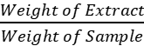 × 100
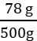 = × 100
= 15.6 %
Therefore, the percentage yield of the S. aromatic extract was 15.6 %

4.2 Phytochemical Screening of Syzygium aromaticum Aqueous Extract
The phytochemical screening of Syzygium aromaticum aqueous extract (SAAE) revealed the presence of tannins, saponins, flavonoids, glycosides, alkaloids, phenols and steroids (Table 4.1). However, terpenoids and phlobatannins in phytochemical screening were not present.

Table 4.1: Phytochemical Screening of Syzygium aromaticum Aqueous Extract
S/N | Phytochemical Class | Results
1 | Tannins | +
2 | Saponins | +
3 | Flavonoids | +
4 | Terpenoids | -
5 | Glycosides | +
6 | Phlobatannins | -
7 | Alkaloids | +
8 | Phenols | +
9 | Steroids | +

Keys:
+ = Present
- = Absent

4.3 Penile Organ-Body Ratios
The penile organ-body ratio of group 2 (dysfunctional untreated group) was significantly lower (p<0.05) compared to others (Figure 4.1). There was no significant difference (p<0.05) in the penile organ-body ratios of normal control and sildenafil citrate (standard) groups. The penile organ-body ratios of groups 4 and 5 (200mg/kg body weight SAAE and 400mg/kg body weight SAAE) were significantly (p<0.05) lower compared to that of the normal control.
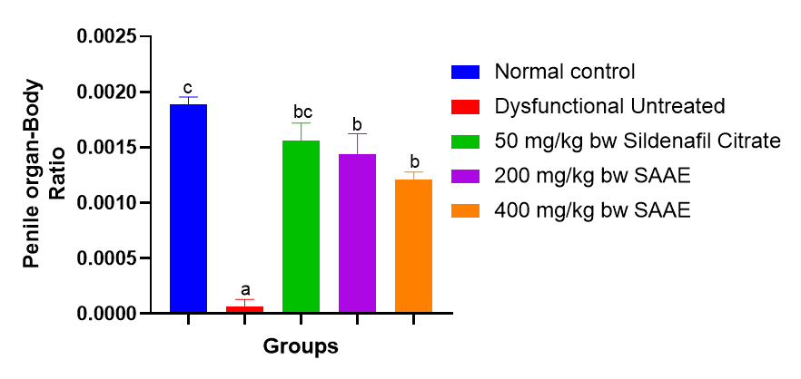
Figure 4.1: Penile Organ-Body Ratios of Paroxetine-Induced Dysfunctional Rats Administered Syzygium aromatic Extract (SAAE)
Values were expressed as Mean ± SEM (n = 3), and bars with different alphabets are statistically different

4.4 Nitric Oxide Concentration
The nitric oxide in group 2 (dysfunctional untreated group) was significantly lower (p<0.05) compared to others (Figure 4.2). There was no significant difference (p<0.05) in the nitric oxide levels of sildenafil citrate, 200mg/kg body weight SAAE and 400mg/kg body weight SAAE groups.

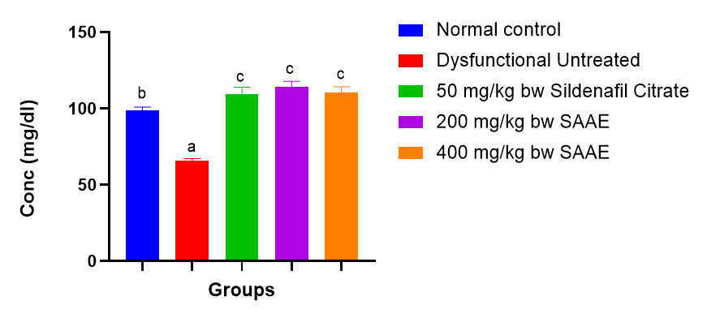
Figure 4.2: Nitric Oxide Levels of Paroxetine-Induced Dysfunctional Rats Administered Syzygium aromatic Extract (SAAE)
Values were expressed as Mean ± SEM (n = 3), and bars with different alphabets are statistically different

4.5 In vivo Enzyme Assays

4.5.1 Phosphodiesterase 5
Phosphodiesterase 5 activity in group 2 (dysfunctional untreated group) was significantly higher (p<0.05) compared to others (Figure 4.3). There was no significant difference (p<0.05) in the phosphodiesterase 5 activity of normal control, sildenafil citrate and 400mg/kg SAAE groups. The phosphodiesterase 5 activity in 200mg/kg SAAE was significantly higher (p<0.05) than those of the normal control, sildenafil citrate and 400mg/kg SAAE groups.

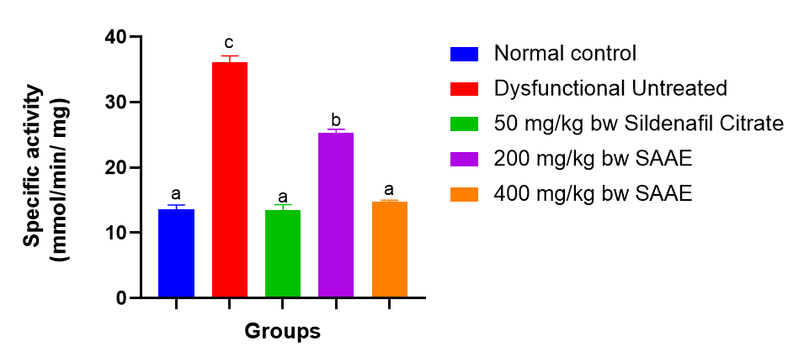
Figure 4.3: The phosphodiesterase Activity of Paroxetine-Induced Dysfunctional Rats Administered Syzygium aromatic Extract (SAAE)
Values were expressed as Mean ± SEM (n = 3), and bars with different alphabets are statistically different

4.5.2 Arginase
Arginase in group 2(dysfunctional untreated group) was significantly higher (p<0.05) compared to other (Figure 4.4). There was no significant difference (p<0.05) in the arginase activity of normal control, sildenafil citrate (standard), 200mg/kg body weight SAAE and 400mg/kg body weight SAAE groups

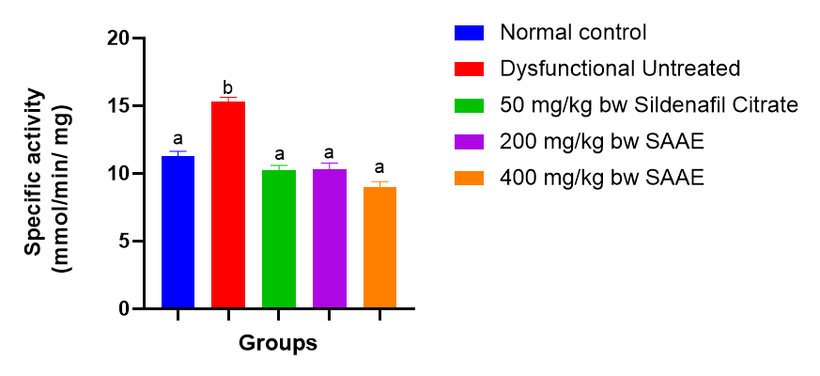
Figure 4.4: The Arginase Activity of Paroxetine-Induced Dysfunctional Rats Administered Syzygium aromatic Extract (SAAE)
Values were expressed as Mean ± SEM (n = 3), and bars with different alphabets are statistically different

4.5.3 Creatinine Kinase
The creatine kinase in group 2 (dysfunctional untreated group) was significantly higher (p<0.05) compared to others (Figure 4.5). There was no significant difference (p<0.05) in the creatine kinase of normal control, sildenafil citrate (standard), 200mg/kg body weight SAAE and 400mg/kg body weight SAAE groups.

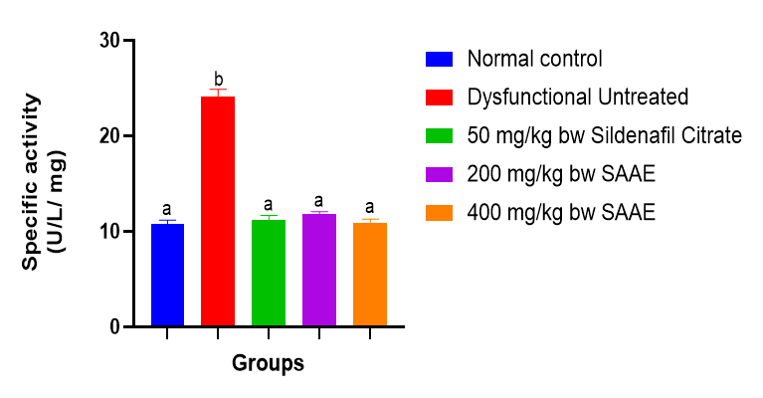
Figure 4.5: Creatinine Kinase Activity of Paroxetine-Induced Dysfunctional Rats Administered Syzygium aromatic Extract (SAAE)
Values were expressed as Mean ± SEM (n = 3), and bars with different alphabets are statistically different

4.6 Serum Lipid Profile
The experiment revealed low density lipoprotein (LDL) in group 2 (dysfunctional untreated group) which was significantly higher (p<0.05) compared to others (Table 4.2). There was no significant difference (p<0.05) in LDL of 400 mg/kg body weight SAAE, 200mg/kg body weight SAAE and sildenafil citrate groups, and their LDL concentrations were significantly higher (p<0.05) than that of normal control.
Higher density lipoprotein (HDL) in group 2 (untreated group) was significantly lower (p<0.05) compared to others. There was no significant difference (p<0.05) in the HDL of sildenafil citrate, 200 and 400 mg/kg body weight SAAE, and their HDL concentrations were significantly (p<0.05) lower compared to the normal control group.
Triacylglycerol (TAG) in group 2 (dysfunctional untreated group) was significantly higher (p<0.05) compared to others. There was no significant difference (p<0.05) in the triacylglycerol concentrations of normal control, sildenafil citrate and 400mg/kg body weight SAAE. The triacylglycerol in 400mg/kg body weight SAAE group was significantly lower (p<0.05) than 200mg/kg body weight SAAE group.
The total cholesterol in group 2 (dysfunctional untreated group) was significantly higher (p<0.05) compared to other groups. There was no significant difference (p<0.05) in the total cholesterol of 200 and 400 mg/kg body weight SAAE groups.
Table 4.2: Serum Lipid Profile of Paroxetine-Induced Dysfunctional Rats Administered Syzygium aromatic Extract
S/N | Groups | LDL  (mmol/L) | HDL  (mmol/L) | TAG  (mmol/L) | Cholesterol  (mmol/L)
1 | Normal Control | 5.14 ± 0.20ª | 9.07 ± 0.33^{c} | 3.01 ± 0.50^{ab} | 16.82 ± 1.13ª
2 | Dysfunctional Untreated | 18.77 ± 0.54^{c} | 6.27 ± 0.37ª | 5.18 ± 0.20^{c} | 23.13 ± 1.22^{c}
3 | 50 mg/kg bw Sildenafil Citrate | 8.78 ± 0.15^{b} | 7.73 ± 0.33^{b} | 3.55 ± 0.24^{ab} | 20.38 ± 1.03^{bc}
4 | 200 mg/kg bw SAAE | 9.37 ± 0.45^{b} | 7.55 ± 0.23^{b} | 3.85 ± 0.48^{b} | 19.13 ± 1.12^{ab}
5 | 400 mg/kg bw SAAE | 8.81 ± 0.09^{b} | 8.15 ± 0.09^{b} | 2.66 ± 0.20ª | 18.02 ± 0.49^{ab}

SAAE: Syzygium aromaticum Aqueous Extract

CHAPTER FIVE

5.0 DISCUSSION, CONCLUSION AND RECOMMENDATION

5.1 Discussion
The observed improvements in paroxetine-induced sexual dysfunction following administration of Syzygium aromaticum aqueous extract (SAAE) highlight the therapeutic potential of clove-derived phytochemicals in modulating biochemical and physiological pathways relevant to male reproductive health. The significant reduction in penile organ-body ratio in the untreated paroxetine group aligns with existing evidence that selective serotonin reuptake inhibitors (SSRIs), such as paroxetine, impair sexual function by inhibiting dopaminergic and nitric oxide (NO)-mediated pathways critical for erection and libido (Khawam et al., 2021). The partial restoration of this ratio in rats treated with 200 mg/kg and 400 mg/kg of SAAE suggests that the bioactive components of S. aromaticum, particularly eugenol, flavonoids, and saponins, exert tissue-protective effects and potentially enhance androgenic stimulation (Taghipour et al., 2023).
The restoration of NO concentrations in the SAAE-treated groups indicates a reversal of paroxetine-mediated oxidative and endothelial dysfunction. Nitric oxide is essential for corpus cavernosum relaxation and penile erection, and its reduction is a hallmark of drug-induced erectile dysfunction (Chauhan et al., 2020). Several phytochemicals found in clove, notably flavonoids and phenolic compounds, are known to enhance NO synthase activity and reduce oxidative stress (Yilmaz-Oral et al., 2020). The similarity in NO levels between the SAAE and sildenafil citrate groups further validates the efficacy of clove extract as a natural PDE5 modulator. This observation is supported by the findings of Elkomy et al. (2018), who demonstrated that clove oil improves testicular function and NO availability in toxicological models.
Phosphodiesterase-5 (PDE5) plays a central role in penile detumescence by degrading cyclic GMP. The elevated PDE5 activity in the paroxetine-only group and its normalization in the 400 mg/kg SAAE group suggest that the extract may inhibit PDE5 enzymatic activity, akin to the mechanism of action of sildenafil. This effect was less pronounced in the 200 mg/kg SAAE group, reinforcing the dose-dependent efficacy of the extract. Eugenol, a major constituent of clove, has been shown to inhibit PDE enzymes and promote smooth muscle relaxation, thus enhancing erectile function (Okukpe et al., 2018). The biochemical inhibition of PDE5 observed in this study corroborates previous in vivo findings that link clove extract administration with restored erectile parameters and enhanced cGMP signaling (Taghipour et al., 2023).
Similarly, the reduction of arginase activity in the treatment groups is significant, as this enzyme competes with nitric oxide synthase for the common substrate L-arginine. Elevated arginase activity is a known contributor to erectile dysfunction through reduced substrate availability for NO synthesis (Gul et al., 2020). The normalization of arginase activity in SAAE-treated rats mirrors the effect of sildenafil and reflects the extract's ability to maintain NO production by regulating arginase expression. These findings are in line with the work of Soltani et al. (2023), who reported that S. aromaticum extract modulates inflammatory and oxidative pathways, potentially downregulating arginase via antioxidant activity.
The decline in creatine kinase (CK) activity in the treatment groups relative to the paroxetine-only group further supports the protective effect of SAAE on muscular energy metabolism in penile tissues. Elevated CK levels are often associated with tissue damage and impaired muscular energy handling. The normalization of CK activity suggests that SAAE supports the restoration of mitochondrial integrity and energy transfer processes in the penile smooth muscle and possibly the testis, as previously indicated by Chikere et al. (2015), who observed clove extract ameliorating histopathological damage in reproductive tissues.
The dyslipidemic effects induced by paroxetine were also evident, with elevated LDL, total cholesterol, and triacylglycerol (TAG), alongside decreased HDL levels in the dysfunctional group. These lipid abnormalities are consistent with the literature on SSRIs, which have been shown to impair lipid metabolism and increase cardiovascular risk (Yuan et al., 2022). Treatment with SAAE effectively reversed these alterations, particularly at the higher dose, showing comparable outcomes to sildenafil. This hypolipidemic effect is likely due to the antioxidant and hepatoprotective action of polyphenols in S. aromaticum, which enhance lipid catabolism and reduce lipid peroxidation (Aboubakr et al., 2018). In a study by Hussien et al. (2024), clove extract significantly reduced LDL and total cholesterol levels in diabetic rats, supporting its potential in correcting drug-induced dyslipidemia.
In addition to biochemical improvements, the broad spectrum of phytochemicals identified in the extract, such as alkaloids, saponins, and flavonoids, contribute synergistically to its therapeutic effects. Flavonoids in particular are well-known for their ability to scavenge free radicals, modulate endothelial function, and enhance reproductive hormone profiles (Dehghani et al., 2012). The absence of terpenoids and phlobatannins, though noteworthy, did not appear to compromise the efficacy of the extract, indicating that the major active compounds present were sufficient to induce measurable physiological and biochemical improvements.

5.2 Conclusion
The administration of Syzygium aromaticum aqueous extract effectively mitigated paroxetine-induced reproductive and metabolic dysfunction in male rats. The extract's rich phytochemical content, including flavonoids, saponins, and eugenol, contributed to the restoration of nitric oxide levels, inhibition of phosphodiesterase-5 activity, normalization of lipid profiles, and protection of reproductive tissues. These findings suggest that clove extract possesses multi-targeted therapeutic potential and could serve as a complementary approach for managing SSRI-induced sexual dysfunction and associated biochemical imbalances. Further research is warranted to explore its clinical relevance and mechanistic pathways in humans.

5.3 Recommendation
Based on the findings of this study, the following are recommended:
- Further mechanistic studies are needed to elucidate the molecular pathways through which clove extract modulates nitric oxide synthesis, phosphodiesterase-5 activity, and lipid metabolism.
- Isolation and characterization of specific bioactive compounds within the extract is recommended to identify the most active constituents responsible for the observed pharmacological effects.
- Public health education initiatives could consider promoting the potential benefits of clove as a dietary supplement, with caution, under appropriate medical supervision.

REFERENCES
Abdel-Kader, M. S., Alam, P., Soliman, G. A., & Al-Shdefat, R. (2021). Eco-friendly stability-indicating RP-HPTLC method for sildenafil analysis, characterization and biological evaluation of its oxidized stress degradation product. Scientific Reports, 11, 1–11. https://www.nature.com/articles/s41598-021-94854-6
Aboubakr, M., Elkomy, A., & Ibrahim, S. (2018). Protective effects of Syzygium aromaticum oil (clove) against acrylamide-induced hepatic, renal, and testicular toxicity in rats. International Journal of Pharmacology and Toxicology, 8(2), 45–55. https://www.researchgate.net/publication/325584549
Adama, O. I. (2025). Hydro-maceration and decoction of clove seed as an aphrodisiac: A structured literature review. Archives of Biotechnology & Pharmaceutical Research. PDF link
Adedayo, B. C., Jesubowale, O. S., & Adebayo, A. A. (2021). Toxicological evaluation and in vitro assessment of antioxidant and anticholinesterase properties of Andrographis paniculata extract. Interdisciplinary Toxicology, 14(1), 1–10. https://sciendo.com/pdf/10.2478/intox-2021-0001
Ademosun, A. O., Adebayo, A. A., & Oboh, G. (2019). Anogeissus leiocarpus attenuates paroxetine-induced erectile dysfunction in male rats via enhanced sexual behavior, nitric oxide level and antioxidant status. Biomedicine & Pharmacotherapy, 111, 716–723. https://doi.org/10.1016/j.biopha.2018.12.142
Ajiboye, T. O., Nurudeen, Q. O., & Yakubu, M. T. (2018). Effect of 50% ethanolic extract of Syzygium aromaticum (L.) Merr. & L.M. Perry (clove) on sexual dysfunction. Journal of Basic and Clinical Physiology and Pharmacology, 29(3), 243–250. https://www.academia.edu/download/101815394/jbcpp-2013-006120230504-1-9xts55.pdf
Al-Qahtani, F. S., Battar, S. S., & Alqahtani, M. M. M. (2025). The prevalence of erectile dysfunction and its associated factors among diabetic patients in the Southwestern Region of Saudi Arabia: An analytical cross-sectional study. Journal of Men's Health, 21(1), 1–9. https://oss.jomh.org/files/article/20250530-552/pdf/JOMH2025020101.pdf
Alrumaihi, F., Raut, R., Yahia, E. A., Kumar, V., & Anwar, S. (2024). A review on risk factors, diagnostic innovations, and plant-based therapies for the management of erectile dysfunction. Uro, 4(2), 60–88. https://www.mdpi.com/2673-4397/4/2/6
Besong, E. E., Akhigbe, T. M., Ashonibare, P. J., & Adeyemi, A. M. (2023). Zinc improves sexual performance and erectile function by preventing penile oxidative injury and upregulating circulating testosterone in lead-exposed rats. Redox Report, 28(1), 1–9. https://www.tandfonline.com/doi/abs/10.1080/13510002.2023.2225675
Bonarska, M., Adasik, D., Szymczyk, S., & Łocik, G. (2025). A narrative review of independent treatment methods for ED: Diet, supplements, pharmacotherapy, and physiotherapy. Journal of Clinical Medicine, 14(7), 2386. https://www.mdpi.com/2077-0383/14/7/2386
Boojar, M. M. A., Shakeri, M., & Saberi, M. (2024). Herbal treatments and their impact on male fertility: A comprehensive review. ResearchGate. Link
Caballero-Gallardo, K., Quintero-Rincón, P., & Michel, M. R. (2025). Aromatherapy and essential oils: Holistic strategies in complementary medicine. Plants, 14(3), 400. https://www.mdpi.com/2223-7747/14/3/400
Campolo, F., Barbagallo, F., Franceschini, E., Crecca, C., & Maggi, M. (2020). PDE5 inhibitors in type 2 diabetes cardiovascular complications. Endocrines, 1(2), 122–135. https://www.mdpi.com/2673-396X/1/2/9
Carella, M. C., Forleo, C., Stanca, A., & Carulli, E. (2023). Heart failure and erectile dysfunction: Clinical implications. Current Heart Failure Reports, 20(4), 241–252. https://doi.org/10.1007/s11897-023-00632-y
Chauhan, N. S., Sharma, V., Dixit, V. K., & Thakur, M. (2020). Endothelial nitric oxide and oxidative stress: key targets for therapeutic efficacy in erectile dysfunction. Biomedicine & Pharmacotherapy, 125, 109898. https://doi.org/10.1016/j.biopha.2019.109898
Chikere, O. U., Liman, F. L., Nnabuihe, E. D., & Uchechi, E. E. (2015). The effects of methanolic extract of Syzygium aromaticum (clove bud) on the histology of testis in adult male Wistar rats. Journal of Natural Sciences Research, 5(3), 102–108. https://core.ac.uk/download/pdf/234655967.pdf
Crescioli, C., & Paronetto, M. P. (2024). Rethinking phosphodiesterase 5 inhibition: the old, the new, and the perspective in human health. Frontiers in Endocrinology, 15, Article 1461642. https://www.frontiersin.org/articles/10.3389/fendo.2024.1461642/full
Dehghani, F., Heshmatpour, A., & Taghizadeh, M. (2012). Toxic effects of water/alcoholic extract of Syzygium aromaticum on sperm quality, sex hormones, and reproductive tissues in male mouse. European Journal of Experimental Biology, 2(6), 2086–2090. https://dergipark.org.tr/en/download/article-file/95639
Dilixiati, D., Waili, A., Tuerxunmaimaiti, A., Tao, L., & Zhang, Y. (2024). Risk factors for erectile dysfunction in diabetes mellitus: A systematic review and meta-analysis. Frontiers in Endocrinology, 15, Article 1368079. https://doi.org/10.3389/fendo.2024.1368079
Elekofehinti, O. O., Akintoye, O. N., & Akinjiyan, M. O. (2024). Effect of Carpolobia lutea leaf extract on erectile dysfunction induced by paroxetine in rats. Phytomedicine Plus, 4(2), 100384. https://doi.org/10.1016/j.phyplu.2024.100384
Elkomy, A., Aboubakr, M., & Ibrahim, S. (2018). Protective effects of clove oil against reproductive toxicity: a biochemical and histological analysis. International Journal of Pharmacology and Toxicology, 8(2), 35–44. https://www.researchgate.net/publication/325584549
El-Saber Batiha, G., Beshbishy, A. M., El-Mleeh, A., Abdel-Daim, M. M., & Devkota, H. P. (2020). Traditional uses, bioactive chemical constituents, and pharmacological and toxicological activities of Glycyrrhiza glabra L. (Fabaceae). Biomolecules, 10(3), 352. https://www.mdpi.com/2218-273X/10/3/352
Feng, Y., Qu, X., & Hao, H. (2025). Progress in the study of the effects of selective serotonin reuptake inhibitors (SSRIs) on the reproductive system. Frontiers in Pharmacology, 16, Article 1567863. https://doi.org/10.3389/fphar.2025.1567863
Gebeyehu, N. A., Gesese, M. M., Tegegne, K. D., & Kebede, Y. S. (2023). Global prevalence of sexual dysfunction among diabetic patients from 2008 to 2022: Systematic review and meta-analysis. Metabolism Open, 19, Article 1000191. https://doi.org/10.1016/j.metop.2023.1000191
Giri, S., Varshney, K. K., & Srivastava, R. (2024). Therapeutic potential and prospects of L-arginine in various diseases and its clinical intervention. Current Drug Therapy, 19(1), 25–33. https://www.benthamdirect.com/content/journals/cdth/10.2174/0115748855260802231019072509
Goldstein, I., Goren, A., Li, V. W., & Tang, W. Y. (2020). Epidemiology update of erectile dysfunction in eight countries with high burden. Sexual Medicine Reviews, 8(1), 48–56. https://doi.org/10.1016/j.sxmr.2019.06.004
Hersch, E., Huang, J., & Grider, J. R. (2004). Gq/G13 signaling by ET-1 in smooth muscle: MYPT1 phosphorylation via ETA and CPI-17 dephosphorylation via ETB. American Journal of Physiology-Cell Physiology, 287(2), C456–C463. https://doi.org/10.1152/ajpcell.00198.2004
Hussien, A. G., Fyiad, A. E. A., & Ali, M. M. (2024). The influence of Syzygium aromaticum ethanolic extract against streptozotocin-induced diabetic rats. Egyptian Journal of Experimental Biology, 20(1), 112–120. https://journals.ekb.eg/article_329525.html
Islam, M. M., Naveen, N. R., & Anitha, P. (2022). Recent advances and interventions to treat or manage erectile dysfunction. Journal of Clinical Medicine, 11(11), 3140. https://www.mdpi.com/2077-0383/11/11/3140
Kaltsas, A., Dimitriadis, F., Zachariou, A., & Sofikitis, N. (2025). Phosphodiesterase type 5 inhibitors in male reproduction: Molecular mechanisms and clinical implications. Cells, 14(2), 120. https://www.mdpi.com/2073-4409/14/2/120
Kassan, M., Lasker, G. F., Sikka, S. C., Mandava, S. H., & Hellstrom, W. J. G. (2013). Chronic escitalopram treatment induces erectile dysfunction by decreasing nitric oxide bioavailability mediated by increased NADPH oxidase activity. Urology, 82(5), 1186–1192. https://doi.org/10.1016/j.urology.2013.05.049
Khawam, E. A., Laurencic, G., & Malone, D. A. (2021). Treating SSRI-induced sexual dysfunction: a review. Annals of Clinical Psychiatry, 33(1), 22–30. https://doi.org/10.12788/acp.0016
Kim, N. N., Kim, J. J., Hypolite, J., & Levin, R. M. (2001). Altered contractility of rabbit penile corpus cavernosum smooth muscle by hypoxia. The Journal of Urology, 166(2), 745–751. https://doi.org/10.1016/S0022-5347(01)66519-4
Kpomah, E. D., Osioma, E., & Agoro, E. S. (2024). Sexual invigorating potentials of a combined extract of Sabicea calycina and Carpolobia lutea on male Wistar rats in crude oil challenged environment. International Journal of Biochemistry Research and Review, 33(2), 32–45. https://www.researchgate.net/publication/377752319
Lee, S., Hwang, Y. G., & Chung, H. K. (2014). A proteomic analysis using an animal model for hyperlipidemia-related erectile dysfunction. Drug Research, 64(5), 237–243. https://doi.org/10.1055/s-0033-1363994
Leyaro, B. J., Nyalile, K. B., Mushi, E. H. P., & Moshi, E. (2020). Prevalence and factors associated with erectile dysfunction among adult men in Moshi Municipal, Tanzania: A community-based study. Basic and Clinical Andrology, 30(1), 1–9. https://doi.org/10.1186/s12610-020-00118-0
Mobley, D. F., Khera, M., & Baum, N. (2017). Recent advances in the treatment of erectile dysfunction. Postgraduate Medical Journal, 93(1105), 679–685. https://doi.org/10.1136/postgradmedj-2017-135045
Muritala, H. F., & Bewaji, C. O. (2021). Paroxetine administration alters some biochemical parameters in male Wistar rats over a systemic period of thirty-five days. Academia.edu. https://www.academia.edu/download/109912536/19.pdf
New Approaches in Oncology for Repositioning Drugs: The Case of PDE5 Inhibitor Sildenafil - Scientific Figure on ResearchGate. Available from: https://www.researchgate.net/figure/General-mechanism-of-action-of-sildenafil-in-erectile-dysfunction-Sexual-stimulation_fig1_349633465 [accessed 8 Jul 2025]
Nguyen, H. N. N., Luong, T. V., & Pham, A. K. (2024). Exploring the bidirectional link between erectile dysfunction and 10-year cardiovascular risk in men with diabetes and hypertension. Scientific Reports, 14, Article 78182. https://doi.org/10.1038/s41598-024-78182-z
Nik-Ahd, F., & Shindel, A. W. (2022). Pharmacotherapy for erectile dysfunction in 2021 and beyond. Urologic Clinics of North America, 49(2), 197–209. https://doi.org/10.1016/j.ucl.2021.12.005
Obalana, E., Oluwatimilehin, O. E. (2024). Assessment of serum biomarkers of cardiac function (creatine kinase and troponin) in Wistar rats treated with Long Jack sperm enhancer. ResearchGate. https://www.researchgate.net/publication/383455071
Odetayo, A. F., & Olayaki, L. A. (2023). Omega-3 fatty acid improves sexual and erectile function in BPF-treated rats by upregulating NO/cGMP signaling and steroidogenic enzymes activities. Scientific Reports, 13, 1–13. https://www.nature.com/articles/s41598-023-45344-4
Okukpe, K. M., Adeyina, A. O., Alli, O. I., & Ajao, B. H. (2018). Hormone inducive effects of Syzygium aromaticum (clove) extract on the reproductive performance of bucks. Nigerian Journal of Animal Production, 45(3), 63–70. https://www.njap.org.ng/index.php/njap/article/view/560
Otunola, G. A. (2022). Culinary spices in food and medicine: An overview of Syzygium aromaticum. Frontiers in Pharmacology, 12, 793200. https://www.frontiersin.org/articles/10.3389/fphar.2021.793200/full
Oyovwi, M. O., & Atere, A. D. (2024). Exploring the medicinal significance of L-arginine-mediated nitric oxide in preventing health disorders. European Journal of Medicinal Chemistry Reports, 3, 100047. https://doi.org/10.1016/j.ejmcr.2024.100047
Paschou, S. A., Athanasiadou, K. I., & Hafford-Letchfield, T. (2024). Sexual health and wellbeing and the menopause: An EMAS clinical guide. Maturitas, 185, 1–10. https://www.sciencedirect.com/science/article/pii/S0378512224001506
Pyrgidis, N., Mykoniatis, I., Haidich, A. B., Tirta, M., & Hatzichristodoulou, G. (2021). The effect of PDE5 inhibitors on erectile function: A systematic overview. Frontiers in Pharmacology, 12, 735708. https://doi.org/10.3389/fphar.2021.735708
Rastrelli, G., Antonio, L., Carrier, S., & Isidori, A. (2025). Hormonal regulation of men’s sexual function: ICSM 2024 recommendations. Sexual Medicine Reviews, 13(2), 147–168. https://doi.org/10.1093/sxmrev/qeaf025
Sağır, S., Ünsal, V., Öner, E., Yıldız, R., & Mert, B. D. (2025). Comparison of PDE-5 inhibitors used in erectile dysfunction with some candidate molecules: A study involving molecular docking, ADMET, DFT, and biological target interactions. BMC Urology, 25, Article 1727. https://doi.org/10.1186/s12894-025-01727-5
Saikia, Q., Adhikari, K., Begum, T., & Dutta, S. (2024). Erectile dysfunction: Basics and its management using plant products. Egyptian Journal of Basic and Clinical Pharmacology, 14(1), 102–112. https://doi.org/10.1080/2314808X.2023.2300560
Salehiyeh, S., Faiz, A. F., & Manzourolhojeh, M. (2024). The functions of hydrogen sulfide on the urogenital system of both males and females: From inception to the present. Naunyn–Schmiedeberg's Archives of Pharmacology. https://doi.org/10.1007/s00210-024-03086-8
Salvio, G., Martino, M., Giancola, G., & Arnaldi, G. (2021). Hypothalamic–pituitary diseases and erectile dysfunction. Journal of Clinical Medicine, 10(12), 2551. https://www.mdpi.com/2077-0383/10/12/2551
Sangiorgi, G., Cereda, A., Benedetto, D., & Bonanni, M. (2021). Anatomy, pathophysiology, molecular mechanisms, and clinical management of erectile dysfunction in patients affected by coronary artery disease: A review. Biomedicines, 9(4), 432. https://www.mdpi.com/2227-9059/9/4/432
Sarkodie, J. A., Amponsah, I. K., & Yeboah, F. O. (2024). Application of the Herbal Marker Ranking System (Herb Mars) for male vitality herbal remedies. SSRN. https://papers.ssrn.com/sol3/papers.cfm?abstract_id=5270490
Stefan, M. G., Kiss, B., Gutleb, A. C., & Loghin, F. (2020). Redox metabolism modulation as a mechanism in SSRI toxicity and pharmacological effects. Archives of Toxicology, 94, 3145–3156. https://doi.org/10.1007/s00204-020-02721-6
Sun, H., Zhao, Y., Liao, X., Ortega, F. B., & Chen, Q. (2025). Effects and moderators of exercise training on erectile function: A systematic review and meta-analysis. Research Square. https://www.researchsquare.com/article/rs-6075962/latest
Svennersten, K., & Reus, C. (2024). Etiology, surgical anatomy, and pathophysiology of male erectile dysfunction. International Journal of Reconstructive Urology, 14(1), 1–12. https://journals.lww.com/ijoru/fulltext/2024/02010/etiology,_surgical_anatomy,_and_pathophysiology_of.2.aspx
Taghipour, Z., Bahmanzadeh, M., & Rahimi, R. (2023). The effects of clove and its constituents on reproductive system: A comprehensive review. Reproductive Sciences, 30(2), 219–231. https://link.springer.com/article/10.1007/s43032-023-01223-x
Tang, X., Olatunji, O. J., Zhou, Y., & Hou, X. (2017). In vitro and in vivo aphrodisiac properties of the seed extract from Allium tuberosum on corpus cavernosum smooth muscle relaxation and sexual behavior parameters in male rats. BMC Complementary and Alternative Medicine, 17(1), 538. https://doi.org/10.1186/s12906-017-2008-5
Tarcan, T., Choi, H. P., & Azadzoi, K. M. (2022). Molecular regulation of concomitant lower urinary tract symptoms and erectile dysfunction in pelvic ischemia. International Journal of Molecular Sciences, 23(24), 15988. https://www.mdpi.com/1422-0067/23/24/15988
Tian, Y., Zhou, Q., Li, W., Liu, M., & Chen, Q. (2023). Efficacy of L-arginine and Pycnogenol® in the treatment of male erectile dysfunction: A systematic review and meta-analysis. Frontiers in Endocrinology, 14, Article 1211720. https://www.frontiersin.org/articles/10.3389/fendo.2023.1211720/full
Tuldjanah, M., Yanuarty, R., & Sasdila, S. (2024). Aphrodisiac activity of clove leaves ethanol extract and fractions in Wistar rats. Sciences of Phytochemistry. https://etflin.com/article/183
Vardi, Y., Appel, B., & Gruenwald, I. (2022). The effect of lifestyle changes on erectile function in obese men. Andrology, 10(1), 34–42. https://doi.org/10.1111/andr.13028
Wang, H., & Chung, E. (2025). Revisiting experimental models of erectile dysfunction and their value in drug discovery and development. Expert Opinion on Drug Discovery, 20(2), 103–114. https://doi.org/10.1080/17460441.2025.2482065
Wang, H., Chang, H., Sun, D., Wang, A., & Yan, B. (2025). Therapeutic challenges of diabetes mellitus-related erectile dysfunction and the potential role of medicinal plants. Drug Design, Development and Therapy, 19, 233–248. https://doi.org/10.2147/DDDT.S515403
Woo, M. A., Martino, M., Arnaldi, G., & Salvio, G. (2021). Endocrinology of male sexual dysfunction. Journal of Clinical Endocrinology, 105(3), 458–467. https://doi.org/10.1210/jc.2020-04588
Xie, Z., Zhang, X., Jia, H., & Zhang, Y. (2025). Efficacy of Chinese herbal medicine in the treatment of anxiety and depression in male sexual dysfunction: A systematic review and meta-analysis protocol. Frontiers in Psychiatry, 16, 1584306. https://www.frontiersin.org/articles/10.3389/fpsyt.2025.1584306/full
Yakubu, M. T., & Jimoh, R. O. (2019). Carpolobia lutea roots restore sexual arousal and performance in paroxetine-induced sexually impaired male rats. Revista Internacional de Andrología, 17(1), 10–18. https://dialnet.unirioja.es/servlet/articulo?codigo=4762193
Yanuarty, R., Tuldjanah, M., & Wulandari, A. (2024). Determination of secondary metabolite levels in clove leaves using LC-HRMS methods. Jurnal Biologi Tropis, 24(1). https://jurnalfkip.unram.ac.id/index.php/JBT/article/view/7975
Yilmaz-Oral, D., Onder, A., & Gur, S. (2020). The beneficial effect of clove essential oil and its major component, eugenol, on erectile function in diabetic rats. Andrologia, 52(2), e13606. https://onlinelibrary.wiley.com/doi/abs/10.1111/and.13606
Yuan, S., Liang, W., & Luo, H. (2022). SSRI-induced lipid dysregulation: a meta-analysis. Journal of Clinical Psychiatry, 83(5), 22r14689. https://doi.org/10.4088/JCP.22r14689
Zachariou, A., Sofikitis, N., Dimitriadis, F., & Kaltsas, A. (2025). Future perspectives for PDE5 inhibitors bridging the gap between cardiovascular health and psychological status. Basic and Clinical Andrology, 35(1), 23. https://link.springer.com/article/10.1186/s12610-024-00245-y
Zhu, D., Pham, Q. M., Wang, C., Colonnello, E., & Facio, F. (2025). Erectile dysfunction and oxidative stress: A narrative review. International Journal of Molecular Sciences, 26(7), 3073. https://www.mdpi.com/1422-0067/26/7/3073
Ziapour, A., Kazeminia, M., & Bakhshi, S. (2024). Global prevalence of sexual dysfunction in cardiovascular patients: A systematic review and meta-analysis. Systematic Reviews, 13(1), 32–45. https://link.springer.com/article/10.1186/s13643-024-02525-0

