DATA COMPRESSION AND DECOMPRESSION USING OF SHANNO-FANO ALGORITHM

BY
YUSUF, AZEEZ OLAMIDE
ND/23/COM/PT/0108

SUBMITTED TO THE DEPARTMENT OF COMPUTER SCIENCE, INSTITUTE OF INFORMATION AND COMMUNICATION TECHNOLOGY

KWARA STATE POLYTECHNIC, ILORIN.
IN PARTIAL FULFILLMENT OF THE REQUIREMENTS FOR THE AWARD OF NATIONAL DIPLOMA (ND) IN
COMPUTER SCIENCE

JUNE, 2025.

CERTIFICATION
This is to certify that this project work was carried out by YUSUF AZEEZ OLAMIDE
with Matriculation Number ND/22/COM/FT/050, has been read and approved as meeting part of the award of National Diploma (ND) in computer Science.

…………………………………. ….………………………
MRS ADEMOLA. R. Date
(Project Supervisor)

…………………………………. ….………………………
MR. OYEDEPO F.S. Date
(Head of Department)

…………………………………. ….………………………
External Examiner Date

DEDICATION
This project is dedicated to God, the most beneficent, the most merciful and to my Parent

ACKNOWLEDGEMENT
My sincere appreciation and profound gratitude goes to God Almighty for sparing my life during the course of this project work.
I wish to express my heartfelt gratitude to the Head of the Computer Science Department, Mr. Oyedepo F.S., for his unwavering support, fatherly guidance, and consistent encouragement throughout the course of my academic journey. His administrative leadership and personal interest in the success of students have been a source of great motivation to me.
My profound appreciation goes to my project supervisor, Mrs Ademola R.., for the invaluable role he played in the successful completion of this research project. His intellectual input, timely corrections, encouragement, and professional mentorship were instrumental in shaping the quality of this work. I consider it a great privilege to have worked under his supervision.
Lastly, great thanks to my lovely parent and my family at large for supporting me endlessly and keeping me up in prayers.

TABLE OF CONTENTS
Title page i
Certification ii
Dedication iii
Acknowledgements iv
Table of contents v
Abstract vi
CHAPTER ONE: GENERAL INTRODUCTION
1.1 Background of the Study 1-2
1.2 Statement of the Problem 3
1.3 Aim and Objectives of the Study 3
1.4 Significance of the Study 3
1.5 Scope of the Study 3
1.6 Organization of the Report 4
CHAPTER TWO: LITERATURE REVIEW
2.1 Review of Related Works 5
2.2 Overview of Data Compression 9-10
2.3 Type of Data Compression 10
CHAPTER THREE:
RESEARCH METHODOLOGY AND ANALYSIS OF THE SYSTEM
  - Research Methodology 12
  - Analysis of the Existing System 14
  - Problem of the Existing System 14
  - Descriptive of the Proposed System 14
  - Advantage of the Propose System 15
CHAPTER FOUR:
DESIGN, IMPLEMENTATION AND DOCUMENTATION OF THE SYSTEM
  - Design of the System 16
    - Output Design 16
    - Input Design 19
    - Database Design 17
    - Procedure Design 20
  - Implementation of the System 20
    - Choice of programming language 20
    - Hardware support 21
    - Software Support 21
  - System Documentation 21
    - Operating the System 22
    - Maintaining of the System 22
CHAPTER FIVE: SUMMARY CONCLUSION AND RECOMMENDATION
5.1 Summary 24
5.2 Conclusion 24
5.4 Recommendations 24
References 25
APPENDICES
Algorithm (if any)
Flowcharts
Source Code

ABSTRACT
Data reduction is one of the data preprocessing techniques which can be applied to obtain a reduced representation of the data set that is much smaller in volume, yet closely maintains the integrity of the original data. That is, mining on the reduced data set should be more efficient yet produce the same analytical results. Data compression is useful, where encoding mechanisms are used to reduce the data set size. In data compression, data encoding or transformations are applied so as to obtain a reduced or compressed representation of the original data. Shanno-fano coding is a successful compression method used originally for text compression. Shanno-fano's idea is, instead of using a fixed-length code such as 8 bit extended ASCII or DBCDIC for each symbol, to represent a frequently occurring character in a source with a shorter codeword and to represent a less frequently occurring one with a longer codewo
CHAPTER ONE
INTRODUCTION
1.1 BACKGROUND TO THE STUDY
The utilization of the computer in modernized activities is increasing virtually everywhere. As a result, sending a plethora of data, especially images and videos over the cyber world, is the most challenging issue because of circumscribed bandwidth and storage capacity; and it is time-consuming and costly as reported in. For instance, a conventional movie camera customarily uses 24 frames per second. Information compression is the process of creating binary representations of data which require less storage space then the original data. There are two main data compression strategies: lossy and lossless. Lossless data compression is used when the data has to be uncompressed exactly as it was before compression. Text files are stored using lossless techniques, since losing a single character can in the worst case make the text dangerously misleading. There are strict limits to the amount of compression that can be obtained with lossless compression. Lossless compression ratios are generally in the range of to Lossy compression in contrast, works on the assumption that the data doesn't have to be stored perfectly. Much information can be simply thrown away from images, video data, and audio data, and when uncompressed such data will still be of acceptable quality. Compression ratios can be an order of magnitude greater than those available from lossless mehods. Lossy compression ratios are in the range 20:1 to 30:1(Atiqur &Mohamed, 2019).
Shanno-fano Algorithm is a common statically which method consists of a modeling stage followed by a coding stage. The model assigns probabilities to the input symbols, and the coding stage then actually codes the symbols based on those probabilities. Starting with a set of n symbols with known probabilities (or frequencies) of occurrence, the Shanno-fano algorithm works by Designed to define an effective Code, For a given list of symbols, develop a corresponding list of probabilities or frequency counts so that each symbol’s relative frequency of occurrence is known, Sort the list of symbols according to frequency, with the most frequently occurring symbols at the top and the least common at the bottom, Divide the list into two parts, with the total frequency counts of the upper half being as close to the total of the bottom half as possible, The upper half of the list is assigned the binary digit 0, and the lower half is assigned the digit. This means that the codes for the symbols in the first half will all start with 0, and the codes in the second half will all start with 1, Recursively apply the same procedure to each of the two halves, subdividing groups and adding bits to the codes until each symbol has become a corresponding code leaf on the tree.
Text compression plays an important role and it is an essential object to decrease storage size and increase the speed of data transmission through communication channels. This research aim to compress and decompress information using Shanno-fano coding that is a stastical compression method for creating the code lengths of a integer-length prefix code, the second method is Oring Bits that deals with data streams of 0 and 1(Bayadir, 2015).
In computer science and information theory, data compression, source coding or bit-rate reduction involves encoding information using fewer bits than the original representation. Compression can be either lossy or lossless. Lossless compression reduces bits by identifying and eliminating statistical redundancy. No information is lost in lossless compression. Lossy compression reduces bits by identifying unnecessary information and removing it. The process of reducing the size of a data file is referred to as data compression. In the context of data transmission, it is called source coding (encoding done at the source of the data before it is stored or transmitted) in opposition to channel coding. Compression is useful because it helps reduce resource usage, such as data storage space or transmission capacity. Because compressed data must be decompressed to use, this extra processing imposes computational or other costs through decompression; this situation is far from being a free lunch. Data compression is subject to a space–time complexity trade-off. For instance, a compression scheme for video may require expensive hardware for the video to be decompressed fast enough to be viewed as it is being decompressed, and the option to decompress the video in full before watching it may be inconvenient or require additional storage.
1.2 STATEMENT OF PROBLEM
File transfer application develop earlier and used by the organization still allow Information redundancy in stored. The proposed system will be introduced to eradicate the lapses in the earlier version. Therefore information compression and decompression using Shanno-fano algorithm to increasing effective data density.
1.3 AIM AND OBJECTIVE OF THE STUDY
The main aim of this project is to develop an application that will carter for information compression and decompression using Shanno-fano algorithm.
The project has the following objectives:
- To create an application that will reduce information size using the algorithm and techniques.
- To create binary representations of data which require less storage space.
- To present an essential object to decrease storage size and increase the speed of data transmission through communication channels.
1.4 SIGNIFICANCE OF THE STUDY
The main importance of this project is that it increases the efficiency in the operations of data and file transfer in an organization. The development of information compress and decompress improves relations by alleviating the difficulties faced in manual ways of sharing data and file. It is very significant because it helps to speed the process and also make the process much easier and assessable.
1.5 SCOPE OF THE STUDY
The scope of this study is to create an application that will provide storage efficiency and information transfer easy. This project is limited to the compress and decompression of data
1.6 ORGANIZATION OF THE STUDY
This is the overall organizational structure of the work as presented in this project write-up.
Chapter one of this project deals with the introduction to the general work in the project. It also entails the statement of the problem, aims and objectives of this project, the significance of the study, the scope and limitation of the study and organization of the report.
Chapter two deals with the review related journals and books, historical background of of the study, as well as computerization current state of the art.
Chapter three covers the methods used for data collection, description of the current procedure, problems of existing system, description of the proposed system and the basic advantages of the proposed web based application.
Chapter four entails design, implementation and documentation of the system. The design involves the system design, output design form, input design form, database structure and the procedure of the system. The implementation involves the implementation techniques used in details, choice of programming language used and the hardware and software support. The documentation of the system involves the operation of the system and the maintenance of the system.
Chapter five deals with the summary, experience gained, conclusion, recommendation and references.

CHAPTER TWO
LITERATURE REVIEW
2.1 REVIEW OF RELATED WORK
Christian (2020) Lossless data compression, This thesis makes several contributions to the field of data compression. Lossless data compression algorithms shorten the description of input objects, such as sequences of text, in a way that allows perfect recovery of the original object. Such algorithms exploit the fact that input objects are not uniformly distributed: by allocating shorter descriptions to more probable objects and longer descriptions to less probable objects, the expected length of the compressed output can be made shorter than the object’s original description. Compression algorithms can be designed to match almost any given probability distribution over input objects. This thesis employs probabilistic modelling, Bayesian inference, and arithmetic coding to derive compression algorithms for a variety of applications, making the underlying probability distributions explicit throughout. A general compression toolbox is described, consisting of practical algorithms for compressing data distributed by various fundamental probability distributions, and mechanisms for combining these algorithms in a principled way. Building on the compression toolbox, new mathematical theory is introduced for compressing objects with an underlying combinatorial structure, such as permutations, combinations, and multisets. An example application is given that compresses unordered collections of strings, even if the strings in the collection are individually incompressible.
Raja & Saraswathi (2021) An effective two stage text compression and decompression technique for data communication, Data compression is a method of encoding rules that allows substantial reduction in the total number of bits to store or transmit a file. Currently, two basic classes of data compression are applied in different areas .One of these is lossy data compression, which is widely used to compress image data files for communication or archives purposes. The other is lossless data compression that is commonly used to transmit or archive text or binary files required to keep their information intact at any time. In this paper, a two level text compression and decompression techniques for lossless data compression is proposed. The features of both LZW (Lempel-Ziv-Welch) and Shanno-fano algorithms are combined to improve the compression ratio. The main advantage of this combined algorithm is that the percentage of data reduction. increases more than 5% compared to the existing text compression techniques.
Gustav Tano (2020) Transparent data compression and decompression for embedded systems, This report aim to study data compression techniques to reduce the size of ROM in embedded applications. At the system initialization on the target platform, an application program will decompress the compressed datashow that the Lempel-Ziv-Welch and Burrows-Wheeler Transform algorithms performs very well and are both suitable for data compression on embedded systems, We propose to compress RW data in ROM to be copied into RAM at the system initialization. The RW data will be collected and compressed during compiling and linking but before loading into the target platform.
Debra & Daniel (2020) Data Compression, The aim of data compression is to reduce redundancy in stored or communicated data, thus increasing effective data density, A framework for evaluation and comparison of methods is constructed and applied to the algorithms presented. Comparisons of both theoretical and empirical natures are reported and possibilities for future research are suggested. . Data compression has important application in the areas of less storage and distributed systems.
Atiqur &Mohamed (2019) Lossless image compression techniques, Modern daily life activities result in a huge amount of data, which creates a big challenge for storing and communicating them. As an example, hospitals produce a huge amount of data on a daily basis, which makes a big challenge to store it in a limited storage or to communicate them through the restricted bandwidth over the Internet. Therefore, there is an increasing demand for more research in data compression and communication theory to deal with such challenges. Such research responds to the requirements of data transmission at high speed over networks. In this paper, we focus on deep analysis of the most common techniques in image compression. We present a detailed analysis of run-length, entropy and dictionary based lossless image compression algorithms with a common numeric example for a clear comparison. Following that, the state-of-the-art techniques are discussed based on some bench-marked images. Finally, we use standard metrics such as average code length (ACL), compression ratio (CR), pick signal-to-noise ratio (PSNR), efficiency, encoding time (ET) and decoding time (DT) in order to measure the performance of the state-of-the-art techniques.
Bayadir (2021) A hybrid compression algorithm by using shannon-fano coding and oring bits, Text compression plays an important role and it is an essential object to decrease storage size and increase the speed of data transmission through communication channels. This research aims to combine two compression methods in one data compression system. The first algorithm is Shannon fano coding that is a stastical compression method for creating the code lengths of a integer-length prefix code, the second method is Oring Bits that deals with data streams of 0 and 1. Data compression is the process of creating binary representations of data which require less storage space then the original data. There are two main data compression strategies: lossy and lossless. Lossless data compression is used when the data has to be uncompressed exactly as it was before compression. Text files are stored using lossless techniques, since losing a single character can in the worst case make the text dangerously misleading. There are strict limits to the amount of compression that can be obtained with lossless compression. Lossless compression ratios are generally in the range of 2:1 to 8:1.
Amandeep &Meenakshi (2020) Research Paper on Text Data Compression Algorithm using Hybrid Approach. Data Compression is an area that needs to be given almost attention is text quality assessment. Different methodologies have been defined for this purpose. Hence choosing the best machine learning algorithm is really important. In addition to different compression technologies and methodologies, selection of a good data compression tool is most important. There is a complete range of different data compression techniques available both online and offline working such that it becomes really difficult to choose which technique serves the best. Here comes the necessity of choosing the right method for text compression purposes and hence an algorithm that can reveal the best tool among the given ones. A data compression algorithm is to be developed which consumes less time while provides more compression ratio as compared to existing techniques. In this paper we represent a hybrid approach to compress the text data. This hybrid approach is combination of Dynamic Bit reduction method and Shanno-fano coding.
Ruchi et al (2021) Data compression - Lossless and lossy techniques, Compression reduces the number of bits required to represent the data. Compression is useful because it helps in reducing the consumption of expensive resources, such as disk space and transmission bandwidth. Compression is built into a broad range of technologies like storage systems, databases operating systems and software applications. Hence selection of data compression algorithm should be appropriate. This paper presents different data compression methodologies. Mainly there are two forms of data compression:- Lossless and Lossy. In this paper, we discussed about some of the Lossless and Lossy data compression methods.
Jasmine (2020) A Study on Data Compression Using Shanno-fano Coding Algorithms, Data reduction is one of the data preprocessing techniques which can be applied to obtain a reduced representation of the data set that is much smaller in volume, yet closely maintains the integrity of the original data. That is, mining on the reduced data set should be more efficient yet produce the same analytical results. Data compression is useful, where encoding mechanisms are used to reduce the data set size. In data compression, data encoding or transformations are applied so as to obtain a reduced or compressed representation of the original data. Shanno-fano coding is a successful compression method used originally for text compression. Shanno-fano's idea is, instead of using a fixed-length code such as 8 bit extended ASCII or DBCDIC for each symbol, to represent a frequently occurring character in a source with a shorter code word and to represent a less frequently occurring one with a longer code word.
Nirmal & Gupta (2021) A Shanno-fano algorithm optimal tree approach for data compression and decompression, Data compression very successful approach for storing, retrieving, and transmitting data at the optimum resources. As the uses of databases are dramatically increasing, the data compression paradigm to reduce the size of data warehouse contents require a basic infrastructure for the organization. The objective of this research work is to reduce the size of data warehouse contents during execution time. The Information Technology has a large number of implementation data compression algorithms that compresses the data and reduces the size of database. It is tough task to reduce the size of contents of database and minimize the time consumption. In this paper we present steps by step algorithm to minimize the size of data warehouse by compressing the database. The algorithm is very simple, clear and specific; this algorithm of data compression and decompression in data warehouse of tree based structure. The algorithm will operates each bit of data exclusive file to reduce the size without losing any data afterward translating which is classified to lossless data compression. This approach is quantified and the business user can operate the organization report using this algorithm.
2.2 OVERVIEW OF DATA COMPRESSION
Data compression is a process by which a file (Text, Audio, and Video) may be transformed to another (compressed) file, such that the original file may be fully recovered from the original file without any loss of actual information. This process may be useful if one wants to save the storage space. For example if one wants to store a 4MB file, it may be preferable to first compress it to a smaller size to save the storage space. Also compressed files are much more easily exchanged over the internet since they upload and download much faster. We require the ability to reconstitute the original file from the compressed version at any time. Data compression is a method of encoding rules that allows substantial reduction in the total number of bits to store or transmit a file. The more information being dealt with, the more it costs in terms of storage and transmission costs. In short, Data Compression is the process of encoding data to fewer bits than the original representation so that it takes less storage space and less transmission time while communicating over a network. Data Compression is possible because most of the real world data is very redundant. Data Compression is basically defined as a technique that reduces the size of data by applying different methods that can either be Lossy or Lossless. A compression program is used to convert data from an easy-to-use format to one optimized for compactness. Likewise, an uncompressing program returns the information to its original form.
TYPES OF DATA COMPRESSION
Currently, two basic classes of data compression are applied in different areas. One of these is lossy data compression, which is widely used to compress image data files for communication or archives purposes. The other is lossless data compression that is commonly used to transmit or archive text or binary files required to keep their information intact at any time. There are two mainly two types of Data Compression:
- Lossy Compression
- Lossless Compression
    - Lossy Data Compression
A lossy data compression method is one where the data retrieves after decompression may not be exactly same as the original data, but is "close enough" to be useful for specific purpose. After one applies lossy data compression to a message, the message can never be recovered exactly as it was before it was compressed. When the compressed message is decoded it does not give back the original message. Data has been lost. Because lossy compression cannot be decoded to yield the exact original message, it is not a good method of compression for critical data, such as textual data. It is most useful for Digitally Sampled Analog Data (DSAD). DSAD consists mostly of sound, video, graphics, or picture files. In a sound file, for example, the very high and low frequencies, which the human ear cannot hear, may be truncated from the file. The examples of frequent use of Lossy data compression are on the Internet and especially in the streaming media and telephony applications. Some examples of lossy data compression algorithms are JPEG, MPEG, MP3.Most of the lossy data compression techniques suffer from generation loss which means decreasing the quality of text because of repeatedly compressing and decompressing the file. Lossy image compression can be used in digital cameras to increase storage capacities with minimal degradation of picture quality.
    - Lossless Data Compression
Lossless data compression is a technique that allows the use of data compression algorithms to compress the text data and also allows the exact original data to be reconstructed from the compressed data. This is in contrary to the lossy data compression in which the exact original data cannot be reconstructed from the compressed data. The popular ZIP file format that is being used for the compression of data files is also an application of lossless data compression approach. Lossless compression is used when it is important that the original data and the decompressed data be identical. Lossless text data compression algorithms usually exploit statistical redundancy in such a way so as to represent the sender's data more concisely without any error or any sort of loss of important information contained within the text input data. Since most of the real-world data has statistical redundancy, therefore lossless data compression is possible.
2.3 OVERVIEW OF DATA DECOMPRESSION
Decompression is thus important for compressed data as all compressed data needs to be decompressed. The application needed for decompression largely depends on how the data was compressed in the first place. There are different techniques and algorithms available for decompression of data. In most cases, the software or application needed for data decompression also comes with the application or software used for data compression. For each compression technique, there exists a corresponding decompression technique as well. Certain compressed files, such as those ending in ".exe" and ".sea" are classified as self-extracting files. These files do not need any special application for decompression, as it is initiated automatically once the file is clicked or run. Most decompression software makes use of a decoder, which aids in the data decompression process.
CHAPTER THREE
METHODOLOGY AND ANALYSIS OF THE EXISTING SYSTEM
  - RESEARCH METHODOLOGY

Research methodology has many research dimensions and methods. The scope of research methodology is wider than research method. This is mainly adopted by the researcher in undertaking this research. Methodology is the underlying principles and rules that govern a system method on the other hand it is a systematic procedure for a set of activities. Thus, from these definitions a methodology encompasses the methods used within a study.

START

WELCOME PAGE

LOGIN

INFORMATION
COMPRESS DATA
DECOMPRESS DATA

REPORT

CHANGE PASSWORD

EXIT

Fig 3.1: System Flow Diagram
COMPRESSION ALGORITHM
Step I: Input the text data to be compressed.
Step II: Find the number of unique symbols in the input text data.
Step III: Assign the numeric code to the unique symbols found in the Step II.
Step IV: Starting from first symbol in the input find the binary code corresponding to that Symbols from assigned numerical codes and concatenate them to obtain binary Output.
Step V: Add number of 0’s in MSB of Binary output until it is divisible by 8. Step VI: Generate the ASCII code for every 8 bits for the binary output obtained in.
Step Vand concatenate them to create input for second phase.
Step VI is the result of dynamic bit Reduction Method in ASCII format
Step VII: Give the output generated by
Step VI to Shanno-fano tree to further compress the data and obtain the result in compressed binary output form. Step VIII: Display the final result obtained in step VII. [Output from step VIII is final compressed output]
DECOMPRESSION ALGORITHM
Step I: Input the Final output from compressed phase.
Step II: Assign this input to the Shanno-fano decoder to decompress the data compressed by Shanno-fano tree in ASCII format.
Step III: Calculate the binary code corresponding to the ASCII values obtained in Step II.
Step IV: Remove the extra bits from the binary output added in the compression phase.
Step V: Calculate the numeric code for every 8 bits obtained in the Step IV.
Step VI: For every numeric value obtained in the step V, find the corresponding symbol to Get the final decompressed data.
Step VII: Concatenate the data symbols obtained in the step VI and obtain the final output.
Step VIII: Display the final result to the user.
3.2 ANALYSIS OF EXISTING SYSTEM
Data compression and decompression has been one of the critical enabling technologies for the on-going digital multimedia revolution for decades. Without compression techniques, none of the ever-growing Internet, digital TV, mobile communication or increasing video communication.
In the physical world, compression concept Data Compression, also known as source coding, is the process of encoding or converting data in such a way that it consumes less memory space. Data compression reduces the number of resources required to store and transmit data.
It can be done in two ways- lossless compression and lossy compression. Lossy compression reduces the size of data by removing unnecessary information, while there is no data loss in lossless compression.
3.3 PROBLEM OF THE EXISTING SYSTEM
The problems of the existing system are as follows;
i. Lack of storage on personal data
ii. Inconsistency of data
iii. Lack of integrity
iv. Information been access by unauthorized user
3.4 DESCRIPTION OF THE PROPOSED SYSTEM
The proposal system is a pc-based data compression and decompression system that works in the windows OS environment. It is designed to be able to accept text input and apply a series of transformations on the input text to produce an encrypted text.
The system is based on the basic creaser substitution techniques, which involves shifting of alphabets of the given plain text by a specified number of place in a specified direction, as already reviewed in the second chapter of the report. The new system operates on a slightly different principle of substitution, but the security is significantly greater than that of the ordinary substitution method. The analysis of the proposed system goes thus:
A variable information is supplied either from keyboard or from disks file and the user selects one of five different encryption schemes. The scheme consists of all a list five different concentration of randomly generated number and characters, based on the system timer. Once a scheme is chosen, the user supplies an encryption key and calls for encryption process.
3.5 ADVANTAGES OF THE PROPOSED SYSTEM
A lot of benefits are derived from the proposed system, they include:-
- Data integrity: Data integrity refers to maintaining and assuring the accuracy and consistency of data over its entire life-cycle, and is a critical aspect to the design, implementation and usage of any system which stores, processes, or retrieves data.
- Message authentication: Message authentication provides two services. It provides a way to ensure message integrity and a way to verify who sent the message. To request authentication, the sending application must set the authentication level of the message to be authenticated.
- Non-repudiation of data: Nonrepudiation is the assurance that someone cannot deny something. Typically, nonrepudiation refers to the ability to ensure that a party to a contract or a communication cannot deny the authenticity of their signature on a document or the sending of a message that they originated.
- Lossless and lossy data compression Data compression is simply a means for efficient digital representation of a source of data such as text, image and the sound. The goal of data compression is to represent a source in digital form with as few bits as possible while meeting the minimum requirement of reconstruction. This goal is achieved by removing any redundancy presented in the source.
CHAPTER FOUR
IMPLEMENTATION AND DOCUMENTATION OF THE SYSTEM
4.1 DESIGN OF THE SYSTEM
Generally, all efforts are geared toward designing a system program that eliminates all the setbacks of the existing manual method. This new approach is simple, efficient and guaranteed.
The proposed is designed in order to meet the goal and objective of the institution. The design of the system is intended to solve the various problems of security.
4.1.1 OUTPUT DESIGN
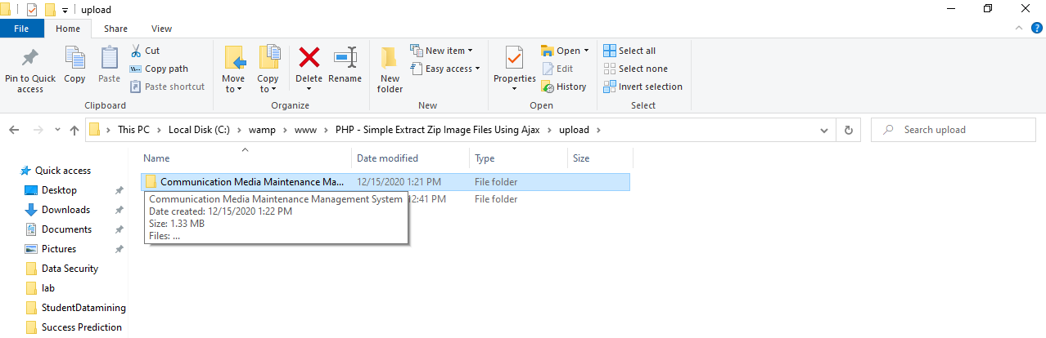
Figure 4.1: Extracted Folder: This is the extraction page that display all file decompressed.

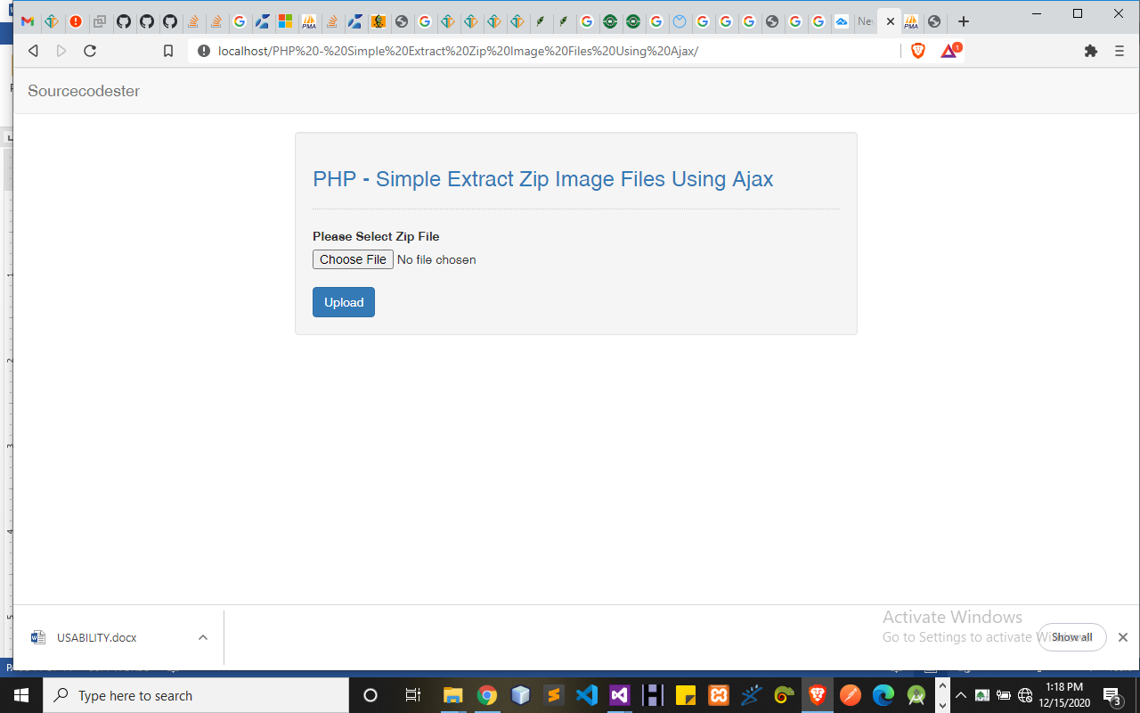
Figure 4.2: Zip Upload: This is allow user to upload zip file.
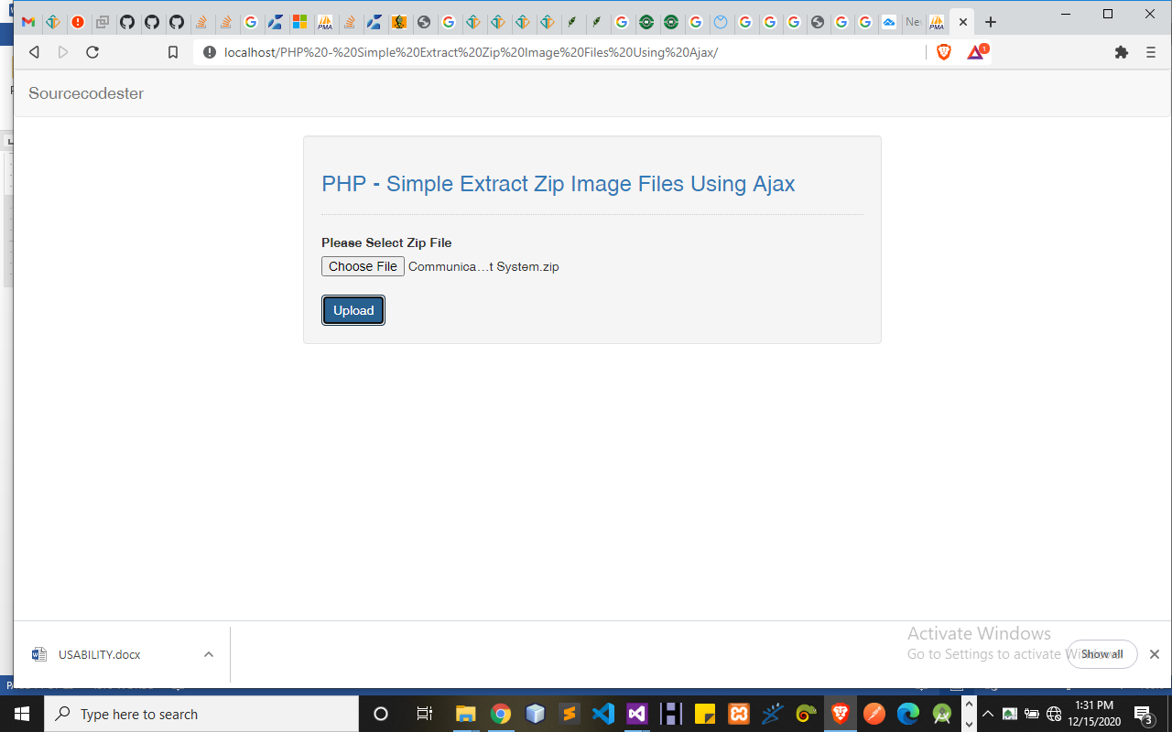

Figure 4.3: Decompress: This is decompress module where a zip file is upload to be decompress.

4.1.2 INPUT DESIGN

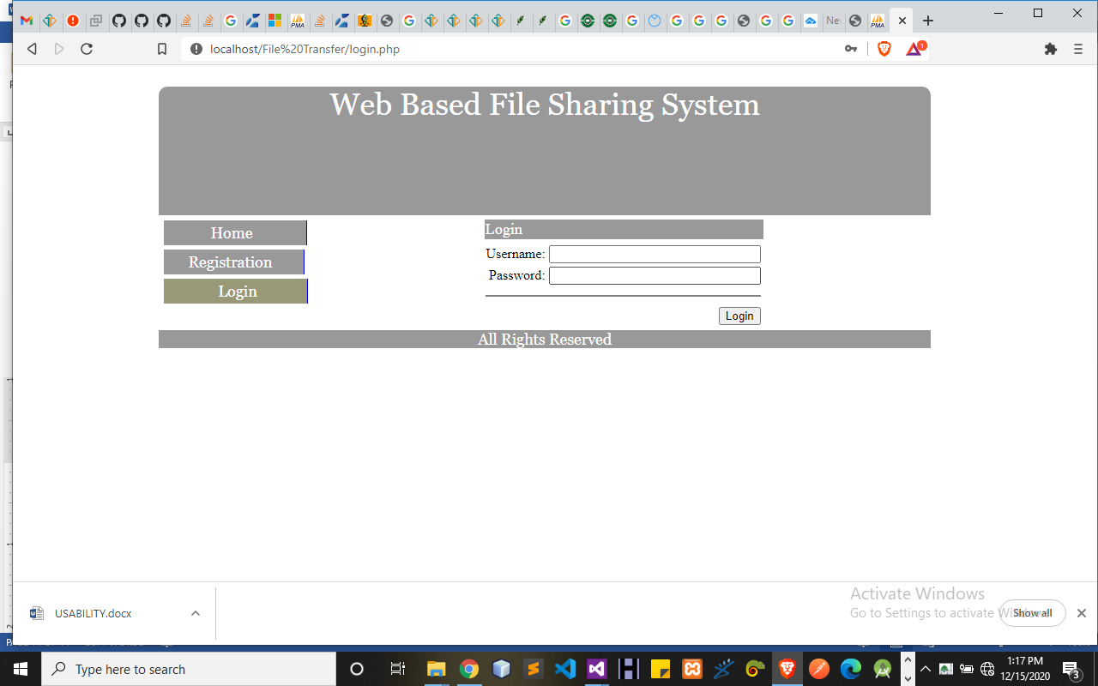

Figure 4.4: Login: This gives authorized user access into the system.

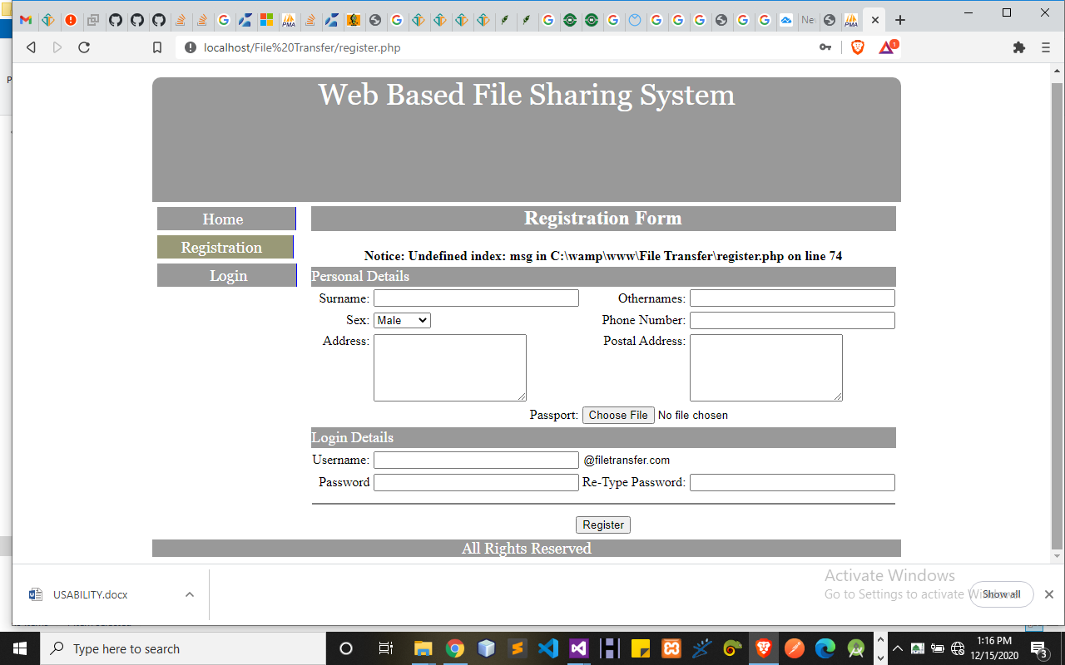
Figure 4.5: Register: This gives users to fill in their information to gain access to the system
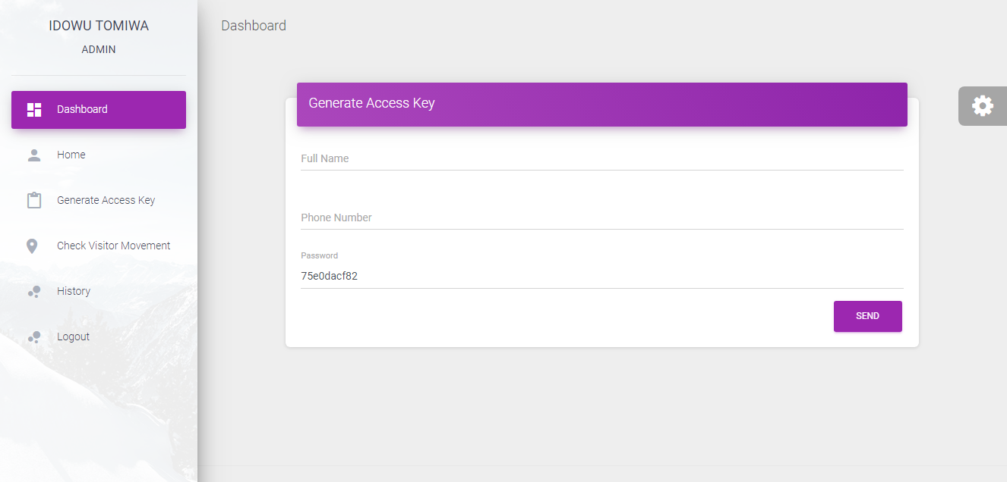
Figure 4.11: Generate Key: This is where admins generate new key.

4.1.5 DATABASE DESIGN
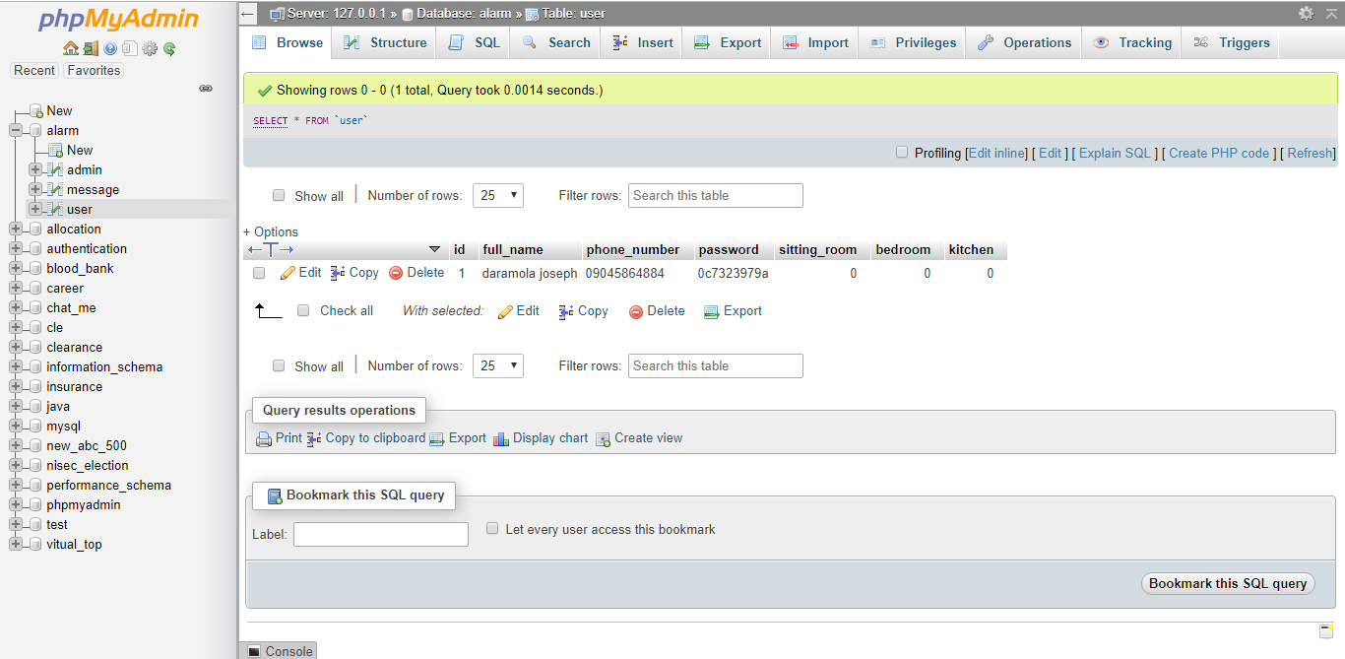Table 4.1: User data table: This is where user’s data are stored and retrieved

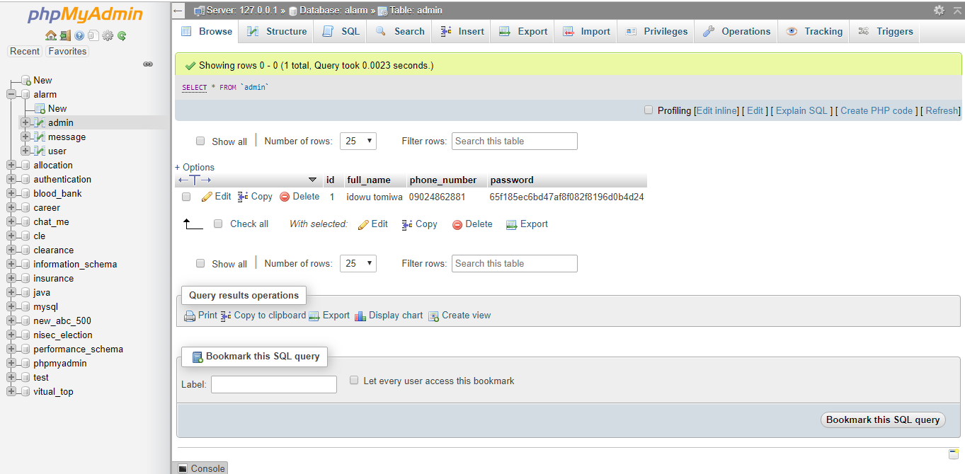
Table 4.2: Admins Data Table: This is where admins data are stored and retrieved.

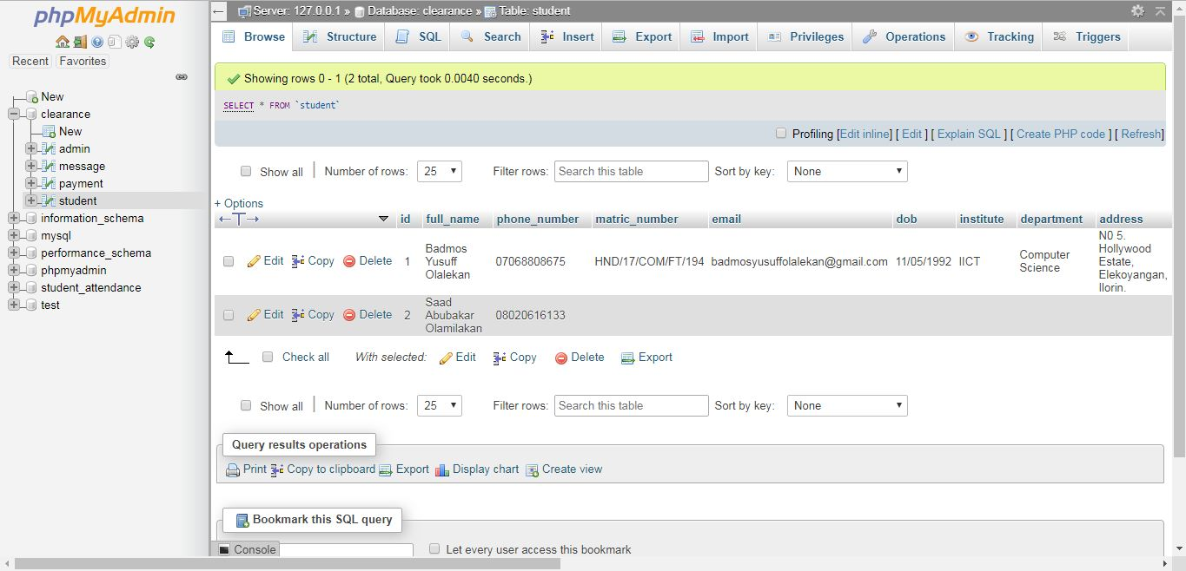Table 4.3: File Table: This table deals with files storage.

4.1.5 PROCEDURE DESIGN
The procedural design describes the system generally. It describes the various main programs in the system as well as the relationship that exist between all subprograms included. The procedural designs in this new system are of 2 modules (admin and user) each modules consist of 4 menus of which each menu has it sub menu.
The application also contains several modules of which each module has its own specific function. The purpose of dividing the program into modules is because it enhances maintainability, readability and easy debugging.
4.2 SYSTEM IMPLEMENTATION
4.2.1 CHOICE OF PROGRAMMING LANGUAGE
The application is designed in Sublime web development package which involves the use of PHP server-side scripting language, MYSQL for database management and HTML (with other embedded functionalities) for the page design and layout settings. Hence, the program testing simply involves running it directly from a Mozilla Firefox web browser on local host server provided by Apache 2.0 inWampServer 2.0 application.
4.2.2 HARDWARE SUPPORT
The computer configuration required to run the software is;
Computer/memory processor PC with a 48dx, MHZ or Pentium, Intel or higher processor required.
Memory : 2GB of RAM
Cache memory : 512KB
Hard disk Minimum size : 500GB
Recommended : 40GB
Virtual Memory :32Bits
Cache memory :512KB
Floppy disk drive :1.44MB
4.2.3 SOFTWARE SUPPORT
i. Interface Design Language, windows Notepad for help interface design Hypertext Mark-up Language (HTML).
ii. MY SQL Database Management Software.
iii. PHP (Hypertext Pre-processor) Programming.
iv. Operating system window 07 professional.
v. Graphic software paint shop and choosing these two formats GIF (Graphic Image Format)
vi. Scanner software, Mira scans.
vii. Web browser software MOZILLA
4.2.4 IMPLEMENTATION TECHNIQUES USED IN DETAILS
The system will be implemented using the parallel approach. This approach is considered because it ensures that the new system is tested alongside with the old system to ensure the effectiveness and efficiency of the system.

4.3 SYSTEM DOCUMENTATION
4.3.1 PROGRAM DOCUMENTATION
The system must be used as instructed according to the hardware and software supports so as to make optimal use of it.
    - OPERATING THE SYSTEM
- Click start on the computer desktop
- Select all programs
- Select any browser e.g Internet Explorer, Mozilla Firefox, Google Chrome e.t.c
- Type the url (Uniform Resource Locator) of the system into the address bar (localhost/password/)
4.3.3 MAINTAINING THE SYSTEM
The use of the term maintenance for software is different from other references to maintenance. Unlike the tires on your car, software does not “wear out”. If this is the case, then why does software maintenance account for such a high percentage of the Total Cost of Ownership for software?
The software maintenance definition refers to changes for defect correction, performance improvements, or adaptations to a changed environment (enhancements). According to this definition, if we build software that is defect-free, performs well, and contains user-controlled parameters to adjust processing rules in response to changing requirements then most maintenance would not be necessary.
Why does this happen? There are many reasons but the most common reasons are time constraints and lack of experience. Adding validation logic takes time. So, people make assumptions about the quality of in-bound data. Assumptions are also made about the volume of transactions and the impact on performance and the stability of the automated business processes. Finally, it is common for new software to be developed by younger developers who don’t understand the maintenance impacts of their designs.
The reality is that business requirements change and most of these assumptions are flawed. Transaction volumes increase, changing business processes require new transactions or new validation criteria, and software users will use the software incorrectly. The cost of software maintenance and the total cost of ownership can dramatically be reduced if developers build software that adjusted to changes in transaction volumes; validated all inbound data and provide user-configurable options for decision logic and data validation.

CHAPTER FIVE
SUMMARY, CONCLUSION AND RECOMMENDATION
5.1 SUMMARY
Data compression is a topic of much importance and many applications. Methods of data compression have been studied for almost four decades. This research has provided an overview of data compression and decompression methods of general utility. The algorithms have been evaluated in terms of the amount of compression they provide, algorithm efficiency, and susceptibility to error. While algorithm efficiency and susceptibility to error are relatively independent of the characteristics of the source ensemble, the amount of compression achieved depends upon the characteristics of the source to a great extent. After the implementation of the algorithms, the searching tool has been able to achieve the goal set for it, which provides an efficient means to update staff record and other modifications with increase in efficiency, speed and reliability of the report; and keep the updated record in archive for future references.
5.2 CONCLUSION
This dissertation has been able to achieve the goal set for it by designing a file management system with an efficient method to sort, merge and extract record using Shanno-fano algorithms. This algorithm helps in sorting different categories of information in the database, and then merges several fields into one single record to generate the desired report in a required format.

5.3 RECOMMENDATION
Future research effort will be towards providing tools that can scan and fix personnel passport photograph into the profile for further clarification, increase the level of security and extract record by speaking to the computer system using voice recognition.

REFERENCES
Amandeep &Meenakshi (2020) Research Paper on Text Data Compression Algorithm using Hybrid Approach, International Journal of Computer Science and Mobile Computing, IJCSMC, Vol. 3, www.ijcsmc.com
Atiqur &Mohamed (2019) Lossless image compression techniques, Symmetry 2019, 11, 1274; doi:10.3390/sym11101274 www.mdpi.com/journal/symmetry
Bayadir (2021) A hybrid compression algorithm by using shannon-fano coding and oring bits, Journal of Kerbala University , Vol. 6 No.3 Scientific. https://www.researchgate.net/publication/309617318
Christian (2020) Lossless data compression, Christian Steinruecken, University of Cambridge. Re-typeset on March 2, 2018, using L ATEX, gnuplot, and custom-written software
Debra & Daniel (2021) Data Compression, International Journal of Application or Innovation in Engineering & Management (IJAIEM) Web Site: www.ijaiem.org
Gustav Tano (2020) Transparent data compression and decompression for embedded systems, International Journal of Application or Innovation in Engineering & Management (IJAIEM) Web Site: http://www.ijaiem.org
Jasmine (2020) A Study on Data Compression Using Shanno-fano Coding Algorithms, International Journal of Computer Science Trends and Technology (IJCST) – Volume 5, ISSN: 2347-8578, www.ijcstjournal.org
Nirmal & Gupta (2021) A Shanno-fano algorithm optimal tree approach for data compression and decompression, International Journal of Engineering Applied Sciences and Technology Vol. 2, Issue 3, ISSN No. 2455-2143, http://www.ijeast.com
Raja &Saraswathi (2020) An effective two stage text compression and decompression technique for data communication, International Journal of Electronics and Communication Engineering. ISSN 0974-2166 Volume 4, pp. 233-241, http://www.irphouse.com
Ruchi et al (2016) Data compression - Lossless and lossy techniques, International Journal of Application or Innovation in Engineering & Management (IJAIEM) , www.ijaiem.org

