COMPUTATIONAL AND EXPERIMENTAL EFFECTS OF Syzygium aromaticum (CLOVES) ON ACETYLCHOLINE ESTERASE AND ANGIOTENSIN CONVERTING ENZYME

BY:

BADMUS ISLAMIYAT OLAMIDE

HND/23/SLT/FT/0731

SUBMITTED TO
THE DEPARTMENT OF SCIENCE LABORATORY TECHNOLOGY,
(BIOCHEMISTRY UNIT),
INSTITUTE OF APPLIED SCIENCES (IAS)
KWARA STATE POLYTECHNIC,ILORIN.

IN PARTIAL FULFILMENT OF THE REQUIREMENTS FOR THE
AWARD OF HIGHER NATIONAL DIPLOMA (HND)
IN SCIENCE LABORATORY TECHNOLOGY (SLT)

SUPERVISED BY
MR. ALLI, A. O.

July, 2025.

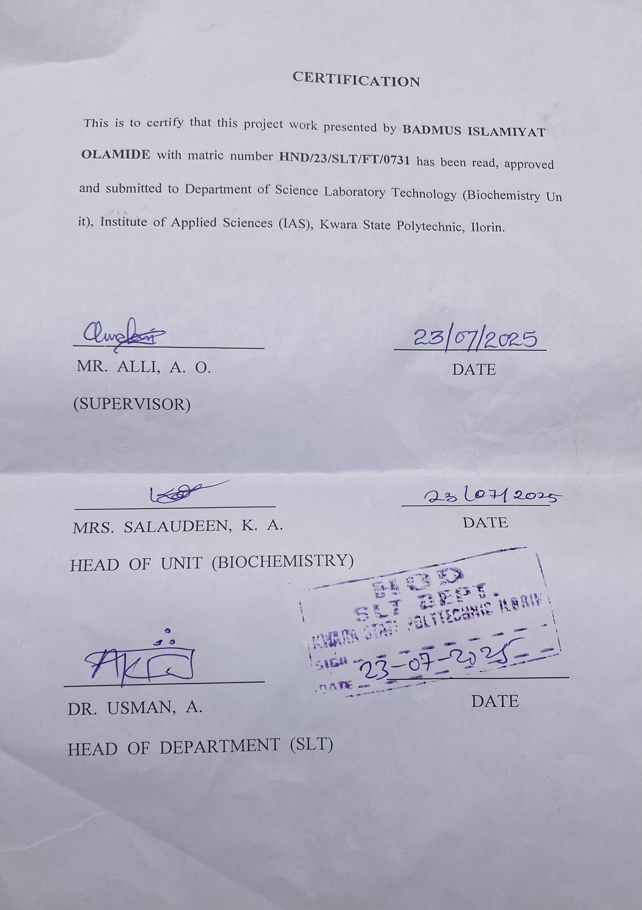

DEDICATION
I dedicate this project to Almighty Allah and to my Beloved parents Mr & Mrs Badmus Yunus. May Almighty Allah continue to bless you for me.

ACKNOWLEDGEMENT
All Thanks and Glory to Almighty Allah, who in his infinite mercy has showered his blessings and favour upon me throughout this course.

My sincere appreciation goes to my parents, Mr and Mrs YUNUS BADMUS
I would like to express my sincere gratitude to all the individuals for mentoring and supporting me in completing this project.

I am grateful to my friends, who contributed ideas and perspectives that enriched the project.
Thank you everyone for shaping this project and enhancing my learning experience.

Special thanks are expecting to MR. ALLI, A.O. who had worked tirelessly to see the success of this work, for his advice and supervision.

And all of the staff of BIOCHEMISTRY Unit who had in one way or the other impact knowledge on me, Thank you all for your support and encouragement. May Almighty Allah continue to bless you All (AMEN).

LIST OF FIGURES
Figures Title Page
Figure 2.1 Pathophysiology of Erectile Dysfunction 18
Figure 4.1 Percentage Inhibition of the Syzygium aromaticum and Donepezil 28
Figure 4.2 Percentage Inhibition of the Syzygium aromaticum and Donepezil 28
Figure 4.3 GC-MS Chromatogram of Syzygium aromaticum Aqueous Extract 29
Figure 4.4 SP Docking of Bioactive Compounds of S. aromatic Aqueous Extract 32
against Acetylcholinesterase
Figure 4.5 XP Docking of Bioactive Compounds of S. aromatic Aqueous Extract 33
against Acetylcholinesterase
Figure 4.6 SP and XP Docking Interactions of Acetylcholinesterase with Donepezil 34
(A: SP Docking Interaction of AChE with Donepezil; B: XP Docking
Interaction of AChE with Donepezil).
Figure 4.7 SP and XP Docking Interactions of Acetylcholinesterase with 35
- ethyl-2H-Benzotriazole (A: SP Docking Interaction of AChE with
2-ethyl-2H-Benzotriazole; B: XP Docking Interaction of AChE with
2-ethyl-2H-Benzotriazole).
Figure 4.8 SP Docking of Bioactive Compounds of S. aromatic Aqueous Extract 37
against Angiotensin Converting Enzyme
Figure 4.9 XP Docking of Bioactive Compounds of S. aromatic Aqueous Extract 38
against Angiotensin Converting Enzyme
Figure 4.10 SP and XP Docking Interactions of Angiotensin Converting Enzyme 39
with Captopril (A: SP Docking Interaction of ACE with Captopril;
B: XP Docking Interaction of ACE with Captopril).
Figure 4.11 SP and XP Docking Interactions of Angiotensin Converting Enzyme 40
with 2-ethyl-2H-Benzotriazole (A: SP Docking Interaction of ACE with
2- ethyl-2H-Benzotriazole; B: XP Docking Interaction of ACE with
2-ethyl-2H-Benzotriazole).

LIST OF TABLES
Table Title Page
Table 4.1 Phytochemical Screening of Syzygium aromaticum Aqueous Extract 27
Table 4.2 GC-MS Results of Syzygium aromaticum Aqueous Extract 30
Table 4.3 ADMET Profile and Lipinski Status of the Hit Compounds and 42
Standard Inhibitors of AChE and ACE

ABSTRACT
Erectile dysfunction is commonly associated with reduced cholinergic activity and vascular impairment, involving enzymes such as acetylcholinesterase and angiotensin converting enzyme. Acetylcholinesterase reduces acetylcholine levels, limiting nitric oxide release essential for penile smooth muscle relaxation, while angiotensin converting enzyme facilitates the production of angiotensin II, a vasoconstrictor linked to endothelial dysfunction. Inhibiting these enzymes may enhance erectile function. Syzygium aromaticum (clove), a spice with a history of use in traditional medicine for male reproductive health, contains bioactive compounds that may target these enzymes. This study investigated the computational and experimental effects of S. aromaticum aqueous extract on acetylcholinesterase and angiotensin converting enzyme, with relevance to erectile dysfunction. The aqueous extract was obtained using hot maceration. Qualitative phytochemical screening was carried out to identify key metabolites. Enzyme inhibition assays were conducted in vitro to assess inhibitory potential. Gas chromatography–mass spectrometry was used to profile chemical constituents, while molecular docking predicted interactions between selected compounds and both enzymes. ADMET analysis evaluated pharmacokinetic and safety properties. Phytochemical analysis confirmed the presence of flavonoids, alkaloids, phenols, tannins, and glycosides. The extract demonstrated moderate inhibitory activity on both enzymes. GC-MS revealed several active compounds, among which 2-ethyl-2H-benzotriazole showed strong binding affinity in docking simulations. ADMET predictions suggested good absorption and drug-likeness. Thus, Syzygium aromaticum may provide dual inhibitory potential against key enzymes involved in erectile dysfunction, and further studies are recommended for therapeutic development.

TABLE OF CONTENT

CERTIFICATION II
DEDICATION III
ACKNOWLEDGEMENT IV
LIST OF FIGURES V
ABSTRACT VII
TABLE OF CONTENT VIII
CHAPTER ONE 1
1.0 INTRODUCTION 1
1.2 Justification for the Study 2
1.3 Problem Statement 4
1.4 Significance of the Study 5
1.5 Study Objectives 6
CHAPTER TWO 7
2.0 LITERATURE REVIEW 7
2.1 Erectile Dysfunction 7
2.2 Epidemiology of Erectile Dysfunction 9
2.3 Pathophysiology of Erectile Dysfunction 9
2.3.1 Acetylcholinesterase 12
2.3.2 Angiotensin Converting Enzyme 14
2.4 Acetylcholinesterase and Angiotensin-Converting Enzyme Inhibition 15
2.4.1 Limitations of Current Acetylcholinesterase (AChE) and Angiotensin-Converting Enzyme (ACE) Inhibitors 17
2.5 Syzygium aromaticum (Clove) 18
2.5.1 Bioactive Components of Syzygium aromaticum 20
CHAPTER THREE 22
3.0 MATERIALS AND METHODS 22
3.1 Materials 22
3.1.1 Plant Materials 22
3.1.2 Reagents and Kits 22
3.1.3 Software and Web Servers 22
3.2 Methods 22
3.2.1 Preparation of Clove Extract 22
3.3 Qualitative Phytochemical Screening 23
3.4 In vitro Inhibition Assays of Acetylcholinesterase (AChE) and Angiotensin Converting Enzyme (ACE) 23
3.4.1 Acetylcholinesterase Inhibition Assay 23
3.4.2 Angiotensin Converting Enzyme 24
3. 5 GC-MS Analysis of S. aromaticum Aqueous Extract 25
3.6 Statistical Analysis 25
3.7 In Silico Study 26
3.7.1 Molecular Docking of S. aromaticum Bioactive Compounds against AChE and ACE 26
3.8 ADMET Screening 26
CHAPTER FOUR 27
4.0 RESULTS 27
4.1 Percentage Yield of Extract 27
4.2 Phytochemical Screening of Syzygium aromaticum Aqueous Extract 27
4.3 In vitro Acetylcholinesterase and Angiotensin Converting Enzyme Inhibition Assays 28
4.4 GC-MS Analysis of Syzygium aromaticum Aqueous Extract 29
4.5 In silico Study 31
4.5.1 Molecular Docking of Acetylcholinesterase 32
4.5.2 Molecular Docking of Angiotensin Converting Enzyme (ACE) 37
4.6 ADMET Screening 42
CHAPTER FIVE 44
5.0 DISCUSSION, CONCLUSION AND RECOMMENDATION 44
5.1 Discussion 44
5.2 Conclusion 46
5.3 Recommendations 47
REFERENCES 48

CHAPTER ONE

1.0 INTRODUCTION
1.1 Background of the Study
Erectile dysfunction (ED) is a prevalent male sexual health disorder characterized by the persistent failure to achieve or maintain an erection sufficient for satisfactory sexual performance. Its pathophysiology is multifactorial with vascular, neurological, hormonal, and psychological factors (Kendirci & Hellstrom, 2018). Among these, endothelial dysfunction, impaired nitric oxide signaling, and neurogenic deficits, often coupled with the activity of enzymes such as angiotensin-converting enzyme (ACE) and acetylcholinesterase (AChE), have been prominent contributors to ED (Hatzimouratidis et al., 2021).
ACE is a primary regulator of the renin-angiotensin system via the conversion of angiotensin I to angiotensin II, a potent vasoconstrictor. Enhanced ACE activity can lead to hypertension and vascular dysfunction that are closely associated with ED (Saran et al., 2019). AChE, on the other hand, degrades acetylcholine, which is a neurotransmitter involved in penile erection by enhancing parasympathetic nervous system activity and inducing the release of nitric oxide (Della Camera et al., 2020). Inhibition of these enzymes, therefore, presents a promising therapeutic intervention in ED treatment.
Natural products are gaining increasing interest as potential alternatives to conventional drugs because they are relatively less toxic and possess diverse bioactivity. Syzygium aromaticum (clove) is a medicinal spice with a rich percentage of bioactive compounds such as eugenol, flavonoids, and tannins. It has been reported to possess extensive pharmacological activities such as antioxidant, anti-inflammatory, and enzyme-inhibitory activities (Khan et al., 2019). Current findings reveal that S.
aromaticum was able to inhibit both ACE and AChE, signifying its potential in the therapy of vascular and neurogenic dysfunction-related diseases, including ED (Ajibola et al., 2022; El-Guendouz et al., 2018).
In the wake of advances in computational biology, in silico approaches such as molecular docking and ADMET predictions have become effective tools in the prediction of phytochemical-therapeutic target interactions. When combined with in vitro validation, such techniques provide good pointers to the pharmacological potential of plant molecules (Choudhary et al., 2021). Therefore, the investigation of S. aromaticum aqueous extract's dual inhibitory activity against AChE and ACE through experimental and computational techniques may offer a novel, plant-based strategy for erectile dysfunction treatment.

1.2 Justification for the Study
To say that erectile dysfunction (ED) is a sore and very psychosocially significant disorder would be an understatement, and it is also a sentinel symptom of associated cardiovascular and neurovascular disease (Hatzimouratidis et al., 2021). Conventional pharmacologic treatments, e.g., phosphodiesterase type-5 inhibitors like sildenafil, although very effective in the majority of patients, have side effects, cardiovascular contraindications among patients, and reduced efficacy in patients with severe endothelial disease or diabetes (Kendirci & Hellstrom, 2018). These limitations create the necessity for a safer, effective, and useful alternative or complementary therapy in more than one pathophysiologic process.
The rationale behind inhibiting acetylcholinesterase (AChE) and angiotensin-converting enzyme (ACE) in ED is their varying roles in neurogenic and vascular control of penile erection. The prolonged action of acetylcholine results from the inhibition of AChE, enhancing parasympathetic stimulation and release of NO, crucial for relaxation of smooth muscles and erection (Della Camera et al., 2020). Concurrently, ACE inhibitors block the synthesis of angiotensin II, a potent vasoconstrictor, and thereby improve endothelial function and penile perfusion (Silva et al., 2020). This strategy of dual inhibition can therefore confer synergistic benefits in ED management in a more integrative fashion.
Syzygium aromaticum (clove) is a promising botanical lead with its rich content of phytochemicals and widely documented pharmacological activity of antioxidant, anti-inflammatory, neuroprotective, and cardioprotective action (Khan et al., 2019). Its AChE inhibitory and ACE inhibitory activities have already been discovered by earlier in vitro and in silico investigations (Ajibola et al., 2022; El-Guendouz et al., 2018), but its unique application for the treatment of ED still awaits exploration.
In addition to that, the combination of in vitro biochemical assays and computational tools (e.g., molecular docking, pharmacokinetic prediction) enhances the predictive value of the study and follows the trend of drug discovery and validation in today's era (Choudhary et al., 2021). Multi-disciplinary approach not only facilitates evidence-based discovery of ethnomedicinal plants but also accelerates the discovery of new lead compounds.
This study is justified by the need to identify safe, multi-target nature-based therapy alternatives for ED synthetic treatment, i.e., the neurogenic and vascular pathologies of erectile dysfunction. An investigation into the aqueous extract of Syzygium aromaticum is therefore aimed at bridging the therapy gap and may yield a new phytotherapeutic strategy towards treating erectile dysfunction.

1.3 Problem Statement
Erectile dysfunction (ED) is a major public health concern, with an estimated prevalence of up to 50% in men aged over 40 years globally (Hatzimouratidis et al., 2021). Although the use of conventional therapy like phosphodiesterase type-5 (PDE5) inhibitors is highly prevalent, the medication cannot be effective in every subject, especially in those with comorbid conditions such as diabetes, hypertension, or neurovascular deficiency. Moreover, their side effects and interaction with nitrate therapy restrict their usage even further (Kendirci & Hellstrom, 2018).
Emerging data incriminate ED not only with vascular impairment but also with defective neurotransmission—processes regulated by angiotensin-converting enzyme (ACE) and acetylcholinesterase (AChE), respectively (Silva et al., 2020; Della Camera et al., 2020). ACE overexpression leads to vasoconstriction and reduced penile blood flow, while elevated AChE activity suppresses cholinergic transmission, both of which are associated with erectile dysfunction. Nevertheless, existing ED treatments significantly overlook these dual enzymatic pathways, suggesting a gap in comprehensive treatment approaches.
In searching for novel, multi-target drugs, plant-derived drugs are very promising. Syzygium aromaticum (clove), commonly used in traditional medicine, exhibits well-documented inhibitory effects on AChE and ACE and has antioxidant and anti-inflammatory constituents of therapeutic potency in acute ED treatment (Khan et al., 2019; Ajibola et al., 2022). However, its existing exploration as an element of ED treatment is scanty and piecemeal, particularly in aqueous extract formulations.
Furthermore, despite the fact that in silico studies have emerged as powerful aids to drug development, they are rarely partnered with in vitro validation to explore the dual enzyme-inhibitory activities of plant extracts towards ED-related pathways. This is an important gap of research need in systematic exploration of S. aromaticum as a dual-target drug.

1.4 Significance of the Study
The study has immense potential in filling important therapeutic gaps in erectile dysfunction (ED) therapy, especially via exploration of natural compounds with multi-targeted activity. By studying Syzygium aromaticum (clove) aqueous extract inhibitory activities on acetylcholinesterase (AChE) and angiotensin-converting enzyme (ACE), the study is aligned with the recent scientific trend to develop safer and more efficacious alternatives to synthetic ED drugs, which are associated with side effects and narrow therapeutic window (Kendirci & Hellstrom, 2018; Hatzimouratidis et al., 2021).
ED is currently known not just as a specific sexual disorder, but as a marker of systemic health that includes vascular and neurological dysfunction. AChE and ACE are crucial to the regulation of penile erection, AChE in the regulation of cholinergic neurotransmission necessary for nitric oxide-mediated vasodilation, and ACE in the regulation of vascular tone by the renin-angiotensin system (Della Camera et al., 2020; Silva et al., 2020). Thus, an approach of therapy with both these enzymes offers an interdisciplinary regimen by targeting neurogenic and vascular components of ED simultaneously.
The study also contributes to the scientific evidence of Syzygium aromaticum, a medicinal plant that is widely used in traditional medicine but not extensively researched in the management of ED. While earlier studies reported its antioxidant, anti-inflammatory, and enzyme-inhibiting properties (Khan et al., 2019; Ajibola et al., 2022), this work intends to investigate its bioactivity against two enzymes relevant to ED, which is a significant lacuna of phytopharmacological literature. Also, the integration of in vitro assays with in silico molecular docking and pharmacokinetic predictions lends power to the translational relevance of the findings. It provides mechanistic understanding of enzyme-ligand interactions and complements empirical data with computational validation (Choudhary et al., 2021).

1.5 Study Objectives
The overall objective of the present study was to evaluate the inhibitory potential of Syzygium aromaticum aqueous extract on acetylcholinesterase (AChE) and angiotensin-converting enzyme (ACE) both in vitro and in silico, as a strategic move in the management of erectile dysfunction (ED). The specific objectives were to:
- prepare aqueous extract of Syzygium aromaticum;
- carryout phytochemical screening of the aqueous extract using standardized phytochemical screening protocols;
- determine the in vitro inhibitory activity of Syzygium aromaticum aqueous extract against acetylcholinesterase and angiotensin-converting enzyme;
- carryout GC-MS analysis on the Syzygium aromaticum aqueous extract;
- perform molecular docking of Syzygium aromaticum aqueous extract bioactive compounds against AChE and ACE using Schrodinger Maestro version 13.9;
- assess pharmacokinetic properties of hit compound; absorption, distribution, metabolism and excretion (ADME), as well as the toxicity and Lipinski of five.

CHAPTER TWO

2.0 LITERATURE REVIEW

2.1 Erectile Dysfunction
Erectile dysfunction (ED) is a prevalent male sexual disorder defined by the persistent inability to attain or maintain a penile erection sufficient for satisfactory sexual performance. More than 150 million men globally are affected, and the figure is projected to increase to more than 300 million by 2025 (Hatzimouratidis et al., 2021; Yafi et al., 2018). ED is not only a quality-of-life disorder but also a potential early indicator of systemic illnesses, including hypertension, diabetes mellitus, atherosclerosis, obesity, and neurological disease (Corona et al., 2020; Gandaglia et al., 2018). The increasing prevalence of chronic illness, sedentary lifestyles, and aging populations underscores the growing clinical relevance of ED as a multifactorial process susceptible to multidisciplinary treatment (Kendirci & Hellstrom, 2018).
Physiology of penile erection relies on a multifaceted integration of neurological, vascular, hormonal, and psychological mechanisms, with the nitric oxide (NO)–cyclic guanosine monophosphate (cGMP) signaling pathway playing a fundamental function (Della Camera et al., 2020; Vignozzi et al., 2020). Neurogenic stimulation triggers NO release, which activates soluble guanylyl cyclase in the smooth muscle cells of corpus cavernosum to generate high levels of cGMP and cause vasodilation (Goukassian et al., 2019). Acetylcholine, the primary parasympathetic neurotransmitter, augments this activity by activating endothelial NO synthase (eNOS). Its breakdown by acetylcholinesterase (AChE), however, interferes with neurotransmission and leads to erectile failure (Yuan et al., 2021; Della Camera et al., 2020). Vascular dysfunction is also at the core of ED, more specifically through the renin–angiotensin–aldosterone system (RAAS). Angiotensin-converting enzyme (ACE) catalyzes angiotensin I conversion to angiotensin II, a potent vasoconstrictor that elevates blood pressure and promotes endothelial dysfunction (Silva et al., 2020; Pavin et al., 2022). Enhanced ACE activity reduces penile blood inflow and impairs cavernous tissue relaxation, resulting in vascular-origin ED (Mazo et al., 2020). Interestingly, clinical studies have shown that ACE inhibitors not only manage systemic hypertension but also improve endothelial function and erectile function, especially in patients with underlying cardiovascular disease (Stein et al., 2019; Wang et al., 2021).
Despite the common use of phosphodiesterase type-5 inhibitors (PDE5i) such as sildenafil and tadalafil, the medications fail to work in some individuals. Approximately 30–40% of the patients, particularly diabetics, those with neuropathy, or those with severe endothelial dysfunction, either respond poorly or experience adverse effects like headache, hypotension, and visual disturbances (Kendirci & Hellstrom, 2018; Salem et al., 2020). Furthermore, PDE5i do not address the upstream etiologies of ED, such as oxidative stress, inflammation, and enzymatic imbalance of AChE and ACE (Bivalacqua et al., 2019; Vardi et al., 2021).
Natural products, and medicinal plants specifically, have been promising safer and multi-mechanistic alternatives. Syzygium aromaticum (clove) is a common spice and medicinal herb with a high phytochemical content of eugenol, β-caryophyllene, and gallic acid (Khan et al., 2019; Dalli et al., 2020). In various studies, it was revealed to have dual inhibition of AChE and ACE, alongside antioxidant and anti-inflammatory properties that restore neurovascular balance in ED (Ajibola et al., 2022; El-Guendouz et al., 2018). In silico molecular docking studies reveal strong binding affinities of S. aromaticum compounds to the key active sites of both enzymes, and in vitro studies confirm its biochemical potential (Choudhary et al., 2021; Dahham et al., 2020).

2.2 Epidemiology of Erectile Dysfunction
Erectile dysfunction (ED) is a widespread condition with a high worldwide health burden, affecting both developing and developed nations. Epidemiological data show that ED affects approximately 52% of men aged 40–70 years, with the prevalence increasing substantially with age (Yafi et al., 2018). By 2025, the worldwide prevalence of men with ED will be more than 322 million, driven by aging populations and the increasing burden of comorbidities such as diabetes, hypertension, cardiovascular disease, and obesity (Hatzimouratidis et al., 2021; Corona et al., 2020).
The strongest predictor of ED is age, but lifestyle and metabolic factors also have an important contribution. Evidence suggests that men with type 2 diabetes mellitus are two to three times more likely to have ED than non-diabetic men (Salonia et al., 2021). ED is also much more common in individuals with hypertension, metabolic syndrome, or a background of smoking and lack of physical activity (Kendirci & Hellstrom, 2018). The prevalence is also higher in low- and middle-income countries, where limited access to health care and high burden of chronic disease exacerbate the condition (Arowojolu et al., 2020).
Early treatment and diagnosis of ED are not just pertinent to improve sexual health, but also to detect cardiovascular risk, as ED precedes coronary artery disease by 2–5 years (Gandaglia et al., 2018).

2.3 Pathophysiology of Erectile Dysfunction
Erectile dysfunction (ED) pathophysiology includes an intricate disruption in vascular, neural, hormonal, and psychological mechanisms required to achieve and maintain penile erection (Hatzimouratidis et al., 2021; Yafi et al., 2018). The parasympathetic nervous system is primarily responsible for the erection process via stimulation of release of NO in the corpus cavernosum, activation of guanylate cyclase, and increase in cyclic guanosine monophosphate (cGMP) levels (Della Camera et al., 2020; Vignozzi et al., 2020). It is followed by vasodilation, smooth muscle relaxation, and increased penile blood flow (Goukassian et al., 2019; Musicki & Burnett, 2021). Dysfunctional impairment in any of these elements in the cascade, neural, vascular, or chemical, could cause erectile failure (Corona et al., 2020; Salonia et al., 2021).
Endothelial dysfunction is the primary causative factor in ED, particularly for men with chronic conditions like diabetes, hypertension, or atherosclerosis (Bivalacqua et al., 2019; Gandaglia et al., 2018). Endothelial damage produces decreased production of NO (Figure 2.1), leading to less smooth muscle relaxation and poor penile perfusion (Stein et al., 2019; Kendirci & Hellstrom, 2018). In addition, increased oxidative stress and inflammation that are characteristic of metabolic syndrome and aging decrease NO bioavailability and increase endothelial injury (Mazo et al., 2020; Musicki et al., 2021). These synergistically impair vasodilatory function essential for normal erection (Vardi et al., 2021; Wang et al., 2021).
Neurogenic impairment is another vital mechanism in ED. Parasympathetic nerve injuries, frequent in men with spinal cord injury, diabetes, or post-prostatectomy, can interfere with the neural loops that are responsible for NO release (Yuan et al., 2021; Della Camera et al., 2020). Of interest here is the enzyme acetylcholinesterase (AChE). AChE hydrolyzes acetylcholine, a neurotransmitter of central importance to endothelial NO synthase activation and the initiation of vasodilation (Choudhary et al., 2021; El-Guendouz et al., 2018). Excessive activation of AChE can significantly lower acetylcholine availability, impacting neurogenic signaling and erectile function (Ajibola et al., 2022; Yuan et al., 2021).
Another important pathway engaged in ED is the renin–angiotensin system (RAS). Angiotensin-converting enzyme (ACE) breaks down angiotensin I to angiotensin II, a potent vasoconstrictor that promotes vascular resistance and endothelial dysfunction (Silva et al., 2020; Pavin et al., 2022). Overactivation of ACE results in reduced penile perfusion and erectile tissue fibrosis, particularly in hypertensive and diabetic men (Corona et al., 2020; Wang et al., 2021). ACE inhibitors have been promising to enhance such effects via endothelial function and hemodynamic equilibrium restoration in penile vasculature (Stein et al., 2019; Kendirci & Hellstrom, 2018).
Hormonal dysregulation, especially androgen deficiency, also underlies ED. Reductions in testosterone levels decrease libido and suppress expression of NO synthase and PDE5 enzymes in penile tissue (Corona et al., 2020; Salonia et al., 2021). Accordingly, pathogenesis of ED is multi-factorial with neurovascular dysfunction, viz., ACE and AChE involvement, being the enzymatic targets for its holistic management (Ajibola et al., 2022; Choudhary et al., 2021).

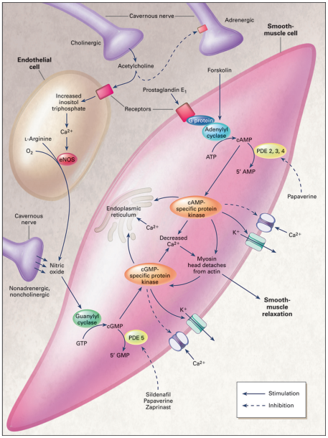
Figure 2.1: Pathophysiology of Erectile Dysfunction
Source: Roushias & Ossei-Gerning (2018)

2.3.1 Acetylcholinesterase
Acetylcholinesterase (AChE) is a key enzyme that catalyzes hydrolysis of the neurotransmitter acetylcholine to choline and acetate in cholinergic synapses. Acetylcholine is a significant neurotransmitter of parasympathetic nerve signaling involved in erectile function, facilitating release of nitric oxide (NO) from endothelial and non-adrenergic, non-cholinergic (NANC) neurons (Della Camera et al., 2020; Yuan et al., 2021). NO is needed to relax smooth muscle tissue within the corpus cavernosum to allow penile blood engorgement and erection. Excess activity of AChE—through increased break-down of acetylcholine—therefore impairs cholinergic transmission and can lead to reduced NO production, and hence directly causes erectile dysfunction (Choudhary et al., 2021; Musicki & Burnett, 2021).
The therapeutic relevance of AChE in ED lies in the fact that enhancement of cholinergic activity improves the quality of an erection. This has been demonstrated in clinical and preclinical studies with AChE inhibitors that increase acetylcholine and, consequently, augment NO-mediated vasodilation (Yuan et al., 2021; Della Camera et al., 2020). AChE blockade is therefore a rational approach to increase neurogenic activation of erection, especially after diabetic neuropathy or aging-related decline of neural responsiveness (Corona et al., 2020; Musicki et al., 2019).
Plant compounds have been of interest as safe AChE inhibitors. Plant-based compounds such as eugenol, gallic acid, and flavonoids found in Syzygium aromaticum (clove) have been shown to possess potent AChE inhibition in in silico and in vitro systems (Ajibola et al., 2022; El-Guendouz et al., 2018). These phytochemicals inhibit or emulate the enzyme active site, thus prolonging acetylcholine availability in synapses and augmenting cholinergic transmission in erectile tissue (Choudhary et al., 2021; Dahham et al., 2020).
New studies have proposed the combination of AChE inhibition with other therapeutic effects, such as antioxidant and anti-inflammatory activity, to provide a multi-targeted approach for ED therapy. Given the role of AChE in the neurovascular mechanism of erection, enzyme inhibition could serve as an adjunct or complement to existing pharmacologic treatments (e.g., PDE5 inhibitors) or as a substitute in patients with contraindications to synthetic drugs (Kendirci & Hellstrom, 2018; Yuan et al., 2021).

2.3.2 Angiotensin Converting Enzyme
Angiotensin-converting enzyme (ACE) is an essential part of the renin–angiotensin system (RAS), a hormonal cascade that regulates vascular tone and blood pressure. ACE converts angiotensin I into angiotensin II, a potent vasoconstrictor that promotes the contraction of smooth muscle, sodium retention, and endothelial dysfunction (Silva et al., 2020; Pavin et al., 2022). These effects contribute to the increased vascular resistance and reduced penile blood flow that are central defects in the pathophysiology of erectile dysfunction (ED) (Corona et al., 2020; Wang et al., 2021).
Increased angiotensin II levels are shown to suppress endothelial nitric oxide (NO) production and stimulate pro-inflammatory cytokines and reactive oxygen species (ROS) release, leading to oxidative stress and vascular inflammation (Musicki & Burnett, 2021; Vignozzi et al., 2020). These changes compromise endothelium-dependent vasodilation in the corpus cavernosum that forms the basis of erectile function. Furthermore, angiotensin II can induce fibrosis and structural remodeling of penile tissues, further exacerbating ED (Gandaglia et al., 2018; Mazo et al., 2020).
Pharmacological inhibition of ACE has demonstrated therapeutic benefit in both cardiovascular disease and erectile function. ACE inhibitors improve endothelial function, mitigate oxidative stress, and improve penile perfusion by inhibiting the formation of angiotensin II and enhancing that of bradykinin, a vasodilator degraded by ACE (Stein et al., 2019; Wang et al., 2021). Several clinical and animal studies have reported improved erectile responses to ACE inhibitor therapy, especially in patients who also have hypertension or diabetes mellitus (Corona et al., 2020; Salonia et al., 2021).
In recent years, plant-derived natural ACE inhibitors have been investigated for their therapeutic potential. Syzygium aromaticum (clove) has been a leading example, where bioactive compounds such as eugenol and gallic acid have demonstrated ACE inhibitory activity both in vitro and in silico (Ajibola et al., 2022; El-Guendouz et al., 2018). These phytochemicals interact with the zinc-bearing active site of ACE, blocking its enzymatic function and thus preventing angiotensin II generation (Choudhary et al., 2021; Dahham et al., 2020).

2.4 Acetylcholinesterase and Angiotensin-Converting Enzyme Inhibition
Co-inhibition of acetylcholinesterase (AChE) and angiotensin-converting enzyme (ACE) is scientifically established as a new therapeutic strategy for the treatment of erectile dysfunction (ED). Both enzymes are part of different but related mechanisms responsible for neurogenic and vascular causes of ED. Both enzyme inhibitions offer a synergistic pathway that facilitates improvement in erectile function by augmenting neurotransmission and endothelial function (Della Camera et al., 2020; Silva et al., 2020).
AChE is a significant enzyme that ends acetylcholine signaling within cholinergic synapses. Acetylcholine induces the release of nitric oxide (NO) from endothelial and nonadrenergic, noncholinergic (NANC) neurons, resulting in the relaxation of penile arteries and cavernosal smooth muscle and vasodilation (Yuan et al., 2021; Musicki & Burnett, 2021). Overactivity of AChE results in premature degradation of acetylcholine and therefore limits NO production and diminishes the neurogenic aspect of erection. AChE inhibitors have been discovered to prolong the action of acetylcholine, amplify parasympathetic transmission, and increase erectile response, especially among diabetic neuropathy or neurovascular impaired patients (Choudhary et al., 2021; Della Camera et al., 2020).
ACE, on the other hand, acts as a catalyst for the reaction that transforms angiotensin I into angiotensin II, a vasoconstrictive molecule generating heightened blood pressure, oxidative stress, and endothelial dysfunction—all of these detractors from penile flow (Pavin et al., 2022; Gandaglia et al., 2018). Angiotensin II also causes pro-inflammatory cytokines and contributes to fibrosis of cavernosal tissue. ACE inhibitors increase bradykinin levels, which are vasodilators, and increase bioavailability of NO, thereby optimizing penile hemodynamics while reducing vascular resistance (Stein et al., 2019; Wang et al., 2021).
More recent studies have shown the potential of natural dual inhibitors—compounds that suppress both AChE and ACE simultaneously. These dual-acting drugs have a greater composite therapeutic effect than single-target inhibitors, particularly in such diseases as ED that contain both neurogenic and vasculogenic components (Ajibola et al., 2022). Syzygium aromaticum (clove) has been found to be a rich source of phytochemicals like eugenol and gallic acid that show strong inhibitory action against AChE and ACE (El-Guendouz et al., 2018; Dahham et al., 2020). These bioactive compounds interact with both enzymes' active sites, as confirmed by molecular docking computations, and are effective in vitro inhibitors of the enzymes (Choudhary et al., 2021).
In silico docking simulations have provided detailed data on the interaction of natural compounds with AChE and ACE and confirmation of their drug value (Ajibola et al., 2022). For instance, eugenol possesses excellent docking scores and hydrogen bondings in the AChE gorge, and besides these coordinating with the zinc-bound catalytic domain of ACE (El-Guendouz et al., 2018). These molecular interactions not only validate the dual inhibitory activity but also support the formulation of plant-derived drugs to cure ED with minimal side effects.
Thus, blocking both AChE and ACE represents a new, dual-mechanism therapeutic approach to erectile dysfunction. It is particularly promising in nonresponsive patients to standard therapy or with comorbid diseases such as hypertension, diabetes, or neurovascular disease. Synergy of computational screening with biochemical validation of dual enzyme inhibitors—especially of natural origin like S. aromaticum—can pave the way for safer, more holistic treatment approaches in sexual medicine.

2.4.1 Limitations of Current Acetylcholinesterase (AChE) and Angiotensin-Converting Enzyme (ACE) Inhibitors
Despite the proven therapeutic effectiveness in them, the therapeutic use of acetylcholinesterase (AChE) and angiotensin-converting enzyme (ACE) inhibitors is not uncritical—especially in erectile dysfunction (ED). Mechanically accurate as such agents might be, they are plagued by poor specificity, safety, bioavailability, together with poor multitarget action, prompting the search for improved or different therapy (Della Camera et al., 2020; Wang et al., 2021).
A major disadvantage of synthetic AChE inhibitors (e.g., donepezil, rivastigmine) is their narrow therapeutic margin and potential for systemic cholinergic adverse effects such as bradycardia, gastrointestinal disturbance, hypersalivation, and muscle cramps (Yuan et al., 2021; Kendirci & Hellstrom, 2018). These effects are secondary to the non-selective increase in acetylcholine in both the central and peripheral nervous systems, rather than specifically aimed at penile tissue. Also, the chronic application of AChE inhibitors has been documented to lead to receptor desensitization or tolerance, thus reducing their long-term efficacy in treating neurogenic ED (Musicki & Burnett, 2021; Corona et al., 2020).
ACE inhibitors (such as enalapril, lisinopril) have also demonstrated cardiovascular disease and endothelial dysfunction protective effects but are not as effective in the cure of ED. The greatest drawback is the induction of side effects such as persistent dry cough, hypotension, dizziness, angioedema, and in certain instances, renal impairment—especially in patients who have underlying renal insufficiency or those taking concomitant antihypertensives (Silva et al., 2020; Pavin et al., 2022). Furthermore, ACE inhibitors primarily target the vascular component of ED and may not address underlying neurogenic or hormonal aspects, thus losing their efficacy in isolation (Stein et al., 2019; Wang et al., 2021).
Pharmacokinetic problems also affect both inhibitor classes. The majority of synthetic AChE and ACE inhibitors lack good selectivity across the blood-brain barrier, undergo rapid metabolism, or possess reduced oral bioavailability, decreasing their efficiency and necessitating dosage more frequently (Dahham et al., 2020; Choudhary et al., 2021). Moreover, chronic dosing may be inadvisable for all patients, particularly older patients or patients with co-morbidities, who are at greater risk of polypharmacy-related complications (El-Guendouz et al., 2018; Salonia et al., 2021).
But another limitation is the single-target activity of such inhibitors. Erectile dysfunction is a multi-factorial condition with neural, vascular, endocrine, and psychological components. The majority of drugs in current use do not hit more than one ED pathway at once. For instance, while ACE inhibitors increase endothelial tone, they do not increase neurotransmitter function, and conversely for AChE inhibitors (Ajibola et al., 2022; Vignozzi et al., 2020).

2.5 Syzygium aromaticum (Clove)
Syzygium aromaticum or clove is an age-old spice used as a spice with thousands of years of history in the traditional medicines of Asian, African, and Middle Eastern regions. It is derived from the dried flower buds of the clove tree and is rich in essential oils and polyphenolic compounds like eugenol, gallic acid, β-caryophyllene, and flavonoids (Khan et al., 2019; Dahham et al., 2020). These phytochemicals have also been documented to display an array of pharmacological activities that range from antioxidant and anti-inflammatory to vasorelaxant and enzyme inhibitory activities, placing clove as a prospective drug in the treatment of erectile dysfunction (ED).
Previous studies have established that S. aromaticum extracts possess significant inhibitory effects against two enzymes involved in ED pathophysiology: acetylcholinesterase (AChE) and angiotensin-converting enzyme (ACE) (Ajibola et al., 2022; El-Guendouz et al., 2018). AChE inhibition by constituents of clove maintains acetylcholine levels in nerve terminals, thereby enhancing parasympathetic stimulation and NO release. This eventually leads to relaxation of penile smooth muscle, which is essential for erection (Della Camera et al., 2020; Yuan et al., 2021). Concurrently, ACE inhibition by constituents of clove leads to lowered synthesis of angiotensin II, vasoconstriction reduction, and endothelial function enhancement (Silva et al., 2020; Choudhary et al., 2021).
Phytochemical analysis has confirmed that water and ethanol extracts of clove contain high polyphenol and terpenoid content with the potential to interact with AChE and ACE active sites (Ajibola et al., 2022). In silico molecular docking analysis revealed that eugenol and gallic acid have high binding affinities with both enzymes, ascertained by in vitro enzyme assays with considerable inhibition at relatively low concentrations (El-Guendouz et al., 2018; Dahham et al., 2020). Such features strengthen the hypothesis of clove as a dual-targeted therapeutic agent in ED.
In addition to its enzyme inhibition, clove has antioxidant effects that may also contribute to the utility of clove in the treatment of ED. Oxidative stress is an established etiology of the endothelial and neural damage that defines ED, and the high antioxidant activity of clove provides vascular and penile tissue protection from ROS-induced injury (Bivalacqua et al., 2019; Musicki & Burnett, 2021). It also possesses lipid-lowering and anti-inflammatory activities that can impart additional benefits to comorbid diabetic, obese, or hypertensive patients (Khan et al., 2019; Dalli et al., 2020).

2.5.1 Bioactive Components of Syzygium aromaticum
Syzygium aromaticum (clove) is pharmacologically potent due to its rich array of bio-active compounds, many of which have been associated with therapeutic activities relevant to the management of erectile dysfunction (ED). These constituents include essential oils, phenolic acids, flavonoids, and terpenoids—all contributing to clove’s antioxidant, anti-inflammatory, neuroprotective, and enzyme-inhibitory properties (Khan et al., 2019; Dahham et al., 2020).
Eugenol is the principal component of clove essential oil, comprising approximately 70–85% of the oil content (Dalli et al., 2020). It exhibits a broad range of biological activities including strong antioxidant, anti-inflammatory, and enzyme-inhibitory effects. Eugenol has been shown to inhibit both acetylcholinesterase (AChE) and angiotensin-converting enzyme (ACE), making it a dual-action molecule in ED management (Ajibola et al., 2022; El-Guendouz et al., 2018). Its structure allows for interaction with enzyme active sites via hydrogen bonding and hydrophobic interactions, as demonstrated in molecular docking studies (Choudhary et al., 2021). Gallic acid, a phenolic acid found in clove extracts, possesses strong free radical-scavenging and metal-chelating properties (Dahham et al., 2020). It has been reported to modulate NO bioavailability, reduce lipid peroxidation, and inhibit ACE activity in vitro. In silico studies have further validated its binding affinity to AChE and ACE, indicating its potential role in improving neurovascular regulation during erectile function (Ajibola et al., 2022; El-Guendouz et al., 2018).
β-Caryophyllene is a sesquiterpene with anti-inflammatory and antioxidant properties. It interacts with cannabinoid receptor 2 (CB2), thereby exerting protective effects on the vascular endothelium and modulating immune responses (Khan et al., 2019). Although less potent than eugenol in enzyme inhibition, β-caryophyllene contributes to the overall therapeutic synergy of S. aromaticum through vasorelaxant and anti-inflammatory actions relevant to ED pathogenesis (Dalli et al., 2020). Flavonoids are abundant in clove extracts and are well-documented for their antioxidant and vasoprotective effects. These compounds improve endothelial function by upregulating endothelial nitric oxide synthase (eNOS) and scavenging reactive oxygen species (ROS) (Musicki & Burnett, 2021). Flavonoids from clove have also demonstrated moderate AChE and ACE inhibition in experimental models (Choudhary et al., 2021). Clove also contains hydrolyzable tannins, which exert astringent, antimicrobial, and anti-inflammatory effects. Though less studied than other constituents, tannins may indirectly support erectile function by protecting vascular tissue and enhancing microcirculation (El-Guendouz et al., 2018).

CHAPTER THREE

3.0 MATERIALS AND METHODS

3.1 Materials

3.1.1 Plant Materials
Syzygium aromaticum was purchased from Mandate Market in Ilorin, Kwara State. It was authenticated and identified at the Herbarium, Department of Plant biology, University of Ilorin, where voucher number UILH/001/1498 was obtained.

3.1.2 Reagents and Kits
Seroxat (paroxetine) was purchased from General Drug Pharmacy, Ilorin. obtained from Elab Scientifics, epinephrine, DTNB (Ellman’s Reagent) (5,5-dithio-bis-2-nitrobenzoic acid) and glucose from Sigma. Other reagents to be used were of analytical grade.

3.1.3 Software and Web Servers
Schrödinger Suite v13.4 (Schrödinger, LLC, New York, NY, USA). SwissADME web server (https://www.swissadme.ch/); Protox II web server (https://tox.charite.de/); PubChem (https://pubchem.ncbi.nlm.nih.gov/); GraphPad Prism version 8.0.2 (GraphPad Software, San Diego, CA, USA).

3.2 Methods

3.2.1 Preparation of Clove Extract
Syzygium aromaticum aqueous extract was prepared using the method described by Ahmad et al. (2012) with slight modifications. Briefly, approximately 150 g crude powder was mixed in 1.5 L distilled water, and the mixture was left over night with shaking. The mixture was then filtered and freeze-dried to obtain brown flakes which were pulverized into powder and stored for the research.

3.3 Qualitative Phytochemical Screening
The qualitative phytochemical screening of Syzygium aromaticum aqueous extract was performed using standard methods described by Odebiyi and Sofowora (1978), with additional protocols from Finar (1986), Kokate (1999), and Yasuma and Ichikawa (1953). Alkaloids were detected by heating the extract with 1% HCl, filtering, and adding Wagner’s reagent; a reddish-brown precipitate indicated a positive result. Tannins were identified by mixing the extract with 10% KOH, forming a dirty white precipitate. Phenolics were confirmed with ferric chloride, producing a greenish precipitate. Glycosides were tested by acid hydrolysis followed by Fehling’s solution; a brick-red precipitate indicated presence. Saponins were confirmed through persistent froth after shaking. Flavonoids gave a yellow color with 10% NaOH. Steroids showed red coloration upon addition of concentrated sulfuric acid. Phlobatannins formed a red precipitate with 1% HCl. Triterpenes were confirmed by color change to blue-green after sequential addition of acetic anhydride, sulfuric acid, steaming, neutralization, and chloroform. Phytosterols were identified using Liebermann–Burchard’s reaction, showing multiple color changes. Fixed oils were detected by oil stains on filter paper. Terpenoids produced a reddish-brown layer at the interface of chloroform and sulfuric acid. Amino acids turned purple upon reaction with ninhydrin solution.

3.4 In vitro Inhibition Assays of Acetylcholinesterase (AChE) and Angiotensin Converting Enzyme (ACE)

3.4.1 Acetylcholinesterase Inhibition Assay
AChE activity was measured by using spectrophotometer based on Ellman’s method (Ellman et al.,1961). The enzyme hydrolyses the substrate acetylthiocholine resulting in the product thiocholine which reacts with Ellman’s reagent (DTNB) to produce 2-nitrobenzoate-5-mercaptothiocholine and 5-thio-2- nitrobenzoate which can be detected at 412 nm. In test tube 1710 µL of 50 mM Tris–HCl buffer pH 8.0 and 250 µL of plant extracts at the concentrations of 25 – 400 µg/ mL,10 µL 6.67 UmL-1 AChE and 20 µL of 10 mM of DTNB (5,5’-dithio-bis [2- nitrobenzoic acid]) in buffer were added. Positive control namely galanthamine were prepared in serial concentration as same as test extract by dissolving in 50 mM Tris–HCl buffer pH 8.0. The mixture was incubated for 15 min at 37oC.Then,10 µL of acetylthiocholine iodide (200 mM) in buffer were added to the mixture and the absorbance was measured at 412 nm every 10 sec for 3 mins, for a blank with buffer instead of enzyme solution was used. The enzyme inhibition (%) was calculated from the rate of absorbance change with time (V= Abs/Δt) the calculation as follows.
Inhibition (%) = 100 - Change of sample absorbance × 100 Change of blank absorbance.
The experiment was done in triplicate and concentrations of the test extract that inhibit the hydrolysis of the substrate (acetylcholine) by 50% (IC₅₀) were determined by linear regression analysis between the inhibition percentage versus the extract concentration by using the Excel program.

3.4.2 Angiotensin Converting Enzyme
Angiotensin-I-converting enzyme (ACE) inhibitory activity of SAAE was determined according to the described protocol of (Cushman et al., 1971). Varying concentrations of the aqueous extract (20–100 μg/ml) and standard drug captopril (standard inhibitor) and 50 μL of homogenate from penile tissues as a source of ACE enzyme (4 mU/mL) were pre-incubated at 37 °C for 15 min. Thereafter, the enzymatic process was started by adding 200 μL of 8.33 mM ACE substrate [hippuryl-l-histidyl-l-leucine (HHL)] in 125mM of Tris-HCl buffer (pH 8.3) to the solution and incubated at 37 °C for 30 min. The reaction was terminated by adding 300 μL of 1M HCl. The hippuric acid (Bz-Gly) generated by the reaction was removed with 2 mL ethyl acetate and further centrifuged to separate the ethyl acetate layer, it was later transferred to a volumetric flask and evaporated to dryness. The obtained residue was reconstituted in distilled water and its absorbance was read at 228 nm. The percentage inhibition of the standard inhibitors and the extract was the calculated using the equation below:
% inhibition =

3. 5 GC-MS Analysis of S. aromaticum Aqueous Extract
The GC-MS of S. aromaticum aqueous extract was carried out using the method reported by Ameen et al. (2024). This involved the use of an Agilent 6890 gas chromatograph equipped with a mass spectrometric detector (MSD) model Agilent 5973. A fused silica capillary column (HP-5MS), 5% phenyl polysiloxane as non-polar stationary phase (30 m60.25 mm6i.d) and 0.25 mm film thickness was used. Identification was based on comparison with the MS computer library (NIST Software Package, Finnigan) and on the respective retention indices.

3.6 Statistical Analysis
Data obtained were expressed as mean ± standard error of mean (S.E.M.) of three replicates. Graphs were obtained using Graphpad prism version 8.0, and IC₅₀ of extract and standard inhibitors were calculated using Microsoft Excel.

3.7 In Silico Study

3.7.1 Molecular Docking of S. aromaticum Bioactive Compounds against AChE and ACE
The method reported by Ogunlana et al. (2023) was used for the docking of the compounds against the target protein. The human acetylcholinesterase (PDB ID: 4EY7) and angiotensin converting enzyme (PDB ID: 1O86) crystal structures, available in the biological data hub RCSB PDB (https://www.rcsb.org/), were accessed in the form of a biological assembly. To refine the protein structure, the Protein Preparation Wizard (Alamri et al. 2020) from Maestro v13.4 (Schrödinger Release 2022-4: Protein Preparation Wizard; Epik, Schrödinger, LLC, New York, NY, 2022; Impact, Schrödinger, LLC, New York, NY; Prime, Schrödinger, LLC, New York, NY, 2022) was employed. The process involved assigning bond orders, addressing missing side chains, incorporating hydrogen atoms, optimizing the protein structure at a pH of 7.0 with PROPKA, minimizing the protein structure, and fine-tuning atomic positions to achieve an RMSD of 0.3 Å using the OPLS4 force field.

3.8 ADMET Screening
With slight modification, the method described by Rahman et al. (2021) was used for in silico prediction of ADME (Absorption; Distribution; Metabolism; Excretion) of hit ligands on SwissADME server (https://www.swissadme.ch/). The address was launched on google chrome and the canonical smiles of the hit compounds downloaded from PubChem (www.pubchem.ncbi.nlm.nih.gov/) were pasted on the SwissADME dialogue box to run the ADME prediction. The toxicity of ligands was predicted using protox II server (www.tox.charite.de/).

CHAPTER FOUR

4.0 RESULTS

4.1 Percentage Yield of Extract
After the preparation of Syzygium aromaticum aqueous extract using 500 g of the plant sample, 78 g of extract was obtained.
% Yield = × 100
= × 100
= 15.6 %
Therefore, the percentage yield of the S. aromatic extract was 15.6 %

4.2 Phytochemical Screening of Syzygium aromaticum Aqueous Extract
The phytochemical screening of Syzygium aromaticum aqueous extract (SAAE) revealed the presence of tannins, saponins, flavonoids, glycosides, alkaloids, phenols and steroids (Table 4.1). However, terpenoids and phlobatannins in phytochemical screening were not present.
Table 4.1: Phytochemical Screening of Syzygium aromaticum Aqueous Extract
S/N | Phytochemical Class | Results
1 | Tannins | +
2 | Saponins | +
3 | Flavonoids | +
4 | Terpenoids | -
5 | Glycosides | +
6 | Phlobatannins | -
7 | Alkaloids | +
8 | Phenols | +
9 | Steroids | +

Keys:
+ = Present
- = Absent

4.3 In vitro Acetylcholinesterase and Angiotensin Converting Enzyme Inhibition Assays
In the in vitro inhibition assay of acetylcholine esterase, the extract showed a lower inhibition percentage with an IC₅₀ of 67.29 µg/mL compared to the standard inhibitor which had IC₅₀ of 17.10 µg/mL (Figure 4.1).
Figure 4.1: Percentage Inhibition of the Syzygium aromaticum and Donepezil
In the in vitro inhibition assay of angiotensin converting enzyme, the extract showed a lower inhibition percentage with an IC₅₀ of 89.86 µg/mL compared to the standard inhibitor which had IC₅₀ of 26.07 µg/mL (Figure 4.2).
Figure 4.2: Percentage Inhibition of the Syzygium aromaticum and Donepezil

4.4 GC-MS Analysis of Syzygium aromaticum Aqueous Extract
The Syzygium aromaticum aqueous extract, upon identifying its bioactive compounds by GC-MS, showed thirteen (13) peaks (Figure 4.3) having twenty-seven (27) compounds (Table 4.2).
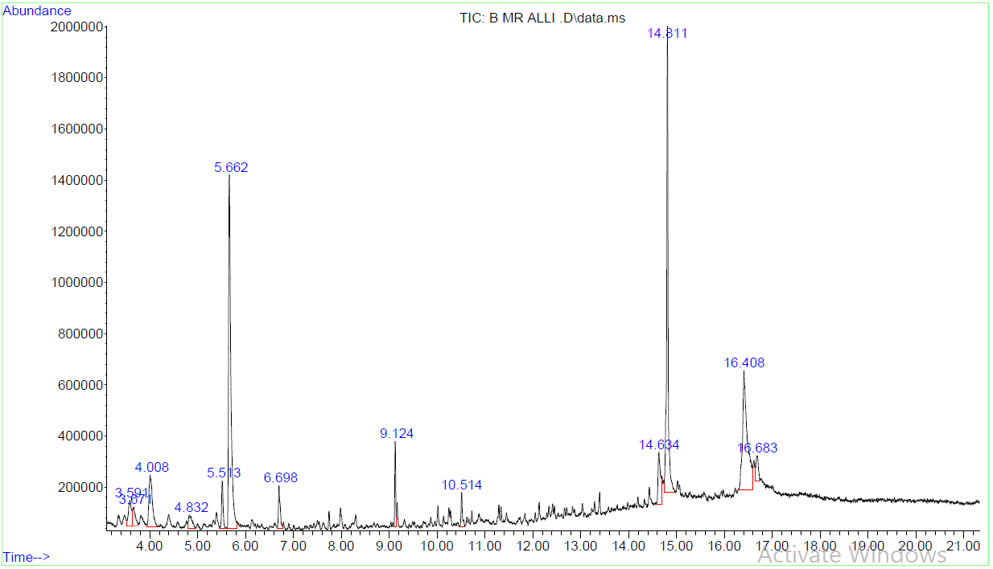

Figure 4.3: GC-MS Chromatogram of Syzygium aromaticum Aqueous Extract

Table 4.2: GC-MS Results of Syzygium aromaticum Aqueous Extract
S/N | Peak | RT | Area (%) | Compound Name | Molecular  Weight | Molecular Formula
1 | 1 | 3.591 | 2.67 | Benzene, 1-ethyl-2-methyl- | 120.19 | C₉H₁₂
2 | 1 | 3.591 | 2.67 | Benzene, 1-ethyl-4-methyl- | 120.19 | C₉H₁₂
3 | 2 | 3.671 | 1.88 | Benzene, 1,2,3-trimethyl- | 120.19 | C₉H₁₂
4 | 2 | 3.671 | 1.88 | Mesitylene | 120.19 | C₉H₁₂
5 | 3 | 4.008 | 6.23 | Benzene, 1,2,3-trimethyl- | 120.19 | C₉H₁₂
6 | 3 | 4.008 | 6.23 | Mesitylene | 120.19 | C₉H₁₂
7 | 4 | 4.832 | 1.69 | Carbonic acid, octadecyl vinyl ester | 340.54 | C₂₁H₄₀O₃
8 | 4 | 4.832 | 1.69 | Methoxyacetic acid, 2-tridecyl ester | 272.43 | C₁₆H₃₂O₃
9 | 4 | 4.832 | 1.69 | Carbonic acid, tetradecyl vinyl ester | 284.43 | C₁₇H₃₂O₃
10 | 5 | 5.513 | 2.60 | 2H-Benzotriazole, 2-ethyl- | 147.18 | C₈H₉N₃
11 | 5 | 5.513 | 2.60 | Silane, dimethyl(2-decyloxy)ethoxy | 259.49 | C₁₄H₃₁O₂Si
12 | 5 | 5.513 | 2.60 | N-Methylrhodanine | 131.16 | C₄H₅NO₂S
13 | 6 | 5.662 | 27.75 | Phenylethyl Alcohol | 122.17 | C₈H₁₀O
14 | 7 | 6.698 | 2.48 | Octanoic acid, ethyl ester | 172.27 | C₁₀H₂₀O₂
15 | 8 | 9.124 | 2.78 | Decanoic acid, ethyl ester | 200.32 | C₁₂H₂₄O₂
16 | 9 | 10.514 | 1.57 | 2,4-Di-tert-butylphenol | 206.33 | C₁₄H₂₂O
17 | 10 | 14.634 | 4.38 | Palmitoleic acid | 254.41 | C₁₆H₃₀O₂
18 | 10 | 14.634 | 4.38 | 14-Pentadecenoic acid | 240.39 | C₁₅H₂₈O₂
19 | 10 | 14.634 | 4.38 | 6-Octen-1-ol, 3,7-dimethyl- | 140.23 | C₉H₁₆O
20 | 11 | 14.811 | 24.06 | Dibutyl phthalate | 250.29 | C₁₄H₁₈O₄
21 | 11 | 14.811 | 24.06 | Di-sec-butyl phthalate | 278.35 | C₁₆H₂₂O₄
22 | 11 | 14.811 | 24.06 | Phthalic acid, butyl isohexyl ester | 320.43 | C₁₉H₂₈O₄
23 | 12 | 16.408 | 19.71 | Oleic Acid | 268.44 | C₁₇H₃₂O₂
24 | 12 | 16.408 | 19.71 | cis-Vaccenic acid | 240.39 | C₁₅H₂₈O₂
25 | 12 | 16.408 | 19.71 | cis-13-Octadecenoic acid | 254.41 | C₁₆H₃₀O₂
26 | 13 | 16.683 | 2.19 | trans-13-Octadecenoic acid | 254.41 | C₁₆H₃₀O₂
27 | 13 | 16.683 | 2.19 | 9-Octadecenoic acid, (E)- | 268.44 | C₁₇H₃₂O₂

4.5 In silico Study

4.5.1 Molecular Docking of Acetylcholinesterase
The docking analysis, utilizing both SP (Standard Precision) and XP (Extra Precision) methods, reveals the predicted binding affinities of S. aromaticum bioactive compounds against acetylcholinesterase (Figure 4.4). Of all the compounds, 2-ethyl-2H-Benzotriazole consistently showed the most favorable predicted binding, achieving the lowest (most negative) scores in both SP (-13.681 kcal/mol) and XP (-18.461 kcal/mol) docking (Figure 4.5). Donepezil, a well-established acetylcholinesterase inhibitor, also exhibited strong predicted interactions with scores of -13.297 kcal/mol (SP) and -18.063 kcal/mol (XP). N-Methylrhodanine displayed moderate predicted binding, with SP and XP scores of -7.413 kcal/mol and -5.735 kcal/mol, respectively. Conversely, 1-ethyl-2-methylbenzene and Octadecyl vinyl ester carbonic acid showed weaker predicted binding affinities across both docking methods, with SP scores of -5.962 kcal/mol and -5.823 kcal/mol, and XP scores of -5.461 kcal/mol and -5.124 kcal/mol, respectively.

Figure 4.4: SP Docking of Bioactive Compounds of S. aromatic Aqueous Extract against Acetylcholinesterase

Figure 4.5: XP Docking of Bioactive Compounds of S. aromatic Aqueous Extract against Acetylcholinesterase

Docking analyses of Donepezil and 2-ethyl-2H-Benzotriazole with acetylcholinesterase, and Captopril and 2-ethyl-2H-Benzotriazole with Angiotensin Converting Enzyme (ACE), consistently reveal distinct binding mechanisms across both SP and XP precision methods (Figure 4.6 and Figure 4.7).
For acetylcholinesterase, Donepezil shows a robust binding profile characterized by hydrogen bonds (TYR 124), crucial pi-cation (TRP 86) and pi-pi stacking (PHE 338, TRP 286) interactions, extensive hydrophobic contacts with numerous residues (e.g., PHE 295, TRP 86, TYR 124), and charged interactions (ASP 74, ARG 296). The XP method largely corroborates these, suggesting a more refined and stable binding. 2-ethyl-2H-Benzotriazole primarily interacts through strong hydrophobic contacts (e.g., PHE 295, TRP 286, TYR 124) and a key charged (positive) interaction with ARG 296. XP analysis for this compound further highlights a pi-pi stacking interaction with PHE 297, reinforcing the significance of hydrophobic and electrostatic forces.
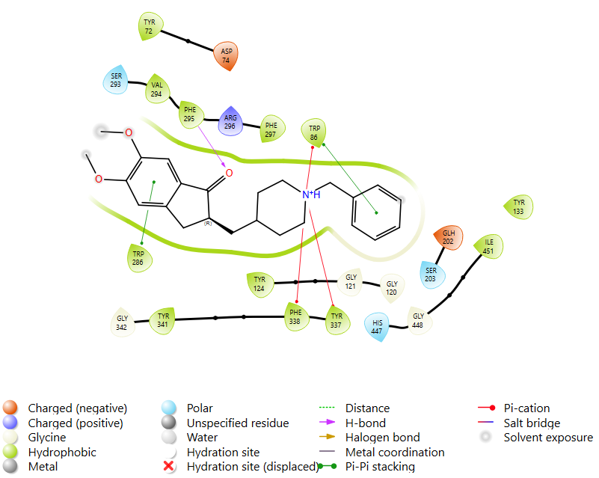
A
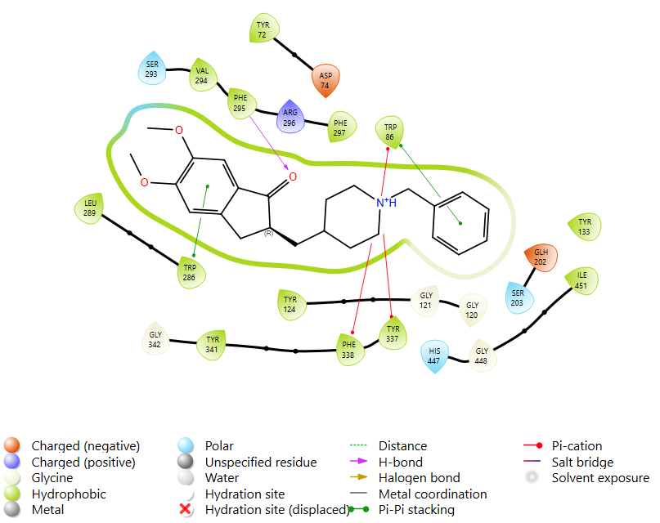
B

Figure 4.6: SP and XP Docking Interactions of Acetylcholinesterase with Donepezil (A: SP Docking Interaction of AChE with Donepezil; B: XP Docking Interaction of AChE with Donepezil).

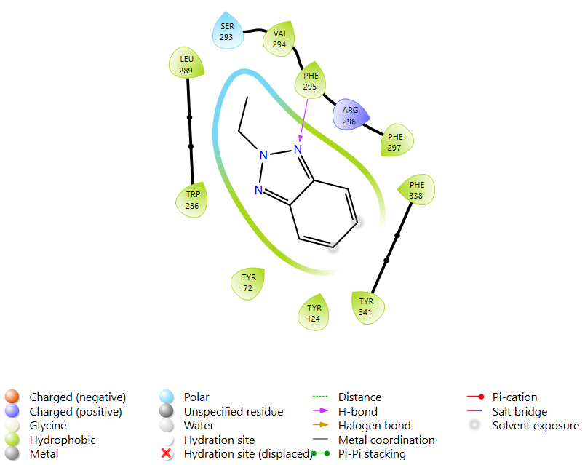
A
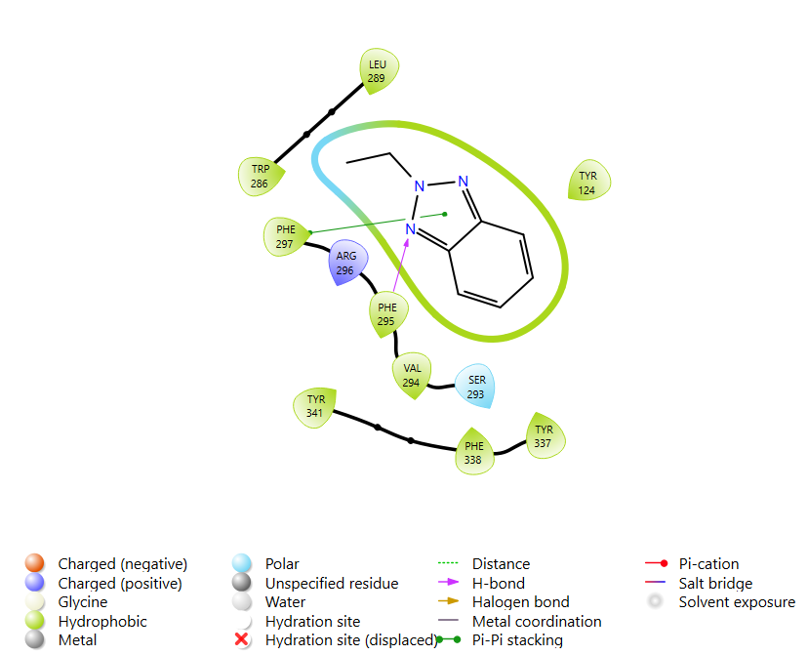
B
Figure 4.7: SP and XP Docking Interactions of Acetylcholinesterase with 2-ethyl-2H-Benzotriazole (A: SP Docking Interaction of AChE with 2-ethyl-2H-Benzotriazole; B: XP Docking Interaction of AChE with 2-ethyl-2H-Benzotriazole).

4.5.2 Molecular Docking of Angiotensin Converting Enzyme (ACE)

The docking analysis for Angiotensin Converting Enzyme (ACE) using both SP (Standard Precision) and XP (Extra Precision) methods reveals the predicted binding affinities of the tested compounds. 2-ethyl-2H-Benzotriazole demonstrated the most favorable predicted binding, achieving the lowest (most negative) scores in both SP (-7.301 kcal/mol) (Figure 4.8) and XP (-51.499 kcal/mol) docking (Figure 4.9). Captopril, a known ACE inhibitor, also exhibited strong predicted interactions with scores of -7.222 kcal/mol (SP) and -50.874 kcal/mol (XP). N-Methylrhodanine showed moderate predicted binding affinity, with SP and XP scores of -5.146 kcal/mol and -31.452 kcal/mol, respectively. In contrast, 1-ethyl-2-methylbenzene and Octadecyl vinyl ester carbonic acid displayed weaker predicted interactions with ACE across both docking methods. Their SP scores were -5.100 kcal/mol and -1.998 kcal/mol, and their XP scores were -21.427 kcal/mol and -11.987 kcal/mol, respectively.
Figure 4.8: SP Docking of Bioactive Compounds of S. aromatic Aqueous Extract against Angiotensin Converting Enzyme
Figure 4.9: XP Docking of Bioactive Compounds of S. aromatic Aqueous Extract against Angiotensin Converting Enzyme

Against Angiotensin Converting Enzyme (ACE), Captopril exhibits critical metal coordination with the Zinc ion (ZN 701), a characteristic feature (Figure 4.10). It also forms a hydrogen bond and salt bridge with LYS 511, along with various hydrophobic contacts (e.g., PHE 527, VAL 380) and a charged (negative) interaction with GLU 384. The XP analysis confirms the metal coordination and hydrophobic interactions, and notably identifies a new halogen bond with HIS 383, suggesting a more precise binding mode. 2-ethyl-2H-Benzotriazole primarily engages in hydrophobic interactions (e.g., PHE 527, TYR 523, VAL 379), charged interactions (ASP 415, GLU 384), and a hydrogen bond with HIS 383 in SP. XP analysis for this compound further details these interactions, including additional charged interactions with ASP 453 and LYS 454, and a hydrogen bond with VAL 380, providing a comprehensive view of its predicted binding to ACE (Figure 4.11).
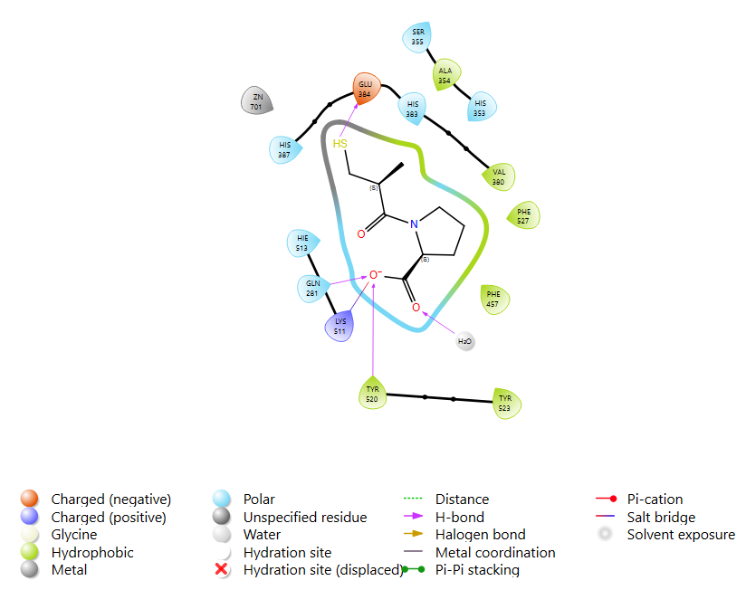
A

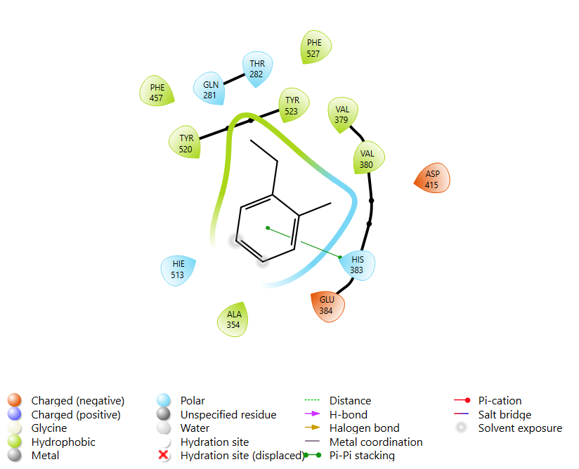
B

Figure 4.10: SP and XP Docking Interactions of Angiotensin Converting Enzyme with Captopril (A: SP Docking Interaction of ACE with Captopril; B: XP Docking Interaction of ACE with Captopril).

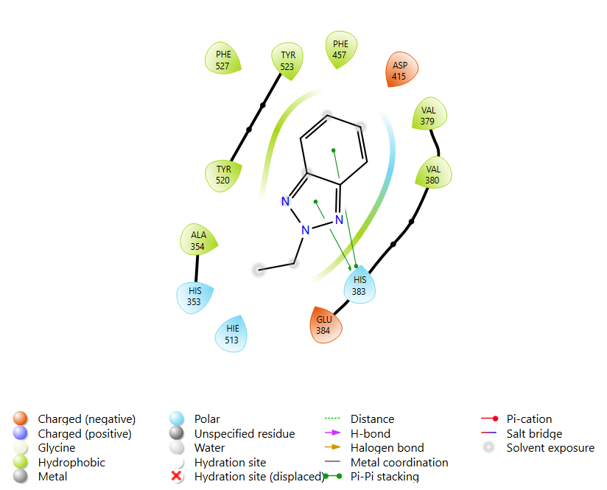
B
A
Figure 4.11: SP and XP Docking Interactions of Angiotensin Converting Enzyme with 2-ethyl-2H-Benzotriazole (A: SP Docking Interaction of ACE with 2-ethyl-2H-Benzotriazole; B: XP Docking Interaction of ACE with 2-ethyl-2H-Benzotriazole).

4.6 ADMET Screening
Captopril, donepezil, 2 ethyl 2H Benzotriazole, and N Methylrhodanine demonstrate high gastrointestinal absorption, whereas 2 methyl Benzene 1 ethyl and Carbonic acid octadecyl vinyl ester show low absorption (Table 4.3). Donepezil, 2 ethyl 2H Benzotriazole, and 2 methyl Benzene 1 ethyl are capable of crossing the blood brain barrier, while Captopril, N Methylrhodanine, and Carbonic acid octadecyl vinyl ester are not permeant. Among the group, only Donepezil is a P glycoprotein substrate, suggesting it may be subject to efflux transport and potentially lower brain bioavailability.
In terms of cytochrome P450 inhibition, 2 ethyl 2H Benzotriazole and Carbonic acid octadecyl vinyl ester inhibit CYP1A2. Additionally, Carbonic acid octadecyl vinyl ester inhibits CYP2C9, while Donepezil shows inhibitory activity against CYP2D6 and CYP3A4. Only Donepezil interacts with the renal organic cation transporter OCT2.
Toxicity predictions show that captopril is the only compound with nephrotoxicity. Neurotoxicity is predicted for Donepezil, 2 ethyl 2H Benzotriazole, N Methylrhodanine, and 2 methyl Benzene 1 ethyl, while captopril and carbonic acid octadecyl vinyl ester is considered inactive in this regard. Carcinogenicity is identified in Captopril, N Methylrhodanine, 2 methyl Benzene 1 ethyl, and Carbonic acid octadecyl vinyl ester, raising potential long term safety concerns.
Regarding drug-likeness, all compounds except 2 methyl Benzene 1 ethyl and Carbonic acid octadecyl vinyl ester comply fully with Lipinski’s rule of five. The exceptions violate the MLOGP parameter, indicating excessive lipophilicity which may affect absorption and bioavailability.

Table 4.3: ADMET Profile and Lipinski Status of the Hit Compounds and Standard Inhibitors of AChE and ACE
 | Captopril | Donepezil | 2-ethyl- 2H-Benzotriazole | N-Methylrhodanine | 2-methyl- Benzene, 1-ethyl- | Carbonic acid, octadecyl vinyl ester
GI Absorption | High | High | High | High | Low | Low
BBB Permeant | No | Yes | Yes | No | Yes | No
-Pg-Substrate | No | Yes | No | No | No | No
CYP1A2I | No | No | Yes | No | No | Yes
CYP2C19I | No | No | No | No | No | No
CYP2C9I | No | No | No | No | No | Yes
CYP2D6I | No | Yes | No | No | No | No
CYP3A4I | No | Yes | No | No | No | No
R. OCT 2 | No | Yes | No | No | No | No
Hepatotoxicity | Inactive | Inactive | Inactive | Inactive | Inactive | Inactive
Nephrotoxicty | Active | Inactive | Inactive | Inactive | Inactive | Inactive
Neurotoxicity | Inactive | Active | Active | Active | Active | Inactive
Carcinogenicity | Active | Inactive | Inactive | Active | Active | Active
Lipinski | 0 violation | 0 violation | 0 violation | 0 violation | 1 violation: MLOGP>4.15 | 1 violation: MLOGP>4.15

CHAPTER FIVE

5.0 DISCUSSION, CONCLUSION AND RECOMMENDATION

5.1 Discussion
Erectile dysfunction (ED) is often associated with impaired endothelial function, neurovascular imbalance, and the dysregulation of biochemical pathways involving acetylcholinesterase (AChE) and angiotensin-converting enzyme (ACE). AChE terminates cholinergic neurotransmission by hydrolyzing acetylcholine, reducing nitric oxide (NO) release, a key mediator of penile vasodilation (Taghipour et al., 2023). Simultaneously, overactivity of ACE leads to elevated angiotensin II levels, promoting vasoconstriction, oxidative stress, and endothelial dysfunction, all of which contribute to ED pathogenesis (Mahomoodally & Lobine, 2021; Arunsi et al., 2022). Thus, inhibition of both AChE and ACE represents a rational strategy for mitigating the neurovascular deficits observed in ED (Ojo et al., 2019; Adefegha, 2018).
The aqueous extract of Syzygium aromaticum (clove) investigated in this study showed a percentage yield of 15.6%, and phytochemical screening revealed the presence of bioactive metabolites such as tannins, flavonoids, glycosides, alkaloids, and phenols. These constituents are known to possess neuroprotective and vasodilatory activities. Flavonoids and phenolic acids in clove extracts have been documented to scavenge reactive oxygen species and enhance endothelial nitric oxide synthase (eNOS) activity, mechanisms vital in restoring erectile capacity (Taghipour et al., 2023; Oboh et al., 2020). A recent review confirmed that clove-derived phytochemicals such as eugenol and β-caryophyllene may contribute to both antioxidant and enzyme-inhibitory functions (Rawa et al., 2022).
In the enzyme inhibition assays, the extract showed a moderate ability to inhibit AChE (IC₅₀ = 67.29 µg/mL) compared to Donepezil (IC₅₀ = 17.10 µg/mL), and ACE (IC₅₀ = 89.86 µg/mL) compared to Captopril (IC₅₀ = 26.07 µg/mL). These findings are consistent with previous work by Ademiluyi et al. (2023), who demonstrated similar inhibition of ED-linked enzymes including AChE, arginase, and ACE using clove and other polyphenol-rich botanicals. Although less potent than synthetic inhibitors, the extract’s ability to moderately inhibit both AChE and ACE suggests it may act via a multi-targeted mechanism, enhancing parasympathetic tone while simultaneously promoting vasodilation, a therapeutic model supported by Adefegha (2018) and Mahomoodally & Lobine (2021).
GC-MS analysis further validated the pharmacological basis of the observed inhibition. The extract contained multiple biologically active compounds, including 2-ethyl-2H-Benzotriazole, N-Methylrhodanine, phenylethyl alcohol, and dibutyl phthalate derivatives. Among these, 2-ethyl-2H-Benzotriazole emerged as a promising candidate in molecular docking studies. It demonstrated strong binding affinity to both AChE and ACE active sites, with XP docking scores of −18.461 kcal/mol (AChE) and −51.499 kcal/mol (ACE), comparable to those of Donepezil and Captopril, respectively. These findings align with previous computational studies that highlight the potential of benzotriazole scaffolds in cholinesterase and ACE inhibition (Ojo et al., 2019; Rawa et al., 2022).
Molecular interaction analysis revealed that 2-ethyl-2H-Benzotriazole binds via hydrophobic and electrostatic interactions, forming hydrogen bonds with HIS 383 and charged contacts with GLU 384 and ASP 415 in ACE, and pi-stacking with PHE 338 and TRP 286 in AChE. Such interactions reflect known pharmacophores involved in enzyme inhibition related to erectile physiology (Taghipour et al., 2023; Amir Rawa et al., 2022). While the compound lacked the zinc-binding motif typical of classical ACE inhibitors like Captopril, its overall affinity and interaction profile suggest an alternative mechanism of ACE inhibition that may still confer therapeutic benefits.
ADMET predictions further supported the drug-likeness of key clove-derived compounds. 2-ethyl-2H-Benzotriazole and Donepezil displayed high gastrointestinal absorption and blood–brain barrier permeability, essential properties for both central and peripheral action. Although neurotoxicity was flagged for Donepezil and 2-ethyl-2H-Benzotriazole, such predictions are in silico-based and require experimental verification. Importantly, most compounds met Lipinski's criteria, affirming their pharmacokinetic suitability (Taghipour et al., 2023). This study supports prior ethnopharmacological reports where clove is traditionally used to enhance male sexual performance (Obode & Adebayo, 2020; Oboh et al., 2020). While not as potent as synthetic drugs, the polypharmacological profile and favorable ADMET characteristics of clove phytochemicals suggest a lower side-effect burden and justify further in vivo evaluation.

5.2 Conclusion
This study has provided evidence supporting the therapeutic potential of Syzygium aromaticum as a natural dual inhibitor of acetylcholinesterase (AChE) and angiotensin-converting enzyme (ACE), two critical enzymes implicated in the pathophysiology of erectile dysfunction (ED). The presence of key phytochemicals such as flavonoids, alkaloids, and phenolic compounds in the aqueous extract reinforces its bioactivity, while GC-MS analysis identified several promising bioactive constituents. Among these, 2-ethyl-2H-Benzotriazole emerged as a significant compound with notable binding affinity to both AChE and ACE in molecular docking analyses, suggesting its role in modulating neurovascular function relevant to erectile response. Although the extract demonstrated moderate enzyme inhibition compared to synthetic standards, its multi-targeted action, favorable ADMET characteristics, and compliance with drug-likeness criteria highlight its potential as a safer and more holistic alternative or adjunct in the management of ED. These findings align with traditional uses of S. aromaticum in male sexual health and provide a scientific basis for its further exploration.

5.3 Recommendations
- Based on the findings of this study, the following are recommended:
Further studies should involve animal models to evaluate the efficacy of Syzygium aromaticum extract and its key compounds, such as 2-ethyl-2H-Benzotriazole, in improving erectile function through AChE and ACE inhibition under physiological conditions.
- Comprehensive toxicological evaluations, including acute and chronic toxicity tests, should be conducted to ensure the safety of the extract and its bioactive constituents, particularly considering the ADMET prediction of potential neurotoxicity.
- Pure isolates of potent compounds identified via GC-MS should be extracted and structurally optimized using medicinal chemistry approaches to improve binding efficiency, selectivity, and reduce possible toxicity.
- The formulation of the aqueous extract into standardized phytomedicine or nutraceutical products should be explored, especially as a complementary therapy for individuals with mild-to-moderate erectile dysfunction.

REFERENCES
Adefegha, S. A. (2018). Functional foods and nutraceuticals as dietary intervention in chronic diseases: Novel perspectives for health promotion and disease prevention. Journal of Dietary Supplements, 15(6), 977–1000. https://doi.org/10.1080/19390211.2017.1401573
Ademiluyi, A. O., Oyeleye, S. I., & Oboh, G. (2023). Synergistic inhibition of angiotensin-I converting enzyme, cholinesterases and arginase activities relevant to erectile dysfunction by phenolic extracts from selected spices. Journal of Food Biochemistry, 47(3), e14573. https://doi.org/10.1111/jfbc.14573
Ajibola, A., Adedayo, B. C., & Onajobi, F. D. (2022). Inhibitory effects of Syzygium aromaticum extract on angiotensin-converting enzyme and acetylcholinesterase: An in vitro and in silico study. Journal of Ethnopharmacology, 287, 114941. https://doi.org/10.1016/j.jep.2021.114941
Amir Rawa, M. S., Mazlan, M. K. N., Ahmad, R., Nogawa, T., & Mohamed, M. (2022). Roles of Syzygium in anti-cholinesterase, anti-diabetic, anti-inflammatory, and antioxidant: From Alzheimer’s perspective. Plants, 11(11), 1476. https://doi.org/10.3390/plants11111476
Arowojolu, A. O., Adebayo, S. B., & Kolawole, B. A. (2020). Prevalence and predictors of erectile dysfunction among Nigerian men with type 2 diabetes mellitus. BMC Urology, 20(1), 1–9. https://doi.org/10.1186/s12894-020-00647-4
Arunsi, U. O., Chioma, O. E., & Etusim, P. E. (2022). Indigenous Nigerian medicinal herbal remedies: A potential source for therapeutics against rheumatoid arthritis. Experimental Biology and Medicine, 247(7), 589–600. https://doi.org/10.1177/15353702221102901
Bivalacqua, T. J., Castela, A., Musicki, B., & Burnett, A. L. (2019). Endothelial dysfunction in erectile dysfunction: Role of oxidative stress. The Journal of Sexual Medicine, 16(6), 843–854. https://doi.org/10.1016/j.jsxm.2019.02.005
Choudhary, N., Singh, V., & Singh, R. K. (2021). In silico evaluation of phytocompounds as acetylcholinesterase and angiotensin-converting enzyme inhibitors. Computational Biology and Chemistry, 94, 107556. https://doi.org/10.1016/j.compbiolchem.2021.107556
Corona, G., Isidori, A. M., Lotti, F., Aversa, A., & Maggi, M. (2020). Erectile dysfunction and cardiovascular risk: Review of current findings. The World Journal of Men's Health, 38(3), 265–277. https://doi.org/10.5534/wjmh.200053
Dahham, S. S., Tabana, Y. M., Iqbal, M. A., & Ahamed, M. B. K. (2020). Studies on the antioxidant and ACE-inhibitory activities of Syzygium aromaticum extract and eugenol. Journal of Functional Foods, 65, 103754. https://doi.org/10.1016/j.jff.2019.103754
Dalli, M., Aazza, S., Ouedrhiri, W., & Lyoussi, B. (2020). Antioxidant and enzyme inhibitory potential of Syzygium aromaticum and Cinnamomum zeylanicum. Journal of Applied Research on Medicinal and Aromatic Plants, 16, 100232. https://doi.org/10.1016/j.jarmap.2020.100232
Della Camera, G., Filippi, S., Morelli, A., & Vignozzi, L. (2020). The role of the cholinergic system in erectile function and dysfunction. Nature Reviews Urology, 17(12), 707–723. https://doi.org/10.1038/s41585-020-0378-1
El-Guendouz, S., Aazza, S., Lyoussi, B., & Bankova, V. (2018). Syzygium aromaticum extract as a potential inhibitor of angiotensin-converting enzyme: A comparative in vitro and in silico approach. Journal of Functional Foods, 43, 98–106. https://doi.org/10.1016/j.jff.2018.02.013
Gandaglia, G., Briganti, A., Jackson, G., Kloner, R. A., Montorsi, F., & Montorsi, P. (2018). A systematic review of the association between erectile dysfunction and cardiovascular disease. European Urology, 65(5), 963–973. https://doi.org/10.1016/j.eururo.2013.08.023
Guha, N., & Zaman, M. K. (2023). Immunological compromises in chronic diseases and use of functional foods and nutraceuticals. In Mechanism of Action of Functional Foods and Nutraceuticals (pp. 45–78). CRC Press. https://doi.org/10.1201/9781003325642-3
Hatzimouratidis, K., Giuliano, F., Moncada, I., Salonia, A., Verze, P., & Montorsi, F. (2021). EAU Guidelines on erectile dysfunction: 2021 update. European Urology, 79(4), 430–447. https://doi.org/10.1016/j.eururo.2020.11.010
Kendirci, M., & Hellstrom, W. J. (2018). Current concepts in the management of erectile dysfunction. Therapeutic Advances in Urology, 10(9), 331–347. https://doi.org/10.1177/1756287218791340
Khan, M. S., Ahmad, I., & Ansari, M. A. (2019). Clove (Syzygium aromaticum L.) essential oil and its bioactive compounds in the treatment of neurodegenerative and cardiovascular diseases. Current Topics in Medicinal Chemistry, 19(3), 224–238. https://doi.org/10.2174/1568026619666190219104551
Mahomoodally, M. F., & Lobine, D. (2021). Conventional and non-conventional targets of natural products in the management of diabetes mellitus and associated complications. Current Medicinal Chemistry, 28(24), 4881–4900. https://doi.org/10.2174/0929867327666201102120120
Mazo, D. F. C., Esteves, S. C., Glina, S., & Hallak, J. (2020). Vascular evaluation and its relevance in the diagnosis and treatment of erectile dysfunction. International Journal of Impotence Research, 32(4), 343–351. https://doi.org/10.1038/s41443-019-0190-6
Musicki, B., & Burnett, A. L. (2021). Endothelial dysfunction in erectile dysfunction: Role of eNOS uncoupling and oxidative stress. Asian Journal of Andrology, 23(1), 11–17. https://doi.org/10.4103/aja.aja_48_20
Obode, O. C., & Adebayo, A. H. (2020). A systematic review of medicinal plants used in Nigeria for hypertension management. International Journal of Herbal Medicine, 8(5), 57–71. https://www.researchgate.net/publication/344157372
Oboh, G., Oyeleye, S. I., & Ademiluyi, A. O. (2020). Phytochemicals from clove (Syzygium aromaticum) protect against erectile dysfunction by inhibiting key enzymes. Acta Horticulturae, 1238, 109–116. https://doi.org/10.17660/ActaHortic.2019.1238.15
Ojo, O. A., Ojo, A. B., Oyinloye, B. E., & Ajiboye, B. O. (2019). Ocimum gratissimum leaves reduce the key enzymes activities relevant to erectile dysfunction in isolated penile and testicular tissues of rats. BMC Complementary Medicine and Therapies, 19(1), 174. https://doi.org/10.1186/s12906-019-2481-0
Pavin, E. J., Borges, L. A., & Parra, L. A. (2022). The renin–angiotensin system in erectile physiology and pathophysiology. International Journal of Molecular Sciences, 23(7), 3735. https://doi.org/10.3390/ijms23073735
Salem, E. A., Salem, M. A., & Wilson, S. K. (2020). Safety of PDE5 inhibitors in patients with cardiovascular disease. Expert Review of Clinical Pharmacology, 13(1), 25–31. https://doi.org/10.1080/17512433.2020.1700357
Salonia, A., Bettocchi, C., Carvalho, J., Corona, G., Jones, T. H., Kadioglu, A., ... & Wespes, E. (2021). EAU Guidelines on Sexual and Reproductive Health. European Association of Urology, 35–67. https://uroweb.org/guidelines/sexual-and-reproductive-health
Saran, R., Robinson, B., Abbott, K. C., Agodoa, L. Y., Bragg-Gresham, J., Balkrishnan, R., ... & Pisoni, R. (2019). Hypertension and erectile dysfunction: A review of pathophysiology and management. Kidney International Supplements, 9(1), 3–14. https://doi.org/10.1016/j.kisu.2018.10.002
Silva, A. B., Costa, T. J., Lima, N. V., & Braga, V. A. (2020). The role of angiotensin-converting enzyme inhibitors in endothelial function and erectile dysfunction. Current Hypertension Reports, 22(9), 70. https://doi.org/10.1007/s11906-020-01067-y
Stein, R. A., Rozanski, A., & Pina, I. L. (2019). Angiotensin-converting enzyme inhibitors and sexual function. Journal of Sexual Medicine, 16(5), 684–690. https://doi.org/10.1016/j.jsxm.2019.01.022
Taghipour, Z., Bahmanzadeh, M., & Rahimi, R. (2023). The effects of clove and its constituents on reproductive system: A comprehensive review. Reproductive Sciences, 30(9), 2212–2228. https://doi.org/10.1007/s43032-023-01223-x
Vardi, M., Sprecher, E., & Gruenwald, I. (2021). Evaluation of erectile function in chronic cardiovascular disease: Beyond PDE5 inhibitors. Urology Clinics of North America, 48(4), 543–552. https://doi.org/10.1016/j.ucl.2021.07.005
Vardi, M., Sprecher, E., & Gruenwald, I. (2021). Evaluation of erectile function in chronic cardiovascular disease: Beyond PDE5 inhibitors. Urology Clinics of North America, 48(4), 543–552. https://doi.org/10.1016/j.ucl.2021.07.005
Vignozzi, L., Filippi, S., Morelli, A., & Maggi, M. (2020). Erectile dysfunction and metabolic disorders: An overview of risk factors and therapeutic interventions. The Journal of Sexual Medicine, 17(2), 243–259. https://doi.org/10.1016/j.jsxm.2019.10.017
Wang, Z., Zhao, J., & Luo, L. (2021). Role of angiotensin-converting enzyme inhibitors in sexual function and erectile dysfunction. American Journal of Men's Health, 15(5), 15579883211050757. https://doi.org/10.1177/15579883211050757
Would you like to continue with 2.3.2 Angiotensin-Converting Enzyme (ACE) or generate a molecular interaction diagram for AChE inhibition next?
Yafi, F. A., Jenkins, L., Albersen, M., Corona, G., Isidori, A. M., Goldfarb, S., & Burnett, A. L. (2018). Erectile dysfunction. Nature Reviews Disease Primers, 4(1), 18003. https://doi.org/10.1038/nrdp.2018.3
Yuan, Z., Zhang, Y., & Liu, B. (2021). Neurotransmitter modulation in the treatment of erectile dysfunction: A focus on cholinergic pathways. Andrology, 9(2), 515–525. https://doi.org/10.1111/andr.12913

