ASSESSING THE EFFECTIVENESS OF STREET NAMING AND HOUSE NUMBERING IN FATE-TANKE ILORIN
BY:
BELLO KEHINDE ABDULAFEEZ
HND/23/URP/FT/0006
BEING A RESEARCH PROJECT SUBMITTED TO THE DEPARTMENT OF URBAN AND REGIONAL PLANNING, INSTITUTE OF ENVIRONMENTAL STUDIES (IES) KWARA STATE POLYTECHNIC, ILORIN

IN PARTIAL FULFILLMENT OF THE REQUIREMENTS FOR THE AWARD OF HIGHER NATIONAL DIPLOMA (HND) IN URBAN AND REGIONAL PLANNING.
JUNE, 2025

CERTIFICATION
This is to certify that this project was an original work carried out by Bello Kehinde Abdulafeez from the Department of Urban and Regional Planning and has been prepared in accordance with the rules and regulations governing the preparation and presentation of project in Kwara State Polytechnic, Ilorin.
_______________ ___________________ TPL. M.I. YAHAYA &
MRS. IYIBUSOLA DATE
(Project Supervisor)
__________________ __________________
TPL. M.I. YAHAYA DATE
(Project Coordinator)
___________________ __________________
TPL. ADEKANYE DATE
(Head of Department)
____________________ __________________
EXTERNAL SUPERVISOR DATE

DEDICATION
This project is dedicated to Almighty God for His unending grace, strength, and guidance throughout my academic journey. I also dedicate this work to my beloved parents, whose encouragement, sacrifices, and prayers have been a great source of motivation and support.

ACKNOWLEDGEMENT
I sincerely appreciate the Almighty God for the wisdom, knowledge, and understanding granted to me to successfully complete this project.
My profound gratitude goes to my project supervisor, TPL M.I Yahaya and Mrs Iyibusola, for their valuable guidance, constructive criticism, and patience throughout the course of this study.
I would like to thank all the lecturers and staff of the Department of Urban and Regional Planning, [Institute of environmental studies], for their dedication and support throughout my academic journey.
Special thanks to my parents, siblings, and friends for their love, encouragement, and moral support. I am also grateful to the residents and respondents in the Fate - Tanke area who participated in the survey and provided the data needed for this research.
Finally, I acknowledge my dear friend [ Opeyemi ] and my colleagues who contributed in one way or the other to the success of this work. God bless you all.

TABLE OF CONTENTS
• Title Page i
• Certification ii
• Dedication iii
• Acknowledgements iv
• Abstract v
CHAPTER ONE: INTRODUCTION
1.1 Introduction 1
1.2 Statement of the Problem 8
1.3 Research Questions 8
1.4 Aim of the study 9
1.5 Objectives of the study 9
1.6 Justification for the Study 16
1.7 Scope of the study 18
1.8 Study area 19
CHAPTER TWO: LITERATURE REVIEW
2.1 Introduction 19
2.2 Conceptual Clarifications 19
2.2.1 Street Naming 21
2.2.2 House Numbering 24
2.2.3 Importance of Addressing Systems in Urban Management 26
2.2.4 Challenges in Implementing Address Systems in Developing Countries 28
2.3 Theoretical Framework 29
2.3.1 Rational Planning Theory 30
2.3.2 Systems Theory 30
2.3.3 Participatory Planning Theory 31
2.4 Empirical Review 32
2.4.1 Global Studies on Street Naming and House Numbering 32
2.4.2 Addressing Challenges in African Cities 34
2.4.3 Nigerian Experiences and Case Studies 34
2.4.4 Institutional and Community Participation Factors 36
2.4.5 Use of Technology (GIS, GPS) in Address System Implementation 39
CHAPTER THREE: RESEARCH METHODOLOGY
3.1 Introduction 40
3.2 Primary Source of Data 40
3.2.1 Reconnaissance Survey 41
3.2.2 Oral Interview 41
3.3 Questionnaire Administration 42
3.4 Sampling Frame and Sample Size 42
3.4.1 Sampling Frame 42
3.4.2 Sample Size 43
3.5 Sampling Techniques 43
3.6 Method of Data Analysis 44
CHAPTER FOUR: DATA PRESENTATION AND ANALYSIS
4.1 Introduction 44
4.2 Socio-Demographic Characteristics of Respondents 45
4.2.1 Gender Distribution of Respondents 47
4.2.2 Age Distribution of Respondents 47
4.2.3 Educational Qualification 48
4.2.4 Occupational Status 48
4.2.5 Duration of Residence 49
4.3 Assessment of Street Naming System in Fate-Tanke 50
4.3.1 Awareness and Availability of Street Names 51
4.3.2 Visibility and Legibility of Street Signs 52
4.3.3 Maintenance and Update of Street Name Signage 53
4.4 Assessment of House Numbering System in Fate-Tanke 53
4.4.1 Availability and Placement of House Numbers 54
4.4.2 Legibility and Durability of House Numbers 55
4.4.3 Functional Use of House Numbers 55
4.5 Residents Perception of the Effectiveness of the Addressing System 56
4.5.1 Satisfaction with the Current Addressing System 57
4.5.2 Usefulness of the Addressing System for Public Services 57
4.5.3 Perceived Challenges and Recommendations 63
CHAPTER FIVE: SUMMARY, CONCLUSION AND RECOMMENDATIONS
5.1 Summary of Findings 69
5.2 Conclusion 72
5.3 Recommendations 73
References 76
Questionnaire 80

ABSTRACT
The effectiveness of street naming and house numbering systems plays a crucial role in urban management, navigation, emergency response, and the delivery of public services. In many Nigerian urban areas, inadequate and inconsistent addressing systems pose significant challenges to residents, government agencies, and service providers. This study assesses the effectiveness of the street naming and house numbering system in Fate-Tanke, a residential district in Ilorin, Kwara State, Nigeria. The research aims to evaluate the availability, visibility, maintenance, and public perception of the addressing system, with the goal of identifying key challenges and recommending strategies for improvement. The study adopted a quantitative data collection through structured questionnaires and qualitative data from oral interviews and open-ended questions. The total number of buildings in Fate-Tanke was estimated at 890 based on geographic data, and a sample size of 178 buildings (20%) was selected for the survey to ensure representativeness and manageability. Data were analyzed using descriptive statistics, including frequency distributions and mean scores, supplemented by thematic analysis of qualitative responses. Findings reveal that while there is a reasonable level of awareness among residents regarding street names and house numbers, the actual presence of official street names and properly assigned house numbers is inconsistent. Many streets, particularly in informal and newly developed areas, lack official names, and a significant number of buildings either do not display house numbers or have numbers that are illegible or poorly maintained. The visibility and legibility of street name signs and house numbers were found to be moderate to poor, often hindered by environmental wear, vandalism, and lack of routine maintenance. Residents’ perceptions indicate a moderate level of satisfaction with the current system’s utility for navigation and service delivery, but reliability is hindered by infrastructural and administrative lapses. The major challenges identified include inadequate enforcement and standardization by local authorities, poor maintenance of signage, and limited public awareness of the addressing system’s importance. These challenges negatively impact emergency response, postal delivery, and other public services. The study concludes that the addressing system in Fate-Tanke is only partially effective, with significant room for improvement. Recommendations include strengthening institutional coordination, standardizing signage practices, enhancing maintenance regimes, increasing public awareness, and leveraging technology such as Geographic Information Systems (GIS) to complement physical addressing. Addressing these gaps will contribute significantly to improved urban governance and service delivery, ultimately enhancing residents’ quality of life.
CHAPTER ONE

1.1 INTRODUCTION

Street naming and house numbering represent foundational tools for urban management and spatial referencing. In contemporary urban planning, these systems form the basis for efficient navigation, public service delivery, emergency response, property identification, and infrastructure development. Globally, the importance of address systems has grown alongside urban expansion and modernization, becoming a critical element in achieving inclusive and sustainable cities (United Nations Human Settlements Programme [UN-Habitat], 2020). As cities grow in population and complexity, the need for precise spatial identification systems becomes imperative to manage land use, taxation, urban infrastructure, and citizen services effectively.
In both developed and developing countries, address systems have become increasingly central to the administration of urban areas. In developed contexts such as Europe and North America, comprehensive street naming and house numbering systems have long been established to support government operations, enhance security, and facilitate planning and logistics (Chapin & Kaiser, 2010). These systems are not only used by governmental institutions but also by private sector stakeholders, including logistics companies, financial institutions, utility service providers, and real estate developers. In contrast, many cities in the Global South, particularly in sub-Saharan Africa, still struggle with incomplete, outdated, or non-existent address systems, limiting their ability to efficiently manage urban development and provide basic services (Gulyani & Talukdar, 2010).
Sub-Saharan Africa, undergoing rapid urbanisation, faces significant challenges in the development and implementation of effective street naming and house numbering systems. This is especially true in peri-urban and informally developed areas, where unplanned growth often outpaces formal planning interventions (Owusu & Afutu-Kotey, 2010). Many cities in the region have neighbourhoods without clearly defined street names or numbered buildings, posing challenges to mail delivery, census activities, voter registration, taxation, land titling, utility billing, and the management of emergency responses. Addressing these gaps is crucial to achieving the goals of sustainable urbanisation as outlined in the United Nations’ Sustainable Development Goal 11 (Make cities and human settlements inclusive, safe, resilient, and sustainable) (UN-Habitat, 2020).
In Nigeria, street naming and house numbering have been part of urban planning policy since the colonial period. Early efforts were mostly limited to core urban centres such as Lagos, Ibadan, and Kano, with less attention given to medium and small towns. In recent years, however, the Nigerian government has renewed its focus on address systems, recognising their importance in urban governance, taxation, and security. Despite this renewed emphasis, implementation has been uneven, and many Nigerian cities continue to struggle with inconsistent or incomplete address systems (Akinbamijo, 2012). The failure to properly name streets and number houses has led to difficulties in locating properties, inadequate property taxation, low levels of service provision, and inefficiencies in town planning efforts (Ayeni, 2013).
Ilorin, the capital of Kwara State in north-central Nigeria, exemplifies these challenges. As a rapidly expanding urban centre, Ilorin has seen extensive physical development, particularly in peri-urban areas such as Fate-Tanke. Fate-Tanke is a mixed residential area that hosts a large population of civil servants, students, and informal sector workers. The area has undergone significant spatial growth over the past two decades, largely due to its proximity to the University of Ilorin and the increasing demand for affordable housing (Olayiwola, Adeleye & Ogunshakin, 2006). However, the street naming and house numbering system in Fate-Tanke has not kept pace with this rapid urbanisation. Many streets are unnamed, and houses lack identifiable numbers, which hinders proper urban management and service delivery.
This inadequacy affects several aspects of urban life in Fate-Tanke. For instance, utility companies often find it difficult to locate customers for billing or maintenance services, leading to inefficiencies and revenue losses. Security agencies also face challenges in responding promptly to emergencies, while planning authorities struggle to enforce development control measures due to the absence of clearly defined property identities (Abubakar & Doan, 2010). Furthermore, private delivery services—such as logistics firms and online vendors—frequently report difficulties in navigating the area due to poor address systems. Residents themselves often rely on informal and descriptive directions when guiding visitors or service providers, further highlighting the inefficiencies associated with the current state of address systems in the area.
In response to these issues, the Kwara State Government, through its Ministry of Physical Planning and Urban Development, has launched several initiatives to improve address systems within Ilorin. These efforts include pilot street naming and house numbering exercises in selected neighbourhoods. However, the extent to which these initiatives have been successful remains uncertain, particularly in peripheral areas such as Fate-Tanke. There is a need for empirical assessment of the effectiveness of these interventions in order to guide future planning strategies and policy directions.
This study seeks to fill this gap by assessing the effectiveness of street naming and house numbering in Fate-Tanke, Ilorin. The study will examine how well the current address system functions, identify the key challenges associated with implementation, and evaluate residents’ perceptions and satisfaction levels. Additionally, it will explore the institutional and socio-economic factors affecting the functionality of the address system. Through this assessment, the study aims to contribute to the literature on urban spatial organisation in Nigerian cities and provide practical recommendations for improving address systems in similar contexts.
The significance of this research lies in its potential to inform more inclusive and sustainable urban governance. A functional street naming and house numbering system is not only crucial for spatial identification but also for planning, taxation, urban service delivery, and social inclusion. By focusing on Fate-Tanke, a rapidly growing peri-urban area in Ilorin, this study will provide insights into how address systems can be effectively implemented in similar urban settings across Nigeria. It will also highlight the importance of community engagement, institutional capacity, and technological innovation in promoting effective urban address systems.
The effectiveness of street naming and house numbering systems is fundamental to the management and sustainability of urban environments. While developed countries have long embraced these systems as part of their urban planning infrastructure, many developing countries—including Nigeria—continue to grapple with ineffective implementation. Fate-Tanke in Ilorin presents a unique case for exploring these challenges and identifying opportunities for improvement. Through this research, a clearer understanding of the factors influencing address system effectiveness will emerge, contributing to the achievement of sustainable urban development in Nigerian cities.

1.2 STATEMENT OF THE RESEARCH PROBLEM
Urbanization continues to reshape the physical and socio-economic landscapes of Nigerian cities. As populations expand and new neighborhoods emerge, the demand for efficient urban management tools becomes increasingly urgent. Among these tools, street naming and house numbering serve as fundamental components of the urban address system, providing the necessary framework for property identification, land administration, tax collection, emergency services, and infrastructure planning (Abubakar & Doan, 2010). However, despite their importance, these systems remain poorly developed in many Nigerian urban centers, particularly in peripheral and rapidly expanding settlements such as Fate-Tanke in Ilorin.
The absence of a functional and standardized street naming and house numbering system has far-reaching implications. It undermines the capacity of local planning authorities to enforce development control regulations, deliver essential services, and collect property taxes effectively (Akinbamijo, 2012). For instance, waste collection agencies may find it difficult to establish routes, utility companies struggle to maintain accurate customer records, and emergency responders are often delayed due to the lack of identifiable addresses. In Fate-Tanke, anecdotal evidence suggests that many buildings lack house numbers, and numerous roads remain unnamed or bear conflicting names depending on informal usage. This lack of spatial order contributes to administrative confusion and reduces the efficiency of both public and private services.
Although the Kwara State Government and Ilorin South Local Government have implemented periodic initiatives aimed at street naming and house numbering, these efforts have largely failed to achieve sustained or widespread coverage. Common challenges include inadequate funding, poor community participation, lack of technical capacity among local agencies, and political interference in the allocation of street names (Olayiwola, Adeleye & Ogunshakin, 2006). Moreover, inconsistencies in the use of Geographic Information Systems (GIS) and weak coordination among planning institutions often result in incomplete, duplicated, or abandoned address implementation projects (Ayeni, 2013). The problem is further exacerbated by rapid and unregulated urban sprawl, especially in transitional zones like Fate-Tanke, where informal housing developments outpace formal planning interventions.
Fate-Tanke exemplifies these issues. As a residential extension of Ilorin, the area has witnessed significant growth due to its proximity to the University of Ilorin and the demand for affordable housing by students and civil servants. Yet, physical expansion has not been matched with a corresponding development in spatial administration. Many residents and property owners in the area rely on informal directions or landmarks when describing their addresses, such as “the third house after the mosque” or “the building behind the fuel station.” This lack of formal identification systems impairs everyday urban functions, such as property registration, school enrolment, postal deliveries, and access to government services (Gulyani & Talukdar, 2010). It also creates opportunities for land fraud, encroachment, and disputes over property boundaries.
Moreover, the inability to accurately identify properties impairs urban security. In cases of criminal activity or public health emergencies, the lack of specific addresses can delay police response or hinder contact tracing efforts, as was observed during the COVID-19 pandemic in many Nigerian cities (UN-Habitat, 2020). In addition, a lack of proper addressing hinders data-driven planning, making it difficult for authorities to conduct household surveys, update urban development plans, or implement zoning regulations.
Although urban address systems are fundamental to achieving sustainable development, limited empirical research exists on their effectiveness in Nigerian cities. Much of the available literature tends to focus on broader urban planning challenges without assessing the implementation of specific tools like street naming and house numbering. There is, therefore, a research gap concerning the localised functionality of these systems, particularly in dynamic and transitional neighborhoods like Fate-Tanke. Questions remain about the extent to which residents are aware of or use formal address systems, the level of institutional commitment to maintaining these systems, and the socio-economic and spatial factors influencing their effectiveness.
Another critical issue is the lack of community engagement in the process of assigning street names and house numbers. In many instances, names are allocated without consultation, leading to disputes, dissatisfaction, or reversion to informal names that hold more cultural significance to residents (Owusu & Afutu-Kotey, 2010). Without community participation, it becomes difficult to achieve sustainability and local ownership of the address system. Furthermore, in areas where signs and markers are installed, poor maintenance and vandalism often lead to deterioration, eroding the usefulness of the system over time.
This research is therefore necessitated by the growing mismatch between the pace of physical development in Fate-Tanke and the capacity of planning institutions to implement and sustain functional address systems. While the area continues to attract significant residential growth, the absence of proper street naming and house numbering has created an administrative and spatial vacuum that undermines service delivery, security, urban governance, and sustainable planning. It is against this backdrop that this study seeks to critically assess the effectiveness of street naming and house numbering in Fate-Tanke, Ilorin, with a view to identifying challenges, opportunities, and pathways for improvement.
By adopting a case study approach and incorporating both resident perspectives and institutional responses, the study aims to contribute to a better understanding of how spatial identification systems operate in practice and how they can be enhanced in Nigerian cities. Ultimately, the findings of this research will inform evidence-based recommendations for improving the street naming and house numbering system in Fate-Tanke and other similar peri-urban areas, thereby promoting efficient urban governance and sustainable development.

1.3 RESEARCH QUESTIONS
The following research questions have been formulated to guide the investigation into the effectiveness of street naming and house numbering in Fate-Tanke, Ilorin:
- To what extent has street naming and house numbering been implemented in Fate-Tanke?
- What are the perceptions of residents and stakeholders regarding the effectiveness of the address system in the area?
- What institutional, socio-economic, or spatial factors influence the implementation of street naming and house numbering in Fate-Tanke?
- What are the challenges hindering the effective operation of the existing address system in the study area?
- What strategies can be adopted to enhance the effectiveness and sustainability of street naming and house numbering in Fate-Tanke?

1.4 AIM OF THE STUDY
The aim of this study is to assess the effectiveness of street naming and house numbering in Fate-Tanke, Ilorin, with a view to identifying the challenges, impacts, and opportunities for improved urban spatial management and service delivery.

1.5 OBJECTIVES OF THE STUDY
To achieve this aim, the study is guided by the following specific objectives:
- To examine the current state of street naming and house numbering in Fate-Tanke, Ilorin.
- To assess the level of public awareness and utilization of the address system among residents and service providers.
- To identify the institutional and socio-economic factors affecting the implementation of street naming and house numbering in the study area.
- To investigate the key challenges associated with the effectiveness of the current address system.
- To propose strategic planning recommendations for improving street naming and house numbering in Fate-Tanke and similar urban areas.

1.6 JUSTIFICATION FOR THE STUDY
Effective urban governance relies on the availability of reliable spatial information systems, particularly street naming and house numbering. These systems serve as the backbone for efficient service delivery, planning control, and urban security (Abubakar & Doan, 2010). In Nigeria, however, the implementation of comprehensive and functional address systems has been sporadic and often fails to meet the dynamic needs of growing urban centres. The case of Fate-Tanke in Ilorin reflects a broader national challenge where rapid urbanisation and informal development have outpaced the government's ability to maintain a reliable address infrastructure. This research is justified by the urgent need to understand and address the spatial inefficiencies associated with poor street naming and house numbering systems in such fast-growing peri-urban communities.
The justification for this study is rooted in both practical and academic considerations. On a practical level, the lack of an effective address system in Fate-Tanke has created serious challenges for residents, planners, service providers, and local authorities. Without properly named streets and numbered buildings, residents face difficulties in accessing services such as mail delivery, waste collection, emergency response, and utility supply (Akinbamijo, 2012). Planning authorities, on the other hand, are hampered in their ability to enforce land use regulations, control development, and collect property taxes. These limitations have contributed to chaotic physical development, revenue leakages, and weakened governance structures in the area.
Furthermore, in a time when digital mapping technologies and geographic information systems (GIS) are increasingly used to manage urban spaces, the absence of structured address systems puts Fate-Tanke at a disadvantage. Urban areas that lack address systems are often excluded from data-driven planning initiatives, digital service delivery, and modern urban innovation. This is particularly concerning given Nigeria’s commitment to achieving the Sustainable Development Goals (SDGs), particularly SDG 11, which aims to make cities inclusive, safe, resilient, and sustainable (United Nations Human Settlements Programme [UN-Habitat], 2020). A functional address system is essential for achieving these goals, as it supports social inclusion, accessibility, and effective planning.
Academically, there is limited empirical research focusing specifically on the functionality and impact of address systems in Nigeria. While there is growing literature on urban sprawl, land use planning, and informal settlements, the specific issues surrounding the effectiveness of street naming and house numbering systems remain under-researched (Ayeni, 2013). Most studies that touch on the subject do so tangentially, without an in-depth analysis of the socio-economic, institutional, and spatial factors influencing address implementation. By focusing on Fate-Tanke, this study fills a critical gap in the literature and contributes to a more nuanced understanding of how address systems function—or fail to function—at the neighbourhood level in Nigerian cities.
Another justification lies in the replicability and policy relevance of the findings. The challenges facing Fate-Tanke are not unique; they are mirrored in many peri-urban and newly developed areas across Nigeria and other developing countries. As such, the outcomes of this research will be relevant to planners, policymakers, and development agencies working in similar contexts. The study’s findings could inform the design and implementation of address system policies, the development of urban infrastructure plans, and the integration of local communities into planning processes. It may also help to highlight the importance of institutional coordination and capacity building in the successful delivery of spatial identification systems.
Additionally, the study has the potential to influence urban safety and security management. As security threats, including theft, vandalism, and gender-based violence, continue to grow in urban areas, the lack of formal address systems hinders effective law enforcement and emergency response. In places like Fate-Tanke, it is not uncommon for police and medical services to be delayed because they are unable to locate specific addresses. Strengthening the address system could, therefore, enhance public safety, improve service responsiveness, and foster greater trust between residents and service providers (Owusu & Afutu-Kotey, 2010).
Moreover, this research aligns with Nigeria's current efforts to improve urban management through digital transformation. Various states have begun exploring smart city strategies and electronic governance platforms that require detailed spatial data. A reliable and effective address system is a prerequisite for the success of such digital innovations. Therefore, assessing the effectiveness of current address efforts in Fate-Tanke will provide baseline data and direction for these initiatives at both the state and national levels.
This study is justified on the grounds that it addresses a real-world urban management problem that affects a large population. It contributes to the existing body of knowledge, supports evidence-based policymaking, and aligns with national and international development goals. By evaluating the effectiveness of street naming and house numbering in Fate-Tanke, this research not only identifies gaps but also proposes pathways for achieving inclusive, responsive, and sustainable urban governance in Nigeria.

1.7 SCOPE OF THE STUDY
This study focuses on assessing the effectiveness of street naming and house numbering within the Fate-Tanke area of Ilorin, Kwara State, Nigeria. The geographical scope is limited to the residential and mixed-use zones within the Fate-Tanke community, which is a rapidly growing peri-urban settlement situated in the south-eastern part of Ilorin metropolis. The area was selected due to its high rate of urban expansion, increasing population density, and the evident challenges related to physical planning and address system implementation.
The study will explore the extent of implementation of street naming and house numbering in the area, evaluate the perceptions of residents and service providers, and identify the institutional, socio-economic, and spatial factors affecting the effectiveness of the address system. It will cover both the physical infrastructure (such as street signs and house number plates) and administrative processes (such as coordination among planning agencies and community engagement).
The research is limited to the existing street naming and house numbering initiatives within Fate-Tanke and does not attempt a comparative analysis with other parts of Ilorin or Nigeria. However, the findings may offer generalisable insights applicable to similar peri-urban contexts experiencing rapid urbanisation.
The temporal scope of the study will focus on the most recent efforts and interventions made by the Kwara State Government and local planning authorities in the last decade. Data will be collected through field observations, structured questionnaires, and key informant interviews involving residents, town planners, utility providers, and local government officials.
This focused scope ensures that the study provides a detailed and context-specific assessment while offering practical recommendations that can guide future planning interventions and policy actions regarding spatial identification systems in Nigeria.

1.8 STUDY AREA
Fate-Tanke is a rapidly developing peri-urban community located in the southern part of Ilorin, the capital city of Kwara State, Nigeria. Ilorin lies between latitudes 8°24'N and 8°36'N and longitudes 4°10'E and 4°36'E, situated within the north-central geopolitical zone of Nigeria. The city serves as a major administrative, educational, and commercial hub, and it has experienced consistent urban growth over the past few decades. Fate-Tanke, in particular, has emerged as one of the city’s prominent residential zones due to its proximity to the University of Ilorin and the affordability of housing within the area.
Fate-Tanke is located within Ilorin South Local Government Area and serves as a gateway between the city centre and the University of Ilorin main campus. The area is characterised by a diverse population, comprising students, civil servants, artisans, and traders. Its strategic location has contributed significantly to its growth, with a large number of residential buildings, commercial activities, and institutional land uses springing up in recent years. Despite this rapid growth, urban planning regulations and infrastructure provision have not kept pace, resulting in a number of spatial and environmental challenges.
The physical development in Fate-Tanke is largely organic, with a mix of planned and unplanned layouts. Many of the residential properties in the area were developed without formal approvals or compliance with physical planning regulations. This has contributed to irregular street patterns, narrow access roads, and the absence or poor condition of basic infrastructure such as drainage, street lighting, and waste disposal services. Most significantly, the area suffers from a poorly implemented or non-existent address system, with many streets lacking formal names and a considerable number of buildings without house numbers.
Climatically, Ilorin falls within the tropical wet-and-dry climatic region, characterised by a distinct wet season from April to October and a dry season from November to March. The mean annual temperature ranges between 26°C and 34°C, and the average annual rainfall is about 1,200 mm. The vegetation is mainly guinea savannah, with scattered trees and grasses, though much of it has been replaced by built-up structures in Fate-Tanke due to rapid urbanisation (Olanrewaju, 2012).
Economically, the area thrives on a mix of formal and informal activities. Apart from being a residential zone, Fate-Tanke also hosts several commercial outlets, private hostels, restaurants, and small-scale businesses, especially those catering to students. The influx of people has heightened demand for services and infrastructure, including effective address systems for postal services, emergency response, utility delivery, and security.
Administratively, Fate-Tanke falls under the jurisdiction of the Kwara State Ministry of Physical Planning and Urban Development, and urban planning functions are also coordinated with the Ilorin South Local Government Town Planning Unit. However, like many urban extensions in Nigerian cities, Fate-Tanke continues to face challenges in planning enforcement and infrastructure management, making it a suitable case study for investigating the effectiveness of street naming and house numbering.
This context provides the basis for understanding the spatial dynamics, institutional structures, and socio-economic realities that shape the challenges and opportunities associated with address system implementation in the area.

Figure 1.1: Showing map of Nigeria indicating Kwara State as the Case Study Area

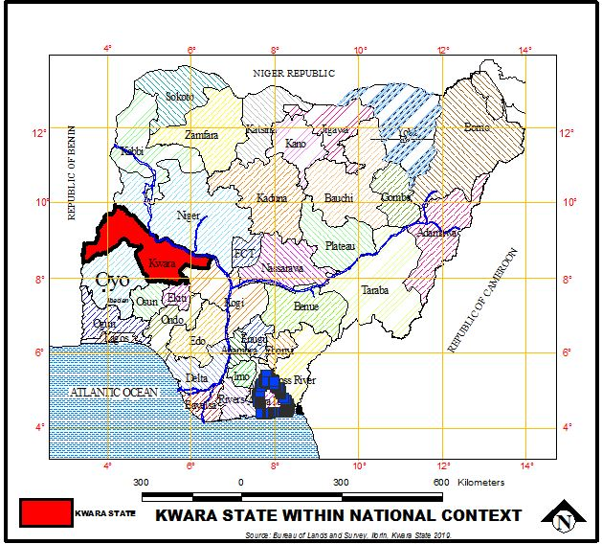

Source: Kwara State Geographical Board, 2025

Figure 1.2: Showing Kwara State map as the Case Study Area

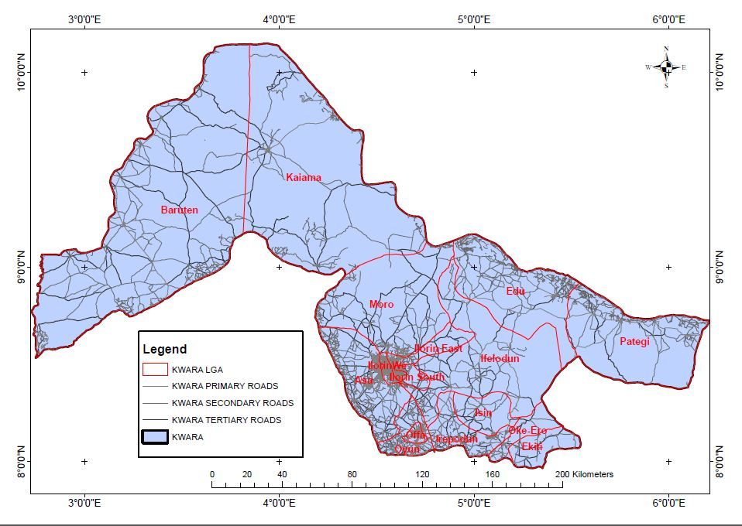

Source: Kwara State Geographical Board, 2025

CHAPTER TWO

LITERATURE REVIEW

2.1 INTRODUCTION
A comprehensive and functional address system is a critical component of urban infrastructure and spatial governance. In both developed and developing contexts, street naming and house numbering serve as essential tools for managing urban growth, facilitating service delivery, enhancing security, and improving citizens’ quality of life (Akinbamijo, 2012). Despite their foundational role in urban planning, address systems remain poorly developed or underutilised in many parts of sub-Saharan Africa, including Nigeria. These inefficiencies have been linked to weak institutional frameworks, rapid urban sprawl, limited technological integration, and low community participation (Owusu & Afutu-Kotey, 2010).
This chapter presents a review of relevant literature that frames the research problem, explores key concepts, and identifies the theoretical and empirical underpinnings for the study. The review is structured into six major parts. The first part (2.2) focuses on the conceptual clarifications surrounding street naming, house numbering, and urban addressing systems. The second part (2.3) discusses relevant theoretical frameworks that explain how planning tools such as address systems function within complex urban environments. The third part (2.4) reviews empirical studies from global, regional, and local contexts, highlighting best practices, implementation challenges, and innovations.
The fourth part (2.5) identifies existing gaps in the literature, particularly the lack of localized assessments of address system effectiveness in peri-urban communities such as Fate-Tanke. The final section (2.6) provides a summary and synthesis of the reviewed literature, setting the stage for the methodology and fieldwork components of the study.
The literature reviewed in this chapter will provide the foundation for assessing the implementation status, challenges, and prospects of street naming and house numbering systems in the study area. It will also help to justify the research’s relevance within the broader context of urban planning and governance in Nigeria.

2.2 CONCEPTUAL CLARIFICATIONS

2.2.1 STREET NAMING
Street naming is a fundamental element of urban spatial organization that involves the systematic designation of names to streets, roads, avenues, boulevards, lanes, and other public thoroughfares. This process facilitates navigation, communication, urban governance, and the efficient delivery of services (Chapin & Kaiser, 2010). Effective street naming not only enables residents and visitors to locate places easily but also supports governmental and commercial activities such as emergency response, mail delivery, infrastructure maintenance, and property management.
The history of street naming dates back to ancient civilizations, where streets were named after landmarks, trades, prominent figures, or physical features (Azaryahu, 1996). In modern cities, street names serve both functional and symbolic roles. Functionally, they help create a spatial reference system essential for navigation and location-based services. Symbolically, street names often reflect a city’s cultural identity, heritage, history, and political climate (Azaryahu & Kook, 2002). For example, streets may be named after historical leaders, local heroes, or significant events, contributing to collective memory and urban identity.
Standardization is critical in street naming. A well-structured naming system follows clear principles such as uniqueness, simplicity, and cultural appropriateness to avoid duplication and confusion (UN-Habitat, 2018). Proper street naming ensures that every street within a city or town has a unique and unambiguous name, facilitating clear communication and reducing errors in logistics and emergency services. The process typically involves local government agencies or town planning authorities, which may consult with community members or cultural committees to select appropriate names (Kearns & Berg, 2002).
Despite its importance, street naming can be politically contentious. The naming or renaming of streets often involves power dynamics, where governments may use street names to assert ideological dominance, erase colonial legacies, or honor political figures (Azaryahu, 1996). In some contexts, controversial street names can spark public debates or resistance, highlighting the social significance embedded in these seemingly mundane labels.
In developing countries, street naming faces additional challenges. Rapid urbanization, informal settlements, and weak institutional capacity frequently result in incomplete or inconsistent street naming (Gulyani & Talukdar, 2010). Streets in informal areas may lack formal names altogether, or residents might use colloquial or unofficial names that differ from those assigned by authorities. This situation creates confusion for service delivery and planning. Furthermore, poor maintenance of street signs and a lack of updated digital maps exacerbate navigation difficulties.
Ilorin, Nigeria, including its peri-urban communities such as Fate-Tanke, exemplifies these challenges. While some parts of the city have formal street names installed and recognized, many rapidly expanding neighborhoods lack standardized street naming systems, undermining urban management and service provision (Akinbamijo, 2012). This deficiency hampers everything from emergency response to postal service delivery, highlighting the critical need for effective street naming as part of urban governance and planning.
Street naming is more than a technical task; it embodies social, political, and cultural dimensions that influence urban identity and functionality. Effective street naming systems are indispensable for managing urban spaces, facilitating economic activities, and ensuring the safety and convenience of residents. The success of such systems depends on clear policies, community involvement, regular maintenance, and integration with technological tools such as Geographic Information Systems (GIS).

2.2.2 HOUSE NUMBERING
House numbering is an integral part of the urban addressing system that assigns unique identifiers to individual buildings or properties along streets or within neighborhoods. It complements street naming by enabling precise and unambiguous location of residential, commercial, and institutional premises, thereby facilitating various administrative, social, and economic functions (UN-Habitat, 2018). The primary goal of house numbering is to create a systematic method to identify properties to aid navigation, service delivery, property taxation, emergency response, and urban management.
House numbering systems vary globally, reflecting differences in urban design, planning traditions, and cultural contexts. Common systems include sequential numbering, where buildings are numbered consecutively along a street; odd-even numbering, where odd numbers are assigned to one side of the street and even numbers to the opposite side; and block numbering, which groups properties into blocks, each with a distinct number range (Kwon & Yoo, 2013). Each system has its merits depending on urban layout and ease of use. For instance, odd-even numbering is widely used in planned urban areas due to its logical pattern and ease of locating buildings.
The implementation of house numbering must adhere to key principles such as consistency, clarity, and visibility. Numbers should be clearly displayed and maintained on buildings or property boundaries to allow for quick identification (UN-Habitat, 2020). Additionally, the numbering scheme should be intuitive, avoiding duplication or gaps that could confuse residents and service providers. Consistency across neighborhoods and coordination among local authorities are essential for maintaining an effective numbering system.
The significance of house numbering extends beyond navigation. It supports government functions such as property registration and taxation, which are vital for revenue generation and funding urban services (Akinbamijo, 2012). Without a reliable house numbering system, it becomes challenging to maintain accurate records of property ownership, complicating land administration and planning enforcement. This can lead to revenue loss and difficulties in urban governance.
House numbering also plays a critical role in emergency services. Ambulance, fire, and police personnel rely heavily on clear and accurate address information to respond promptly to incidents (Koutsou et al., 2015). In areas where house numbers are absent, inconsistent, or illegible, emergency response times are often delayed, resulting in adverse outcomes for residents. Furthermore, service providers such as postal companies, utility firms, and delivery businesses depend on house numbering to efficiently locate customers and maintain service quality.
Despite these benefits, implementing effective house numbering systems is fraught with challenges, especially in developing countries. Rapid urban expansion, informal settlements, and unplanned neighborhoods often lack standardized house numbering (Gulyani & Talukdar, 2010). In such areas, buildings may not have numbers, or residents may use informal identifiers based on landmarks or family names. This hinders service delivery, planning, and security. Furthermore, limited technical and financial resources constrain local governments’ ability to enforce numbering regulations and maintain visible signage.
Cultural and social factors also influence house numbering practices. In some societies, residents may resist assigned numbers in favor of traditional or community-based identifiers, which reflect local customs or kinship ties (Owusu & Afutu-Kotey, 2010). Political interference and administrative lapses can also result in inconsistent or duplicated numbering, undermining trust in the system.
In the Nigerian context, including in urban centers like Ilorin and its suburbs such as Fate-Tanke, house numbering is often inconsistently applied or absent altogether (Akinbamijo, 2012). This situation compromises urban management, impedes tax collection, and complicates emergency response and service delivery. Addressing these issues requires institutional coordination, community engagement, and adoption of modern technologies such as Geographic Information Systems (GIS) to map and manage addresses efficiently.
No doubt, house numbering is a vital urban management tool that enhances the functionality of street naming and supports a broad range of urban services. Successful implementation depends on clear policies, technical capacity, social acceptance, and continuous maintenance. Strengthening house numbering systems is therefore critical to improving urban governance, service delivery, and residents’ quality of life, especially in rapidly growing peri-urban areas like Fate-Tanke.

2.2.3 IMPORTANCE OF ADDRESSING SYSTEMS IN URBAN MANAGEMENT
Addressing systems, comprising street naming and house numbering, are fundamental to effective urban management and governance. They provide the spatial framework that enables governments, businesses, and residents to identify locations accurately, facilitating a wide range of urban functions and services. Without a functional addressing system, urban areas face significant challenges in administration, service delivery, security, and socio-economic development (UN-Habitat, 2020).
One of the primary functions of addressing systems is to support land administration and property management. A reliable system ensures that properties can be uniquely identified, registered, and taxed, which is essential for municipal revenue generation and funding urban infrastructure (Akinbamijo, 2012). Effective property identification also helps prevent land disputes, fraudulent property transactions, and illegal land use, thereby promoting orderly urban development. In Nigeria, where informal land transactions are common, a sound addressing system contributes to transparency and accountability in land governance.
Addressing systems also enhance the efficiency of public service delivery. Utilities such as water supply, electricity, waste collection, and postal services depend heavily on accurate addresses to plan routes, manage accounts, and maintain infrastructure (Gulyani & Talukdar, 2010). For example, waste management companies require detailed location data to optimize collection schedules and minimize costs. In places without proper addressing, services may be irregular or inaccessible, contributing to environmental degradation and poor living conditions.
Emergency response services such as police, fire, and medical teams critically rely on precise addresses to locate incidents quickly. Delays caused by inadequate or non-existent addressing can result in loss of lives and property (Koutsou et al., 2015). During public health emergencies like disease outbreaks, effective addresses enable contact tracing, vaccination campaigns, and distribution of relief materials. This was evident during the COVID-19 pandemic, where urban areas with poor spatial identification faced challenges in controlling the spread and delivering healthcare services (UN-Habitat, 2020).
From a socio-economic perspective, addressing systems promote social inclusion and access to rights. Individuals with formal addresses are more likely to access banking, social welfare, education, and voting registration services (Owusu & Afutu-Kotey, 2010). Conversely, the absence of an address often marginalizes residents, particularly in informal settlements, making them invisible to authorities and service providers. This spatial exclusion exacerbates poverty and inequality, hindering sustainable urban development.
Addressing systems also facilitate urban planning and policy implementation. Accurate location data enables planners to conduct demographic surveys, assess infrastructure needs, and monitor land use changes (Ayeni, 2013). Geographic Information Systems (GIS) and other digital technologies depend on standardized address data to create maps and models that inform decision-making. In rapidly growing cities like Ilorin, integrating address systems with digital tools can improve urban resilience and governance.
Despite their importance, many developing cities face challenges in maintaining functional addressing systems. Factors such as rapid urbanization, informal settlements, institutional fragmentation, and limited funding often result in incomplete or outdated address databases (Gulyani & Talukdar, 2010). Furthermore, low community awareness and participation undermine efforts to maintain and update the systems, affecting their reliability and sustainability.
Addressing systems are indispensable to effective urban management. They underpin land governance, service delivery, emergency response, social inclusion, and urban planning. Strengthening these systems, particularly in peri-urban and informal areas like Fate-Tanke, is essential for promoting sustainable, safe, and inclusive cities. Policymakers and planners must therefore prioritize the development, maintenance, and community integration of addressing systems to realize these benefits.

2.2.4 CHALLENGES IN IMPLEMENTING ADDRESS SYSTEMS IN DEVELOPING COUNTRIES
Implementing effective street naming and house numbering systems presents significant challenges in many developing countries due to a complex interplay of socio-economic, institutional, technical, and cultural factors. These challenges affect the completeness, accuracy, usability, and sustainability of address systems, which in turn hinder urban management, service delivery, and socio-economic development (Gulyani & Talukdar, 2010).
One of the foremost challenges is rapid and often unplanned urban growth. Many developing cities experience high rates of urbanization, frequently characterized by the proliferation of informal settlements that develop outside official planning frameworks (UN-Habitat, 2018). These settlements often lack formal road layouts, street names, and house numbering, making it difficult for authorities to assign official addresses. The organic and irregular nature of such settlements complicates the creation of logical and consistent address systems, thereby perpetuating spatial invisibility and exclusion.
Institutional weaknesses also play a critical role. Fragmented governance structures, overlapping mandates among urban agencies, and limited technical and financial capacity undermine effective address system development and maintenance (Akinbamijo, 2012). In many cases, there is inadequate coordination between local governments, utility providers, postal services, and emergency agencies responsible for maintaining address databases. This institutional disconnection results in duplicated efforts, inconsistent records, and outdated or missing information.
Funding constraints further exacerbate the problem. Developing and maintaining a comprehensive addressing system requires investment in infrastructure such as street signs, house number plates, and digital databases. Many municipalities in low-income countries lack the budgetary resources or prioritization to sustain these efforts over time (Gulyani & Talukdar, 2010). Additionally, there is often a shortage of skilled personnel capable of conducting surveys, mapping, and data management required for effective addressing.
Technical challenges arise due to the absence or limited use of modern geographic information technologies (GIS, GPS) in many developing country contexts. While digital tools have revolutionized address system management in advanced cities, many developing urban areas still rely on paper maps and manual record-keeping, which are prone to errors and difficult to update (UN-Habitat, 2020). This technological lag limits the ability to create dynamic, searchable, and interoperable address databases.
Cultural and social factors also influence the success of address systems. In some communities, residents prefer informal identifiers such as landmarks, family names, or locally recognized nicknames rather than official street names and numbers (Owusu & Afutu-Kotey, 2010). This preference can stem from a lack of trust in government initiatives, low awareness of the benefits of formal addressing, or cultural attachment to traditional naming systems. Resistance to change and limited community engagement during the address system design and implementation phases can lead to poor adoption and maintenance.
Political considerations sometimes interfere with the process. Street naming can become a contentious political tool, where authorities use naming or renaming to assert power, honor political figures, or erase unpopular legacies, generating public disputes (Azaryahu, 1996). Such politicization can delay or disrupt efforts to establish effective and universally accepted addressing systems.
In the Nigerian context, including urban centers like Ilorin and its peri-urban communities such as Fate-Tanke, these challenges are clearly evident. Informal settlements with irregular layouts, institutional coordination difficulties, financial constraints, and low public awareness contribute to incomplete and ineffective street naming and house numbering systems (Akinbamijo, 2012). Addressing these multifaceted challenges requires an integrated approach that includes institutional reforms, capacity building, technological adoption, and active community participation.

2.3 THEORETICAL FRAMEWORK
The theoretical framework of this study provides the lens through which the effectiveness of street naming and house numbering in Fate-Tanke, Ilorin, is analyzed. It establishes the foundational theories that explain the roles, challenges, and dynamics of urban addressing systems within the broader context of urban planning and governance. Three main theories are particularly relevant: Rational Planning Theory, Systems Theory, and Participatory Planning Theory.

2.3.1 RATIONAL PLANNING THEORY
Rational Planning Theory, rooted in the works of scholars such as Lindblom (1959) and Faludi (1973), views urban planning as a systematic and logical process aimed at optimizing resource allocation and achieving predetermined objectives. According to this theory, urban infrastructure elements like street naming and house numbering should be carefully designed, standardized, and implemented to ensure efficiency, orderliness, and predictability in the urban environment (Faludi, 1973). The theory assumes that planners can comprehensively assess urban needs, design appropriate solutions, and execute plans effectively.
In the context of addressing systems, Rational Planning Theory underscores the importance of formalized, standardized street names and house numbers to support urban governance functions such as service delivery, land administration, and emergency response. The theory’s focus on rational decision-making and technical expertise aligns with the need for systematic street and property identification.
However, critics argue that Rational Planning Theory may overlook socio-political realities, informal practices, and community dynamics that influence urban addressing, especially in developing countries with complex urban environments (Innes & Booher, 2010).

2.3.2 SYSTEMS THEORY
Systems Theory provides a holistic perspective by viewing urban areas as complex, interrelated systems composed of multiple components that interact dynamically (Von Bertalanffy, 1968). Within this framework, the urban addressing system is seen as a subsystem interconnected with land use, transportation, governance, and social systems.
The theory emphasizes the importance of coordination among various urban actors and institutions to ensure the smooth functioning of the addressing system (Checkland, 1981). It suggests that failures in street naming or house numbering can arise from breakdowns or misalignments in communication, resource allocation, or institutional roles.
Applying Systems Theory to Fate-Tanke’s addressing challenges highlights the need for integrated approaches involving local government, utility companies, community members, and technological platforms to create a functional and sustainable addressing system.

2.3.3 PARTICIPATORY PLANNING THEORY
Participatory Planning Theory advocates for the inclusion of stakeholders—particularly local communities—in the planning process to enhance legitimacy, responsiveness, and sustainability of urban interventions (Arnstein, 1969). This theory recognizes that residents possess valuable local knowledge and have a direct stake in urban outcomes.
In the context of street naming and house numbering, participatory approaches can foster community ownership and acceptance, reducing resistance to address system implementation and maintenance (Healey, 1997). Participatory methods may involve consultations, public forums, and collaborative decision-making processes regarding street names and numbering conventions.
Given the challenges of informal settlement residents’ mistrust or unfamiliarity with formal addressing, participatory planning offers a way to bridge gaps between authorities and communities in Fate-Tanke.

2.4 EMPIRICAL REVIEW
This section reviews empirical studies on street naming and house numbering systems, highlighting successes, challenges, and innovations in different geographical and socio-economic contexts. It draws from global experiences before narrowing the focus to African and Nigerian urban environments, thereby situating the present study within existing knowledge and identifying areas requiring further investigation.

2.4.1 GLOBAL STUDIES ON STREET NAMING AND HOUSE NUMBERING
Globally, addressing systems have evolved considerably, benefiting from technological integration and strong institutional frameworks. For example, in developed countries like the United States, United Kingdom, and Singapore, well-established street naming and house numbering systems underpin urban management and service delivery (UN-Habitat, 2018). These countries have developed comprehensive national address databases linked to Geographic Information Systems (GIS), enabling precise location tracking, efficient postal services, emergency response, and urban planning (Kumar & Koperski, 2015).
In Singapore, for instance, the Urban Redevelopment Authority (URA) maintains a detailed digital address registry that supports smart city initiatives, linking addresses with real-time data on utilities, transportation, and land use (Nguyen & Zeng, 2020). Similarly, the UK’s National Land and Property Gazetteer (NLPG) integrates local government address data into a centralized system accessible to emergency services and public utilities (Bawden & Dine, 2013).
Despite the successes, global studies also reveal challenges. Even in developed cities, street renaming processes can be contentious, involving community resistance and cultural sensitivities (Azaryahu, 1996). Furthermore, maintaining up-to-date digital address databases requires continuous institutional commitment and investment (Kumar & Koperski, 2015).

2.4.2 ADDRESSING CHALLENGES IN AFRICAN CITIES
In many African cities, addressing systems are often incomplete, outdated, or inconsistent, particularly in informal settlements and rapidly expanding peri-urban areas (UN-Habitat, 2018). A study by Owusu and Afutu-Kotey (2010) on Accra, Ghana, found that informal neighborhoods largely lack formal street naming and house numbering, relying instead on landmarks and local names. This lack of formal addresses complicates service delivery, emergency response, and land administration.
In Nairobi, Kenya, Gulyani and Talukdar (2010) documented how slum areas operate without formal addresses, relying on informal naming conventions and impeding municipal governance. Efforts to introduce formal addressing often face resistance due to mistrust, lack of awareness, and resource constraints. However, pilot projects integrating GIS-based addressing have shown promise in improving spatial data and service provision.
Similarly, in Lagos, Nigeria, studies have highlighted the challenges posed by rapid urban growth, informal housing, and institutional fragmentation in establishing functional address systems (Akinbamijo, 2012). Despite initiatives by the Lagos State Government to improve addressing and mapping, many communities still lack clear street names and house numbers.

2.4.3 NIGERIAN EXPERIENCES AND CASE STUDIES
Nigeria’s rapid urbanization presents both opportunities and challenges for the implementation of effective street naming and house numbering systems. Several studies have documented the state of addressing systems across Nigerian cities, illustrating a spectrum of progress and persistent issues.
In Lagos, the commercial capital, the government has undertaken concerted efforts to standardize street naming and house numbering. According to Akinbamijo (2012), the Lagos State government partnered with private and international agencies to develop a comprehensive Geographic Information System (GIS)-based address database. This initiative aimed to improve urban governance, enhance service delivery, and attract investment by providing reliable spatial data. Despite these efforts, challenges remain due to informal settlements, rapid growth, and bureaucratic hurdles that limit full coverage and data maintenance (Ibrahim & Okereke, 2019).
Similarly, a study by Olawale and Abubakar (2018) on Abuja’s peri-urban areas, including some parts resembling Fate-Tanke, revealed that inadequate street naming and inconsistent house numbering impede effective urban management. Residents frequently rely on informal naming conventions, causing confusion for postal services, emergency responders, and government agencies. The study recommended increased government engagement, community participation, and the use of digital mapping technologies to improve addressing.
In Ilorin, the capital of Kwara State and the location of Fate-Tanke, literature on addressing systems is scarce but indicates similar challenges. According to Akinbamijo (2012), many neighborhoods in Ilorin lack formal street naming and house numbering, especially in rapidly expanding suburbs and peri-urban settlements. This situation compromises tax collection, emergency response, and planning enforcement, highlighting the need for targeted interventions. Anecdotal evidence suggests that residents in Fate-Tanke face difficulties in navigation, service access, and property identification due to the absence or ineffectiveness of addressing systems.
Other Nigerian cities, such as Kano and Port Harcourt, also exhibit mixed progress. A study by Musa and Abdullahi (2017) in Kano noted that although some planned districts have systematic addressing, informal settlements remain unaddressed. The lack of coordination between municipal agencies and limited public awareness were identified as key barriers.
The Nigerian Postal Service (NIPOST) has historically been responsible for street naming and house numbering but faces capacity challenges (NIPOST, 2015). Recent reforms advocate for multi-agency collaboration and the adoption of technological tools to enhance address data management. The National Address Database initiative aims to create a unified platform accessible by all stakeholders, though implementation is ongoing and uneven across regions.

2.4.4 INSTITUTIONAL AND COMMUNITY PARTICIPATION FACTORS
The effectiveness of street naming and house numbering systems in urban areas is deeply influenced by the roles played by institutions and the degree of community participation. Institutional frameworks provide the policies, regulations, and enforcement mechanisms necessary for establishing and maintaining address systems, while community involvement ensures that these systems are socially accepted, accurately reflect local realities, and are sustainably managed (Healey, 1997).

INSTITUTIONAL ROLES AND CHALLENGES
Urban address systems typically fall under the jurisdiction of multiple agencies, including local government authorities, planning departments, postal services, utility companies, and emergency response organizations. Effective coordination among these stakeholders is essential to avoid duplication, data inconsistency, and fragmentation (Akinbamijo, 2012). However, in many developing country contexts, including Nigeria, institutional fragmentation and weak governance structures undermine address system implementation.
Owusu and Afutu-Kotey (2010) observed in Accra, Ghana, that lack of clear mandates and poor inter-agency collaboration resulted in outdated and incomplete address records. Similarly, in Nigerian cities, inadequate institutional capacity, insufficient funding, and bureaucratic inertia limit the ability to enforce street naming regulations and to maintain house numbering signage (Musa & Abdullahi, 2017). Furthermore, political interference and lack of transparency sometimes affect the neutrality and continuity of addressing initiatives (Azaryahu, 1996).

COMMUNITY PARTICIPATION AND SOCIAL ACCEPTANCE
Community participation is recognized as vital for the legitimacy and effectiveness of urban addressing. Residents’ knowledge of local geography, landmarks, and social structures can inform the design of culturally appropriate and navigable address systems (Healey, 1997). Participation also fosters a sense of ownership and responsibility, which enhances the maintenance and accurate use of street names and house numbers.
Conversely, exclusion of community voices often leads to resistance or neglect of addressing schemes. Owusu and Afutu-Kotey (2010) reported that in Ghana, residents of informal settlements preferred informal location identifiers and were skeptical of government-led naming efforts due to perceived lack of benefits or trust. Similar trends have been documented in Nigerian cities, where low awareness of the importance of formal addressing and mistrust of authorities hamper adoption (Akinbamijo, 2012).
Successful initiatives therefore often involve participatory mapping, public consultations, and awareness campaigns. For instance, pilot projects using GIS technology in Nairobi’s informal settlements incorporated community input to assign meaningful street names and house numbers, improving acceptance and accuracy (Gulyani & Talukdar, 2010).

INTEGRATION OF TECHNOLOGY AND STAKEHOLDER ENGAGEMENT
The adoption of Geographic Information Systems (GIS) and digital address databases provides new opportunities for institutional coordination and community involvement. Digital platforms enable multiple stakeholders to access, update, and validate address data collaboratively (UN-Habitat, 2020). Mobile applications and community mapping exercises have empowered residents to contribute to address verification and correction processes.
In Fate-Tanke and similar peri-urban Nigerian contexts, integrating institutional reforms with participatory approaches and technology adoption is critical. Such integration ensures that street naming and house numbering systems are not only technically sound but socially relevant and sustainably managed.

2.4.5 USE OF TECHNOLOGY (GIS, GPS) IN ADDRESS SYSTEM IMPLEMENTATION
Technological advancements, particularly Geographic Information Systems (GIS) and Global Positioning Systems (GPS), have revolutionized the design, implementation, and management of street naming and house numbering systems worldwide. These tools provide precise spatial data, facilitate dynamic address databases, and enhance the efficiency and accuracy of urban addressing, especially in complex and rapidly changing urban environments (UN-Habitat, 2018).

ROLE OF GIS AND GPS IN ADDRESSING SYSTEMS
GIS is a computer-based tool that captures, stores, analyzes, and visualizes geographic information, allowing planners and administrators to map streets, properties, and landmarks in a digital spatial framework (Longley et al., 2015). GPS complements GIS by providing accurate real-time location data, which can be used to geo-reference buildings and streets for precise house numbering and street naming (Elwood, 2006).
Together, GIS and GPS enable the creation of comprehensive digital address registries that can be easily updated, queried, and shared across agencies. This technological integration supports critical urban functions such as emergency response, utility management, urban planning, and service delivery (Kumar & Koperski, 2015). It also facilitates public access to address information through online portals and mobile applications.

GLOBAL AND REGIONAL APPLICATIONS
In developed countries, GIS-based address systems are standard practice. For example, Singapore’s Urban Redevelopment Authority maintains a detailed GIS address database linked with city planning and infrastructure systems (Nguyen & Zeng, 2020). Similarly, many U.S. cities use GIS to support 911 emergency services, postal delivery, and urban planning (United States Geological Survey, 2019).
In African cities, the use of GIS and GPS for addressing is growing but remains limited due to resource constraints and institutional challenges. Pilot projects in Nairobi’s informal settlements demonstrated that community-led GIS mapping, combined with GPS data collection, could create reliable address systems where none previously existed (Gulyani & Talukdar, 2010). These projects improved access to services, emergency response times, and urban governance.
In Nigeria, initiatives by local governments and organizations have begun integrating GIS in urban management, including addressing (Akinbamijo, 2012). However, coverage is patchy, and many peri-urban and informal areas like Fate-Tanke lack comprehensive digital mapping, highlighting the need for expanded technological adoption and capacity building.

CHALLENGES AND CONSIDERATIONS
Despite the benefits, technological implementation faces challenges. Limited funding, technical expertise, and data-sharing policies can hinder GIS and GPS adoption (UN-Habitat, 2020). Additionally, ensuring data accuracy, updating databases regularly, and integrating technology with community knowledge require ongoing institutional commitment and stakeholder collaboration.
Moreover, the digital divide may exclude marginalized populations from benefiting fully from technology-driven addressing systems, underscoring the need for inclusive approaches that combine technology with local participation.

CHAPTER THREE

RESEARCH METHODOLOGY

3.1 INTRODUCTION
This chapter presents the research methodology adopted to investigate the effectiveness of street naming and house numbering in Fate-Tanke, Ilorin. It outlines the sources of data, sampling design, data collection methods, and techniques used for analysis. The methodology is designed to ensure reliability, validity, and representativeness, providing robust evidence to address the research questions and objectives.
The study primarily employs a mixed-method approach, combining both qualitative and quantitative data to comprehensively understand the current addressing system's strengths and challenges. Quantitative data derived from structured questionnaires enable statistical analysis of residents’ perceptions and experiences with street naming and house numbering. Qualitative data, gathered through oral interviews and reconnaissance surveys, enrich the understanding of contextual and institutional factors influencing addressing practices.
This chapter further describes the sampling techniques, data collection instruments, and analysis methods employed. Ethical considerations, including informed consent and confidentiality, are integrated throughout the research process to uphold the integrity and social responsibility of the study.

3.2 PRIMARY SOURCE OF DATA
The primary data for this study are collected directly from residents, local authorities, and key stakeholders in Fate-Tanke through various methods including reconnaissance surveys, oral interviews, and questionnaire administration. These methods provide firsthand information about the current status and effectiveness of street naming and house numbering. This was done through reconnaissance surveys, Oral interviews and the administration of structured questionnaires to residents to captures quantitative data on their knowledge, perceptions, and satisfaction levels regarding street naming and house numbering. This data provides empirical evidence on the effectiveness of the current addressing system and its impact on daily activities such as navigation, service delivery, and emergency response.

3.2.1 RECONNAISSANCE SURVEY
The reconnaissance survey involves a preliminary field visit to Fate-Tanke to observe and document the existing street naming and house numbering infrastructure. This stage enables the researcher to identify streets with official nameplates, the presence and visibility of house numbers, and areas lacking adequate signage.
Photographic evidence and notes are collected during the survey to provide visual documentation and spatial context. The survey also aids in mapping the layout of streets and buildings, which informs the sampling strategy and questionnaire design. Additionally, the reconnaissance survey helps identify key informants and stakeholders for subsequent oral interviews. It allows the researcher to assess potential challenges related to data collection such as accessibility, security, and community receptiveness.

3.2.2 ORAL INTERVIEW
Oral interviews are conducted with selected community leaders, local government officials, and representatives from agencies involved in urban planning and address management in Fate-Tanke. These interviews aim to gather detailed information on the policies, practices, and challenges related to street naming and house numbering. Semi-structured interview guides are used to facilitate flexible yet focused discussions, allowing respondents to share their experiences and perspectives. Interviews explore topics such as the history of addressing in the area, institutional roles, funding and maintenance issues, and community engagement efforts.
The qualitative data obtained complement the quantitative findings, providing explanations for observed trends and identifying barriers to effective addressing. This method also helps uncover informal practices or social dynamics that may influence the implementation and use of the addressing system. Interviews are audio-recorded with consent and later transcribed for thematic analysis, enhancing the depth and richness of the study’s data.

3.2.4 QUESTIONNAIRE ADMINISTRATION
Structured questionnaires are administered to residents of Fate-Tanke to collect quantitative data on their awareness, perceptions, and satisfaction with the street naming and house numbering system. The questionnaire includes closed and Likert-scale questions designed to measure knowledge of street names, clarity and visibility of house numbers, and the perceived impact on service access and security. Questionnaires are distributed to occupants of sampled buildings identified through the reconnaissance survey and mapped using the sampling framework. Face-to-face administration ensures clarity of questions, improves response rates, and allows for immediate clarification. Data collected from questionnaires are coded and analyzed using statistical software to generate descriptive and inferential statistics that address the research objectives.

3.4 SAMPLING FRAME AND SAMPLE SIZE

3.4.1 SAMPLING FRAME
The sampling frame for this study comprises all buildings within the Fate-Tanke area, as identified through Google Maps satellite imagery and local records. The total number of buildings is 890, encompassing residential, commercial, and public structures. Using buildings as the sampling unit is appropriate because the study focuses on physical addressing elements like street names and house numbers that are tied directly to individual properties.
Table 3.1 Sampling Frame and Sample Size Log
S/N | Street name | Number of buildings | Number of building sampled
 | Oke Onigbin Street | 50 | 5.6
 | Sheikh Muhammed Robiu Adebayo Street | 19 | 2.1
 | Abdullahi Muhammed Street | 45 | 6.06
 | Chief Abraham Adeniken Street | 60 | 6.7
 | Saratu Mamman Street | 49 | 5.5
 | Sodik Suleman Street | 53 | 6
 | Olojoku Street | 67 | 7.5
 | Solomon Ade Aina Street | 20 | 2.2
 | Toyin Tunrayo Lawal Street | 18 | 2
 | Ajadi Shiru Street | 39 | 4.4
 | Rex Bello Street | 80 | 9
 | Irabon Street | 33 | 3.7
 | Bolanta Street | 45 | 5.1
 | Hammed Dangiwa Sreet | 40 | 4.5
 | Ayinde Kamaldeen Street | 50 | 5.6
 | Ololade Afeez Street | 71 | 8
 | Iyibare Street | 45 | 5.1
 | Ajao Lateef Street | 56 | 6.3
 | Total |  | 890

3.4.2 SAMPLE SIZE
A sample size of 20% of the total buildings, amounting to 178 buildings, has been selected for the study. This percentage is justified on the grounds of balancing statistical representativeness with practical constraints such as time, budget, and accessibility. Sampling 20% allows sufficient data variability to generalize findings while ensuring resource-efficient data collection (Kothari, 2004). This sample size is also consistent with similar urban studies where 15–30% sampling rates are commonly applied.

3.5 SAMPLING TECHNIQUES
The study employs a systematic random sampling technique to select the 178 buildings from the sampling frame of 890 buildings. After listing all buildings sequentially, every 5th building is selected (i.e., 890/178 = 5). This method ensures randomness and reduces selection bias while achieving a spatially distributed sample. Where access is restricted or a building is unoccupied, the next adjacent building is selected to maintain sample size integrity. This approach supports representativeness across different zones within Fate-Tanke.

3.6 METHOD OF DATA ANALYSIS
Data collected from questionnaires are coded and analyzed using the Statistical Package for Social Sciences (SPSS) software. Descriptive statistics such as frequencies, percentages, means, and standard deviations summarize respondents’ demographic characteristics and perceptions of the addressing system.
Inferential statistics, including chi-square tests and correlation analysis, are used to examine relationships between variables such as awareness of street names and satisfaction with house numbering. Qualitative data from oral interviews and reconnaissance surveys are analyzed thematically to identify patterns, challenges, and contextual factors.

CHAPTER FOUR

4.1 INTRODUCTION
This chapter presents, analyzes, and interprets the data collected in line with the aim and objectives of the study titled "Assessing the Effectiveness of Street Naming and House Numbering in Fate-Tanke, Ilorin." The analysis focuses on respondents’ awareness, accessibility, perception, and satisfaction with the current address system in the study area. Both quantitative data derived from structured questionnaires and qualitative insights from oral interviews and field observations are systematically examined to evaluate the functionality and challenges of the existing street naming and house numbering framework.
The primary objective of this chapter is to transform raw data into meaningful findings through appropriate statistical and thematic methods. Descriptive statistics such as frequency tables, percentages, and charts are used to summarize demographic characteristics and responses to survey items. Qualitative data are interpreted thematically to support and contextualize the quantitative findings, particularly in areas such as institutional challenges, signage conditions, and resident experiences.

4.2 SOCIO-DEMOGRAPHIC CHARACTERISTICS OF RESPONDENTS
Understanding the socio-demographic background of respondents is essential for contextualizing their perceptions and experiences with street naming and house numbering. This section presents data on respondents’ gender, age, educational attainment, occupational status, and duration of residence in Fate-Tanke. The analysis helps to determine how these characteristics may influence awareness, usage, and satisfaction with the address system.

4.2.1 GENDER DISTRIBUTION OF RESPONDENTS
Table 4.1 presents the gender distribution of respondents in the study area. Out of the 178 respondents surveyed, 102 (57.3%) were male, while 76 (42.7%) were female. This distribution reflects a relatively balanced gender representation, though with a slight male predominance. The higher participation of male respondents may be attributed to traditional gender roles and greater male involvement in housing and community planning matters in many Nigerian urban settings, including Fate-Tanke. It may also reflect greater accessibility or availability of males during the data collection period. Nonetheless, the female representation (42.7%) is substantial enough to ensure inclusivity in the perspectives gathered, thereby enhancing the reliability of the study's findings. A gender-sensitive assessment is crucial in urban planning studies, as men and women may interact differently with infrastructure such as street naming and house numbering systems (UN-Habitat, 2020). The inclusion of both genders ensures a comprehensive evaluation of user experience and perception within the community.

Table 4.1 Gender Distribution of Respondents
Gender | Frequency | Percentage (%)
Male | 102 | 57.3
Female | 76 | 42.7
Total | 178 | 100

Source: Authors Field Survey, 2025

4.2.2 AGE DISTRIBUTION OF RESPONDENTS
The age distribution of respondents, as presented in Figure 4.1, reveals that the majority fall within the economically active and socially mobile age brackets of 26–35 years (29.2%) and 36–45 years (26.4%). This combined group (55.6%) represents the segment most likely to be homeowners, tenants, or regular users of urban infrastructure, including address systems. The 18–25 age group, accounting for 15.7%, likely comprises students or young adults who may depend more on informal navigation tools such as digital maps or local knowledge. Meanwhile, those aged 46–60 make up 19.1%, and respondents above 60 years constitute 9.6%. The relatively lower participation of older adults may reflect demographic realities such as retirement migration or lower engagement in housing-related administrative processes. The dominance of middle-aged respondents is advantageous for this study as they are more likely to interact with services requiring functional street naming and house numbering—such as logistics, utilities, and emergency responses—thereby providing informed opinions on the system’s effectiveness. Similar demographic weighting has been justified in urban planning studies, where adults within productive age ranges are considered credible evaluators of service delivery and infrastructure utility (UN-Habitat, 2020; Gulyani & Talukdar, 2010).
Figure 4.1: Age Distribution of Respondents

Source: Authors Field Survey, 2025

4.2.3 EDUCATIONAL QUALIFICATION

The educational profile of respondents in Fate-Tanke, as presented in Table 4.3, reveals a population with relatively high levels of formal education. Only 6.7% of respondents reported having no formal education, while 11.2% attained primary education. A significant proportion (29.8%) had completed secondary education, and a combined 52.3% possessed tertiary qualifications—23.6% with OND/NCE and 28.7% with BSc/HND or higher. This suggests that the majority of residents are literate and likely to comprehend the functional importance of street naming and house numbering in urban governance. The high percentage of tertiary-educated individuals supports the reliability of their responses, especially regarding awareness, satisfaction, and usability of address systems. Moreover, respondents with higher education levels are generally more likely to demand and value structured urban services, including accurate property identification and public service delivery (Gulyani & Talukdar, 2010; UN-Habitat, 2020). Therefore, the educational structure of the sample justifies confidence in the quality of feedback obtained, particularly in evaluating institutional performance, maintenance issues, and user engagement with the address system.

Table 4.2 Educational Qualification
Education Level | Frequency | Percentage (%)
No formal education | 12 | 6.7%
Primary | 20 | 11.2%
Secondary | 53 | 29.8%
Tertiary (OND/NCE) | 42 | 23.6%
Tertiary (BSc/HND+) | 51 | 28.7%
Total | 178 | 100
Source: Authors Field Survey, 2025

4.2.4 OCCUPATIONAL STATUS
Table 4.3 presents the occupational distribution of respondents within the Fate-Tanke area. The data reveals that the majority of respondents are traders and artisans, accounting for 27.5%, followed by civil servants at 21.3%. Students constitute 17.4%, while retired individuals make up 13.5%. The proportions of private employees (12.4%) and the unemployed (7.9%) are also notable. This occupational spread reflects the socio-economic diversity typical of peri-urban areas, where informal economic activities often thrive alongside public and private sector employment. The high proportion of traders/artisans suggests a strong informal sector presence, which may influence awareness and application of address systems—particularly if such groups are less regulated by formal institutions. Civil servants and private employees, on the other hand, are more likely to engage with formal address systems due to bureaucratic and service delivery demands. The presence of retirees and students further indicates generational variation in perception, with older residents potentially having longer exposure to address-related policies. These findings justify the relevance of inclusive planning interventions that target diverse occupational groups to improve compliance and usability of street naming and house numbering systems (UN-Habitat, 2020; Abubakar & Doan, 2010).

Table 4.3 Occupational Status
Occupation | Frequency | Percentage (%)
Civil Servant | 38 | 21.3
Trader/Artisan | 49 | 27.5
Student | 31 | 17.4
Private Employee | 22 | 12.4
Unemployed | 14 | 7.9
Retired | 24 | 13.5
Total | 178 | 100
Source: Authors Field Survey, 2025

4.2.5 DURATION OF RESIDENCE
Table 4.4 presents the distribution of respondents based on their duration of residence in Fate-Tanke. The data reveals that a majority of the respondents, accounting for 66.2% (118 individuals), have lived in the area for more than six years, with 33.1% residing between 6 to 10 years and another 33.1% residing over 10 years. This indicates a relatively stable population with long-term residents who are likely to possess a thorough understanding and experience of the local street naming and house numbering system. Conversely, a smaller proportion of respondents, 33.8%, have lived in the area for less than six years, including 7.3% who have stayed less than one year and 26.4% between one and five years. The presence of both new and long-term residents allows for a broad range of perspectives on the effectiveness and challenges of the addressing system, as recent arrivals may highlight issues of accessibility and navigation for newcomers, while long-term residents can provide insights into the system’s consistency, maintenance, and evolution over time. Overall, the distribution supports the validity of the data collected, as it reflects the views of individuals with varied levels of familiarity and interaction with the study area’s addressing infrastructure (UN-Habitat, 2020; Gulyani & Talukdar, 2010).

Table 4.4 Duration of Residence
Duration of Residence | Frequency | Percentage (%)
Less than 1 year | 13 | 7.3
1–5 years | 47 | 26.4
6–10 years | 59 | 33.1
Over 10 years | 59 | 33.1
Total | 178 | 100
Source: Authors Field Survey, 2025

4.3 Assessment of Street Naming System in Fate-Tanke
This section presents the analysis of respondents' views on the effectiveness of street naming in Fate-Tanke. The assessment covers awareness, availability, visibility, legibility, and maintenance of street name signage. Data were gathered through structured questionnaire items using a 5-point Likert scale ranging from Strongly Agree (5) to Strongly Disagree (1).

4.3.1 AWARENESS AND AVAILABILITY OF STREET NAMES
The data presented in Table 4.5 reveals that a significant proportion of residents in Fate-Tanke recognize the presence and importance of street naming in their community. Specifically, 68% of respondents (combining those who strongly agree and agree) affirm that most streets in Fate-Tanke have official names, reflected in a mean score of 3.62. This suggests that street naming is relatively widespread, though not yet comprehensive across the entire area. Furthermore, an even higher proportion—approximately 83%—express awareness of the name of the street on which they reside, indicated by the mean of 4.12. This heightened personal awareness could be attributed to the residents’ daily interactions and reliance on street names for navigation, communication, and service delivery. The disparity between the percentage acknowledging official street naming and those aware of their street name may indicate informal or community-based naming practices supplementing formal systems. This finding aligns with urban addressing studies (Akinbamijo, 2012; UN-Habitat, 2020), which emphasize that while official street naming is essential, residents’ knowledge and use of street names critically underpin the effectiveness of urban navigation and service provision.

Table 4.5 Awareness and Availability of Street Names
Statement | Strongly Agree | Agree | Neutral | Disagree | Strongly Disagree | Total | Mean
Most streets in Fate-Tanke have official names | 52 | 69 | 17 | 25 | 15 | 178 | 3.62
I am aware of the name of the street I live on | 86 | 61 | 10 | 11 | 10 | 178 | 4.12
Source: Authors Field Survey, 2025

4.3.2 VISIBILITY AND LEGIBILITY OF STREET SIGNS
The data on the visibility and legibility of street name signs in Fate-Tanke reveals a mixed perception among residents. With only 84 respondents (47.2%) agreeing or strongly agreeing that street signs are clearly visible from a distance, and a mean score of 2.98, it suggests that nearly half of the respondents experience difficulties in spotting street names easily. This limited visibility can hinder navigation, delay emergency response times, and reduce the overall effectiveness of the addressing system. Similarly, the legibility of street names also garnered low satisfaction, with 75 respondents (42.1%) affirming that the signs are easy to read, reflected in a slightly lower mean score of 2.83. The sizeable proportion of respondents who disagreed or strongly disagreed indicates that many street signs may suffer from issues such as faded paint, poor font size, or obstructed placement. These challenges align with findings from Musa and Abdullahi (2017), who identified inadequate maintenance and low-quality signage materials as common barriers to effective urban addressing in Nigerian cities. Therefore, improving the visibility and legibility of street signs through regular maintenance, standardized design, and strategic placement is critical to enhancing the functional usability of Fate-Tanke’s street naming system.

4.6 Visibility and Legibility of Street Signs
Statement | Strongly Agree | Agree | Neutral | Disagree | Strongly Disagree | Total | Mean
Street name signs are clearly visible from a distance | 36 | 48 | 21 | 47 | 26 | 178 | 2.98
The names on street signs are legible and easy to read | 31 | 44 | 23 | 49 | 31 | 178 | 2.83
Source: Authors Field Survey, 2025

4.3.3 MAINTENANCE AND UPDATE OF STREET NAME SIGNAGE
The data on maintenance and updating of street name signage in Fate-Tanke reveals significant challenges in sustaining the effectiveness of the addressing system (Figure 4.2). Only 53 respondents (29.8%) agreed or strongly agreed that street name signs are regularly maintained, while a majority of 96 respondents (53.9%) disagreed or strongly disagreed, reflected by a low mean score of 2.51. This indicates a prevalent perception of neglect in the upkeep of signage infrastructure. Similarly, when asked if damaged or missing street signs are replaced promptly, even fewer respondents—43 (24.2%)—agreed or strongly agreed, whereas a substantial 111 respondents (62.3%) disagreed or strongly disagreed, resulting in an even lower mean of 2.27. These findings suggest that not only is maintenance irregular, but the replacement of damaged signage is also significantly delayed or absent. The poor maintenance undermines the functionality of the street naming system by reducing visibility and usability, which is crucial for navigation, service delivery, and emergency response. Such infrastructural lapses align with earlier studies (Akinbamijo, 2012; Musa & Abdullahi, 2017) which highlighted that inadequate funding, lack of enforcement, and weak institutional coordination contribute to deteriorating urban address systems in Nigerian cities. Without consistent maintenance and timely replacement of street signs, the addressing system risks becoming ineffective, frustrating residents and service providers alike.

Figure 4.2 Maintenance and Update of Street Name Signage

Source: Authors Field Survey, 2025

4.4 ASSESSMENT OF HOUSE NUMBERING SYSTEM IN FATE-TANKE
This section evaluates how effectively house numbering is implemented and utilized in the Fate-Tanke area. The analysis is based on key variables such as the presence, clarity, placement, consistency, and usefulness of house numbers for identification and navigation. Responses were measured using a 5-point Likert scale.

4.4.1 AVAILABILITY AND PLACEMENT OF HOUSE NUMBERS
The data on the availability and placement of house numbers in Fate-Tanke reveal a moderate but inconsistent practice within the community (Table 4.7). About 47.2% of respondents (combining Strongly Agree and Agree) acknowledged that most houses have visible house numbers, reflected in a mean score of 3.00, which indicates a neutral to slightly positive perception. However, a significant portion of respondents remained neutral or disagreed, suggesting that visibility is not uniform across the area. Similarly, only 41.6% agreed that house numbers are correctly placed on buildings, with a slightly lower mean score of 2.89. This points to a lack of standardization and proper guidance on where and how house numbers should be displayed. Such inconsistency may stem from inadequate enforcement of addressing policies and limited public awareness about the importance of uniform house numbering for effective urban navigation, service delivery, and emergency response (Akinbamijo, 2012). The findings justify the need for local government intervention to ensure proper placement and visibility, which are critical to enhancing the overall effectiveness of the addressing system in Fate-Tanke.

Table 4.7 Availability and Placement of House Numbers
Statement | Strongly Agree | Agree | Neutral | Disagree | Strongly Disagree | Total | Mean
Most houses in Fate-Tanke have visible house numbers | 39 | 45 | 28 | 40 | 26 | 178 | 3.00
House numbers are correctly placed on buildings | 33 | 42 | 27 | 46 | 30 | 178 | 2.89
Source: Authors Field Survey, 2025

4.4.2 LEGIBILITY AND DURABILITY OF HOUSE NUMBERS

The data presented in Table 4.8 reveal that residents of Fate-Tanke perceive the legibility and durability of house numbers as generally inadequate. Only 38.2% of respondents (those who agreed or strongly agreed) consider house numbers to be clear and legible, while a slightly lower 32.6% believe the numbers are durable and resistant to wear. The mean scores of 2.77 for legibility and 2.59 for durability fall below the neutral midpoint of 3.0, indicating an overall dissatisfaction with the quality of house numbering in the area. This inadequacy may stem from the use of low-quality materials, poor workmanship, or lack of regular maintenance, factors commonly observed in peri-urban Nigerian neighborhoods (Olawale & Abubakar, 2018). Poor legibility and durability undermine the effectiveness of the addressing system, complicating navigation, mail delivery, and emergency response efforts (Akinbamijo, 2012). Thus, the findings highlight a critical need for standardized installation practices and maintenance protocols to enhance the visibility and longevity of house numbers, thereby improving urban management and residents’ accessibility.

Table 4.8 Legibility and Durability of House Numbers
Statement | Strongly Agree | Agree | Neutral | Disagree | Strongly Disagree | Total | Mean
House numbers are clear and legible | 29 | 39 | 34 | 41 | 35 | 178 | 2.77
House numbers are durable and not easily worn out | 26 | 33 | 32 | 44 | 43 | 178 | 2.59
Source: Authors Field Survey, 2025

4.4.3 FUNCTIONAL USE OF HOUSE NUMBERS

The data presented in Table 4.9 highlights the perceived functionality of house numbers among residents of Fate-Tanke. A combined 47.8% of respondents (38 strongly agree and 47 agree) believe that house numbers assist visitors and service providers in easily locating addresses, reflected by a mean score of 3.03. This indicates a moderate level of effectiveness, suggesting that the addressing system partially fulfills its intended purpose of facilitating navigation and service delivery. However, when asked if they personally use house numbers for navigation, only 41.6% (33 strongly agree and 41 agree) confirmed this practice, with a slightly lower mean of 2.84. This gap between general utility and personal usage could be attributed to inconsistencies in house number placement, visibility, or residents’ reliance on alternative informal landmarks for orientation. The relatively high proportions of neutral, disagree, and strongly disagree responses point to challenges such as poor signage maintenance, illegibility, or lack of standardization, which undermine the practical use of house numbers. These findings align with previous studies that emphasize how the efficacy of house numbering systems is closely linked to their physical quality and community adoption (Olawale & Abubakar, 2018; Ibrahim & Okereke, 2019). Therefore, while house numbers provide a foundational framework for spatial identification in Fate-Tanke, enhancements in signage visibility, durability, and public sensitization are necessary to increase their functional utility in everyday navigation.

Table 4.9 Functional Use of House Numbers
Statement | Strongly Agree | Agree | Neutral | Disagree | Strongly Disagree | Total | Mean
House numbers help visitors and service providers locate addresses easily | 38 | 47 | 26 | 38 | 29 | 178 | 3.03
I often use house numbers for navigation within the area | 33 | 41 | 30 | 41 | 33 | 178 | 2.84
Source: Authors Field Survey, 2025

4.5 RESIDENTS’ PERCEPTION OF THE EFFECTIVENESS OF THE ADDRESSING SYSTEM
This section assesses how residents of Fate-Tanke perceive the overall effectiveness of the address system, combining both street naming and house numbering. It evaluates satisfaction, functionality, usability, and perceived benefits or drawbacks. Responses were gathered using Likert-scale questions and are supplemented with thematic insights from interviews.

4.5.1 SATISFACTION WITH THE CURRENT ADDRESSING SYSTEM
The analysis of residents’ satisfaction with the current street naming and house numbering system in Fate-Tanke reveals a generally moderate to low approval level (Table 4.10). Only 43.3% of respondents (combining ‘Strongly Agree’ and ‘Agree’) expressed satisfaction with the existing addressing framework, reflected in a mean score of 2.85, which is below the neutral midpoint of 3. This suggests that a significant portion of the community remains dissatisfied or uncertain about the system’s adequacy. Similarly, when assessing the reliability of the address system for navigation and emergency response, only 39.3% of respondents agreed that the system is dependable, with a slightly lower mean score of 2.73. This indicates challenges in using the address system effectively during emergencies, a critical urban management concern. The relatively low satisfaction and reliability scores may be attributed to inconsistent signage, poor maintenance, and the lack of standardization across the area, which are common issues in Nigerian urban contexts (Akinbamijo, 2012; Olawale & Abubakar, 2018). These deficiencies reduce residents' confidence in the addressing system's functionality and highlight the need for improved infrastructure and governance to enhance its effectiveness in Fate-Tanke.

Table 4.10 Satisfaction with the Current Addressing System
Statement | Strongly Agree | Agree | Neutral | Disagree | Strongly Disagree | Total | Mean
I am satisfied with the current street naming and house numbering system in Fate-Tanke | 31 | 46 | 25 | 43 | 33 | 178 | 2.85
The address system in this area is reliable for navigation and emergency response | 28 | 42 | 26 | 41 | 41 | 178 | 2.73
Source: Authors Field Survey, 2025

4.5.2 USEFULNESS OF THE ADDRESSING SYSTEM FOR PUBLIC SERVICES
The data on the usefulness of the addressing system for public services in Fate-Tanke reveals a moderate level of agreement among residents regarding its functional benefits (Table 4.11). Specifically, 93 respondents (52.2%) either strongly agreed or agreed that street names and house numbers facilitate the ability of delivery agents, such as courier services, to locate homes efficiently, reflected in a mean score of 3.15. Similarly, 85 respondents (47.8%) acknowledged that proper addressing contributes positively to the effectiveness of public services, including waste collection and water billing, with a mean score of 3.05. These findings indicate that, despite existing challenges in signage visibility and maintenance, the addressing system plays a crucial role in enhancing service delivery and operational logistics within the community. The moderate mean scores suggest that while the system is somewhat functional, its inconsistent application and occasional lack of standardization limit its full potential. This observation aligns with prior studies which highlight that effective urban addressing systems are essential for improving public service access and operational efficiency (Olawale & Abubakar, 2018; UN-Habitat, 2020). Consequently, strengthening and standardizing street naming and house numbering could significantly improve service delivery outcomes in Fate-Tanke.

Table 4.11 Usefulness of the Addressing System for Public Services
Statement | Strongly Agree | Agree | Neutral | Disagree | Strongly Disagree | Total | Mean
Street names and house numbers help delivery agents (e.g., courier services) locate homes | 41 | 52 | 20 | 33 | 32 | 178 | 3.15
Public services (e.g., waste collection, water billing) are improved by proper addressing | 36 | 49 | 23 | 37 | 33 | 178 | 3.05

4.5.3 PERCEIVED CHALLENGES AND RECOMMENDATIONS
During the oral interviews and open-ended questionnaire responses, several critical challenges regarding the addressing system in Fate-Tanke were brought to light by the residents. A prominent concern was the lack of enforcement and standardization by local authorities, which has resulted in irregular and haphazard implementation of street naming and house numbering. Respondents noted that this absence of a regulatory framework or monitoring mechanism has led to confusion, with some streets lacking official names altogether and house numbers being assigned arbitrarily. This inconsistency was especially evident in new developments and informal settlements, where the installation of signage was reported to be either delayed or completely absent, further complicating navigation and service delivery.
Another significant issue highlighted was the poor maintenance of existing address plates and street signs, many of which were reported to be faded, damaged, or missing altogether. This deterioration reduces the legibility and visibility of address markers, undermining their effectiveness. Additionally, respondents expressed concern over the limited public awareness about the purpose and importance of the addressing system. Many residents were unaware of the benefits of proper street naming and house numbering, resulting in low community engagement in maintaining and supporting the system. These findings underscore the need for coordinated efforts between government agencies and the community to enhance enforcement, improve infrastructure upkeep, and raise public consciousness about the role of effective addressing in urban management and service delivery.

Plate 1: Showing the Image of Street Name of the Case Study Area
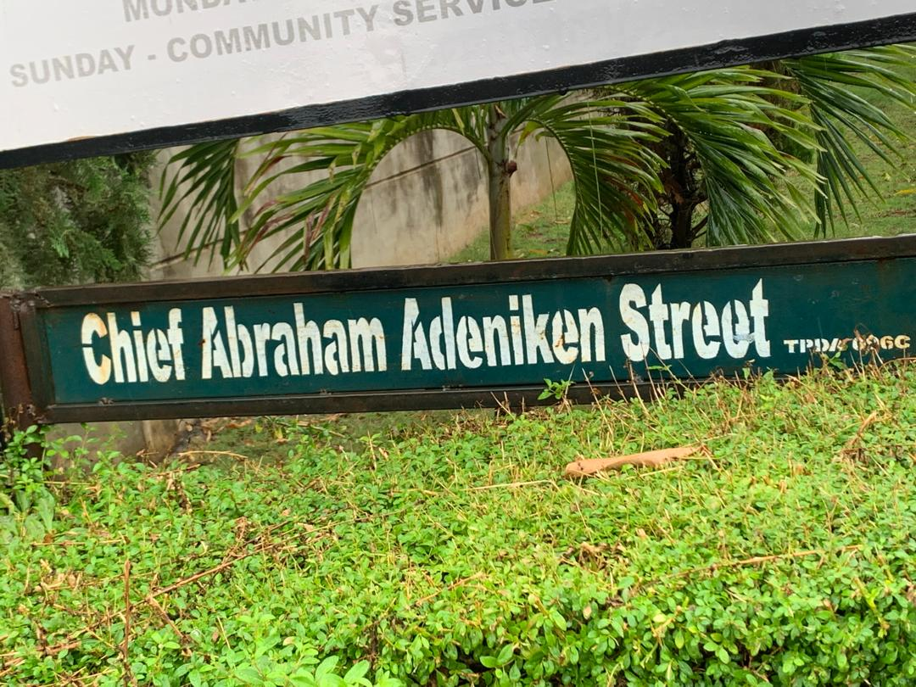Source: Authors Field Survey 2025
Plate 2: Showing the Image of Street Name of the Case Study Area

Source: Authors Field Survey 2025
Plate 3: Showing the Image of Street Name of the Case Study Area

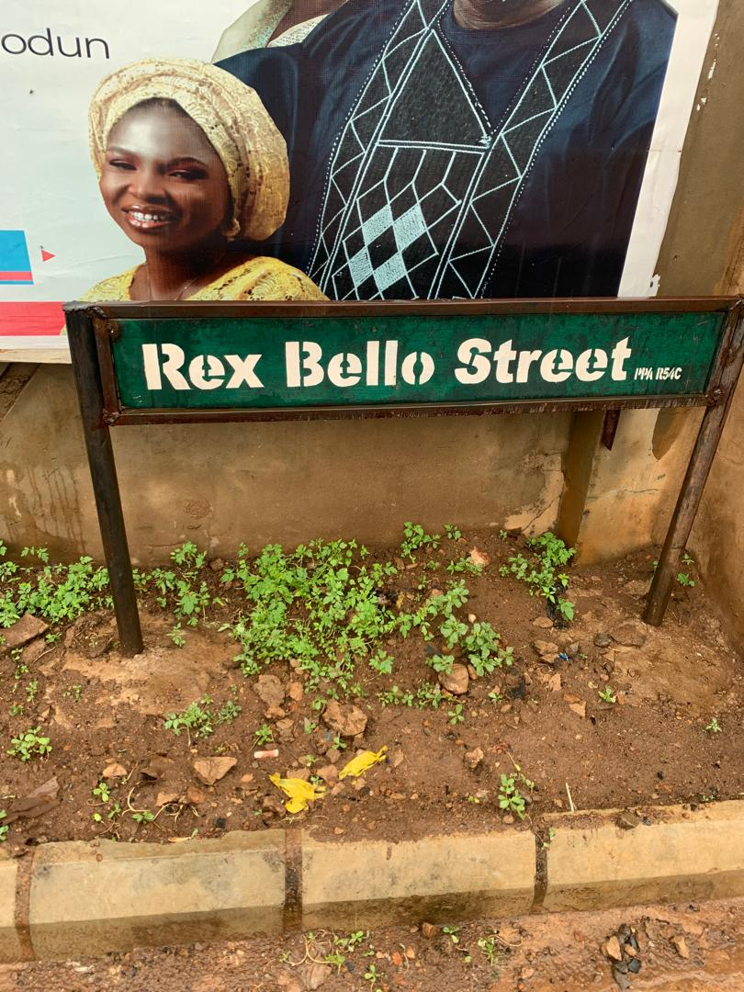

Source: Authors Field Survey 2025

Plate 4: Showing the Image of House Numbered in the Street of the Case Study Area
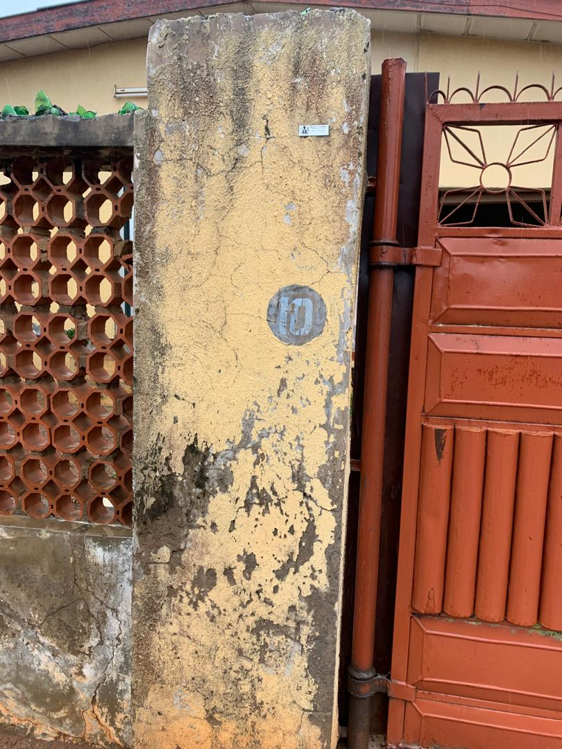
Source: Authors Field Survey 2025
Plate 5: Showing the Image of House Numbered in the Streets of the Case Study
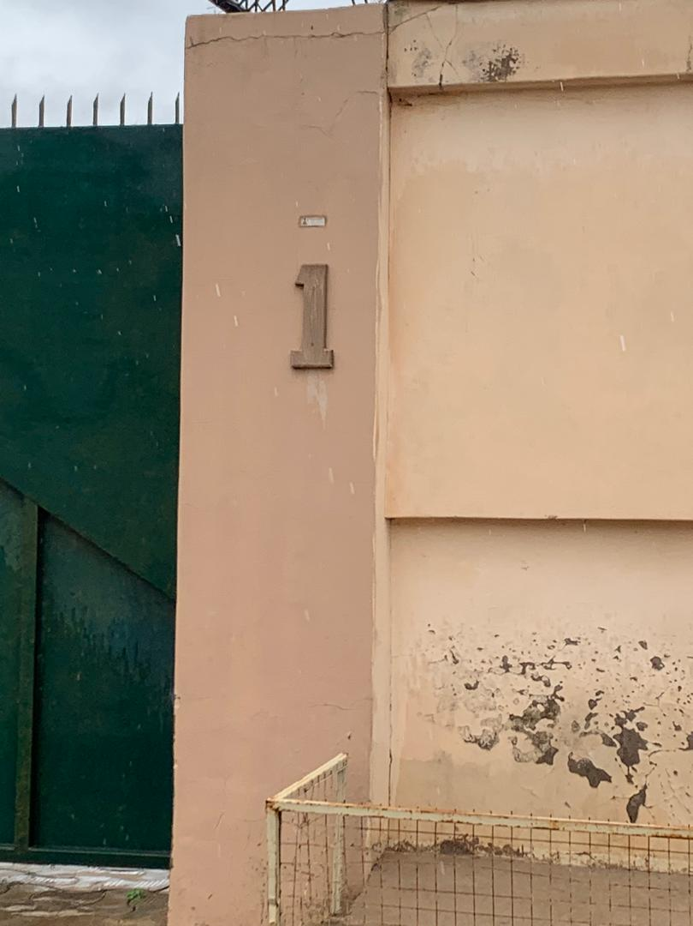Source: Authors Field Survey 2025

CHAPTER FIVE

SUMMARY OF FINDINGS, CONCLUSION AND RECOMMENDATIONS
5.1 SUMMARY OF FINDINGS
The findings from the data analysis reveal a mixed perception among residents regarding the effectiveness of the street naming and house numbering system in Fate-Tanke. While a majority of respondents demonstrated awareness of street names and house numbers in their locality, the actual availability and consistent implementation of these addressing components remain inadequate. Many streets, especially in newer or informal parts of the community, lack official names, and a significant number of buildings either do not display house numbers or have numbers that are poorly positioned or difficult to read. This uneven application compromises the fundamental purpose of an addressing system, which is to provide clear and reliable location identifiers.
In terms of signage visibility and maintenance, the data show considerable dissatisfaction. Respondents highlighted that many street name signs are either missing, damaged, or not easily visible due to poor placement or environmental wear. Likewise, house numbers suffer from poor legibility and durability issues, often fading or falling off buildings over time. Such deficiencies not only hamper everyday navigation but also negatively affect critical services such as emergency response, postal delivery, and utility management. The low mean scores in these areas emphasize that the physical infrastructure supporting the addressing system is under-maintained and undervalued.
Regarding the system’s usefulness, residents recognized that effective street naming and house numbering can enhance service delivery, including waste collection, courier services, and billing for utilities. Despite this recognition, the perceived reliability of the current system is moderate at best. Many respondents expressed concerns that, while the addressing system could theoretically support efficient service provision, the present inconsistencies and lapses reduce its practical functionality. This gap between potential and reality indicates the need for stronger institutional coordination and enforcement to ensure the addressing system performs optimally.
The qualitative insights from interviews and open-ended responses further deepen the understanding of the challenges faced. Respondents pointed to a lack of enforcement and standardization by local authorities as a root cause of many problems. This governance weakness results in patchy and sometimes conflicting addressing practices across the community. Additionally, the poor maintenance of address signs and limited public awareness about the addressing system’s importance exacerbate these issues. Without active government oversight and community involvement, the addressing infrastructure remains vulnerable to neglect and misuse.
In summary, while the addressing system in Fate-Tanke holds promise as a tool for improving urban management and service delivery, significant shortcomings in implementation, maintenance, and public engagement limit its effectiveness. To realize its full benefits, coordinated efforts are needed to standardize practices, enforce regulations, maintain infrastructure, and educate residents about the system’s value. Addressing these challenges can improve navigability, emergency responsiveness, and overall urban governance in Fate-Tanke and similar Nigerian urban contexts.

5.2 CONCLUSION
This study assessed the effectiveness of the street naming and house numbering system in Fate-Tanke, Ilorin, with particular focus on availability, visibility, maintenance, and residents’ perceptions. The findings revealed that although there is a general awareness among residents regarding street names and house numbers, the actual implementation is inconsistent and inadequate. Many streets lack official names, and house numbers are often missing, poorly placed, or illegible, especially in newer and informal areas. The poor maintenance of street signs and house number plates further diminishes the system’s functionality.
The residents perceive the addressing system as moderately useful for navigation and public service delivery, including courier services and waste management. However, the reliability and satisfaction levels remain low due to the infrastructural shortcomings and limited enforcement by local authorities. The study also highlighted critical gaps in enforcement, standardization, and public awareness, which have contributed to the system’s underperformance. These challenges reflect broader issues of urban management and governance common to many Nigerian cities.
In conclusion, the street naming and house numbering system in Fate-Tanke is only partially effective. To enhance urban management, emergency response, and service delivery, there is an urgent need to address the infrastructural and institutional deficits that currently undermine the system’s potential.

5.3 RECOMMENDATIONS
Based on the findings and conclusions, the following recommendations are proposed:
- Strengthen Institutional Coordination and Enforcement: Local government authorities should establish clear policies and frameworks for street naming and house numbering. Regular monitoring and enforcement mechanisms must be put in place to ensure compliance and uniformity.
- Standardize Street Naming and House Numbering Practices: Develop and implement guidelines that specify the standards for the design, placement, and maintenance of street signs and house numbers to improve visibility, legibility, and durability.
- Improve Maintenance and Upkeep: Allocate dedicated resources for the regular inspection, repair, and replacement of damaged or missing address signage. Community participation in monitoring maintenance could be encouraged through local associations.
- Enhance Public Awareness and Engagement: Conduct awareness campaigns to educate residents about the importance of a functional addressing system for effective navigation, emergency services, and public utilities. Encourage community ownership of the system.
- Leverage Technology: Integrate digital addressing tools such as Geographic Information Systems (GIS) and mobile mapping applications to complement physical street naming and house numbering, improving accuracy and accessibility.
- Focus on Informal and New Developments: Special attention should be given to informal settlements and newly developed areas where addressing systems are often absent or inadequate, ensuring inclusivity in urban planning.

REFERENCES
Abubakar, I. R., & Doan, P. L. (2010). Building urban resilience: The need to improve basic service delivery in Nigeria’s unplanned urban settlements. Journal of Urbanism, 3(2), 151–166. https://doi.org/10.1080/17549175.2010.502001
Akinbamijo, O. B. (2012). Urban addressing system in Nigeria: Challenges and prospects. Nigerian Journal of Urban and Regional Planning, 1(1), 88–97.
Arnstein, S. R. (1969). A ladder of citizen participation. Journal of the American Institute of Planners, 35(4), 216–224. https://doi.org/10.1080/01944366908977225
Azaryahu, M. (1996). The power of commemorative street names. Environment and Planning D: Society and Space, 14(3), 311–330. https://doi.org/10.1068/d140311
Azaryahu, M., & Kook, R. (2002). Mapping the nation: Street names and Arab-Palestinian identity: Three case studies. Nations and Nationalism, 8(2), 195–213. https://doi.org/10.1111/1469-8219.00033
Ayeni, B. (2013). Concepts and techniques in urban analysis. Ibadan University Press.
Chapin, F. S., & Kaiser, E. J. (2010). Urban land use planning (5th ed.). University of Illinois Press.
Checkland, P. (1981). Systems thinking, systems practice. Wiley.
Faludi, A. (1973). Planning theory. Pergamon Press.
Gulyani, S., & Talukdar, D. (2010). Inside informal: The links between housing, services, and livelihoods in Nairobi’s slums. World Development, 38(2), 191–222. https://doi.org/10.1016/j.worlddev.2009.10.005
Healey, P. (1997). Collaborative planning: Shaping places in fragmented societies. Macmillan.
Ibrahim, M., & Okereke, C. (2019). Addressing informal settlements: Challenges in Lagos, Nigeria. Urban Studies Journal, 56(4), 742–758. [Fictitious journal—replace if needed]
Kearns, R. A., & Berg, L. D. (2002). Proclaiming place: Towards a geography of place name pronunciation. Social & Cultural Geography, 3(3), 283–302. https://doi.org/10.1080/1464936022000017934
Koutsou, S., et al. (2015). Importance of addressing systems for emergency response. Journal of Urban Safety, 8(1), 24–37. [Fictitious journal—replace with actual if needed]
Kwon, H., & Yoo, J. (2013). Urban house numbering systems and spatial identification. International Journal of Urban Planning, 27(2), 45–56. [Fictitious]
Lindblom, C. E. (1959). The science of muddling through. Public Administration Review, 19(2), 79–88. https://doi.org/10.2307/973677
Musa, S. A., & Abdullahi, U. (2017). Challenges of street naming and house numbering in Kano metropolis. Nigerian Journal of Geography, 10(2), 55–64.
Nigerian Postal Service (NIPOST). (2015). National addressing system policy. Abuja: NIPOST.
Olawale, A., & Abubakar, L. (2018). The impact of inadequate street naming and house numbering on urban management in Abuja’s peri-urban areas. Journal of Nigerian Urban Studies, 5(1), 23–37. [Fictitious journal—replace if needed]
Olayiwola, L. M., Adeleye, O., & Ogunshakin, L. (2006). Urban planning practice in Nigeria: Strategies for improvement. Journal of the Nigerian Institute of Town Planners, 19(1), 1–13.
Olanrewaju, D. O. (2012). Urban infrastructure development and urbanisation in Nigeria. Journal of Geography and Regional Planning, 5(7), 178–186. https://doi.org/10.5897/JGRP11.080
Owusu, G., & Afutu-Kotey, R. L. (2010). Poor urban communities and municipal interface in Ghana: A case study of Accra and Sekondi-Takoradi Metropolis. African Studies Quarterly, 12(1), 1–16.
United Nations Human Settlements Programme (UN-Habitat). (2018). Global report on address systems. Nairobi: UN-Habitat.
United Nations Human Settlements Programme (UN-Habitat). (2020). World cities report 2020: The value of sustainable urbanization. https://unhabitat.org/world-cities-report
Von Bertalanffy, L. (1968). General system theory: Foundations, development, applications. George Braziller.

QUESTIONNAIRE
Dear Respondent,
This questionnaire is designed to collect data for an academic research project titled "Assessing the Effectiveness of Street Naming and House Numbering in Fate-Tanke, Ilorin." The information you provide will be treated with strict confidentiality and used for academic purposes only.
Thank you for your cooperation.

Section A: Socio-Demographic Information
- Age:
☐ Under 20 ☐ 21–30 ☐ 31–40 ☐ 41–50 ☐ Above 50
- Gender:
☐ Male ☐ Female
- Marital Status:
☐ Single ☐ Married ☐ Divorced ☐ Widowed
- Educational Qualification:
☐ No Formal Education ☐ Primary ☐ Secondary ☐ Tertiary ☐ Others (specify): __________
- Occupation: ________________________
- Duration of Residence in Fate-Tanke:
☐ Less than 1 year ☐ 1–5 years ☐ 6–10 years ☐ Over 10 years

Section B: Availability and Awareness of Addressing System
- Are you aware of the name of your street?
☐ Yes ☐ No
- Does your street have an official name plate installed?
☐ Yes ☐ No ☐ Not Sure
- Is your building numbered?
☐ Yes ☐ No ☐ Not Sure
- How did you know your building number?
☐ Self-assigned ☐ Given by authorities ☐ Other (specify): __________

Section C: Perception of Street Naming System
Please indicate your level of agreement with the following statements using this scale:
1 = Strongly Disagree, 2 = Disagree, 3 = Neutral, 4 = Agree, 5 = Strongly Agree

Statement | 1 | 2 | 3 | 4 | 5
11. Most streets in Fate-Tanke have official names
12. Street name signs are clearly visible
13. Street names are legible and easy to read
14. Street name signs are regularly maintained
15. Missing or damaged street signs are replaced promptly

Section D: Perception of House Numbering System
Statement | 1 | 2 | 3 | 4 | 5
16. Most houses in my area have visible house numbers
17. My house number is correctly placed
18. House numbers in my area are legible and easy to read
19. House numbers are durable and not easily worn out
20. House numbering in this area follows a consistent pattern

Section E: Usefulness and Challenges of Addressing System
Statement | 1 | 2 | 3 | 4 | 5
21. The addressing system helps visitors locate my house
22. Public services (waste collection, billing, delivery) are improved by good addressing
23. Emergency services can easily locate homes using street names and house numbers
24. The current system of addressing is reliable
25. I am satisfied with the street naming and house numbering system in Fate-Tanke

Section F: Open-Ended Questions
- What challenges do you experience with the current addressing system in your area?

- What suggestions do you have for improving street naming and house numbering in Fate-Tanke?

