KWARA STATE POLYTECHNIC
FABRICATION OF METAL OFFICE CABINET

YUSUF OLANREWAJU SESAN

A PROJECT REPORT SUBMITTED TO THE DEPARTMENT OF WELDING AND FABRICATION ENGINEERINGN, INSTITUTE OF TECHNOLOGY, KWARA STATE POLYTECHNIC.

IN PARTIAL FULFILMENT OF THE REQUIREMENTS FOR THE AWARD OF NATIONAL DIPLOMA (ND) IN WELDING AND FABRICATION TECHNOLOGY

ILORIN, NIGERIA

JULY, 2025

CERTIFICATION
This is to certify that this project work was carried out by YUSUF

OLANREWAJU SESAN with Matric Number: ND/23/WEC/FT/028 has
met the requirement and regulations governing the award of National Diploma (ND) in Welding and Fabrication Engineering, Kwara State Polytechnic, Ilorin and under the supervision of the project supervisor.
____________________ | _________________
ENGR. Alonge Peter O.  Project Supervisor | DATE
___________________________ | _________________
ENGR. M. A. Salahudeen Gold Head of Department | DATE
____________________ | _________________
External Supervisor | DATE

DEDICATION
I dedicate this project first and foremost to Allah Almighty, whose endless mercy, guidance and blessings have given me the strength, knowledge, and perseverance to complete this work. All praise and thanks are due to Him alone.
I also dedicate this work to my beloved parents, whose constant support, prayers and sacrifices have been the foundation of my journey. Their love, encouragement, and belief in me have been a source of motivation throughout my education. May this be a small reflection of all that they have given.

ACKNOWLEDGEMENT
All praises and honour are due to the Almighty God, the one who created all and was not created, I testify that nobody is worthy of praise except him alone and may his mighty hands of mercies and guidance remain on every single one of us.
My sincerely with a grateful heart acknowledge the role played by the supervisor over this project Engr. Alonge Peter O. despite his busy schedules. He is an inspiration to this generation.
My sincere gratitude also goes to Head of the Department Engr. M. A. Salahudeen Gold and the entire lecturers who has always been supportive and for their contribution towards the success of the students in the department.
I also acknowledge my parents, Mr and Mrs Yusuf for their constant motivation, prayers and financial support given to me, I pray that Almighty
God will continue to protect and bless you all.

ABSTRACT
Metal office cabinet is one the major important needs of humans in their homes, offices, schools for proper safekeeping and showcase of books and other printed materials aim set the production of durable, fashionable and affordable cabinet. The locally available wood furniture was used with indigenous technology without compromising the standard. The office cabinet fabricated was subjected to series of tests and found to be totally efficient, it has the strength and capability to withstand a considerable amount of load.

TABLE OF CONTENTS
Title page
Certification
Dedication
Acknowledgement
Abstract
Table of contents

CHAPTER ONE
1.0 Introduction
1.1 Background of the Study
1.2 Metal Office Cabinet
1.2.1 Advantages of Metal Office Cabinet
1.3 Aims of the Project
1.4 Objectives of the Project
1.5 Scope of the Study
1.6 Justification of the Study

CHAPTER TWO
2.0 Literature Review /Alternatives of Metal Office Cabinet
2.1 Brief History of Metal Office Cabinet
2.2 Alternatives to Metal Office Cabinet
2.3 Disadvantages of Wooden Cabinet
2.4 Types of Cabinet
2.5 Uses of Metal Cabinet
2.6 Types of Metal Cabinet

CHAPTER THREE
3.0 Description of Component and Working Principles
3.1.1 Description of Metal Office Cabinet
3.1 Selection of Raw Materials
3.2 Components of Metal Office Cabinet
3.3 Types of Metals Used
3.3.1 Mechanical Properties of Mild Steel
3.3.2 Advantages of Mild Steel
3.3.3 Disadvantages of Mild Steel
3.4 Methodology
3.4.1 Dimensioning
3.4.2 Cutting
3.4.3 Bending
3.4.4 Joining and Assembling
3.4.5 Welding
3.4.6 Heat Treatment
3.4.7 Painting process
3.5 Test of Materials
3.6 Economic Cost
3.7 Physical Properties

3.8 Chemical Properties
CHAPTER FOUR
4.0 Calculation

CHAPTER FIVE
5.0 Fabrication Detail and Bills of Engineering Measurement and
Evaluation
5.1 Factors to be considered
5.2 Properties of Selected Materials
5.3 Operation Sequence
5.4 Industrial Process Description
5.5 List of Tools Used
5.6 Fabrication Details
5.7 Safety Process
5.8 Precautions Taken
5.9 Description of Operation and Tools used for Fabrication of Metal
Office Cabinet
5.10 Bill of Engineering Measurement Evaluation
5.11 General Description of Components Parts
5.12 Testing of Fabricated Parts
5.13 Problems Encountered and Solutions
Conclusion and Recommendation
Conclusion
Recommendation
REFERENCES
CHAPTER ONE
1.0 INTRODUCTION

1.1 BACKGROUND OF THE STUDY
New discoveries, innovations and technology brings about the storing of value documents or valuable properties in shelves and cabinet compare with the olden days methods using by our forefathers which they used to store most of their important documents in calabashes, clay pot, under their mats. As time and decades passed, cabinets were create which were and see still very efficient. The most efficient of them all was the metal cabinet.
Metal cabinet was introduced to give peace of mind to its users at that due to its ability to protect files and documents from mostly insects that devour files such as goats, termites, ants, rat and other kinds of rodents.
The metal and fixture industry consists of a number of companies that constantly manufacture metal cabinets. These companies are well known for getting the best raw metal materials for their cabinets’ production. Therefore these cabinets are made up of very strong basic or raw materials and due to that they have a very long life span and also give their users less concern because of their ability to strive in harsh conditions.

1.2 METAL OFFICE CABINET
A typical office cabinet is a type of cabinet parts are uniformly made of steel gauge usually 18 inches gauge steel while the bottom of the case may or may not be enclosed. Although some metal file cabinets cases, usually those produced for individual consumers are made from mainly steel.

1.2.1 Advantages of Metal Office Cabinet
Metals are easy to clean and don’t allow house give room for pests because of its hard and cold surface.
- It’s also easy to replace parts that might go missing such as bolts or nuts.
- Metals do have long durability.
- Its material components are very hard so it does not give room for chips.
- It usually has a protective coat that protects it from rusting.

1.2.2 Disadvantages
- It usually causes damage to floors
- Most of the metal parts are not properly smoothed most times and cause injuries the to its sharp edges.
- Its very heavy
- It usually gets rust exposed to liquid

1.3 AIMS OF THE PROJECT
The aim of the project of the project is to design and construct metal office cabinet.

1.4 OBJECTIVES OF THE PROJECT
The objectives of the project are as follows:
- To serve as storage for important files and documents
- To give stylish appearance to the office
- To use locally source materials
- Its helps serve as a study protection to valuable documents and materials
1.5 SCOPE OF STUDY
The project is limited to the fabrication and design of metal office

1.6 JUSTIFICATION OF THE STUDY
Problems may be classified into two broad categories;
- Natural or inherent problems based on the characteristics of the material and the conditions of exposure
- Vandalism and human induced problems
Although there is some overlap between the two categories, the inherent material deterioration problems generally occur gradually over long period of time, at predictable rates and require appropriate routine or preventive

maintenance to control. Conversely, many human induced problems are random in occurrence; can produce catastrophic results and are difficult prevent, and require emergency action to mitigate.
CHAPTER TWO

2.0 LITERATURE REVIEW/ ALTERNATIVES TO METAL OFFICE CABINETS
This review will concern itself with understanding why prefer metal office cabinets to other office cabinets. During my research found out that office cabinets have been in existence for a long period of time and as time went there were was a constant upgrade of office cabinets from wooden office metal office cabinets. As time went by series of production of metal office cabinets were made using different metal materials such as steel, wrought iron, aluminum and so on according to their durability, strength, hardness and also their life span. Initially there were alternative’s to metal office cabinets and are still in existence.

2.1 BRIEF HISTORY OF A METAL OFFICE CABINET
There was a time in which books were written by hand and not by advance gadgets as we have today and they were not produced in large quantities, and they were kept in some boxes or chest in which owners carried about. As the manuscript volume of books increased in large religious houses and in the home of mostly wealthy individuals, they were then now stored in shelves and cupboards. These cupboards are the main predecessors for the modern cabinets we now use in our day to day activities. The household metal manufacturing industry comprises of wooden furniture which account for almost 60 per cent of the household metal industry shipment (Edwin G. Seibel’s 1898).
It was not until the invention of printing had greatly reduced the cost of books, thus acquiring books, therefore increasing the need for creative cabinet.
Most cabinets created in the early days were usually made of pure metals due to the ideology that it is more appropriate for cabinet because of the characteristics for elegant it possesses.
In most great libraries of the nineteenth to twentieth century, the office cabinet were often metal as in the British museum where the shelves are usually covered with cowhide as in the wrong of the congress in Washington and in other states. The bureau of the census estimates that 1992, 267,000 people were employed by the household furniture manufacturing sector of the furniture industry, and a decline of approximately 10 percent from 1987. The 1993 valued shipment of these firm exceeded 5 22 billion representing an increase of approximately seven percent over the previous year.

2.2 ALTERNATIVES TO METAL OFFICE CABINETS (WOODEN OFFICE CABINETS)
There were countless alternatives to metal cabinets due to the fact that before the invention of this kind of cabinets our forefathers had ways of storing their document such clay pots, drums, under their beds and so on. And as time passed by wooden office cabinets came into the picture but the disadvantages of the invention seem to surpass its advantages. (Philip Howie postdoctoral in material science September 2, 2016).

2.3 DISADVANTAGES OF WOODEN OFFICE CABINETS
- Doest not have efficient durability
- It was prone to destructible insects such as termites
- It was not as strong as the metal office cabinet
- It was prone to fungus in which made it unfit for official purposes.
Now metal office cabinets are mostly due their incomparable efficiency to any other office cabinets and due to constant research of scientist there is a constant improvement on metal office cabinets making it the best and also making it increase it efficiency and durability by each research done.

2.4 TYPES OF CABINETS 1. METAL CABINET
USES OF METAL CABINETS
- A metal cabinet is used as part of an office or a home decoration due to its stylish design, size colour.
- A metal cabinet can also be used for displaying books, magazines, and other items that can be found in a library.
- It helps in homes and office in keeping important papers, all in one place for easy and immediate access.
- A metal cabinet is used to store books and other valuable items such as jewelries and mechanical devices depending on the principle of available number of shelves.

2.5 TYPES OF METAL CABINETS
There are many types and styles of metal cabinets available and many different plans to build metal cabinet and also there are different metal raw materials used to produce metal cabinets. These are as follows:
- STEEL METAL CABINET
- WROUGHT IRON CABINET
- ALUMINIUM METAL CABINET
There are also metal cabinets that are home to both books and home decorative items. The metal cabinet manufacturing industry uses quality raw materials for its production.
CHAPTER THREE
3.0 DESCRIPTION OF COMPONENT AND WORKING

PRINCIPLES

3.1 DESCRIPTION OF METAL OFFICE CABINET
The metal office cabinet is a stylish of quality metals and its materials. The cabinet under this project is a metal type of bookcase that has different drawers and shelves that get progressively smaller to the bottom. The cabinet is a type of design to hold large amount of books. The main purpose why the cabinet was established is for the main purpose of keeping important and also necessary information for basically future purposes and also making sure that adequate materials are available to complete any task at any required time. It also consists of a number of metal constructed items for the sole purpose of producing required items within the country’s facilities. The main or sole purpose of cabinets is for safekeeping of books and documents from harsh conditions (FARLEX 18, 2015).

3.1.1 SELECTION OF RAW MATERIALS
There are various reasons for the selection of raw materials for metal office cabinets. The most important are as follows.
- AVAILABILITY: Due to the fact that metals are very efficient it is very easy to access as long the right source is gotten.
- COST OF PURCHASE: Since the raw materials are easy to access
the cost of purchase is always at a reasonable price and is not usually influenced by inflation or scarcity the prices are usually fixed.
- COST OF PRODUCTION: The cost of production is very less and affordable
- DURABILITY: It has a long life span and lasts long.
- HARDNESS: It is usually hard so its is very strong against pests and any other rodents.
- QUALITY: It has high quality that why is advisable to use.

3.2 COMPONENTS OF A METAL OFFICE CABINET
- METAL
- HANDLE
- PLATE
- HINGES
- STAND
- LOCK

3.3 TYPES OF METALS USED
1. MILD STEEL: can be defined as plain carbon steel. Mild steel is a type of steel that contains 2 percent of carbon of less. This materials is also referred to as soft steel because its softer than other types of steel. Sheets of mild steel can be easily welded together to one continuous piece or to connect the metal joints. Also known as alloy of iron and carbon, it was discovered 1856 in an attempt to mass produce to wrought iron, MADE by melting of cast iron and removal of carbon and slag. Small residual carbon content casts ingot and rolled into all sections. Cheaper than puddle iron after 1876. Higher strength and better consistency, poor resistance to corrosion.

3.3.1 MECHANICAL PROPERTIES OF MILD STEEL
Steel is made up of carbon and iron, with much iron than carbon. In fact at most, steel can have about 2.1 percent of carbon. Mild steel is one of the commonly used construction materials. Its very strong and can be made from readily available materials. Its known as mild steel due to its relatively low carbon content. Mild steel is very strong metal due to its low carbon it contains. In material science strength is a very complicated term. Mild steel has high resistance to breakage. Mild steel as opposed to higher carbon steels, is quite malleable even when cold. This means it has high tensile and impact strength. Higher carbon steels usually shatter or crack under stress while mild steel bends or deforms (ES HAJI 22, 2012).

3.3.2 ADVANTAGES OF MILD STEEL
- Its efficiently malleable
- Its lighter in weight than steel
- Its greatly affordable
- It has low carbon content
- It can be easily welded
- It can be made from readily available materials

3.3.3 DISADVANTAGES OF MILD STEEL
- Its comparatively less stronger
- It has limitation to heat treatment

3.3.4 PROPERTIES OF MILD STEEL
- Malleability: can be defined as a substance ability to deform under pressure. If malleable, a material, may be flattened into thin sheets by hammering or rolling. Malleable materials can be flattened into metal leaf. Many metals with high malleability also have high ductility.
- Durability: its is the ability of a product to perform its required function over a lengthy period under normal conditions of use without excessive expenditure on maintenance or repair. Several units may be removed used to measure of durability of a product according to its field of application, such as years of usage, hours of use, and operational cycles. In economics, goods with long usable life are referred to as durable goods.
- Ductility: can be defined as when a material stretches under tensile stress. If ductile, a material may be stretched into a wire. Malleability, a similar property, is a material’s ability to deform under stress pressure.
- Strength: This is the ability of a material to withstand tensile, compressive or shear force without rupture.
- Plasticity: This is the tendency that causes a material to undergo deformation hot or cold working.
- Toughness: The capacity of a material to resists load.
- Brittleness: This is tendency of a material to fracture without visible metal deformation when subjected to applied force.

3.4 METHODOLOGY
This contains all description and working process of making a METAL
OFFICE CABINET. The processes are follows:
- Dimensioning
- Cutting
- Bending
- Joining or Assembling
- Welding
- Heat Treatment
- Painting

3.4.1 DIMENSIONING
Dimensioning in fabrication of metal office cabinet is a very important
process. There’s something we call DATUM DIMENSIONING. A datum dimension is a group design object is allows for dimensioning of linear distance of a collection of object, relative to a single reference object. The first object chosen in the base. All subsequent objects are relative to this first object
(ADES 16, 2017).

3.4.2 CUTTING
This also an important process in fabrication of metal office cabinet, it involves procedures such as marking out before cutting of the material is made possible. Cutting process is mostly done by shearing, chiseling, (all with manual and powered variants); touching with handled torches such as oxy-fuel torches or plasma torches and via numerical control (CNC) cutters using a laser, mill bits, torch or water jets. (https:en.m.wikipedia/Metal_fabrication).

3.4.3 BENDING
This particular mild steel fabrication process requires the application of force to the mild steel in order to bend it at a certain angle and to form a specific shape. The deformation is caused along a single axis, but if the operators wish to, he can also perform multiple bends which results in a more complex part. The process of bending a material results in both compression and tension in the mild steel. Therefore, while the inside part of the steel is going to be shortened after being compressed, the part external part will stretch to a certain length after experiencing tension.
When mild steel is being bent, due to the residual stresses in the material, the steel will slightly spring back after its being exposed to a force that can cause to bend. Because of this slight recovery, the steel needs to be over-bent to a certain extent in order to achieve the desired bend angle and bend radius. The final bend angle is going to be smaller, while the bend radius is going to be larger. The initial bend to the final bend ratio is referred to as springback factor and the amount of it varies based on certain factors, such as the initial bend radius, the bend radius, the bend angle, the bending operation and the material.

3.4.4 JOINING OF ASSEMBLING
This process is done by welding, binding with adhesives, riveting, threaded fasteners, or even yet more bending in the form of crimped seam.
Structural steel and sheet steel are usually starting materials for fabrication, along with the welding wire, flux and fasteners that will join the cut pieces. As with other manufacturing processes, both human labour and the automation are commonly used. The product resulting from fabrication may be called a fabrication (https:en.m.wikipedia/Metal_fabrication).

3.4.5 WELDING
Mild steel is also referred to as soft metal and so mild steel can be easily welded together to form one continuous piece or to connect the metal joints. Also metal inert gas (MIG) welding, a common welding process using electric arc from a wire electrode, is typically used to fuse mild steel together
(ES HAJI AND CO) eshaji.in/technical-info/ms-flanges).

3.4.6 HEAT TREATMENT
Mild heat treating of steel components describes a process in which steel is subjected to a combustion of heating and cooling operation in order to increase its strength and durability. Heat treatment refines the grains of steel as the carbon molecules react with the iron content. This traditional process works for medium and high carbon steel but not for mild steel, which has low carbon content. Mild steel must be case hardened. This involves changing the chemical composition of the surface layer of the metal by allowing it to react with a source. This process creates a hardened steel case around the softer low carbon mild steel (ES HAJI and CO) (eshaji.in/technical-info/ms-flanges).

3.4.7 PAINTING PROCESS
Paint the most commonly used material to protect steel. Paint systems for steel structure have developed over the years to comply with the industrial environment legislation and in response demands from bridge and building owners for improved durability performance.
Modern specifications usually compromise a sequential coating
application or paints or alternatively paints applied over metal coating to form a duplex coating system. The protective paint system usually consist of primer, undercoat and finish coats. Each coating layer in any protective system has a specific function, and the different types are applied in a particular sequence of primer followed by intermediate/build coats in the shop, and finally the finish, or top coat either in the shop or on site.
(https://www.steelconstruction.info/pain_coatings )

3.5 TEST OF MATERIALS
The following tests were out on the available materials:
- Hardness Test: A resistance of metal of plastic deformation, usually indention, however, the term also refers to the stiffness or temper or resistance to scratching, abrasive or cutting. It is the property of metal which gives it the ability to resist being permanently deformed when a load is supplied. The greater the hardness of the metal, the greater the resistance and the known level of the deformation of the material used.
- Creep Test: to measure the creep, that is the tendency of a material after being subjected to high level of stress to change its form in relation to time.
Creep is high in temperature progressive deformation at constant stress.
High temperature is a relative term dependent upon the materials involved. Any application that involves high temperature under load understanding high temperature behaviour of metal is useful designing failure resistance.

3.6 ECONOMIC COST
Due to the depreciation of naira, the available materials for this project were cost.

3.7 PHYSICAL PROPERTIES
These are the characteristics of materials that are determined by virtue of their natural occurrence. They can be determined through visual means e.g. colour, through measurement of volume, weighing of masses of the objects
(Anyakoha, 2001).

3.8 CHEMICAL PROPERTIES
These are material characteristic’s that relate the structure of a material and its formation from elemental stages. It cannot be determined by visual observation but by through material destruction to measure the chemical properties. The following parameters through which chemical analysis are made to help in selection of materials. (OKEKE, 2011).
- Composition: As engineers, we are not to select materials by their trade name except by knowing the composition of that material to be used for design.
- Corrosion Resistance: The ability to resists deterioration due to chemical or electrochemical relation usually affected by oxygen and moisture. This is an important factor in determining the choice of serviceability of materials (Abdulquadir, 2010).
- Micro-Structure: This is a small scale structure of material, defined as structure prepared a surface of material as revealed by a microscope. The micro-structure of a material such as metals, polymers, ceramics or composite can strongly influence physical properties in turn govern the application of these materials in industries practices.
- Crystal Structure: It describes a highly ordered structure, occurring due to the intrinsic nature of its constituent’s to form symmetric patterns.
CHAPTER FOUR

4.0 DESIGN CALCULATION OF METAL OFFICE CABINET
4.1 Volume of Frame
Volume of Frame = 1 x b x h
= 0.150 x 0.0471 x 0.471
= 0.0033m ³
MASS of frame = Density x Vol of Frame
Density of Mild Steel = 7870 Kg/m
Mass of frame = 7870 x 0.0033
= 25.97Kg
Weight of the fame = Mass (m)X Acceleration due to gravity
The value of Acceleration due to gravity = 10N/Kg
Weight of the frame = 25.97 x 10
= 259.7N
4.2 Total weight of the front and back frame
Total Weight = 2(259.7)
= 519.4N
4.3 Volume of Bottom Frame Volume of frame = Area x Thickness Thickness pipe x Thickness of sheet = 0.294
Area of Frame = 0.0294 m
= 0.104 x 0.02
= 0.00208m ²
Volume of Frame = 0.000208 x 0.0294
= 0.00006115m ³
Mass of Bottom Frame = Density x Vol of Frame
= 7860 x 0.0006115
= 0.481
Weight of Bottom Frame = Mf x G
= 0.481 x 10
Total Weight = 2(259.7)
= 519.4 N
4.3 Volume of Bottom Frame Volume of Frame = Area x Thickness
Thickness pipe x Thickness of sheet = 0.294
Area of Frame = 0.0294 m
= 0.104 x 0.02
0.00209m ²
Volume of Frame = 0.00208 x 0.0294
= 0.0000615m ³
Mass of Bottom Frame = Density x Vol of Frame
= 7860 x 0.0006115
= 0.481
Weight of Bottom Frame = mf x G
= 0.481 x 10
= 4.81 N
4.4 Volume of Shelve Unit A
The Shelve Unit A is in the form of a TRAPEZIUM
Area of Trapezium = ½ (a + b) h
½(0.025 + 0.035) 0.03
= 0.00002646m ³
Mass of the shelve unit A = Density x Vol
= 7860 x 0.00002646
= 0.208 Kg
Weight of Unit Shelve Unit A = Ma x G
= 0.208 x 10
= 2.08 N
4.5 Total Weight of Shelve Unit A
= 4(2.08)
= 8.32 N
4.6 Volume of Unit A Volume = Area x Thickness
Area of Trapezium = ½(a + b) h
= ½(0.025 + 0.035) x 0.03
½(0.06) x 0.03
= 0.0018/2
Volume = 0.00090 x 0.0294
= 0.0000265m³
MASS OF UNIT B
= 0.208 x 10
= 2.08 N
4.7 Total Weight of Cabinet B
= 3(2.08)
= 6.24 N
4.8 Volume of Cabinet C Volume = Area x Thickness
Area of Trapezium = ½(0.02 + 0.035) x 0.03
= 0.000825m²
Volume of the Unit C = DENSITY X VOLUME OF UNIT C
Mass of unit C = 0.000825 x 0.0294
= 0.1906 Kg
Weight of the Unit C = MC x G
= 0.1906 x 10
= 1.906 Kg
4.9 Total weight of the Cabinet C
= 3(1.906)
= 5.72
4.10 Volume of the Cabinet D
Vol = Area x Thickness
Area of Trapezium = ½ (0.015 x 0.035) x 0.03
= 0.00075m ²
Volume of the Unit D = 0.00075 x 0.0294
= 0.00002205m ³
Mass of the Unit D = Density x Volume of the unit D
= 7860 x 0.00002205
= 0.17Kg
Weight of unit D = MD x G
= 0.17 x 10
= 1.7 Kg
4.11 Total Height of Cabinet D
= 3(1.7)
= 5.2 N
4.12 Volume of Cabinet E Volume = Area x Thickness
The Cabinet Unit E is in Form of a Square
Area of Square = 0.03 x 0.03
= 0.0009 m ³
Volume of Unit E = 0.0009 x 0.0294
= 0.000265m³
Mass of Unit E = Density x Volume of Unit E
= 7860 x 0.0000265
= 0.21 Kg
Weight of Unit E = ME x G
= 0.21 x 10
= 2.1 N
4.13 Total Weight of Cabinet Unit E
= 3(2.1)
= 6.3 N
4.14 Volume of Legs
= 0.025 x 0.0381 x 0.0381
Mass of Legs = Density x Volume
= 7800 x 0.0000363
= 0.285 Kg
Weight of the Legs = Ml x G
= 0.285 x 10
= 2.85 N
Total of the four Legs
= 4(2.85)
= 11.4 N
4.15 Total Weight of the whole Metal Office Cabinet
519.4 N + 4.81 N + 8.32 N + 6.24 N + 5.72 N + 5.2 N + 6.3 N + 11.4 N
= 567.39 N
ISOMETRIC VIEW
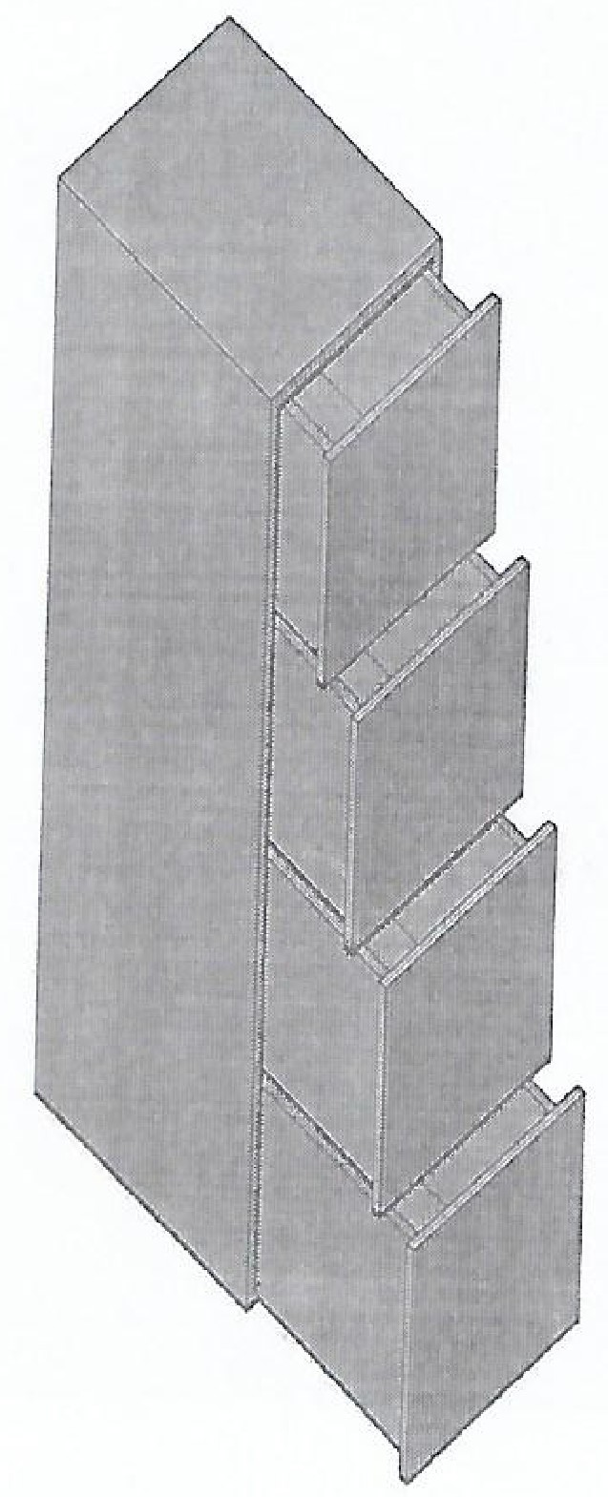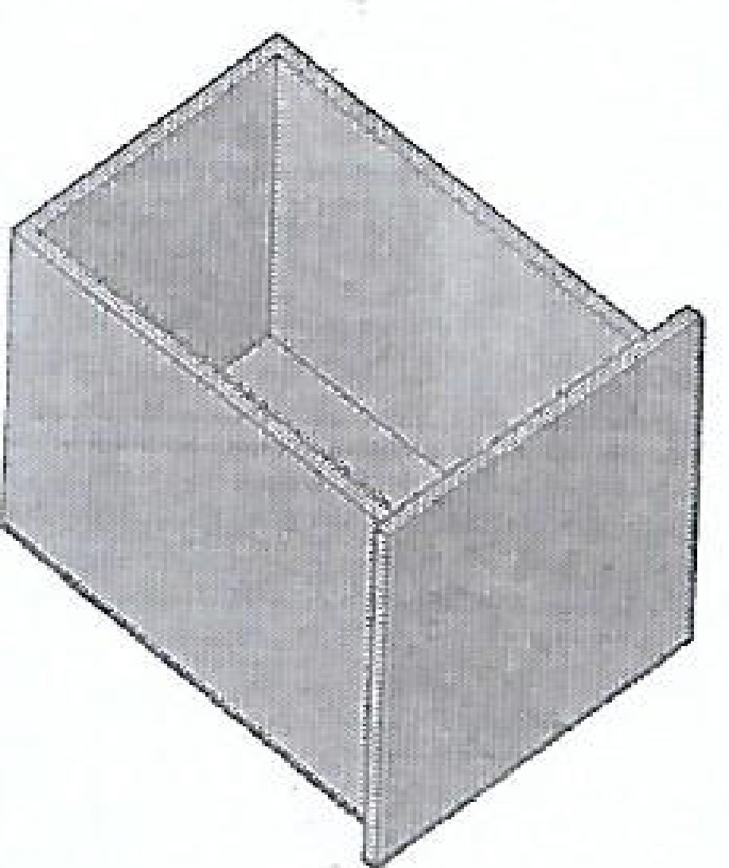
SIDE VIEW
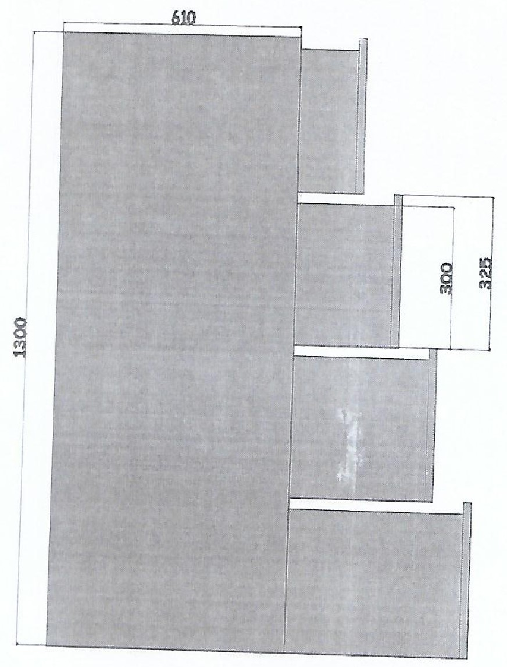
TOP VIEW
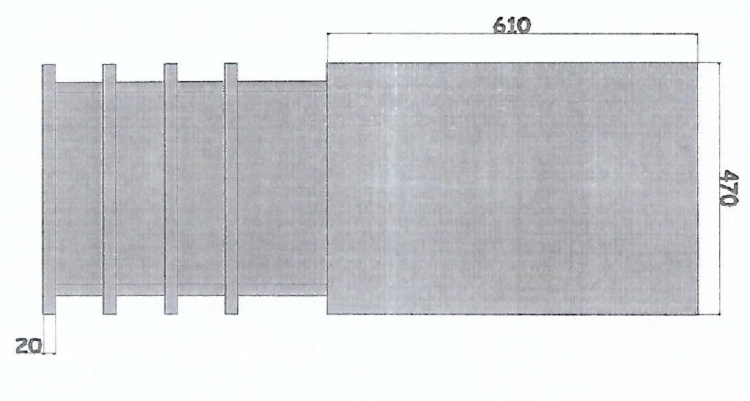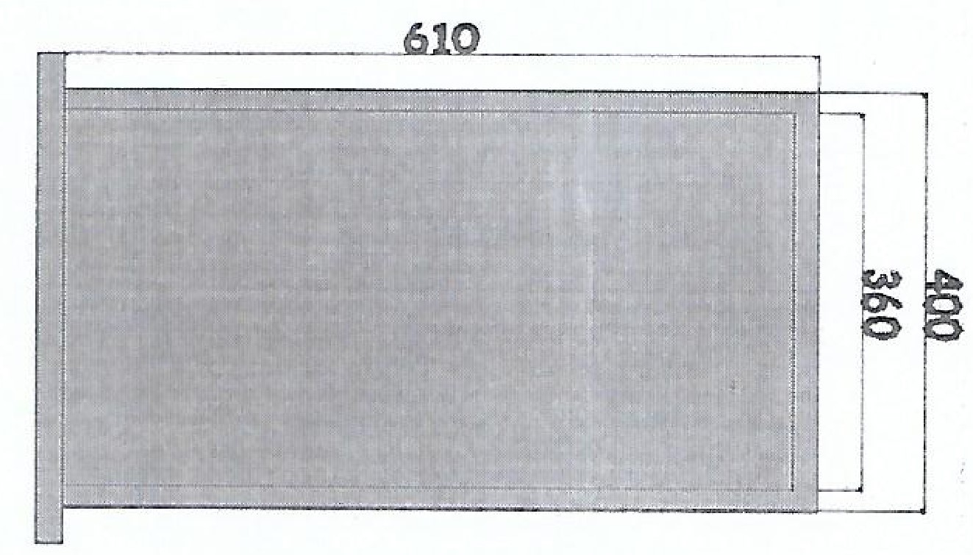
CHAPTER FIVE

5.0 FABRICATION DETAILS AND BILLS OF ENGINEERING MEASUREMENT AND EVALUATION
Consideration of material for construction of this project in the field of engineering is one of the major tasks of an engineer. The following are to be considered during the fabrication and construction of this project.

5.1 FACTORS TO BE CONSIDERED
- Availability of materials
- Condition of materials
- Importance of the project
- Economic requirements
- Fabrication requirements

5.2 PROPERTIES OF SELECTED MATERIALS
- Mechanical properties
- Physical properties
- Chemical properties

5.3 OPERATION SEQUENCE
Various operations were carried out during the fabrication of this project. They are as follows:
- Measurement and marking out
- Cutting of part of metal sheet
- Joining
- Grinding operation
- Assembly
- Spraying (painting) operation

5.4 INDUSTRIAL PROCESS DESCRIPTION
This section is included for the sole purpose of describing the major industrial process during the production of the METAL OFFICE CABINET, including the materials and tools that were used during this process and the kind of processes used. This section does not in any way attempt replicate any published engineering information already on this project, the primary input for meal office cabinets is mostly steel and some other metals. Some of the
production processes are CUTTING, WELDING, ASSEMBLING,
SMOOTHING and so on.

5.5 LIST OF TOOLS USED
Before the completion of the project work is carried out mostly in the fabrication workshop and painting workshop. The major tools used during this project:
- Steel Rule
- Vanier Caliper
- Hammer
- Chisel
- Welding Machine
- Saw Blade

5.6 FABRICATION DETAILS
S/N | OPERATION | WORKDONE | TOOLS/MACHINE  USED
1. | DEVELOPMENT | Drawing of components  parts of the cabinet on a drawing board | Drawing sheets, drawing set, drawing board
2. | MEASUREMENT  PROCESS | Marking out the  dimensions on the metals | Engineering steel rule, Vanier caliper
3. | CUTTING  PROCESS | Cutting out the marked  areas | Hacksaw, chisel, hammer
4. | DRILLING | Drilling of the metals on the specified areas
5.7 SAFETY PROCESS:
- The use of apron
- The use of boots
- The use of nose grid
- The use of hand gloves
- The use of all essential safety materials

5.8 PRECAUTIONS TAKEN
- Adequate precaution of all kinds should be taken during cutting process.
- All parts of the machines to be used must be properly assembled.
- The use of the correct materials is very important in order to get the desired result.
5.9 DESCRIPTION OF OPERATIONS AND TOOLS USED FOR

FABRICATION OF METAL OFFICE CABINET
S/N | OPERATIONS | TOOLS USED
1. | Marking | Steel rule, tape rule, engineering  T-square
2. | Cutting | Hacksaw
3. | Clamping | F-clamp
4. | Drilling of holes | Drilling machine, punch, hammer
5. | Tapping of plates | Tap and wrench
6. | Welding of plates | Gauge “12”, electrode holder, safety goggle, gloves, filled rood
7. | Fixing and cutting | Drill, hacksaw, file, screwdriver,
8. | Cleaning of dust | Petrol and wire brush
9. | Grinding of welded parts | Disc grinder, sander
10. | Spraying | Red oxide, blue paint, spraying machine
5.10 BILL OF ENGINEERING MEASUREMENT AND

EVALUATION
S/N | Materials | Dimension | Quantity | UNIT  (naira) | COST  (naira)
1. | Sheet of mild steel | 1.5mm | 1 | 9,000 | 9,000.00
2. | Sheet of plate | 1mm | 1 | 7,500 | 7,500.00
3. | Paco jam lock |  | 1 | 2,500 | 2,500.00
4. | Electrode gauge | 12 | ½ | 600 | 600.00
5. | Hinges |  | 4 | 300 | 300.00
6. | Grinding disc |  | 1 | 5,000 | 5,000.00
7. | Petrol (litre) |  | 2 | 290 | 290.00
8. | Spraying and painting tin |  | 1 | 2,000 | 2,000.00
9. | Materials |  |  | 10,000 | 10,000.00
10. | Labour |  | 2 | 1,200 | 1,200.00
11. | Miscellaneous |  |  |  | 4,130.00
 | TOTAL |  |  |  | 42,520

5.11 GENERAL DESCRIPTION OF COMPONENTS PARTS
S/N | COMPONENTS | DESCRIPTION DONE | TOOLS USED
1. | FRAME UNIT | The mild steel was measured, marked, cut-out according to the marked measurement and thereafter welded to form a frame. | Steel rule, tape rule, scriber, hacksaw, electric arc welding machine and gauge  12 electrodes
2. | METAL SHEET | The sheet metal was taken to bending machine and was bent to the desired form and shape. Thereafter it was measured, marked and cut-out. | Bending machine, tape rule, hacksaw and vice
3. | PANEL  COMPONENT | The mild steel cut into required sizes were tacked together and later welded with arc welding machine to produce a rigid frame of the metal office cabinet. | Hacksaw, tape rule, cutting machine, arc welding machine.

4. | JOINING PANEL  TO MAINFRAME | The panel was joined to its mainframe with three hinges which were welded to both frames. The hinges allow free opening and closing of the drawers in the cabinet. | Electric arc welding machine, tape rule, electrode safety goggles.
5. | Locking device | A lack device paco jam lock was fastened to an opening made for it. When the device is locked, it projects into the hole drilled on the inner side of the main frame. This keeps the metal office cabinet drawers locked to its frame. | Hammer, screwdriver
6. | GRINDING AND  PAINTING | A hand grinding machine was used to smoothing the surface of the welded joints and thereafter it was painted with navy blue colour paint | Hand grinding machine, wire brush, paint brush, and spraying machine.

5.12 TESTING OF THE FABRICATED COMPONENTS
The testing of all components after fabrication was essential to check is there if there were any faults in any of the parts or components used.

5.13 PROBLEMS ENCOUNTERED AND SOLUTION
During the construction of this project, some problems were encountered and listed below:
- High cost of materials
- Scarcity of some working tools
- Transportation of some materials
CONCLUSION AND RECOMMENDATION

CONCLUSION
No matter the constant improvement in technology in Nigeria, the metal office cabinet will still stand reliable and efficient. Almost all well-organized industries in Nigeria comprehend the positive effect of the metal office cabinet in their organization.
The metal office cabinet was designed, constructed and tested. It was designed to give comfort; it’s also very economical due to its affordable rate in the market.
The tests carried out revealed that the device has been able to satisfy the objectives in terms of efficiency and cost effectiveness.

6.2 RECOMMENDATION
The school implores for the provision of more welding machine for students to be able to carry out the practical activities successfully, provision of adequate laboratory and workshop materials in mechanical engineering.
All materials produced should be used continually for more performance evaluation. There should be an increase in awareness of this project within the polytechnic.
Metal office cabinet are highly recommended for both interior and exterior both homes and offices. They can be used both officially and also for individual purposes. Also all kind of documents are guaranteed safe within this project.

REFERENCES
Abdulquadir, B.L. (2010). “ Strength of materials lecture note” Department of
Mechanical Engineering.
Bolton, W. (1994). “ Materials for Engineering ” Bath press Great Britain.
British Museum Washington, D.C. (2012). “ Fitzwilliam Library” “Brief history of Metal Office Cabinet”.
Chris Brown (2018). “I nnovating your office décor” “Disadvantages of wooden Cabinet ”
Carritean John, (2006). “ Tools for fabrication”
Chapman, W.A. (1990) “Workshop technology” part II 3 ^{rd} Edition published limited, 4 Bedford square, London W.C. 183D.
Edwin, G. Seibel’s “Brief history of metal office cabinet”
Lange (2019). “Metal office cabinet fabrication” handbook of metal forming
1 st Edition, society of manufacturing Engineers.
Metalcuts4u.com “Advantages and Disadvantages of mild steel”
Metal cabinet, by the free Dictionary by FARLEX. Retrieved 2012-05018
Olagoke, S.A. (2006). “Properties of materials” 3 rd Edition S.O.A. multi ventures. Ibadan, Nigeria.
Properties of Mild Steel by David published in 2000.
Philip Howie postdoctoral researcher in material science “Alternatives to metal cabinets” published in September 2, 2016.

