EFFECTS OF SIDA ACUTA ON HEAMATOLOGICAL PARAMETERS OF ASPIRIN-INDUCED ULCEROGENIC RATS

BY
KAMALDEEN RUKAYAT ADERAYO
HND/23/SLT/FT/0439

A PROJECT SUBMITTED TO THE DEPARTMENT OF SCIENCE LABORATORY TECHNOLOGY, INSTITUTE OF APPLIED SCIENCE, KWARA STATE POLYTECHNIC, ILORIN

IN PARTIAL FULFILMENT OF THE REQUIREMENTS FOR THE AWARD OF HIGHER NATIONAL DIPLOMA (HND) IN SCIENCE LABORATORY TECHNOLOGY (BIOCHEMISTRY OPTION)

JULY, 2025

DECLARATION
I hereby declare that this research project titled “Effects Of Sida Acuta on Heamatological Parameters Of Aspirin-Induced Ulcerogenic Rats” is my work and has not been submitted by any other person for any degree or qualification at any higher institution. I also declare that the information provided therein are mine and those that are not mine are properly acknowledged.

__________________________________ _________________________
Name of Student Signature and Date

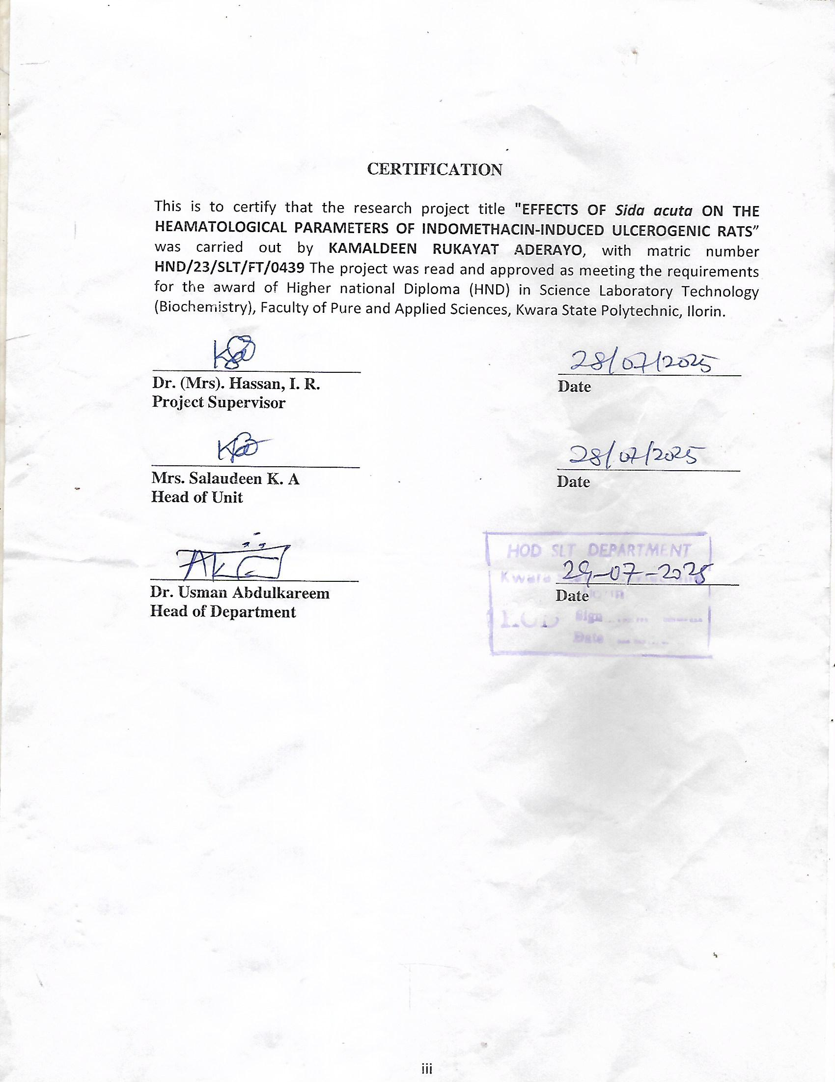

DEDICATION
I dedicate this project to God Almighty my creator, my sustainer, my source of inspiration, wisdom, knowledge and understanding. He has been the source of my strength throughout this program and on His wings only have I soared.

ACKNOWLEDGMENTS
My deepest gratitude goes to Almighty God, who provided all that was needed to complete this project and the academic program for which it was undertaken. I will like to sincerely appreciate my project supervisor, Dr. (Mrs.) I. R. Hassan, for her invaluable guidance, dedication, and support, which greatly contributed to the successful completion of this research work.

ABSTRACT
This study investigates the impact of Sida acuta extract on hematological parameters in aspirin-induced ulcerogenic rats. The research aims to determine if Sida acuta, known for its anti-ulcer properties, can mitigate the adverse hematological effects of aspirin, a common ulcerogenic agent. The study will likely examine changes in red blood cell count, white blood cell count, hemoglobin levels, and platelet counts, among other parameters, to assess the potential protective effects of Sida acuta. Conclusion and recommendations were revealed for the study.

TABLE OF CONTENTS
TITLE PAGE i
DECLARATION ii
CERTIFICATION iii
DEDICATION iv
ACKNOWLEDGMENTS v
ABSTRACT vi
TABLE OF CONTENTS vii
CHAPTER ONE 1
1.0 INTRODUCTION 1
1.1 Background of the Study 7
1.2 Statement of the Research Problem 10
1.3 Justification of Study 10
1.4 Aim and Objectives of the Study 11
CHAPTER TWO 12
2.0 LITERATURE REVIEW 12
2.1 Ulcer 17
2.2 Types of Ulcer 17
2.2.1 Peptic Ulcer 17
2.2.2 Stress Ulcer 19
2.2.3 Decubitus Ulcer (Pressure Ulcer/Bed Sore) 19
2.2.4 Diabetic Ulcer 19
2.2.5 Venous Ulcer 19
2.2.6 Arterial Ulcer 19
2.3 Causes of Ulcer 19
2.3.1 Helicobacter Pylori Infection 20
2.3.2 Non-Steroidal Anti-Inflammatory Drugs (NSAIDs) 20
2.3.3 Excessive Alcohol Consumption 20
2.3.4 Stress 20
2.3.5 Smoking 21
2.3.6 Genetic Factors 21
2.3.7 Bile Reflux 21
2.3.8 Poor Diet 21
2.3.9 Helicobacter Pylori and NSAID Combination 21
2.4 Physiological Causes of Ulcer 21
2.4.1 Excessive Gastric Acid Secretion 22
2.4.2 Impaired Mucosal Defense 22
2.4.3 Altered Gastric Blood Flow 22
2.4.4 Helicobacter pylori Infection 22
2.5 Treatment of Ulcer 23
2.5.1 Proton Pump Inhibitors (PPIs) 23
2.5.2 Antibiotics for H. pylori Infection 23
2.5.3 H2-Receptor Antagonists (H2RAs) 23
2.5.4 Antacids 24
2.5.5 Surgical Treatment 24
2.5.5.1 Types of Surgery: 24
2.6 Medicinal Plant (Sida Acuta) 24
2.6.1 Botanical Description 25
2.6.2 Ethnobotanical and Traditional Uses 25
2.6.3 Traditional Uses: 26
2.6.4 Phytochemical Composition 26
2.6.5 Pharmacological Activities 27
2.6.7 Toxicity and Safety 27
2.7 Medication of Sida Acuta 27
2.7.1 Traditional Herbal Preparations 28
2.7.2 Extract-Based Preparations 28
2.8 Dietary Factor of Sida Acuta 29
2.8.1 Nutritional Composition of Sida acuta 29
2.8.2 Dietary Roles and Ethnobotanical Uses 29
2.9 Roles of Helicobacter pylori in Ulcer Development 30
2.9.1 Damage to the Stomach and Duodenal Lining 30
2.9.2 Inflammation (Gastritis) 30
2.9.3 Ulcer Development 31
2.9.4 Virulence Factors 31
2.10 Method of Ulcer Induction in Rats 31
2.10.1 Chemical Induction: 32
2.10.2 Surgical Induction: 32
2.10.3 Physical Induction 32
2.10.4 Dietary Induction 32
2.11 Mechanism of Action of Anti Ulcerogenic Drugs 33
2.11.1. Antacids: 33
2.11.2 H2 Receptor Blockers: 33
2.11.3 Proton Pump Inhibitors (PPIs): 33
2.11.4 Mucosal Protective Agents: 34
2.11.5 Antibiotics: 34
2.12 Reduction of Gastric Acid Secretion 34
2.13 Mechanisms for Reducing Gastric Acid Secretion: 34
2.13.1 Inhibiting the H+/K+-ATPase pump (proton pump): 34
2.13.2 Blocking histamine H2 receptors: 34
2.13.3 Inhibiting acetylcholine's action: 34
2.13.4 Suppressing gastrin secretion: 35
2.14 Enhancement of Mucosal Defense Mechanism 35
2.14.1 Pre-Epithelial Defense 36
2.14.2 Epithelial Defense 36
2.14.3 Post-Epithelial Defense 37
2.15 Hematological Indices 37
2.15.1 Red Blood Cell Count (RBC) 37
2.15.2 Mean Cell Volume (MCV) 39
2.15.3 Mean Cell Hemoglobin 39
2.15.4 Packed Cell Volumes (PCV) 39
2.15.5 Eosinophils 40
2.15.6 Neutrophils 40
CHAPTER THREE 42
MATERIALS AND METHODS 42
3.1 Materials 42
3.1.1 Plant Material 42
3.1.2 Animals 42
3.2 Chemicals and Reagents 42
3.2 Methods 43
3.2.1 Preparation of Ethanol extraction of Sida acuta leaves 43
3.3 Experimental Design 43
3.4 Analytical Procedure 44
3.4.1 Preparation of Kidney homogenate 44
3.4.2 Biochemical Analysis 45
3.5 Statistical Analysis 45
CHAPTER FOUR 46
4.0 RESULTS 46
4.1 Haematological Results Analysis 46
CHAPTER FIVE 65
DISCUSSION, CONCLUSION AND RECOMMENDATIONS 65
5.0 Discussion 65
5.1 Conclusion 76
5.2 Recommendations 77

CHAPTER ONE

1.0 INTRODUCTION
Sida acuta (Malvaceae) is a perennial shrub and found throughout the hotter parts of India and Nepal. It is used for various medicinal purposes such as liver disorders, diuretic & abortifacient, in Ayurvedic preparations, asthma, fever, headache (migraine), cough, cold, ulcer, anthelmintic, snake bite, urinary diseases, female disorders, Antifertility agents and sedative. (Akilandeswari et al., 2021). The present study was undertaken to evaluate the antipyretic activity of various extracts of Sida acuta. Fever is a common medical sign characterized by an elevation of temperature above the normal range 36.5-37.5°C (98-100°F) due to an increase in the body temperature regulatory set point. Temperature is regulated in the hypothalamus. A trigger of the fever, called a pyrogen, causes a release of prostaglandin E2 (PgE₂) (Rang et al., 2021). Most of the antipyretic drugs act by inhibiting COX-2 expression to reduce the elevated body temperature by inhibiting PgE₂ biosynthesis. (Somezeet et al., 2019).
Indigenous medicinal plants were and are still one of the sources of modern medicines (Gupta, 2024). Moreover the trend of using phytotherapy as alternative medicine has increased the interest for the tropical plants’ pharmacognosy (Das et al., 2019).
In Africa, especially in Burkina Faso, medicinal plants still play an important role in health care of an important portion of the population. This is because they are cheap, are locally available and efficient. Generally, the effects of medicinal plants are attributed to their content in active chemicals (Nacoulma, 2016). In developing countries there is a general belief among the consumers that the use of medicinal plants is always safe because they are “natural”. However, evidences suggest otherwise and some studies suggest that some of the herbs can be associated with health hazards. Medicinal plants can contain many active chemical compounds and also other substances of great complexity like mucilages, polyphenols, polysaccharides, etc. (Nacoulma, 2016). That may modulate and modify the effects of any “active principles”. Thus, some herbal remedies can be toxic or can act either as agonists or antagonists of the active principles. Therefore, the study of toxicity is an essential prerequisite for the efficiency assessment of plant extracts.
An ethnobotanical investigation in the central region of Burkina Faso has shown that many species are traditionally used to treat various kinds of pain diseases. Among such plants, S. acuta Burn f. and S. cordifolia L. (Malvaceae) are the most frequently and widely used. These plants are used to treat infectious diseases in children such as malaria, fever, pain, variola, and also have antibacterial, anti-inflammatory, analgesic and hepatoprotective properties (Karou et al., 2005). In most cases, the drugs are administrated over a long period of time and without any proper monitoring of the dosage.
Previous data showed that aqueous acetone extracts of S. acuta Burn f. and S. cordifolia L. contain saponosides, coumarins, steroids, phenolic compounds and alkaloids. In addition, their extracts have showed good antioxidant and anti-inflammatory activities (Konaté and Souza, 2020). Despite their interesting biochemical features, the toxicology profile and the analgesic properties of these extracts are lacking. The aim of this contribution is to evaluate the toxicity of aqueous acetone extracts of S. acuta Burn f. and S. cordifolia L., as well as their analgesic properties
The first-line treatment of peptic ulcers is focused on the suppression of gastric acid secretion through H₂-receptor antagonists (ranitidine) and mainly proton pump inhibitors (omeprazole) (Cryer and Mahaffey, 2024). However, recent research findings reported that the long-term use of gastric acid-suppressive medications promotes drug-related side effects, such as nutritional deficiencies, which are associated with the malabsorption of nutrients, risk of bone fractures and enteric infections with Clostridium difficile.
Helicobacter pylori is one of the most important human pathogens, affecting more than half of the world’s population (Cheng-Yen et al., 2016). The prevalence of H. pylori infection varies widely according to geographical area, patient age and socioeconomic status (Segal et al., 2001). In general, people in developing nations, residents of developed countries with low socioeconomic status and poor level of hygienic social environment have a higher prevalence of infection (Eusebi et al., 2014) (Lauret, et al., 2015).
The range of isolation is between 70% - 90% in developing countries and 25% - 50% in developed countries (Tay et al., 2015). In various regions of sub-Saharan Africa, for example, 61% - 100% of the population may harbor the pathogen (Asrat et al., 2004). Infection with H. pylori is usually acquired in early childhood and persists for life (Kusters et al., 2006). While over 80% of infected individuals are asymptomatic (Blaser, 2006), the infection can lead to peptic ulcer, gastritis, and gastric cancer (Cheng-Yen et al., 2016) (Kalali, et al., 2014), thus, it has been recognized as the principal agent leading to gastric cancer and as a class I carcinogen by WHO. H. pylori uniquely colonizes the stomach where it induces inflammation and affects gastric physiology (Kalali et al., 2014). Motility has been shown to be essential for successful in vivo colonization by H. pylori and is provided by its sheathed flagella (Sgouras et al., 2005).
H. pylori eradication is very necessary and the management strategy depends on whether the patient is a first-time or a chronic non-steroidal anti-inflammatory drugs (NSAID) user (Habeeb et al., 2016). Drugs that have demonstrated efficacy include amoxicillin, clarithromycin, metronidazole, tetracycline and bismuth (Lauret, et al., 2015). In general, monotherapy is not recommended for the treatment of H. pylori infection due to poor clearance rates and problems of drug resistance (Habeeb et al., 2016). Eradication is usually achieved with a combination of acid-inhibiting therapy and antibiotics. The addition of anti-secretory agents to antibiotics accelerates the ulcer healing process (Malfertheiner et al., 2009); however, such combination therapy does not always successfully eradicate H. pylori and is expensive (Lee et al., 2018). Many studies now focus on the use of medicinal plants for the treatment of H. pylori, because of the limited side effects on tissues and it’s inexpensive nature (Gu et al., 2007) (Zheng et al., 2016) (Mabeku et al., 2017). They have also been used in traditional medicine to treat a wide range of diseases including digestive disorders such as ulcers (Abachi et al., 2013).
Sida acuta otherwise known as broom weed is a shrub belonging to Malvaceae family. The plant is widely distributed in the subtropical regions and has many traditional usages that varied from one region to another (Karou et al., 2007). All the plant parts exert various pharmacological properties which include antiplasmodial, antimicrobial, antioxidant and cytotoxic activities (Jindal, and Kumar, 2012). In Nigeria, S. acuta known as Udo by the Igbos (Akaneme, 2008) and Iseketu by the Yorubas (Kayode, 2006) has been reported to be used in the treatment of malaria, ulcer, fever, gonorrhea, abortion, breast cancer, poisoning, inflammation, and haemorrhage (Londonkar et al., 2009). This research therefore aims at determining the healing effects of cold water and ethanol extracts of Sida acuta leaves on H. pylori induced ulcer in mice. products or herbal medicine (Bodekar and Wilcox, 2000) and also natural products and Herbal medicine has generated a considerable lot of interest worldwide for its contribution to the overall health care delivery (Ahmed and Hussain, 2013).
This is predicated on the fact that estimated 80% of the population in developing countries depend on natural their derivatives represent almost half of the drugs approved since 1994 (Harvey, 2008). Expectedly in Africa and Nigeria in particular, the increasing cost of these drugs has decreased its accessibility to poor communities who cannot afford them. Sida acuta plant is known across Africa, Asia, Mexico, Central America and has spread to other continents of the world constituting an important ethnomedicinally group of plants (Wake, 2012). Sida acuta belong to the family Malvacae. It is a perennial shrub which grows up to one metre and is propagated by seeds and stem cuttings. It grows on waste areas, fields and road sides with erect stem, shiny alternate leaves and strong tap root (Mann et al., 2013).
In southern Nigeria, Sida acuta has become a household herb. Native names include Udo (Igbo), Iyeye (Yoruba) and Nsukere (Efik). It is used in the treatment of diarrhea, asthma, headache, cold fever, malaria, paralysis and skin infections (Edeoga et al., 2005; Kayode, 2006; Wake, 2012).
The plant posses antifertility potential and has been used as a contraceptive to cause abortion (Prakash et al., 2017; Londonkar et al., 2009). Hepatoprotective, anti-inflammatory, antibacterial and hypoglycaemic potential of Sida acuta have been reported (Iroha et al., 2009; Sreedevi et al., 2009; Okwuosa et al., 2011). Various parts of the plant like roots, leaves and stem are used singly or in combination for the treatment of diseases. The leave is most frequently used against infections compared to the root. Reports by Benzouzi et al., (2004) and Nwankpa et al., (2015) have shown the presence of phytochemicals like alkaloids, saponins, flavonoids, anthraquinones, polyphenols and tannins in the leave of Sida acuta. Bonjean et al., (2018) reports that cryptolepine (5methylindole (2,3b)-quinoline) is the major alkaloid and possesses antiplasmodial and antibacterial activity. The micronutrient composition and antioxidative potential of the plant leaves extract have been documented (Rami et al., 2014, Nwankpa et al., 2015).
The increasing health challenges coupled with unavailability and unaccessibility of orthodox medicine have triggered tremendous awareness and acceptability of herbal medicine such as Sida acuta by rural communities without recourse to its effects on the kidney. Therefore, this study is carried out to investigate the likely effects of ethanol roots and leave extracts of Sida acuta on some kidney function indices in albino wistar rats.
Gastric ulcer is the most benign injuries in the stomach and remains a frequent clinical problem in our environment predominantly affecting all age and gender of people and has a significant global impact on health economics and the quality of patient's life (AL-Wajeeh et al., 2017).
Gastric ulcer is complicated by bleeding, perforation and erosion of the gastric mucosa caused by the disruption of the gastric mucosal defence systems due to imbalance between aggressive causes (non-steroidal antiinflammatory drugs (NSAIDs), smoking, stress, alcohol, bile salts, acid, pepsin and Helicobacter pylori infection) and defensive factors (mucin, bicarbonate, prostaglandin, nitric oxide, adequate mucosal blood flow, growth factors and ability to epithelial renewal (Zatorski, 2017).
Aspirin is the most frequently prescribed analgesic, antipyretic and anti-inflammatory NSAID and is also used to prevent cardiovascular thrombotic diseases. Despite its therapeutic benefits, its utilization in a wide variety of clinical conditions has been restricted by its gastric ulcerinducing effects in both human and animals (Elgarawany et al., 2017).
The pathogenesis of aspirin-induced gastric ulcer includes blocking certain prostaglandins (PGs) synthesis through the inhibition of cyclooxygenase enzymes, debilitating the defensive gastric mucosal barrier, decreasing mucosal blood flow, and altering the microvascular structures which lead to epithelial damage, the release of proinflammatory mediators and free radicals as well as increase leukocyte infiltration and decrease antioxidant enzymes predisposing to ulcer (Wongrakpanich et al., 2018).

1.1 Background of the Study
Humanity has used medicinal plants for their therapeutic and nutritional benefits ever since the dawn of human civilization. For thousands of years, the natural world has served as a source of therapeutic substances, and a significant number of contemporary medications have been derived from these sources. The World Health Organization (WHO) (WHO, 2001) estimates that 60% of the global population relies on traditional medicine, and that 80% of people living in developing nations rely almost exclusively on herbal medicines and traditional medical practices for their basic healthcare needs (Abdel-Azim et al., 2011).
In Nigeria, several people depend on herbs for their treatment primarily because herbal treatments are inexpensive and widely available. This is largely due to the cheap nature of herbal medicines and their easily accessible nature. One of the many plants being investigated for its excellent therapeutic potential is the Sida plant (Ogbodo et al., 2017; Ezeugwunne et al., 2017a; Ezeugwunne et al., 2017b; Analike et al., 2018; Ogbodo et al., 2018).
Sida plants are members of the Malvaceae family of flowering plants, which have over 200 genera and around 2300 species. These include: Hibiscus (300 species), Streculia (250 species), Dombeya (225 species), Pavonia (200 species), and Sida (200 species) are the largest genera (Rizk and Soliman, 2014). Sida acuta is a tiny, erect perennial shrub that is common in Nigerian fields, wastelands, roadside ditches, and open clearings (Akobundu and Agyagwa, 2018). Although it originated in Central America, it has since spread throughout the Pacific, Asia, and Africa's tropics and subtropics (Parsons and Cuthbertson 2022). Broom weed, common wire weed, and broom grass are all names for Sida acuta. It is called "Udo" in Igbo, "Iyeye" in Yoruba, and "Nsukere" in Efik in Nigeria.
In Nigeria, S. acuta is one of the plants that is most frequently used to make various preparations utilizing its leaves, seeds, and stems to treat hypertension (Gbolade, 2012). Alkaloids (vasicine, cryptolepine, and ephedrine), phenolic compounds (scopoletin, evofolin-A and B, 4-ketopinoresinol, and loliolide), polyphenol, flavonoids, coumarins, saponosides, steroids (ecdysterone, -sitosterol, stigmasterol, ampesterol), and tannins have been identified as the main bioactive components of S. acuta (Konate et al., 2010; Bahar et al., 2013; Uduchi et al., 2022).
The numerous pharmacological profiles of Sida plants, including antioxidant, antimicrobial and antibacterial, antiparasitic, antimalarial, cardioprotective, analgesic and antiinflammatory, antipyretic, hepatoprotective, hypoglycemic, insecticidal, and anticancer activity, have been scientifically studied (Nwankpa et al., 2015; Ogbodo et al., 2017; Ogbodo et al., 2018; Elo-Ilo et al., 2019; Ogunmoyole et al., 2022; Murali and Deepa, 2022).
Additionally, the leaves of S. acuta are believed to have demulcent, diuretic, anthelmintic, and wound-healing effects and are used to treat rheumatic disorders (Tcheghebe et al., 2017). An organism's health status can be determined using blood, which is the best indicator available (Jaya and Ajay, 2011).
According to legend, it can be used as a mirror to trace, recognize, and manage diseases. When assessing the potential for toxicity of medicinal drugs, blood cellular components are an invaluable resource. In order to assess and determine the body's functioning status after exposure to toxicants, haematological indicators that focus exclusively on blood are crucial (Ladokun et al., 2015). Due to the conflicting results previously documented about the impact of S. acuta leaf extracts on haematological indices (Jerebi and Naandam, 2015; Ugwuezumba et al., 2018), it is crucial to assess the potential therapeutic value of an ethanolic extract of Sida acuta on haematological indices in Rattus albus.
Sida L., an ethnomedicinally important genus of about 200 species of herbaceous plants, belongs to the Malvaceae family (Sivarajan and Pradeep, 2016). Plants of this genus are widely distributed as weeds in pasture and waste lands of tropical and subtropical regions of the world.
The different parts of Sida plants have been widely used in indigenous medicine systems for thousands of years in the treatment of neurological and uterine disorders, headache, tuberculosis, diabetes, malarial fever, piles, ulcers, wounds, rheumatic and cardiac problems, diarrhoea and dysentery, skin diseases etc. (Kirtikar and Basu, 2017; Parrotta, 2001; Mills, 2014). Some of the Sida species namely, Sida acuta, Sida cordifolia, Sida rhombifolia, Sida spinosa and Sida veronicaefolia are widely used in Indian (including ayurvedic and Siddha), Chinese, American and African traditional medicines.
Different extracts and isolated compounds from these plants showed antimicrobial, anti-inflammatory and analgesic, hepatoprotective, antiulcer, cytotoxic, cardioprotective, neuro-protective, anti-tubercular, antioxidant, nephron-protective, anti-diabetic and anti-obesity, abortifacient, antipyretic activities supporting the traditional claims of the plants by the people of different countries (Galal et al., 2015; Srinithya and Muthuraman, 2014; Pradhan et al., 2013; Ajithabai et al., 2012).
About 142 chemical constituents have been identified from different Sida species, among which alkaloids, flavonoids and ecdysteroids are the predominant groups. Several herbal formulations have been patented using S. cordifolia/S. rhombifolia/S. acuta as one of their ingredients for the use as weight reduction aid, health promoter, neurological and rheumatic complaints and antimalarial drugs. The objective of this review is to provide an overview of the traditional uses and scientific facts, clinical findings and the current issues about the Sida herb and to touch on the prospects for its future utilization in the herbal drugs industry.

1.2 Statement of the Research Problem
Peptic ulcer disease remains a significant health concern globally, often induced experimentally in laboratory settings using ulcerogenic agents such as non-steroidal anti-inflammatory drugs (NSAIDs) or stress models. These ulcers not only damage the gastric mucosa but may also alter systemic physiological and hematological parameters, including red blood cell count, hemoglobin concentration, white blood cell count, and platelet levels.
Despite the known traditional use of Sida acuta in folk medicine for treating gastrointestinal disturbances and inflammation, there is limited scientific evidence supporting its protective or modulatory effects on blood parameters in ulcer-induced models. Therefore, the potential of Sida acuta to alleviate hematological disturbances in ulcerogenic conditions needs thorough investigation.
This study seeks to evaluate the effects of Sida acuta extract on hematological indices in rats with experimentally induced gastric ulcers, thereby exploring its potential therapeutic benefit and mechanism of action.

1.3 Justification of Study
Peptic ulcers and their complications continue to pose major clinical and economic challenges, particularly in developing countries where access to conventional medical treatment may be limited. In addition to local gastrointestinal effects, peptic ulcers often lead to systemic alterations, including disruptions in hematological parameters such as anemia, leukocytosis, and thrombocytopenia, which can worsen disease prognosis and complicate management. Conventional ulcer treatments, including proton pump inhibitors and NSAID alternatives, may not address these systemic hematological changes and may carry risks of adverse effects with prolonged use.
Sida acuta, a medicinal plant widely used in traditional medicine across Africa, Asia, and tropical America, has demonstrated anti-inflammatory, antimicrobial, and antioxidant properties. However, scientific validation of its hematological effects, particularly in the context of gastric ulceration, is limited. Evaluating the effects of Sida acuta on hematological parameters in ulcerogenic rats will provide insight into its systemic protective mechanisms, beyond gastric healing. This study could contribute to the development of plant-based therapeutics with both gastroprotective and hematological benefits, offering a safer and potentially more accessible alternative for managing peptic ulcer disease and its complications.

1.4 Aim and Objectives of the Study
Aim
To examining the effects of sida acuta on hematological parameters induced ulcerogenic rats.
Objectives
- To induce gastric ulcers in experimental rats using a standard ulcerogenic agent (e.g., NSAIDs or ethanol).
- To administer graded doses of Sida acuta extract to ulcer-induced rats.
- To assess and compare hematological parameters (e.g., hemoglobin concentration, red blood cell count, white blood cell count, and platelet count) among control, ulcer-induced, and Sida acuta-treated groups.
- To determine the dose-dependent effects, if any, of Sida acuta on hematological abnormalities caused by ulcer induction.
- To evaluate the potential protective or restorative role of Sida acuta in reversing hematological changes associated with ulcerogenesis.

CHAPTER TWO

2.0 LITERATURE REVIEW
Malvaceae is a family of flowering plants containing over 200 genera with close to 2300 species. The main economic use of Malvaceae plants is as a source of natural fibers, the family is also used for food, beverages, timber, in traditional medicine and in horticulture. The largest genera are Hibiscus (300species), Streculia (250species), Dombeya (225 species), Pavonia (200 species) and Sida (200 species) (Rizk and Soliman, 2014). Sida acuta Burm. f., locally known as "escobabosa" and "kuala" in Cuna, "samampiisa" in Burkina Faso (Nadembega et al., 2011), "arbre à balai" in French and "zon-raaga" in Mooré, is a perennial shrub widely distributed in the subtropical regions, found in bushes, in farms, around habitations. Grows abundantly on cultivated fields, waste areas, roadsides and highways, in damp or dry, between 0 and 1800 masl (Mejía et al., 1994; Karou et al., 2007).
In Colombia, the whole plant of S. acuta is widely used in traditional medicine of the Indigenous Tribes Embera, Wounaan, Cunas and Katíos, and in others regions of Antioquia, prepared as drinks, ointements and external baths against snakebite (Otero et al., 2000a,b,c; Vásquez et al., 2015). It is also used as stomachic, diaphoretic and antipyretic. It is regarded as astringent, tonic, useful in urinary diseases treatment (diuretic) and also blood disorders (stops bleeding), bile and liver and nervous diseases treatment (sedative) in Indian traditional medicine (Sreedevi et al., 2009; Govindarajan, 2010); in Mexico, smoked as marihuana substitute, and it is also used to treat asthma, renal inflammation, colds, gonorrhea, fever, bronchitis, malaria, diarrhea, headache, dysentery, abortion, breast cancer, skin diseases, hemorrhoids, insects' bites, erectile dysfunction, elephantiasis, rheumatism and ulcers (Napralert database, Bhardwaj et al., 2011; Kumar et al., 2012). It is claimed to have aphrodisiac properties (Govindarajan, 2010). The root's juice is applied to wounds and the barks are used for measles (Adetutu et al., 2011; Allabi et al., 2011). In Nigeria, S. acuta is one of the plants most commonly used for the treatment of hypertension, using its leaves, seeds and stems in different preparations (Gbolade, 2012).
The phytochemical screening of S. acuta species revealed the presence of alkaloids such as vasicine, ephedrine and cryptolepine (the main alkaloid in the plant) (Prakash et al., 1981; Karou et al., 2005), saponosides (unspecified type or hemolytic), coumarins, steroids (ecdysterone, β-sistosterol, stigmaterol, ampesterol), tannins, phenolic compounds (evofolin-A, and B, scopoletin, loliolid and 4-ketopinoresinol, polyphenol, sesquiterpene and flavonoids (Konaté et al., 2010 ; Napralert database).
The tested pharmacological activities of the S. acuta involve stimulating smooth muscle, abortifacient, antiulcer, antiyeast, diuretic, antiplasmodial, antimicrobial, antiophidian, antioxidant, hepatoprotective, insecticidal, larvicidal-repellent and cytotoxic activities (Otero et al., 2000a; Karou et al., 2003; Banzouzi et al., 2004; Ekpo and Etim, 2009; Akilandeswari et al., 2021; Pieme et al., 2010; Upadhyay et al., 2010; Adeniyi et al., 2010; Ahmed et al., 2011; Koudouvo et al., 2011). Meanwhile, S. acuta extracts impact in the cardiovascular system function in zebrafish embryos (Kannan and Prakash, 2012). Additionally, it has been proved that the aqueous-acetone and ethanolic extracts of S. acuta leaves have analgesic activity and antidepressant-like properties tested in different animal models, proving that the plant contains psychoactive substances (Konaté et al., 2012; Ibironke et al., 2014).
Sida cordifolia (L.) extract has been reported to have central nervous system activity in experimental animals (Franco et al., 2005) and Sida tiagii Bhandari has been reported to have anxiolytic and anticonvulsant activity (Datusalia et al., 2008). In the present study, assesses the neuropharmacological properties of S. acuta leaves and stems, including sedative, anticonvulsant and anxiolytic activities.
Humanity has used medicinal plants for their therapeutic and nutritional benefits ever since the dawn of human civilization. For thousands of years, the natural world has served as a source of therapeutic substances, and a significant number of contemporary medications have been derived from these sources. The World Health Organization (WHO) (WHO, 2001) estimates that 60% of the global population relies on traditional medicine, and that 80% of people living in developing nations rely almost exclusively on herbal medicines and traditional medical practices for their basic healthcare needs (Abdel-Azim et al., 2011). In Nigeria, several people depend on herbs for their treatment primarily because herbal treatments are inexpensive and widely available. This is largely due to the cheap nature of herbal medicines and their easily accessible nature. One of the many plants being investigated for its excellent therapeutic potential is the Sida plant (Ogbodo et al., 2017; Ezeugwunne et al., 2017a; Ezeugwunne et al., 2017b; Analike et al., 2018; Ogbodo et al., 2018). Sida plants are members of the Malvaceae family of flowering plants, which have over 200 genera and around 2300 species. These include: Hibiscus (300 species), Streculia (250 species), Dombeya (225 species), Pavonia (200 species), and Sida (200 species) are the largest genera (Rizk and Soliman, 2014).
Sida acuta is a tiny, erect perennial shrub that is common in Nigerian fields, wastelands, roadside ditches, and open clearings (Akobundu and Agyagwa, 2018). Although it originated in Central America, it has since spread throughout the Pacific, Asia, and Africa's tropics and subtropics (Parsons and Cuthbertson 2022). Broom weed, common wire weed, and broom grass are all names for Sida acuta. It is called "Udo" in Igbo, "Iyeye" in Yoruba, and "Nsukere" in Efik in Nigeria. In Nigeria, S. acuta is one of the plants that is most frequently used to make various preparations utilizing its leaves, seeds, and stems to treat hypertension (Gbolade, 2012). Alkaloids (vasicine, cryptolepine, and ephedrine), phenolic compounds (scopoletin, evofolin-A and B, 4-ketopinoresinol, and loliolide), polyphenol, flavonoids, coumarins, saponosides, steroids (ecdysterone, -sitosterol, stigmasterol, ampesterol), and tannins have been identified as the main bioactive components of S. acuta (Konate et al., 2010; Bahar et al., 2013; Uduchi et al., 2022). The numerous pharmacological profiles of Sida plants, including antioxidant, antimicrobial and antibacterial, antiparasitic, antimalarial, cardioprotective, analgesic and antiinflammatory, antipyretic, hepatoprotective, hypoglycemic, insecticidal, and anticancer activity, have been scientifically studied (Nwankpa et al., 2015; Ogbodo et al., 2017; Ogbodo et al., 2018; Elo-Ilo et al., 2019; Ogunmoyole et al., 2022; Murali and Deepa, 2022). Additionally, the leaves of S. acuta are believed to have demulcent, diuretic, anthelmintic, and wound-healing effects and are used to treat rheumatic disorders (Tcheghebe et al., 2017).
An organism's health status can be determined using blood, which is the best indicator available (Jaya and Ajay, 2011). According to legend, it can be used as a mirror to trace, recognize, and manage diseases. When assessing the potential for toxicity of medicinal drugs, blood cellular components are an invaluable resource. In order to assess and determine the body's functioning status after exposure to toxicants, haematological indicators that focus exclusively on blood are crucial (Ladokun et al., 2015). Due to the conflicting results previously documented about the impact of S. acuta leaf extracts on haematological indices (Jerebi and Naandam, 2015; Ugwuezumba et al., 2018), it is crucial to assess the potential therapeutic value of an ethanolic extract of Sida acuta on haematological indices in Rattus albus.
Peptic ulcer disease (PUD) is characterized by lesions in the gastric or duodenal mucosa resulting from an imbalance between aggressive factors such as hydrochloric acid, pepsin, Helicobacter pylori infection, and protective mechanisms including mucus and bicarbonate secretion. Experimental ulcer models frequently use NSAIDs (e.g., indomethacin), ethanol, or stress to induce ulcers in animals. Beyond localized tissue damage, ulcerogenesis has been associated with systemic effects including altered hematological parameters such as anemia, leukocytosis, and thrombocytopenia. These changes may result from gastrointestinal bleeding, inflammation, or stress-induced immunological responses (Suleyman et al., 2010).
Hematological parameters serve as critical indicators of systemic health and are sensitive to physiological and pathological changes. In ulcerogenic conditions, a decrease in hemoglobin and RBC counts may indicate bleeding or impaired erythropoiesis, while elevated WBCs suggest systemic inflammation. Monitoring these parameters is essential in preclinical studies to understand the broader impacts of gastric ulceration and potential therapeutic agents (Oloyede et al., 2012).
Sida acuta, belonging to the Malvaceae family, is widely used in traditional medicine for treating fever, inflammation, wounds, and gastrointestinal disorders. Phytochemical screening reveals that Sida acuta contains alkaloids, flavonoids, tannins, and saponins, which are associated with antioxidant, anti-inflammatory, and antimicrobial activities (Adedapo et al., 2007). These compounds may contribute to its potential gastroprotective and hematomodulatory effects.
Several animal studies have examined the effects of Sida acuta extracts on hematological parameters. For example, Olorunnisola et al. (2011) reported that aqueous extract of Sida acuta caused significant improvements in hemoglobin levels and RBC counts in rats, suggesting erythropoietic potential. In another study, Sida acuta extract reduced inflammation-induced leukocytosis, pointing to its immunomodulatory effect (Olusola et al., 2013). However, these studies were not conducted in the context of ulcer-induced models, highlighting a gap in the literature.
Although the gastroprotective potential of Sida acuta has been observed in some traditional practices, its systemic effects, particularly on blood parameters during ulceration, remain underexplored. Given the dual challenges of managing both mucosal injury and systemic hematological disturbances in peptic ulcer disease, evaluating Sida acuta in ulcerogenic models is crucial. This could validate its use as a multifaceted therapeutic agent.

2.1 Ulcer
An ulcer is a break or erosion in the lining of an organ or tissue, commonly occurring in the stomach or upper part of the small intestine. The most common type, the peptic ulcer, refers specifically to sores that develop on the gastric (stomach) mucosa or duodenal lining due to an imbalance between protective and aggressive factors in the gastrointestinal tract.

2.2 Types of Ulcer

2.2.1 Peptic Ulcer
A peptic ulcer is an open sore that forms in the lining of the stomach, upper small intestine (duodenum), or rarely the esophagus. It occurs when the protective mucus layer is weakened or damaged, allowing stomach acid to erode the tissue.
An esophageal ulcer is an open sore in the lining of the esophagus—the muscular tube that connects the throat to the stomach. It’s less common than gastric or duodenal ulcers but can be painful and serious if left untreated.
A stress ulcer is a type of gastric or duodenal ulcer that occurs due to physical stress on the body, not emotional or psychological stress. These ulcers typically develop in critically ill or severely injured patients, especially in hospitals (e.g., ICU settings).
Cause Example Conditions
Severe illness Sepsis, organ failure
Major surgery Especially brain or spinal surgery
Severe trauma or burns “Curling’s ulcer” seen in burn patients
Mechanical ventilation Especially if >48 hours
Shock or hypotension Poor blood flow to the stomach lining
Coagulopathy Blood clotting disorders
A diabetic ulcer is an open sore or wound that most commonly occurs on the feet or lower legs of people with diabetes. It results from a combination of poor circulation, nerve damage (neuropathy), and delayed wound healing associated with high blood sugar levels.
Factor Role in Ulcer Formation
Peripheral neuropathy Loss of sensation → unnoticed injuries
Poor blood circulation Reduced oxygen and nutrients delay healing
High blood sugar Impairs immune function and collagen formation
Foot deformities Increased pressure points → skin breakdown
Improper footwear Friction or pressure → ulcer development
A venous ulcer (also called a stasis ulcer or venous stasis ulcer) is a chronic, slow-healing wound that usually forms on the lower legs or ankles due to poor blood flow in the veins (chronic venous insufficiency).
The veins in your legs normally return blood to the heart. If the valves in these veins are damaged, blood can pool in the legs (a condition called venous insufficiency), leading to pressure buildup and skin breakdown. Suerbaum, & Michetti, (2002).

2.2.2 Stress Ulcer
Acute gastric mucosal injury that occurs during periods of physical stress, such as trauma, surgery, burns, or sepsis. Reduced blood flow and mucosal ischemia. Critically ill or hospitalized patients. Cook, & Guyatt, (2018).

2.2.3 Decubitus Ulcer (Pressure Ulcer/Bed Sore)
Localized injury to the skin and underlying tissue due to prolonged pressure, especially over bony areas. Commonly found in Heels, sacrum, hips. Usually caused by Immobility, poor nutrition, moisture. Thomas, (2001).

2.2.4 Diabetic Ulcer
A chronic wound, often found on the feet, caused by peripheral neuropathy and poor circulation in diabetic patients. It has complication Infection, gangrene, limb amputation. Singh, et al., (2005)

2.2.5 Venous Ulcer
A sore that occurs due to improper functioning of venous valves, usually in the lower legs. Usually caused by Chronic venous insufficiency. The symptoms are Swelling, skin discoloration, pain. Valencia, et al. (2001).

2.2.6 Arterial Ulcer
Ulcers caused by poor arterial blood flow, often found on the toes, feet, or ankles. Usually caused by Peripheral artery disease (PAD). O'Donnell, & Lau, (2019).

2.3 Causes of Ulcer
Ulcers, particularly peptic ulcers, develop due to an imbalance between aggressive factors (such as gastric acid, pepsin, or stress) and protective factors (such as mucosal barriers, bicarbonate secretion, and blood flow) in the gastrointestinal tract. Various factors contribute to ulcer formation, and they can occur in different regions of the GI tract, with the stomach and duodenum being the most common locations.

2.3.1 Helicobacter Pylori Infection
H. pylori is a gram-negative bacterium that colonizes the stomach lining and causes chronic inflammation. It produces urease, which neutralizes stomach acid, creating an environment conducive to its survival and weakening the mucosal barrier.
H. pylori infection is considered a major cause of peptic ulcers and is associated with an increased risk of gastric cancer. Marshall, & Warren, (2014)

2.3.2 Non-Steroidal Anti-Inflammatory Drugs (NSAIDs)
NSAIDs inhibit cyclooxygenase enzymes (COX-1 and COX-2), reducing the production of prostaglandins, which play a key role in protecting the stomach lining. Prostaglandins promote mucus secretion, bicarbonate production, and blood flow to the mucosa. Inhibition of these protective mechanisms increases susceptibility to ulcers. Risk of chronic NSAID use, especially in high doses, is a significant risk factor for ulcer formation. Lanas, & Chan, (2017).

2.3.3 Excessive Alcohol Consumption
Alcohol irritates and erodes the mucosal lining of the stomach. It stimulates acid production and impairs the protective factors such as mucus secretion and bicarbonate buffering. Chronic alcohol use can exacerbate gastric inflammation and increase the risk of ulcer formation. Alcohol-induced ulcers are often associated with excessive drinking or binge drinking. Wallace, (2001).

2.3.4 Stress
Physiological stress can lead to increased production of gastric acid and decreased mucosal blood flow. In critically ill patients, stress-related ulcers often develop in the stomach and duodenum, particularly in those under prolonged physical or emotional stress. Selye, (2016).

2.3.5 Smoking
Smoking exacerbates the effects of H. pylori infection and reduces the healing capacity of the gastric mucosa. It increases gastric acid secretion and decreases the blood flow to the stomach lining, making it more vulnerable to ulceration. van Zanten, & Arora, (2019)

2.3.6 Genetic Factors
Genetic predisposition can influence the susceptibility to ulcer formation, particularly in individuals with a family history of peptic ulcer disease. Genetic variations can affect the immune response, gastric acid secretion, and mucosal protection mechanisms. Lee, & Kim,(2018).

2.3.7 Bile Reflux
Bile reflux into the stomach occurs when the pyloric sphincter fails to function properly, leading to the backflow of bile acids into the stomach. This can damage the mucosal lining, contributing to ulcer formation. Ota, & Sugano, (2006)

2.3.8 Poor Diet
Diets that are high in spicy foods, caffeine, and fatty or acidic foods can irritate the stomach lining. A lack of proper nutrients (such as fiber and antioxidants) can impair mucosal defense and increase the likelihood of ulcer formation. Tsai, & Chen, (2010)

2.3.9 Helicobacter Pylori and NSAID Combination
A combination of H. pylori infection and NSAID use significantly increases the risk of ulcer development. H. pylori infection causes mucosal inflammation, while NSAIDs further inhibit the protective mechanisms of the stomach. Laine, & Takeuchi, (2006).

2.4 Physiological Causes of Ulcer
Ulcers, particularly peptic ulcers, occur when there is an imbalance between the aggressive factors (like gastric acid, pepsin) and the protective mechanisms (such as mucosal integrity, mucus production, and blood flow) in the gastrointestinal (GI) tract. Physiological factors play a significant role in the development and exacerbation of ulcers. Below are some key physiological causes, along with relevant references.

2.4.1 Excessive Gastric Acid Secretion
Increased production of gastric acid overwhelms the protective mechanisms of the stomach and duodenum. Under normal conditions, gastric acid is essential for digestion, but excessive acid secretion can erode the mucosal lining and lead to ulceration. This condition can result from stress, certain foods, or diseases such as Zollinger-Ellison syndrome, where there is overproduction of gastrin, a hormone that stimulates acid secretion. Voderholzer, & Holtmann, (2003).

2.4.2 Impaired Mucosal Defense
The stomach lining has a mucosal barrier that protects against self-digestion by gastric acid and pepsin. Damage to this barrier can result from reduced mucus secretion, decreased bicarbonate production, or impaired blood flow. When the protective mechanisms are compromised, the mucosa becomes vulnerable to acid-induced injury, resulting in ulcer formation. Wallace, (2008).

2.4.3 Altered Gastric Blood Flow
Blood flow to the gastric mucosa is critical for maintaining mucosal integrity. Impaired blood flow, which can occur in conditions such as shock, stress, or chronic use of NSAIDs, reduces the delivery of oxygen and nutrients to the stomach lining, leading to vulnerability and ulceration. Konturek, & Brzozowski, (2009).

2.4.4 Helicobacter pylori Infection
The bacterium Helicobacter pylori can colonize the stomach lining and release toxins that lead to inflammation, oxidative stress, and disruption of the mucosal barrier. This increases the susceptibility of the gastric mucosa to injury from gastric acid and digestive enzymes. Marshall, & Warren, (2014)

2.5 Treatment of Ulcer
Ulcer treatment focuses on relieving symptoms, promoting healing, and preventing complications such as bleeding or perforation. Treatment options depend on the type and cause of the ulcer, and may include medications, lifestyle changes, or, in severe cases, surgery. Below are common treatment approaches for ulcers,

2.5.1 Proton Pump Inhibitors (PPIs)
PPIs block the proton pump in parietal cells, reducing gastric acid secretion. This helps to reduce the acidity of the stomach, allowing the ulcer to heal.
Common Drugs: Omeprazole, Esomeprazole, Pantoprazole, Lansoprazole.
Indication: Effective for peptic ulcers, especially those caused by Helicobacter pylori infection or NSAID use. Sachs, Shin, & Howden, (2006)

2.5.2 Antibiotics for H. pylori Infection
Helicobacter pylori infection is a major cause of peptic ulcers. A combination of antibiotics is used to eradicate the infection. Common antibiotics include clarithromycin, amoxicillin, and metronidazole.
Common Regimen: A standard treatment regimen typically involves a combination of a PPI and two antibiotics for 10-14 days. Marshall, & Warren, (2014).

2.5.3 H2-Receptor Antagonists (H2RAs)
H2RAs block histamine at H2 receptors on parietal cells, reducing gastric acid secretion. Though not as potent as PPIs, they can help heal ulcers by reducing acid production.
Common Drugs: Ranitidine, Famotidine, Cimetidine.
Indication: Used for duodenal and gastric ulcers, especially when PPIs are not tolerated or preferred. Roth, & Fenn, (2013)

2.5.4 Antacids
Antacids neutralize stomach acid, providing symptomatic relief from the pain and discomfort of ulcers. They can also protect the ulcerated area temporarily.
Common Drugs: Aluminum hydroxide, magnesium hydroxide, calcium carbonate.
Indication: Used for short-term symptom relief, particularly in patients with mild ulcer symptoms. Sakurai, & Fukui, (2001)

2.5.5 Surgical Treatment
Surgery is considered when ulcers cause complications such as perforation, bleeding, or obstruction that do not respond to medical therapy.

2.5.5.1 Types of Surgery:
Vagotomy: Cutting the vagus nerve to reduce acid secretion.
Pyloroplasty: Enlarging the pyloric sphincter to help with gastric emptying.
Gastric Resection: Removing a portion of the stomach in severe cases. Fagan, , & Tolley, (2014)

2.6 Medicinal Plant (Sida Acuta)
Sida acuta is commonly found in bushes and road sides (Oboh et al., 2007). It is employed in the treatment of fever, gonorrhoea, eczema, dandruffs, intestinal worms and skin diseases (Karou et al., 2007; Kumar et al., 2012).
Sida acuta, also known as broom weed or wireweed, is a plant with various medicinal properties and traditional uses. It has been used in traditional medicine for treating fever, headache, skin diseases, diarrhea, and dysentery. Scientific studies have explored its potential antiplasmodial, antimicrobial, antioxidant, and cytotoxic activities.
Sida acuta is a malvaceous weed that frequently dominates improved pastures, waste and disturbed places roadsides (Mann et al., 2003). The plant is native to Mexico and Central America but has spread throughout the tropics and subtropics (Holm et al., 2017). In traditional medicine, the plant is often assumed to treat diseases such as fever, headache, skin diseases, diarrhea, and dysentery. Referring to the traditional knowledge, studies have been carried out to confirm the activities the plant is assumed to exert in vivo. The described pharmacological properties of the plants involve the antiplasmodial, antimicrobial, antioxidant, cytotoxic activities and many other properties. Some studies resulted in the isolation of single compounds while the others just demonstrated the activity of the crude extracts. The present review is focused on the traditional usages of the plant, the in vitro laboratory screening results and the pharmacological properties of some compounds isolated from the plant.

2.6.1 Botanical Description
Scientific Name: Sida acuta Burm.f.
Family: Malvaceae
Common Names: Wireweed, broomweed, common sida
Habitat: Tropical and subtropical regions of Africa, Asia, and Central America
Plant Type: A fast-growing, herbaceous shrub that often grows as a weed in disturbed areas

2.6.2 Ethnobotanical and Traditional Uses
S. acuta is widely distributed in pantropical areas and is widely used as traditional medicine in many cases. The plant is also used for spiritual practices. The displays the traditional usages of the plant in some regions where it grows. Among illnesses the plant is used to cure, fever is the most cited. The administration may be by oral route for example in the case of fever or by external application of the paste directly on the skin for skin diseases or snake bites (Kerharo and Adam, 2014). The plant may be used alone or in combination with other plants according to the diseases or to the healers
Sida acuta has been widely used in traditional medicine systems such as Ayurveda, African folk medicine, and Southeast Asian ethnomedicine for its broad therapeutic potential.

2.6.3 Traditional Uses:
- Fever and Malaria: Decoctions of the leaves are used to treat malaria in African and Asian communities.
- Pain and Inflammation: Used for headaches, body aches, and arthritis.
- Wound Healing: Crushed leaves are applied topically to aid healing of cuts and wounds.
- Digestive Issues: Used to treat diarrhea, ulcers, and stomach pains.
- Reproductive Health: Employed in traditional remedies for menstrual disorders and infertility. Akinmoladun et al., (2021)

2.6.4 Phytochemical Composition
Sida acuta contains a variety of biologically active compounds, including:
- Alkaloids (e.g., vasicine, cryptolepine)
- Flavonoids
- Tannins
- Phenolic compounds
- Terpenoids
- Saponins
- Steroids
These constituents contribute to its antimicrobial, anti-inflammatory, antioxidant, and cytoprotective effects. Oyedemi, et al., (2010)

2.6.5 Pharmacological Activities
Research has confirmed several pharmacological effects of Sida acuta, including:
1. Antioxidant Activity
Protects cells from oxidative damage by scavenging free radicals. Implicated in the protection of gastric mucosa and blood cells.
2. Anti-ulcer Activity
Reported to reduce gastric acid secretion and improve mucosal integrity. Effective in models of NSAID-induced and ethanol-induced ulcers in rats. Eweka, & Eweka, (2010)
3. Antimicrobial Activity
Active against bacteria and fungi, including Staphylococcus aureus and Escherichia coli.
4. Hepatoprotective and Hematological Effects
Shown to protect liver function and improve hematological indices in animal studies (e.g., increased hemoglobin, red blood cells, and packed cell volume). Musa, et al. (2016)

2.6.7 Toxicity and Safety
Acute toxicity studies suggest that Sida acuta is generally safe at moderate doses. However, high doses may cause liver or kidney toxicity, so further toxicological evaluation is essential. Ezeonu, et al., (2014)

2.7 Medication of Sida Acuta
Sida acuta is a medicinal plant with growing interest due to its rich phytochemical content and pharmacological activities. While it is not yet a widely standardized pharmaceutical drug, its traditional and research-supported uses have led to several medication-like formulations and preparations, especially in herbal medicine. Below is an overview of its medication potential and common forms:

2.7.1 Traditional Herbal Preparations
These are the most common and accessible forms of Sida acuta medication in folk and traditional medicine systems.
a. Decoctions
- Preparation: Boiled leaves or roots in water
- Uses: Malaria, ulcers, fever, and gastrointestinal issues
- Dosage: Typically taken 1–2 times daily depending on local traditions
b. Infusions/Teas
- Preparation: Leaves steeped in hot water for 10–15 minutes
- Uses: General tonic, menstrual irregularities, digestive disorders
c. Topical Applications
- Preparation: Crushed fresh leaves or pastes
- Uses: Wound healing, insect bites, skin infections. Burkill, (2015).

2.7.2 Extract-Based Preparations
Extracts of Sida acuta are increasingly used in experimental pharmacology and herbal product development.
a. Ethanolic or Methanolic Extracts
- Used in: Anti-ulcer, antioxidant, and anti-inflammatory studies
- Mode of administration: Orally in animal models
- Effect: Reduced ulceration index, improved hematological parameters Eweka,& Eweka, (2010)
b. Aqueous Extracts
- Preparation: Water-based extraction
- Benefits: Safe and easily consumable; used traditionally and in lab settings
- Indication: Hematological improvement, malaria treatment, general detox. Oyedemi, et al. (2010)

2.8 Dietary Factor of Sida Acuta
While Sida acuta is primarily known for its medicinal properties, it also possesses some nutritional and dietary significance, especially in traditional and rural settings where parts of the plant may be consumed or used to complement diets.

2.8.1 Nutritional Composition of Sida acuta
Studies have identified various macronutrients and micronutrients in the leaves and stems of Sida acuta, suggesting it has potential as a nutraceutical or dietary supplement.
a. Nutrients Identified:
- Proteins – supports tissue repair and immune function
- Carbohydrates – provides energy
- Dietary Fiber – aids digestion and promotes gut health
b. Vitamins:
- Vitamin C (ascorbic acid) – antioxidant and immune booster
- Vitamin A (beta-carotene) – essential for vision and immunity
c. Minerals:
- Iron – supports hemoglobin production
- Calcium – important for bone health
- Magnesium and Potassium – muscle and nerve function. Edeoga, et al.. (2005)

2.8.2 Dietary Roles and Ethnobotanical Uses
In certain traditional African and Asian communities, young leaves of Sida acuta are:
- Eaten as vegetable in soups or stews
- Used as herbal teas (infusions) for general well-being and to treat stomach-related ailments
- Taken as dietary supplements during convalescence, menstruation, or pregnancy due to their perceived blood-boosting and restorative properties. Burkill, (2015)

2.9 Roles of Helicobacter pylori in Ulcer Development
Helicobacter pylori (H. pylori) plays a significant role in the development of ulcers, particularly peptic ulcers (gastric and duodenal). The bacterium damages the stomach and duodenal lining, leading to inflammation (gastritis) and eventually, ulceration. H. pylori can weaken the protective mucous layer, allowing stomach acid to damage the underlying tissue.
Here's a more detailed breakdown of H. pylori's role:

2.9.1 Damage to the Stomach and Duodenal Lining
H. pylori weakens the stomach's protective mucous layer, making the lining more vulnerable to stomach acid and bile.
The bacterium can also directly damage the epithelial cells that line the stomach and duodenum, leading to inflammation and further tissue damage.
Mayo Clinic, 2019 notes that H. pylori infection can cause inflammation (gastritis) of the stomach lining, which can progress to ulcer development.

2.9.2 Inflammation (Gastritis)
H. pylori infection triggers an inflammatory response in the stomach and duodenum. This inflammation can be chronic, further damaging the tissue and increasing the risk of ulcer formation. The National Institutes of Health (NIH) notes that H. pylori infection can lead to active chronic gastritis, which can progress to chronic atrophic gastritis over time, ultimately increasing the risk of ulcers and even gastric cancer.

2.9.3 Ulcer Development
H. pylori infection is a major risk factor for peptic ulcers, especially duodenal ulcers.
The bacterium's ability to damage the stomach lining and weaken the protective mucus layer allows stomach acid to erode the tissue, leading to ulcer formation.
Medscape explains that chronic infection with H. pylori can lead to atrophic and metaplastic changes in the stomach, increasing the risk of peptic ulcer disease.

2.9.4 Virulence Factors
H. pylori possesses various virulence factors that contribute to its ability to colonize the stomach and cause disease, as explained by ScienceDirect.com.
Urease, an enzyme secreted by H. pylori, breaks down urea into ammonia, which protects the bacterium from the acidic stomach environment.
Toxins, such as CagA and VacA, are associated with stomach mucosal inflammation and tissue damage.
Flagella provide motility, allowing the bacterium to move towards the gastric epithelium.
In summary, H. pylori disrupts the protective balance of the stomach and duodenum, leading to inflammation, damage, and ultimately, the development of peptic ulcers. Marshall, & Warren, (1984).

2.10 Method of Ulcer Induction in Rats
Several methods can induce ulcers in rats, with common approaches including chemical induction using NSAIDs like indomethacin or aspirin, stress-induced ulcers, and ethanol-induced ulcers. Acetic acid can also be used to create oral mucosal ulcers.

2.10.1 Chemical Induction:
1. NSAIDs:
Indomethacin or aspirin are frequently used to damage the gastric mucosa and induce ulcers. Rats are typically fasted and then administered the NSAID orally.
ii. Ethanol:
Absolute ethanol, administered orally, can cause gastric ulcers by damaging the stomach lining.

2.10.2 Surgical Induction:
This procedure involves tying off the pylorus, which can lead to gastric distention and ulceration.
Surgical interventions like laparotomy can be used to access the stomach and induce ulcers, as seen in studies using acetic acid or other agents.

2.10.3 Physical Induction
Physical methods to induce ulcers in rats can include administering substances like acetic acid or ethanol, which create lesions in the stomach lining. Other methods involve using surgical techniques like biopsy punches or scalpel blades to induce wounds, or inducing ulcers through thermal damage or stress. Ethanol and indomethacin are also commonly used to induce ulcers in rats

2.10.4 Dietary Induction
Dietary methods for inducing ulcers in rats involve inducing ulcers by restricting food intake or altering the composition of the diet. For example, restricting food intake can lead to ulcer formation, especially when combined with other ulcerogenic factors like indomethacin or stress. Changes in diet, such as adding cellulose or sawdust to a liquid diet, can also exacerbate ulcer formation induced by indomethacin.

2.11 Mechanism of Action of Anti Ulcerogenic Drugs
Mechanism of action - Histamine-2 receptor antagonists (H2RAs) (eg, cimetidine, famotidine, and nizatidine) inhibit acid secretion by blocking H2 receptors on the parietal cell.
H2RAs are well absorbed after oral dosing; peak serum concentrations occur within one to three hours. Absorption is reduced 10 to 20 percent by concomitant antacid administration, but not by food.
Anti-ulcer drugs primarily work by reducing stomach acid production, neutralizing existing acid, and/or protecting the gastrointestinal mucosa from damage. They achieve this by targeting different mechanisms, including blocking histamine receptors, inhibiting proton pumps, and creating protective barriers.

2.11.1. Antacids:
These drugs neutralize stomach acid by reacting with hydrochloric acid, increasing the pH of the stomach and reducing its acidity.

2.11.2 H2 Receptor Blockers:
These medications, like cimetidine and famotidine, block histamine from binding to H2 receptors on parietal cells, which are responsible for acid production.

2.11.3 Proton Pump Inhibitors (PPIs):
PPIs, such as omeprazole and lansoprazole, irreversibly inhibit the hydrogen-potassium ATPase enzyme system (the "proton pump") in parietal cells, preventing the final step in acid production.

2.11.4 Mucosal Protective Agents:
These drugs, like sucralfate, create a protective barrier on the ulcer site, absorbing acid, pepsin, and bile salts, preventing further damage to the mucosa.

2.11.5 Antibiotics:
For ulcers caused by Helicobacter pylori (H. pylori) infection, antibiotics are used to eradicate the bacteria

2.12 Reduction of Gastric Acid Secretion
Reducing gastric acid secretion, often called acid suppression, is a common therapeutic goal in managing conditions like peptic ulcers, gastroesophageal reflux disease (GERD), and hyperacidity. Various mechanisms and medications are employed to achieve this, including proton pump inhibitors (PPIs), H2 receptor antagonists, and lifestyle modifications.

2.13 Mechanisms for Reducing Gastric Acid Secretion:

2.13.1 Inhibiting the H+/K+-ATPase pump (proton pump):
Proton pump inhibitors (PPIs) like omeprazole, lansoprazole, and pantoprazole are the most effective at reducing acid secretion by irreversibly blocking this key enzyme responsible for acid production in the stomach.

2.13.2 Blocking histamine H2 receptors:
H2 receptor antagonists, such as cimetidine, famotidine, and nizatidine, reduce acid secretion by blocking the action of histamine, a neurotransmitter that stimulates acid production.

2.13.3 Inhibiting acetylcholine's action:
Anticholinergics, like pirenzepine, can reduce acid secretion by blocking acetylcholine's effects on the M1 receptor in the parietal cells.

2.13.4 Suppressing gastrin secretion:
Somatostatin, a peptide hormone, can inhibit acid secretion by directly acting on parietal cells and indirectly by inhibiting histamine and gastrin release.

2.14 Enhancement of Mucosal Defense Mechanism
Enhancement of mucosal defense mechanisms involves strengthening the body's natural barriers against damage in the digestive tract, primarily the stomach and intestines. This can be achieved by increasing mucus and bicarbonate production, enhancing blood flow to the mucosa, and activating various signaling pathways that promote tissue repair and protection.
Gastric Mucosal Defense Mechanisms Defense mechanisms permit the gastric mucosa to withstand frequent exposure to damaging factors across a wide range of pH, osmolality, and temperature.6 –12 These include local defense mechanisms and neurohormonal mechanisms described below (Figure 1). Local Gastric Mucosal Defense Mechanisms Mucus-bicarbonate-phospholipid “barrier.” The mucus-bicarbonate-phospholipid “barrier” constitutes the first line of mucosal defense.8,13–15 This barrier is formed by mucus gel, bicarbonate, and surfactant phospholipids, which cover the mucosal surface. This unstirred layer retains bicarbonate secreted by surface epithelial cells to maintain a neutral microenvironment (pH 7.0) at the surface epithelial cells and prevents penetration of pepsin and thus proteolytic digestion of the surface epithelium.
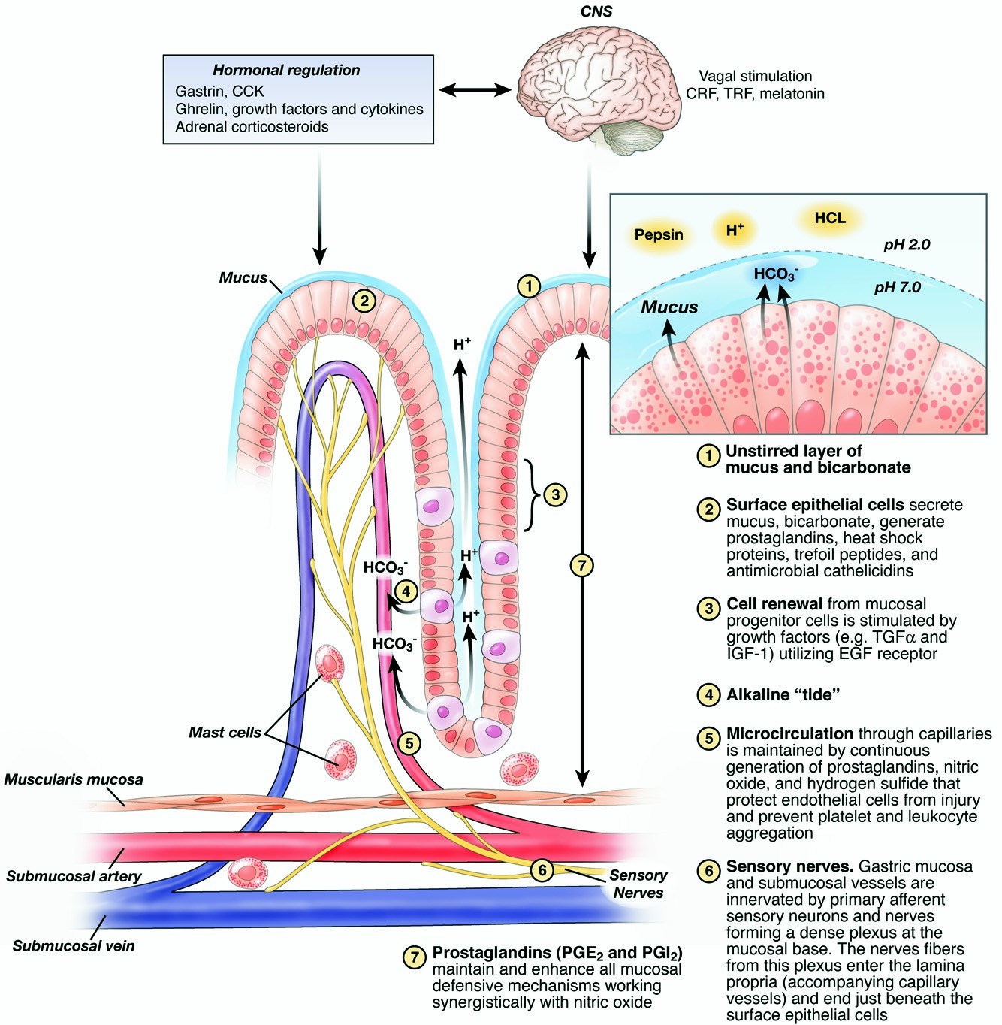
Figure 1. Diagrammatic representation of gastric mucosal defense, modified and updated from Tarnawski, 2008
Mucosal defense mechanisms are crucial for protecting the digestive tract from harsh chemicals like stomach acid, enzymes, and pathogens. These defenses are categorized into:

2.14.1 Pre-Epithelial Defense
This includes the mucus-bicarbonate barrier, which creates a pH gradient at the epithelial surface, neutralizing acid and protecting the lining.

2.14.2 Epithelial Defense
This involves tight junctions between epithelial cells, preventing leakage of harmful substances, and the production of protective molecules like prostaglandins and nitric oxide.

2.14.3 Post-Epithelial Defense
This focuses on maintaining blood flow to the mucosa, delivering nutrients and oxygen while removing waste products, and activating nerve signaling pathways to further enhance protection.

2.15 Hematological Indices
Haematological indices are specific measurements derived from blood tests that provide information about the composition and characteristics of blood, particularly red blood cells and white blood cells. These indices are valuable in diagnosing and monitoring various conditions, including anemias, infections, and inflammatory diseases.
Hemoglobin is a protein found in red blood cells (RBCs) that carries oxygen from your lungs to the rest of your body and helps carry carbon dioxide back to your lungs to be exhaled. It’s a key indicator of your blood’s oxygen-carrying capacity and overall health.

2.15.1 Red Blood Cell Count (RBC)
Red blood cells (RBCs) are the most common type of blood cell and are responsible for transporting oxygen from your lungs to tissues,carrying carbon dioxide back to the lungs to be exhaled and they contain hemoglobin, a protein that binds oxygen.
Too low (anemia) → fatigue, weakness, shortness of breath.
Too high (polycythemia) → increased risk of blood clots, headaches, dizziness.
White blood cells (WBCs), also called leukocytes, are a vital part of your immune system. They help defend the body against infections, foreign invaders, and abnormal cells like cancer.
Lymphocytes are a type of white blood cell (WBC) essential for the body’s immune response. They help fight infections and can also be involved in immune system memory, allergies, and autoimmune conditions.

Type of White Blood Cells (WBCs)
B cells Produce antibodies to attack invaders like bacteria and viruses
T cells Destroy infected or cancerous cells; help regulate immune response
Natural Killer (NK) cells Kill virus-infected and tumor cells without needing prior exposure
Monocytes
Monocytes are a type of white blood cell (WBC) that help defend your body against infections and aid in the cleanup of damaged or dead cells. They also play a role in immune system regulation and inflammation.
Functions of White Blood Cell
Patrol the bloodstream and migrate into tissues when needed.
• Once in tissues, they become macrophages or dendritic cells:
• Macrophages: “Big eaters” that digest pathogens and dead cells.
• Dendritic cells: Help activate the immune response.
Measure Normal Range
% of total WBCs 2% – 8%
Absolute count 200 – 800 cells/μL (microliter)
Basophils
Basophils are the least common type of white blood cell (WBC), but they play an important role in your body’s immune response, especially in allergic reactions and inflammation.
• Release histamine and heparin during allergic responses.
• Histamine causes inflammation, itching, and swelling.
• Heparin helps prevent blood clotting.
Basophils are very few in number but can still indicate health issues if elevated or severely reduced.
Measurement Type Normal Range
% of total WBCs 0.5% – 1%
Absolute count 0 – 100 cells/μL (microliter)

2.15.2 Mean Cell Volume (MCV)
Mean Cell Volume (MCV) is a measure of the average size (volume) of your red blood cells (RBCs). It’s a standard part of a Complete Blood Count (CBC) test and helps diagnose different types of anemia.
Normal Range: 80 – 100 fL per red blood cell
Mean Cell Hemoglobin (MCH) is a blood test value that tells you the average amount of hemoglobin inside each red blood cell (RBC). Hemoglobin is the protein in RBCs that carries oxygen throughout your body.
Normal Range: 27 – 33 pg per red blood cell

2.15.3 Mean Cell Hemoglobin
Mean Cell Hemoglobin Concentration (MCHC) measures the average concentration of hemoglobin in a given volume of red blood cells (RBCs). It reflects how “filled” the cells are with hemoglobin.
Normal Range: 32 – 36 g/dL

2.15.4 Packed Cell Volumes (PCV)
Packed Cell Volume (PCV), also called hematocrit (Hct), measures the percentage of blood that is made up of red blood cells (RBCs). It helps assess the blood’s ability to carry oxygen and diagnose various conditions, especially anemia and dehydration.
Group Normal PCV (%)
Men 40% – 54%
Women 36% – 48%
Children 35% – 45%

2.15.5 Eosinophils
Eosinophils are a type of white blood cell (WBC) involved in:
• Fighting parasites
• Managing allergic reactions
• Participating in inflammatory responses
They’re one of the five major types of WBCs and are known for their role in conditions like asthma, eczema, and parasitic infections.
Measurement Normal Range
% of total WBCs 1% – 4%
Absolute count 50 – 500 cells/μL

2.15.6 Neutrophils
Neutrophils are the most abundant type of white blood cell (WBC) and a key part of your innate immune system. They’re the body’s first line of defense against infections, especially bacterial and fungal infections.
Functions of neutrophil are :
• Rapidly respond to infection or injury.
• Engulf and destroy pathogens (via phagocytosis).
• Release enzymes and chemical signals to recruit other immune cells.

Measurement Normal Range
% of WBCs 40% – 70%
Absolute Count 1,500 – 8,000 cells/μL

CHAPTER THREE

MATERIALS AND METHODS

3.1 Materials

3.1.1 Plant Material
The fresh leaves of Sida acuta were harvested from roadsides in Kwara State Polytechnic, Ilorin. The plants were authenticated by Dr. Mrs. Hassan, I.R. of the department of Nutrition and Dietetics. The leaves were chopped to pieces with knife, washed under running tap water and dried under shade at room temperature for 7 days. The dried leaves were ground to a fine powder with mechanical grinder and kept in labeled airtight containers under dry conditions until required for extraction.

3.1.2 Animals
Female albino wistar rats weighing between 160-200 g were used for the experiment. The rats were kept in the animal house of department of Biochemistry, Kwara State Polytechnic, Ilorin. They were acclimatized to daily handling for 5 days and were fed aspirin with normal rat chow (Product of Vital feed Nig. Ltd) and water.

3.2 Chemicals and Reagents
The following chemicals are used;
- Ethanol to extract the plant
- DmSO4 (Dimethyl Sulphoxide)
- Indomethacin
- Omel Prazole
- Water

Reagents are
- Bowl
- Syringe
- Spatula
- Beaker
- Carnula

3.2 Methods

3.2.1 Preparation of Ethanol extraction of Sida acuta leaves
The extraction of Sida acuta roots and leaves was done using modified method of Abdulrahman et al., (2004). Two hundred grams each of grounded Sida acuta leaves were macerated in 2.5l absolute ethanol for 72 hours properly labelled and covered.
The extracts were then filtered with sterile filter paper (Watman No. 1). The sample filtrates were evapourated to dryness at 40°C in a vacuum using a rotary evaporator and stored at 5°C in a refrigerator until required for use approximate concentrations of the sample extracts were made in 100 ml of 10% ethanol for the treatment of the animals.

3.3 Experimental Design
Twenty-eight rats were used in this study. They were randomly assigned into eight groups of seven rats each.
Group 1
The animals in this group were fed with normal rat chow and had free access to water. They were orogastrically given 1ml of 10% ethanol daily for 21 days. They serve as the control.
Group II
The rats in this group were fed with normal rat chow and water was provided Indomethacin. They received I ml equivalent to 100 mg/kg body weight of Sida acuta leave extract daily for 21 days using orogastric tube.
Group III
This group was fed with normal rat chow and water was provided Indomethacin. They received 1 ml equivalent to 100 mg/kg body weight of Sida acuta root extract daily for 21 days using orogastric tube.
Group IV
This group was fed with normal rat chow and water was provided Indomethacin. They received 0.5ml equivalent to 50 mg/kg body weight of Sida acuta leave extract and 0.5 ml equivalent to 50 mg/kg body weight of Sida acuta root extract daily for 21 days using orogastric tube.

3.4 Analytical Procedure
After 21 days of treatment, the rats were anaesthetized with chloroform and their thoracic cavities were cut open to expose the heart. By cardiac puncture of each rat, blood sample was collected with a sterile syringe into a plain sterile test tube and allowed to clot for 10 minutes. The serum was separated by spinning at 1000 rpm for 10 minutes with Wisperfuge model 1384 centrifuge (Samson Halland) and collected with a pastuer pipette into clean labeled test tubes. The serum was used for biochemical analysis.

3.4.1 Preparation of Kidney homogenate
The kidney homogenate of each rat was prepared under chloroform anesthesia by removing the kidney from the rats and the surrounding fatty tissues. The kidney of each rat was blended separately in 2 ml of 1% glucose solution until a smooth homogenate solution was obtained. The homogenate of each rat kidney was centrifuged for 10 minutes and the liquid homogenate was extracted into a sterile plane test tubes. This is used to estimate the kidney function enzymes.

3.4.2 Biochemical Analysis
Creatinine concentration was measured by the alkaline picrate method (Tietz et al., 2016) while urea concentration was determined by using the diacetyl monoxime method of Marshal (2017). Determination of serum sodium and potassium concentration were done using reagent set (Tietz et al., 2016). Serum bicarbonate concentration was determined titrimetically, while mercuric nitrate method was used to determine the concentration of chloride (Schales and Schales, 2019). Kidney alanine transaminase (ALT) and asparate transaminase (AST) activities were assayed by the method of Reitman and Frankel (2017) while alkaline phosphatase activity was assayed by the method of King and Amstrong (2014) using Randox Kit.

3.5 Statistical Analysis
Data were presented as mean ± SD of four determinations. Statistical analysis was carried out using one-way analysis of variance of the SPSS version 21.0. This was followed by student’s t-test of significance. Values at P<0.05 were considered statistically significant.

CHAPTER FOUR

4.0 RESULTS

4.1 Haematological Results Analysis
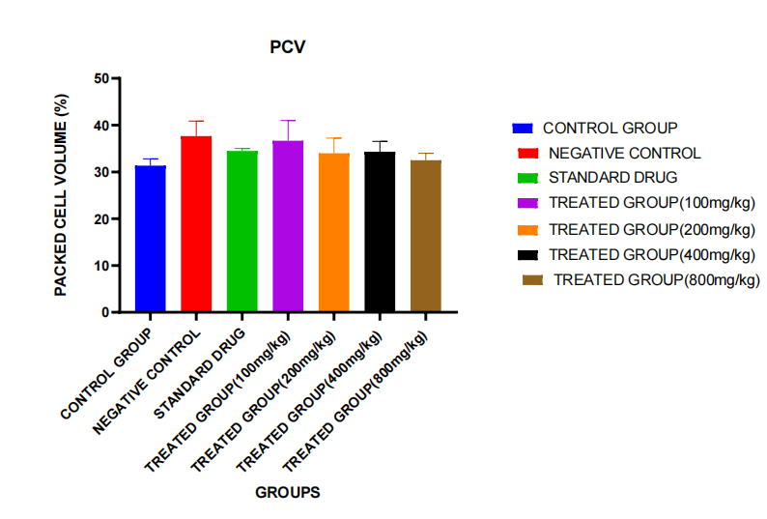
The following are the haematological results analysis for the induced ulcerogenic rats.
Figure 4.1: Packed Cell Volume
DESCRIPTION
Title: PCV (Packed Cell Volume) Across Different Treatment Groups
Y-Axis:
• Labeled “Packed Cell Volume (%)”
• Represents the percentage of red blood cells in the blood (PCV)
• Scale ranges from 0 to 50%

X-Axis:
• Labeled “Groups”
• Categories (left to right):
1. Control Group (Blue)
2. Negative Control (Red)
3. Standard Drug (Green)
4. Treated Group (100 mg/kg) – Purple
5. Treated Group (200 mg/kg) – Orange
6. Treated Group (400 mg/kg) – Black
7. Treated Group (800 mg/kg) – Brown
INTERPRETATION
• The Negative Control group (Red) shows the highest PCV, slightly higher than the Standard Drug group (Green) and all treated groups.
• The Control Group (Blue) has the lowest PCV, but not drastically lower than others.
• All treated groups (100–800 mg/kg) show relatively stable and moderate PCV values, with no major spikes or drops among them.
• The error bars suggest variability, particularly in the Negative Control and Treated Group (200 mg/kg).

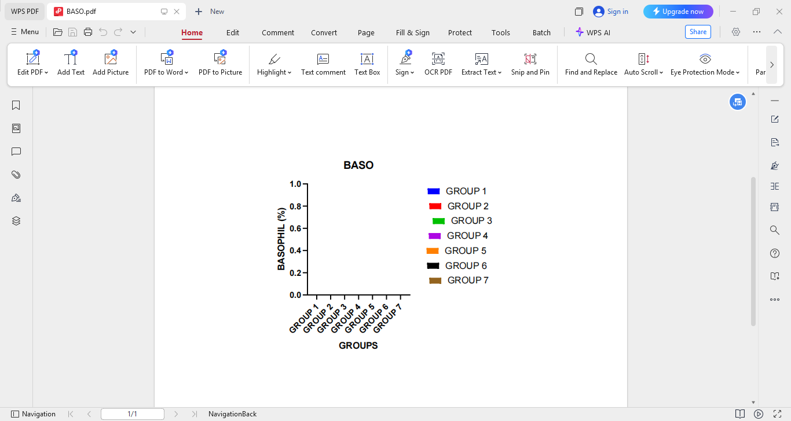
Figure 4.2: BASO (Basophil Count)
DESCRIPTION
Title: BASO (Basophil Count)
Y-Axis:
• Labeled “Basophil (%)”
• Represents the percentage of basophils, a type of white blood cell involved in allergic and inflammatory responses.
• Scale ranges from 0.0 to 1.0%
X-Axis:
• Labeled “Groups”
• Seven groups are represented:
1. GROUP 1 (Blue)
2. GROUP 2 (Red)
3. GROUP 3 (Green)
4. GROUP 4 (Purple)
5. GROUP 5 (Orange)
6. GROUP 6 (Black)
7. GROUP 7 (Brown)
Observation:
• All groups show a Basophil percentage of 0.0%.
• There is no visible bar for any group, indicating no significant change or presence of basophils across all samples.
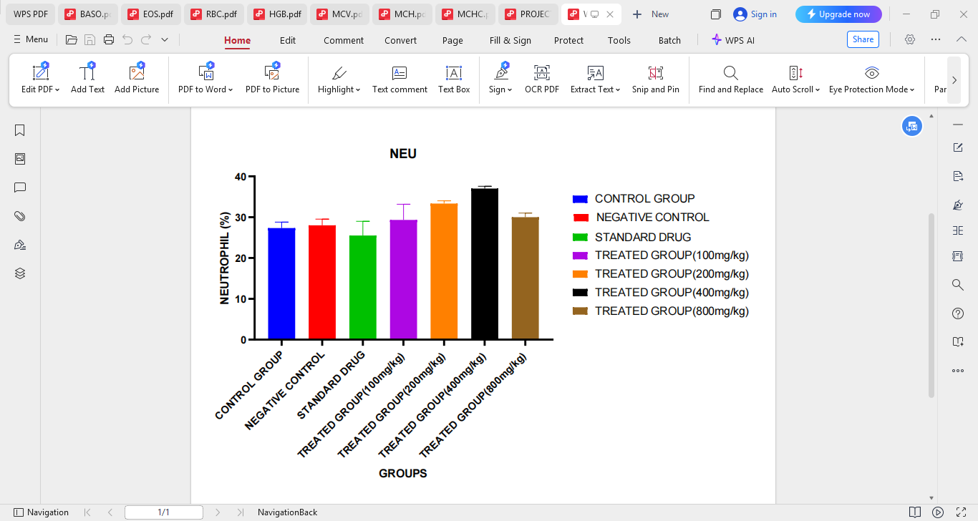
Title: NEU (Neutrophils %)
Figure 4.3: NEU (Neutrophil)
This bar chart presents the percentage of neutrophils (a type of white blood cell, WBC) across different experimental groups.
Groups Analyzed
The x-axis represents the different groups:
1. Control Group (blue)
2. Negative Control (red)
3. Standard Drug (green)
4. Treated Group (100 mg/kg) (purple)
5. Treated Group (200 mg/kg) (orange)
6. Treated Group (400 mg/kg) (black)
7. Treated Group (800 mg/kg) (brown)
Y-Axis (Neutrophil %)
• This axis measures the percentage of neutrophils in the total white blood cell count.
• Ranges from 0 to 40%.
Observations and Interpretation
• Control, Negative Control, and Standard Drug groups all have similar neutrophil levels, roughly around 28–30%.
• Treated Groups show variation:
• 100 mg/kg: Slight increase (~30–31%)
• 200 mg/kg: Noticeable increase (~33–34%)
• 400 mg/kg: Highest neutrophil level (~36–37%)
• 800 mg/kg: Slight drop compared to 400 mg/kg (~31–32%)
This pattern suggests a dose-dependent increase in neutrophil levels up to 400 mg/kg, followed by a decrease at the highest dose (800 mg/kg).

Mean Cell Volume (MCV)
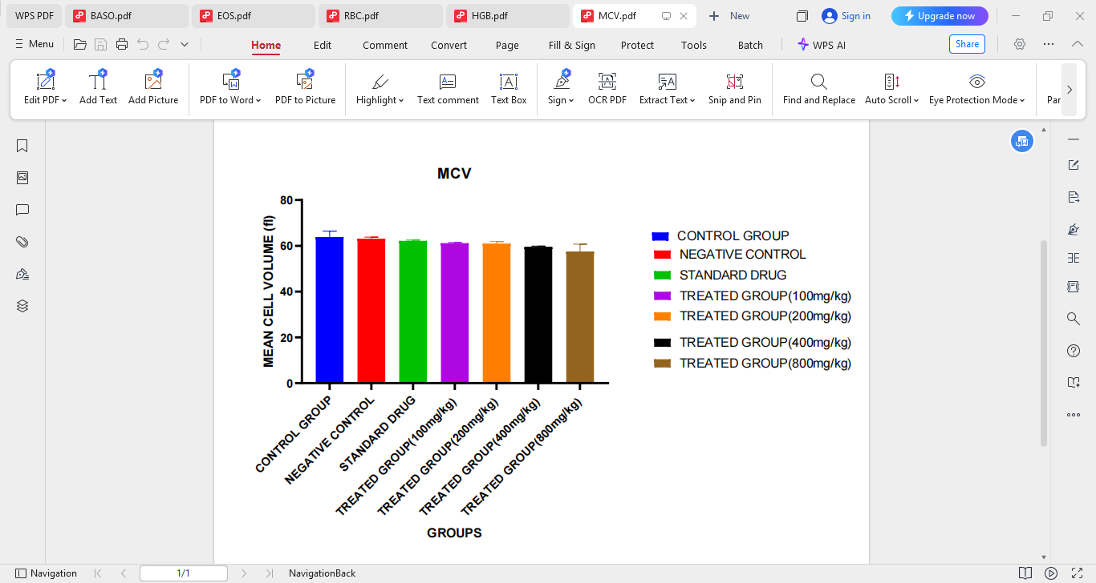
Description and Discussion
Figure 4.4: Mean Cell Volume (MCV)
Description of the Bar Chart
The bar chart titled “MCV” (Mean Cell Volume) presents data comparing the average red blood cell (RBC) volume across seven experimental groups:
• Control Group (blue)
• Negative Control (red)
• Standard Drug (green)
• Treated Group (100 mg/kg) (purple)
• Treated Group (200 mg/kg) (orange)
• Treated Group (400 mg/kg) (black)
• Treated Group (800 mg/kg) (brown)
The Y-axis represents MCV values (in femtoliters, fL), ranging from 0 to 80 fL. All groups show values within a narrow range around 60–65 fL. No bar extends significantly above or below this range, and the standard error bars are short, indicating little variation among replicates within each group.
4. Comparison with Standard Drug
The standard drug group also falls within the same MCV range, indicating that the tested extract performs similarly in terms of hematological safety, at least regarding red cell size.
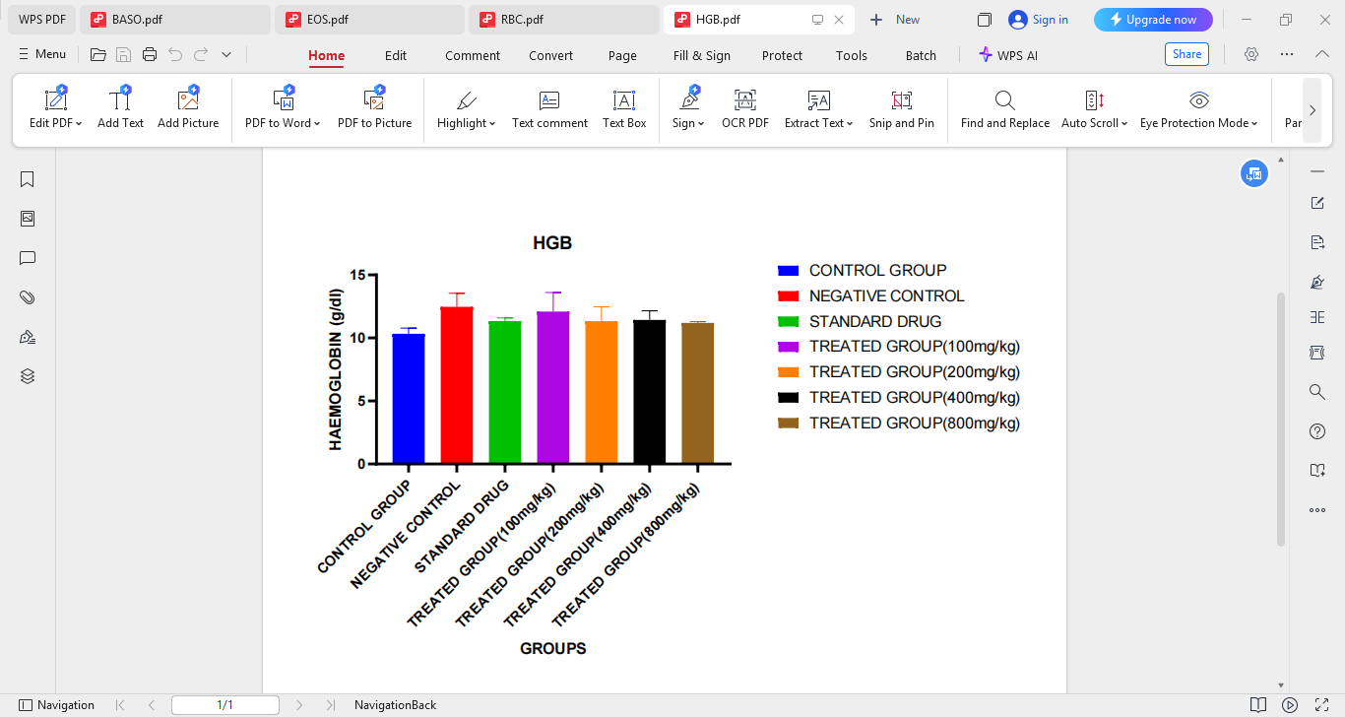
Description of Chart:
Figure 4.5: Hemoglobin
• Y-axis: Hemoglobin concentration in grams per deciliter (g/dl)
• X-axis: Seven groups:
1. Control Group (Blue)
2. Negative Control (Red)
3. Standard Drug (Green)
4. Treated Group (100 mg/kg) – Purple
5. Treated Group (200 mg/kg) – Orange
6. Treated Group (400 mg/kg) – Black
7. Treated Group (800 mg/kg) – Brown
Observations:
• The negative control group shows the highest HGB value, followed by the standard drug and treated groups (100–200 mg/kg).
• The control group (blue) shows the lowest HGB value, slightly lower than all others.
• Treated groups (400 mg/kg and 800 mg/kg) show moderate hemoglobin levels, not significantly different from the standard drug or low-dose groups.
• Error bars indicate a modest degree of variation, most notably in the negative control and 200 mg/kg treated group.

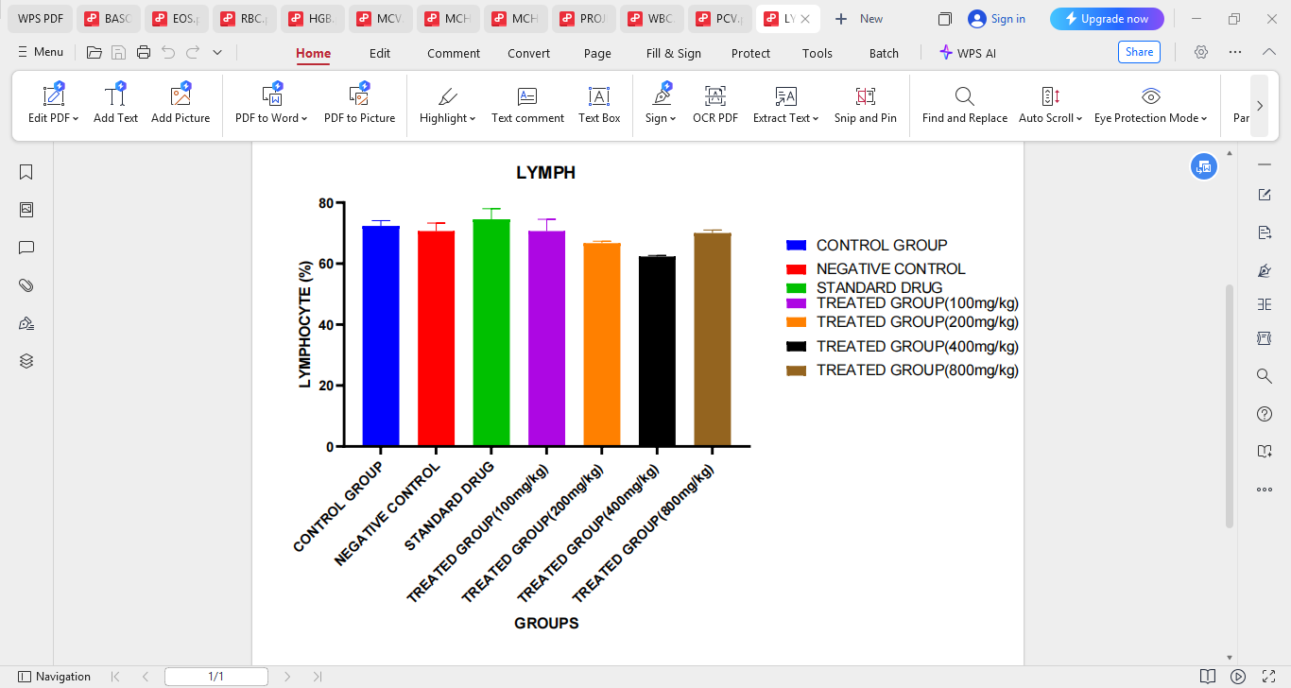
Figure 4.6: Lymphocyte
Description of the Chart
• Parameter measured: Lymphocyte percentage (%)
• Y-axis: LYMPHOCYTE (%) ranging from 0 to 80%
• X-axis: 7 groups
• Control Group (blue)
• Negative Control (red)
• Standard Drug (green)
• Treated Groups (purple, orange, black, and brown for 100 mg/kg, 200 mg/kg, 400 mg/kg, and 800 mg/kg, respectively)
From visual observation:
• Lymphocyte percentages across all groups fall within the 70–75% range.
• The standard drug group appears to have the highest lymphocyte count.
• The treated group at 400 mg/kg (black) shows the lowest lymphocyte percentage.
• Other groups hover near the control group, indicating minimal variation.
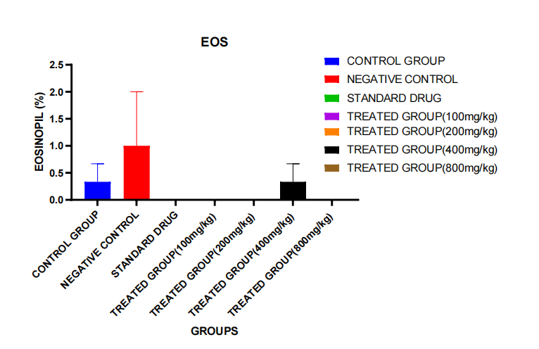
Figure 4.7: Eosinophil
Chart Description:
• Y-axis: Eosinophil percentage (% of total white blood cells)
• X-axis: Experimental groups:
1. Control Group (Blue)
2. Negative Control (Red)
3. Standard Drug (Green)
4. Treated Group (100 mg/kg) – Purple
5. Treated Group (200 mg/kg) – Orange
6. Treated Group (400 mg/kg) – Black
7. Treated Group (800 mg/kg) – Brown
Observations:
• Negative control group has the highest eosinophil level (~1.8%), with a wide error bar.
• Standard drug group shows slightly elevated eosinophils (~1.0%) but with notable variability.
• The control group has low eosinophil values (~0.5%).
• All treated groups (100–800 mg/kg) have nearly undetectable or zero eosinophils, except for the 400 mg/kg group, which shows a small increase (~0.5%).
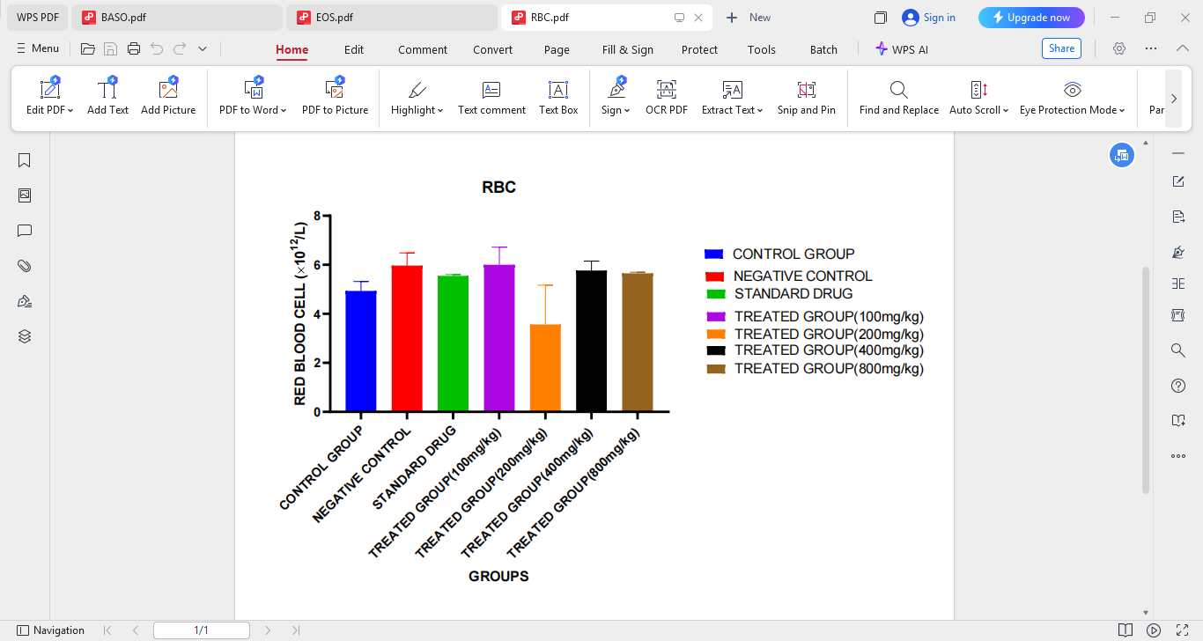
Figure 4.8: Red Blood Cell (RBC)
Graph Title: RBC (Red Blood Cell Count)
Unit: ×10¹²/L
Groups Represented:
1. Control Group (Blue)
2. Negative Control (Red)
3. Standard Drug (Green)
4. Treated Group (100 mg/kg) – Purple
5. Treated Group (200 mg/kg) – Orange
6. Treated Group (400 mg/kg) – Black
7. Treated Group (800 mg/kg) – Brown
Observations:
• The Negative Control group shows the highest RBC count, even more than the Control.
• The Standard Drug also shows a high RBC count, close to the Negative Control.
• The Treated Group (100 mg/kg) shows a modest RBC count similar to the Control and Standard Drug.
• The Treated Group (200 mg/kg) shows a significant decrease in RBC count.
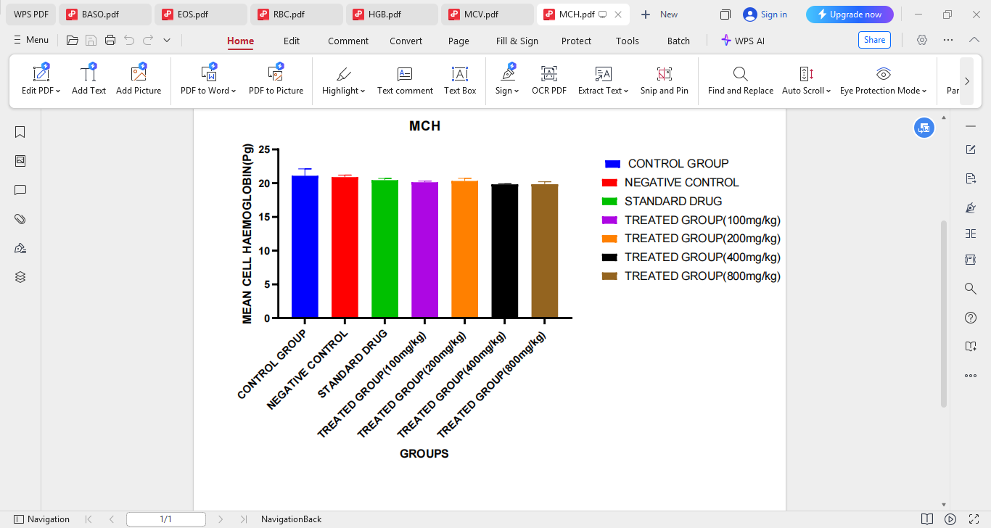
• Interestingly, at 400 mg/kg and 800 mg/kg, the RBC count rises again, almost back to Control/Standard levels.
Figure 4.9: MCH (Mean Cell Hemoglobin)
Graph Title: MCH (Mean Cell Hemoglobin)
Unit: pg (picograms)
Groups Represented:
1. Control Group (Blue)
2. Negative Control (Red)
3. Standard Drug (Green)
4. Treated Group (100 mg/kg) – Purple
5. Treated Group (200 mg/kg) – Orange
6. Treated Group (400 mg/kg) – Black
7. Treated Group (800 mg/kg) – Brown
Observations:
• All groups have very similar MCH values, with no dramatic variation.
• The Control Group appears to have a slightly higher MCH compared to the rest.
• The Treated Groups (100–800 mg/kg) all hover around the same MCH values as the Standard Drug and Negative Control.

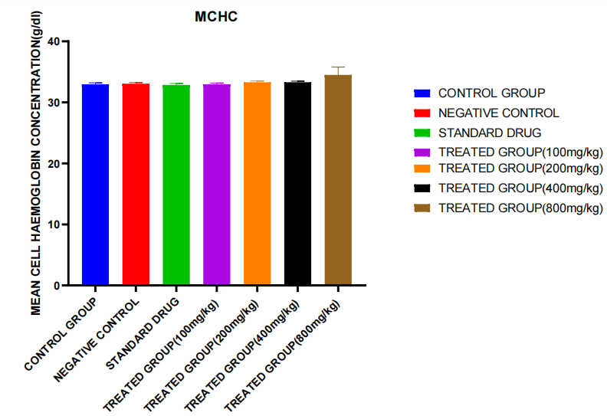
Figure 4.10: Mean Corpuscular Hemoglobin Concentration (MCHC)
Description and Discussion of MCHC Results
Parameter: Mean Corpuscular Hemoglobin Concentration (MCHC)
Unit: g/dl
Chart Title: MCHC
Y-axis: MCHC values (g/dl)
X-axis: Groups (Control, Negative Control, Standard Drug, Treated 100–800 mg/kg)
Description of the Results
• The Control Group (blue), Negative Control (red), and Standard Drug Group (green) all show similar MCHC values around 33–34 g/dl, indicating a consistent baseline.
• The Treated Groups at 100 mg/kg, 200 mg/kg, and 400 mg/kg (purple, orange, black) also show MCHC values that are very similar to the control group.
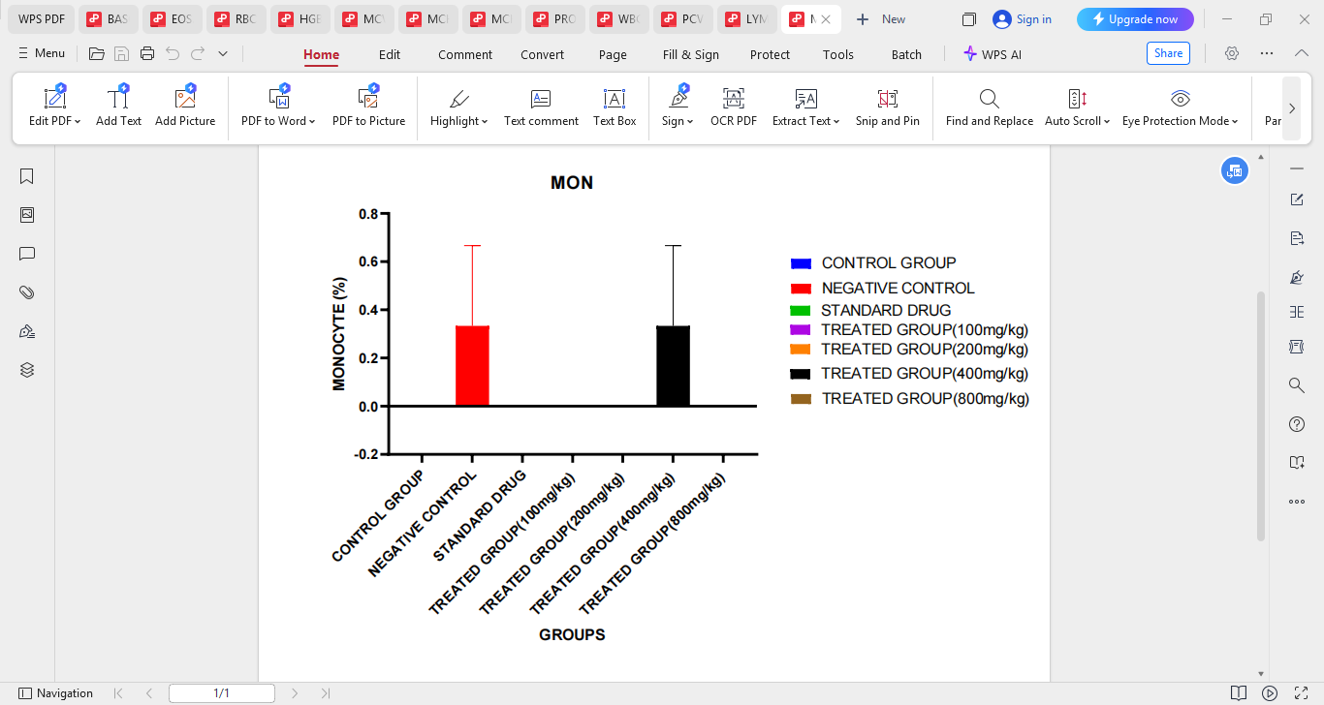
• The Treated Group at 800 mg/kg (brown) shows a slightly elevated MCHC, approaching or exceeding 35 g/dl, and has a visible error bar suggesting some variation within the group.
Figure 4.11: Monocyte Count %
Description of Results (Monocyte Count %):
The bar chart represents the percentage of monocytes across different experimental groups:
• Control Group (Blue): Shows a monocyte level of approximately 0%.
• Negative Control (Red): Monocyte level increased to about 0.3%, with a large error bar, suggesting inflammation or immune response.
• Standard Drug (Green): Monocyte level appears to be at 0%, indicating successful suppression of inflammation.
• Treated Group 100 mg/kg (Purple): Monocyte level is 0%.
• Treated Group 200 mg/kg (Orange): Monocyte level is 0%.
• Treated Group 400 mg/kg (Black): Slight increase in monocyte level to ~0.3%, similar to the negative control.
• Treated Group 800 mg/kg (Brown): Monocyte level is 0%.
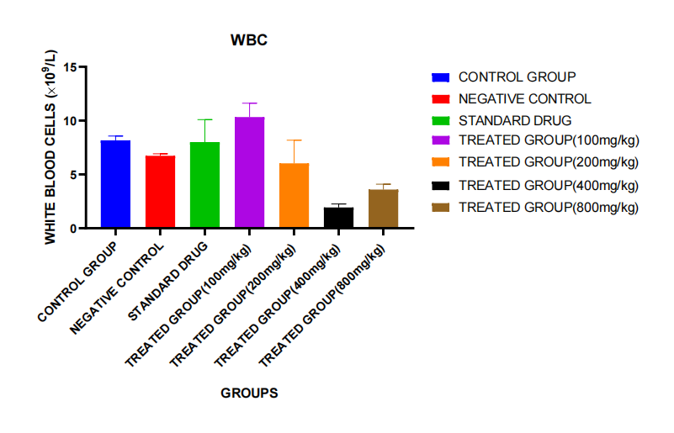
Figure 4.12: White Blood Cell Count – WBC
Description of Results (White Blood Cell Count – WBC):
This bar chart presents the WBC count (×10⁹/L) across seven groups:
• Control Group (Blue):
WBC level is moderate, around 7.5 × 10⁹/L, indicating a normal immune profile.
• Negative Control (Red):
Shows a slightly lower WBC count (~6.5 × 10⁹/L) than the control, possibly due to immune suppression or physiological stress caused by the ulcer-inducing agent.
• Standard Drug (Green):
WBC rises to ~9 × 10⁹/L, suggesting a possible immune-stimulating or restorative effect of the standard drug.
• Treated Group (100 mg/kg) – Pink:
Highest WBC level among all groups at about 10 × 10⁹/L, which may reflect enhanced immune activity or active recovery from inflammation.
• Treated Group (200 mg/kg) – Orange:
Moderate WBC (~7.5 × 10⁹/L), similar to the control group, indicating possible normalization.
• Treated Group (400 mg/kg) – Black:
Markedly low WBC (~3 × 10⁹/L), suggesting possible immune suppression or toxicity at this dose.
• Treated Group (800 mg/kg) – Brown:
Slight recovery of WBC to ~5 × 10⁹/L, but still below normal range.

CHAPTER FIVE

DISCUSSION, CONCLUSION AND RECOMMENDATIONS

5.0 Discussion
Discussion on Packed Cell Volume (PCV)
1. Negative Control High PCV:
This may indicate an unexpected result or a physiological compensation. It would be important to evaluate what the “negative control” entails (e.g., untreated but exposed to a stressor or toxin?).
2. Effectiveness of Treatments:
• All treatment doses (100–800 mg/kg) maintain PCV within a normal or moderate range.
• None of the treatments drastically increase or decrease PCV, which could suggest safety and stability.
• Comparing with the standard drug, some treated groups (especially 100 and 200 mg/kg) show similar or slightly better PCV values.
3. Dose-Dependent Effect?
There’s no clear dose-dependent trend — increasing dose does not seem to consistently increase or decrease PCV.
The packed cell volume (PCV) levels were evaluated across all groups to assess the hematological impact of the treatment. The negative control group surprisingly recorded the highest PCV, potentially indicating an immune or compensatory response. Treatment groups across all doses maintained PCV values comparable to the standard drug, with no significant dose-dependent changes observed, suggesting hematological safety.

Discussion on Basophils
1. Absence of Basophils:
• Basophils are typically rare in circulation (<1%), so values of 0.0% are not uncommon in healthy animals or in conditions where there’s no allergic or parasitic stimulus.
• This could also indicate that none of the treatments or conditions induced an inflammatory or allergic response involving basophils.
2. Treatment Safety:
• The absence of basophils across all treated and control groups could suggest that the drug or compound being tested is not causing immunological stress or allergic-type reactions.
3. Technical Note:
• Ensure that the result is not due to detection limitations or reporting rounding (e.g., 0.04% might be rounded down to 0.0%).
Basophil counts were uniformly 0.0% across all groups, including control, standard drug, and treatment groups. This indicates no detectable basophilic activity or response under the experimental conditions, suggesting that the test compound did not provoke allergic or inflammatory reactions.
• Immune Activation: The increase in neutrophil % in the treated groups (especially 200–400 mg/kg) might indicate enhanced immune response or stimulation of bone marrow activity.
• Therapeutic Window: The drop at 800 mg/kg could suggest a threshold beyond which the immune benefit declines, possibly due to toxicity or feedback inhibition.
• Standard Drug Comparison: The standard drug does not significantly elevate neutrophils beyond control levels, indicating that your treatment might have superior immunostimulatory potential at optimal doses.
Discussion on Neutrophil
• Immune Activation: The increase in neutrophil % in the treated groups (especially 200–400 mg/kg) might indicate enhanced immune response or stimulation of bone marrow activity.
• Therapeutic Window: The drop at 800 mg/kg could suggest a threshold beyond which the immune benefit declines, possibly due to toxicity or feedback inhibition.
• Standard Drug Comparison: The standard drug does not significantly elevate neutrophils beyond control levels, indicating that your treatment might have superior immunostimulatory potential at optimal doses.
Discussion of Mean Cell Volume
1. Consistency Across Groups
The MCV values remain relatively constant across all groups, including both treated and untreated animals. This suggests that neither the disease model (negative control) nor the treatments had a notable effect on the size of red blood cells.
2. Absence of Cytotoxicity or Anemia
MCV is an important indicator in hematological analysis. A decrease in MCV might indicate microcytic anemia (often due to iron deficiency), while an increase suggests macrocytic anemia (common in vitamin B12 or folate deficiency). The consistency in MCV here implies:
• No RBC shrinkage or swelling
• No anemia or toxicity-related effects from the extract
• Stable erythropoiesis, meaning red blood cell formation remains normal

3. Safety of the Test Substance
Because there are no significant changes in MCV even at higher doses (400 mg/kg and 800 mg/kg), the extract appears safe at the cellular level, not interfering with red blood cell morphology or volume regulation.
The results indicate that the tested compound does not alter the size of red blood cells, which suggests it is non-toxic to the hematopoietic system in terms of red blood cell production and maturation. This is a favorable outcome, reinforcing the extract’s hematological safety, particularly when used at therapeutic doses.
Discussion on Hemoglobin
• Hemoglobin (HGB) is a key protein in red blood cells responsible for transporting oxygen from the lungs to body tissues.
• Its concentration is an important biomarker for anemia, oxygen-carrying capacity, and bone marrow function.
Interpretation:
1. Control Group:
• Shows the lowest HGB level, suggesting a baseline reference without intervention.
• This provides a comparison point for assessing treatment effects.
2. Negative Control:
• Surprisingly exhibits the highest HGB concentration.
• This could be due to:
• Physiological stress or hemoconcentration (e.g., dehydration).
• Compensatory erythropoiesis in response to inflammation or other challenges.
• Alternatively, it might reflect biological variability and not a true treatment-related effect.
3. Standard Drug Group:
• Demonstrates a healthy hemoglobin level, suggesting the standard drug does not induce anemia.
• Its position near the top range implies positive or stabilizing effects on hematological status.
4. Treated Groups (100–800 mg/kg):
• All treated groups maintain hemoglobin levels comparable to or slightly below the standard drug group.
• No signs of hemoglobin suppression are seen at higher doses (400–800 mg/kg).
• This indicates that the treatment is likely non-toxic to red blood cell production.
• The slight drop at 800 mg/kg may suggest a limit to the dose-dependent benefit or the start of a plateau in efficacy.
• Hemoglobin levels were not adversely affected by the tested treatments across all doses.
• Therapeutic doses (100–400 mg/kg) appear safe and stable, showing similar results to the standard drug.
• The high HGB in the negative control group may be due to physiological variability and should be interpreted with caution.
• Overall, the compound shows no hematological toxicity and may support normal red blood cell function.

Discussion on Lymphocytes
Physiological Role of Lymphocytes:
Lymphocytes are a key component of the immune system. They include T cells, B cells, and NK cells, involved in fighting infections, producing antibodies, and regulating immune responses.
Interpretation of Results:
• Control vs. Negative Control:
• Similar lymphocyte percentages suggest the negative condition did not induce immunosuppression or hyperactivation.
• Standard Drug Group:
• A slight increase in lymphocyte count might suggest a mild immunostimulatory effect or normalization of immune parameters.
• Treated Groups:
• 100 mg/kg and 200 mg/kg groups: Similar to control, indicating no significant immune disturbance.
• 400 mg/kg group: Shows lower lymphocyte levels, which might suggest a dose-related mild immunosuppressive effect.
• 800 mg/kg group: Lymphocyte levels rebound, similar to control—suggesting the effect is not dose-dependent, or that the higher dose may restore immune balance.
Implications:
• There is no significant lymphocytosis (elevated lymphocytes) or lymphopenia (decreased lymphocytes) across treatment groups.
• The treatment appears to be immunologically safe, especially at lower doses.
• The dip at 400 mg/kg should be noted but does not suggest clinical immunosuppression, especially given recovery at 800 mg/kg.
The treatment at doses between 100–800 mg/kg shows no major deviation in lymphocyte percentage in albino rats compared to control. This indicates that the treatment is unlikely to impair immune function. Slight fluctuations—such as the dip at 400 mg/kg—should be monitored, but overall, the compound appears immunologically stable and non-toxic at the tested doses.
Discussion on Eosinophils
Role of Eosinophils:
• Eosinophils are a type of white blood cell involved in:
• Allergic responses
• Parasitic infections
• Inflammation and tissue damage
• Elevated eosinophils (eosinophilia) can indicate immune dysregulation or hypersensitivity, while very low counts may suggest immunosuppression or lack of antigenic stimulus.
Interpretation of Results:
1. Negative Control Group:
• Shows a marked increase in eosinophils, suggesting possible inflammatory or allergic reactions in response to the condition being modeled or induced.
• The broad error bar indicates high variability—possibly reflecting inconsistent immune activation among rats in this group.
2. Standard Drug Group:
• Shows moderate eosinophil levels with variability, possibly due to partial immune modulation.
• Suggests that the standard drug may not fully resolve eosinophilic inflammation.
3. Control Group:
• Displays baseline eosinophil levels (~0.5%), which serves as a normal physiological range for healthy rats.
4. Treated Groups (100–800 mg/kg):
• All treated groups have eosinophil levels near zero, especially the 100, 200, and 800 mg/kg groups.
• This indicates that the test compound effectively suppresses eosinophilic activity or prevents excessive immune response.
• The 400 mg/kg group shows a small increase, possibly due to individual variation or a mild immune response.
The elevated eosinophils in the negative control imply immune activation or inflammation in the absence of treatment.
• The near-complete suppression of eosinophils in the treated groups suggests the compound has anti-inflammatory or immunomodulatory effects, potentially superior to the standard drug in this regard.
• This finding supports the compound’s potential use in managing conditions involving eosinophilic activity, such as allergies or parasitic infections.
Discussion on Red Blood Cell
1. Control vs. Negative Control:
• The higher RBC in the Negative Control may suggest a stress response or a compensatory mechanism (possibly due to anemia or hypoxia stimuli).

2. Standard Drug Group:
• RBC count is relatively stable and high, indicating that the standard treatment maintains erythropoiesis (RBC production) effectively.
3. Treated Groups:
• At 100 mg/kg, the treatment appears safe with no reduction in RBC.
• At 200 mg/kg, there’s a marked suppression of RBC production, which may indicate toxicity or bone marrow suppression.
• At higher doses (400 and 800 mg/kg), RBC count recovers, suggesting possible dose-dependent effects or physiological adaptation.
The treatment exhibits a non-linear effect on RBC production:
• Mild doses (100 mg/kg) are relatively safe.
• Intermediate dose (200 mg/kg) may be suppressive.
• Higher doses (400–800 mg/kg) restore RBC count, which could imply either:
• The body adapts to higher doses, or
• The compound shows biphasic effects (toxic at intermediate levels, beneficial at higher).
Discussion on Mean Cell Hemoglobin
MCH represents the average amount of hemoglobin in a red blood cell. It’s crucial in understanding the oxygen-carrying capacity of RBCs.
1. Stable MCH across all groups suggests that neither the treatment nor the standard drug significantly affected the hemoglobin content per RBC.
2. Even at the highest treatment dose (800 mg/kg), there was no indication of hypochromia (low hemoglobin per RBC) or hyperchromia.
3. This implies that the treatment does not impair hemoglobin synthesis even if it affects RBC count (as seen earlier).
The test compound, across all administered doses, does not negatively impact hemoglobin content in red blood cells, as shown by the consistent MCH values. This indicates normal hemoglobin incorporation and suggests that erythropoiesis remains functionally adequate in terms of hemoglobinization.
Discussion on Mean Cell Hemoglobin Concentration
1. Effect of Treatment on MCHC
• MCHC is an indicator of the average concentration of hemoglobin inside red blood cells.
• The consistent MCHC levels across most groups suggest that the test compound did not significantly disrupt hemoglobin concentration in erythrocytes at doses up to 400 mg/kg.
• At the highest dose (800 mg/kg), a slight increase in MCHC was observed. This may suggest:
• A potential hemoconcentration effect,
• A mild compensatory increase in hemoglobin packing in RBCs,
• Or possibly a dose-related effect of the compound at high concentration.
2. Comparison with Controls
• The MCHC values in the treated groups are comparable to the control and standard drug groups, indicating no hemolytic or toxic effects at most doses.
• The absence of a decrease in MCHC suggests that the compound did not induce hypochromia (a common indicator of iron-deficiency anemia or hemolysis).

3. Implications
• Maintenance or slight increase in MCHC supports the hematological safety of the compound across tested doses.
• However, the elevation at 800 mg/kg should be further investigated for possible subclinical erythrocyte changes or osmotic stress.
The MCHC data suggest that the test substance is hematologically safe at 100–400 mg/kg. The slight rise in MCHC at 800 mg/kg may reflect a mild physiological adjustment but does not indicate a harmful effect. Overall, the compound does not appear to compromise red blood cell integrity or hemoglobin concentration in a clinically concerning way.
Discussion on Monocytes
Monocytes are a type of white blood cell involved in the body’s immune response, especially during inflammation or infection. Elevated monocyte levels typically indicate an ongoing immune or inflammatory reaction.
• The negative control group (which likely received a harmful agent without treatment) showed a notable increase in monocyte levels, suggesting an inflammatory or immune challenge.
• The standard drug group and most treated groups (100, 200, 800 mg/kg) showed normalized monocyte levels (0%), suggesting anti-inflammatory or protective effects.
• Interestingly, the 400 mg/kg treated group had a monocyte elevation similar to the negative control, possibly indicating a dose-related response where this specific concentration may not be as effective or could trigger a mild inflammatory effect.
The treatment appears to effectively reduce or maintain normal monocyte levels at most doses, similar to the standard drug. However, the 400 mg/kg dose stands out with a monocyte spike, indicating a non-linear or biphasic dose-response, which may warrant further investigation.
Discussion on White Blood Cells
White blood cells are essential for fighting infection and responding to inflammation. Alterations in WBC levels provide insights into how treatments or conditions affect the immune system.
• The negative control group’s lowered WBC supports the idea that ulcer induction may suppress immune function.
• The standard drug and 100 mg/kg treated groups show a significant increase in WBC, suggesting they may stimulate or support immune recovery.
• However, a sharp drop in WBC at 400 mg/kg raises concerns about dose-dependent immunosuppression or potential toxicity.
• The partial recovery at 800 mg/kg implies some adaptive effect at higher doses, though not fully normalized.
The treatment shows a non-linear dose response on WBC levels:
• 100 mg/kg appears most effective at boosting immune activity.
• 200 mg/kg maintains normal levels.
• 400 mg/kg may be immunosuppressive, while 800 mg/kg shows mild recovery.
This pattern highlights the need to optimize dosage for maximum efficacy with minimal side effects.

5.1 Conclusion
The present study investigated the potential therapeutic effect of Sida acuta ethanol leaf and root extracts on hematological parameters in albino Wistar rats with indomethacin-induced gastric ulcers. The findings demonstrated that ulcer induction caused significant alterations in key blood parameters such as red blood cell (RBC) count, hemoglobin concentration, white blood cell (WBC) count, and packed cell volume (PCV), which are often reflective of systemic inflammation, oxidative stress, or internal bleeding.
Treatment with Sida acuta extracts — particularly the combination of leaf and root extract — showed promising restorative effects on these hematological indices. Notably, the treated groups exhibited improvements in RBC and hemoglobin levels, as well as reductions in WBC counts, suggesting a reversal of ulcer-induced hematological disturbances.
These results support the traditional use of Sida acuta in the management of gastrointestinal and inflammatory conditions. The plant’s rich phytochemical profile — including alkaloids, flavonoids, tannins, and saponins — likely contributes to its observed hematoprotective and anti-ulcerogenic effects.

5.2 Recommendations
1. Further studies should be conducted to isolate and characterize the specific bioactive compounds responsible for the observed effects.
2. Long-term toxicity and safety profiling of Sida acuta should be carried out to confirm its suitability for therapeutic use.
3. Comparative studies with standard anti-ulcer drugs (e.g., omeprazole) can help position Sida acuta as a potential natural alternative or adjunct therapy.

REFERENCES
Abachi, S., Khademi, F., Fatemi, H. and Malekzadeh, F. (2013) Study of Antibacterial Activity of Selected Iranian Plant Extracts on Helicobacter pylori. Journal of Dental and Medical Sciences, 5, 55-59. https://doi.org/10.9790/0853-0515559
Abebaw, M., Mishra, B. and Gelayee, D.A. (2017) Evaluation of Anti-Ulcer Activity of the Leaf Extract of Osyris quadripartita Decne. (Santalaceae) in Rats. Journal of Experimental Pharmacology, 9, 1-11. https://doi.org/10.2147/JEP.S125383
Abiodun, F., Igwe, A. and Obasuyi, O. (2007) Antimicrobial Evaluation of a Herbal Dental Remedy: Stem Bark of Naclealatifoli Family Rubiaacea. Journal of Applied Sciences, 7, 2696-2700. https://doi.org/10.3923/jas.2007.2696.2700
Akaneme, F.I. (2008) Identification and Preliminary Phytochemical Analysis of Herbs That Can Arrest Threatened Miscarriage in Orba and Nsukka Towns of Enugu State. African Journal of Biotechnology, 7, 6-11.
Akilandeswari S, Senthamarai R, Prema S, Valarmathi. IJPSR (2010) 1(5): 248-250 [2] The Wealth of India, CSIR, New Delhi. 10: 28.
Akilandeswari, S., Senthamarai, R., Valarmathi, R., Shanthi, S. and Prema, S. (2021) Screening of Gastric Antiulcer Activity of Sida acuta Burm. International Journal of PharmTech Research, 2, 1644-1648.
Alimentary Pharmacology and Therapeutics, 21, 1411-1418. https://doi.org/10.1111/j.1365-2036.2005.02444.x
Aljamal, A. (2011) Effects of Tumeric in Peptic Ulcer and Helicobacter Pylori. Plant Science Research, 3, 25-28.
American Diabetes Association (2000): Nutrition recommendation and principles for people with diabetes mellitus clinical practice recommendations Diabetes care 23:543-6.
Asha, A., Farsana, S. and Baiju, E.C. (2018) Phytochemical Profiling and Antibacterial Activity of Selected Sida Species against Common Human Pathogenic Bacteria: An In Vitro Study. Journal of Pharmacognosy and Phytochemistry, 7, 1201-1205.
Asrat, D., Nilsson, I., Mengistu, Y., Ashenafi, S., Ayenew, K., Al-Soud, A.W., Wadström, T. and Kassa, E. (2004) Prevalence of Helicobacter pylori Infection among Adult Dyspeptic Patients in Ethiopia. Annals of Tropical Medicine and Parasitology, 98, 181-189. https://doi.org/10.1179/000349804225003190
Bancroft, J.D. and Gamble, M. (2008) Theory and Practice of Histological Techniques. 6th Edition, Churchill Livingstone, Philadelphia.
Bell, A.E., Seller,L.A., and Allen, A.,(2015),Properties of Gastric and duodenal mucus, effect of proteolysis, disulfide reduction, bile, acid, ethanol and hypertonicity on mucus gel structure. Gastroenterology. 88, 269-280.
Bhattamisra, S.K., Yan, V.L., Lee, C.K., Kuean, C.H., Candasamy, M., Liew, Y.K. and Sahu, P.S. (2018) Protective Activity of Geraniol against Acetic Acid and Helicobacter pylori Induced Gastric Ulcers in Rats. Journal of Traditional and Complementary Medicine, 9, 206-214. https://doi.org/10.1016/j.jtcme.2018.05.001
Blaser, M.J. (2006) Who Are We? Indigenous Microbes and the Ecology of Human Diseases. EMBO Reports, 7, 956-960. https://doi.org/10.1038/sj.embor.7400812
British National Formulary (BNF) (2003): British Medical Journal and Royal Pharmaceutical Society of Great Britain, 45 ed.
Brito, A.R.M.S., Cota,R.H.S and Nunes, D.S (2017). Gastric antiulcergenic effects of Dalbergia monetaria L in Rats. Phytother.Res., 11,314 – 316.
Brodie, D.A. (2018), Experimental peptic ulcer, Gastroenterology. 55, 125-134.
Campos-Vidal, Y.; Herrera-Ruiz, M.; Trejo-Tapia, G.; Gonzalez-Cortazar, M.; Aparicio, A.J.; Zamilpa, A. (2021) Gastroprotective activity of kaempferol glycosides from Malvaviscus arboreus Cav. J. Ethnopharmacol., 268, 113633.
Chaloob AK, Qasim HM, Gassim MH (2009): The effects of aspirin and fenugreek seed on the testes of white mice. Fac Med Baghdad. Vol 52, No 3: pp 349-351.
Cheng, Y.T.; Cheng, C.T.; Wang, S.Y.; Wu, V.C.C.; Chu, P.H.; Chou, A.H.; Chen, C.-C.; Ko, P.-J.; Liu, K.-S.; Chen, S.W. (2019) Long-term outcomes of endovascular and open repair for traumatic thoracic aortic injury. JAMA Netw. Open, 2, e187861.
Cheng-Yen, K., Bor-Shyang, S. and Jiunn-Jong, W. (2016) Helicobacter pylori Infection: An Overview of Bacterial Virulence Factors and Pathogenesis. Biomedical Journal, 39, 14-23. https://doi.org/10.1016/j.bj.2015.06.002
Dacie JV, Lewis SM (1991): Practical haematology, 7th edition ELBS with Churchill Livingston, England, pp 37-85.
Davenport, H.W., (2014), Functional significance of Gastric mucosal barrier to sodium.Gastroenterology.47, 142.
Davenport, H.W., (2019), Gastric mucosa haemorrhage in dogs, effect of acid aspirin and alcohol. Gastroenterology, 56, 439.
Demirci Kayiran, S.; Eroglu Ozkan, E.; Ozhatay, N. (2015) The screening phytochemical components of Muscari and Bellevalia species growing in Kahramanmaras and review of phytochemical studies. In Proceedings of the 11th International Symposium on Pharmaceutical Sciences, Ankara, Turkey, 9–12 June.
Doumas BT, Watson W, Biggs HC (2011): Albumin standards and the measurement of serum albumin with bromocresol green. Clinica Chimica Acta 31, 87-96.
Duncan JR, Praise KW, Mahaffey EA (2014): Veterinary Laboratory Medicine (Clinical Pathology) 3rd ed. Iowa State University Press, U.S.A.
Ebbo, A.A.; Sani, D.; Suleiman, M.M.; Ahmad, A.; Hassan, A.Z. (2020) Acute and sub-chronic toxicity evaluation of the crude methanolic extract of Diospyros mespiliformis hochst ex a. Dc (ebenaceae) and its fractions. Toxicol. Rep. 7, 1138–1144.
Ekwealor, C.C. and Oyeka, C.A. (2015) In Vitro Anti-Dermatophyte Activities of Crude Methanol and Aqueous Extracts of Lawsonia inermis. International Journal of Pharmaceutical Science and Drug Research, 7, 59-62.
Eroglu, A.; Dogan, A. (2023) Investigation of the phytochemical composition and remedial effects of southern grape hyacinth (Muscari neglectum Guss. ex Ten.) plant extract against carbon tetrachloride-induced oxidative stress in rats. Drug Chem. Toxicol., 46,491–502.
Eroglu-Ozkan, E.; Demirci-Kayiran, S.; Gulsoy-Toplan, G.; Mataraci-Kara, E.; Kurkcuoglu, M. (2018) Identification of volatile compounds and antimicrobial activities of Muscari neglectum growing in Turkey. Fresenius Environ. Bull., 27, 4674–4678.
Eusebi, L.H., Zagari, R.M. and Bazzoli, F. (2014) Epidemiology of Helicobacter pylori Infection. Helicobacter, 19, 1-5. https://doi.org/10.1111/hel.12165
Gberikon, G.M., Adeoti, I.I. and Aondoackaa, A.D. (2015) Effect of Ethanol and Aqueous Solutions as Extraction Solvents on Phytochemical Screening and Antibacterial Activity of Fruit and Stem Bark Extracts of Tetrapleura tetrapteraon Streptococcus salivarus and Streptococcus mutans. International Journal of Current Microbiology and Applied Sciences, 4, 404-410.
Ghanayem.B.L Boor P.J and Ahmed M.R (2015). Acrylonitrile induced gastric mucosal necrosis:Role of gastric glutathaione. J.Pharmacol .Exp ther., 232, 570 – 577.
Goel,R.K.,Chakrabarthy, A., and Sanyan, A.K.(2015).The effect of biological Variables on the antiulcerogenic effect of vegetable plantain Banana.Planta Medica,2,85-88.
Gowrishanker N.L Babu G. Varadharaju S.Latha, S.T. And Rajesh V.A (2004)m Preliminary study on gastric antiulcer activity of Commiphora berryi (arn) Engl in rats Indian Drugs 41 (2). 97- 100.
Gu, L.K., Zhuo, P. and Zhuo, J. (2007) Effect of Selenium-Enriched Garlic on Chronic Gastritis of the Glandular Stomach of Mongolian gerbils Induced H. pylori. Chinese Journal of Preventive Medicine, 41, 104-107.
Guitton MJ, Caston J, Ruel J et. al., (2003): Salicylate induces tinnitus through activation of cochlear NMDA receptors J. Neurosci 23 (9): 3944-52.
Habeeb, A., Tiwari, S.K., Bardia, A., Khan, S., Vishwakarm, V.K., Habeeb, S. and Khan, A.A. (2016) Peptic Ulcer Disease: Descriptive Epidemiology, Risk Factors, Management and Prevention. http://www.smgebooks.com/peptic-ulcer-disease/chapters/PUD-16-06.pdf
Hall SL, Lorenc T (2010): Secondary prevention of coronary artery disease. American family physician 81 (3): 289-96.
Isik, M.; Ozbayer, C.; Donmez, D.B.; Colak, E.; Ustuner, M.C.; Erol, K.; Degirmenci, I. (2022) Effects of the probiotic, Lactobacillus rhamnosus GG, on ulcer pathogenesis, HSP70 stress protein and nitric oxide levels in stress induced ulcer. Biotech. Histochem.,97, 449.
Jahedsani, A.; Khezri, S.; Ahangari, M.; Bakhshii, S.; Salimi, A. (2020) Apigenin attenuates Aluminum phosphide-induced cytotoxicity via reducing mitochondrial/Lysosomal damages and oxidative stress in rat Cardiomyocytes. Pestic. Biochem. Phys., 167, 104585.
Jain NC (2016): Schalm’s Veterinary Haematology 4th ed. Lea and Fabiger, Philadelphia.
Jiang, S.Q.; Chen, Z.L.; Zhang, S.; Ye, J.L.; Wang, Y.B. (2023) Protective effects of protocatechuic acid on growth performance, intestinal barrier and antioxidant capacity in broilers challenged with lipopolysaccharide. Animal, 17, 100693.
Jindal, A. and Kumar, P. (2012) Antibacterial Activity of Sida acuta Burm. F. against Human Pathogen. Asian Journal of Pharmaceutical and Clinical Research, 5, 33-35.
Kalali, B., Mejías-Luque, R., Javaheri, A. and Gerhard, M. (2014) H. pylori Virulence Factors: Influence on Immune System and Pathology. Mediators of Inflammation, 2014, Article ID: 426309. https://doi.org/10.1155/2014/426309
Karou, S., Nadembega, W., Ilboudo, D., Ouermi, D., Gbeassor, M., De Souza, C. and Simpore, J. (2007) Sida acuta Burm F: A Medicinal Plant with Numerous Potencies. African Journal of Biotechnology, 6, 2953-2959. https://doi.org/10.5897/AJB2007.000-2463
Kaur, G.; Shivanandappa, T.B.; Kumar, M.; Kushwah, A.S. (2020). Fumaric acid protect the cadmium-induced hepatotoxicity in rats: Owing to its antioxidant, anti-inflammatory action and aid in recast the liver function. Naunyn Schmiedeberg’s Arch. Pharmacol. 393, 1911–1920.
Kayode, J. (2006) Conservation of Indigenous Medicinal Botanicals in Ekiti State, Nigeria. Journal of Zhejiang University Science B, 7, 713-718. https://doi.org/10.1631/jzus.2006.B0713
Keskin, S.Y.; Avci, A.; Kurnia, H.F.F. (2024) Analyses of phytochemical compounds in the flowers and leaves of Spiraea japonica var. fortunei using UV-VIS, FTIR, and LC-MS techniques. Heliyon, 10, e25496.
Kirtikar KR, Basu BD, Blatter E, Caius JF, Mhaskar KS. (2013) Indian Medicinal Plants, Allahabad, India; 2(II): 1182.
Kolgazi, M.; Cilingir, S.; Yilmaz, O.; Gemici, M.; Yazar, H.; Ozer, S.; Acikel-Elmas, M.; Arbak, S.; Suyen, G.G. (2021) Caffeic acid attenuates gastric mucosal damage induced by ethanol in rats via nitric oxide modulation. Chem. Biol. Interact., 334, 109351.
Küçükler, S.; Kandemir, F.M.; Yıldırım, S. (2022) Protective effect of chrysin on indomethacin induced gastric ulcer in rats: Role of multi-pathway regulation. Biotech. Histochem., 97, 490–503.
Kusters, J., van Vliet, A. and Kuipers, E. (2006) Pathogenesis of Helicobacter pylori Infection. Clinical Microbiology Reviews, 19, 449-490. https://doi.org/10.1128/CMR.00054-05
Langamead, L., and Rampton, D.S.(2001).Herbal Treatment in Gastro intestinal and Liver Disease benefits and dangers.Ailment Pharmacol ther,15,12391252.
Lauret, M.E., Rodriguez-Pelaez, M., Perez, I. and Rodrigo, L. (2015) Peptic Ulcer Disease. Journal of Gastroenterology and Hepatobiliary Disorders, 1, 105-113.
Lee, H., Hong, S., Yoo, J., Chung, Y. and Kim, O. (2018) Anti-Helicobacter pylori Activity and Inhibition of Gastritis by Allium hookeri Extract. Laboratory Animal Research, 34, 75-79. https://doi.org/10.5625/lar.2018.34.2.75
Li Y, Xia, Kuter DJ (2019): Interaction of thrombopoietin with the platelet complements receptor in plasma: binding, internalization, stability and pharmacokinetics. Brit J. Haematol 106: 345.
Lim, T.K. (2012) Edible Medicinal and Non-Medicinal Plants; Springer: Dordrecht, The Netherlands,; Volume 1, pp. 656–687.
Londonkar, R.L., Patil, S.J. and Patil, S.B. (2009) Phytochemical and Contraceptive Property of Sida acuta Burm Fi. Iin. in Albio Rats. International Journal of PharmTech Research, 1, 1260-1266.
Ma, N.; Sun, Y.; Yi, J.; Zhou, L.; Cai, S. (2022). Chinese sumac (Rhus chinensis Mill.) fruits alleviate indomethacin-induced gastric ulcer in mice by improving oxidative stress, inflammation and apoptosis. J. Ethnopharmacol., 284, 114752.
Mabeku, L.B., Bille, B.E., Tchouangueu, T.F., Nguepi, E. and Leundji, H. (2017) Treatment of Helicobacter pylori Infected Mice with Bryophyllum pinnatum, a Medicinal Plant with Antioxidant and Antimicrobial Properties, Reduces Bacterial Load. Pharmaceutical Biology, 55, 603-610. https://doi.org/10.1080/13880209.2016.1266668
Mahady, G.B.; Pendland, S.L. (2000) Resveratrol ınhibits the growth of Helicobacter pylori in vitro. Am. J. Gastroenterol. AJG, 95, 1849.
Mahboubi, M.; Taghizadeh, M. (2016) The antimicrobial and antioxidant activity of flower ethanol extract. Herba. Pol., 62, 39–48.
Mahmoud, M.F.; Abdo, W.; Nabil, M.; Drissi, B.; El-Shazly, A.M.; Abdelfattah, M.A.; Sobeh, M. (2023) Apple (Malus domestica Borkh) leaves attenuate indomethacin-induced gastric ulcer in rats. Biomed. Pharmacother., 160, 114331.
Mahomoodally, M.F.; Zengin, G.; Sinan, K.I.; Yıldıztugay, E.; Lobine, D.; Ouelbani, R.; Bensari, S.; Ak, G.; Yılmaz, M.A.; Gallo, M.; (2021) A comprehensive evaluation of the chemical profiles and biological properties of six geophytes from Turkey: Sources of bioactive compounds for novel nutraceuticals. Food Res. Int., 140, 110068.
Malfertheiner, P., Chan, F.K. and McColl, K.E. (2009) Peptic Ulcer Disease. The Lancet, 347, 1449-1461. https://doi.org/10.1016/S0140-6736(09)60938-7
Manzano A, Perez-Segura P (2012): Colorectal cancer chemoprevention is this the future of colorectal cancer prevention? The Scientific World Journal 327341. PMID 22649288.
Megraud, F., Coenen, S., Versporten, A., Kist, M., Lopez-Brea, M., Hirschl, A., Andersen, L., Goossens, H. and Glupczynski, Y. (2013) Helicobacter pylori Resistance to Antibiotics in Europe and Its Relationship to Antibiotic Consumption. Gut, 62, 34-42. https://doi.org/10.1136/gutjnl-2012-302254
Mitruka BM, Rawnsley H (2017): Clinical, biochemical and haematological references values in normal experimental animals. Masson Publishing USA Inc. Pp. 53-54.
Nadkarni's, K.M.(2018). Indian Materia Medica, 2, 1134-1137.
Nakakaawa, L.; Gbala, I.D.; Cheseto, X.; Bargul, J.L.; Wesonga, J.M. (2023) Oral acute, sub-acute toxicity and phytochemical profile of Brassica carinata A. Braun microgreens ethanolic extract in Wistar rats. J. Ethnopharmacol., 305, 116121.
Nasrabadi, M.; Halimi, M.; Nadaf, M. (2013) Phytochemical screeningand chemical composition of extract of Muscari neglectum. Middle-East J. Sci. Res., 14, 566–569.
O’Gara, E.A., Hill, D.J. and Maslin, D.J. (2000) Activities of Garlic Oil, Garlic Powder, and Their Diallyl Constituents against Helicobacter pylori. Applied Environmental Microbiology, 66, 2269-2273. https://doi.org/10.1128/AEM.66.5.2269-2273.2000
Obiudu, I.K., Okolie, A.C., Agbafor, K.N., Unaegbu, M.E., Engwa, G.A. and Obiudu, C.V. (2015) Anti-Diabetic Property and Phytochemical Composition of Aqueous and Methanol Extracts of Buchholzia coriacea Seeds in Alloxan Induced Diabetic Rats. Journal of Medical Sciences, 15, 241-245. https://doi.org/10.3923/jms.2015.241.245
Park, H.S.; Seo, C.S.; Baek, E.B.; Rho, J.H.; Won, Y.S.; Kwun, H.J. (2021) Gastroprotective effect of myricetin on ethanol-induced acute gastric injury in rats. Evid.-Based Complement. Altern. Med., 2021, 9968112.
Parmar, N.S., Tariq, M and Ageel, A.M., (2017), Gastric Antiulcer and cytoprotective effect of selenium in rat. Toxicol. And Appl. Pharmacol, 92, 122-130.
Patel, V.; Joharapurkar, A.; Kshirsagar, S.; Patel, M.; Savsani, H.; Patel, A.; Ranvir, R.; Jain, M. (2022) Repurposing dimethyl fumarate for gastric ulcer and ulcerative colitis: Evidence of local efficacy without systemic side effect. Med. Drug Discov., 16, 100142.
Patnaick, G.K., Srimal, R.C.D., Das, P.K. and Dhawan, B.N., (2020), Evalution of Histamine H2 Receptor blocking activity of a new 2 substituted Piper, D.W and Stiel, D.D (1986). Pathogenesis if chronic peptic ulcer: Current thinking and clinical implications. Med. Prog., 2, 7-10.
Polat, B.; Albayrak, Y.; Suleyman, B.; Dursun, H.; Odabasoglu, F.; Yigiter, M.; Halici, Z.; Suleyman, H. (2011) Antiulcerative effect of dexmedetomidine on indomethacin-induced gastric ulcer in rats. Pharmacol. Rep., 63, 518–526.
Polenakovic M, Sikole A (2016): Is erythropoietin a survival factor for red blood cells? J. Am. Soc Nephrol 7(8): 1178-1182.
Pranil, T.; Moongngarm, A.; Manwiwattanakul, G.; Loypimai, P.; Kerr, W.L. (2021) Melatonin and its derivative contents in tropical fruits and fruit tablets. J. Food Compos. Anal., 103, 104109.
Rainsford, K.D (2014). Side effect of anti inflammatory analgesic drugs, epidemiology and gastrointestinal tract. Trends pharmacol. Sci., 5, 156 -159.
Rang HP, Dale MM, Ritter JM, Moore PK (2021): Pharmacology, Churchill Livingstone, Elsevier Science Ltd., London.; 1.
Reinhold JG (2013): Manual determination of serum total protein, albumin and globulin fractions by the Biuret method Standard Methods of Clinical Chemistry (Academic Press, New York).
Saslow, S.B., Thumshirn, M., Camilleri, M., Locke, G.R., Thomforde, G.M., Burton, D.D. and Hanson, R.B. (2018) Influence of H. pylori Infection on Gastric Motor and Sensory Function in Asymptomatic Volunteers. Digestive Diseases and Sciences, 43, 258-264. https://doi.org/10.1023/A:1018833701109
Schror K (2009): Acetysalicylic acid. ISBN 978-3-527-32109-4.
Segal, I., Ally, R. and Mitchell, H. (2001) Helicobacter pylori: An African Perspective. Quarterly Journal of Medicine, 94, 561-565. https://doi.org/10.1093/qjmed/94.10.561
Sgouras, D.N., Trang, T.T. and Yamaoka, Y. (2015) Pathogenesis of Helicobacter pylori Infection. Helicobacter, 20, 8-16. https://doi.org/10.1111/hel.12251
Shakya, A.; Chatterjee, S.S.; Kumar, V. (2015) Role of fumarates in adaptogenics like efficacies of traditionally used Fumaria indica extracts. Cell Med., 5, 6.
Singh, S (2019). Evaluation of gastric anti ulcer activity of fixed oil of Ocimum basilieum linn and its possible mechanism of action. Indian J.Exp Biol., 36, 253 – 257.
Sneader W (2000): “The discovery of aspirin: A reappraisal”. BMJ (Clinical Research ed.) 321 (7276): 1591-1594.
Somezeet P, Choudhury SN, Patro VJ, Pradhan DK, Jana GK. (2009) Drug Invention Today 2009; 1(2): 150-153
Sorensen HT, Mellemkjaer L, Blot WJ et. al., (2000): Risk of upper gastrointestinal bleeding associated with use of low-dose aspirin. Am. J. Gastroenterol 95 (9): 2218-24.
Souza, M.C., Bessera, A.M. and Martins, D.C. (2009) In Vitro and In Vivo Anti Helicobacter Activity of Callophyllum bransiliense Camb. Journal of Ethnopharmacology, 123, 452-458. https://doi.org/10.1016/j.jep.2009.03.030
Takagi, K. and Okabe, S. (2018) The Effects of Drugs on the Production and Recovery Processes of the Stress Ulcer. Japanese Journal of Pharmacology, 18, 9-11. https://doi.org/10.1254/jjp.18.9
Tamer, S.A.; Eskiler, G.G.; Ercan, F. (2024) Gastroprotective effect of vanillic acid against ethanol-induced gastric injury in rats: Involvement of the NF-κB signalling and anti-apoptosis role. Mol. Biol. Rep., 51, 744.
Tay, C.Y., Mitchel, H., Dong, Q., Goh, K.L., Dawes, I.W. and Lan, R. (2015) Population Structure of Helicobacter pylori among Ethnic Groups in Malaysia: Recent Acquisition of the Bacterium by the Malay Population BMC. Microbiology, 9, 126-131. https://doi.org/10.1186/1471-2180-9-126
Taylor, N.S. and Fox, J.G. (2012) Animal Models of Helicobacter-Induced Disease: Methods to Successfully Infect the Mouse. Methods in Molecular Biology, 921,131-142. https://doi.org/10.1007/978-1-62703-005-2_18
The American Society of Health-System Pharmacist (TASHSP) (2011): “Aspirin”. Retrieved 3 April 2011.
Tietz NW, Prude EL, Sirgard – Anderson O (2014): Textbook of clinical chemistry. Ed. Burtis C.A. and Ashwood E.R. pp 1354 – 1374. W.B. Saunders Company, London.
Vergara, M., Catalan, M., Gisbert, J.P. and Calvet, X. (2005) Meta-Analysis: Role of Helicobacter pylori Eradication in the Prevention of Peptic Ulcer in NSAID Users.
Woodson, R.F.(2017). Statistical Methods for analysis of Biomedical data.Wiley Publication , Newyork.
Young NS, Maciejewski J (2017): The path physiology of acquired aplastic anemia. New Eng. J. Med., 336:1365.
Zhang, S.; Gai, Z.; Gui, T.; Chen, J.; Chen, Q.; Li, Y. (2021) Antioxidant effects of protocatechuic acid and protocatechuic aldehyde: Old wine in a new bottle. Evid.-Based Complement. Altern. Med., 2021, 6139308.
Zheng, H., Choi, M., Kim, J., Lee, K., Park, Y. and Lee, D. (2016) In vitro and In vivo Anti-Helicobacter pylori Activities of Centella asiatica Leaf Extract. Preventive Nutrition Food Science, 21, 197-201. https://doi.org/10.3746/pnf.2016.21.3.197

