DESIGN AND IMPLEMENTATION OF DRUG VERIFICATION AND MANAGEMENT SYSTEM USING DEEP LEARNING ALGORITHM.

BY
OGUNNIYI OLUWATOSIN AUSUSTUS
ND/23/COM/FT/019

A PROJECT SUBMITTED TO THE

DEPARTMENT OF COMPUTER SCIENCE,
INSTITUTE OF INFORMATION AND COMMUNICATION TECHNOLOGY,KWARA STATE POLYTECHNIC, ILORIN.

IN PARTIAL FULFILLMENT OF THE REQUIREMENTS FOR THE AWARD OF NATIONAL DIPLOMA (ND) IN COMPUTER SCIENCE.

JUNE, 2025
CERTIFICATION
This is to certify that this project research was carried out by OGUNNIYI OLUWATOSIN AUGUSTUS with Matriculation Number: ND/23/COM/FT/019, has been read and approved as meeting part of the requirement for the award of National Diploma (ND) in computer science

__________________________ __________________
MR. OLAJIDE, A.T. Date
Project Supervisor

__________________________ ___________________
MR. OYEDEPO F.S Date
Head of Department

__________________________ ___________________
External Examiner Date

DEDICATION
This project work is sincerely dedicated to Almighty God for his mercy upon my live, divine protection, for his wisdom, knowledge and understanding given to me to put this project work together and throughout the course our study in this great polytechnics. May his name be praise forever and ever (amen).Also to my lovely, caring and darling parents for their moral and financial support. God bless you.

ACKNOWLEDGEMENT
All praise and thanks to my inestimable Almighty God the most beneficial, merciful, nourished and the sustainer for his guidance over my lives throughout this research work and my programme in this great institution.
I also appreciate the effort of my amiable supervisor Mr OLAJIDE A.T for his supervision and corrections made during the project work. May almighty God bless you and your home (amen).
Special thanks to Hod of the department Mr Oyedepo F.S, MR. ISIAKA O.S, Mrs olusi R.T, Dr Agboola O.M ,Mrs Dada M.O, Dr.Raji A.K and other members of the staff of the Department of Computer science for their support always.
Finally, i express my profound gratitude to all lecturers in computer science department in Kwara State Polytechnics, Ilorin. God bless you all (amen). More grease to your elbow.

TABLE OF CONTENTS
TITLE PAGE i
CERTIFICATION PAGE ii
DEDICATION iii
ACKNOWLEDGMENT iv
TABLE OF CONTENTS v
ABSTRACT vi
CHAPTER ONE: GENERAL INTRODUCTION
  - INTRODUCTION 1-2
  - STATEMENT OF THE PROBLEM 2
  - AIM AND OBJECTIVES 2
  - SIGNIFICANCE OF THE STUDY 3
  - SCOPE OF THE STUDY 3
  - ORGANIZATION OF THE REPORT 3
  - DEFINATION OF TERMS 4
CHAPTER TWO: LITERATURE REVIEW
2.1 REVIEW OF RELATED PAST WORK 6-7
2.2 REVIEW OF GENERAL TEXT 7
2.3 BIOMETRIC 7-8
2.4 FINGERPRINT ALGORITHM 8
2.5 PRE-PROCESSING 8
2.6 PATTERN-BASED (ORIMAGE-BASED) ALGORITHMS 8
2.7 CONCEPT OF DRUG 8-9
2.8 EFFECT OF FAKE DRUGS 9-10
2.9 FUNCTIONS OF NATIONAL AGENCY FOR FOOD AND DRUG ADMINISTRATION AND CONTROL (NAFDAC) 11-12
CHAPTER THREE: METHODOLOGY AND ANALYSIS OF THE SYSTEM
3.1 RESEARCH METHODOLOGY 13
3.2 ANALYSIS OF THE EXISTING SYSTEM 13-14
3.3 PROBLEM OF THE EXISTING SYSTEM 14
3.4 DESCRIPITON OF THE PROPOSED SYSTEM 14
3.5 ADVANTAGE OF THE PROPOSED SYSTEM 15
CHAPTER FOUR: DESIGN, IMPLEMENTATION AND DOCUMENTATION TO THE SYSTEM
4.1 DESIGN OF THE SYSTEM 16
4.2 OUTPUT DESIGN 16
4.3 INPUT DESIGN 17
4.4 FILE DESIGN 18
4.5 PROCEDURE DESIGN 19
4.6 IMPLEMENTATION OF THE SYSTEM 19
4.7 CHOICE OF PROGRAMMING LANGUAGE 20
4.8 HARDWARE SUPPORT 20
4.9 CHANGE OVER TECHNIQUES 20-21
4.10 STUDENT DOCUMENTATION 21
4.11 DOCUMENTATION OF THE SYSTEM 21
4.13 OPERATING SYSTEM 22
4.14 MENTAINING THE SYSTEM 22
4.15 SUMMARY 22 CHAPTER FIVE: CONCLUSIONS AND RECOMMENDATIONS
5.1 SUMMARY 23
5.2 CONCLUSION 23
5.3 RECOMMENDATION 23
REFERENCE SECTION
REFERENCES 24

ABSTRACT
The agencies responsible for regulating and approving these pharmaceutical drugs are doing their best to provide the general population with at least a yearly update of all registered drugs approved for various distributions at local drug stores, hospital pharmacies, private pharmacies and licensed chemical sellers. However, due to challenging factors such as cost of production, middlemen distribution, research and legal issues, availability and reliable source of sale, there have been more issues arising from the illegal and unregistered pharmaceutical drugs. There is also no guarantee of an individual seeking medical help through the use of prescription drugs. Records gained after each annual registration will be made available and it will provide the various stakeholders with information regarding pharmaceutical drugs allowed for regulation on the local drug markets and the also the manufacturers responsible for each drug distribution. Statement Of The Problem. The major and core issue that gave rise to this project work, is on the fact that most of the pharmaceutical drug users seek to use original product but because fake counterfeit drugs now, do not let one differentiate from the original anymore, and the process of verifying a product currently is not encouraging because it will take much time and before then, the ill person is supposed to take his medication, which is to say that the verification process is slow and not reliable as sometimes you don’t get thee feedback at all. This issue is what the research work seek to resolve by developing a secure and reliable system that can function better than the previous one. The objective are Structure Mapping Technique (SME) technique will be used in the software development, an Application enabling the citizens to check the authenticity of the drugs online, tracking and tracing of the drug where manufactured to ensure the reliable supply of drugs to consumers for patient safety and brand protection of manufacturer as well as nation and the information like Name of Drug, Name of Manufacturer, Batch number, Date of nation and the information like Name of Drug, Name of Manufacturer, Batch number, Date of manufacturing, Date of expiry, Usage of drug (optional) and Composition of drug (optional), to be provided on the web platform to the consumer. This is develop using web developing tools like html, php, css and mysql.

CHAPTER ONE
GENERAL INTRODUCTION

  - BACKGROUND TO THE STUDY
With the majority of the world’s population seeking required medications for various illnesses and medical conditions day-in-day-out, there is a need for appropriate pharmaceutical drugs. The agencies responsible for regulating and approving these pharmaceutical drugs are doing their best to provide the general population with at least a yearly update of all registered drugs approved for various distributions at local drug stores, hospital pharmacies, private pharmacies and licensed chemical sellers. However, due to challenging factors such as cost of production, middlemen distribution, research and legal issues, accessibility and reliable source of sale, there have been more issues arising from the illegal and unregistered pharmaceutical drugs. There is also no guarantee of an individual seeking medical help through the use of prescription drugs. Records gained after each annual registration will be made available and it will provide the various stakeholders with information regarding pharmaceutical drugs allowed for regulation on the local drug markets and also the manufacturers responsible for each drug distribution. The stakeholders are to make use of the information available include manufacturers, medical institutions, pharmacies and pharmaceutical drug importers, distributors and the general public. The provision or availability of the system will help the public to be aware of the pharmaceutical drugs that have being approved by the authority in charge. Also, to improve the quality of life by the healthcare community and life in general, and awareness of unregistered and fake pharmaceutical drugs to the public and stakeholders. This information of registered pharmaceutical drugs needs to be integrated and made accessible to the majority of population to enable them to view for themselves [Gostin, Lawrence O (2015)]. Over the years, a number of hybrid solutions have been applied to this problem. In general, they can be classified as employing a combination of stepped-up regulatory enforcement and technological innovation. Being pioneers in technology, industrialized nations have typically enjoyed a good balance between these two key ingredients World Health Organization (W.H.O). Developing nations, however, are comparatively less-endowed and generally not in the position to invest vast amounts in the research and development needed to yield effective anti-counterfeit technologies. Thus, where such countries have chosen to tackle the unregistered pharmaceutical drug problem, stepped up regulatory enforcement (syndicated raids and legal proceeding is the only deployable tool. Fortunately, the need for technological assistance to the enforcement-only approach has been identified, and innovators in the first world have developed a number of products. Technologies like Nano-particle taggant, RFID tags and UV-sensitive labels, all require new training and expensive readers currently not present on the developing nation market. Holograms are the leading anti-counterfeit measure, but the mature technology is currently subject to routine counterfeiting due to low cost reproduction equipment. All these solutions will not give the consumer control in checking the validity of the drugs at the point of sale, but a system that can with them, such as an online system for checking registered pharmaceutical drugs, will aid to an extent [Gillian J. Buckley (2014)]. As users of pharmaceutical drugs, being able to identify unregistered and fake drugs has become very challenging in recent times. What baffles many is why and how some of these fake pharmaceutical drugs find their way in to the market without the knowledge and approval of the Food and Drug Administration (FDA). Some even believe that to cover their incompetence, the Food and Drug Administration (FDA), once in a while, picks on one of the local companies simply to give the impression that it is working. “In a statement issued on October 8, 2013, Imani Ghana said the Food and Drug Administration (FDA) could not absolve itself from the apparent retrogressing in quality terms of products by the pharmaceutical companies as it has failed to ramp up its own internal capacity to lift up Ghanaian pharmaceutical companies.”[http://www.ghanaweb.com] There is also the belief that the regulators have to “review the processes involved in the registration of pharmaceutical drugs in the country including, but not limited to, evaluation of documents/dossiers, average throughput time for registration, risk/analytical assessment reports of pharmaceutical drugs, the entry and clearance of pharmaceutical product at the various points of entry.” The Food and Drugs Authority occasionally publishes list of registered drugs but by then the harm of these unregistered pharmaceutical drugs will have already crippled our healthcare system and markets. Interestingly, most of these companies have advertisements of the apparently fake drugs running on radio, television and in newspapers on daily basis. As a result, there are so many ways of ascertaining the availability of particular pharmaceutical drugs at any drug outlet. This leads to situations where majority of the population seeking healthcare solutions to variety of health problems not being able to cure themselves efficiently and Effectively. there is currently no centralized system of checking list of registered and unregistered pharmaceutical drugs when needed. Depending on the locality of the user, he/she can research for himself/herself if a drug being purchased is registered and has fulfilled all necessities needed to distribute and sell to the population
1.2 STATEMENT OF THE PROBLEM The major and core issue that gave rise to this project work, is on the fact that most of the pharmaceutical drug users seek to use original product but because fake of counterfeit drugs now, do not let one differentiate from the original anymore, and the process of verifying a product currently is not encouraging because it will take much time and before then, the ill person is supposed to take his medication, which is to say that the verification process is slow and not reliable as sometimes you don’t get the feedback at all. This issue is what the research work seek to resolve by developing a secure and reliable system that can function better than the previous one.
1.3 AIM AND OBJECTIVES The aim of this project is to develop a web application system for drug verification and management system. The basic objective of the project is to provide simpler means to the consumer and regulatory agencies for establishing drug authentication and protect the consumers’ health and life safety. In achieving the objective, following goals have to be set:
i. Web based portal
ii. Structure Mapping Technique (SME) technique will be used in the software development
iii. An Application enabling the citizens to check the authenticity of the drugs online
iv. Tracking and tracing of the drug where manufactured to ensure the reliable supply of drugs to consumers for patient safety and brand protection of manufacturer as well as nation
v. The information like Name of Drug, Name of Manufacturer, Batch number, Date of manufacturing, Date of expiry, Usage of drug (optional) and Composition of drug (optional), to be provided on the web platform to the consumer.
vi. Provide necessary support to the regulatory agencies in prevention of counterfeiting, fraud and illegal sale of drugs.
1.4 SIGNIFICANCE OF THE STUDY
The importance of drugs validity and authenticity to our health. It is believed that if this project works in fully implemented it will help reduce the rate of counterfeit in drugs production and uses among individual. It is also expected that the study will benefit the manufacturers of this drugs that is the original company and industry because they will have more sales as the citizens will go for the original one and the fake will have no sales in the market anymore. The software developed from this project work will be useful to the end users or the customers in helping them to verify the drugs they buy for medication. It is expected that the findings will expose the fake drug sellers in the market and their production companies. By this exposure, the pharmaceutical industry will learn more and stand by manufacturing quality products. It is possible that by this outcome the fake pharmaceutical industries will realistically adjust to the standard of production approved by the World Health Organization (WHO). Subsequently, it will go a long way to enhance the computer science students’ effectiveness in the society by being capable of carrying out what they have learned, thereby contributing to the building up of the society at the local, national and international levels.
1.5 SCOPE OF THE STUDY The drug verification, management and authentication system project is an initiative of the researcher to ensure the genuineness and authenticity of the drugs used within the country, imported from any part of the country to ours (Nigeria) basically imported from India and for citizens in the domestic market. The project covers most common drugs sold in our country Nigeria.
1.6 DEFINITION OF TECHNICAL TERMS
i. MENU: This is a list of options presented on the screen with each option identified by short code followed by longer description of its purposes.
ii. DRUG: It is referred to as a medicine or chemical substances that are administered to Patients for curative measures.
iii. PHARMACY: A placed in a hospital where medicine or chemical substances are kept, stored and prepared.
iv. RELATION: A relation is a named table with columns and rows Attribute; An attributes is a named column of a relation Domain; A set of allowable values for one or more table.
v. MANAGEMENT INFORMATION SYSTEM: collection of people; database, and devices produced to use in providing routine information to manager and decision makers
vi. PHARMACY DRUG: a pharmaceutical drug or medicine is a chemical substance used to treat, cure, prevent, diagnose a disease or promote well-being. Traditionally drugs were obtained through extraction from medicinal plants, but more recently also by organic synthesis. Pharmaceutical drugs may be used for a limited duration, or on a regular basis for chronic disorders.
vii. PRODUCT: Products are the species formed from chemical reactions. During a chemical reaction reagents are transformed into products after passing through a high energy transition state. This process results in the consumption of the reagents. It can be a spontaneous reaction or mediated by catalysts which lower the energy of the transition state, and by solvents which provide the chemical environment necessary for the reaction to take place.
viii. (polished stone) by the natural secretion of sweet from the accrue that are present in epidermal ridges.
ix. DIRECTORY: directory is a file system cataloging structure which contains references to other computer files, and possibly other directories
x. REGULATORY AGENCY: is a public authority or government agency responsible for exercising autonomous authority over some area of human activity in a regulatory or supervisory capacity
xi. MEDICAL DEVICE: is any instrument, apparatus, appliance, software, material or other article, whether used alone or in combination, including the software intended by its manufacturer to be used specifically for diagnostic and/or therapeutic purposes and necessary for its proper application, intended by the manufacturer to be used for human beings for the purpose of Diagnosis, prevention, monitoring, treatment or alleviation of disease.
xi. DIETHYLENE GLYCOL (DEG): is an organic compound with the formula (HOCH2CH2)2O. It is a colorless, practically odorless, poisonous, and hygroscopic liquid with a sweetish taste.
1.7 ORGANIZATION OF THE REPORT This project work is divided into five chapters and below are the description of what each chapter contains.
Chapter One describes the background of the project, statement of the problem, project aim and objective, significance of the project, report outlines, definition of term.
Chapter Two talks about the review of the past work related to work, review of general test, comparison of system development process models, comparison of application manage used, comparison of relationship database management system, summary.
Chapter Three deals with the research methodology, analyzing of the existing system, flowchart of the existing system, problem of the existing system, description of the proposed system, flowchart of the proposed system, advantages of proposed system, summary.
Chapter Four includes design of the system, output system, input system, database design, procedure design, implementation of the system, choice of programming language, hardware support, change over techniques, student documentation, documentation of the program, operating system, maintaining the system and summary.
Chapter Five deals with the conclusion, recommendation and reference

CHAPTER TWO
LITERATURE REVIEW

2.1 REVIEW OF RELATED WORK
Richard (2022), says Information Technology (IT) has set a new world order turning the world into a global village, where information plays an indispensable role. National Agency for Food and Drug Administration and Control is an agency whose responsibility is to detect and arrest drug addicts and traffickers for necessary prosecution according to the law. If we should go by this maxim, it buttresses the need at which classified information is to this outfit. Over the years, this outfit had made tremendous impact in combating drug related crimes, but in recent times, there has been an avalanche of drug tracking and usage in the country leading to insecurity of life and properties close investigation concerning crime activities reveals that most offenders were under the influence of drugs hence the importance of this Agency and the upgrading of their obsolete equipment to meet with the international standard. Lovett (2019), Also contribute to the research. Despite the glint strides taken by this outfit over the years changing their investigation and recording equipment to tape storage using cassette as recorder, there are still a lot of insurmountable problems which has hitherto, reduced the efficiency of the outfit throughout Nigeria. The panacea to this may no doubt, lie in the introduction of a properly designed case filing system which will bring the much-desired automation hence, a prerequisite for being a member of the new world order vis-à-vis information technology. Rose (2023), Over the years the Monitor has aimed to share both positive and negative experiences in this critical field. This issue reports on the strengths and constraints of some national, provincial and local initiatives to rationalize drug supply and use. It also draws on material published in the comprehensive second edition of Managing Drug Supply, issued in collaboration with the Action Programme on Essential Drugs. This publication, which has long been a fundamental tool in many countries, now compiles state of the art knowledge, experience and guidance on every aspect of the drug management cycle. Watch out in future issues of the Monitor for a new “how to” section drawn from Managing Drug Supply and from accompanying training materials currently being developed. What works best in drug supply has no simple answer. As the article posing this question on 7 concludes, it will never be possible to state that one particular system is “the best”. Each country brings unique political, economic and geographical factors to the equation. And to weigh the pros and cons of one drug supply system against another cannot be properly done from a global perspective without detailed study.
Degna (2019) The action Programme is embarking on just such a multicountry study to examine in depth at the country level the outcomes of the drug supply systems in use. This study will look at the advantages and disadvantages of the systems and the factors which influence the level of success or failure. However, what the experiences of countless countries and programmer do demonstrate is that substantive and sustainable improvements in the supply and use of drugs are possible. But an equal or greater number of negative experiences show that success is by no means assured. Clear goals, sound plans, effective implementation and monitoring of performance are essential ingredients in pharmaceutical sector development. And we can be sure that if changes in a drug supply system are not based on a careful analysis of the underlying causes for the weaknesses of the existing system then they are unlikely to produce the desired outcome.
Stevenson (2022) Alternative drug supply strategies for public drug supply include the traditional central medical stores system, autonomous supply agencies, the direct delivery system, the prime vendor system and fully private supply. Several of these systems involve different public-private roles and rely on greater competition to improve efficiency. The practical results of different mechanisms for public drug supply have yet to be clearly documented. Governments seeking to improve efficiency in public drug supply should do so with the knowledge that a number of options exist and that success depends not only on choosing an appropriate option, but also on the way in which the option is implemented.

2.2 REVIEW OF GENERAL TEXT
2.2.1 THREE REASONS CAN BE GIVEN TO EXPLAIN WHY DRUGS NEED TO BE MANAGED PROPERLY.
Firstly, drugs are part of the link between the patient and health services. Consequently, their availability or absence will contribute to the positive or negative impact on health. Secondly, poor drug management, particularly in the public sector of developing countries, is a critical issue, but major improvements are possible that can save money and improve access. Finally, drugs are no longer the responsibility of health workers only. Political, economic, financial and traditional considerations have become so crucial in health care that it has become imperative to look at drugs and health care from these perspectives. All of these factors contribute to appropriate financial expenditure, avoid wastage, increase access and ensure that drugs are properly used. As is inherent within the Bamako Initiative, proper drug management may also be a source of revenue, which can be used to cater for other health care needs and in particular for disadvantaged populations.
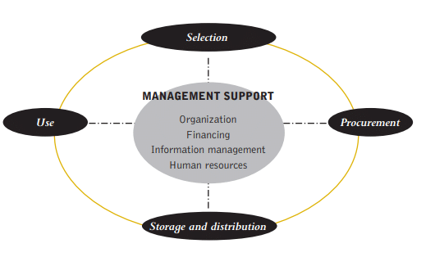

Figure 2.1: policy and legal frame work
Source: http://apps.who.int/medicinedocs/document/s19604en/s19604en.pdf

The selection of drugs for use at health services is usually determined at the national level by the Ministry of Health and is based on a number of factors. After determination of the quantities required, based on price, delivery conditions and quality, the selected drugs go through a procurement process. After storage and distribution, the use of the drugs requires prescribing, packaging, dispensing and counseling. These tasks require qualified health workers or other relevant personnel with appropriate skills and attitudes. Management support tools are important for the acquisition of relevant skills in drug management. Drug management functions are undertaken in four principal phases, which are interlinked and are reinforced by appropriate management support systems (i.e. tools). The following diagram (Diagram 1) illustrates the drug management cycle. From drug selection to drug use, passing through procurement, storage and distribution, a whole range of management capacities are required and necessitate using the appropriate tools within a given legal and policy framework.
2.2.3 FUNCTIONS OF THE DRUG VERIFICATION
Functions of drug verification includes:
- Regulate and control the importation, exportation, manufacture, advertisement, distribution, sale and use of drugs, cosmetics, medical devices, bottled water and chemicals.
- ii. Conduct appropriate tests and ensure compliance with standard specifications designated and approved by the council for the effective control of quality of food, drugs, cosmetics, medical devices, bottled water, and chemicals.
- iii. Undertake appropriate investigation into the production premises and raw materials for food, drugs, cosmetics, medical devices, bottled water and chemicals and establish a relevant quality assurance system, including certification of the production sites and of the regulated products.
- iv. Undertake inspection of imported foods, drugs, cosmetics, medical devices, bottled water, and chemicals and establish a relevant quality assurance system, including certification of the production sites and of the regulated products
- Compile standard specifications, regulations, and guidelines for the production, importation, exportation, sale and distribution of food, drugs, cosmetics, medical devices, bottled water, and chemicals
- vi. Undertake the registration of food, drugs, medical devices, bottled water and chemicals
- vii. Control the exportation and issue quality certification of food, drugs, medical devices, bottled water and chemicals intended for export
- viii. Establish and maintain relevant laboratories or other institutions in strategic areas of Nigeria as may be necessary for the performance of its functions.
2.2.4 DRUG CONTROL
This strives to ensure that medical products containing controlled drugs are available for patients and that the control regime prevents the diversion of these controlled drugs into illegal channels.
Drug control sets standards for drugs control and assists national competent authorities in regulating and monitoring all transactions and activities involving controlled substances. It facilitates the daily management of licit movements, production, distribution and consumption as well as International trade in all controlled substances in both raw material forms as well as in the form of pharmaceutical preparations.

CHAPTER THREE
METHODOLOGY AND ANALYSIS OF THE EXISTING SYSTEM

3.1 RESEARCH METHOD
Recursion is a method where the solution to a problem depends on solutions to smaller instances of the same problem (as opposed to iteration). This approach can be applied to many types of problems.
METHODS OF DATA ANALYSIS
A recursive function definition has one or more base cases, meaning input(s) for which the function produces a result trivially (without recurring). A recursion is a special class of object that can be defined by two properties:
- Base case
- ii. Special rule to determine all other cases
After the collection of data, the researcher started collating for analysis. Analysis of data was based on recursive algorithm.
Formula used;
k! = 1 and, for all n > k, n! = n (n - 1)!
In this formula, 'k' stands for the total number of students occupying a seat while 'n' stands for the total number of students occupying each role. In this case 'k' is the base case while 'n' is the special rule that determines all other cases.

3.2 ANALYZING OF THE EXISTING SYSTEM
The existing system is manual system, which deals with the entering of drugs into a paper, be it adding of new stock detail, updating of drug record or better still manipulating of drugs record in the database. Starting from the bringing of drug into the stock, the detail of the stock is been added into the record book with the supplier of the drug and the quantity supply. Then when the stock is to be updated, the record of such drug would be search from where it was recorded and then updated, so also when some manipulation is to be made on the drugs in the database, these manipulations would be done manually. In clinical trials, the need to link patients to treatment kits makes automated inventory management a natural extension of automated randomization. Drug inventory management systems are based on a series of rules and thresholds developed with our clients. The systems use the same centralized database as their randomization counterparts. This prevents human error from compromising the ordering, assignment, and distribution of supplies, and provides opportunities for cost-savings.
3.3 PROBLEM OF THE EXISTING SYSTEM
The problem of the system is related to the problems related to the manual ways of doing things such problem could be either,
- Time consumption during the processes of adding or performing some manipulation on drugs in the stock.
- The manual system is stressful because the existing system is error prone when performing some manipulation of the drugs in the store.
- Inefficient of data when carrying out some manipulation of the drugs.
- Printing out of ordered turn over list can't be made possible
- Manual process proceed some problem which arise through the manual system, the manual system is record manipulation is very tedious
- Making turn over list of drugs a tedious manipulation to perform.
- Time Consuming: The current procedure makes the registration process to be every slow due to stages involves in processing quality to be issued from the department handling verification of product.
- Inefficiency: Many errors being make reduce efficiency of the material methods.
- Difficulty in enquiry: Making enquiry in the department is always based on the manual processing by consulting the department involver in each enquiry to be made.
- High Labor Requirement: Enough labors are requested due to stages involved in getting product to be registered, Organizing information for data entry, Decide on product classification, e.t.c
- Security Lapses: The record of companies and drug are not safe as the manual method is still in use
3.4 DESCRIPTION OF THE PROPOSED SYSTEM
This entails undertaking preparatory work to meet prerequisites, organizing working procedures, establishing information formats, securing resources
To create a standard National Agency for Food and Drug administration and control (NAFDAC) online drug registration and verification solution. In a computerized system it is very easy to retrieve and review decisions previously made on a similar drug item. This ensures that technical decisions are made with a proper degree of consistency and transparency. The ease of retrieval and access to a great variety of up to date reports reduces the likelihood of inappropriate duplications, and permits a global view of the drugs already authorized. A computerized system can also track any application process, allowing the regulatory authority to determine the status of an application at any given time, and raise alarms when the process is delayed beyond user-defined limits.
3.5 ADVANTAGES OF PROPOSED SYSTEM
i. To order for drugs without mistake of procuring more than required: This is very essential since all drug as validity date of expiry. This helps store not to obtain drugs more than required to avoid expired product been sold out
ii. To take good stock of drugs: This will enhance good stock keeping which will reduce drug abuse knowing what has been sold out compare to the rampant use of drugs by youth
iii. To prevent dispensary of expired drugs: This will avoid the distribution of expired drugs
iv. To ensure accurate keeping of records of drugs: To help validate the information of drugs in the store.
v. To regulate and control the importation, exportation, manufacture, advertisement, distribution, sale and use of drugs, cosmetics, medical devices, packaged water and chemicals.
vi. To conduct appropriate tests and ensure compliance with standard specifications designated and approved by the council for the effective control of quality of food, drugs, cosmetics, medical devices, packaged water, and chemicals.
vii. To undertake appropriate investigation into the production premises and raw materials for food, drugs, cosmetics, medical devices, bottled water and chemicals and establish a Relevant quality assurance system, including certification of the production sites and of the regulated products.

CHAPTER FOUR
DESIGN AND IMPLEMENTATION OF THE SYSTEM

4.1 DESIGN OF THE SYSTEM
System design calls for the creativity of the analyst. Therefore, creating an acceptable system design must exclude all prejudice. The design of the system is the approach to work out how best computers together with other resources may be applied to perform data management and retrieval for decision making.

4.1.1 OUTPUT DESIGN

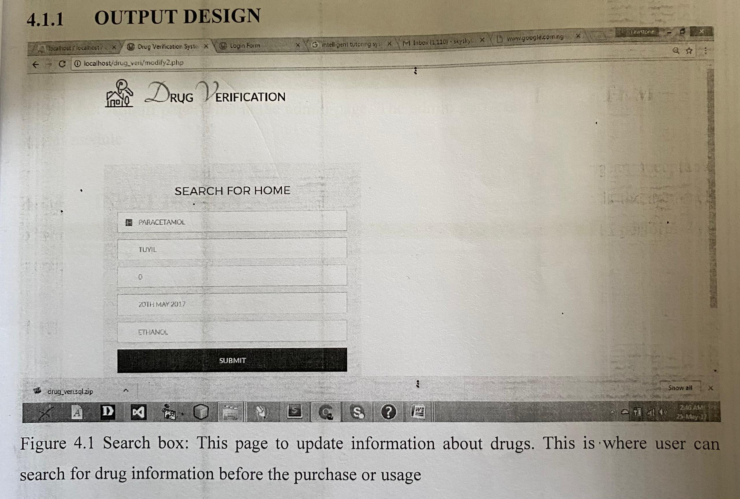

Figure 4.1 search box: this page to update information about drugs. This is where user can search for drug information before the purchase or usage

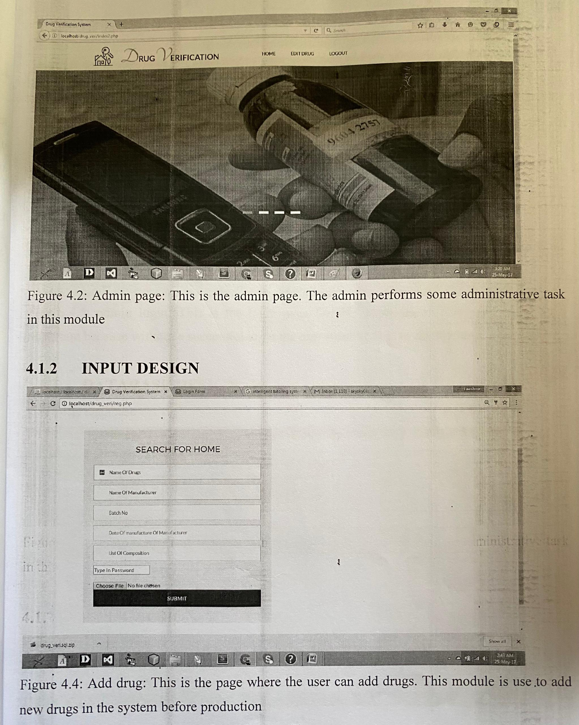

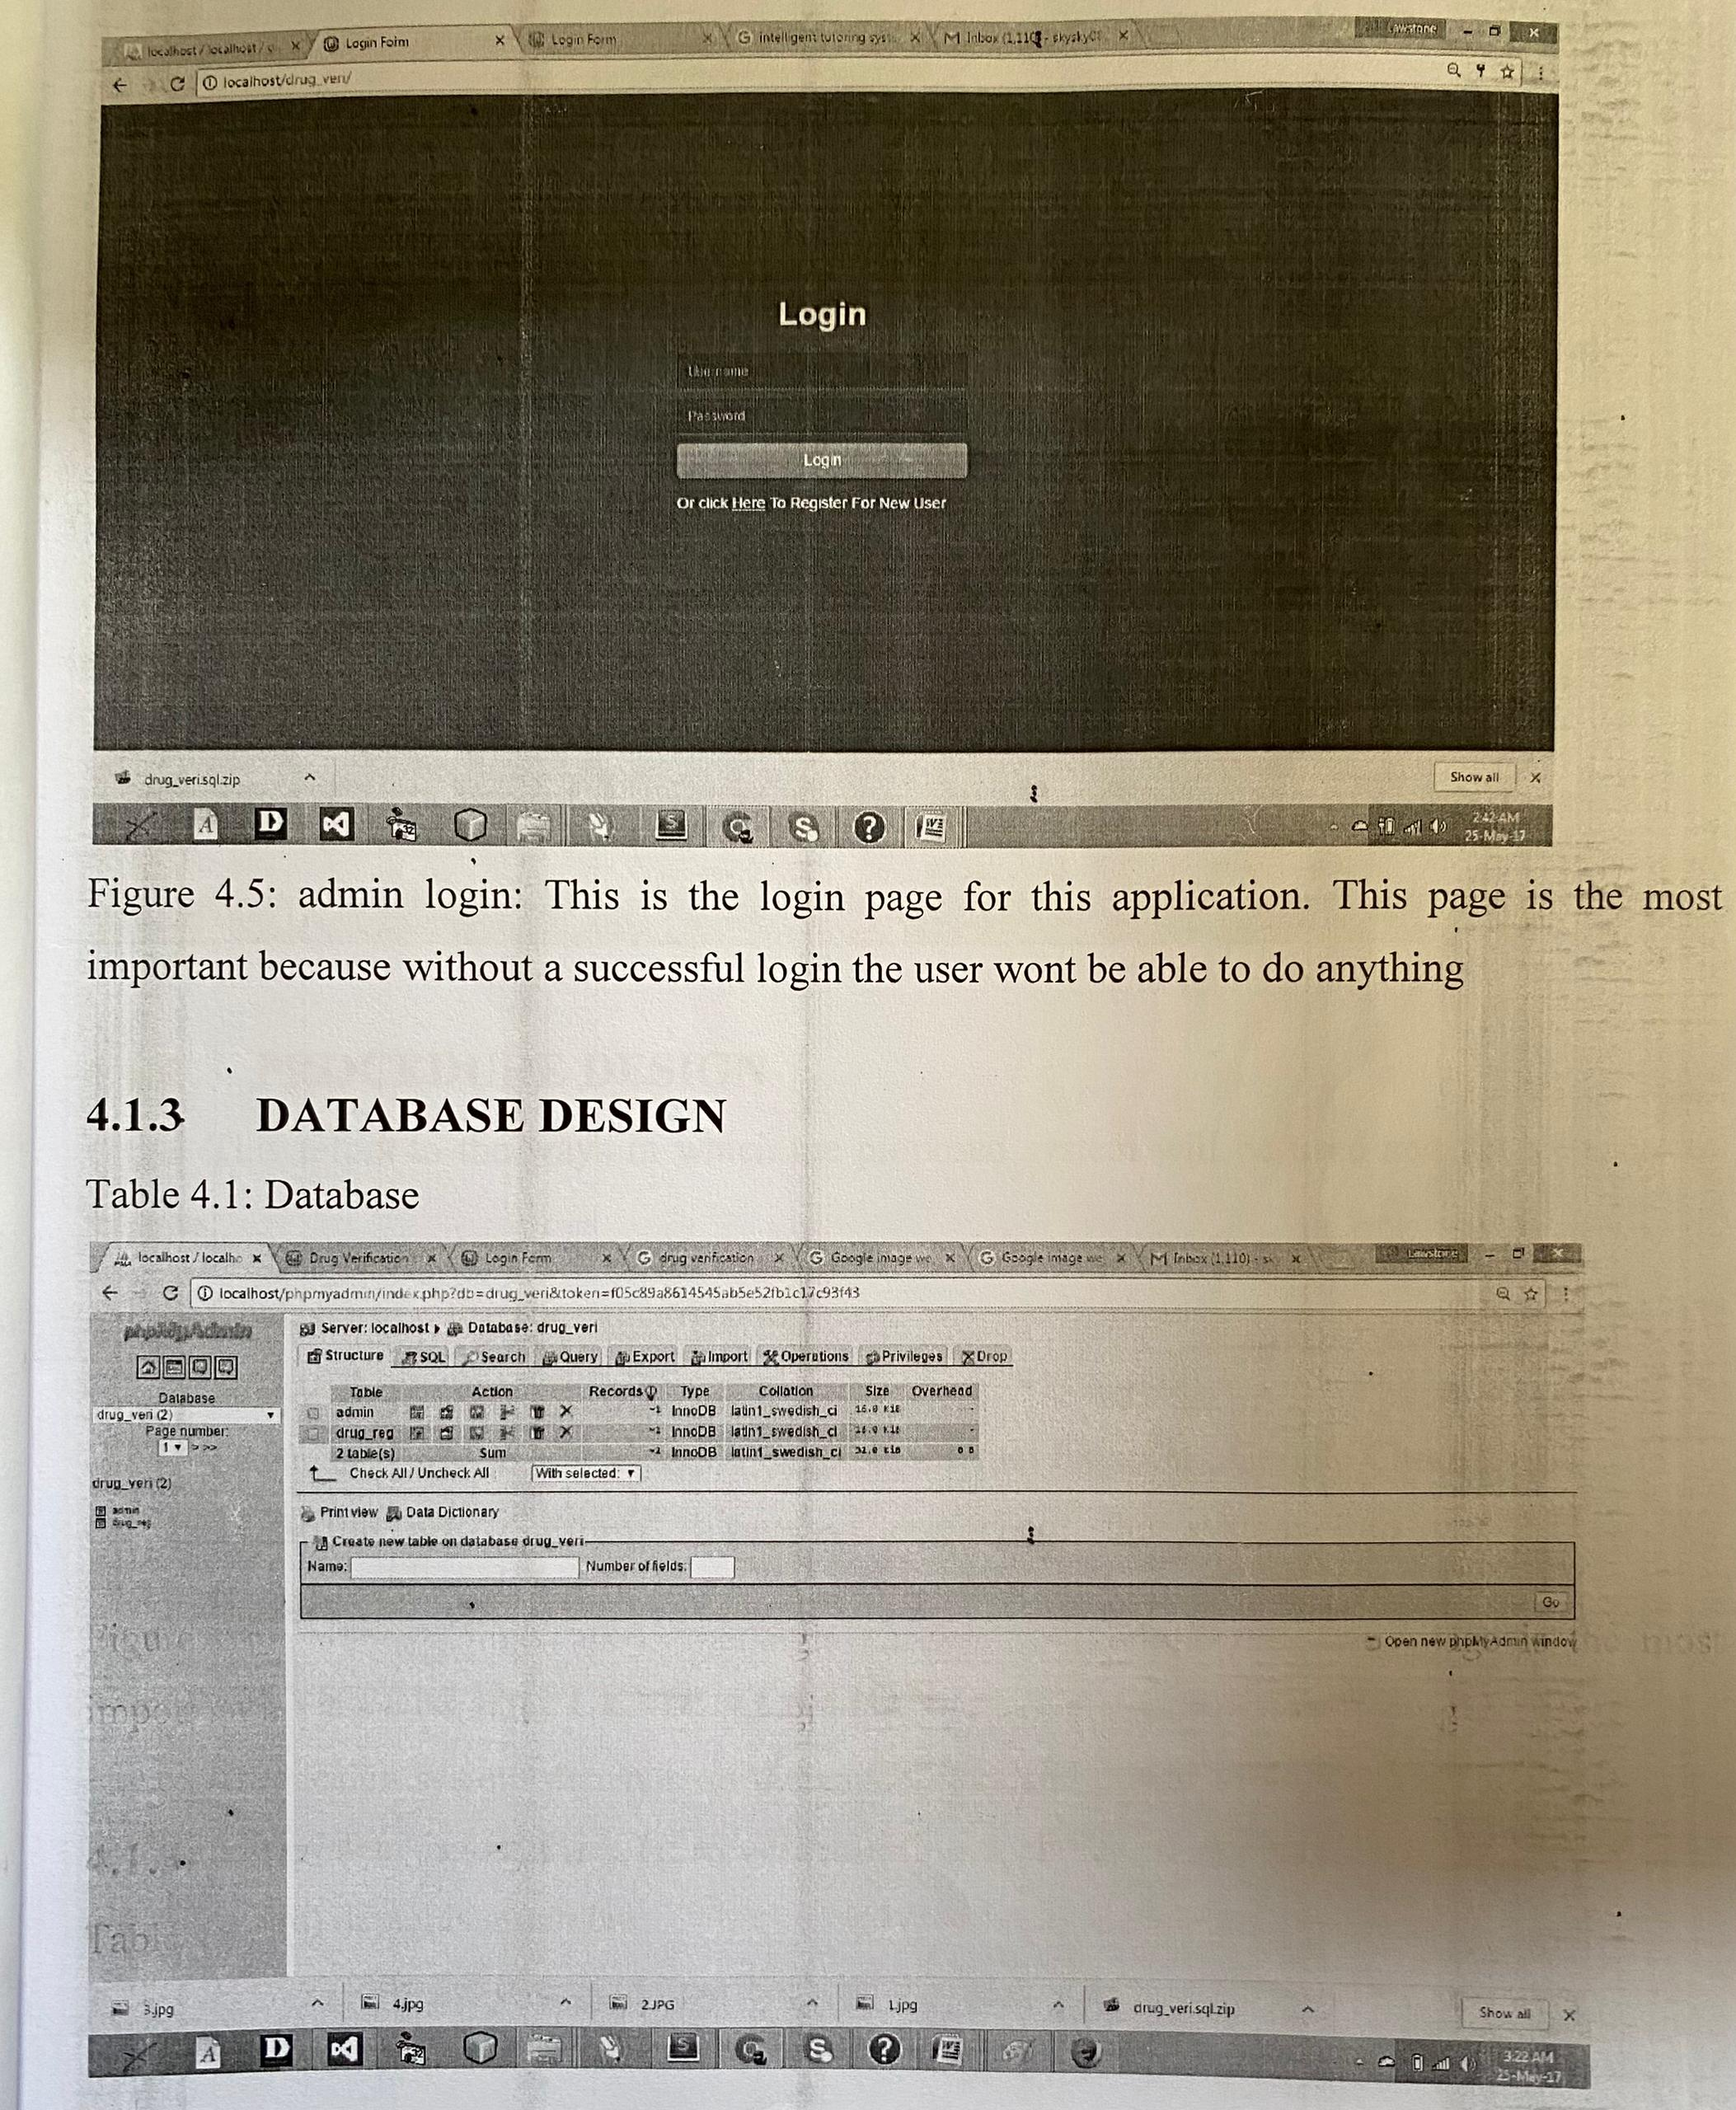

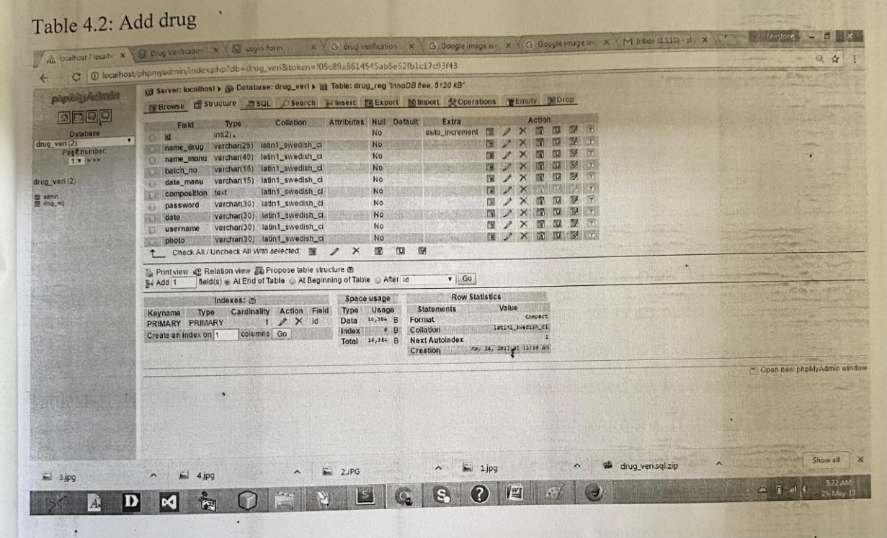

4.1.4 PROCEDURE DESIGN
This refers to the ways in which the proposed system will be used and the steps are as follows:
a) Click start on the computer desktop
b) Select all programs
c) Select any browser e.g Morzilla Firefox, Internet Explorer, Google Chrome e.t.c
d) Type the url (Uniform Resource Locator) of the system into the address bar (localhost/drug_veri/index.php)
4.2 SYSTEM IMPLEMENTATION
The design system depends on the capabilities and power of the computer on which the application system is installed. However, selecting a choice of application support (Hardware and Software) depends much on:
-How readily the user is to interfere with the computer
-Cost and benefit
Managements support for changes Hence, choosing the appropriate hardware and software will enhance the performance of the system. A most important requirement on which the running of the program basically depends on is the provision of internet facility. So any system that must run this program must be internet ready.
4.2.1 CHOICE OF PROGRAMMING LANGUAGE The programming language used in the proposed system is php. PHP meaning (PHP Hypertext Preprocessor) is a server-side programming language. It is an open source server-side scripting language that has taken web-based development to a new level of sophistication. The PHP scripting engine is well optimized for the response times needed on web applications, it can even be part of the web server itself improving the throughput even more. If it were only a matter of improving the speed of the scripts, then PHP will be one of many solutions. But there is more to the PHP equation than that. There is the simplicity and robustness of the language and the scripting engine. There is the connectivity to an ever increasing number of database servers, the shorter development cycles and the ease (encouraged by the syntaxes and constructs) of creating modular and reusable components.
4.2.2 HARDWARE SUPPORT
The hardware requirements for the support of the online inventory application are as follows:
- An enhanced keyboard and mouse
- Minimum of PIII computer and internet enabled
- A processor speed of 500MHz
- RAM size is 18mb
- hard disk size is 100mb
- UPS v
- VGA or SVGA colored monitor to be able to achieve the effective user friendliness of the program viii. A printer for hard copy record production.

4.2.3 IMPLEMENTATION TECHNIQUES
Phased: The new system is tried out on a small scale to see if it works. For example a supermarket might introduce a new stock control system at just its Bury branch. At the other branches the old system remains in use. When the supermarket is happy the new system works the old system will be gradually replaced at its other stores with the new system. Any problems that occur would only affect the store(s) that the new system was being tried at.

4.2.4 SYSTEM DOCUMENTATION
The software required are basically any web browser (internet explorer, Firefox and the likes), WampServer and a network service, be it wired or wireless.
- A network operating system windows NT from Microsoft, Novell Netware.
- A DBMS either PhpMyAdmin
- MySQL as the query language to query the database.
- WampServer

4.3 PROGRAM DOCUMENTATION
It has to do with the installation and usage of the new system.
After the program has been well tested with input that the output has already been known, the next is to install the software into the computer system for use.
The process of installing are been stated below
- Insert the CD into the system through the CD-ROM after the computer is switch on
- Locate the CD drive directory in my computer and click it to open
- After open, locate setup.exe, and then click to install the program by following the necessary step in installing the program.
- Ensure full installing of the software for effective operation of the system. After the program has been fully install. The next thing is to locate the package install to put it into operation, to locate the package for expiration purpose the following step are to be taking
- Click on start menu from task bar. Then select all program

From the display sub option, select by loading the software installed named ‘temperament’ personality check to load the software.
4.3.2 OPERATING THE SYSTEM
i. HOME
ii. ADMIN LOGIN
iii. USER LOGIN
iv. SEARCH
v. TRACK
vi. LIST
vii. REGISTER
4.3.3MAINTAINING OF THE SYSTEM
This refers to the changes that have to be made to complete systems after having been delivered. This project takes care of two types of maintenance these are:
- Adaptive Maintenance: This refers to the type of maintenance which will be done to the system to make it adjust to any changes occurring to it. An example of adaptive maintenance is the yearly updating of the customers database to change account code in database.
- Corrective Maintenance: This is a type of maintenance which takes care of some parts of the system which have been omitted in the initial design. The need for this arises as the system is being put into use over a period of time.

CHAPTER FIVE
CONCLUSION AND RECOMMENDATION

5.1 CONCLUSION

With the majority of the world’s population seeking required medications for various illnesses and medical conditions day-in-day-out, there is a need for appropriate pharmaceutical drugs. The agencies responsible for regulating and approving these pharmaceutical drugs are doing their best to provide the general population with at least a yearly update of all approved drugs approved for various distributions at local drug stores, hospital pharmacies, private pharmacies and licensed chemical shops. However, due to challenging factors such as cost of production, middlemen distribution, research and legal issues, accessibility and reliable source of sale, there have been more issues arising from the illegal and unregistered pharmaceutical drugs. There is also no guarantee of an individual seeking medical help through the use of prescription drugs. Records gained after each annual registration will be made available and it will provide the various stakeholders with information regarding pharmaceutical drugs allowed for regulation on the local drug markets and also the manufacturers responsible for each drug distribution.
5.2 RECOMMENDATION
During the real life operation of the new system, the following change over procedures are recommended during implementation. The training must be supervised by the system designer and presentation of the new system must be carried out. The old and the new system should be run completely and concurrently using of some input from the old system until the new system proves to be satisfactory by the coordinating committee.

REFERENCE

Adam M (2012), "Guide to Inspection of Computerised Systems (The Blue Book)". US Food and Drug Administration, Maryland, USA.
Agalloco, J. (2013). "Validation: an unconventional review and reinvention". Validation: an unconventional review and reinvention". Validation: an
Degna, M. (2014). "Taming the Regulatory Beast: Regulation vs Functionalism". Pharmaceutical Technology Europe. 17 (3): 55-58.
Gillian, J. (2009), "An investigation of the Therac-25 accidents", Computer, vol. 26, no. 7, pp. 18-41.
Gostin, L., (2015), "Computer system validation: An overview of official requirements and standards", Pharmaceutica Acta Helvetiae, vol. 72, no. 6, pp. 317-325.
Hennig, Q. (2012) A Constraint Programming Approach to the Multi-Stage Batch Scheduling Problem, Foundations of Computer-Aided Operations (FOCAPO)
Herrmann, G. (2013) Jeffrey W., editor, 2006, Handbook of Production Scheduling, Springer, New York.
Koulouris, A (2013), "Efficient Short-Term Scheduling of Refinery Operation Based on a Continuous Time Formulation", Foundations of Computer-Aided Operations (FOCAPO)
Lustig, I. (2015) Progress in Linear and Integer Programming and Emergence of Constraint Programming, Foundations of Computer-Aided Operations (FOCAPO)
Marcus V. (2012), "Crude Oil Scheduling," Foundations of Computer-Aided Operations (FOCAPO)
Méndez, J. (2015) Cerdá, I. Grossmann, I. Harjunkoski, M. Fahl, State of the art Review of Optimization Methods for Short Term Scheduling of Batch Processes, Computers and Chemical Engineering. 30 (2006), pp 913-946
Michael, L. (2014) "Optimize Manufacturing of Pharmaceutical Products with Process Simulation and Production Scheduling Tools," Chemical Engineering Research and Design (IChemE publication)
Pinedo, T. (2013) Scheduling Theory, Algorithms, and Systems, Prentice Hall.
Rose, I. (2013). "Testing Times in Computer Validation". Journal of Validation Technology. 9 (2): 153-161.
Siiemi, C (2013) "Design and Optimization of a Large Scale Biopharmaceutical Facility using Process Simulation and Scheduling Tools," Pharmaceutical Engineering
Smith H (2012), "Guidelines on General Principles of Process Validation".
Smith, F. G (2013) Process control, Perry's Chemical Engineer's Handbook, R. Perry and D. W. Green eds.,McGraw
Stevenson, H. (2014), "Considerations for Improving Software Validation, Securing better assurance for less cost". Journal of Validation Technology. 7 (2): 150-157.
Tracy, D (2012). "A Validation Approach for Laboratory Information Management Systems". Journal of Validation Technology. 9 (1): 6-14.
Weglarz, A. (2014) Scheduling Computer and Manufacturing Processes, Berlin (Springer)
Weichel, P. (2010). "Survey of Published FDA Warning Letters with Comment on Part 11 (21 CFR Part 11)". Journal of Validation Technology. 11 (1): 62-66.

