
KWARA STATE POLYTECHNIC, ILORIN
INSTITUTE OF APPLIED SCIENCES

PHYTOCHEMICALS AND MINERAL COMPOSITION OF Sida acuta LEAF EXTRACT
BY
AKINDELE PRECIOUS TENIOLA
HND/23/SLT/FT/0441

A Research Project Submitted to the Department Science Laboratory Technology, Faculty of Pure and Applied Sciences, Kwara State Polytechnic, Ilorin.
In partial fulfillment of the Requirements for the Award of Higher national Diploma (HND) in Science Laboratory Technology (Biochemistry).

JULY, 2025



DECLARATION
I hereby declare that this research project titled ‘Phytochemicals and Mineral
Composition of Sida acuta Leaf Extract’ is my work and has not been submitted by any other person for any degree or qualification at any higher institution. I also declare that the information provided therein are mine and those that are not mine are properly acknowledged.

__________________ ________________
Name of Student Signature and Date

DEDICATION
I dedicate this project to God Almighty my creator, my sustainer, my source of inspiration, wisdom, knowledge and understanding. He has been the source of our strength throughout this program and on His wings only have I soared.

ACKNOWLEDGMENTS
My deepest gratitude goes to Almighty God, who provided all that was needed to complete this project and the academic program for which it was undertaken. I will like to sincerely appreciate my project supervisor, Dr. (Mrs.) I. R. Hassan, for her invaluable guidance, dedication, and support, which greatly contributed to the successful completion of this research work.

TABLE OF CONTENT

DECLARATION ......................................................................................................ii
CERTIFICATION ...................................................................................................iii
DEDICATION ......................................................................................................vi
ACKNOWLEDGMENTS ....................................................................................... v
TABLE OF CONTENT ........................................................................................... viABSTRACT ............................................................................................................. ix
CHAPTER ONE ......................................................................................................1
1.0 INTRODUCTION ............................................................................................. 1
1.1 Background of study .......................................................................................... 2
1.2 Statement of the problem .................................................................................. 6
1.3 Justification of the study .................................................................................... 6
1.4 Aim and objectives of the study......................................................................... 7
CHAPTER TWO ..................................................................................................... 8
2.0 LITERATURE REVIEW .................................................................................. 8
2.1 Previous studies on Sida acuta ......................................................................... 8
2.2 Phytochemicals ................................................................................................11
2.2.1 Phenols .........................................................................................................13
2.2.2 Saponins .......................................................................................................16
2.2.3 Tannins ..........................................................................................................18
2.2.4 Alkaloids .......................................................................................................19
2.2.5 Flavonoids .....................................................................................................21
2.2.6 Steroids ..........................................................................................................24
2.2.7 Triterpenoids ................................................................................................26
2.2.8 Glycosides .....................................................................................................28
2.2.9 Medical significance of phytochemicals .......................................................29
2.3.0 Minerals ........................................................................................................32
2.3.1 Importance of minerals in human health ......................................................36
2.3.2 Techniques used in phytochemical and mineral analysis .............................39 CHAPTER THREE................................................................................................48
3.0 MATERIALS AND METHODS .....................................................................48
3.1 Materials ...........................................................................................................48
3.1.1 Plant material ................................................................................................48
3.1.2 Chemicals and reagents .................................................................................48
3.2 Methods ............................................................................................................48
3.2.1 Preparation of plant extract ...........................................................................48
3.2.2 Qualitative and quantitative phytochemicals ................................................48
3.2.2.1 Determination of phenols ...........................................................................48
3.2.2.2 Determination of saponins .........................................................................49
3.2.2.3 Determination of tannins............................................................................49
3.2.2.4 Determination of alkanoids ........................................................................49
3.2.2.5 Determination of flavonoids ......................................................................50
3.2.2.6 Determination of steriods ...........................................................................50
3.2.2.6 Determination of triterpenoids ...................................................................50
3.2.2.7 Determination of glucosides ......................................................................51
3.2.3 Determination of mineral content .................................................................51
3.2.3.1 Determination of mineral content using AAS ...........................................51 CHAPTER FOUR .................................................................................................56
4.0 RESULTS ........................................................................................................56
4.1 Phytochemical profile of Sida acuta ................................................................56
4.1.1 Detected phytochemicals and their significance ...........................................57
4.1.2 Absent phytochemicals and their implications .............................................58 4.3 Mineral contents of Sida acuta ........................................................................58 CHAPTER FIVE ....................................................................................................60
5.0 DISCUSSION ..................................................................................................60
5.1 Conclusion ........................................................................................................62
5.2 Recommendations ............................................................................................63
References ..............................................................................................................65

ABSTRACT
Sida acuta, a traditionally significant medicinal plant commonly known as “stubborn grass,” has long been used in various cultures for treating ailments such as malaria, fever, inflammation, wounds, and infections. This study investigates the phytochemical and mineral composition of Sida acuta to scientifically validate its ethnomedicinal uses and explore its potential in modern therapeutics. Qualitative and quantitative analyses revealed the presence of several bioactive compounds including alkaloids, flavonoids, tannins, saponins, phenols, steroids, triterpenoids, and glycosides. These phytochemicals exhibited potential antioxidant, antiinflammatory, antimicrobial, and antidiabetic properties. Furthermore, mineral analysis indicated significant levels of calcium, potassium, iron, sodium, magnesium, phosphorus, and trace elements like copper and aluminum. The rich presence of these bioactive constituents supports the pharmacological and nutritional relevance of Sida acuta, highlighting its potential as a source for natural drug development and nutraceutical applications. The findings underscore the need for further pharmacological and toxicological evaluations to enhance its utilization in healthcare and pharmaceutical industries.

CHAPTER ONE

1.0 INTRODUCTION
Plants have been integral to human survival for millennia, serving as sources of food, shelter, and medicine. Among their most significant contributions is their role in traditional and modern medicine, where they provide an abundance of natural compounds used in the prevention, management, and treatment of a wide range of diseases. Medicinal plants are particularly valued for their therapeutic potential, and this significance is underscored by the fact that approximately 50% of all clinically approved chemotherapeutic drugs are derived either directly or indirectly from plantbased sources (Murray, 2021). Globally, medicinal plants are distributed across various geographical regions, but tropical regions are especially rich in plant biodiversity. These areas harbor thousands of plant species, many of which possess pharmacologically active compounds that have been harnessed in traditional medicine practices for centuries (Calixto, 2020). Indeed, since the earliest days of human civilization, plant-based remedies have been employed to alleviate ailments and promote overall well-being, forming the backbone of indigenous medical knowledge (Hassan et al., 2022). Over time, this wealth of empirical knowledge has attracted scientific scrutiny, leading to the identification, isolation, and development of several bioactive compounds that now serve as lead molecules in drug discovery (Lamidi et al., 2019).
One area of increasing scientific interest is the study of phytochemicals— naturally occurring bioactive compounds in plants. These compounds are known to play key roles in the defense mechanisms of plants, and many exhibit antioxidant, anti-inflammatory, antimicrobial, and anticarcinogenic properties. In addition to phytochemicals, plants are also a source of essential minerals and micronutrients vital to human nutrition and health. Consequently, investigating the phytochemical and mineral composition of medicinal plants provides valuable insights into their therapeutic potentials, mechanisms of action, and possible applications in both traditional and modern healthcare systems (Srinivasan and Murali, 2022).
This study focuses on one such plant of ethnomedicinal significance, Sida acuta. Despite its widespread traditional use, especially in Nigeria and other parts of Africa and Central America, detailed scientific analyses of its phytochemical and mineral profile remain limited. This research, therefore, seeks to bridge that gap by providing a comprehensive evaluation of the phytochemical and mineral constituents of Sida acuta, thereby contributing to the growing body of scientific evidence supporting its medicinal value.

1.1 BACKGROUND OF STUDY
Sida acuta, commonly known as “stubborn grass,” is a fast-growing herbaceous plant that belongs to the Malvaceae family. It is widely distributed in tropical and subtropical regions and grows well in a variety of soil types, although it tends to avoid seasonally flooded soils or those derived from limestone. In Nigeria, it is referred to by different names in various local languages: “Isekotu” in Yoruba, “Udo” in Igbo, and “Kalkashin kwado” in Hausa (Murray, 2021). Its adaptability, wide distribution, and multifaceted uses make it a plant of interest in both ethnobotanical and pharmacological studies. Traditional healers and local communities have long used different parts of Sida acuta—including the leaves, roots, bark, and flowers—to treat a wide range of ailments. These include common illnesses such as fever, malaria, colds, ulcers, and headaches, as well as more severe conditions like gonorrhea, inflammation, and even breast cancer (Kayode et al., 2019). Beyond human medicine, the plant is also utilized in animal husbandry as livestock feed and in first aid treatments, particularly for wounds and bleeding.
The medicinal properties of Sida acuta are believed to be due to its rich phytochemical composition. Research has shown that the plant contains numerous bioactive compounds, including alkaloids, flavonoids, terpenoids, tannins, steroids, cardiac glycosides, and essential oils (Adeniyi et al., 2010). These compounds contribute to the plant’s antimicrobial, anti-inflammatory, and antioxidant activities. For instance, flavonoids are known to act as antioxidants, neutralizing harmful free radicals in the body. Alkaloids have demonstrated a wide range of pharmacological effects including analgesic and antibacterial actions, while tannins and saponins exhibit antimicrobial and astringent properties (Okigbo and Igwe, 2017).
In addition to phytochemicals, Sida acuta is also a source of vital minerals and vitamins. The leaves are reported to contain micronutrients such as vitamin C (ascorbic acid), thiamine, niacin, riboflavin, and β-carotene, all of which play crucial roles in boosting immunity, supporting metabolism, and maintaining overall health. Mineral elements such as calcium, phosphorus, iron, magnesium, and sodium are also present in significant quantities and contribute to functions ranging from bone formation to enzymatic activity and muscle contraction (Raimi et al., 2014). Experimental studies support the pharmacological potential of Sida acuta. For example, phytochemical screenings have indicated that the plant may induce quinine reductase activity and inhibit the formation of precancerous lesions, especially in mammary tissue, as demonstrated in mouse models (Jang et al., 2003). Alkaloids derived from Sida acuta have been particularly noted for their promise in pharmaceutical research, while flavonoids, though found in trace amounts (Ekpo and Etim, 2009), contribute synergistically to the plant’s healing properties. The plant's therapeutic potency has been attributed to the complex interactions between its diverse bioactive constituents (Karou et al., 2007). Furthermore, Ekor et al. (2010) reported that the juice extracted from the leaves of Sida acuta has anthelmintic properties and is used to treat intestinal worm infections.
The traditional application of Sida acuta extends beyond Nigerian borders. In Central America and other regions, it is used to manage asthma, urinary disorders, liver diseases, nervous system conditions, blood-related ailments, and biliary diseases (Mohideen et al., 2002). In Nigeria, local populations continue to chew the leaves as a folk remedy for gonorrhea and other infections. Despite its wide ethnomedicinal use, scientific studies analyzing the specific phytochemical and mineral constituents of this plant remain sparse. Therefore, a comprehensive evaluation of the phytochemical and mineral composition of Sida acuta is not only timely but also essential. Such studies are pivotal for validating traditional medical claims, identifying potential therapeutic compounds, and providing foundational data for further pharmacological investigations. By understanding the chemical and nutritional profile of Sida acuta, researchers and healthcare professionals can better appreciate its role in traditional medicine and explore its potential for incorporation into modern therapeutic applications (Ezeabara and Egenti, 2018).
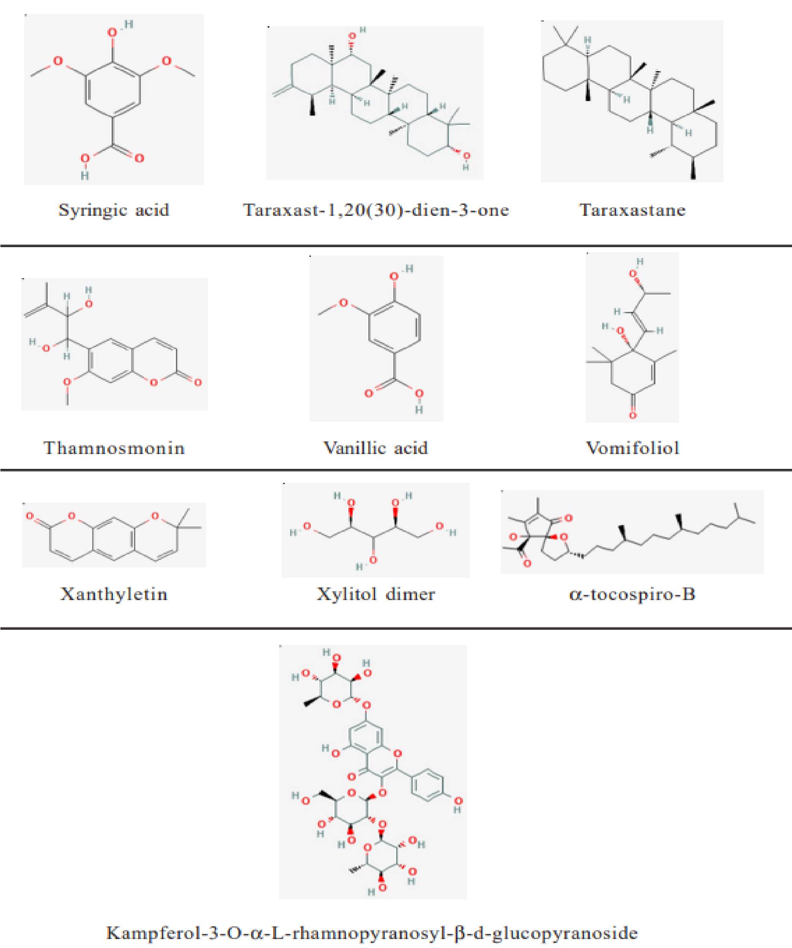
Figure 1.1: Chemical structures of the phytoconstituents isolated from Sida acuta (Srinivasan and Murali, 2022).

1.2 STATEMENT OF THE PROBLEM
Despite the long-standing use of Sida acuta in traditional medicine for the treatment of various ailments such as malaria, fever, wounds, infections, and inflammatory diseases, there is a noticeable gap in scientific literature regarding its comprehensive phytochemical and mineral composition. While anecdotal evidence and preliminary studies suggest that Sida acuta contains a variety of bioactive compounds and essential nutrients, many of these claims remain largely unverified or insufficiently documented using standard scientific protocols. Moreover, most existing studies focus primarily on the ethnomedicinal uses of the plant without delving deeply into the specific phytoconstituents responsible for its therapeutic effects. The absence of detailed data on its mineral profile also limits the ability to understand its nutritional and pharmacological value. This lack of comprehensive information hampers the potential of Sida acuta to be developed further for pharmaceutical or nutraceutical applications. Therefore, there is a critical need to scientifically investigate and validate the phytochemical and mineral constituents of this widely used medicinal plant.

1.3 JUSTIFICATION OF THE STUDY
The increasing global interest in plant-based therapies, coupled with the rising cost and side effects of synthetic drugs, has led to a renewed focus on medicinal plants as alternative sources of treatment. In regions like Africa, where access to modern healthcare may be limited, traditional medicine remains the primary form of treatment for a large portion of the population. Sida acuta, being widely available and culturally accepted, represents a valuable resource for affordable and accessible healthcare solutions.
This study is justified by the urgent need to substantiate traditional claims about the medicinal efficacy of Sida acuta through scientific analysis. By identifying and quantifying the phytochemicals and mineral elements present in the plant, this research will provide a foundation for understanding the mechanisms behind its medicinal actions. Furthermore, the findings could contribute to drug discovery, nutritional supplementation, and the broader field of natural product research. Additionally, the study has the potential to promote the sustainable use and conservation of Sida acuta, especially if its therapeutic and nutritional value can be clearly demonstrated. The documentation of its phytochemical and mineral composition may also inspire further research into its pharmacological properties and pave the way for its incorporation into formal healthcare systems.

1.4 AIM AND OBJECTIVES OF THE STUDY
To determine the phytochemical and mineral composition of Sida acuta, with the goal of evaluating its potential as a therapeutic and nutritional resource.

Specific Objectives
- to conduct a qualitative phytochemical screening of Sida acuta leaves to identify the major bioactive compounds present.
- to perform quantitative analysis of selected phytochemicals (e.g., flavonoids, alkaloids, tannins, saponins, etc.) in the plant extract.
- to determine the concentration of essential minerals (such as calcium, iron, magnesium, sodium and phosphorus) in the leaves of Sida acuta using AAS
- to analyze and interpret the potential health benefits and therapeutic implications of the identified phytochemicals and minerals.
- to compare the findings with existing literature to validate traditional medicinal uses of Sida acuta.

CHAPTER TWO

2.0 LITERATURE REVIEW

2.1 PREVIOUS STUDIES ON Sida acuta
The important of plants of various types cannot be over emphasized. Since the time immemorial, plant has been taking so important in various approaches. Several plant leaves are delicacy in the preparation of stew in some tribes, which when its number and types is not complete the stew look awkward and unacceptable to them. The belief is that different plant contributes different nutrient to the stew which make it delicious and nutritional. Therefore plenty plants of proven nutritional/ medicinal quality are of important to many pharmaceutical companies manufacturing a wide range of allopathic medicines, due to their phytochemical properties. This has caused increasing consideration of natural drug to an individual and most companies producing most synthetic drug (Shittu and Alagbe, 2020).
Sida acuta (broom weed) is one of the plants with medicinal potential qualities and present in abundance in the tropics. It is drought resistance tropical weeds that are common in almost everywhere. Sida acuta is an erect, branched and perennial shrub with a woody tap root, hairy branded up to 1 m high and is reproduced from their seeds. The stem is woody, rounded and slender, and is fibrous and hairy especially when young. The leaves are simple and alternate while the inflorescence is solitary and axillary with stalks up to 1.3 cm long jointed about half of the length. The flowers are yellow with five petals and the fruit is capsuled with 5-6 carpels (Ekpo and Etim, 2009). Sida acuta is a malvaceous weed that frequently dominates improved pastures, waste and disturbed places roadsides (Mann et al., 2003). The plant is native to Mexico and Central America but has spread throughout the tropics and subtropics. In traditional medicine, the plant is often assumed to treat diseases such as fever, headache, skin diseases, diarrhea, and dysentery. Referring to the traditional knowledge, studies have been carried out to confirm the activities the plant is assumed to exert in vivo. The described pharmacological properties of the plants involve the antiplasmodial, antimicrobial, antioxidant, cytotoxic activities and many other properties. Some studies resulted in the isolation of single compounds while the others just demonstrated the activity of the crude extracts (Simplice et al., 2007).
The bark is smooth, greenish, the root is thin, long, cylindrical and very rough; leaves are lanceolate, the flowers are yellow, solitary or in pairs; seeds are smooth and black. In Indian traditional medicine, the root of Sida acuta is extensively used as a stomachic, diaphoretic and antipyretic. It is regarded as cooling, astringent, tonic and useful in treating nervous and urinary diseases and also disorders of the blood, bile and liver (Khare et al., 2002). It is also used to treat gonorrhoea, elephantiasis and ulcers and is claimed to have aphrodisiac properties. The juice of the root is applied to wound. The whole plant is used to treat snake bite and it lessened the haemorrhagic effect of Bothrops atrox venom (Sreedevi et al., 2009). The ethanol extract of S. acuta whole plant exhibited moderate anti-ulcer activity in ulcer models in rats (Malairajan et al., 2006). The ethanol extract of S. acuta leaf also exhibited antiulcer activity in ulcer models in rats (Akilandeswari et al., 2010). MeOH extract of S. cordifolia aerial parts showed antiulcer activity in aspirin plus ethanol induced ulcer model in rats (Philip et al., 2008). Antiulcer activity of S acuta leaf extract advocates the traditional use of the plant leaf in gastric disorders and ulcers (Dinda et al., 2015).

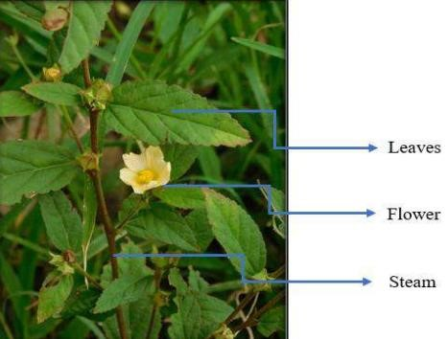
Figure 2.1: Sida acuta Plant with arrow indicating different parts (Tejas et al., 2024)

Table 2.1: Taxonomical Hierarchy

Kingdom | Plantae
Phylum | Anthophyta
Class | Dicotyledonae
Order | Malvales
Family | Malvaceae
Genius | Sida
Species | Sida acuta
Scientific Name Sida acuta Burm f.

Tejas, et al. (2024)

2.2 PHYTOCHEMICALS
Phytochemicals are secondary metabolites of low-molecular weight that occur naturally in plants. These biologically active molecules have evolved in the interaction between the plant and its environment (Watzl and Leitzmann, 2012). Phytochemicals includes a variety of plant ingredients with different structures that are capable of health-promoting effects. Phytonutrients are natural substances but are not called nutrients in the traditional sense, since they are synthesized by plants neither in energy metabolism nor in anabolic or catabolic metabolism, but only in specific cell types. They differ from primary plant compounds in that they are not essential to the plant. Phytonutrients perform important tasks in the secondary metabolism of plants as repellents to pests and sunlight as well as growth regulators. They occur only in low concentrations and usually have a pharmacological effect (Leitzmann, 2016).
Sida acuta Burm. f. (Malvaceae) is a widely distributed medicinal plant found in tropical and subtropical regions. It is traditionally used in various cultures for its therapeutic properties, including antibacterial, anti-inflammatory, antidiabetic, antioxidant, and anti-ulcer activities (Okokon et al., 2018). Studies have identified a variety of bioactive compounds in Sida acuta, including alkaloids, flavonoids, tannins, saponins, terpenoids, and phenolic compounds (Ogunyemi et al., 2019). These secondary metabolites are responsible for its medicinal properties. The presence of flavonoids and polyphenols contributes significantly to its antioxidant activity, which plays a crucial role in neutralizing free radicals (Edeoga et al., 2020). The antimicrobial efficacy of Sida acuta has been widely reported. Studies indicate that extracts from the plant exhibit strong antibacterial properties against Grampositive and Gram-negative bacteria, including Escherichia coli, Staphylococcus aureus, and Pseudomonas aeruginosa (Adegboye et al., 2021). Additionally, antifungal activity has been observed against Candida albicans and Aspergillus niger (Olajide et al., 2019). The anti-inflammatory potential of Sida acuta has been demonstrated in animal models, where ethanolic extracts significantly reduced inflammation and pain. The analgesic effect is attributed to the modulation of pain pathways, possibly through inhibition of cyclooxygenase enzymes (Mbagwu and Okoro, 2017).
Oxidative stress is a major contributor to various diseases, including cancer and cardiovascular disorders. Extracts of Sida acuta have been shown to possess potent antioxidant properties, which help in reducing oxidative damage and protecting cells from lipid peroxidation (Uche et al., 2020). Animal studies have demonstrated that Sida acuta extracts can significantly reduce blood glucose levels in diabetic rats (Akinpelu et al., 2021). The antihyperglycemic activity is thought to be mediated through inhibition of carbohydrate-digesting enzymes and enhancement of insulin sensitivity. The potential of Sida acuta in ulcer treatment has been explored in various experimental models. Research shows that aqueous extracts of the plant exhibit gastroprotective effects by enhancing mucus production and reducing gastric acid secretion (Ezekwesili et al., 2018). These effects make it a promising candidate for ulcer management. Despite its numerous pharmacological benefits, toxicological assessments are necessary to determine the safety of Sida acuta. Some studies report mild hepatotoxicity and nephrotoxicity at high doses, emphasizing the need for controlled usage (Ajayi et al., 2022).

Table 2.2: Phytochemical investigation of Sida acuta leaf
 |  | Solvents
Phytochemical Alcohol  Constituents |  | Water | Chloroform | Petroleum ether
Alkaloids | +
Flavonoids | + | + | + | +
Terpenoids |  |  |  | +
Saponins |  |  | + | +
Phenols | + |  | + | +
Glycosides | + | + | + | +
Tannis | + |  | + | +
Steroids | + |  | + | +
Semwal and Kumar, (2014); Asha, et al. (2018)

2.2.1 PHENOLS
Phenols are a class of aromatic compounds in which a hydroxyl group (-OH) is directly attached to an aromatic benzene ring. This structural feature distinguishes them from alcohols, where the hydroxyl group is bonded to a saturated carbon atom (Solomons, Fryhle, & Snyder, 2016). The presence of the aromatic ring significantly influences the chemical behavior of phenols, making them more acidic than alcohols. This is because the phenoxide ion, formed after deprotonation, is stabilized by resonance within the aromatic system (McMurry, 2018). The acidity of phenols is also affected by substituents on the aromatic ring. Electron-withdrawing groups, such as nitro groups, increase acidity by stabilizing the negative charge on the oxygen atom, while electron-donating groups reduce acidity (Carey & Sundberg, 2007). Phenols readily undergo electrophilic aromatic substitution reactions, such as nitration, sulfonation, and halogenation, due to the activating effect of the hydroxyl group on the ring (Bruice, 2017).
Sida acuta phenols play a crucial role in neutralizing free radicals and reducing oxidative stress, which is linked to chronic diseases such as cancer, cardiovascular disorders, and neurodegenerative conditions (Edeoga et al., 2020). Phenolic compounds exhibit strong radical-scavenging abilities by donating hydrogen atoms to reactive oxygen species (ROS), thereby preventing cellular damage and enhancing the body’s defense mechanisms (Uche et al., 2020). Phenols display significant antimicrobial activity against various bacterial and fungal pathogens. Studies have shown that these compounds inhibit the growth of Escherichia coli, Staphylococcus aureus, and Candida albicans, making them effective agents in combating infectious diseases (Adegboye et al., 2021). The antimicrobial mechanism involves disrupting microbial cell membranes, inhibiting essential enzymes, and interfering with microbial DNA synthesis (Olajide et al., 2019). This highlights the potential of Sida acuta as a natural source for developing antimicrobial drugs.
Phenolic compounds from Sida acuta also exhibit potent anti-inflammatory properties. Chronic inflammation is associated with various diseases, including arthritis, diabetes, and cardiovascular conditions. Phenols modulate inflammatory responses by inhibiting the release of pro-inflammatory cytokines and suppressing key enzymes such as cyclooxygenase (COX) and lipoxygenase (LOX) (Mbagwu and Okoro, 2017). These actions contribute to pain relief and inflammation control, making Sida acuta a promising candidate for anti-inflammatory therapy. They help maintain vascular health by reducing blood pressure, improving endothelial function, and preventing the oxidation of low-density lipoprotein (LDL), which plays a critical role in atherosclerosis (Hagerman and Butler, 2020). The inhibition of platelet aggregation further reduces the risk of thrombosis and other cardiovascular complications, emphasizing the role of Sida acuta in heart disease prevention and management. Recent research also highlights the anticancer properties of Sida acuta phenols. These compounds induce apoptosis, inhibit cancer cell proliferation, and interfere with tumor progression by modulating various signaling pathways (Fraga et al., 2019). The phenolic content of Sida acuta makes it a promising candidate for further studies in cancer prevention and treatment. However, additional research is required to establish the full molecular mechanisms and therapeutic potential of these bioactive molecules. Phenols contribute to gastroprotection by reducing gastric acid secretion, enhancing mucosal defense, and promoting ulcer healing (Ezekwesili et al., 2018). These compounds have demonstrated significant protective effects in experimental models of gastric ulceration, suggesting their potential application in the treatment of gastrointestinal disorders. The overall pharmacological significance of phenols in Sida acuta highlights the need for further studies to optimize their medicinal applications and evaluate their long-term safety and efficacy in clinical settings.
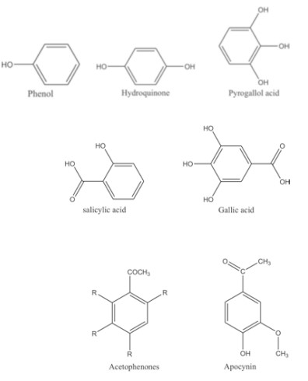
Figure 2.4 Examples of phenolic compounds (Velu et al., 2018)

2.2.2 SAPONINS
Saponins are bioactive glycosides with a characteristic foaming property, widely studied for their medicinal benefits (Ogunyemi et al., 2019). Saponins in Sida acuta are a class of triterpenoid or steroidal glycosides known for their amphiphilic nature (Edeoga et al., 2020). Phytochemical screening has confirmed the presence of these compounds in various parts of the plant, including leaves, stems, and roots (Adegboye et al., 2021). Their structural diversity contributes to various biological activities, including antimicrobial, anti-inflammatory, and antioxidant effects (Olajide et al., 2019). The extraction of saponins from Sida acuta is typically performed using aqueous or alcoholic solvents, with ethanol and methanol being the most effective (Mbagwu and Okoro, 2017). Chromatographic techniques such as High-Performance Liquid Chromatography (HPLC) and Gas ChromatographyMass Spectrometry (GC-MS) have been utilized to characterize these bioactive compounds (Uche et al., 2020). Saponins exhibit significant antibacterial and antifungal properties. Studies have shown that Sida acuta saponins inhibit the growth of Escherichia coli, Staphylococcus aureus, and Candida albicans (Adegboye et al., 2021). Their mode of action involves membrane disruption and inhibition of microbial adhesion.
Saponins in Sida acuta have demonstrated hypoglycemic effects in diabetic models, improving insulin sensitivity and reducing postprandial glucose levels (Akinpelu et al., 2021). Although saponins offer numerous health benefits, their potential toxicity at high concentrations must be considered. Excessive intake has been linked to hemolytic effects and gastrointestinal disturbances (Ajayi et al., 2022).
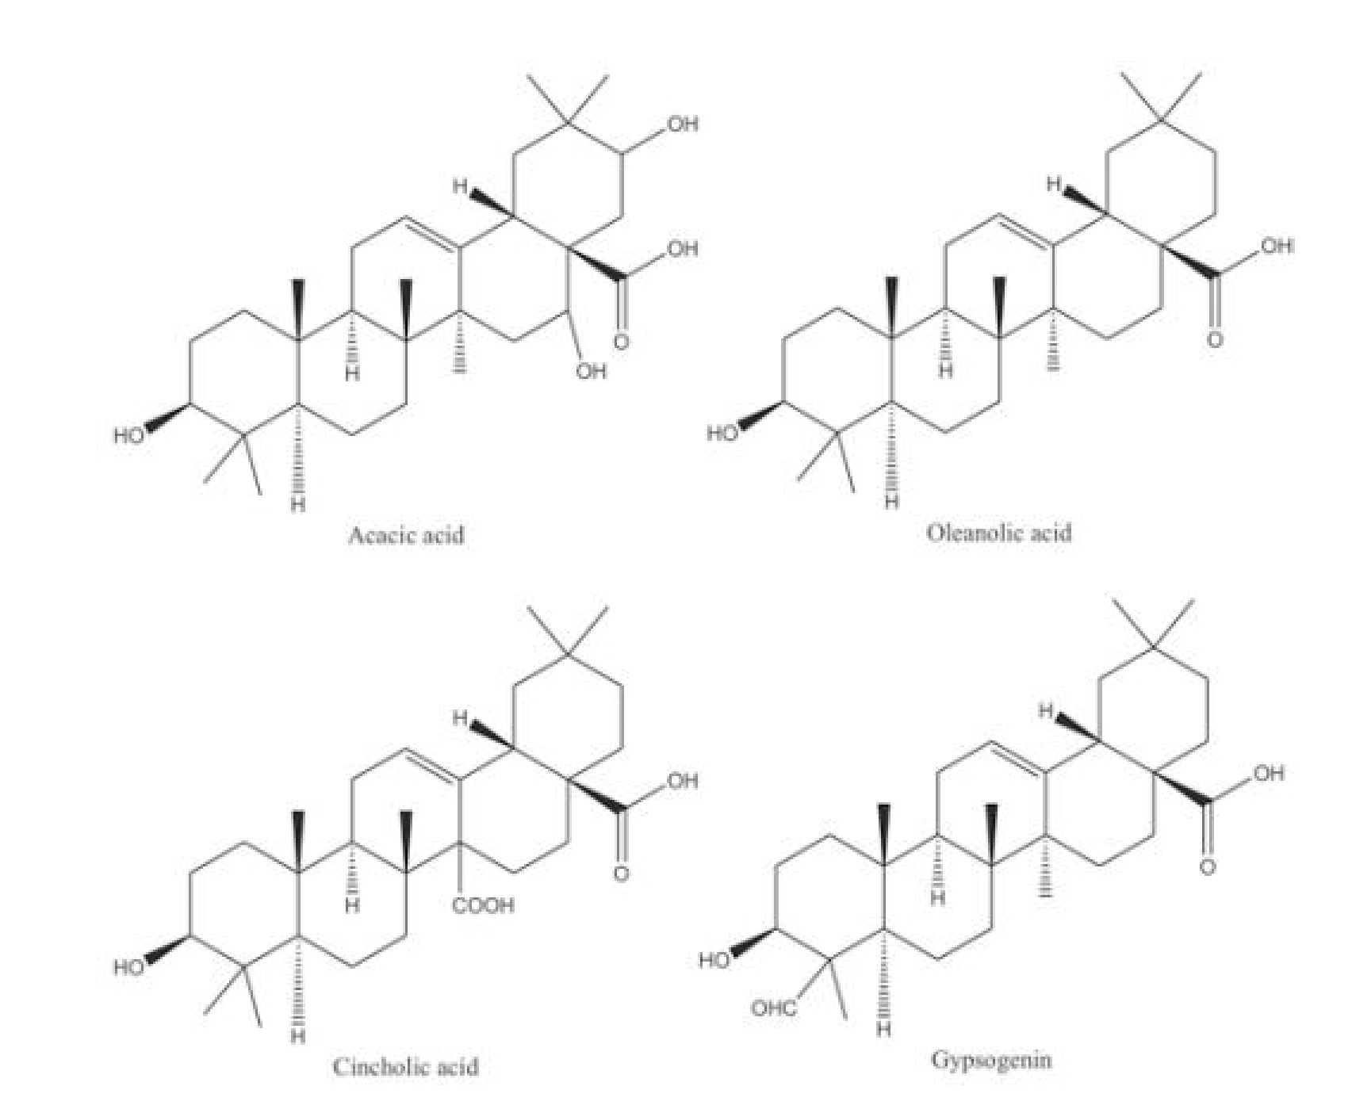
Figure 2.2 Examples of saponin compounds (Velu et al., 2018)

2.2.3 TANNINS
Tannins are a class of polyphenolic compounds widely distributed in plants, and Sida acuta has been reported to contain significant amounts of these compounds. Tannins exhibit strong astringent properties and have been associated with various pharmacological activities, including antimicrobial, antioxidant, anti-inflammatory, and gastroprotective effects (Bennett and Wallsgrove, 2019). Tannins in Sida acuta contribute significantly to its antioxidant properties. These compounds can scavenge free radicals and chelate metal ions, thereby preventing oxidative damage to cells (Hagerman and Butler, 2020). The antioxidant potential of Sida acuta tannins has been linked to its effectiveness in preventing lipid peroxidation and oxidative stressrelated diseases (Uche et al., 2020).
Tannins play a crucial role in the gastroprotective activity of Sida acuta. They enhance mucus secretion, reduce gastric acid production, and strengthen the mucosal barrier, thereby preventing ulcer formation (Ezekwesili et al., 2018). These properties make Sida acuta tannins a promising candidate for treating gastrointestinal disorders, including peptic ulcers. The tannins anti-inflammatory are well-documented, and Sida acuta tannins have been implicated in reducing inflammatory responses. Tannins exert their effects by inhibiting the release of proinflammatory cytokines and modulating enzymatic pathways involved in inflammation (Fraga et al., 2019). Studies indicate that Sida acuta tannins suppress inflammation-induced edema in animal models, supporting their role in managing inflammatory disorders (Mbagwu and Okoro, 2017).

2.2.4 ALKALOIDS
Alkaloids are a diverse class of low molecular weight nitrogen-containing secondary metabolites, predominantly synthesized by plants as part of their defense mechanisms against herbivores and pathogens. These compounds are typically derived from amino acid precursors and exhibit a wide array of structural frameworks, including indole, isoquinoline, pyridine, and tropane backbones (Roberts & Wink, 1998). Chemically, alkaloids are basic in nature due to the presence of at least one nitrogen atom, usually within a heterocyclic ring. Biologically, they display significant pharmacological effects, making them vital scaffolds in the development of therapeutic agents such as morphine, quinine, vincristine, and atropine (Dewick, 2009).
The presence of alkaloids in medicinal plants has long been associated with their therapeutic potentials. Alkaloids often exert bioactivity at low concentrations, interacting with molecular targets such as enzymes, ion channels, neurotransmitter receptors, and DNA. Their pharmacodynamics can range from central nervous system stimulation or depression, smooth muscle relaxation, antimicrobial activity, to cytotoxicity against cancer cells. Due to these effects, the study of alkaloid profiles in medicinal plants has become a focal point in phytochemical and pharmacognostic research (Wink, 2010).
In-depth phytochemical investigations into Sida acuta, a plant used in traditional medicine across various regions, have consistently revealed a rich alkaloid profile. The plant is a known source of structurally diverse alkaloids, several of which possess bioactivities that justify the ethnopharmacological uses of Sida acuta-based remedies. Among the alkaloids identified in Sida acuta, cryptolepine, vasicine, ephedrine, and choline derivatives are notable. Cryptolepine, an indoloquinoline alkaloid, has been widely reported for its antimicrobial, antiinflammatory, and notably antimalarial activity. It exerts its antiplasmodial effect by intercalating with DNA and inhibiting topoisomerase II, thereby blocking replication in Plasmodium species (Forkuo et al., 2016)..
Vasicine, a quinazoline alkaloid, is another major component of Sida acuta. It is pharmacologically active as a bronchodilator, expectorant, and uterotonic agent. Its presence in Sida acuta supports its use in managing respiratory conditions and menstrual disorders. Vasicine is known to enhance respiratory function by stimulating bronchi and reducing airway resistance (Srinivasan et al., 2001). Ephedrine, a sympathomimetic amine alkaloid structurally similar to amphetamines, has also been isolated from Sida acuta. It exhibits stimulant, decongestant, and appetite suppressant effects through the activation of adrenergic receptors (Igboh et al., 2009). Additionally, choline derivatives and other nitrogenous bases such as betaines have been reported in Sida acuta, indicating a complex spectrum of bioactive alkaloids. These compounds are involved in neurotransmission and cellular signaling, and may contribute to the neuromodulatory effects observed in traditional medicinal applications of the plant (Edeoga et al., 2005).
Quantitative phytochemical screening has shown that Sida acuta contains a relatively high amount of total alkaloids compared to many other tropical shrubs. Alkaloid content varies depending on environmental conditions, harvest time, and extraction methods. For instance, methanolic and ethanolic extracts of Sida acuta leaves have yielded higher alkaloid concentrations than aqueous extracts or those obtained from stems and roots (Edeoga et al., 2005; Igboh et al., 2009).

2.2.5 FLAVONOIDS
Sida acuta is a medicinal plant rich in flavonoids, which are polyphenolic compounds known for their diverse biological activities. Flavonoids play a critical role in the pharmacological potential of Sida acuta, exhibiting antioxidant, antimicrobial, anti-inflammatory, and other health benefits (Ogunyemi et al., 2019). The presence of these bioactive compounds in the plant contributes significantly to its traditional and therapeutic uses in managing various diseases. The antioxidant properties of Sida acuta flavonoids are particularly noteworthy. These compounds act as potent free radical scavengers, reducing oxidative stress and preventing cellular damage (Edeoga et al., 2020). Oxidative stress is a major contributor to aging and various chronic diseases, including cardiovascular diseases, neurodegenerative disorders, and cancer. Flavonoids neutralize reactive oxygen species (ROS) and enhance the activity of endogenous antioxidant enzymes, thus protecting cells from oxidative damage (Uche et al., 2020).
Sida acuta flavonoids exhibit strong antimicrobial effects. Studies have demonstrated their efficacy against various bacterial and fungal pathogens, including Staphylococcus aureus, Escherichia coli, and Pseudomonas aeruginosa (Adegboye et al., 2021). The antimicrobial mechanism involves disruption of microbial cell membranes, inhibition of bacterial enzyme systems, and interference with biofilm formation (Olajide et al., 2019). This makes Sida acuta extracts a promising alternative for combating antibiotic-resistant infections. Flavonoids from Sida acuta also possess significant anti-inflammatory properties. Chronic inflammation is a common underlying factor in many diseases, including arthritis, diabetes, and cardiovascular conditions. Flavonoids help modulate inflammatory pathways by inhibiting the production of pro-inflammatory cytokines, reducing nitric oxide synthesis, and downregulating inflammatory enzymes such as cyclooxygenase (COX) (Mbagwu and Okoro, 2017). These effects contribute to pain relief and inflammation management in various conditions. Cardiovascular health benefits of Sida acuta flavonoids have also been well-documented. These compounds improve endothelial function, regulate blood pressure, and prevent the oxidation of lowdensity lipoprotein (LDL), which is a major contributor to atherosclerosis (Hagerman and Butler, 2020). Additionally, flavonoids inhibit platelet aggregation, reducing the risk of thrombosis and heart disease. The protective effects of these compounds on the cardiovascular system highlight their potential role in preventing and managing hypertension and other heart-related disorders.
Research suggests that Sida acuta flavonoids have anticancer properties. They exhibit cytotoxic effects against tumor cells by inducing apoptosis, inhibiting proliferation, and modulating key signaling pathways involved in cancer progression (Fraga et al., 2019). These properties make Sida acuta a promising candidate for further investigation in cancer prevention and treatment. However, more studies are needed to fully understand the molecular mechanisms and therapeutic applications of these compounds. Flavonoids Sida acuta contribute to gastroprotection by enhancing mucosal defense mechanisms, reducing gastric acid secretion, and promoting ulcer healing (Ezekwesili et al., 2018). These compounds have shown promising results in experimental models of gastric ulceration, suggesting their potential application in the treatment of gastrointestinal disorders. The overall pharmacological significance of flavonoids in Sida acuta highlights the need for further research to optimize their medicinal applications and evaluate their long-term safety and efficacy in clinical settings.

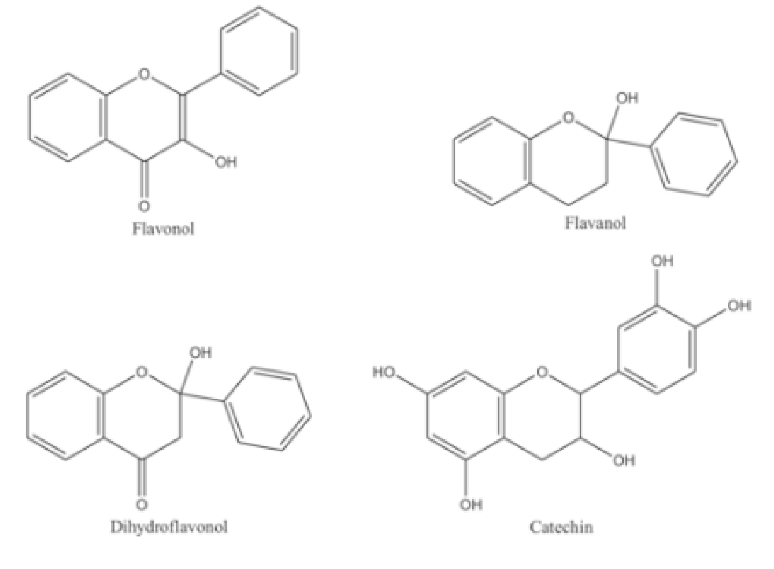
Figure 2.3: Examples of flavonoid compounds (Velu et al., 2018)

2.2.6 STEROIDS
Steroids are complex four-ringed organic molecules that serve many roles and functions in multicellular organisms. They are structural components of cell membranes exemplified by the important dietary steroid cholesterol and have many functional regulatory roles as modified structural forms of cholesterol to function as endogenous endocrine hormones. In all organisms, hormones in vivo play key regulatory roles in mediating communication and regulation of important functions and processes within and between cells, and across tissues, to connect all organs of the body (Cole et al., 2019).
Phytochemical screening of Sida acuta has revealed the presence of several important secondary metabolites, including alkaloids, flavonoids, tannins, saponins, terpenoids, glycosides, and steroids (Akinmoladun et al., 2007; Nandikar & Gurav, 2011). Steroids, particularly phytosterols, are lipophilic compounds that structurally resemble cholesterol and occur naturally in plants. They have garnered attention for their bioactive properties, including anti-inflammatory, anticancer, and cholesterollowering effects (Chaturvedi, 2011). Key phytosterols identified in Sida acuta include β-sitosterol, stigmasterol, and campesterol (Onocha et al., 2011; Sharma et al., 2014). These compounds are typically isolated through solvent extraction techniques involving methanol, ethanol, chloroform, or petroleum ether. Chromatographic techniques such as thin-layer chromatography (TLC), column chromatography, and gas chromatography–mass spectrometry (GC-MS) are commonly used for their separation and identification. The pharmacological relevance of steroids in Sida acuta is well-documented. β-sitosterol, the most predominant phytosterol in the plant, exhibits anti-inflammatory, antioxidant, immunomodulatory, and anticancer activities. It acts by modulating key enzymes and inflammatory mediators such as cyclooxygenase (COX) and nitric oxide synthase (NOS), which are involved in inflammation and oxidative stress (Sharma et al., 2014). In addition, β-sitosterol is known to enhance cell membrane integrity, regulate immune responses, and promote wound healing, which supports the traditional use of Sida acuta for treating sores and skin infections (Chaturvedi, 2011). Stigmasterol, another important phytosterol found in Sida acuta, has been associated with anti-arthritic, antioxidant, and cholesterol-lowering effects. It serves as a precursor for the biosynthesis of steroid hormones and vitamin D analogs in pharmaceutical applications (Nandikar & Gurav, 2011). Similarly, campesterol contributes to the regulation of lipid metabolism and exhibits anti-inflammatory potential, making it relevant in the management of cardiovascular and metabolic disorders (Sharma et al., 2014).
The presence of these steroidal compounds provides a scientific basis for the traditional medicinal uses of Sida acuta. In various African and Asian communities, the plant is prepared in decoctions, infusions, or poultices for treating infections, wounds, fever, and inflammation (Idu & Onyibe, 2007). The anti-inflammatory and wound-healing properties attributed to the steroids support these uses, as phytosterols like β-sitosterol have been shown to accelerate epithelial regeneration and reduce inflammatory cytokines at wound sites (Akinmoladun et al., 2007).
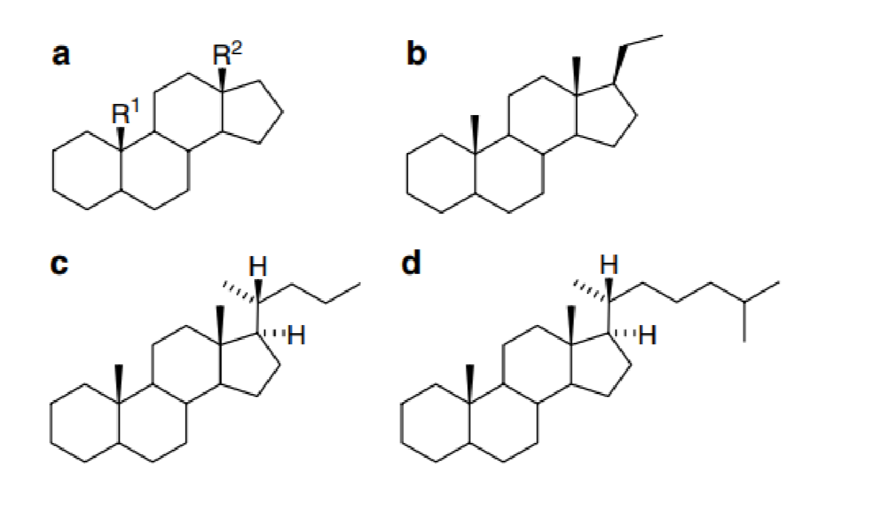
Figure 2.4: Basic steroid hydrocarbons: (a) gonanes, estranes, androstanes; (b) pregnanes; (c) cholanes; (d) cholestanes (Kasal, 2010).

2.2.7 TRITERPENOIDS
Triterpenoids are a large and structurally diverse class of plant-derived compounds formed from six isoprene units, resulting in a C₃₀ backbone. They are synthesized predominantly through the mevalonate (MVA) pathway, where squalene, a linear 30-carbon hydrocarbon, undergoes enzymatic cyclization and further oxidation, hydroxylation, or glycosylation to produce a variety of biologically active compounds. In plants, triterpenoids serve critical ecological roles, including membrane stabilization, pathogen defense, and signaling, and have become widely recognized for their pharmacological potential in humans (Thimmappa et al., 2014). Triterpenoids can be broadly categorized into acyclic, tetracyclic, and pentacyclic structures. Among these, pentacyclic triterpenoids such as oleanolic acid, ursolic acid, lupeol, and betulinic acid are of particular interest due to their notable bioactivities, including anti-inflammatory, anticancer, antiviral, and hepatoprotective properties. These compounds are commonly found in medicinal plants and often exist in conjugated forms known as saponins, which further enhance their bioavailability and therapeutic potential (Dzubak et al., 2006; Liu, 2005).
Triterpenoids are well-documented for their anti-inflammatory activity, primarily through the inhibition of cyclooxygenase (COX), lipoxygenase (LOX), and NF-κB pathways. For example, ursolic acid has been shown to downregulate inflammatory cytokines and suppress macrophage activation (Sun et al., 2013). Anticancer properties are mediated through mechanisms such as mitochondrial pathway-mediated apoptosis, inhibition of angiogenesis, and cell cycle arrest, particularly by triterpenoids like betulinic acid (Yogeeswari & Sriram, 2005). These compounds also show strong antioxidant effects, protecting cells from oxidative stress by scavenging reactive oxygen species (ROS) and upregulating endogenous antioxidant enzymes. This makes them valuable in preventing or managing chronic diseases such as diabetes, cardiovascular diseases, and neurodegeneration (Shukla et al., 2014).
Lupeol, a pentacyclic triterpenoid, has been identified in the leaves and stem extracts of Sida acuta. Lupeol possesses anti-inflammatory and anticancer properties and has been shown to inhibit tumor proliferation, suppress NF-κB signaling, and reduce lipid peroxidation. Its presence supports the plant’s traditional use in the treatment of inflammatory conditions, wounds, and infections (Igboh et al., 2009; Saleem, 2009). In addition to lupeol, studies have suggested the possible presence of ursolic acid and oleanolic acid in Sida acuta, although these may vary depending on the plant’s geographic origin, part used, and extraction method (Edeoga et al., 2005).

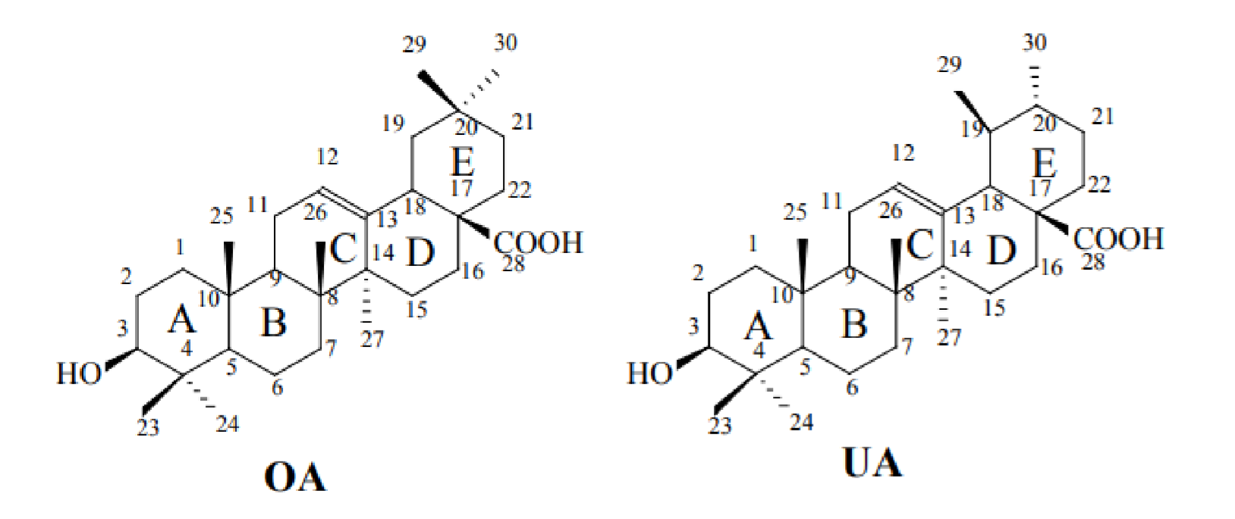
Figure 2.5: Representative triterpenoids, Oleanolic acid (OA) and ursolic acid (UA) (Sun et al., 2006).

2.2.8 GLYCOSIDES
Glycosides represent a broad and structurally diverse group of naturally occurring compounds characterized by the presence of a sugar moiety (glycone) bonded to a non-sugar component (aglycone or genin) via a glycosidic linkage. This unique structural feature not only increases the compound’s solubility but also modulates its pharmacological activities. Widely distributed in plants, glycosides fulfill critical biological functions, including defense against herbivores and pathogens, regulation of growth, and facilitation of storage and transport of active molecules (Evans, 2009).
The classification of glycosides hinges on the chemical nature of their aglycone. Common types include flavonoid glycosides, saponin glycosides, cardiac glycosides, and anthraquinone glycosides. Among these, flavonoid and saponin glycosides are especially prominent in medicinal plants and are renowned for their broad spectrum of bioactivities, such as antioxidant, anti-inflammatory, antimicrobial, and cardiotonic effects (Wink, 2010). In the context of Sida acuta, a plant extensively utilized in traditional medicine across various regions, glycosides play a significant role in the plant's therapeutic profile. Phytochemical investigations have revealed the presence of both flavonoid glycosides and saponin glycosides in Sida acuta extracts (Edeoga et al., 2005). Flavonoid glycosides such as quercetin and kaempferol derivatives contribute to the plant’s antioxidant and vascular protective properties, which support its traditional use in managing fever, cardiovascular diseases, and malaria (Igboh et al., 2009).
The saponin glycosides which are triterpenoid or steroidal compounds conjugated to sugar units exhibit potent anti-inflammatory, hepatoprotective, and antimicrobial activities. These surface-active molecules disrupt microbial membranes and enhance the permeability of pathogens, explaining the ethnomedicinal use of Sida acuta in treating infections and wounds. The synergistic effect of saponins alongside other phytochemicals, such as alkaloids and triterpenoids, further amplifies the plant’s pharmacological potential (Wink, 2010). Moreover, glycosylation significantly influences the pharmacokinetic behavior of
Sida acuta’s bioactive constituents. The sugar moiety improves water solubility and stability, facilitating extraction during traditional decoction processes and enhancing bioavailability in vivo (Hostettmann & Marston, 1995).

2.2.9 MEDICAL SIGNIFICANCE OF PHYTOCHEMICALS
Ever since the primeval period, mankind has used the natural yields such as plant life, animals, microbes and aquatic organism, in medicine for the treatment of diseases. The practice of traditional medication has continued as a most reasonable and effortlessly accessible primary source of treatment for the humans since the prehistoric time in the effective management of disease and others various ailments (Madhumitha et al. 2016). As per fossil documentation, the application of medicinal plants as medications accredited over 60,000 years ago (Shi et al., 2010). Sumerians have documented medication from the plant sources for the various illnesses. The primary treatment for the heart and circulatory disorders were clearly documented over 3500 years back in the papyrus. The practice of traditional medication still exists in China. Nearly half of the total population of China indirectly depends upon the traditional medication for treating diseases predominantly in rural areas of China. There are almost five thousand different traditional medications available for the prevention and treatment of diseases throughout the China which account over onefifth of the total pharmaceutical market of China (Li, 2010).
In current scenario, the applications of traditional knowledge on plant materials for the treatment and prevention of disease have received wide attention among the plant-based research community which resulted in the augmented exceptional attention among the drug discovery researchers towards the plant-based drug discovery research in phytochemistry and natural products (Anupama et al., 2014). This increased wave of attention towards the plant-based natural product chemistry research in modern drug discovery accredited to numerous factors. The most important factor includes, the unchallenged therapeutic requirements, for many a dreadful diseases like Cancer, HIV, Alzheimer’s diseases etc., there are no current available treatments to cure or prevent these diseases. Hence, the modern drug discoveries have turned their interest towards the plant-based drug discovery as an alternative source for the drug discovery to meet the unchallenged therapeutic requirements for this modern world (Velu et al., 2018).
The other important factor includes the availability of wide variety of natural secondary metabolites in plant sources which act as potent curative medicines. The secondary metabolites thus obtained from these medicinal plant sources have a significant broad sequence of the inimitable chemical structure with different therapeutic activity. The novel bioactive lead compound derived from the secondary metabolites of medicinal plant sources can be easily developed as a bioactive probe into drug moiety because of the rapid advancement of modern science with wide range of modern analytical development technique availability to identify and isolate the particular desired bioactive phytocompound from the plant materials to exert the targeted pharmacological activity with minimal toxic effect (Velu et al., 2018).
The importance of the role of traditional medicine based drug discovery was accepted by World Health Organization (WHO 1993) and documented the guiding principle for the strategic methods employed in the standardization and drug discovery development process from the medicinal plant materials (WHO 1993). The secondary metabolites rich medicinal plant materials are widely available throughout the terrestrial and aquatic world which acts as an alternative source for the novel drug discovery in the modern medicines. The large number phytocompounds were predominantly listed in the modern pharmacopoeias due to the accessibility of high efficient screening methods available to isolate the bioactive phytocompound from the medicinal plant materials and the advancement of combinatorial chemistry to modify the isolated novel bioactive phytocompound into semi-synthetic compound with improved structural activity relationship for the better efficacy of drug moiety for its targeted therapeutic pharmacological action with no or less toxic effects. So far, the very small proportional of plant materials have been systematically studied by the researchers from the total number of 500,000 existing plant species around the world. The further extensive research on the medicinal plant materials will pave the way for more isolation of novel bioactive phytocompounds that will bring more future drug discoveries in the modern medicines (Fowsiya and Madhumitha 2017).
Phytochemicals, are non-nutritive plant chemicals that have either defensive or disease protective properties. They are nonessential nutrients and mainly produced by plants to provide them protection. Dietary intake of phytochemicals may promote health benefits, protecting against chronic degenerative disorders, such as cancer, cardiovascular and neurodegenerative diseases. Majority of foods, such as whole grains, beans, fruits, vegetables and herbs contain phytonutrients/ phytochemicals. These phytochemicals, either alone and/or in combination, have tremendous therapeutic potential in curing various ailments. Phytochemicals with nutraceutical properties present in food are of enormous significance due to their beneficial effects on human health since they offer protection against numerous diseases or disorders such as cancers, coronary heart disease, diabetes, high blood pressure, inflammation, microbial, viral and parasitic infections, psychotic diseases, spasmodic conditions, ulcers, osteoporosis and associated disorder (Prakash et al., 2012)

2.3.0 MINERALS
The diverse mineral profile of Sida acuta enhances its pharmacological relevance, supporting its traditional applications in treating mineral deficiencies and metabolic disorders. Continued research is necessary to quantify the bioavailability of these minerals and their precise roles in human health. The potential for Sida acuta as a nutraceutical or functional food supplement remains promising, warranting further investigation into its therapeutic benefits and clinical applications (Fraga et al., 2019). Trace elements such as iron (Fe), zinc (Zn), and copper (Cu) are also present in Sida acuta and are essential for various biological processes. Iron is crucial for hemoglobin formation and oxygen transport, making Sida acuta beneficial in addressing iron deficiency anemia (Mbagwu and Okoro, 2017). The combination of these trace elements enhances the plant’s potential as a natural supplement for micronutrient deficiencies. Phosphorus (P) is another significant mineral found in Sida acuta, essential for ATP synthesis, bone mineralization, and cell signaling. Adequate phosphorus intake is vital for energy metabolism and the maintenance of genetic material (Fraga et al., 2019). Similarly, manganese (Mn) contributes to antioxidant defense, bone development, and the metabolism of amino acids, cholesterol, and carbohydrates. The presence of these elements in Sida acuta highlights its role in promoting metabolic efficiency and overall well-being

Calcium
Among the macrominerals found in Sida acuta, calcium (Ca) is one of the most abundant. Calcium is essential for bone health, nerve transmission, and muscle function. The presence of calcium in Sida acuta suggests its potential role in preventing osteoporosis and maintaining skeletal integrity (Edeoga et al., 2020). Sida acuta, traditionally used in herbal medicine, has been found to contain a notable amount of calcium. According to Enin (2015), the calcium content in Sida acuta leaves is approximately 185 mg per 100 grams of dried sample. This level is relatively high when compared with other wild leafy vegetables and highlights the plant’s potential to support calcium requirements, especially in plant-based or lowincome diets. Shittu and Alagbe, (2020) similarly observed a significant calcium presence in their analysis of the plant’s mineral profile, further supporting its nutritional relevance. The calcium found in Sida acuta may also play a supportive role in its medicinal applications, particularly in promoting bone health and aiding recovery in conditions where mineral depletion is a concern. However, like many plant sources, the bioavailability of calcium can be influenced by the presence of phytates and oxalates, which may interfere with absorption (Gupta et al., 2013).

Potassium
Potassium (K) is another vital mineral present in Sida acuta, playing an essential role in maintaining electrolyte balance, nerve signaling, and cardiovascular function. A potassium-rich diet has been linked to reduced blood pressure and a lower risk of stroke (Adegboye et al., 2021). The presence of potassium in Sida acuta suggests its potential contribution to heart health and blood pressure regulation. Furthermore, sodium (Na) is present in trace amounts, ensuring proper fluid balance and nerve function without contributing to hypertension (Olajide et al., 2019).

Sodium
Sida acuta, commonly referred to as broom weed, is a medicinal plant widely utilized in traditional medicine across tropical regions. One of its lesser-discussed but important attributes is its mineral composition—particularly sodium. Sodium, a key electrolyte in human physiology, plays essential roles in fluid regulation, nerve transmission, and muscle function. Although many dietary sources provide sodium, the relevance of its presence in medicinal plants like Sida acuta is significant, especially for populations relying on herbal remedies for both nutrition and therapy. Recent analyses have revealed that Sida acuta leaves contain appreciable amounts of sodium. According to Shittu and Alagbe (2020), the sodium content in Sida acuta leaf extract was recorded at 0.222 mg per gram. This indicates that even in small servings, the plant contributes measurable sodium to the diet. Similarly, Enin (2015) found that the leaves contain approximately 110 mg of sodium per 100 grams of dried plant material, further confirming the plant’s role as a potential sodium source.

Phosphorus
Phosphorus is a critical mineral required for various physiological processes, including energy metabolism, bone mineralization, and cellular signaling. While commonly obtained through animal products and cereals, some medicinal plants like Sida acuta also contribute to dietary phosphorus intake, especially in regions where plant-based diets are predominant. The phosphorus content in Sida acuta has been analyzed in several nutritional studies. According to Enin (2015), the leaves of Sida acuta contain approximately 18.6 mg of phosphorus per 100 grams of dried plant material. This level, though modest compared to animal-based sources, is notable for a wild leafy plant often used in herbal infusions or as a supplementary food source. Shittu and Alagbe (2020) similarly reported the presence of phosphorus in the leaf extract, suggesting its contribution to the mineral profile of the plant.

Iron and copper
Iron is crucial for the formation of hemoglobin, the protein responsible for transporting oxygen in the blood, and plays a role in cellular respiration and immune function. Copper, on the other hand, assists in iron metabolism, supports antioxidant activity, and is necessary for the development of connective tissue and the nervous system. When found together in a plant like Sida acuta, these minerals suggest that the plant may serve as a valuable dietary supplement, especially in areas where irondeficiency anemia is common.
According to Shittu and Alagbe (2020), the iron content in Sida acuta leaf extract was reported to be approximately 1.02 mg per gram. This relatively high value indicates a promising potential for combating iron deficiency through traditional herbal consumption. Enin (2015) also reported a comparable iron concentration, further supporting the idea that Sida acuta could be an effective natural source of dietary iron. In terms of copper, Sida acuta also shows a meaningful mineral profile. Enin (2015) documented the presence of about 0.35 mg of copper per 100 grams of dried leaf sample. Although the copper content is lower compared to iron, it remains within a beneficial range for human nutrition. This trace amount contributes to several physiological functions, including the formation of red blood cells and maintenance of healthy bones and blood vessels.

Aluminum
Aluminium, although not considered an essential nutrient for human physiology, is a naturally occurring element that can be found in various plants, soils, and water sources. In recent years, the presence of aluminium in medicinal plants such as Sida acuta has sparked interest, especially due to growing concerns about its potential health effects when consumed in large quantities or over extended periods.
Sida acuta, known for its medicinal versatility, has been examined for its elemental composition, including trace amounts of aluminium. According to Enin (2015), the leaves of Sida acuta were found to contain approximately 3.08 mg of aluminium per 100 grams of dried sample. This value indicates that while aluminium is present in the plant, it is within a relatively low concentration compared to other essential minerals like iron or calcium. Shittu and Alagbe (2020) also acknowledged the presence of aluminium in their study of the plant’s mineral profile, although it was not a primary focus due to its non-essential status. The presence of aluminium in Sida acuta is largely attributed to its natural absorption from the surrounding environment, particularly the soil in which it grows. Plants often absorb aluminium passively through their roots, especially in acidic soils where aluminium becomes more soluble. While occasional and moderate consumption of plants like Sida acuta may not pose immediate health risks, chronic exposure to elevated aluminium levels has been associated with neurological issues, including links to Alzheimer’s disease and other cognitive impairments (Krewski et al., 2007).

2.3.1 IMPORTANCE OF MINERALS IN HUMAN HEALTH
Minerals are inorganic nutrients, usually required in small amounts from less than 1 to 2500 mg per day, depending on the mineral. As with vitamins and other essential food nutrients, mineral requirements vary with animal species. For example, humans and other vertebrates need large amounts of calcium for construction and maintenance of bone and normal function of nerves and muscles. Phosphorus is an important constituent of adenosine triphosphate (ATP) and nucleic acid and is also essential for acid-base balance, bone and tooth formation. Red blood cells can not function properly without iron in haemoglobin, the oxygen-carrying pigment of red blood cells. Iron is also an important component of the cytochromes that function in cellular respiration. Magnesium, copper, selenium, zinc, iron, manganese and molybdenum are important co-factors found in the structure of certain enzymes and are indispensable in numerous biochemical pathways. Vertebrates need iodine to make thyroid hormones (Soetan et al., 2010).
Sodium, potassium and chlorine are important in the maintenance of osmotic balance between cells and the interstitial fluid. Magnesium is an important component of chlorophyll in plants. The interactions between nutrition and diseases, nutrition and drug metabolism have been reported. Excessive intake of some minerals can upset homeostatic balance and cause toxic side effects. For example, excess sodium intake is associated with high blood pressure and excess iron can cause liver damage. Also, severe shortages or self-prescribed minerals can alter the delicate balance in body functions that promotes health. The knowledge of the biochemistry of the mineral elements is also essential because individuals suffering from a chronic illness or taking medications that affect the body’s use of specific nutrients need to be enlightened (Soetan et al., 2010)
Mineral nutrients are indispensible to the maintenance of life. A mineral element is considered essential when deficient ingestion results in harm or suboptimal function, and if supplementation with physiological levels of this specific element prevents or repairs this damage. Human nutritional requirements demand at least 23 mineral elements, and there are various methods available to establish the nutritional status of minerals (Quintaes and Diez‐Garcia, 2015).. The required daily quantities of mineral nutrients are small, particularly when compared with nutrients such as carbohydrates and lipids. The minimum and maximum mineral contents necessary to produce adverse effects can vary widely between different mineral nutrients. Chosen food regimens are related to geographical availability, and the corresponding biodiversity. Biological adaptive processes, constrained by the regional diversity of diets, have over time established existing nutritional requirements. Nutritional recommendations define mineral consumption values that are not easily achieved with the contemporary Western diet. Scientific evidence suggests that nutrient supplements cannot replace a healthy diet, with the consumption of a wide variety of nutritious foods being the best way to maintain health and prevent chronic disease (Quintaes and Diez‐Garcia, 2015).
Mineral nutrients are essential for the proper functioning of every organism on earth. The interactions between mineral elements in biological systems and their role in mediating the chemical and biological reactions fundamental to life are still being discovered. Archaeological evidence of the feeding habits adopted by our human predecessors has been discovered by fossil studies from different periods and sites. Determination of the minerals in mineralized prehistoric human remains reveals the dietary conditions and food habits, and also the environmental and living conditions, of the population. Understanding the feeding habits adopted by our ancestors helps to elucidate the evolution of the species (Maurer et al., 2012).
The availability and distribution of foods and their preparation indicate the preferences of the population and provide knowledge of the social organization practised. The main tool used to unravel the past is archaeological chemistry (archaeochemistry), which has been useful in discovering the practices and lifestyles of past human populations, including their feeding habits (Maurer et al., 2012).. Human remains studied using archaeochemistry, be it via the recovery of tools or paintings or analysis of the concentration of the chemical elements and their isotopic forms, help us understand the role of the biocultural system resulting from the interaction between humans and their environment (Quintaes and Diez‐Garcia, 2015)..
The form of the mineral incorporated into the bones can be distinct for the various elements. Reconstruction of the diet consumed based on the mineral composition of bones requires that the diagenetic process has not altered bone composition over time. In fossils, the concentrations of the elements Fe, Mn and Cu can be increased due to diagenesis of the soil in which the individuals were buried (Carvalho et al., 2004). It is known that the majority of Mg in the human organism comes from foods of animal origin. One of the functions of Mg in the human is its involvement in cell metabolism, and insufficient amounts appear to affect the senescence process negatively (Killilea et al., 2008). Because of the high level of Zn in blood and meat, a diet based on meat could induce a higher level of this element. However, high levels of Zn can also be found in certain legumes and vegetables and can lead to erroneous interpretation of the diet (Carvalho et al., 2004).

2.3.2 TECHNIQUES USED IN PHYTOCHEMICAL AND MINERAL

ANALYSIS Mineral analysis techniques

i. X-ray diffraction (XRD)
X-rays have wavelengths comparable to atomic size, and therefore, intensities of X-ray diffraction technique or diffraction patterns are used for harnessing information about atomic structures. For instance, X-ray diffraction (XRD) is used for examining and characterizing the position of atoms, their arrangement in each unit cell, and spacing between the atomic planes (Pappas et al., 2006). XRD is a nondestructive testing technique, which can be employed for examining a wide variety of materials including minerals, polymers, plastics, metals, semiconductors, ceramics, and solar cells. This technique is also extensively used in power generation, aerospace, microelectronics, and other industries (Guma et al., 2012). ii. X-ray Diffraction Principle
When the X-rays impinge on solid materials, they become scattered by the electrons revolving around the nucleus of atoms. These scattered waves, emitted in multiple directions, interfere with each other. The nature of interference can be constructive or destructive, based on the direction and type of interaction of waves (Fultz and Howe, 2013). Diffraction is the constructive interference of scattered Xrays. It is worthy to note here that the orderly arrangement (periodicity) of atomic structures in solids causes constructive interference. It is, therefore, apparent to clearly interpret the XRD graphs of crystalline substances. A strong correlation exists between periodicity and diffraction, i.e., higher diffraction angles are observed with shorter periodicity and vice versa (Fultz and Howe, 2013).

iii. EDTA Complexometric Titration
The hexadentate ligand ethylenediaminetetraacetate (EDTA) forms stable 1:1 complexes with numerous mineral ions. This gives complexometric titration using EDTA broad application in mineral analysis. Stability of mineral–EDTA complexes generally increases with valence of the ion, although there is significant variation among ions of similar valence due to their coordination chemistry. The complexation equilibrium is strongly pH dependent. With decreasing pH the chelating sites of EDTA become protonated, thereby decreasing its effective concentration. Endpoints are detected using mineral chelators that have coordination constants lower than EDTA (i.e., less affinity for mineral ions) and that produce different colors in each of their complexed and free states. Calmagite and Eriochrome Black T (EBT) are such indicators that change from blue to pink when they complex with calcium or magnesium. The endpoint of a complexometric EDTA titration using either Calmagite or EBT as the indicator is detected as the color changes from pink to blue. The pH affects a complexometric EDTA titration in several ways and must be controlled for best performance. The pH must be 10 or more for calcium or magnesium to form stable complexes with EDTA. Also, the sharpness of the endpoint increases with increasing pH. However, magnesium and calcium precipitate as their hydroxides at pH 12, and titration pH should probably be no more than 11 to ensure their solubility. Considering all factors, EDTA complexometric titration of calcium and magnesium is specified at pH 10 ± 0.1 using an ammonia buffer (Nielsen et al., 2010).

iv. Mass Spectrometry-Based Techniques
The use of laser ablation inductively coupled plasma mass spectrometry (LAICP-MS) for characterization of mineral chemistry has grown since its first application to geological media. Its application for characterizing mineral chemistry has grown in the past 15 years to include a broad range of minerals (Dare et al., 2014). Conceptually the application of laser ablation for mineral chemical and isotopic analyses is a straightforward, albeit destructive, technique. A short-pulsed (femto- to nanosecond) laser ablates a small volume (5–8000 µm³ ) of a mineral sample over a period of 10 s of seconds. During ablation the mineral is converted into vapour and aerosol components. This material is then continually transferred in an Ar or He carrier gas to be ionized in an inductively coupled plasma and mass analyzed in either a quadrupole or magnetic-sector mass spectrometer (Hill 2008). There are several instrument parameters that must be optimized to measure element and isotopic compositions of a mineral by LA-ICP-MS (Arevalo et al., 2010); these include
- laser pit-size;
- laser wavelength;
- laser pulse-rate;
- mass spectrometer;
- matrix-match standards; and
- curve calibration.
Most laser ablation instruments are capable of adjusting the laser beam size from 1– 2 to 300 microns, however, most analyses are completed at ~30 microns (Figure 2D). If a laser pit is too small, not enough material is ablated to create a suitable signal in the mass spectrometer. If a laser pit is too large, the mass spectrometer detector may become saturated or go beyond the element calibration curve. Numerous studies have examined the analyses of geological media using variable laser wavelengths and laser pulse-rates and collectively using similar laser energies. There is consensus that shorter wavelengths and higher laser pulse rates produce superior data that require fewer corrections for elemental and isotopic bias (Poitrasson et al., 2003). In mineral analysis, a shorter wavelength laser (i.e., 193 nm vs. 213 nm) produces a flat-bottomed and sharp-walled ablation pit. The higher pulse rate (i.e., femtosecond vs. nanosecond) of the mineral can produce less thermal heating with a lower abundance of secondary condensates (Hirata et al., 2004). Ultimately, the ability of LA-ICP-MS to measure low-concentration elemental and isotopic data is a function of the mass spectrometer paired with the laser ablation system.
There are three options for inductively coupled plasma mass spectrometers for use in laser ablation: (1) Quadrupole;
- Time of Flight;
- High-resolution single collector; and
- High-resolution multi-collector.
By far the most common mass spectrometer used in laser ablation studies of mineral chemistry is the quadrupole mass analyzer. These instruments filter ions created in the plasma by mass and charge (m/z) as they travel to the detector using variable DC voltages on four parallel stainless steel rods. By adjusting the DC voltage on the quadrupoles, the transient ions created in laser ablation can be filtered and analyzed for most elements on the periodic table in milliseconds (Hill, 2008). Time-of-flight mass spectrometers have seen less application to laser ablation applications in geological sciences. However, they are ideally suited to capitalize on the extremely fast washout times of new ablation cells and higher laser frequencies (Bussweiler et al., 2017).
These plasma-based instruments use the difference in ballistic travel and kinetic energy of light versus heavy isotope masses through a vacuum and a charge potential to separate mass to charge ratios over short time intervals (Guilhaus et al., 2000). Current Time-of-flight mass spectrometers can complete a full mass scan at ~30 µs allowing 33,000 full mass scans per second. Early Time-of-flight mass spectrometers did not have the sensitivity of quadrupole mass analyzers, however recent research would suggest sensitivities that rival sector field instruments and allow single digit parts per million for single-shot laser pulse from a 10-µm diameter laser spot (Gundlach-Graham et al., 2015).
In high-resolution mass spectrometers, ions created in laser ablation and in the inductively coupled plasma are passed along a curved flight path through magnetic and electrical fields to disperse ions according to their momentum and translational energy. By adjusting the magnetic and electro-static fields, the transient ions arriving at the detector(s) Minerals 2022, 12, 59 11 of 27 can be varied on the basis of mass. Because of this geometry, the mass resolution of these instruments is superior to that of quadrupole instruments (e.g., ~10,000 versus ~600, respectively). As such, fractions of mass unit can be effectively separated during analysis, allowing for separation of polyatomic interferences (Hill, 2008).

Phytochemical analysis techniques

Qualitative and quantitative analysis of phytochemicals
i. Preliminary Qualitative Analysis
1. Test for Alkaloids
- Mayer’ s test To a few ml of plant sample extract, two drops of Mayer‟s reagent are added along the sides of test tube. Appearance of white creamy precipitate indicates the presence of alkaloids.
- Wagner’s test A few drops of Wagner‟s reagent are added to few ml of plant extract along the sides of test tube. A reddish- Brown precipitate confirms the test as positive (Chen et al., 2006).
- Test for Amino acids
The extract (100 mg) is dissolved in 10 ml of distilled water and filtered through Whatmann No. 1 filter paper and the filtrate is subjected to test for Amino acids. a. Ninhydrin test Two drops of ninhydrin solution (10 mg of ninhydrin in 200 ml of acetone) are added to 2 ml of aqueous filtrate. Appearance of purple colour indicates the presence of amino acids (Begum et al., 2002).
- Test for Carbohydrates
- Molish’ s test To 2 ml of plant sample extract, two drops of alcoholic solution of α- naphthol are added. The mixture is shaken well and few drops of concentrated sulphuric acid is added slowly along the sides of test tube. A violet ring indicates the presence of carbohydrates.
- Benedict’ s test To 0.5 ml of filtrate, 0.5 ml of Benedict‟s reagent is added. The mixture is heated on a boiling water bath for 2 minutes. A characteristic coloured precipitate indicates the presence of sugar. iv. Test for Phenolic compounds and Tannins
- Ferric Chloride test The extract (50 mg) is dissolved in 5 ml of distilled water. To this few drops of neutral 5% ferric chloride solution are added. A dark green colour indicates the presence of phenolic compound.
- Gelatin test The extract (50 mg) is dissolved in 5 ml of distilled water and 2 ml of
1% solution of Gelatin containing 10% NaCl is added to it. White precipitate indicates the presence of phenolic compounds (Nikhal et al., 2010).
- Lead acetate test The extract (50 mg) is dissolved in of distilled water and to this 3 ml of 10% lead acetate solution is added. A bulky white precipitate indicates the presence of phenolic compounds.
- Alkaline reagent test An aqueous solution of the extract is treated with 10% ammonium hydroxide solution. Yellow fluorescence indicates the presence of flavonoids. e. Magnesium and Hydrochloric acid reduction The extract (50 mg) is dissolved in 5 ml of alcohol and few fragments of magnesium ribbon and concentrated hydrochloric acid (drop wise) are added. If any pink to crimson colour develops, presence of flavonol glucosides is inferred (Ncube et al., 2008).

Qualitative and quantitative Analysis
Qualitative and quantitative analysis of phytochemicals can be done using Gas
Chromatography

- Mass Spectroscopy (GCMS).
GCMS can be applied to solid, liquid and gaseous samples. First the samples are converted into gaseous state then analysis is carried out on the basis of mass to charge ratio. High Performance Liquid Chromatography is applicable for compounds soluble in solvents. High performance thin layer chromatography is applicable for the separation, detection, qualitative and quantitative analysis of phytochemicals (Banu and Cathrine, 2015)..
- Gas Chromatogrophy
Gas chromatography is applicable for volatile compounds. In this method, species distribute between a gas and a liquid phase. The gas phase is flowing and the liquid phase is stationary. When the sample molecules are in liquid phase they are stationary. The rate of migration depends on how much of chemical species is distributed into liquid phase. Higher the percentage of material in the gaseous state faster will be the migration. The species which distributes itself 100% in the stationary state will not migrate. If a sample distributes itself in both phases, it will migrate at an intermediate rate. This gas chromatography gives the total amount of vapour. Thus it is most widely used for quantitative analysis.
- High Performance Liquid Chromatography (HPLC)
HPLC is also known as High- Pressure Liquid Chromatography. This separates compounds on the basis of their interaction with solid particles of a tightly packed column and the solvent of the mobile phase. High pressures of up to 400 bars are required to elute the analyte through the column before they pass through detector. HPLC is useful for compounds that cannot be vapourised or that decompose under high temperatures. HPLC provides both quantitative and qualitative analysis in a single operation (Banu and Cathrine, 2015).

CHAPTER THREE

3.0 MATERIALS AND METHODS

3.1 MATERIALS
Beaker, pipette, Steria bottle, funnel, filter paper, sieving cloth, syringe, cannular

3.1.1 PLANT MATERIAL
Sida acuta

3.1.2 CHEMICALS AND REAGENTS
DMSO, distilled water, ethanol

3.2 METHODS

3.2.1 PREPARATION OF PLANT EXTRACT
500g of blended stubborn grass was weighed into a bowl and dissolved with 2.5mL of ethanol. The mixture was left for 72 hours, then the solution was filtered and left for concentration.

3.2.2 QUALITATIVE AND QUANTITATIVE PHYTOCHEMICALS

3.2.2.1 DETERMINATION OF PHENOLS
Folin-Ciocalteu Method (Quantitative);
Procedure:
1 mL of the sample was mixed with 5 mL of Folin–Ciocalteu reagent (diluted 1:10). After 5 minutes, 4 mL of 7.5% sodium carbonate was added. The mixture was incubated for 30 minutes at room temperature. Absorbance was measured at 765 nm. Gallic acid was used as the standard for quantification

3.2.2.2 DETERMINATION OF SAPONINS
Gravimetric Method (Quantitative)
One gram (1g) of dry extract was weighed and boil in 100 mL of 20% ethanol for 30 minutes. Filter and re-extract the residue twice using 20% ethanol. The filtrates were combined and evaporate to dryness. Dry residue in a desiccator and weigh. The weight corresponds to total saponin content.

3.2.2.3 DETERMINATION OF TANNINS
One milliliter of the sample extract was pipetted into a test tube, followed by the addition of 5 mL of Folin-Denis reagent. The mixture was thoroughly mixed, after which 10 mL of 17% sodium carbonate solution was added and mixed again. The reaction mixture was then allowed to stand at room temperature for 30 minutes to allow full color development. After incubation, the absorbance of the blue-colored complex formed was measured at 760 nm using a spectrophotometer against a reagent blank. The absorbance values of the sample were used to plot a calibration curve, and the tannin content of the sample was determined by comparison with this curve. The results were expressed as tannic acid equivalents per gram or per milliliter of the sample.

3.2.2.4 DETERMINATION OF ALKANOIDS
The extract was concentrated by evaporating to one-quarter of its original volume using gentle heating. Concentrated ammonium hydroxide was added dropwise to the concentrated extract until precipitation was complete, and the solution was allowed to settle. The precipitated alkaloids were collected by filtration and washed with dilute ammonium hydroxide solution. The residue was then dried in an oven at 60°C to a constant weight. The weight of the residue corresponded to the alkaloid content in the sample.

3.2.2.5 DETERMINATION OF FLAVONOIDS
Aluminum Chloride Colorimetric Method (Quantitative); Procedure:
1 mL of the extract was mixed of with 1 mL of 2% AlCl₃ in methanol. Incubated for 10 minutes at room temperature. The absorbance was measured at 415 nm. A quercetin standard curve was used for quantification.

3.2.2.6 DETERMINATION OF STERIODS
The filtrate was concentrated under reduced pressure using a rotary evaporator to obtain a crude extract. This crude extract was subjected to qualitative and quantitative analysis by adding Liebermann-Burchard reagent (a mixture of acetic anhydride and concentrated sulfuric acid) to an aliquot of the extract. The mixture was allowed to stand for color development, where the appearance of a green or blue-green color indicated the presence of steroids. For quantitative determination, the absorbance of the colored complex was measured spectrophotometrically at an appropriate wavelength (620 nm). The concentration of steroids in the sample was calculated by comparing the absorbance to a calibration curve prepared from standard steroid solutions.

3.2.2.6 DETERMINATION OF TRITERPENOIDS
The filtrate was concentrated under reduced pressure to obtain a crude extract.
The presence of triterpenoids was confirmed by adding a few drops of LiebermannBurchard reagent to the concentrated extract. The mixture was allowed to stand, and the development of a blue-green or green color indicated the presence of triterpenoids. For quantitative determination, the absorbance of the colored complex was measured using a spectrophotometer at an appropriate wavelength (usually around 540–620 nm). The concentration of triterpenoids in the sample was calculated by comparing the absorbance with a standard calibration curve prepared from known concentrations of a standard triterpenoid compound.

3.2.2.7 DETERMINATION OF GLUCOSIDES
2 mL of glacial acetic acid with a drop of FeCl₃ was added to 1 mL of the extract. Then, 1 mL of concentrated H₂SO₄ was carefully added down the side of the test tube. The formation of a brown ring at the interface indicated the presence of deoxy-sugars in cardiac glycosides.

3.2.3 DETERMINATION OF MINERAL CONTENT

3.2.3.1 DETERMINATION OF MINERAL CONTENT USING AAS

Calcium
The sample was digested using a mixture of nitric acid and perchloric acid until a clear solution was obtained. The digested solution was then filtered and diluted to a known volume with deionized water. The calcium content was determined using Atomic Absorption Spectrophotometry (AAS) at a wavelength of 422.7 nm. Standard calcium solutions were prepared to generate a calibration curve. The absorbance of the sample was compared to the calibration curve to quantify the calcium concentration.

Sodium
Sodium Ion (Na⁺)
The Procedure described by Tietz (1983) was used to assay for sodium analysis.
Procedure:
1000µl of sodium reagent was added to 10µl of the sample and standard in a test tube. The solution was incubated at 37ᶿC for five (5) minutes. The absorbance value was read at 630nm.
Calculation:
Sodium ion concentration (mmol/L) = A_{sample} × Concentration of standard
Astandard
Note; Sodium reagent contains Tris buffer, proclin 300 and Chromogen. Potassium
Potassium Ion (K⁺)
The method described by Tietz, (1995) was used to assay for this analysis.
Principle:
Sodium tetraphenylboron reacts with potassium in an alkaline medium to produce a turbid suspension of potassium tetraphenylboron. Thus, the turbidity produced is directly proportional to the concentration of potassium in the serum tested.
Procedure:
1.0ml of tetraphenylboron reagent was added to 10µ of sample and standard in a test tube. The mixture was then incubated for five (5) minutes at 37ᶿC. The absorbance value was taken at 578nm.
NB;Tetraphenylboron reagent contains 0.6mol/L NaOH and 250mmol/L sodium tetraphenylboron.
Calculation:
Potassium ion concentration (mmol/L) = A_{sample} × Concentration of standard
Astandard

Phosphorus
The sample was digested using a mixture of nitric acid and perchloric acid until a clear solution was obtained. After cooling, the digested sample was filtered and diluted to a known volume with deionized water. An aliquot of the prepared sample was mixed with ammonium molybdate reagent, followed by the addition of ascorbic acid as a reducing agent. The mixture was allowed to stand for 30 minutes to develop a blue color. The absorbance was measured at 880 nm using a UV-Visible spectrophotometer. A standard curve was prepared using known concentrations of phosphate, and the phosphorus content in the sample was determined by comparison with the standard curve.

Iron
Iron (Fe)
The method described by Tietz, (1995) was used to assay for this analysis.
Principle
Ferric iron is dissociated from its carrier protein transferrin in an acid medium and simultaneously reduced to the ferrous iron. The ferrous iron is then complexed with the chromogen to produce a blue chromophore. In the measurement of unsaturated iron binding capacity (UIBC) a known amount of ferrous iron is added in excess to the serum at alkaline Ph. This saturates the UIBC sites on the transferrin. The amount of free iron is then measured and subtracted from the total amount added to calculate the UIBC. Procedure;
0.5ml of sample and standard was dispensed into a test tube, 2ml buffer, 0.1ml of reductant and 0.5ml of iron-free water was subsequently added to it. The initial absorbance was immediately taken after which the 0.1ml of chromogen was added to the mixture. The mixture was then incubated for 5minutes at 37ᶿC after which the final absorbance value was taken. The absorbance values were read at 590nm.
Calculation;
Fe=Abs Sample × Concentration Cal/std
Abs Standard

Copper (Cu)
The method described by Kasper et al, (2012) was used to assayed for this analysis Principle
At pH 4.7 (acid buffer), copper, which is bound to ceruloplasmin is released by a reducing agent. It then react with a specific colour reagent, 3.5-Di-Br-PAESA, to form a stable, colored chelate. The intensity of the colour, photometrically measurable at 570nm, is directly proportional to the amount of copper present in the sample. Procedure
1000µl of working reagent was added to 50µl of the sample and standard in a cuvette. The mixture was incubated for 5minutes at 37ᶿC. The absorbance value was immediately taken after the incubation at 570nm.
Calculation
Cu=Abs Sample × Concentration Cal/std
Abs Standard

Conversion factor: Copper [µg/dl] ×0.1573=Copper [µmol/l]

3.3 EXPERIMENTAL DESIGN
The experimental design adopted for this study was a completely randomized design (CRD), which is appropriate for laboratory-based studies involving homogeneous sample. Fresh plant materials of Sida acuta were collected, cleaned, and divided into experimental units. The leaves were subjected to drying, grinding, and sieving to obtain a fine powder, which was then used for all proximate analyses. The experiments were conducted in triplicates to allow for accurate statistical comparison and to account for random error.
The study was divided into two: phytochemical analysis and mineral analysis. For the phytochemical screening. The qualitative tests were carried out using standard procedures to identify the presence of various secondary metabolites such as alkaloids, tannins, flavonoids, saponins, phenols, steroids, triterpenoids, and glycosides.
For the mineral analysis, a known quantity of the dried powdered sample was subjected to wet digestion using a mixture of nitric acid and perchloric acid. The digested samples were analyzed for mineral content using standard techniques. Atomic Absorption Spectrophotometry (AAS) was used to determine the concentrations of iron (Fe), zinc (Zn), calcium (Ca), magnesium (Mg), and copper (Cu), while sodium (Na) and potassium (K) were analyzed using atomic absorption spectroscopy (AAS)

CHAPTER FOUR

4.0 RESULTS

4.1 PHYTOCHEMICAL PROFILE OF Sida acuta
The table 4.1 shows the phytochemical screening result of Sida acuta, where the presence (+) or absence (-) of various phytochemicals is recorded for each test. The table format appears to include ABS (Absence) and PRS (Presence result score). The phytochemical screening indicates the presence or absence of specific bioactive compounds in Sida acuta, a medicinal plant known for its traditional uses in treating infections, inflammation, and other health conditions.
Table 4.1 phytochemical composition of the Sida acuta under study.
Sample Code
Phenol | ABS
 | PRS | +
Saponin | ABS
 | PRS | +
Tannin | ABS
 | PRS | +
Alkaloids | ABS
 | PRS | +
Flavonoids | ABS
 | PRS | +
Steroids | ABS
 | PRS | +
Triterpenoids | ABS
 | PRS | +
Glycoside | ABS
 | PRS | +
Reducing Sugar | ABS | -
 | PRS
Proteins | ABS | -
 | PRS

4.1.1 DETECTED PHYTOCHEMICALS AND THEIR SIGNIFICANCE
Phenols: The presence of phenolic compounds indicates that Sida acuta possesses strong antioxidant properties, as phenols are known to scavenge free radicals and reduce oxidative stress. This supports its traditional use in managing inflammation and preventing degenerative diseases. Saponins: These are glycosides with foaming characteristics and are known for their antimicrobial, antifungal, and cholesterol-lowering effects. Their presence suggests that Sida acuta may be beneficial in improving immunity and possibly in managing blood lipid levels. Tannins: Tannins are polyphenolic compounds with astringent properties and are known to contribute to wound healing, antimicrobial activity, and anti-diarrheal effects. This aligns with the traditional external use of Sida acuta in wound management.
Alkaloids: These are nitrogen-containing compounds known for their physiological effects on the nervous system and their antimalarial, analgesic, and antimicrobial properties. The presence of alkaloids may explain the plant’s use in pain relief and treatment of infections. Flavonoids: These are potent antioxidants with anti-inflammatory, anti-cancer, and cardioprotective properties. Their presence reinforces the medicinal potential of the plant in managing oxidative stress-related disorders. Steroids: Steroidal compounds contribute to anti-inflammatory and hormone-regulating effects. Their presence may partly explain the use of Sida acuta in treating inflammatory conditions and possibly reproductive disorders. Triterpenoids: These are involved in anti-inflammatory, anticancer, and hepatoprotective activities. Their presence points toward the plant’s potential in liver protection and chronic disease management. Glycosides: These compounds often exert cardiotonic and purgative effects, depending on their specific structure. The detection of glycosides suggests that Sida acuta might influence cardiac function or possess laxative properties.

4.1.2 ABSENT PHYTOCHEMICALS AND THEIR IMPLICATIONS
Reducing Sugars: These were not detected, indicating the plant extract lacks simple reducing sugars. This absence may be favorable from a metabolic or diabetic treatment perspective, as it suggests the plant does not contribute simple sugars that could raise blood glucose. Proteins: The absence of proteins is not uncommon in phytochemical screenings, especially if the test focuses on secondary metabolites. Proteins are not typically the primary constituents in medicinal plant bioactivity, so their absence may not diminish the therapeutic value of the plant.

4.3 MINERAL CONTENTS OF Sida acuta
The mineral composition analysis of Sida acuta is shown in table 4.2 where the plant possesses appreciable amounts of essential minerals that are important. The iron (Fe) content was found to be 2.023 mg/100g. Iron is critical for the synthesis of hemoglobin and the prevention of anemia, suggesting that Sida acuta could serve as a beneficial dietary component in combating iron deficiency. Copper (Cu) was present at 1.0948 mg/100g. Copper plays a vital role in iron metabolism and supports the proper functioning of the cardiovascular and nervous systems. The zinc (Zn) content, recorded at 0.570 mg/100g.
The sodium (Na) content was relatively low at 2.962 mg/100g. This low sodium level is noteworthy because diets high in sodium are associated with hypertension and cardiovascular diseases; thus, the consumption of Sida acuta may not pose such risks. Conversely, the potassium (K) level was relatively high at 5.833 mg/100g.
Potassium is known for its role in maintaining electrolyte balance, nerve transmission, and regulating blood pressure. The high potassium-to-sodium ratio observed in Sida acuta further highlights its potential cardiovascular benefits.
Magnesium (Mg) content was measured at 5.376 mg/100g. Magnesium is indispensable for neuromuscular transmission, energy production, and bone development. Manganese (Mn) was detected at 0.476 mg/100g. Calcium (Ca) content was found to be 4.031 mg/100g. Calcium is essential for the development and maintenance of strong bones and teeth, as well as for muscular function and nerve signaling.
Table 4.2 Determination of Mineral contents of Sida acuta
S/N | Sample code | Fe Cu Zn | Na | K | Mg | Mn Ca
1 | A1 | 2.023 1.0948 0.570  2.023 1.948 0.570 | 2.962  2.962 | 5.833  5.833 | 5.376  5.376 | 0.476 4.031  0.476 4.031
Key: iron (Fe), copper (Cu), zinc (Zn), sodium (Na), potassium (K), and Magnesium (Mg)

CHAPTER FIVE

5.0 DISCUSSION
The findings from this study provide substantial evidence supporting the ethnopharmacological relevance of Sida acuta, a plant long utilized in traditional medicine for treating a wide range of ailments. The presence of diverse secondary metabolites and essential minerals underscores its therapeutic potential and validates its folkloric applications. The phytochemical screening of Sida acuta revealed the presence of several key secondary metabolites, including alkaloids, flavonoids, tannins, saponins, phenols, steroids, triterpenoids, and glycosides. Each of these compounds contributes uniquely to the pharmacological profile of the plant. Flavonoids are powerful antioxidants capable of neutralizing free radicals and reducing oxidative stress, a condition associated with chronic diseases such as cancer, cardiovascular disorders, and diabetes. This finding aligns with earlier reports that emphasized the role of flavonoids in managing metabolic and inflammatory conditions. Tannins contribute to the plant’s antimicrobial and astringent properties, which could be beneficial in treating wounds, gastrointestinal infections, and skin diseases.
Saponins, known for their cholesterol-lowering and immune-modulating properties, further highlight the plant’s potential in supporting cardiovascular health and immune response. Phenolic compounds, like flavonoids, are effective antioxidants and have been associated with anti-aging, anticancer, and antiinflammatory effects. Steroids and triterpenoids are associated with antiinflammatory, antifungal, and anticancer properties, while glycosides, especially cardiac glycosides, may support cardiovascular function. The rich phytochemical profile of Sida acuta explains its traditional use in managing infections, inflammatory conditions, wounds, ulcers, and various metabolic disorders. These findings are consistent with previous studies that have reported similar bioactive constituents in medicinal plants used across various cultures.
The mineral analysis of Sida acuta showed that it is a rich source of macronutrients such as calcium, potassium, phosphorus, sodium, and magnesium, as well as micronutrients like iron and copper. Trace levels of aluminum were also detected. Calcium and phosphorus are crucial for bone development, muscle function, and neurological signaling. The presence of these elements suggests that the plant may play a role in supporting musculoskeletal health. Potassium and sodium are vital electrolytes responsible for fluid balance, nerve impulse transmission, and muscle contractions, including heart function. Iron is a central component of hemoglobin and myoglobin, and its presence in Sida acuta supports the plant’s potential use in managing anemia and boosting oxygen transport. Magnesium serves as a cofactor in numerous enzymatic reactions, including those involved in energy metabolism, protein synthesis, and DNA repair. Copper, although required in small quantities, plays significant roles in iron metabolism, connective tissue formation, and antioxidant defense mechanisms. The detection of trace amounts of aluminum, though not an essential mineral, highlights the importance of dosage regulation and safety evaluation when using the plant therapeutically, particularly in long-term or high-dose contexts.
The synergy between the identified phytochemicals and minerals explains the multi-dimensional therapeutic properties attributed to Sida acuta. Traditional practitioners have long used the plant in the treatment of fevers, wounds, respiratory tract infections, gastrointestinal issues, and metabolic diseases like diabetes. This study provides a scientific basis for these claims by demonstrating the presence of compounds with established antimicrobial, anti-inflammatory, and antioxidant properties.
Moreover, the antioxidant-rich profile of the plant points toward its potential role in managing oxidative stress, which has been identified as a contributing factor in a variety of chronic and degenerative diseases. The cumulative effects of the phytochemicals and minerals may help modulate inflammation, improve metabolic functions, and protect against cellular damage, thus making Sida acuta a valuable candidate for herbal drug development.

5.1 CONCLUSION
The findings of this study provide compelling evidence that Sida acuta possesses a diverse array of phytochemicals and essential minerals that confer significant therapeutic and nutritional benefits. The presence of bioactive compounds such as flavonoids, alkaloids, tannins, phenols, saponins, and glycosides affirms the plant’s traditional use in the management of inflammatory conditions, microbial infections, oxidative stress-related disorders, and gastrointestinal ailments. These phytochemicals play critical roles in scavenging free radicals, modulating inflammatory pathways, and enhancing immune responses.
Additionally, the plant’s mineral profile revealed an appreciable amount of essential macro and microelements such as calcium, potassium, phosphorus, sodium, magnesium, iron, and copper. These minerals are fundamental to various physiological and biochemical processes including bone formation, electrolyte balance, oxygen transport, enzyme function, and cellular metabolism. The synergistic effect of these minerals with phytochemicals contributes to the overall therapeutic potential of the plant.
The study also validates several of the ethnomedicinal claims surrounding Sida acuta, making it a promising candidate for further development into pharmaceutical formulations or nutraceutical supplements. Moreover, the identification of compounds with antimicrobial, antidiabetic, and anticancer potentials opens new avenues for research into the plant’s use in managing chronic and infectious diseases. Despite these promising findings, it is important to note that variations in extraction methods, environmental conditions, and plant maturity could affect the concentration and efficacy of these constituents. Furthermore, while some reports suggest possible toxicity at high doses, the overall safety profile remains favorable when used in traditional dosages.

5.2 RECOMMENDATIONS
Pharmacological Validation: There is a need for detailed pharmacological studies, including in vivo and in vitro assays, to explore the therapeutic mechanisms of the identified phytochemicals in Sida acuta.
Toxicological Studies: Comprehensive toxicological evaluations should be carried out to determine safe dosage limits, long-term effects, and possible interactions with conventional drugs.
Formulation Development: The bioactive compounds and minerals identified should be considered for formulation into herbal products such as teas, tinctures, capsules, or creams, following standardization protocols.
Nutraceutical Application: Given its rich mineral content, Sida acuta could be developed as a plant-based dietary supplement, especially in regions with high prevalence of micronutrient deficiencies.
Cultivation and Conservation: Due to its medicinal importance, there should be conscious efforts towards the sustainable cultivation and conservation of Sida acuta to ensure its availability for both traditional and scientific use.
Public Health Education: Awareness should be raised within local communities about the proper identification, preparation, and usage of Sida acuta, emphasizing both its benefits and potential risks.

REFERENCES
Akinmoladun, F. O., Akinrinlola, B. L., & Komolafe, T. O. (2007). Phytochemical screening and antioxidant activity of Sida acuta Burm. f. African Journal of Traditional, Complementary and Alternative Medicines, 4(2), 123–130.
Arevalo Jr, R., Bellucci, J., & McDonough, W. F. (2010). GGR Biennial Review: Advances in Laser Ablation and Solution ICP‐MS from 2008 to 2009 with Particular Emphasis on Sensitivity Enhancements, Mitigation of Fractionation Effects and Exploration of New Applications. Geostandards and Geoanalytical Research, 34(4), 327-341.
Banu, K. S., & Cathrine, L. (2015). General techniques involved in phytochemical analysis. International journal of advanced research in chemical science, 2(4), 25-32.
Begum, S., Hassan, S. I., Siddiqui, B. S., Shaheen, F., Ghayur, M. N., & Gilani, A. H. (2002). Triterpenoids from the leaves of Psidium guajava. Phytochemistry, 61(4), 399-403.
Bruice, P. Y. (2017). Organic chemistry (8th ed.). Pearson.
Carey, F. A., & Sundberg, R. J. (2007). Advanced organic chemistry: Part A: Structure and mechanisms (5th ed.). Springer.
Chaturvedi, D. (2011). Plant Steroids: A Review of their Biological Significance and
Distribution. Journal of Plant Biochemistry and Biotechnology, 20(1), 31–
36. https://doi.org/10.1007/s13562-011-0013-0
Chen, F. A., Wu, A. B., Shieh, P., Kuo, D. H., & Hsieh, C. Y. (2006). Evaluation of the antioxidant activity of Ruellia tuberosa. Food chemistry, 94(1), 14-18.
Cole, T. J., Short, K. L., & Hooper, S. B. (2019, June). The science of steroids. In Seminars in Fetal and Neonatal Medicine (Vol. 24, No. 3, pp. 170-175). WB Saunders.
Cowan, M. M. (1999). Plant products as antimicrobial agents. Clinical microbiology reviews, 12(4), 564-582.
Dare, S. A., Barnes, S. J., Beaudoin, G., Méric, J., Boutroy, E., & Potvin-Doucet, C. (2014). Trace elements in magnetite as petrogenetic indicators. Mineralium Deposita, 49, 785-796.
Dewick, P. M. (2006). Medicinal natural products: a biosynthetic approach. John Wiley & Sons.
Dzubak, P., Hajduch, M., Vydra, D., Hustova, A., Kvasnica, M., Biedermann, D., ... & Sarek, J. (2006). Pharmacological activities of natural triterpenoids and their therapeutic implications. Natural product reports, 23(3), 394-411.
Dzubak, P., Hajduch, M., Vydra, D., Hustova, A., Kvasnica, M., Biedermann, D., ... & Sarek, J. (2006). Pharmacological activities of natural triterpenoids and their therapeutic implications. Natural product reports, 23(3), 394-411.
Edeoga, H. O., Okwu, D. E., & Mbaebie, B. O. (2005). Phytochemical constituents of some Nigerian medicinal plants. African journal of biotechnology, 4(7), 685-688.
Edeoga, H. O., Okwu, D. E., & Mbaebie, B. O. (2005). Phytochemical constituents of some Nigerian medicinal plants. African journal of biotechnology, 4(7), 685-688.
Edeoga, H. O., Okwu, D. E., & Mbaebie, B. O. (2005). Phytochemical constituents of some Nigerian medicinal plants. African journal of biotechnology, 4(7), 685-688.
Ekop, A. S. (2007). Determination of chemical composition of Gnetum africanum (AFANG) seeds.
Ekpo, M. A., & Etim, P. C. (2009). Antimicrobial activity of ethanolic and aqueous extracts of Sida acuta on microorganisms from skin infections. J. Med. Plants Res, 3(9), 621-624.
Ezeabara, C. A., & Egenti, M. O. (2018). Phytochemical and antimicrobial investigations on various parts of Sida acuta Burm. f. Journal of Ayurvedic and Herbal medicine, 4(2), 71-75.
Forkuo, A. D., Ansah, C., & Gyan, B. (2016). Antimalarial and anti-inflammatory properties of cryptolepine. Journal of Pharmaceutical Research
International, 10(1), 1–9.
Fowsiya, J., & Madhumitha, G. (2017, November). Preliminary phytochemical analysis, Antioxidant and cytotoxicity test of Carissa edulis Vahl dried fruits. In IOP Conference Series: Materials Science and Engineering (Vol. 263, No. 2, p. 022018). IOP Publishing.Velu, G., Palanichamy, V., & Rajan, A. P. (2018). Phytochemical and pharmacological importance of plant secondary metabolites in modern medicine. Bioorganic phase in natural food: an overview, 135-156
Fultz, B., & Howe, J. M. (2012). Transmission electron microscopy and diffractometry of materials. Springer Science & Business Media.
Guilhaus, M., Selby, D., & Mlynski, V. (2000). Orthogonal acceleration time‐offlight mass spectrometry. Mass spectrometry reviews, 19(2), 65-107.
Guma, T. N., Madakson, P. B., Yawas, D. S., & Aku, S. Y. (2012). X-ray diffraction analysis of the microscopies of some corrosion-protective bitumen coatings. Int. J. Mod. Eng. Res, 2, 4387-4395.
Gundlach-Graham, A., Burger, M., Allner, S., Schwarz, G., Wang, H. A., Gyr, L., ... & Günther, D. (2015). High-speed, high-resolution, multielemental laser ablation-inductively coupled plasma-time-of-flight mass spectrometry imaging: part I. Instrumentation and two-dimensional imaging of geological samples. Analytical chemistry, 87(16), 8250-8258.
Harborne, A. J. (1998). Phytochemical methods a guide to modern techniques of plant analysis. springer science & business media.
Hassan, M., Musa, F. M., Adamu, A., & Baba, G. (2022). Phytochemical analysis and antibacterial activity of fractions of Sida acuta against some reference isolates of bacteria. Science World Journal, 17(1), 26-30.
Hirata, T. (2004). Improvements in the precision and accuracy of elemental and isotopic analyses of geochemical samples by a lazar ablation‐ICP‐mass spectrometer. Bulletin of Japan Society for Analytical Chemistry, 53, 491.
Idu, M., & Onyibe, H. I. (2007). Medicinal plants used by the Emai people of Edo State, Nigeria. The Nigerian Journal of Science and Environment, 6, 92–100.
Igboh, N. M., Ikewuchi, J. C., & Ikewuchi, C. C. (2009). Chemical profile of Sida acuta. Pakistan Journal of Nutrition, 8(9), 1631–1635.
Igboh, N. M., Ikewuchi, J. C., & Ikewuchi, C. C. (2009). Chemical profile of Sida acuta. Pakistan Journal of Nutrition, 8(9), 1631–1635.
Igboh, N. M., Ikewuchi, J. C., & Ikewuchi, C. C. (2009). Chemical profile of Sida acuta. Pakistan Journal of Nutrition, 8(9), 1631–1635.
Jang, D. S., Park, E. J., Kang, Y. H., Su, B. N., Hawthorne, M. E., Vigo, J. S., ... & Kinghorn, A. D. (2003). Compounds obtained from Sida acuta with the potential to induce quinone reductase and to inhibit 7, 12-dimethylbenz-[a] anthracene-induced preneoplastic lesions in a mouse mammary organ culture model. Archives of pharmacal research, 26, 585-590.
Karou, D., Dicko, M. H., Simpore, J., & Traore, A. S. (2005). Antioxidant and antibacterial activities of polyphenols from ethnomedicinal plants of Burkina Faso. African journal of biotechnology, 4(8), 823-828.
Kasal, A. (2010). Structure and nomenclature of steroids. Steroid Analysis, 1-25.
Kayode, J. (2019). Conservation of indigenous medicinal botanicals in Ekiti State, Nigeria. Journal of Zhejiang University Science B, 7, 713-718.
Killilea DW, Maier JAM. A connection between magnesium deficiency and aging: new insights from cellular studies. Magnesium Res 2008;21:77–82.
Lamidi, M.E., Oliver, R., Faure, L., Debrauweri, L., Nze-ekukang.and Balansard, G. (2019).Quino Vic Acid Glycolysides. Journal of Planta Medica. 6, 280-296.
Leitzmann, C. (2016). Characteristics and health benefits of phytochemicals. Forschende Komplementärmedizin/Research in Complementary Medicine, 23(2), 69-74.
Li, W. R., Xie, X. B., Shi, Q. S., Zeng, H. Y., Ou-Yang, Y. S., & Chen, Y. B. (2010). Antibacterial activity and mechanism of silver nanoparticles on Escherichia coli. Applied microbiology and biotechnology, 85, 1115-1122.
Liu, J. (2005). Oleanolic acid and ursolic acid: research perspectives. Journal of ethnopharmacology, 100(1-2), 92-94.
Madhumitha, G., Elango, G., & Roopan, S. M. (2016). Biotechnological aspects of ZnO nanoparticles: overview on synthesis and its applications. Applied microbiology and biotechnology, 100, 571-581.
Maurer, A. F., Gérard, M., Person, A., Barrientos, I., del Carmen Ruiz, P., Darras, V., ... & Faugère, B. (2011). Intra-skeletal variability in trace elemental content of Precolumbian Chupicuaro human bones: the record of postmortem alteration and a tool for palaeodietary reconstruction. Journal of Archaeological Science, 38(8), 1784-1797.
McMurry, J. (2018). Organic chemistry (9th ed.). Cengage Learning.
Mohideen, S., Sasikala, E., & Gopal, V. (2002). Pharmacognostic studies on Sida acuta burm. f. Ancient science of life, 22(1), 57-66.
Nandikar, M. D., & Gurav, R. V. (2011). Pharmacognostic and phytochemical evaluation of Sida acuta Burm. f. (Malvaceae). International Journal of Pharmaceutical Sciences Review and Research, 7(2), 64–68.
Ncube, N. S., Afolayan, A. J., & Okoh, A. I. (2008). Assessment techniques of antimicrobial properties of natural compounds of plant origin: current methods and future trends. African journal of biotechnology, 7(12).
Nielsen, S. S., Ward, R. E., & Carpenter, C. E. (2010). Traditional methods for mineral analysis. Food analysis, 201-215.
Okigbo, R. N., & Igwe, M. (2017). The Antimicrobial Effects of Piper Giuneense and Phyllantus Amarus on Candida albicans and Streptococccus faecalis. Immunological. Hungeria, 54(4), 354-366.
Onocha, P. A., Afolabi, Q. O., & Ogunbusola, E. M. (2011). Isolation and biological activity of constituents of the leaves of Sida acuta. African Journal of Biomedical Research, 14(3), 191–196.
Poitrasson, F., Mao, X., Mao, S. S., Freydier, R., & Russo, R. E. (2003). Comparison of ultraviolet femtosecond and nanosecond laser ablation inductively coupled plasma mass spectrometry analysis in glass, monazite, and zircon. Analytical Chemistry, 75(22), 6184-6190.
Prakash, D., Gupta, C., & Sharma, G. (2012). Importance of phytochemicals in nutraceuticals. Journal of Chinese Medicine Research and
Development, 1(3), 70-78.
Quintaes, K. D., & Diez‐Garcia, R. W. (2015). The importance of minerals in the human diet. Handbook of mineral elements in food, 1-21.
Roberts, M. F. (Ed.). (2013). Alkaloids: biochemistry, ecology, and medicinal applications. Springer Science & Business Media.
Saleem, M. (2009). Lupeol, a novel anti-inflammatory and anti-cancer dietary triterpene. Cancer Letters, 285(2), 109–115.
Sharma, R., Bhatia, V., & Jaitak, V. (2014). Phytosterols: Extraction, Isolation, and Bioactivities. Journal of Pharmacognosy and Phytochemistry, 3(3), 171– 175.
Shukla, S., Mehta, A., & Mehta, P. (2014). Phytochemical and pharmacological profile of oleanolic acid and its derivatives. Natural Product Communications, 9(4), 1-15.
Soetan, K. O., Olaiya, C. O., & Oyewole, O. E. (2010). The importance of mineral elements for humans, domestic animals and plants: A review. African journal of food science, 4(5), 200-222.
Soetan, K. O., Olaiya, C. O., & Oyewole, O. E. (2010). The importance of mineral elements for humans, domestic animals and plants: A review. African journal of food science, 4(5), 200-222.
Solomons, T. W. G., Fryhle, C. B., & Snyder, S. A. (2016). Organic chemistry (12th ed.). Wiley.
Srinivasan, K., Muruganandan, S., Lal, J., & Chandra, S. (2001). Evaluation of antiinflammatory activity of Sida acuta in rats. Journal of Ethnopharmacology, 78(2–3), 291–294.
Sun, H., Cheung, M., & Wang, X. (2013). Anti-inflammatory activities of triterpenoids. Journal of Functional Foods, 5(2), 408–419.
Tanner, M., Bussweiler, Y., & Borovinskaya, O. (2017). Laser ablation and inductively coupled plasma–time-of-flight mass spectrometry—A powerful combination for high-speed multielemental imaging on the micrometer scale.
Thimmappa, R., Geisler, K., Louveau, T., O'Maille, P., & Osbourn, A. (2014). Triterpene biosynthesis in plants. Annual review of plant biology, 65(1), 225257.
Wink, M. (2011). Annual plant reviews, biochemistry of plant secondary metabolism. John Wiley & Sons.
Yogeeswari, P., & Sriram, D. (2005). Betulinic acid and its derivatives: a review on their biological properties. Current medicinal chemistry, 12(6), 657-666.

