
`

A PROJECT REPORT
ON
TOPOGRAPHICAL SURVEY OF GOVERNMENT GIRLS DAY SECONDARY SCHOOL, PAKATA, ILORIN WEST LGA, KWARA STATE.

BY
AGBENI OLUWATOYIN AMEENAT
HND/23/SGI/FT/0008

SUBMMITED TO:
THE DEPARTMENT OF SURVEYING AND GEO-INFORMATICS, INSTITUTE OF ENVIRONMENTAL STUDIES, KWARA STATE POLYTECHNIC ILORIN.

IN PARTIAL FULFILLMENT OF THE REQUIREMENT FOR THE AWARD OF HIGHER NATIONAL DIPLOMA IN SURVEYING AND GEO-INFORMATICS.

JUNE, 2025

CERTIFICATE
I hereby certified that the information given in this project was obtained as a result of the observation and measurement made by me and that the survey was carried out in accordance with survey laws, regulations and departmental instructions

_________________________________
AGBENI OLUWATOYIN AMEENAT
Matric. No: HND/23/SGI/FT/0008

CERTIFICATION
This is to certify that this project was carried out by AGBENI OLUWATOYIN AMEENAT with Matric No.: HND/23/SGI/FT/0008 under my instruction and supervision for the award of Higher National Diploma in Surveying and Geo-informatics, Kwara State Polytechnic, Ilorin, Kwara State Nigeria. I hereby declared that she has conducted herself with due diligence and honesty on the said duties.

………………………………… ………………………………
SURV.A. AYUBA DATE
(Project Supervisor)

………………………………. …………………………
SURV. R.S. AWOLEYE DATE
(Project Coordinator)

……………………………… ………………………………
A.I ISAU DATE
Head of Department (H.O.D)
Surveying & Geo-informatics

……………………………….. ……………………………..
EXTERNAL EXAMINER DATE

DEDICATION
This project is dedicated to Almighty ALLAH, the author and the finisher of everything who gave me the grace and privilege to attain this stage in my education pursuit.

ACKWOLEDGEMENT
I give thanks and glory to my Creator for the privilege bestowed on me that resulted in the accomplishment of this project work and also a big thanks to the management of Kwara State Polytechnic for the privilege and opportunity given to me to study in their great institution.
My sincere gratitude goes to my Head of Department (HOD); A.I ISAU and my Supervisor; SURV.A. AYUBA for their support towards the success of this project, I really appreciate you sir.
To all the lecturers in the department of Surveying and Geo-informatics; Abimbola I. Isau, Surv. A. Ayuba, Surv. R.S. Awoleye, Surv. A.G. Aremu, Surv. B.F Diran, Surv. Wlliams Kazeem, Surv. Kabir Babatunde, Surv. R.O. Asonibare who has imparted their knowledge in me in one area or the other during my year of study, I am grateful for the effort and support. May Almighty ALLAH bless you all (Amiin).
I'm deeply grateful to my parents; MR & MRS AGBENI for their unconditional love, support, and wisdom. Their encouragement and sacrifices have been the driving force behind my endeavors. Thank you, Mom and Dad, for being my pillars of strength and inspiration. I dedicate this project to you, with love and appreciation.
Special thanks to my husband for your unwavering love, care, and dedication that has shaped me into the person I am today. Your selfless love and your influence and values have guided me throughout this project, and I'm forever grateful for your presence in my life.
I would like to extend my heartfelt thanks to my beloved family members and friends who have supported me throughout this project.
May Almighty ALLAH bless you all (Amiin).

TABLE OF CONTENTS
Pages
Title Page i
Certification ii
Dedication iii
Acknowledgment iv
Table of contents v
List of Figures ix
Abstract x
CHAPTER ONE
General Introduction
1.1 Background to the Study 1
1.2 Statement of the Problem 2
1.3 Aim and Objectives of the Project 4
1.3.1 Aim 4
1.3.2 Objectives 4
1.4 Scope of the Project 4
1.5 Personnel 5
1.6 Significance of the Study 5
1.7 Study Area 6
CHAPTER TWO
Literature review
2.1 Introduction 7
2.1.1 Fundamentals of Topographical Survey 9
2.2 Concept of Topographic Information 10
2.2.1 Technologies in Topographic Data Collection 12
2.2.2 Data Integration in Geographic Information Systems (GIS) 15
2.2.3 Topographic Data Models and Formats 17
2.3 Applications of Topographical Surveys 18
2.4 Challenges in Topographical Surveys 21
2.5 Recent Advances and Trends 23
CHAPTER THREE
Research Methodology
3.1 Methodology 23
3.2 Equipment and Materials 23
3.3 Survey Procedure 24
3.3.1 Reconnaissance Survey 24
3.3.2 Establishment of Control Points 26
3.3.3 Perimeter Surveying (Boundary Measurement) 30
3.3.4 Fixing of Details 31
3.3.5 Spot Height Measurement 33
3.4 Deliverables and Output 34
CHAPTER FOUR
Result and Analysis
4.1 Perimeter Survey Result 35
4.2 Detailed (Planimetric) Survey Result 36
4.3 Spot Height Measurement and Elevation Analysis 37
4.4 Topographic Map Result 39
4.5 Digital Terrain Model (DTM) Output 40
4.6 Integrated Spatial Interpretation and Site Assessment 41
CHAPTER FIVE
Costing, Summary, Problem Encountered, Conclusion and Recommendations
5.1 Cost Estimation 43
5.2 Summary 45
5.3 Problem Encountered 47
5.4 Conclusion 47
5.5 Recommendations 48
References
Appendix

LIST OF TABLES
Pages
Table 1.1: Table showing the personnel 5
Table 3.1: Table showing the new established control points 27
Table 3.2: Table showing the coordinate of the control point after the orientation 29
Table 5.1: Table showing the cost estimation 43

LIST OF FIGURES
Pages
Fig. 1.1: Maps Showing the Study Area 6
Fig. 3.1: Diagram showing the control station connection 28
Fig. 4.1: Detailed plan of the study area 37
Fig. 4.2: Spot Height Plan of the study area 38
Fig. 4.3: Contour Map of the study area 40
Fig. 4.4: Digital Terrain Model Map of the study area 41

ABSTRACT
This project developed a detailed Topographical Survey (TIS) for a section of Government Girls’ Day Secondary School, Pakata, Ilorin West Local Government Area, Kwara State, Nigeria. Recognizing the critical need for accurate spatial data to support effective land use planning, infrastructure development, and environmental management in this rapidly urbanizing area, the study employed field surveys using GPS technology and Total Station (TS). Key topographic features, including elevation points, contours, slopes, drainage patterns, and significant man-made structures, were meticulously captured and integrated. The processed data was used to generate essential digital products, including a high-resolution Digital Elevation Model (DEM), detailed contour maps, slope classification maps, and a comprehensive topographic map of the study area. These outputs were systematically organized and managed within a Geographic Information System (GIS) environment, creating a robust spatial database. The resulting Topographical Survey provides a vital geospatial framework. It offers planners, engineers, environmental scientists, and local government authorities precise and readily accessible information on the terrain characteristics of Government Girl’s Day Secondary School. This system is fundamental for informed decision-making in site suitability analysis, flood risk assessment, road network planning, construction projects, and sustainable land management within the studied locality.
CHAPTER ONE
INTRODUCTION
1.1 BACKGROUND OF THE STUDY
The concept of topographic mapping dates back to ancient civilizations, where rudimentary maps were created to represent land features for navigation, agriculture, and territorial expansion. However, the systematic study and development of Topographical Surveys began in the 19th and 20th centuries with the advent of advanced surveying techniques, aerial photography, and cartography. The introduction of computers in the mid-20th century revolutionized the field, enabling the digitization of maps and the development of GIS, which laid the foundation for modern TIS.
The rapid urbanization of Government Girls Day Secondary School, Pakata, Ilorin West LGA, Kwara State, has brought about significant changes in land use patterns, creating a pressing need for accurate and reliable spatial data to support effective urban planning and management. Among the critical components of such data is topographic information, which provides essential insights into terrain characteristics, including elevation, slope, and drainage patterns. These factors play a crucial role in infrastructure development, flood risk assessment, and environmental sustainability, particularly in growing residential areas like Government Girls Day Secondary School, Pakata, Ilorin West LGA, Kwara State is a rapidly developing neighborhood that faces several challenges, including inadequate drainage systems, uneven terrain, and unplanned urban expansion. These issues underscore the importance of developing a detailed Topographical Survey (TIS) to address the unique needs of the area and support sustainable development.
Advances in geospatial technologies, such as Geographic Information Systems (GIS), Global Positioning Systems (GPS), and remote sensing, have revolutionized the way topographic data is collected, analyzed, and visualized. These tools enable the creation of accurate digital maps that can guide urban planning and decision-making processes. While previous studies have explored urban development in Ilorin, there is a noticeable gap in research focusing on the application of Topographical Surveys in specific neighborhoods like Government Girls Day Secondary School, Pakata. This study seeks to address this gap by developing comprehensive TIS for part of Government Girls Day Secondary School providing a detailed spatial representation of its physical features and terrain characteristics.
The relevance of this study extends beyond local urban planning efforts, aligning with global and national goals for sustainable development. By offering a framework for managing land resources and mitigating environmental risks, the TIS can serve as a valuable tool for stakeholders, including government agencies, urban planners, and residents. Government Girls Day Secondary School, Pakata, as a fast-growing community with a mix of residential, commercial, and institutional land uses, presents a unique context for this study. The development of a TIS for Government Girls Day Secondary School not only addresses immediate challenges but also sets a precedent for similar urban areas facing rapid growth and development pressures. This study, therefore, highlights the critical role of Topographical Surveys in promoting sustainable urban development and informed decision-making in rapidly urbanizing environments.
1.2 STATEMENT OF THE PROBLEM
Government Girls Day Secondary School, Pakata, Ilorin West LGA, Kwara State, is undergoing a rapid urbanization, characterized by unplanned and haphazard development that has led to significant challenges in infrastructure and land use management. One of the primary issues is the lack of detailed and accurate topographic data, which is essential for understanding the terrain and guiding sustainable development initiatives. Without this critical information, the area faces persistent problems such as frequent flooding due to poorly designed drainage systems and insufficient knowledge of natural drainage patterns and elevation changes. Additionally, the absence of reliable topographic data has resulted in inefficient land use planning, leading to the misuse of available land resources and increased vulnerability to environmental hazards.
The challenges extend to infrastructure development, where the lack of a comprehensive Topographical Survey hampers the design and implementation of essential infrastructure such as roads, buildings, and utilities. This not only affects the quality of life for residents but also contributes to environmental degradation, including soil erosion and the loss of natural vegetation. Furthermore, while urban development in Ilorin has been the focus of various studies, there is a noticeable gap in research specifically addressing the application of Topographical Surveys in neighborhoods like Government Girls Day Secondary School. This gap limits the ability of stakeholders, including government agencies, urban planners, and residents, to make informed decisions that promote sustainable development and effective disaster risk management. The absence of a robust Topographical Survey underscores the urgent need for a solution that can address these multifaceted challenges and support the sustainable growth of Government Girls Day Secondary School, Pakata, Ilorin West LGA, Kwara State and similar urban areas.
1.3 AIM AND OBJECTIVES OF THE PROJECT
1.3.1 AIM OF THE PROJECT
The aim of this project is to carry out the Topographical Survey of GOVERNMENT GIRLS DAY SECONDARY SCHOOL, PAKATA, ILORIN WEST LGA, KWARA STATE.

1.3.2 OBJECTIVES OF THE PROJECT
In accomplishing this research work, the objectives of the study are to:
- conduct a detailed topographic survey of the study area using geospatial techniques such as GPS mapping and GIS applications.
- generate an accurate topographic map that represents the terrain characteristics, elevation levels, drainage patterns, and land use distribution within the estate.
- analyze the impact of topography on land development, infrastructure planning, and environmental risks such as flooding and erosion.
- create a digital database for storing and managing topographic information, which can be accessed for future planning and decision-making.
- provide recommendations on the application of topographic data in sustainable urban development, land administration, and disaster mitigation strategies.
1.4 SCOPES OF THE PROJECT
The project scopes are the stages that will be involve to achieve our aims.
- Project planning
- Recce
- Data acquisition
- Data processing
- Data analysis
- Data presentation
- Technical report writing

1.5 PERSONNEL
The students listed below were the members of this group who participated in the execution of the project.
Table 1.1: Table showing the personnel
NAME | MATRIC NO. | ROLE
AJIBADE TIMILEHIN PRAISE | HND/23/SGI/FT/0036 | AUTHOR
AGBENI OLUWATOYIN AMEENAT | HND/23/SGI/FT/0008 | MEMBER
HAMMED QUDUS OPEYEMI | HND/23/SGI/FT/0040 | MEMBER
ABDULWAHEED LAWAL OLAREWAJU | HND/23/SGI/FT/0039 | MEMBER
FANIWA ELIZABETH BRIGHT | HND/23/SGI/FT/0035 | MEMBER
SMART OPEYEMI EWAOLA | HND/23/SGI/FT/0037 | MEMBER

1.6 SIGNIFICANCE OF THE PROJECT
The importance of carrying out this project can be enumerated as follows:
- Improved Urban Planning and Development.
- Enhanced Land Management.
- Disaster Risk Reduction.
- Infrastructure Development.
- Replicability of other Estates.

1.7 STUDY AREA
Government Girls Day Secondary School Pataka, Ilorin is along Oloje in Ilorin West Local Government Area of Kwara State, the premises is on Latitude 008⁰ 30’ 05"N and Longitude 004⁰ 30' 58” E on the geographical location of the State.
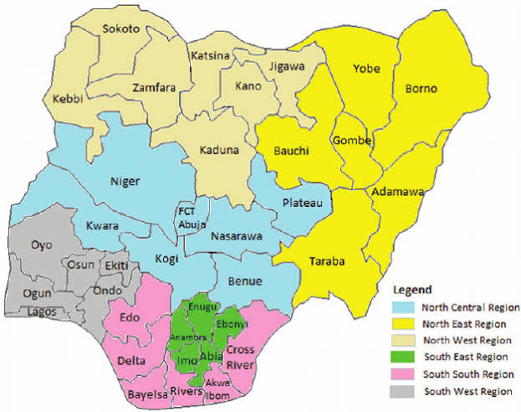
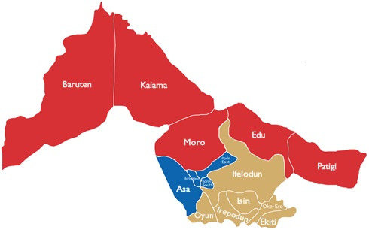
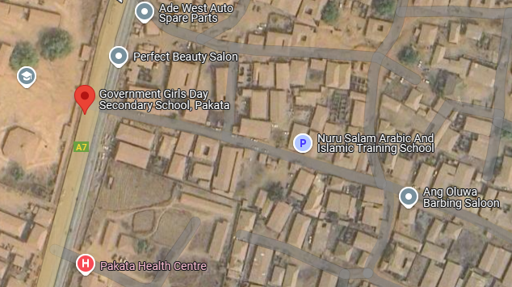
Fig. 1.1: Maps showing the study area

CHAPTER TWO
LITERATURE REVIEW
2.1 INTRODUCTION
A Topographical Survey (TIS) represents a critical framework in the geospatial sciences, integrating advanced technologies to capture, analyze, and visualize terrain data for diverse applications. Rooted in the evolution of Geographic Information Systems (GIS), TIS focuses specifically on representing the three-dimensional characteristics of the Earth’s surface, including elevation, slope, landforms, and natural or human-made features. The growing demand for precise topographic data in fields such as urban planning, environmental conservation, disaster management, and infrastructure development has driven the development of these systems, which combine traditional cartographic principles with modern computational tools. Recent advancements in remote sensing, LiDAR (Light Detection and Ranging), GPS (Global Positioning System), and machine learning have further enhanced the accuracy and accessibility of topographic modeling, enabling real-time data processing and dynamic spatial analysis. However, challenges persist in managing large-scale datasets, ensuring interoperability across platforms, and addressing the computational demands of high-resolution terrain modeling. This literature review explores the theoretical foundations, technological innovations, and practical implementations of TIS, while examining gaps in current research and emerging trends that could redefine its role in addressing global challenges such as climate change adaptation and sustainable land-use planning. By synthesizing interdisciplinary perspectives, this review aims to provide a comprehensive understanding of how TIS bridges geospatial science, engineering, and policy-making in the modern era.
The historical development of topographic mapping reflects a transformative journey from rudimentary manual techniques to sophisticated digital systems, shaped by technological innovation and evolving societal needs. Early topographic practices emerged in ancient civilizations, such as the Egyptians and Romans, who employed basic surveying tools like chains, levels, and theodolites to demarcate land boundaries and plan infrastructure. However, systematic topographic mapping gained momentum in the 18th and 19th centuries with the rise of national cartographic initiatives, exemplified by projects like the Cassini family’s Carte de France and the Ordnance Survey in Britain. These efforts relied on triangulation networks and plane-table surveys, producing highly detailed but labor-intensive paper maps that became foundational for military, administrative, and exploratory purposes. The 20th century marked a paradigm shift with the advent of aerial photography and photogrammetry, enabling the capture of large-scale terrain data from aircraft, which significantly improved map accuracy and coverage. Post-World War II advancements in computing catalyzed the transition from analog to digital methods, with the 1970s-1980s witnessing the integration of Geographic Information Systems (GIS), which allowed spatial data to be stored, analyzed, and visualized electronically. The proliferation of satellite-based technologies, such as GPS in the 1990s, and remote sensing tools like LiDAR (Light Detection and Ranging), revolutionized data acquisition, offering unprecedented precision in elevation modeling and 3D terrain representation. Concurrently, the development of open-source platforms and cloud computing democratized access to topographic data, fostering collaboration across disciplines. Today, digital topographic systems seamlessly blend real-time data streams, machine learning algorithms, and high-resolution sensors to support dynamic applications, from disaster response to autonomous navigation. This evolution underscores not only technological progress but also a broader shift toward interdisciplinary, data-driven approaches in addressing global geospatial challenges.
2.1.1 FUNDAMENTALS OF TOPOGRAPHICAL SURVEY
The fundamentals of Topographical Surveys (TIS) rest on an integrated framework of core components—data acquisition, storage, processing, and visualization—that collectively enable the accurate representation and analysis of terrain features. Data acquisition forms the foundational step, encompassing diverse methodologies to capture spatial and elevation data. Traditional ground-based techniques, such as theodolite surveys and leveling instruments, have been augmented by advanced technologies like LiDAR (Light Detection and Ranging), aerial and satellite remote sensing, and GPS (Global Positioning System), which offer high-resolution, three-dimensional terrain data over vast areas. These methods are complemented by photogrammetric analysis of stereo imagery and the growing use of unmanned aerial vehicles (UAVs) for flexible, localized data collection. Once acquired, the data must be systematically stored in structured databases or geospatial repositories, often leveraging relational database management systems (RDBMS) or cloud-based platforms to handle the volume, variety, and velocity of modern topographic datasets. Efficient storage solutions ensure data integrity, scalability, and accessibility, facilitating seamless retrieval for downstream applications.
The processing component involves transforming raw data into actionable insights through algorithms and computational workflows. This includes generating digital elevation models (DEMs), calculating slope and aspect ratios, performing hydrological modeling to predict water flow patterns, and applying machine learning techniques to classify landforms or detect changes over time. Interoperability between software tools, such as GIS platforms (e.g., ArcGIS, QGIS) and specialized terrain analysis programs, is critical to streamline these processes.
Finally, visualization translates processed data into interpretable outputs, ranging from traditional 2D contour maps to dynamic 3D renderings and immersive virtual environments. Advances in computer graphics, web mapping services, and augmented reality (AR) have expanded the possibilities for interactive and real-time terrain visualization, aiding decision-makers in fields like urban planning, environmental monitoring, and disaster risk assessment. Together, these components form a cohesive pipeline that underscores the functionality of TIS, emphasizing not only technical precision but also user-centric design to bridge the gap between complex geospatial data and practical, real-world applications.
2.2 CONCEPT OF TOPOGRAPHIC INFORMATION
A Topographical Survey (TIS) has been extensively explored by scholars, reflecting its interdisciplinary significance. Longley et al. (2015) emphasize that TIS builds on the foundational principles of Geographic Information Systems (GIS), integrating terrain-specific data to model elevation, slope, and landforms, which are critical for applications such as hydrology and urban planning. They argue that the integration of digital elevation models (DEMs) and remote sensing data has revolutionized topographic analysis, enabling dynamic spatial modeling (Longley et al., 2015). Tomlin (2013) highlights the role of cartographic modeling in TIS, stressing that map algebra—a technique for raster-based spatial analysis—is indispensable for processing topographic data to derive derivatives like aspect and curvature. His work underscores the mathematical rigor required to transform raw elevation data into actionable insights (Tomlin, 2013).
Li et al. (2005) delve into advancements in data acquisition, particularly the shift from traditional surveying to LiDAR and photogrammetry. They note that LiDAR’s ability to penetrate vegetation and generate high-resolution DEMs has addressed longstanding limitations in terrain mapping, especially in densely forested or complex landscapes (Li et al., 2005). Goodchild (2007) expands on the theoretical underpinnings of TIS, framing it within the broader context of geographic information science (GIScience). He posits that the accuracy and interoperability of topographic data depend on robust metadata standards and spatial reference systems, which are vital for cross-platform compatibility (Goodchild, 2007).
From a technological perspective, Vosselman and Maas (2010) explore the integration of airborne and terrestrial laser scanning in TIS, demonstrating how point cloud data can be processed to reconstruct 3D terrain models with sub-meter precision. Their work underscores the synergy between hardware advancements and algorithmic innovations, such as noise filtering and surface interpolation (Vosselman & Maas, 2010). Meanwhile, Zhou et al. (2017) focus on the application of TIS in disaster management, illustrating how real-time topographic data can enhance flood modeling and landslide prediction. They argue that the fusion of TIS with hydrological models has improved the predictive capacity of hazard assessments (Zhou et al., 2017).
Critically, Fisher and Tate (2006) address the challenges of data quality and error propagation in TIS, noting that uncertainties in DEMs—stemming from sensor limitations or interpolation methods—can significantly impact downstream analyses like slope stability or watershed delineation. They advocate for probabilistic modeling to quantify and mitigate these errors (Fisher & Tate, 2006). In contrast, Harvey (2008) critiques the over-reliance on technological solutions, cautioning that the complexity of TIS workflows may alienate non-technical stakeholders. He calls for user-centered design principles to enhance the accessibility of topographic tools for policymakers and community planners (Harvey, 2008).
Emerging trends in TIS are explored by scholars like Song et al. (2020), who discuss the role of artificial intelligence (AI) in automating feature extraction from topographic datasets. Their research demonstrates how convolutional neural networks (CNNs) can classify landforms or detect erosion patterns with minimal human intervention, marking a shift toward data-driven terrain analysis (Song et al., 2020). Similarly, Yang et al. (2020) highlight the potential of cloud-based TIS platforms to democratize access to high-resolution topographic data, enabling collaborative global initiatives like climate resilience planning.
In summary, the literature reveals TIS as a dynamic field shaped by advancements in geospatial technology, theoretical innovations in GIScience, and evolving societal demands. While authors like Li et al. (2005) and Vosselman and Maas (2010) emphasize technical progress, others such as Fisher and Tate (2006) and Harvey (2008) stress the importance of addressing data quality and usability challenges. Collectively, these contributions underscore the need for interdisciplinary collaboration to optimize TIS for both scientific rigor and practical relevance.
2.2.1 TECHNOLOGIES IN TOPOGRAPHIC DATA COLLECTION
The evolution of technologies in topographic data collection has revolutionized the way terrain and surface features are measured, analyzed, and represented, enabling unprecedented precision, efficiency, and scalability. Global Positioning System (GPS) technology, a cornerstone of modern geospatial data acquisition, provides real-time, centimeter-level accuracy in positioning through satellite-based triangulation. Differential GPS (DGPS) and Real-Time Kinematic (RTK) systems have enhanced reliability in challenging environments, such as dense forests or urban canyons, by correcting signal errors caused by atmospheric interference. GPS is integral to field surveys, enabling the georeferencing of ground control points (GCPs) that anchor aerial or satellite data to real-world coordinates, ensuring spatial consistency across datasets.
Remote sensing, spanning satellite and aerial platforms, offers synoptic and multi-temporal perspectives of the Earth’s surface. Optical sensors, such as those on Landsat or Sentinel satellites, capture multispectral and panchromatic imagery, which is processed to derive topographic indices like Normalized Difference Vegetation Index (NDVI) or land cover classifications. Synthetic Aperture Radar (SAR) systems, unaffected by cloud cover or darkness, penetrate vegetation and soil to map subsurface features or monitor ground displacement. Photogrammetric techniques, using stereo imagery from drones or aircraft, generate high-resolution digital elevation models (DEMs) by triangulating overlapping images, a method particularly effective for large-area mapping.
LiDAR (Light Detection and Ranging) represents a paradigm shift in topographic data collection, employing pulsed laser beams to measure distances between the sensor and the ground. Airborne LiDAR systems, mounted on planes or helicopters, produce dense point clouds that resolve fine-scale terrain features, even beneath vegetation, by distinguishing between canopy and ground returns. Terrestrial LiDAR, deployed on tripods or mobile platforms, captures intricate 3D models of structures, slopes, or archaeological sites with millimeter accuracy. The technology’s ability to generate digital terrain models (DTMs) free from vegetation interference has proven invaluable in floodplain mapping, forestry, and urban planning. Recent advancements in miniaturized LiDAR sensors for drones (UAV-LiDAR) have democratized access to high-resolution topographic data, enabling rapid surveys of inaccessible or hazardous areas.
Drone-based mapping, facilitated by unmanned aerial vehicles (UAVs), has emerged as a versatile and cost-effective tool for localized topographic data collection. Equipped with RGB cameras, multispectral sensors, or LiDAR payloads, drones capture ultra-high-resolution imagery and elevation data at scales previously unattainable with manned aircraft. Photogrammetric software, such as Structure-from-Motion (SfM), processes drone imagery into orthomosaics and 3D point clouds, enabling detailed volumetric analysis of landscapes, quarries, or construction sites. Drones excel in rapid response scenarios, such as post-disaster assessments, where real-time data on landslides or flood extents is critical. Their flexibility in deployment, combined with advancements in automation and AI-driven flight planning, reduces operational costs and human error, making them indispensable for both academic research and commercial applications.
The integration of these technologies has created synergies that enhance topographic data quality and utility. For instance, GPS provides the geospatial framework for aligning LiDAR and drone datasets, while remote sensing offers contextual layers (e.g., vegetation cover) that enrich terrain analysis. Challenges remain, including the computational demands of processing massive point clouds, the need for standardized data formats across platforms, and the high costs of advanced sensors like LiDAR. Nevertheless, ongoing innovations—such as AI-driven noise filtering in LiDAR data, edge computing for real-time drone analytics, and the fusion of SAR with optical datasets—continue to push the boundaries of what topographic systems can achieve. As these technologies mature, they promise to further democratize access to high-fidelity topographic information, empowering diverse sectors to address global challenges like climate resilience, sustainable infrastructure, and ecosystem conservation.
2.2.2 DATA INTEGRATION IN GEOGRAPHIC INFORMATION SYSTEMS (GIS)
Data integration in Geographic Information Systems (GIS) involves the harmonization of topographic data with diverse geospatial datasets to create cohesive, multi-layered analytical frameworks that support complex spatial decision-making. Topographic data, which includes elevation models, slope gradients, landforms, and hydrological features, serves as a foundational layer in GIS, anchoring other thematic data—such as land use, infrastructure, vegetation, or socio-economic information—to a spatially accurate terrain context. The integration process begins with ensuring compatibility in data formats and coordinate systems. Topographic datasets, often acquired through LiDAR, GPS surveys, or remote sensing, are typically stored in raster formats (e.g., Digital Elevation Models, or DEMs) or vector formats (e.g., contour lines, point clouds). GIS platforms like ArcGIS, QGIS, or open-source tools employ georeferencing and projection transformations to align these datasets with other spatial layers, such as satellite imagery or cadastral maps, ensuring geometric consistency across scales and sources.
Interoperability standards, such as those defined by the Open Geospatial Consortium (OGC), play a pivotal role in enabling seamless data exchange. For instance, web services like Web Map Service (WMS) or Web Feature Service (WFS) allow topographic data hosted on remote servers to be dynamically integrated into GIS workflows without requiring local storage. Topographic data is often fused with attribute data through spatial joins or overlay analyses, such as combining elevation data with soil type layers to assess landslide susceptibility or merging slope maps with transportation networks to optimize road planning. Advanced GIS platforms leverage geoprocessing tools—such as raster algebra, hydrological modeling extensions, or 3D visualization modules—to synthesize topographic inputs with environmental, urban, or climatic variables, enabling predictive analytics like flood risk simulations or solar potential mapping.
A critical challenge in integration lies in managing data resolution and accuracy disparities. High-resolution LiDAR datasets, for example, may conflict with coarser satellite-derived layers, necessitating resampling or generalization techniques to maintain analytical coherence. Semantic harmonization is equally vital; metadata standards (e.g., ISO 19115) ensure that parameters like vertical accuracy, sensor type, and acquisition dates are documented, allowing users to evaluate the fitness-for-purpose of integrated datasets. Cloud-based GIS platforms, such as Google Earth Engine or Esri’s ArcGIS Online, further streamline integration by offering centralized repositories where topographic data can be combined with global datasets in real time, facilitating large-scale analyses like continental-scale erosion modeling or cross-border infrastructure planning.
Emerging trends in data integration emphasize automation and artificial intelligence. Machine learning algorithms are increasingly used to automate feature extraction from topographic data—such as identifying river networks from DEMs or classifying urban structures from 3D point clouds—and link these features to external databases (e.g., census data or climate records). The rise of 3D GIS and Building Information Modeling (BIM) integration also highlights how topographic data is merging with architectural and engineering datasets to support smart city initiatives, where terrain dynamics inform everything from drainage systems to energy grids. Despite these advancements, issues like data sovereignty, computational scalability, and user accessibility persist, underscoring the need for collaborative frameworks that balance technical rigor with practical usability. Ultimately, effective integration of topographic data into GIS platforms transforms raw geospatial information into actionable intelligence, bridging the gap between terrain science and interdisciplinary applications in sustainability, disaster resilience, and resource management.
2.2.3 TOPOGRAPHIC DATA MODELS AND FORMATS
Topographic data models and formats serve as the structural backbone for representing terrain characteristics in digital environments, with raster and vector paradigms offering distinct approaches to capturing elevation and surface features. Raster-based models, such as Digital Elevation Models (DEMs), represent terrain as a grid of cells (pixels), where each cell stores an elevation value. DEMs are widely used due to their simplicity and compatibility with remote sensing data, enabling efficient computation of slope, aspect, and hydrological flow patterns. However, their fixed resolution can lead to large file sizes in high-detail applications and may oversimplify complex terrain features like cliffs or ravines. Vector-based models, on the other hand, use geometric primitives (points, lines, polygons) to represent terrain. Triangulated Irregular Networks (TINs) exemplify this approach, constructing a mesh of interconnected triangles where each vertex corresponds to a measured elevation point. TINs adapt dynamically to terrain complexity, using fewer points in flat areas and denser triangles in rugged regions, optimizing both accuracy and storage efficiency. This flexibility makes TINs ideal for engineering and hydrological modeling, where precise representation of breaklines (e.g., ridges, streams) is critical.
DEMs and TINs differ fundamentally in their data structures and applications. DEMs excel in large-scale, uniform terrain analysis, such as continental-scale elevation mapping or satellite-derived flood modeling, while TINs are favored for localized, high-precision projects like road design or landslide risk assessment. Hybrid approaches, such as converting DEMs to TINs for specific analyses, are common in GIS workflows to leverage the strengths of both models. Data formats for these models vary widely: raster formats like GeoTIFF, ASCII GRID, or proprietary formats (e.g., Esri’s GRID) dominate DEM storage, whereas TINs are often stored in vector formats such as shapefiles or specialized structures within GIS software. Emerging formats like LAS/LAZ (for LiDAR point clouds) and Cloud Optimized GeoTIFF (COG) enhance interoperability and cloud-based processing, addressing challenges of scalability and accessibility.
The choice between raster and vector models hinges on the project’s scale, resolution requirements, and computational resources. For instance, global climate models might rely on low-resolution DEMs for efficiency, while urban planners may use TINs to integrate infrastructure data with 3D terrain. Despite advancements, challenges persist, including balancing resolution with storage costs, managing error propagation in interpolated datasets, and ensuring compatibility across software platforms. Standards like the USGS DEM specification or OpenTopography initiatives promote consistency, while machine learning techniques are increasingly employed to refine DEM accuracy or automate TIN generation from point clouds. As topographic data grows in volume and complexity, the evolution of these models and formats continues to shape their utility in addressing geospatial challenges, from precision agriculture to disaster resilience, underscoring their foundational role in modern geospatial science.
2.3 APPLICATIONS OF TOPOGRAPHICAL SURVEYS
Topographical Surveys (TIS) have become indispensable across diverse sectors by providing spatially explicit insights into terrain dynamics, enabling data-driven decision-making in urban planning, disaster management, environmental monitoring, and infrastructure development. In urban planning, TIS underpins the design of resilient cities by integrating elevation data, slope analysis, and 3D terrain models to optimize land-use zoning, mitigate flood risks, and plan transportation networks. For instance, digital elevation models (DEMs) and LiDAR-derived datasets are used to identify low-lying areas prone to inundation, guiding the placement of critical infrastructure away from floodplains. Urban planners leverage TIS to simulate scenarios such as stormwater runoff in proposed developments, ensuring compliance with sustainability standards. Additionally, 3D city models, enriched with topographic data, facilitate visual impact assessments for high-rise buildings or green spaces, balancing aesthetic, ecological, and functional priorities.
In disaster management, TIS plays a pivotal role in predicting, mitigating, and responding to natural hazards. Hydrological models built on high-resolution DEMs simulate flood propagation, enabling authorities to delineate evacuation routes and design retention basins. For example, Zhou et al. (2017) demonstrated how integrating LiDAR-derived terrain data with rainfall forecasts improves flood prediction accuracy in urban catchments. Similarly, landslide susceptibility maps, generated by analyzing slope stability and soil composition through TIS, inform early warning systems in mountainous regions. Post-disaster, drone-based topographic surveys rapidly assess damage, as seen in earthquake-affected areas where collapsed structures and blocked roads are mapped in near real-time to coordinate rescue operations. These applications highlight TIS’s capacity to transform raw terrain data into life-saving actionable intelligence.
Environmental monitoring leverages TIS to track ecological changes and inform conservation strategies. DEMs and multispectral satellite imagery are combined to monitor deforestation, soil erosion, and habitat fragmentation. For instance, topographic wetness indices derived from DEMs help identify critical wetland areas requiring protection, while LiDAR data reveals canopy height variations to assess forest health. In coastal zones, TIS analyzes beach morphology changes due to sea-level rise or storm surges, supporting adaptive management of shorelines. Researchers also use TIS to model sediment transport in river basins, aiding in the restoration of degraded ecosystems. The integration of time-series topographic data with climate models further enables the prediction of long-term environmental shifts, such as glacier retreat or desertification, fostering proactive policy interventions.
For infrastructure development, TIS ensures the engineering resilience and cost-effectiveness of projects such as highways, dams, and energy grids. Engineers rely on TINs (Triangulated Irregular Networks) to model cut-and-fill operations, minimizing earthwork costs during road construction in hilly terrain. Slope stability analyses, powered by DEMs and geotechnical data, prevent failures in railway or pipeline routes. In hydropower projects, TIS-driven watershed modeling optimizes dam placement by predicting water yield and sedimentation rates. Renewable energy sectors use topographic solar radiation models to identify optimal sites for solar farms, while wind corridor analyses inform turbine placement. Furthermore, TIS supports underground utility mapping, reducing risks during excavation by integrating subsurface LiDAR or ground-penetrating radar data with surface terrain models.
These applications underscore TIS’s transformative role in bridging geospatial science with practical solutions. Challenges such as data resolution mismatches, computational demands, and the need for interdisciplinary collaboration persist, yet advancements in AI, cloud computing, and sensor technologies continue to expand TIS’s potential. By harmonizing topographic data with socio-economic and environmental variables, TIS not only addresses immediate technical needs but also fosters sustainable development in an era of escalating climatic and anthropogenic pressures.
2.4 CHALLENGES IN TOPOGRAPHICAL SURVEYS
Topographical Surveys (TIS) face significant challenges that hinder their effectiveness and scalability, despite their transformative potential. Accuracy remains a persistent concern, as errors propagate through every stage of data acquisition, processing, and analysis. Sensor limitations, such as LiDAR’s reduced efficacy over water surfaces or GPS signal degradation in urban canyons, introduce inaccuracies in raw datasets. Even advanced technologies struggle with environmental variables: dense vegetation can obscure ground returns in LiDAR, while cloud cover disrupts optical remote sensing. Post-processing steps, such as interpolating sparse elevation points into continuous DEMs (Digital Elevation Models), further amplify uncertainties. For instance, Fisher and Tate (2006) emphasize that small vertical errors in DEMs can drastically skew hydrological models, misrepresenting flood extents or watershed boundaries. Ensuring accuracy demands rigorous validation against ground truth data, which is often resource-intensive and geographically limited.
Data updating poses another critical challenge, as topographic datasets rapidly become obsolete due to dynamic natural and anthropogenic changes. Erosion, landslides, deforestation, and urban expansion alter terrain features, rendering existing models inadequate for time-sensitive applications like disaster response. Traditional update methods, such as aerial surveys, are costly and logistically complex, while satellite-based systems may lack the resolution or revisit frequency needed for localized changes. Although drones and crowdsourced geodata (e.g., OpenStreetMap) offer more agile alternatives, they often lack the standardization and coverage required for large-scale updates. This inconsistency creates gaps in monitoring long-term processes like glacial retreat or coastal erosion, where continuous, high-resolution data is essential.
Cost barriers further constrain the adoption and maintenance of TIS. High-resolution LiDAR surveys, for example, require significant investment in equipment, specialized personnel, and computational infrastructure. Storage and processing of massive datasets—such as terabytes of point clouds from airborne LiDAR—add to operational expenses, particularly for resource-limited organizations or developing regions. Proprietary software licenses for advanced GIS tools and machine learning platforms compound these costs, creating inequities in access. While open-source solutions like QGIS and cloud-based processing (e.g., Google Earth Engine) mitigate some financial burdens, they often lack the precision or support needed for specialized applications, such as engineering-grade slope stability analysis.
Interoperability issues arise from the heterogeneous formats, standards, and scales of topographic data. Integrating LiDAR point clouds with satellite imagery or legacy vector datasets demands laborious format conversions and spatial alignment, often resulting in data loss or misregistration. Divergent metadata standards—such as variations in vertical datums or coordinate systems—complicate cross-platform collaboration, as seen in cross-border infrastructure projects where national mapping agencies use incompatible frameworks. While initiatives like the Open Geospatial Consortium (OGC) promote standardization, proprietary systems and fragmented policies persist. For example, merging 3D city models (BIM) with TIS for smart city planning requires reconciling architectural and geospatial data paradigms, a task hindered by technical and institutional silos.
These challenges are interconnected: accuracy limitations drive up costs through repeated surveys, while interoperability gaps reduce the utility of updated data. Addressing these issues requires advancements in sensor technology, AI-driven error correction, and policy frameworks that incentivize open data sharing. Collaborative efforts, such as global DEM initiatives (e.g., NASA’s SRTM) and federated cloud platforms, exemplify progress, yet systemic barriers remain. Overcoming these hurdles is crucial to unlocking TIS’s full potential in fostering resilience, equity, and sustainability in an era of rapid environmental and urban change.
2.5 RECENT ADVANCES AND TRENDS
Recent advances and trends in Topographical Surveys (TIS) reflect a convergence of cutting-edge technologies and interdisciplinary innovation, driving unprecedented precision, accessibility, and scalability in terrain analysis. Artificial Intelligence (AI) and Machine Learning (ML) have emerged as transformative forces, automating tasks such as feature extraction from LiDAR point clouds, landform classification, and error correction in digital elevation models (DEMs). Deep learning algorithms, including convolutional neural networks (CNNs), now enable rapid identification of geological hazards (e.g., landslides, sinkholes) and urban infrastructure from multispectral and 3D data, reducing reliance on manual interpretation. For instance, Song et al. (2020) demonstrated how AI can classify micro-topographic features in coastal zones, enhancing erosion prediction models. Cloud computing and edge processing have democratized access to high-performance topographic analytics, with platforms like Google Earth Engine and Microsoft Planetary Computer offering global-scale DEM processing and real-time hydrological simulations. Edge computing further empowers field devices, such as drones, to perform on-board LiDAR data filtering and 3D reconstruction, enabling instant decision-making in disaster response.
Advances in sensor technology continue to redefine data acquisition. Miniaturized LiDAR sensors integrated with unmanned aerial vehicles (UAVs) now deliver centimeter-level accuracy at a fraction of traditional costs, while hyperspectral drones capture terrain-vegetation interactions for precision agriculture. Satellite constellations (e.g., ICEYE, Capella Space) equipped with Synthetic Aperture Radar (SAR) provide frequent, all-weather topographic updates, critical for monitoring glacial dynamics or volcanic activity. Multi-sensor fusion—combining LiDAR, SAR, and optical imagery—has improved terrain modeling in challenging environments, such as dense forests or urban canyons, by compensating for individual sensor limitations.
The rise of 3D geospatial frameworks and digital twins has blurred the lines between TIS and smart city planning. High-resolution 3D city models, enriched with real-time topographic data, simulate urban growth, flood scenarios, and energy consumption patterns, fostering resilient infrastructure design. Augmented Reality (AR) and Virtual Reality (VR) tools now visualize terrain data immersively, aiding stakeholders in collaborative planning and public engagement. Open-source initiatives, such as OpenTopography and OpenStreetMap, coupled with FAIR (Findable, Accessible, Interoperable, Reusable) data principles, promote global collaboration, while blockchain technology is being explored to ensure data provenance and security in shared topographic repositories.
Ethical and sustainable trends are gaining traction, emphasizing equitable access to topographic resources and minimizing the environmental footprint of data collection. Low-cost UAVs and community-driven mapping projects empower marginalized regions to address local challenges, such as deforestation or water scarcity. Meanwhile, green LiDAR initiatives aim to reduce energy consumption in airborne surveys through optimized flight paths and sensor efficiency.
Looking ahead, the integration of TIS with Internet of Things (IoT) networks and 5G connectivity promises real-time terrain monitoring for adaptive climate resilience. As these trends evolve, they collectively address longstanding challenges in accuracy, cost, and interoperability, positioning TIS as a cornerstone of 21st-century geospatial intelligence.

CHAPTER THREE
3.1 METHODOLOGY
The methodology adopted for this topographic survey involved the use of a Total Station to establish the perimeter, fix details, and capture spot heights for terrain representation. The science behind the process relies on geodetic principles, trigonometry, and electronic distance measurement (EDM) to determine precise locations, elevations, and feature positions. The Total Station, an advanced surveying instrument, integrates an electronic theodolite, EDM, and a data processor to measure angles and distances with high accuracy. The data collected was later processed using specialized software to produce topographic maps and elevation models.
3.2 EQUIPMENT AND MATERIALS
The equipment used to carried out the Topographical Survey of Government Day Secondary School, Pakata are;
- Differential Global Positioning System (DGPS)
- Total Station (South Total Station)
- Prism
- Cutlass
- Survey Beacon
- Field Book
- Computer System
The primary instrument used was a Total Station, which operates on the principle of trigonometric distance measurement. It emits an infrared or laser beam that reflects off a prism placed at the target point. By analyzing the time taken for the signal to return, the Total Station calculates distances and, together with angular measurements, determines the precise position of each point. A tripod provided stability for the Total Station, ensuring measurement accuracy. A prism and prism pole were used as target reflectors, allowing the Total Station to lock onto and measure the position of survey points.
Benchmarks and control points provided a reference framework, ensuring all measurements were relative to a fixed coordinate system. A field book was used to manually record observations, sketches, and any necessary adjustments during the survey. Finally, data processing software such as AutoCAD Civil 3D and ArcGIS was employed to analyze and visualize the collected data, transforming it into usable topographic outputs.
3.3 SURVEY PROCEDURE
The survey was conducted in a systematic manner to ensure precision. It involved pre-survey planning, control point establishment, perimeter measurement, detail fixing, spot height recording, and data processing.
3.3.1 RECONNAISSANCE SURVEY
A reconnaissance survey is the preliminary stage of a topographic survey that involves gathering essential information about the site both in the office and in the field. The goal is to assess the terrain, identify potential challenges, plan the survey workflow, and ensure all necessary resources are available before the detailed survey begins.
Office Planning
The office reconnaissance involves researching existing data, reviewing maps, and planning the fieldwork to improve efficiency and accuracy. This step ensures that surveyors are well-prepared before stepping into the field.
1. Gathering Existing Data
- Available maps, and previous survey records of the area are collected and reviewed.
2. Identifying Control Points
- Existing geodetic control points are identified from national or local survey databases.
- Since control points are unavailable, plans are made to establish new ones within the survey area.
3. Planning Survey Workflow
- The survey approach, including the use of Total Stations, GPS, and leveling instruments, is determined.
- Team roles and responsibilities are assigned, and required equipment is listed.
- Potential challenges such as dense vegetation, water bodies, or built-up areas are noted for field adaptation.
4. Preparation of Field Materials
- Field sketches, coordinate lists, and necessary software for data collection are prepared.
- Batteries, tripods, and measuring tools are checked and calibrated.
Field Reconnaissance
The field reconnaissance involves physically visiting the site to verify office findings and assess real-time conditions that may impact the survey.

1. Site Visit and Visual Assessment
- The team walks through the survey area, confirming boundaries, terrain conditions, and accessibility.
- The presence of obstacles like water bodies, dense forests, or buildings is noted.
2. Verification of Control Points
- New control point locations are selected for proper coverage of the survey area.
3. Identifying Suitable Instrument Stations
- Locations for Total Station setups are chosen based on line-of-sight and coverage.
- Safe and stable positions for survey equipment are determined to minimize measurement errors.
3.3.2 ESTABLISHMENT OF CONTROL POINTS
Control points are the foundation of any survey, providing fixed reference positions that all subsequent measurements rely upon. These points ensure that the survey maintains consistency and accuracy across the entire area. The process of establishing control points involves setting up known reference stations from which measurements of boundaries, details, and elevations can be made.
Scientific and Technological Basis
Control points are based on geodetic and trigonometric principles. The positions of these points are determined using total stations, ensuring their precise locations in relation to a coordinate system. The Total Station works by measuring the horizontal and vertical angles, along with the slope distances to reference targets, and calculating the X, Y, and Z coordinates using trigonometry and EDM (Electronic Distance Measurement).
Step-by-Step Procedure
1. Selection of Control Point Locations
- The first step is to identify existing geodetic control points near the site.
- Since, no existing control points are available, new ones are established in stable, accessible locations.
- The locations are selected based on visibility, accessibility, and security, ensuring that the points can be used throughout the survey.
- The equipment used for the establishment of the control point is Differential Global Positioning System (DGPS)
Table 3.1: Table showing the new established control points
Control Station | Northing | Easting
KP 001 | 938 774.336 | 666 705.731
KP 002 | 938 668.328 | 666 518.319
KP 003 | 938 665.326 | 666 559.394

2. Setting up the Total Station
- A tripod is placed over the control point and carefully leveled to ensure stability.
- The Total Station is mounted on the tripod and centered over the control point using the built-in optical plummet or laser plummet.
- Fine adjustments are made using the leveling screws and circular bubble to ensure accuracy.
3. Backsighting to a Known Point
- The instrument is aligned to a known reference point (geodetic benchmark or previously established control point).
- A prism is placed at the reference point, and a backsight measurement is taken to establish orientation.
- This ensures that all subsequent measurements are tied to the correct coordinate system.
Fig. 3.1: Diagram showing the control station connection

KP
001

KP
002

KP
003
Backsight
Total Station

4. Measurement of New Control Points
- The Total Station emits a laser or infrared beam toward the prism held at the target control point location.
- The instrument measures the angle and distance and automatically calculates the X, Y, and Z coordinates of the new control point.
- Multiple readings are taken for accuracy.
5. Checking and Adjustment of Control Points
- A closed traverse is conducted, ensuring that the last control point connects back to the first one, forming a loop.
- Any misclosure errors are adjusted using the Bowditch method or Least Squares Adjustment, ensuring consistency and reliability of control points.
These control points now serve as the reference framework for all subsequent survey operations.
Table 3.2: Table showing the coordinate of the control point after the orientation
Control Station | Northing | Easting
KP 001 | 938 774.214 | 666 705.643
KP 002 | 938 668.328 | 666 518.319
KP 003 | 938 665.200 | 666 559.254

3.3.3 PERIMETER SURVEYING (BOUNDARY MEASUREMENT)
Once control points have been established, the next step is to determine the exact perimeter of the survey area. This involves measuring all boundary points to create an accurate map of the land extent.
Scientific and Technological Basis
Perimeter surveying relies on traverse computations and geospatial mapping. Using the Total Station, precise angular and distance measurements are taken from control points to define the boundary. The EDM system in the Total Station measures distances by calculating the travel time of an emitted laser beam, while the internal processor applies trigonometric calculations to determine the boundary points’ exact coordinates.
Step-by-Step Procedure
1. Setting Up the Total Station
- The Total Station is positioned at a control point and carefully leveled.
- A backsight measurement is taken to orient the instrument correctly to the established control network.
2. Marking Boundary Points
- The boundary points are identified in the field using physical markers (wooden pegs, iron rods, or concrete beacons).
- Each boundary corner is assigned a unique point number.
3. Measuring Boundary Points
- The prism reflector is placed at each boundary corner.
- The Total Station records horizontal angles, vertical angles, and slope distances to compute the exact location of each boundary point.
- If the distance is too far, the instrument is repositioned at a new control point to continue measurements.
4. Closing the Perimeter Traverse
- To ensure accuracy, the last boundary point is connected back to the first boundary point, creating a closed traverse.
- If errors exist in the traverse, adjustments are made using a traverse adjustment technique.
The perimeter survey ensures that the land boundaries are accurately mapped and legally verifiable.
3.3.4 FIXING OF DETAILS
After defining the perimeter, the next step is to fix natural and man-made details within the site, such as buildings, roads, trees, drainage channels, power poles, fences, and water bodies.
Scientific and Technological Basis
Fixing details involves topographic feature mapping, using the Total Station to determine the precise locations of objects within the survey area. The coordinate geometry (COGO) principles and EDM technology allow for highly accurate spatial positioning of objects.

Step-by-Step Procedure
1. Total Station Setup at a Control Point
- The Total Station is placed at a known control point, and backsighting is performed for orientation.
2. Detail Point Identification
- A prism pole is placed at specific feature locations, such as corners of buildings, road edges, electric poles, and trees.
- For linear features such as roads and drainage channels, multiple points are measured along their alignment.
3. Measurement of Features
- The Total Station records angles, distances, and elevations, calculating the precise X, Y, and Z coordinates of each detail point.
- Each recorded feature is assigned a category, ensuring organized mapping.
4. Verification and Cross-Checking
- The recorded points are plotted on a real-time sketch or digital map to verify their correctness.
Fixing details ensures that all site features are mapped accurately for design, analysis, or documentation.

3.3.5 SPOT HEIGHT MEASUREMENT
Spot height measurement is essential for understanding the elevation variations across the survey area. It involves recording the altitude (Z-coordinates) of multiple locations, which is crucial for terrain modelling, contour mapping, and engineering design.
Scientific and Technological Basis
Spot height measurement uses trigonometric leveling and terrain modeling principles. The Total Station calculates elevations by measuring vertical angles and slope distances to the prism, computing the precise height difference between the instrument and each point.
Step-by-Step Procedure
1. Setting Up the Total Station and Backsighting
- The instrument is placed on a control point with a known elevation (benchmark).
- A backsight is taken on another reference point to ensure correct height reference.
2. Grid-Based Spot Height Measurement
- A grid system is established, where spot heights are measured at uniform intervals across the site.
- The prism pole is placed at each grid point, and the Total Station records the elevation.
3. Recording Breakline Heights
- Additional spot heights are taken at breaklines (significant slope changes) such as road edges, embankments, and depressions.
4. Processing and Contour Mapping
- The collected elevations are used to generate contour lines and Digital Elevation Models (DEM), which visually represent the terrain.
Spot height measurements are essential for engineering design, flood analysis, and landscape assessment.
3.4 DELIVERABLES AND OUTPUT
The final deliverables of the topographic survey included:
1. Topographic Map – A detailed representation of the survey area, including contour lines, elevation points, and fixed features.
2. Digital Elevation Model (DEM) – A 3D visualization of the terrain, useful for hydrological and engineering analysis.
3. GIS and CAD Files – Digital data compatible with GIS and CAD software for further analysis and integration into project designs.

CHAPTER FOUR
RESULTS AND ANALYSIS
This chapter presents the results derived from the topographic survey carried out using Total Station equipment. The survey generated key outputs that include the defined perimeter of the site, fixed planimetric features, measured spot heights, a topographic map, and a digital terrain model (DTM). These outcomes were analyzed to evaluate the spatial characteristics, elevation dynamics, and surface morphology of the project site. The interpretations presented in this chapter are intended to aid physical planning, civil engineering design, land assessment, and environmental appraisal.
4.1 PERIMETER SURVEY RESULT
The first deliverable from the survey was the precise demarcation of the boundary enclosing the project area. Using Total Station equipment, angular and linear measurements were recorded along traverse lines connecting perimeter points. A closed traverse was executed, and adjustments were applied to eliminate angular and linear misclosures using Bowditch’s method. After corrections, coordinate computation yielded a total enclosed area of 5.746 hectares.
Each traverse station was referenced to a consistent datum, and coordinates were computed in a Universal Traverse Mercator (UTM) coordinate system. Bearings between stations and line distances were recorded with high accuracy, and redundant checks (backsight and foresight readings) confirmed data integrity.
Interpretation
The perimeter defines the legal footprint of the land parcel and forms the spatial foundation for all subsequent surveying and design activities. Its accuracy is critical for preventing encroachment and for ensuring compliance with planning laws. The 5.746-hectare area size is moderately expansive and suitable for mixed land uses, such as institutional development, housing schemes, or infrastructural expansion. The successful closure of the traverse with minimal misclosure values indicates a high level of precision in the control framework.
4.2 DETAILED (PLANIMETRIC) SURVEY RESULT
Following perimeter control, planimetric detail features were fixed within the site. This involved the identification and coordinate measurement of all physical features, both natural and man-made. The detail survey recorded 21 existing buildings, all of which were measured using reflector-based Total Station shots to capture at least three to four defining corners per building. This allowed for accurate plotting of their geometries.
Additionally, two mature trees were observed within the site. These were recorded with their coordinates and plotted for spatial awareness and environmental relevance. The survey also documented the adjoining road infrastructure along the stretch between PL11 and PL1, providing vital context for access and transport planning.
Interpretation:
The detailed feature inventory is essential for base mapping, land-use classification, and infrastructure alignment. The presence of 21 structures indicates active or past land usage, which must be considered in any redevelopment or land allocation strategy. Their layout can also inform site zoning, access corridors, and utility planning. The inclusion of tree positions aids in environmental impact assessments and landscaping design. Moreover, the bordering road increases the site's connectivity and suitability for development by ensuring access and linking the site to external infrastructure networks.
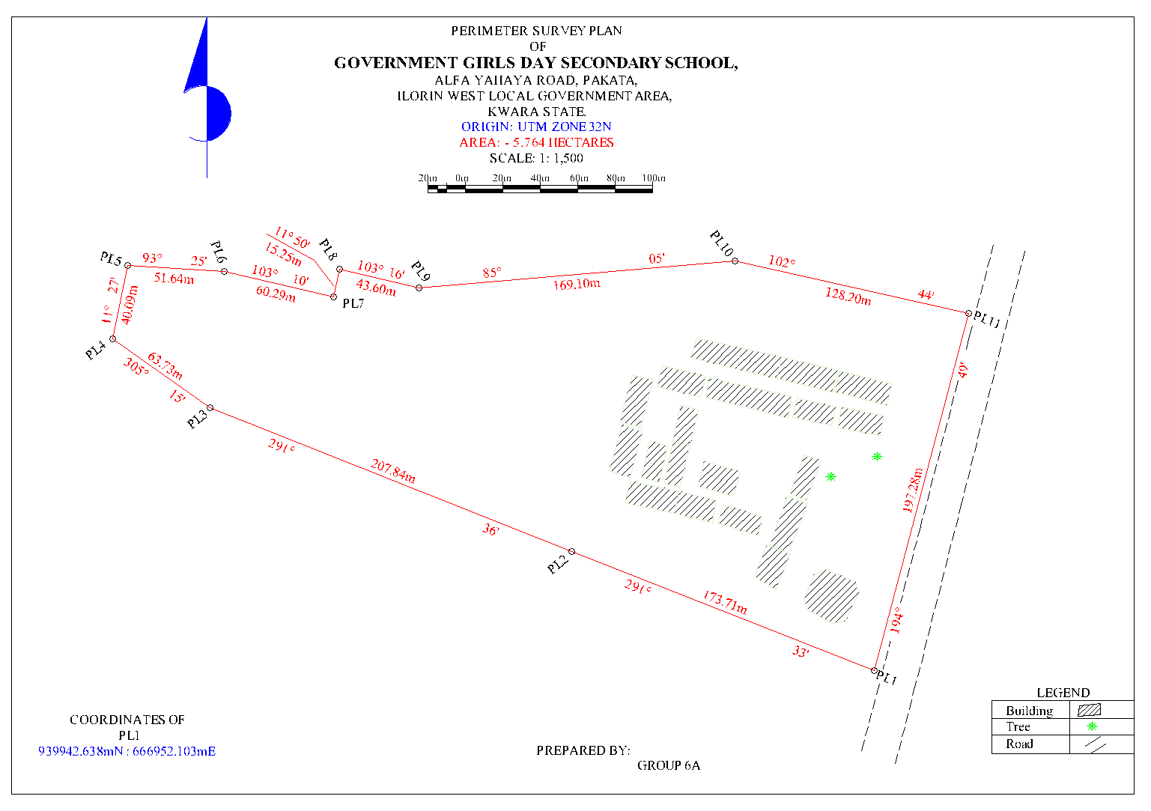 Fig 4.1: Detailed Plan of the Study area
4.3 SPOT HEIGHT MEASUREMENT AND ELEVATION ANALYSIS
Spot height measurements were obtained at regularly spaced intervals across the terrain to capture the vertical variation of the site. The spot heights ranged from 302.00 meters to 321.00 meters above mean sea level, indicating an elevation variation of 19 meters. Readings were taken at terrain breaks, slope transitions, and grid intersections to provide a full surface elevation dataset.
From the spot heights, contour lines were interpolated at 1.00-meter intervals, generating a continuous representation of elevation change across the site. The contours illustrate gradual and moderate slope patterns, with the steepest gradients located toward the northeastern section and relatively flatter terrain to the southwest.
Interpretation:
The elevation range reflects a moderate topographic undulation, which is advantageous for natural surface drainage, minimizing the risk of waterlogging. Slopes are not extreme, suggesting that grading requirements for construction will be minimal and cost-effective. The elevation profile also guides where best to site sensitive infrastructure such as roads, buildings, and stormwater channels. High points (up to 321m) are ideal for positioning critical structures, while lower points (around 302m) should be evaluated for potential runoff collection or water retention.
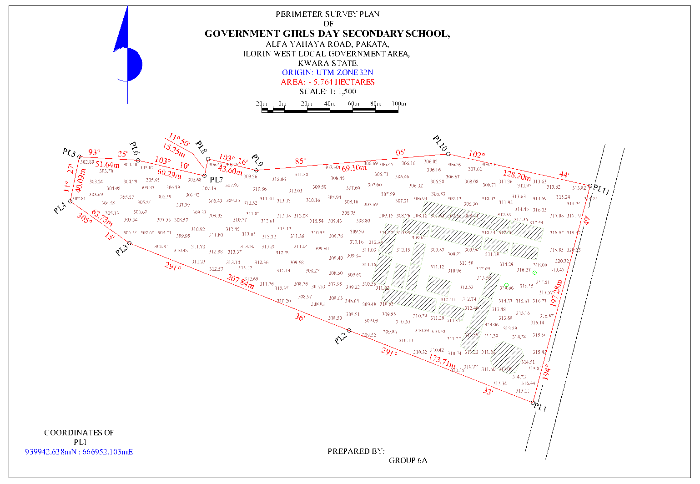 Fig 4.2: Spot Height Plan of the Study area
PLAN SHEWING THE SPOT HEIGHTS
OF
GOVERNMENT GIRLS DAY SECONDARY SCHOOL,
ALFA YAHAYA ROAD, PAKATA,
ILORIN WEST LOCAL GOVERNMENT AREA,
KWARA STATE.
ORIGIN: UTM ZONE 32N
AREA: - 5.764 HECTARES
SCALE: 1: 1,500

4.4 TOPOGRAPHIC MAP RESULT
The topographic map produced combines all collected spatial data — perimeter, details, and elevation — into a georeferenced and scaled map. The map visually represents both the horizontal arrangement of features and the vertical variations in elevation. Buildings are symbolized with clearly marked outlines, trees are shown with natural feature symbols, and roads are represented with line features matching their real-world orientation.
Contour lines dominate the elevation representation, showing continuous terrain levels at 1.00-meter intervals. The map layout includes northing, easting, scale bar, legend, and title block to comply with cartographic standards.
Interpretation:
The topographic map provides a single-source spatial document that aids decision-making across various disciplines. For architects, it allows the preparation of conceptual site layouts; for engineers, it supports terrain grading and slope analysis; and for urban planners, it informs land zoning and development control. Its clarity and completeness make it useful as both a presentation and analytical tool. It also enables integration into GIS environments for further spatial modeling or overlay with satellite imagery and planning datasets.
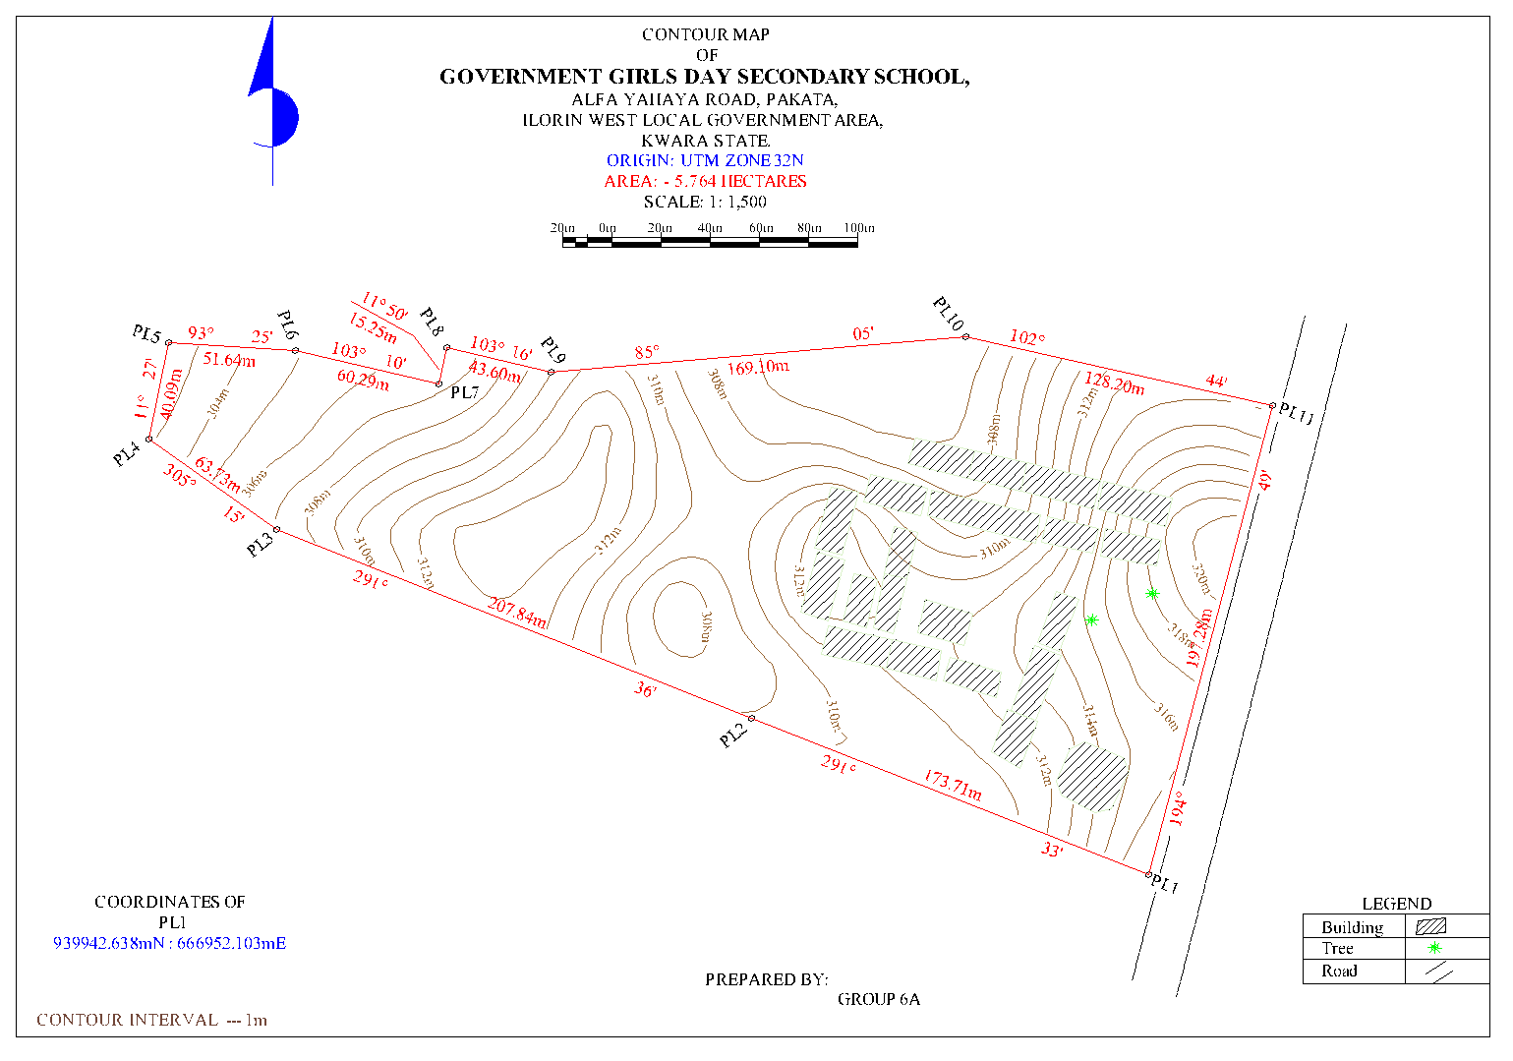 Fig 4.3: Contour Map of the Study area
CONTOUR PLAN
OF
GOVERNMENT GIRLS DAY SECONDARY SCHOOL,
ALFA YAHAYA ROAD, PAKATA,
ILORIN WEST LOCAL GOVERNMENT AREA,
KWARA STATE.
ORIGIN: UTM ZONE 32N
AREA: - 5.764 HECTARES
SCALE: 1: 1,500
4.5 DIGITAL TERRAIN MODEL (DTM) OUTPUT
Using the spot height dataset, a Digital Terrain Model (DTM) was generated to present the terrain as a continuous, 3D surface. The DTM was developed using interpolation techniques (e.g., Triangulated Irregular Network or Inverse Distance Weighting), and surface rendering was applied to visualize elevation differences, slope directions, and terrain curvature.
The DTM reveals subtle terrain changes not always visible on contour maps, such as micro-depressions or ridgelines. It is capable of supporting 3D visualization, fly-throughs, and terrain profiling, thereby enabling more advanced engineering applications.
Interpretation:
The DTM is a powerful tool for simulating hydrological flow, estimating earthwork quantities, and visualizing site development impact. It is especially useful for road design, cut-and-fill balancing, and modeling surface runoff. The 19-meter elevation range, when analyzed in the DTM, supports the identification of natural drainage paths and areas of potential erosion. The use of the DTM improves efficiency and reduces risks during planning and construction.
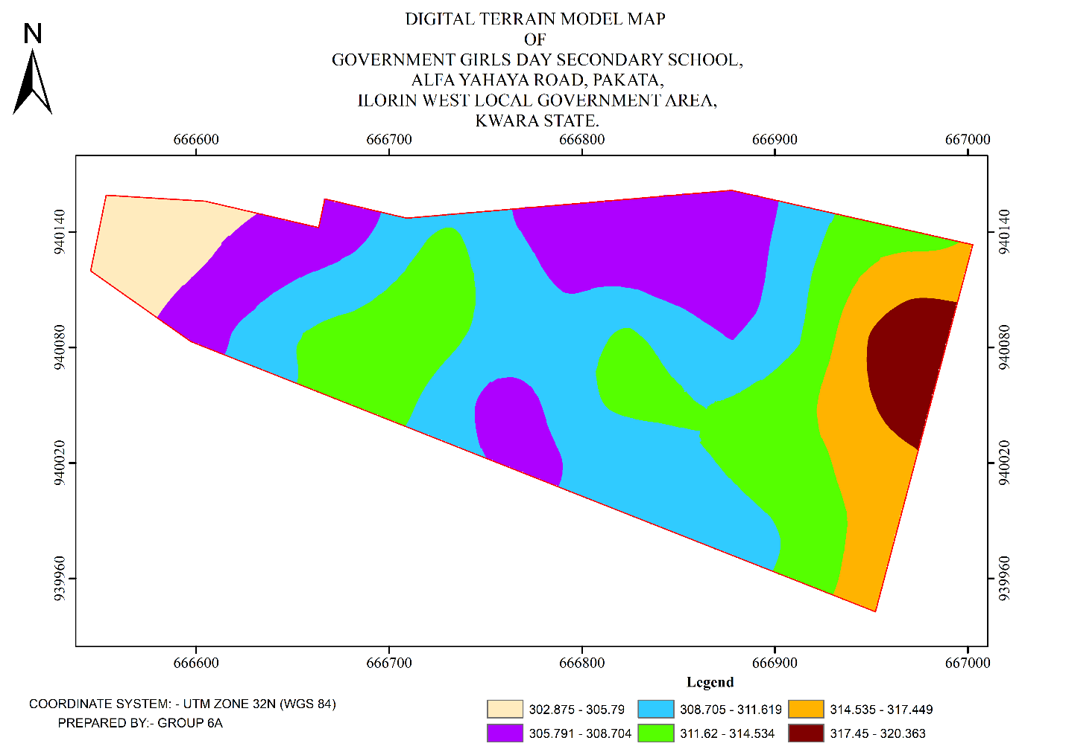 Fig 4.4: Digital Terrain Model Map of the Study area
4.6 INTEGRATED SPATIAL INTERPRETATION AND SITE ASSESSMENT
From the compiled results, it is evident that the site exhibits a balanced terrain with mild slopes, active land use, and strong access potential due to the bordering road. The presence of several buildings suggests partial occupation or previous use, while the terrain characteristics support new development with minimal site modification.
The combination of perimeter survey, detailed feature fixing, spot height data, contour mapping, and digital modeling ensures a comprehensive understanding of the site. The overall dataset can be used for:
- Land-use planning and zoning (based on building distribution and access routes)
- Engineering design (based on elevation and slope analysis)
- Drainage and stormwater design (from DTM slope flow directions)
- Construction layout and supervision
Integration into a GIS-based land information system

CHAPTER FIVE

COSTING, SUMMARY, PROBLEM ENCOUNTERED CONCLUSION AND RECOMMENDATIONS.
5.1 COST ESTIMATION
This stage the total cost spent on the project from day one to the final stage.
Table 5.1.1: Direct cost parameters
S/N | DIRECT COST
1 | Reconnaissance (1 day)
 | PERSONNEL | Rate | Total Amount (N:K)
 | 1 x surveyor | 10500 | 10500
 | 1 x assistant surveyor | 7500 | 7500
 | 1 x technical officer | 6500 | 6500
 | 3 x skilled labour | 4000 | 12000
 | basic equipment | 5000 | 5000:00
 | transportation (vehicle, Driver and fuel) | 10000 | 10000:00
 |  | sub-total | 51,500
2 | Monumentation (1 day)
 | PERSONNEL
 | 1 x assistant surveyor | 7500 | 7500
 | 1 skilled labour | 4000 | 4000
 | transportation (vehicle, Driver and fuel) | 10000 | 10000
 | basic equipment | 5000 | 5000:00

 | Beacon (6) | 1000 | 6000
 |  | sub-total | 32,500
3 | Data acquisition (2 days)
 | PERSONNEL
 | 1 x assistant surveyor | 7500 | 7500
 | 1 x technical officer | 6500 | 6500
 | 3 x skilled labour | 4000 | 12000
 | Total Station and accessories | 15000 | 15000
 | transportation (vehicle, Driver and fuel) | 10000 | 10000
 |  | sub-total | 51,000
5 | Data Processing (2 days)
 | PERSONNEL
 | 1 x surveyor | 10500 | 10500
 | 1 x assistant surveyor | 7500 | 7500
 | 1 x technical officer | 6500 | 6500
 | computer / accessories | 15000 | 15000
 |  | sub-total | 39,500
7 | Technical Report (1 day)
 | PERSONNEL
 | 1 x surveyor | 10500 | 10500
 | 1 x assistant surveyor | 7500 | 7500

 | 1 x secretary | 5000 | 5000:00
 | computer / accessories | 15000 | 15000:00
 |  | sub-total | 38,000
TOTAL (DIRECT COST) 212,500 MOBILIZATION/DEMOBILIZATION = 5% of Direct Cost
= 0.05 × 212,500

= N10,625

CONTINGENCY ALLOWANCE
= 5% of Direct Cost
= 0.05 × 212,500

= N10,225

GRAND TOTAL = N212,500 + N10,625 + N10,625

= N233,750

VAT (@5% GRAND TOTAL) = 0.05 × 233750

= N11,687.5
TOTAL COST PAYABLE = GRAND TOTAL + VAT

= N233,750+ N11,687.5 = N245,437.5

5.2 SUMMARY
The application of Topographical Surveys (TIS) to the study of part of the Government Girls Day Secondary School, Pakata, Ilorin West (LGA), Kwara State, represents an important step towards modernizing urban planning, infrastructure development, and environmental management in the region. TIS, through the integration of advanced tools such as Digital Elevation Models (DEMs), satellite imagery, and geospatial data analysis, provides a comprehensive understanding of the terrain characteristics of the area, including elevation, slope, and landforms. This information is critical for planning and development in urban zones like the Government Girls Day Secondary School, where the population density is increasing, and there is a need for sustainable infrastructure development.
The topographic data derived from TIS can assist in a variety of applications, including flood modeling, land use planning, drainage system design, and risk assessment for potential natural hazards, particularly flooding due to the region’s topographic features and seasonal rainfall patterns. The detailed mapping and analysis of the area’s topography also provide insights into potential sites for future urban expansion and infrastructure projects while ensuring that the built environment is adapted to the natural terrain. Moreover, TIS can aid local authorities and stakeholders in creating policies that prioritize environmental sustainability, resilient urban infrastructure, and public safety, particularly in the face of climate change and population growth.
As the use of TIS in Government Girls Day Secondary School continues to grow, it will contribute to the integration of smart city technologies, including real-time data integration and IoT-driven solutions for more effective urban management. This could include the continuous monitoring of infrastructure health, soil conditions, and environmental changes. Additionally, the accurate terrain data generated by TIS will be instrumental in addressing challenges related to land tenure, property disputes, and infrastructure maintenance.

5.3 PROBLEM ENCOUNTERED
The following were the problems encountered during the execution of this project.
- The project was financially expensive, energetic and time consuming.
- On the day of carrying out the practical, there was a delay in getting the instrument that resulted in getting to the site lately.
- Throughout the practical, we worked under the sun reason that we got to the site lately.

5.4 CONCLUSION
In conclusion, the integration of Topographical Surveys (TIS) into the planning and development of Government Girls Day Secondary School, Pakata, Ilorin West (LGA), Kwara State, offers a transformative approach to understanding and managing the region’s complex topographic and environmental characteristics. By leveraging advanced geospatial tools such as Digital Elevation Models (DEMs), satellite imagery, and real-time data collection technologies, TIS provides crucial insights into the terrain, which are invaluable for urban planning, disaster management, and infrastructure development. The use of TIS in this area enables stakeholders to make informed decisions about land use, flood risk assessment, and the design of resilient infrastructure that is aligned with the natural landscape, helping to mitigate the risks associated with topographic challenges.
Furthermore, the potential of TIS to integrate with emerging technologies like AI, IoT, and virtual/augmented reality promises to enhance the system's capability for real-time monitoring and dynamic decision-making. This integration will be pivotal in addressing future challenges as the region continues to urbanize, ensuring that growth is sustainable and that urban systems can effectively adapt to environmental changes.
However, for TIS to reach its full potential in Government Girls Day Secondary School, it is essential that data accuracy, accessibility, and local expertise are prioritized. Moreover, addressing the ethical concerns related to data privacy and ensuring equitable access to TIS benefits are key considerations for the long-term success of this technology in the region. With proper implementation and continuous improvements in data integration, TIS will play a critical role in shaping a more sustainable, resilient, and efficient urban future for Ilorin West LGA, enhancing the quality of life for its residents and fostering more effective governance.

5.5 RECOMMENDATION
Here is the recommendation section for the topic "Topographical Surveys (TIS) of Government Girls Day Secondary School, Pakata, Ilorin West (LGA), Kwara State, in a listed format:
  - Enhance Data Accuracy and Resolution: It is recommended to improve the resolution and accuracy of topographic data by using advanced technologies such as LiDAR and UAV-based photogrammetry for more detailed mapping of terrain features in Government Girls Day Secondary School. This will provide more precise information for urban planning and flood risk assessments.
  - Integrate Real-Time Monitoring Systems: The integration of Internet of Things (IoT) sensors and other real-time monitoring systems within the TIS framework will enable continuous updates on environmental changes, infrastructure health, and disaster management. This will facilitate quicker decision-making and responses to dynamic urban challenges.
  - Adopt Advanced Visualization Technologies: Utilize Virtual Reality (VR) and Augmented Reality (AR) technologies to create immersive 3D models of the topography for urban planners, engineers, and the local community. This will improve stakeholder engagement, enhance understanding of the terrain, and aid in effective spatial decision-making.
  - Strengthen Capacity Building and Training: Provide training programs for local government officials, urban planners, and other stakeholders to build capacity in using TIS tools and interpreting topographic data. This will ensure better utilization of the system and foster local expertise in managing urban development challenges.
  - Promote Public-Private Partnerships: Foster collaborations between government agencies, private sector firms, and academic institutions to improve data collection, system development, and the long-term sustainability of TIS in the region. These partnerships can support funding, research, and the sharing of best practices.

REFERENCES
Amirebrahimi, S., Rajabifard, A., Mendis, P., & Ngo, T. (2016). A data model for integrating GIS and BIM for assessment and 3D visualization of flood damage to building infrastructure. International Journal of Digital Earth, 9(4), 363–386.
Billinghurst, M., Clark, A., & Lee, G. (2015). A Survey of Augmented Reality. Foundations and Trends in Human–Computer Interaction, 8(2-3), 73–272.
Burrough, P. A., & McDonnell, R. A. (1998). Principles of Geographical Information Systems. Oxford University Press.
Campbell, J. B., & Wynne, R. H. (2011). Introduction to Remote Sensing (5th ed.). Guilford Press.
Chen, Y., Yu, J., & Khan, S. (2009). Spatial sensitivity analysis of multi-criteria weights in GIS-based land suitability evaluation. Environmental Modelling & Software, 24(12), 1508–1515.
Colomina, I., & Molina, P. (2014). Unmanned aerial systems for photogrammetry and remote sensing: A review. ISPRS Journal of Photogrammetry and Remote Sensing, 92, 79–97.
Crampton, J. W. (2010). Mapping: A Critical Introduction to Cartography and GIS. Wiley-Blackwell.
Goodchild, M. F. (2018). Reimagining the History of GIS. Annals of GIS, 24(1), 1–8.
ISO (2003). ISO 19115: Geographic Information—Metadata. International Organization for Standardization
Kukutai, T., & Taylor, J. (Eds.). (2016). Indigenous Data Sovereignty: Toward an Agenda. ANU Press.
Li, S., Da Xu, L., & Zhao, S. (2020). 5G Internet of Things: A survey. Journal of Industrial Information Integration, 10, 1–9.
Longley, P. A., Goodchild, M. F., Maguire, D. J., & Rhind, D. W. (2015). Geographic Information Science and Systems. Wiley.
Nebert, D. D. (2004). Developing Spatial Data Infrastructures: The SDI Cookbook. GSDI Association.
Percivall, G. (2010). The role of open standards in geospatial interoperability. In Handbook of Research on Geoinformatics, IGI Global, 92–103.
Shekhar, S., & Xiong, H. (2008). Encyclopedia of GIS. Springer.
Turner, M. G., Gardner, R. H., & O'Neill, R. V. (2001). Landscape Ecology in Theory and Practice. Springer.
Wilson, J. P., & Gallant, J. C. (2000). Terrain Analysis: Principles and Applications. Wiley.
Zhu, X. X., Tuia, D., Mou, L., Xia, G. S., Zhang, L., Xu, F., & Fraundorfer, F. (2017). Deep Learning in Remote Sensing: A Comprehensive Review and List of Resources. IEEE Geoscience and Remote Sensing Magazine, 5(4), 8–36.
APPENDIX
GROUP 6A TOPO RAW DATA
P.I.D EASTING NORTHING ELEVATION | P.I.D EASTING NORTHING ELEVATION
1,PT,666559.393,938655.226,324.403  2,BLD,666564.888,938655.589,324.609  3,BLD,666572.856,938656.418,324.845  4,BLD,666579.384,938656.990,325.081  5,BLD,666587.417,938657.779,325.249  6,FF,666584.030,938674.217,324.847  7,FF,666578.461,938674.102,324.602  8,SH,666562.850,938672.506,324.086  9,SH,666548.780,938675.012,323.749  10,SH,666529.505,938681.031,323.445  11,WF,666509.740,938692.262,322.828  12,GT,666501.195,938679.925,323.593  13,GT,666500.602,938679.080,323.629  14,WF,666494.023,938669.408,323.585  15,PIL,666489.939,938663.250,323.784  16,SH,666504.839,938663.969,323.640  17,SH,666518.319,938668.328,323.512  18,SH,666534.636,938665.045,323.618  19,SH,666537.246,938651.342,324.351  20,SH,666537.116,938640.217,324.791  21,PIL,666549.802,938626.341,325.710  22,BLD,666566.949,938635.507,325.534  23,SH,666560.052,938640.072,325.173  24,SH,666551.407,938652.598,324.272  25,SH,666550.568,938689.169,323.494  26,SH,666538.375,938698.658,323.125  27,SH,666518.282,938705.519,322.835  28,TR,666530.522,938714.804,323.065  29,BLD,666532.985,938723.275,322.886  30,BLD,666535.020,938722.153,323.014  31,BLD,666536.550,938724.511,323.043  32,BLD,666537.444,938726.038,323.111  33,BLD,666538.628,938728.344,323.073  34,TR,666547.428,938716.448,323.439  35,SH,666561.960,938714.995,323.735  36,SH,666577.398,938714.165,323.962  37,SH,666588.013,938713.553,324.333  38,SH,666594.902,938733.181,324.533  39,FF,666585.859,938745.789,324.080  40,FF,666580.138,938746.859,324.004  41,SH,666567.418,938742.689,323.674  42,BLD,666562.092,938744.078,323.581  43,BLD,666553.297,938748.849,323.116  44,WF,666548.166,938751.757,323.022  45,BLD,666573.843,938764.473,323.318  46,SH,666582.419,938761.025,323.802  47,SH,666592.201,938757.277,323.907  48,SH,666599.902,938752.070,324.093  49,SH,666602.626,938762.939,324.184  50,SH,666596.583,938765.303,324.118  51,SH,666588.891,938769.861,323.589  52,SH,666576.869,938779.026,323.581  53,SH,666579.252,938790.592,323.338  54,PIL,666578.121,938796.557,323.355  55,WF,666591.126,938795.641,323.822  56,SH,666599.788,938791.439,324.047  57,SH,666596.692,938780.969,323.967  58,SH,666606.748,938775.310,324.247  59,BLD,666616.773,938784.907,324.987  60,BLD,666617.378,938787.730,325.240  61,WF,666617.119,938792.478,324.683  62,BLD,666619.559,938784.367,325.202  63,BLD,666622.361,938785.821,325.247  64,BLD,666621.226,938776.323,324.742  65,SH,666620.229,938765.813,325.022  66,SH,666612.733,938767.946,324.700  67,SH,666611.600,938753.333,324.728  68,SH,666612.441,938739.964,324.961  69,SH,666615.825,938724.599,325.333  70,TR,666621.296,938715.292,325.998  71,SH,666610.096,938713.356,325.410  72,SH,666609.137,938700.165,325.546  73,SH,666611.831,938687.882,325.848  74,SH,666615.842,938679.399,326.144  75,SH,666616.033,938674.189,326.252  76,BLD,666615.837,938662.628,326.442  77,SH,666605.260,938663.643,326.041  78,BLD,666593.748,938659.167,325.634  79,SH,666592.892,938667.768,325.400  80,BLD,666619.597,938663.260,326.505  81,BLD,666639.099,938665.984,327.375  82,BLD,666643.840,938666.654,327.485  83,BLD,666665.520,938669.765,328.330  84,BLD,666668.596,938670.268,328.448  85,BLD,666690.662,938673.491,329.178  86,BLD,666693.533,938675.060,329.155  87,BLD,666691.985,938685.179,328.896  88,SH,666692.573,938693.992,328.445  89,SH,666695.917,938702.946,328.240  90,BLD,666700.844,938707.759,328.343  91,BLD,666709.733,938708.123,328.623  92,SH,666710.532,938699.058,328.854  93,SH,666712.030,938688.499,329.226  94,SH,666693.790,938710.254,327.952  95,SH,666686.278,938708.401,327.550  96,SH,666671.562,938706.433,327.388  97,SH,666672.225,938694.999,327.675  98,SH,666676.052,938681.708,328.054  99,SH,666662.792,938677.496,327.654  100,SH,666652.241,938687.813,327.079  101,SH,666644.262,938681.957,327.057  102,SH,666638.083,938670.981,327.071  103,SH,666628.032,938668.980,326.716  104,SH,666630.313,938687.812,326.474  105,SH,666631.197,938704.013,326.052  106,SH,666642.761,938708.216,326.404  107,EP,666656.192,938706.350,326.926  108,SH,666661.644,938716.765,326.692  109,FF,666667.418,938725.667,326.569  110,FF,666667.138,938728.920,326.538  111,SH,666685.351,938726.847,327.195  112,BLD,666699.212,938737.115,327.714  113,BLD,666698.524,938740.612,327.598  114,SH,666693.983,938749.480,327.262  115,BLD,666697.372,938760.585,327.093  116,BLD,666700.240,938766.370,327.154  117,SH,666688.669,938758.316,326.945  118,SH,666677.388,938760.922,326.541  119,BLD,666679.895,938768.787,326.580  120,SH,666667.611,938770.000,326.252  121,BLD,666655.808,938771.721,325.814  122,BLD,666648.235,938772.767,325.569  123,BLD,666643.650,938773.528,325.455  124,WT,666640.280,938769.175,325.522 | 125,WT,666639.790,938767.687,325.569  126,WT,666641.358,938766.991,325.575  127,SH,666634.854,938764.789,325.446  128,SH,666637.255,938755.218,325.526  129,SH,666648.479,938750.478,326.051  130,SH,666651.677,938748.545,326.060  131,SH,666651.176,938743.616,325.941  132,SH,666653.487,938743.635,326.074  133,EP,666664.619,938749.247,326.356  134,SH,666661.779,938738.151,326.352  135,SH,666650.737,938734.922,326.119  136,SH,666638.825,938734.261,325.675  137,FF,666627.213,938729.227,325.561  138,FF,666627.154,938726.027,325.519  139,FF,666652.971,938722.396,326.084  140,FF,668126.774,939305.647,371.880  141,CP,666731.883,938714.114,329.118  142,CP,666722.880,938709.571,329.095  143,CP,666731.861,938714.103,329.090  144,BLD,666719.330,938776.283,328.847  145,BLD,666724.640,938775.642,329.538  146,BLD,666724.811,938777.345,329.013  147,WF,666727.860,938779.930,328.852  148,SH,666729.117,938765.766,328.551  149,SH,666713.970,938764.828,328.315  150,SH,666705.731,938774.336,328.143  151,WF,666703.715,938782.214,328.655  152,BLD,666707.042,938760.928,328.164  153,SH,666714.641,938751.563,328.524  154,SH,666711.044,938743.638,328.569  155,BLD,666708.008,938741.096,329.147  156,BLD,666708.301,938737.492,329.393  157,SH,666719.039,938737.120,328.664  158,SH,666728.749,938734.462,328.506  159,SH,666741.792,938741.734,328.911  160,SH,666747.719,938751.513,328.909  161,BLD,666740.177,938763.414,328.789  162,SH,666749.275,938757.111,328.961  163,BLD,666759.775,938762.004,329.385  164,SH,666759.454,938748.967,329.185  165,SH,666751.653,938739.045,329.162  166,SH,666753.335,938727.717,329.548  167,SH,666755.412,938716.761,329.795  168,SH,666756.582,938710.874,329.914  169,BLD,666769.016,938706.899,330.306  170,BLD,666749.991,938703.089,329.885  171,BLD,666746.416,938702.440,329.791  172,BLD,666727.171,938698.381,329.546  173,BLD,666729.017,938689.493,329.729  174,PIL,666727.095,938688.956,330.002  175,PIL,666728.798,938676.309,330.773  176,PIL,666714.192,938674.035,330.810  177,BLD,666713.774,938676.953,330.512  178,BLD,666713.612,938677.901,330.458  179,BLD,666712.298,938688.217,329.882  180,SH,666721.299,938676.028,330.531  181,SH,666721.212,938690.196,329.749  182,SH,666717.543,938705.002,329.084  183,SH,666719.324,938719.819,328.830  184,BLD,666772.395,938707.875,330.401  185,BLD,666791.143,938711.646,330.850  186,BLD,666796.208,938712.817,331.437  187,BLD,666815.736,938717.126,331.687  188,SH,666813.009,938726.677,331.091  189,SH,666800.600,938724.265,330.640  190,SH,666785.915,938721.751,330.486  191,SH,666772.111,938719.587,330.221  192,SH,666757.289,938716.674,329.897  193,SH,666753.103,938726.211,329.572  194,SH,666764.504,938730.925,329.584  195,SH,666776.799,938733.664,329.930  196,SH,666787.651,938734.839,330.088  197,SH,666800.791,938739.366,330.340  198,SH,666809.360,938743.631,330.602  199,SH,666824.472,938747.742,330.967  200,SH,666814.001,938751.846,330.764  201,SH,666797.995,938745.083,330.206  202,SH,666785.156,938745.079,329.911  203,SH,666777.323,938745.625,329.701  204,SH,666762.019,938747.240,329.348  205,SH,666753.730,938750.513,329.096  206,BLD,666764.031,938761.616,329.347  207,BLD,666796.632,938759.832,330.269  208,BLD,666806.074,938758.626,330.484  209,BLD,666810.530,938757.750,330.603  210,CP,666837.386,938731.730,332.055  211,CP,666829.131,938729.840,331.835  212,CP,666837.322,938731.715,332.032  213,GT,666843.144,938741.280,331.875  214,GT,666842.294,938746.971,331.905  215,GH,666839.370,938746.798,331.704  216,GH,666838.857,938750.142,331.727  217,PIL,666839.251,938771.826,331.955  218,BLD,666831.234,938766.354,331.569  219,BLD,666830.371,938756.749,331.569  220,TR,666832.903,938751.431,331.596  221,TR,666805.617,938750.605,331.361  222,TR,666790.209,938742.444,331.555  223,BLD,666786.825,938760.003,331.241  224,BLD,666783.240,938760.270,331.293  225,EP,666810.029,938738.888,331.489  226,BLD,666817.703,938707.898,332.618  227,BLD,666818.554,938700.375,332.887  228,BLD,666839.493,938700.429,333.542  229,WF,666813.858,938682.646,333.753  230,SH,666812.465,938693.685,333.032  231,SH,666817.384,938702.759,332.763  232,SH,666823.585,938706.568,332.769  233,SH,666827.141,938719.144,332.147  234,SH,666837.287,938714.607,332.603  235,SH,666847.470,938710.193,332.886  236,SH,666849.643,938698.050,333.158  237,SH,666851.768,938687.648,333.427  238,SH,666845.065,938725.354,332.337  239,SH,666843.736,938733.935,332.005  240,SH,666834.883,938741.786,331.707  241,SH,666825.509,938741.317,331.440  242,SH,666816.523,938749.139,331.327  243,SH,666815.465,938738.232,331.351  244,SH,666808.713,938719.009,331.950  245,SH,666797.606,938718.224,331.998  246,SH,666803.858,938715.008,332.217  247,SH,666790.493,938713.012,332.421  248,SH,666775.471,938711.294,332.557

