CONSTRUCTION OF WOODEN CONCRETE CUBE MOULDS

BY

JIMOH IMAMANIF BABATUNDE
ND/23/CEC/PT/0153

SUBMITTED TO:
THE DEPARTMENT OF CIVIL ENGINEERING, INSTITUTE OF TECHNOLOGY, KWARA STATE POLYTECHNIC, ILORIN

IN PARTIAL FULFILMENT OF THE REQUIREMENTS FOR THE AWARD OF NATIONAL DIPLOMA (ND) CERTIFICATE IN CIVIL ENGINEERING

JULY, 2025

CERTIFICATION
This is to certify that this project has been read by ND/23/CEC/PT/0153 and approved as meeting the requirements for the award of National Diploma (ND) in the Department of Civil Engineering, Institute of Technology, Kwara State Polytechnic, Ilorin.

____________________ __________
Engr. (Mrs) K.O Olorunfemi Date
(Project Supervisor)

______________________ __________
Engr. A. Nallah Date
(Head of Department)

______________________ __________
External Examiner Date

DEDICATION
This project work is dedicated to Allah, the Lord of the Universe, the Most Gracious and Most Merciful, for sparing my life to reach this stage. It is also dedicated to my parents, Mr. and Mrs. Jimoh. May Almighty Allah bless them abundantly. (Amin)
ACKNOWLEDGEMENT
All praises, honors, and adoration be to Almighty Allah for His mercies, blessings, guidance, kindness, and protection over me till this day, and also for granting me the opportunity to be among the students that completed the ND program this year. Despite the stress, by His power and mercy upon me, I finally pulled through. He gave me the courage and strength to complete my studies at Kwara State Polytechnic, in spite of all odds.
My sincere gratitude goes to my supervisor, Mrs Olorunfemi, for his tolerance, understanding, cooperation, valuable advice, and sound guidance during the period of writing this project. May Almighty Allah reward you abundantly. Thank you, sir.
Every step in human history was taken by those who were ready to serve humanity in all aspects of life. On this note, I appreciate the efforts of my parents Mukadam Ahmad Jimoh and Sayyida Ruqayyah Salaudeen

TABLE OF CONTENTS
Title
Certification
Dedication
Acknowledgement
Tables of Contents
Abstract
CHAPTER ONE
1.0 Introduction
1.1 Aim and Objectives of the Project
1.2 Methodology
1.3 Modification

CHAPTER TWO
2.0 Literature Review
2.1 Genealogy of Quality Control in Construction
2.1 Important of Quality Control in civil engineering
2.1.1 To Comply With Specifications
2.1.2 To Reduce Costs and Avoid water
2.1.3 Helps in Planning and Design Stage
2.2 Compressive Strength of Concrete
2.3 Procedure for the Compressive Strength Test
2.4 Design and Construction
2.4.1 Adequate Strength
2.4.2 Rigidity
2.4.3 Durability
2.4.4 Portability
2.4.5 Moderate Cost
2.5 Design Calculation
2.6 Constructional Detail
2.6.1 Marking
2.6.2 Cutting
2.6.3 Grinding
2.6.4 Drilling
2.6.5 Tapping
2.6.6 Carpentry Process and Procedure

CHAPTER THREE
3.0 Design and Calculation
3.2 Calculation
3.3 Importance and Significance of Cube Test

CHAPTER FOUR
4.0 Construction Techniques
4.1 Tools and Equipment Used for the Construction
4.2 Material Used for the Construction
4.3 The Choice of Materials
4.4 Properties of The Materials
4.5 Safety Precautions and Maintenance of Tools
4.5.1 Safety Precaution
4.6 Joints Connections in Timber
4.7 Finishing
4.7.1 Types of Finishes

CHAPTER FIVE
5.0 Conclusion and Recommendation
5.1 Conclusion
5.2 Recommendation
REFERENCES

Abstract
Quality control on concrete works normally adopted on Civil Engineering works is very important to ensure durable structure. Wooden concrete moulds are essential instruments used to cast fresh concrete on construction site which are produced for compressive strength tests. This project work gives details on the design and construction of wooden concrete cube mould of 100mm x 100mm x 100mm. The design and construction were carried out using locally available materials and based on standard specification.

CHAPTER ONE
1.0 Introduction
Engineering is defined by the engineering council for professional development in the United States of America as the creative application of "Scientific principles to design, or develop structure machines, apparatus, or manufacturing process, utilizing them singly or in combination. To construct or operate the same with full cognizance of their design, or to forecast their behaviors under specific operation condition, function, economic operation and safety of life and property".
In the ancient time, there was no formal "engineering" education. Men built structure by trial and error. They learnt from their mistakes, today engineering education in the tertiary institution has been helping students to work in a certain branch of field of engineering. A code of ethic regulates the professional performances and quality of job.
In regard to this, civil engineering project calls for "quality control". This regulates and keeps the standard of work on specification. This project which is the construction of a wooden concrete cube mould has aroused my desire in contributing largely to the calls for locally made quality control equipment in this country.
1.1 Aim and Objectives of the Project
The aim of this project is to review the standard of the imported moulds, considering the strength and other properties, thereby leading to the design and construction of mould using available materials for its construction. The objectives of the project are summarized as follows.
i. To design and construct mould that will be suitable for use in a construction site.
ii. To make use of locally wood for construction.
iii. To provide a cheap and durable mould which can compete favorably with imported ones.
1.2 Methodology
Variation arises in terms of materials selection for the execution of this project. The materials that can be used are mild steel and wood. Though, the imported ones are made of cast iron and they arranged in different ways. The British type mould is made of cast iron, which is rigid, while the ones made of wood can be used for slight term work wears away easily. Therefore the materials used for the project is wood.
The wood plates for mould are high density fibre bead and purchased and the designed plate size are sought in the market, cut to size in its different components in the carpentry workshop. The designed plate size is 100mm, which can withstand the stresses from the fresh concrete.
1.3 Modification
The existing moulds both locally produced and imported one fall in the categories of plastic steel or 10% chromium steel all are classified, according to BS.3100. By choosing locally available materials, the project was modified using the following dimension for the wooden.
The wall Plate --------------------- 100x 100mm²
The side Place --------------------- 100 x 100mm²
The base Plate --------------------- 100 x 100mm²
Therefore, the design stipulated 100mm plate

CHAPTER TWO
2.0 LITERATURE REVIEW
2.1 Genealogy of Quality Control in Construction
In the ancient time, there was no formalized rule governing construction of any structure. People built by trial and error, thereby learning from the mistakes. But in 1750, the work civil engineering was first mentioned and since the beginning of 19th century, construction work had begin to take new shape because there was formulation of standard ways of ensuring that the work done is the true representative of the specification.
Right from this time, the word quality is a regulatory process through which we measure actual quality performance, compare it with standards and acts on the difference. There are many test carried out in the construction industry to check for quality, some of these test are slump test, trial mix and cube test, etc.

2.1 Important of Quality Control in civil engineering
2.1.1 To Comply With Specifications
Construction quality control help to construct the project in accordance with the construction drawings and design details while also delivering to the client a project that meets and exceeds their standards and specifications.
As with cost control, the most important decisions regarding the quality of a completed facility are made during the design and planning stages rather than during construction. It is during these preliminary stages that component configurations, material specifications and functional performance are decided.
Quality control during construction consists largely of insuring conformance to these original designs and planning decisions.
2.1.2 To Reduce Costs and Avoid wastes
Defect or failure in constructed facilities can result in very large costs. Even with minor defect, re-construction may be require and facility operations impaired. Construction quality control can help to reduce construction costs by lowering level of waste and rework, cutting costs and improving productivity and production efficiency.
2.1.3 Helps in Planning and Design Stage
Safety during the construction project is also influence in large part by decision made during the planning and design process. This is one of the benefit of construction quality control. For example using a mix ratio 1:2:4, will help to achieve a strength of 20N/mm²
Quality control is critically important to a successful construction project and should be adhered to throughout a project from conception and design to construction and installation. Inspection during construction will prevent costly repairs after the project is completed.
By suggestion new work methods, by avoiding rework, and by avoiding long term problems, good construction quality control can pay for itself. Owners should promote good construction quality control and seek out contractors who maintain such standards.
2.2 Compressive Strength of Concrete
Compressive strength of concrete is the capacity of a materials or structure to withstand axially directed pushing force. When the limit of compressive strength is reached, brittle materials are crushed. The compressive strength is used to determine the hardness of cubic and cylindrical specimens of concrete.
2.3 Procedure for the Compressive Strength Test
i. Cube Casting
Measuring the dry proportion of material (cement, sand, and coarse aggregate) as per the design requirements. The material should be sufficient enough to test cubes. Thoroughly mix, the dry material to obtains the uniform mixture. Add design quantity of water to the dry proportion (water/cement ratio) and mix well to obtain uniform texture. Fill the concrete to the mould with the help of a vibrator for thorough compaction. Finish the top of the concrete by trowel and tapped well till the cement slurry comes to the top of the cube.
ii. Curing
Curing After some time the mould should be covered with red gunny bag and put undisturbed for 24 hours at a room temperature. After 24hours remove the specimen from the mould. Keep the specimen submerged under fresh water 2°F Celsius. The specimen should be kept for 7 or 28 days. The specimen should be removed from the water 30 minutes prior to the testing. The specimen should be in dry condition before conducting the testing. The cube weight should not be less than 80N.
iii. Testing
Testing now place the concrete cube into the crushing machine (centrally) as shown in fig 2.1. The cubes should be placed correctly on the machine plate (check the circle mark on the machine) carefully align the specimen with the spherically seated plate. The load will be applied to the specimen axially. Now slowly apply the load at the rate of 140N/mm² per minute till the cube collapse. The maximum load at which the specimen breaks is taken as a compressive load.
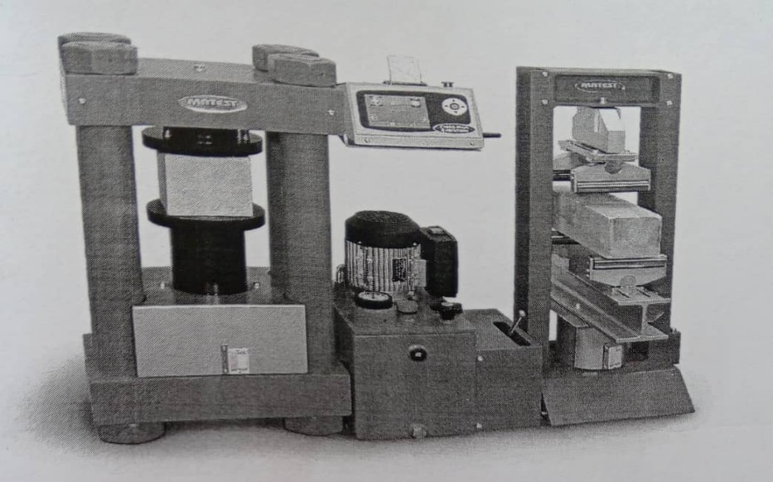

Fig 2.1: Compressive Strength Testing Machine
2.4 Design and Construction
Design is the determination of the behavior of the stress acting on a particular material. And in this content, the behavior of the stress acting on the wooden steel concrete mould component parts will be discussed. When designing for the mould, we must consider the size of the mould, the technique of mould detachment and the principle of assembling, among other factors and the most important aspect, we must design to met the following engineering requirement which are discussed as follows:
- Adequate
- Strength
- Rigidity
- Durability
- Portability
- Moderate cost
2.4.1 Adequate Strength
This is the determination of the behavior on the stress acting on the mould parts. This enables us to select the appropriate materials for the construction of the mould. Therefore, the wood used in constructing the mould is able to withstand tension and enough compression.
2.4.2 Rigidity
This is the property of component to resist change in shape when acted upon by forces. However, the nature of operation of the mould is considered and appropriate materials are selected with facts from the design calculation and the joining process are fastened by bolts and nuts and whole others parts nailed to give appropriate eccentricity for absolute rigidity of the concrete mould.
2.4.3 Durability
The mould is coated with used black oil to prevent corrosion and rusting. The other components are chosen to resist corrosion and rusting to ensure durability. Therefore, the components of the mould are chosen so that they can last for a longtime before any sign of corrosion or damage are noticeable.
2.4.4 Portability
The precast concrete moulds are detachable with bolts and nuts for easy portability or movement.
2.4.5 Moderate Cost
Since the objective of construction this precast mould is to use locally available materials to produce concrete mould that can generally withstand the precast cub stress. Therefore, it should be less expensive compare to the imported one but should be of the same strength.
2.5 Design Calculation
In designing for a mould one has to design for the thickness of the plate to be used. Appropriate consideration is made before choosing the size of plates used in the mould construction. The design for the thickness is given in the Table 3.1.
2.6 Constructional Detail
Constructional detail is the act of the putting together the component parts of the mould to form a complete mould that will be suitable for its intended purpose. The construction details involved series of step are explained as follows.
2.6.1 Marking
Marking is done with the aid of measuring tape and shape object to mark out where will be made
2.6.2 Cutting
The cutting is done with hacksaw or cutting machines, where by the plate are cut in to different size to make up the mould
2.6.3 Grinding
This is the stage where the woods are grinded to form a smooth surface. This is done by electric machine with a rolling disc on its which make a smooth surface.
2.6.4 Drilling
The wooden plate is drilled to make hole to allow the plate to be firmly fixed together with the use of screws. This drilling operation is carried out by the sue of drilling machine in the workshop.
2.6.5 Tapping
This is the method of joining together to two of the four pieces of the plates to the base plate permanently with nuts and grinds the spot to a smooth surface.

2.6.6 Carpentry Process and Procedure
Wooden processing is the act of joining parts of the same materials together in such a way that result in a continuity of homogenous material joined together.

CHAPTER THREE
3.0 Design and Calculation
In designing for a mould one has to design for the thickness of the plate to be use. Appropriate consideration is made before choosing the size of plates used in the mould construction. The design for the thickness is given in the Table 3.1.
Table 3:1: Design Calculation for Wooden Cube Mould
Calculation | Outputs
Size of mould = 100mm x 100mm x 100mm  Volume of mould = L x b x h  =0.15 x 0.15 x 0.15  = 3.375 x 10⁻³m³  Density = 24 x 10³ KN/m³  Weight (w) = volume x Density of wooden mould  = 3.375 x 10-3 x 24 x 10-3  = 81N  Force = Wgh  Where, W = weight of wooden mould  g = acceleration due to gravity  h = height of mould  = 81 x 9.81 x 0.15  = 1191.92N  = 1191.92 x 10-3  = 1.1919KN  Total force = Force + self weigh of wooden mould  = 1.919 + 0.05  = 1.2419KN  Allowable stress = 1.15N/mm²  Thickness =$\frac{total force}{allowable stress ×height}$  =$\frac{1.2419 × {10}^{3}}{1.5 ×150}$  = 7.20mm | 3.375 x 10⁻³m³  81N  1191.9N  1.1919KN  1.2419KN  7.20mm
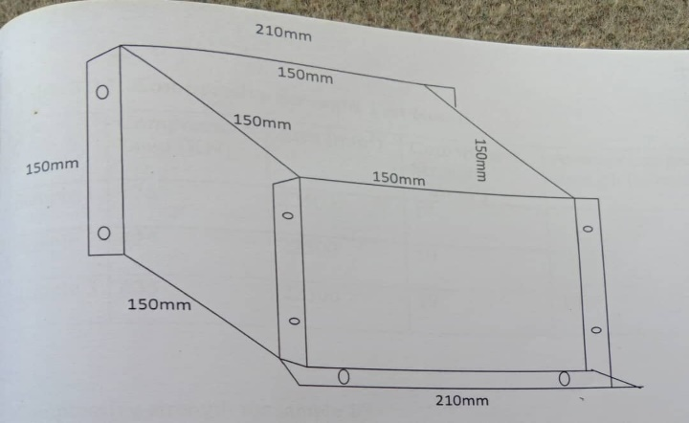

Fig 3.1: Sketch of Concrete Cube Mould
3.2 Calculation
Compressive strength of concrete = $\frac{maximum compressive load}{cross sctional area}$
Cross Sectional Area = 100mm x 100mm
= 22500mm²
Assume the compression load is 450KN
Compressive strength =$\frac{450 ×{10}^{3}}{22500}$
= 20N/mm²
Table 3.2: A Typical Compressive Strength Test Result
S/N | Compressive Load (KN) | Area (mm²) | Compressive Strength (N/mm²) | Average compressive strength (N/mm²)
Sample 1 | 375 | 22500 | 17
Sample 2 | 435 | 22500 | 19
Sample 3 | 435 | 22500 | 19 | 18

Compressive strength for sample 1
= $\frac{375 ×{10}^{3}}{22500}$
= 17N/mm²
Compressive strength for sample 2
= $\frac{425 × {10}^{3}}{22500}$
= 19N/mm²
Compressive Strength for sample 3
= $\frac{425 × {10}^{3}}{22500}$
= 19N/mm²
Average Compressive Strength =$\frac{17+19+19}{3}$
= 18N/mm²
3.3 Importance and Significance of Cube Test
i. it is used to determine the compressive strength of concrete.
ii. It is used to ensue compliance with specification
iii. To control dry shrinkage and mistake contents.
iv. It acts as basis for design before construction.

CHAPTER FOUR
4.0 Construction Techniques
This chapter deals with the techniques adopted in the design and construction of the wooden concrete cube mould.
The following steps techniques were followed respectively:
- Measurement of various size required
- Cutting of measured size according to dimension
- Planning and scrapping out all the sawn boards
- Cutting of joint grooves
- Fixing of each member with fastener and 1^{1/2} nails
- Coupling of the already cut board with glue and srew
- Covering the edges using tape and adhesive
- Fixing the lock, handle and hinges on the mould
The supervisor/instructor also told us to follow the under listed steps during the woodwork construction to have a reliable and durable result.
The steps are as follow:
Step 1: choose the better face side, place it perfectly flat on the bench then test for squarness and mark the face side
Step 2: place the face edge straight and square to face side, test with tri- square for squarness
Step 3: guage for width and place to the guage
Step 4: guage for thickness with marking gauge and place down to the edge lines and test for flatness
Step 5: square out and slot to the end test
Step 6: marking out or setting out the position and shape of joint and wastes are marked with crosses
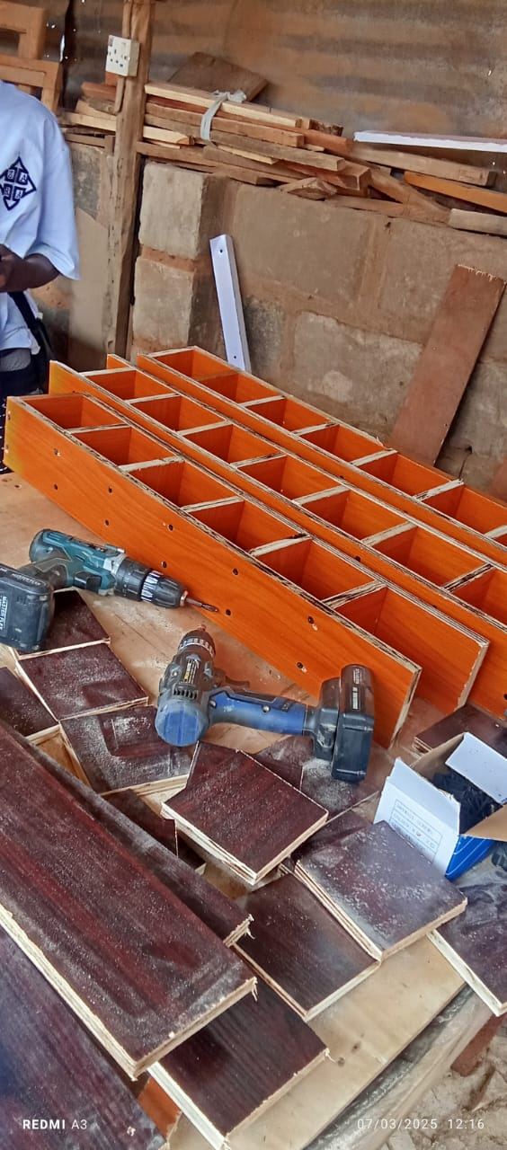
Step 7: cutting the joints: cut the mortise first, the tenor and shoulder of tenor. All shapes and cut and wastes are cut before final assemblance.

Fig 4.1: The constructed wooden moulds.
4.1 Tools and Equipment Used for the Construction
Tools and equipment are very important in the introduction process of any construction project; the quality and finishing depend largely on the efficiency of the tools used for the project.
The major tools are described below;
- Pencil: This is used for drawing lines, setting out the shapes on part of the wood. Pencils should always be used when setting out.

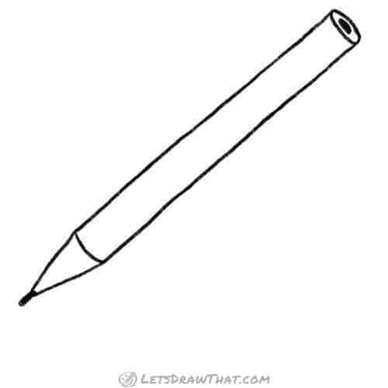
FiFig 4.2: Pencil
- Saw: These are use in the cutting to the needed or required sizes and shapes panel saw is sued for ripping tenor for joints
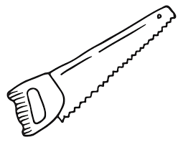

Fig 4.3: Saw
- G-Clamp: This is a metal clamp and it’s used for holding small jobs to the bench. While sawing or chiseling. It is referred to as G-Clamp because of its ‘G’ shape
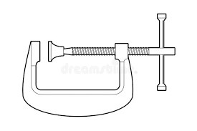

Fig 4.4: G-Clamp
- Pincher: It is used for withdrawing nails from wood
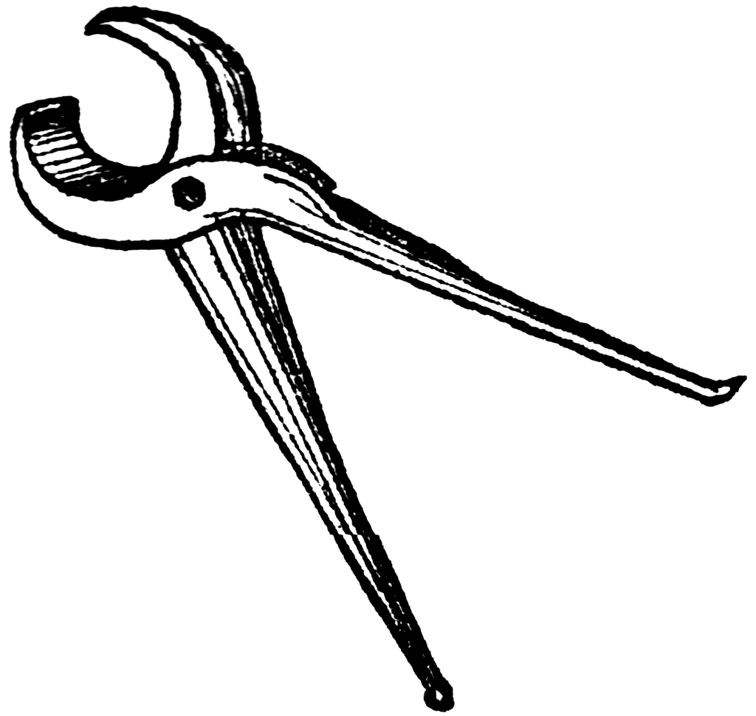

Fig 4.5: Pincher
- Sandpaper: It is a strong paper used for smoothing the timber before the application of polish. It also enables the polish to flow on timber.
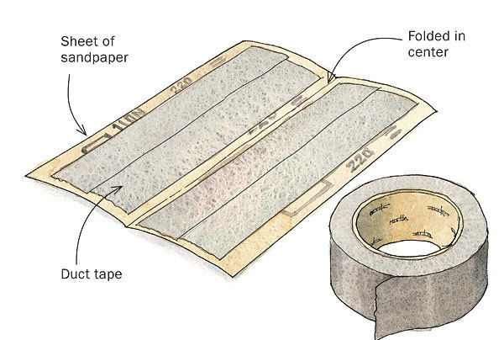

Fig 4.6: Sandpaper
- Screwing Machine:- May refer to a screw machine (Authomatic lathe), a small-to medium-size automatic lathe that is used for screwing into wood.
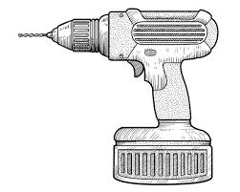

Fig 4.7: Screwing Machine
- Screw: Is a type of fastener, in some way similar to a bolt, typically made of metal and characterized by a helical edge, known as a male thread. It was used to tighten the joints of structural members together in the shoe rack construction.
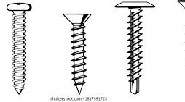

Fig 4.8: Screw

4.2 Material Used for the Construction
George Mitchell (1991), the main material used for this construction work is timber (MDF), while other materials used are nails, glue, screw, silver rod, one-quarter plywood, polish and sandpaper. All of these were used subordinately to hold member in position and also gives smooth appearance.
- Timber: The type of timber used for the construction is called (MDF). This is one of the timber for which hardwoods are obtained. MDF is chosen for this construction because of its durability and little susceptibility to defect and insect attacks. It is reddish brown in colour and very strong
- One-quarter plywood: Is a material manufactured from thin layers or pills of wood veneers that are glued together with adjacent layers having their wood grain rotated up to 90 degrees to on another.
A one-quarter of this material (plywood) was used in this project.
- Nail: These are metallic material with flat head and pointed mouth; it is driven are various types of nail available in the market for different work.
- Glue: It serves the purpose of bonding member together. It is viscous in texture and very hard when dried.
- Screw: is a type of fastener, in some way similar to a bolt, typically made of metal and characterized by a helical edge, known as a male thread.
It was used to tighten the joints of structural members together in the shoe rack construction.
- Polish: This is a viscous material used for finishing; it gives smooth and attractive look. It also protects the timber from insect attacks and normally applied in coat of three with the preceding coat dries up before another application.
- Silver rod: is a material crafted, it is soft, malleable metal with a characteristic sheen. It has the highest thermal and electrical conductivity.
- Sandpaper: It is a strong paper used for smoothing the timber before the application of polish. It also enables the polish to flow on timber.
4.3 The Choice of Materials
To have the best quality of the console and shoe rack to be design and constructed, the material (MDF) used must be able to withstand any stress subjected to without collapse.
Therefore, the materials must be chosen in times of its availability, durability, stability and resistibility to weather attack and defect.
4.4 Properties of the Materials
Before starting any construction project, the properties of the materials to be use must be considered. This is done in order to ensure the stability of the project.

A. Properties of Timber
- It is hard and light in weight
- It is strong
- It must be moderate in shape, size and dimension
- The cost must be moderate
B. Properties of Glue
i. It must have the ability to fasten two joints
ii. It is not easily cleaned
- Semi- solid which is easily solidify
C. Properties of Nails
i. It must be durable and reliable
ii. It must be strong and have high resistivity to bending
- Properties of adhesive
- It has a foul odour
- It evaporates easily
- It can be mix with gasoline
- It gives a very attractive appearance.
4.5 Safety Precautions and Maintenance of Tools
4.5.1 Safety Precaution
Tools have to be handled with care in the workshop to avoid accidents. Therefore to avoid accident, the following safety precautions are necessary;
- Do not remove any notice or instructions pasted in the workshop
- Learn how to switch off in the workshop incase of an emergency
- Do not use tools and machine other than for the work they are designed for
- Do not throw tools in the workshop
- Do not match the machine while running
- Switch off machines when not in use
- Always work with care in the workshop to avoid unnecessary accidents.
4.6 Joints Connections in Timber
Joints are the procedure by which the pieces of wood for construction are being fined or assembled together to give necessary structure. It holds the structural members in position.
There are various types of joints and each type is designed to suit special jobs. Joints used in chair and table (Conslole and shoe rack) constructions are as follow;
- Angle or box joint
- Widening joint
- Framing joint
Other types are Tongue, Rebate, Dowell butt, Plain butt, Rebated butt plain lap joint, Mortise and tenor joints.
- Tongue joint: This is used for joint over 13mm stiff, the edges of these joints are grooved with a plough plane to about 13mm deep and loose tongue glue into grooves.
- Butt joint: This method of joint is the simplest and easiest to use and it is very common in roof and fabricated house construction and simple box construction.
This is done by allowing the pieces of wood to be joined butt, i.e. touching at either end of the edge. It is rather a weak joint because the end grain of timber is the weakest part of wood for joining.
- Plain butt joint: The butt joint often reinforced with a corner glue block dowel can be used to strengthen butt joint at a joint. Many table tops, chair logs and benches have this kind of joint i.e. butt joint reinforced with dowels.
- Rebated butt plain lap joint: The endo of one piece is fitted into a rebated worked across the end of another pieces. It is an improvement on the butt joint reinforced with dowels.
- Mortise and tenor joint: This is one of the most common joint used in woodwork and the strongest from of joint in wood construction work.
Some of the various forms of mortise and tenor joint are:
- Common or through mortise and tenor joint
- Hunched mortise and tenor joint
4.7 Finishing
Finishing in wood work is a term given to the process of coating or polishing that gives the job an attractive appearance. The surface of the wood should first be smoothen, this can be achieved by first using the smoothing plane, then the scrapper and finally the sand paper which clean and smoothen the surface of the wood and makes it ready for finishing by polishing or spraying.
Application of finishes is done on wood surface because of the following reasons;
- For hygienic reason: Wood surfaces that are covered or protected with smooth film are easier to clean and keep free or dust, dirt, stains and chemical strains.
- For decoration purpose: That is to beautify the appearance and to form a protective film or coating against chit, moisture and insect attack. And also to throw water away from the surface of the table chairs.
4.7.1 Types of Finishes
All wood finishing are classified into three (3) major categories, namely;
- Transparent finish
- Opaque finish
- Semi-opaque finish
- Transparent finish: It is referred to as a clear or natural finish. This is a finish that reveals the grains and it is usually a natural colour of the wood. It is added to the surface to protect and enhance the beauty of the wood, obscure or hide it e.g. Wax shellac, varnish lacquer, penetrating oil stain and boiled in seed oil.
- Opaque finish: An opaque finish is designed in order to completely obscure the wood surface. It is usually unattractive when applied to the surface of wood. Examples are: Enamel paint, pigmented lacquer.
- Semi-opaque finish: This gives the appearance of being transparent, but not in the real sense of wood surface, it’s either partially or completely obscured. E.g. a clear finish mixed with pigmented wiping stain.
The following precautions must be observed during finishing works;
- It must be free from dust
- The temperature must be conducive
- No smoking around the work area
- Hand should be washed and cleaned up to avoid stain on the cover
- The cover or leather must be kept from flammable materials.

CHAPTER FIVE
5.0 Conclusion and Recommendation
5.1 Conclusion
Since wood designed for constructional wooden cube mould is adequate, and the components materials are locally available in our market and the construction procedure are relatively less tedious and work force requirement are easily available and avoidable, couple with cheap cost of production. Therefore foreign made concrete cube mould could be replaced by locally made ones.
5.2 Recommendation
It is recommended that during the selection of materials for the mould, a material that will be able to withstand the stresses is to be selected based on the general mechanical property possessed by the materials. Also the cutting should be done by an electrically powered guillotine machine to avert the waste of material which might be caused by using electrical and cutting, this we also enhance good surfacing. The mould should be jointed together using bolts and nuts for easy coupling and dismantling. Finally, I also recommend that culture of quality control be maintained by all contractors handling civil engineering project

REFERENCES
Ajeigbe S. Et al (2018). “Design and construction of household furniture (Dressing mirror) using MDF”. National Diploma project report in the Department of Civil Engineering Kwara State Polytechnic, Ilorin.

Azobuid (2007): “Seasoning of wood” different ways that seasoning in wood can be achieved. Azobuid.com

Buckley Micheal (2005): “A basic guide to softwood and hardwoods” wouldhardwood.com

Mitchell G (1999): “Carpentry and joinery. Published by cassell, London, England and New York

Occena, L.G (2000): “Hardwood sawyer trainer proceedings. 28th annual hardwood symposium, West Virginia

Oyindamola D.O (2008): “Design and Construction of sitting room timber furniture”. National Diploma Project Report in the Department of Civil Engineering Kwara State Polytechnic, Ilorin.

Schmoldt, D.L et al (2000). “Automated labeling of log feature in CT imagery of multiple hardwood species. “Wood and fiber Science – 32 (3): 287 – 300

