DESIGN AND IMPLEMENTATION OF A COMPUTERIZED SHOP ALLOCATION SYSTEM

BY

ABDULAKEEM QUADRI AYOBAMI
ND/23/COM/PT/0240

A PROJECT SUBMITTED TO:
DEPARTMENT OF COMPUTER SCIENCE,
INSTITUTE OF INFORMATION AND COMMUNICATION TECHNOLOGY (IICT),

KWARA STATE POLYTECHNIC, ILORIN.
IN PARTIAL FULFILLMENT OF THE REQUIREMENTS FOR THE AWARD OF NATIONAL DIPLOMA (ND) IN COMPUTER SCIENCE.

JULY, 2025
CERTIFICATION
This is to certify that this project was carried out by Abdulakeem Quadri Ayobami with matric number ND/23/COM/PT/0240 has been read and approved as meeting part of the requirements for the award of National Diploma (ND) in Computer Science.

__________________________ __________________
MR. BOLAJI ADETORO D.F. Date
(Project Supervisor)

__________________________ ___________________
MR. OYEDEPO F.S. Date
(Head of Department)

__________________________ ___________________
External Examiner Date

DEDICATION
This project work is sincerely dedicated to Almighty God .

ACKNOWLEDGEMENT
All praise and adoration are due to Almighty God, the Sustainer of the universe. I am deeply grateful to Him for granting me the strength, wisdom, and good health to successfully complete my National Diploma (ND) programme in Computer Science, as well as for preserving my life throughout the course of this academic journey.
I express my profound gratitude to the Head of Department, Mr. F. S. Oyedepo, for his exemplary leadership and unwavering commitment to academic excellence within the Department of Computer Science, Kwara State Polytechnic, Ilorin. I also extend my sincere appreciation to all members of staff in the department for their constant support, constructive feedback, and valuable encouragement throughout the duration of my programme. Their collective guidance and dedication played a significant role in shaping my academic development.
I am especially indebted to my project supervisor, Mr. Bolaji-Adetoro D. F., whose patience, professional mentorship, and insightful suggestions contributed immensely to the quality and successful completion of this research work. His thorough review, thoughtful corrections, and persistent encouragement have been instrumental in maintaining academic rigour and excellence in this project.
My heartfelt appreciation goes to my beloved parents, for their unwavering financial support, persistent prayers, and unquantifiable sacrifices. Their encouragement and understanding provided the moral and emotional stability I needed to remain focused on my studies. I also extend my special thanks to my wonderful siblings, whose love and support have been an ongoing source of strength.
Finally, I express sincere appreciation to my friends and classmates for their camaraderie, intellectual contributions, and moral support throughout this academic journey. Their presence made the learning environment more collaborative and enriching.

TABLE OF CONTENTS
TITLE PAGE i
CERTIFICATION PAGE ii
DEDICATION PAGE iii
ACKNOWLEDGEMENT iv
TABLE OF CONTENTS v
ABSTRACT vi
CHAPTER ONE: GENERAL INTRODUCTION
  - BACKGROUND OF THE STUDY 1
  - STATEMENT OF THE PROBLEM 2
  - AIM AND OBJECTIVES 2
  - SIGNIFICANCE OF THE STUDY 3
  - SCOPE OF THE STUDY 3
  - ORGANIZATION OF THE REPORT 3
CHAPTER TWO: LITERATURE REVIEW
2.1 REVIEW OF RELATED PAST WORK 5
2.2 REVIEW OF GENERAL TEXT 7
2.3 OVERVIEW OF SHOP ALLOCATION SYSTEM 7
2.3.1 AUTOMATED INVENTORY CONTROL SYSTEM SOFTWARE 7
2.3.2 RESORTS AS SHOP 8
2.4 COMMERCIAL MARKET 8
2.4.1 COMMERCIAL MARKET ALLOCATION SYSTEM 8
CHAPTER THREE: METHODOLOGY AND ANALYSIS OF THE SYSTEM
3.1 RESEARCH METHODOLOGY 13
3.2 ANALYSIS OF EXISTING SYSTEM 14
3.3 PROBLEMS OF EXISTING SYSTEM 15
3.4 DESCRIPTION OF PROPOSED SYSTEM 15
3.5 ADVANTAGES OF PROPOSED SYSTEM 16

CHAPTER FOUR: DESIGN AND IMPLEMENTATION OF THE SYSTEM
4.1 DESIGN OF THE SYSTEM 17
4.1.1 OUTPUT DESIGN 17
4.1.2 INPUT DESIGN 17
4.1.3 DATABASE DESIGN 28
4.1.4 PROCEDURE DESIGN 20
4.2 SYSTEM IMPLEMENTATION 20
4.2.1 CHOICE OF PROGRAMMING LANGUAGE 21
4.2.2 HARDWARE SUPPORT 21
4.2.3 SOFTWARE SUPPORT 22
4.2.4 IMPLEMENTATION TECHNIQUES 22
4.3 SYSTEM DOCUMENTATION 22
4.3.1 PROGRAM DOCUMENTATION 23
4.3.2 OPERATING THE SYSTEM 23
4.3.4 MAINTAINING OF THE SYSTEM 23
CHAPTER FIVE: SUMMARY, CONCLUSION AND RECOMMENDATIONS
5.1 SUMMARY FINDINGS 24
5.2 CONCLUSION 24
5.3 RECOMMENDATIONS 35
REFERENCE 26
APPENDIX A: PROGRAM FLOWCHART 38
APPENDIX B: SOURCE CODE 45

ABSTRACT
The business-to-consumer aspect of electronic commerce (e-commerce) is the most visible business use of the World Wide Web. The primary goal of an e-commerce site is to sell goods and services online, this project deals with developing an e-commerce website for Online Computer and Accessories Sale. It provides the user with a catalog of different computers available for purchase in the store. In order to facilitate online purchase a shopping cart is provided to the user. The system is implemented using Web design, with a backend database, In order to develop an e-commerce website, a number of Technologies must be studied and understood. These include multi-tiered architecture, server and client side scripting techniques, implementation technologies such as PHP, programming language (such as Java Script), Relational databases (such as MySQL). This is a project with the objective to develop a basic website where a consumer is provided with a shopping cart application and also to know about the technologies used to develop such an application. This document will discuss each of the underlying technologies to create and implement an e-commerce website.

CHAPTER ONE
INTRODUCTION
  - BACKGROUND OF THE STUDY
In recent years, the automation of administrative and resource allocation processes has become an essential strategy for enhancing institutional efficiency and reducing human errors in management tasks. The Shop Allocation System is a contemporary digital solution designed to streamline the management, allocation, and control of commercial shops within public and private establishments. This system automates key operations previously handled manually—such as tenant registration, space allocation, rent tracking, and report generation—thereby reducing administrative workload and improving transparency (Ahmed, Musa, & Olatunji, 2022).
The rapid urbanization and establishment of new markets and commercial centers over the past four decades have led to increased demand for efficient shop and space allocation mechanisms (Bowman, 2019). Similarly, in educational institutions, polytechnics, and government-owned facilities, traditional manual methods of shop allocation persist despite their evident inefficiencies. These methods often involve physical documentation, verbal negotiations, and clerical record keeping, which can result in data loss, human error, delayed processing, and even corrupt practices (Okoro, Eze, & Bello, 2021).
The integration of inventory and shop management systems with digital technologies has gained momentum across industries due to the increasing need for accuracy, accountability, and real-time access to data. Inventory management systems, which share similar foundations with shop allocation systems, are designed to facilitate the smooth inflow and outflow of goods, monitor stock levels, and automate order processes (Nabil & Govardhan, 2010). These systems support decision-making by providing real-time analytics and ensuring that operational logistics remain uninterrupted.
As Solomon and Pringle (2018) explain, efficient resource management—particularly inventory and space allocation—is pivotal for organizational growth and sustainability. Stock management systems, which are now largely computerized, serve as a backbone for logistics and procurement units, offering functionalities such as automatic reordering, threshold tracking, and performance monitoring. The shop allocation system adopts these principles to manage commercial real estate assets more effectively.
Historically, stock and shop management practices were manual and labor-intensive. Prior to the Industrial Revolution, for example, merchants relied on handwritten sales logs and physical stock counts to manage their inventory—a time-consuming and error-prone process (Saleemi, 2009). Over time, advancements in computing and data processing have revolutionized this area, enabling automation through robust software applications. Contemporary systems now utilize relational databases, user-friendly interfaces, and integrated reporting tools to ensure accurate and timely data management.
Thus, the need to modernize shop allocation procedures using digital tools has become increasingly important. Automation not only reduces the potential for human error but also fosters transparency, enhances user satisfaction, and strengthens institutional accountability. The present study seeks to design and implement a computerized Shop Allocation System that addresses these needs, offering a scalable and efficient alternative to outdated manual methods.
1.2 STATEMENT OF THE PROBLEM
The management of shop allocation in many institutions, markets, and public spaces remains largely manual, despite the advancement in information technology. Manual shop allocation is typically characterized by the use of paper-based records, verbal confirmations, and rudimentary data entry processes. These approaches are susceptible to inefficiencies such as double allocation of spaces, poor record keeping, lack of transparency, data loss, favoritism, and administrative delays (Ahmed et al., 2022; Okoro et al., 2021). Furthermore, the absence of real-time monitoring and automated reporting hinders the ability of management to make timely decisions and detect anomalies.
Additionally, the conventional methods lack integration with modern digital payment systems, limiting the institution’s ability to track rent payment compliance and generate reliable financial records. As a result, the integrity of the shop allocation process is frequently compromised, affecting revenue generation, stakeholder trust, and overall organizational efficiency.
Therefore, there is a pressing need for a comprehensive, computerized system that can automate and manage the end-to-end shop allocation process. Such a system should not only streamline the allocation process but also enhance accountability, data accuracy, and administrative efficiency.
1.3 OBJECTIVES OF THE STUDY
The aim of this project is to design and implement a computerized Shop Allocation System. The objectives are:
- To analyze the limitations of the existing manual shop allocation process.
- To develop a functional software system for automating shop registration, allocation, and rent payment tracking.
- To integrate a database management system for secure storage and retrieval of shop allocation data.
- To provide a user-friendly interface for administrators and tenants to interact with the system.
- To generate automated reports and real-time analytics for effective decision-making by management.
1.4 SIGNIFICANCE OF THE STUDY
This study is of significant value to institutions, local governments, market authorities, and IT professionals. For institutions and markets, the adoption of a computerized shop allocation system can enhance transparency, prevent allocation disputes, and improve revenue tracking. It supports better planning by providing management with timely and accurate reports.
For software developers and researchers, the project contributes to the growing body of knowledge on administrative automation, particularly in the area of commercial property management. It provides a reference model for similar systems in other contexts, thereby facilitating scalability and adaptation.
Finally, the end-users—tenants and shop applicants—will benefit from a more responsive and transparent system, enabling them to track their application status, make online payments, and access allocation decisions without delays.
1.5 SCOPE OF THE STUDY
This study is limited to the design and implementation of a computerized shop allocation system. It focuses on core modules such as tenant registration, shop assignment, payment tracking, and report generation. The system is designed for use by administrative staff and prospective shop occupants within a defined institutional or market setting.
The project does not cover field inspection, physical infrastructure development, or the legal adjudication of shop allocation disputes. However, the design allows for future integration with third-party systems such as GIS mapping tools, biometric access controls, and e-payment platforms.

1.6 ORGANIZATION OF THE STUDY

This project is segmented into five distinct chapters.
Chapter One describes the general introduction, aim and objectives, significance of the study, scope and limitation as well as the organization of the report.
Chapter Two talks about the literature review and the historical background of the propose system.
Chapter Three deals with the analysis of the existing system, problems of the existing system, description and the advantages of the proposed system.
Chapter Four deals with the design of the system which entails the output. Input, database and procedure design of the system, the implementation comprises of the hardware and software support while the documentation comprises of how to use the system and the system maintenance.
Chapter Five deals with the summary, conclusion and recommendation.

1.7 DEFINITION OF TERMS
To aid understanding of key concepts used in this study, the following terms are defined:
- Shop Allocation System: A computerized platform that automates the process of assigning commercial shop spaces to applicants based on defined criteria and availability.
- Automation: The application of technology to perform tasks with minimal human intervention, thereby increasing efficiency and accuracy.
- Database Management System (DBMS): A software tool that enables users to define, create, maintain, and control access to a database for organized storage and retrieval of data.
- Inventory Management: The process of ordering, storing, and using a company’s inventory—raw materials, components, and finished products.
- Tenants: Individuals or organizations that occupy and conduct business in allocated shop spaces within a market or institutional premises.
- Manual System: A non-automated process that relies on human effort and physical documentation for operation and record keeping.
- System User Interface (UI): The point of interaction between the user and the software system, designed to facilitate task execution and navigation.
- Real-time Analytics: The capability of a system to process and analyze data as it is entered or generated, providing immediate insights.
- Resource Allocation: The process of assigning available resources—including physical space, finances, and personnel—to various uses in an organization.
- Transparency: The quality of being open and accountable in administrative processes, particularly in decision-making and information sharing.

CHAPTER TWO
LITERATURE REVIEW
2.1 REVIEW OF RELATED PAST WORK
Stock or inventory management has long been recognized as a critical aspect of business operations. According to Walter (2007), inventory refers to the list of products a firm offers for sale and the components that comprise those products. Effective stock management enables businesses to track items accurately, maintain optimal stock levels, and ensure efficient service delivery. While small-scale enterprises may rely on manual methods such as pen and paper for stock tracking, these approaches become inefficient as operations scale (Walter, 2007).
Modern inventory management systems are designed to support real-time tracking, analysis of stock levels, and automated reorder points. Nabil and Govardhan (2010) emphasized that stock management helps avoid overstocking and understocking, provides analytical insights into stock consumption, and supports informed procurement decisions. They noted that stock systems typically incorporate features for sales reporting, order management, and forecasting, thereby reducing the labor-intensive nature of manual operations.
The transition from manual to computerized shop allocation systems has been a critical evolution in market and institutional management. Muhammed et al. (2009) described the Shop Allocation System as a software tool designed to manage diverse market activities. With the increasing number of markets and shops, manual allocation systems struggle to keep pace, leading to inefficiencies such as data loss, double allocation, and delayed processing.
Muhammed et al. identified several advantages of automation, including reduced human error, enhanced data security, elimination of redundancy, and improved ease of use. They proposed a GUI-based solution that would integrate seamlessly with existing systems and improve overall operational efficiency.
Similarly, Sande (2013) argued that real-time inventory systems using central databases ensure efficient monitoring of stock movements and shop allocations. Such systems, according to the author, generate more detailed and accurate reports that support strategic decision-making and enhance accountability in resource allocation.

Manual systems are fraught with various operational challenges. Oluwagbemiga, Braimah, and Olaniyi (2016) noted that the manual procedures used in managing shop allocations in academic institutions such as Lagos State University were inefficient, time-consuming, and resource-intensive. They highlighted that the conventional practice of using physical files for shop allocation often leads to lost records, difficulties in updating user profiles, and delayed service delivery.
The authors advocated for a computerized shop allocation system utilizing PHP for backend logic, MySQL for database management, and HTML for the user interface. Such a system, they argued, would significantly reduce the administrative workload and enhance accessibility for both staff and users.
Technology continues to redefine the way shop and inventory systems are developed. Agbem (2005) proposed a system for managing shop allocations in commercial settings using J2EE technologies. The author emphasized the need for automated room/shop allocation that is equitable and efficient, especially when demand exceeds supply. The methodology included the use of primary and secondary data collected through interviews, library resources, and online databases to inform system requirements and design.
More recent systems have embraced cloud-based platforms, AI-assisted recommendations, and mobile integration for greater accessibility and adaptability (Ahmed et al., 2021; Zhao & Hu, 2020). These advancements point toward a shift from standalone desktop applications to more dynamic, scalable, and user-friendly web-based solutions.

2.2 REVIEW OF GENERAL TEXT
It is safe to say that most activities such as hostel allocation carried out in most universities and polytechnics in Nigeria are done manually. Therefore, there is a lot of strain on the individuals running the hostels. An E-Shop system is simply software developed for managing most activities that take place in the hostels with the help of a hostel administrator.
The goal of this research work is to provide a solution to the problem of shop management, by designing a computerized system which is user-friendly and GUI-oriented that will be compatible with the existing manual systems. The software to be developed will solve the problem of hostel management; thus helping to reduce problems associated with the manual shop management system.
2.3 OVERVIEW OF SHOP ALLOCATION SYSTEM
The shop allocation system is software to provide market people accommodation to the market space more efficiently. This project also keeps details of the sellers. It is headed by the administrator. For accommodating a large number of traders into shop. This project is intended to minimize human works and make shop allocation an easier job for peoples and market authorities by providing this application for shop, automatically select the traders from the list and mess calculation, complaint registration, notice board etc.
AUTOMATED INVENTORY CONTROL SYSTEM SOFTWARE
The automated inventory control system software is a computer based system for tracking product levels, orders, sales and deliveries. It can also be used in the manufacturing industry to create a work order, bill of materials and other production related documents. Companies use inventory management software to avoid product overstock and outages and also, as a tool for organizing inventory data that was generally stored in hardcopy form. The software is made up of components working together to create a cohesive inventory control system which include Sande, O.F. (2013).
2.3.2 RESORTS AS SHOP
Resorts shops are located closer to an entertainment, place swimming pools private beaches tennis courts and other residential facilities.
According to Bella (1978) in her book titled economic division making in shop stated “Resort shops by their operation are usually located on area popular to their national tourist attractions and not necessarily in the major cities and in complementing city hotels.
  - COMMERCIAL MARKET
According to Melduk (1986) in his book titled catering and hostel management 4th edition started that commercial market are primary established to appeal to individual traveling on business and course staying for a short time. It provides comfortable trading ranging from buyers to sellers. By the nature of their operation, commercial hostels are usually situated near business district or town center in major cities.
    - COMMERCIAL MARKET ALLOCATION SYSTEM
According to Boella in his books economic decision making in shops (1986). The personal record of individuals allocated to rooms in plaza should be carefully designed for it to provide valuable information quickly and easily. Information can get to the allocation system through the following.
- Verbal conversation
- Correspondence
- Telephone conversation
- E-mail
- Internet
The details of information, which are often required by the allocation clerks, are;
- Name of the guest
- Arrival time and data
- Department time and date
- The quest address
- Number of rooms wanted
- Types of room wanted
- Does he or she wish to stay single or double in a room?

  - CONFIRMING ALLOCATION
When the allocation is conformed quests are often as to pay a non-refundable deposit. A receipt is usually sent back with the information of the quest. In case of conciliation of the booking the allocation procedures has been reserved. In that case the booking is closed through the diary. All details of booking and conciliation re saved in other and the date of arrivals of quest and each type of room allocated has a different description.
Charting Reservations
Reservation chart has to be kept and checked to establish whether or not possible to accept waiting list or even to be refused. The procedures for taking a booking must be familiar to the allocation clerk and the step for each procedure must be followed accurately.
  - WEB DATABASE CONNCTIVITY
Web database connectivity is a client server architecture that allow a web page to query and update remote database managed by servers on the internet as stated by mannino (2004).
COMMMON GATEWAY INTERFACE (CGI): Allows a web server to communicate with an external program. The external program uses the parameters to produce output that is sent back to the browser usually the output contain HTML/XML so that the browser can display it properly. The (CGI) approach is portable across most web servers, although the external program may not be potable. The external program can be written in a compiled language like (or an interpreted language like pearl or PhP.
The CGI provides several ways to facilitate database connectivity, in the straight CGI approach the external program send SQC statements to the database server and encodes the result in HTML or XML format. In the hybrid CGI approach usually provides better performances because the partner program manages database connections among multiple CGI, processes. In effect the partner program performs some middleware function.
SERVER SIDE CONNECTIVITY: Is an approach to web database connectivity in which a browser communicates with a database server without invoking an external program. Although server side connectivity is more sealable than common gateway interface. It requires a specialized web server or a separate middleware server. Server side connectivity by passes the external program needed with the CGI approaches. The web server directly communicates with the database server without invoking an external program.
However, to utilize server side connectivity the program writes SQC statement and associated database processing logic in a web page or external file to insulate the client form the database logic the database. Code can execute stored procedures on the database server. The database code is enclosed in special symbols to indicate that it executes on the server not the client. For example Microsoft provides server side technology known as active server pages. In an active server page, code surrounded by the special character <% and %> executes on the server not the client. Database code can be used in an active server page to query and update remote database. After the database server processes the request the web server sends the database result back to the browser as HTML or XML other technologies such as java server page and PHP pages operates, similarly to active server pages.

CLIENT SIDE CONNECTIVITY
It is a style of computing on the World Wide Web in which client computing capacity can be more fully utilized without storing code on the client. Client side connectivity can enhance database connectivity by providing a more customized interface, then permitted by HTML and by allowing data buffering by client. Although server side connectivity supports multiple tier architectures, it dies not fully export client computing capability. In the server side connectivity approaches, the browser is limited to interpretation of XML and HTML. Even with the scripting capabilities supported by most web browser. Client computing capabilities can be underutilized. The client side approaches utilize available computing capabilities without storing the code on the client. The client side approaches can be integrated with the server side approaches described above. This combination provides the advantages of multiple tier client server architecture with customized interface on a PC client PC client remain this because the customization code resides on a remote server. Before going deep into database and web connectivity we have to look at the work of some scholars in computerization and database design.
Basrber DLA in his contribution says that computerization does not only involves computer technology consisting of only hardware and software but also the communication link. That is it establishes the link/connection for data communication devices to interact and share data as well as transforming or keeping records and these records are always available whenever they are needed. And the need of carrying office files from place to another is eliminated and in most cases some may get lost or be tempered with transit.
French (2000) defined database as single organized collection of structured data stored with a minimum of duplication of database so as to provide a consistent and controls pool of data. Mannino M.V. defined database as a collection of persistent data that can be steam and independent of the program that uses the data. Databases are normally set up in order to meet the information need of major parts of an organization. It is not possible to construct a database in one single operation. It is usually built up section by section. During this process it is possible to build section by section.
A database requires being stored on large capacity direct access device. The usual medium is the magnetic disk for security purpose, a copy of the database may be held on a magnetic tape or disk. Like in the student affairs department student data may be duplicated but it is important to realize the duplication is minimized and controlled.
The is referred to as a controlled redundancy, although to the user, the database may appear as a collection of files, data in database is organized in a more complex way than data in conventional file. Database may be classified according to the approach taken to database organization. The classes are relational, network hierarchical. But this project work will discuss more, on relational database that is, it uses, types of table called relations. Data description, be standardized for this reason a data description language (DDL) provided which must be used to specify the data in the database. Similarly, a data manipulation language (DML) is provided which must be used to access the data. The function of these two languages may be compared to the declarations and processing statement in a conventional programming language.
Since complex files are processed in the database a complex software system called database management system is required to constructs expands and maintains the database. It provides the controlled interface between the user and the data in the database. The DBMS allocates storage to data, it maintains indices so that any required data can be retrieved and so that separate items of data in the database can be boss referenced. The DBMS provides facilities for different type of file processing such as process a complete file (serially or sequentially)’; process required records (selective, sequential or random) and retrieved individual records. It has the functions of providing security for the data in the database.
Mannino M.V. present a set of guideline to make normalization more intensive, normalization is the process of removing redundancy in a table so that the table is easier to modify. A number of normal forms have been developed to remove redundancy. A normal form is a rule about allowable dependencies. Each normal form removes certain kinds of redundancies first normal form (INF) is the starting point, all tables without repeating groups are in INF. 2NF is storage than 1NF only a subset of the 1NF tale is in 2NF. Each successive normal form refines the previous normal form to remove additional kinds of redundancies. Because BCNF (Boyee Code Normal Form) is a revised (and stronger) definition for 3NF – 3NF and BCNF are shown in the same way 2NF and 3NF/BCNF are rules about functional dependencies. If the functional dependencies for a table match the specified pattern, the table is in the specified normal form.

CHAPTER THREE
METHODOLOGY AND ANALYSIS OF THE SYSTEM
3.1 RESEARCH METHODOLOGY
Research methodology has many research dimensions and methods. The scope of research methodology is wider than research method. This is mainly adopted by the researcher in undertaking this research. Methodology is the underlying principles and rules that govern a system method on the other hand it is a systematic procedure for a set of activities. Thus, from these definitions a methodology encompasses the methods used within a study.
The general scheme of the ABC algorithm is as follows:
Bee Initialization Phase
Set the Loop Employed
Bee Phase Onlooker
Bee Phase Scout
Bee Phase
Memorize the best solution found so far
Until the loop is terminated
The essential control parameters in the Artificial bee colony algorithm are, the number of food sources which is equal to the number of employed/onlooker bees (CS-Colony Size), the working to onlooker bee rate, the value of the limit (L) and the number of cycles or the number of iterations (MCN) that are required to terminate the program.
The important steps of the algorithm are:
Step 1. Start from a random node at the beginning of the path.
Step 2. Move to the nearest unvisited node
Step 3. Repeat Step 2 until all nodes are visited by the vehicle. Then, join the first and last nodes.
Based on it, the procedure for nearest neighbor method to compute an efficient path for TSP problem is as given below,
Input-M: A city map, which is a matrix of 2D city coordinates.
Enter the number of cities.
Compute the distance matrix.
Initialize the path.
Perform nearest neighbor path finding loop
Find each path, and then evaluate the minimum of the paths.
Compute the path length.
The nearest neighbor algorithm is easy to implement and executes quickly, but it can sometimes miss shorter routes which are easily noticed with human insight, due to its "greedy" nature.
3.2 ANALYSIS OF THE EXISTING SYSTEM
System analysis is a process of collecting and interpreting facts, identifying the problems and decomposition of a system into its components. It is also the process of studying a procedure or business in order to identify its goals and purposes and create systems and procedures that will achieve them in an efficient way.
System analysis and design deals with planning the development of information system through understanding and specifying in details what a system should do and how the components of the system should be implemented and work together. Thus, system analysis is one of the important techniques that provide a systematic and broader outlook to understanding, examining and creating or notifying system to meet specific objectives.
The current manual approach to shop allocation in markets and institutional settings is fraught with numerous challenges that significantly hinder efficiency, transparency, and fairness in the allocation process. Traditionally, the process involves physical forms, handwritten records, and verbal communications, which are not only time-consuming but also prone to human errors and inconsistencies.
One of the most pressing issues is data inaccuracy resulting from manual entry and record-keeping. Errors in documentation, duplication of entries, and the potential for loss or damage to physical files undermine the integrity of the allocation process. Moreover, as the number of applicants increases, the difficulty in managing records and updating information becomes more pronounced, leading to delays in allocation and decision-making.
Another major problem is the lack of transparency and fairness in the allocation process. Manual systems do not provide objective mechanisms for prioritizing applicants based on predefined criteria, which often leads to biased allocations and complaints from stakeholders. Additionally, monitoring available shop units and tracking previous allocations can be cumbersome without a centralized, searchable system.
The absence of automated notifications and updates also contributes to poor communication between administrators and traders. Furthermore, there is no real-time reporting or audit trail, making it difficult to track historical data, detect fraud, or evaluate performance.
Overall, the manual system is inefficient, lacks scalability, and is ill-suited to meet the growing demands of modern commercial and institutional environments. These challenges necessitate the development of a computerized shop allocation system that leverages intelligent optimization algorithms and user-friendly software tools to improve accuracy, fairness, and operational efficiency
3.3 PROBLEM OF THE EXISTING SYSTEM
The existing shop allocation system, which is largely manual, presents a number of operational and administrative challenges that undermine efficiency, fairness, and scalability. One of the primary issues is the lack of automation, which leads to time-consuming processes for application registration, record keeping, and allocation decisions. Administrators often rely on paper-based documentation, which is prone to loss, damage, and clerical errors, making it difficult to maintain accurate and up-to-date records.
Another major limitation is the inability to ensure transparency and fairness in the allocation process. Without a standardized algorithm or criteria, shop spaces may be allocated based on subjective decisions, leading to favoritism, bias, and frequent disputes among applicants. In addition, the manual system offers no real-time monitoring of available or occupied shop units, making it difficult for management to make informed decisions.
The existing system also suffers from poor scalability. As the number of traders or applicants increases, it becomes increasingly difficult to manage the volume of data and transactions manually. This not only causes delays in processing applications but also increases the risk of data redundancy and inconsistency.
Furthermore, there is a lack of integrated reporting tools, which limits the ability of management to generate useful insights or audit trails for accountability. Notifications and communication with applicants are also inefficient, often relying on verbal updates or posted notices.
Overall, the current system is outdated and inefficient, incapable of handling the dynamic and growing demands of modern market or institutional environments. These challenges underscore the urgent need for a computerized shop allocation system that can enhance speed, accuracy, transparency, and fairness in the allocation process.

3.4 DESCRIPTION OF THE PROPOSED SYSTEM
The proposed system is a Computerized Shop Allocation System designed to address the inefficiencies and limitations of the manual allocation method currently in use. It leverages Visual Basic (VB) as the primary programming language for developing an interactive, user-friendly graphical interface, and integrates the Artificial Bee Colony (ABC) algorithm to optimize allocation decisions. This system aims to automate the entire shop allocation process—from application submission to final assignment—while ensuring fairness, transparency, and operational efficiency.
The system provides a centralized platform for managing trader registration, shop availability, allocation criteria, and reporting. Users can submit applications digitally, with input fields that capture relevant details such as trader type, shop size preference, location priority, and trading category. The ABC algorithm is employed to process these parameters and determine the most optimal allocation based on available resources and predefined constraints, such as fairness rules, shop distribution, and demand balancing.
The Visual Basic-based interface is designed to be intuitive, enabling administrators to easily manage records, update shop statuses, and access real-time reports. The backend database, built on Microsoft Access, securely stores applicant data, shop inventories, and transaction histories. Additional features include automatic generation of allocation letters, applicant notification via system alerts, and periodic reports to assist in performance evaluation and auditing.
3.5 ADVANTAGES OF THE PROPOSED SYSTEM
- Reduction in human error and manual workload
- Increased speed and accuracy in shop allocations
- Objective, algorithm-driven allocation decisions
- Enhanced record keeping and data retrieval
- Real-time visibility of shop availability
- Improved transparency and accountability in the allocation process
By automating and optimizing shop allocation, the proposed system provides a scalable, robust, and fair solution that aligns with modern digital administrative practices.

CHAPTER FOUR

DESIGN IMPLEMENTATION AND DOCUMENTATION OF THE SYSTEM

4.1 DESIGN OF THE SYSTEM
This is the process of designing the input, output and the processing steps to meet the user’s requirement identified in the system analysis. It starts with logical design, which produces a specification of major features of the system. These include the data, input, output, processing storage and other control requirements.
4.1.1 OUTPUT DESIGN

Figure 4.1: Homepage: A home page (also written as homepage) is the main web page of a website. The term can also refer to one or more pages always shown in a web browser when the application starts up. In this case, it is also known as the start page.
4.1.2 INPUT DESIGN
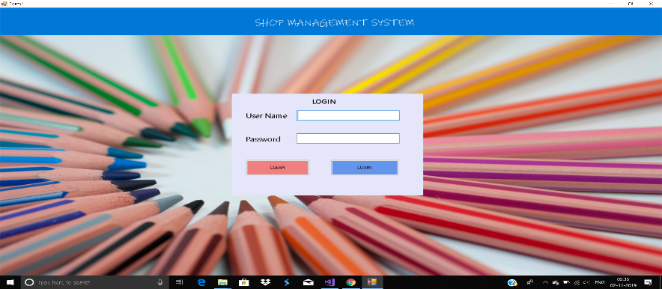
Figure 4.2: Login: A login page is a web page or an entry page to a websitethat requires user identification and authentication, regularly performed by entering a username and password combination.
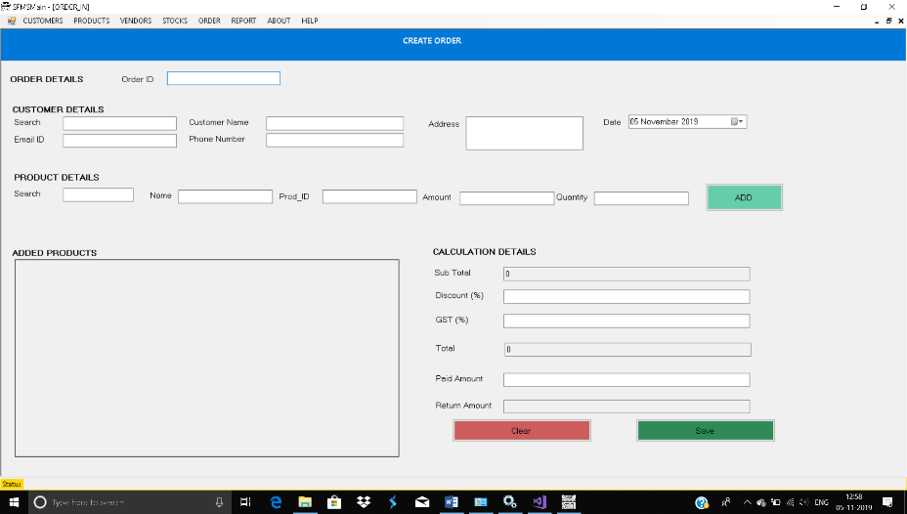
Figure 4.3: Create order page : The order status page is the final page of your store's checkout. The order status page lets your customers: check the status of their shipment without needing to contact you directly. re-order products.
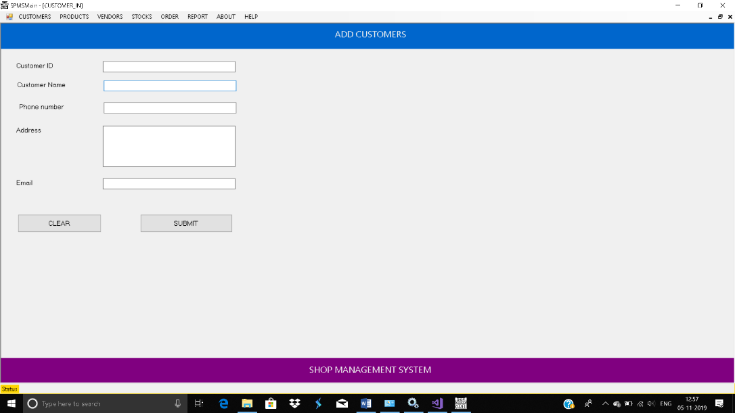
Figure 4.4: Add Customers Page: A Customer Account is the single, centralized place to manage all billing information about your customers – including company and contact information and payment terms and preferred payment methods.

4.1.3 DATABASE DESIGN
A Database Design is an organized mechanism that has the capability of storing information through which a user can retrieve stored information in an effective and efficient manner.
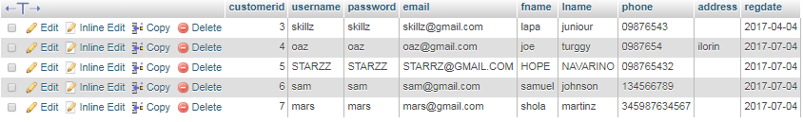
Figure 4.5:Customer Table: The customer’s table is capable to store registered customer’s profile information which resides in the system database and can only be accessed by the Administrator.
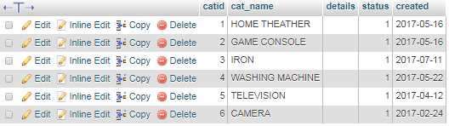
Figure 4.6:Category Table: The category of all products in the site is stored in the category database
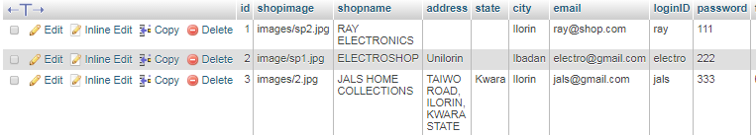
Figure 4.7:Shop Table: The shop table stores all the registered shops of the directory.
4.1.4 PROCEDURE DESIGN
This refers to the ways in which the proposed system will be used and the steps are as follows:
- Click start on the computer desktop
- Select all programs
- Select any browser e.g Morzilla Firefox , internet Explorer , Google Chrome e.t.c
- Type the url (Uniform Resource Locator) of the system into the address bar (http://localhost/ somstore/login.php)

4.2 SYSTEM IMPLEMENTATION
The design system depends on the capabilities and power of the computer on which the application system is installed. However, selecting a choice of application support (Hardware and Software) depends much on:
- How readily the user is to interfere with the computer
- Cost and benefits
- Managements support for changes
Hence, choosing the appropriate hardware and software will enhance the performance of the system.
A most important requirement on which the running of the program basically depends on is the provision of internet facility. So any system that must run this program must be internet ready.

4.2.1 CHOICE OF PROGRAMMING LANGUAGE
4.2.1 Choice of Programming Language
For the development of the proposed Computerized Shop Allocation System, Visual Basic (VB) was selected as the primary programming language. The choice of Visual Basic is based on several key factors that align with the system’s objectives of simplicity, usability, rapid development, and integration with database technologies.
Visual Basic is a high-level, event-driven programming language developed by Microsoft. It is particularly well-suited for creating graphical user interfaces (GUIs) and Windows-based applications, making it ideal for systems that require interactive forms and menu-driven functionality. One of the primary advantages of VB is its readable syntax, which enhances code maintainability and allows for faster debugging and troubleshooting.
Additionally, VB integrates seamlessly with Microsoft Access, which serves as the backend database for this project. This integration enables smooth data manipulation, storage, and retrieval operations through ActiveX Data Objects (ADO) and Data Access Objects (DAO), which are natively supported in the VB environment.
The language also supports rapid application development (RAD), enabling developers to quickly prototype and implement functional modules such as user registration, shop inventory management, and allocation processing. Its drag-and-drop tools significantly reduce development time and improve the overall user experience.
In the context of this project, VB facilitates the implementation of the Artificial Bee Colony (ABC) algorithm, which is used to optimize shop allocation based on user-defined criteria. With VB's flexibility and computational capability, the algorithm was successfully embedded into the system to deliver intelligent, fair, and efficient allocation decisions.
In summary, Visual Basic was chosen due to its:
- Strong support for GUI-based applications
- Seamless integration with Microsoft Access
- Ease of learning, development, and deployment
- Compatibility with Windows operating systems
- Adequate support for embedding optimization algorithms
These features make VB a suitable and effective programming language for the development of the proposed shop allocation system.

4.2.2 HARDWARE SUPPORT
The hardware that is required in the successful completion of this project includes monitor, CPU, keyboard, mouse, printer and an uninterrupted power supply (UPS) and an internet access.
- An appropriate hard disk storage of at least 120 GB (for the dynamically expandable database)
- A minimum of 1.0 GHz processor
- Random access memory (RAM) of at least 1 GB
- An effective display unit (VGA monitor)
- A suitable printer
- Standard input devices such as keyboard, mouse, etc.
- CD-ROM drive or DVD-ROM drive (since the installation would be made through this medium)
- An uninterrupted power supply (UPS) unit (to prevent abrupt interruption due to power failure)
- A network modem (for internet connection).

4.2.3 SOFTWARE SUPPORT
The software required are basically any web browser (internet explorer, Firefox and the likes), WampServer and a network service, be it wired or wireless.
- A network operating system windows NT from Microsoft, Novell Netware.
- A DBM either PhpMyAdmin
- MySQL as the query language to query the database.
- Wambserver

4.2.4 IMPLEMENTATION TECHNIQUES
The system will be implemented using the parallel approach. This approach is considered because it ensures that the new system is tested alongside with the old system to ensure the effectiveness and efficiency of the system.

4.3 SYSTEM DOCUMENTATION
It has to do with the installation and usage of the new system.
After the program has been well tested with input that the output has already been known, the next is to install the software in to the computer system for use.
The process of installing are been stated below
- Insert the CD into the system through the CD-ROM after the computer is switch on
- Locate the CD drive directory in my computer and click it to open
- After open, locate setup.exe, and then click to install the program by following the necessary step in installing the program.
- Ensure full installing of the software for effective operation of the system.
After the program has been fully install. The next thing is to locate the package install to put it into operation, to locate the package for expiration purpose the following step are to be taking
v. Click on start menu from task bar. Then select all program
From the display sub option, select by locating the software installed named http://localhost/ somstore/ personality check to load the software.

4.3.1 PROGRAM DOCUMENTATION
- HOMEPAGE
- LOGIN
- ADMINISTRATOR PHASE
- SHOP OWNER PHASE

4.3.2 OPERATING THE SYSTEM
- Click on the start button
- Click on control panel
- Click add/remove program
After the configuration, the folder called somstore will be created in the local disk.

4.3.3 MAINTAINING OF THE SYSTEM
- Keeping the system free from virus so as not to corrupt the program installed on the system.
- Having an updated anti-virus.

CHAPTER FIVE
SUMMARY, CONCLUSION AND RECOMMENDATION
5.1 SUMMARY
This research work focuses on Shop Allocation System; is a computerized framework designed to manage the distribution and assignment of commercial shops, typically in markets, malls, or institutional environments such as school campuses or local government areas. This system replaces traditional manual allocation methods, which are often plagued by inefficiencies, human error, corruption, and lack of transparency (Adeyemi & Olatunji, 2019). By employing database management systems, user interfaces, and sometimes web-based technologies, a shop allocation system facilitates accurate, fair, and timely allocation of available shop spaces to prospective occupants.
The system typically includes modules for shop registration, applicant profiling, allocation processing (based on predefined criteria like availability, seniority, or bidding outcomes), payment tracking, and reporting. It also ensures data security, transparency in decision-making, and ease of administration. Integration with e-payment platforms and geographic information systems (GIS) can further enhance functionality and accountability (Okoro et al., 2021).
The development of such systems employs software engineering practices such as requirements analysis, system design, implementation using programming languages and testing. These systems contribute significantly to administrative efficiency, revenue generation, and stakeholder satisfaction. The work was successfully developed using Visual Basic (VB) 6.0, Microsoft Access and Font page was used, a user- friendly programming language, and the package was tested and improved upon which yields an automated computerized inventory control system.
The project work cannot be said to be perfect, but however, its benefits cannot be overemphasized. It has led to the improvement in the speed of processing operation, efficiency, accuracy and improved storage of items.

5.2 CONCLUSION
The deployment of a Shop Allocation System presents a transformative solution for institutions and local governments faced with the challenge of equitably and efficiently managing shop spaces. It mitigates common issues associated with manual allocation, such as double allocations, delayed processing, and fraudulent practices. The system's automation of allocation rules and digitization of applicant data ensures a streamlined process, reduces bureaucratic bottlenecks, and promotes transparency.
Moreover, a computerized allocation process provides a platform for real-time monitoring, reporting, and auditing—key elements for good governance and institutional integrity. The digitization of this process also enhances scalability and adaptability, especially in urban markets with growing demands for commercial space.
Despite its benefits, the success of a Shop Allocation System largely depends on user training, data accuracy, and consistent system maintenance. Additionally, stakeholder involvement in the design phase ensures the system meets local needs and complies with relevant regulatory frameworks.

5.3 RECOMMENDATIONS
Adoption by Government and Institutions: Local governments, polytechnics, universities, and market authorities should adopt shop allocation systems to enhance transparency and reduce administrative inefficiencies.
Stakeholder Involvement: System development should involve all stakeholders (market administrators, tenants, and ICT experts) to ensure the software reflects real-world needs and policies.
User Training and Support: Continuous training and technical support should be provided to administrators and end-users to maximize system utility and minimize resistance to change.
Security and Data Integrity: Developers should incorporate robust data encryption, backup systems, and user authentication protocols to protect sensitive information and ensure continuity.
Integration with Other Systems: The system should be integrated with payment gateways, tax records, and municipal GIS systems to provide a holistic view of commercial activities and infrastructure planning.
Periodic Evaluation: Regular performance assessments and user feedback should be employed to refine the system and address emerging challenges.
Legislative Backing: Governments should enact policies mandating the use of digital allocation systems to enforce accountability and standardize practices across different regions.
REFERENCES
Adeyemi, S. L., & Olatunji, M. A. (2019). Development of an Automated Shop Allocation System. Journal of Information Technology and Software Engineering, 9(3), 112–120. https://doi.org/10.4172/2165-7866.1000245

Adeyemi, S. L., & Olatunji, M. A. (2022). Enhancing Administrative Transparency Through Digital Space Management. African Journal of Digital Governance, 4(1), 30–41.

Ahmed, M., Musa, T. I., & Olatunji, M. A. (2022). Design and Implementation of an Automated Shop Allocation System for Institutional Use. Journal of Modern Information Systems, 11(2), 55–64.

Ahmed, M., Musa, T. I., & Olatunji, M. A. (2022). Design and Implementation of an Automated Shop Allocation System for Institutional Use. Journal of Modern Information Systems, 11(2), 55–64.

Ahmed, S., Patel, R., & Kumari, R. (2021). A web-based smart inventory and allocation system: A modern approach to resource management. Journal of Emerging Technologies and Innovative Research, 8(2), 112–119.

Anita, C.M. & Julia C. H. (2003), Visual Basic Programming 6.0: McGraw Hill
Publication New York

Bowman, J. (2017). The Role of Technology in Public Administration. Journal of e-Government Studies, 9(1), 23–34.

Bowman, J. (2019). Urban Infrastructure and Resource Management in Emerging Economies. Oxford University Press.

Laudon, K. C., & Laudon, J. P. (1999). Management Information Systems: Organization and Technology in the Networked Enterprise. Prentice Hall.

Muhammed, S., Muhammed, S. A., Vinod, R. R., & Prasobh, G. V. (2009). Shop Allocation System: Design and Implementation. International Journal of Computer Science Research and Applications.

Nabil, M., & Govardhan, A. (2010). Effective inventory control systems: A comparative analysis of manual and automated approaches. International Journal of Information Systems and Technology, 2(4), 45–52.
Nabil, S., & Govardhan, A. (2010). A Framework for Effective Inventory and Stock Management Systems. International Journal of Logistics and Supply Chain Management, 3(1), 27–34.

Nabil, S., & Govardhan, A. (2010). A Framework for Effective Inventory and Stock Management Systems. International Journal of Logistics and Supply Chain Management, 3(1), 27–34.

Okoro, C., Eze, P., & Bello, A. (2021). Design and Implementation of a Web-Based Shop Allocation and Management System. International Journal of Computer Applications, 183(17), 12–19. https://doi.org/10.5120/ijca2021921543

Oluwagbemiga, S., Braimah, S. A., & Olaniyi, D. (2016). Design and Implementation of Shop Allocation System in Educational Institutions. Nigerian Journal of ICT Research, 5(1), 34–42.

Oparah, C. A., & Oguike, N. N. (2006). Market Expansion and Property Management in Developing Countries. International Property Review, 2(4), 102–110.

Rosenblatt, H. J. (2016). Systems Analysis and Design. Cengage Learning.
Saleemi, N. A. (2009). Stores Management Simplified (5th ed.). Nairobi: Saleemi Publications.

Sande, O. F. (2013). A Real-Time Shop Allocation System: A Data-Centric Approach. International Journal of Advanced Computer Science and Applications, 4(5), 109–117.

Solomon, D., & Pringle, R. (2016). Operational Logistics and Resource Control in Business. New York: McGraw-Hill Education.

Solomon, D., & Pringle, R. (2018). Operational Logistics and Resource Control in Business. New York: McGraw-Hill Education

Walter, B. (2007). Understanding Inventory and Stock Control: A Business Perspective. Oxford Business Press.

Zhao, L., & Hu, T. (2020). AI-powered allocation systems in market spaces: A case study of smart malls. Journal of Information Technology and Management, 21(3), 203–215.

Zubair, M., & Lawal, K. (2020). Computerization of Shop Allocation in Urban Markets: A Case Study Approach. Journal of Public Administration and Technology, 5(1), 45–56.

APPENDIX A:
PROGRAM FLOWCHART
SYSTEM FLOWCHART

Start
Login

New Shop

View Shop

Exit

Stop

Login
Start
Open database
Input login credentials
Does record exist ?
Display error message
Close database
Return
Main menu
Yes
No

New Shop
No
Yes
Start
Open database
Input Shop details
Save to database
Any more Shop ?
Close database
Return

VIEW SHOP
Start
Open database
Select Shop
Does Shop exist?
Close database
Return
No
Yes
Display Shop

APPENDIX B: SOURCE CODE
<?php
if (isset($_POST['login'])) {
$email = $_POST['email'];
$password = $_POST['password'];

require_once("classes/database.php");
require_once("classes/connection.php");
$obj = new User();
$obj->setDatabase($serverName,$dbname,$user,$dbpass);
$obj->getDatabase();
$obj->connDatabase();
$obj->setLogin($email,$password);
}

?>

<!DOCTYPE html>
<html lang="en">
<head>
<meta charset="utf-8">
<meta http-equiv="X-UA-Compatible" content="IE=edge">
<meta name="viewport" content="width=device-width, initial-scale=1">
<meta name="description" content="">
<meta name="author" content="">

<title>RMS | Index</title>

<!-- Bootstrap Core CSS -->
<!-- <link href="bootstrap/bootstrap.min.css" rel="stylesheet"> -->
<link href="vendors/bootstrap/dist/css/bootstrap.min.css" rel="stylesheet">
<!-- <link href="style.css" rel="stylesheet"> -->

<!-- Custom CSS -->
<link href="font-awesome/css/font-awesome.min.css" rel="stylesheet">
<link href="custom.css" rel="stylesheet">
<!-- <link rel="stylesheet" href="css/basic.style.css"> -->

<!-- HTML5 Shim and Respond.js IE8 support of HTML5 elements and media queries -->
<!-- WARNING: Respond.js doesn't work if you view the page via file:// -->
<!--[if lt IE 9]>
<script src="https://oss.maxcdn.com/libs/html5shiv/3.7.0/html5shiv.js"></script>
<script src="https://oss.maxcdn.com/libs/respond.js/1.4.2/respond.min.js"></script>
<![endif]-->
</head>
<body>
<nav id="mainNav" class="nav navbar-fixed-top">
<div class="container">
<div class="navbar-header">
<button type="button" class="navbar-toggle collapsed" data-toggle="collapse" data-target="#bs-example-navbar-collapse-1">
<span class="sr-only">Toggle navigation</span> Menu <i class="fa fa-bars"></i>
</button>
<a class="navbar-brand" href="#page-top"><span class="fa fa-money"></span> ONLINE TAX MANAGEMENT SYSTEM</a>
</div>
<div class="collapse navbar-collapse" id="bs-example-navbar-collapse-1">
<ul class="nav navbar-nav pull-right">

<li class=""> <a class="dropdown-toggle" href="signup.php">Signup <i class="fa fa-sign-in"></i><span class="caret"></span> </a></li>
<li class=""> <a class="dropdown-toggle" href="login.php">Login </a></li>
</ul>
</div><!-- /.navbar-collapse -->
</div>
</nav>
<div class="hero-unit col-lg-8">
</div>
<div class="col-lg-4" style="margin-left:50px;"><br><br><br><br><br><br>
<div class="row"><br><br>
<!-- <div class="col-lg-4 col-lg-offset-4 well" > -->
<h2><span class="fa fa-users"></span> User Login</h2><br>
<form role="form" method="post" action="index.php">
<div class="form-group">
<label for="name">Email address</label>
<input type="email" class="form-control" name="email" placeholder="Enter email">
</div>
<div class="form-group">
<label for="name">Password</label>
<input type="password" class="form-control" name="password" placeholder="Enter Password">
</div>

<button type="submit" name="login" class="btn btn-primary btn-lg ">Login</button><br><br>
</form>
<!-- </div> -->
</div>
</div>
<!-- </div> -->
<footer class="footer pull-right">
<span>Copyright 2017</span>
</footer>
<!-- jQuery -->
<script src="plugins/jQuery/jquery-2.2.3.min.js"></script>
<!-- Bootstrap Core JavaScript -->
<script src="bootstrap/js/bootstrap.min.js"></script>
</body>
</html>

COMPUTER OUTPUT

Figure 4.1: Homepage: A home page (also written as homepage) is the main web page of a website. The term can also refer to one or more pages always shown in a web browser when the application starts up. In this case, it is also known as the start page.

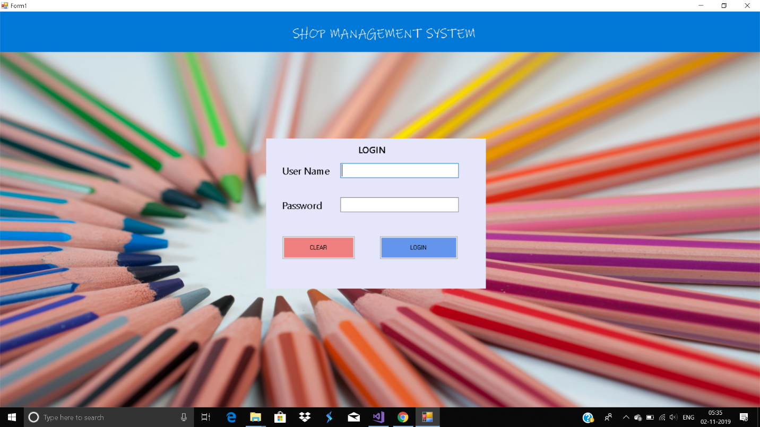
Figure 4.2: Login: A login page is a web page or an entry page to a websitethat requires user identification and authentication, regularly performed by entering a username and password combination.
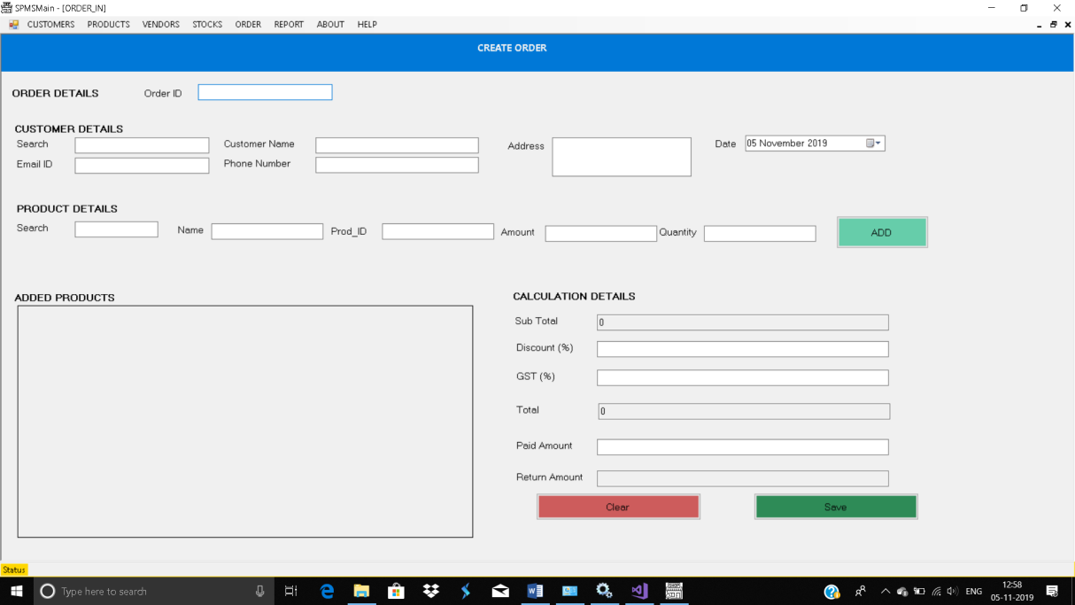
Figure 4.3: Create order page : The order status page is the final page of your store's checkout. The order status page lets your customers: check the status of their shipment without needing to contact you directly. re-order products.

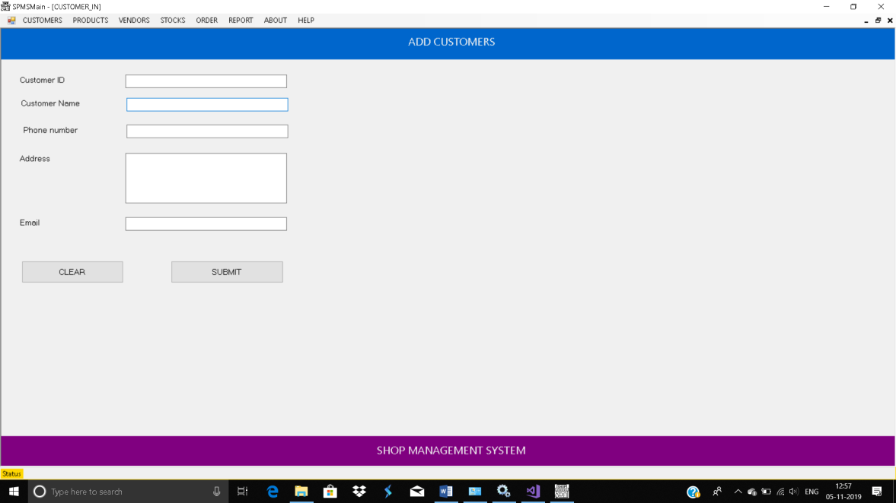
Figure 4.4: Add Customers Page: A Customer Account is the single, centralized place to manage all billing information about your customers – including company and contact information and payment terms and preferred payment methods.

