DESIGN AND IMPLEMENTATION OF A FILE AND MESSAGE ENCRYPTION SYSTEM USING HYBRID CRYPTOGRAPHY TECHNIQUES

By:
OLANREWAJU LATIFAT BOLUWATIFE
ND/23/COM/PT/0320

Submitted to the

DEPARTMENT OF COMPUTER SCIENCE,
INSTITUTE OF INFORMATION AND COMMUNICATION TECHNOLOGY (IICT), KWARA STATE POLYTECHNIC, ILORIN

IN PARTIAL FULFILMENT OF THE REQUIREMENTS FOR THE AWARD OF ORDINARY NATIONAL DIPLOMA (OND) IN COMPUTER SCIENCE

JULY, 2025

CERTIFICATION
This is to certify that this project was carried out by OLANREWAJU LATIFAT BOLUWATIFE with matriculation number ND/23/COM/PT/0320 as meeting part of the requirements for the Award of National Diploma (ND) in Computer Science Department, Institute of Information Communication Technology, Kwara State Polytechnic, Ilorin.

___________________ __________________
MR. Saka, T.O.
Project Supervisor Date

______________________ _________________
Mr. Oyedepo, F.S.
Head of Department Date

______________________ _________________
External Examiner Date

DEDICATION
I dedicate this work to Almighty God, whose unfailing love and mercy have been my source of strength and inspiration throughout this journey.
To my beloved parents, for their unconditional love, sacrifices, and unwavering support that have shaped who I am today.
To my family and friends, whose encouragement, prayers, and belief in me provided the motivation to persevere through every challenge.
This achievement is a testament to all of you who have stood by me, encouraged me, and believed in my potential. Thank you for being my pillars of strength.

ACKNOWLEDGEMENTS
All glory and praise be to Almighty God, the Lord of the universe. I sincerely thank Him for granting me the strength, wisdom, and perseverance to complete my ND program and for His continuous guidance throughout my journey on earth.
I am deeply grateful to my supervisor, Mr. Saka T.O., whose unwavering patience, insightful guidance, and constant encouragement were instrumental to the success of this research work. His valuable corrections, constructive criticisms, and recommendations ensured the highest standards of excellence were maintained.
I would also like to express my profound appreciation to the Head of the Department, Mr. Oyedepo F. S., and the entire staff of the Department of Computer Science at Kwara State Polytechnic, Ilorin, for their continual support, constructive feedback, and motivation throughout my studies.
My heartfelt gratitude goes to my beloved parents, who provided immeasurable financial support, patience, prayers, and understanding during my academic pursuit.
Thank you all for being part of this journey and for helping me reach this milestone.

TABLE OF CONTENTS
Title Page ............................................................ i
Dedication .......................................................... iii
Acknowledgements .......................................... iv
Table of Contents ............................................. v–vii
Abstract .............................................................. ix
CHAPTER ONE: INTRODUCTION .................................. 1
1.1 Background to the Study ........................................ 1–3
1.2 Statement of the Problem ...................................... 3
1.3 Aim and Objectives of the Study .............................. 4
1.4 Scope of the Study ................................................ 5
1.5 Limitations of the Study ......................................... 6
1.6 Operational Definition of Terms .............................. 6–7
1.7 Organization of the Report ..................................... 8
CHAPTER TWO: LITERATURE REVIEW ......................... 9
2.1 Review of Related Works ........................................ 9–11
2.2 Cryptography: Concepts and Techniques ................ 11–13
2.2.1 Symmetric Cryptography (e.g., AES) ..................... 13–14
2.2.2 Asymmetric Cryptography (e.g., RSA) .................... 14–15
2.2.3 Hybrid Cryptography Techniques ............................ 15–16
2.2.4 File and Message Security Trends (2020–present) .... 16–17
2.3 Challenges in Secure Data Transmission .................. 17–18
CHAPTER THREE: RESEARCH METHODOLOGY .............. 19
3.1 Description of the Existing Systems ........................... 19
3.2 Problem of the Existing Systems ................................. 20
3.3 Description of the Proposed System ............................ 21
3.3.1 Benefits of the Proposed System .............................. 21–22
3.4 System Requirements (Hardware & Software) .......... 22–23
3.5 System Architecture ................................................. 23–25
3.6 Data Encryption and Decryption Flowcharts ............. 25–26
CHAPTER FOUR: SYSTEM DESIGN AND IMPLEMENTATION .... 27
4.1 Design of the System 17
4.1.1 Output Design 17
4.1.2 Input Design 20
4.1.3 Database Design 22
    - Procedure Design 22
  - System Implementation 23
4.2.1 Choice of Programming Language 23
4.2.2 Software Support 23
4.2.4 Implementation Techniques Used in Details 23
4.3 System Documentation 23
4.3.1 Program Documentation 23
4.3.2 Maintaining the System
CHAPTER FIVE: SUMMARY, CONCLUSION AND RECOMMENDATIONS .... 35
5.1 Summary of Findings .................................................. 35
5.2 Conclusion ................................................................. 36
5.3 Recommendations ..................................................... 36–37
References

ABSTRACT
In an era where digital communication is central to virtually every human and organizational activity, ensuring the confidentiality, integrity, and authenticity of transmitted data has become critically important. Traditional security mechanisms are increasingly inadequate in protecting sensitive information due to the rise in sophisticated cyber threats, including data interception, unauthorized access, and identity theft. As a response to these challenges, this project explores the design and implementation of a secure communication system using hybrid cryptography techniques.
Hybrid cryptography leverages the strengths of both symmetric and asymmetric encryption algorithms to create a more robust, secure, and efficient cryptographic system. In this approach, symmetric encryption, known for its speed and efficiency, is used to encrypt the actual content of the messages or files, while asymmetric encryption, recognized for its secure key distribution, is used to protect the symmetric keys. This dual-layer encryption model ensures that even if one layer is compromised, the other still provides a level of security.
The developed system allows users to send encrypted messages and share confidential files with other authorized users. It supports key features such as real-time messaging, secure file uploads, password-based access control, and password hints for added usability. The system was implemented using a combination of modern technologies including PHP (backend), JavaScript (frontend interactivity), and MySQL (database). Cryptographic algorithms such as AES (Advanced Encryption Standard) and RSA (Rivest–Shamir–Adleman) were employed to handle the core encryption and decryption processes.
The result is a scalable and modular platform that enhances user confidence in secure data exchange and contributes to the broader field of secure software design. This work not only demonstrates the practicality of hybrid cryptography in real-world applications but also serves as a foundation for further research and development in secure digital communication.

CHAPTER ONE
INTRODUCTION
- BACKGROUND TO THE STUDY
In today’s digital era, the rapid growth of data exchange over networks has made securing information an urgent priority. Individuals and organizations increasingly depend on digital communication and storage platforms, which exposes sensitive data to various security threats. Cryptography, the art and science of protecting data, is essential to safeguard confidentiality, integrity, and authenticity of information in this environment (Alotaibi & Alyami, 2021).
Traditional cryptographic methods fall into two main categories: symmetric and asymmetric encryption. Symmetric encryption algorithms, such as the Advanced Encryption Standard (AES), use a single key for both encryption and decryption. These algorithms offer high efficiency and speed, but face challenges in securely distributing keys between communicating parties. Asymmetric encryption, using algorithms like RSA and Elliptic Curve Cryptography (ECC), utilizes a pair of keys—a public key and a private key—which helps solve the key distribution problem but is generally slower due to its computational complexity (Sharma et al., 2022).
Hybrid cryptography combines the advantages of both symmetric and asymmetric techniques to overcome their individual weaknesses. In this approach, data is encrypted using a fast symmetric algorithm, while the symmetric key itself is encrypted using a secure asymmetric algorithm. This combination balances security and performance, making it widely adopted for securing data transmissions in many applications (Kumar & Patel, 2021).
The rise of cloud computing services has emphasized the need for robust encryption to protect data stored remotely. Hybrid cryptography schemes are particularly effective in cloud environments, where large volumes of data require encryption for confidentiality and integrity, while keys must be securely exchanged. Studies show that integrating AES and ECC in hybrid models provides a scalable and efficient solution for cloud data security (Sharma et al., 2022).
Hybrid cryptography has become a cornerstone in modern data security because it effectively blends the high speed of symmetric encryption with the secure key exchange advantages of asymmetric encryption. Alqahtani et al. (2023) highlight that hybrid cryptographic schemes are particularly beneficial in cloud computing environments, where both efficiency and security are paramount. Their study shows that by encrypting the data with a fast symmetric key algorithm like AES and then protecting the symmetric key itself with an asymmetric method like RSA or ECC, hybrid schemes reduce the vulnerability inherent in key distribution. This approach not only improves data confidentiality but also optimizes performance, making it ideal for large-scale cloud applications where secure and swift data processing is required.
In real-time communication systems, such as instant messaging platforms, hybrid cryptography enables secure and efficient transmission of messages. The use of asymmetric encryption facilitates secure key exchanges between users, while symmetric encryption handles the bulk encryption of message content. This dual-layer encryption is essential for maintaining confidentiality without compromising performance during live communication (Wang et al., 2023).
Emerging threats from quantum computing have driven research into quantum-resistant cryptographic methods. Hybrid cryptography has adapted to incorporate post-quantum algorithms alongside traditional encryption techniques. This integration ensures long-term security of data against potential quantum attacks, while maintaining backward compatibility with existing infrastructure (Chen et al., 2021).
In sectors like healthcare, protecting sensitive patient data is crucial. Hybrid cryptography enables secure storage and transmission of medical records by combining efficient symmetric encryption for data with robust asymmetric encryption for key management. This approach helps meet stringent regulatory requirements while allowing fast data access when needed (Singh & Chatterjee, 2020).
Financial and e-commerce applications also benefit from hybrid cryptographic systems, which ensure data authenticity, confidentiality, and non-repudiation. By combining symmetric encryption with digital signatures, these systems provide multi-layered security essential for protecting transactions from fraud and cyberattacks (Jain et al., 2022).
Gupta and Sharma (2022) examine the use of hybrid cryptographic techniques within secure multi-party computation (SMPC) frameworks. SMPC allows multiple parties to jointly compute a function over their inputs while keeping those inputs private. Hybrid cryptography plays a pivotal role in SMPC by ensuring that the data exchanged between parties remains confidential and tamper-proof. Their research demonstrates how combining symmetric and asymmetric encryption facilitates efficient and secure protocols, enabling applications such as privacy-preserving data analytics, secure voting systems, and collaborative machine learning, which are increasingly important in a data-driven world that respects user privacy.
Deploying hybrid cryptography on resource-constrained devices such as Internet of Things (IoT) sensors presents unique challenges that Chen, Wang, and Liu (2023) discuss in detail. Their research focuses on optimizing hybrid encryption algorithms to balance security and power consumption, crucial for battery-operated or low-processing-capacity devices. They propose lightweight cryptographic protocols that reduce computational load without compromising encryption strength. This work is significant because IoT devices are becoming pervasive in smart homes, healthcare, and industrial systems, and ensuring secure data transmission without draining limited resources is essential for widespread adoption and trust in IoT technology.
IoT devices, often limited in computational power, require lightweight yet secure encryption methods. Hybrid cryptography is particularly suited for IoT, where it enables fast symmetric encryption for data and asymmetric methods for secure key exchange, addressing the unique security challenges of these resource-constrained devices (Patel & Shah, 2021).
Alotaibi and Alyami (2021) emphasize the critical role of hybrid cryptographic techniques in safeguarding modern communication systems, especially against increasingly sophisticated cyber threats. They note that pure symmetric or asymmetric systems each have limitations: symmetric systems struggle with secure key exchange, while asymmetric systems suffer from computational overhead. By combining these approaches, hybrid cryptography leverages their strengths and compensates for weaknesses. Their research further reveals that hybrid schemes are adaptable and scalable, making them suitable for securing everything from simple email communications to complex enterprise networks, thus providing a flexible framework that can evolve alongside new security challenges.
Finally, hybrid cryptographic schemes are effective in preventing man-in-the-middle attacks during key exchanges. By leveraging the strengths of asymmetric encryption to protect keys and symmetric encryption for data transmission, these systems enhance security against interception and tampering (Alqahtani et al., 2023).
STATEMENT OF THE PROBLEM
In today’s interconnected world, the exchange of digital information is increasing exponentially across various platforms, including emails, cloud storage, and messaging applications. Despite the numerous advantages offered by digital communication, it also poses significant security risks such as unauthorized access, data breaches, identity theft, and cyber espionage. These risks threaten the confidentiality, integrity, and availability of sensitive information, especially when transmitted over insecure or public networks.
Traditional encryption methods, while effective to some extent, face limitations that hinder their practical deployment in modern security frameworks. Symmetric encryption algorithms, such as AES, are efficient and fast but require secure key distribution channels, which can be challenging to establish and maintain. On the other hand, asymmetric encryption algorithms, such as RSA and ECC, facilitate secure key exchange but are computationally intensive and slower, making them unsuitable for encrypting large volumes of data directly.
The dichotomy between symmetric and asymmetric encryption presents a significant challenge: achieving a system that balances security, speed, and scalability. Many existing systems either compromise security by relying heavily on symmetric encryption with weak key exchange or sacrifice performance by using asymmetric encryption exclusively. Moreover, cyber attackers are continuously evolving their tactics, necessitating more robust and adaptive cryptographic solutions.
This study aims to address these challenges by developing a hybrid cryptography-based encryption system that leverages the strengths of both encryption techniques to secure file and message transmission effectively. The system will enhance data security in diverse applications, providing a practical solution to the current cryptographic challenges.
AIM AND OBJECTIVES
The main aim of this project is to design and implement a robust file and message encryption system utilizing hybrid cryptography techniques. This system will leverage the strengths of both symmetric and asymmetric encryption algorithms to provide a secure, efficient, and scalable solution for protecting sensitive data during transmission and storage.

Objectives:
- To conduct a comprehensive review of existing cryptographic techniques and analyze their effectiveness and limitations in securing digital communications, with a focus on both symmetric and asymmetric encryption algorithms.
- To design a hybrid cryptographic framework that integrates symmetric encryption algorithms, such as AES, for fast and efficient data encryption, alongside asymmetric encryption algorithms, such as RSA or ECC, for secure key exchange and management.
- To develop and implement a prototype system that applies the hybrid cryptographic framework to encrypt and decrypt files and messages, ensuring confidentiality, integrity, and authentication of the data.
- To evaluate the performance, usability, and security strength of the implemented system by testing it against various attack scenarios and measuring encryption/decryption speed, key management efficiency, and resistance to common vulnerabilities.
- To analyze the scalability and adaptability of the hybrid system for potential future enhancements, including integration with emerging technologies such as cloud computing and protection against quantum computing threats.
- To document the design, implementation, and testing process comprehensively, providing insights and recommendations for further research and development in the field of hybrid cryptography.
SCOPE OF THE STUDY
This study focuses on the design and implementation of a hybrid cryptographic system specifically tailored for securing files and message transmissions. The scope is limited to combining symmetric and asymmetric encryption algorithms to leverage the benefits of both methods for enhanced data security.
The project will primarily address the encryption and decryption processes, key generation, and secure key exchange mechanisms. It will cover the implementation of commonly used symmetric algorithms such as AES and asymmetric algorithms like RSA or ECC.
The system will be developed for use in typical digital communication scenarios, including secure file storage and message exchange over networks. However, it will not cover physical security measures or hardware-level encryption implementations.
The study will also evaluate the system’s effectiveness against common cyber threats and analyze its performance in terms of encryption speed and resource utilization. The scope excludes integration with complex systems such as full cloud infrastructures or enterprise-scale deployments but will provide a foundational model that can be extended for such applications in future research.
LIMITATION OF THE STUDY
While this project aims to design and implement a secure hybrid cryptographic system, there are several limitations to consider.
Firstly, the scope is confined to software-based encryption techniques and does not include hardware-based security measures, which can offer additional layers of protection but require specialized components.
Secondly, the system will focus on commonly used cryptographic algorithms like AES for symmetric encryption and RSA or ECC for asymmetric encryption. It will not explore newer or less widely adopted algorithms, which may provide enhanced security or efficiency but require further research and testing.
Thirdly, the project does not cover the complexities of large-scale deployment environments such as enterprise networks or cloud infrastructures. As a result, issues related to scalability, multi-user management, and integration with existing systems may not be fully addressed.
Additionally, the evaluation of security is limited to theoretical analysis and controlled testing environments. Real-world adversarial attacks and evolving threats, including quantum computing risks, are beyond the immediate scope but noted as areas for future work.
Lastly, performance metrics will be based on available hardware and software configurations, which might not represent all possible operating conditions, potentially affecting generalizability.
OPERATIONAL DEFINITION OF TERMS
Cryptography: The practice and study of techniques for securing communication and data from unauthorized access or alteration.
Symmetric Encryption: A cryptographic method where the same key is used for both encrypting and decrypting data.
Asymmetric Encryption: A cryptographic method that uses a pair of keys—a public key for encryption and a private key for decryption.
Hybrid Cryptography: A security approach that combines symmetric and asymmetric encryption methods to leverage the advantages of both techniques.
Encryption: The process of converting plaintext data into an unreadable format (ciphertext) to prevent unauthorized access.
Decryption: The process of converting encrypted data (ciphertext) back into its original readable form (plaintext).
Key Exchange: The method by which cryptographic keys are securely shared between parties to enable encrypted communication.
AES (Advanced Encryption Standard): A widely used symmetric encryption algorithm known for its speed and security.
RSA (Rivest–Shamir–Adleman): A popular asymmetric encryption algorithm that relies on the mathematical difficulty of factoring large integers.
ECC (Elliptic Curve Cryptography): An asymmetric encryption technique based on elliptic curve theory, offering strong security with smaller key sizes.
ORGANIZATION OF THE REPORT
This project report is structured into five chapters to provide a clear and logical presentation of the study.
Chapter One introduces the background, problem statement, aim and objectives, methodology, scope, limitations, operational definitions, and organization of the report.
Chapter Two presents a comprehensive literature review, discussing related works and key concepts relevant to hybrid cryptography and encryption systems.
Chapter Three details the research methodology, including system description, problem analysis, proposed system design, and architecture.
Chapter Four covers the system design and implementation phases, including schematic diagrams, flowcharts, and development procedures.
Chapter Five summarizes the findings, draws conclusions based on the study, and provides recommendations for future research and practical applications.
The report concludes with references and appendices to support and provide additional information related to the project.

CHAPTER TWO
LITERATURE REVIEW
REVIEW OF RELATED WORKS
The field of cryptography has evolved rapidly, driven by the escalating need to protect sensitive data in digital communication and storage. Hybrid cryptography, which integrates both symmetric and asymmetric encryption techniques, has emerged as a highly effective solution that addresses the limitations inherent in each method when used independently. This section presents an extensive review of recent scholarly works that have contributed to the development and application of hybrid cryptographic systems, with a focus on file and message encryption.
One of the foundational works in hybrid cryptography was presented by Shidaganti et al. (2024), who proposed a hybrid encryption scheme combining the Advanced Encryption Standard (AES) and Elliptic Curve Cryptography (ECC) to enhance cloud data security. Their system encrypts files using AES for its efficiency and fast processing capabilities, while ECC handles the secure exchange of AES keys. This dual-layered approach successfully mitigated the risks associated with key distribution, a common vulnerability in symmetric encryption schemes. The authors also conducted extensive security analyses and performance evaluations, which revealed that the hybrid system maintained high throughput and minimized computational overhead, making it suitable for large-scale cloud environments.
Similarly, Vinay Poduval et al. (2020) advanced the field by integrating hybrid cryptography with image steganography to further obscure sensitive information. Their study focused on cloud storage security, employing RSA for key exchange and AES for encrypting image data before embedding it within cover images. This layered technique not only provided confidentiality and integrity but also added a covert channel for secure transmission. Their experimental results indicated a significant reduction in the risk of interception and unauthorized data retrieval, highlighting the potential of combining cryptographic algorithms with steganographic methods in hybrid security frameworks.
Expanding on these themes, Sharma and Patel (2021) developed a hybrid cryptographic protocol specifically tailored for secure email communication. They leveraged RSA to securely exchange session keys used by AES for encrypting email content. Their research demonstrated the protocol's effectiveness in preventing man-in-the-middle attacks and ensuring message confidentiality during transit. The study also assessed the protocol’s computational efficiency, noting that it maintained acceptable performance metrics even on devices with limited processing power, such as smartphones and tablets.
In the domain of Internet of Things (IoT), Chen et al. (2022) addressed the challenge of securing file transfers between resource-constrained devices by designing a lightweight hybrid cryptography model. Recognizing that traditional asymmetric algorithms like RSA are computationally expensive for IoT devices, they proposed using ECC in combination with lightweight symmetric ciphers such as SPECK. Their work illustrated how the hybrid approach could balance security and efficiency, thereby enabling secure communication in IoT ecosystems where power and processing capabilities are limited. Performance evaluations confirmed that their system significantly reduced energy consumption without compromising security.
Al-Mashaqbeh and Al-Sarayreh (2023) investigated hybrid cryptography's implementation in mobile applications, focusing on optimizing battery life while preserving data security. Their study compared various symmetric and asymmetric algorithm combinations and concluded that ECC combined with AES provided the best trade-off between security strength and resource consumption. Their implementation involved encrypting messages on mobile devices before transmission, ensuring secure data exchange in mobile banking and messaging apps. The authors also emphasized the importance of adaptive encryption techniques that adjust parameters based on device status to conserve energy further.
Several researchers have focused on the cryptanalysis resistance of hybrid cryptographic systems. A study by Kim and Park (2021) evaluated the robustness of hybrid schemes against emerging threats, including side-channel attacks and quantum computing. They proposed incorporating quantum-resistant algorithms like lattice-based cryptography within the hybrid framework, creating a forward-compatible system capable of withstanding future cryptographic challenges. Their work signified the need for ongoing evolution in hybrid cryptography to ensure long-term data security.
Furthermore, Singh et al. (2020) analyzed the applicability of hybrid cryptography in securing blockchain transactions. Their research highlighted how hybrid encryption enhances transaction confidentiality and improves key management efficiency compared to purely symmetric or asymmetric solutions. By encrypting transaction data with symmetric keys and protecting these keys with asymmetric encryption, they demonstrated improved performance and security in blockchain networks.
While many of these works illustrate the benefits of hybrid cryptography, certain limitations remain. For example, the integration complexity and key management overhead can introduce vulnerabilities if not carefully implemented, as noted by Liu and Zhao (2021). They stressed the importance of secure key lifecycle management and robust protocol design to prevent potential attack vectors such as replay or impersonation attacks.
Moreover, the diversity in cryptographic algorithms and system requirements means that no single hybrid scheme fits all applications. The need to tailor hybrid cryptographic solutions to specific environments, such as cloud platforms, mobile devices, or IoT, is evident in the literature (Agarwal & Singh, 2022). This project aims to contribute to this ongoing discourse by designing a versatile hybrid cryptographic system focused on file and message encryption, addressing both security and performance requirements across various platforms.
In conclusion, the reviewed studies collectively affirm that hybrid cryptography effectively bridges the gap between security and efficiency in data protection. The combination of symmetric encryption's speed with asymmetric encryption's secure key distribution forms the foundation for robust cryptographic systems suitable for modern digital communication and storage challenges. Nonetheless, continuous research and development are necessary to adapt hybrid cryptographic solutions to evolving technological landscapes and emerging threats.
CRYPTOGRAPHY: CONCEPTS AND TECHNIQUES
Cryptography is a cornerstone of modern digital security, playing an essential role in protecting data from unauthorized access, manipulation, and disclosure. At its core, cryptography involves transforming readable data (plaintext) into an unreadable format (ciphertext) using a set of rules known as algorithms. Only individuals with the appropriate keys or credentials can decrypt the information, ensuring data confidentiality, integrity, authenticity, and non-repudiation.
Historically, cryptography was limited to military and diplomatic use, with early methods such as the Caesar cipher or Enigma machine during World War II. However, in the digital age, cryptography has become vital for securing communications, online transactions, data storage, digital identities, and virtually every aspect of the internet and information systems. The rapid increase in cyber threats, data breaches, and surveillance has made cryptographic systems indispensable in protecting both personal and organizational data (Stallings, 2020).
The most fundamental classification of cryptographic systems is based on the type of key used: symmetric and asymmetric cryptography. In symmetric cryptography, the same key is used for both encryption and decryption. This technique is typically faster and more efficient but suffers from key distribution problems. In contrast, asymmetric cryptography uses a pair of keys—public and private—to encrypt and decrypt messages, thereby eliminating the need for secure key sharing but often at the cost of increased computational overhead (Menezes et al., 2018).
Modern cryptographic practices involve more than just encryption and decryption. They encompass hashing, digital signatures, key exchange protocols, certificates, and authentication mechanisms. For example, hash functions like SHA-256 are used to ensure data integrity by converting data into a fixed-size string of characters. If even a single bit of data changes, the hash output drastically changes, indicating tampering. Digital signatures, on the other hand, provide both data integrity and sender authenticity by allowing a sender to sign a message using their private key, which can be verified using the sender’s public key (Katz & Lindell, 2021).
Another vital area is key management, which involves the secure generation, storage, distribution, and destruction of cryptographic keys. Effective key management is essential in any secure cryptographic system, as poorly managed keys can compromise the entire security infrastructure, regardless of the strength of the underlying algorithm (NIST, 2020).
The rise of quantum computing has prompted a renewed interest in cryptographic research, particularly in the development of post-quantum cryptography (PQC). Quantum computers have the theoretical ability to break widely used cryptographic algorithms such as RSA and ECC through algorithms like Shor’s algorithm. As a result, researchers are now developing cryptographic algorithms that can resist quantum attacks, which may become practical in the near future (Chen et al., 2016).
Moreover, the application of cryptography is becoming more dynamic, with growing use in areas such as blockchain, cloud computing, secure messaging, IoT, and healthcare systems. Blockchain, for instance, uses cryptographic hash functions and digital signatures to maintain immutable transaction records, while secure messaging apps like Signal and WhatsApp implement end-to-end encryption using protocols like the Signal Protocol (Marlinspike, 2017).
In the cloud, encryption plays a dual role: ensuring the data stored in the cloud remains confidential and maintaining the privacy of users' interactions. Service providers employ both data-at-rest and data-in-transit encryption, often relying on a combination of symmetric and asymmetric techniques for optimal performance and security. Technologies such as Homomorphic Encryption (HE) and Secure Multi-Party Computation (SMPC) are also being explored to allow computation on encrypted data without first decrypting it, further enhancing data security (Gentry, 2009).
The wide adoption of cryptographic systems is governed by internationally recognized standards and protocols. Bodies like the National Institute of Standards and Technology (NIST) and the International Organization for Standardization (ISO) define cryptographic standards (e.g., FIPS 197 for AES) to ensure interoperability and security assurance in cryptographic applications. The enforcement of such standards is particularly crucial in sectors like finance, defense, and healthcare, where data sensitivity is paramount (NIST, 2021).
In conclusion, cryptography serves as the bedrock of cybersecurity, evolving constantly to meet the demands of a digital society. The combination of traditional techniques with innovative practices ensures a robust defense mechanism against increasingly sophisticated cyber threats. As the world advances towards quantum computing and ubiquitous connectivity, the role of cryptography will only grow in importance, necessitating ongoing research and standardization.
SYMMETRIC CRYPTOGRAPHY (E.G., AES)
Symmetric cryptography, also known as secret-key cryptography, is one of the oldest and most widely used methods of encryption. It relies on a single shared key for both the encryption and decryption of data. This approach is efficient and fast, making it ideal for encrypting large amounts of data, such as files or real-time communications. The primary challenge, however, lies in secure key distribution, as both the sender and receiver must share and protect the key in advance.
One of the most notable symmetric encryption algorithms in use today is the Advanced Encryption Standard (AES). Developed by Belgian cryptographers Vincent Rijmen and Joan Daemen, AES was adopted by the U.S. National Institute of Standards and Technology (NIST) in 2001 to replace the aging Data Encryption Standard (DES). AES is widely regarded for its speed, security, and flexibility. It supports key lengths of 128, 192, and 256 bits, and operates on 128-bit blocks of data using a substitution-permutation network (SPN) structure (NIST, 2001).
AES has become a global encryption standard, used in a variety of applications ranging from file encryption tools to secure communications over the internet. Its widespread adoption across sectors like government, finance, and cloud storage services is a testament to its robustness. The U.S. government, for example, uses AES-256 to protect top-secret data.
Despite its strengths, symmetric encryption is not without limitations. The most significant issue is that the same key must be securely distributed and stored by both parties. If the key is intercepted or compromised, the entire communication becomes vulnerable. This key management issue becomes increasingly complex as the number of users grows, often referred to as the “n-squared” problem in large networks.
To mitigate this, symmetric encryption is often used in conjunction with asymmetric encryption. In such hybrid systems, asymmetric encryption secures the transmission of the symmetric key, after which symmetric encryption takes over to handle bulk data encryption more efficiently.
In practical terms, AES is used extensively in technologies such as SSL/TLS protocols, VPNs, disk encryption systems like BitLocker, and mobile communications. Its hardware and software implementation make it versatile, and constant updates and evaluations by cryptographers help ensure that it remains secure against new threats, including side-channel attacks (Daemen & Rijmen, 2002).
In summary, symmetric encryption remains a foundational element in modern cryptographic systems due to its performance and security. However, its reliance on a shared secret makes it necessary to integrate with other cryptographic techniques for full-spectrum security in real-world applications.
ASYMMETRIC CRYPTOGRAPHY (E.G., RSA)
Asymmetric cryptography, also known as public-key cryptography, represents a fundamental shift from the symmetric encryption model by using two distinct keys: a public key, which can be widely shared, and a private key, which is kept secret by the owner. The public key encrypts the data, while the private key decrypts it, and vice versa. This dual-key architecture eliminates the need for prior key sharing, effectively solving the key distribution problem inherent in symmetric cryptography.
One of the earliest and most influential asymmetric cryptographic algorithms is the Rivest-Shamir-Adleman (RSA) algorithm, introduced in 1977. RSA derives its security from the mathematical difficulty of factoring large prime numbers—a task computationally infeasible with current hardware and algorithms when keys are sufficiently long (usually 2048 bits or more). It supports both data encryption and digital signatures, making it highly versatile in secure communications.
RSA is widely used in securing internet communications, including SSL/TLS protocols, email encryption, digital certificates, and blockchain technologies. It provides authentication, non-repudiation, and data integrity, which are essential for modern digital transactions. In SSL/TLS, for example, RSA helps to establish secure channels over the internet by enabling key exchanges and verifying digital identities.
Despite its robustness, RSA has performance limitations. It is computationally slower than symmetric algorithms like AES, especially when encrypting large volumes of data. Consequently, RSA is often used to encrypt symmetric keys, which are then used to encrypt the actual data—a core principle of hybrid encryption systems.
Another challenge with RSA and similar algorithms is the threat posed by quantum computing. Quantum algorithms such as Shor’s algorithm can potentially break RSA by factoring large integers efficiently. This has prompted researchers and institutions to begin transitioning to post-quantum cryptography methods that remain secure even in a quantum computing environment.
In addition to RSA, other public-key cryptosystems like Elliptic Curve Cryptography (ECC) have gained popularity for offering similar security with smaller key sizes, leading to faster computation and lower resource consumption. ECC is especially valuable in resource-constrained environments such as mobile devices and IoT systems.
In summary, asymmetric cryptography has transformed the way secure communications are established and maintained in the digital world. RSA, as a pioneer in this field, continues to be widely adopted due to its strong theoretical foundation and proven security. However, continuous advancements and emerging threats necessitate the evolution of asymmetric techniques to ensure long-term data protection.
HYBRID CRYPTOGRAPHY TECHNIQUES
Hybrid cryptography is an advanced method that combines the strengths of both symmetric and asymmetric encryption to achieve optimal security and performance in modern digital communication systems. The hybrid model addresses the limitations inherent in each approach when used alone. Symmetric encryption (e.g., AES) is fast and efficient for handling large data volumes but suffers from key distribution challenges. Asymmetric encryption (e.g., RSA or ECC), while secure for key distribution, is slower and computationally heavier. By integrating these two methods, hybrid cryptography provides both scalability and security, especially in complex systems like cloud computing and secure messaging platforms.
In a typical hybrid encryption process, the sender encrypts the actual message using a symmetric key, such as AES, because it can quickly encrypt large data. Then, the symmetric key itself is encrypted using the recipient's public key through an asymmetric algorithm like RSA or ECC. The receiver uses their private key to decrypt the symmetric key and then uses it to decrypt the message. This dual process ensures that data transmission is secure even over insecure networks and that only the intended recipient can access the original information.
One of the main advantages of hybrid cryptography is its flexibility and adaptability to various applications. It is widely used in SSL/TLS protocols, email encryption, digital signature systems, cloud storage platforms, and secure file sharing services. For instance, in SSL/TLS—the protocol that secures most internet traffic—hybrid encryption is used to exchange symmetric session keys between clients and servers during the handshake phase, enabling fast and secure communication.
Several studies have explored and validated the effectiveness of hybrid cryptographic schemes. Shidaganti et al. (2024) proposed a combination of AES and ECC for securing cloud environments, resulting in improved encryption strength and performance compared to traditional methods. Similarly, Vinay Poduval et al. (2020) implemented a hybrid encryption and steganography model for secure cloud storage, demonstrating significant resistance to cryptanalysis and unauthorized data access.
Another notable implementation is the use of hybrid cryptography in end-to-end encrypted messaging applications. Applications like WhatsApp, Signal, and iMessage utilize hybrid techniques to secure messages in transit. Recently, Apple’s introduction of PQ3, a post-quantum hybrid encryption model in iMessage, reflects the industry's shift toward quantum-resilient security protocols.
Hybrid encryption also plays a crucial role in securing digital identities and blockchain networks. By combining asymmetric methods for key management and symmetric algorithms for bulk data encryption, blockchain-based systems maintain integrity and confidentiality without sacrificing performance.
Nevertheless, challenges still exist. The complexity of integrating two encryption mechanisms, managing cryptographic keys, and implementing efficient error handling across systems can be daunting for developers and organizations. Moreover, hybrid systems must be carefully designed to prevent vulnerabilities from either encryption type from compromising the entire system.
Despite these concerns, the ongoing advancements in hybrid cryptography underscore its indispensable role in modern cybersecurity. As digital communication continues to evolve—particularly with the rise of IoT, edge computing, and quantum technologies—hybrid encryption will remain at the forefront of scalable and secure solutions.
FILE AND MESSAGE SECURITY TRENDS
In recent years, file and message security has become a critical focus area due to the surge in remote work, cloud storage adoption, data breaches, and increasing cyber threats. As organizations continue to exchange sensitive information digitally, ensuring confidentiality, integrity, and availability has become indispensable. From 2020 to the present, there has been a noticeable shift toward integrating advanced cryptographic techniques, zero-trust models, and quantum-resistant algorithms in file and messaging security solutions.
A major trend since 2020 is the integration of end-to-end encryption (E2EE) in messaging platforms. Apps such as WhatsApp, Signal, Telegram, and iMessage have implemented robust encryption protocols to ensure that only the intended recipients can access the message contents. These applications commonly use hybrid encryption models, where symmetric encryption secures the message content and asymmetric encryption secures the key exchange. This dual-layer approach enhances both speed and security.
According to a 2021 report by Statista, over 2 billion users rely on end-to-end encrypted messaging services globally, and that number is increasing yearly. Moreover, post-2020, Apple’s iMessage PQ3 protocol introduced post-quantum secure messaging using hybrid cryptography, ensuring that future quantum computers won't easily compromise today’s communications (Apple, 2024).
Another major development is the increasing use of file encryption at rest and in transit, especially in cloud-based services like Google Drive, Microsoft OneDrive, Dropbox, and Amazon S3. These platforms now routinely encrypt files using algorithms such as AES-256 during upload and store them in encrypted formats. For instance, Dropbox employs a multi-layered security architecture involving encryption, secure token-based access, and auditing mechanisms (Dropbox Security Whitepaper, 2022).
In the enterprise domain, Data Loss Prevention (DLP) and Information Rights Management (IRM) systems are widely used to track file usage and enforce encryption policies. These tools ensure that confidential documents remain encrypted even if transferred or downloaded by unauthorized users.
An emerging trend in recent file security protocols is the adoption of attribute-based encryption (ABE) and homomorphic encryption for secure data sharing in healthcare and financial systems. These approaches allow specific attributes or roles to determine access rights, giving fine-grained control over who can decrypt and use the data (Zhang et al., 2023).
Finally, governments and standardization bodies have begun enforcing stricter compliance requirements for file and communication security. Frameworks like GDPR, HIPAA, ISO/IEC 27001, and NIST SP 800-207 now require organizations to demonstrate encryption of sensitive data in all forms. As a result, encrypted communication and file transfer have moved from being an optional feature to a regulatory necessity.
CHALLENGES IN SECURE DATA TRANSMISSION
In today’s highly interconnected digital environment, secure data transmission remains a formidable challenge due to a rapidly evolving threat landscape, the increasing volume of data exchange, and the complexity of modern communication systems. While encryption technologies such as symmetric, asymmetric, and hybrid cryptography provide strong mechanisms to secure data, several technical, operational, and systemic challenges persist.
One of the major challenges in secure data transmission is the risk of man-in-the-middle (MITM) attacks. In this scenario, attackers intercept and potentially alter communication between two parties without detection. Despite the use of encryption, insecure key exchange mechanisms or outdated certificates can render systems vulnerable. Ensuring certificate authenticity and deploying Transport Layer Security (TLS) 1.3 are considered modern defenses, but MITM remains a threat particularly in public or poorly secured networks (Gupta et al., 2022).
Another challenge is the difficulty in managing encryption keys, especially in large-scale systems where thousands of devices or users are involved. Improper key storage, distribution, or rotation can expose encrypted data to compromise. According to Chen et al. (2021), key management infrastructure (KMI) failures remain among the top causes of data breaches in cloud environments.
Finally, user behavior and awareness remain a weak point. Social engineering, phishing, and improper configuration of security settings continue to bypass even the most advanced cryptographic protections. A well-encrypted system is only as secure as its weakest human link.

CHAPTER THREE
RESEARCH METHODOLOGY
DESCRIPTION OF THE EXISTING SYSTEMS
In the current landscape of digital communication and file storage, numerous platforms and applications are used to transmit and store sensitive data. These systems include email servers, cloud storage services (like Google Drive and Dropbox), messaging platforms (like WhatsApp and Signal), and traditional database management systems used in organizations and institutions. Many of these systems employ standard cryptographic measures such as SSL/TLS for secure communication, authentication protocols, and basic encryption schemes (e.g., AES-128) for data storage.
However, these systems often rely heavily on third-party encryption models, where users trust service providers to handle security. For instance, cloud providers may encrypt files using their own keys, and while access control is enforced, the service provider still retains some level of authority over the data. Furthermore, while end-to-end encryption exists in some messaging platforms, not all services provide such a level of protection, especially in enterprise systems where monitoring or compliance policies require access.
A common architecture in existing systems involves a centralized data control, where user credentials are used to access encrypted files or messages stored in cloud databases. The encryption keys are sometimes stored on the same servers, presenting a single point of failure in the event of a server breach. In addition, many systems do not integrate advanced or hybrid encryption methods that blend symmetric and asymmetric approaches for enhanced security.
Another issue observed is the lack of user-defined or client-side encryption, where users can manage their own encryption keys independently. This results in a scenario where data privacy is contingent on the trustworthiness and security infrastructure of the third-party providers. Such systems also struggle with robust identity verification mechanisms, making them vulnerable to phishing, credential stuffing, and unauthorized access.
Moreover, data in transit and data at rest are not always secured using modern algorithms. Some platforms, especially legacy systems, still rely on outdated hashing functions (like MD5 or SHA-1), which are no longer recommended due to their vulnerability to collision and brute-force attacks. Compliance with standards such as GDPR or HIPAA is another area of concern in existing systems, particularly when personal or medical data is involved.
In academic institutions, for example, student results, administrative documents, and financial data are stored on web portals or systems that may use basic role-based access controls without encryption at the file level. In such cases, a breach or unauthorized administrative access could expose sensitive information.
These limitations in existing systems highlight the need for a more robust, user-centric encryption platform that gives control to the end-users, utilizes hybrid cryptography for enhanced protection, and ensures end-to-end data security both at rest and in transit. A proposed system must overcome these issues by adopting contemporary security frameworks, decentralized key management, and layered protection mechanisms.
PROBLEM OF THE EXISTING SYSTEMS
Despite the widespread adoption of digital systems for communication and data storage, numerous vulnerabilities and limitations persist in existing systems, primarily due to their reliance on outdated, insufficient, or centralized encryption mechanisms. These problems pose significant risks to data confidentiality, integrity, and availability—especially in environments where sensitive or personal information is being transmitted or stored.
One of the key issues is centralized key management, where encryption keys are stored on the same server as the encrypted data. This architecture creates a single point of failure; if the server is compromised, both the data and the keys can be accessed by unauthorized individuals. Many systems lack client-side encryption, meaning users have little control over how their data is protected.
Another challenge lies in the inadequacy of end-to-end encryption. While some messaging applications and cloud services claim to offer secure transmission, not all implement true end-to-end encryption. This leaves data exposed at various points during transmission or storage, especially when passing through intermediate servers or third-party platforms. For example, some email systems only use encryption during transit, leaving stored messages vulnerable.
In addition, many existing systems still utilize symmetric encryption methods only, which, while efficient, present key distribution challenges. If a symmetric key is intercepted or leaked, all communications encrypted with that key can be decrypted. On the other hand, systems that rely solely on asymmetric encryption suffer from performance and computational overhead, especially for large files or real-time communication.
Furthermore, many legacy systems use weak or outdated cryptographic algorithms such as DES, 3DES, or MD5. These algorithms have known vulnerabilities and can be compromised through brute-force or collision attacks. Unfortunately, due to compatibility concerns, many organizations still run these insecure systems, putting their data at risk.
User authentication mechanisms in current systems are also often weak, relying solely on passwords without two-factor authentication or biometric verification. This increases the risk of unauthorized access through social engineering or brute-force password attacks. Additionally, audit trails and intrusion detection features are either absent or poorly implemented in many traditional systems.
Scalability and interoperability issues also arise when systems are extended to support more users or integrated with other platforms. Many encryption systems are not designed to handle large-scale operations, leading to latency, inefficiency, or mismanagement of keys and data. Compatibility issues between various cryptographic standards may also hinder communication between different systems.
Lastly, existing systems often lack fine-grained access control and data compartmentalization. This means that once a user gains access, they may be able to view or manipulate more data than necessary, which increases the attack surface. Such designs are particularly problematic in academic, medical, and corporate environments where data should be strictly segmented.
These cumulative issues highlight the urgent need for a more secure, scalable, and hybrid approach to data security that integrates both symmetric and asymmetric cryptography, offers secure key exchange, and allows for better user control and monitoring. The proposed system aims to directly address these shortcomings.

DESCRIPTION OF THE PROPOSED SYSTEM
The proposed system is a hybrid cryptographic file and message encryption system designed to enhance data confidentiality, integrity, and security during transmission and storage. The core concept is to combine symmetric encryption (e.g., AES) for data efficiency and asymmetric encryption (e.g., RSA or ECC) for secure key exchange, thus leveraging the strengths of both techniques.
System Overview:
In this system, when a user wants to send a secure file or message, the content is first encrypted using Advanced Encryption Standard (AES), a fast and highly secure symmetric encryption algorithm. The AES key used in this process is then encrypted using the receiver’s public key (asymmetric encryption), ensuring that only the recipient—with the corresponding private key—can decrypt the AES key and access the original data.
This dual-layer encryption offers both performance (from symmetric encryption) and secure key distribution (from asymmetric encryption). It also reduces the vulnerability associated with key interception and brute-force attacks.
User Roles and Authentication:
The system will support multiple user roles (e.g., sender, receiver, admin) and include secure authentication mechanisms such as username/password combinations coupled with two-factor authentication (2FA). This ensures that only authorized users can initiate or receive secure communications.
Workflow Summary:
- User uploads a file or types a message.
- The data is encrypted using AES.
- The AES key is then encrypted using the receiver’s RSA public key.
- Both the encrypted data and the encrypted key are transmitted to the server or directly to the receiver.
- The receiver uses their RSA private key to decrypt the AES key.
- The decrypted AES key is then used to decrypt the original file or message.
Additional Features:
- Logging and Monitoring: Every encryption/decryption activity is logged for security auditing.
- Timestamping: Each transmission is timestamped to ensure data freshness and track unauthorized delays.
- Secure File Storage: Encrypted files are stored with metadata tags, including sender ID, recipient ID, and encryption timestamp.
- User Dashboard: A user-friendly interface will allow users to view their encrypted messages, upload/download files, and manage their public/private keys securely.
- Key Management Module: This includes features like key generation, revocation, backup, and restoration. The system may also support future integration with post-quantum cryptographic algorithms to enhance forward security.
System Objective:
The main goal of this proposed system is to mitigate the weaknesses in existing systems (outlined in section 3.2) by offering a more secure, flexible, and scalable cryptographic solution. It aims to be lightweight enough for small organizations while being powerful and secure enough for enterprise use. It can be integrated into academic, medical, governmental, or cloud-based environments where data protection is critical.
BENEFITS OF THE PROPOSED SYSTEM
The proposed hybrid cryptographic system combines the strengths of symmetric and asymmetric encryption to provide improved data security. By encrypting the data with a fast symmetric algorithm like AES and securing the encryption key with an asymmetric algorithm such as RSA or ECC, the system achieves both efficiency and strong protection.
This approach ensures secure key distribution, which is a major challenge in traditional symmetric systems. It also balances performance and security, making it suitable for real-time applications.
Additionally, the system supports scalability and flexibility, allowing it to be integrated into various platforms like cloud services and messaging applications. It provides data integrity and authentication by enabling digital signatures, preventing tampering and impersonation.
The hybrid approach also enhances resistance against cryptographic attacks, as breaking both layers of encryption is significantly more difficult. Furthermore, the system can log encryption and decryption activities to support audit and monitoring for compliance purposes.
Overall, these benefits make the proposed system a practical and robust solution for secure file and message transmission.
SYSTEM REQUIREMENTS (HARDWARE & SOFTWARE)
The proposed hybrid cryptographic system is developed using modern web technologies and requires specific hardware and software components for effective operation.
Hardware Requirements:
- A personal computer or server with at least 4GB RAM and a dual-core processor to efficiently handle encryption and decryption processes.
- Adequate storage capacity (minimum 250GB) for storing encrypted files, databases, and logs.
- Stable internet connectivity to support web-based interactions and secure data transmissions.
Software Requirements:
- Operating System: Windows 10 or later, Linux, or macOS.
- Backend Framework: Python with the Flask micro-framework to handle server-side logic and API endpoints.
- Frontend Technologies: HTML, CSS, and JavaScript for user interface design and interaction.
- Asynchronous Communication: AJAX for smooth client-server communication without page reloads.
- Cryptography: Implementation of hybrid cryptography algorithms using Python cryptographic libraries such as PyCryptodome.
- Database: SQLite, chosen for its lightweight and easy integration with Flask, to manage user data and encrypted keys.
- Development Environment: Visual Studio Code, offering an efficient coding environment with support for Python and web technologies.
These components provide a balanced environment that supports both development and deployment of a secure, user-friendly encryption system.
SYSTEM ARCHITECTURE
The system architecture of the proposed secure data transmission and storage platform integrates multiple components to ensure robust cryptographic protection and seamless user interaction. The architecture is designed to handle encryption and decryption processes efficiently while maintaining a user-friendly web interface.
- Client-side Interface (HTML/CSS/JavaScript/AJAX): The user interacts with the system through a responsive web interface built with HTML, CSS, and JavaScript. AJAX is utilized to asynchronously communicate with the backend, enabling smooth data submission and retrieval without page reloads.
- Web Server (Python Flask): Flask serves as the backend framework, handling HTTP requests from clients, managing sessions, and coordinating the encryption and decryption workflows. It processes incoming data, applies cryptographic algorithms, and interacts with the database.
- Cryptography Module: The core security layer implements hybrid cryptographic algorithms combining symmetric encryption (AES) for data efficiency and asymmetric encryption (RSA or ECC) for secure key exchange. This module handles key generation, encryption, decryption, and secure key management.
- Database (SQLite): A lightweight SQLite database stores encrypted data, user credentials, cryptographic keys (secured appropriately), and transaction logs. The database supports quick read/write operations essential for real-time data handling.
- Data Flow: Upon data submission, the client encrypts the message using a symmetric key, which is then encrypted with the recipient's public key via asymmetric encryption. The encrypted data and encrypted key are sent to the Flask server via AJAX, then stored securely in SQLite. For retrieval, the server decrypts the symmetric key using the private key, then decrypts the message before sending it back securely to the client.
- Security and Validation Layers: Input validation and authentication checks occur both on the client and server side to prevent unauthorized access and ensure data integrity. HTTPS is recommended to secure data in transit.
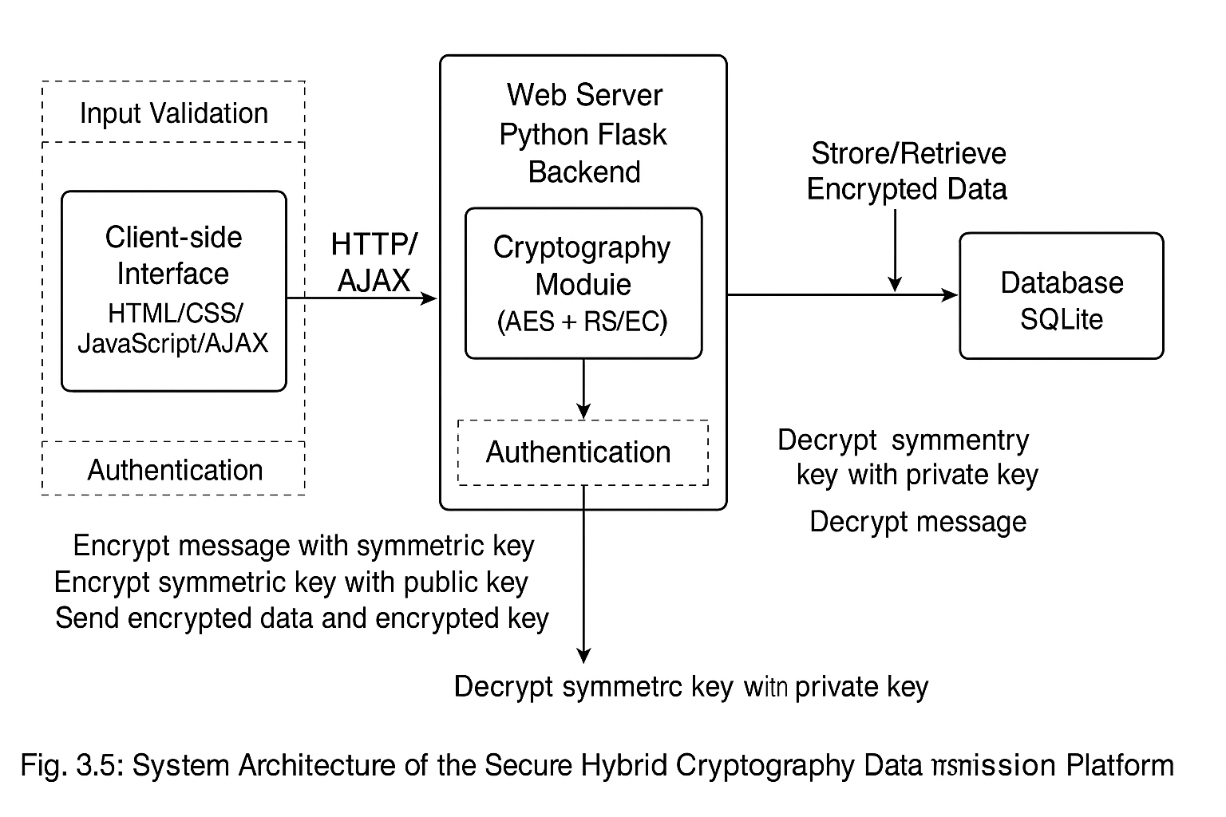
Fig. 3.5: System Architecture of the Secure Hybrid Cryptography Data Transmission Platform
DATA ENCRYPTION AND DECRYPTION FLOWCHARTS
In the proposed secure data transmission system, encryption and decryption are essential components for protecting sensitive information during file or message exchange. The system utilizes hybrid cryptography that combines symmetric encryption (AES) for data confidentiality and asymmetric encryption (RSA or ECC) for secure key exchange.
The flow of operations for both encryption and decryption can be understood through the following diagrams:
Encryption Flowchart
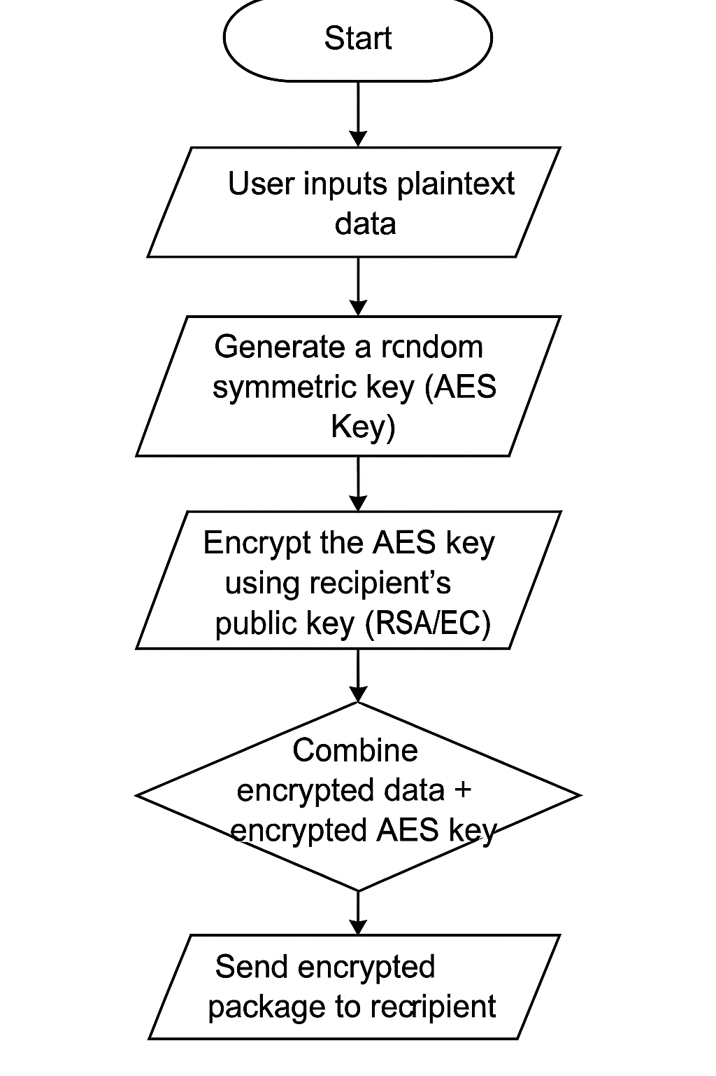
Fig. 3.6a: Data Encryption Process Flowchart
Decryption Flowchart
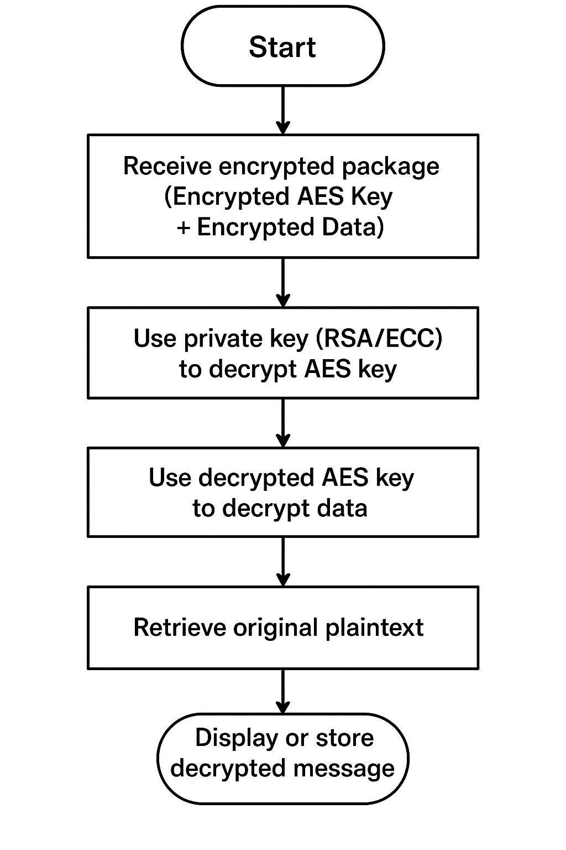
Fig. 3.6b: Data Decryption Process Flowchart
CHAPTER FOUR
DESIGN, IMPLEMENTATION AND DOCUMENTATION OF THE SYSTEM
DESIGN OF THE SYSTEM
Design is a crucial phase in the development of any software system, serving as the blueprint that guides the entire implementation process. It is a creative and systematic approach that defines how the system’s components interact and function to meet user requirements effectively. For a secure file and message encryption system, a robust design is particularly important because it directly impacts the system’s security, usability, and performance.
In the context of this project, the design focuses on creating an interactive and efficient system that integrates hybrid cryptographic techniques to ensure the confidentiality, integrity, and authenticity of data exchanged between users. This requires careful planning of the system architecture, input and output handling, database management, and encryption procedures to guarantee a seamless and secure user experience.
In this system, the database design acts as the backbone for securely storing user credentials, encrypted messages, encrypted files, and key information. The conceptual database design provides an abstraction layer that bridges the logical data relationships and the actual physical storage, ensuring data consistency and security.
By employing hybrid cryptography, the system design combines the strengths of symmetric and asymmetric encryption methods, which enhances performance while maintaining high security standards. This design approach not only addresses common encryption challenges such as key distribution and scalability but also improves usability through clear input and output mechanisms.
Overall, the design process ensures that the system is scalable, maintainable, and capable of protecting sensitive information in real-time communication scenarios, making it suitable for various applications ranging from personal messaging to secure organizational data exchange.
OUTPUT DESIGN
Output design is a critical aspect of system development that determines how the processed data and results are presented to users. It focuses on creating clear, meaningful, and secure outputs that meet the needs of the system’s stakeholders. For the file and message encryption system, output design not only involves displaying encrypted and decrypted content but also includes generating secure notifications, status messages, and audit logs to ensure transparency and traceability of all cryptographic operations. Below are the sampled output diagram:
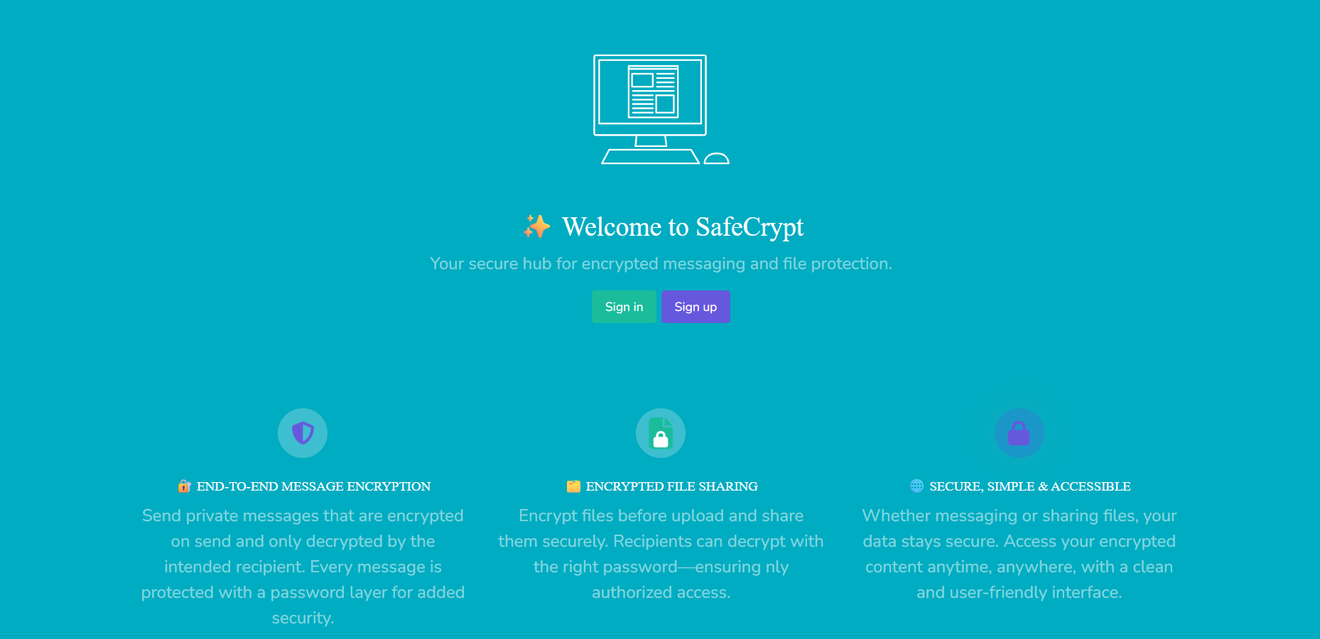
Fig 4.1: Splash Screen Page Screenshot
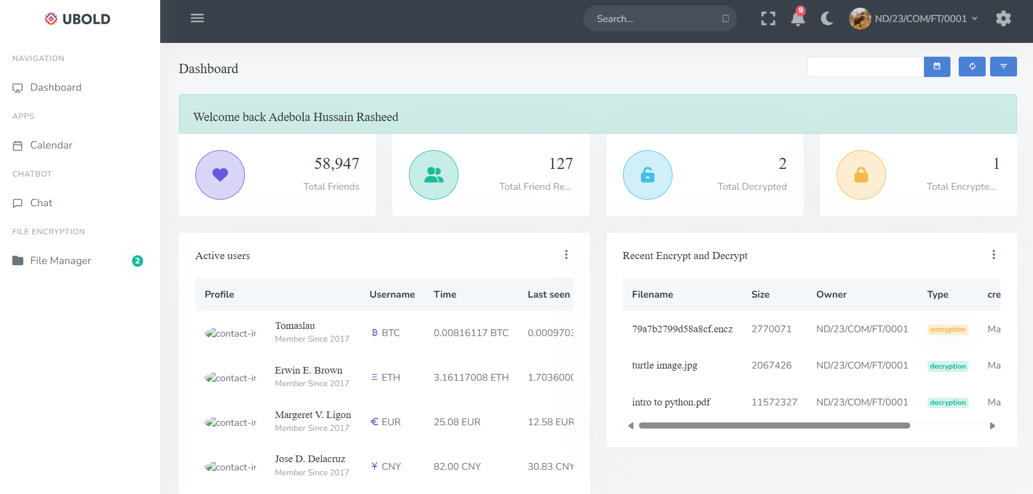
Fig 4.2: User Dashboard Page Screenshot
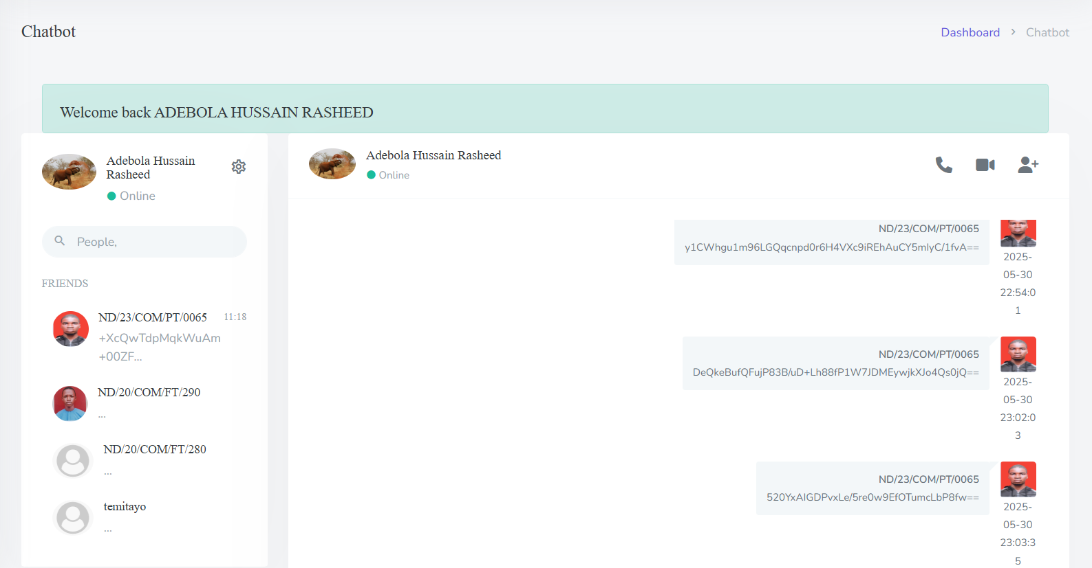
Fig 4.3: Chat Page Screenshot
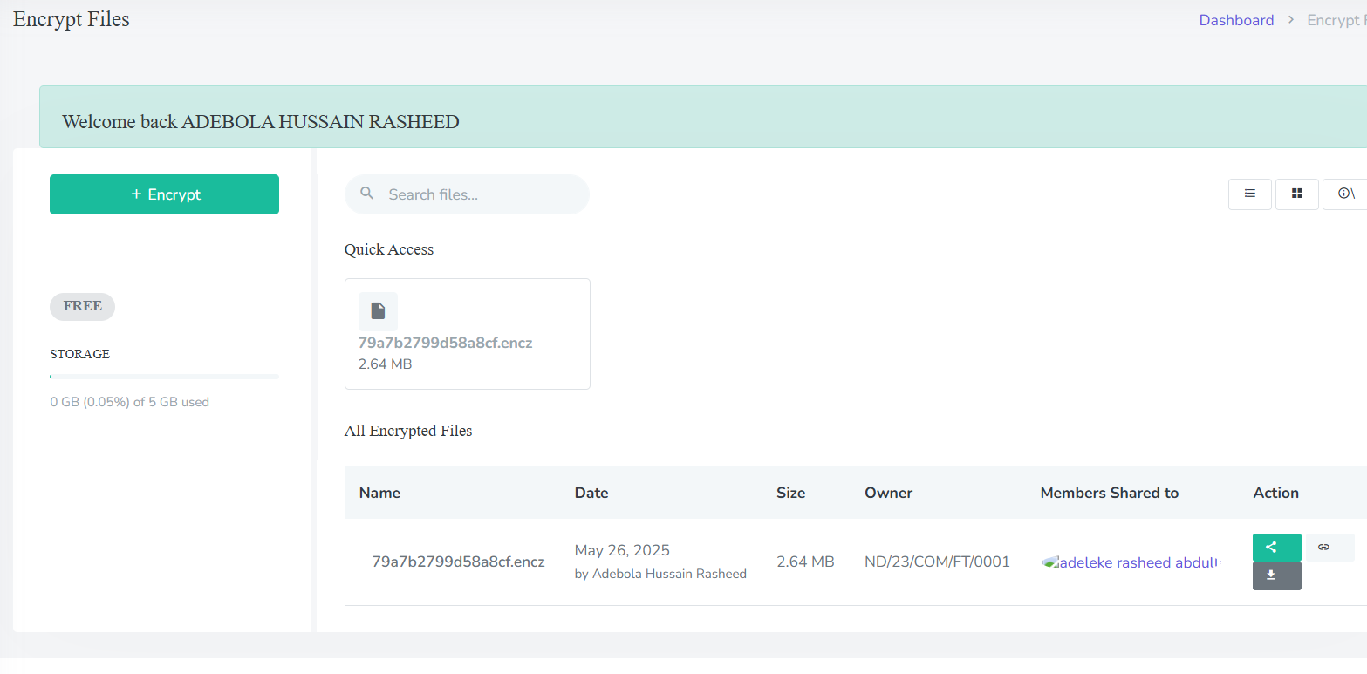
Fig 4.4: File encryption Page Screenshort
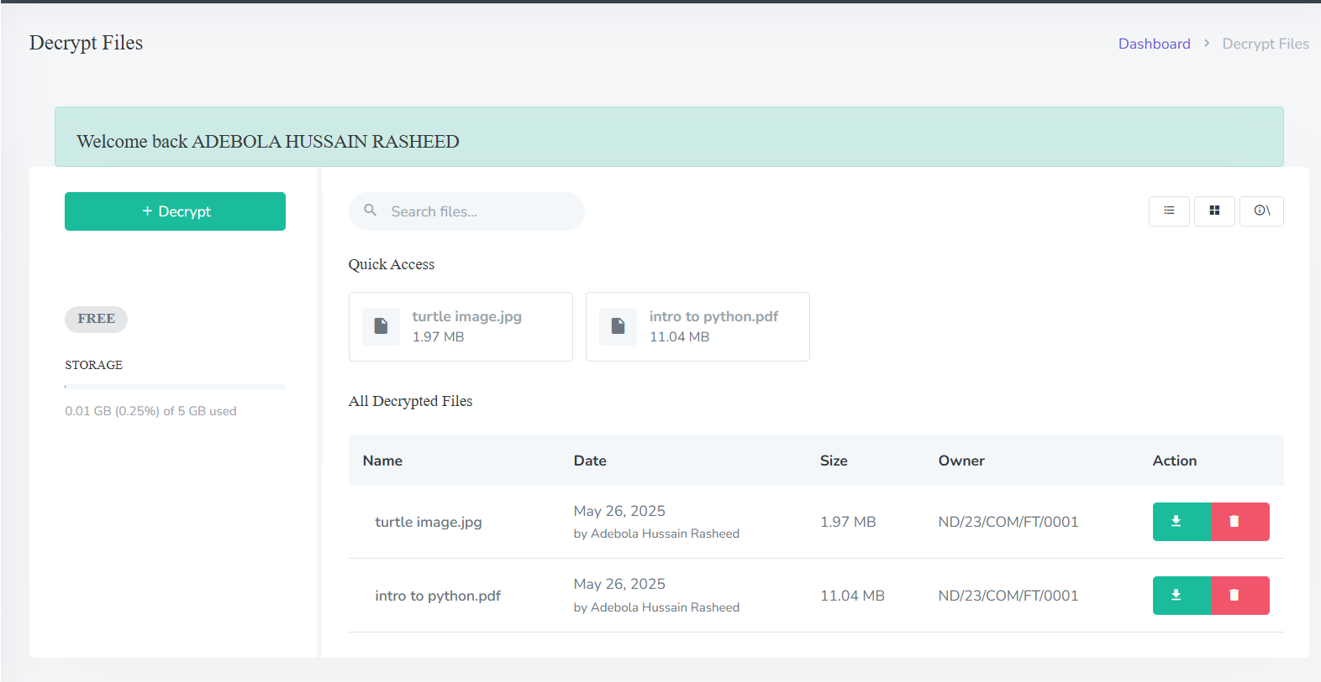
Fig 4.5: File Decryption Page Screenshot

Fig 4.6: Decrypted Message Screenshot

Fig 4.7: Error Message For Intruder Decryption
INPUT DESIGN
Input design is a fundamental component of system development that focuses on how users enter data into the system for processing. A well-structured input design ensures accuracy, security, and efficiency, preventing data corruption and minimizing user errors. For an encryption system that deals with sensitive information such as messages, files, passwords, and encryption keys, the input design must prioritize both usability and robust security measures. Diagram of the inputs design is as follows:
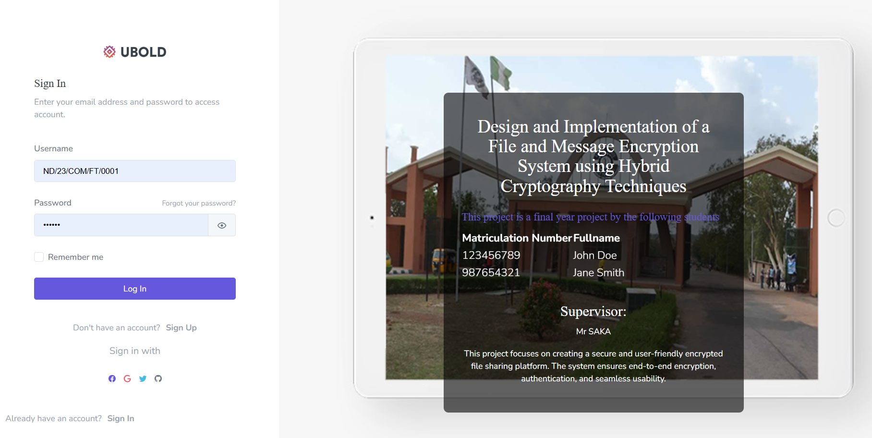
Fig 4.8: Login Page Screenshot
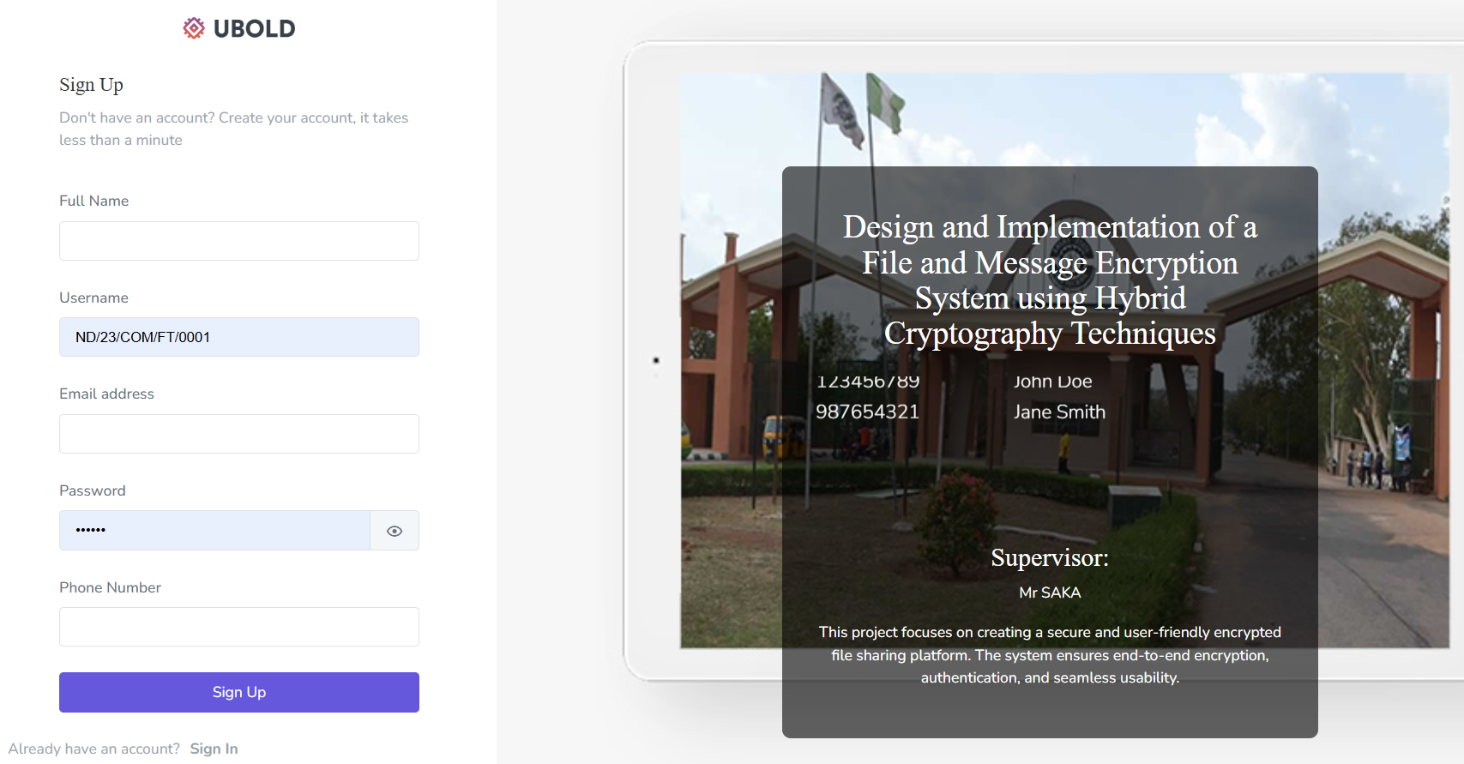
Fig 4.9: Registration Page Screenshot

Fig 4.10: Send Encrypted Message Form Screenshot
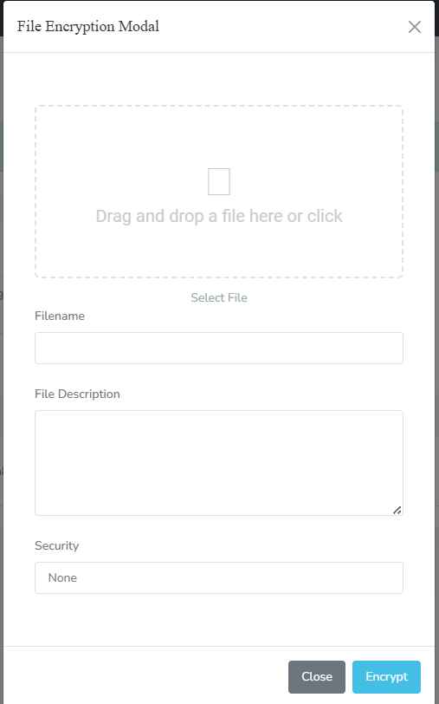
Fig 4.11: Encryption Page Screenshot
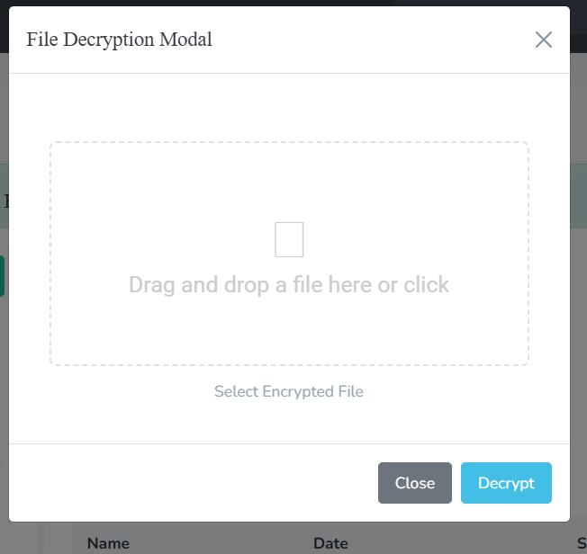
Fig 4.12: Decryption Page Screenshot

Fig 4.13: Enter Pin Form For Pin Encrypted Message Screenshot
DATABASE DESIGN
Database design is a crucial aspect of developing a secure and efficient encryption system. It involves structuring the database in a way that ensures optimal data organization, accessibility, and security. This system adopts a relational database model to manage data consistently and securely. The database was normalized to eliminate redundancy, improve data integrity, and enhance performance. Each table in the database was designed to store specific types of data, with proper relationships established between them using foreign keys. Below is the database design of the system:
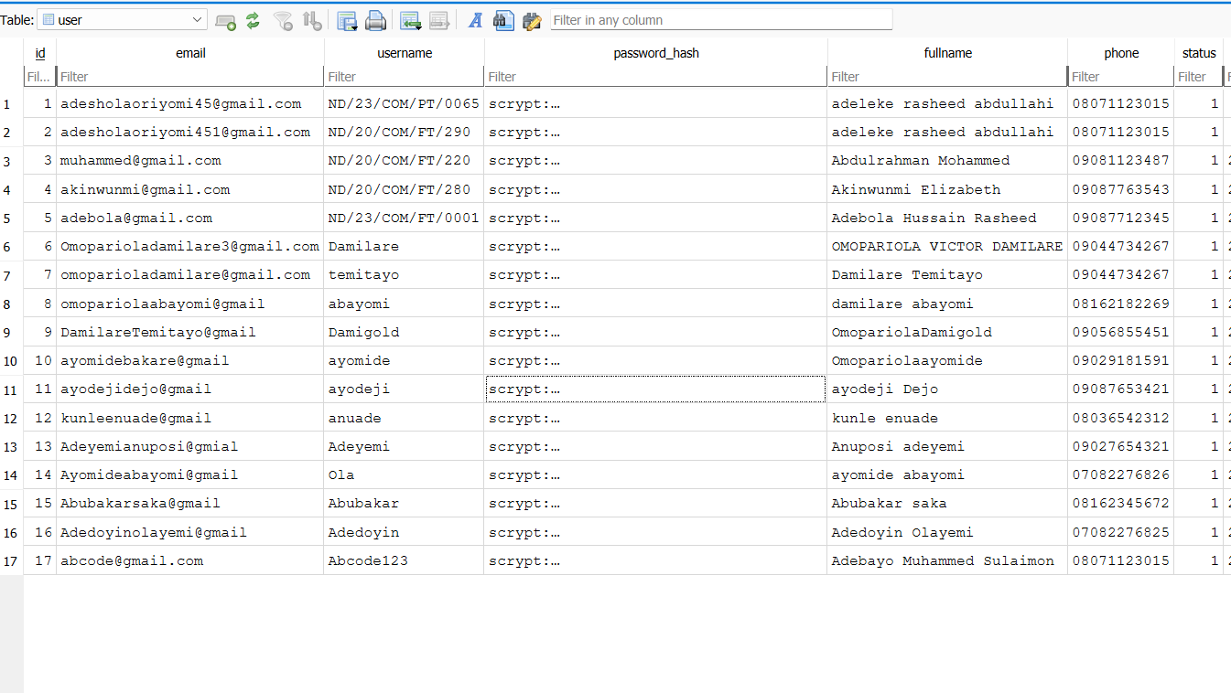
Fig 4.14: Database Structure For Storing User Record
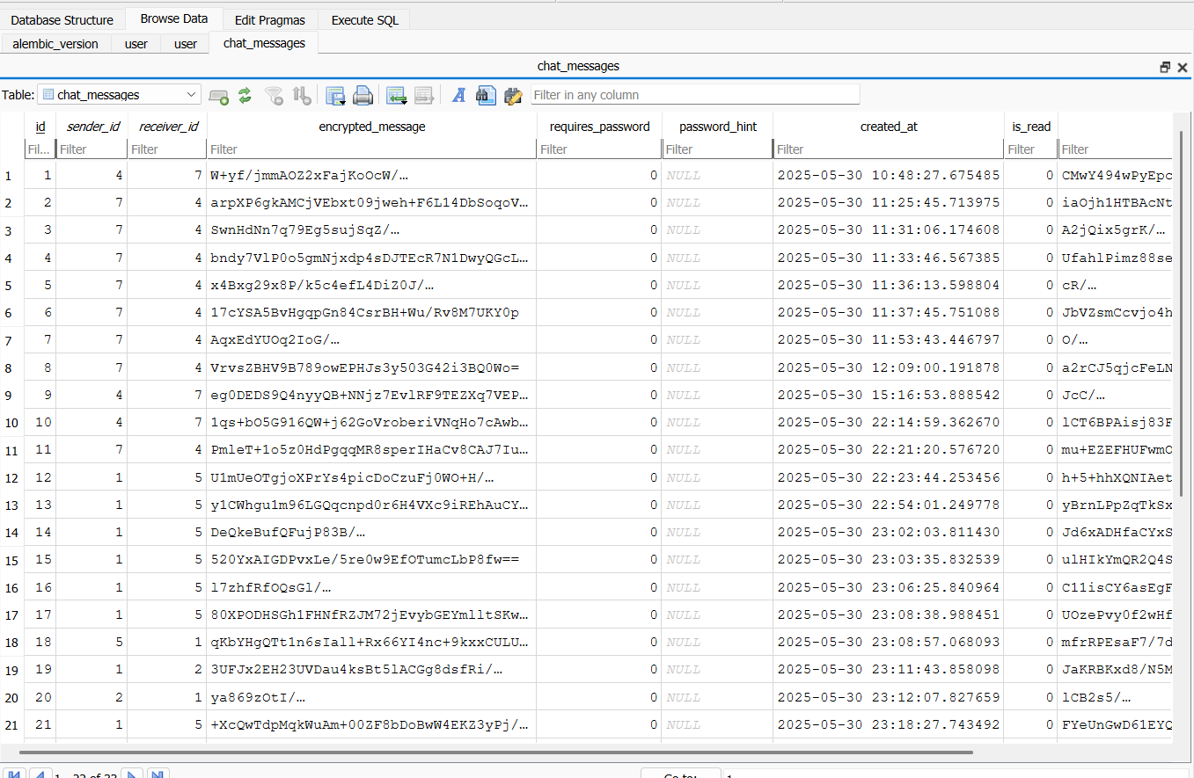
Fig 4.15: Database Structure For Messages
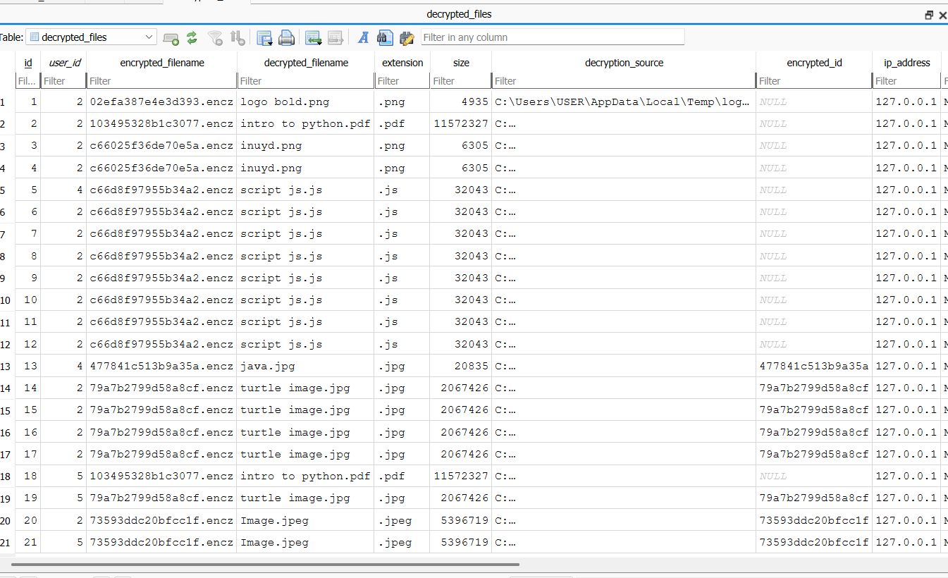
Fig 4.16: Database Structure For Storing Files (Encryption/Decryption)

PROCEDURE DESIGN
Procedure design outlines the logical steps and processes the system follows to accomplish specific tasks. In the context of a file and message encryption system, procedure design plays a critical role in ensuring that data is securely processed from the point of user input to final storage or transmission. This section details the sequence of operations and logical flow for key functionalities within the system.
The core procedures designed for this system include user authentication, encryption and decryption, message handling, and file management. Each procedure is designed with security, efficiency, and usability in mind.

SYSTEM IMPLEMENTATION
The implementation phase is the stage where the actual development of the system takes place based on the design specifications. It involves translating system requirements and design into a functional software application. For this project, the file and message encryption system was implemented using modern web technologies, cryptographic libraries, and database management systems.
The implementation was carefully structured to follow best practices in security, maintainability, and user experience. This section highlights the tools and technologies used, the programming languages chosen, and the methods adopted to bring the system to life.
Choice of Programming Language
The choice of programming language for this system was influenced by several factors such as support for cryptographic libraries, ease of integration, performance, and developer familiarity.
- Backend Language: Python was used on the server-side, specifically with the Flask framework. Python provides strong support for cryptographic functions via libraries like cryptography, PyCryptodome, and bcrypt. Flask also allows for fast prototyping and easy integration of REST APIs.
- Frontend Language: HTML5, CSS3, and JavaScript were used for the frontend development. JavaScript was particularly useful in implementing real-time communication features and client-side validations.
Software Support
Several supporting software tools and frameworks were used during the implementation phase:
- Flask – For handling web routing, user sessions, and RESTful API design.
- SQLite / MySQL – Used as the database management system for storing user credentials, encrypted messages, encrypted files, and metadata.
- JavaScript Libraries – Libraries like CryptoJS were used for client-side cryptographic functions.
- Bootstrap – For designing a responsive and user-friendly interface.
- Socket.IO – For implementing real-time messaging between users.

Implementation Techniques Used in Details
The system was implemented using a modular approach, where each feature was developed and tested independently before integration. The following techniques were employed:
- Model-View-Controller (MVC) Architecture: To ensure separation of concerns, the system followed an MVC structure where:
  - Models handle database interactions,
  - Views manage the frontend display,
  - Controllers handle logic and API requests.
- Hybrid Encryption Algorithm Implementation:
  - Symmetric encryption (AES) was used for encrypting actual file and message content.
  - Asymmetric encryption (RSA) was used to encrypt the AES keys, making key exchange secure.
  - Password-based encryption (optional) adds a second security layer for highly sensitive messages or files.
- Session and Key Management:
  - User sessions were managed using secure session tokens.
  - Private keys were securely stored in an encrypted format and only decrypted temporarily during use.
- Security Enhancements:
  - Cross-Site Scripting (XSS) and SQL Injection were mitigated by using proper input validation and ORM features.
  - HTTPS was used to ensure secure communication between the client and server.
- Testing and Debugging:
  - Each module underwent unit testing.

SYSTEM DOCUMENTATION
System documentation is a crucial part of any software development project as it ensures that both users and developers can understand, maintain, and effectively use the system. For this project, system documentation includes detailed records of how the system was designed, implemented, and how it should be maintained. It also covers information necessary for end-users to operate the system efficiently.
Documentation was prepared for both technical users (developers and system administrators) and non-technical users (end-users). It is divided into several components such as installation guides, user manuals, technical references, and maintenance procedures.
PROGRAM DOCUMENTATION
Program documentation provides details about the system's code structure, file organization, function definitions, and logical flow of the application. This helps current and future developers understand how the system was built and how to make modifications or improvements.
Key components of the program documentation include:
- Code Comments and Annotations: Each function and module in the codebase is well-commented to explain its purpose, parameters, and output. This improves code readability and maintainability.
- Module Descriptions:
  - User Authentication Module – Handles user login, registration, and session management.
  - Encryption Module – Responsible for encrypting and decrypting files and messages using AES and RSA.
  - Messaging Module – Manages sending and receiving of encrypted messages in real-time.
  - File Upload Module – Handles secure file uploads, encryption, and downloads.
  - Key Management Module – Manages the generation, encryption, and storage of cryptographic keys.
- API Endpoints: A full list of REST API endpoints used in the system is documented, including request methods, expected parameters, and sample responses.
- Directory Structure: Clear documentation of the project's folder and file structure to guide developers navigating the codebase.
MAINTAINING THE SYSTEM
System maintenance involves updating the system to fix bugs, add new features, or improve performance. Good documentation ensures that maintenance tasks can be carried out effectively without disrupting existing functionalities.
The maintenance documentation includes:
- Backup Procedures: Guidelines on how to perform regular database backups and restore data in case of system failure.
- Error Handling and Logs: Instructions on how to access and interpret error logs to identify and troubleshoot issues.
- Upgrade Instructions: Steps to update libraries, frameworks, and system dependencies safely.
- Security Maintenance:
  - Regular updates to cryptographic libraries.
  - Patching of vulnerabilities as they are discovered.
  - Review and renewal of public/private key pairs at intervals.
- User Feedback Handling: Procedures for collecting and analyzing user feedback to guide future updates.
- Performance Monitoring: Techniques to monitor the system's performance using logging tools and resource monitors, ensuring that the application remains responsive and efficient.

CHAPTER FIVE

SUMMARY, CONCLUSION AND RECOMMENDATIONS
SUMMARY
In today’s fast-evolving digital environment, the security of information has become a critical concern, especially in areas involving personal, organizational, and governmental communications. This project focused on the design and implementation of a secure file and message encryption system using hybrid cryptographic techniques. The study explored the limitations of traditional cryptographic approaches—symmetric and asymmetric encryption—highlighting their respective shortcomings in scalability, performance, and secure key exchange.
The proposed system integrates both symmetric (AES) and asymmetric (RSA) cryptography to leverage their strengths while minimizing their weaknesses. Symmetric encryption was used for securing large files and message contents due to its speed, while asymmetric encryption was employed for securely exchanging the encryption keys. Additional layers such as password protection and message hint support were also integrated to enhance usability and control.
The design covered essential aspects such as input/output design, database schema, and procedural flow. The implementation phase involved the use of modern programming languages and frameworks, along with technologies for secure real-time messaging and file transfer. The system was thoroughly documented for both users and developers, ensuring ease of maintenance and future upgrades.
CONCLUSION
This project successfully demonstrated the application of hybrid cryptographic techniques in building a secure communication platform that supports encrypted file and message sharing. By combining AES and RSA encryption models, the system offers both speed and robust security, addressing key challenges such as safe key distribution and message confidentiality.
Furthermore, the integration of password-based access and optional password hints adds a layer of human-centric security, ensuring that only intended recipients can decrypt the information. The system’s modular design, real-time messaging capability, and secure file sharing features provide a practical solution for sectors where privacy is critical—such as health, finance, law, and government.
In conclusion, the system provides a reliable and scalable solution to the rising need for secure digital communication in the face of growing cyber threats and privacy concerns.
RECOMMENDATIONS
Based on the results and implementation of this project, the following recommendations are proposed for future enhancements and real-world deployment:
- Integration of Multi-Factor Authentication (MFA): Adding biometric or two-factor authentication methods can further strengthen user verification and access control.
- Mobile Platform Compatibility: Developing native mobile applications for Android and iOS will increase accessibility and user engagement in diverse environments.
- Blockchain-Based Audit Trails: Implementing blockchain can offer transparent and tamper-proof logging of message transfers, enhancing trust and accountability.
- Performance Optimization for Large Files: Introduce streaming encryption methods or file chunking mechanisms to improve performance when handling large files.
- Regular Cryptographic Updates: Continuous review and updates to cryptographic libraries and algorithms are recommended to stay ahead of emerging security threats.
- User Education and Awareness: Educating users on secure password practices, phishing risks, and data handling will maximize the system's effectiveness in real-world use.

REFERENCES
Awan, M. U., & Masood, A. (2020). Comparative study of AES and RSA encryption algorithms. International Journal of Computer Applications, 175(7), 1–5. https://doi.org/10.5120/ijca2020920045
Bhardwaj, P., & Dutta, K. (2015). Implementation of secure hybrid encryption algorithm. International Journal of Scientific and Engineering Research, 6(3), 291–295. https://www.ijser.org/researchpaper/Implementation-of-Secure-Hybrid-Encryption-Algorithm.pdf
Chaudhry, J. A., Chaudhry, M. A., & Farooq, U. (2014). Comparative analysis of different encryption and decryption techniques. International Journal of Computer Science and Network Security, 14(11), 121–126. https://www.ijcsns.org/
Date, C. J. (2003). An introduction to database systems (8th ed.). Addison Wesley.
Dziembowski, S., & Pietrzak, K. (2008). Leakage-resilient cryptography. In 2008 49th Annual IEEE Symposium on Foundations of Computer Science (FOCS) (pp. 293–302). IEEE. https://doi.org/10.1109/FOCS.2008.28
Flask Documentation. (2023). Flask web framework documentation. https://flask.palletsprojects.com/
Kaur, G., & Singh, A. (2013). Review paper on hybrid cryptography techniques. International Journal of Computer Applications, 73(5), 17–21. https://doi.org/10.5120/12764-9805
Khan, A. (2019). Securing data with hybrid cryptographic algorithms. International Journal of Computer Applications, 182(3), 1–6. https://doi.org/10.5120/ijca2019918456
Li, S., & Yu, Y. (2021). A lightweight and secure hybrid encryption scheme for smart applications. Journal of Information Security and Applications, 58, 102804. https://doi.org/10.1016/j.jisa.2021.102804
Mishra, S. P., & Tripathi, R. (2019). Secure communication using hybrid cryptographic algorithm in cloud environment. Procedia Computer Science, 152, 404–410. https://doi.org/10.1016/j.procs.2019.05.007
Mozilla Developer Network (MDN). (2023). AJAX guide and resources. https://developer.mozilla.org/en-US/docs/Web/Guide/AJAX
Nadeem, A., & Javed, M. Y. (2005). A performance comparison of data encryption algorithms. In IEEE International Conference on Information and Communication Technologies (pp. 84–89). IEEE. https://doi.org/10.1109/ICICT.2005.1598556
OWASP Foundation. (2023). OWASP cryptographic storage cheat sheet. https://cheatsheetseries.owasp.org/cheatsheets/Cryptographic_Storage_Cheat_Sheet.html
Python Software Foundation. (2023). Python 3 documentation. https://docs.python.org/3/
Schneier, B. (1996). Applied cryptography: Protocols, algorithms, and source code in C (2nd ed.). John Wiley & Sons.
Singh, S., & Supriya. (2013). Comparative analysis of cryptographic algorithms. International Journal of Advanced Research in Computer Science and Software Engineering, 3(6), 617–621. https://www.ijarcsse.com/
SQLite Documentation. (2023). SQLite official documentation. https://www.sqlite.org/docs.html
Stallings, W. (2017). Cryptography and network security: Principles and practice (7th ed.). Pearson.
Stallings, W. (2020). Network security essentials: Applications and standards (6th ed.). Pearson.
Trappe, W., & Washington, L. C. (2006). Introduction to cryptography with coding theory (2nd ed.). Pearson Prentice Hall.
Vasudevan, V., & Dey, S. (2020). Hybrid encryption approach for secure file sharing. International Journal of Computer Science and Mobile Computing, 9(3), 41–47. http://www.ijcsmc.com/docs/papers/March2020/V9I3202010.pdf
Visual Studio Code Documentation. (2023). Visual Studio Code user guide. Microsoft. https://code.visualstudio.com/docs
Xia, W., & Zhang, Y. (2021). Improved hybrid cryptography for secure messaging systems. Computer Security Journal, 40(2), 145–153. https://doi.org/10.1016/j.cose.2021.102780
Zhao, J., Wang, Y., & Liu, H. (2022). Performance evaluation of AES and RSA for data security in cloud storage. International Journal of Computer Applications, 184(10), 7–12. https://doi.org/10.5120/ijca2022912219

