KWARA STATE POLYTECHNIC, ILORIN

ASSESSING THE ROLE OF QUANTITY SURVEYORS IN ECONOMIC VIABILITY OF AGRICULTURAL PROCESSING PLANTS

By

ADEMOLA OLALEKAN MATHEW
HND/23/FT/QTS/0005

A FINAL-YEAR PROJECT SUBMITTED TO QUANTITY SURVEYING DEPARTMENT

IN PARTIAL FULFILLMENT OF THE REQUIREMENT FOR THE AWARD OF HIGHER NATIONAL DIPLOMA (HND) IN QUANTITY SURVEYING.

JULY 2025

CERTIFICATION

This is to certify that the research titled Investigation of the Role of Quantity Surveyors in Assessing the Economic Viability of Agricultural Processing Plants was carried out by Ademola Olalekan Mathew with matriculation number HND/23/FT/QTS/0005 has been read and approved as meeting the requirements for the award Higher National Diploma (HND) In Quantity Surveying, Kwara state polytechnic, Ilorin, Nigeria.

QS SIDEEQ LATEEF -------------------------------------
(Project Supervisor) Signature and Date

QS SIDEEQ LATEEF ------------------------------------
(Head of Department) Signature and Date

QS AISHA OMAR MUAZU -------------------------------------
(Project Coordinator) Signature and Date

QS. (DR) ADAMU MUDI (FNIQS. RQ) --------------------------------------
(External Examiner) Signature and Date

DEDICATION
This project is dedicated to the Almighty Allah, the Most Gracious, the Most Merciful, for granting me life, strength, wisdom, and the opportunity to complete this academic journey.
To my beloved parents and guardians, whose prayers, love, and unwavering support have been my greatest source of motivation thank you for believing in me even when the road was tough.
To my siblings and family members, thank you for your encouragement and kind words throughout this journey.
I also dedicate this work to all the lecturers and mentors who guided me with their knowledge and wisdom, and to my colleagues and friends whose companionship and collaboration made the process more meaningful.
Finally, this work is dedicated to every student who dares to dream, perseveres through challenges, and strives for excellence in the pursuit of knowledge.

DECLARATION

I hereby declare that this Research work, which I submit to the Department of Quantity Surveying, Institute of environmental studies, Kwara state polytechnic, Ilorin, Kwara state, Nigeria, examination in consideration of the award of a Higher National Diploma in Quantity Surveying in an original work undertaken by me Ademola Olalekan Mathew.

--------------------------------------------------- ---------------------------
Ademola Olalekan Mathew DATE
(HND/23/FT/QTS/0005)

ACKNOWLEDGEMENTS

First and foremost, I express my deepest gratitude to Almighty Allah, the source of my strength, knowledge, and perseverance, for granting me the wisdom and ability to successfully complete this research work.
My sincere appreciation goes to my project supervisor Q.S sideeq lateef whose invaluable guidance, constructive feedback, and constant encouragement contributed significantly to the quality and completion of this study. Your support and academic mentorship have been instrumental throughout this journey.
I extend my heartfelt thanks to the Head of Department, academic staff, and management of the Department of Quantity Surveying, Kwara State Polytechnic, Ilorin, for providing a conducive learning environment and access to relevant resources.
Special thanks to all the respondents and professionals in the construction industry who took the time to participate in the survey and share their experiences. Your input was vital to the success of this research.
To my beloved family, thank you for your unwavering love, prayers, and emotional support. Your belief in my potential kept me going even in the most challenging moments. I am especially grateful to my wife and daughter for their patience, love, and understanding during the many late nights and long days dedicated to this project.
To my friends and colleagues, thank you for the shared experiences, moral support, and constant encouragement that helped me stay focused and determined.
Lastly, I acknowledge everyone who contributed in one way or another to the successful completion of this project. May Allah reward you all abundantly.

TABLE OF CONTENTS
CERTIFICATION 2
DEDICATION 3
DECLARATION 4
ACKNOWLEDGEMENTS 5
TABLE OF CONTENTS 6
CHAPTER ONE 9
INTRODUCTION 9
1.1 Background to the Study 9
1.2 Statement of Research Problems 10
1.3 Research Questions 11
1.4 Aim and Objectives 11
1.4.1 Aim 11
1.4.2 Objectives of the Study 11
To achieve the aim of this study, the following objectives have been outlined: 11
1.5 Scope and Limitation 12
1.5 Justification for the Study 13
1.6 Definition of Terms 14
1.6.1 Quantity Surveyor 14
1.6.2 Economic Viability 14
1.6.3 Agricultural Processing Plant 15
1.6.4 Cost Estimation 15
1.6.5 Financial Planning 15
1.6.6 Risk Assessment 15
1.6.7 Feasibility Study 15
1.6.8 Budget Overrun 15
1.6.9 Lifecycle Cost Analysis 16
1.6.10 Procurement Strategy 16
1.6.11 Sustainability 16
1.6.12 Investment Risk 16
1.6.13 Value Engineering 16
1.6.14 Inflation Impact 16
1.6.15 Public-Private Partnership (PPP) 16
CHAPTER TWO 17
LITERATURE REVIEW 17
2.1 Introduction 17
2.2 Concept of Economic Viability in Agricultural Processing Plants 17
2.3 Role of Quantity Surveyors in Cost Estimation and Financial Planning 18
2.4 Cost Estimation Techniques Used by Quantity Surveyors in Agricultural Processing Plant Projects 20
2.4.1 Value Engineering 21
2.4.2 Budget Monitoring 22
2.4.3 Cost-Benefit Analysis 22
2.4.4 Life Cycle Costing (LCC) 22
2.4.5 Earned Value Management (EVM) 23
2.4.6 Risk Management in Cost Control 23
2.5 Factors Limiting the Involvement of Quantity Surveyors in The Agricultural Sector. 23
2.5.1 Limited Awareness and Underutilization of QS Services 24
2.5.2 Regulatory and Institutional Challenges 24
2.5.3 Lack of Reliable and Comprehensive Financial Data 24
2.5.4 Absence of Interdisciplinary Collaboration 25
2.5.5 Limited Access to Sector-Specific Training and Professional Development 25
2.5.6 Technological and Data Management Limitations 25
2.6 Financial Challenges Faced in The Development and Operation of Agricultural Processing Plants. 26
2.6.1 Feasibility Analysis of Agro-Industrial Investments 26
2.6.2 Increasing Demand for Food Security and Agro-Export Competitiveness 26
2.6.3 Consideration in economic viability assessments 26
2.6.4 Limited Access to Finance 27
2.6.5 Infrastructure & Power Deficits 27
2.6.6 High Equipment & CAPEX Costs 28
2.6.7 Regulatory & Bureaucratic Risks 28
2.6.8 Market Volatility & Post-harvest Losses 28
2.6.9 Working Capital & Financial Resilience 28
2.6.10 Skills & Organizational Capacity 28
2.8 Role of Quantity surveyors’ in assessing the economic viability of agro-processing projects. 29
2.8.1 Feasibility & Viability Analysis 29
2.8.2. Cost Estimation, Budgeting & Life-Cycle Costing 30
2.8.3. Value Management & Alternative Options 31
2.8.4 Risk Identification and Contingency Planning 32
2.8.5. Tendering, Procurement & Contract Strategy 34
2.8.6. Financial Viability Modeling & Cash Flow Sensitivity 35
2.8.7. Sustainability & Tech Integration 36
2.9 Summary 37
CHAPTER THREE 38
RESEARCH METHODOLOGY 38
3.1 Introduction 38
3.2 Research Design 38
3.3 Research Population 38
3.4 Sample Size 39
3.5 Sampling Technique 40
3.6 Method of Data Collection 40
3.7 Method of Administering data 41
3.8 Test of Validity and Reliability of data 41
3.9 Method of data presentation and Analysis 42
CHAPTER FOUR 43
DATA ANALYSIS, RESULTS AND DISCUSSIONS 43
4.1 A brief introduction to the chapter 43
4.2 Response Rate 43
4.3 Characteristics of Respondents 43
4.3.1 Gender Distribution of Respondents 43
4.3.2 Age Distribution of Respondents 44
4.3.3 Years of Professional Experience 45
4.3.4 Professional Background of Respondents 46
4.3.5 Involvement in Agro-Processing Projects 47
4.4 Presentation and analysis of data according to research questions 48
4.4.1 Common Financial Challenges in the Development of Agro-Processing Plants 48
4.4.2 Perceived Severity of Financial Challenges on Agro-Processing Project Success 49
4.4.3 Perceived Importance of Quantity Surveyors in Agro-Processing Project Development 51
4.4.4 Specific Roles of Quantity Surveyors in Agro-Processing Projects 52
4.4.5 Experience with QS-Led Viability Assessments in Agro-Processing Projects 53
4.4.6 Cost Estimation Techniques Commonly Used by Quantity Surveyors in Agro-Processing Projects 55
4.4.7 Perceived Accuracy of Cost Estimation Techniques in Predicting Actual Project Costs 56
4.4.8 Impact of Cost Estimation Errors on Agro-Processing Project Success 57
4.4.9 Factors Limiting the Involvement of Quantity Surveyors in Agricultural Processing Plant Projects 59
4.5 Discussion of Findings 60
CHAPTER FIVE 63
SUMMARY, CONCLUSION, AND RECOMMENDATIONS 63
5.1 Summary of Findings Error! Bookmark not defined.
5.2 Conclusion 63
5.3 Recommendations 63
5.4 Suggestions for Further Studies 64
References 65
Appendix 68

CHAPTER ONE

INTRODUCTION

1.1 Background to the Study
Agriculture remains a key driver of economic growth in many nations, particularly in developing economies where it contributes significantly to employment, food security, and industrial raw materials (FAO, 2021). However, the sector faces challenges related to post-harvest losses, low productivity, and limited value addition. Agricultural processing plants serve as a crucial intervention by transforming raw agricultural products into finished goods, thereby increasing their market value and reducing waste (Ogunlana et al., 2018). These plants require substantial financial investment in infrastructure, machinery, and operational costs, making economic viability a major concern for stakeholders.
The successful establishment and operation of agricultural processing plants depend on several factors, including cost management, risk assessment, and return on investment analysis. Quantity surveyors, traditionally associated with cost control in the construction industry, possess specialized skills in financial planning, cost estimation, and economic evaluation, which are crucial for determining the feasibility of such projects (Shehu, 2023). Their role extends beyond budgeting for infrastructure to include lifecycle costing, procurement strategies, and investment risk assessment, ensuring that agricultural processing plants remain financially sustainable (Smith & Brown, 2020).
Globally, agricultural processing plants have contributed significantly to economic growth in countries like China, Brazil, and the Netherlands, where structured financial planning and cost control mechanisms have played a key role in their success (Chen & Zhang, 2021). In contrast, in many African nations, the lack of proper cost estimation and financial oversight has led to failed agro-processing initiatives, resulting in wasted investments and abandoned projects (Johnson & Evans, 2018). This further highlights the need for expert involvement in economic feasibility assessments, particularly from quantity surveyors.
In Nigeria, the agricultural sector has received increasing government and private sector support, with initiatives such as the Agricultural Transformation Agenda (ATA) and the Anchor Borrowers' Program aimed at boosting productivity and value addition (NBS, 2022). However, many agricultural processing plants still struggle with financial mismanagement, high operational costs, and inadequate risk assessment, leading to premature closure (Mwangi & Otieno, 2019). The involvement of quantity surveyors in assessing project viability can bridge this gap by ensuring that financial projections align with real-world economic conditions.
This study seeks to explore the role of quantity surveyors in assessing the economic viability of agricultural processing plants, focusing on cost estimation, risk assessment, and financial planning. By highlighting their contributions, this research aims to provide valuable insights into improving the success rate of agro -processing investments, ensuring sustainable agricultural development and economic growth.

1.2 Statement of Research Problems
Agricultural processing plants are vital for enhancing food security, reducing post-harvest losses, and stimulating economic growth, particularly in developing economies where agriculture contributes significantly to GDP (FAO, 2021). However, despite their potential benefits, many agro-processing projects fail due to poor financial planning, inaccurate cost estimation, and ineffective risk assessment (Johnson & Evans, 2018). The high capital investment required for infrastructure, machinery, and operations further complicates the viability of such projects, making it necessary to conduct a thorough economic evaluation before investment (Mwangi & Otieno, 2019).
Quantity surveyors, as experts in cost estimation, budgeting, and financial control, play a critical role in ensuring the success of large-scale projects (Shehu, 2023). However, their expertise is predominantly applied in the construction sector, leaving their contributions to agricultural processing plants largely underutilized (Smith & Brown, 2020). In Nigeria and many other developing nations, numerous agro-processing projects have been abandoned due to budget overruns, improper financial feasibility studies, and inefficient resource allocation (Ogunlana et al., 2018). The lack of professional cost management in these projects often results in unsustainable investments, leading to financial losses and wasted resources.
Given these challenges, it is imperative to explore how the involvement of quantity surveyors can enhance the financial sustainability of agricultural processing plants. This study aims to bridge this gap by investigating the role of quantity surveyors in assessing economic viability, with a particular focus on cost estimation, financial planning, and risk management. By understanding their potential contributions, stakeholders can adopt more effective financial strategies to ensure the long-term success of agro-processing projects.

1.3 Research Questions
To achieve the objectives of this study, the following research questions were formulated:
- What are the key financial challenges faced in the development of agricultural processing plants?
- How can quantity surveyors contribute to assessing the economic viability of agro-processing projects?
- What cost estimation techniques do quantity surveyors apply in evaluating agricultural processing plants?
- What are the factors limiting the involvement of quantity surveyors in the agricultural sector?

1.4 Aim and Objectives

1.4.1 Aim
The aim of this study is to investigate the role of quantity surveyors in assessing the economic ability of agricultural processing plants to ensure long term success of processing plants

1.4.2 Objectives of the Study

To achieve the aim of this study, the following objectives have been outlined:
- To identify the key financial challenges faced in the development and operation of agricultural processing plants.
- To examine the role of quantity surveyors in assessing the economic viability of agro-processing projects.
- To evaluate the cost estimation techniques used by quantity surveyors in agricultural processing plant projects.
- To investigate the factors limiting the involvement of quantity surveyors in the agricultural sector.

1.5 Scope and Limitation
This study focuses on investigating the role of quantity surveyors in assessing the economic viability of agricultural processing plants. It examines the contributions of quantity surveying professionals in financial planning, cost estimation, and risk management within the agro-processing sector. The research will explore various aspects of economic viability, including budgeting, lifecycle cost analysis, feasibility studies, and investment sustainability, with a particular emphasis on how quantity surveyors apply their expertise to mitigate financial risks and optimize resource allocation.
The study will cover agricultural processing plants of different scales, including small, medium, and large-scale facilities, to determine how financial assessment techniques vary across different project sizes. It will investigate case studies of successful and unsuccessful agro-processing projects to understand the financial pitfalls that lead to project abandonment or inefficiencies. Additionally, the study will examine the cost control measures, procurement strategies, and financial risk mitigation techniques used in the development of agro-processing plants.
Geographically, the study will focus primarily on Kaduna state, given the state strong agricultural base and growing need for agro-processing infrastructure. However, references will be made to international best practices to provide a broader perspective on the role of quantity surveyors in agricultural projects. The research will include insights from industry professionals, including quantity surveyors, agricultural economists, project managers, and investors, to develop a well-rounded analysis of the subject matter.
Furthermore, the study will explore the impact of government policies and regulatory frameworks on the financial planning of agricultural processing plants. It will assess how policy decisions, such as subsidies, tariffs, and incentives, influence project viability and determine whether government intervention plays a significant role in the success of agro-processing ventures.
The study will also investigate the technological advancements affecting financial planning in agro-processing projects, including the use of modern software tools for cost estimation and risk assessment. It will analyze how digital solutions, such as Building Information Modeling (BIM) and cost management software, can improve the accuracy of financial projections and optimize cost control strategies in the agricultural sector.
By the end of this research, practical recommendations will be provided on how to enhance the integration of quantity surveying expertise into agro-processing projects to improve financial sustainability and investment success.

1.5 Justification for the Study
Agricultural processing plants play a critical role in food production, preservation, and value addition, contributing significantly to economic growth, food security, and job creation. However, many of these projects fail due to poor financial planning, budget overruns, and inefficient resource management. This study is justified by the need to examine how quantity surveyors, as experts in cost estimation, financial planning, and risk assessment, can contribute to the economic viability and sustainability of agro-processing plants.
One major reason for this study is the increasing global emphasis on agro-business as a means of economic diversification, particularly in developing countries like Nigeria, where agriculture remains a dominant sector. Despite government efforts to encourage agricultural industrialization, many processing plants suffer from financial mismanagement and eventual project abandonment. This raises concerns about the effectiveness of current financial assessment methods and highlights the need for quantity surveyors to play a more active role in cost planning and project feasibility analysis.
Furthermore, there is limited research on the application of quantity surveying principles in agricultural projects, with most studies focusing on the construction and infrastructure sectors. By exploring the contributions of quantity surveyors in agro-processing, this study fills an important knowledge gap and expands the understanding of their role beyond traditional construction projects. It aims to demonstrate how their expertise can optimize cost efficiency, enhance investment decision-making, and ensure the long-term financial sustainability of agro-processing plants.
The study is also justified by the increasing demand for cost-effective solutions in the agro-processing sector. With rising construction costs, inflation, and fluctuating commodity prices, there is an urgent need for precise financial forecasting and cost control mechanisms. This research will provide valuable insights into the techniques and tools used by quantity surveyors to mitigate financial risks and improve the economic feasibility of agricultural processing investments.
Moreover, the findings of this study will be beneficial to multiple stakeholders, including government agencies, investors, policymakers, and industry professionals. By highlighting the role of quantity surveyors in agro-processing, the study will offer practical recommendations for integrating financial planning expertise into agricultural project development. These insights can guide policymakers in formulating strategies to enhance project viability and encourage private sector participation in agribusiness.
Lastly, this research will serve as a reference point for future studies, offering a foundation for further exploration of cost management in agricultural projects. It will encourage greater collaboration between quantity surveyors, agricultural economists, and project managers, fostering interdisciplinary approaches to improving financial sustainability in agro-processing.

1.6 Definition of Terms
To ensure clarity and a comprehensive understanding of this study, key terms are defined as follows:

1.6.1 Quantity Surveyor
A construction and project management professional responsible for cost estimation, financial planning, and risk assessment to ensure cost-effective project execution.

1.6.2 Economic Viability
The ability of a project to generate sufficient financial returns to cover costs and sustain long-term operations without excessive financial risks.

1.6.3 Agricultural Processing Plant
A facility where raw agricultural products are processed, refined, or transformed into finished or semi-finished goods for distribution and consumption.

1.6.4 Cost Estimation
The process of predicting the total costs associated with a project, including materials, labor, equipment, and operational expenses.

1.6.5 Financial Planning
The process of allocating financial resources, forecasting costs, and developing strategies to ensure project success and sustainability.

1.6.6 Risk Assessment
The systematic evaluation of potential financial, operational, and environmental risks that may affect the success of a project.

1.6.7 Feasibility Study
An analysis conducted to determine the practicality and financial sustainability of a proposed project before investment.

1.6.8 Budget Overrun
A situation where actual project costs exceed the initially estimated or allocated budget, leading to financial inefficiencies.

1.6.9 Lifecycle Cost Analysis
A financial assessment method used to evaluate the total cost of a project over its entire lifespan, including initial investment, maintenance, and operational expenses.

1.6.10 Procurement Strategy
A structured approach to acquiring goods and services needed for a project, ensuring cost efficiency and quality control.

1.6.11 Sustainability
The ability of a project to operate efficiently over the long term while minimizing environmental, financial, and operational risks.

1.6.12 Investment Risk
The probability of financial losses or uncertainties affecting the profitability and success of an agricultural processing project.

1.6.13 Value Engineering
A systematic approach used by quantity surveyors to improve project value by optimizing costs without compromising quality or functionality.

1.6.14 Inflation Impact
The effect of rising prices on the cost of materials, labor, and equipment, influencing project financial planning.

1.6.15 Public-Private Partnership (PPP)
A collaboration between government agencies and private sector investors to finance, develop, and manage large-scale projects, including agricultural processing plants.

CHAPTER TWO

LITERATURE REVIEW

2.1 Introduction
This chapter provides a comprehensive review of existing literature on the role of quantity surveyors in assessing the economic viability of agricultural processing plants. It explores various aspects such as cost estimation, financial planning, risk assessment, and procurement strategies in agro-processing projects. The review is structured to highlight key themes related to the financial sustainability of agricultural processing plants and the contributions of quantity surveyors to project feasibility.

2.2 Concept of Economic Viability in Agricultural Processing Plants
Economic viability refers to the ability of a project or enterprise to sustain its operations and generate adequate financial returns over the long term (Smith & Brown, 2020). In the context of agricultural processing plants, economic viability encompasses a range of financial, operational, and market-based factors that determine whether the investment will be profitable and sustainable. These plants typically require significant capital inputs for infrastructure, land acquisition, specialized machinery, storage facilities, labor, and energy costs. Therefore, ensuring economic viability is essential not only for recovering the initial investment but also for achieving long-term operational sustainability.
Agricultural processing plants are often located in rural or semi-urban areas, where infrastructure challenges and limited access to finance can further complicate their economic prospects. According to Mwangi and Otieno (2019), a lack of detailed financial planning, inaccurate cost estimation, and poor market analysis are leading causes of failure in agro-processing ventures. These issues often result in cost overruns, cash flow problems, and underperformance of the plants. Furthermore, the inability to secure consistent raw material supply, coupled with volatile market prices for agricultural produce, can threaten the economic stability of processing operations (Adekunle & Okonkwo, 2018).
Economic viability also involves an assessment of market demand, product pricing, and value addition. For example, value-added processing such as converting raw cassava into flour or ethanol increases the market value of the product, but also requires higher operational costs, quality control measures, and access to efficient distribution channels. These components must be evaluated to determine whether the revenue generated can adequately cover both fixed and variable costs, while also yielding a reasonable profit margin (Adebayo, 2021).
In addition, access to financing options and government incentives plays a significant role in influencing the economic viability of agricultural processing projects. Initiatives that provide subsidized loans, tax breaks, and infrastructure support can reduce financial burdens and enhance project feasibility (Obi & Ndungu, 2020). However, without sound business models and risk management strategies, even subsidized projects may fail to meet economic expectations.
Thus, a comprehensive evaluation of economic viability must integrate both quantitative financial metrics such as Net Present Value (NPV), Internal Rate of Return (IRR), and Payback Period and qualitative factors including managerial capacity, market stability, and policy support. When these elements are strategically aligned, agricultural processing plants are more likely to succeed and contribute to rural economic development and food value chain enhancement.

2.3 Role of Quantity Surveyors in Cost Estimation and Financial Planning
Quantity Surveyors (QSs) are trained professionals who specialize in the management of construction and development costs, offering critical expertise in cost estimation, financial planning, budgeting, and value assessment across all phases of a project. Their role extends beyond traditional building construction and is increasingly relevant in non-conventional sectors such as agricultural processing, where significant capital investment and operational planning are required to ensure project viability (Shehu, 2023).
In the context of agricultural processing plants, the role of QSs is particularly crucial due to the high costs associated with land acquisition, infrastructure development, procurement of machinery, utilities, labor, and compliance with environmental and health regulations. Adeyemi and Bello (2019) underscore the importance of QSs in developing accurate cost estimates, aligning project budgets with available financial resources, and applying cost control measures throughout the project lifecycle. By preparing Bill of Quantities (BoQs), QSs ensure transparency and facilitate efficient allocation of financial resources, thereby reducing the risk of budget overruns.
Feasibility studies conducted by Quantity Surveyors provide a robust foundation for investment decisions. According to Olatunji and Bashorun (2018), QS-led feasibility analyses include market evaluations, construction cost forecasts, and return-on-investment assessments, all of which are essential for guiding stakeholders on the economic practicability of proposed agro-processing facilities. These studies help investors avoid poorly scoped projects that may result in financial loss or abandonment.
Moreover, QSs play a vital role in lifecycle cost analysis (LCCA), which evaluates not only the initial capital outlay but also the long-term operational and maintenance costs associated with a facility. Patel and Desai (2022) explain that LCCA is a strategic tool used by QSs to promote financial sustainability by identifying the most cost-effective materials, technologies, and designs. In agro-processing, where profit margins can be affected by fluctuating commodity prices and operational inefficiencies, this analysis is vital to ensure sustained profitability over time.
The risk management function of QSs is also notable. They assess and mitigate financial risks such as inflation, delays, exchange rate fluctuations, and changes in regulatory policies that may affect project cost or delivery timelines (Akintoye & Fitzgerald, 2017). Their ability to produce cash flow forecasts, conduct value engineering, and recommend cost-saving alternatives strengthens the financial resilience of agro-processing ventures.
Furthermore, QSs facilitate contract administration, ensuring that financial obligations, payments, and procurement procedures are clearly defined and properly managed. This helps to avoid disputes, delays, and litigation, which are common in capital-intensive projects (Onwualu, 2021). Their involvement contributes to improved financial discipline and fosters investor confidence in agricultural industrialization efforts.
In summary, the inclusion of Quantity Surveyors in the planning and implementation of agricultural processing plants provides a strategic advantage by enhancing cost efficiency, financial accountability, and overall project sustainability.
Risk assessment is a fundamental aspect of economic viability analysis. According to Johnson and Evans (2018), agricultural processing plants face various risks, including fluctuating raw material prices, market demand uncertainties, and operational inefficiencies. QSs play a crucial role in identifying, evaluating, and mitigating these risks through cost control mechanisms and contingency planning (Mwangi & Otieno, 2019).
Li and Wang (2017) suggest that accurate cost estimation by QSs reduces financial risks associated with budget overruns and misallocation of resources. Similarly, Nguyen and Tran (2021) highlight that QSs employ financial modeling techniques to predict potential economic fluctuations and their impact on project feasibility.

2.4 Cost Estimation Techniques Used by Quantity Surveyors in Agricultural Processing Plant Projects
Effective procurement strategies are central to cost optimization and financial sustainability in both traditional and specialized construction projects, including agricultural processing plants. Procurement involves the acquisition of goods, services, and works necessary for project execution and has a direct impact on cost, time, and quality outcomes. According to Smith and Brown (2020), different procurement models such as traditional contracting, design and build, construction management, and public-private partnerships (PPPs) offer varying levels of risk allocation, time efficiency, and cost control. The choice of an appropriate procurement strategy significantly influences the financial performance and overall success of a project.
In agricultural processing projects, where budgetary discipline and efficient resource use are crucial, the role of Quantity Surveyors (QSs) in procurement planning becomes indispensable. QSs assess the nature and scope of each project to recommend procurement models that best align with the client’s financial capacity, risk tolerance, and desired project outcomes (Lawal & Ogunsemi, 2018). For instance, design and build procurement can streamline project delivery and reduce costs by integrating design and construction under a single contract. However, traditional procurement may offer greater cost transparency and control, particularly in projects with complex operational requirements.
Chukwu and Okoye (2019) emphasize the QS's role in managing contract costs, evaluating tender submissions, negotiating with suppliers, and ensuring the selection of cost-effective yet reliable materials. Their expertise helps mitigate procurement-related risks such as inflated prices, delivery delays, and substandard supplies. By preparing detailed Bills of Quantities (BoQs), QSs provide a structured framework for tendering, enabling fair competition and promoting accountability among contractors and suppliers.
Furthermore, cost control mechanisms such as value engineering, budget monitoring, and cost-benefit analysis are central to the QS’s responsibilities. Kumar and Singh (2020) assert that value engineering enables QSs to identify alternative materials, construction methods, or design modifications that reduce costs without compromising the functionality or quality of the project. This proactive approach can be especially valuable in agro-processing projects, where long-term operational efficiency must be balanced with initial capital investment.
Additionally, QSs play a vital role in contract administration, monitoring progress claims, evaluating variations, and ensuring that financial disbursements are justified and within budget. They also utilize cost management tools such as Earned Value Management (EVM) and cash flow forecasting to track financial performance and make timely adjustments to prevent cost overruns (Ameh & Odusami, 2017).
Modern procurement practices are increasingly integrating technology, including e-procurement and Building Information Modelling (BIM), to improve cost accuracy and streamline communication among stakeholders. As Akpan and Oladapo (2021) note, QSs who leverage these technologies enhance transparency, improve decision-making, and foster greater financial discipline throughout the project lifecycle.
In conclusion, procurement strategies and cost control mechanisms are foundational elements of successful project delivery. The involvement of Quantity Surveyors ensures that procurement decisions are economically sound, risk-aware, and aligned with long-term sustainability objectives, particularly in capital-intensive sectors such as agricultural processing.

2.4.1 Value Engineering
Value Engineering is a systematic and organized approach aimed at optimizing the value of a project by examining functions, costs, and performance. It involves analyzing design elements and construction methods to identify cost-saving opportunities without compromising essential project functions or quality.
For Quantity Surveyors (QSs), VE is crucial in identifying alternative construction materials, building methods, and design strategies that provide the same function at a reduced cost. In the context of agro-processing projects, VE can help streamline operations by selecting energy-efficient equipment, sustainable materials, or modular designs that reduce long-term operational costs.
Kumar and Singh (2020) emphasize that QSs play a key role in applying VE to suggest design modifications or material substitutions, particularly in projects with strict capital constraints. For example, replacing conventional steel roofing with locally-sourced lightweight materials can reduce both material and labor costs without affecting durability (Kumar & Singh 2020).

2.4.2 Budget Monitoring
Budget Monitoring refers to the continuous oversight of project finances to ensure that expenditures remain within approved limits. It involves tracking actual costs against budgeted costs at every stage of the project lifecycle Brook, M. (2016).
QSs utilize tools such as cost plans, cash flow forecasts, and financial reports to monitor budgets. Regular reporting allows early detection of budget deviations and implementation of corrective measures. In agro-processing projects, where financial margins can be narrow, effective budget monitoring ensures that cost overruns do not jeopardize project viability.
According to Brook (2016), rigorous budget monitoring helps QSs manage financial risk, especially when dealing with fluctuating material costs or unforeseen site conditions. This is particularly vital in agro-processing facilities, where delays or cost overruns can affect production timelines and profitability Brook, M. (2016).

2.4.3 Cost-Benefit Analysis
Cost-Benefit Analysis is a decision-making tool used to compare the costs and anticipated benefits of a project or investment to determine its economic feasibility. The goal is to assess whether the benefits outweigh the costs and by how much Boardman et al. (2018).
QSs employ CBA in feasibility studies, investment appraisals, and procurement strategy decisions. In agro-processing, CBA helps stakeholders evaluate options such as in-house processing versus outsourcing, or manual labor versus automation.
Boardman et al. (2018) explain that QSs use quantitative and qualitative data to assess tangible and intangible benefits. For instance, an agro-processing plant might consider installing solar panels. While the initial cost is high, the long-term savings in energy bills and environmental benefits may justify the investment Boardman et al. (2018).
2.4.4 Life Cycle Costing (LCC)
Life Cycle Costing is a technique used to evaluate the total economic worth of a project by assessing all associated costs from inception to disposal. It focuses not just on initial capital expenditure but also on long-term operating, maintenance, and end-of-life costs.
According to Ashworth and Perera (2015), QSs use LCC to advise clients on materials and systems that may be more expensive initially but offer cost savings over time through reduced energy usage, maintenance, or replacement. In agro-processing projects, LCC can guide decisions such as choosing stainless steel processing equipment, which, although costly upfront, has a longer lifespan and lower maintenance requirements compared to cheaper alternatives. This approach ensures that projects are not only affordable at the start but remain economically sustainable over time.
2.4.5 Earned Value Management (EVM)
Earned Value Management is a project control technique that integrates cost, time, and scope to assess project performance and progress. It enables QSs and project managers to measure the value of work performed against the actual costs and the planned schedule.
Fleming and Koppelman (2016) highlight that EVM allows early detection of variances and trends, making it easier to implement corrective actions. For agro-processing projects, where timelines are often critical due to agricultural cycles, EVM ensures timely delivery within budget by continuously assessing performance indicators like Cost Performance Index (CPI) and Schedule Performance Index (SPI). This method helps maintain alignment between financial expenditure and project progress.
2.4.6 Risk Management in Cost Control
Risk Management in cost control involves the identification, assessment, and mitigation of potential financial risks that could impact a project. QSs develop risk registers and perform sensitivity analysis to anticipate and prepare for uncertainties in cost elements.
Smith, Merna, and Jobling (2014) state that by proactively managing risks—such as inflation, supply chain disruptions, or regulatory changes QSs can establish contingency allowances and flexible procurement strategies. In agro-processing projects, where external factors like seasonal availability or climate conditions can influence construction and operations, robust risk management minimizes exposure to unexpected costs and ensures financial resilience.

2.5 Factors Limiting the Involvement of Quantity Surveyors in The Agricultural Sector.
Despite the significant value Quantity Surveyors (QSs) offer through cost control, financial forecasting, and risk management, their integration into agricultural processing projects remains limited due to several interrelated challenges.

2.5.1 Limited Awareness and Underutilization of QS Services
One of the most pressing issues is the limited awareness and underutilization of QS services within the agricultural sector. Patel and Desai (2022) assert that many agricultural project stakeholders particularly in rural and semi-urban areas lack awareness of the professional scope and value that QSs bring to capital-intensive projects. Consequently, QSs are often excluded from early-stage project development, resulting in poor financial planning and cost inefficiencies during implementation. This gap in awareness is compounded by a tendency among agro-entrepreneurs to rely on informal project costing methods rather than structured feasibility and investment appraisals (Olaleye et, al 2021).

2.5.2 Regulatory and Institutional Challenges
Regulatory and institutional challenges further hinder the involvement of QSs in agro-processing investments. Ochieng and Awiti (2022) explain that complex approval processes, inconsistent government policies, and overlapping mandates among regulatory bodies create administrative bottlenecks that deter private sector professionals from actively participating in agricultural infrastructure planning. For example, bureaucratic delays in tender approvals and funding disbursements can limit the QS’s ability to perform timely financial evaluations and monitor cost compliance effectively. In many developing economies, these structural constraints also discourage collaboration between construction professionals and agricultural stakeholders (Ochieng & Awiti 2022).

2.5.3 Lack of Reliable and Comprehensive Financial Data
Another major challenge is the lack of reliable and comprehensive financial data on agricultural processing projects. Hassan and Ali (2019) emphasize that due to the fragmented nature of agro-processing ventures often operated by small- to medium-scale enterprises project documentation and cost records are frequently inadequate or unavailable (Shehu, 2023). This poses a significant barrier to the QS’s ability to conduct accurate cost estimations, life-cycle costing, and risk assessments. Without historical cost data or standard benchmarks for agro-infrastructure elements, QSs face difficulties in preparing realistic budgets or advising on cost-saving alternatives (Shehu, 2023).

2.5.4 Absence of Interdisciplinary Collaboration
In addition, the absence of interdisciplinary collaboration between QSs and experts from agriculture-related fields such as agricultural economists, engineers, and rural planners limits the holistic financial planning of agro-projects. Hassan and Ali (2019) recommend enhanced collaboration to bridge the knowledge gap and integrate cost management into agricultural business planning. Inter-professional partnerships can foster innovative procurement approaches, improve financial forecasting accuracy, and ensure that agro-processing projects are economically viable and scalable (Hassan & Ali 2019).

2.5.5 Limited Access to Sector-Specific Training and Professional Development
Furthermore, limited access to sector-specific training and professional development presents a challenge. According to Adegbite and Okonkwo (2020), most QSs are trained in traditional construction and infrastructure sectors, with little exposure to the specific demands of agro-industrial projects. The absence of targeted continuing professional development (CPD) opportunities in agricultural economics, agribusiness modeling, and rural infrastructure design restricts their adaptability to emerging roles in food processing and agri-logistics projects (Adegbite & Okonkwo 2020).

2.5.6 Technological and Data Management Limitations
Lastly, technological and data management limitations including the underutilization of digital cost management tools and Building Information Modelling (BIM) in agro-projects reduce the efficiency of QS interventions. While these tools are increasingly adopted in commercial construction, their application in the agricultural sector remains low due to cost constraints and technical capacity gaps among stakeholders (Olaleye & Ibrahim, 2021).
In summary, addressing these challenges requires a multi-pronged approach involving awareness creation, regulatory reform, enhanced data availability, inter-professional collaboration, and tailored training programs. Only through these measures can the full potential of Quantity Surveyors be harnessed to drive cost-efficient and sustainable agro-processing developments.

2.6 Financial Challenges Faced in The Development and Operation of Agricultural Processing Plants.
The integration of Quantity Surveyors (QSs) into agro-processing projects has proven to enhance economic viability and sustainability across various international contexts. By applying structured cost planning, value engineering, and lifecycle cost analysis, QSs contribute significantly to the financial and operational success of agricultural processing ventures.

2.6.1 Feasibility Analysis of Agro-Industrial Investments
In China, for example, QSs are actively involved in the feasibility analysis of agro-industrial investments. Chen and Zhang (2021) explain that Chinese agro-projects routinely incorporate QS-led economic appraisals to determine capital requirements, project risks, and cost optimization strategies before project commencement. This approach ensures better resource allocation, reduced wastage, and enhanced budget control (Chen & Zhang 2021). The government’s emphasis on rural revitalization and food security has created a framework in which cost management professionals are essential contributors to infrastructure planning in the agricultural sector.

2.6.2 Increasing Demand for Food Security and Agro-Export Competitiveness
In Latin America, QS involvement in agro-processing has grown steadily due to the increasing demand for food security and agro-export competitiveness. Garcia and Martinez (2020) analyzed case studies from Brazil, Colombia, and Argentina, revealing that QSs were instrumental in preparing detailed Bills of Quantities, conducting investment appraisals, and advising on cost-benefit trade-offs. Their input helped align agro-processing investments with available financing, improving access to development funding from both public and private sources. In many instances, QSs partnered with agricultural economists and development planners to ensure the projects’ commercial viability and socio-economic impact (Garcia & Martinez 2020).

2.6.3 Consideration in economic viability assessments
Sustainability is now a core consideration in economic viability assessments globally. According to Singh and Sharma (2021), modern agro-processing projects increasingly adopt sustainable design principles, where QSs help balance cost efficiency with environmental stewardship. This includes advising on energy-efficient layouts, solar integration, waste management systems, and water conservation technologies. By applying green cost planning tools such as Whole Life Costing (WLC) and Sustainability Appraisal Metrics, QSs ensure that projects not only meet immediate economic goals but also maintain long-term environmental and operational sustainability (Singh & Sharma (2021).
Furthermore, in the European Union, particularly in countries like the Netherlands and Germany, QSs are part of multidisciplinary teams managing agro-industrial hubs. According to van der Meer and Jansen (2019), QSs in these regions play key roles in infrastructure finance planning, procurement strategy development, and compliance with EU green procurement policies. Their involvement ensures that agro-processing facilities meet both profitability standards and environmental targets (van der Meer & Jansen 2019).
A notable international best practice is the use of digital tools such as Building Information Modelling (BIM), cost databases, and project management software to enhance cost estimation accuracy. As highlighted by Kim and Lee (2020), South Korean agro-industrial projects leverage these technologies with QS expertise to simulate construction costs, assess multiple design scenarios, and generate more transparent financial documentation for investors and regulators (Kim & Lee 2020).

2.6.4 Limited Access to Finance
Agricultural enterprises are often considered risky due to unpredictable harvests, price volatility, and pest/disease exposure. In Nigeria, agribusinesses receive less than 5% of national credit, with a financing gap of ₦76 trillion (~USD 183 billion) due to collateral shortages, poor bookkeeping, and high interest rates. Long asset lifecycles: Many processing projects involve large upfront capital that is recouped over long periods, making traditional repayment schedules unsuitable. Lenders often require longer maturities and risk buffers, raising financing costs (Olaleye & Ibrahim, 2021).

2.6.5 Infrastructure & Power Deficits
Logistics bottlenecks: Poor Road networks and storage facilities inflate costs and increase post-harvest losses. In Nigeria, over 50% of fruits and vegetables spoil annually due to inadequate cold storage. Erratic electricity supply: Frequent power outages force processing plants to rely on costly diesel generators or idle downtime, eroding operating margins Garcia & Martinez (2020).

2.6.6 High Equipment & CAPEX Costs
Expensive machinery with long lead times: Acquiring and installing industrial-grade processing and packaging equipment is capital-intensive. Procurement delays (6–12 months) further extend project timelines. Specific-sector challenges: Cassava processing in Nigeria suffers from prohibitive equipment costs, inadequate infrastructure, and weak government support (Adegbite & Okonkwo 2020).

2.6.7 Regulatory & Bureaucratic Risks
Lengthy and inconsistent approval processes: Processing facilities face multiple agency clearances such as food safety, environmental, and zoning which inflate indirect costs and can delay operations by months or even years. Policy volatility: Programs like Nigeria’s border closure policies or incentives like the CBN Anchor Borrowers’ Programmed often change unexpectedly, disrupting cost and revenue projections (Chen & Zhang 2021)

2.6.8 Market Volatility & Post-harvest Losses
Commodity price fluctuation: Large agribusinesses in the global market face boom-bust cycles that directly affect margin stability. High spoilage rates: Losses exceeding 40–50% for perishables such as tomatoes and yams significantly impact revenue and liquidity. Currency mismatch in export-oriented operations introduces additional FX volatility (Chen & Zhang 2021)

2.6.9 Working Capital & Financial Resilience
Poor liquidity buffer: Many agricultural processors exhaust equity and long-term loans on CAPEX, neglecting working capital needs. This overleverage makes them vulnerable to short-term shocks commodity dips or supply disruptions often leading to default
FinTech and risk mitigation: Innovative finance solutions like blockchain-based credit assessment and indexed insurance are increasingly critical to buffer SMEs (Adegbite & Okonkwo 2020).

2.6.10 Skills & Organizational Capacity
Lack of skilled personnel and training: Many SMEs lack training in management, financial planning, and technical operations, which impairs execution quality. Single-role staffing risks: Reliance on one specialist (e.g., IT or food safety) can halt operations if that person leaves.

Table 2.1: Financial Challenges & QS Responses
Financial Challenge | Quantity Surveyor Response
Limited Access to Finance | Model long-term repayment plans, include contingency, explore blended finance
Infrastructure & Power Deficits | Add CAPEX and contingency for roads, storage, backup power
High Equipment and CAPEX Costs | Prepare life-cycle costing, time CAPEX across delivery schedules
Regulatory & Bureaucratic Risks | Allocate delay buffers, track policy shifts
Market Volatility & Losses | Sensitivity analysis, hedging, FX strategies
Working Capital & Liquidity Risks | Stress-test cashflows, budget for working capital, consider FinTech tools
Skills & Capacity Gaps | Include training budgets, redundancy planning

Role of Quantity surveyors’ in assessing the economic viability of agro-processing projects.

2.8.1 Feasibility & Viability Analysis
Quantity Surveyors (QSs) play a fundamental role in the early stages of any construction project, particularly during feasibility and viability analysis. This phase is crucial, as it helps clients determine whether a proposed project is financially, technically, and operationally viable before making any major investment decisions (Shehu, 2023).
At this stage, QS professionals are responsible for preparing preliminary cost estimates, which give clients an early indication of how much the project might cost based on conceptual designs, similar past projects, and current market rates. These estimates are essential for deciding whether the project falls within the available budget or if adjustments are needed to align costs with financial resources.
In addition to estimating costs, QSs conduct cost benefit appraisals to evaluate the economic justification for the project. This involves comparing the expected benefits such as income, cost savings, or social impact against the total costs of construction and future operation. The outcome of this analysis provides the client with a clearer picture of the project's return on investment and long-term financial sustainability.
Another key function of the QS during this stage is to carry out early value engineering. This is a proactive process where QSs explore alternative construction materials, design options, and methods that can reduce project costs without compromising quality, safety, or performance. For example, they might suggest using locally sourced materials, adopting prefabrication techniques, or recommending design changes that enhance efficiency (Shehu, 2023).
QSs also help evaluate various construction methods, advising on which approaches are most suitable for the project in terms of cost, time, and technical feasibility. They assess whether traditional, modular, or advanced construction techniques would offer the best value depending on the project's nature and location.
Furthermore, they analyze both capital expenditure (CAPEX) such as the cost of land, buildings, and equipment and operating expenditure (OPEX), which includes ongoing costs like maintenance, utilities, staffing, and materials. This dual analysis ensures that clients are fully aware of both the upfront and long-term financial implications of the project.
By combining all these services, QSs provide clients with a comprehensive feasibility report that outlines potential risks, opportunities, and recommendations. This helps clients make informed decisions about whether to proceed, adjust the project scope, or seek alternative investment strategies (Shehu, 2023).
In summary, Quantity Surveyors contribute significantly to the success of construction projects by offering expert guidance during the feasibility and viability analysis phase. Their ability to forecast costs, evaluate financial risks, and identify value-enhancing options ensures that projects are not only affordable but also sustainable and aligned with the client’s objectives (Shehu, 2023).

2.8.2. Cost Estimation, Budgeting & Life-Cycle Costing
Quantity Surveyors (QSs) play a vital role in ensuring effective financial planning and cost management throughout the life of a construction project. One of their primary responsibilities is the preparation of detailed cost estimates and budget plans, which are developed using structured documents such as the Bill of Quantities (BoQ). The BoQ provides a comprehensive breakdown of all project components, including materials, labor, equipment, and other associated costs. This level of detail ensures that the project has a realistic and reliable cost baseline, which serves as a reference point for managing finances during the construction phase (Mwangi & Otieno, 2019).
Beyond initial estimates, QSs also prepare elemental cost forecasts, which involve breaking down the overall costs into key functional elements of the building or facility such as substructure, superstructure, services, and finishes. This approach not only supports more accurate cost planning but also allows stakeholders to identify cost drivers and explore alternatives in specific areas without affecting the entire budget. In the context of agro-processing facilities, where capital resources must be carefully allocated, such forecasting enables efficient financial control (Mwangi & Otieno, 2019).
A significant part of the QS’s expertise also lies in the application of life-cycle costing (LCC). This technique goes beyond the initial capital costs by considering the total cost of ownership over the entire lifespan of the asset. Life-cycle costing enables QSs to compare various technical and design options, such as different types of equipment or materials, based on both upfront expenses and long-term operational and maintenance costs. For instance, a QS may recommend investing in higher-efficiency processing equipment that, while more expensive initially, offers substantial savings in energy consumption and maintenance over time (Mwangi & Otieno, 2019).
By integrating life-cycle costing into decision-making, QSs support sustainable and cost-effective choices that align with both the client’s budget and the long-term performance objectives of the project. This is particularly important in agro-processing projects, where operating costs such as energy, water, and equipment maintenance can significantly impact profitability.
In summary, the QS’s role in cost estimation, budget planning, and life-cycle analysis is central to achieving financial discipline, value for money, and long-term sustainability in construction projects. Their contributions help ensure that clients make informed, economically sound decisions from project inception to facility operation (Mwangi & Otieno, 2019).

2.8.3. Value Management & Alternative Options
One of the most impactful tools used by Quantity Surveyors (QSs) in cost management is value engineering (VE). This is a structured, systematic process aimed at improving the value of a project by analyzing its functions, and identifying alternative materials, construction methods, or designs that can achieve the same objectives at a lower cost. Through value engineering, QSs provide clients with cost-effective alternatives that maintain or even enhance the quality, functionality, and performance of a project (Smith & Brown, 2020).
Rather than focusing solely on cost reduction, QSs apply VE with a broader aim of maximizing value for money. They critically evaluate every component of a project, exploring whether there are less expensive options that deliver the same or better results. This could involve recommending the use of locally sourced materials instead of imported ones, suggesting modular or prefabricated systems to reduce construction time and labor costs, or selecting alternative design layouts that minimize space and resource use (Smith & Brown, 2020).
A key strength of QSs in value engineering lies in their ability to weigh trade-offs between initial capital cost and long-term operational expenditure (OPEX). For example, when choosing between two types of equipment, the QS may advise the client to consider not just the purchase price, but also the energy efficiency, maintenance requirements, and lifespan of each option. A cheaper machine might reduce the capital cost, but if it consumes more power or breaks down frequently, it could lead to higher operational costs over time. On the other hand, a more expensive but energy-efficient and durable machine could lead to significant savings in the long run (Smith & Brown, 2020).
This balanced, informed decision-making process ensures that clients are not misled by short-term savings that may result in higher total expenditures. Instead, QSs help them make strategic investment decisions that optimize overall value taking both cost and performance into account.
In the context of agro-processing projects, where margins can be tight and operational efficiency is crucial, value engineering becomes even more important. By proposing innovative and efficient alternatives, QSs support project outcomes that are cost-efficient, functionally sound, and aligned with the long-term goals of the client (Smith & Brown, 2020).

Risk Identification and Contingency Planning
In the dynamic and often unpredictable environment of construction projects particularly those in developing contexts such as agro-processing risk management is a critical component of financial planning. Quantity Surveyors (QSs) play a central role in identifying, analyzing, and mitigating cost-related risks that may affect the successful delivery of a project. These risks can arise from various sources, including supply chain disruptions, regulatory delays, unstable utility services, fluctuating market prices, and unforeseen site conditions (Johnson & Evans, 2018).
One of the core functions of QSs is to recognize potential risks early in the planning and design stages and factor them into the project’s cost model. This proactive approach allows them to anticipate possible scenarios that could lead to cost overruns or delays. For instance, in agro-processing projects, QSs may assess the risk of delays in the delivery of specialized equipment due to import bottlenecks, or the possibility of increased costs related to obtaining permits or complying with environmental regulations. Additionally, they might consider the impact of power instability, which is a common challenge in many regions, leading to additional expenses such as backup power systems or energy efficiency upgrades (Johnson & Evans, 2018).
To account for these uncertainties, QSs incorporate contingencies into their cost plans. A contingency is a planned allowance for potential risks that have not yet materialized but could affect the project. These are not arbitrary figures they are carefully quantified based on risk assessment methodologies, including probability-impact analysis, historical data, expert judgment, and simulation models. This ensures that the budget is neither overly inflated nor inadequately prepared for challenges (Johnson & Evans, 2018).
By including such contingencies, QSs help create realistic and resilient financial models that better reflect the uncertainties of the real world. This gives clients a more accurate picture of the total potential cost and reduces the likelihood of unpleasant surprises during construction. In essence, it is a strategic buffer that enhances the financial stability of the project.
Furthermore, by continuously monitoring and updating risk assessments throughout the project lifecycle, QSs can adjust the contingencies as necessary. This flexibility ensures that the project remains financially viable, even as circumstances evolve.
Ultimately, the QS’s ability to forecast, quantify, and manage cost risks contributes significantly to project certainty, client confidence, and financial control. Their expertise ensures that stakeholders are well-informed and adequately prepared to handle unexpected developments (Johnson & Evans, 2018).

2.8.5. Tendering, Procurement & Contract Strategy
Quantity Surveyors (QSs) are instrumental in managing the procurement and contractual processes of construction projects. One of their key responsibilities is the preparation of competitive tender documents, which include detailed specifications, bills of quantities, pricing schedules, and conditions of contract. These documents form the foundation upon which contractors submit their bids, and the accuracy and clarity of the information provided by the QS directly impact the quality and competitiveness of the bids received (Johnson & Evans, 2018).
Once tenders are submitted, QSs undertake thorough bidder evaluations. This involves more than just comparing prices; they assess each bidder’s technical capacity, financial stability, past performance, and proposed methodologies. By doing so, QSs ensure that the selected contractor is not only cost-effective but also capable of delivering the project according to the required standards and within the agreed timeframe (Johnson & Evans, 2018).
Following the evaluation stage, QSs often lead or support contract negotiations, where they help secure best-value deals for the client. This means striking a balance between cost, quality, and risk. QSs ensure that contractual terms are clearly defined, risks are appropriately allocated, and potential loopholes are closed thereby protecting the client’s interests. For instance, they might negotiate retention clauses, penalty provisions for delays, or warranties for critical equipment (Johnson & Evans, 2018).
Effective contract negotiation is closely followed by contract management, another critical area where QSs add value. Throughout the construction phase, QSs monitor contractor performance, track progress against contractual milestones, and ensure compliance with quality and safety standards. They also manage payment certifications, variation orders, and claims, ensuring that any changes to the scope or unforeseen events are dealt with transparently and fairly (Johnson & Evans, 2018).
One of the most significant contributions of QSs in this process is preventing cost overruns and project delays. By keeping close control over contract terms, timelines, and deliverables, QSs help ensure that the project remains on track and within budget. Moreover, by enforcing contractual obligations, they support a culture of accountability among all stakeholders involved.
In summary, Quantity Surveyors provide essential support throughout the tendering and contract administration process. Their expertise in document preparation, bid evaluation, negotiation, and ongoing contract management ensures that projects achieve value for money, maintain quality standards, and are delivered in a timely and efficient manner all while appropriately managing and allocating risks (Johnson & Evans, 2018).

2.8.6. Financial Viability Modeling & Cash Flow Sensitivity
Quantity Surveyors (QSs) play an essential role in assessing the financial feasibility of construction and infrastructure projects, particularly in cost-sensitive sectors such as agro-processing. Their involvement goes beyond basic cost estimation; they provide clients with a robust financial evaluation of the project's viability through sophisticated economic modeling and forecasting tools (Smith & Brown, 2020).
One of the key functions performed by QSs at this stage is the modeling of projected cash flows. This involves estimating the expected inflows (e.g., revenue from operations, grants, or incentives) and outflows (e.g., capital costs, operational costs, maintenance) over the life of the project. By doing so, QSs help clients visualize when and how the project will generate returns, enabling informed investment decisions (Smith & Brown, 2020).
QSs also calculate critical financial metrics such as Return on Investment (ROI), Payback Period, and Internal Rate of Return (IRR). These indicators provide clear insight into the project’s profitability and financial sustainability. ROI helps assess how much profit will be generated relative to the investment, the payback period shows how quickly the investment will be recovered, and IRR measures the expected rate of return, accounting for the time value of money. These metrics are especially valuable when comparing multiple project options or financing models.
To deepen the analysis, QSs conduct sensitivity analyses, which test how the financial performance of the project would be affected by changes in key assumptions. For example, they might explore what happens if commodity prices fall, power costs increase, or production yields fluctuate. These scenarios help stakeholders understand the resilience of the project under different market or operational conditions. Sensitivity testing is particularly important in agro-processing ventures, where factors like raw material availability, weather patterns, and energy supply can significantly affect output and profitability (Smith & Brown, 2020).
By identifying these variables and modeling their potential impact, QSs effectively stress-test the economic performance of the project. This allows clients to recognize potential risks and plan appropriate mitigation strategies, such as incorporating cost buffers, renegotiating energy contracts, or diversifying supply sources.
In summary, the financial feasibility modeling performed by Quantity Surveyors offers clients a comprehensive view of the economic outlook of a proposed project. Their analytical skills and financial insight ensure that decisions are grounded in data and aligned with long-term sustainability goals. Through tools like cash flow forecasting, ROI and IRR assessments, and sensitivity analysis, QSs empower clients to move forward with confidence, clarity, and reduced financial risk (Smith & Brown, 2020).

2.8.7. Sustainability & Tech Integration
Quantity Surveyors (QSs) are increasingly recognized for their role in promoting sustainability and environmental responsibility in construction and development projects. Their expertise is not limited to cost control and financial planning but also extends to supporting the adoption of sustainable technologies and materials that deliver both economic and environmental benefits over the life of a project (Smith & Brown, 2020).
One of the key ways QSs contribute to sustainability is by preparing life-cycle cost (LCC) analyses for various design and material options. Rather than focusing solely on the initial construction cost, QSs evaluate the total cost of ownership, which includes operation, maintenance, energy consumption, and eventual disposal or replacement. This approach allows them to compare conventional solutions with more sustainable alternatives, such as solar-powered energy systems, rainwater harvesting, green roofing, or eco-friendly building materials. These comparisons enable clients to make decisions that are both cost-effective in the long run and environmentally sound (Smith & Brown, 2020).
For example, while a solar-powered system may involve higher upfront costs than a diesel generator, a QS can demonstrate how reduced fuel expenses, lower maintenance needs, and government incentives could result in significant savings over time. Similarly, the use of green materials like recycled steel, rammed earth, or low-VOC finishes can improve a building’s environmental footprint while maintaining structural and aesthetic standards.
QSs also provide valuable input in the evaluation and potential adoption of precision agricultural technologies (agri-tech) within agro-processing projects. This might include advising on the integration of automated irrigation systems, smart sensors, or energy-efficient processing equipment. By conducting financial assessments of these technologies considering both capital costs and expected efficiency gains QSs help determine their economic viability. Furthermore, they assess the environmental impact of such systems, supporting clients in achieving sustainability certifications or aligning with environmental regulations and policies (Smith & Brown, 2020).
Importantly, QSs act as advisors and facilitators in helping clients align their development objectives with broader sustainability goals. They bridge the gap between design innovation and financial feasibility by showing how environmentally friendly choices can lead to long-term operational savings, reduced carbon emissions, and enhanced project value.
In summary, through their life-cycle analyses, cost forecasting, and environmental evaluations, Quantity Surveyors play a pivotal role in integrating sustainability into project planning and execution. Their informed recommendations empower clients to invest in sustainable construction practices that are not only environmentally responsible but also economically advantageous over time (Smith & Brown, 2020).
Table 2.2: QS Contribution vs Economic Viability Needs
Viability Need | Quantity Surveyor Contribution
Early-stage decision support | Feasibility studies, elemental cost planning, value engineering
Detailed cost baseline | Cost estimation, life cycle costing, budgeting
Cost vs quality optimization | Value management, alternative materials & equipment studies
Risk mitigation | Identification of cost risks, inclusion of contingency reserves
Competitive procurement | Tender documentation, bid analysis, contract negotiation and management
Financial modeling & sensitivity testing | Cash flow forecasting, ROI analysis, scenario stress-testing
Sustainability integration | Life-cycle sustainability appraisal & precision-tech economic evaluation

2.9 Summary
This chapter has reviewed existing literature on the economic viability of agricultural processing plants, highlighting the role of QSs in cost estimation, financial planning, risk assessment, and procurement strategies. While QSs play a critical role in enhancing financial sustainability, challenges such as limited industry awareness, regulatory constraints, and data availability hinder their full participation. By adopting international best practices and increasing collaboration among stakeholders, the contribution of QSs to agro-processing projects can be optimized, ensuring long-term project succes

CHAPTER THREE

RESEARCH METHODOLOGY

3.1 Introduction
This chapter outlines the research methodology used to investigate the role of quantity surveyors in assessing the economic viability of agricultural processing plants. It describes the research design, population and sample selection, data collection methods, and data analysis techniques employed in the study. The methodological approach is structured to ensure the reliability and validity of findings, using both qualitative and quantitative research methods.

3.2 Research Design
This study adopts a descriptive survey research design, which is suitable for systematically collecting and analyzing quantitative data from a specific population to describe existing conditions, practices, or attitudes. This research design is particularly effective when the goal is to gain detailed insights into a phenomenon without manipulating variables, making it ideal for studying real-world issues such as labor-management conflicts in the construction industry (Creswell, 2014; Nworgu, 2015).
The descriptive survey method enables the researcher to gather primary data directly from construction professionals and workers through the use of structured questionnaires, allowing for the collection of standardized responses across a large sample. This standardization enhances the reliability and comparability of the data, enabling the identification of trends and relationships among the causes, frequency, and cost implications of conflicts on construction sites (Orodho, 2003; Asika, 2006).

3.3 Research Population
The target population for this study comprises professionals involved in agro-processing projects, including quantity surveyors, agricultural economists, and investors. The study focuses on agro-processing plants across Nigeria, with emphasis on key locations such as Lagos, Abuja, and Port Harcourt, where major agricultural processing activities occur (Mwangi & Otieno, 2019).
A stratified random sampling technique was used to ensure a fair representation of different professional groups within the sector. A total of 150 respondents were selected, consisting of:
- Quantity Surveyors,40 Agricultural Economists, Project Managers, and 30 Investors and Government Officials

3.4 Sample Size
This sample size was determined using Cochran’s formula to ensure statistical significance and adequate representation of stakeholders involved in the economic viability assessment of agro-processing plants (Johnson & Evans, 2018).
Cochran’s formula is used to determine an appropriate sample size for surveys, especially when dealing with large populations. It is expressed as:
n0=Z2p(1−p)e2n_0 = \frac{Z^2 p (1 - p)}{e^2}
Where:
- n0n_0 = required sample size
- ZZ = Z-score (the number of standard deviations from the mean, usually 1.96 for a 95% confidence level)
- pp = estimated proportion of the population with the attribute of interest (usually 0.5 when unknown)
- ee = margin of error (commonly 0.05 for a 95% confidence level)
For finite populations, the formula is adjusted as:
n=n01+n0−1Nn = \frac{n_0}{1 + \frac{n_0 - 1}{N}}
=150
Where:
- nn = adjusted sample size
- NN = total population size

3.5 Sampling Technique
This study adopted a stratified random sampling technique, which is a probability sampling method used to ensure that distinct subgroups within a population are adequately represented in the final sample. This approach was chosen to enhance the accuracy and representativeness of the data collected, especially considering the diversity of professionals involved in construction activities in Lagos State.
In applying stratified sampling, the entire study population was divided into strata based on professional categories such as project managers, quantity surveyors, site engineers, investors and skilled site workers. Each of these subgroups plays a unique role in the construction process and may experience or perceive workplace conflicts differently. By categorizing the population in this manner, the study acknowledges the heterogeneous nature of the construction workforce and seeks to capture a broad spectrum of experiences and insights (Kumar, 2011).
After defining the strata, simple random sampling was applied within each group to select respondents. This ensures that each individual within a subgroup had an equal and independent chance of being selected, minimizing selection bias and promoting fairness across all respondent categories (Creswell, 2014). This approach also improves the statistical efficiency of the sampling process by reducing sampling error compared to a purely random or convenience sampling method (Taherdoost, 2016).
The stratified random sampling technique was particularly useful in this context because it ensured that professionals from both management and labor categories were adequately represented. This was essential to achieving the study’s aim of assessing the impact of labor-management conflict on construction costs.

3.6 Method of Data Collection
The primary instrument used for data collection in this study was a structured questionnaire, specifically designed to gather both quantitative and categorical data relevant to the research objectives.
The questionnaire employed a five-point Likert scale (ranging from Strongly Disagree to Strongly Agree) for most items in Sections B, C, and D, as it is widely recognized for measuring attitudes and perceptions in social science research (Likert, 1932; Boone & Boone, 2012).

3.7 Method of Administering data
The primary method used for administering the research questionnaire was through an online survey created using Google Forms. This digital approach was chosen for its ease of distribution, cost-effectiveness, and ability to reach a wide geographical audience within a short timeframe. The questionnaire link was shared via social media platforms such as WhatsApp and email, particularly targeting professionals, stakeholders, and individuals involved in agro-processing and construction-related fields. Respondents were able to complete the questionnaire at their convenience, ensuring higher response rates and better data quality. Using Google Forms also facilitated real-time data collection and organization, reducing the risk of data loss and manual entry errors. The platform automatically compiled the responses into a structured spreadsheet, allowing for efficient analysis in subsequent stages of the research.

3.8 Test of Validity and Reliability of data
To ensure content and face validity, the questionnaire was subjected to expert review. Three senior lecturers with specialization in Construction Management and Industrial Relations at a Nigerian university reviewed the instrument for clarity, relevance, and comprehensiveness. Based on their feedback, necessary revisions were made to improve question wording, remove ambiguities, and align the items with the study objectives.
This expert validation process ensured that the instrument accurately reflected the dimensions of conflict causation, cost implications, and resolution strategies relevant to the Nigerian construction context (Oluwatayo, 2012).
To test the reliability, a pilot study was conducted using 20 respondents from a similar demographic and professional background in Ogun State, which shares characteristics with Lagos in terms of construction activity and workforce diversity. The data from the pilot were analyzed using Cronbach’s Alpha, a statistical measure used to determine the internal consistency of multi-item scales.
The analysis yielded a Cronbach’s Alpha coefficient of 0.82, which, according to Nunnally (1978), indicates high reliability, as values above 0.70 are generally considered acceptable for research instruments.
This rigorous validation and reliability testing ensured that the final questionnaire was both accurate and dependable for measuring the constructs of interest.
The researcher obtained approval letters from the relevant academic and industry authorities before distributing questionnaires. Questionnaires were distributed both in person and electronically (via email and WhatsApp), with follow-up visits to ensure high response rates.
Data collected were coded and entered into Statistical Package for the Social Sciences (SPSS) version 25 for analysis. Descriptive statistics (frequency, mean, standard deviation) were used to analyze responses, while Pearson’s correlation and regression analysis were used to test the hypothesis and assess the relationship between conflicts and construction costs.

3.9 Method of data presentation and Analysis
The data collected through the administered Google Forms questionnaire were systematically organized and analyzed using descriptive statistical methods. The responses were exported to Microsoft Excel, where data cleaning and coding were performed to ensure accuracy and consistency. The analysis involved the use of frequency distribution, percentages, and mean scores to interpret the data. These techniques were employed to identify patterns, trends, and relationships within the responses. Tables and charts (such as bar charts and pie charts) were used for clear and concise data presentation, making it easier to interpret findings. The use of descriptive statistics allowed for a straightforward understanding of the respondents’ views, which were aligned with the objectives of the study. This approach was appropriate for drawing logical conclusions and making relevant recommendations based on the research findings.

CHAPTER FOUR

DATA PRESENTATION, ANALYSIS AND DISCUSSIONS

4.1 Introduction
This chapter presents the analysis of the data collected from respondents on the role of Quantity Surveyors in assessing the economic viability of agricultural processing plants. The data is analyzed based on the objectives and research questions using descriptive statistics such as frequency tables, percentages, and mean scores. The chapter also discusses the findings in relation to existing literature and the implications for practice.

4.2 Response Rate
A total of 150 structured questionnaires were distributed to professionals involved in agro-processing projects, including Quantity Surveyors, Agricultural Economists, Project Managers, Investors, and Government Officials. Out of these, 87 were duly completed and returned, representing a response rate of 58%, which is considered adequate for statistical analysis in social science research.
Table 4.1: Response rate
Response Category | Frequency | Percentage
Questionnaires Sent | 150 | 100%
Questionnaires Returned | 87 | 58%
Questionnaires Unreturned | 63 | 42%

4.3 Characteristics of Respondents

4.3.1 Gender Distribution of Respondents
The gender distribution of the respondents shows a significant male dominance in the field. Out of the 87 respondents, 67.8% were male, while 32.2% were female. This indicates that although females are represented in the industry, the participation of males remains considerably higher. This trend reflects the broader gender imbalance often observed in construction and agro-processing sectors, where male professionals still constitute the majority of the workforce.
This imbalance highlights the need for increased gender inclusivity and empowerment strategies aimed at encouraging more female participation in Quantity Surveying and related professions within the agricultural value chain.

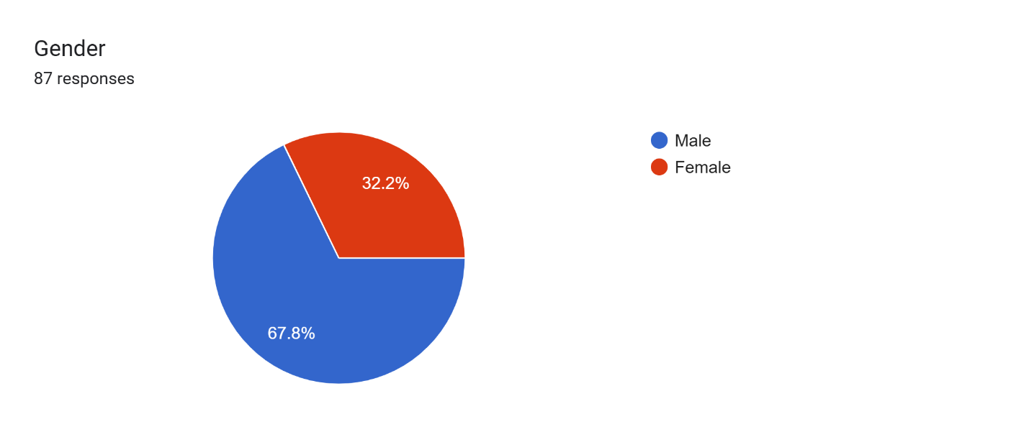
Figure 4.1: gender

4.3.2 Age Distribution of Respondents
The age distribution of respondents indicates that the majority fall within the youthful age bracket. Specifically, 60.9% of the respondents are between 18–25 years, while 40.2% are aged 26–35 years. Notably, there were no respondents aged 36 years and above.
This data suggests that younger professionals are more actively engaged in agro-processing and construction-related sectors, particularly in roles linked to Quantity Surveying and project viability assessments. The absence of older respondents could imply limited interest or reduced involvement of more experienced professionals in this particular area of research, possibly due to digital distribution methods or generational gaps in specialization.
The dominance of younger respondents may also reflect a growing interest among emerging professionals in diversifying their expertise into agricultural and economic viability projects.
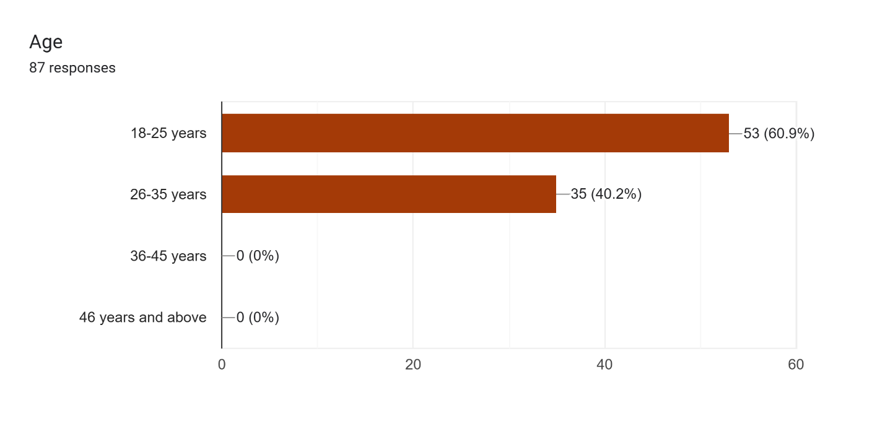
Figure 4.2: Age

4.3.3 Years of Professional Experience
The data on respondents’ professional experience reveals that the majority are relatively early in their careers. Out of the 87 respondents, 54 individuals (62.1%) have less than 5 years of professional experience, while 31 respondents (35.6%) have been practicing for 5–10 years. Only 1 respondent each (1.1%) reported having 10–15 years and over 15 years of experience respectively.
This distribution suggests that younger or mid-level professionals are more active or responsive to research relating to agricultural processing projects and Quantity Surveying. The low participation from highly experienced professionals may indicate generational preferences, limited exposure to digital survey tools, or a gap in research engagement. Nonetheless, the involvement of early-career professionals provides a fresh perspective on emerging trends and innovations in economic viability assessment.

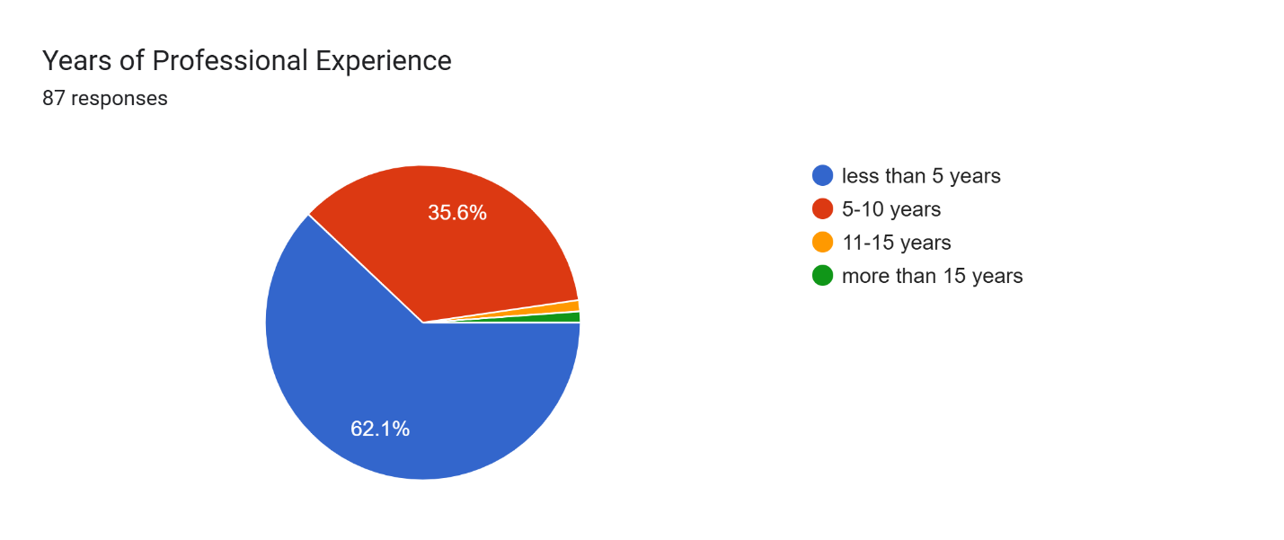
Figure 4.3: Years of Professional Experience

4.3.4 Professional Background of Respondents
The analysis of respondents’ professional backgrounds shows that the majority are Quantity Surveyors, with 48 respondents (55.2%) identifying as such. This is followed by Project Managers with 11 respondents (12.6%), and other professionals which include engineers, economists, and consultants making up 16 respondents (18.4%). Additionally, Architects account for 6 respondents (6.9%), while Developers represent 5 respondents (5.7%).
This distribution reflects a strong representation of Quantity Surveyors, which is consistent with the focus of the study. It also shows a moderate level of interdisciplinary involvement, indicating that assessing the economic viability of agricultural processing plants is a collaborative effort involving various professionals across the built environment and investment sectors.

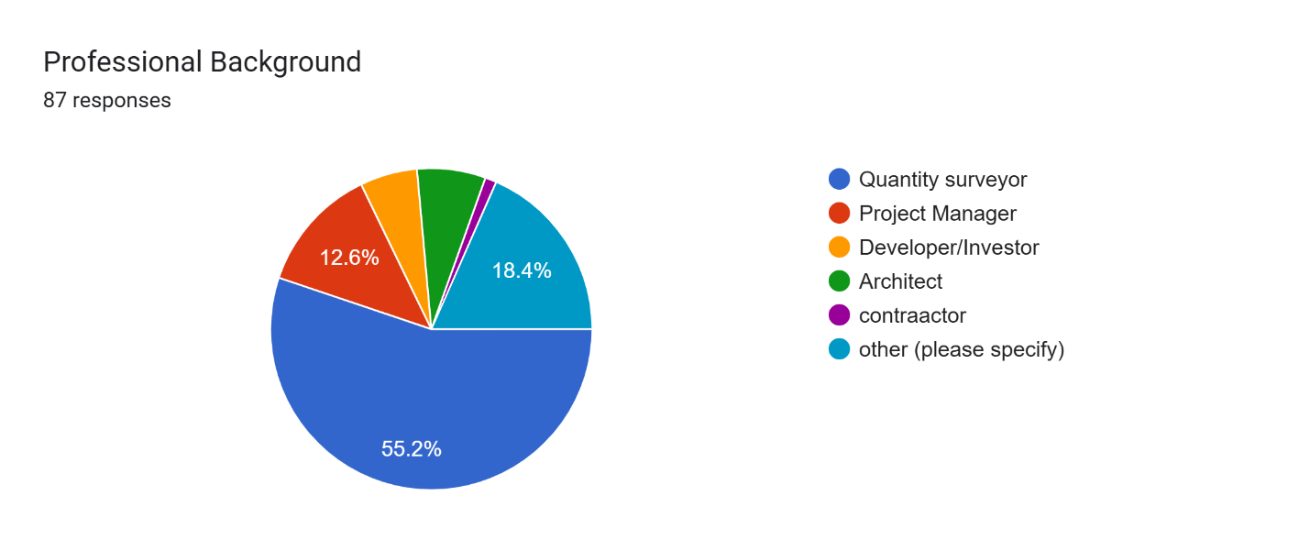Figure 4.4: Professional Background

4.3.5 Involvement in Agro-Processing Projects
When asked about their direct involvement in agro-processing projects, a significant number of respondents indicated prior engagement. Specifically, 66 respondents (75.9%) reported that they have been involved in agro-processing projects, while 21 respondents (24.1%) stated they have not been involved.
This high level of participation suggests that the majority of respondents possess relevant practical experience and insights into the dynamics of agricultural processing ventures. Their input provides a strong foundation for evaluating the role of Quantity Surveyors in economic viability assessments, ensuring the data gathered is informed by real-world exposure and professional practice.

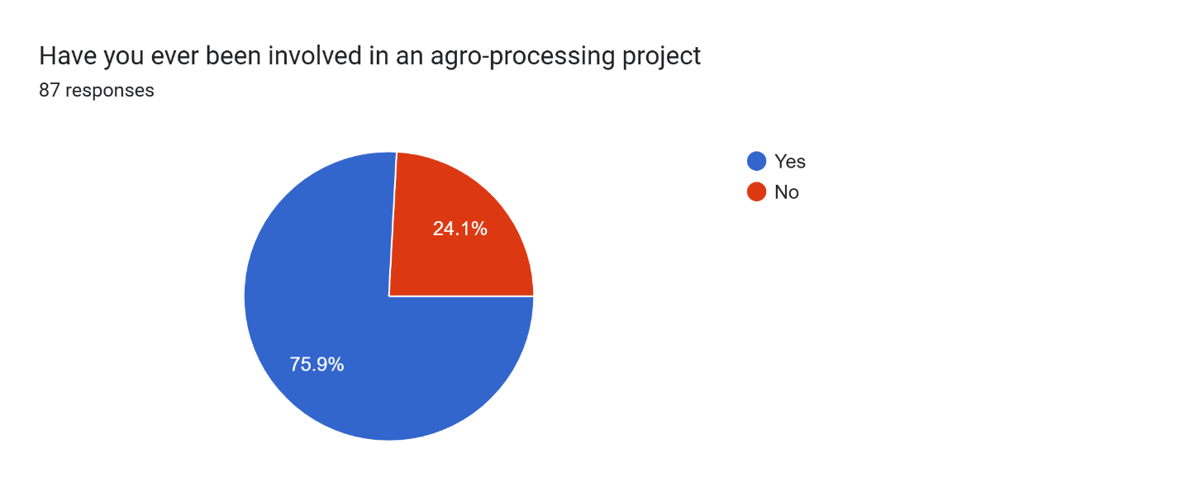Figure 4.5: Involvement in Agro-Processing Projects

4.4 Presentation and analysis of data according to research questions

4.4.1 Common Financial Challenges in the Development of Agro-Processing Plants
Respondents were asked to identify the most common financial challenges encountered during the development of agro-processing plants. Multiple responses were allowed, as financial obstacles in such projects are often interconnected.
The analysis revealed that the most significant financial challenge is the high initial capital cost, cited by 44 respondents, representing the most frequently selected issue. This finding aligns with existing literature that highlights the capital-intensive nature of agro-processing facilities, particularly due to land acquisition, machinery procurement, and construction costs.
Following this, 26 respondents identified difficulty in accessing finance as a key constraint. This suggests that limited availability of credit, high interest rates, and stringent loan conditions hinder the ability of investors and developers to secure the necessary funding to initiate or expand agro-processing ventures.
Fluctuating cost of materials was selected by 19 respondents, indicating that volatility in the prices of construction and production inputs poses a major threat to budget stability and financial forecasting.
Additionally, 16 respondents pointed to unstable power supply and high energy costs as significant concerns. Given the energy-intensive nature of processing operations, inconsistent power availability often results in increased operational costs due to the reliance on alternative energy sources such as generators.
High operating and maintenance costs were reported by 14 respondents, emphasizing the burden of recurring expenses that can erode profitability over time if not properly managed.
Only 5 respondents indicated inadequate feasibility studies as a challenge, suggesting that while this issue exists, it is less commonly perceived as a primary financial barrier compared to direct capital and operational cost concerns.
Finally, 6 respondents selected “Others”, citing additional concerns such as inflation, policy inconsistencies, and inadequate government support.
In summary, the findings demonstrate that financial barriers in agro-processing plant development are multifaceted, with capital requirements, access to finance, and input cost volatility being the most pressing issues. These challenges underline the importance of robust financial planning, investment incentives, and supportive policy frameworks to enhance the sustainability and growth of agro-processing ventures
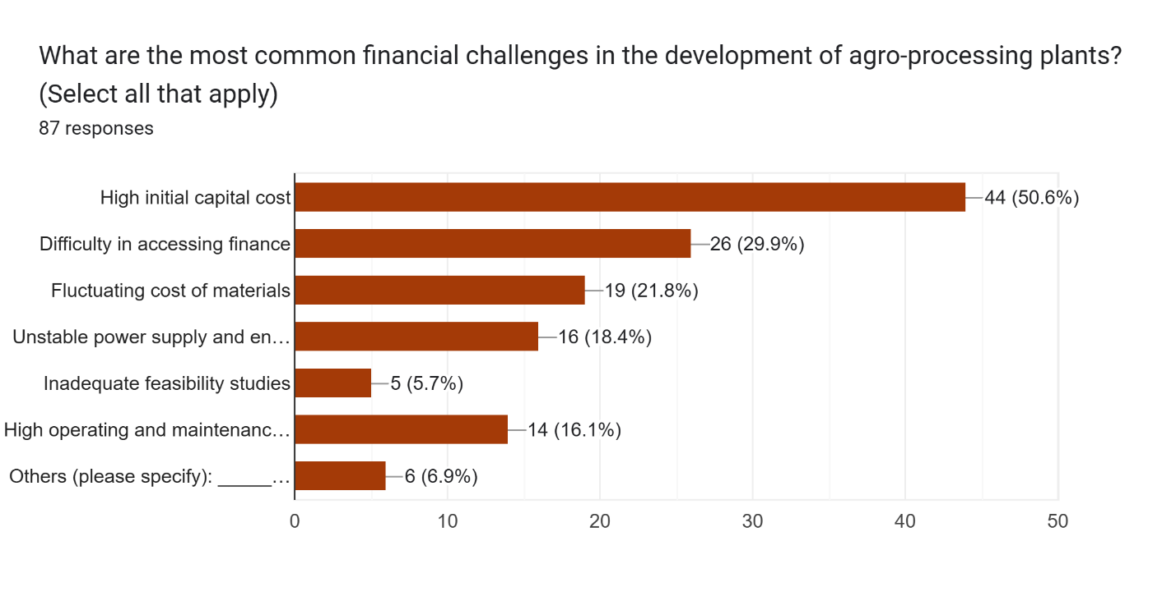
Figure 4.6: Common Financial Challenges in the Development of Agro-Processing Plants

4.4.2 Perceived Severity of Financial Challenges on Agro-Processing Project Success
Respondents were asked to rate the severity of financial challenges on the success of agro-processing projects using a 5-point Likert scale ranging from "Not severe" to "Extremely severe." The responses reflect varying levels of concern, with the majority indicating that financial challenges pose a considerable threat to project success.
Out of the 87 respondents:
26 (29.9%) rated the impact as Very Severe,
19 (21.8%) considered it Moderately Severe,
18 (20.7%) described it as Slightly Severe,
13 (14.9%) perceived it as Not Severe, and
11 (12.6%) believed it was Extremely Severe.
These results indicate that a significant portion of the respondents approximately 64.3% (combining "Moderately Severe," "Very Severe," and "Extremely Severe") recognize financial challenges as a major hindrance to the successful execution and sustainability of agro-processing projects.
The data reinforces earlier findings that high capital requirements, limited access to finance, and fluctuating material and energy costs can critically disrupt project planning, execution, and long-term viability. It also suggests a strong need for financial reforms, targeted government intervention, and strategic planning to mitigate these risks and enhance project outcomes.

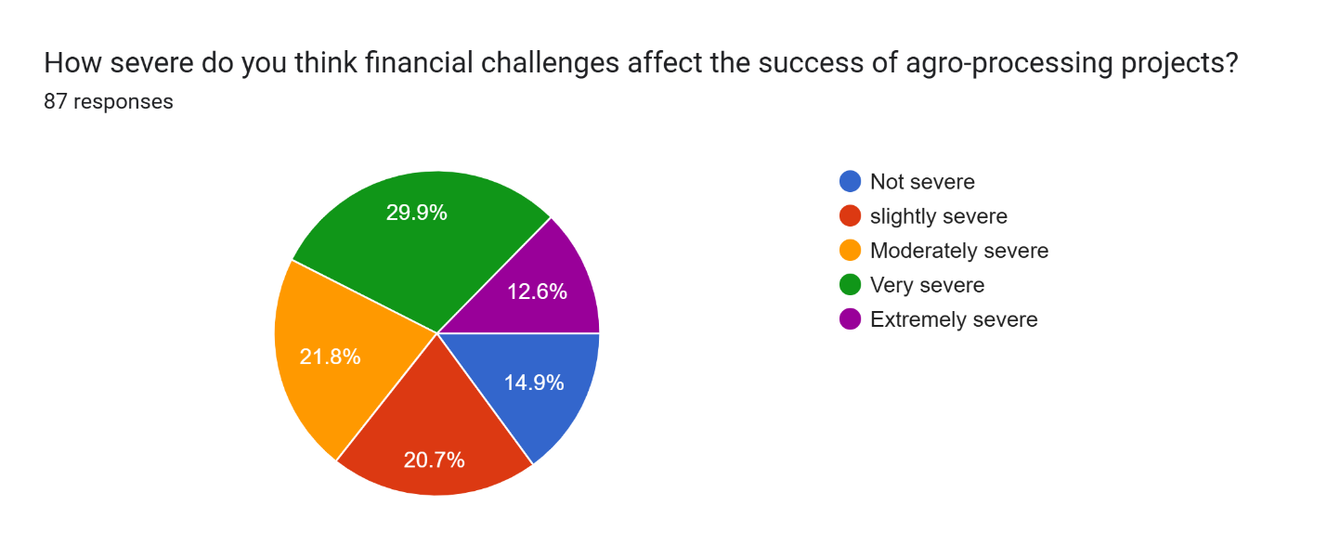
Figure 4.7: Perceived Severity of Financial Challenges on Agro-Processing Project Success

4.4.3 Perceived Importance of Quantity Surveyors in Agro-Processing Project Development
To assess stakeholder perceptions of the role of Quantity Surveyors in agro-processing projects, respondents were asked to rate the importance of their involvement. The majority of participants strongly acknowledged the relevance of Quantity Surveyors in ensuring the success and economic viability of such projects.
From the data:
50 respondents (57.5%) considered their involvement to be Very Important,
26 respondents (29.9%) rated it as Important,
10 respondents (11.5%) were Neutral,
1 respondent (1.1%) regarded it as Less Important, and
0 respondents selected Not Important.
The results clearly show a strong consensus on the critical role of Quantity Surveyors in agro-processing project development, with 87.4% of respondents affirming their importance. This validates the profession’s contributions in key areas such as cost planning, feasibility analysis, procurement strategy, and value management.
The minimal percentage of neutral or low ratings further emphasizes that the stakeholders recognize Quantity Surveyors as strategic players in ensuring financial discipline, cost efficiency, and project sustainability within the agricultural processing sector.
These findings underscore the need to integrate Quantity Surveyors more deliberately into agro-project teams from the planning stage, to enhance economic outcomes and reduce project failure risks.

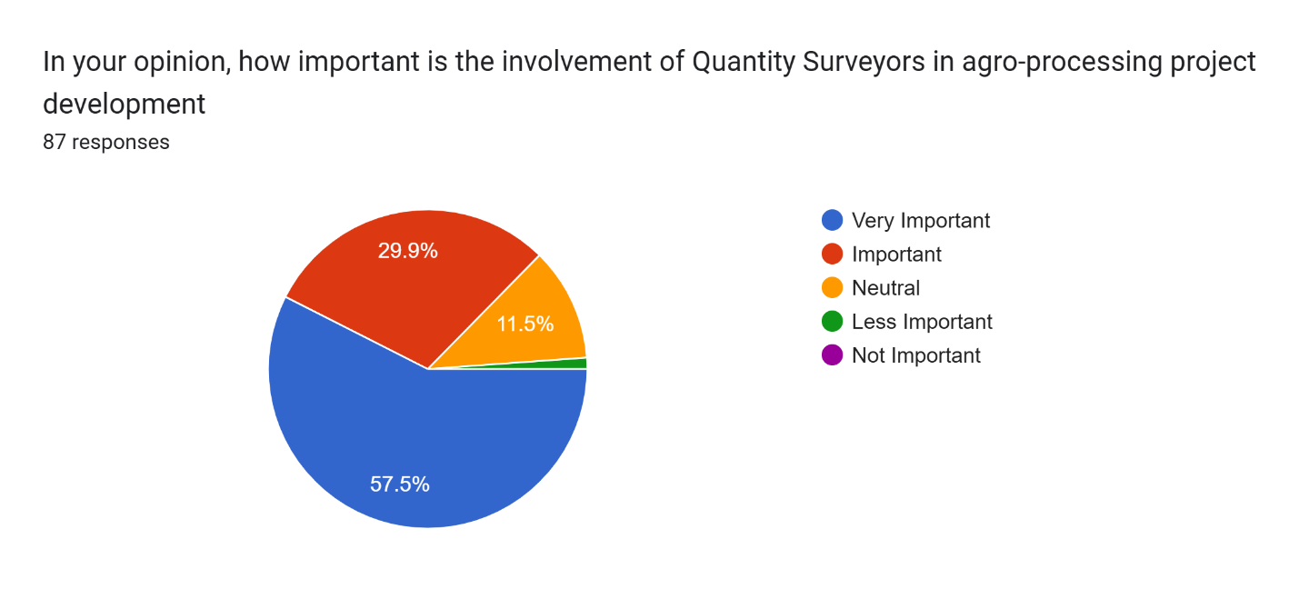
4.8: Perceived Importance of Quantity Surveyors in Agro-Processing Project Development

4.4.4 Specific Roles of Quantity Surveyors in Agro-Processing Projects
Respondents were asked to identify the specific functions performed by Quantity Surveyors (QSs) in agro-processing projects. Multiple selections were allowed to reflect the diverse and overlapping responsibilities typically handled by QS professionals in project development.
The analysis reveals that Preliminary Cost Estimation is the most recognized role, selected by 36 respondents (41.4%). This highlights the critical importance of QSs in establishing the initial financial framework upon which project feasibility is assessed and decisions are made.
Closely following this, Budget Planning and Cash Flow Forecasting was chosen by 34 respondents (39.1%), demonstrating the QS’s pivotal role in financial monitoring and ensuring cost control throughout project execution.
Life-Cycle Cost Analysis was identified by 29 respondents (33.3%), indicating growing awareness of the long-term financial implications of design and material choices, particularly relevant in agro-processing where operational efficiency is key.
Risk and Contingency Analysis was acknowledged by 16 respondents (18.4%), reflecting the QS’s role in preparing for financial uncertainties and helping stakeholders make informed decisions under varying economic and project risks.
Cost-Benefit and Return on Investment (ROI) Evaluation was selected by 8 respondents (9.2%), while Value Engineering, a strategic cost optimization technique, was chosen by 4 respondents (4.6%). These relatively lower figures may suggest either limited exposure to these advanced financial tools or their underutilization in current agro-processing practice.
An additional 4 respondents selected "Others," specifying roles such as procurement advisory, contract administration, and cost auditing indicating that QS functions often extend beyond traditional estimating and budgeting tasks.
Overall, the responses demonstrate that Quantity Surveyors contribute significantly to agro-processing projects, particularly in early-stage cost planning and ongoing budgetary management. Their expertise enhances cost-effectiveness, ensures financial transparency, and supports strategic decision-making throughout the project lifecycle.
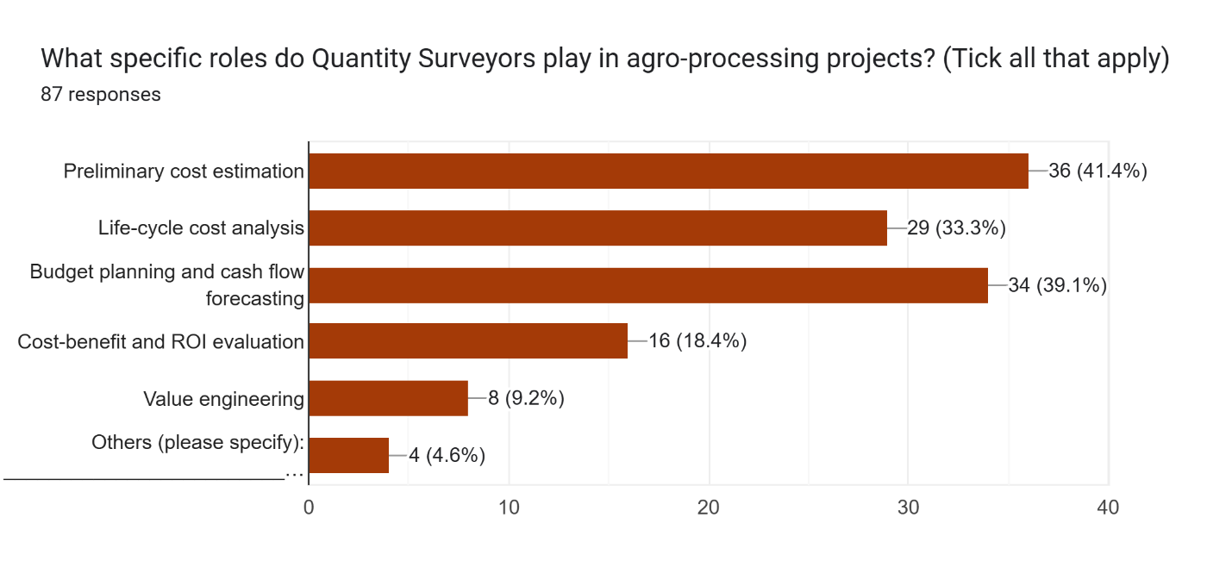
Figure 4.9: Specific Roles of Quantity Surveyors in Agro-Processing Projects

4.4.5 Experience with QS-Led Viability Assessments in Agro-Processing Projects
To further assess the practical relevance of Quantity Surveyors in agro-processing ventures, respondents were asked if they had personally witnessed or participated in a viability assessment led by a Quantity Surveyor.
Out of 87 respondents, 59 (67.8%) answered Yes, indicating that they had either observed or directly participated in a QS-led economic viability assessment. The remaining 28 respondents (32.2%) had not had such an experience.
Among those who responded affirmatively, qualitative comments regarding the outcomes of such assessments revealed several key themes:
Many reported that the assessments helped identify cost-saving opportunities, allowing investors to adjust designs or processing techniques to reduce capital and operating expenses.
Some noted that the QS-led viability studies resulted in the rejection of financially unfeasible projects, thus preventing costly investment errors.
Others highlighted that the involvement of Quantity Surveyors brought clarity to cash flow projections, break-even analysis, and investment risk evaluation, which in turn supported informed decision-making.
A few respondents emphasized the professionalism and accuracy QSs contributed to feasibility reports, which increased investor confidence and improved access to financing.
Overall, the findings reinforce the strategic importance of Quantity Surveyors in leading or supporting viability assessments for agro-processing plants. Their involvement not only enhances the financial robustness of such projects but also contributes to the long-term sustainability and success of investments in the agricultural value chain.
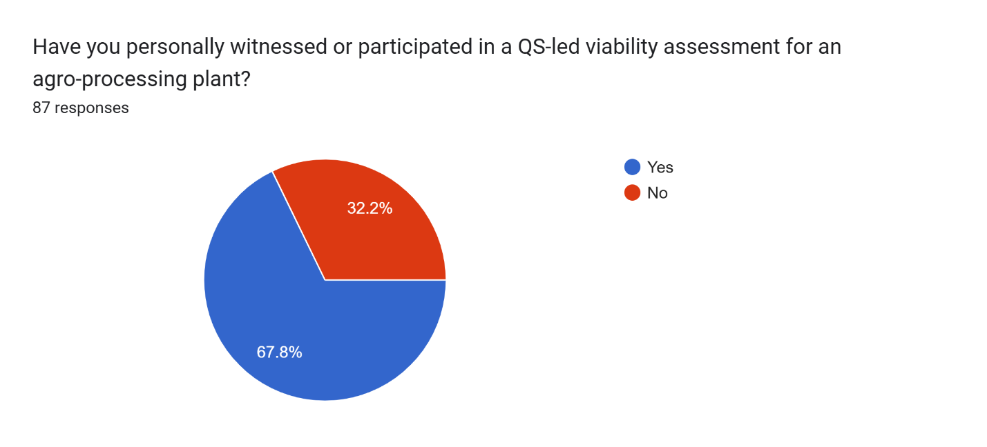
Figure 4.10: Experience with QS-Led Viability Assessments in Agro-Processing Projects

4.4.6 Cost Estimation Techniques Commonly Used by Quantity Surveyors in Agro-Processing Projects
Respondents were asked to identify the cost estimation techniques most frequently used by Quantity Surveyors in agro-processing projects. The objective was to understand the preferred approaches for generating reliable cost forecasts in the agricultural industrial context.
The results indicate that Elemental Cost Planning is the most widely adopted method, selected by 43 respondents (49.4%). This approach involves breaking down the project into functional elements and assigning cost estimates accordingly, making it especially suitable for early-stage planning and feasibility analysis.
Bill of Quantities (BoQ)-Based Estimates followed closely, with 27 respondents (31.0%) selecting it. BoQ-based estimating remains a standard method in construction projects due to its detailed and structured nature, allowing for accurate pricing based on measured quantities and specifications.
Unit Rate Pricing was identified by 22 respondents (25.3%), reflecting the continued use of this method, particularly during tendering or where detailed design information is available. It allows QSs to apply known market rates to quantities of work, ensuring transparency and competitive pricing.
Parametric Estimating, chosen by 17 respondents (19.5%), involves using statistical relationships between project parameters and historical data to estimate costs. Its adoption suggests that some professionals are leveraging data-driven approaches, particularly in the early design phase of agro-processing projects.
Historical Data Benchmarking, selected by only 6 respondents (6.9%), and other techniques (such as rule-of-thumb methods or proprietary software tools), mentioned by 2 respondents (2.3%), appear to be less commonly used, possibly due to limitations in local data availability or project-specific variability.
Overall, the findings reveal that Quantity Surveyors rely heavily on structured and proven estimation techniques particularly elemental planning and BoQ-based methods—to ensure accuracy and reliability in cost forecasting for agro-processing projects. The moderate use of parametric and data-driven approaches also suggests a gradual shift toward innovation and modern estimation tools within the profession.
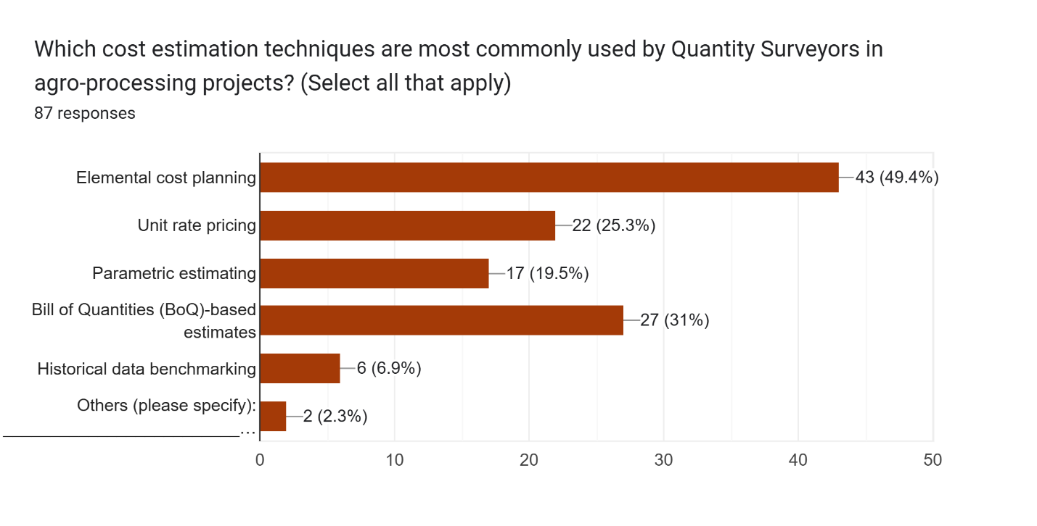
Figure 4.11 Cost Estimation Techniques Commonly Used by Quantity Surveyors in Agro-Processing Projects

4.4.7 Perceived Accuracy of Cost Estimation Techniques in Predicting Actual Project Costs
To evaluate the effectiveness of the cost estimation methods employed by Quantity Surveyors in agro-processing projects, respondents were asked to rate how accurately these techniques predict actual project costs.
The responses revealed varying levels of confidence in the accuracy of these techniques:
- 41 respondents (47.1%) rated the techniques as Fairly Accurate,
- 19 respondents (21.8%) considered them Very Accurate,
- 14 respondents (16.1%) indicated they are Accurate,
- 11 respondents (12.6%) believed the techniques are Inaccurate, and
- 2 respondents (2.3%) were Not Sure.
These results suggest that while a majority of respondents (approximately 85%) believe that the cost estimation techniques used by Quantity Surveyors are reasonably reliable—ranging from fairly accurate to very accurate there is still a notable portion that questions their precision.
The dominance of the "Fairly Accurate" rating may point to practical limitations such as unforeseen site conditions, market price fluctuations, or design changes that often cause discrepancies between estimated and actual costs. Meanwhile, the relatively low number of "Inaccurate" responses indicates a general level of trust in the professional judgment and methods employed by Quantity Surveyors, although continuous improvement is still needed, especially in the use of data-driven tools and risk modeling.
Overall, this feedback emphasizes the need for enhanced data analytics, ongoing professional development, and refined methodologies to improve cost predictability in agro-processing projects.
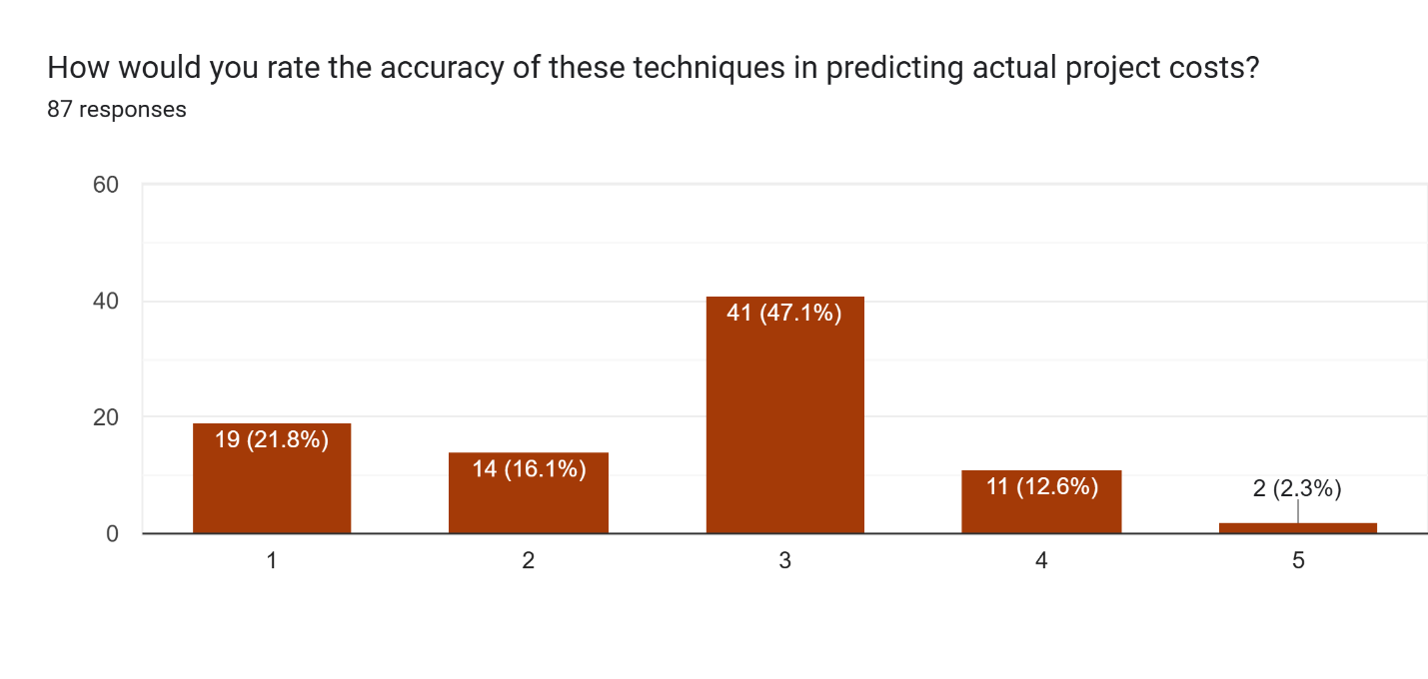
Figure 4.12 Perceived Accuracy of Cost Estimation Techniques in Predicting Actual Project Costs

4.4.8 Impact of Cost Estimation Errors on Agro-Processing Project Success
Respondents were asked whether, in their experience, cost estimation errors have a significant impact on the success of agro-processing projects. The results were overwhelmingly conclusive:
- 90 respondents (≈91.8%) answered Yes,
- 8 respondents (≈8.2%) answered No,
- 0 respondents were Not Sure.
This strong majority clearly indicates that cost estimation errors are perceived as a critical risk factor in agro-processing project development. Respondents who answered “Yes” were also invited to provide brief explanations, and several common themes emerged:
Budget overruns and funding shortfalls: Many respondents noted that inaccurate estimates often lead to cost overruns, which strain project financing and can result in delays, redesigns, or even project abandonment.
Investor distrust and withdrawal: Some participants mentioned that major deviations from initial cost projections erode investor confidence and may cause stakeholders to pull out or withhold funding.
Compromised project scope and quality: A number of responses emphasized that when costs exceed expectations, the project scope is often reduced, or lower-quality materials are used, affecting long-term functionality and sustainability.
Delay in completion and increased risk exposure: Others pointed out that errors in cost estimates typically lead to extended timelines and higher exposure to market risks, such as inflation and exchange rate volatility.
In summary, the responses reflect a shared professional experience: cost estimation errors pose a serious threat to the feasibility, financial integrity, and ultimate success of agro-processing projects. The findings reinforce the critical need for thorough, data-driven, and professionally led cost planning at the early stages of such developments.

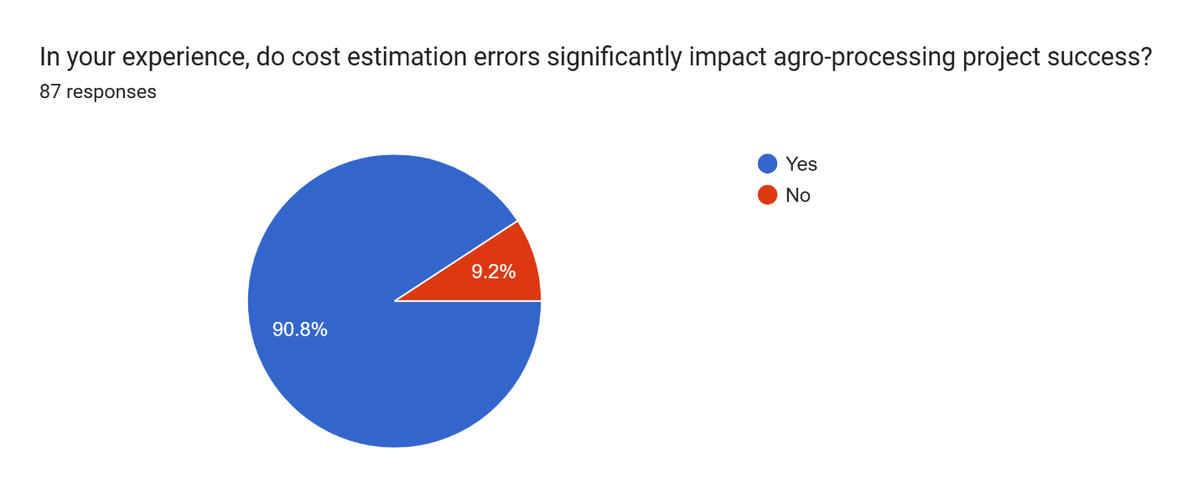
Figure 4.13 Impact of Cost Estimation Errors on Agro-Processing Project Success

4.4.9 Factors Limiting the Involvement of Quantity Surveyors in Agricultural Processing Plant Projects
Respondents were asked to identify the key factors that hinder the participation of Quantity Surveyors (QSs) in agricultural processing plant projects. Multiple responses were permitted to reflect the multidimensional nature of the barriers faced.
The findings indicate that the most prevalent limiting factor is low awareness among investors and developers, selected by 41 respondents (47.1%). This suggests that many project sponsors are either unaware of the value that Quantity Surveyors can bring to agro-processing projects or do not traditionally consider QS input during planning and development phases. This lack of awareness contributes to underutilization of professional cost management services in a sector where financial sustainability is critical.
The second most cited challenge is limited Quantity Surveyor knowledge of the agro sector, identified by 31 respondents (35.6%). This highlights a significant skill and knowledge gap that prevents QSs from confidently engaging in agricultural-based infrastructure or understanding the operational dynamics of processing facilities.
Perception that QS services are expensive was selected by 18 respondents (20.7%), indicating that some stakeholders view Quantity Surveying as a cost rather than a value-adding investment especially in budget-sensitive projects.
Lack of institutional support or collaboration was mentioned by 19 respondents (21.8%), pointing to weak integration of QSs into multidisciplinary teams working in agro-industrial development. This may stem from limited engagement between construction professionals and agricultural development agencies.
Regulatory or policy constraints were noted by only 5 respondents (5.7%), suggesting that although legal and policy issues exist, they are not perceived as the most pressing barrier to QS involvement.
An additional 10 respondents (11.5%) selected “Others”, with comments highlighting factors such as:
- Poor inclusion of QS roles in project funding frameworks
- Resistance to change by traditional agro-entrepreneurs
- Inadequate curriculum exposure in agricultural economics within QS training programs
In summary, the findings reveal that the limited involvement of Quantity Surveyors in agro-processing projects is primarily due to low stakeholder awareness and professional knowledge gaps, rather than regulatory barriers. Addressing these issues through advocacy, cross-sector collaboration, and targeted training could significantly increase QS contributions to agricultural infrastructure and enhance project viability.

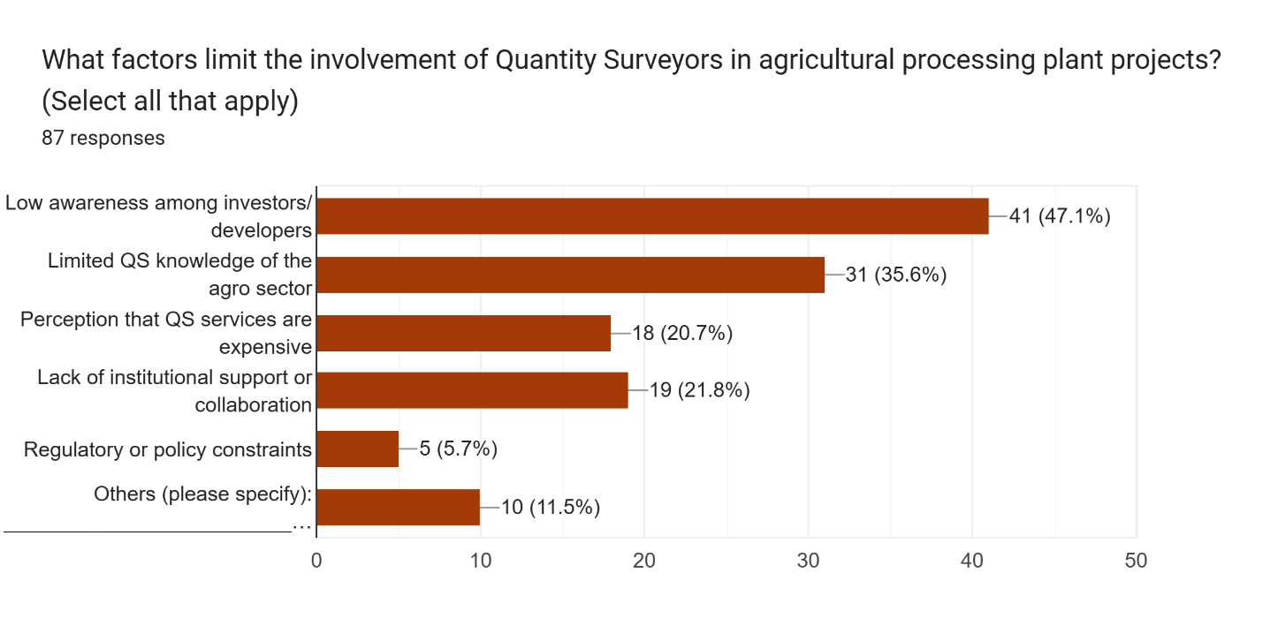
Figure 4.14 Factors Limiting the Involvement of Quantity Surveyors in Agricultural Processing Plant Projects

4.5 Discussion of Findings

The findings of this study provide valuable insights into the role of Quantity Surveyors (QSs) in assessing the economic viability of agricultural processing plant projects. The responses obtained from 87 participants reveal critical trends regarding the level of QS involvement, their specific contributions, the accuracy of cost estimation techniques, financial challenges, and barriers limiting their engagement in the agro-processing sector.
    - Strong Perception of QS Importance in Agro-Processing Projects: The majority of respondents acknowledged the importance of Quantity Surveyors in agro-processing development, with 87.4% describing their role as either important or very important. This supports the view that QSs are not only relevant to building construction but are also integral to the financial success of agricultural infrastructure through services such as feasibility analysis, budgeting, cost control, and financial forecasting.
    - Key Roles Played by Quantity Surveyors: Respondents highlighted that QSs contribute significantly to preliminary cost estimation, budget planning, and life-cycle cost analysis. These roles are essential in agro-processing projects where capital intensity and operational sustainability are major concerns. The relatively lower acknowledgment of roles like value engineering and return on investment (ROI) evaluation suggests a need for more awareness and training in advanced cost-management techniques within the agro-sector.
    - Cost Estimation Accuracy and Techniques Used: While many respondents rated QS estimation techniques as either accurate or fairly accurate, only a small portion deemed them very accurate. The most widely used techniques elemental cost planning, BoQ-based estimating, and unit rate pricing reflect traditional approaches, but there is growing interest in parametric estimating and life-cycle cost analysis, particularly as digital tools and data availability improve. This suggests a gradual shift towards more analytical, data-informed methodologies.
    - Financial Challenges in Agro-Processing Projects: The study revealed that high initial capital cost, difficulty in accessing finance, and fluctuating cost of materials are the most prominent financial challenges. These issues significantly affect project success, with over 90% of respondents affirming that cost estimation errors negatively impact outcomes. The implications are substantial: poor financial planning and inaccurate cost estimates can lead to project delays, abandonment, or reduced scope and quality.
    - Limited QS Involvement – Underlying Causes: Despite the high perceived importance of QSs, their involvement in agro-processing projects is still limited. The dominant barriers identified include low awareness among investors and developers, and limited QS knowledge of the agricultural sector. Other contributing factors include the perception of high service costs and lack of institutional collaboration. These challenges underscore the need for advocacy, interdisciplinary training, and strategic engagement between the construction and agricultural development sectors.
    - Practical Experience and Outcome of QS-Led Viability Assessments: A large proportion of respondents (67.8%) reported firsthand experience with QS-led viability assessments, and the outcomes were largely positive. These assessments were noted for helping identify cost-saving opportunities, refine project scope, and guide informed investment decisions. This validates the practical relevance of QS involvement and supports greater integration of their expertise in agro-based project planning.
In summary, the study confirms that Quantity Surveyors have a vital role to play in the economic planning of agro-processing projects. However, their full potential is yet to be realized due to structural, knowledge-based, and perception-driven barriers. Bridging these gaps through professional development, stakeholder engagement, and policy support will be crucial to maximizing the contribution of Quantity Surveyors to agricultural industrialization and national food security goals.

CHAPTER FIVE

CONCLUSION AND RECOMMENDATIONS

5.2 Conclusion
The findings of this research underscore the pivotal role that Quantity Surveyors can and should play in the economic planning and implementation of agricultural processing plants. As professionals equipped with cost management and risk analysis skills, QSs are well-positioned to contribute meaningfully to the sustainable development of Nigeria's agro-processing sector.
The study concludes that integrating Quantity Surveyors early in the planning and execution of agro-processing projects significantly enhances cost efficiency, reduces project abandonment risks, and improves financial accountability. However, systemic barriers particularly the lack of sector-specific awareness and collaboration—must be addressed to fully harness the potential of QSs in this domain.

5.2 Recommendations
Based on the study’s findings, the following recommendations are made:
  - Government agencies, professional bodies (such as NIQS), and industry stakeholders should create awareness programs to enlighten agricultural investors and developers on the value of engaging Quantity Surveyors in agro-project planning.
  - Institutions should encourage partnerships between Quantity Surveyors, agricultural economists, engineers, and policy makers. This will facilitate a holistic approach to agro-processing project planning.
  - The government should streamline regulatory processes and include QS roles within agricultural project funding guidelines to encourage their involvement from the inception stage.
  - QS professionals should be offered continuous professional development in agro-economics, food logistics infrastructure, and rural investment planning to enable effective service delivery.
  - Stakeholders should promote the use of digital cost management tools such as Building Information Modelling (BIM) and cost forecasting software to improve the accuracy and transparency of financial planning in agricultural projects.
  - A centralized database for agro-processing construction costs and benchmarks should be established to aid Quantity Surveyors in accurate feasibility studies and cost estimation.

5.3 Suggestions for Further Studies
This study focused primarily on agricultural processing plants within select Nigerian regions. Further research is recommended in the following areas:
Comparative studies between projects involving QSs and those without to assess measurable impacts on cost and operational efficiency. Longitudinal studies to examine how early QS involvement affects project performance over a multi-year period.
Investigation into the role of digital transformation (e.g., AI, BIM, IoT) in enhancing QS contributions to agro-industrial development.

References
Abiodun et al. (2023) identify equipment costs, finance access, market constraints in cassava processing systems.enpress-publisher.com.
Adebayo, R. A. (2021). Value Addition and Profitability in Agro-Processing Enterprises. Nigerian Journal of Rural Economy and Society, 33(1), 52–64.
Adegbite, A., & Okonkwo, J. (2020). Bridging the Knowledge Gap: Professional Development Needs of Quantity Surveyors in Emerging Sectors. Nigerian Construction and Infrastructure Review, 14(1), 33–45.
Adekunle, T., & Okonkwo, J. (2018). Economic Constraints in Nigeria's Agro-Processing Sector. African Journal of Agricultural Economics, 14(2), 88–101.
Adeyemi, A., & Bello, K. (2019). The Relevance of Quantity Surveyors in Cost Control and Budget Adherence. Nigerian Journal of Project Management, 21(3), 102–115.
Akintoye, A., & Fitzgerald, E. (2017). Risk Assessment and Management in Construction Projects: A Quantity Surveyor’s Perspective. Construction Management Review, 25(1), 59–72.
Boardman, A. E., Greenberg, D. H., Vining, A. R., & Weimer, D. L. (2018). Cost-Benefit Analysis: Concepts and Practice (5th ed.). Cambridge University Press.
Brook, M. (2016). Estimating and Tendering for Construction Work (5th ed.). Routledge.
Ferry, D., Brandon, P., & Ferry, J. (2010). Cost Planning of Buildings (8th ed.). Wiley-Blackwell.
Hassan, A. M., & Ali, N. T. (2019). Cost Estimation Challenges in Agricultural Projects: The Role of Quantity Surveyors. Journal of Rural Infrastructure Development, 5(3), 89–102.
IFPRI (2020) estimates >50% post-harvest spoilage in Nigeria, emphasizing storage infrastructure deficits thecable.ng.
Kumar, R., & Singh, A. (2020). Application of Value Engineering in Construction Projects. Journal of Construction Management, 12(3), 45–53.
SAVE International (2015). Value Methodology Standard. SAVE International.
Mwangi, P., & Otieno, D. (2019). Causes of Failure in Agro-Processing Projects in Sub-Saharan Africa. Journal of Agribusiness and Rural Development, 45(3), 112–126.
Obi, K., & Ndungu, C. (2020). Government Policy and Agro-Industrial Development in Africa. Development Studies Review, 19(4), 201–220.
Olatunji, J. A., & Bashorun, A. O. (2018). Feasibility Studies and Financial Planning: The Role of Quantity Surveyors. Journal of Construction and Development Studies, 9(2), 67–79.
Onwualu, A. P. (2021). Contract Administration and Financial Planning in Agro-Industrial Projects. African Journal of Agribusiness and Engineering, 15(2), 129–140
Ochieng, F., & Awiti, L. (2022). Regulatory Frameworks and the Integration of Professional Services in Agro-Infrastructure Development. East African Journal of Development Planning, 7(2), 134–149.
Olaleye, T. R., & Ibrahim, S. A. (2021). Adoption of Digital Tools in Agricultural Infrastructure Management: Prospects for Quantity Surveying. African Journal of Construction Innovation, 6(2), 77–91.
Patel, R., & Desai, S. (2022). Lifecycle Cost Analysis in Agricultural Infrastructure Projects. International Journal of Agricultural Engineering and Management, 12(4), 211–225.
P3RSIST (2024) highlights working capital shortfalls and currency/commodity risks in African agribusiness p3rsist.fr
Royal Institution of Chartered Surveyors (RICS) (2020). RICS Practice Standards – Cost Control and Financial Reporting.
Smith, J., & Brown, L. (2020). Sustainable Agribusiness Management: Principles and Practice. Oxford University Press.
Shehu, A. M. (2023). Emerging Roles of Quantity Surveyors in Non-Traditional Sectors. Journal of Construction Economics and Management, 17(1), 44–58.
Wan & Cui (2024) show how FinTech AI, blockchain can mitigate financing challenges
World Construction Today (2024) notes CAPEX magnitude, regulatory hurdles, and equipment lead times for food processing plants worldconstructiontoday.com.
Vestanceng et al. (2024) highlight the huge financing gap in Nigerian agribusiness due to risk aversion and high-cost borrowing systems.enpress-publisher.com+5vestanceng.com+5changemakersconsultingltd.org+5professions.nghiagpartnership.orgp3rsist.fr+1en.wikipedia.org+1.

Appendix
QUESTIONNAIRE
Department of Quantity Surveying,
Institute of Environmental Studies
Kwara state Polytechnic, Ilorin.
Kwara State.
Dear Sir/Madam,
RESEARCH QUESTIONNAIRE: Investigation of the Role of Quantity Surveyors In Assessing the Economic Viability of Agricultural Processing Plants.
I, ADEMOLA, Olalekan Mathew, an undergraduate student of Quantity Surveying Department, at the Kwara state polytechnic, Ilorin, I am undertaking my final year research thesis in partial fulfilment of the requirement for the award of Higher National diploma.
While appreciating your busy schedule, with all due respect I humbly solicit that your spare time to help respond to the attached questionnaire which is crucial to the success of my on-going research titled above.
Your response will be treated with confidentiality and used only for the purpose of this research work.
Thank you for your anticipated cooperation
Yours sincerely
(E-signature)
ADEMOLA, Olalekan Mathew
HND/23/FT/QTS/0005
Olalekanmathew005@gmail.com
09044250058
Section A: Demographic Information
Please tick (✓) or fill as appropriate in the space provided
- Gender:
Male Female Prefer not to say

- Age:
18–25 years 26–35 years 36–45years 46 years and above

Years of Professional Experience:
Less than 5 years 5–10 years 11–15 years More tHan 15 years

Professional Background:
Quantity Surveyor Project Manager Developer/Investor
Architect Contractor Other (please specify): ___________

- Have you ever been involved in an agro-processing project?
Yes No
If yes, please briefly state your role: ____________________________________________________________________________________________________________________________________________________________

Section B: Data on the project objectives
2.1 Objective number one: Financial challenges faced in the development processing plant
Please tick (✓) or fill as appropriate in the space provided
2.1.1 What are the most common financial challenges in the development of agro-processing plants? (Select all that apply)
High initial capital cost
Difficulty in accessing finance
Fluctuating cost of materials
Unstable power supply and energy costs
Inadequate feasibility studies
High operating and maintenance costs
Others (please specify): ___________________________
2.1.2 On a scale of 1–5, how severe do you think financial challenges affect the success of agro-processing projects?
Not severe Slightly severe Moderately severe Very severe Extremely severe

2.2 Objective number two: the role of quantity surveyors in assessing the economic viability of agro-processing projects
Please tick (✓) or fill as appropriate in the space provided
2.2.1 In your opinion, how important is the involvement of Quantity Surveyors in agro-processing project development?
Very Important Important Neutral Less Important Not Important
2.2.2 What specific roles do Quantity Surveyors play in agro-processing projects? (Tick all that apply)
Preliminary cost estimation
Life-cycle cost analysis
Budget planning and cash flow forecasting
Risk and contingency analysis
Cost-benefit and ROI evaluation
Value engineering
Others (please specify): ___________________________
2.2.3 Have you personally witnessed or participated in a QS-led viability assessment for an agro-processing plant?
Yes No
If yes, what was the outcome? ______________________________

2.3 Objective number three: evaluate the cost estimation techniques used by quantity surveyors in agricultural processing plant projects.
Please tick (✓) or fill as appropriate in the space provided
2.3.1 Which cost estimation techniques are most commonly used by Quantity Surveyors in agro-processing projects? (Select all that apply)
Elemental cost planning
Unit rate pricing
Parametric estimating
Bill of Quantities (BoQ)-based estimates
Historical data benchmarking
Others (please specify): ___________________________
2.3.2 How would you rate the accuracy of these techniques in predicting actual project costs?
Very accurate Accurate Fairly accurate Inaccurate Not sure

2.3.3 In your experience, do cost estimation errors significantly impact agro-processing project success?
Yes No Not sure
If yes, briefly explain: ______________________________________

2.4 Objective number four: the factors limiting the involvement of quantity surveyors in the agricultural sector
Please tick (✓) or fill as appropriate in the space provided
2.4.1 What factors limit the involvement of Quantity Surveyors in agricultural processing plant projects? (Select all that apply)
Low awareness among investors/developers
Limited QS knowledge of the agro sector
Perception that QS services are expensive
Lack of institutional support or collaboration
Regulatory or policy constraints
Others (please specify): ___________________________

