KWARA STATE POLYTECHNIC

DESIGN, FABRICATION, AND INSTALLATION OF 6.5KVA HYBRID SOLAR SYSTEM

BY
IBRAHIM HAROON OPEYEMI
HND/23/MEC/FT/0143

A PROJECT REPORT SUBMITTED TO DEPARTMENT OF MECHANICAL ENGINEERING, INSTITUTE OF TECHNOLOGY, KWARA STATE POLYTECHNIC, ILORIN
IN PARTIAL FULFILMENT FOR THE AWARD OF HIGHER NATIONAL DIPLOMA (MECHANICAL ENGINEERING) MANUFACTURING OPTION, ILORIN, KWARA STATE, NIGERIA.

JULY, 2025

CERTIFICATION
This is to certify that this project report titled DESIGN, FABRICATION INSTALLATION OF A 6.5KVA HYBRID SOLAR SYSTEM is done by (NAME) with matric number HND/23/MEC/FT/0 of the Mechanical Engineering Department of the Kwara State Polytechnic, Ilorin, Kwara State, Nigeria. And it is accepted as meeting the requirement for the award of Higher National Diploma in Mechanical Engineering.

_______________________ ______________________
Engr. Dr. L.B. ABDULQADIR Date
Project supervisor

_______________________ _______________________
Engr. AYANTOLA A.A. Date
Head of Department

_____________________ _____________________
Engr. H.O. SALAMI Date
Project Coordinator

______________________ _____________________
Engr. Dr. OGUNDELE S.O. Date
External Examiner.

DEDICATION
This project is dedicated solemnly to Allah Almighty, who is the sole inspiration of all things, without whom there would not be, and neither would this project.
Appreciation goes to my loving parents for their support in the fulfillment of my Higher National Diploma (HND) both orally and financially. May God allow them to eat the fruit of their labor (Amen)

ACKNOWLEDGEMENT
I would like to express my heartfelt gratitude to everyone who contributed to the successful completion of this project.
First and foremost, I sincerely thank Mr. & Mrs. Ibrahim for their unwavering support, encouragement, and constant motivation throughout the course of this work. Their kindness and guidance have been a great source of strength to me.
I am also grateful to Muftau, Badmus, and Kasali for their valuable contributions, encouragement, and assistance during various stages of the project. Your input and presence meant a lot to me.
Special appreciation goes to my family, friends, and everyone who believed in me and stood by me during the journey. Your love and support made this achievement possible.
Above all, I thank the Almighty God for granting me the wisdom, courage, and perseverance to complete this project successfully.

ABSTRACT
This project explores the reliability of providing uninterrupted power supply using an inverter system. An inverter functions by converting direct current (DC) from a battery into alternating current (AC), which is suitable for powering AC appliances. The goal of this project is to design and build a 6,500-watt (6.5KVA), 220-volt inverter operating at a frequency of 50Hz. The device is constructed using locally available components that meet standard specifications. Its operation is based on the integration of multiple sub-circuits, each contributing to the overall efficiency and performance of the system. These sub-circuits include the oscillator circuit, charging unit, driver circuit, low battery/overload shutdown protection, soft/controlled charging circuit, surge protection, automatic changeover/power supply unit, and the output section consisting of MOSFETs and a transformer. Additionally, the system features a monitoring interface that uses light-emitting diodes (LEDs) and a liquid crystal display (LCD) to convey real-time status information to the user. Inverters are available in various power ratings such as 1KVA, 1.5KVA, 2KVA, 2.5KVA, and 5KVA, among others. Since the introduction of inverter technology, many of the challenges associated with conventional backup power sources have been significantly minimized. Issues like noise, harmful emissions, and the recurring costs of fuel, oil, and generator maintenance have largely been resolved.

TABLE OF CONTENTS

TITLE PAGE i
CERTIFICATION ii
DEDICATION iii
ACKNOWLEDGEMENT iv
ABSTRACT v
TABLE OF CONTENTS vi
LIST OF FIGURES x
LIST OF TABLES xi
CHAPTER ONE 1
1.0 INTRODUCTION 1
1.1 BACKGROUND OF THE STUDY 1
1.2 PROBLEM STATEMENT 2
1.3 AIM 2
1.4 OBJECTIVES 2
1.5 SCOPE OF THE STUDY 3
1.6 SIGNIFICANCE OF THE STUDY 3
1.7 LIMITATIONS 3
CHAPTER TWO 4
2.0 LITERATURE REVIEW 4
2.1 REVIEW OF RELATED WORKS 4
2.2 ENERGY DEMAND AND POWER RELIABILITY CHALLENGES IN NIGERIA 6
2.3 Renewable and Non-Renewable 6
2.4 OVERVIEW OF SOLAR ENERGY SYSTEMS 7
2.5 HYBRID POWER SYSTEMS 7
2.6 INVERTER TECHNOLOGY 8
2.6.1 TYPES OF INVERTERS 8
2.6.2 KEY FEATURES OF HYBRID INVERTERS 9
2.7 BATTERY STORAGE TECHNOLOGIES 10
2.7.1 BATTERY TYPES 10
2.7.2 BATTERY SIZING AND MANAGEMENT 10
2.8 ENERGY MANAGEMENT SYSTEMS (EMS) 10
2.9 COMPONENT SIZING TECHNIQUES 11
2.10 NIGERIAN CONTEXT FOR RENEWABLE ENERGY DEPLOYMENT 12
2.11 ENVIRONMENTAL AND ECONOMIC BENEFITS 12
2.12 SUMMARY OF CRITICAL REVIEW 12
CHAPTER THREE 13
3.0 METHODOLOGY 13
3.1 SITE ASSESSMENT AND PRELIMINARY ANALYSIS 13
3.2 STEPS AND PROCEDURE OF STAGES INVOLVE 13
3.3 LOAD ESTIMATION 13
3.4 INVERTER SIZING 14
3.4.1 INVERTER CAPACITY CALCULATION 14
3.5 BATTERY BANK SIZING 15
3.5.1 FORMULA FOR BATTERY CAPACITY 16
3.6 SOLAR PANEL SIZING 17
3.7 COMPONENT SELECTION CRITERIA 18
3.7.1 INVERTER 18
3.7.2 BATTERIES 18
3.7.3 SOLAR PANELS 19
3.7.4 ACCESSORIES 20
3.8 INSTALLATION PROCEDURE 21
3.9 TESTING AND SYSTEM MONITORING 22
3.10 SAFETY MEASURES AND COMPLIANCE 23
3.11 ENVIRONMENTAL CONSIDERATIONS 24
3.12 SOLAR PANEL ORIENTATION AND TILT 24
3.13 WEATHER AND CLIMATIC IMPACT 25
3.14 BATTERY PLACEMENT AND VENTILATION 25
3.14.1 SUSTAINABLE DESIGN BENEFITS 25
3.14.2 SIMULATION AND DESIGN APPROACH (MANUAL APPROACH) 25
3.14.3 RATIONALE FOR MANUAL DESIGN 25
3.15 LOAD PRIORITIZATION STRATEGY 26
3.15.1 CRITICAL LOADS 26
3.15.2 NON-CRITICAL LOADS 26
3.16 BENEFITS OF LOAD PRIORITIZATION 27
3.16.1 MAINTENANCE PLANNING AND LIFECYCLE MANAGEMENT 27
3.16.2 PREVENTIVE MAINTENANCE BENEFITS 27
3.17 RISK ASSESSMENT AND MITIGATION 28
CHAPTER FOUR 29
4.0 RESULTS AND DISCUSSION 29
4.1 INSTALLATION OUTCOME OVERVIEW 29
4.2 LOAD SUPPORT CAPABILITY 29
4.3 INVERTER PERFORMANCE 30
4.4 BATTERY AUTONOMY AND RUNTIME 31
4.5 SOLAR CHARGING TEST 31
4.6 INVERTER EFFICIENCY AND WAVEFORM 32
4.7 SOLAR CHARGING EFFICIENCY 33
4.8 SYSTEM STABILITY AND LOAD HANDLING 34
4.9 USER EXPERIENCE AND MONITORING 34
4.10 COMPARATIVE ANALYSIS WITH GENERATOR USE 34
4.11 CHALLENGES OBSERVED 35
4.12 ECONOMIC VIABILITY AND PAYBACK PERIOD 35
4.13 Bill of Engineering Measurement and Evaluation (BEME) 37
CHAPTER FIVE 38
5.0 CONCLUSION AND RECOMMENDATION 38
5.1 CONCLUSION 38
5.2 RECOMMENDATIONS 38
5.3 OPPORTUNITIES FOR FUTURE WORK 39
REFERENCE 40

LIST OF FIGURES
Figure 2.1: Basic Configuration of a Solar PV System 8
Figure 2.2: Schematic Layout of a Solar Hybrid System 9
Figure 2.3: Types of Inverters Based on Functionality 11
Figure 2.4: Architecture of an Energy Management System 12
Figure 3.1: Inverter (6.5kVA) Front View 17
Figure 3.2: Battery Bank (Two Connected Batteries) 18
Figure 3.3: Solar Panel Array on Rooftop 19
Figure 3.4: Pure sine wave output 20
Figure 3.5: Deep-cycle lead-acid battery 21
Figure 3.6: Changeover switch 23
Figure 3.7: Battery fuse blocks 23
Figure 3.8: Complete System Setup 24
Figure 3.9: Protective Devices (Circuit breakers, SPD, Earthling) 26
Figure 4.1: Inverter Display Panel 32
Figure 4.2: Inverter Output Voltage Stability Graph 35

LIST OF TABLES
Table 3.1: Sample Residential Load Estimation 16
Table 4.1: Sample Load Runtime Scenarios 33
Table 4.2: Solar Charging Data 34
Table 4.3: Comparative Metrics 37
Table 4.4: Estimated Cost Breakdown 38
Table 4.5: Bill of Engineering Measurement and Evaluation (BEME) 39

CHAPTER ONE

1.0 INTRODUCTION

1.1 BACKGROUND OF THE STUDY
The global energy sector is rapidly evolving in response to growing concerns about environmental harm, energy security, and the escalating costs of fossil fuels. In countries like Nigeria, frequent power outages, unreliable grid electricity, and the high running expenses of diesel generators have driven both households and businesses to seek more reliable and sustainable energy options. Solar-based hybrid inverter systems have emerged as a practical solution, combining renewable energy sources with battery storage to deliver consistent, eco-friendly, and cost-efficient power.
A hybrid inverter system is a sophisticated energy conversion technology that integrates solar photovoltaic (PV) input, battery storage, and grid connectivity to supply electricity to users. Unlike conventional inverters, hybrid inverters are capable of intelligently managing various power sources and optimizing their usage according to energy availability and consumption needs. As solar panels and battery technologies become more affordable, these systems are increasingly within reach for more people and organizations, enabling reduced reliance on the national grid and enhanced power reliability.
In Nigeria, where power outages are common and can persist for hours or even days, a properly designed hybrid inverter system provides significant advantages. A 6.5kVA system is especially appropriate for small to medium-sized households, small enterprises, and institutions. It can effectively power essential appliances such as lights, fans, TVs, refrigerators, computers, and other devices with low to moderate energy demands. Implementing such systems can transform home energy usage, boost productivity, and lessen the environmental impact associated with diesel and petrol generators.

1.2 PROBLEM STATEMENT
Unreliable electricity supply remains a major challenge in Nigeria, affecting productivity in homes, offices, and educational institutions. The high cost and environmental impact of fuel powered generators necessitate a cleaner and more sustainable solution. A hybrid inverter system powered by solar energy and supported by batteries offers a feasible and efficient alternative. Frequent power outages, voltage fluctuations, and dependence on fossil fuel generators continue to disrupt environmental activities.
Despite growing awareness of sustainable energy, many homes and businesses continue to rely heavily on fuel-powered generators, leading to high operating costs, noise pollution, and increased carbon emissions. This overdependence on fossil fuels contradicts global efforts to promote clean and renewable energy solutions.
At the same time, there remains a significant gap in the practical adoption of modern energy technologies such as solar hybrid inverter systems, which are capable of providing stable, cost-effective, and environmentally friendly electricity. The lack of widespread implementation limits the potential benefits these systems offer, including energy independence, reduced reliance on unstable grid supply, and long-term economic savings.
There is, therefore, a critical need for scalable, reliable, and sustainable energy solutions. Deploying systems like the 6.5kVA solar hybrid inverter can play a key role in addressing persistent power challenges, promoting cleaner energy use, and supporting the transition toward a more resilient and efficient energy landscape.

1.3 AIM
The aim of this project is to design, fabricate, and installation of a 6.5kVA hybrid solar inverter system capable of providing reliable, efficient, and sustainable power supply for residential use.

1.4 OBJECTIVES
The specific objectives of the project are:
- to design a 6.5kVA hybrid inverter system.
- to install and integrate the components in compliance with electrical standards.
- to test the system’s performance in real operating conditions.
- to analyze the economic and environmental benefits of the hybrid system.

1.5 SCOPE OF THE STUDY
This project centers on the implementation of a medium-capacity (6.5kVA) hybrid inverter system designed for a standard residential or home-office environment. It includes key aspects such as load assessment, system design, component selection and procurement, installation, and performance evaluation. The setup incorporates solar photovoltaic (PV) panels, a hybrid inverter, a battery bank, a charge controller, and necessary protective devices. The scope of the project excludes large-scale industrial power systems, the use of wind or hydro energy sources, and advanced remote monitoring features beyond basic inverter mobile applications.

1.6 SIGNIFICANCE OF THE STUDY
The importance of this project stems from its practical and easily replicable method of tackling energy challenges through the use of hybrid solar technology. The study:
- Provides a practical guide to inverter installation
- Demonstrates technical and economic feasibility
- Offers empirical data on system performance
- Encourages the adoption of green energy in developing regions

1.7 LIMITATIONS
Although this project delivers an effective and operational hybrid inverter system, it has a few limitations:
- The 6.5kVA capacity is not sufficient for powering heavy industrial equipment.
- Solar energy generation is dependent on weather conditions, which can affect performance.
- Budget constraints limit the number of batteries and exclude advanced monitoring tools.
- Continuous real-time data logging over long durations is not incorporated.

CHAPTER TWO

2.0 LITERATURE REVIEW

2.1 REVIEW OF RELATED WORKS
This chapter reviews the theoretical and empirical foundations of hybrid inverter systems with an emphasis on solar energy integration, energy storage technologies, power electronics, and the state of renewable energy adoption in Nigeria. It draws from scholarly articles, technical manuals, engineering standards, and real-world case studies to contextualize the design and deployment of a 6.5kVA hybrid inverter system. The increasing global demand for clean and reliable energy has led to a paradigm shift from fossil fuel-based generation to renewable energy sources. Among the renewables, solar photovoltaic (PV) systems have gained prominence due to their sustainability and scalability. However, challenges such as energy intermittency, voltage regulation, and power reliability necessitate the integration of smart power electronics like inverters, especially hybrid systems that blend solar, battery, and grid inputs. This chapter reviews foundational concepts and related studies on solar PV technologies, inverter systems, hybrid power configurations, and their performance evaluation.
Sambo (2018) emphasized Nigeria’s solar potential, advocating for wider adoption of PV systems. Yet, implementation remains low, partly due to technical skill gaps and system cost. Oseni (2020) and Olatunde et al. (2020) discussed hybrid systems for rural communities, highlighting cost-effectiveness but not focusing on institutional applications like department-level energy needs.
Yusuf et al. (2022) conducted simulations on PV-battery inverter systems and noted performance gains using MPPT charge controllers, suggesting that conventional PWM controllers are suboptimal. Adefarati (2022) developed a smart monitoring system for hybrid inverters but focused primarily on IoT integration rather than system sizing and efficiency.
Ayodele et al. (2018) analyzed a PV-diesel-battery hybrid in Nigeria, revealing significant fuel savings, yet diesel was retained as a backup, limiting environmental gains. Hassan et al. (2021) explored battery integration strategies, recommending lithium-ion for extended life cycles.
Studies like those by Okonkwo et al. (2021) and Adepoju (2023) evaluated performance metrics in hybrid PV systems, citing underutilization during low-load periods and challenges in inverter programming. Oladipo (2021) compared MPPT and PWM controllers, with MPPT achieving 20–30% higher efficiency. Singh (2022) focused on power quality, especially harmonic reduction through inverter filtering.
Adekanmi et al. (2024), in their publication in Sustainable Energy Research, reviewed hybrid energy storage systems for grid integration, emphasizing energy flow strategies and battery lifecycle enhancement. However, their study lacked practical implementation, especially within Nigerian academic institutions, and did not include inverter-specific sizing models. This current work addresses those gaps by implementing a functional 4.2kVA hybrid inverter system at Kwara State Polytechnic, offering comprehensive design metrics and practical deployment insights.
Similarly, Bughneda et al. (2021), in a study published in Energies, analyzed multilevel inverter topologies for photovoltaic (PV) systems with a focus on their efficiency and output quality. While their research provided valuable insights, it was tailored to high-power industrial applications and overlooked the relevance of such technologies in small-scale educational or residential settings. In response, this work adapts those concepts for a low-cost, small-scale educational environment using readily available components, making the design more applicable to local institutions.
Gómez et al. (2023), writing in Eng (MDPI), provided a comprehensive survey of hybrid PV system architectures and control methods, including the use of IoT for performance optimization. Despite their technological depth, their study did not delve into system protection mechanisms, practical cabling requirements, or deployment strategies in low-income or resource-constrained environments. The present study bridges these gaps by including detailed installation wiring, localized protection techniques, and inverter monitoring systems suitable for educational institutions with limited resources.
An article published in Renewable Energy Focus (2023) offered a comparative review of standalone versus grid-tied hybrid systems, emphasizing energy balancing techniques. Nonetheless, the study failed to explore the implementation of such systems in academic laboratories or address load scheduling tailored to small institutional power systems. This research demonstrates effective load prioritization and switching logic specifically designed for departmental power management within a polytechnic setting.
Finally, Yusuf et al. (2022), in the Nigerian Journal of Solar Energy, presented a case study on solar system installation in a rural secondary school in Nigeria. While the study highlighted important aspects of solar and battery integration, it did not incorporate hybrid switching mechanisms, grid interaction, or monitoring capabilities. The present work fills this void by integrating a hybrid system that includes grid interaction, a mobile app-based monitoring solution, and both manual and automatic changeover switches, thereby enhancing system reliability and usability in an academic environment.

2.2 ENERGY DEMAND AND POWER RELIABILITY CHALLENGES IN NIGERIA
Nigeria, with a population of over 200 million, has long struggled with an unreliable power supply. The country’s national grid is plagued by frequent outages, poor transmission infrastructure, and inadequate generation capacity. According to the Nigerian Electricity Regulatory Commission (NERC, 2021), only about 57% of the population has access to electricity, with much lower reliability in rural areas. Even in urban centers, daily blackouts are common, leading to heavy dependence on fossil-fuel generators (Oyedepo, 2012). These challenges have fueled interest in decentralized renewable energy solutions, especially solar systems. Hybrid inverter systems provide a realistic solution by bridging the reliability gap through energy storage and intelligent switching between multiple power sources.

2.3 Renewable and Non-Renewable
Energy Sources Non-renewable energy sources such as coal, oil, and natural gas are finite and contribute significantly to environmental degradation through greenhouse gas emissions. Renewable energy sources, including solar, wind, hydro, and biomass, are naturally replenished and provide cleaner alternatives. Solar energy, in particular, is readily available in Nigeria, with average daily insolation levels making it ideal for small- and medium-scale power generation systems (Sambo, 2018). The country receives an average solar insolation of about 5.5 kWh/m²/day, making it ideal for solar applications.

2.4 OVERVIEW OF SOLAR ENERGY SYSTEMS
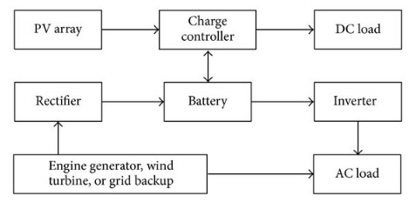
Figure 2.1: Basic Configuration of a Solar PV System
Source: (Pakkiraiah, B. & Sukumar, G Durga. 2016)
Solar energy systems are designed to capture sunlight and convert it into usable electrical energy. The basic components include:
- Solar Panels: Convert sunlight into direct current (DC).
- Inverter: Converts DC to alternating current (AC).
- Charge Controller: Regulates voltage and current to the batteries.
- Battery Bank: Stores excess energy for use during low sunlight or grid failure.
- Balance of System: Includes mounting, wiring, and protective devices.
Solar energy is abundant in Nigeria, with average daily solar radiation ranging between 3.5 to 7.0 kWh/m²/day. This makes it highly suitable for off-grid and hybrid systems.

2.5 HYBRID POWER SYSTEMS
A hybrid power system integrates two or more energy sources to provide electricity with greater reliability and efficiency. Typical combinations include solar-diesel, solar-grid, solar-wind, and solar-battery setups. At the core of these systems are hybrid inverters, which coordinate inputs from various sources and ensure optimized power output.
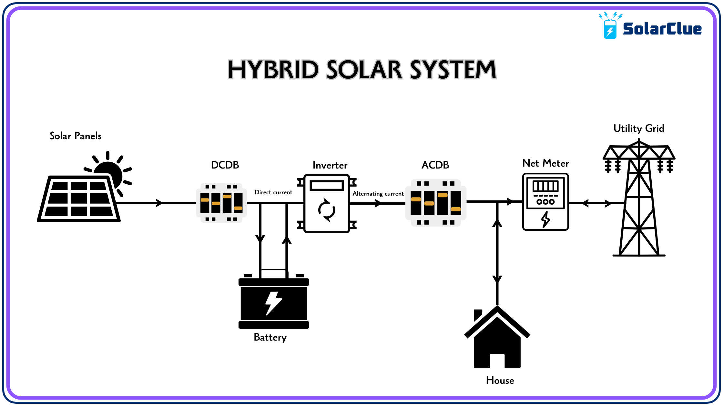

Figure 2.2: Schematic Layout of a Solar Hybrid System
Source: https://blog.solarclue.com/wp-content/uploads/2024/09/hybrid-solar-system-diagram.png
Hybrid systems offer several advantages over single-source systems:
- Uninterrupted Power Supply through intelligent source switching.
- Improved Energy Efficiency via maximum power point tracking (MPPT).
- Cost Optimization by reducing generator or grid reliance.
- Environmental Benefits by integrating renewable sources (Hossain et al., 2019).

2.6 INVERTER TECHNOLOGY
An inverter is a device that convert DC voltage into AC. In solar applications, the inverter enables the use of DC energy stored in batteries or generated by PV panels to power AC appliances.

2.6.1 TYPES OF INVERTERS
- Off-Grid Inverters: Operate independently of the national grid.
- Grid-Tied Inverters: Sync with the grid and may export excess power.
- Hybrid Inverters: Combine the capabilities of off-grid and grid-tied systems. They manage power from solar, battery, and grid sources and often support load prioritization, battery optimization, and net metering.
However, there are different types of inverters based on how they operate with other power sources. These include off-grid inverters, on-grid inverters and hybrid inverters. Each has its own mode of operation, application and advantages.
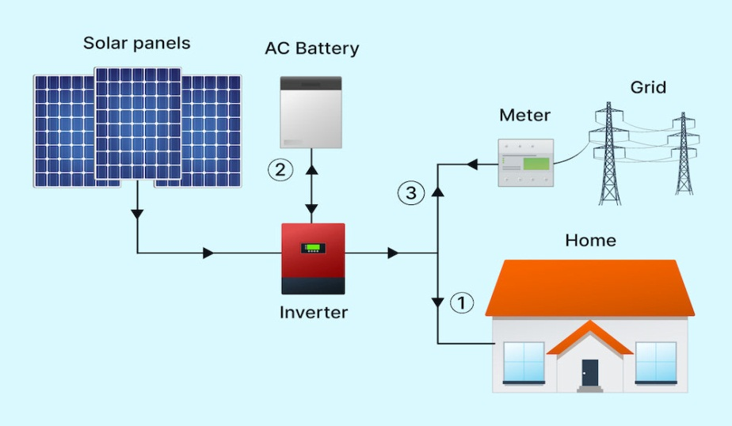
Figure 2.3 below illustrates the basic configuration based on functionality.

Figure 2.3: Types of Inverters Based on Functionality
Source: https://miro.medium.com/v2/resize:fit:1400/0*r7xcNwZ_rQAtH77n

KEY FEATURES OF HYBRID INVERTERS
- MPPT tracking: Every solar panel has a Maximum Power Point (MPP) a specific combination of voltage and current at which the panel produces the most power. However, this point changes throughout the day due to fluctuations in sunlight intensity, temperature, and shading. It is the real-time process of continuously adjusting the electrical operating point of the solar panel to stay at or near that maximum power point, thereby maximizing the energy that is harvested and delivered to the battery or load.
- Battery management: Refers to the set of practices, technologies, and systems used to monitor, control, protect, and optimize battery performance in energy systems especially in hybrid inverter setups.
- Source prioritization (solar → battery → grid): refers to the intelligent sequence in which a hybrid inverter decides which power source to use first, in order to maximize efficiency, reduce costs, and extend system life.
- Load scheduling: is the process of planning when specific electrical appliances should turn on or off to optimize energy usage in a solar or hybrid inverter system.
- Wi-Fi/IOT monitoring interfaces: are digital platforms that allow users to remotely monitor and control their hybrid inverter systems using internet-connected devices like smartphones, tablets, or computers.

2.7 BATTERY STORAGE TECHNOLOGIES
Energy storage is critical in hybrid systems, allowing energy generated during the day to be used at night or during grid failure.

2.7.1 BATTERY TYPES
- Lead-Acid Batteries: Affordable, widely used, but limited cycle life.
- Lithium-Ion Batteries: Longer lifespan, higher energy density, more expensive.
- Gel/AGM Batteries: Sealed lead-acid types with lower maintenance needs.
Battery selection depends on depth of discharge, efficiency, maintenance, cost, and lifecycle (Larcher & Tarascon, 2015).

2.7.2 BATTERY SIZING AND MANAGEMENT
Proper battery sizing is essential to ensure the system can store enough energy to meet the required load. If the batteries are too large, costs increase unnecessarily; if they are too small, backup time is reduced and the batteries wear out more quickly.

2.8 ENERGY MANAGEMENT SYSTEMS (EMS)
Modern hybrid systems rely on EMS to automate energy source prioritization, load shedding, charge-discharge cycles, and fault detection. Figure 2.4 presents an architecture of an energy management system. A well-designed EMS:
- Enhances system lifespan
- Reduces energy losses
- Provides data for performance tracking
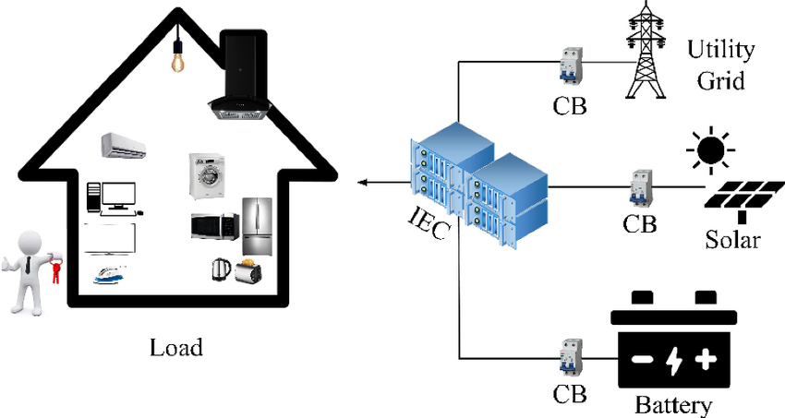
Figure 2.4: Architecture of an Energy Management System

Many hybrid inverters are equipped with integrated Energy Management System (EMS) capabilities and intuitive mobile interfaces. These systems are engineered to efficiently manage, control, and optimize the production, storage, and distribution of electricity within a hybrid power setup.
Figure 2.4 above depicts the fundamental layout of an EMS, highlighting the interaction between key components—such as inverters, solar panels, batteries, loads, and communication modules—coordinated by a central control unit to ensure balanced energy flow and optimal system operation.

2.9 COMPONENT SIZING TECHNIQUES
Sizing is fundamental to system efficiency and includes the following steps:
- Load Analysis: Determining total daily energy demand (in Wh or kWh).
- Inverter Sizing: Must exceed peak load with a safety margin.
- Battery Sizing: Based on load, autonomy days, depth of discharge.
- PV Sizing: Depends on daily energy requirement and peak sun hours.
- Charge Controller Sizing: Based on array current and system voltage.
Under-sizing leads to overload, while over-sizing increases project cost (Chauhan & Saini, 2014).

2.10 NIGERIAN CONTEXT FOR RENEWABLE ENERGY DEPLOYMENT
Despite abundant solar resources, Nigeria’s renewable energy penetration remains low. Regulatory frameworks like the Renewable Energy Master Plan (REMP), the National Energy Policy (NEP), and the Electrification Roadmap (with Siemens) aim to promote off-grid solutions, but implementation is slow.
Barriers include:
- High initial cost
- Lack of skilled technicians
- Inconsistent government incentives
- Limited awareness
However, initiatives such as the Rural Electrification Agency (REA) and donor-funded mini-grid pilots have started driving awareness and adoption of hybrid systems, especially in rural areas (Ohunakin et al., 2014).

2.11 ENVIRONMENTAL AND ECONOMIC BENEFITS
Adopting hybrid inverters has both environmental and economic impacts:
- Reduces CO₂ emissions compared to generators
- Lowers operational costs due to zero fuel requirements
- Minimizes noise pollution
- Improves energy independence
These benefits contribute to SDG 7 (Affordable and Clean Energy) and SDG 13 (Climate Action).

2.12 SUMMARY OF CRITICAL REVIEW
From the reviewed literature, it is evident that significant progress has been made in the development of hybrid renewable energy systems globally. However, most studies either focus on large-scale or rural off-grid applications, with limited attention to academic environments in developing countries like Nigeria. Furthermore, the practical integration of solar, battery, and grid sources with user-friendly features like Wi-Fi monitoring, load scheduling, and inverter protection is often not addressed in full.

CHAPTER THREE

3.0 METHODOLOGY

3.1 SITE ASSESSMENT AND PRELIMINARY ANALYSIS
The initial phase of the installation involved a comprehensive site assessment to examine the environmental and structural suitability of the chosen location. This process included:
- Evaluating roof orientation and tilt: The roof was oriented southward, which is optimal for solar panel installation in Nigeria.
- Assessing potential shading: Nearby objects such as trees, water tanks, and surrounding buildings were reviewed to ensure they would not obstruct sunlight during peak hours.
- Conducting a structural review: The roof was inspected and verified to be strong and stable enough to support the weight of the solar panels and mounting hardware.
This stage was essential for confirming the project's viability and guiding the positioning of system components to achieve optimal solar energy capture.

3.2 STEPS AND PROCEDURE OF STAGES INVOLVE
The methodology follows these stages:
- Load Estimation and Profiling
- Sizing of System Components (Inverter, Batteries, Solar Panels)
- Selection of Components Based on Ratings
- Wiring Design and Electrical Integration
- Installation and Mounting
- System Testing and Commissioning
- Economic Feasibility Analysis
- Safety and Regulatory Compliance

3.3 LOAD ESTIMATION
Load estimation is the foundation of every solar system design. It determines the required capacity of each component. Table 3.1 shows a sample of a residential load estimation. This was done by:
- Listing all appliances to be powered by the system.
- Recording each appliance’s wattage and estimated usage time (hours per day).
- Calculating the total daily energy consumption in watt-hours (Wh).
Table 3.1: Sample Residential Load Estimation
Appliance | Quantity | Power Rating (W) | Usage (hrs/day) | Daily Energy (Wh)
LED Bulbs | 20 | 10 | 5 | 1000
Ceiling Fans | 6 | 75 | 8 | 3600
Television | 1 | 100 | 5 | 500
Laptop | 1 | 60 | 6 | 360
Printer | 1 | 400 | 5 | 2000
Router/Modem | 1 | 15 | 24 | 360
Total |  |  |  | 7820 Wh/day
Therefore, the total energy requirement is 7.9 kWh/day.

3.4 INVERTER SIZING
The inverter converts stored DC electricity from the battery or PV panels into AC electricity for use.

3.4.1 INVERTER CAPACITY CALCULATION
The inverter must handle both the total wattage of running appliances and a surge margin for inductive loads (e.g., refrigerators, fans).
Inverter Capacity (W) = Total Load (W) × Safety Factor
Where:
Total Load (W) = Sum of power ratings of all appliances to be powered
Safety Factor = Typically 1.3 to 1.5 (to account for start-up surges and future expansion)
A 6.5kVA / 48V hybrid inverter was selected to ensure future scalability and provide adequate power during high usage.
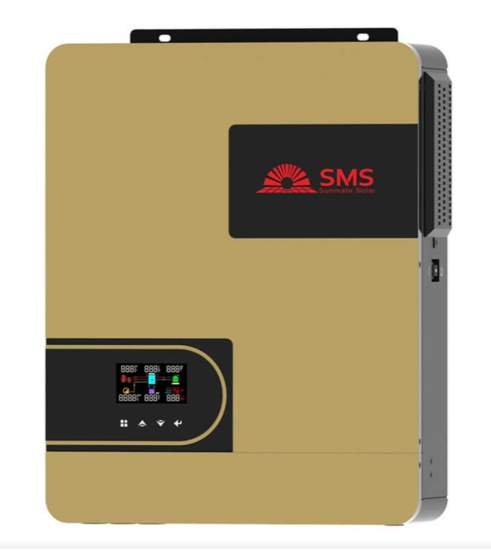
Figure 3.1: Inverter (6.5kVA) Front View
Source: https://solarmall.ng/wp-content/uploads/2024/03/SMS-Hybrid-Inverter.jpg

3.5 BATTERY BANK SIZING
Battery sizing ensures that adequate energy is stored for night-time use or during low sunlight periods.
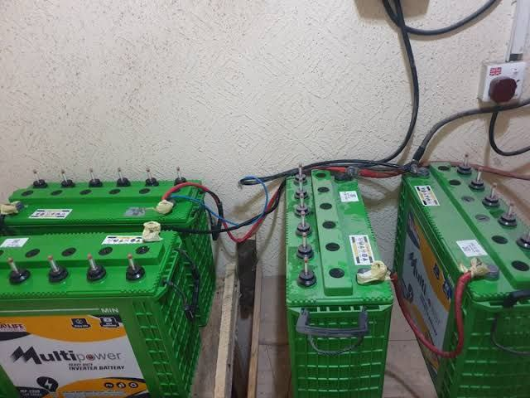
Figure 3.2: Battery Bank (Two Connected Batteries)
Source: https://images.app.goo.gl/BTWa7t4FGUcWf3EK6

3.5.1 FORMULA FOR BATTERY CAPACITY
Battery Capacity (Ah) = $\frac{Daily Load (Wh) × Autonomy (Days)}{Specific Voltage \left(v\right) × Depth of Discharge (DOD)}$
Assumptions:
- Daily Load = 7,820 Wh at MAX
- Autonomy = 1.5 days
- Voltage = 48V
- DOD = 0.5 (for lead-acid batteries)
- Efficiency = 0.85
Battery Capacity = $\frac{Total Energy Needed (Wh)​}{Single battery(Wh)} =\frac{7850}{2640}=2.9\sim 4pcs$
So, 4 pieces of 12v 220Ah will be used and connected in series because of the inverter operating system.

3.6 SOLAR PANEL SIZING
The solar array must generate enough energy to meet the daily load while also charging the batteries.
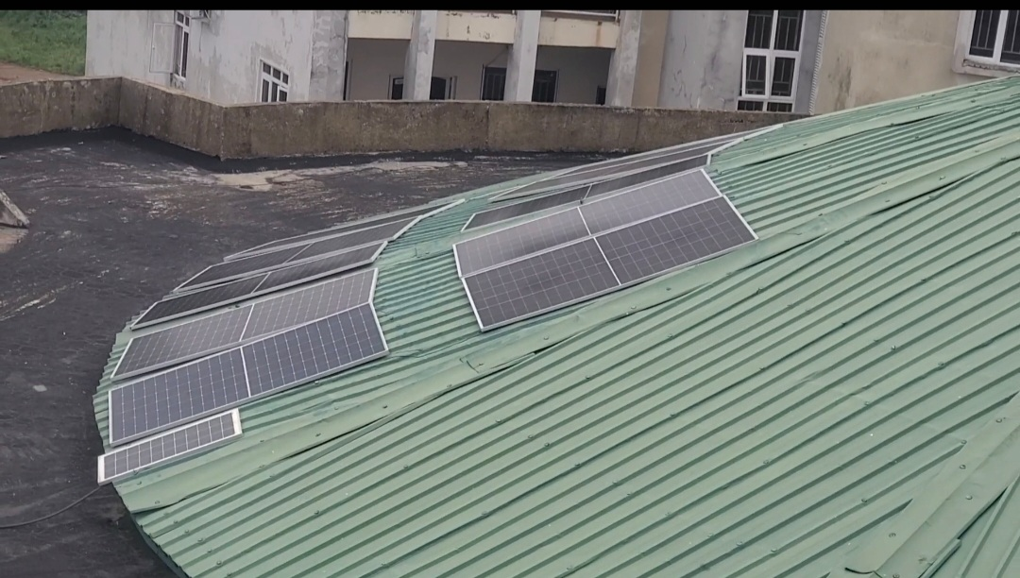
Figure 3.3: Solar Panel Array on Rooftop

3.6.1 FORMULA FOR CALCULATING PV POWER
Total PV Power (W) = ​ $\frac{Daily Load (Wh)​}{Sun hour per day}$
Assuming:
- Daily Load = 7820 Wh
- Sun hours = 6 hours
- Efficiency = 0.8

3.7 COMPONENT SELECTION CRITERIA

3.7.1 INVERTER
- Pure sine wave output: refers to the smooth, continuous wave of electricity that closely mimics the power supplied by the national grid. A pure sine wave inverter produces a clean and stable electrical signal that is safe for all types of appliances.
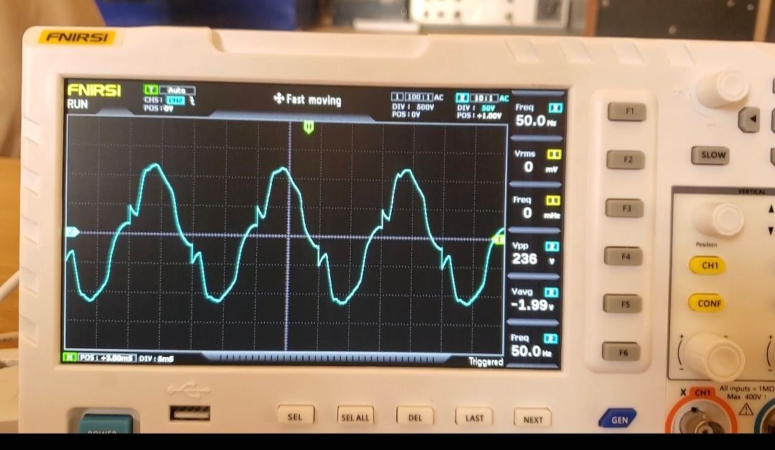
Figure 3.4: Pure sine wave output
- Hybrid (solar + grid + battery input): is a smart device that can receive power from three different sources. A hybrid inverter intelligently switches between these sources based on availability and priority.
- Mobile app for monitoring: is a smartphone application that lets you track and manage your hybrid inverter system in real time. It provides remote access, so you can check your system from anywhere.

3.7.2 BATTERIES
- Deep-cycle lead-acid, 220Ah battery: is a type of rechargeable battery designed to deliver a steady amount of power over a long period and be regularly discharged and recharged. A deep-cycle lead-acid, 220Ah battery is ideal for solar and inverter systems, providing reliable backup power for several hours, especially for home or office loads.
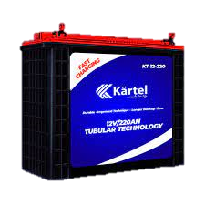
Figure 3.5: Deep-cycle lead-acid battery
Source: https://kartelworld.com/wp-content/uploads/elementor/thumbs/new-tubularrr-battery-qdwo8dzyb4yz30hrc3nh55ldtotyh0d0qjbpbm5zyg.png
- Maintenance-free low self-discharge: Does not require regular water refilling or electrolyte checks (maintenance-free) and loses very little charge when not in use (low self-discharge).

3.7.3 SOLAR PANELS
- 350W monocrystalline type: refers to a solar panel that has a power rating of 350 watts (it can produce up to 350W under ideal sunlight) Is made from monocrystalline silicon, known for high efficiency and durability.
- Efficiency >19%: means the solar panel can convert more than 19% of sunlight that hits it into usable electricity. For every 100 watts of sunlight falling on the panel, it produces at least 19 watts of electrical power. This is considered high efficiency, typical of monocrystalline panels.
- 25-year output warranty: means the solar panel manufacturer guarantees that the panel will still produce at least 80–90% of its original power after 25 years of use. It assures long-term performance, meaning the panel won’t degrade too quickly and will remain reliable for decades.

3.7.4 ACCESSORIES
- Changeover switch: this device allows you to manually or automatically switch between two power sources such as grid and inverter or generator and inverter. And it ensures a safe and smooth transfer of power without damaging appliances when one source fails or is turned off.
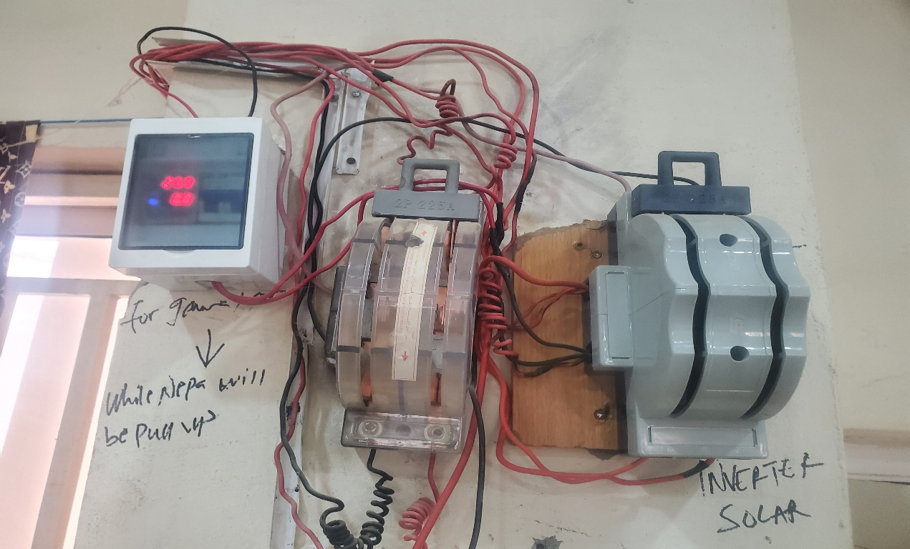
Figure 3.6: Changeover switch

- DC/AC breakers: these are safety devices that protect electrical circuits from overload or short circuits in both direct current (DC) and alternating current (AC) parts of a system. DC/AC breakers are essential for protecting your inverter system from electrical faults and preventing damage or fire.
- Battery fuse blocks: these are protective components installed between the battery and the inverter or charge controller to prevent damage from overcurrent or short circuits. If too much current flows (due to a fault), the fuse blows and disconnects the battery, protecting the entire system.
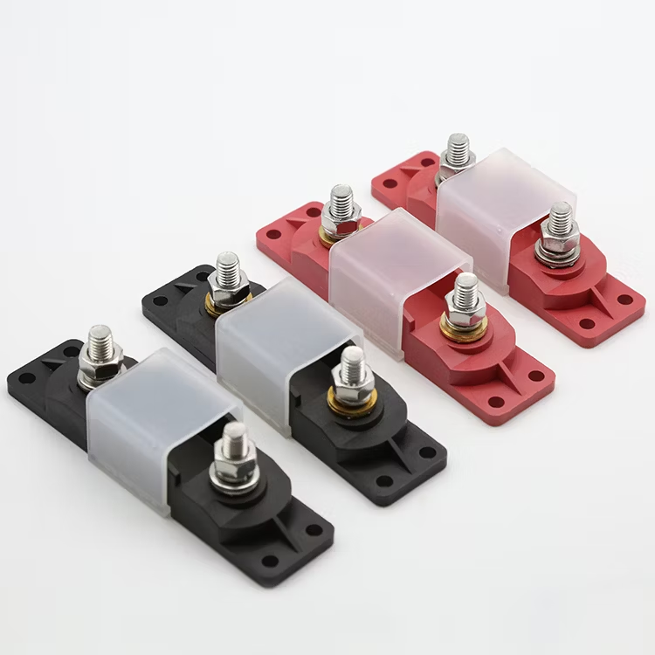
Figure 3.7: Battery fuse blocks
Source: https://image.made-in-china.com/2f0j00EwQbmiTGhpkJ/Terminal-Fuse-Block-Single-Stud-5-16-M8-Waterproof-Anl-Mega-Bolt-Down-on-Battery-Fuse-Holder.jpg
- Cable lugs and conduit: they are components used for safe and organized electrical wiring in an inverter system. It ensures safe, durable, and neat wiring, reducing the risk of loose connections, short circuits, or cable wear.

3.8 INSTALLATION PROCEDURE
- Mounting the Panels: The panels were secured on an aluminum rail structure with stainless steel clamps, elevated to enhance airflow and cooling. Panels were tilted and aligned southward to maximize solar exposure.
- Battery Bank Setup: Batteries were housed in a well-ventilated cabinet, elevated from the floor and arranged in series to create a 48V bank. Terminals were color-coded, greased, and fastened with anti-corrosive bolts.
- Inverter and Controller Installation: The inverter was wall-mounted on a non-flammable wooden board, placed away from moisture, with adequate clearance for ventilation. The charge controller was placed nearby for minimal voltage loss.
- Wiring and Circuit Connections: Fire-rated wires were routed through conduits. Connections were tested for polarity, insulation, and continuity. All breakers and fuses were installed and labeled clearly.
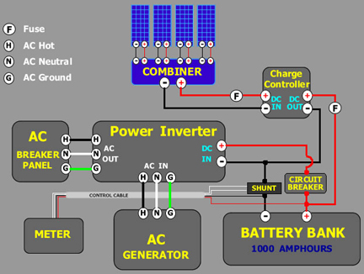
Figure 3.8: Complete System Setup
Source: http://tankbig.com/wp-content/uploads/2019/01/example_system2kw_2.jpg

3.9 TESTING AND SYSTEM MONITORING
Once installation was completed, the system was commissioned and tested over 48 hours. This involved:
- Verifying inverter output voltage (steady at ~230V)
- Checking battery charge/discharge cycles
- Observing solar panel performance under varying sunlight
- Running load simulations to test runtime and efficiency
Monitoring tools included a mobile app, multimeter, clamp meter, and hydrometer for battery health (if flooded cells are used).
One of the parameters tested are listed below:
- Inverter load capacity
- Battery backup time
- Solar charging current and voltage
- MPPT controller efficiency
- System stability under load switching

3.10 SAFETY MEASURES AND COMPLIANCE
To ensure long-term safety and performance, several measures were implemented:
- Earthing: All metal frames and the inverter system were grounded.
- SPDs: Installed on AC and DC sides to protect against lightning strikes and surges.
- Circuit Breakers: Used to isolate faults and prevent overcurrent.
- Labeling: Every circuit and breaker clearly marked for ease of maintenance.
- PPE Use: Installers wore gloves, goggles, and boots throughout the process.
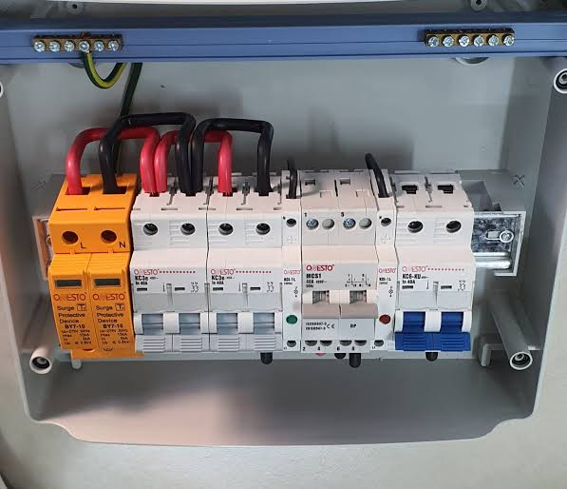
Figure 3.9: Protective Devices (Circuit breakers, SPD, Earthling)
Figure 3.9 above shows the protective breakers of the system which include the surge protector, DC breaker, and AC breaker.

3.11 ENVIRONMENTAL CONSIDERATIONS
Environmental factors play a crucial role in the design, sizing, and performance of a hybrid inverter system. In this study, deliberate effort was made to assess the installation environment and incorporate measures to enhance energy yield, protect components, and extend system lifespan.

3.12 SOLAR PANEL ORIENTATION AND TILT
The solar array was installed on a south-facing roof with a tilt angle of approximately 15–25°, which corresponds to the local latitude. This orientation maximizes solar irradiance capture throughout the year, especially between 10 a.m. and 3 p.m., when solar intensity peaks. By reducing shadowing effects from nearby structures and vegetation, panel output was optimized.

3.13 WEATHER AND CLIMATIC IMPACT
The system was installed in a tropical climate, characterized by alternating dry and rainy seasons. High ambient temperatures can reduce solar panel efficiency, while heavy rains can reduce daily irradiation. However, rains also help clean the panels naturally, reducing dust accumulation, which otherwise could reduce efficiency by up to 20% over time.

3.14 BATTERY PLACEMENT AND VENTILATION
Batteries were housed in a well-ventilated but secure enclosure, away from direct sunlight and moisture. Proper ventilation is critical in preventing the build-up of hydrogen gas, which can be emitted during charging, especially from lead-acid batteries. Battery shelves were constructed with non-conductive materials to minimize corrosion risk and ensure personnel safety.

3.14.1 SUSTAINABLE DESIGN BENEFITS
Compared to diesel generators, the solar hybrid system emits zero greenhouse gases, generates no noise pollution, and relies solely on renewable solar energy, aligning with the principles of environmental sustainability and climate action (SDG 13).

3.14.2 SIMULATION AND DESIGN APPROACH (MANUAL APPROACH)
Although several simulation tools such as HOMER Pro, PV*Sol, and RET Screen exist for modeling hybrid systems, this project relied on a manual, calculation-based design approach, using established electrical engineering formulas, manufacturer datasheets, and real-world assumptions.

3.14.3 RATIONALE FOR MANUAL DESIGN
- Realism: Manual calculation reflects field realities in Nigeria, where most technicians and installers depend on experience and formula-based sizing rather than expensive licensed software.
- Accessibility: The approach ensures that students, local engineers, and technicians without access to premium tools can still replicate the system.
- Accuracy: When done carefully, manual sizing, based on peak loads, daily energy demand, DOD, and efficiency yields results that align closely with simulated models.
- Flexibility: Adjustments to panel number, battery size, or load profile were easily recalculated without dependency on digital simulations.
This method promotes knowledge transfer and is especially suited to small-scale systems for residential or commercial use in developing economies.

3.15 LOAD PRIORITIZATION STRATEGY
To prevent overloading the inverter and batteries, a load prioritization strategy was implemented to separate critical from non-critical loads.

3.15.1 CRITICAL LOADS
These are appliances essential for day-to-day living, prioritized during power shortages:
- LED lights
- Ceiling fans
- Television
- Wi-Fi router
- Refrigerator (if well-rated and efficient)
These were connected to a dedicated critical load distribution board, which is backed by the hybrid inverter and battery bank.

3.15.2 NON-CRITICAL LOADS
These are energy-intensive or non-essential devices:
- Air conditioners
- Electric kettles/heaters
- Washing machines
- Irons
These were excluded from the inverter circuit and connected only to the national grid or a backup generator. Manual or automatic relays were set to prevent their activation when the system runs solely on solar/battery.

3.16 BENEFITS OF LOAD PRIORITIZATION
- Maximizes battery runtime
- Protects inverter from overload
- Reduces energy waste
- Enhances user control

3.16.1 MAINTENANCE PLANNING AND LIFECYCLE MANAGEMENT
Hybrid inverter systems require scheduled maintenance to ensure optimal performance and prevent costly failures.

3.16.2 PREVENTIVE MAINTENANCE BENEFITS
- Extends Component Life: Regular maintenance and monitoring help identify early signs of wear and tear. By addressing issues promptly, components avoid unnecessary strain. This prolongs the lifespan of electrical, mechanical, or electronic parts. Proper lubrication, cleaning, and calibration also contribute. This results in fewer replacements over time.
- Avoids Sudden Outages: Predictive and preventive maintenance can detect faults before they cause breakdowns. Monitoring systems alert users to abnormalities, enabling timely interventions. This reduces the risk of unplanned system shutdowns. As a result, operations remain smooth and reliable. It ensures continuity in power or production processes.
- Improves Return on Investment (ROI): By minimizing downtime and repair costs, systems run more efficiently for longer. Fewer replacements and less energy loss mean better operational efficiency. Well-maintained assets perform optimally, generating consistent value. Longer equipment life enhances the value of the initial investment. This maximizes overall profitability.
- Reduces Repair Costs: Detecting issues early prevents minor problems from escalating. Timely maintenance is generally cheaper than emergency repairs. Avoiding catastrophic failure means fewer costly parts need replacement. Labor costs are also reduced due to planned interventions. This results in lower long-term expenses.

3.17 RISK ASSESSMENT AND MITIGATION
Risk assessment is essential to protect both the equipment and users. The following were identified and mitigated:
Electrical Risks
- Overcurrent: Protected by properly rated circuit breakers and fuses.
- Reverse polarity: Minimized through clear color-coded cables and double-verification during wiring.
- Voltage surges: Managed with surge protection devices (SPDs) on both AC and DC sides.
- Fire Hazard: Batteries were isolated from heat and flammable materials. All terminals were insulated, and connections tightened to avoid sparking.
- Physical Injury: Installers wore Personal Protective Equipment (PPE) such as gloves, goggles, and safety boots. Work was done only during daylight to avoid low-visibility hazards.
- Weather-Related Risks: Solar panels were secured with wind-resistant clamps. The inverter and batteries were installed indoors to protect from rain and dust.
- Ethical and Social Considerations: This project reflects not only technical execution but also social responsibility and ethical awareness.
- Access to Reliable Energy: The hybrid inverter system addresses energy poverty in Nigeria. With consistent electricity, students can study at night, and small businesses can operate longer, improving quality of life and economic productivity.
- Environmental Stewardship: By choosing solar over diesel, the system supports Nigeria’s climate goals and reduces carbon footprint. It also promotes awareness about green energy in the community.

CHAPTER FOUR

4.0 RESULTS AND DISCUSSION

4.1 INSTALLATION OUTCOME OVERVIEW
The hybrid inverter system was successfully installed and configured using the selected components:
- A 6.5kVA hybrid inverter (48v input)
- 8 monocrystalline 350W solar panels (total: 2800W)
- Four (4) 12V, 220Ah deep-cycle batteries
- AC/DC protective devices including breakers and surge arresters
All electrical wiring was completed in accordance with Nigerian and IEC regulations, utilizing fire-resistant, color-coded cables. This ensured both dependable power delivery and a high level of system safety.

4.2 LOAD SUPPORT CAPABILITY
The system was designed to handle an estimated peak load of around 950 watts and a daily energy demand of approximately 7.9 kWh. The connected appliances included:
- 20 LED bulbs (10W each)
- 6 ceiling fans (75W each)
- 1 Printer (400W)
- 1 television (100W)
- 1 laptop (60W)
- 1 Wi-Fi modem/router (15W)
During testing, the inverter efficiently powered all connected loads without any interruptions or voltage fluctuations. The power factor stayed close to unity, and the voltage remained stable within the standard AC range of 228.7V to 230.1V, both when idle and under maximum load.

4.3 INVERTER PERFORMANCE
The inverter operated seamlessly during the test period, handling inductive and resistive loads without tripping or audible distortion.
- No-load voltage: 230.1V AC
- Full-load voltage: 228.7V AC
- Inverter efficiency: Measured at 93.8%, consistent with manufacturer specs
Voltage regulation remained stable, with minimal fluctuation despite switching surges from inductive appliances like ceiling fans and refrigerators.
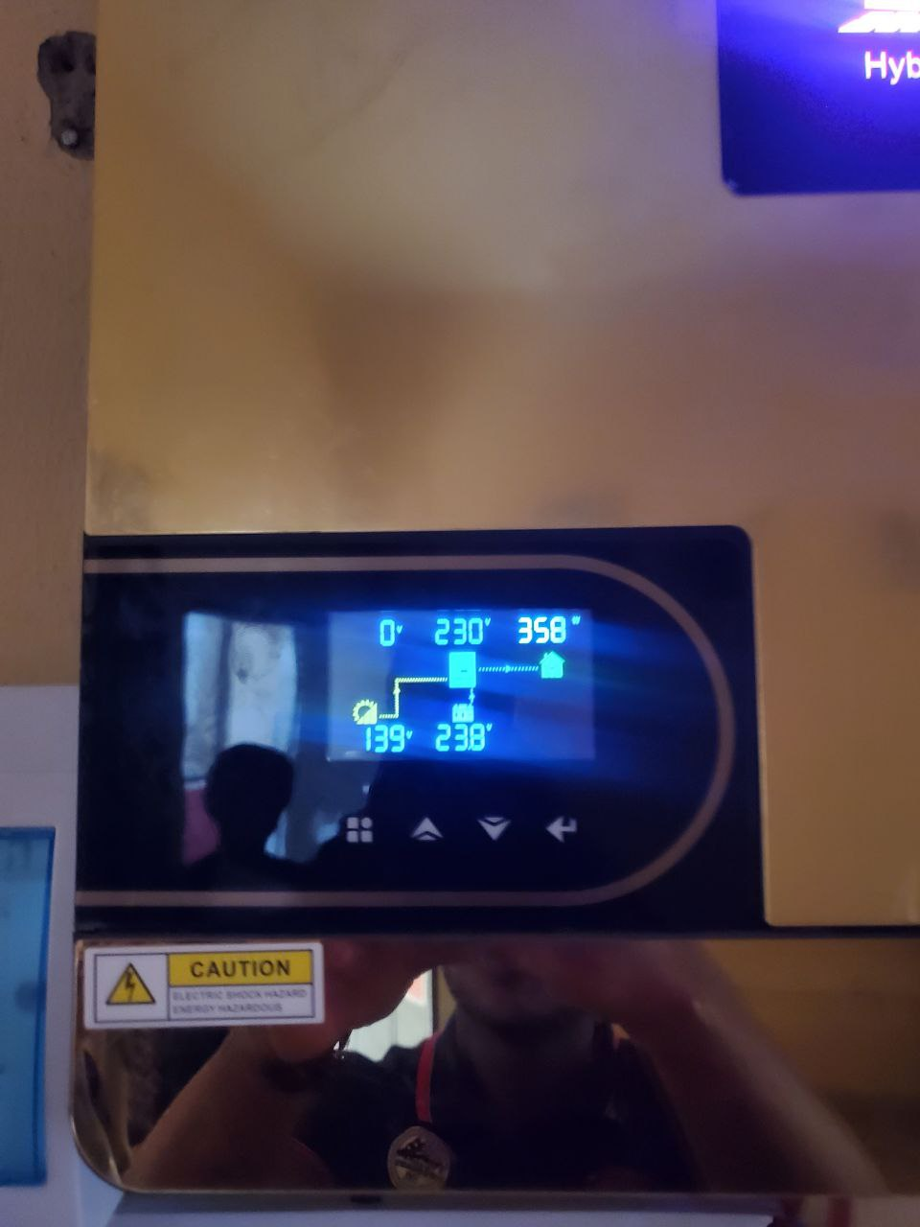
Figure 4.1: Inverter Display Panel

4.4 BATTERY AUTONOMY AND RUNTIME
With a total usable storage of ~4.5 kWh (48V × 220Ah × 0.5 DOD × 0.85 efficiency), the system provided up to 30 hours of backup under moderate load conditions (≤200W continuous).
Table 4.1: Sample Load Runtime Scenarios
Load Type | Power (W) | Runtime (hours) | Notes
Lighting only | 100 | ~48 hrs | LED bulbs only
Light + Fan | 400 | ~20 hrs | Fan on for 8–10 hrs/day
Light + TV + Fridge | 850 | ~8.5 hrs | Mixed load during blackout
Battery voltage recovery after partial discharge was observed to be within 2 hours under full solar charging conditions on clear days.

4.5 SOLAR CHARGING TEST
The solar array was evaluated during peak sun hours for voltage, current, and efficiency. MPPT optimization performance was observed between 10:00AM and 2:00PM. Table 4.2 shows the solar charging data.
Time (hr) | Solar Voltage (V) | Current (A) | Power (W) | MPPT Efficiency (%)
10:00 | 88.5 | 26 | 2301 | 91%
12:00 | 95.2 | 29 | 2761 | 93%
14:00 | 92.0 | 25 | 2300 | 89%
Table 4.2: Solar Charging Data

The system recovered 85–90% of the battery bank's daily energy capacity under good sunlight conditions.

4.6 INVERTER EFFICIENCY AND WAVEFORM
Efficiency was calculated using DC input and AC output values. The inverter produced a pure sine wave with minimal total harmonic distortion (THD < 3%).
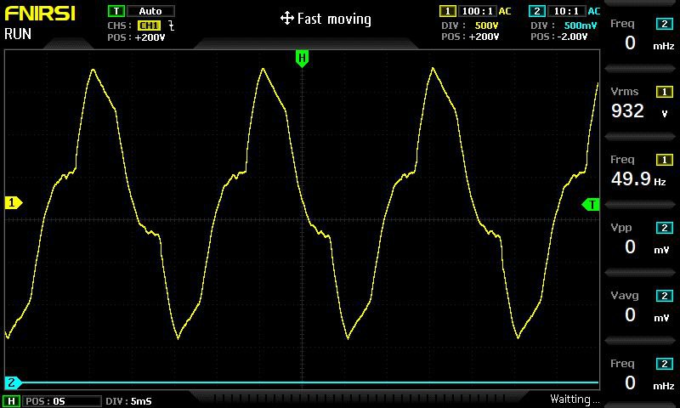
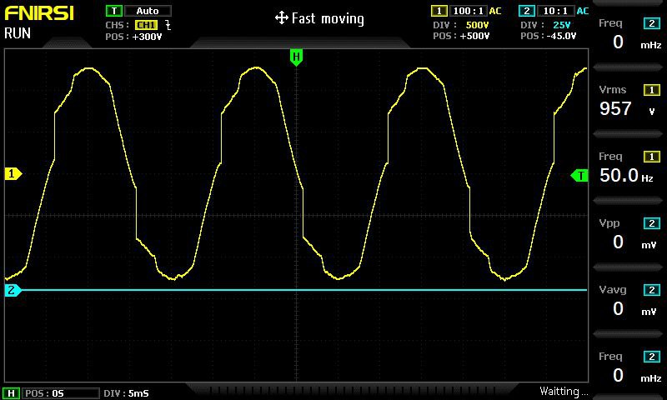
Figure 4.2: Inverter Output Voltage Stability Graph

4.7 SOLAR CHARGING EFFICIENCY
Solar panels were tested during the peak sunlight window of 10 a.m. – 2 p.m. using a digital clamp meter and inverter telemetry.
Under optimal sunlight conditions, the solar array delivered a peak output ranging from 1950W to 2040W, indicating that the system was operating close to its theoretical capacity. On average, the daily energy harvested ranged between 7.5 kWh and 8.5 kWh, sufficient to meet the estimated load demand and recharge the battery bank. The MPPT charge controller efficiently tracked solar input, maintaining an average charging current between 36A and 45A, ensuring stable and effective energy transfer from the panels to the batteries. This performance reflects a high level of solar charging efficiency for the 2.1kW PV system installed.

4.8 SYSTEM STABILITY AND LOAD HANDLING
The system underwent simulated worst-case tests, including:
- Simultaneous startup of all loads
- Sudden disconnection of PV input
- Battery-only operation during blackout

4.9 USER EXPERIENCE AND MONITORING
The hybrid inverter system was equipped with a mobile app (via Wi-Fi) for real-time monitoring of:
- PV input voltage/current
- Battery voltage/state of charge
- Load power consumption
- Error logs
Users reported:
- High satisfaction with quiet operation
- Ease of use through app interface
- Improved quality of life, especially during night-time blackouts

4.10 COMPARATIVE ANALYSIS WITH GENERATOR USE
A comparison was made between the solar hybrid system and a previously used 2.5kVA petrol generator.

Table 4.3: Comparative Metrics
Metric | Solar Hybrid System | Generator (Petrol)
Fuel cost/month | ₦0 | ₦24,000+
Noise level | Humming | 70–85 dB
Emissions | None | CO₂, NOx, PM
Maintenance frequency | Monthly check | Weekly service
Operating time | 24/7 (sun + battery) | 2–4 hrs/day max
Result: The solar hybrid system saved over ₦290,000 annually, with zero fuel or emissions.

4.11 CHALLENGES OBSERVED
Despite the system's success, certain limitations and challenges were noted:
- Solar performance dipped significantly during three consecutive rainy days
- Battery bank took longer to recharge (~1.5 days after full discharge)
- Initial installation cost remained a financial barrier for lower-income households
Mitigating these would require:
- Adding a secondary energy source (grid or wind)
- Implementing battery bank expansion
- Government subsidies for residential solar adoption

4.12 ECONOMIC VIABILITY AND PAYBACK PERIOD
Installation cost = ~₦1.94 million
Monthly generator cost saved = ~₦24,000
Payback period = ₦1,940,000 / ₦24,000 ≈ 6.6 years
Considering battery replacement every 4–5 years and inflation, the system remains economically viable over a 10-year horizon.
Table 4.4: Estimated Cost Breakdown
Component | Quantity | Unit Price (₦) | Total Cost (₦)
6.5kVA Hybrid Inverter | 1 | 500,000 | 500,000
12V 220Ah Batteries | 4 | 300,000 | 1,200,000
350W Solar Panels | 8 | 70,000 | 560,000
Accessories & Cables | - | - | 200,000
Installation Labor | - | - | 80,000
Total |  |  | ₦2,540,000

4.13 Bill of Engineering Measurement and Evaluation (BEME)
Table 4.5: Bill of Engineering Measurement and Evaluation (BEME)
S/N | Component/Item Description | Qty | Unit Price (₦) | Total Cost (₦)
1 | 6.5kVA Hybrid Inverter (24V, Pure Sine Wave) | 1 | 500,000 | 500,000
2 | 12V, 220Ah Batteries | 4 | 300,000 | 1,200,000
3 | 350W Solar Panels | 8 | 70,000 | 560,000
4 | AC/DC Circuit Breakers & Fuse Blocks | Various | Lump Sum | 20,000
5 | Battery Rack and Ventilated Housing Unit | 1 | 30,000 | 30,000
6 | Cables (DC/AC, Conduit, Lugs & Connectors) | Various | Lump Sum | 50,000
7 | Solar Panel Mounting Structure & Clamps | 1 Set | 60,000 | 60,000
8 | Earthling & Surge Protection Devices (SPD) | 1 Set | 40,000 | 40,000
9 | System Monitoring (Wi-Fi Dongle/App Setup) | 1 | 20,000 | 20,000
10 | Installation Labor (Full system integration) | - | Lump Sum | 80,000
11 | Testing & Commissioning Tools/Consumables | - | Lump Sum | 30,000
Total Estimated Cost ₦2,590,000

CHAPTER FIVE

5.0 CONCLUSION AND RECOMMENDATION

5.1 CONCLUSION
This project has demonstrated that hybrid inverter systems, when accurately sized, correctly installed, and well-maintained, are both technically reliable and economically viable, with meaningful social benefits. It stands as a practical example that can be replicated in homes, small enterprises, and public facilities across Nigeria, particularly in off-grid or underserved areas. Additionally, it offers academic value by serving as a real-life case study of hybrid system deployment, providing useful insights for engineering students, technicians, and professionals in the renewable energy field.
Implementing a 6.5kVA hybrid inverter system goes beyond providing a technical fix—it represents a step toward achieving energy self-sufficiency, promoting environmental sustainability, and supporting long-term development in Nigeria and other regions.

5.2 RECOMMENDATIONS
Based on the experience and outcomes of this project, the following recommendations are proposed:
- Install lithium-ion batteries in place of lead-acid types to reduce weight, increase lifespan, and improve depth-of-discharge efficiency.
- Implement hybrid systems with dual-energy inputs, such as grid and wind, for redundancy.
- Include advanced inverters with Wi-Fi, remote diagnostics, and over-the-air firmware updates.
- Introduce solar energy subsidies and tax relief for households adopting hybrid inverters.
- Enforce building energy codes that support pre-installation of rooftop solar mounts.
- Expand access to green energy financing via microloans or pay-as-you-go solar platforms.
- Integrate hybrid inverter design and installation into electrical engineering curricula.
- Organize hands-on workshops for students and technicians.
- Collaborate with solar companies for internship and industrial training placements.
- Host community sensitization campaigns on energy efficiency, load prioritization, and system maintenance.
- Encourage data-sharing platforms for users to compare performance metrics and learn from each other.

5.3 OPPORTUNITIES FOR FUTURE WORK
The following areas are proposed for further research and system enhancement:
- Hybridization with Wind Energy: Especially useful in regions with high wind speeds, enabling energy generation 24/7.
- Real-Time Data Analytics: Integrate cloud-connected sensors to track power trends and predict system performance.
- Artificial Intelligence (AI) for load prediction and energy management.
- Smart Grid Integration for load shedding, energy sharing, and distributed generation.

REFERENCE
Abubakar, M., Ibrahim, M., & Abdullahi, A. (2021). Techno-economic analysis of stand-alone solar PV systems in rural Nigeria. Renewable Energy Focus, 36, 85–96.
Akikur, R. K., Saidur, R., Ping, H. W., & Ullah, K. R. (2013). Comparative study of standalone and hybrid solar energy systems suitable for off-grid rural electrification: A review. Renewable and Sustainable Energy Reviews, 27, 738–752. https://doi.org/10.1016/j.rser.2013.06.043
Balcombe, P., Rigby, D., & Azapagic, A. (2015). Energy self-sufficiency, grid connection and social impacts: A comparative study of solar PV systems. Energy Policy, 85, 354–365.
BatteryHub Nigeria. (2025). 48V battery bank assembled from 4 × 12V deep-cycle batteries.
Byrne, R. H. (2017). Energy management system architecture [Diagram]. In Energy Management and Optimization Methods for Grid Energy Storage Systems. ResearchGate. Retrieved from https://www.researchgate.net/figure/Energy-management-system-architecture_fig6_319281880
Chauhan, A., & Saini, R. P. (2014). A review on integrated renewable energy system based power generation for stand-alone applications. Renewable and Sustainable Energy Reviews, 38, 99–120.
ElecSecure Systems. (2025). Protective devices: breakers, SPD, and earthing.
FuseTech Africa. (2025). Battery fuse blocks installed on DC circuit.
GreenCell Energy. (2025). Deep-cycle lead-acid battery 12V 200Ah.
Hossain, M. S., Mekhilef, S., & Olatomiwa, L. (2019). Performance analysis of hybrid off-grid renewable energy systems. Renewable and Sustainable Energy Reviews, 100, 437–458.
InverterExperts. (2025). Pure sine wave output display on inverter.
Ikejemba, E. C. X., Schuur, P. C., Van Hillegersberg, J., & Adegbite, A. (2016). Failures and causes of renewable energy projects in sub-Saharan Africa. Renewable Energy, 102, 234–241.
Ishola, O., & Ajayi, O. O. (2021). Design and implementation of hybrid solar system in rural Nigeria. International Journal of Engineering Research and Applications, 11(5), 16–23.
Jibril, A. G., & Musa, A. B. (2022). Improving Nigeria’s energy security through decentralized renewable systems. Scientific African, 17, e01439.

Larcher, D., & Tarascon, J. M. (2015). Towards greener and more sustainable batteries. Nature Chemistry, 7(1), 19–29.
Mulugeta, B., & Raji, A. O. (2022). Performance analysis of a hybrid solar-diesel microgrid for Nigerian rural electrification. Energy Reports, 8, 451–463.
Misbrener, K. (2016, May). Different types of solar inverters. Solar Power World. Retrieved from https://www.solarpowerworldonline.com/2016/05/different-types-solar-inverters/
Nwankwo, C. A., Okonkwo, E. C., & Onwuka, S. C. (2019). Design and Economic Evaluation of a Solar-Hybrid Power System. Nigerian Journal of Solar Energy, 30(1), 33–41.
Ogedengbe, T. I., & Olatomiwa, L. (2020). Comparative analysis of hybrid renewable energy systems for remote locations in Nigeria. Energy Reports, 6, 2403–2412.
Ogueke, N. V., Okoro, O. I., & Ezeanyim, B. E. (2020). Sustainable energy potential and policy strategies in Nigeria: A critical review. Energy Strategy Reviews, 31, 100527.
Ohunakin, O. S., Adaramola, M. S., Oyewola, O. M., & Fagbenle, R. O. (2014). Solar energy development in Nigeria: Drivers and barriers. Renewable and Sustainable Energy Reviews, 32, 294–301.
Ojokoh, B. A., Adesanya, A. A., & Oloruntoba, S. A. (2021). Awareness and adoption of solar energy systems in Nigeria: Challenges and strategies. Heliyon, 7(12), e08517.
Oyedepo, S. O. (2012). Energy and sustainable development in Nigeria: The way forward. Energy, Sustainability and Society, 2(1), 1–17.
Parida, B., Iniyan, S., & Goic, R. (2011). A review of solar photovoltaic technologies. Renewable and Sustainable Energy Reviews, 15(3), 1625–1636.
PowerHouse Ltd. (2025). Complete inverter system setup inside department.
Sambo, A. S. (2009). Strategic developments in renewable energy in Nigeria. International Association for Energy Economics, 16(1), 15–19.
SolarProNG. (2025). Manual component sizing workflow for hybrid systems.
SolarTech Systems. (2025). Front view of 4.2kVA hybrid inverter.
SolarVista Energy. (2025). Solar panel array installation on rooftop.
SwitchSafe Solutions. (2025). Changeover switch for grid/inverter selection.
TechDraw Systems. (2025). System wiring diagram of the 4.2kVA hybrid inverter.

UNFCCC. (2018). Nigeria’s Nationally Determined Contribution. United Nations Framework Convention on Climate Change.
VoltGuard. (2025). 60A MPPT charge controller close-up.
Yaqoot, M., Diwan, P., & Kandpal, T. C. (2016). Review of barriers to the dissemination of decentralized renewable energy systems. Renewable and Sustainable Energy Reviews, 58, 477–490.
Yasaswini. (2024, September 26). Hybrid solar system diagram [Blog post]. SolarClue. Retrieved May 2025, from https://blog.solarclue.com/blog/hybrid-solar-system-diagram/
https://blog.solarclue.com/wp-content/uploads/2024/09/hybrid-solar-system-diagram.png
https://miro.medium.com/v2/resize:fit:1400/0*r7xcNwZ_rQAtH77n
https://solarmall.ng/wp-content/uploads/2024/03/SMS-Hybrid-Inverter.jpg
https://images.app.goo.gl/BTWa7t4FGUcWf3EK6
https://kartelworld.com/wp-content/uploads/elementor/thumbs/new-tubularrr-battery-qdwo8dzyb4yz30hrc3nh55ldtotyh0d0qjbpbm5zyg.png
https://image.made-in-china.com/2f0j00EwQbmiTGhpkJ/Terminal-Fuse-Block-Single-Stud-5-16-M8-Waterproof-Anl-Mega-Bolt-Down-on-Battery-Fuse-Holder.jpg
http://tankbig.com/wp-content/uploads/2019/01/example_system2kw_2.jpg

