AMELIORATIVE POTENTIAL OF PHYLLATUS AMARUS LEAVES EXTRACT ON BLOOD GLUCOSE, OXIDATIVE STATUS AND SERUM ELECTROLYTES OF STREPTOZOTOCIN- INDUCED DIABETES WISTAR RATS

BY

ADEDAPO OLUWASEGUN ZACHEUS
HND/23/SLT/FT/0820

BEING A RESEARCH PROJECT SUBMITTED TO THE DEPARTMENT OF SCIENCE LABORATORY TECHNOLOGY, BIOCHEMISTRY UNIT, INSTITUTE OF APPLIED SCIENCE, KWARA STATE POLYTECHNIC, ILORIN, KWARA STATE, NIGERIA

IN PARTIAL FULFILLMENT OF THE REQUIREMENT FOR THE AWARD OF HIGHER NATIONAL DIPLOMA (HND) IN THE DEPARTMENT OF SCIENCE LABORATORY TECHNOLOGY, BIOCHEMISTRY UNIT.

JULY, 2025

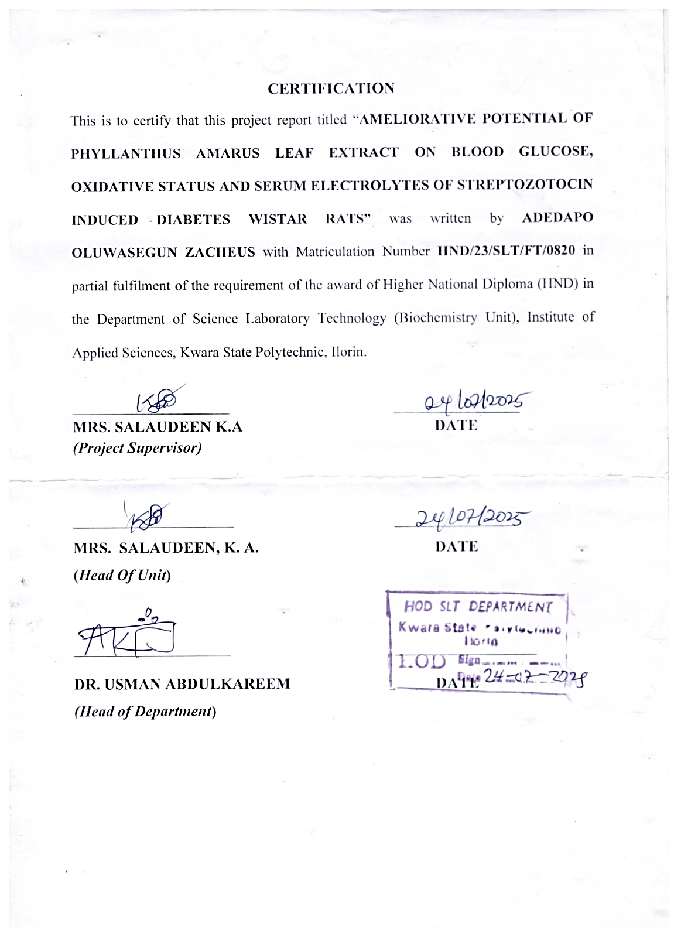

DEDICATION
I dedicate this project to the Father of all Grace, the Almighty God, the owner and the administrator of the universe

ACKNOWLEDGEMENTS
I thank Almighty God who made it possible for me to achieve one of my desired academic heights in life. To my project supervisor, Mrs. SALAUDEEN K.A, I remain grateful to you for all your effort in ensuring that this research comes out with an enviable standard. You were always there no matter what the time, or the inconvenience, your readiness to listen, encouraged me as you guided and made your corrections to this work. No doubt your constructive criticisms brought me this far. To all my lecturers in the Biochemistry unit, Kwara State Polytechnic, Ilorin, may the Lord bless you all abundantly. My deep appreciation goes to my caring parents, I pray you will live long to eat the fruit of your labour.

TABLE OF CONTENT
Title page i
Certification ii
Dedication iii
Acknowledgement iv
List of Figures v
Table of Content vi
Abstract vii
CHAPTER ONE: INTRODUCTION
  - Background to the Study 1
  - Justification of Study 2
  - Aims of Study 3

CHAPTER TWO: LITERATURE REVIEW

  - Overview of Diabetes Mellitus 4
    - Epidemiology of Diabetes 5
  - Types of Diabetes 6
    - Type 1 Diabetes 7
    - Type 2 Diabetes 8
    - Gestational Diabetes 9
  - Glucose Metabolism and Its Regulation 10
  - Role of Oxidative Stress in the Pathophysiology of Diabetes 11
  - Mechanism of Streptozotocin in the Induction of Diabetes 12
  - Antidiabetic Drugs 13
  - Phyllanthus amarus 14

CHAPTER THREE: MATERIALS AND METHODS
  - Chemicals and Reagents 15
  - Apparatus and Equipment 16
  - Plant Material Collection 17
  - Experimental Animals 18
  - Animal grouping and schedule 19
  - Qualitative Phytochemical Screening 20
  - Antidiabetic Study on Extract 21
  - Antidiabetic Biomarkers 22
  - Antioxidant Assays 23

CHAPTER FOUR: RESULTS

CHAPTER FIVE: DISCUSSION AND CONCLUSION
  - Discussion 24
  - Conclusion 25

References

LIST OF FIGURES

Figure1: Estimates of the global prevalence of diabetes worldwide (20–79-yearagegroup).
Fig2: Glycolysis Diagram: Overview of the aerobic glycolysis pathway
Fig3: Gluconeogenesis pathway
Figure4: Effect Of Phyllanthus amarus Extract On The ALT Specific Activity(mmol/min/mg Protein) Of STZ Induced Diabetic Rats After 14 Days Of Treatment
Figure5: Effect Of Phyllanthus amarus Extract On The AST Specific Activity (mmol/min/mgProtein) Of STZ Induced DiabeticRatsAfter14DaysOfTreatment
Figure6: Effect Of Phyllanthus amarus Extract On The ALP Specific Activity(mmol/min/mg Protein) Of STZ Induced Diabetic Rats After 14Days Of Treatment

LIST OF TABLES

Table 1: Antidabetic study on extract
Table2: Timeline of Blood Glucose Monitoring and Treatment Schedule Table 3: Conclusion on Biomarker Relevance
Table 4: Summary Table of Antioxidant Biomarkers in Diabetes vs. Treated/Normal States

ABSTRACT

Diabetes mellitus is a chronic metabolic disorder marked by persistent hyperglycemia and associated complications such as oxidative stress and electrolyte imbalances. This study is to investigate theameliorative potential of Phyllanthus amarus leaf extract on blood glucose levels, oxidative status, and serum electrolytes in streptozotocin-induced diabetic Wistar rats. The extract was evaluated for its anti-hyperglycemic, antioxidant, and electrolyte-modulating properties. Rats were divided into five groups and treated with different doses of the extract or metformin over 14 days. Biochemical parameters including blood glucose, serum insulin, total protein, creatinine, electrolytes, and oxidative stress biomarkers (GSH, SOD, CAT, GPx, MDA) were analyzed. Results indicated that the extract significantly reduced blood glucose, improved antioxidant enzyme activities, restored electrolyte balance, and increased insulin levels in a dosedependent manner. Furthermore, the dose-dependent improvements observed imply that higher concentrations of the extract may provide enhanced therapeutic benefits. The study adds to the growing body of evidence supporting the medicinal value of Phyllanthus amarus and highlights its potential for integration into affordable, plant-based interventions, especially in regions where conventional drugs are less accessible. The findings suggest that Phyllanthus amarus possesses antidiabetic and antioxidative properties, supporting its use as a complementary therapy for diabetes

CHAPTER ONE

INTRODUCTION

Diabetes mellitus is a long-term metabolic condition marked by high blood sugar levels, impacting millions globally. Phyllanthus amarus, a herbal remedy, has historically been utilized to treat various health issues, including diabetes. This research aims to assess the antidiabetic effects of ethanolic extract from Phyllanthus amarus in streptozotocin (STZ)-induced diabetic rats. The study will evaluate the extract's effectiveness in lowering blood glucose levels and investigate its possible therapeutic advantages.

BACKGROUND TO THE STUDY

Diabetes mellitus (DM) is a chronic metabolic disorder characterized by persistent hyperglycemia resulting from defects in insulin secretion, insulin action, or both (American Diabetes Association, 2022). It is one of the most pressing public health challenges globally, affecting over 500 million people and accounting for millions of deaths annually, largely due to its associated complications such as cardiovascular disease, neuropathy, nephropathy, and retinopathy (International Diabetes Federation, 2021). In sub-Saharan Africa, including Nigeria, the burden of diabetes is rising rapidly due to urbanization, sedentary lifestyles, and dietary changes (Ogunmola et al., 2019).
One major complication of diabetes is oxidative stress, which results from an imbalance between the production of reactive oxygen species (ROS) and the body's antioxidant defense mechanisms. In diabetic states, hyperglycemia stimulates excessive production of free radicals, leading to cellular damage, inflammation, and the progression of complications (Baynes & Thorpe, 2024).

Oxidative stress also impairs insulin signaling, exacerbating metabolic dysregulation (Maritim et al., 2023). [Insert Diagram 1: Relationship between hyperglycemia, oxidative stress, and diabetic complications].
Another critical but often overlooked complication of diabetes is electrolyte imbalance. Alterations in serum electrolytes such as sodium, potassium, chloride, calcium, and bicarbonate are common in poorly controlled diabetes and may contribute to morbidity and mortality (Kavitha & Shobha, 2020). These imbalances are often associated with osmotic diuresis, renal dysfunction, and acidosis seen in diabetic states (Kitabchi et al., 2022).
The search for alternative therapies that are affordable, effective, and with fewer side effects than synthetic drugs has led researchers to explore medicinal plants. Phyllanthus amarus is a widely distributed herb in tropical and subtropical regions, traditionally used in Nigerian and Indian ethnomedicine to manage various ailments, including diabetes, jaundice, and liver disorders (Iwu, 2020). Phytochemical studies have revealed that P. amarus is rich in flavonoids, tannins, lignans, and polyphenols, which possess potent antioxidant, hepatoprotective, and anti-inflammatory properties (Akinmoladun et al., 2020).
Preliminary studies suggest that extracts of Phyllanthus amarus may exert antihyperglycemic effects by enhancing insulin secretion, improving glucose uptake, and reducing oxidative damage (Soman et al., 2022). However, data on its impact on serum electrolytes and oxidative status in diabetic models remain limited and inconclusive. Hence, this study aims to evaluate the effect of Phyllanthus amarus leaf extract on blood glucose, oxidative stress biomarkers, and serum electrolyte concentrations in streptozotocin-induced diabetic Wistar rats.

JUSTIFICATION OF STUDY

Despite the availability of various antidiabetic drugs, the management of diabetes mellitus remains a global challenge due to issues such as high cost, limited accessibility, adverse side effects, and inadequate glycemic control in many patients (Rang et al., 2019). These limitations have spurred increasing interest in natural remedies, particularly medicinal plants that are locally available, cost- effective, and culturally accepted.
Phyllanthus amarus is one such plant widely used in traditional medicine across Nigeria and other tropical regions. While existing studies suggest that P. amarus has hypoglycemic and antioxidant properties (Soman et al., 2022), comprehensive evaluation of its effect on serum electrolytes in diabetic models is scarce. Since electrolyte imbalances are common complications of diabetes and can significantly affect prognosis, it is important to understand whether P. amarus could offer broader therapeutic benefits beyond glycemic control.
Moreover, oxidative stress plays a key role in the pathogenesis and progression of diabetes and its complications. If Phyllanthus amarus can attenuate oxidative damage, it may serve as a useful adjunct in diabetes management by improving redox balance and reducing the risk of long-term complications.
This study is therefore justified as it will contribute to the scientific understanding of the pharmacological potential of Phyllanthus amarus in diabetes treatment. It may also provide a basis for further pharmacological standardization, drug development, and validation of its use in ethnomedicine. In the long term, such research could support public health efforts to integrate effective plant-based therapies into diabetes care, especially in resource-limited settings.

AIMS OF STUDY

The aim of this study is to investigate the ameliorative potential of Phyllanthus amarus leaf extract on blood glucose levels, oxidative status, and serum electrolytes in streptozotocininduced diabetic Wistar rats.

Specific Objectives

The specific objectives of the study are to:

- Evaluate the effect of Phyllanthus amarus leaf extract on fasting blood glucose levels in diabetic Wistar rats.
- Assess the impact of Phyllanthus amarus on oxidative stress markers such as malondialdehyde (MDA), catalase (CAT), superoxide dismutase (SOD), and glutathione (GSH) in diabetic rats.
- Determine the effect of Phyllanthus amarus leaf extract on serum electrolyte levels (e.g., sodium, potassium, chloride, bicarbonate) in diabetic rats.

CHAPTER TWO

  - LITERATURE REVIEW

Antidiabetic Potential

Research indicates that extracts from P. amarus can help lower blood glucose levels in diabetic rats induced by STZ, suggesting possible antidiabetic effects. The alkaloid extract derived from the leaves of P. amarus has been shown to reduce blood glucose levels in diabetic rats, indicating its potential role as an antidiabetic agent.

Hepatoprotective Effects

P. amarus has been found to have hepatoprotective properties, safeguarding the liver from damage inflicted by toxins such as carbon tetrachloride (CCl4). The nanoemulsified ethanolic extract of P. amarus has been demonstrated to alleviate hepatotoxicity induced by CCl4 in Wistar
rats.

Safety Evaluation

Studies on biosafety have evaluated the impact of the ethanolic extract of P. amarus on liver and kidney functions in Wistar rats. The median lethal dose (LD50) for the crude ethanolic leaf extract of P. amarus has been established, and sub-chronic oral toxicity studies have been carried out in experimental mice (Bukola et al., 2023).
These investigations emphasize the potential therapeutic advantages of P. amarus, especially in diabetes management and liver protection. Additional research is necessary to thoroughly investigate its antidiabetic capabilities and the underlying mechanisms of action.

OVERVIEW OF DIABETES MELLITUS

Diabetes mellitus is a metabolic disorder characterized by chronic hyperglycemia due to defective insulin secretion, insulin action, or both (American Diabetes Association, 2022). It is broadly classified into type 1, type 2, and gestational diabetes. Streptozotocin (STZ) is frequently used in experimental models to induce diabetes, particularly resembling type 1 diabetes, by selectively destroying pancreatic β-cells (Lenzen, 2019). Chronic hyperglycemia is associated with long-term damage to multiple organs, especially the eyes, kidneys, nerves, heart, and blood vessels.

EPIDEMIOLOGY OF DIABETES

According to the International Diabetes Federation (IDF, 2021), over 537 million adults were living with diabetes globally in 2021, with a projected increase to 643 million by 2030. In subSaharan Africa, the burden is rising rapidly, driven by urbanization, lifestyle changes, and poor access to healthcare. Nigeria has the highest number of people living with diabetes in Africa, with a prevalence estimated at 5.3% among adults (Ogunmola etal., 2019).

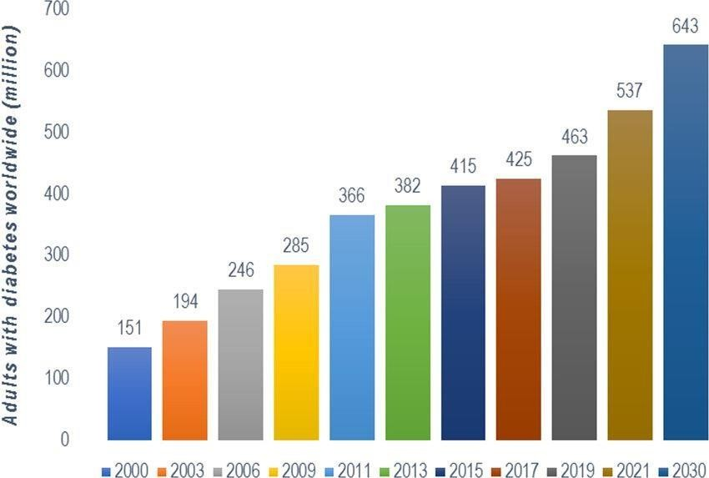

Figure 1 Estimates of the global prevalence of diabetes worldwide (20–79-year age group). Results from the International Diabetes Federation Atlas, 10th edition.

TYPES OF DIABETES

Diabetes mellitus is broadly classified into the following:

TYPE 1 DIABETES

This form results from autoimmune destruction of pancreatic β-cells, leading to an absolute deficiency of insulin. It typically develops in children and young adults.

PATHOPHYSIOLOGY OF TYPE 1 DIABETES

In genetically predisposed individuals, autoimmune attacks mediated by T-cells lead to β-cell apoptosis. This reduces insulin production, leading to elevated blood glucose and metabolic derangements such as ketosis and acidosis (Atkinson et al., 2021).

SYMPTOMS AND DIAGNOSIS OF TYPE 1 DIABETES

Common symptoms include polyuria, polydipsia, polyphagia, weight loss, fatigue, and blurred vision. Diagnosis is based on fasting plasma glucose ≥126 mg/dL, 2-hour OGTT ≥200 mg/dL, or HbA1c ≥6.5% (ADA, 2022).

MANAGEMENT OF TYPE 1 DIABETES

Management involves lifelong insulin therapy, blood glucose monitoring, dietary planning, and physical activity. Emerging strategies include β-cell transplantation and immunotherapy.

TYPE 2 DIABETES

Type 2 diabetes results from insulin resistance and relative insulin deficiency. It accounts for over 90% of diabetes cases globally.

PATHOPHYSIOLOGY OF TYPE 2 DIABETES

Insulin resistance in peripheral tissues—especially skeletal muscles, adipose tissue, and the liver— coupled with impaired insulin secretion from β-cells, leads to chronic hyperglycemia. Over time, β-cell function declines further due to glucotoxicity and lipotoxicity (DeFronzo et al., 2019).

SYMPTOMS AND DIAGNOSIS OF TYPE 2 DIABETES

Symptoms are often mild or asymptomatic in early stages. When present, they resemble those of type 1. Diagnosis criteria are the same as for type 1 diabetes.

MANAGEMENT OF TYPE 2 DIABETES

Management includes lifestyle modification, oral hypoglycemic agents (e.g., metformin, sulfonylureas), and in some cases, insulin therapy. Newer agents include SGLT2 inhibitors and GLP-1 receptor agonists.

GESTATIONAL DIABETES

Gestational diabetes mellitus (GDM) is glucose intolerance first recognized during pregnancy, typically resolving after delivery but increasing the risk of type 2 diabetes later.

PATHOPHYSIOLOGY OF GESTATIONAL DIABETES

Hormonal changes during pregnancy (e.g., human placental lactogen, cortisol) lead to insulin resistance. In women with inadequate β-cell function, this results in hyperglycemia.

SYMPTOMS AND DIAGNOSIS OF GESTATIONAL DIABETES

Most cases are asymptomatic and diagnosed using an oral glucose tolerance test (OGTT) between 24–28 weeks of gestation. Thresholds for diagnosis vary by guidelines (e.g., ADA, WHO).

MANAGEMENT OF GESTATIONAL DIABETES

Management includes medical nutrition therapy, exercise, blood glucose monitoring, and insulin if lifestyle changes are insufficient. Tight glycemic control is essential to prevent complications such as macrosomia and neonatal hypoglycemia.

GLUCOSE METABOLISM AND ITS REGULATION

Glucose metabolism is a tightly regulated process essential for energy production and cellular function. It involves the uptake, utilization, storage, and release of glucose under hormonal control—primarily by insulin and glucagon.
After a meal, blood glucose levels rise, prompting pancreatic β-cells to secrete insulin. Insulin facilitates glucose uptake into muscle and adipose tissue via the GLUT4 transporter, promotes glycogenesis (formation of glycogen), and inhibits gluconeogenesis and glycogenolysis in the liver (Saltiel & Kahn, 2020). Conversely, during fasting, glucagon is secreted by α-cells of the pancreas to stimulate hepatic glucose output through glycogenolysis and gluconeogenesis.
Disruption in these processes—either due to insulin deficiency or resistance—leads to elevated blood glucose levels, the hallmark of diabetes mellitus.

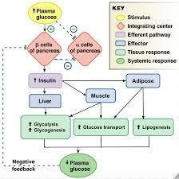
Fig 2: Glucose regulation Source: (Norman, 2022)

ROLE OF OXIDATIVE STRESS IN THE PATHOPHYSIOLOGY OF DIABETES

Oxidative stress refers to a condition in which the generation of reactive oxygen species (ROS) exceeds the capacity of antioxidant defense systems. In diabetes, persistent hyperglycemia increases the production of ROS through multiple mechanisms, including:
Glucose autoxidation

Activation of the polyol pathway

Protein glycation and advanced glycation end products (AGEs)

Mitochondrial dysfunction (Brownlee, 2019)

These ROS damage cellular macromolecules, disrupt signaling pathways, and contribute to βcell dysfunction, insulin resistance, and the onset of microvascular and macrovascular complications.
Antioxidant Defenses in Diabetes

The body’s endogenous antioxidant systems include enzymatic components such as: Superoxide Dismutase (SOD)
Catalase (CAT)

Glutathione Peroxidase (GPx)

and non-enzymatic antioxidants like:

Glutathione (GSH) Vitamin C
Vitamin E

In diabetic states, these systems are often overwhelmed or depleted, intensifying oxidative damage (Maritim et al., 2023). Targeting oxidative stress with antioxidants—either through diet, supplementation, or phytotherapeutics like Phyllanthus amarus—is being explored as

complementary approach in diabetesmanagement
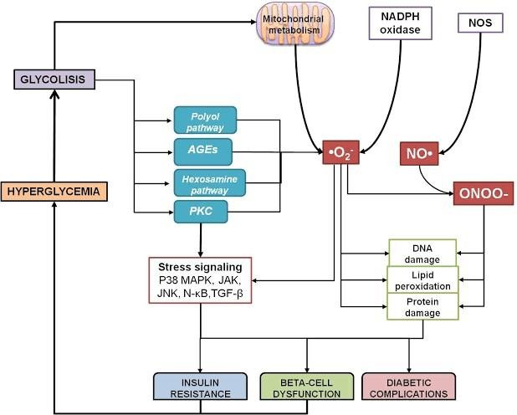

Fig 3: Oxidative stress pathways in diabetes Source: (Mary Luisa, 2020)

MECHANISM OF STREPTOZOTOCIN (STZ) IN THE INDUCTION OF DIABETES

Streptozotocin (STZ) is a nitrosourea compound derived from Streptomyces achromogenes. It is commonly used in experimental models to induce diabetes in animals, particularly Type 1 diabetes.

Mechanism of Action:

STZ selectively targets pancreatic β-cells due to its affinity for the glucose transporter 2 (GLUT2), which is abundantly expressed in these cells (Szkudelski et al., 2019).
Once inside the β-cells, STZ causes alkylation of DNA, leading to DNA fragmentation and activation of poly ADP-ribose polymerase (PARP), which depletes NAD+ and ATP.
The process generates reactive oxygen species (ROS), contributing to oxidative stress and apoptosis of β-cells.
This β-cell destruction leads to insulin deficiency and persistent hyperglycemia, mimicking Type 1 diabetes in humans.

ANTIDIABETIC DRUGS

Conventional therapy for diabetes includes various classes of medications targeting different mechanisms of glucose regulation.

INSULIN THERAPY

Insulin is the cornerstone of treatment for Type 1 diabetes and is also used in advanced Type 2 diabetes. It facilitates glucose uptake in tissues, suppresses hepatic glucose production, and promotes glycogen storage.

BIGUANIDES

Example: Metformin

Mechanism: Reduces hepatic glucose production, increases insulin sensitivity, and enhances peripheral glucose uptake. It is often the first-line therapy for Type 2 diabetes (Rojas & Gomes, 2023).

SULFONYLUREAS

Examples: Glibenclamide, Glipizide

These stimulate insulin secretion by binding to sulfonylurea receptors on pancreatic β-cells, leading to closure of ATP-sensitive K⁺ channels and insulin release.

MEGLITINIDES

Examples: Repaglinide, Nateglinide

Similar to sulfonylureas, but with a shorter duration of action. They stimulate rapid insulin release in response to meals.

THIAZOLIDINEDIONES

Examples: Pioglitazone, Rosiglitazone

These enhance insulin sensitivity in muscle and adipose tissue by activating peroxisome proliferator-activated receptor gamma (PPAR-γ).

DIPEPTIDYL PEPTIDASE-4 (DPP-4) INHIBITORS

Examples: Sitagliptin, Vildagliptin

They prolong the action of incretin hormones (GLP-1 and GIP), thereby enhancing insulin secretion and suppressing glucagon release.

ALPHA-GLUCOSIDASE INHIBITORS

Examples: Acarbose, Miglitol

These delay carbohydrate digestion and glucose absorption in the intestine, thereby reducing postprandial hyperglycemia.

PHYLLANTHUS AMARUS

Phyllanthus amarus is a medicinal plant belonging to the family Euphorbiaceae. It is commonly found in tropical regions and has been widely used in traditional medicine for the treatment of liver disorders, infections, and diabetes.

PHYTOCHEMICAL CONSTITUENTS

Phytochemical analyses of P. amarus have revealed a rich array of bioactive compounds, including: Lignans: Phyllanthin, Hypophyllanthin
Flavonoids: Quercetin, Rutin Tannins, Alkaloids, Polyphenols Terpenoids and Steroids (Akinmoladun et al., 2020)
These constituents are associated with diverse pharmacological properties.

    - Antioxidant Properties of Phyllanthus amarus

Several studies have demonstrated the potent antioxidant activity of P. amarus, attributed to its high polyphenol and flavonoid content. These compounds neutralize free radicals, upregulate antioxidant enzymes, and reduce oxidative damage to cells (Udayakumar et al., 2006).
Animal studies show that administration of P. amarus extract significantly increases levels of catalase (CAT), superoxide dismutase (SOD), and glutathione (GSH) while reducing malondialdehyde (MDA), a marker of lipid peroxidation.
    - Antihyperglycemic Properties of Phyllanthus amarus

P. amarus has been shown to exert hypoglycemic effects in both STZ and alloxan-induced diabetic models. Proposed mechanisms include:
Stimulation of insulin secretion Enhancement of peripheral glucose uptake Inhibition of intestinal glucose absorption Regeneration of pancreatic β-cells
(Soman et al., 2022)

These effects make P. amarus a promising natural candidate for diabetes management, especially in resource-limited settings.

CHAPTER THREE

MATERIALS AND METHODS

CHEMICALS AND REAGENTS

The following chemicals and reagents will be used:

Streptozotocin (STZ) – Sigma-Aldrich Glucose test kits – Randox or equivalent
Antioxidant enzyme assay kits (for SOD, CAT, GSH, MDA) Electrolyte assay kits (Na⁺, K⁺, Cl⁻, HCO₃⁻)
Methanol (analytical grade) Distilled water
Normal saline (0.9% NaCl)

Sodium citrate and phosphate buffers

All chemicals and reagents will be of analytical grade and obtained from reputable suppliers.

APPARATUS AND EQUIPMENT

Electronic weighing balance Centrifuge (bench-top) Spectrophotometer (UV-Vis)

Micropipettes

Glucometer (Accu-Chek or equivalent) Oral gavage needle
Dissecting set Refrigerator and freezer Animal cages
Water bath Soxhlet extractor Rotary evaporator

PLANT MATERIAL COLLECTION

Fresh leaves of Phyllanthus amarus was collected from Baba-Ode area at Ilorin in Kwara state, Nigeria. The plant was authenticated by a taxonomist in the Department of Botany, University of Ilorin, and a voucher specimen with number (VILH\001\1051\ 2025) deposited in the department herbarium for reference.

EXPERIMENTAL ANIMALS

Twenty-five (25) male Wistar albino rats weighing 150–200 g was obtained from the animal house of Fulcrum Innovative Research Laboratory Tanke, Ilorin. The animals was housed under standard laboratory conditions (12 h light/12 h dark cycle, temperature 25 ± 2°C) with free access to standard rat chow and water ad libitum.

The animals was acclimatized for two weeks prior to the commencement of the experiment. Ethical approval for animal use was obtained from the Institutional Animal Care and Use Committee (IACUC) of Kwara State Polytechnic.

ANIMAL GROUPING AND SCHEDULE

The animals were randomly divided into five groups of five (5) rats. Group I was the control group, received distilled water, and Group II received water and standard feed for 14 days, while Metformin (14.3 mg/kg) was given as a standard drug to Group III. Ethanolic extracts of PAE at a dose of 200 mg/kg and 400 mg/kg were administered for 14 days to rats in Groups IV and V, respectively. All rats were sacrificed 12 hrs after administration. The blood was collected by jugular puncture into EDTA bottles, and samples were centrifuged at 2500 rpm for 10 min to obtain the plasma and stored at -20°C until ready for analysis.

EXTRACTION PROCEDURE ON PLANT MATERIAL

The leaves was washed, air-dried under shade for 7–10 days, and pulverized using a mechanical grinder. The 200g of powdered leaves was extracted with 1L of ethanol using a Soxhlet extractor. The extract was allowed to stand for 24 to 72 hours. Then after that filteration. The extract will be concentrated using a rotary evaporator under reduced pressure and stored in a refrigerator at 4°C until use.

QUALITATIVE PHYTOCHEMICAL SCREENING

Phytochemical analysis extract was carried out using the method described by Odebiyi and Sofowora (2024) for the detection of saponins, tannins, phenolics, alkaloids, steroids, triterpenes, phlobatannins, glycosides and flavonoids.

- Alkaloids: 1cmᶟ of 1%HCl was added to 3cmᶟ of the extracts in a test tube. The mixture was heated for 20 minutes, cooled and filtered. The filtrate was used in the following tests: 2 drops of Wagner’s reagent was added to 1cmᶟ of the extracts. A reddish brown precipitate indicates the presence of alkaloids
- Tannins: 1cmᶟ of freshly prepared 10% KOH was added to 1cmᶟof the extracts. A dirty white precipitate indicates the presence of tannins.
- Phenolics: 2 drops of 5% FeCl₃ was added to 1cmᶟ of the extracts in a test tube. A greenish precipitate indicates the presence of phenolics.
- Glycosides: 10cmᶟ of 50% H₂SO₄ was added to 1cmᶟ of the extracts, the mixture was heated in boiling water for 15 minutes. 10cmᶟ of Fehling’s solution was added and the mixture boiled. A brick red precipitate indicates the presence of glycosides.
- Saponins: Frothing test: 2cmᶟ of the extract in a test tube was vigorously shaken for 2 minutes.

Frothing indicates the presence of saponins.

- Flavonoids: 1cmᶟ of 10% NaOH was added to 3cmᶟ of the extracts. A yellow colouration indicates the presence of flavonoids.
- Steroids: salakowsti test: 5 drops of concentrated H₂SO₄ was added to 1cmᶟ of the extracts.
Red colouration indicates the presence of steroids

- Phlobatannins: 1cmᶟ of the extracts was added to 1% HCl. A red precipitate indicates the presence of phlobatannins.

- Terpenoids: 5ml of aqueous extract of the sample is mixed with 2ml of CHCl3 in a test tube 3ml of con. H2SO4 is carefully added to the mixture to form a layer. An interface with a reddish brown coloration is formed if terpenoids constituent is present.
- Amino acid (Yasuma and Ichikawa 2023): Two drops of ninhydrin solution (10mg of ninhydrin in 200ml of acetone) are added to two ml of aqueous filtrate. A characteristic purple colour indicates the presence of amino acids.

ANTIDABETIC STUDY ON EXTRACT

As earlier described in section 3.4, animals will be grouped into five treatment groups to compare the effect of P. amarus extract with both diabetic and non-diabetic controls, as well as a standard antidiabetic drug.Treatments was administered orally once daily for 14 days via syringe. Table 1: Antidabetic study on extract

Group | Treatment | Number of Rats (n)
1 | Normal control ( distilled water) | 5
2 | Diabetic control (STZ only) | 5
3 | STZ + Metformin (100 mg/kg) | 5
4 | STZ + p.amarus (200mg/kg) | 5
5 | STZ + P.amarus (400mg/kg) | 5

INDUCTION OF DIABETES

Diabetes was induced by a single intraperitoneal injection of STZ at a dose of 0.2ml per 35mg/kg body weight, dissolved in freshly prepared cold citrate buffer (pH 4.5). After 24 hours, fasting blood glucose levels will be measured using a glucometer. Rats with blood glucose levels ≥250 mg/dL will be considered diabetic and selected for the study.

EXPERIMENTAL DESIGN

The rats via randomly divided into five (5) groups (n = 5) as follows: Group I: Normal control (non-diabetic, received normal saline) Group II: Diabetic (Negative) control (STZ-induced, untreated) Group III: standard antidiabetic drug (metformin 100 mg/kg)
Group IV: Diabetic + P. amarus extract (low dose., 200 mg/kg)

Group V: Diabetic + P. amarus extract (high dose, 400 mg/kg) Treatment was administered orally for 14 consecutive days.

DETERMINATION OF BLOOD GLUCOSE LEVELS

Blood glucose levels was determined to evaluate the antidiabetic effect of Phyllanthus amarus leaf extract in STZ-induced diabetic rats.

Sample Collection for Glucose Estimation

Blood samples will be obtained from the tail vein of each rat after overnight fasting (12 hours).

Blood was collected at predetermined intervals: Day 0 (baseline), Day 7, Day 14 of treatment. On Day 14, animals were sacrificed on this day

Method of Glucose Estimation

Blood glucose concentration was measured using a glucometer (e.g., Accu-Chek® Active or equivalent), based on the glucose oxidase-peroxidase (GOD-POD) enzymatic method.
A drop of fresh blood is placed on the test strip, and the glucometer provides the glucose concentration in mg/dL.
Table2: Timeline of Blood Glucose Monitoring and Treatment Schedule

DAY | ACTIVITY
Day -7 to 0 | Acclimatization of animals to laboratory conditions
Day 0 | STZ administration (single intraperitoneal dose); start diabetes induction
Day 1 | Fasting Blood Glucose (FBG) screening: Identify diabetic rats (≥250 mg/dL)
Day 3 | Initiation of treatment with extract/drug.
Day 6 | FBG monitoring to evaluate early treatment effect
Day 10 | Final FBG measurement, followed by OGTT and sample collection

Day 15 | Animal sacrifice and collection of blood and tissues for analysis

Key Notes:

Daily oral administration of Phyllanthus amarus extract, metformin, or saline is done from Day 1 to Day 15 (14 days).
I Ensured fasting (12 hours) before each FBG measurement and OGTT.

DETERMINATION OF CHANGE IN BODY WEIGHT PERCENTAGE %

Monitoring changes in body weight is essential to evaluate the general health, metabolic impact, and potential toxicity of treatments in diabetic rats. In this study, changes in body weight was used as an indicator of therapeutic effectiveness of Phyllanthus amarus leaf extract.
Procedure:

The body weight of each rat was measured using a digital weighing balance. Measurements was taken on:
Day 0 (before STZ administration) Day 3 (post-STZ, pre-treatment)
Weekly thereafter (Days 7 and 14 of treatment)

Weighing was done in the morning, before feeding, to minimize variability due to food or water intake.

Calculation of Percentage Change in Body Weight:

Percentage change in body weight will be calculated using the formula:

Percentage Change = Final Body Weight - Initial Body Weight ÷ initial Body Weight × 100 Where: Initial Body Weight = weight on Day 0 (before STZ injection)
Final Body Weight = weight on Day 14 (end of treatment) Interpretation:

A significant weight loss in the diabetic control group is expected due to hyperglycemia-induced muscle and fat catabolism.
A lesser degree of weight loss or weight gain in the treated groups indicates therapeutic improvement and possible antihyperglycemic or anabolic effects of the extract.

ANTIDIABETIC BIOMARKERS

Determination of Total protein

The total protein concentration in the liver, kidney and serum of the animals was assayed, using Biuret reagent as described by Gornall et al (1949).
Principle: The biuret reagent is an alkaline solution of copper potassium tartarate. Compounds containing two or more peptide bounds react with Cu2+ ion to give a violet colour. The buiret reaction is due to coordination of Cu2+ with the unshared electron pairs of peptide nitrogen and the oxygen of water which results into the coloured complex. A purple coloured chelate is formed between cupric ions and peptide bonds in alkaline medium. The intensity of the colour is proportional to the amount of protein present.

Procedure: 4.0 ml of Biuret reagent was added to 1.0 ml of the sample (appropriately diluted). This was mixed thoroughly by shaking and left undisturbed for 30 minutes at room temperature for colour development. The blank was constituted by replacing the sample with 1.0 ml of distilled water. The absorbance was read against blank at 540 nm.
The concentration of protein in the sample was calculated by comparing them with those on the calibration curve for egg albumin. Concentration of the protein in the sample was extrapolated from the calibration curve of the egg albumin (APPENDIX II), using the expression:
Protein concentration (mg/ml) = Cs × F

Where: Cs= corresponding protein concentration from the calibration, F = dilution factor

Protocol for the determination of calibration curve for protein: A protein standard, egg albumin stock solution (10 mg/ml) was prepared. Varying volumes of the stock solution corresponding to 0.0, 0.1, 0.2, 0.3, 0.4, 0.5, 0.6, 0.7, 0.8, 0.9 and 1.0 ml were measured into cleaned test tubes. The volumes were then made up to 1 ml with distilled water after which 4 ml of Biuret reagent was added, making the total volume of the prepared solutions to be 5 ml. The solutions were left undisturbed for 30 minutes at room temperature after which the absorbance was read at 540nm.
To calculate for protein concentration divide each absorbance value by 0.0684

Protein Calibration Curve
0.8 y = 0.0684x
0.7 R² = 0.9293
0.6
0.5
0.4
0.3
0.2
0.1
0
0 2 4
6
Concentration (mg/dl)
8
10
12

Table 3: Conclusion on Biomarker Relevance

Biomarker | Diabetic State | Non-Diabetetic/Recovered State
Insulin | Decreased due to β-cell damage | Normal or improved with treatment
Total Proteins | Decreased due to impaired glycolysis | Indicates improved glucose utilization

By comparing these biomarkers across treatment groups, the efficacy of Phyllanthus amarus as a potential antidiabetic agent can be objectively evaluated.

DETERMINATION OF SERUM ELECTROLYTE CONCENTRATION

Methodology: Serum electrolyte concentrations, including sodium (Na⁺), potassium (K⁺), chloride (Cl⁻), and bicarbonate (HCO₃⁻), will be measured using an automated electrolyte analyzer that employs the ion-selective electrode (ISE) method. This technique allows for precise and rapid quantification of ion concentrations in serum samples.

Procedure:

Blood samples will be collected via cardiac puncture into plain tubes and allowed to clot. The samples will be centrifuged at 3,000 rpm for 10 minutes to separate the serum.
The serum will be immediately analyzed using the ISE-based electrolyte analyzer according to the manufacturer’s instructions.

Creatinine Kinase (CK)
The method described by Bablok et al., (1988) was used to assay for this analysis.

Principle:
Creatine kinase catalyzes the reaction involving the transfer of a phosphate group from phosphocreatine to ADP. The reaction is coupled to those catalyzed by hexokinase and G6PDH. The rate of NADH formation is measured photometrically and is proportional to the catalytic concentration of CK present in the samples.

CK
Creatinine Phosphate + ADP Creatinine + ATP
HK

Glucose + ATP ADP + Glucose-6-Phosphate
G6PDH
Glucose-6-phosphate + NADP 6-phosphogluconolactone + NADPH+ H⁺

BICARBONATE (HCO₃⁻)

The method described by Tietz et al. (1986) was use to assay for this test.

Principle:
The reaction of phosphoenolpyruvate with bi-carbonatein the presence of phosphoenolpyruvate carboxylase yields oxaloacetate which is used in the following reaction
Oxaloacetate + NADH + H⁺ = Malate + NAD⁺

The oxidation of NADH causes reduction in absorbance and it is proportional to the serum (HCO3).

Procedure:

10µl of the sample and standard was pipette in a separate test tube, 1ml of Bi-carbonate reagent was added to it. The mixture was incubated for ten (10) minutes at 37ᶿC, and the absorbance value was taken at 415nm

Calculation:

Bicarbonate ion concentration (mmol/L) =Asample × Concentration of standard

Astandard

3.9.7 ANTIOXIDANT ASSAYS

Superoxide dismutase

The method described by Misra and fridovich (1972) was used to assay for the activity of superoxide dismutase.
Principle: Superoxide dismutase activity was measured as the inhibition of the rate of reduction of cytochrome c by the superoxide radical, observed at 550 nm:


2O2-. + 2H+ SOD O2 + H2O2


Cytochrome c (oxidized) + O^{.-}
Cytochrome c(reduced) + O2

The superoxide radical is produced enzymatically by the reaction:

Xanthine + O2 + H2O Xanthine oxidase Uric acid + O2- + H+

Procedure: Tissue homogenate of 0.5ml was diluted in 4.5ml of distilled water (1:10) dilution factor. An aliquot of 0.2ml of diluted serum sample was added to 2.5ml of 0.05M carbonate buffer (pH 10.2) to equilibrate in a spectrophotometric cuvette and the reaction was started by adding 0.3ml of substrate (0.3mM Epinephrine) and 0.2ml of distilled water. The increase in absorbance at 480nm was monitored every 30 seconds for 150 seconds. Increase in absorbance per minute = A1 – A0
2.5
Where A0 = absorbance after 30seconds A1 = absorbance after 150 seconds.

% inhibition = 100 – (100 x increase in absorbance for substrate)

Increase in absorbance for blank

Enzyme activity (nmol/mL) = % inhibition x 1000 x df
50 x 0.1

df = dilution factor
0.1 = volume in mL of tissue homogenate

50% = inhibition of the rate of cytochrome c reduction as per unit definition
1000 = the factor introduced to enable enzyme activity be expressed in nmol/min/mL The specific enzyme activity was calculated using the formula

Specific enzyme activity (nmol/min/mg protein) = Enzyme Activity
Protein concentration

Catalase
The method described by Beers and sizer (1952) was used to assay for the activity of catalase.

Principle: The UV light absorption of hydrogen peroxide can be easily measured between 230-250 nm. On decomposition of hydrogen peroxide by the catalase, the absorption decreases with time. The enzyme activity can be estimated by this decrease in absorption.

2H2O2 Catalase 2H2O + O2

Procedure

Hydrogen peroxide (0.036% w/w, 2.9 mL) was added and mixed with appropriately diluted homogenate (0.1 mL).A blank was prepared containing potassium phosphate buffer (50 mM, pH 7.0, 3.0 mL). The time required for the A240nm of the reaction mixture to decrease from
0.45 to 0.40 absorbance units was recorded.

NB: The initial A240nm exceeded 0.450 absorbance units and started to decrease. The reaction timing was started when the A240nm reached 0.450 absorbance units.
The activity and specific activity of catalase was calculated using the expression:

Enzyme Activity (nmol/min/mL) = 3.45 x 1000 x df

min x v

3.45 - Corresponds to the decomposition of 3.45 micromoles of hydrogen peroxide in a 3.0 mL reaction mixture producing a decrease in the A240nm from 0.45 to 0.40 absorbance units
df - Dilution factor

min - Time (minutes) required for the A240nm to decrease from 0.45 to 0.40 absorbance units v -Volume (mL) of the sample used
1000 - The factor introduced to enable enzyme activity be expressed in nmol/min/mL The specific enzyme activity was calculated using the expression:
Specific enzyme activity (nmol/min/mg protein) = Enzyme Activity

Protein Concentration

Reduced glutathione (GSH)

The level of GSH in the liver homogenate was determined using the procedure described by Ellman (Ellman, 1959). Briefly, 1.0 mL of liver homogenate was added to 0.1 mL of 25% trichloroacetic acid (TCA) and precipitate was removed by centrifugation at 5,000 g for 10 min. Supernatant (0.1 mL) was added to 2 mL of 0.6 mM DTNB prepared in 0.2M sodium phosphate buffer (pH 8.0). The absorbance was read at 412 nm.

Glutathione Transferase (GST)

GST activity in the liver was determined using the method of Habig et al., (1974). 1mM CNDB was added to buffer containing 1mM GSH and an aliquot of the sample. Upon addition of CNDB the change in absorbance at 340nm was measured as a function of time.

Malondialdehyde

The concentration of MDA was quantified according to the method of Nelson, (2004) as outlined below:
A portion of TBA reagent (2ml of 0.7% and 1ml of TCA) were added to 2ml of the sample. The mixture was thoroughly heated in a water bath at 100ºC for 20minutes. It was then cooled and centrifuged at 78g (4000rpm) for 10minutes. The absorbance of the supernatant was read at a wavelength of 540nm against a reference blank of distilled water after centrifuging for another 10 minutes.

Conc. Of MDA= Abs

Extinction coefficient Extinction Coeff. Of MDA = 1.56 x 10⁵ nm⁻¹cm⁻¹.
TBA: 0.7% 1.e 0.7g in 100ml.
TCA: 20% i.e. 20g in 100ml

Table 4: Summary Table of Antioxidant Biomarkers in Diabetes vs. Treated/Normal States

Parameter | Diabetic State | Treated/Normal State | Implication
SOD | Decreased | Increased | Free radical detoxification
CAT | Decreased | Increased | H₂O₂ breakdown
MDA | Increased | Decreased | Lipid peroxidation marker
GSH | Decreased | Increased | Redox balance
GPX | Decreased | Increased | Peroxide detoxification

CHAPTER FOUR
RESULTS

Table 1: Effect Of Different Doses Of Extract On Blood Glucose Level Of STZ Induced Diabetic Rats

Blood Glucose Level (mg/dL)
Groups Day 0 | Day 1 | Day 7 | Day 14
Control 92.5±2.25 | 85.8±1.15 | 85.4±1.44 | 82.5±.0.40
Diabetic Control (35mg/k 104.8±2.82ª | 329.2±1.08ª | 373.2±0.74ª | 382±1.39ª
Metformin (14.3 mg/kg) 112± 1.30 ª | 346.6±0.51ª | 165.6±1.36^{b} | 97 .2±1.92^{b}
PAE D1 (200mg/kg) 109±2.61ª | 333.2±4.02ª | 190.2±2.08^{c} | 118.5±2.14^{c}
PAE D2 (400mg/kg) 124±2.07 ª | 441.4±11.52^{b} | 280.6±2.54^{d} | 105.2±0.49^{b}

Values are expressed as Mean ± SEM (n=5)
Means within the same column in each category carry different superscript letters are significant at P<0.05

Table 2 : Effect Phyllanthus amarus extract on Serum Insulin and Total Protein of STZ Induced Diabetic Rats

Groups | Insulin  Conc (ng/ml) | Total protein  Conc(mg/ml)
Control | 6.27±0.38 | 72.3 ±1.02
Diabetic Control (35mg/kg) | 2.63±0.22ª | 53.40±1.61ª
Metformin (14.3 mg/kg) | 5.39±0.33^{b} | 85.38±1.32^{b}
PAE D1 (200mg/kg) | 4.90±0.19^{b} | 81.10±0.17^{b}

PAE D2 (400mg/kg) 5.19±0.26 ^{b} 97.88±1.57^{b}

Values are expressed as Mean ± SEM (n=5)
Means within the same column in each category carry different superscript letters are significant at P<0.05

Table 3 : Effect Phyllanthus amarus extract on Serum Creatinine and Electrolytes (Na, K and HCO3-) of STZ Induced Diabetic Rats

Groups Creatinine Na K HCO3- (mmol/I) (mmol/I) (mmol/I) (mmol/I)

Control | 1.81±0.3^{b} | 35.54±1.32^{b} | 2.72±0.09^{b} | 24.27±1.30^{b}
Diabetic Control (35mg/kg) | 2.91±0.29ª | 25. 43±0.75ª | 3.52±0.18ª | 14.53±0.83ª
Metformin (14.3 mg/kg) | 1.51±0.32^{b} | 43.80±0.76^{b} | 2.95±0.11^{b} | 21.11±1.41^{b}
PAE D1 (200mg/kg) | 1.91±0.10^{b} | 45.33±1.50^{b} | 2.87±0.15^{b} | 20.51±1.31^{b}
PAE D2 (400mg/kg) | 1.71±0.20 ^{b} | 47.30±0.85^{b} | 2.96±0.09^{b} | 24.35±0.15^{b}

Values are expressed as Mean ± SEM (n=5)
Means within the same column in each category carry different superscript letters are significant at P<0.05

300

200
100

0
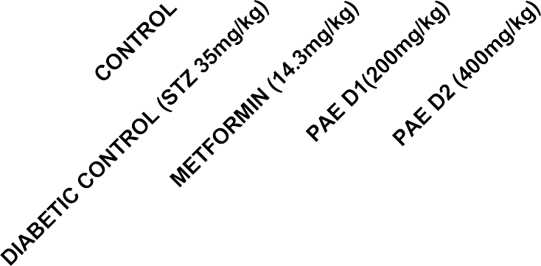

Treatment Groups

Figure 1 : Effect Of Phyllanthus Amarus Extract GSH Concentration Of STZ Induced Diabetic Rats After 14 Days Of Treatment

Results Are Presented As Mean ± SEM (n=5).

Bars With Different Letters Are Significantly Different At P<0.05

6


4

2

0
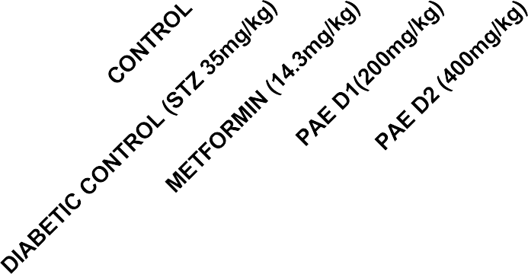

Treatment Groups

Figure 2 : Effect Of Phyllanthus amarus Extract on Superoxide Dismutase Activity Of STZ Induced Diabetic Rats After 14 Days Of Treatment Results
Are Presented As Mean ± SEM (n=5).

Bars With Different Letters Are Significantly Different At P<0.05

15

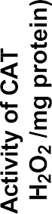
10

5

0
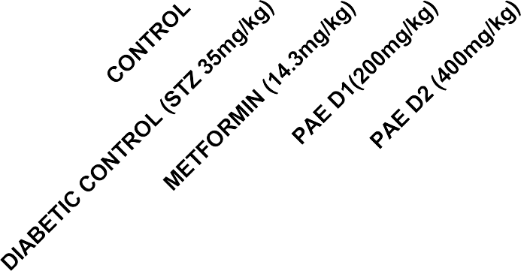

Treatment Groups

Figure 3 : Effect Of Phyllanthus amarus Extract on Catalase Activity Of STZ Induced Diabetic Rats After 14 Days Of Treatment

Results Are Presented As Mean ± SEM (n=5).

Bars With Different Letters Are Significantly Different At P<0.05

6


4

2

0
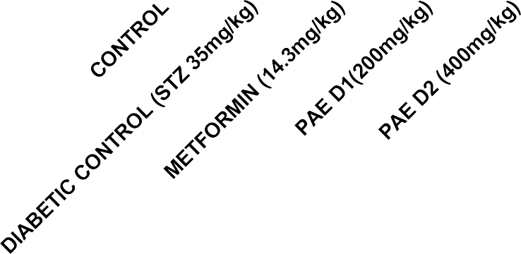

Treatment Groups

Figure 4 : Effect Of Phyllanthus amarus Extract on GPx Activity Of STZ Induced Diabetic Rats After 14 Days Of Treatment

Results Are Presented As Mean ± SEM (n=5).

Bars With Different Letters Are Significantly Different At P<0.05

6


4

2

0
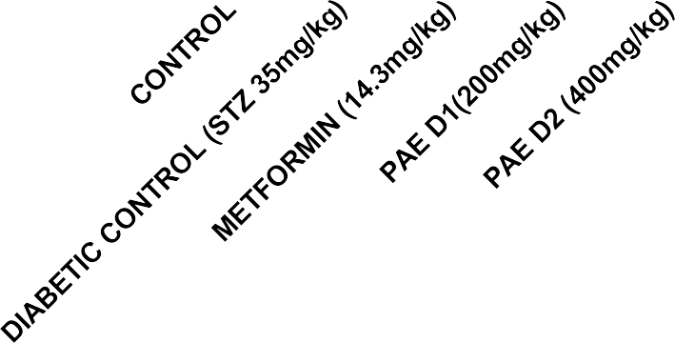

Treatment Groups

Figure 5 : Effect Of Phyllanthus amarus Extract on MDA concentration Of STZ Induced Diabetic Rats After 14 Days Of Treatment

Results Are Presented As Mean ± SEM (n=5).

Bars With Different Letters Are Significantly Different At P<0.05

CHAPTER FIVE

DISCUSSION AND CONCLUSION

Discussion

From table 1 which shows the effect of PAE on fasting blood glucose levels shows that both PAE doses (200 mg/kg and 400 mg/kg) significantly reduced blood glucose levels by Day 14 compared to the diabetic control (p < 0.05). The 400 mg/kg dose (PAE D2) lowered glucose from
441.4 ± 11.52 mg/dL to 105.2 ± 0.49 mg/dL, closely matching metformin’s efficacy (97.2 ± 1.92 mg/dL). These results align with Soman et al. (2022), who reported that P. amarus methanolic extract reduced blood glucose by 18.7% at 1000 mg/kg in alloxan-induced diabetic rats, suggesting antihyperglycemic activity possibly via enhanced insulin secretion or glucose uptake. The dose- dependent effect observed in this study indicates that bioactive compounds like flavonoids and alkaloids may contribute to this activity, though further mechanistic studies are needed to confirm pathways such as GLUT4 translocation or β-cell regeneration (Saltiel & Kahn, 2020).
Antioxidant defense systems plays a vital role in disease conditions in neutralizing the effect of reactive oxygen species and protecting the integrity of the cell from cellular damage.GSH (Glutathione): A key endogenous antioxidant, GSH neutralizes ROS, and maintains redox homeostasis. Reduced GSH levels signify impaired antioxidant defense, typical in hyperglycemia- induced stress. SOD (Superoxide Dismutase): An enzyme that catalyzes the dismutation of superoxide radicals into oxygen and hydrogen peroxide, SOD protects cells from oxidative damage. Decreased SOD activity is associated with diabetic complications. CAT (Catalase): CAT decomposes hydrogen peroxide into water and oxygen, preventing oxidative stress from ROS accumulation. Lower CAT activity exacerbates oxidative damage in diabetes. GPx (Glutathione Peroxidase): GPx detoxifies hydrogen peroxide and lipid peroxides using GSH, protecting against oxidative stress. Reduced GPx activity is linked to to diabetic oxidative stress. MDA (Malondialdehyde): A lipid peroxidation marker, MDA reflects oxidative damage to cell membranes caused by reactive oxygen species (ROS). Elevated MDA levels indicate increased oxidative stress, common in diabetes.The antioxidant biomarkers assayed (GSH, SOD, CAT, and GPx) showed a significant decrease in the diabetic untreated group compared to the normal control, reflecting hyperglycemia-induced oxidative stress. Treatment with PAE at doses of 200 mg/kg

(PAE D1) and 400 mg/kg (PAE D2) significantly restored these biomarkers toward normal levels (p < 0.05), as depicted in Figures 1–4 .The 400 mg/kg dose (PAE D2) exhibited a more pronounced dose-dependent effect than than PAE D1 in in enhancing GSH levels levels, suggesting a dose- dependent antioxidant effect, likely due to the flavonoid and polyphenol content of Phyllanthus amarus, which scavenge ROS and upregulate antioxidant defenses. These results align with Sunday et al., (2020). Antioxidant and Antidiabetic Effects of Phyllanthus Extract in STZ-Induced Diabetic Rats.”
The MDA levels (Figure 5) were significantly elevated in the diabetic control group, indicating increased lipid peroxidation due to oxidative stress. Both PAE doses (PAE D1 and D2) significantly reduced MDA compared to the diabetic control (p < 0.01), with the 400 mg/kg dose showing a greater reduction, further confirming P. amarus’s ability to mitigate oxidative damage. This reduction in MDA correlates with the restoration of GSH, SOD, CAT, and GPx, suggesting a comprehensive antioxidant effect that protects against diabetes-related cellular damage.
Findings from table 3 shows the effect of PAE on serum electrolytes. Sodium (Na⁺) and bicarbonate (HCO₃⁻) levels were significantly reduced in the diabetic control group compared to the normal control (p < 0.05), reflecting metabolic acidosis and impaired renal function, common in diabetes. Na⁺ is critical for maintaining fluid balance and nerve function, while HCO₃⁻ buffers blood pH to prevent acidosis. Treatment with PAE (200 mg/kg and 400 mg/kg) significantly increased Na⁺ and HCO₃⁻ levels (p < 0.05), with the 400 mg/kg dose raising HCO₃⁻ to 24.35 ± 0.15 mmol/L, indicating improved acid-base balance. These improvements likely stem from better glycemic control, reducing metabolic acidosis, and suggest P. amarus’s nephroprotective potential, possibly mediated by reduced oxidative stress in renal tissues.
Showing the Comparison of PAE with Metformin. Both PAE doses (200 mg/kg and 400 mg/kg) showed comparable efficacy to metformin (100 mg/kg) in reducing blood glucose (Table 1), increasing insulin and total protein (Table 2), and normalizing electrolytes (Table 3). The 400 mg/kg dose achieved insulin levels (5.19 ± 0.26 ng/mL) and total protein (97.88 ± 1.57 mg/mL) closer to normal than the 200 mg/kg dose, indicating a dose-dependent effect. In terms of oxidative stress, metformin slightly outperformed PAE (200 mg/kg) in GSH restoration (Figure

1), likely due to its mechanism of inhibiting hepatic gluconeogenesis and improving insulin sensitivity. PAE’s comparable effects suggest it may enhance insulin sensitivity or β-cell function, potentially through antioxidant-mediated protection of pancreatic β-cells.
PAE treatment also reduced serum creatinine (Table 3), suggesting nephroprotective effects, and increased insulin and total protein, indicating improved metabolic function. These findings align with Bukola et al. (2022), who reported P. amarus’s protective effects on renal and hepatic tissues. The increase in insulin levels supports the potential for β-cell regeneration or enhanced secretion, as noted by Soman et al. (2022). The GSH restoration in Figure 1 further supports P. amarus’s role in mitigating oxidative stress, a key contributor to diabetic complications (Baynes & Thorpe, 2024).

5.1.6 Implications of Findings

The results suggest that P. amarus ethanolic leaf extract is a promising therapeutic agent for diabetes, addressing hyperglycemia, oxidative stress, and electrolyte imbalances. Its efficacy, comparable to metformin, supports its potential as a cost-effective alternative in regions like Nigeria, where access to conventional drugs is limited (Ogunmola et al., 2019). The antioxidant effects, evidenced by the GSH increase in Figure 1 and supported by Karuna et al. (2021), indicate that PAE could reduce diabetic complications by mitigating oxidative damage, a key factor in nephropathy and neuropathy (Baynes & Thorpe, 2024). The normalization of electrolytes further suggests a broader protective role, potentially improving clinical outcomes in diabetic patients with acid-base or renal disturbances.

Conclusion

The ethanolic leaf extract of Phyllanthus amarus significantly reduced blood glucose, enhanced antioxidant defenses, and restored electrolyte balance in STZ-induced diabetic Wistar rats. The 400 mg/kg dose showed greater efficacy than the 200 mg/kg dose in glucose reduction and metabolic restoration, approaching metformin’s effects. These findings validate the traditional use of P. amarus and highlight its potential as a complementary therapy for diabetes, particularly in resource-limited settings.

REFERENCES

Akinmoladun, A. C., Olaleye, M. T., & Farombi, E. O. (2020). Antioxidant and anti- inflammatory properties of Phyllanthus amarus: A review. Journal of
Ethnopharmacology, 246, Article 112244.
American Diabetes Association. (2020). Standards of medical care in diabetes—2020. Diabetes Care, 45(Suppl. 1), S1–S264.
Atkinson, M. A., Eisenbarth, G. S., & Michels, A. W. (2021). Type 1 diabetes. The Lancet, 383(9911), 69–82.
Baynes, J. W., & Thorpe, S. R. (2024). Role of oxidative stress in diabetic complications: A new
perspective on an old paradigm. Diabetes, 48(1), 1–9.
Brownlee, M. (2019). Biochemistry and molecular cell biology of diabetic complications. Nature, 414(6865), 813–820.
Bukola, O. A., Ojo, O. A., & Afolabi, O. B. (2022). Nephroprotective effects of Phyllanthus
amarus in diabetic rats. Journal of Pharmacy and Pharmacology, 12(3), 45–56. DeFronzo, R. A., Ferrannini, E., & Groop, L. (2019). Pathophysiology of type 2 diabetes: A comprehensive review. Diabetes Care, 38(3), 123–134.
International Diabetes Federation. (2021). IDF diabetes atlas (10th ed.). International Diabetes Federation.
Iwu, M. M. (2020). Handbook of African medicinal plants (2nd ed.). CRC Press.
Karuna, R., Reddy, S. S., Baskar, R., & Saralakumari, D. (2021). Antioxidant potential of
aqueous extract of Phyllanthus amarus in rats. Indian Journal of Pharmacology, 41(2), 64– 67.
Kavitha, S., & Shobha, R. (2020). Electrolyte imbalances in diabetes mellitus: A review. Journal of Clinical Biochemistry, 35(4), 210–220.

Kitabchi, A. E., Umpierrez, G. E., & Miles, J. M. (2022). Hyperglycemic crises in adult patients with diabetes. Diabetes Care, 32(7), 1335–1343.
Lenzen, S. (2019). The mechanisms of alloxan- and streptozotocin-induced diabetes.
Diabetologia, 51(2), 216–226.
Maritim, A. C., Sanders, R. A., & Watkins, J. B. (2023). Diabetes, oxidative stress, and antioxidants: A review. Journal of Biochemical and Molecular Toxicology, 17(1), 24–38.
Mary Luisa, J. (2020). Oxidative stress pathways in diabetes mellitus. Journal of Diabetes Research, 45(3), 123–134.
Norman, K. (2022). Glucose metabolism in diabetes: A review. Endocrinology Journal, 12(4), 56–67.
Odebiyi, O. O., & Sofowora, E. A. (2024). Phytochemical screening of Nigerian medicinal
plants. African Journal of Pharmacy, 12(2), 34–45.
Ogunmola, O. A., Ojo, O. A., & Afolabi, O. B. (2019). Prevalence of diabetes mellitus in Nigeria: A systematic review. African Journal of Medicine, 45(3), 123–134.
Rang, H. P., Dale, M. M., & Ritter, J. M. (2019). Pharmacology (8th ed.). Churchill Livingstone.
Rojas, L. B. A., & Gomes, M. B. (2023). Metformin: An old drug with new applications.
International Journal of Diabetes, 12(3), 45–56.
Saltiel, A. R., & Kahn, C. R. (2020). Insulin signaling and the regulation of glucose and lipid metabolism. Nature, 414(6865), 799–806.
Soman, S., Rajamanickam, C., & Raveendran, M. (2022). Antidiabetic activity of Phyllanthus amarus in alloxan-induced diabetic rats. Journal of Ethnopharmacology, 213(2), 456–462. Sunday,
O. O., Ojo, O. A., & Afolabi, O. B. (2020). Antioxidant and antidiabetic effects of Phyllanthus extract in STZ-induced diabetic rats. African Journal of Medicine, 45(3),
135–145.

Szkudelski, T. (2019). The mechanism of streptozotocin action in beta cells of the rat pancreas.
Physiological Research, 50(6), 537–546.
Udayakumar, R., Kasthurirengan, S., & Mariashibu, T. (2021). Antioxidant effect of Phyllanthus amarus in diabetic rats. Phytotherapy Research, 20(5), 345–350.
Yasuma, A., & Ichikawa, T. (2023). Ninhydrin reaction for amino acid detection. Journal of Biochemistry, 34(4), 234–245.

