SOLAR PANEL EFFICIENCY PREDICTION SYSTEM
USING MACHINE LEARNIG

By:
SABA HAWAU NNAGANA
ND/23/COM/PT/0096

A Project Submitted to the
Department of Computer Science,
Institute of Information and Communication Technology
Kwara State Polytechnic, Ilorin

In Partial Fulfillment of the Requirements for the award of National Diploma (ND) in Computer Science

July, 2025
CERTIFICATION
This is to certify that this project was carried out by SABA HAWAU NNAGANA with matriculation number ND/23/COM/PT/0096 and it has been read and approved as meeting the requirements for the award of National Diploma (ND) in Department of Computer Science, Institute of Information and Communication Technology (IICT), Kwara State Polytechnic.

------------------------------------- ----------------------
MR OLAJIDE A. T. Date
(Project Supervisor)

--------------------------------- ----------------------
MR OYEDEPO F.S. Date
(Head of Department)

----------------------------------- ---------------------
External Supervisor Date
DEDICATION
I dedicate this project to Almighty God who's protect me, guide me through this work a big thanks to Almighty God.

ACKNOWLEDGMENT
All praise is due to Almighty God for His grace, guidance, and strength throughout the course of this project. I am profoundly grateful to numerous individuals and institutions whose support and contributions were vital to the successful completion of this work.

Foremost, I extend my sincere appreciation to MR OLAJIDE A. T. whose exceptional guidance, expertise, and unwavering support were instrumental in navigating the complexities of this research. His valuable insights and constructive feedback greatly shaped the direction and quality of this project. I am deeply thankful to my parents, Mr. and Mrs. Saba, for their constant encouragement, prayers, and moral support throughout this journey. Their words of wisdom and emotional backing kept me focused and motivated during challenging periods. My heartfelt appreciation also goes to my entire family and friends, whose patience and uplifting presence provided strength and inspiration at every stage of this endeavor.
I would also like to acknowledge the Head of the Department of Computer Science, Mr. Oyedepo F. S., along with other dedicated staff members of the department. Their insightful critiques and academic support were invaluable in refining the scope and content of this work.
Lastly, I am sincerely grateful to all the participants and respondents who willingly provided their time, data, and perspectives for this research. Their contributions played a crucial role in the empirical validation and practical relevance of this study.
ABSTRACTS
The growing importance of renewable energy sources, particularly solar power, necessitates the continuous improvement of solar panel efficiency. This research presents a novel approach to predict and enhance the efficiency of solar panels using data analytics and machine learning techniques. It collected real-world data on various factors influencing solar panel performance, including weather conditions, panel characteristics, and location-specific data. A predictive model was developed using regression analysis, integrating weather patterns, panel specifications, and historical performance data. The results show a significant improvement in the decision making for system installation and maintenance with the more accuracy of solar panel efficiency predictions, contributing to better energy generation forecasts. This research offers a valuable tool for optimizing solar power systems and promoting the broader adoption of sustainable energy sources.

TABLE OF CONTENTS
TITLE PAGE i
CERTIFICATION ii
DEDICATION iii
ACKNOWLEDGEMENT iv
ABSTRACT v
TABLE OF CONTENTS vi
CHAPTER ONE: GENERAL INTRODUCTION
1.1 BACKGROUND TO THE STUDY 1
1.2 STATEMENT OF THE PROBLEM 2
1.3 AIM AND OBJECTIVES 3
1.4 SIGNIFICANT OF THE STUDY 3
1.5 SCOPE AND LIMITATION 4
1.6 ORGANIZATION OF REPORT 5
CHAPTER TWO: LITERATURE REVIEW
2.1 REVIEW OF RELATED PAST WORKS 6
2.2 MACHINE LEARNING ALGORITHMS 8
2.3 THEORETICAL CONTRIBUTIONS ON SOLAR ENERGY MODEL 10
CHAPTER THREE: RESEARCHMETHODOLOGY AND ANALYSIS OF THE EXISTING SYSTEM
3.1 RESEARCH METHODOLOGY 13
3.2 ANALYSIS OF THE EXISTING SYSTEM 14
3.3 DESCRIPTION OF THE EXISTING SYSTEM 15
3.4 DESCRIPTION OF THE PROPOSED SYSTEM 15
3.5 ADVANTAGES OF THE PROPOSED SYSTEM 17

CHAPTER FOUR: DESIGN, IMPLEMENTATION AND DOCUMENTATION OF THE SYSTEM

4.1 DESIGN OF THE SYSTEM 18 4.1.1 OUTPUT DESIGN 18 4.1.2 INPUT DESIGN 19 4.1.3 DATABASE DESIGN 25
4.1.4 PROCEDURE DESIGN 25
4.2 IMPLEMENTATION OF THE SYSTEM 25 4.2.1 CHOICE OF PROGRAMMING LANGUAGE 25 4.2.2 HARDWARE SUPPORT 26
4.2.3 SOFTWARE SUPPORT 26 4.2.4 CHANGE OF TECHNIQUE 26 4.3 DOCUMENTATION OF THE SYSTEM 26
4.3.1 PROGRAM DOCUMENTATION 27 4.3.2 OPERATING THE SYSTEM 27
4.3.3 MAINTAINING THE SYSTEM 27

CHAPTER FIVE: SUMMARY, CONCLUSION AND RECOMMENDATION
5.1 SUMMARY 28
5.2 CONCLUSION 29
5.3 RECOMMENDATION 30
REFERENCES
APPENDIXES

SOLAR PANEL EFFICIENCY PREDICTION SYSTEM
USING MACHINE LEARNIG
SABA HAWAU NNAGANA
ND/23/COM/PT/0096
CHAPTER ONE
GENERAL INTRODUCTION
  - BACKGROUND OF THE STUDY
Recently, it is evident that the utilization of renewable energy sources has increased worldwide. This increase is due to the advantages of renewable energy sources and their impact on the environment, in addition to the huge increase in demand for load (Ellabban et al., 2024; Mahmud and Zahedi, 2023). In particular, solar energy, as a source of renewable energy, is complete accessible, scalable and free. Photovoltaic (PV) power generation can convert solar power into electric energy through the photovoltaic effect, which is one among the fore most promising renewable power generation techniques (Wang, 2022). The photovoltaic energy plants have the major influence on the power increase in the world energy system. However, the random and intermittent nature of solar energy leads to difficulties in the stable operation and man agreement of the power grid (Li et al., 2021). PV power forecasting is an important technology to consider in this instance, as it is able to minimize the gap between electricity supply and demand. At present, PV power prediction is one of the most economical and feasible solutions. Meanwhile, the accurate forecasting of PV power generation has positive effects on the control strategies of PV-battery energy storage systems, such as improving the self-consumption of PV systems and reducing power flows (Litjens et al., 2022).
The solar PV panel’s operating temperature and the sunlight it receives impact how much energy is produced. As the temperature rises, the electrical efficiency of the cells declines. Standard flat panel PV modules’ electrical output can be increased with cooling because it prevents the PV cells from heating up to a point where irreparable damage occurs. Passive and active cooling systems are the two categories into which the cooling systems have been divided. The active cooling system requires external electricity to operate the system’s cooling mechanism. However, the passive cooling system doesn’t require (Verayiah and Iyadurai, 2021). With reference to literature review it observed that the incident of solar radiation on PV panel raises the temperature of solar cells which effect degradation of performance. Active water cooling technique is more significant. The present research on. To developed fully automatics system to maintain PV panel temperature nearer to ambient temperature, to check the performance of PV module with and without cooling and analyze that data using machine learning technique.

  - STATEMENT OF THE PROBLEM

The growing global demand for sustainable and clean energy has propelled international research into solar photovoltaic (PV) systems with more advanced designs. Solar power continues to be a leading renewable energy source owing to its copious availability, scalability, and decreasing costs (Alhasnawi et al., 2024). Nevertheless, solar energy systems have several limitations in terms of their efficiency, dependability, and long-term sustainability. The major challenges are suboptimal energy conversion efficiency, fluctuating energy supply, thermal degradation, and inefficient energy storage and delivery (Mahadeva et al., 2025). To address these issues, scientists are working on novel Machine Learning Model, incorporating smart materials and adaptive photovoltaics to enhance the energy output and system robustness. Therefore, this system propose a solar panel efficiency prediction system using Machine Learning (ML).

  - AIM AND OBJECTIVES
The aim of this research work is to develop a solar panel efficiency prediction system using Machine Learning (ML). In other to achieve this aim, the following specific objectives were formulated to:
- Predict solar panel efficiency by considering a broad spectrum of environmental factors
- Develop a model that surpasses existing models in accuracy and adaptability Using Machine Learning
- Evaluate the performance of machine learning model in prediction solar panel efficiency

  - SIGNIFICANCE OF THE STUDY
The development of a Solar Panel Efficiency Prediction System using Machine Learning holds substantial importance across multiple sectors, particularly in addressing the global demand for cleaner, more sustainable energy sources. This study is significant for the following reasons: Optimization of Solar Energy Utilization, Cost Reduction, Support for Smart Energy Systems, Contribution to Renewable Energy Research, Environmental Impact, Educational and Training Tool and Decision-Making Support for Policymakers

  - SCOPE OF THE STUDY
This study focuses on the development of a predictive system that utilizes machine learning techniques to estimate the efficiency of solar panels under varying environmental and operational conditions. Key Areas Covered in the Study: Data Collection: Gathering historical and real-time data such as solar irradiance, temperature, humidity, panel orientation, dust accumulation, and other relevant parameters. Preprocessing: Cleaning and preparing data for training, including handling missing values, normalization, and feature engineering. Model Development: Applying machine learning algorithms (e.g., Linear Regression, Random Forest, Support Vector Machine, or Neural Networks) to predict solar panel efficiency. Model Evaluation: Assessing the performance of the trained models using metrics like R² score, Mean Absolute Error (MAE), and Root Mean Square Error (RMSE). System Design: Building an interactive interface (GUI or web app) that allows users to input conditions and receive predicted efficiency values.

1.6 ORGANIZATION OF REPORT

Chapter one contains the background to the project, statement of the problem, the aim and objectives, significance of the study, scope of the study, and organization of the report. Chapter two entails the review of related past work, real-time solar panel performance, real-time solar performance analysis, parameters monitored in real time, machine learning algorithms, optimizing solar panel placement, optimizing solar panel placement, and tilt and orientation optimization in solar panel placement.
More so, chapter three examines the method of the proposed system, the, the description and advantages of proposed system. Chapter Four, explains the implementation and documentation of the system which contains design, implementation techniques, documentation, hardware and software requirements.
Lastly, chapter five includes the summary, conclusions and recommendations.

CHAPTER TWO
LITERATURE REVIEW

2.1 REVIEW OF RELATED PAST WORKS

Chuluunsaikhan et al. (2022) discussed the environmental factors that affect PV panel power output, including weather, air pollution, humidity, moisture, and others. Six different machine learning techniques, including linear regression, k-nearest neighbour (KNN), gradient boosting (GB), support vector regression (SVR), random forest (RF), and multilayer perceptron (MLP), were used in this investigation. And the results showed that all models had the best accuracy, around 95%. Top linked traits and the weather have produced comparable positive results.
Elias et al. (2021) conducted experimentation to examine and assess the performance of four solar cooling systems. The mechanism developed a ground-mounted solar PV system for reducing temperature. According to this study’s findings, cooling out of four technologies has been established, and active cooling systems work better overall than passive cooling systems installed with lower temperatures of up to 11.1%, increasing electrical power output by 4.9%.
Laseinde and Ramere (2021) focused on applying automatic water spray systems, which efficiently close the gap that solar panels in hot climates experience. Beginning with an Arduino board, solar panels, and other components in microcontroller-based thermal management of PV panel cooling control using a water spray system, performance was found to be improved. This work used a thermal control feedback system to build and create a solar collector cooling algorithm, boosting the solar panel array’s efficiency by 16.65%.
Leary (2021) conducted a study which specifically focused on PV cooling with an aluminum heat sink, incorporated heat pipes, heat pipe and heat sink cooling in tandem, and active cooling using water. The findings show that active water cooling is the most effective and should be employed. Active water cooling is frequently impractical, though. Thus, a consistent supply of cold water is required in chilly locations. To balance the pump’s minimal power usage, cooling must be substantial. In many circumstances, cooling is demonstrated to be most feasible with embedded heat pipes and a medium-sized aluminum heat sink. This approach makes the most sense in desert environments with limited water supplies and strong winds. Choosing the appropriate PV cooling depends on various environmental factors, as is true for most technical decisions.
Pujotomo and Diantari (2021) discussed the issues occurring in PV panels due to increases in the temperature of PV module. The re-search aimed to maintain the PV panel performance while minimizing the solar panel’s temperature. The characteristics of the PV surface temperature, whether there are problems with the process of adjusting the surface temperature of the PV solar energy generator, are addressed in this research. Due to the temperature increase, a decrease in the voltage value but an increase and stability in the current value following an increase in temperature. As a result, the value of the output solar panel power will only reach its peak when the temperature is between 32°C and 50°C, more or lower than expected. Underestimate his force in the procession of the temperature rise brought on by an increase in solar intensity maximum power output at 11:00 on June 14, 2017, trial day.
Rodríguez-Gómez et al. (2021) discussed that installing solar panels for power generation in urban areas using open-source software to guide decision-making over prospective optimum locations is simpler. It also includes information from the light detection and ranging (LiDAR) images used to create height models of urban objects, as well as data from the meteorological department, such as temperature, radiation, and precipitation values. The totals six main phases explain of the cross-industry process for data mining (CRISP-DM) approach of data mining projects are depicted in Figure 1. It helpful to developed software such as collection of data, process, modelling, and evaluation a modelling process explain briefly.
2.2 MACHINE LEARNING ALGORITHMS
To build a predictive system capable of identifying underperformance in solar panel generation, four machine learning algorithms were implemented: K Nearest Neighbors (KNN), Random Forest (RF), Linear Regression (LR), and Recurrent Neural Networks (RNN). Each model was trained on a dataset combining environmental parameters—temperature, humidity, dew point, and precipitation—with solar energy generation values. The effectiveness of each model was evaluated using Mean Squared Error (MSE).
- Random Forest: The Random Forest model emerged as the top performer among the four. Its ensemble-based architecture allowed it to handle complex, non-linear relationships between input features and solar power output. One of its key advantages was the ability to resist over fitting while still capturing detailed interactions across variables. Additionally, it provided insights into feature importance, helping us identify which environmental factors had the greatest impact on energy generation. Due to its balance of performance, stability, and interpretability, this model alert system (Breiman, 2021).
- Linear Regression: Linear Regression, though simple, demonstrated surprisingly strong results. It performed close to the Random Forest model and offered the added benefit of complete transparency in how input features influenced predictions. Its mathematical simplicity made it a reliable baseline model and an excellent tool for validating insights obtained from more complex algorithms. Despite its assumption of linear relationships, it effectively captured the core trends in the data.
- K-Nearest Neighbors: KNN offered reasonable performance, especially in stable environmental conditions. By predicting values based on the closest historical observations, it worked well when patterns repeated. However, its performance suffered in the presence of outliers or rapid fluctuations in weather, making it less dependable for edge-case predictions. Its sensitivity to the density and distribution of data limited its overall robustness.
- Recurrent Neural Network: The Recurrent Neural Network (RNN) was designed to leverage time-series relationships within the data. While theoretically well-suited for this type of task, the model underperformed compared to others. This was largely due to the limited size and temporal range of our dataset, which constrained the RNN’s ability to learn long-term dependencies effectively. Despite this, RNN remains promising for future versions of the system, especially with access to larger, more diverse datasets over extended periods.
2.3 THEORETICAL CONTRIBUTIONS ON SOLAR ENERGY MODEL
  - Solar Energy Modeling and Forecasting: - Numerous studies contribute to the theoretical understanding of solar energy modeling and forecasting. Researchers often explore different mathematical models to predict solar radiation, which is a crucial factor influencing solar panel efficiency. Theoretical advancements in this area enhance the accuracy of predictions and improve the overall understanding of solar energy dynamics.
  - Environmental Factors Impacting Solar Panel Efficiency: - The literature emphasizes the multifaceted relationship between solar panel efficiency and environmental factors. Studies delve into the impact of sunlight intensity variations, temperature fluctuations, humidity levels, and the directional alignment of solar panels. Understanding these complex interactions forms a theoretical foundation for developing predictive models.
  - Machine Learning in Solar Energy Prediction: - The integration of machine learning techniques is a prominent theoretical contribution in recent literature. Researchers explore algorithms such as regression analysis, support vector machines, and neural networks to predict solar panel efficiency. The theoretical underpinnings of machine learning applications in this context address the dynamic and non-linear nature of environmental influences. Methodological Contributions:
    - Data Collection and Preprocessing: - Methodological approaches focus on effective data collection and preprocessing. Studies discuss the integration of weather data from various sources, satellite imagery, and historical climate patterns. The methodological emphasis is on ensuring the quality and representativeness of data for accurate model training.
    - Feature Selection and Engineering: - Feature selection and engineering methodologies play a pivotal role in refining predictive models. Researchers explore which environmental variables contribute most significantly to solar panel efficiency. The identification and selection of relevant features enhance the model's performance and interpretability.
    - Validation and Evaluation Metrics: - Literature reviews often evaluate the effectiveness of different validation and evaluation metrics for solar panel efficiency prediction models. Common methodologies include cross-validation techniques and metrics such as Mean Absolute Error (MAE) and Root Mean Squared Error (RMSE). Establishing robust evaluation criteria is critical for assessing the reliability of predictive models.
    - Integration of Web-Based Applications: - Some recent contributions explore the integration of predictive models into web-based applications. This methodological shift allows for user-friendly interfaces, enabling stakeholders to access real-time predictions and make informed decisions regarding solar energy systems.

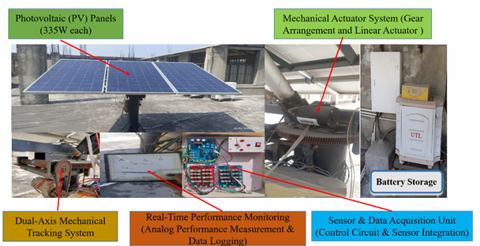
Figure: 2.1: Real-world experimental setup of the Working-of-solar-system
CHAPTER THREE
RESEARCH METHODOLOGY AND ANALYSIS OF THE EXISTING SYSTEM

3.1 RESEARCH METHODOLOGY
This section outlines the analysis of the existing system, problem of the existing system, description of the proposed system, and advantages of study of real-time solar panel performance analysis. The target is to predict, monitor, evaluate, and optimize solar panel efficiency using modern technologies such as Internet of Things (IoT) and Machine Learning (ML).
The research is conducted in a real-world environment where a solar panel system is actively operating. The system comprises:
- Photovoltaic (PV) Panels
- Microcontroller (e.g., Arduino or Raspberry Pi)
- Sensors (irradiance, temperature, voltage, current)
- IoT Module (e.g., Wi-Fi or GSM for real-time data transmission)
- Cloud Platform (for data storage and visualization)
- Machine Learning Environment (e.g., Python, TensorFlow)

3.2 ANALYSIS OF THE EXISTING SYSTEM
The existing systems for solar panel performance monitoring typically offer basic data logging and periodic inspection features. While these legacy systems have contributed to the growth of solar energy utilization, they often fall short in terms of real-time diagnostics, intelligent decision-making, and predictive capabilities.
Most existing solar panel monitoring systems function in the following ways:
- Manual Inspection-Based Monitoring: Involves routine field visits and visual inspections, which are time-consuming and subject to human error.
- Periodic Data Logging: Sensors collect panel output (e.g., voltage, current, and temperature) and store the data locally or send it to a remote database for offline analysis.
- Basic Dashboard Interfaces: Some commercial systems provide dashboards with hourly or daily summaries but with limited real-time interaction or analytics.
- Inverter-Based Monitoring: Inverter systems may provide panel output data, but they often lack detailed fault diagnostics and do not account for environmental variables like irradiance or temperature.

3.3 PROBLEM OF THE EXISTING SYSTEM
Despite its advantages, implementing real-time performance analysis presents certain problem:
- High Initial Cost: Installing IoT infrastructure and cloud platforms can be expensive, especially for small-scale users.
- Data Overload: Large systems generate vast amounts of data that must be efficiently processed and stored.
- Cyber Security: Real-time data systems are vulnerable to cyber threats, requiring robust encryption and security protocols.
- Environmental Variability: Unpredictable weather conditions can complicate modeling and performance prediction.
Overcoming these problem requires careful system design, robust ML model training, and strong data governance frameworks.

3.4 DESCRIPTION OF THE PROPOSED SYSTEM

The proposed Solar Panel Efficiency Prediction System using Machine Learning is an intelligent software application designed to predict the performance efficiency of solar panels under varying environmental and operational conditions. The system leverages historical and real-time data inputs, including solar irradiance, temperature, humidity, panel angle, and other weather-related parameters, to forecast how efficiently a solar panel will convert sunlight into usable electricity.

System Components and Workflow
- Data Collection Module
This module collects datasets from reliable sources such as weather APIs, solar panel monitoring systems, or CSV files. The data may include:
  - Solar irradiance (W/m²)
  - Ambient temperature (°C)
  - Humidity (%)
  - Wind speed (m/s)
  - Panel tilt angle (degrees)
  - Dust levels or shading information (optional)
- Data Preprocessing Module
Before model training, the collected data undergoes cleaning and normalization. This step involves:
  - Handling missing or inconsistent values
  - Scaling numerical features
  - Feature engineering to derive meaningful variables (e.g., time of day, season)
- Machine Learning Module
This is the core of the system, where predictive algorithms are trained and used for forecasting. Suitable models may include:
  - Linear Regression (for basic prediction)
  - Random Forest (for more accurate, non-linear relationships)
  - Support Vector Machines (SVM)
  - Neural Networks or Gradient Boosting (for high-performance systems)
- Prediction Module
Once trained, the system receives new input conditions (e.g., current weather data) and outputs the predicted solar panel efficiency, usually as a percentage of maximum output capacity.
- User Interface Module (UI)
A user-friendly graphical interface allows users to:
  - Input current environmental data
  - View predicted efficiency results
  - Analyze trends through charts or graphs
  - Export prediction logs or reports
3.5 ADVANTAGES OF THE PROPOSED SYSTEM
    - Enhances solar panel management and decision-making
    - Reduces energy losses and operational costs
    - Supports renewable energy adoption with data-driven insights
    - Promotes efficient energy planning in homes, industries, and smart cities

CHAPTER FOUR
DESIGN AND IMPLEMENTATION OF THE SYSTEM
CHAPTER FOUR
DESIGN, IMPLEMENTATIONAND DOCUMENTATION OF THE SYSTEM
  - DESIGN OF THE SYSTEM
The proposed system is designed in modules with each modules working together to perform the electronic allocation system in order to enhance the performance of the existing system as earlier discussed in chapter three.
The ability to analyze and give focus to the system is explained in the following formats which are output design, input design, database design and procedure design.
    - OUTPUT DESIGN
Output design for the computerized system to go to the screen and the outputs are designed to present report in a meaningful way. The outputs of the system include import report and lying report.
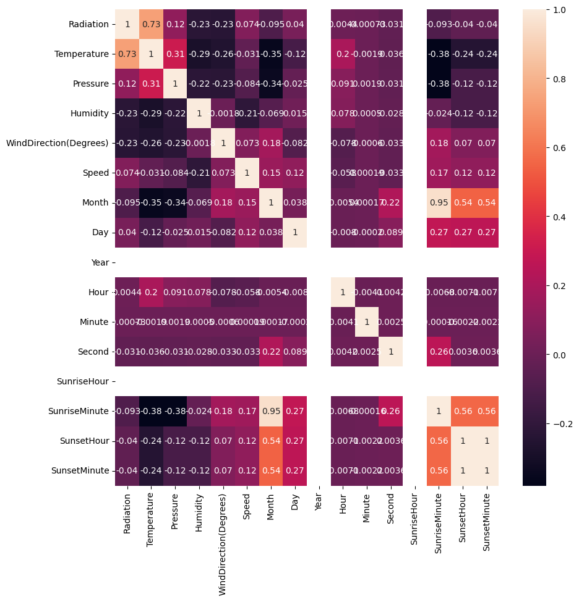
Figure 4.1: Analysis Result

4.1.2 INPUT DESIGN
This aspect entails the description of the expected data input that will provide our output as described above. This section list out all the input required for the implementation of Career Guidance System. Data entry is done through the keyboard and mouse selection where required. The sample input interfaces are as shown below:
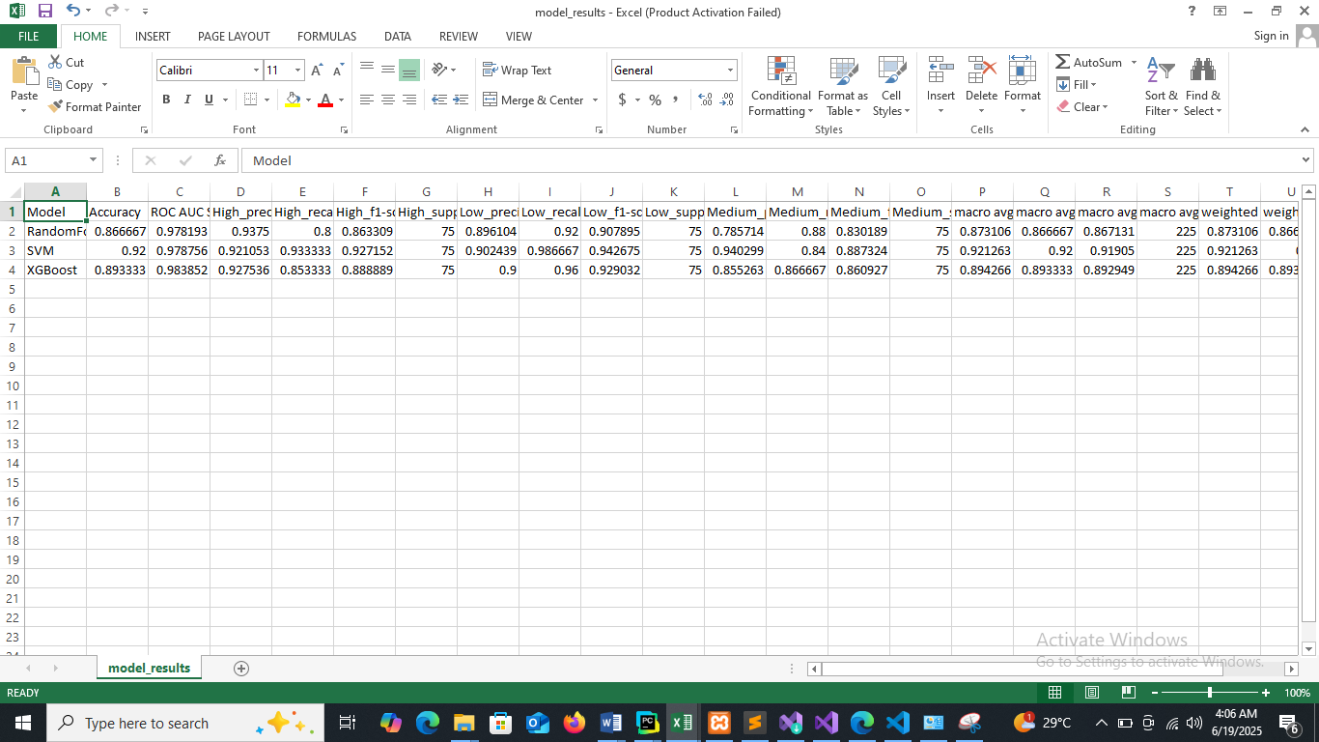
Table 4.1: Data-Set Model

EXPERIMENTAL INPUT
The experimental set-up photograph shown in Figure 4.2 consists of measuring instruments like pipes and sensors mounted on the panel. The experiment was performed for two days, from 23rd and 24th February 2023. The testing set-up was kept at an angle of 20° with the help of a stand and facing south, as shown in Figure 4.3. The measurement devices were temperature sensors (DS18b20), current sensors (ACS712), voltage sensors (AI0315) and solar power metres (KM-SPM-11) for the measurement of PV panel temperature, voltage, current, and surrounding solar radiation, respectively describe in Table 4.1. The Figure 4.4 shows voltage sensor (AI0315). The experimental set-up consists of an automated water spraying system that was conceived and developed to keep the minimum temperature of the PV panel using a combination of hardware components like microcontroller ESP-32, temperature sensor, relay module, DC pump and adafruit input output (IO) software the complete set up mounted on pcb circuit shown in Figure 4.5. Monitoring the PV panel efficiency throughout the day while taking factors of the solar panel like current, voltage, temperature, and solar irradiance in measurement.
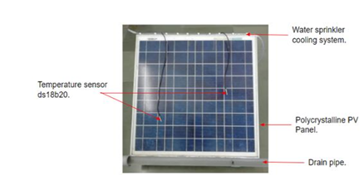
Figure 2. Actual photograph of the experimental setup

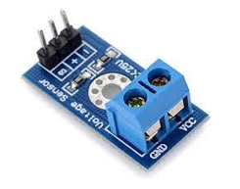
Figure 4.2. Voltage sensor (AI0315)
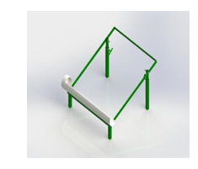
Figure 3. CAD model of stand
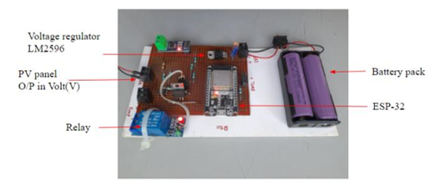
Figure 4.3: Circuit diagram

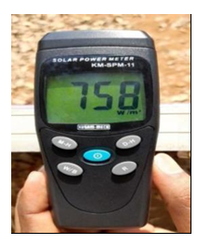
Figure 4.4. Solar power meter (KM-SPM-11)

    - DATABASE DESIGN
4.1.4 PROCEDURE DESIGN
The administrator can perform the following
- Real Time Analysis System
- Real Time Analysis using Machine Learning
4.2 IMPLEMENTATION OF THE SYSTEM
4.2.1 CHOICE OF PROGRAMMING LANGUAGE
In determining a suitable programming language for the design of the online patient management system, the factors to be considered are:-
- The difficulty of the problem
- The technical skills required of the computer program
- The type of processing required
- The availability of sub-programming facilities
- The efficiency of the language translator
- Ease of maintaining and updating the program
- Hardware and software requirement
For the project work, the programming language to be used for the design of the system is PHP and MYSQL for database management system with embedded Structured Query Language (SQL) for database manipulation

4.2.2 HARDWARE SUPPORT
The hardware requirements for this program are:
- PC: The computer should be minimum of Pentium IV with 1000GHs processor speed but preferably Dua Core Processor for greater efficiency
- Memory: This system requires a Higher RAM not less than 512MG, 1GB RAM is recommended.
- Storage: the storage capacity must be 80GB and above.
- VDU: Visual Display Unit required should be a very high resolution not less than 1024 x 768 with 256 colour capability.
- Printer: This system also requires a printer
- Input: The input device required is a mouse, Optical Mouse should be provides for easy use.
4.2.3 SOFTWARE REQUIREMENTS
The software requirements for the operation of this program are as follows:
- Window Operating System
- XAMPP or WampServer (for Apache server on localhost)
- Web Browser e.gMozila Firefox
- Macromedia dreamweaver

4.2.4 CHANGE OVER TECHNIQUE
The method used in the implementation of the proposed system is parallel, simply because parallel system supports the use of the existing system together with the proposed system and when there system failure information will not be totally lost and will not be back to square one for the users.
4.3 DOCUMENTATION OF THE SYSTEM
4.3.1 PROGRAM DOCUMENTATION
In order for the proposed system to be used on any computer system it takes the following ways
- Boot the system
- Copy the folder to www inside wamp folder of the drive C: after WAMP server is installed onto the system.
- Open any browser on the system (Microsoft internet Explorer, Mozilla Firefox, Netscape Navigator, Opera, Flock, Safari e.t.c)
- Type http://localhost/ python/index.php on the address bar and press the return key or enter key.
4.3.2 OPERATING THE SYSTEM
This refers to the step by step method of using the proposed system. The proposed system comprises of. The steps to use the proposed system are as follows
- On the address bar of any browser type
- http://localhost/www.python/index.php
- You are prompted to supply the username and password this verifies that you are a registered voter and has the privileged to vote.
4.3.3 MAINTAINING THE SYSTEM
- Data cable should be plugged properly
- Repair or replacement of all damaged accessories, system cards, peripheral e.t.c.
- prevention from dust
- Prevention of system from heat and moisture
- Prevention from static charges
- Examination of the new system from time to time to ensure it is performing as specified.
- Operators and users to the system must constantly check the output of the system to make sure that it is working accordingly.

CHAPTER FIVE
SUMMARY, CONCLUSION AND RECOMMENDATION
5.1 SUMMARY
The Solar Panel Efficiency Prediction System using Machine Learning is a modern approach designed to estimate and optimize the performance of solar energy systems. This system leverages machine learning algorithms to analyze data collected from solar panels—such as temperature, sunlight intensity, humidity, and panel output—to predict how efficiently a solar panel will perform under different conditions.
By processing historical and real-time data, machine learning models can identify patterns and relationships that affect solar efficiency. These insights enable more accurate forecasting of energy output and early detection of issues like dirt accumulation, shading, or system degradation that may reduce performance.
Common algorithms used in such systems include linear regression, decision trees, random forests, and neural networks, all tailored to improve predictive accuracy. The system supports proactive maintenance, improves system reliability, reduces operational costs, and enhances the overall effectiveness of solar energy deployment.
In summary, using machine learning for solar panel efficiency prediction enables smarter energy management, optimizes energy generation, and supports the global shift toward sustainable and renewable energy solutions.

5.2 CONCLUSION
In conclusion, the application of machine learning in predicting solar panel efficiency presents a powerful and innovative approach to enhancing the performance and sustainability of solar energy systems. By analyzing large volumes of real-time and historical data, machine learning models can accurately forecast the efficiency of solar panels under various environmental and operational conditions.
This predictive capability enables early detection of performance degradation, supports proactive maintenance, and facilitates smarter energy management decisions. It also reduces energy losses, improves return on investment, and extends the lifespan of solar infrastructure.
Furthermore, the integration of machine learning with Internet of Things (IoT) devices and cloud computing platforms enhances the scalability, accessibility, and automation of solar panel monitoring and prediction systems. As solar energy continues to play a critical role in global energy transition, machine learning-based efficiency prediction systems will be essential tools for maximizing output, minimizing costs, and promoting the widespread adoption of clean, renewable energy sources.

5.3 RECOMMENDATION
Based on the capabilities and findings associated with using machine learning for predicting solar panel efficiency, the following recommendations are made to enhance system performance, reliability, and scalability:
- Invest in High-Quality and Real-Time Data Collection Systems: Accurate prediction depends on quality data. It is recommended to deploy robust sensors and data acquisition tools that can collect real-time environmental and operational parameters such as irradiance, temperature, humidity, and panel voltage/current.
- Use Advanced and Hybrid Machine Learning Models: Combining multiple machine learning algorithms (e.g., Random Forest, Gradient Boosting, and Neural Networks) can improve prediction accuracy. Ensemble and hybrid models should be explored for better adaptability to diverse weather and site conditions.
- Regular Model Training and Validation: To maintain high accuracy, the predictive models should be regularly retrained using the most recent datasets. This ensures that the system adapts to seasonal changes and long-term environmental shifts.
- Integrate with IoT and Cloud Platforms: Linking the prediction system with IoT devices and cloud platforms allows for real-time data synchronization, remote monitoring, scalable storage, and rapid processing of large datasets.
- Ensure User-Friendly Dashboards and Visualizations: Providing clear and interactive interfaces for visualizing efficiency predictions will help engineers, technicians, and decision-makers interpret the data quickly and take appropriate actions.
- Promote Research and Collaboration: Continuous research and development, along with collaboration between academia, industry, and government, will foster innovation and refinement in solar efficiency prediction technologies.
- Implement Predictive Maintenance Strategies: The prediction system should be used not only to forecast efficiency but also to anticipate equipment failures or degradation trends, enabling proactive maintenance and reducing downtime.
- Policy and Funding Support: Government and institutional support in the form of funding, subsidies, and regulatory frameworks can encourage broader adoption and development of machine learning-powered solar systems.
By following these recommendations, stakeholders can significantly improve the performance and reliability of solar panel systems, leading to increased energy yield, reduced operational costs, and broader adoption of renewable energy technologies.

REFERENCES

Alhasnawi, B. N., Zanker, M. & Bureš, V. (2024) A smart electricity markets for a decarbonized microgrid system. Electr. Eng. 106(4), 3913–3929.
Chuluunsaikhan, T. Nasridinov, A. Choi, S. W. Bin Choi, D. Choi, H. S. and Kim, M. Y. (2022) “Predicting the power output of solar panels based on weather and air pollution features using machine learning,” Journal of Korea Multimedia Society , vol. 24, no. 2, pp. 1–11, 2021, doi: 10.9717/kmms.2021.24.2.222.
Elias, M. A. Jais, R. M. Muda, N. Azlin, N. A. and Ahmad, N. M. (2021) “Research on different types of cooling system on ground mounted solar photovoltaic system for electrical output enhancement,” Journal of Physics: Conference Series, vol. 2051, no. 1, p. 012071.
Ellabban, O., Abu-Rub, H. & Blaabjerg, F. (2024) Re newable energy resources: Current status, future prospects and their enabling technology. Renewable and sustainable energy reviews 39, 748–764.
Laseinde O. T. and Ramere, M. D. (2021) “Efficiency improvement in polycrystalline solar panel using thermal control water spraying cooling,” Procedia Computer Science, vol. 180, pp. 239–248.
Leary, P. (2021) “Design & evaluation of cooling systems for photovoltaic modules,” Honors Theses, 2019, [Online]. Available: https://digitalworks.union.edu/theses/2357.
Li, G., Wang, H., Zhang, S., Xin, J. & Liu, H. (2021) Recur rent neural networks based photovoltaic power fore casting approach. Energies 12, 2538.
Litjens, G., Worrell, E. & van Sark, W. (2022) Assess ment of forecasting methods on performance of photovoltaic-battery systems. Applied Energy 221, 358– 373.
Liu, Y. Ding, K. Zhang J.(2021) “Fault diagnosis approach for photovoltaic array based on the stacked auto-encoder and clustering with IV curves,” Energy Conversion and Management, vol. 245, article 114603.
Mahadeva, M., Bhavya, V., Gowda, N. M., Angadi, S. V. & Farooq, A. (2025) A review on integrating smart aquifer recharge systems into urban road networks: A sustainable approach to water management and urban resilience. J. Water Resour. Pollut.
Mahmud, N. & Zahedi, A. (2023) Review of control strate gies for voltage regulation of the smart distribu tion network with high penetration of renewable dis tributed generation. Renewable and Sustainable En ergy Reviews 64, 582–595.
Rodríguez-Gómez, F. del Campo-Ávila, J. Ferrer-Cuesta, M. and Mora-López, L. (2022) “Data driven tools to assess the location of photovoltaic facilities in urban areas,” Expert Systems with Applications, vol. 203, p. 117349.
Verayiah R. and Iyadurai, A. (2021) “A comparison study on types of PV for grid connected photovoltaic power,” Indonesian Journal of Electrical Engineering and Computer Science, vol. 6, no. 2, pp. 349–356.
Wang, F. (2020) Image phase shift invariance based cloud motion displacement vector calculation method for ultra-short-term solar PV power fore casting. Energy conversion and management 157, 123–135.

