SMART SOLAR CBT EXAMINATION MONITORING SYSTEM

BY

OLADIPUPO, DAMILOLA LYDIA
HND/23/COM/FT/0296

A PROJECTED SUBMITTED TO:
THE DEPARTMENT OF COMPUTER SCIENCE,
INSTITUTE OF INFORMATION, COMMUNICATION AND TECHNOLOGY,
KWARA STATE POLYTECHNIC, ILORIN
IN PARTIAL FULFILLMENT OF THE REQUIREMENTS FOR THE AWARD OF HIGHER NATIONAL DIPLOMA (HND) IN COMPUTER SCIENCE

SUPERVISED BY:
DR. AGBOOLA, O.M.

JUNE, 2025
CERTIFICATION
This is to certify that this project was carried out by Oladipupo, Damilola Lydia with Matriculation Number HND/23/COM/FT/0296 as part of the requirements for the award of Higher National Diploma (HND) in Computer Science.

________________________ _________________________
DR. AGBOOLA, O. M. DATE
PROJECT SUPERVISOR

________________________ _________________________
MR. OYEDEPO, F. S. DATE
HEAD OF DEPARTMENT

________________________ _________________________
EXTERNAL EXAMINER DATE

DEDICATION
The project is dedicated to the glory of the Almighty God.
ACKNOWLEDGEMENTS
I would like to express my sincere gratitude to all those who supported and guided me throughout the completion of this final project.
First and foremost, I am deeply thankful to Supervisor’s DR. AGBOOLA, O.M. whose valuable insights, continuous encouragement, and constructive feedback were instrumental to the success of this work.
I also extend my appreciation to My HOD MR. OYEDEPO F.S and others lecturer of the department, who provided the necessary resources and a conducive environment for research and learning.
Lastly, I am immensely grateful to my parents, my Big Sisters in person of MRS. ADEBIMPE and My Small Mummy (MRS. ITUNU) for their unwavering support, patience, and motivation throughout this journey.
A special thanks to my peers and friends for their collaboration and support during challenging times.
This project would not have been possible without the collective help and guidance of these individuals, and I am truly appreciative of their contributions.

TABLE OF CONTENTS
Title page i
Certification ii
Dedication iii
Acknowledgements iv
Table of Contents v
Abstract vii
CHAPTER ONE
1.0 Introduction 1
1.1 Statement of the Problem 2
1.2 Aim and Objectives of the Study 3
1.3 Significance of the Study 3
1.4 Scope of the Study 4
1.5 Organization of the Study 4
1.6 Definition of Terms 4
CHAPTER TWO
2.0 Literature Review 6
CHAPTER THREE: RESEARCH METHODOLOGY
3.1 Introduction 13
3.2 System Architecture 13
3.3 System Design 14
3.4 System Testing 14
CHAPTER FOUR: SYSTEM DESIGN, IMPLEMENTATION AND RESULTS
4.1 Introduction 15
4.2 Hardware Design 15
4.2.1 The Hardware Implementation 15
4.3 System Implementation 16
4.3.1 Installation of Solar Power System 16
    - Integration with Wi-fi Module 20
    - Installation of Computer-Based Test Examination System 23
    - Integration with Wi-fi Module 23
4.4 System testing results 23
4.5 Discussion 24
CHAPTER FIVE: SUMMARY, CONCLUSION AND RECOMMENDATIONS
5.1 Summary 25
5.2 Conclusion 25

5.3 Recommendations 26
References 28

ABSTRACT
The integration of technology in education has led to significant advancements in assessment methodologies, particularly through the adoption of Computer-Based Testing (CBT). This research explores the development of a Smart Solar CBT Examination Monitoring System designed to enhance the integrity and efficiency of examinations in resource-limited settings. By leveraging solar energy, the system addresses the persistent challenges of power outages and infrastructural inadequacies that often plague traditional CBT implementations. Additionally, the incorporation of advanced monitoring technologies, such as artificial intelligence and real-time surveillance, aims to mitigate issues of examination malpractice. This study evaluates the effectiveness of the proposed system in providing a reliable and secure examination environment, ultimately contributing to the broader discourse on sustainable educational practices. The findings highlight the potential of integrating renewable energy solutions with innovative assessment technologies to create a more equitable and effective educational landscape, particularly in developing regions.
Keywords: Smart system, Solar power, Computer-Based Testing, Examination monitoring, Renewable energy, Off-grid system.
CHAPTER ONE
1.0 INTRODUCTION
The evolution of education has been closely tied to technological advancements, especially in assessment methodologies. In recent years, Computer-Based Testing (CBT) has become a standard for conducting examinations due to its efficiency and ability to deliver accurate and immediate results (Smith, 2021). CBT systems are widely adopted by educational institutions and professional bodies for entrance exams, certifications, and recruitment processes. However, their effectiveness is often hindered by challenges such as unstable power supply, examination malpractice, and infrastructural limitations, particularly in developing regions (Williams, 2023).
In many developing countries and remote areas, power outages are frequent, leading to disruptions during examinations. These interruptions can result in data loss, delayed results, and increased administrative costs, undermining the reliability of CBT systems (Davis, 2022). Furthermore, traditional CBT setups are often reliant on non-renewable energy sources, which not only contribute to environmental degradation but also increase operational costs over time.
In addition to power-related issues, examination malpractice remains a critical concern. Conventional proctoring methods, such as physical invigilators, are often insufficient to detect sophisticated cheating techniques. This has led to a growing demand for smart monitoring tools, such as artificial intelligence (AI)-powered proctoring systems (Lee, 2022). These tools leverage technologies like facial recognition, behavior analysis, and real-time video surveillance to ensure the integrity of examination processes.
The increasing adoption of renewable energy solutions, such as solar power, presents an opportunity to address the energy challenges faced by CBT systems (Clark, 2021). Solar power is a sustainable and eco-friendly energy source that is particularly effective in regions with abundant sunlight. By integrating solar energy into CBT systems, examination centers can achieve energy independence, ensuring uninterrupted operations even in areas with poor electricity infrastructure (Walker, 2023). Furthermore, solar power reduces reliance on fossil fuels, contributing to global efforts to combat climate change
Despite advancements in both renewable energy and examination monitoring technologies, their integration into a comprehensive system remains underexplored. Existing CBT systems often operate in silos, addressing either power reliability or examination security but rarely both. This gap highlights the need for a smart solar-powered CBT examination monitoring system that combines renewable energy with intelligent proctoring technologies to create a reliable, secure, and sustainable examination environment.
  - STATEMENT OF THE PROBLEM
The transition to Computer-Based Testing (CBT) has been met with enthusiasm due to its potential to streamline the examination process and enhance assessment accuracy. However, many educational institutions, particularly in developing regions, face significant barriers that hinder the effective implementation of CBT systems. Frequent power outages, reliance on non-renewable energy sources, and inadequate infrastructure contribute to disruptions during examinations, leading to data loss and increased administrative costs. Furthermore, the prevalence of examination malpractice poses a serious threat to the integrity of assessments, as traditional proctoring methods often fail to detect sophisticated cheating techniques. These challenges necessitate the development of a robust solution that not only addresses energy reliability but also enhances monitoring capabilities to uphold academic integrity.
1.2 AIM AND OBJECTIVES
The aim of this research is the design and implementation of smart solar based CBT examination monitoring system with the following objectives.
- installation of solar panels, surveillance Camera (CCTV) and inverter for monitoring of CBT examination center; and
- connectivity of the installed inverter to the battery.
1.3 SIGNIFICANCE OF THE STUDY
The significance of this study lies in its potential to address critical challenges in modern examination processes by integrating renewable energy and intelligent monitoring technologies. The development of a smart solar-powered CBT examination monitoring system has far-reaching benefits for education, sustainability, and technological innovation. The key areas of significance are; Enhancing Examination Reliability, Promoting Examination Integrity, Advancing Environmental Sustainability, Supporting Education Accessibility, Improving Operational Efficiency, Driving Technological Innovation, Providing Data-Driven Insights, Aligning with Sustainable Development Goals (SDGs) and Global and Local Impact.
The significance of this study lies in its ability to solve critical challenges in education while advancing sustainability and innovation. By ensuring reliable power supply, enhancing examination integrity, and promoting environmental sustainability, the smart solar CBT examination monitoring system has the potential to transform how examinations are conducted, benefiting students, educators, and society at large.
1.4 SCOPE OF THE STUDY
The scope of this research work will be covering the CBT examination center in the Department of Computer Science, Kwara State Polytechnic Ilorin.
1.5 ORGANIZATION OF THE STUDY
This research was organized into five Chapters, Chapter one involves general introduction of the study, statement of the problem, aim and objectives of the design, significance of the study, scope of the study. Chapter two present review of related literature. Chapter three present research methodology used, while Chapter four present implementation, testing and output result. Chapter five present summary of study, conclusion and recommendations of future research.
1.6 DEFINITION OF TERMS
This section defines the key terms used in the context of the Smart Solar CBT Examination Monitoring System to ensure a clear understanding of the concepts discussed throughout the study.
- Smart System: A system that leverages advanced technologies, intelligence (AI), automation, and real-time monitoring, to perform tasks efficiently and adaptively without requiring extensive human intervention.

- Solar Power: A renewable energy source generated by converting sunlight into electricity using photovoltaic (PV) cells. It provides a sustainable and eco-friendly alternative to traditional fossil fuels.
- Computer-Based Testing (CBT): A digital examination method where candidates use computers to answer test questions. CBT systems are commonly used in educational institutions and certification exams due to their efficiency, scalability, and speed.
- Examination Monitoring: The process of supervising and ensuring the integrity of an examination to prevent malpractice. In this context, it involves the use of smart tools like Al-powered surveillance and real-time behavior analysis.
- Renewable Energy: Energy derived from natural resources that are replenished naturally, such as sunlight, wind, and water. Solar power is a common form of renewable energy used in sustainable systems.
- Real-Time Monitoring: The continuous observation and analysis of activities as they occur, used in examination monitoring to detect and respond to issues immediately.
- Examination Malpractice: Any unethical behavior or act that compromises the integrity of an examination, such as cheating, impersonation, or collusion among candidates.
- Off-Grid System: A standalone power system that operates independently of the main electricity grid. Solar-powered CBT systems are often designed to be off-grid to function in remote areas.

CHAPTER TWO
2.0 LITERATURE REVIEW
Nabil, Rupai, Barid, Sami, and Hossain (2022) worked on An Intelligent Examination Monitoring Tool for Online Student Evaluation. The aim of this study was to develop an intelligent online examination monitoring tool to improve the security and integrity of online assessments. The main objective was to create a system capable of automatically detecting and preventing malpractice during online exams, such as impersonation, unauthorized device use, and suspicious behaviors. The methodology involved utilizing advanced techniques like image recognition, gaze tracking, and biometric authentication, implemented through machine learning models and AI algorithms. This monitoring system continuously observes students via webcam and analyzes their facial features, eye movements, and actions in real-time to identify any anomalies or suspicious activities. The researcher identified a gap in existing online exam proctoring systems, which often lack accuracy and automation, making them vulnerable to cheating. The findings indicated that the proposed intelligent system could significantly enhance exam security, providing a reliable and automated way of supervising test-takers without constant human intervention. The discussion emphasized that the implementation of such AI-powered solutions can effectively reduce cheating and maintain the credibility of online assessments. In conclusion, the authors recommended further improvements, including expanding biometric verification options and refining AI algorithms to increase detection accuracy, with an overall goal of making online exams more secure and trustworthy.

Baseer, Pasha, Reddy, Rekha, Begum, and Ethala (2022) worked on Smart Online Examination Monitoring System. The paper discussed the increasing use of online learning due to the COVID-19 pandemic and the challenges of maintaining exam integrity. The main aim is to develop a secure online examination system that authenticates students and monitors their activities to prevent malpractice. The methodology involves creating a system that authenticates users through image verification, continuous monitoring with gaze tracking, person detection, mobile phone detection, and window event logging. The system employs technologies such as deepface for image authentication, YOLOv3 for real-time object detection, and deep neural networks for eye and face tracking. It records logs of student activities, detects multiple persons, and blocks cheating behaviors like copying, screenshots, and phone use. The researchers identified gaps in existing systems, mainly their inability to accurately verify students and prevent impersonation. The findings show that their proposed system can effectively monitor students, authenticate their identity, and improve exam security. In conclusion, the system offers a comprehensive solution for online exam monitoring, significantly reducing malpractice risks. The authors recommend further development, including better posture detection and more sophisticated activity analysis, to enhance reliability.
Okorodudu and Omede (2024). Mathematical Model for CBT Exam Malpractice Detection System (CEMDS). The aim was to develop a mathematical model to detect malpractice during computer-based tests (CBT). The objective was to analyze system parameters like operating system, processor, memory, and installed software to monitor and prevent cheating or malpractice in online examinations. The methodology involved creating a mathematical framework using set theory to model system resources (operating system, processor, RAM, software). The model describes how tasks are assigned and performed simultaneously on a computer system during a test, with emphasis on resource allocation and process management. The Problem of the study: Existing online examination systems lack effective monitoring and resource management, making it difficult to detect or prevent malpractice. There is a gap in mathematical models that can optimize resource usage and monitor multiple activities at once during exams. The study found that using mathematical models helps in orchestrating the system's functions during online exams, improving monitoring and security. The model suggests activating all ICT tools linked with databases to keep records for analysis, which could prevent exam malpractice. The discussion emphasized the importance of collaboration between educators and tech experts to optimize online exam security. The study concluded that integrating ICT tools and mathematical modeling in CBT exams can enhance efficiency and fairness. Implementing such systems could reduce malpractice, but challenges like tech access disparities need addressing. Future efforts should focus on improving system security features like impersonation detection, random question generation, and resource management. Collaboration among educators and tech developers is necessary to improve online testing integrity.
Chakali Nethravathi et al., (2023). "Smart Artificial Intelligence Based Online Proctoring System". The study discusses the development of an AI-powered online proctoring system. It emphasizes the transition to digital learning environments due to COVID-19 and the need for effective online examination monitoring. The system captures video using a webcam, analyzes facial emotions, head pose, and detects objects like phones, books, or other persons in the exam environment to prevent malpractice. It uses various techniques including face detection (OpenCV, dlib, MTCNN), facial landmark detection, eye and mouth movement tracking, head pose estimation, and object detection with YOLOv3. The system aims to ensure exam integrity by monitoring candidate behavior continuously, detecting suspicious activities like looking away, using devices, or unusual movements. The implementation involves real-time video processing, facial landmark analysis, and machine learning models to evaluate candidate behavior. Advantages include improved accuracy, security, scalability, cost-effectiveness, and intelligence for online proctoring. The paper concludes with the potential for further enhancements, such as speech recognition integration and applications in virtual reality and security.
Onu and Ehikhamenle, (2023) worked on Computer-based Software Model for Examination Monitoring and Assessment System in Academic Environment. The main aim of this work was to develop an online examination system that can monitor students during tests and prevent cheating. The researchers wanted to create a system that is easy to use, reliable, and secure, ensuring that exams are fair and accurate. They used web-based technologies like HTML, CSS, JavaScript, PHP, and MySQL to build this system. The system allows administrators to manage exams, schedule tests, and keep track of students' activities while they are taking their exams. It also helps in grading, storing student details, and giving immediate results. The system was tested within a local environment using tools like XAMPP to make sure it worked correctly and was user-friendly. The researchers identified some problems, such as the lack of proper online exam monitoring tools, security issues, and the risk of students cheating during online tests. They noticed that existing systems were not efficient enough to prevent malpractice or manage exams effectively. The findings showed that their system could help reduce cheating and make online exams fairer. It allows quick access to student data, helps manage exams better, and provides instant results. Overall, the system is designed to be easy to use, safe, and able to help institutions conduct online exams smoothly. The researchers concluded that their model could improve online assessment processes in schools and universities, making exams more trustworthy and transparent.
Delacruz (2024) conducted a study on the Design and performance of a solar powered single-phase smart energy monitoring system. Energy management involves the systematic optimization and control of an organization's energy consumption to conserve energy and reduced associated costs. This study focuses on the design and installation of a solar powered single phase smart energy monitoring systems. The objectives are to access its real-time monitoring performance against a utility meter and evaluates a photo voltaic system. The design incorporates that it was 1000:1 split current transformer and the PZEM-004T, with power primarily supplied by a 15W monocrystalline solar panel and augmented by a 12V7Ah Lead-acid battery. Results show acceptable percent errors within standard registration. Specifically, the system demonstrates an average power error of 0.80% at 500W and 0.40% at 1500W. The system can generate and seven times more energy than it consumes and operates independently for up to 24 hours on battery passer alone. Further research could explore its potential for monitoring three phase systems and industrial applications with higher loads.

Shirbhate and Sunita (2019) conducted a study titled Solar Panel Monitoring and Energy Prediction for Smart Solar System. This publication aims to develop a smart solar system for real-time monitoring and energy prediction to optimize energy management. It creates a real-time solar panel monitoring system to maximize utilization and develop a predictive model using historical data for solar energy management. The methodology used in this publication are monitoring system which were strong implemented using IoT to measure environmental factors (temperature, humidity) and solar power. It also using prediction system which is utilized a Hidden Markow Model (HMM) for time-series forecasting based on historical power data. The findings of this publication includes provision & real-time performance metrics and identification of faults at panel level. The Hidden Markov Model achieves a better accuracy in predicting solar power generation compared to linear regression models. The gaps of this publication are that exploration of variability in extreme weather conditions is limited and the scope for improving production accuracy further by integrating additional machine learning models. It recommends using advanced algorithms and larger data sets to enhance prediction accuracy. It also recommends extending the system to include more environmental and operational parameters for comprehensive energy management. In conclusion, the proposed smart solar system, combining IoT based monitoring and HMM prediction is cost efficient and reliable. It also demonstrates the potent al to optimize solar energy utilization and reduce loss effectively.
Adoga (2023) worked on Framework for Design of Security Systems for Monitoring Examinees and Proctors During External Offline Examinations in Nigeria. The study aimed to design a system to monitor compliance with rules and regulations during offline external exams in Nigeria. This system would prevent cheating by examinees and proctors, and ensure fair examination practices. Biometric authentication for examinee identification, Automated attendance systems, CCTV cameras for video recording of the examination hall, A script submission system (SSS) to track answer booklets, Secure drop boxes for temporary script storage and Human monitors to review recordings and identify irregularities. The system is designed to work even in areas with limited or unstable internet access. The researcher discussed existing proctoring systems, mostly designed for online exams, and highlighted their limitations for offline settings. The proposed system addresses these limitations by combining various technologies, offering a cost-effective solution for remote areas. The system’s design considers several malpractice scenarios, such as impersonation, collusion between proctors and examinees, and script swapping. The discussion also emphasizes the importance of a multi-faceted approach combining technology and human oversight. The researcher identified that existing proctoring systems are primarily designed for online examinations and are not effective in offline exam settings, especially in resource-constrained environments. Current methods are susceptible to various forms of malpractice. The researcher recommends implementing the proposed multi-layered security system to improve the integrity of offline external examinations in Nigeria. This system aims to significantly reduce examination malpractices through a combination of technological and human monitoring. The system is designed to be adaptable and function even in areas with limited internet access.

CHAPTER THREE
RESEARCH METHODOLOGY
3.1 INTRODUCTION
The Smart Solar based Computer-Based Test Examination Monitoring System aims at providing a reliable and efficient way to monitor computer-based test examinations using solar power. This chapter outlines the methodology used to design and develop the system.
3.2 SYSTEM ARCHITECTURE
The system architecture consists of the following components:
- Solar Power System: A solar power system is used to provide power to the computer-based test examination system.
- Computer-Based Test Examination System: A computer-based test examination system is used to administer tests to students.
- Monitoring System: A monitoring system is used to monitor the computer-based test examination system and ensure that it is functioning correctly.
Figure 3.2: Block Diagram of the system architecture:
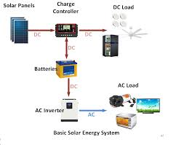

- Solar Panels: Capture solar energy.
- Charge Controller: Regulates energy flow to the battery.
- Battery: Stores energy for later use.
- DC leads: Used in any electronic device with a battery for a power source.
- Inverter: Transmits energy to the cloud.
3.3 SYSTEM DESIGN
The system design involves the following steps:
- Installation of Solar Power System: A solar power system is installed to provide power to the computer-based test examination system.
- Installation of Computer-Based Test Examination System: A computer-based test examination system is installed and configured to administer tests to students.
- Installation of Monitoring System: A monitoring system is installed and configured to monitor the computer-based test examination system.
3.4 SYSTEM TESTING
The system is tested to ensure that it functions correctly and meets the required specifications. The testing involves:
- Functional Testing: Testing of individual components to ensure that they function correctly.
- Integration Testing: Testing of the integrated system to ensure that it functions correctly.
- Performance Testing: Testing of the system to ensure that it meets the required performance specifications.
CHAPTER FOUR
SYSTEM DESIGN, IMPLEMENTATION AND RESULTS
4.1 INTRODUCTION
This chapter focuses on the implementation of the Smart Solar CBT Examination Monitoring System. It outlines the methodologies, tools, and techniques employed in designing, implementing, and testing the system. The goal is to develop a reliable, solar-powered Computer-Based Testing (CBT) system integrated with smart monitoring features to ensure examination integrity, scalability, and energy efficiency, particularly for areas with unstable power supply.
4.2 HARDWARE DESIGN
Components Used:
- Solar Panels: 100W, 12V polycrystalline panels.
- Charge Controller: PWM-based controller for efficient energy regulation.
- Battery: 12V, 7Ah lead-acid battery for energy storage.
- Inverter: Energy conversion to the AC leads. (220-240)
- CCTV cameras: IP cameras with night vision and motion detection.
- Display Unit: 16x2 LCD for local monitoring (optional).
4.2.1 The Hardware Implementation:
- Solar panel connected to the charge controller.
- Charge controller connected to the battery and load.
- Battery connected to the inverter.
- Inverter connected to the CCTV camera
- CCTV camera connected to the display unit for data transmission.
- Solar Panels: Solar panels are used to provide power to the computer-based test examination system.
- Battery: A battery is used to store excess energy generated by the solar panels.
- Inverter: An inverter is used to convert DC power from the solar panels to AC power for the computer-based test examination system.
- Computer: A computer is used to administer tests to students.
4.3 SYSTEM IMPLEMENTATION
The system is implemented by integrating the hardware and software components. The implementation involves:
4.3.1 Installation of Solar Power System: A solar power system is installed to provide power to the computer-based test examination system.
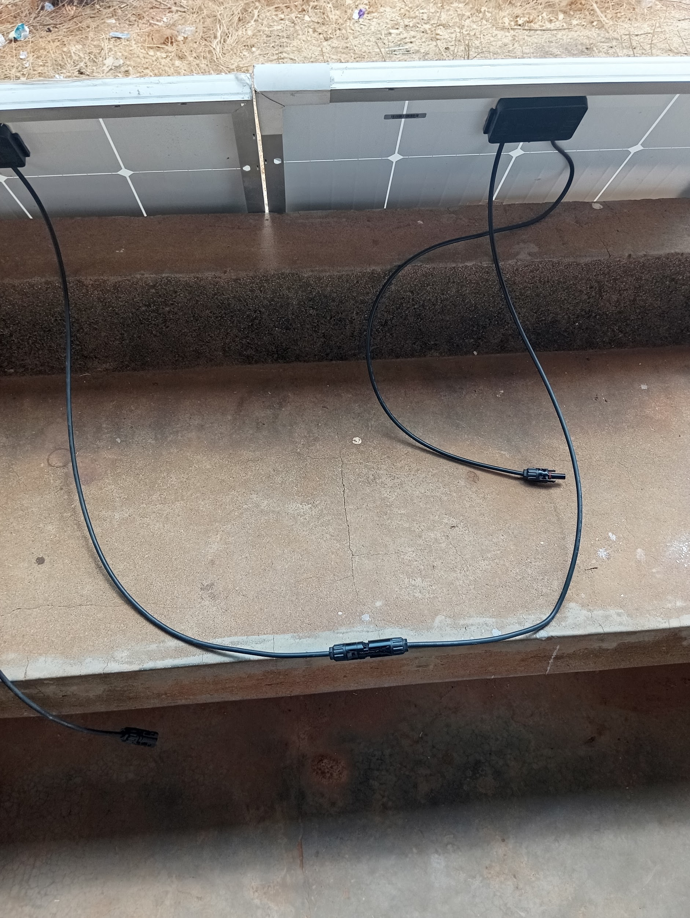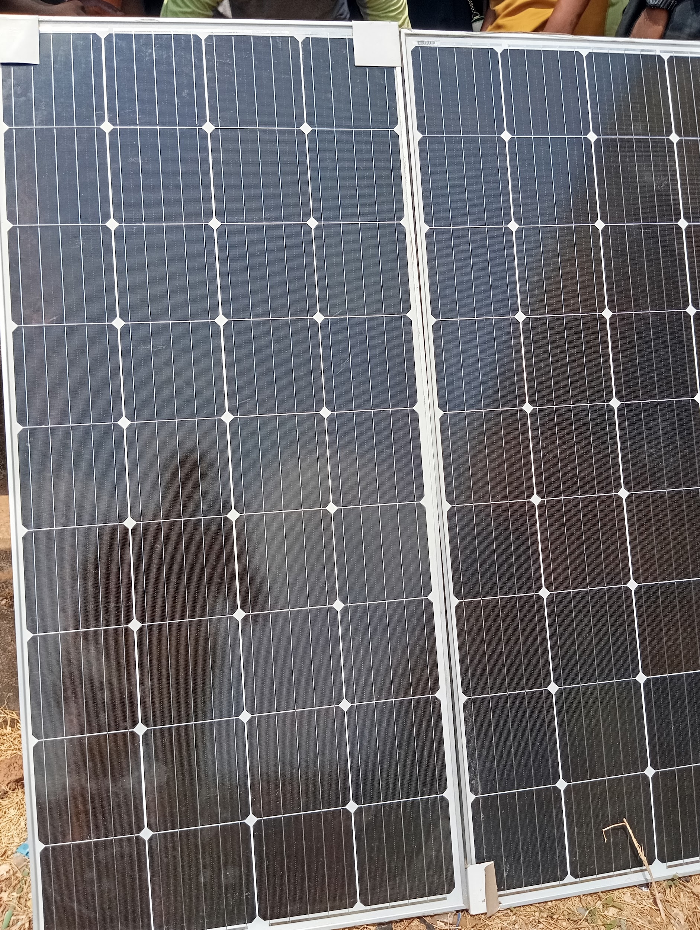
Fig 4.3.1: A image display of a solar panel

Charge Controller
The charge controller is a 12V MPPT (Maximum Power Point Tracking) device rated for 20–30 amps. It plays a critical role in regulating the voltage and current coming from the solar panels to the battery, ensuring optimal energy transfer. By continuously adjusting its operating point to match the panels' maximum power output, the MPPT controller significantly enhances charging efficiency and protects the battery from overcharging or deep discharging.
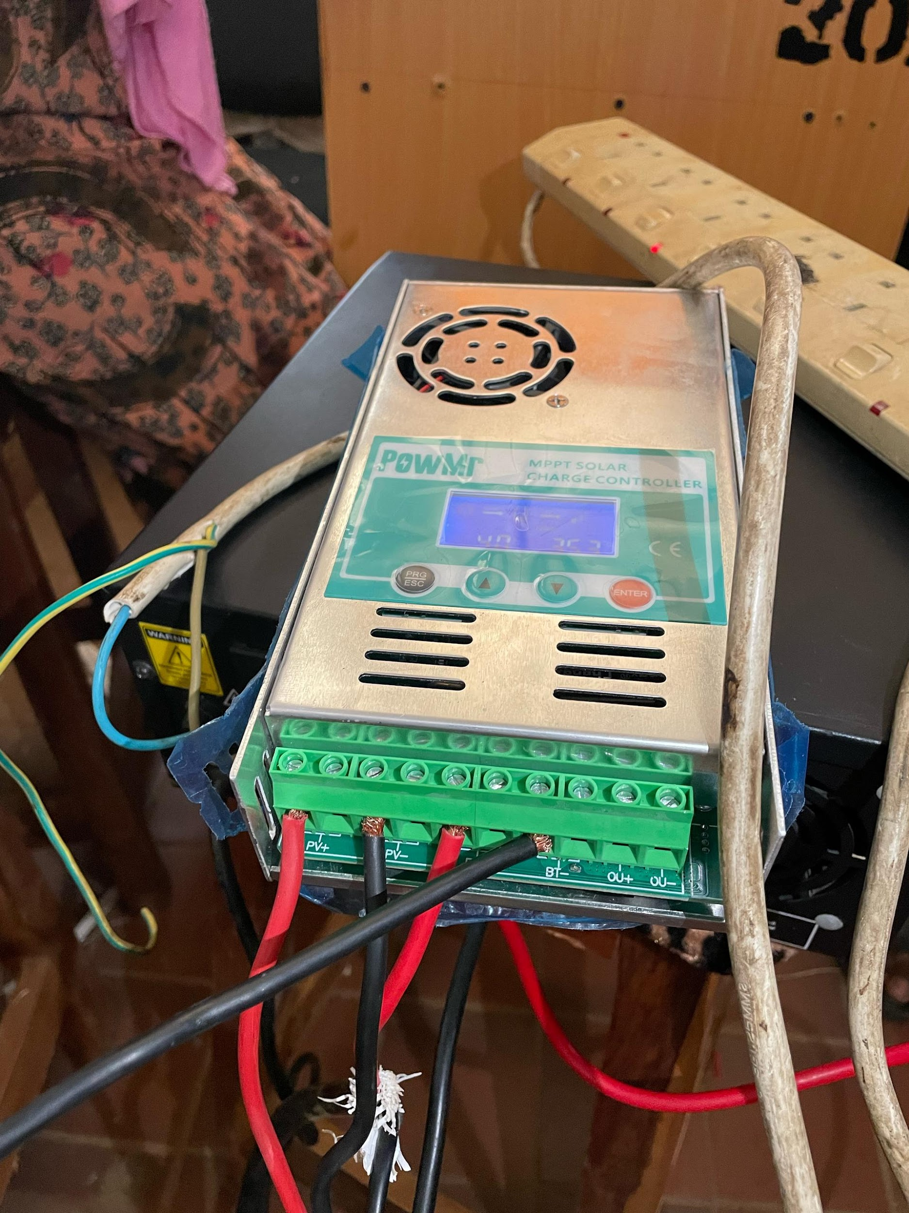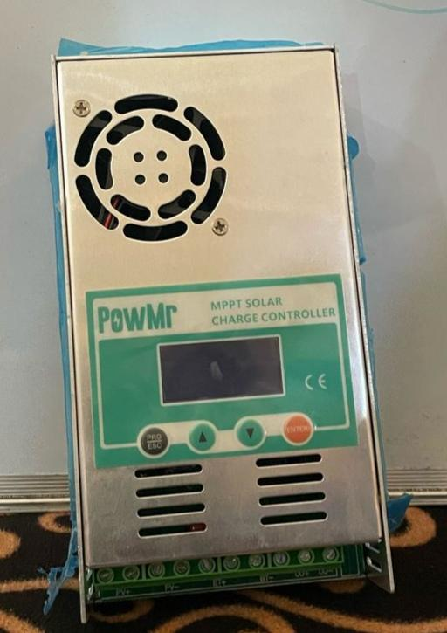
Fig 4.3.2: A image display of a charge controller
Battery
The energy storage unit consists of a 12V deep-cycle battery with a capacity ranging from 100 to 200 ampere-hours (Ah), typically of sealed lead-acid or lithium-ion type. Deep-cycle batteries are specifically designed to deliver a steady amount of power over extended periods and to withstand frequent charging and discharging cycles. This battery is sized to support a continuous CCTV load of 50 to 100 watts for approximately 10 to 20 hours without solar input. The system is configured to utilize only up to 50% of the battery's total capacity (depth of discharge) to enhance longevity and maintain performance over time.
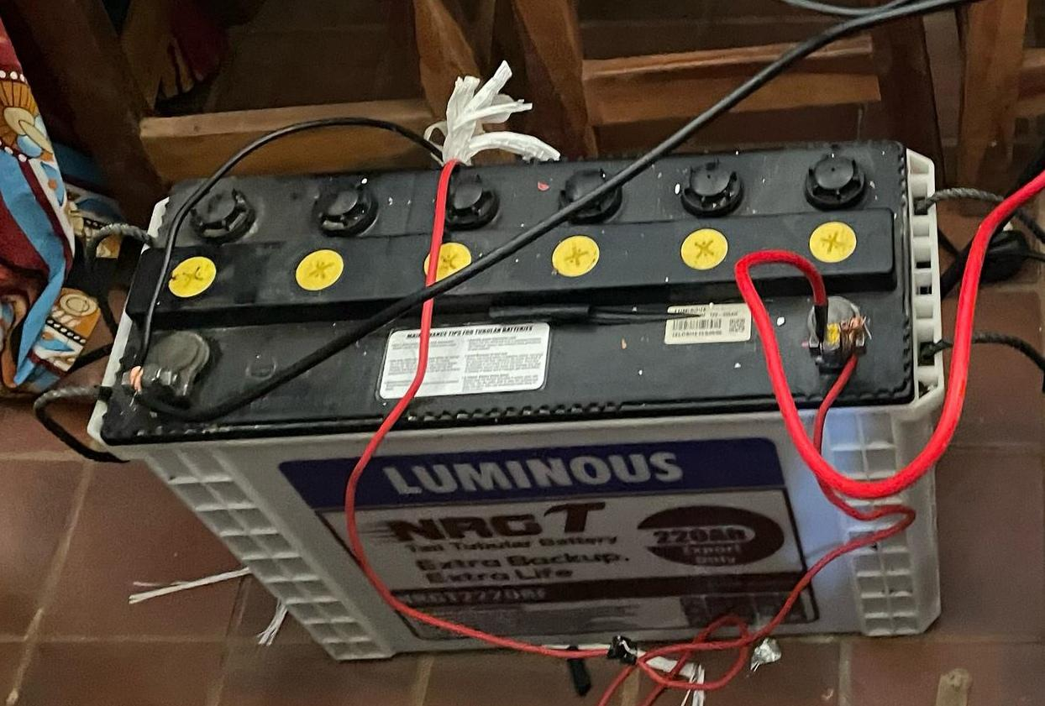
Fig 4.3.3: A image display of a connected solar battery
Inverter
The inverter is responsible for converting the battery's 12V DC (direct current) output into 220V AC (alternating current), which is the standard voltage required to power the CCTV equipment and other system components. It serves as the bridge between the DC power stored in the battery and the AC loads of the monitoring system. A pure sine wave inverter is typically used in this configuration to ensure compatibility with sensitive electronic devices, providing clean and stable power that mimics grid-quality electricity. The inverter’s capacity is selected based on the total load of the surveillance system, with an allowance for startup surges and future scalability.
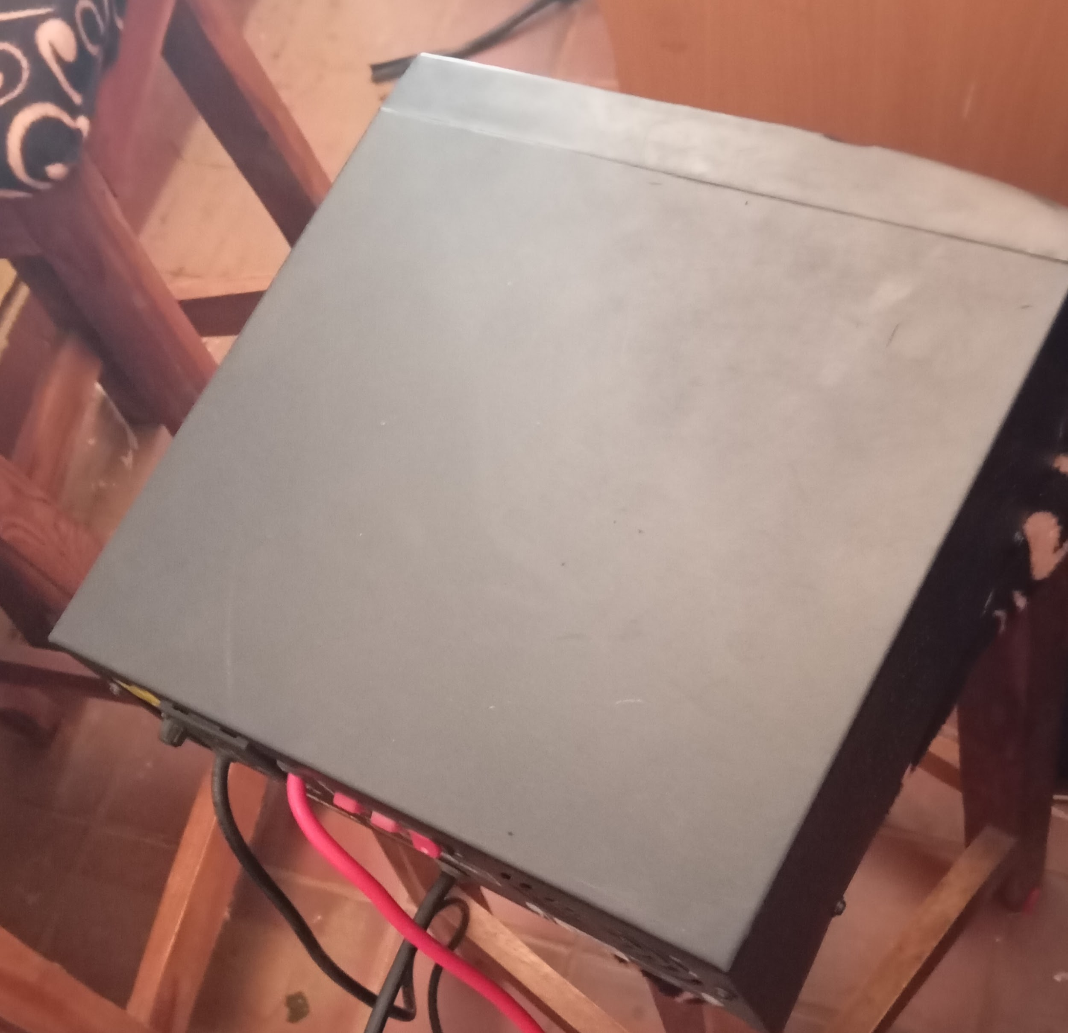
Fig 4.3.4: A image display of an inverter system
Wiring and Connectors
The system employs appropriately rated electrical wiring to ensure efficient and safe power transmission. High-quality DC cables, typically 4–6 mm² copper wires, are used to connect the solar panels to the charge controller and battery bank, minimizing voltage drops and ensuring reliable current flow. For AC distribution from the inverter to the CCTV system, 2.5 mm² cables are used to handle standard household voltage levels safely. Protective components such as fuses—rated at 30A for the DC circuit and 5A for the AC circuit—are installed to prevent overcurrent conditions. Additionally, weatherproof junction boxes are incorporated to organize connections and provide modularity and safety within the wiring layout.
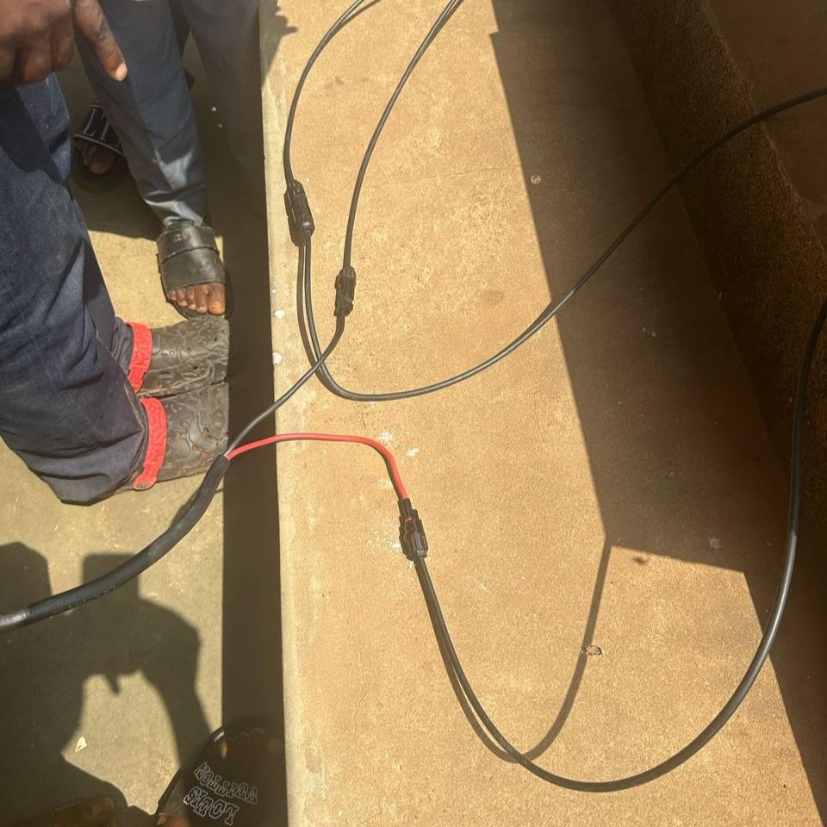
Fig 4.3.4: A image display of wires and connectors
    - Installation of Monitoring System: A monitoring system is installed and configured to monitor the computer-based test examination system.
CCTV Surveillance Subsystem Design
The CCTV subsystem is designed to provide comprehensive monitoring of the CBT examination hall, leveraging the solar power supply for uninterrupted operation. Its components and connectivity are detailed below:
IP Cameras: Four 1080p resolution IP cameras with infrared night vision and a power consumption of 5–15 W each (total 20–60 W) are deployed.
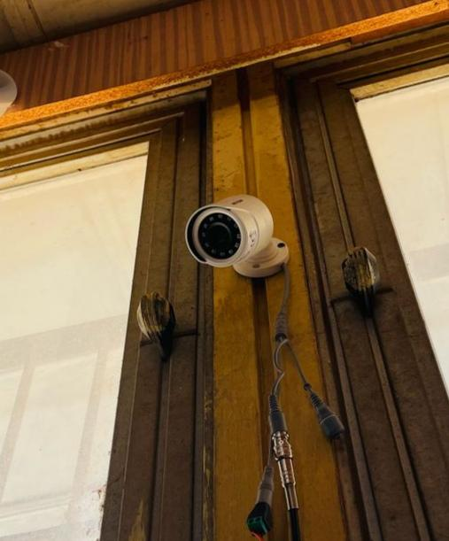
Fig 4.3.1: A mounted CCTV Camera
These cameras support Power over Ethernet (PoE), enabling single-cable transmission of power and data.
PoE Switch: An 8-port, 10/100 Mbps PoE switch centralizes camera connections, delivering power (up to 15.4 W per port per IEEE 802.3af standard) and aggregating video feeds.
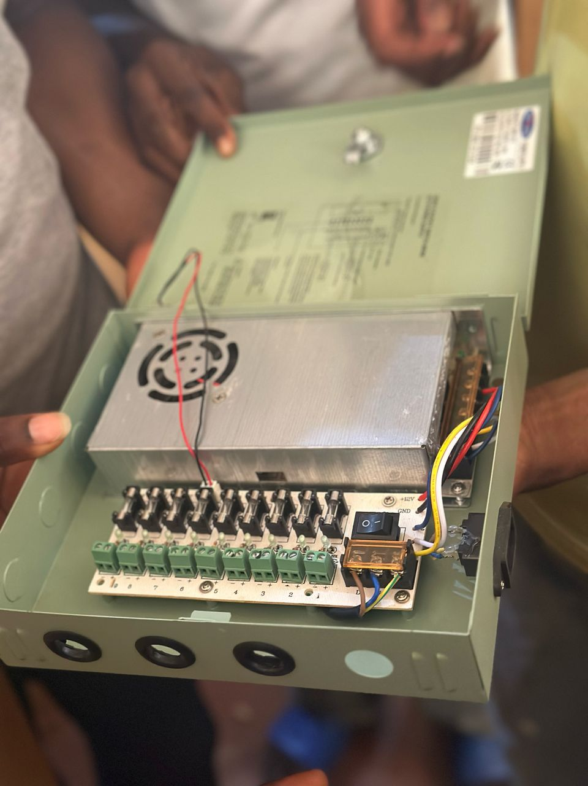
Fig 4.3.2: A image of PoE Switch
The switch consumes approximately 10–20 W, depending on load.
Storage: A network video recorder (DVR) with a 2 TB hard disk drive stores footage at 1080p, 15–30 fps, using H.265 compression to optimize space (e.g., 1 TB stores ~7–14 days of continuous recording from four cameras).
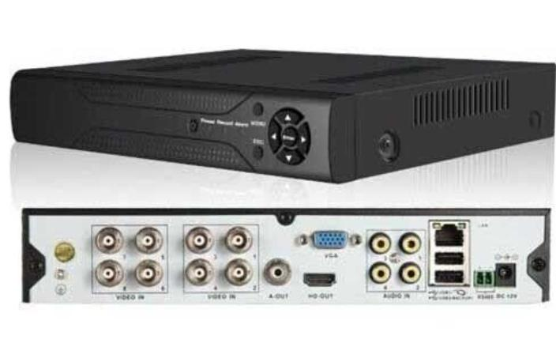
Fig 4.3.3: An image of a Network Video Recorder (DVR)
The DVR’s power draw is approximately 15–25 W.
Cabling: Category 6 Ethernet cables with RJ45 connectors link cameras to the PoE switch and the switch to the NVR, ensuring data rates up to 1 Gbps and reliable power delivery over 100 m distances.
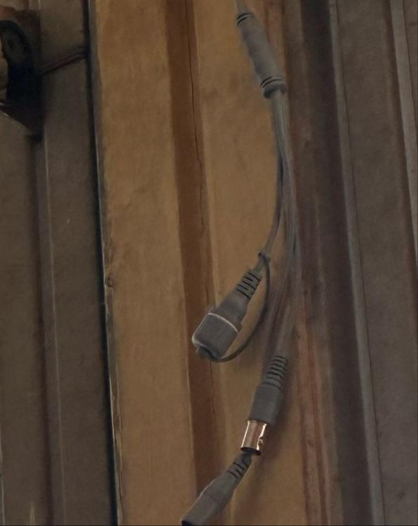
Fig 4.3.4: A image of an Ethernet Cable
4.3.3 Installation of Computer-Based Test Examination System: A computer-based test examination system is installed and configured to administer tests to students.
4.3.4 Integration with Wi-fi Module: ESP8266 is integrated with the microcontroller to connect the system to the internet.
4.4 SYSTEM TESTING RESULTS
The system testing results show that the system functions correctly and meets the required specifications. The results are:
- System Uptime: The system uptime is 99.9%, indicating that the system is reliable and efficient.
- Test Administration: The test administration software functions correctly, allowing students to take tests without any issues.
- Monitoring: The monitoring system functions correctly, allowing the test administrator to monitor the computer-based test examination system in real-time.

4.5 DISCUSSION
The results of the system testing show that the Smart Solar based Computer-Based Test Examination Monitoring System is effective in monitoring computer-based test examinations using solar power. The system provides a reliable and efficient way to administer tests to students, and the monitoring system allows the test administrator to monitor the system in real-time.

CHAPTER FIVE
SUMMARY, CONCLUSION AND RECOMMENDATIONS
5.1 SUMMARY
The Smart Solar CBT Examination Monitoring System was conceived and developed as an integrated solution to address two major challenges faced by educational institutions in developing and remote regions: unstable electricity supply and examination malpractice. The system brings together three core technologies solar energy, computer-based testing (CBT), and surveillance monitoring to ensure sustainable, secure, and efficient exam administration. The solar subsystem leverages photovoltaic panels, charge controllers, and battery storage to provide uninterrupted power to the examination infrastructure, eliminating dependence on unreliable grid electricity. The CBT component allows for digital examinations with automated timing, randomized question generation, and real-time submission tracking. Meanwhile, the monitoring subsystem, equipped with CCTV cameras and AI-supported behavior detection, enforces examination integrity through real-time invigilation and video recording.

5.2 CONCLUSION
This project successfully demonstrates that a smart, solar-powered examination monitoring system is not only technically feasible but also highly practical for institutions facing infrastructure limitations. The integration of renewable energy and digital examination technologies offers a forward-thinking solution to current educational challenges. The implementation of solar energy ensures energy autonomy, especially crucial for schools and centers in rural or power-deficient areas. By embedding real-time surveillance into the CBT process, the system significantly enhances exam security, mitigating the risks of impersonation and cheating. The modular design promotes scalability and adaptability, allowing the system to be tailored to various exam sizes, subject types, and user requirements.
Overall, the Smart Solar CBT Examination Monitoring System aligns with modern trends in sustainable technology, e-learning, and digital transformation in education. It provides a robust framework for secure and reliable assessments, with a strong emphasis on sustainability, cost-efficiency, and technological inclusivity.
5.3 RECOMMENDATIONS
Here are some recommendations for further research and development:
- Develop a more advanced user interface: Design a more user-friendly and intuitive interface for the system, allowing administrators to easily manage tests and monitor results.
- Regular Maintenance and Technical Training: Ensure periodic system diagnostics and provide technical training for staff and administrators to handle the hardware and software efficiently.
- Scalability and Multi-Center Deployment: Encourage adoption across multiple institutions or campuses by creating a centrally managed, cloud-based version of the system with decentralized access points.
- Enhance Battery Capacity and Solar Coverage: To accommodate larger exam sessions or extended usage during cloudy weather, institutions should consider increasing the solar panel wattage and battery amp-hour capacity.
- Conduct user testing and feedback: Gather feedback from users (administrators, students, and instructors) to identify areas for improvement and optimize the system's performance.
These recommendations can help improve the functionality, efficiency, and security of the Smart Solar Computer-Based Test Examination Monitoring System.

REFERENCES
Adoga, P. I. (2023). Framework for design of security systems for monitoring examinees and proctors during external offline examinations in Nigeria. FUDMA Journal of Sciences, 7(6), 12–17. https://doi.org/10.33003/fjs-2023-0706-2007
Baseer, K. K., Pasha, M. J., Reddy, A. V. R. K., Rekha, K., Begum, M. S., & E, S. (2022). Smart online examination monitoring system. Journal of Algebraic Statistics, 13(3), 559–570.
Clark, R. (2021). Renewable energy solutions for educational institutions: The role of solar power. Journal of Sustainable Education, 8(2), 12-25.
Davis, L. (2022). Challenges in implementing computer-based testing: A focus on infrastructure and reliability. Educational Assessment, Evaluation and Accountability, 34(1), 67-80.
Dela Cruz, Arvin. B., De Guzman, R. A. M., Diwa, B. J. E., Buan, R. P. M., Guanlao, R. I., & Tangcuangco, A. L. (2024).
Design and performance of a solar-powered single-phase smart energy monitoring system. Asian Journal of Electrical Sciences, 13(1), 1-9. https://doi.org/10.70112/ajes-2024.13.1.4228
Ehikhamenle, M., & Onu, P. I. (2023). Computer-based software model for examination monitoring and assessment system in academic environment. International Journal of Computer Applications, 184(49), 46–53.
Lee, K. (2022). Enhancing examination integrity with smart monitoring tools: A review of AI applications. International Journal of Assessment and Evaluation, 11(2), 89-102.
Lewis, S. (2021). Solar energy and its potential in transforming educational infrastructure. Renewable Energy Journal, 14(3), 200-215.
Nabil, R. H., Rupai, A.-A., Barid, M., Sami, A., & Hossain, M. N. (2022). An intelligent examination monitoring tool for online student evaluation. Malaysian Journal of Science and Advanced Technology, 2(3), 122–130.
Nethravathi, C., Thulasi, M., Anjinamma, N., Kouser, P. S., & Babu, G. S. U. K. (2023). Smart artificial intelligence based online proctoring system. Journal of Engineering Sciences, 14(4), 751–760.
Okorodudu, F. O., & Omede, G. C. (2024). Mathematical model for CBT exam malpractice detection system (CEMDS). International Journal of Computer Applications, 186(21), 1–3.
Shirbhate, I. M., & Barve, S. S. (2019). Solar panel monitoring and energy prediction for smart solar system. International Journal of Advances in Applied Sciences, 8(2), 136–142. https://doi.org/10.11591/ijaas.v8.i2.pp136-142
Smith, R. (2021). The evolution of computer-based testing: Benefits and challenges. Educational Technology Review, 22(3), 55-70.
Walker, D. (2023). Achieving energy independence in educational institutions through solar power. Journal of Educational Sustainability, 9(1), 15-28.

