TOPOGRAHICAL INFORMATION SYSTEM (T.I.S)
PART OF
MAIGIDA HOUSING ESTATE, ALONG TAOHEED SANGO ROAD, ILORIN SOUTH LOCAL GOVERNMENT AREA, KWARA STATE

BELLO DAMILOLA
MATRIC NO: HND/23 /SGI/FT/0022

SUBMITTED TO THE DEPARTMENT OF SURVEYING AND GEOINFORMATICS,
INSTITUTE OF ENVIRONMENTAL STUDIES,
KWARA STATE POLYTECHNIC, ILORIN,
KWARA STATE

MAY 2025

TOPOGRAHICAL INFORMATION SYSTEM (T.I.S)
PART OF MAGIDA HOUSING ESTATE SANGO
KWARA STATE, ILORIN,
MORO LOCAL GOVERNMENT AREA, KWARA STATE

BY GROUP 6A.
HND/23/SG1/FT/0022 ( WRITER)
HND/23/SGI/FT/0024
HND/23/SGI/FT/0019
HND/23/SGI/FT/0027
HND/23/SGI/FT/0028
HND23/SGI/FT/0032

A PROJECT SUBMITTED IN PARTIAL FULFILLMENT OF THE REQUIREMENTS FOR THE AWARD OF HIGHERNATIONAL DIPLOMA IN THE DEPARTMENT OF SURVEYING AND GEOINFORMATICS, KWARA STATE POLYTECHNIC, ILORIN, KWARA STATE, NIGERIA
.

MAY 2025

CERTIFICATE
I hereby certify that the information in this project was obtained as a result of the field observation made by me and other group members through immeasurable assistance of our supervisor in accordance with survey rules and regulations as well as supervisor instruction.
Name. BELLO DAMILOLA

Matric No: HND / 20 / SGI / FT / 0022
Signature…………………………………….
Date of completion:………………………….

CERTIFICATION
We hereby certify that Bello Damilola with matric no: - HND / 23/ SGI / FT / 0022 has satisfactory carried out his project under our instructions and direct supervision. We hereby declare that he has conducted himself with due diligence, honesty and sobriety in this project

Supervisor’s signature……………………Date of Approval……………….
SURV.Isau Ibrahim abimbola
Head of department signature…………………….. Date of Approval…………..
Mr. Isau Ibrahim Abimbola

Project Coordinator Signature:……………………… Date of Approval…………
SURV. R.O AWOLEYE
External Moderator Signature:…………………..…… Date of Approval…………

DEDICATION
This project is dedicated to the Almighty God - the creator of heaven and earth. All honors and adoration belong to Him who gave me strength and wisdom to start this program and bring it to a successful end and my Loving Parents, my love for you is endless.

ACKNOWLEDGEMENTS
I give God all encomiums for His unfailing love over me. I cannot but appreciate the Him for making this project a huge success for me. Without Him nothing is possible. In Him alone lies knowledge and wisdom, which He has bestowed on me during the course of my study.
My profound gratitude goes to my able supervisor in person of Surv. Isau Abimbola for his efforts and motivational instructions, correction and direct supervisions. God will crown your efforts. Also, to all my lecturers Surv. Abdulsalam Ayuba, Survb. AG Aremu, Surv. Banji, Surv. Diran, Surv, Awoleye, Surv, Ashonibare and all non teaching thanks you all staff.
I give gratitude to my parents Mr. and Mrs. Bello for their desire and prayer on me to be somebody in life. And to my family members who at one time or the other been supportive, I say a big thank you.
My acknowledgements will be incomplete without expressing my gratitude to all my wonderful friends, you guys are too numerous to mention
I cannot just leave this page without commending the effort of all my group members and the entire students of my surveying and geo-informatics department 2023 /2025 academic session; I say success to you all in your various endeavors.
BELLO DAMILOLA

ABSTRACT
This project focuses on Topographical Information System(T.I.S)ofthe Campus, Part of magida housing estate Sango Kwara State,
. TIS were carried out in order to produce tools for successive planning and land management of the school. Field and Office reconnaissance were carried out in order to be familiar with the terrain and do proper planning. The equipment used to acquire spatial data (X, Y, Z coordinates) is the Total Station Kolida KTS 556R series. The method used in acquiring data was ‘Radiation’ through the process of traversing, leveling and detailing simultaneously.The data processing were effectively and adequately done with the use of CivilCAD 2014 and AutoCAD 2013 Software. The usefulness of the Topographic Information generated was highlighted and map revealed the true configuration of study area and vacant areas for future development. A digital terrain model [DTM] was created to enhance further analysis using Shaded Relief Map, 3D wire Frame and surface Map, and Grid Vector Map of the study area. The information is also available for decision making that will assist in the physical planning of the area under investigation. The study concludes that Topographic Information System is essential for physical planning and accurate decision making as the slope is not to sharp using the contour interval of 0.5m. The system allows easy updating of information and quick retrieval of information for better planning and environmental management.

TABLE OF CONTENT

CHAPTER ONE

1.0 INTRODUCTION

1.1 BACKGROUND TO THE STUDY
Man all activities is on land and will return to it, the interest on land and the determination of the size, shape and position of the earth features such as land itself, building, infrastructures and other socio-economic facilities are paramount and this interest was not limited to the immediate vicinity ofhome and residency alone but all on lands. As man develops intellectually, so is his interest in understanding and mapping the size, shape and composition of the earth.
Surveying profession dates back to the beginning of the world which has its origin in the Almighty God. The dictionary defines Surveying as “taking a general view of; by observation and measurement determining the boundaries, sizes, position, quantity, condition, values etc of land, estates, buildings, farms, mines etc”. This definition covers the work of the valuation Surveyor, Quantity Surveyor, Mining Surveyor as well as Land Surveyor. However, in every case there is a common basic approach to the work, which ends with presentation of survey data in suitable form.Surveying can as well be grouped into so many areas which includes Geodetic survey, Hydrographic survey, Topographic survey, Cadastral survey, engineering survey etc.

Surveying, which is also interchangeably called ‘Geometrics’’ has traditionally been defined as the science, art and technology of determining the relative positions of points above, on, or beneath the earth’s surface or of establishing such points. In a board sense, surveying (Geomatics) can be regarded as that discipline which encompasses all methods for measuring and collecting information about the physical earth and our environment, processing that information, and disseminating a variety of resulting products to a wide range of clients. Ghilani C.Dand Wolf P.R (2008).
Topographic surveying or mappings are essential and indispensable tools in this regard. Hence, a topographical map could be defined as a two dimensional representative of the earth’s surface which shows by the use of suitable conventional signs, the spatial configuration of the earth’s surface. This includes such features as hills and valley; other natural features such as trees and streams and physical changes wrought upon the earth’s surface by man such as houses, roads, canals and cultivation. A topographical map is required in planning, construction and also for military purpose.
Topography of an area describes the surface characteristics of relief features of such area as depicted by hills, valleys and plains. It can be used to study and represent as a surface, any characteristic that has a continuously changing value other than elevation, for instance, population, geo-magnetic data and geo-chemical data. Topographical surveying involves the acquisition of topographic data of the features on the earth‘s surface, both man-made and natural in three-dimension (x y z). This employs the techniques of plane surveying and other special techniques to establish horizontal and vertical controls.
According to Olaniyi, 2013, he define Topography is generally known as the study of earth surface, and its features and shape. It also gives the description of the features (such as surface, shapes, vegetation cover & elevations), depicted in maps. In essence, topography mainly concerned with local details such as vegetative and man-made features including local history and culture. More specifically, topographic surveying involves the gathering information on terrain, three dimensional details of the surface including recognizing the specific landforms. In modern terms, it is the generation of data digitally or electronically. The outcome of topographic survey is the graphic representation of a given land parcel on a map using several techniques such as contour lines, Hypsometric tints and relief shading(i.e. topographic maps). There are varieties of methods used in topographic surveying. For example, direct surveying, remote sensing, aerial and satellite imagery, photogrammetry, radar and sonar. The most appropriate method to be used depends on the scale, size (extent of the area of interest), purpose and complexity of the subject to be study. Also, it depends on the accessibility and the quality of existing survey information. For this project we are going to adopt direct surveying in producing our topographical survey/maps using Topographical information System.
Topographic Information System is very crucial in this present age in other to be able to update maps and retrieve necessary data at any given time with minimal efforts. Topographic Information System can be explained as the combination of human effort and computer-based tools for the collection, storage, analysis, manipulation and retrieval of various kinds of data relating to geographic features (man-made and natural) on the surface of the earth (Lexicon Universal Encyclopedia , 1989). In view of this, it is necessary to create Topographic Information System for different locations because the information generated from such system can be used for various purposes in physical planning and decision making in such locations. Some of the usefulness and advantages of this digital database for such system over the conventional maps include:-
i. Possibility of fast amendment and dynamic updating of data
ii. Fast capturing of data with Total Stations or GPS
iii. Analysis of many important spatial problems
iv. Versatility in integrating data collected from various sources
v. Flexibility output possibilities
vi. Provides bases for additional information with relative ease for production of maps.

1.2 AIM AND OBJECTIVES OF THE PROJECT
1.2.1 AIM OF THE PROJECT
The project is aimed at creating Topographic Information System using radiation method for data acquisition for Part of magida housing estate sango, Kwara State Ilorin, Moro Local Government, Kwara State.
1.2.2 OBJECTIVES
In executing this project, the following objectives must be achieved.
- Reconnaissance of the study area, station selection and control search
- Test of Equipment and in-situ check of the control
- collection of data through radiation method
- Perimeter traversing
- Detailing of features and Spot heighten within the area
- Production of Plan showing boundaries, spot height and contour
- Comprehensive report writing and analysis
1.3 SIGNIFICANCE OF THE JOB
Topographical Information System is meant for effective exploration, developmental purpose, planning and management of resources on lands; hence it will help the Government in proper planning and decision making and provide a suitable reference for other researchers, the basis on which to carry out further research work.
1.4 SCOPE OF THE PROJECT
The scope of the project includes:
- Data acquisition using Total Station instrument in radiation method
- Data downloading, editing and data manipulation usingAutoCad 2013,CivilCAD 2014for contours/Mapscreation
- Information presentation: This is based on analysis in form of perimeter/detailing survey, spot heighten / contour maps and surface maps of the study, with a comprehensive project report.

1.5 STUDY AREA
This project site isPart of magida housing estate sango Kwara State, Ilorin in Moro Local Government Area ofKwara State in Nigeria. Itwithin geographical coordinate of08˚ 58ʹ 55ʺN and 04˚ 31ʹ 34ʺE

Figure 1 : MAP OF NIGERIA MAP OF KWARA STATE

KINDLY INSERT SATELLITE IMAGERY OF STUDY AREA HERE

CHAPTER TWO
2.0 LITERATURE REVIEW
Land is the solid part of the earth surface upon which foundation of all forms of human activities exits from the shelter we live,the food we eat, the vegetations, water bodies, the road we drive our cars, drainage channels to mention a few, land is finite in extent and permanent by nature, and it is man’s most valuable resource. The resources of the land are neither inexhaustible nor indestructible. The importance of land to human existence and the need to survey it and manage it effectively inefficiently for the use and good of mankind is very crucial. Therefore, for sustainable development, information relating to the layout of the relief of an area, natural and artificial features on the surface of the earth, must be aggregated as a system so that its administration would not be cumbersome, hence the evolution of Topographical Information System (Kraus F. 2000).
Surveying has been very important since the beginning of civilization as it plays an integral role in land development, from the planning and design of land, construction of roads, utilities and landscaping. Today, the importance of measuring and monitoring our environment is becoming increasingly critical as our population expands, land values appreciates, our natural resources dwindle, and human activities continue to pollute our land, water and air. As a result, the breadth and diversity of practice of surveying, as well as its importance in modern civilization is increasing from time to time (Wolf &Ghilani, 2012, P1).
Topographic Surveys determine the position of natural and artificial features, for example, trees, shorelines, roads, sewers, buildings etc. These features can then be drawn to scale on a plan or map. In addition, Topographic Surveys includes the determination of ground elevations, which can later be drawn on plans or maps for the construction of contours, or plotted in the form of cross sections and profiles.A topographic map on the other hand, shows, through the use of suitable symbols, (1) the spatial characteristics of the earth’s surface, with such features as hills and valleys, vegetation and rivers, and (2) constructed features such as buildings, roads, canals, and cultivation. The distinguishing characteristic of a topographic map, as compared with other maps, is the representation of the terrain relief (Anderson, & Mikhail, 1998; USACE, 2007).
Topography defined as the physic-graphic relief of an area, it is a layout natural and artificial feature on the surface of the earth and the science of their detailed graphic representations on maps and charts. This shows the surface configuration of the earth which uniquely distinguishes the shape of the earth at different points. Topography can also be said to be a collective term for all the physical features of an area, particularly as represented on a topographic map (Kraus, F. 2000)
Topographic surveys are now performed using different Surveying techniques, with the plans and digital elevations models (DEMs) constructed using modern computerized equipment.Topographic surveys of small area are often performed using digital equipment like Differential GPS and Total Stations. The horizontal location (X and Y) and the vertical location (Z) can be captured easily with one sighting, with point descriptions and other attribute data entered into electronic storage for later transfer to the computer (Author 2022).
Topographical plan is a basic instrument for the engineers and decision makers at the planning stage of most developmental projects. Information present on a particular portion of the earth surface could either be artificial or natural. Therefore, it is worthy to note that the above required information in the developmental effort could only be made readily available by a Surveyor who provides the precise and accurate data in the form of Topographical map which is the focus of this project.
The graphical portrayal of the features by conventional symbols is a topographic map. Such a map shows both the horizontal distance between the features and their elevations above a given datum. The representation of the difference in elevation is called relief. This implies that, the purpose of topographic survey is to gather data necessary for the construction of topographic maps which are very essential for the planning and designing of the most engineering projects, drainage systems, the development of hydro-electric power, layout of city planning and industrial plants, and land use architecture. Topographic maps are also helpful for directing military operations during a war. Data from topographic surveying forms the basic topographic database relevant for an information system, in this case, a topographical information system.(Chandra A.M 2008)
Information is set of data of some kind which help in decision making. It can also be defined as the knowledge contained in a message, or it can be said to be a data which has been processed or refined into a form that is meaningful to the recipient and has a perceived values in current or prospective decision making. This means that information must be meaningful to the users in addition to being valuable in current needs since decisions are made based on present problems that need urgent solutions. Topographic information system must be meaningful both to the software employed and the users of the end products of information.
Hardon Y.J (2003) viewed an information system to be a combination of human and technical resources with a set of organized procedures that result in the collection, storage and retrieval, dissemination and use of data in a system fashion. Information system is viewed as a chain of operations that takes us form is planning the observation and the collection of data to storage and analysis of data to the use of derived information in a decision making process. The system of acquiring, storing, manipulating, display of spatial information can be called Geographical Information System (GIS) which is a computer based tool for mapping the earth surface. Topographical Information System is a subset of GIS which is our main concern in this project.(Calkins L& Tom Johnson F 1997)
Topographic detailing and Geographic Information Systems (GIS) are a sine-qua-non for the successful creation of any Topographic Information System. A TIS would be best described as an incorporation of human efforts, Information and Communication Technology ICT using computerized tools and relevant software for the collection, storage, analysis, manipulation and retrieval of various kinds of earth related data (natural and artificial). The demand for Geo-Information about topographic features of the landscape has been increasing continuously. Its ranges of application are for the planning of power supply, transportation, construction among others.
Topographic information system can be derived from the topographic data with the employment of the analytical capabilities of GIS (Onuigbo, Zita, Gbedu, Pious, & Samaila, 2015). The modern digital techniques for the compilation of topographic maps greatly differ from the conventional processes. Today, the collection of topographical data by modern digital tools is carried with the view of building a complex topographic multi-purpose system. Thus, the focus of topographic surveying has shifted from production of analogue topographic maps printed on paper to the structuring, production, capture and maintenance of an organized and regulated database of digital spatial information (Igor, 2010).
Carter J.R (1989) stressed that Topographic Information System is a decision support system which involves the integration of spatially referenced data in a problem solving environment or even an institutional entity that integrates technology with database and expertise. Keeping in view of the present day capabilities of GIS and the role it plays, Chakraborty and Sahoo (2009) explained that we can define Geographic Information System in our own language, as an informative system used to store, organize, retrieve, analyze, output and update geo-referenced (or spatially referenced) data, in order to support decision making for planning and management of activities like natural resources and environmental management, transportation and telecommunication utilities, commerce and business affairs, defense services and various administrative management.
Topographical Information System is a type of GIS that enable the capturing, storing and maintaining of data in a compact form for easy and fast retrieval, manipulation and display of data either in graphical or non-graphical format. This type of information system is capable o buffering, spatial search; topographic operations and connection operation. There are different methods of acquiring data for Topographical Information System such as:
- Digitizing existing map scanning existing map
- Aerial Photographs (Photogrammetric means)
- Satellite imageries (remote sensing)
The end result of Topographical Information System after data acquisition and processing includes:
- Contour map
- Volume estimation by numerical integration
- Map of slope, convexity, concavity and aspect
- Shaded relief maps or images
- Spot Height
- Surface map
All these could be done with the use of Digital Terrain Modeling (DTM)
Oyinloye R.O(2002), defined DTM as a computer assisted techniques representing the nature of the terrain of an area. It can be described as the numerical description of the terrain based on the measured or derived coordinates of numerous points distributed all over the area using both planimetric (X,Y) and Z quantities while Kufoniyi O (1994) viewed DTM as a model representing terrain relief i.e slope of the topographic surface in 3D space, they opined that, with the increasing awareness and use of GIS attentions is being focuses on the integration of DTM and related packages into GIS such that DTM specific information can be derived from the same database just like any spatial information under a single database management system (DBMS)
Therefore, Topographic information is essential to economic planning and development and is much a part of the nation infrastructure as its other elements such as the transport network, health care system, telecommunication, should be accorded the required support and rightful place in the scheme of our national planning and decision support system. The creation of Topographical Information System cannot be possible without a dependable topographic database. This clearly shows why we must take a look at the database for topographic analysis.
In view of the foregoing, topographic information system products are useful in so many areas some of which includes:
- Topographic maps which are useful in military operation
- Planning and designing engineering projects like location of roads, railways, canals, drainage irrigation etc.
- Airline operation safety
- Disaster management
- Generating and updating geo information
- Forest planning and management
- Relief assessment
Therefore, going with the above review of literature, it is important to carry out the topographical information system (TIS) for Part of Institute of Applied Science, Kwara State Polytechnic, Ilorin. This will help to facilitate developmental projects in the school premises and will equally check environmental hazards such as erosion/flood, environmental pollution amongst others.

CHAPTER THREE

3.0 METHODOLOGY
This chapter deals with the theoretical overview of Topographic Information System of Part of Institute of Applied Science, Kwara State Polytechnic, Ilorin. It assesses the sources of data used, method of Survey applied in the execution of the project. It encompasses the type of job being done, its scope, specification and the required accuracy, the type of instruments used for the execution of the job and the procedure followed, so as to obtain a reliable and accurate result. The procedure in carrying out the project follows a pattern in which one step leads to the other, dataanalysis and ends product usefulness.
For the aims and operation of the project to be realized, the operation was planned as listed below;
- Reconnaissance and Selection of station
- Test of instrument and Control check
- Traversing, Detailing and spot heightening
- Computation of data.
- Plotting using appropriate software.
- Report of project production.

3.1 RECONNAISSANCE
Reconnaissance is an aspect of planning which must be done before any survey operation is carried out. It is very important in surveying since it assists the surveyor to have a good outlook of the area where the work is to be executed or to achieve a good knowledge of the land to be surveyed. The stages of reconnaissance include;
Studying the project site, method to be adopted, and equipment to be used and getting necessary information such as the controls needed for orientation etc. Reconnaissance is divided into two aspects namely.
- Field reconnaissance
- Office reconnaissance

3.1.1 FIELD RECONNAISSANCE
This aspect requires the actual visit of every group member to the project site in order to have general understanding and view of the area, then of the best points that will serve as the external boundaries thereby considering the inter-visibility of the selected stations. However, selected points were delineated with wooden pegs. A sketch of the area was drawn in the field book, this served as a guide during the field operation. The recce diagram was shown below;

3.1.1 OFFICE RECONNAISSANCE
This aspect involves understanding the purpose of the project, the accuracy at which the work is to executed, the equipment to be used, number of personnel needed for the project, the amount to expended on the work, the location of the existing set of controls needed for orientation and also the existing plan of the project area.
The table below shows the control station details that were found on ground which was collected from the Kwara State Polytechnic Ilorin,Surveying and Geo-informatics department with their co-ordinates of each control stations.

TABLE 3.1 Co-ordinates Control Points
Pillar number | Nothing (m) | Easting (m) | Height
KWPT 717 | 945878.200 | 680020.790 | 340.998
KWPT 704 | 946211.220 | 680040.971 | 348.097
KWPT 705 | 946568.300 | 680054.255 | 352.148

3.13 CHOICE OF INSTRUMENTS USED
The choice of instruments used for the project was based on the following considerations:
i. Project specification and accuracy requirements of the survey,
ii. Size and type of terrain involved,
iii. Equipment availability and specification,
iv. Availability of processing software,
v. Distance between survey stations,
vi. Survey station locations
vii. Time and resources required as compared to conventional surveys
viii. Availability of suitable reference control.

3.14 EQUIPMENT USED
The equipments used for this project includes the following:
i. Mato (MTS554R Series) Total Station and its accessories
ii. Pegs
iii. Beacons
iv. Hand Trowels
v. Head pan
vi. Cutlasses etc
3.15 TEST OF INSTRUMENT AND IN-SITU CHECK
- For Survey Instrument to give the best possible results, it should be frequently tested and, if necessary, adjusted.
- The Total Station used for the execution of the project was tested to see if it was in good working condition to give the required result within the accuracy limit of the order of the survey job.
iii. The following tests were carried out to know the workability of the instrument before the data capturing process.
1. Temporary Adjustment
2. Permanent Adjustment
1. Temporary Adjustments
These are the adjustments required to be made at every instruments station before making any observation. This was achieved through:
i. Centering the Total station over the station
ii. Leveling the Total Station
iii. Elimination of parallax

i. Centering the Total Station over the Station
This includes setting up the Total Station over the ground with the help of the tripod legs and the instrument being fairly leveled with the optical plummet focusing on the ground mark.
ii. Leveling the Total Station
Accurate leveling is done with the help of plate levels using leveling screws. The plate bubble tube was turned parallel to two foot screws and leveled with two foot screws; the tube was then turned through 90º, now over the third foot – screw and level accordingly using the third foot screw. It was then returned to its former position and accurately leveled with the pair of the two initial foot – screws.

iii. Elimination of Parallax
This was done by focusing the eye piece for distinct vision of cross hairs and focusing the object to bring the image of the object in the plane of cross hairs. Accurate bisection and sighting is difficult when there is parallax. The focusing screw was moved in and out till the cross hairs and the object of site were seen sharp and distinct.
2. Permanent Adjustment
An instrument is said to be in permanent adjustment if it satisfies all the relations among its fundamental lines. The permanent adjustment of an instrument usually gets disturbed after long use and in most cases as a result of miss handling. So, the states of relationship among different fundamental lines within the instrument are checked occasionally and corrections required were done.
3.16 MATO (Mato MTS554R) TOTAL STATION TEST
Various tests were conducted on the Total Station used, to ascertain its working condition prior to the commencement of the project execution. These tests are as follows:
3.17 PLATE LEVEL TEST
This test was to verify that the vertical axis of the instrument used was truly vertical when the plate level was at the centre of its run.
PROCEDURE: The Total Station was set up firmly on a point arbitrarily. The plate bubble tube was turned parallel to two foot screws and leveled with two foot screws; the tube was then turned through 90º, now over the third foot – screw and level accordingly using the third foot screw. It was then returned to its former position and accurately leveled with the pair of the two initial foot – screws. To complete the test, the instrument was rotated through 180º and 360º and the bubble was said to be in order and requires no adjustment.
3.18 HORIZONTAL COLLIMATION TEST
The aim of this test was to make sure that the line of sight is truly perpendicular to the trunion axis.
PROCEDURE: The Total Station instrument was setup on a point and all necessary temporary adjustments performed. The instrument was switched on, collimation program was selected from the menu and consequently the horizontal collimation test was chosen. This test was done by bisecting a well-defined vertical target about 100m away and recording the horizontal readings on Face Left and Face Right. From the analysis of the results, the Total Station was in good adjustment. Analysis is as shown in appendix.

3.19 VERTICAL INDEX ERROR TEST
This adjustment ensures that the vertical circle reading is exactly 90º when the line of sight is horizontal. Any deviation from this figure is termed vertical index error.
PROCEDURE: The instrument was set over a station point and all necessary temporary adjustments (centering, leveling and focusing) were performed. The vertical index error test was carried out by sighting a target at a distance of about 120m on Face Left. The Vertical Circle reading was recorded and the target was sighted and bisected again on Face Right and the vertical circle reading was recorded. Analysis is as shown in appendix.

Total
Station
Reflector
Fairly Leveled Ground
Approximately 120m
Station B
Station A
Line of Sight

3.15 ANALYSIS OF COLLIMATION AND VERTICAL INDEX DATA
The readings obtained during the calibration were reduced to obtain the new horizontal collimation and vertical index errors. The results of the calibration data acquired for the total station used for this project are shown in the table below;
Table 3.4: Horizontal and Vertical Collimation Test Reading
InstStn. | Sight (Reflector) | Face | Hor.Circle Reading | Ver. Circle Reading
 | B | L | 87º 35’ 10’’ | 88º 26’ 15’’
A | B | R | 267º 35’ 12’’ | 271º 33’ 46’’
 |  |  | Diff= 180º 00’ 02’’ | Sum= 360º 00’ 01’
Horizontal Collimation = [(FR – FL) - 180º]/2
= [(180º 00’ 02’ - 180º 00’ 00’’) /2] = 00º 00’ 02’’/2 = 00° 00’ 01’’
Vertical Collimation = [(FR – FL) - 360º]/2
= [(360º 00’ 01’’ - 360º 00’ 00’’)/2] = 00º 00’ 01’’/2= 00° 00’ 01’’
Table 3.5: Comparison of Old and New Values.
HORIZONTAL COLLIMATION | OLD | NEW
HORIZONTAL COLLIMATION | + 00º 00’ 02’’ | +00º 00’ 01’’
VERTICAL INDEX | +00º 00’ 00’’ | + 00’ 00’ 01’’

With the result obtained, it is evident that the instrument is in good working condition. Therefore, the new readings were adopted for the instruments Horizontal Collimation Error and Vertical Index Error respectively.
3.16.3 IN-SITU CHECK FOR THE CONTROLS
In-situ check was carried out to check the positions and reliability of the control pillars to ascertain that they were still in-situ. The instrument was setup on beacon KWPT 704, while two Reflectors were also setup on beacons KWPT. 705. and KWPT 703. Then, the temporary adjustment (Centering, Leveling and Elimination of parallax) were performed on the instrument before observations were carried out as thus;
i) The instrument was oriented by sighting the target (back sight) at station KWPT 705, the coordinates, the height of the instrument and the target were keyed into the Total Station, then the “ALL” button was pressed to take the measurement.
ii) Thereafter, the instrument was turned to focus, bisect and a Foresight Observation to the target at KWPT 703 were made. The telescope of the instrument was transited to measure on the other Face. See figure 3.1 for the control check diagram.

KWPT 703
181⁰ 05’ 37”

KWPT 705
KWPT 704

Figure 3.3: In-situ check Diagram (not drawn to scale).
The values observed were compared with the known values, and the result of the comparison depicted shows that the controls were found to be in-situ. The summary is as shown in the table 1.6 below.

Table 3.4.: Angle and Distance Observation for “In-Situ” Check of Controls
Inst. Stn | Sight | Face | Hor. Reading | Difference | Measure Dist (m) | Known  Value | Difference
 | KWPT 705 | L | 01°55’ 48” |  | 323.9 | 323.99 | -0.002m
KWPT 704 | KWPT 703 | L | 183°01’ 26” | 181°05’38”
 | KWPT 703 | R | 341°08’ 51” | 181° 05’37”
 | KWPT 705 | R | 160°03’ 14” |  | 338.93 | 338.93 | +0.002m
 |  |  | Mean | 181° 05’37” |  | 181°5’37” | 0º0 01”

Hence, it was confirmed that the control pillars were in stable condition for usage. KWPT 704 to KWPT 705 was used as Starting Control Pillars and KWPT 703 to KWPT 704 as Closing Control Pillars.

3.2 MONUMENTATION
Monumentation was carried out using short wooden pegs to mark out the boundary points. The pegs where about 18cm long with diameter of 2cm and driven about 16cm into the ground with bottle cover nailed on top for proper indication of the exact position of a station, so as to stability of the station hence avoiding its displacement.

Ground level
18cm
18cm
Beneath Ground level
75cm long
60cm
80cm Iron rod
Above Ground level
15cm

KW

Figure 3.2: Pre- cast property beacon

3.3 DATA ACQUISITION
This is the process through which the data was acquired and recorded on the field (site), which is the actual measurement and recording of data in the field by using several surveying instrument and methods. In acquiring data, the following procedures were adopted
- Total Station traversing and detailing.
- Linear measurement using steel or linen tape.
- Spot heighten using Radiation Techniques
After temporary adjustment of the instrument, the operational steps are as follows; after which Instrument was powered on; new job file was created through the menu by pressing Function key survey, Job, and New. Then input the file name for the job. Thereafter, observation and Enter keys were pressed. Then instrument at this stage require input parameters of the position occupied which are height of instrument, Easting and northing coordinates if require reduce level (height) with the height of reflector, Easting and northing coordinates and height of the back station (for orientation). Reflector at back station was bisected and after orientation was confirmed and certified within allowable accuracy, all other points of interest were bisected and coordinated simultaneously using Radiation method of survey and all button pressed and all data were store in the memory. All the point number serially by the total station was recorded accordingly in the working sheet for easy data presentation. All data were saved in the file created within the memory of the instrument.

3.4 DATA RECORDINGS
All observed data were saved inside total station internal memory for downloading and hand field book was used as well to easy downloaded data for plotting, the records of work done in the field. They typically contain measurements, sketches, descriptions, and many other items of miscellaneous information. In the past, field notes were prepared exclusively by hand lettering in field books or special note pads as the work progressed and data were gathered. Still, they are still use as side note.

CHAPTER FOUR

4.0 DATA PROCESSING
Data processing deals with processing, calculation and plotting of data. The data acquired on site were processed and plotted with the AutoCAD 2013and CivilCAD 2104 respectively.

4.1.1 PERIMETER PLAN

4.1.2 DETAIL PLAN

4.1.3 CONTOUR PLAN

4.1.4 TOPOGRAPH MAP

4.2 DATA PRESENTATION
All data obtained from the Data were processed and plotted digitally with Surfer 10, AutoCAD, to scale 1/500.

4.3 ANALYSIS OF RESULTS
Topographical Information System is carried out in order to know the Area, Elevation or Terrain and see the natural and artificial features of a particular place and examine the position of objects and further decision making for the area
The topographical map of Part of Institute of Applied Science, Kwara State Polytechnic, Ilorin Moro Local Government Area, Kwara State was produced at 0.5meter contour interval. The total area is 14.839 hectares. The coordinates for the boundary points are presented in Appendix.
For the purpose of determining the linear accuracy, observation was closed on KWPT 705 (also used for connection) control point and discrepancy computed as shown below:
Starting coordinates: 680047.220mE, 946547.830mN
Closing coordinates: 680047.215mE, 946547.919mN
Change in Easting or cumulative error in Eastings (DE) = -0.015m
Change in Nothing or cumulative error in Northings (DN) = 0.089m
Known height: 352.820
Closing height: 352.853
Discrepancy in height: 0.033
Vertical accuracy = ±0.033m
Total distance (perimeter) = 1702.85m
Linear misclosure = √(Δ𝐸2+ Δ𝑁2)
= √((−0.015)2+ (0.089)2)
= 0.08772.
The relative precision of a traverse is expressed by a fraction that has the linear misclosure as its numerator and the traverse perimeter or total length as its denominator, or relative precision= linear misclosure traverse length.
The fraction that results from above equation is then reduced to reciprocal form, and the denominator rounded to the same number of significant figures as the numerator. Thus, relative precision= 1702.85/0.08772
= 1/19412.335 ≈ 1/20,000

4.4 AREA OF APPLICATION
Results so generated from the project could be used by concerned authority in various ways and applicable area.
- It can be used to document what has been completed by a specific data.
- It can be used to work out payment to contractors.
- It is a useful tool in adjusting the schedule of a large construction project.

  - ABSTRACT OF RESULTS
The following are the abstracts of results submitted with this report:
- i. Downloaded raw coordinates of the entire field work;
- ii. Processed coordinates used for map production;
- iii. Area and back computation sheet;
- iv. Plan shewing the perimeter boundary at scale of 1:5,000;
- v. Plan shewing the spot height at a scale of 1: 5,000.
- vi. Plan shewing the contour at a scale of 1: 5,000; and
- Plan shewing the topographical survey of the site at scale 1: 5,000.

CHAPTER SIX

6.0 PROJECT COSTING
Project costs are any expenditures made.. Therefore, estimating a project’s costs is important for several reasons; it allows you to see whether the necessary funds are available to support the project and serves as a guideline to help ensure that there were sufficient funds to complete the project. The costing of the project was carried out based on the Nigerian Institution of Surveyors (NIS) scale of fees for consultant surveyors 2008 approved by the Federal Government for Construction Industry. The direct field cost for the execution of the survey works for which each is applicable include:
i. Personnel
ii. Equipment
iii. Beacons
iv. Transportation

S/N | PROJECT COMPONENTS | DIRECT COST PARAMETER (DAILY RATE) | COST (N)
1. | Reconnaissance  (Office and Field) (2 days) | 1 Pupil Surveyor @ N9,814.20/day  1 Asst. Technical Officer @N4,673.43/day  2 Survey Assistants @ N2,039.33 each/ day  Vehicle Lease @ N12000/day  Basic Equipment (hand-held GPS) @ N2000/day | 19,628.40  9,97.86  8,157.32  24,000.00  4,000.00
 |  | Sub-Total | 65,132.58
2. | Beaconing and Capping  (1 day) | 1 Pupil Surveyor @  N9,814.20/ day  1 Asst. Technical Officer @ N4,673.43/ day  4 Survey Assistants @ N2,039.33 each/ day  Vehicle Lease @ N12,000  8 beacons @ N800 each  Basic Equipment (Spades, trowel etc) @ N3,000/day | 9,814.20  9,97.86  8,157.32  12,000.00  6,400.00  3,000.00
 |  | Sub – Total | 48,718.38
3. | Perimeter Traversing, Detailing  (5days) | 1 Pupil Surveyor @ N9,814.20/5day  1 Technical Officer @ N6,542.80/5day  1 Asst. Technical Officer @ N4,673.43/ 5day  4 Survey Assistants @ N2,039.33 each/ 5day  Vehicle Lease @ N12,000/5day | 49,071.00  32,714.00  23,367.10  40,798.60  60,000.00
 |  | Sub-Total | 205,950.70
4. | Leveling and Detailing  (2 days) | 1 Pupil Surveyor @ N9,814.20/2day  1 Technical Officer @ N6,542.80/2day  4 Survey Assistants @  N2,039.33 each /2day  Vehicle Lease @ N12,000 /2day | 29,442.60  19,628.40  24,471.96  36,000.00
 |  | Sub-Total | 109,542.96
The summary of the project is a+b+c+d
Hence the total cost for Perimeter and Topographic Survey of Partof magida housing estate sango Kwara State, Ilorin Moro Local Government Area, Kwara State was N429,344.62 ( Four hundred and twenty-nine thousand, Three hundred and Forty-FourNaira, Sixty-Two Kobo) Only. However, it was carried out by the Office under direct labor.

CHAPTER THREE

  - METHODOLOGY

This stage outlines the methods and procedures used throughout the project, including planning, data collection, data processing, database creation, development of a database management system, and presentation of information. These activities were systematically organized and executed in phases, particularly focusing on database design. The process typically involves a spatially referenced, structured digital database and suitable application software for geospatial analysis. Overall, this section details the techniques and principles applied during the execution of the project.

  - DATABASEDESIGN

Thedesignof anydatabaseinvolves threestages namely;i Conceptualdesign
ii Logical designiii Physicaldesign

    - VIEWOF REALITY

In database design, it is essential to consider reality, which encompasses all existing phenomena—whether or not they are perceived by individuals. A "view of reality" refers to the mental abstraction or simplified representation of this reality, tailored for a specific application or set of applications. In the context of this project, the view of reality focuses on the topography of the project area. Since it is not feasible to fully replicate the real world, the approach involves conceptualizing and modelling key elements to represent it accurately. The specific features of interest in this project include the Green Reserve, roads, electric poles, trees, water facilities, buildings, a football pitch, and streams.

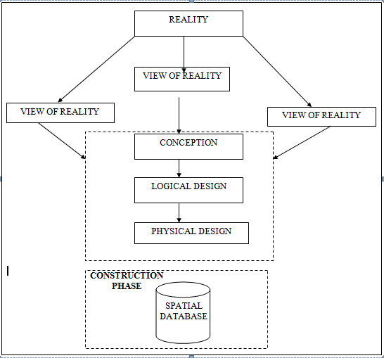

Fig.3.1Design andConstructionPhasesinSpatialDatabase

    - CONCEPTUALDESIGN

Vectordatamodelisthedatatypeadoptedforthisproject,whichisrepresented,bypoints,linesandpolygon. Theidentifiedentities are: -
      - GreenReserve(polygon)

      - Roads(line)

      - Electricpoles(point)

      - Trees(point)

      - Buildings(polygon)

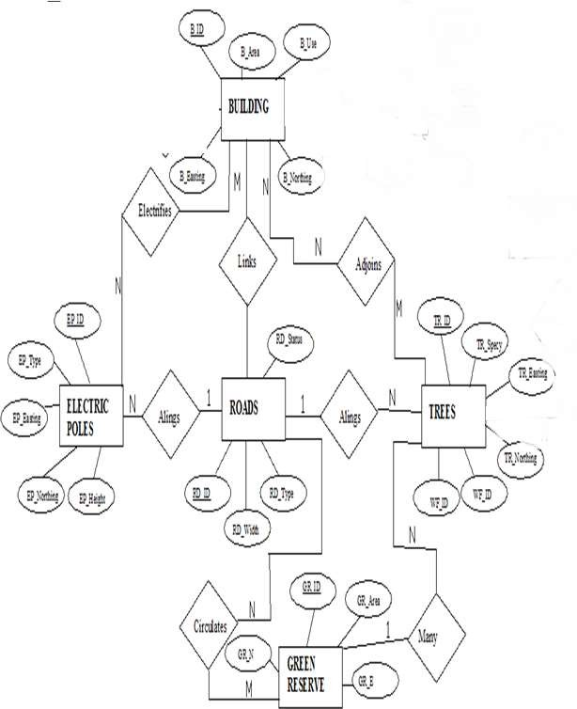

Fig.3.1.2.1:E-RDiagram(Entityrelationship diagram)

    - LOGICALDESIGN

The design phase of the database involves developing a conceptual framework that defines the structure and organization of spatial data within the system. This includes identifying data elements, establishing their relationships, and setting rules for data manipulation and analysis. During this phase, entities, their attributes, and their relationships are represented in a consistent and uniform format—typically as relations—ensuring no loss of information and avoiding unnecessary data duplication. In this study, a logical database design approach is used to create a geo-relational database structure. Each entity is assigned a unique identifier, highlighted in bold. An attribute or a combination of attributes used to uniquely distinguish an entity type is referred to as an identifier.
- Building (B_ID,B_Area, B_Name,B_Easting,B_Northing)

- Roads(R_ID,R_Width,R_Type,R-Condition,R_Easting,R_Northing)

- Tree(TR_ID,TR_spp,TR_Importance,TR_Easting,TR_Northing)

- ElectricPole(EP_No,EP_Type,EP_Height,EP_Easting,EP_Northing

    - PHYSICALDESIGN

Table3.1.4.1.: Buildingand itsattribute

ENTITY | DESCRIPTION
B_ID | BuildingIdentification
BLD_name | BuildingName
B_Area | BuildingArea
BLD_COND | Building Condition
BLD_COL | Building Color

B_Easting | BuildingEasting
B_Northing | BuildingNorthings

Table3.1.4.2:Roadanditsattributes

ENTITY | DESCRIPTION
R_ID | RoadIdentifier
R_Length | RoadLength
R_Width | Road Width
R_Type | RoadType
R_Condition | RoadCondition

Table3.1.4.3:Treesanditsattributes

ENTITY | DESCRIPTION
TR_ID | TreeIdentifier
TR_Spp | Treespecy
TR_E | Tree_Easting
TR_N | TreeNorthing

  - RECONNAISSANCE

Thisisthepreparatorystagebeforetheexecutionofthisproject;itinvolvescollectionofavailableinformation about theproject area.
Thenecessarysteptakenforthesuccessfulexecutionoftheprojectinvolvestwostages,whichare: -
- OfficePlanning

- Fieldreconnaissance

    - OFFICEPLANNING
This phase involves gathering detailed information about the study area, testing the tools and instruments required for project execution, and outlining the necessary resources. It includes listing the equipment needed, estimating the number of days for each task, defining the procedures for carrying out each activity, and assigning responsibilities to team members based on the supervisor’s guidance and instructions.

    - FIELDRECONNAISSANCE

Thefieldreconnaissanceisthefirstvisitationtotheprojectsitetogetintimatedwiththeenvironment.
- Boundarypoints was selected

- Thedistributionoffeatureswasstudied

- Controlstobeusedwerelocated

- Methodandtypeof instrumenttobe useswasdetermined

- SubsidiarypointforGroundcontrolPointswerepickedanddefineusingnailandbottlecock
- Adiagram of the studyareawas drawn.

Fig.3.2.2.1: shows Reccediagramofthestudy area (notdrawn to scale)

  - EQUIPMENTUSED/SYSTEMSELECTIONANDSOFTWARE

    - HARDWAREUSED

- Totalstation

- 1reflectorwith atrackingrod.

- 1Tripod

- One(1)50m tape

- One(1)umbrella

- 1cutlass

- HandheldGPS

- Hammer

- Nailsandbottlecover

- Fieldbookandwriting materials

- 1-NoofPersonalComputerHP655 andits accessories

- 1-NoofHP DeskJetK7100 A3 printer

- 1-NoofHPDeskJet 1110 A4printer

    - SOFTWARECOMPONENT

- Notepad.

- MicrosoftExcel.

- AutoCAD2007

- ArcMAP10.2

- Surfer25

- MicrosoftWord.

  - INSTRUMENTTEST
To ensure data quality,the TotalStationused for thisprojectwastested for bothverticalindex and horizontal collimation errors.It was also to ascertain the efficiency and reliabilityofthe instrument. Theprocedureused isdescribed below.
    - HORIZONTALCOLLIMATIONTEST
This test was performed to verify that the line of sight was perpendicular to the trunnion axis. The Total Station was set up over a known point, with initial adjustments made for proper alignment, levelling, and focusing to eliminate parallax. A vertical target was placed 100 meters away from the instrument. To begin the test, the configuration menu was accessed by holding the menu key for about two seconds. From the main menu, the calibration sub-menu was selected, followed by the horizontal collimation test. The target was then observed and bisected, and horizontal readings were taken for both Face Left and Face Right positions. The recorded results are presented in Table 3.4.1 below.

TotalStation

REFLECTOR(TARGET)
100m

STATIONA
FairlyLevelGround
STATIONB

Fig3.4.1.1;HorizontalCollimation andVerticalIndexerrortest.

Table3.4.1.1:HorizontalCollimation Data

Station | Target | Face | HzReading | Difference | Error
A | B | L | 38˚42‟32”
 |  | R | 218˚42‟35” | 180˚00‟03” | 03”

    - VERTICALINDEXERRORTEST

This test was conducted to verify the accuracy of the vertical reading when the line of sight ishorizontal.Thedesiredmeasurementforthistestisexactlyninetydegrees(90˚),anydeviationfrom this valueis referred to asthevertical index error.

The Total Station was positioned over a specific point, and necessary temporary adjustmentswere made to ensure proper alignment and functionality. A target was placed approximately100 meters away fromthe TotalStation,and the instrumentwasaimedatthe target.Thetarget was bisected by aligning the instrument on the face left, and the corresponding readingwas recorded. Similarly, the target was then bisected on the face right, and the respectivereadingwasalso recorded.Therecordedreadingsareprovided below:

Table3.4.2.1:VerticalIndexData

InstrumentStation | TargetStation | Face | Vertical | Sum | Error
A | B | L | 90˚00‟00”
 |  | R | 270˚00‟02” | 360˚00‟02” | 02”

    - ANALYSISOFCOLLIMATIONANDVERTICALINDEXDATA

Thereadingobtainduringcalibrationwerereducedtoobtainnewcollimationandverticalerrors.
Horizontalcollimation={(FR–FL)–180}/2={(00˚00‟03”}/2=1.5”

Verticalcollimation={(FL+FR)–360}=(90˚00‟00”+270˚00‟02”)-360}=02”Theresult shows thattheinstrument is stillin good working condition.

  - CONTROLCHECK

Three control beacons (PBIL3304, PBIL3306 and NILL) were used.In order toascertain the in-situ of the control beacons, a check was carried out on them by observing theangle between them and comparing the result obtained with the computed angles from thegivingcoordinates.
The total station instrument was set on the control beacon PBIL3306. After performing allthenecessarytemporaryadjustment,thereflectorwasplacedonthecontrolbeacon PBIL3306which served as the back station. The horizontal angular reading was taken andrecorded while the instrument was on face left. The reflector was then taken to the NILL which serves as the forward station, the horizontal angle reading wasthen taken and recorded on both face left and face right. The reflector was taken back to thebackstation, the horizontal angle wasthenrecorded on face right.

Table3.5.1:Tableshowing thebackcomputationof thecontrolcoordinates

From STN | Bearing | Dist(m) | ∆N | ∆E | Northing(m) | Easting(m) | ToSTN
 |  |  |  |  | 940288.197 | 678281.701 | PBIL3306
PBIL3306 | 245°11'  30’’ | 30.242 | -12.689 | -27.451 | 940275.508 | 678254.250 | PBIL3304
PBIL3304 | 188°19'  41” | 264.560 | -261.774 | -38.320 | 940013.734 | 678215.930 | NILL

Table3..2: Tableshowingthedistanceobservationresultofthecontrolcheck

FROM | OBSERVED DISTANCE  (m) | COMPUTED DISTANCE  (m) | TO
PBIL3306 | 30.240 | 30.242 | PBIL3304
PBIL3304 | 264.559 | 11.562 | NILL

Table3..3: Tableshowing theobservation resultof thecontrol check

STN | SIGHT | FACE | OBSERVEDHZANGLE | REDUCED HZANGLE | MEAN
 | PBIL3306 | L1 | 350°22'43''
PBIL3304 | PBIL3306 | L2 | 105° 11'24'' | 245° 11'19''
 | PBIL3306 | R2 | 285° 14'13'' | 245° 11'26''
 | PBIL3306 | R1 | 170° 25'39'' |  | 245° 11'23''

Differenceinangle (observed -computed)=245°11'23''-245°11'19''

=00° 00'04''

Since the allowable accuracy (angular) of third order traverse of one station is 00° 00' 30'' andtheresultobtainedfromthecontrolcheck(00°00'04'')islessthanallowableerror.Therefore,thecontrols wereangularlyintact.

  - MONUMENTATION

The boundary of the designated area was marked using precast concrete beacons, following the clearing of necessary lines of sight. Points where the boundary changed direction were identified, excavated, and beacons were installed, leaving approximately 15 cm of each beacon exposed above ground level. The beacons were placed at intervals determined by the terrain and the nature of the boundary.
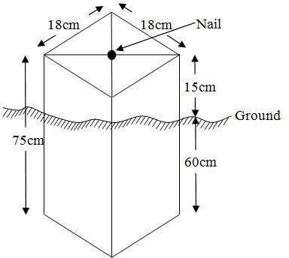

Fig.3.6.1:PillarDescription

  - DATAACQUISITION

PRIMARYDATASOURCE

Field observation was the primary source of data for this project. Ground based method wasused in acquiring data with the use of Total Station Instrument, which involved the collectionofX, Y, Z data through coordinated Ground control Points (GCP) established at conspicuouspoints within thestudyarea.

SECONDARYDATASOURCE

AnimageryoftheareawasacquiredthroughUpdatedGoogleearth;thiswasusedtoascertaintheextent ofcoverageof theproject area.

    - GEOMETRICDATAACQUISITION

The Total Station was carefully set up over control point ND20, with a back sight taken to point KW3009PT after performing the necessary station adjustments, including cantering, levelling, and focusing. The same procedure was repeated to determine the coordinates of the next point (NL1), and continued progressively until the site was reached. The radiation method was used for data acquisition, where two or more points were coordinated from a single instrument station.
The following steps outline the procedure:
i. After completing temporary adjustments, the instrument was powered on, and a new job titled GRP2B was created in the internal memory under the job menu.
ii. The coordinates of two control points were input into the instrument's memory, along with predefined feature codes such as "RD" for roads, "SP" for spot heights, and "BD" for buildings.
iii. The height of the instrument and the reflector height were measured and entered into the instrument's memory.
iv. In the coordinate menu, orientation was established by inputting the coordinates of the instrument station and back sight. The reflector at the back sight was accurately bisected before confirming the orientation.
v. Once oriented, the reflector was aimed at the next target (nail), and the "OBS" (observe) function was selected. The three-dimensional coordinates (Easting, Northing, and Height) were displayed and saved by pressing "REC" (record). For subsequent observations, the "ALL" option was used to streamline the process.
vi. It was ensured that the centre of the prism on the reflector was properly aligned and securely mounted on the tripod to minimize height determination errors.
vii. Once all visible details, including spot heights and boundary points, had been observed from the current station, the instrument was relocated to the next control nail, and the temporary adjustments were repeated.
This process was systematically carried out until all boundary points and elevation data were captured. In this project, spot heights were not recorded at regular grid intervals but were instead collected randomly. For each building, three corner points were surveyed. Upon completing the data acquisition phase, all relevant features were accurately recorded and positioned accordingly on the final site plan.
    - ATTRIBUTESDATAACQUISITION

Attribute data refers to information that describes the characteristics and properties of spatial features. It provides details such as names, classifications, and functions of geographic objects. In this study, the attribute data collected included the names and uses of buildings (e.g., classrooms), as well as information on roads, water facilities, and significant natural features such as rivers, trees, and surrounding vegetation. These attributes were accurately identified and documented within and around the study area.

  - DATADOWNLOADINGANDPROCESSING

    - DATADOWNLOADINGANDEDITING
This stage involves transferring all acquired data, which were automatically stored in the Total Station, to a personal computer. The data download was carried out using a connecting cable and supported by compatible software installed on the computer to facilitate the transfer and management of the data.

    - DATAPROCESSINGANDDATAEDITING

The downloaded geometric data were further processed to convert them into usable formats and improve their accuracy. The resulting coordinate data were edited and exported in multiple formats, including .txt, .xls, and .pdf. These files were then imported into ArcGIS 10.3 for additional processing and to perform spatial analysis.

    - DATAPROCESSINGUSINGAUTOCAD 2007
Before using AutoCAD, we processed the coordinate data observed in the field by first transferring it into Notepad, then copying it into AutoCAD. The following steps outline the process for handling the data in AutoCAD:
- Launch AutoCAD on the computer.
- Click "New" from the application menu to start a new drawing.
- Type UNITS in the command line and press Enter.
- Select the desired unit type (e.g., decimal, architectural, engineering).
- In the menu bar, select the "Polyline" tool.
- Copy the data from Notepad and paste it into AutoCAD.
- Type Z (for zoom) and press Enter, then type E (for extents) and press Enter to adjust the view.

    - DATAPROCESSINGUSINGARCGIS10.3
ArcGIS, AutoCAD was used to plot feature data, saving them separately in different files such as roads, boundary lines, buildings, and trees.
To load and process this data in ArcGIS 10.3, follow these steps:
- Launch ArcMap in ArcGIS 10.3.
- When the dialog box appears, click on "A NEW EMPTY MAP" to start a new project.
- Click on "Tools" in the menu bar, then select "Extensions." Mark all extensions and click "Close."
- On the left-hand side (LHS), right-click on "Layers" and select "Properties."
- In the "Layer Properties" window, click on the "Coordinate System" tab to set the projection system to "Minna Datum Zone 31N." Then, go to the "General" tab to set the units and click "Apply," followed by "OK."
- On the toolbar, click "Add Data," select all the saved AutoCAD files, and load them into the "Table of Contents" layer section.

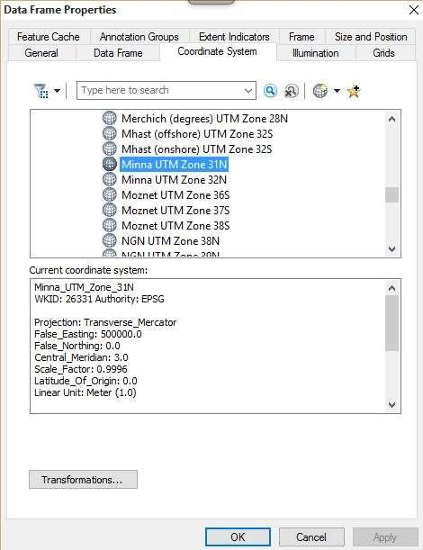
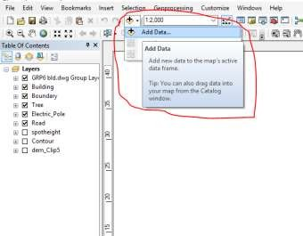

All drawings were exported to a shapefile. Once the feature class was created, click on the "Editor" button to start editing, then select "Start Editing" to load the object.

Creating Contours:
- First, create a Digital Elevation Model (DEM) by searching for "INTERPOLATION > NATURAL NEIGHBOR" in the search icon. Select the XYZ data to create the DEM, using the boundary line as the extent.
- To create contours, enable the Spatial Analyst Toolbar by going to Customize > Toolbars > Spatial Analyst, or you can open the search bar by clicking on Windows > Search or using the search icon.

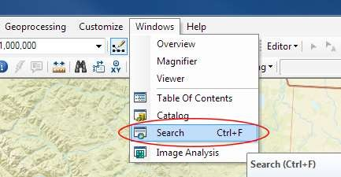

Inthesearchbartype Contour,andselect Contour(SpatialAnalyst) fromthesearchresultslist.
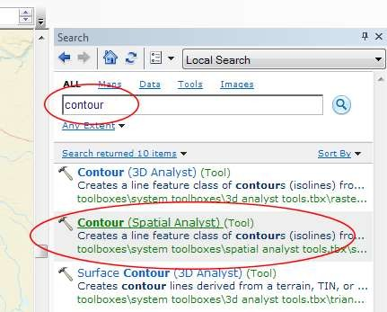

After selecting Contour, a dialog window will appear, prompting you to set the following five parameters:
- Input Raster: Select the DEM file from which you want to generate contours. You can either locate it on your hard drive or choose it from the dropdown menu that shows layers present in the Table of Contents.
- Output Polyline Features: Specify the location where you want to save your output contours.
- Contour Interval: Set the distance between contour lines in meters. A smaller interval results in more contour lines. For example, setting a contour interval of 10 meters will create more frequent contour lines compared to a 50-meter interval.
- Base Contour (Optional): Define the starting point from which the contours will be generated. The default is 0, so with a 25-meter interval, the contours will be generated at 25, 50, 75, 100, and so on. If the base contour is set to 40, the contours will be generated at 65, 90, 115, 140, etc.
- Z Factor (Optional): Adjusts the vertical scale of the data. For example, if your data is in meters and you want to display contours in feet, use a Z-factor of 3.28 (since 1 meter = 3.28 feet).

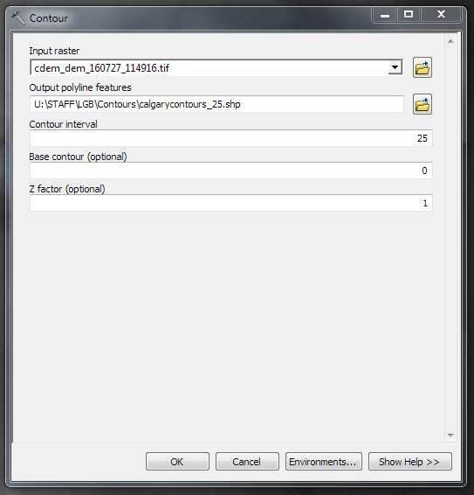

Thegeneratedcontourswill automaticallybe added tothemap.
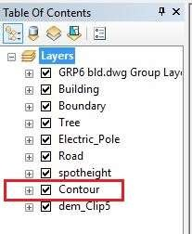

- Input Data: Load the AutoCAD drawing and select the feature type you want to import.
- Click "Add": Click "Next" to proceed, then choose the Target Layer where the feature will be loaded.
- Load Data: Import the data from the feature class that was created in ArcGIS.
- Query the Feature: Click "Next" and select "Only the features that satisfy the query." Then, click on Query Builder to create a query for the feature you want to load, for example: "layer" = 'Boundary'.
- Finish Setup: Click "Next" and then "Finish" to complete the process.
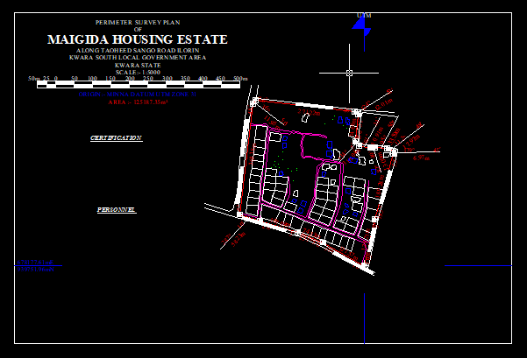
- View the Feature: Right-click on the Boundary layer in the Table of Contents and click Zoom to Layer to display the feature on the map.

Editing, Converting, and Merging Geodatabase
- Removing Features:
  - To remove unnecessary features, right-click on the feature and select Remove.
- Converting Features:
  - If features are not correctly classified (e.g., points, lines, polygons), they need to be converted to the appropriate feature type.
- Converting a Geodatabase Feature Class:
  - For Converting Line Feature Class to Polygon Feature Class:
    - Go to Window on the menu bar and select Arc Toolbox.
    - In Arc Toolbox, select Data Management Tools, then Features, and click on Feature to Polygon.
    - In the Input Features section, select the feature you want to convert. In the Output Feature Class, specify the location (e.g., save in the GRP6C folder), and click OK.
    - After the conversion, remove the feature class from both the Layer Menu and ArcCatalog.
- Merging Feature Classes:
  - To merge multiple feature classes:
    - In Input Datasets, select the features you wish to merge.
    - In Output Datasets, specify where to save the merged file (e.g., in the GRP6C folder), and click OK.
    - After the merge is complete, remove the merged feature class from both the Layer Menu and ArcCatalog.

Table Creation
- Creating Attribute Tables:
  - Attribute tables are essential for performing queries. Ensure that Editing is stopped before adding fields to the table.
- Steps to Add Fields:
  - Right-click on the feature class and select Open Attribute Table.
  - Click on Options and select Add Field.
  - In the Field Name section, give the field a name.
  - In the Type dropdown, select the appropriate type:
    - Short Integer or Long Integer for whole number variables.
    - Double for decimal variables.
    - Text for text variables.
    - Date for date variables.
  - For Text fields, set the Length (e.g., text width), and for Decimal fields, set the Scale (decimal places). Click OK.
- Inputting Data into the Attribute Table:
  - To input data, go to the Editor menu on the menu bar and select Start Editing.
  - Click on Attributes on the menu bar (behind the Target).
  - Select the features in the Data View Display and input the required variables, which may come from social surveys or field data.
  - Once the data is entered, click Save Edits in the Editor menu.
  - To switch between layers, select Stop Editing from the Editor menu.
  - Repeat the steps above to create additional fields and populate the table, then save the edits.

Table3.8.3.1: Building

ENTITY | FIELDALIAS | DATATYPE | FIELDSIZE
B_ID | BuildingIdentification | Numeric | -
B_name | BuildingName | Text | 14
B_Area | BuildingArea | Numeric | -
B_E | BuildingEasting | Numeric | -
B_Northing | BuildingNorthings | Numeric | -

Table3.8.3.2:Road

ENTITY | FIELDALIAS | DATATYPE | FIELDSIZE
R_ID | RoadIdentifier | Numeric | -
R_Length | RoadLength | Numeric | -
R_Width | Road Width | Numeric | -
R_Type | RoadType | Text | 14
R_Condition | RoadCondition | Text | 14

Table3.8.3.3:Trees

ENTITY | FIELDALIAS | DATATYPE | FIELDSIZE
TR_ID | TreeIdentifier | Numeric | -
TR_Spp | Treespecy | Text | 14
TR_E | Tree_Easting | Numeric | -
TR_N | TreeNorthing | Numeric | -

Table3.8.3.4:ElectricPoles

ENTITY | FIELDALIAS | DATATYPE | FIELDSIZE
EP_ID | ElectricpoleIdentifier | Numeric | -
EP_Type | ElectricpoleType | Text | 14
EP_Height | ElectricpoleHeight | Numeric | -
EP_E | ElectricpoleEasting | Numeric | -
EP_N | ElectricpoleNorthing | Numeric | -

ADDINGSPOTHEIGHTSDATA

- NOTE:STOPEDITINGontheEDITORMENU before addingdatafield,

- GotoFIELD ONTHE MENUBAR,scrolltoaddDataandthenADDXYZDATA

- BrowsetheEXCELFILEforSPOTHEIGHTS,selectEASTINGVALUEonX-FIELD andNORTHINGVALUEon Y-IELD andELEVATION
- « Select DATA the EXPORT DATA, locate the folder created and give it name thenYESANDOK,removethepreviouslayerbyrightclickingonitandselectREMOVE.

TIN,ASPECTANDSLOPECREATIONUSINGARCMAP
Tin has a wide range of uses due to its versatility. It is primarily used for tin plating to protect other metals from corrosion, in soldering for joining electrical components, and as an alloy in various applications like bronze and pewter. It also plays a role in the chemical industry and battery production.
NOTE:Makingsurethe3DAnalystExtensionisactive,selectVIEWonMENUbar,thenclickTOOLBARS andMARK the3DAnalyst EXTENTION Then X,YData

TOCREATE TIN

- Clickon3DAnalystarrow,selectcreateTINandthencreateTIN fromFEATURE.

- OnlayersmarktheSPOTHEIGHT LAYER,selectheightdataonHEIGHT,thenok.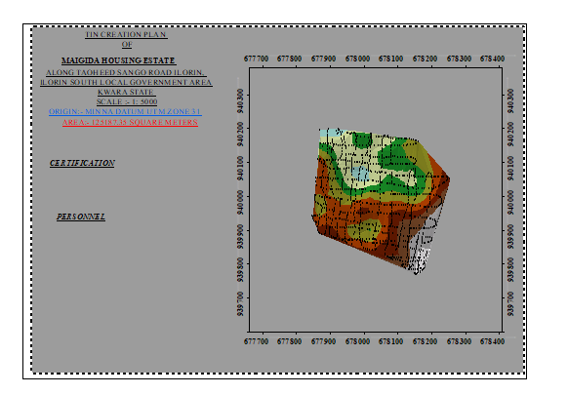

TOCHANGETHEFACEOF THETINACCODINGTOITSELEVATION

- RIGHTCLICKontheTIN,selectPROPERTIES,andclickonSYMBOLOGY.

- Then ADD, select FACE ELEVATION WITH COLOR RAMP, click ADD, and thenselectAPPLYand OK.

TOCREATE ASPECT

Slope aspect, which refers to the compass direction a slope faces, has several important applications. It influences sunlight exposure, temperature, soil moisture, vegetation, and even wildlife distribution, making it crucial for various fields like agriculture, forestry, and ecology. Understanding aspect helps in making informed decisions about land use, resource management, and understanding environmental processes. This is the step we used to create slope slopeaspet
- Click on 3D analyst arrow, select SPATIAL ANALYST TOOLS, SURFACE andTHENDOUBLE CLICKon ASPECT.
- Browse to where the raster format of all the acquired data created from the surfer wassavedto.
- BrowsetowhereyouwanttheOUTPUTRASTERtobesaved

- Youcanchangethe OUTPUTMEASUREMENTtoDegree ORpercent

- ClickOK[then itdisplays onthedata viewscreen], thenClose.

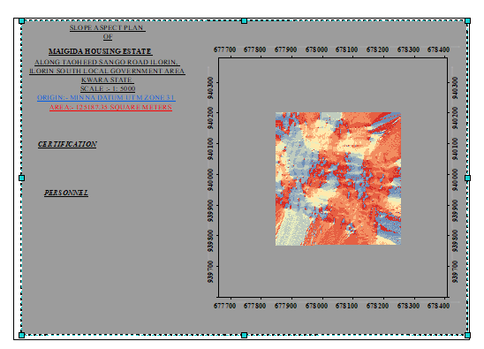
  - DATABASEIMPLEMENTATION
This phase involves the creation of the database. After completing the three stages of the design process—Reality, Conceptual, and Logical design—the database was established using ArcGIS 10.3 software. This process combines and stores both the acquired graphical data and attribute data, facilitating spatial analysis and queries.
A database is an organized, integrated collection of data stored in a way that allows it to be accessed by relevant applications. The data is structured so it can be retrieved by different logical components. After populating the attribute table through manual input, certain attributes, such as the areas of settlements, were automatically displayed using specific commands in ArcGIS 10.3. The software was then used to link the graphical data with the attribute table, enabling query generation.
    - DATABASEMANAGEMENTSYSTEMS
Database management refers to a collection of software used for creating, storing, manipulating, updating, organizing, and querying information within a database (Kufoniyi, 1998). It is a software system designed to manage and manipulate a database on behalf of the user.
A good Database Management System (DBMS) should provide the following essential functions:
a. Storage and Retrieval of Data: Efficient storage and retrieval of data within the database.
b. Concurrent Access: The ability to allow multiple users to access the database simultaneously without compromising data integrity.
c. Standardized Interface: A standardized interface between the database and application programs, enabling seamless integration and communication.
d. Separation of Data Functions: Standardized access to data, with a clear separation of the data storage and retrieval functions from the applications using the data.
e. Data Security and Integrity: Ensuring the security and integrity of the data, protecting it from unauthorized access, corruption, and loss.

3.9.2 Database Maintenance
Once the database is created, it is essential to perform proper maintenance to ensure it meets its intended objectives. Regular maintenance allows for the inclusion of new data and the removal of irrelevant or outdated data. Since physical changes can occur in the landscape over time, it is crucial that the database is updated frequently to reflect these changes.
Both data security and integrity are integral aspects of maintenance, ensuring that the database remains reliable and functional. Proper database management, including regular updates and consistent monitoring, helps to maintain its currency and quality, which is essential for effective use in a Spatial Decision Support System (SDSS). The quality of a database is determined by its timeliness and its fitness for use as part of a decision support system (DSS).
The storage media used for the database must be periodically assessed to prevent potential issues such as data inaccessibility or the physical deterioration of the media. Additionally, careful attention should be paid during data entry, as the integrity of the database is only as good as the quality of the data provided. For archiving purposes, stable and durable storage media should be employed, such as:
- Computer-compatible tape readers
- Magnetic tape
- Optical discs and compact discs

CHAPTERFOUR

  - SPATIALANALYSESANDPRESENTATION

GIS stands out from other information systems due to its spatial analytical capabilities, which include overlay operations, buffering, spatial search, topographic analysis, and neighbourhood and connectivity operations. These features allow GIS to address key generic questions related to location, condition, trends, routing, patterns, and modelling by manipulating and analysing input data. In this project, the primary analyses performed were overlay operations, topographic operations, and spatial search.

  - TESTINGOF DATABASE

This test was conducted to determine whether a relationship exists between the data modeled about entities in the spatial database and to assess its retrieval capabilities. The test involved designing a sample query with specific conditions, which was then executed to verify if the desired results were achieved.

Analysisof Result
The contour with a value greater than or equal to 350 meters indicates areas that are less likely to be prone to flooding within the project area, as shown in Fig. 4.5 (Query 1). This contour represents the elevation of points above 350 meters. The displayed attribute table confirms that the north-eastern part of the institute has the highest elevation. Elevation is a critical factor when assessing the surface or slope of the terrain. Conversely, the southwestern part of the school has the lowest elevation and is highly susceptible to erosion. Buildings constructed in this region must have elevated foundations to protect them from potential damage. The results of this query will help the school management make informed decisions about the terrain characteristics and guide them in choosing the appropriate type of construction for each area of the project site, considering the unique terrain conditions.
SINGLESELECTIONCRITERION
Query1: Shows theretrievingAreawhoseheightisGreaterthan310meters

SELECT* FROM Contour WHERE "CONTOUR">310

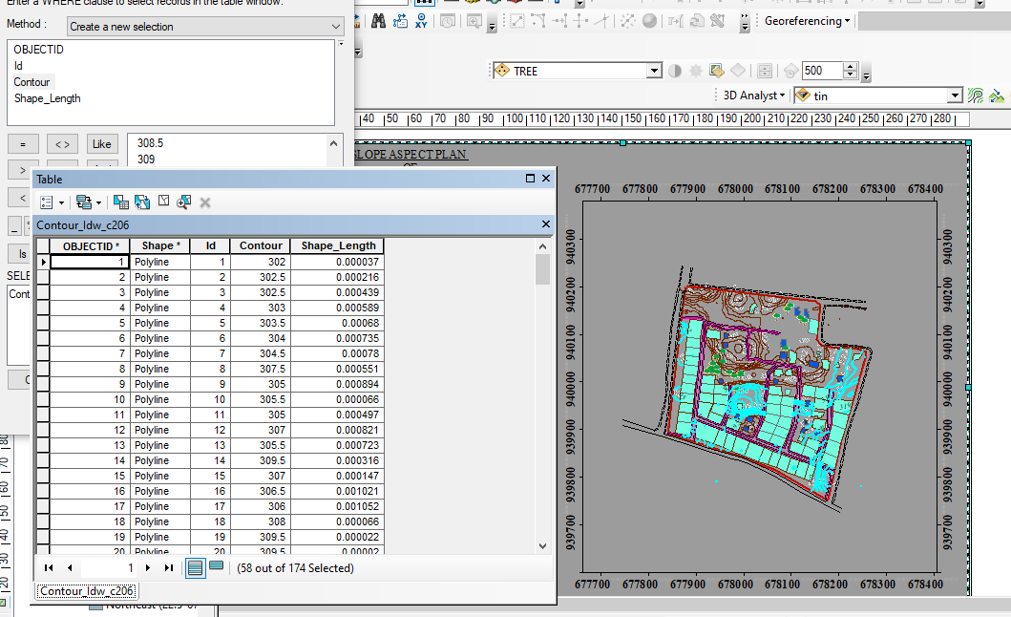

Fig4.1.1:Shows the retrievingAreawhoseheightisgreaterthan310meters
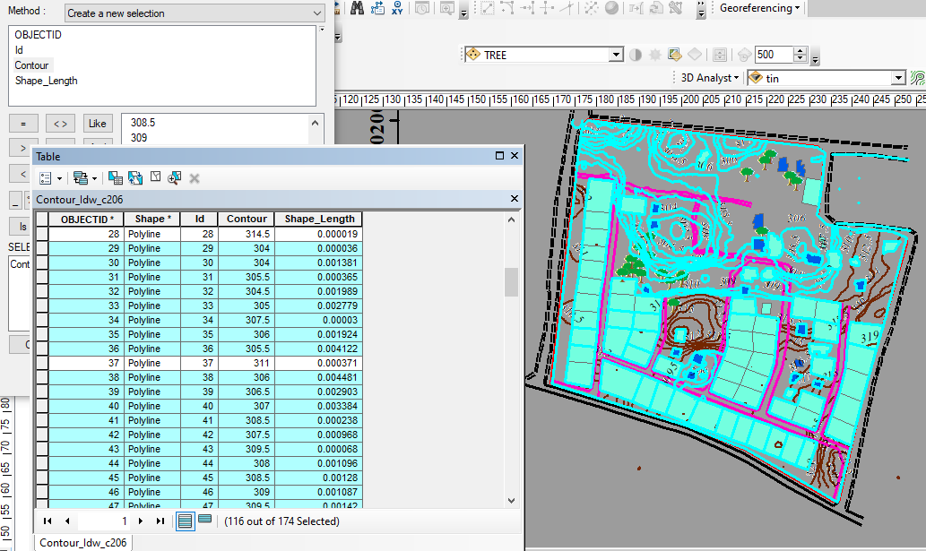

Fig4.1.2: Shows the resultof area whose heightisgreaterthan310 meters
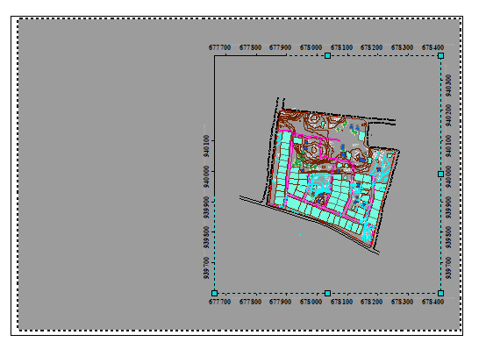

Fig4.1.3:Show the resultof areawhoseheightisgreaterthan310 meters
The displayed attribute table confirmed that all the contours are selected is greater than 310 meters and this area is the place that have highest heights. It improved data filtering, enhanced data analysis and effective visualization.

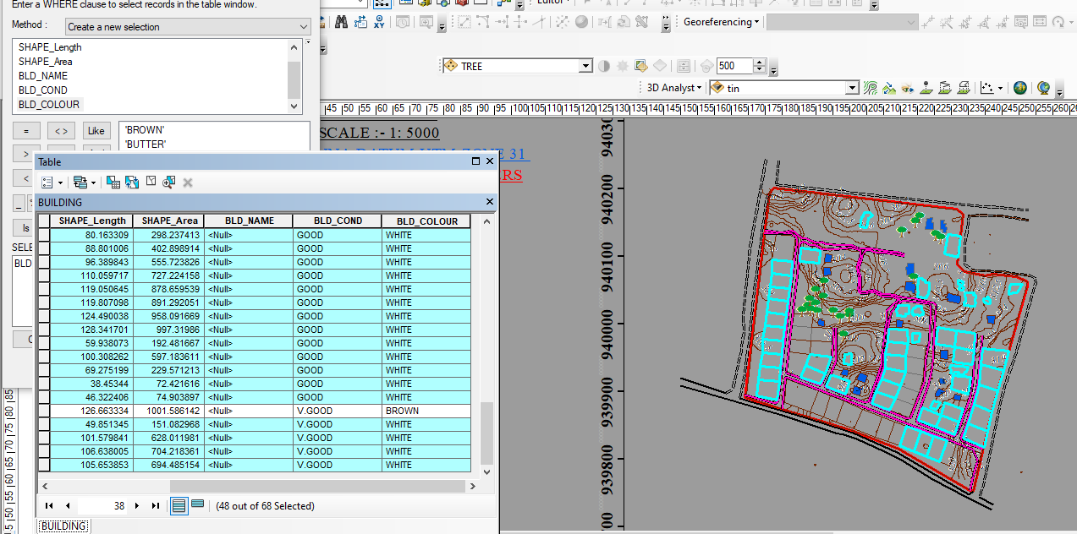

Fig4.1.4Query Shows the resultofBuildingsthat painted in white colorfor(BLD_COLOUR = 'WHITE')
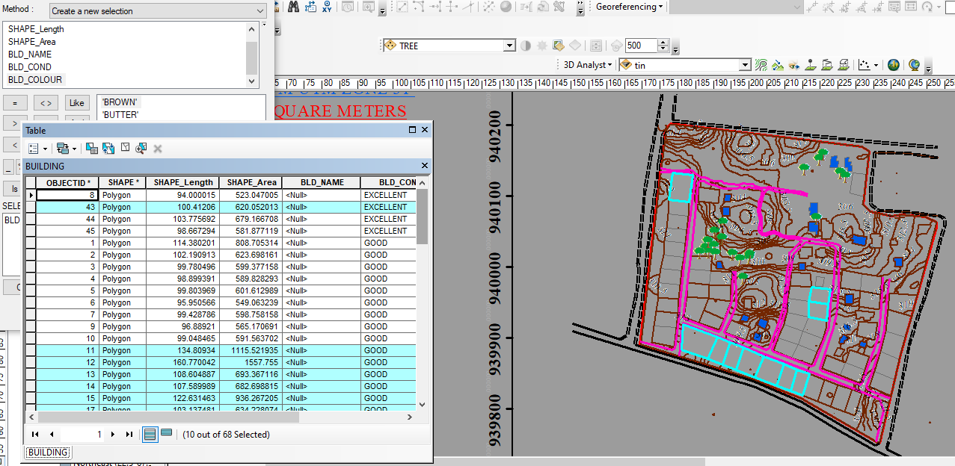

Fig4.1.5QueryShows the resultofBuildingsthat painted in brown color (B_NAME = 'BROWN')
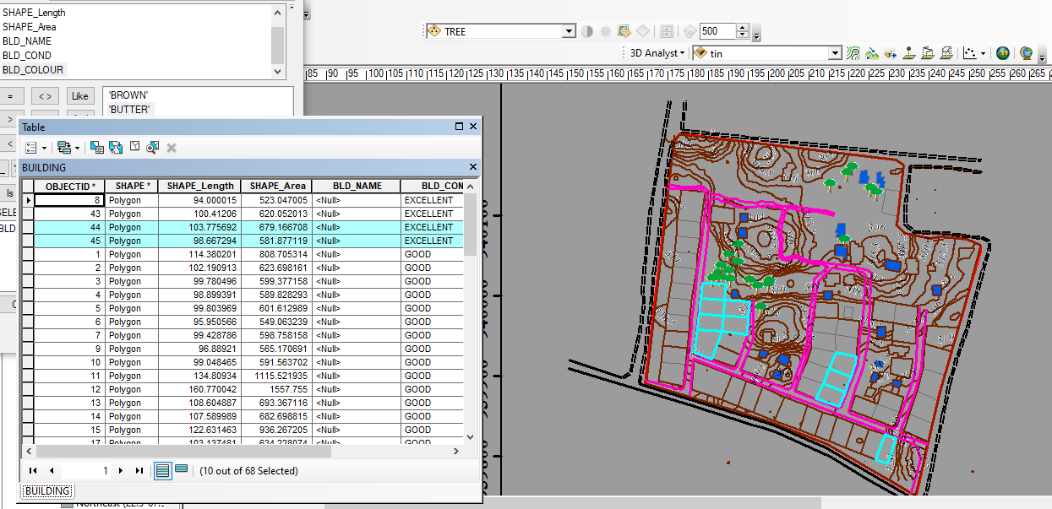

Fig4.1.6QueryShows the resultofBuildingsthat painted in butter color (B_NAME = 'BUTTER')
The total number of building that painted in white color in this category are 57, the building that painted in butter color is 10 and the building painted brown are also ten while some of it are not painted.

CHAPTER FIVE
5.0 COSTING, PROBLEMS ENCOUNTERED, RECOMMENDATION AND CONCLUSION
5.1 COSTING
The costing of this project was done using the Nigeria Institution of Surveyor's (NIS) professional scale of fees for consultant in the construction industry. This stage shows the total cost that was spent on the project from day one to the final stage.
5.1.1 RECCI
PERSONAL/QUALITY | DAY(S) | UNITRATE(N) | TOTAL AMOUNT(N)
Principal surveyor | 1 | 18,000.00 | 18,000.00
Senior Surveyor | 1 | 15,000.00 | 15,000.00
Assistant Surveyor | 1 | 8,000.00 | 8,000.00
Transportation | 1 | 7,000.00 | 7,000.00
Basic Equipment | 2 | 10,000.00 | 20,000.00
TOTAL |  |  | #68,000.00

5.1.2 BEACON= 5,000 × 4
= #20,000

5.1.3 BEACONING
PERSONAL/QUALITY | DAY(S) | UNITRATE(N) | TOTALAMOUNT(N)
1Assistant Surveyor | 2 | 8,000.00 | 16,000.00
Unskilled Labor | 2 | 5,000 | 10,000
Basic Equipment(6) | 1 | 10,000.00 | 10,000.00
Transportation | 1 | 7,000.00 | 7,000.00
TOTAL |  |  | #43,000.00

5.1.4 TRAVERSING
PERSONAL/QUALITY | DAY(S) | UNITRATE(N) | TOTALAMOUNT(N)
Senior Surveyor | 2 | 15,000.00 | 30,000.00
Assistant Surveyor | 2 | 8,000.00 | 16,000.00
Basic Equipment | 2 | 10,000.00 | 20,000.00
Transportation | 2 | 7,000.00 | 7,000.00
TOTAL |  |  | #73,000.00

5.1.5 TOPOGRAPHY
PERSONAL/QUALITY | DAY(S) | UNITRATE(N) | TOTALAMOUNT(N)
Senior Surveyor | 2 | 15,000.00 | 30,000.00
Assistant Surveyor | 2 | 8,000.00 | 16,000.00
Basic Equipment | 2 | 10,000.00 | 20,000.00
Transportation | 2 | 7,000.00 | 14,000.00
TOTAL |  |  | #80,000.00

5.1.6 DOWNLOADING DATA AND PLOTTING
PERSONAL/QUALITY | DAY(S) | UNITRATE(N) | TOTALAMOUNT(N)
Pricipal surveyor | 1 | 18,000.00 | 18,000.00
Senior Surveyor | 2 | 15,000.00 | 30,000.00
AssistantSurveyor | 2 | 8,000.00 | 16,000.00
Transportation | 2 | 7,000.00 | 14,000.00
Computers accessaries | 2 | 15,000.00 | 30,000.00
M I S | 2 | 15,000 | 30,000
TOTAL |  |  | #138,000.00
5.1.7 INFORMATION PRESENTATION
PERSONAL/QUALITY | DAY(S) | UNITRATE(N) | TOTALAMOUNT(N)
Principal surveyor | 1 | 18.000 | 18,000.00
Basic Equipment | 1 | 10,000.00 | 10,000.00
Logistics | 1 | 10,000 | 10,000
Transportation | 1 | 7,000.00 | 7,000.00
TOTAL |  |  | #45,000.00

(1) # 68,000.00
(2) # 20,000.00
(3) # 43,000.00
(4) # 73,000.00
(5)#80,000.00
(6) # 138,000.00
(7) # 45,000.00
TOTAL # 467,000.00
5.1.7 CONSTIGENCIES=5%
467,000.00×5%÷ 100
=#23,350
5.1.8 V. A. T = 7.5%
467,000.00×7.5%÷100
= #35,025
MOBILIZATION AND DEMOBILIZATION =10%
467000 × 10%. ÷ 100
= #46,700
5.1.10 ACCOMODATION = 1.5%
467,000.00 ×1.5%÷100
= 7,005
TOTAL = 467,000.00
23,350
35,025
46,700
7,005
GRAND TOTAL = 579,080

PROBLEM ENCOUNTERED, SUMMARY, CONCLUSION, RECOMMENDATIONS
5.1PROBLEM ENCOUNTERED
The following area the problem we encountered when carrying out the field works
- Unfavorable weather condition.
- Difficult in communication with each other because of the relatively far distance between the instrument man and the pole man.
- The movement of the students and cars in the school premises also hindered the observation to the pole a title bit.

5.2SUMMARY
The main aim of this project was to create a topographical information system of Part of magida housing estate sango Kwara StateIlorin, Moro Local Government Area, Kwara State, Nigeria. It was done in accordance with the rules and regulation and the supervisor instruction. A ground surveying method was used for the data acquisition, processed with AutoCAD 2007 and CivilCAD 2014 with other software’s and the aim of the project was achieved at the end of the project
5.3 CONCLUSION
The aim and objectives of this project were achieved to its fullest, since the results obtained were all within the limits of permissible accuracies.
Meanwhile, it is quite important to mention that, all the observations and measurements were made in total conformity with survey rules and regulations and supervisor instructions and guidance. The Perimeter and Topographical Information provided for Partof magida housing estate sango Kwara State , Ilorin Moro Local Government Area, Kwara State was successfully carried out.
Conclusively, these plans will be useful as source of information for planning a purpose for the designing and future construction of the proposed structures for vacant space and re-construction.

5.4 RECOMMENDATION
Sequel to the experience acquired during the course of the project and the need to provide an atmosphere for improvement in the execution of similar project in future, the following recommendations are proffered:
- That the school authority should look at the sufficient way of maximizing the use of landfor severe environment for both the Staff and the Students.
- The school authority should use the database created for the study area for proper monitoring of structures, erosion control and landscaping.
- The project is subjected to review and can be use as a model

APPENDIX
PT296 | 678034.610 | 940067.109 | 288.552
PT297 | 678051.525 | 940067.109 | 185.681
PT298 | 678068.440 | 940067.109 | 297.702
PT299 | 678085.355 | 940067.109 | 339.568
PT300 | 678102.270 | 940067.109 | 95.652
PT301 | 678119.185 | 940067.109 | 85.153
PT302 | 678136.100 | 940067.109 | 192.204
PT303 | 678153.015 | 940067.109 | 208.123
PT304 | 678169.931 | 940067.109 | 278.798
PT305 | 678186.846 | 940067.109 | 243.119
PT306 | 678203.761 | 940067.109 | 296.789
PT307 | 678220.676 | 940067.109 | 281.625
PT308 | 678237.591 | 940067.109 | 282.376
PT309 | 677865.459 | 940085.154 | 131.641
PT310 | 677882.374 | 940085.154 | 181.302
PT311 | 677899.290 | 940085.154 | 102.162
PT312 | 677916.205 | 940085.154 | 68.618
PT313 | 677933.120 | 940085.154 | 74.314
PT314 | 677950.035 | 940085.154 | 99.768
PT315 | 677966.950 | 940085.154 | 157.085
PT316 | 677983.865 | 940085.154 | 164.301
PT317 | 678000.780 | 940085.154 | 212.636
PT318 | 678017.695 | 940085.154 | 212.145
PT319 | 678034.610 | 940085.154 | 261.402
PT320 | 678051.525 | 940085.154 | 185.167
PT321 | 678068.440 | 940085.154 | 209.625
PT322 | 678085.355 | 940085.154 | 178.661
PT323 | 678102.270 | 940085.154 | 207.028
PT324 | 678119.185 | 940085.154 | 213.521
PT325 | 678136.100 | 940085.154 | 174.566
PT326 | 678153.015 | 940085.154 | 195.951
PT327 | 677865.459 | 940103.199 | 190.069
PT328 | 677882.374 | 940103.199 | 67.865
PT329 | 677899.290 | 940103.199 | 90.745
PT330 | 677916.205 | 940103.199 | 55.045
PT331 | 677933.120 | 940103.199 | 51.381
PT332 | 677950.035 | 940103.199 | 180.395
PT333 | 677966.950 | 940103.199 | 147.717
PT334 | 677983.865 | 940103.199 | 135.039
PT335 | 678000.780 | 940103.199 | 171.308
PT336 | 678017.695 | 940103.199 | 212.308
PT337 | 678034.610 | 940103.199 | 258.797
PT338 | 678051.525 | 940103.199 | 241.847
PT339 | 678068.440 | 940103.199 | 183.679
PT340 | 678085.355 | 940103.199 | 177.607
PT341 | 678102.270 | 940103.199 | 198.430
PT342 | 678119.185 | 940103.199 | 211.586
PT343 | 678136.100 | 940103.199 | 215.438
PT344 | 678153.015 | 940103.199 | 206.246
PT345 | 677882.374 | 940121.244 | 47.971
PT346 | 677899.290 | 940121.244 | 54.162
PT347 | 677916.205 | 940121.244 | 95.419
PT348 | 677933.120 | 940121.244 | 91.436
PT349 | 677950.035 | 940121.244 | 278.431
PT350 | 677966.950 | 940121.244 | 264.827
PT351 | 677983.865 | 940121.244 | 179.812
PT352 | 678000.780 | 940121.244 | 222.810
PT353 | 678017.695 | 940121.244 | 207.351
PT354 | 678034.610 | 940121.244 | 284.207
PT355 | 678051.525 | 940121.244 | 292.422
PT356 | 678068.440 | 940121.244 | 276.493
PT357 | 678085.355 | 940121.244 | 181.216
PT358 | 678102.270 | 940121.244 | 230.653
PT359 | 678119.185 | 940121.244 | 249.254
PT360 | 678136.100 | 940121.244 | 271.772
PT361 | 678153.015 | 940121.244 | 320.173
PT362 | 677882.374 | 940139.289 | 333.123
PT363 | 677899.290 | 940139.289 | 55.251
PT364 | 677916.205 | 940139.289 | 48.110
PT365 | 677933.120 | 940139.289 | 109.353
PT366 | 677950.035 | 940139.289 | 224.489
PT367 | 677966.950 | 940139.289 | 221.813
PT368 | 677983.865 | 940139.289 | 214.569
PT369 | 678000.780 | 940139.289 | 175.177
PT370 | 678017.695 | 940139.289 | 180.301
PT371 | 678034.610 | 940139.289 | 183.244
PT372 | 678051.525 | 940139.289 | 326.351
PT373 | 678068.440 | 940139.289 | 305.327
PT374 | 678085.355 | 940139.289 | 19.655
PT375 | 678102.270 | 940139.289 | 282.533
PT376 | 678119.185 | 940139.289 | 233.611
PT377 | 678136.100 | 940139.289 | 253.374
PT378 | 678153.015 | 940139.289 | 1.193
PT379 | 677882.374 | 940157.334 | 49.846
PT380 | 677899.290 | 940157.334 | 18.110
PT381 | 677916.205 | 940157.334 | 50.891
PT382 | 677933.120 | 940157.334 | 207.829
PT383 | 677950.035 | 940157.334 | 130.080
PT384 | 677966.950 | 940157.334 | 226.732
PT385 | 677983.865 | 940157.334 | 170.815
PT386 | 678000.780 | 940157.334 | 147.876
PT387 | 678017.695 | 940157.334 | 114.015
PT388 | 678034.610 | 940157.334 | 137.138
PT389 | 678051.525 | 940157.334 | 15.443
PT390 | 678068.440 | 940157.334 | 318.436
PT391 | 678085.355 | 940157.334 | 332.768
PT392 | 678102.270 | 940157.334 | 326.663
PT393 | 678119.185 | 940157.334 | 322.009
PT394 | 678136.100 | 940157.334 | 321.076
PT395 | 678153.015 | 940157.334 | 343.335
PT396 | 677882.374 | 940175.379 | 20.482
PT397 | 677899.290 | 940175.379 | 347.355
PT398 | 677916.205 | 940175.379 | 23.413
PT399 | 677933.120 | 940175.379 | 337.876
PT400 | 677950.035 | 940175.379 | 295.959
PT401 | 677966.950 | 940175.379 | 304.409
PT402 | 677983.865 | 940175.379 | 229.221
PT403 | 678000.780 | 940175.379 | 90.484
PT404 | 678017.695 | 940175.379 | 61.952
PT405 | 678034.610 | 940175.379 | 69.365
PT406 | 678051.525 | 940175.379 | 42.232
PT407 | 678068.440 | 940175.379 | 298.995
PT408 | 678085.355 | 940175.379 | 297.031
PT409 | 678102.270 | 940175.379 | 285.812
PT410 | 677882.374 | 940193.424 | 357.454
PT411 | 677899.290 | 940193.424 | 351.067
PT412 | 677916.205 | 940193.424 | 340.130
PT413 | 677933.120 | 940193.424 | 323.310
PT414 | 677950.035 | 940193.424 | 289.041

REFERENCES
Adesina, A.A (2009): Geographic/Land Information System Principle and Application. 1st published, Fakodemo press, Lagos, Nigeria.
Burrough, P.A (1986): Principles of Geographic Information for Land resources Assessment, Oxford University press
Carter, J.R (1989): on defining the Geographic Information System in W.J Ripple(ed) Fundamentals of GIS: A compendium, ASPRS/ACSM, Falls Church, Pp 3-7.
Calkins, L. and Tomhnson, F. (1977) in Adeniran, O. (2000): Geographic Information System (GIS) Application, Lecture delivered during the training organized by the Resources Development Department, Federal School of Surveying, Oyo, Nov-Dec 2000, unpublished, Pp215,221-222.
Chandra A.M (2008): Higher Surveying, Revised Second Edition, New Age International (p) Limited, Publishers. New Delhi, www.newagepublishers.com Pp2-3
Hardon Y.J (2003): Fundamentals of Geographic Information System, 2nd edition, John Wiley & sons, New York, Pp 7-9
Ghilani C.D and Wolf P.R (2008): Elementary Surveying, An Introduction to Geomatics, Twelfth edition, Pearson Education Inc., Upper Saddle River, New Jersey, Pp 1
Kraus, B.F (2000): Topographic Information System, downloaded from www.pf.tuwien.ac.at/fr/buildi.g/didd/node41.html 2000, Pp 1-2
Kraus F. (2000): Topographic Information System wichmemm verlag, Heidelberg, Pp 1-8
Kufoniyi O. (1998): Database Design and creation in C.U Ezeigbo (Edited), Principles and Application of Geographic Information System, series in Surveying and Geo informatics 1st Edition Department of Surveying Oyo. Pp 45
Oyinloye R.O (2002): Topographical Database Management System for National Development, paper presented at the NIS 37th Annual General Meeting and Conference (Imo), Tuesday 7th of May to 10th May 2002, Pp1
Smith T.R Menon, Starr and Estes J. (1987): Requirements and principles for the Implementation and construction of large scale GIS, International Journal of GIS 1, 1987, Pp 13-31.

