DESIGN AND IMPLEMENTATION OF STUDENT PROJECT ALLOCATION SYSTEM USING ANT-BEE COLONY ALGORITHM

BY

OYEBAMIRE KEHINDE OYEBANJI
ND/23/COM/PT/0170

SUBMITTED TO THE DEPARTMENT OF COMPUTER SCIENCE,
INSTITUTE OF INFORMATION AND COMMUNICATION TECHNOLOGY
KWARA STATE POLYTECHNIC, ILORIN.

IN PARTIAL FULFILLMENT OF THE REQUIREMENTS FOR THE AWARD OF NATIONAL DIPLOMA (ND) IN
COMPUTER SCIENCE

JUNE, 2025.

CERTIFICATION
This is to certify that this project was carried out by OYEBAMIRE KEHINDE OYEBANJI with the matriculation Number: ND/23/COM/PT/0170 has been read and approved as meeting parts requirements for the award of National Diploma (ND) in Computer Science Department, Institute of Information Communication Technology, Kwara State Polytechnic, Ilorin, Kwara State.

…………………………………. ….………………………
MR OLAJIDE A.T Date
Project Supervisor

…………………………………. ….………………………
MR OYEDEPO F.S Date
Head of Department

…………………………………. ….………………………
External Examiner Date

DEDICATION
I dedicate this project work to Almighty God who inspired me and directed my ways during my academic stay in the polytechnic.

ACKNOWLEDGEMENT
All praise is due to Almighty God the Lord of universe. I praise him and thank him for giving me the strength and knowledge to complete my ND program and also for our continued existence on the earth.
I appreciate the utmost effort of our supervisor, MR OLAJIDE A.T whose patience, support and encouragement have been the driving force behind the success of this research work. She gave useful corrections, constructive criticisms, comments, recommendations, advice and always ensures that an excellent research is done. My sincere gratitude goes to Head of Department and other members of staff of the Department of Computer Science, Kwara State Polytechnic, Ilorin, for their constant cooperation, constructive criticisms and encouragements throughout the programme.
Special gratitude to my parents and siblings, who exhibited immeasurable financial, patience, support, prayers and understanding during the period in which I was busy tirelessly on mystudies, special thanks go to my lovely siblings
My sincere appreciation goes to my friends and classmates.

TABLE OF CONTENTS
Title page i
Certification ii
Dedication iii
Acknowledgements v
Abstract vi
Table of contents vii
CHAPTER ONE: GENERAL INTRODUCTION
1.1 Background to the Study 1
1.2 Statement of the Problem 2
1.3 Aim and Objectives 3
1.4 Significance of the Study 3
1.5 Scope of the Study 3
1.6 Organization of the Report 3
CHAPTER TWO: LITERATURE REVIEW
2.1 Review of Related Works 5
2.2 Review Of General Test 5
2.3 Overview Parking System 9
2.4 Technologies and Commercial Software 11
CHAPTER THREE: RESEARCH METHODOLOGY AND ANALYSIS OF THE SYSTEM
  - Research Methodology 14
  - Analysis of the Existing System 17
  - Problem of the Existing System 17
  - Analysis of the Proposed System 18
  - Advantage of the Propose System 19

CHAPTER FOUR: DESIGN, IMPLEMENTATION AND DOCUMENTATION OF THE SYSTEM
  - Design of the System 20
    - Output Design 21
    - Input Design 22
    - Database Design 22
    - Procedure Design 23
  - Implementation of the System 23
    - Choice of programming language 24
    - Hardware support 24
    - Software Support 24
  - System Documentation 35
    - Operating the System 25
    - Maintaining of the System 25
CHAPTER FIVE: SUMMARY CONCLUSION AND RECOMMENDATION
5.1 Summary 27
5.2 Conclusion 27
5.4 Recommendations 28
References 29

ABSTRACT
A randomized algorithm is an algorithm that employs a degree of randomness as part of its logic. The algorithm typically uses uniformly random bits as an auxiliary input to guide its behavior, in the hope of achieving good performance in the "average case" over all possible choices of random bits. In many tertiary institutions in the country, students seek a project in a given field of specialty as part of the upper level of their degree programme. Usually, a project can be filled by at most one student, though in some cases a project is suitable for more than one student to work on simultaneously. To give students something of a choice, there should be as wide a range of available projects as possible, and in any case the total number of project places should not be less than the total number of students. Typically a lecturer will also offer a range of projects, but does not necessarily expect that all will be taken up. Each student has preferences over the available projects that he/she finds acceptable, whilst a lecturer will normally have preferences over the students that he/she is willing to supervise. There may also be upper bounds on the number of students that can be assigned to a particular project, and the number of students that a given lecturer is willing to supervise. In this paper we consider the ways of allocating student project in our various institutions. Much can be achieve if an institution have a well organized management system. Students project can easily be allocated to each or group of students without the problem of delayed project allocation from the supervisor or conflict of topic between two individual or group of student in the same department. Students update can be easily be accessed if the database system is enhanced. This project program implementation that is best suit for this proposed system is developing it with Microsoft visual basic 6.0 and Microsoft access as the database

CHAPTER ONE
GENERAL INTRODUCTION
  - BACKGROUND OF THE STUDY
A randomized algorithm is an algorithm that employs a degree of randomness as part of its logic. The algorithm typically uses uniformly random bits as an auxiliary input to guide its behavior, in the hope of achieving good performance in the "average case" over all possible choices of random bits. Formally, the algorithm's performance will be a random variable determined by the random bits; thus either the running time, or the output (or both) are random variables. One has to distinguish between algorithms that use the random input so that they always terminate with the correct answer, but where the expected running time is finite (Las Vegas algorithms), and algorithms which have a chance of producing an incorrect result (Monte Carlo algorithms) or fail to produce a result either by signaling a failure or failing to terminate. John, T. (2020)
In the second case, random performance and random output, the term "algorithm" for a procedure is somewhat questionable. In the 0case of random output, it is no longer formally effective. However, in some cases, probabilistic algorithms are the only practical means of solving a problem. In common practice, randomized algorithms are approximated using a pseudorandom number generator in place of a true source of random bits; such an implementation may deviate from the expected theoretical behavior. In many tertiary institutions in the country, students seek a project in a given field of specialty as part of the upper level of their degree programme. Usually, a project can be filled by at most one student, though in some cases a project is suitable for more than one student to work on simultaneously. To give students something of a choice, there should be as wide a range of available projects as possible, and in any case the total number of project places should not be less than the total number of students. Typically a lecturer will also offer a range of projects, but does not necessarily expect that all will be taken up. Smith, K. (2023)
Each student has preferences over the available projects that he/she finds acceptable, whilst a lecturer will normally have preferences over the students that he/she is willing to supervise. There may also be upper bounds on the number of students that can be assigned to a particular project, and the number of students that a given lecturer is willing to supervise. In this paper we consider the ways of allocating student project in our various institutions.

  - STATEMENT OF THE PROBLEM
The traditional way of allocating project to students in our higher institution need to be reconsidered since project/research writing is sensitive aspect of student education in the higher institution. Before now, lecturers ask students to go out and get project topics for themselves for approval. This system made project writing look less like a class assignment which does not require an extra effort to complete rather an issue of copying.

  - AIM AND OBJECTIVES
The aim of this project work is to develop a software system for project allocation using random algorithm.
The objectives of this project are;
- With the advancement in file saving and file retrieval system, institution cannot afford to be ignorant of the basic tool, which is the driving force behind technological oriented administration.
- Much can be achieve if an institution have a well organized management system.
- Students project can easily be allocated to each or group of students without the problem of delayed project allocation from the supervisor or conflict of topic between two individual or group of student in the same department.
- Students update can be easily be accessed if the database system is enhanced.

  - SIGNIFICANCE OF THE STUDY
Projects provide a flexible framework for engaging students in exploring curricular topics and developing important 21st century skills, such as communication, teamwork, and technology skills. In addition, students are motivated by the fun and creative format and the opportunity to make new friends around the world. For teachers, a school portal enables quick and easy management of student accounts and review of project work.

  - DEFINITION OF TECHNICAL TERM
- Email - Email, also sometimes written as e-mail, is simply the shortened form of electronic mail, a protocol for receiving, sending, and storing electronic messages. Email has gained popularity with the spread of the Internet. In many cases, email has become the preferred method of communication.
- Tcp/Ip - This often used but little understood set of operations stands for Transmission Control Protocol/Internet Protocol. TCP/IP is the combination of the two and describes the set of protocols that allows hosts to connect to the Internet. In actuality, TCP/IP is a combination of more than those two protocols, but the TCP and IP parts of TCP/IP are the main ones and the only ones to become part of the acronym that describes the operations involved
- Text File - A text file is a computer file that stores a typed document as a series of alphanumeric characters, usually without visual formatting information. The content may be a personal note or list, a journal or newspaper article, a book, or any other text that can be rendered accurately in typewritten form.
- Hyper Link - A hyperlink is a graphic or a piece of text in an Internet document that can connect readers to another webpage, or another portion of a document. Web users will usually find at least one hyperlink on every webpage. The simplest form of these is called embedded text or an embedded link.

  - ORGANIZATION OF THE REPORT
This project work is divided into five chapters and below are the description of what each chapter contains.
Chapter One describes the background of the project, statement of the problem, project aim and objective, significance of the project, report outlines, definition of term.
Chapter Two talks about the review of the past work related to work, review of general test, comparison of system development process models, comparison of application manage used, comparison of relationship database management system, summary
Chapter Three deals with the research methodology, analyzing of the existing system, flowchart of the existing system, problem of the existing system, description of the proposed system, flowchart of the proposed system, advantages of proposed system, summary.
Chapter Four includes design of the system, output system, input system, database design, procedure design, implementation of the system, choice of programming language, hardware support, change over techniques, student documentation, documentation of the program, operating system, maintaining the system and summary.
Chapter Five deals with the conclusion, recommendation and reference

CHAPTER TWO
LITERATURE REVIEW
2.1 REVIEW OF THE PAST WORK
Aderogba (2023) Project management is the discipline of initiating, planning, executing, controlling, and closing the work of a team to achieve specific goals and meet specific success criteria. A project is a temporary endeavor designed to produce a unique product, service or result with a defined beginning and end (usually time-constrained, and often constrained by funding or deliverables) undertaken to meet unique goals and objectives, typically to bring about beneficial change or added value. The temporary nature of projects stands in contrast with business as usual (or operations), which are repetitive, permanent, or semi-permanent functional activities to produce products or services. In practice, the management of these two systems is often quite different, and as such requires the development of distinct technical skills and management strategies.
Also Mark (2022) resources are required to carry out the project tasks. They can be people, equipment, facilities, funding, or anything else capable of definition (usually other than labour) required for the completion of a project activity. The lack of a resource will therefore be a constraint on the completion of the project activity. Resources may be storable or non storable. Storable resources remain available unless depleted by usage, and may be replenished by project tasks which produce them. Non-storable resources must be renewed for each time period, even if not utilised in previous time periods.

2.2 REVIEW OF GENERAL TEST
2.2.1 INFORMATION SYSTEM
An information system (IS) is any organized system for the collection, organization, storage and communication of information. More specifically, it is the study of complementary networks that people and organizations use to collect, filter, process, create and distribute data."An information system (IS) is a group of components that interact to produce information." A computer information system is a system composed of people and computers that processes or interprets information. The term is also sometimes used in more restricted senses to refer to only the software used to run a computerized database or to refer to only a computer system. Information systems is an academic study of systems with a specific reference to information and the complementary networks of hardware and software that people and organizations use to collect, filter, process, create and also distribute data. An emphasis is placed on an information system having a definitive boundary, users, processors, storage, inputs, outputs and the aforementioned communication networks. Any specific information system aims to support operations, management and decision-making. An information system is the information and communication technology (ICT) that an organization uses, and also the way in which people interact with this technology in support of business processes.
Some authors make a clear distinction between information systems, computer systems, and business processes. Information systems typically include an ICT component but are not purely concerned with ICT, focusing instead on the end use of information technology. Information systems are also different from business processes. Information systems help to control the performance of business processes. Alter argues for advantages of viewing an information system as a special type of work system. A work system is a system in which humans or machines perform processes and activities using resources to produce specific products or services for customers. An information system is a work system whose activities are devoted to capturing, transmitting, storing, retrieving, manipulating and displaying information. As such, information systems inter-relate with data systems on the one hand and activity systems on the other. An information system is a form of communication system in which data represent and are processed as a form of social memory. An information system can also be considered a semi-formal language which supports human decision making and action. Information systems are the primary focus of study for organizational informatics.
2.2.2 TYPES OF INFORMATION SYSTEM
The "classic" view of Information systems found in the textbooks in the 1980s was of a pyramid of systems that reflected the hierarchy of the organization, usually transaction processing systems at the bottom of the pyramid, followed by management information systems, decision support systems, and ending with executive information systems at the top. Although the pyramid model remains useful, since it was first formulated a number of new technologies have been developed and new categories of information systems have emerged, some of which no longer fit easily into the original pyramid model.
Some examples of such systems are:
- data warehouses
- enterprise resource planning
- enterprise systems
- expert systems
- search engines
- geographic information system
- global information system
- office automation.
A computer(-based) information system is essentially an IS using computer technology to carry out some or all of its planned tasks. The basic components of computer-based information systems are:
- Hardware- these are the devices like the monitor, processor, printer and keyboard, all of which work together to accept, process, show data and information.
- Software- are the programs that allow the hardware to process the data.
- Databases- are the gathering of associated files or tables containing related data.
- Networks- are a connecting system that allows diverse computers to distribute resources.
- Procedures- are the commands for combining the components above to process information and produce the preferred output.
The first four components (hardware, software, database, and network) make up what is known as the information technology platform. Information technology workers could then use these components to create information systems that watch over safety measures, risk and the management of data. These actions are known as information technology services.
Certain information systems support parts of organizations, others support entire organizations, and still others, support groups of organizations. Recall that each department or functional area within an organization has its own collection of application programs, or information systems. These functional area information systems (FAIS) are supporting pillars for more general IS namely, business intelligence systems and dashboards. As the name suggest, each FAIS support a particular function within the organization, e.g.: accounting IS, finance IS, production/operation management (POM) IS, marketing IS, and human resources IS. In finance and accounting, managers use IT systems to forecast revenues and business activity, to determine the best sources and uses of funds, and to perform audits to ensure that the organization is fundamentally sound and that all financial reports and documents are accurate. Other types of organizational information systems are FAIS, Transaction processing systems, enterprise resource planning, office automation system, management information system, decision support system, expert system, executive dashboard, supply chain management system, and electronic commerce system. Dashboards are a special form of IS that support all managers of the organization. They provide rapid access to timely information and direct access to structured information in the form of reports. Expert systems attempt to duplicate the work of human experts by applying reasoning capabilities, knowledge, and expertise within a specific domain.

CHAPTER THREE

METHODOLOGY AND ANALYSIS OF THE EXISTING SYSTEM
3.1 RESEARCH METHODOLOGY
System study is aims at establishing request for the system to be acquire, developed and installed. It involves studying and analyzing the ways of an organization currently processing the data to produce information analyzing the problem thoroughly, the vital part of the system studies in system analysis, different situation of problem are identified and information is solvated. Data gatherings essential to any analysis or request. It is necessary that this analysis familiarizes the designer with objectives, activities and the function of the organization in which the system is to be implemented. In this system a number of activities were carried out in an attempt to complete the project. Some of these are briefly described in this. Since direct observation is one of the most successful tools employed investigation technique, because it yields very high and accurate result. It entails direct contact with the subject understudy. Direct observation helps in data validation and verification. Therefore, the compilations of the data used in this write-up are gathered using observation method. Thus, some materials were also gotten using some website on the internet.
Research methodology has been described as all specific technique used to secure and analyze the raw or original observations. Research methodology typically involves a full breakdown of all the options that have been chosen by a company in order to investigate something. This would include the procedures and techniques used to perform the research; as well as any of the terminology and explanations of how these methods will be applied effectively. The research methodology used is the observation method. The students were observed to collect the information or procedures involved in the examination verification system.

3.2 ANALYZING OF THE EXISTING SYSTEM
The way project are allocated to project student is tedious and not encouraging. At first student are grouped into segment under supervisor. Students are now to forward their project topics to their supervisor for approval. The project topic is approved only if the supervisor is satisfied with the project topic submitted to him/her. This process is continued until they project topic is satisfied and approved.

3.3 PROBLEM OF THE EXISTING SYSTEM
Disadvantage
From the view of the current project allocation system in Kwara State Polytechnic even other institution, it is glaring that a lot of problem has being undergone by the students which cost them a lot stress. It is difficult to monitor project topics for duplication and to be able to make all student submitted materials to be attended to on time.
3.4 DESCRIPTION OF THE PROPOSED SYSTEM
- The Administrator Role: The administrator is to login to the system first page of the application and create a user account for a supervisor and assign username and password.
- The Student Role: The student will register into the system if he/she is a new use also the details of the students will be entered like home, age, date of birth, college, his knowledge of the latest technologies and other prior details experience. After entering the details successfully he/she is given a project topic immediately. Whenever a student log in successfully after registration he/she is allocated a project and a group number if it happens to be a ND project database.
- The Supervisor Role: A registered director who is assigned a username and a password by the administrator will log in and will enter a least one student name its description which he is willing to allocate to the student. He/she is given an opportunity to sort and shortlist student name by various criteria such as location of the company. The supervisor is expected to know the student status such as whether the student is
available of has already been assigned a supervisor or not and if possible assigned the student name will be stored in the database.

3.5 ADVANTAGES OF PROPOSED SYSTEM
The following are the function of the proposed system
- Allocating is done on the internet.
- It’s makes project details of the student be retrieve
- It’s makes student to be more serious with their project
- Its guide against laziness among student where by 90% of student
relying on been at home.
- It’s maintain student database

CHAPTER FOUR
DESIGN AND IMPLEMENTATION OF THE SYSTEM
4.1 DESIGN OF THE SYSTEM
This consists of the design which includes output design, input design, database design and procedure design. Each of the sections is explained as follows with a diagram

4.1.1 OUTPUT DESIGN
This refers to the results generated from the system. The results include randomly generated project grouping from the list of available lecturerand students that are already added to the table of the database. The output of the proposed system are as shown below

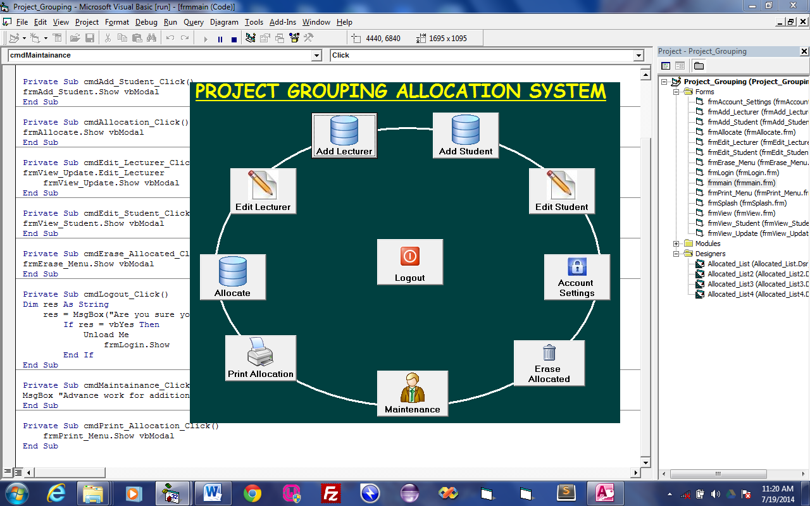
Figure 4.2: This is the main menu in which user can navigate to any operation.
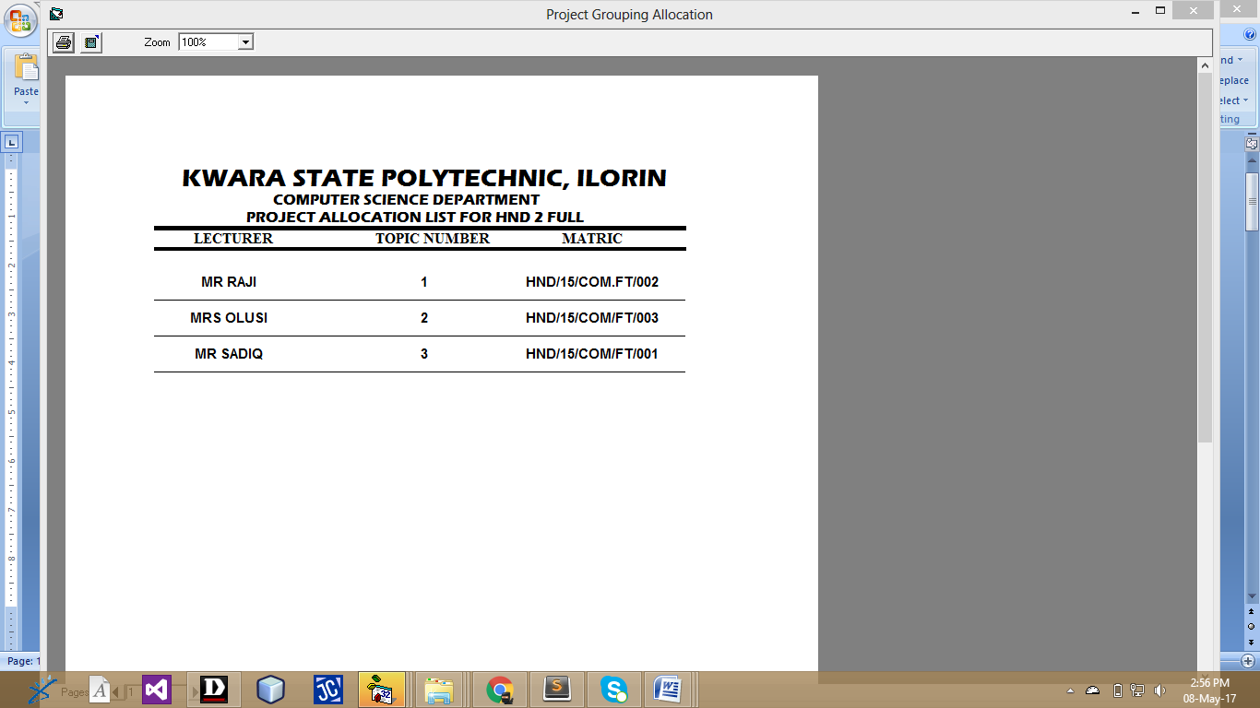
Figure 4.3: This is the List of HND 2 Full Time project grouping.
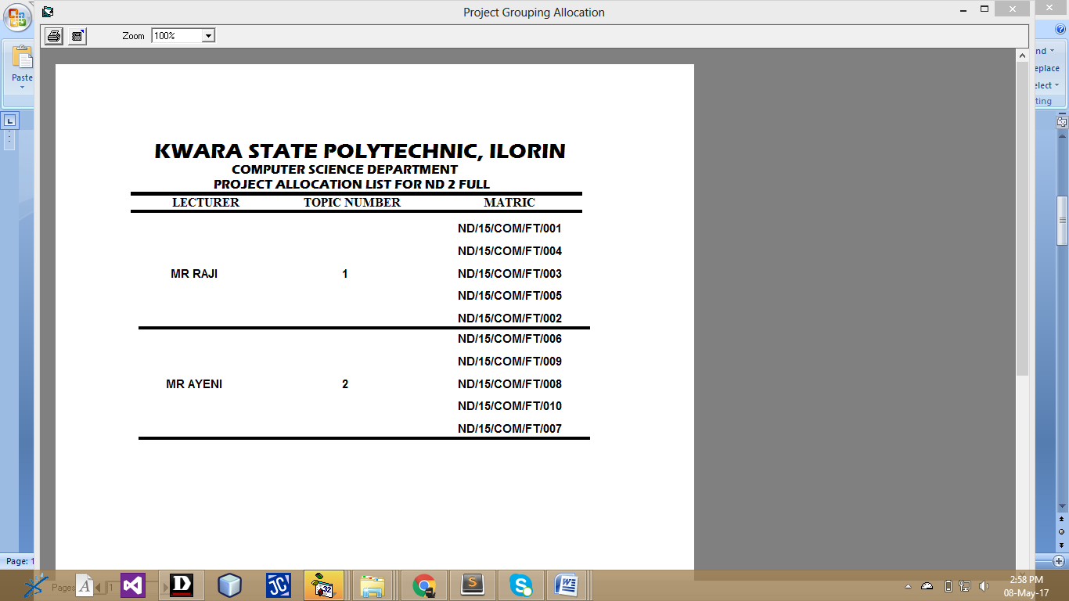
Figure 4.4: This is the List of ND 2 Full Time project grouping.
4.1.2 INPUT DESIGN
This refers to the inputs required to make the website functioning as intended. The inputs to the system include user details for registration as well as list of toipics and availablke departments in kwara state polytechnic. The input to the proposed system are as shown below
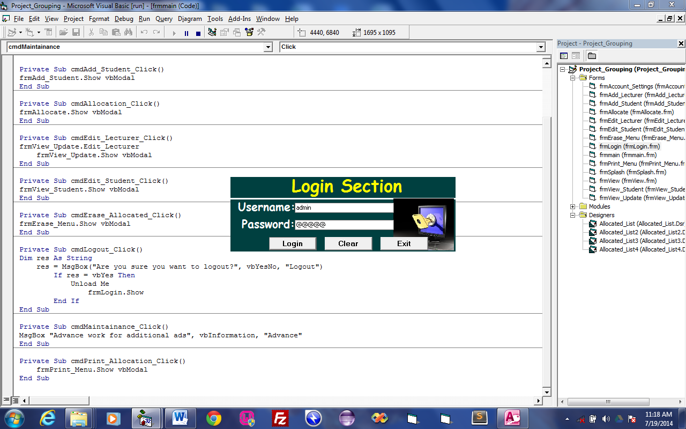
Figure 4.5: This is the login form which give user access
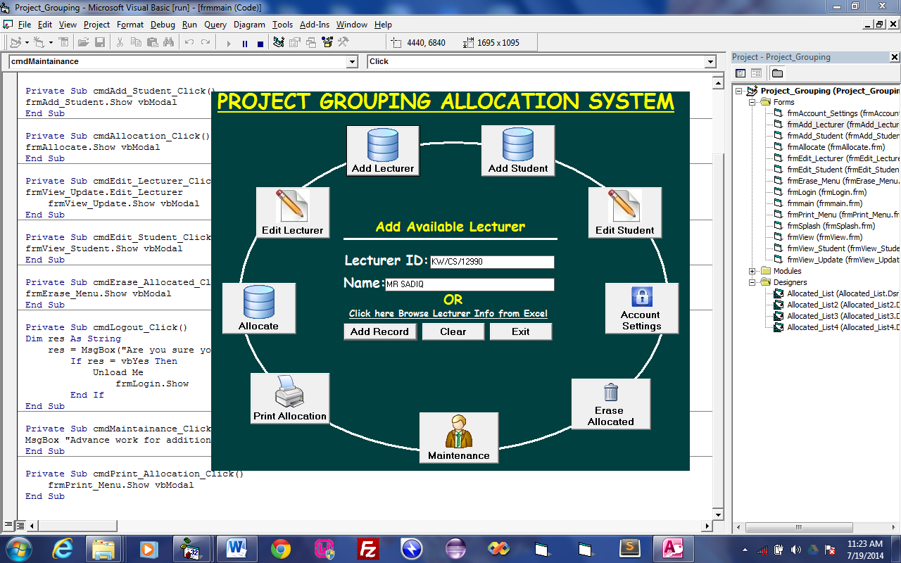
Figure 4.6: This is the module which user will add available lecturer in the department.
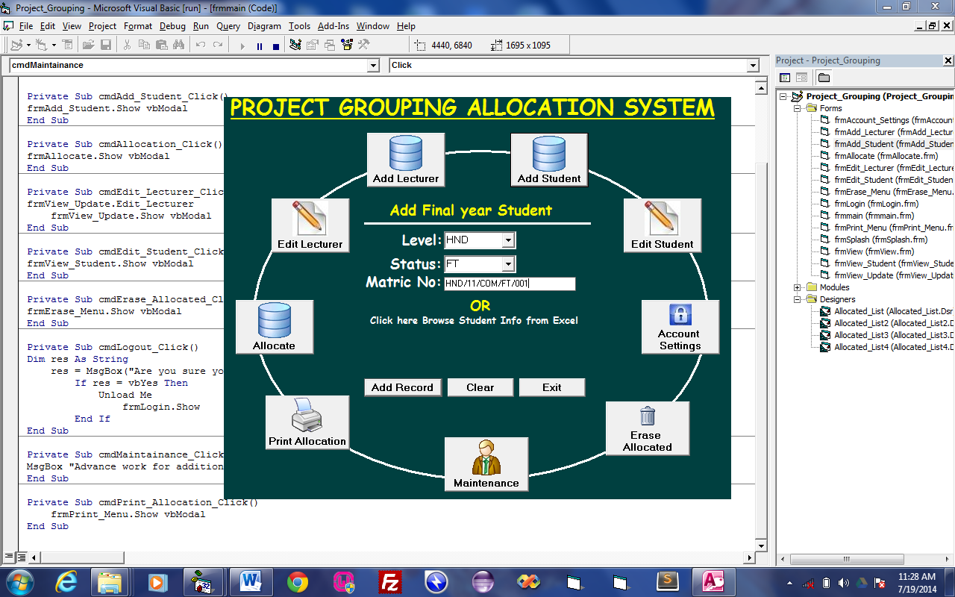
Figure 4.7: This is the module which user can enter final year student information.
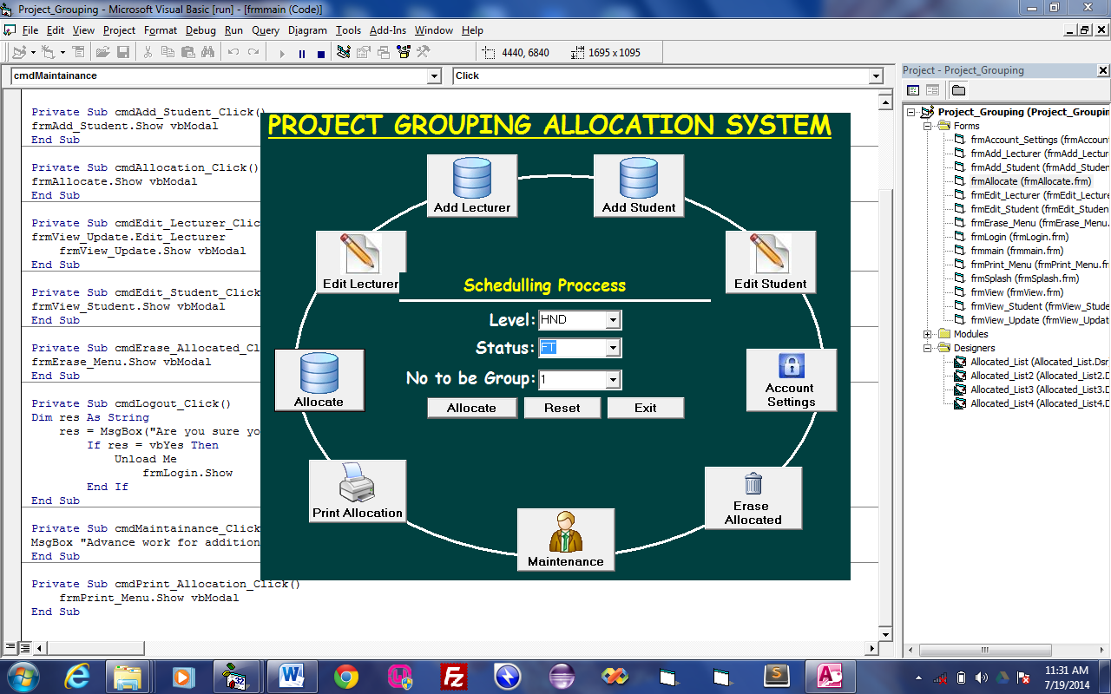
Figure 4.8: This is the allocation module in which the allocation process takes place.
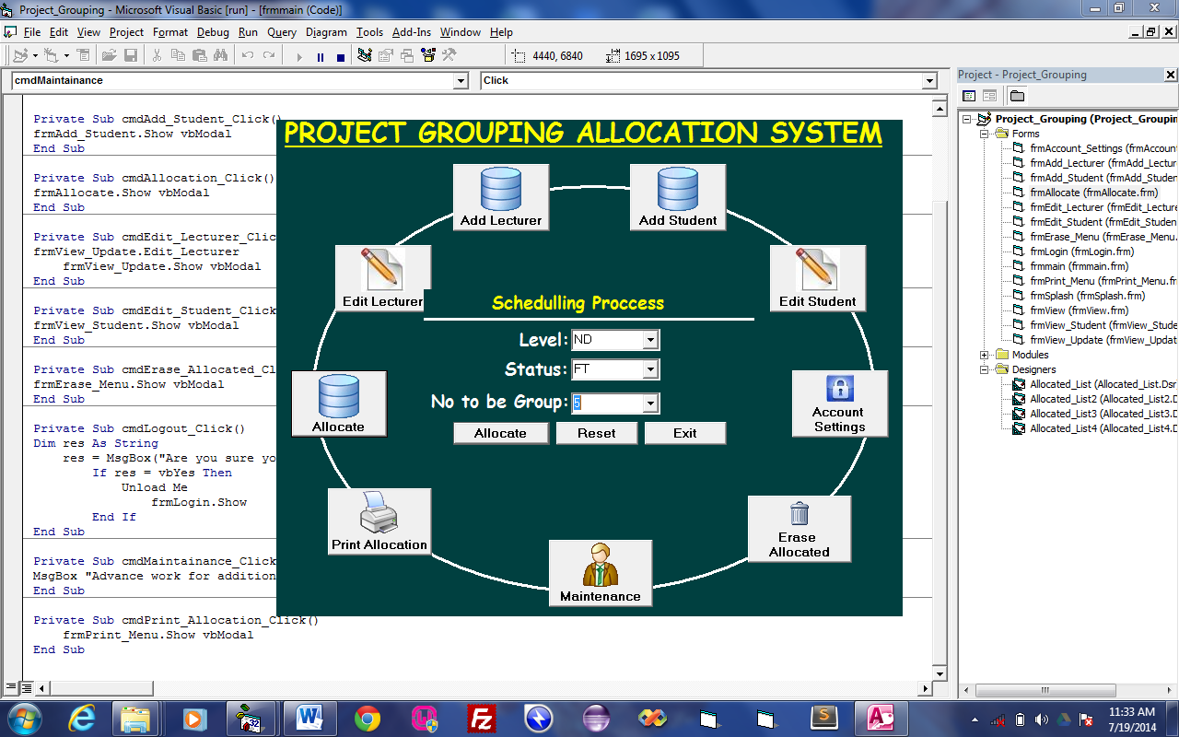
Figure 4.9: This is the allocation module in which the allocation process takes place.

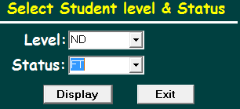
Figure 4.10: This is where user can print allocated project grouping for a particular level.
4.1.3 DATABASE DESIGN
The database design holds the records of all available lecturers and students’ matric no in the department that has been added to the database, the departments in Kwara State Polytechnic as well as the administrator login details. This section consists of the tables used in the database of the system.
Table 4.1: This is the database design of available lecturers in the department.
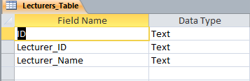
Table 4.2: This is the database design of HND FT final year student in the department.
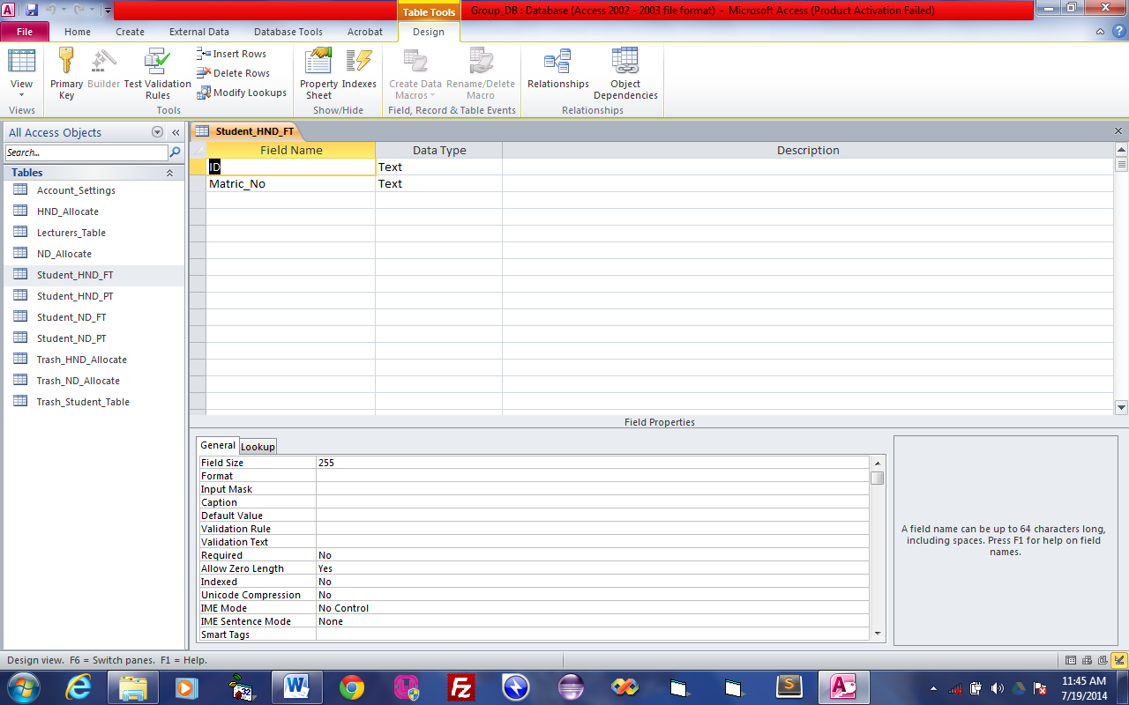
Table 4.3: This is the database design of grouped allocated HND student.
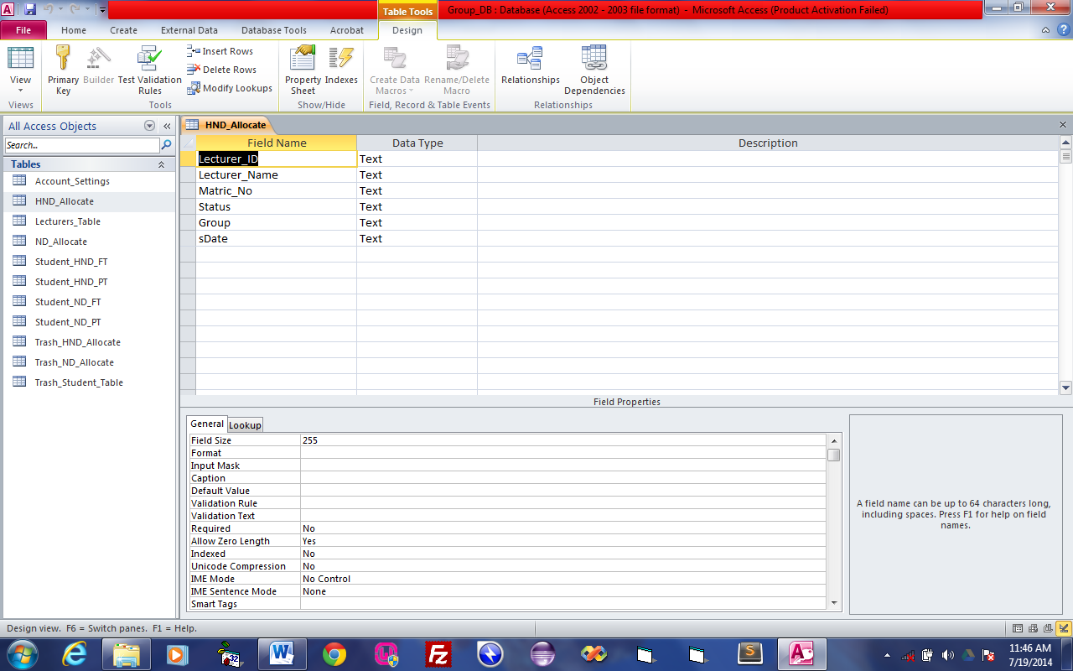
Table 4.4: This is the database design of grouped allocated ND student.
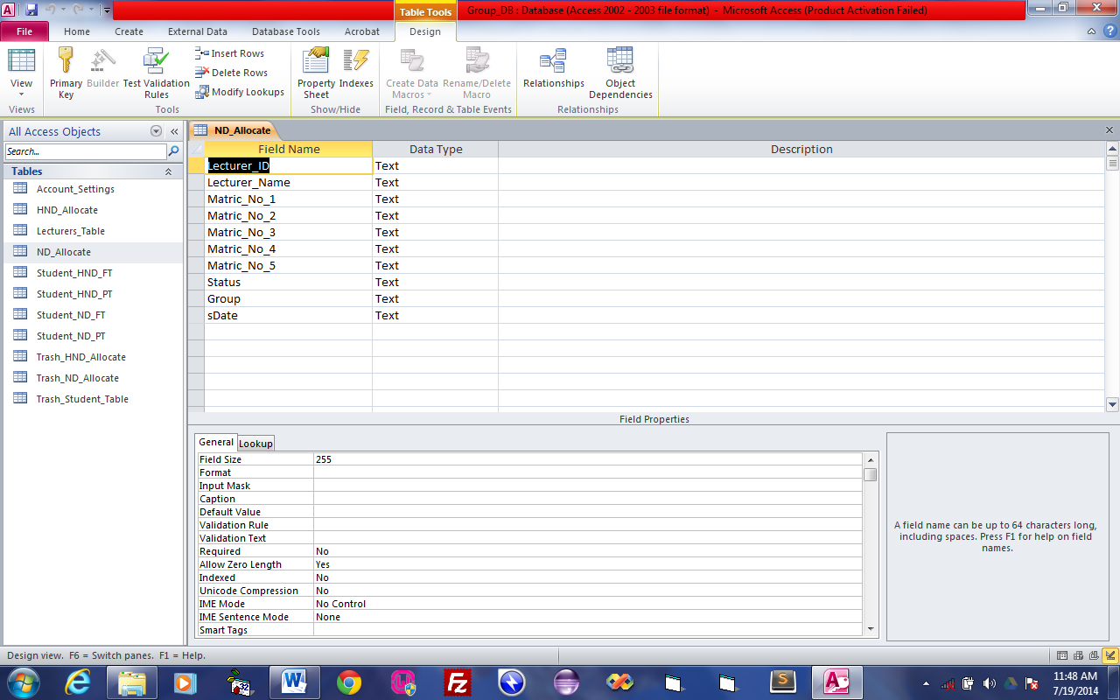
Table 4.5: This is the database design of account settings for username and password.
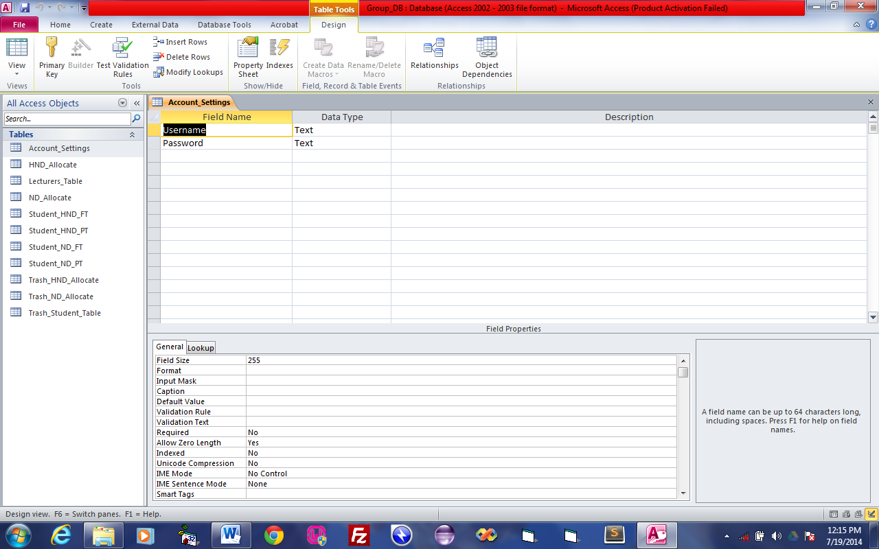
4.1.4 PROCEDURE DESIGN
This refers to the step by step method of using the proposed system. The proposed system comprises of Login, Add lecturer and student, account settings, allocate student(s) to a lecturer, printing the allocation list, Logout.
4.2 IMPLEMENTATION OF THE SYSTEM
4.2.1 CHOICE OF PROGRAMMING LANGUAGE
Visual Basic6.0 is the chosen programming language for the implementation of the proposed system because of its pedagogy and open source help when needed. As well it has a support for variety of database application like sql server, sqllite, mysql, and Microsoft access but Microsoft access is selected.

4.2.2 HARDWARE SUPPORT
The hardware that is required in the successful completion of this project includes monitor, CPU, keyboard, mouse, printer and an uninterrupted power supply (UPS) and an internet access.
- An appropriate hard disk storage of at least 120 GB (for the dynamically expandable database)
- A minimum of 1.0 GHz processor
- Random access memory (RAM) of at least 1 GB
- An effective display unit (VGA monitor)
- A suitable printer
- Standard input devices such as keyboard, mouse, etc.
- CD-ROM drive or DVD-ROM drive (since the installation would be made through this medium)
- An uninterrupted power supply (UPS) unit (to prevent abrupt interruption due to power failure)
- A network modem (for internet connection).

4.2.3 IMPLEMENTATION TECHNIQUES
A randomized algorithm is an algorithm that employs a degree of randomness as part of its logic. The algorithm typically uses uniformly random bits as an auxiliary input to guide its behavior, in the hope of achieving good performance in the "average case" over all possible choices of random bits. Formally, the algorithm's performance will be a random variable determined by the random bits; thus either the running time, or the output (or both) are random variables.
One has to distinguish between algorithms that use the random input so that they always terminate with the correct answer, but where the expected running time is finite (Las Vegas algorithms), and algorithms which have a chance of producing an incorrect result (Monte Carlo algorithms) or fail to produce a result either by signalling a failure or failing to terminate. In the second case, random performance and random output, the term "algorithm" for a procedure is somewhat questionable. In the case of random output, it is no longer formally effective. However, in some cases, probabilistic algorithms are the only practical means of solving a problem. In common practice, randomized algorithms are approximated using a pseudorandom number generator in place of a true source of random bits; such an implementation may deviate from the expected theoretical behavior.
This algorithm does not guarantee success, but the run time is bounded. The number of iterations is always less than or equal to k. Taking k to be constant the run time (expected and absolute) is Randomized algorithms are particularly useful when faced with a malicious "adversary" or attacker who deliberately tries to feed a bad input to the algorithm (see worst-case complexity and competitive analysis (online algorithm)) such as in the Prisoner's dilemma. It is for this reason that randomness is ubiquitous in cryptography. In cryptographic applications, pseudo-random numbers cannot be used, since the adversary can predict them, making the algorithm effectively deterministic. Therefore, either a source of truly random numbers or a cryptographically secure pseudo-random number generator is required. Another area in which randomness is inherent is quantum computing.
4.2.4 PROGRAM DOCUMENTATION
Project topic allocation enables final year students of the institution to be able to get a supervisor to guide them for their project and it take control of their documents and even help the environment by opting to receive electronic statements. According to Javelin Strategy & Research, 61 million households regularly use Internet facilities today. This project is developed due to modern development on student project grouping allocation and management. The design of the new system provides an effective and efficient information system which can handle student records, which would have required reference to paper files but now an electronic system.
4.3.2 OPERATING THE SYSTEM
In order for the proposed system to be used on any computer system it takes the following ways
- Boot the system
- Copy the software to your system then install it onto the system.
- After the installation then go to start->all program->project grouping.
- Then follow the operating process thereafter

4.3.3 MAINTAINING THE SYSTEM
This is the last stage in the system life cycle and can be described as the periodical evaluation and modification of the system. This is done from time to time and to ascertain whether system meets the requirement and provide the service which it is designed for.
This software can be easily maintained by adding more modules or removing which are found to be less useful by the user. Also the database allows the data resilience and portability maintenance of program simply refers to the correction, by adding or deletion of parts of the program with ease which is referred to as a good structure program.

CHAPTER FIVE
SUMMARY, CONCLUSION AND RECOMMENDATION
  - SUMMARY
Project TOPIC allocation enables final year students of the institution to be able to get a supervisor to guide them for their project and it take control of their documents and even help the environment by opting to receive electronic statements. According to Javelin Strategy & Research, 61 million households regularly use Internet facilities today. This project is developed due to modern development on student project grouping allocation and management. The design of the new system provides an effective and efficient information system which can handle student records, which would have required reference to paper files but now an electronic system.
5.2 CONCLUSION
Project grouping allocation system can be considered if the need arise. Developing a good system is critical to the success of the system to prevent system failures and to gain wide acceptance as the best method available. A good Project grouping allocation system requires eight characteristics. These are:
- Accuracy
- Verifiability
- Security
- Convenience
- Flexibility
- Reliability
- Consistency
- Social Acceptance
When designers analyze, design, implement, and maintain standards, they need to consider these characteristics as the foundation.
5.3 RECOMMENDATION
This project is hereby recommended to the project coordinator in Kwara State Polytechnic Ilorin that if this method could be adopted it will solve all problems faced in the manual method of student project grouping allocation system. We wish to make the following recommendations for future improvement. Students should be exposed to serious practical exercise during the course of their studies. This could be accomplished by providing more computers qualified lecturers in the department. Also, the state should computerize their tax collector means system for greater efficiency, neatness, and reliability.

REFERENCES
Abraham D.J and Irving R.W. and Manlove D.F. (2016). Two algorithms for the student- project allocation problem. Journal of Discrete Algorithms 5(1):pp. 73-90.
Abraham, D.J. ( 2013). Algorithmics of two-sided matching problems. Master’s thesis, University of Glasgow, Department of Computing Science,.
Charalampos Papamanthou, (2013). A Parametric Visualization Software for the Assignment Problem”. Yugoslav Journal of Operations Research, 15(1):147-158.
H. Biermann, R. Cole, (2013). Comic Strips for Algorithm Visualization, NYU, New York, NY, Tech. Rep. 1999-778.
J. Mestre, (2014). Weighted popular matchings, in Pro. of ICALP 2006, the 33rd Inter-national Colloquium on Automata, Languages and Programming, vol. 4051 of LNCS, pp 715–726.
John, T. (2015). in the second case random performance and random output, the term algorithm for a procedure is somewhat questionable.
M. Thorn, (2014). A constraint programming approach to the student-project allocation problem, BSc Honours project report, University of York ,Department of Computer Science.
M.D. Byrne, R. Catrambone and J. T. Stasko, (2013). Evaluating animations as student aids in learning computer algorithm, Computers and Education 33 253-378.
Mahmoud I. Moussa and Ahmed H. Abu El-Atta, (2012). Student Project Allocation with Preference Lists over (Student, Project) Pairs, The 2nd International Conference on Computer and Electrical Engineering , Dubai, UAE.
Manlove D.F. and Malley G. O, (2015) . Student project allocation with preferences over projects. In Proceedings of ACID:the 1stAlgorithms and Complexity in Durham workshop, volume 4 of Texts in algorithmics, pages 69- 80. KCL Publications,.
Michael O. (2013). miller’s primality test can be turned into a randomized algorithm at that time no practical deterministic algorithm for primality was known.
Miller, R. (2013). primality test relies on a binary relation between two positive integers k and n that can be expressed by saying that k is a witness to the compositeness of n.
Robert, M. (2012). the study of randomized algorithm was spured by the discovery of a randomized primality test (i.e determining the primality of a randomized primality of a number).
Shafer C., Heath and J. Yang, (2012). Using the Swan Data Structure Visualization system for Computer Science Education, Proceedings of the SIGCSE, ACM Press, 1996, pp. 140-144.
Smith, K. (2015). typically a lecturer will also offer a range of project but does not necessarily expect that all will be taken up.
Teo C.Y, Ho D.J, (2015). A systematic approach to the implementation of final year project in an electrical engineering undergraduate course, IEEE Transactions on Education 41 (1) (1998) 25–30.

PROJECT FLOWCHART
MAIN MENU
Start
Login
Main Menu
Add Lecturer
Add Student
Edit Lecturer
Edit Student
Allocate
Account setting
Print Allocation
Erase Allocation
Stop

ALLOCATE
Start
Enter Level and Status
Is Any Field Empty?
Allocate and Group
Please Fill Necessary Fields
Display Allocation Group
Print Allocation
Save to Database
Return
Open Database

Close Database

NO
YES

CHANGE PASSWORD
Star
Does password match the one in Database
Invalid Password
Input Password
Change Password
Update Password
Return
Open Database

Close Database

NO
YES

ERASE ALLOCATION
Start
Enter Level and Status
Open Database

Close Database

Is Record Found?
Display No Record Found
Delete Record
Return
NO
YES

PRINT ALLOCATION
Start
Open Database
Enter Level and Status
Is any field empty?
Display All Fields are required
YES
NO
Display Allocated Groups
Print Allocation
Close Database
Return

MAIN MENU
Start
Select Operation
Allocate
Is Operation Allocate?
YES
Add Lecturer
Is Operation Add Lecturer?
Add Lecturer
Is Operation Add Student?
Edit Lecturer
Is Operation Edit Lecturer?
Edit Student
Is Operation Edit Student?
No
No
No
YES
YES
YES
No
Account Settings
Is Operation Account Settings?
Print Allocation
Is Operation Print Allocation?
Erase Allocation
Is Operation Erase Allocation?
No
YES
No
YES
No
YES
No
Return

YES

PROGRAM SOURECODE
SPASH
Dim K As Integer
Private Sub Form_KeyPress(KeyAscii As Integer)
Unload Me
frmLogin.Show
End Sub

Private Sub Form_Load()
K = 0
End Sub

Private Sub Timer1_Timer()
K = K + 1
End Sub
Private Sub Timer2_Timer()
lblBlink.Visible = Not lblBlink.Visible
End Sub
Private Sub Timer3_Timer()

End Sub
Private Sub Timer4_Timer()
If shpball.Top >= 3120 Then
Timer4.Enabled = False
Timer5.Enabled = True
ElseIf shpball.Left >= 8040 Then
Timer4.Enabled = False
Timer5.Enabled = False
Timer6.Enabled = True
Else
shpball.Top = shpball.Top + 200
shpball.Left = shpball.Left + 50
End If
End Sub
Private Sub Timer5_Timer()
If shpball.Top <= 600 Then
Timer5.Enabled = False
Timer4.Enabled = True
ElseIf shpball.Left >= 8040 Then
Timer5.Enabled = False
Timer4.Enabled = False
Timer6.Enabled = True
Else
shpball.Top = shpball.Top - 200
shpball.Left = shpball.Left + 50
End If
End Sub
Private Sub Timer6_Timer()
If shpball.Top >= 3120 Then
Timer6.Enabled = False
Timer7.Enabled = True
ElseIf shpball.Left <= 0 Then
Timer6.Enabled = False
Timer7.Enabled = False
Timer4.Enabled = True
Else
shpball.Top = shpball.Top + 200
shpball.Left = shpball.Left - 50
End If
End Sub

Private Sub Timer7_Timer()
If shpball.Top <= 600 Then
Timer7.Enabled = False
Timer6.Enabled = True
ElseIf shpball.Left <= 0 Then
Timer7.Enabled = False
Timer6.Enabled = False
Timer4.Enabled = True
Else
shpball.Top = shpball.Top - 200
shpball.Left = shpball.Left - 50
End If
End Sub
FRMACCOUNT
Private Sub cmdChange_Click()
On Error GoTo Err
If txtUsername.Text = Empty Then
MsgBox "Please Enter Your username", vbCritical, "Empty Field"
txtUsername.SetFocus
Exit Sub
End If
If txtOld_Password.Text = Empty Then
MsgBox "Please Enter Your Old password", vbCritical, "Empty Field"
txtOld_Password.SetFocus
Exit Sub
End If
If txtNew_Password.Text = Empty Then
MsgBox "Please Enter Your New Password", vbCritical, "Empty Field"
txtNew_Password.SetFocus
Exit Sub
End If
If txtConfirm_Password.Text = Empty Then
MsgBox "Please Enter Your Confirmation password", vbCritical, "Empty Field"
txtConfirm_Password.SetFocus
Exit Sub
End If

If txtConfirm_Password.Text <> txtNew_Password.Text Then
MsgBox "Password Mismatch", vbCritical, "Mismatch"
txtConfirm_Password.SetFocus
Exit Sub
End If

Network
sql = "SELECT * FROM Account_Settings Where Username='" & Trim(txtUsername.Text) & "' And Password='" & Trim(txtOld_Password.Text) & "'"
rec.Open sql, con, adOpenDynamic, adLockOptimistic
With rec
If Trim(txtUsername.Text) = !UserName And Trim(txtOld_Password.Text) = !Password Then
!Password = Trim(txtNew_Password.Text)
.Update
Else
GoTo Err
End If
End With
MsgBox "Password created successfully", vbInformation, "Update"
cmdClear_Click
Exit Sub
Err:
MsgBox "Invalid username or old password", vbCritical, "Invalid"
End Sub

Private Sub cmdClear_Click()
txtUsername.Text = Empty
txtNew_Password.Text = Empty
txtOld_Password.Text = Empty
txtConfirm_Password.Text = Empty
txtUsername.SetFocus
End Sub
Private Sub cmdClose_Click()
Unload Me
End Sub

Private Sub cmdCreate_Click()
If txtUser.Text = Empty Then
MsgBox "Please Enter Your username", vbCritical, "Empty Field"
txtUser.SetFocus
Exit Sub
End If
If txtPass.Text = Empty Then
MsgBox "Please Enter Your Password", vbCritical, "Empty Field"
txtPass.SetFocus
Exit Sub
End If
If txtConfirm.Text = Empty Then
MsgBox "Please Enter Your Confirmation password", vbCritical, "Empty Field"
txtConfirm.SetFocus
Exit Sub
End If

If txtConfirm.Text <> txtPass.Text Then
MsgBox "Password Mismatch", vbCritical, "Mismatch"
txtConfirm.SetFocus
Exit Sub
End If

Network
rec.Open "Account_Settings", con, adOpenDynamic, adLockOptimistic
With rec
.AddNew
!UserName = Trim(txtUser.Text)
!Password = Trim(txtPass.Text)
.Update
End With
MsgBox "Account created successfully", vbInformation, "Account Created"
cmdReset_Click
End Sub

Private Sub cmdExit_Click()
Unload Me
End Sub
Private Sub cmdReset_Click()
txtUser.Text = Empty
txtPass.Text = Empty
txtConfirm.Text = Empty
txtUser.SetFocus
End Sub
ADDLECTURER
Dim Lv As ListItem

Private Sub cmdAdd_Click()
Dim cnt As Integer
If txtLecturer_ID.Text = Empty And keep = Empty Then
MsgBox "Please Enter Lecturer ID or browse from Excel", vbCritical, "Empty"
txtLecturer_ID.SetFocus
Exit Sub
End If
If txtLecturer_Name.Text = Empty And keep = Empty Then
MsgBox "Please Enter Lecturer Name or browse from Excel", vbCritical, "Empty"
txtLecturer_Name.SetFocus
Exit Sub
End If
Network
sql = "SELECT COUNT(*) as cnt FROM Lecturers_Table"
rec.Open sql, con, adOpenDynamic, adLockOptimistic
With rec
cnt = !cnt + 1
End With

Network
If txtLecturer_ID.Text <> Empty And txtLecturer_Name.Text <> Empty Then
rec.Open "Lecturers_Table", con, adOpenDynamic, adLockOptimistic
With rec
.AddNew
!Lecturer_ID = UCase(Trim(txtLecturer_ID.Text))
!Lecturer_Name = UCase(Trim(txtLecturer_Name.Text))
!ID = cnt
.Update
End With
End If
If keep <> Empty Then
Open keep For Input As #1
While Not EOF(1)
Input #1, A, B
rec.Open "Lecturers_Table", con, adOpenDynamic, adLockOptimistic
With rec
.AddNew
!Lecturer_ID = UCase(Trim(A))
!Lecturer_Name = UCase(Trim(B))
!ID = cnt
.Update
.Close
End With
Wend
Close #1
End If
MsgBox "Lecturer Information Added successfully", vbInformation, "Added"
keep = Empty
txtLecturer_ID.Text = Empty
txtLecturer_Name.Text = Empty
txtLecturer_ID.SetFocus
End Sub

Private Sub cmdClear_Click()
txtLecturer_ID.Text = Empty
txtLecturer_Name.Text = Empty
txtLecturer_ID.SetFocus
cdl.FileName = Empty
keep = Empty
End Sub

Private Sub cmdExit_Click()
Unload Me
End Sub
Private Sub Form_MouseMove(Button As Integer, Shift As Integer, X As Single, Y As Single)
lblBrowse.Font.Underline = False
End Sub

Private Sub lblBrowse_Click()
On Error GoTo Err
cdl.Filter = "Excel File (*.CSV)|*.CSV"
cdl.ShowOpen
keep = cdl.FileName
frmView.lecturer
Open cdl.FileName For Input As #1
While Not EOF(1)
Input #1, A, B
Set Lv = frmView.lstView.ListItems.Add(, , A)
Lv.SubItems(1) = B
Wend
Close #1
Unload Me
frmView.Show vbModal
Exit Sub
Err:
MsgBox "You click cancel", vbCritical, "Error"
Exit Sub
End Sub
Private Sub lblBrowse_MouseMove(Button As Integer, Shift As Integer, X As Single, Y As Single)
lblBrowse.Font.Underline = True
End Sub

COMPUTER OUTPUT
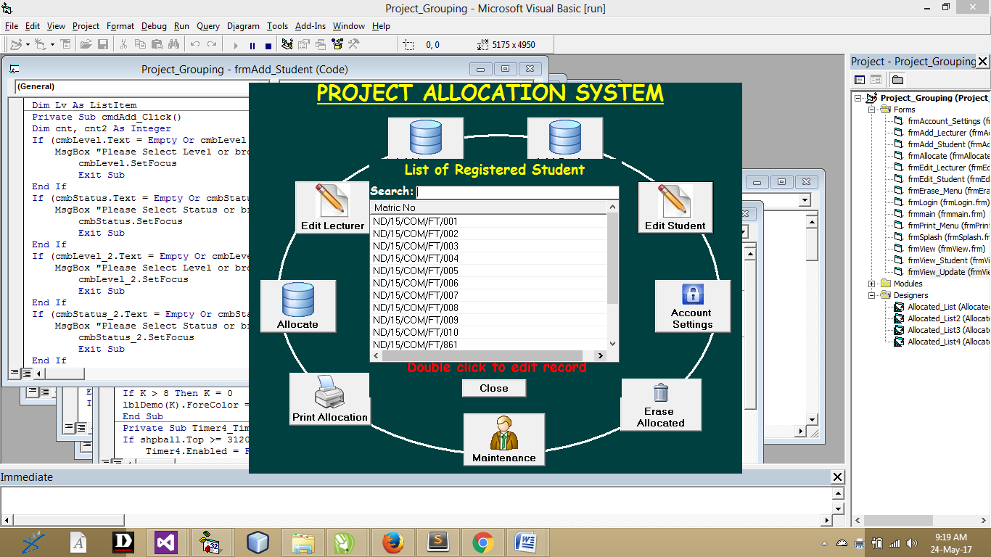
Figure 4.1: This is the page that shows the list of registered student
Figure 4.2: This is the main menu in which user can navigate to any operation.
Figure 4.3: This is the List of HND 2 Full Time project grouping.
Figure 4.4: This is the List of ND 2 Full Time project grouping.
Figure 4.5: This is the login form which give user access
Figure 4.6: This is the module which user will add available lecturer in the department.
Figure 4.7: This is the module which user can enter final year student information.
Figure 4.8: This is the allocation module in which the allocation process takes place.
Figure 4.9: This is the allocation module in which the allocation process takes place.
Figure 4.10: This is where user can print allocated project grouping for a particular level.

