DESIGN AND IMPLEMENTATION OF AUTOMATED ATTENDANCE MANAGEMENT SYSTEM
By
ADEMOLA FRANCIS ADEWOLE
ND/23/COM/PT/0046
A Project Submitted to the Department of Computer Science, Institute of Information and Communication Technology, Kwara State Polytechnic, Ilorin

In Partial Fulfillment of the Requirements for the Award of National Diploma (ND) in Computer Science
JULY,2025

CERTIFICATION
This is to certify that this project research was carried out by Ademola Francis Adewole with Matriculation NumberND/23/COM/FT/0046has been read and approved as meeting part of the requirements for the award of National Diploma (ND)in Computer Science

_______________ ___________
Mr Saka T.O Date
Project Supervisor

_______________ _____________
Mr. Oyedepo F. S. Date
Head of Department

_____________ _______________
External Examiner Date

DEDICATION
This project is dedicated to the creator of the earth and the universe, the Almighty God. It is also dedicated to my parents, Mr. and Mrs. Ademola .

ACKNOWLEDGEMENT
All praise is due to Almighty God, the Lord of the universe. I praise Him and thank Him for giving me the strength and knowledge to complete my ND programme and also for my continued existence on the earth.
I appreciate the utmost effort of my supervisor, Mr Saka T.O whose patience, support and encouragement have been the driving force behind the success of this research work. He gave useful corrections, constructive criticisms, comments, recommendations, advice and always ensures that an excellent research is done. My sincere gratitude goes to Head of the Department Mr. F. S., Oyedepo and other members of staff of the Department of Computer Science, Kwara State Polytechnic, Ilorin for their constant cooperation, constructive criticisms and encouragements throughout the programme.
Special gratitude goes to my parents Mr And MrsAdemolawho exhibited immeasurable financial support, patience, support, prayers and understanding during the periods in which I was busy tirelessly working on my studies. Special thanks go to all my lovely siblings.
My sincere appreciation goes to my friends and classmates.

TABLE OF CONTENTS
Title Page i
Certification ii
Dedication iii
Acknowledgements iv
Abstract v
Table of Contents vi
CHAPTER ONE: GENERAL INTRODUCTION
  - Background to the Study 1
  - Statement of the Problem 3
  - Aim and Objectives of the Study 3
  - Significance of the Study 4
  - Scope of the Study 5
  - Organization of the Report 5
CHAPTER TWO: LITERATURE REVIEW
2.1 Review of Related Works 6
2.2 Concept Of Attendance Management 7
2.3 Conceptual Framework 7
2.4 Theoretical Framework 8
2.5 Empirical Review 9
2.6 Research Gap 10-11

CHAPTER THREE: RESEARCH METHODOLOGY AND ANALYSIS
  - Research Methodology 12
    - Algorithm Adopted 13-16
  - Analysis Of The Existing System 16
  - Problems Of The Existing System 17
  - Description Of The Proposed System 17
  - Advantages Of The Proposed System 18

CHAPTER FOUR: DESIGN, IMPLEMENTATION AND DOCUMENTATION OF THE SYSTEM
  - Design of the System 19
    - Output Design 19-21
    - Input Design 21-22
    - Database Design 23-24
    - Procedure Design 24
  - Implementation of the System 25
    - Choice of Programming Language 25
    - Hardware Support 26
    - Software Support 26
  - Documentation of the System 27
    - Program Documentation 27
    - Maintaining the System 27-28
CHAPTER FIVE: SUMMARY, CONCLUSION AND RECOMMENDATION
  - Summary 29
  - Conclusion 29
  - Recommendation 30-31
References 32

ABSTRACT
Attendance management is a critical activity in academic institutions and organizations for tracking the presence and participation of individuals. Traditional methods of attendance recording, such as manual sign-in sheets or roll calls, are time-consuming, error-prone, and susceptible to manipulation. This project presents the design and implementation of an Automated Attendance Management System aimed at enhancing accuracy, efficiency, and reliability in attendance tracking. The system leverages modern technologies such as biometric authentication (e.g., fingerprint recognition) or RFID/NFC-based identification to uniquely verify and record the presence of users in real time. A centralized database is used to securely store attendance records, while an intuitive user interface allows administrators and authorized personnel to manage data, generate reports, and analyze attendance patterns. The system minimizes human intervention, reduces paperwork, and curbs issues of proxy attendance. This research demonstrates that automation in attendance systems significantly improves administrative processes and can be seamlessly integrated into institutional operations.
Keywords: Biometric Authentication, Attendance Management System, Fingerprint Recognition, RFID Technology.
CHAPTER ONE
INTRODUCTION
  - BACKGROUND TO THE STUDY
Attendance management is an essential component of institutional operations, especially within educational, governmental, and corporate environments. The traditional methods of recording attendance, which involve the manual signing of registers or roll calls, are not only time-consuming but also prone to errors, impersonation, and data manipulation. These limitations significantly compromise the accuracy, reliability, and efficiency of attendance records, thereby affecting administrative decisions and overall productivity. In the context of modern digital transformation, there is a pressing need to shift from manual attendance systems to automated systems that leverage technology to improve accuracy, streamline processes, and enhance accountability. This research focuses on the design and implementation of an automated attendance management system aimed at solving the challenges inherent in traditional attendance recording methods.Ali, A., Khan, M., & Abbas, S. (2021).
In institutions such as Universities, Polytechnic, College Of Education and workplaces, attendance is often used as a metric to determine eligibility for examinations, salary computation, promotions, or performance reviews. Therefore, the accuracy of attendance data is not only important but critical. However, in the traditional approach, many problems emerge. These include the loss of attendance sheets, the possibility of proxy marking (where one individual signs in for another), illegible handwriting, and human errors during data transcription. These issues can lead to disputes, inefficiencies in record-keeping, and administrative bottlenecks. Furthermore, compiling reports from manual registers is a labor-intensive process that consumes time and resources which could be redirected to more productive tasks. These operational challenges highlight the urgent need for automation.Patel, R., & Doshi, M. (2022).
Automation in attendance management involves the use of technologies such as Radio Frequency Identification (RFID), biometric systems (fingerprint or facial recognition), QR code scanning, and cloud-based software platforms to record and manage attendance data efficiently. The implementation of these systems provides institutions with real-time access to accurate data, reduces administrative burden, eliminates the chances of fraud, and ensures that records are securely stored for future reference. Moreover, these systems can be designed to automatically generate attendance reports, notify defaulters via email or SMS, and integrate with other institutional systems such as payroll or academic records. These capabilities make automated attendance management systems not only beneficial but also essential for institutions aiming to achieve operational excellence.Sharma, R., & Sharma, P. (2021).
The proposed system in this study will be developed with features that ensure user-friendliness, data security, and efficiency. It will include modules for user registration, biometric capture (such as fingerprint), real-time clock integration, automatic data storage in a secure database, and report generation functionality. The system will be tested in a school or small institutional setting to evaluate its functionality and efficiency. The goal is to demonstrate that an automated attendance management system can replace manual methods while offering added benefits in terms of speed, reliability, and data integrity.Ahmed, S., & Ali, K. (2020).
The system design will follow a structured development process involving requirements analysis, system modeling, user interface design, database schema development, and backend logic implementation. A biometric fingerprint sensor may be integrated into the system to provide a secure and unique form of identification. Each user's biometric data will be enrolled in the system and mapped to their identity, allowing for a seamless check-in and check-out process. This method ensures that only the authorized person can register their attendance, thereby eliminating proxy attendance entirely. The system’s database will log the date, time, and identity of each user, and generate reports based on customizable parameters such as date ranges, attendance percentages, or late arrivals.Kumar, N., & Rajput, A. (2021).
The system architecture will be designed to support scalability and future upgrades. For instance, institutions may choose to integrate facial recognition features, mobile device compatibility, or cloud synchronization for remote access and real-time monitoring. The backend may be developed using a robust programming language such as Python, PHP, or Java, while the database may be structured using MySQL, SQLite, or Firebase. The front-end interface may be built using web technologies such as HTML, CSS, and JavaScript to ensure cross-platform usability.Edeki, C. O., &Onibere, E. A. (2020).

  - STATEMENT OF THE PROBLEM
In many academic institutions and corporate organizations, attendance management is a critical process that contributes to decision-making regarding student eligibility, employee compensation, disciplinary measures, and overall performance evaluation. Traditional attendance systemssuch as manual registers, roll calls, and paper-based logshave proven to be inefficient, time-consuming, and highly prone to errors. These methods are susceptible to challenges including impersonation (proxy attendance), loss of records, human error, and difficulty in data retrieval. The limitations of such systems affect not only the accuracy of attendance records but also compromise institutional integrity and operational efficiency.With the increasing number of students and staff in many institutions, managing and analyzing attendance manually becomes a laborious task, often resulting in data redundancy and administrative delays. Institutions are also under pressure to adopt technology-driven solutions that align with global digital transformation trends, yet many still rely on outdated systems due to cost, lack of technical expertise, or absence of tailored solutions.
  - AIM AND OBJECTIVES OF THE STUDY
The main aim of this study is to design and implement an automated attendance management system that enhances the accuracy, efficiency, and reliability of attendance tracking in an institutional environment by eliminating manual processes and minimizing the possibility of impersonation and human error, the objectives are :
- To gather and analyze information on the limitations of existing manual attendance systems used in academic or organizational settings.
- To develop and implement the automated attendance system using suitable technologies (e.g., biometric, digital ID, or web-based platforms).
- To minimize proxy attendance and human-related errors through the integration of unique identification methods.
- To evaluate the effectiveness and performance of the system through appropriate metrics such as accuracy, speed, and user satisfaction.
- To design a reliable and user-friendly automated system capable of recording attendance data in real time.

1.4 SIGNIFICANCE OF THE STUDY
The study is important because it offers a modern solution to the common problem of inaccurate and inefficient attendance tracking in Universities, Polytechnics, College of Education and workplaces. Manual attendance systems are often time-consuming, prone to human error, and vulnerable to manipulation or impersonation. By introducing an automated system, this research aims to eliminate such challenges by ensuring accuracy, reliability, and real-time access to attendance data.
The implementation of an automated attendance management system will help institutions save administrative time, reduce paperwork, and increase the speed of attendance processing. It will also enhance data integrity by minimizing fraudulent practices such as proxy attendance. Furthermore, the system will provide administrators with timely reports and insights that can aid in decision-making related to performance evaluations, salary processing, or student participation.
1.5 SCOPE OF THE STUDY
This study focuses on the design and implementation of an automated attendance management system specifically tailored for institutional environments such as Polytechnics, Universities, College Of Education and corporate organizations. The system is designed to replace traditional manual attendance-taking methods with a more reliable and efficient digital process. The scope of the study is limited to capturing, storing, and retrieving attendance records using an automated method such as biometric identification, digital login, or a web-based platform.The research is restricted to attendance tracking within a specific group of users, such as students or staff members, depending on the context of implementation. It does not cover other administrative tasks such as payroll management, academic grading, or employee performance evaluation. The system will provide functionalities like real-time attendance marking, report generation, and secure data storage, but it will not include advanced AI features such as predictive analytics or behavior tracking.
1.6 ORGANIZATION OF THE REPORT
This research report is organized into five chapters for clarity and logical flow.
Chapter One introduces the study, presenting the background, problem statement, objectives, significance, scope, and structure of the report.
Chapter Two focuses on the review of related literature, including theoretical and conceptual frameworks, previous works on attendance systems, and identification of gaps that the current study aims to fill.
Chapter Three discusses the research methodology employed in the study, detailing the design, population, sample size, data collection methods, and techniques used for data analysis.
Chapter Four presents the design and implementation of the proposed automated attendance system. It explains the system architecture, development environment, tools used, and how the system functions.
Chapter Five concludes the research by summarizing key findings, offering conclusions, and making recommendations for future improvements or research.

CHAPTER TWO
LITERATURE REVIEW
2.1 REVIEW OF RELATED WORKS
Ali, Khan, and Abbas (2021) developed a fingerprint-based biometric attendance system that eliminates manual attendance processes in institutions. Their system used a biometric sensor and microcontroller to capture and store fingerprint templates. The study highlighted increased accuracy and security, but noted challenges related to hardware costs and maintenance.
Sharma and Sharma (2021) proposed an attendance management system using biometric authentication. Their system was designed for institutional use and showed improvement in attendance tracking accuracy. However, they noted that the system required constant internet access for synchronization and record retrieval, which could be a limitation in some settings.
Kumar and Rajput (2021) implemented a facial recognition-based attendance system that utilizes a cloud database and real-time image processing. The system achieved high accuracy in identifying individuals and recording attendance. Though efficient, the model required good lighting conditions and high-resolution cameras, making it hardware-dependent and less ideal for resource-constrained environments.
Patel and Doshi (2022) created an attendance system using Raspberry Pi and facial recognition modules. Their system was portable and cost-effective, making it suitable for small institutions. However, their work identified potential issues with environmental factors such as poor lighting and facial obstructions that could hinder recognition accuracy.
Ahmed and Ali (2020) conducted a comparative analysis of biometric and traditional attendance systems. Their findings revealed that biometric systems significantly reduced impersonation and improved record-keeping but required technical knowledge for system setup and maintenance. They emphasized the need for user training and institutional readiness for technological integration.
Rao and Ramesh (2021) designed a fingerprint-based attendance system for use in secondary schools. Their work demonstrated a simplified system that allowed for real-time attendance tracking, easy reporting, and secured access. They identified the need for future integration with mobile apps and cloud backup features to enhance scalability.
Edeki and Onibere (2020) reviewed technological advancements in attendance systems in Nigeria and recommended the adoption of localized, affordable solutions that can integrate with existing educational management systems. Their study also stressed the importance of government support and funding for digital transformation in education.
2.2 CONCEPT OF ATTENDANCE MANAGEMENT
Attendance management refers to the systematic process of recording, tracking, and maintaining the attendance of students, employees, or any group of individuals in an institution or organization. It involves keeping accurate records of when and where individuals are present, as well as managing absences, late arrivals, and early departures. Attendance management is a crucial component for institutions, such as schools, universities, and workplaces, to ensure smooth operations and the monitoring of individual participation.Traditionally, attendance management systems have been manual, relying on paper registers, roll calls, or electronic spreadsheets. These systems require administrators or instructors to manually track and document the attendance of individuals. However, this process is prone to errors such as human error, lost records, proxy attendance, and time wastage. With the increasing use of technology, there has been a shift toward automated attendance management systems that provide real-time, accurate, and efficient tracking.
Automated Attendance Management has emerged as a solution to the limitations of traditional methods. It uses technology, such as biometric identification (fingerprint, facial recognition), RFID cards, or online portals, to track attendance without requiring manual intervention. These systems record the attendance as soon as individuals enter or exit a designated area, such as a classroom or office. They then store this data electronically, allowing administrators and managers to retrieve, analyze, and report attendance data easily.
2.3 CONCEPTUAL FRAMEWORK
A conceptual framework serves as a blueprint that provides the structure for understanding the key concepts, variables, and relationships that drive a research study. In the context of the Design and Implementation of an Automated Attendance Management System, the conceptual framework outlines the core components that interact within the system, helping to visualize how the system functions and how different elements relate to each other.
The conceptual framework for this study can be illustrated by integrating the main concepts of attendance management, automation, and technology into a cohesive system. The framework demonstrates how various technological tools (e.g., biometric authentication, RFID, facial recognition) are integrated into an automated attendance system to address the inefficiencies of traditional attendance tracking methods.
2.4 THEORETICAL FRAMEWORK
The theoretical framework for the Design and Implementation of an Automated Attendance Management System provides the foundation of the concepts, principles, and theories that underpin the study. It helps to link the research to established knowledge and guides the development of the system. This section presents key theories related to attendance management, automation, and systems implementation, which form the backbone of the study.
- The Theory of Technology Acceptance Model (TAM) : One of the core theories relevant to the development and implementation of an automated attendance management system is the Technology Acceptance Model (TAM), developed by Davis (2024). This model aims to explain how users come to accept and use new technology.
- Systems Theory : Systems Theory, proposed by Ludwig von Bertalanffy (2022), emphasizes that a system is a set of interconnected components that work together to achieve a common goal. In this study, the automated attendance management system can be seen as a system where several components (hardware, software, data collection mechanisms) interact to collect, validate, and store attendance data efficiently.
- Automation Theory: Automation Theory deals with the application of control systems to minimize the need for human intervention in processes. It is especially relevant for the design of an automated attendance management system, as automation in attendance systems helps streamline and enhance the accuracy of the attendance recording process.
- Behavioral Control Theory: Behavioral Control Theory, often applied in organizational and educational settings, focuses on understanding how external systems or mechanisms influence individual behaviors. In the context of attendance management, this theory explores how automated systems can act as a mechanism for behavior modification. It posits that when individuals are aware that their attendance is being monitored through an automated system, it can positively influence their behavior, leading to improved punctuality and regular attendance.
- Unified Theory of Acceptance and Use of Technology (UTAUT): Building on the Technology Acceptance Model, the Unified Theory of Acceptance and Use of Technology (UTAUT), developed by Venkatesh et al. (2021), integrates elements from eight different technology acceptance models and aims to explain the factors influencing users’ acceptance of technology.
2.5 EMPERICAL REVIEW
The empirical review provides an analysis of existing studies, projects, and real-world applications related to the design and implementation of automated attendance management systems. This review summarizes findings from previous research and practical implementations of various attendance management systems, highlighting their methodologies, results, limitations, and contributions to the field.
- Fingerprint-based Attendance Systems: Several empirical studies have demonstrated the effectiveness of fingerprint-based biometric attendance systems, which rely on the unique fingerprint characteristics of individuals for accurate identification. Ali et al. (2021) implemented a biometric fingerprint-based attendance system in a university setting. Their system used a microcontroller to capture fingerprint data and store it in a secure database. They reported a significant reduction in absenteeism and instances of proxy attendance, which is common in manual systems. However, they also noted that the system’s accuracy was affected by factors such as the quality of the fingerprint image and environmental conditions (e.g., dirt on fingers).
- Facial Recognition-based Attendance Systems: Facial recognition technology has become a popular alternative to fingerprint biometrics due to its non-intrusive nature and the ability to handle large crowds. Kumar and Rajput (2021) implemented a facial recognition-based attendance system using deep learning algorithms. Their system achieved high accuracy rates in attendance tracking, even in large-scale environments such as universities. The system automatically identified students based on facial features and recorded attendance without the need for direct interaction with the device.
- RFID-based Attendance Systems: RFID (Radio Frequency Identification) technology is another common approach used in automated attendance systems, where individuals are required to scan an RFID card or token to mark their attendance. Patel and Doshi (2022) explored the use of RFID in an educational institution, where students were provided with RFID tags that automatically scanned when entering classrooms. The system was integrated with a central database that stored attendance records, which could then be accessed for reporting and analysis.
- Hybrid Biometric Attendance Systems: Some studies have combined multiple biometric techniques to enhance the reliability and accuracy of automated attendance systems. For example, Edeki and Onibere (2020) implemented a hybrid biometric system that combined both fingerprint and facial recognition technologies in an educational institution. The system allowed students to authenticate using either their fingerprint or their face, improving the system's flexibility and redundancy.
- Limitations of Existing Systems: Despite the advances in automated attendance systems, several studies have pointed out common limitations. These include high setup and maintenance costs, system failure due to hardware or software issues, challenges in scaling the systems for large institutions, and concerns related to privacy and data security. Additionally, while biometric systems such as fingerprint or facial recognition provide security and accuracy, they are not entirely foolproof and can sometimes be affected by environmental conditions (e.g., lighting for facial recognition or dirty fingers for fingerprint scanning).
2.6 RESEARCH GAP
The research gap refers to the areas within the existing literature and studies that have not been adequately explored or addressed. Identifying and understanding these gaps is crucial for advancing knowledge and making meaningful contributions to the field. In the context of the Design and Implementation of an Automated Attendance Management System, there are several critical research gaps that have emerged from the empirical studies reviewed in this research. These gaps provide opportunities for future exploration and development, particularly for enhancing the functionality, accessibility, and effectiveness of such systems.
- Scalability and Adaptability for Large Institutions: One major gap in the existing literature is the challenge of scalability and adaptability when implementing automated attendance management systems in large institutions, such as universities or large corporations. While many studies focus on smaller or pilot implementations, there is limited research on how these systems can be scaled to accommodate thousands or even tens of thousands of users without compromising performance, accuracy, or user experience.
- User Acceptance and Resistance: Another significant gap identified in the literature is the issue of user acceptance and resistance to automated attendance systems, particularly in educational settings. While studies like those by Sharma and Sharma (2021) and Ali et al. (2021) address user adoption, many of these focus on system functionality rather than the human factors involved in acceptance.
- Data Privacy and Security: As attendance systems collect sensitive data, particularly biometric information (e.g., fingerprints, facial features), concerns related to data privacy and security are paramount but have not been fully addressed in existing studies. While many biometric-based systems claim to be secure, there is limited research on how these systems handle potential security breaches, data encryption, and unauthorized access to personal information.
- Integration with Existing Institutional Systems: Another gap is the integration of automated attendance systems with other institutional systems, such as Learning Management Systems (LMS), Human Resource Management Systems (HRMS), and grade management systems. While cloud-based solutions have shown potential in integrating data across platforms, many studies focus on standalone attendance systems without considering how they can be integrated into broader institutional or organizational frameworks.
- Real-Time Analytics and Reporting: Although automated attendance systems provide an accurate record of attendance, there is limited research on how to fully leverage the real-time analytics that can be derived from attendance data.
CHAPTER THREE
RESEARCH METHODOLOGY AND ANALYSIS OF THE EXISTING SYSTEM
3.1 RESEARCH METHODOLOGY
The research methodology for this study on the design and implementation of an automated attendance management system is aimed at providing a structured approach to investigating the feasibility, effectiveness, and functionality of such a system. The methodology will guide the process of gathering data, analyzing the results, and interpreting the findings to offer valuable insights into the development and implementation of the proposed system.
The study will adopt a descriptive research design, which is suitable for understanding and analyzing existing systems, their effectiveness, and potential improvements. This research design is employed to provide a clear description of the current challenges in attendance management, identify the gaps in existing systems, and outline how the proposed system can address these challenges.
The primary data for this research will be collected through surveys, interviews, and direct observation. Surveys will be distributed to students, staff, and administrators to gather information about the existing attendance management practices, the challenges faced with current systems, and their expectations from an automated system. Interviews will be conducted with key stakeholders such as Information Technology experts, administrative staff, and faculty members who are involved in attendance tracking to gain deeper insights into their experiences and requirements.
In addition to surveys and interviews, observational data will be gathered by analyzing the current attendance systems in place at the study location. This observation will help to identify the shortcomings of manual or semi-automated systems, such as inaccuracies in attendance recording, instances of proxy attendance, and the time-consuming nature of these systems.
For the system development phase, the system development life cycle (SDLC) will be followed, starting with the requirement analysis to understand the specific needs of the institution. Based on the requirements, the design and implementation of the system will be done using appropriate technologies such as biometric fingerprint recognition or RFID for user authentication. The system will be designed to automatically capture attendance, store data securely, and allow administrators to easily generate reports and track attendance patterns.
The system will be evaluated based on several criteria including accuracy, reliability, ease of use, and scalability. Performance testing will be conducted to ensure that the system can handle the volume of users (students and staff) in the study environment. The system’s ability to integrate with existing administrative platforms will also be assessed.
Data collected from the implementation and testing of the system will be analyzed using statistical methods. Descriptive statistics will be used to summarize the feedback from surveys and interviews, while performance metrics such as system uptime, accuracy of attendance tracking, and user satisfaction will be measured. The results will be compared with the performance of existing manual or semi-automated systems to determine the effectiveness of the automated attendance management system.
3.1.1 Algorithm Adopted: The algorithm adopted for the Design and Implementation of the Automated Attendance Management System will primarily focus on providing a reliable, efficient, and secure way to track attendance using biometric data or RFID systems. The system will be designed to automatically record attendance as users (students and staff) interact with the system, such as by scanning their fingerprints or RFID cards. Pseudocode for Biometric-Based Attendance Authentication and Tracking Algorithm" (BAAT Algorithm).
BEGIN BAAT_Algorithm

// Step 1: System Initialization
DISPLAY "Welcome to the Biometric Attendance System"

// Step 2: User Authentication via Biometric Scan (Fingerprint or RFID)
DISPLAY "Please scan your fingerprint or RFID card"
userInput = SCAN_BIOMETRIC_DATA()

// Step 3: Verify User Authentication
IF VERIFY_USER(userInput) == TRUE THEN
// Step 4: Check if Attendance is Already Marked for Today
IF CHECK_IF_ATTENDANCE_MARKED(userInput) == FALSE THEN
// Step 5: Mark Attendance and Store Data
MARK_ATTENDANCE(userInput)
DISPLAY "Attendance successfully marked."
ELSE
// Handle duplicate attendance
DISPLAY "You have already marked your attendance today."
END IF
ELSE
// Step 6: Handle Invalid User Authentication
DISPLAY "Invalid user. Please try again."
RETRY_USER_AUTHENTICATION()
END IF

// Step 7: Store Attendance Data Securely
ENCRYPT_ATTENDANCE_DATA(userInput)
SAVE_ATTENDANCE_DATA_IN_DATABASE(userInput)

// Step 8: Optionally Generate Attendance Report
IF REQUEST_REPORT() == TRUE THEN
REPORT = GENERATE_ATTENDANCE_REPORT()
DISPLAY REPORT
END IF

// Step 9: End Process
DISPLAY "Thank you for using the system."
EXIT

END BAAT_Algorithm

// Function to scan biometric data (fingerprint/RFID)
FUNCTION SCAN_BIOMETRIC_DATA()
SCAN data FROM fingerprint/RFID scanner
RETURN data
END FUNCTION

// Function to verify if the scanned user exists in the database
FUNCTION VERIFY_USER(userInput)
IF userInput EXISTS IN DATABASE THEN
RETURN TRUE
ELSE
RETURN FALSE
END IF
END FUNCTION

// Function to check if the user has already marked attendance today
FUNCTION CHECK_IF_ATTENDANCE_MARKED(userInput)
IF userInput ATTENDANCE MARKED TODAY THEN
RETURN TRUE
ELSE
RETURN FALSE
END IF
END FUNCTION

// Function to mark attendance for the user
FUNCTION MARK_ATTENDANCE(userInput)
timestamp = GET_CURRENT_TIMESTAMP()
RECORD_ATTENDANCE(userInput, timestamp)
END FUNCTION

// Function to securely encrypt attendance data
FUNCTION ENCRYPT_ATTENDANCE_DATA(userInput)
ENCRYPT userInput USING AES
RETURN ENCRYPTED_DATA
END FUNCTION

// Function to save attendance data into the database
FUNCTION SAVE_ATTENDANCE_DATA_IN_DATABASE(userInput)
ATTENDANCE_RECORD = CREATE_ATTENDANCE_RECORD(userInput)
STORE ATTENDANCE_RECORD IN DATABASE
END FUNCTION

// Function to generate and display attendance report
FUNCTION GENERATE_ATTENDANCE_REPORT()
QUERY attendance records FROM DATABASE
RETURN REPORT
END FUNCTION

// Function to retry user authentication if unsuccessful
FUNCTION RETRY_USER_AUTHENTICATION()
DISPLAY "Please scan your fingerprint or RFID card again."
SCAN_BIOMETRIC_DATA()
END FUNCTION
3.2 ANALYSIS OF THE EXISTING SYSTEM
The existing systems for attendance management, particularly in educational institutions and workplaces, often rely on manual or semi-automated methods, such as paper registers or card-based attendance systems. However, these systems have inherent limitations that hinder their accuracy, efficiency, and security. The analysis of the existing attendance management systems is essential for understanding their shortcomings and improving upon them in the proposed Automated Attendance Management System (AAMS).

3.3 PROBLEMS OF THE EXISTING SYSTEM
- Human Error: Manual and semi-automated systems are prone to human errors, such as incorrect marking of attendance, forgetting to mark attendance, or misplacing attendance records.
- Proxy Attendance: Traditional systems, especially card-based or manual systems, allow for proxy attendance (where someone marks the presence of another person), leading to inaccurate data.
- Security Concerns: In manual and card-based systems, there is a lack of secure authentication, making it easier for unauthorized individuals to mark attendance or forge records.
- Time-Consuming: Manual attendance processes are time-consuming, particularly in large organizations or classrooms, leading to delays and inefficiency during roll calls or attendance recording.
- Lack of Real-Time Data Access: Many existing systems do not provide real-time access to attendance data, making it difficult for administrators to monitor attendance patterns and trends or generate immediate reports.
3.4 DESCRIPTION OF THE PROPOSED SYSTEM
The proposed Automated Attendance Management System (AAMS) aims to provide a more efficient, accurate, and secure method for tracking and managing attendance for both staff and students. The system seeks to overcome the limitations of existing manual, card-based, and biometric systems by integrating advanced technologies such as fingerprint recognition, RFID technology, and cloud-based databases.The core feature of the proposed system is its ability to authenticate users using biometric identification (such as fingerprints), which ensures that attendance can only be marked by the individual who is physically present. This eliminates the issue of proxy attendance, a common problem in traditional systems. The system captures biometric data and compares it against stored templates in the database to verify the identity of the individual. Once authenticated, the system records the timestamp of the attendance in real-time, ensuring that the attendance data is accurate and up-to-date.The system will include a real-time reporting feature, allowing administrators to view and analyze attendance data as it is recorded. Reports can be generated for individual users, specific classes, or for the entire institution. These reports will help in identifying attendance patterns and trends, making it easier for administrators to take corrective actions if necessary.To enhance security and data integrity, the proposed system will also integrate data encryption to safeguard personal and biometric information. This ensures that sensitive data is stored and transmitted securely, minimizing the risk of unauthorized access or data breaches.The user interface of the proposed system will be intuitive and user-friendly, allowing both administrators and users (students or employees) to easily navigate the system. The system will also have features to handle failed authentication attempts, such as reattempting biometric verification or providing alternative authentication methods.In terms of scalability, the system is designed to handle a large number of users and can be easily integrated with other institutional or organizational management systems, such as payroll or academic records. This will provide a seamless experience and ensure that the system can grow with the institution or organization.
3.5 ADVANTAGES OF THE PROPOSED SYSTEM
- Enhanced Accuracy: The use of biometric authentication (such as fingerprint recognition) eliminates human errors, ensuring that attendance is marked accurately and only by the individual present.
- Prevention of Proxy Attendance: By relying on biometric verification, the system ensures that proxy attendance (where someone marks another person’s attendance) is prevented, ensuring the integrity of attendance data.
- Time Efficiency: The automated system significantly reduces the time required for attendance marking compared to manual or semi-automated systems, allowing more time for instructional or work activities.
- Real-Time Data Access: The system provides administrators with instant access to attendance data and reports, enabling real-time monitoring, analysis, and decision-making.
- Improved Security: The system integrates encryption to protect sensitive biometric data, ensuring that attendance information is securely stored and transmitted, reducing the risk of unauthorized access or data breaches.

CHAPTER FOUR
DESIGN, IMPLEMENTATION AND DOCUMENTATION OF THE SYSTEM
4.1 DESIGN OF THE SYSTEM
The design of the automated attendance system focuses on creating a reliable, efficient, and user-
friendly solution for recording and managing attendance. The system is structured around a central
database that stores all attendance records and user information. Users, typically students or
employees, are identified using unique credentials such as biometric data (fingerprint or facial
recognition), QR codes, or RFID tags, depending on the chosen technology.Once a user is
authenticated, the system automatically records their attendance along with the exact date and time.
The design includes a responsive user interface that allows administrators to view attendance logs,
generate reports, and manage user accounts. The system is developed using suitable programming
languages and frameworks, with the backend connected to a secure database to ensure data
integrity and accessibility. To enhance usability, the system supports both web and mobile
platforms, allowing flexible access and real-time synchronization. Overall, the design emphasizes
automation, accuracy, security, and ease of use, with the goal of eliminating manual errors and
improving efficiency in attendance management.
4.1.1 OUTPUT DESIGN
The output design of the automated attendance system is centered on presenting accurate, clear,
and meaningful attendance information to both users and administrators. The system generates
various outputs including individual attendance status, summary reports, and analytical charts to
support decision-making. These outputs are displayed through an intuitive dashboard that updates
in real time as users check in or out. For administrators, the system provides downloadable reports
in formats such as PDF and Excel, which include details like names, timestamps, attendance
percentages, and absence trends. Visual indicators such as color codes and status labels (e.g.,
“Present,” “Absent,” “Late”) are used to enhance readability. The design also allows filtering by
date, user, or department to streamline data access. Additionally, automated alerts or notifications
can be sent via email or SMS for irregular attendance patterns, making the output not only
informative but also proactive in supporting attendance monitoring and management.
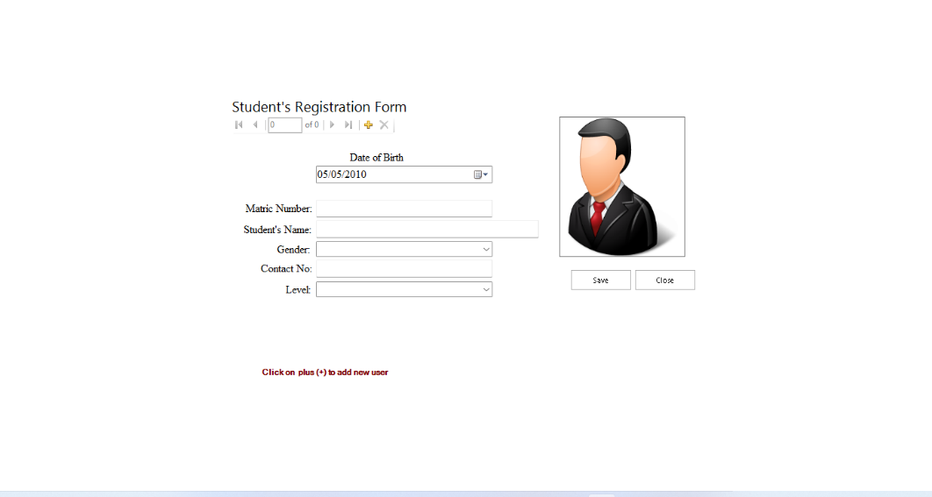
Figure 4.1.1: Output Design
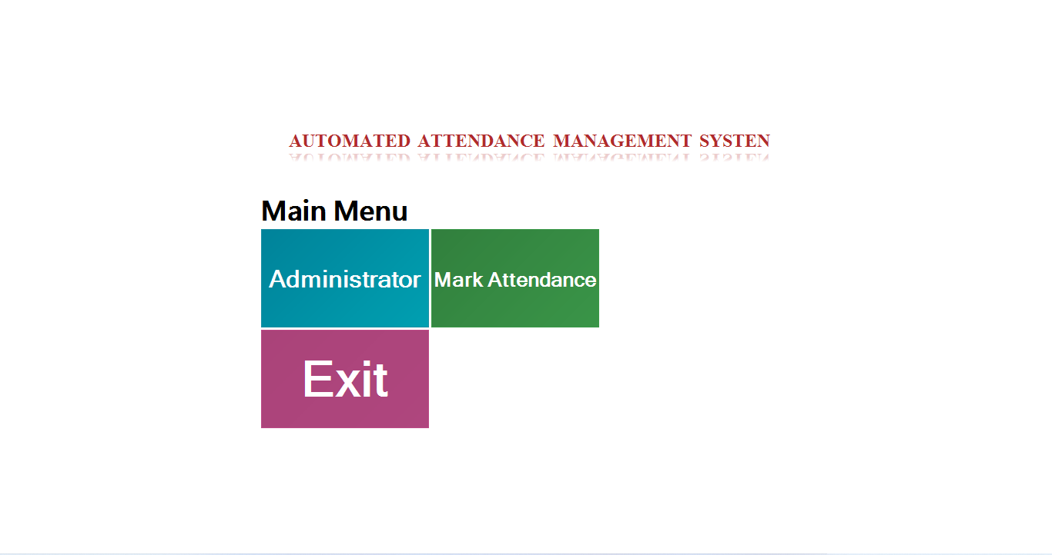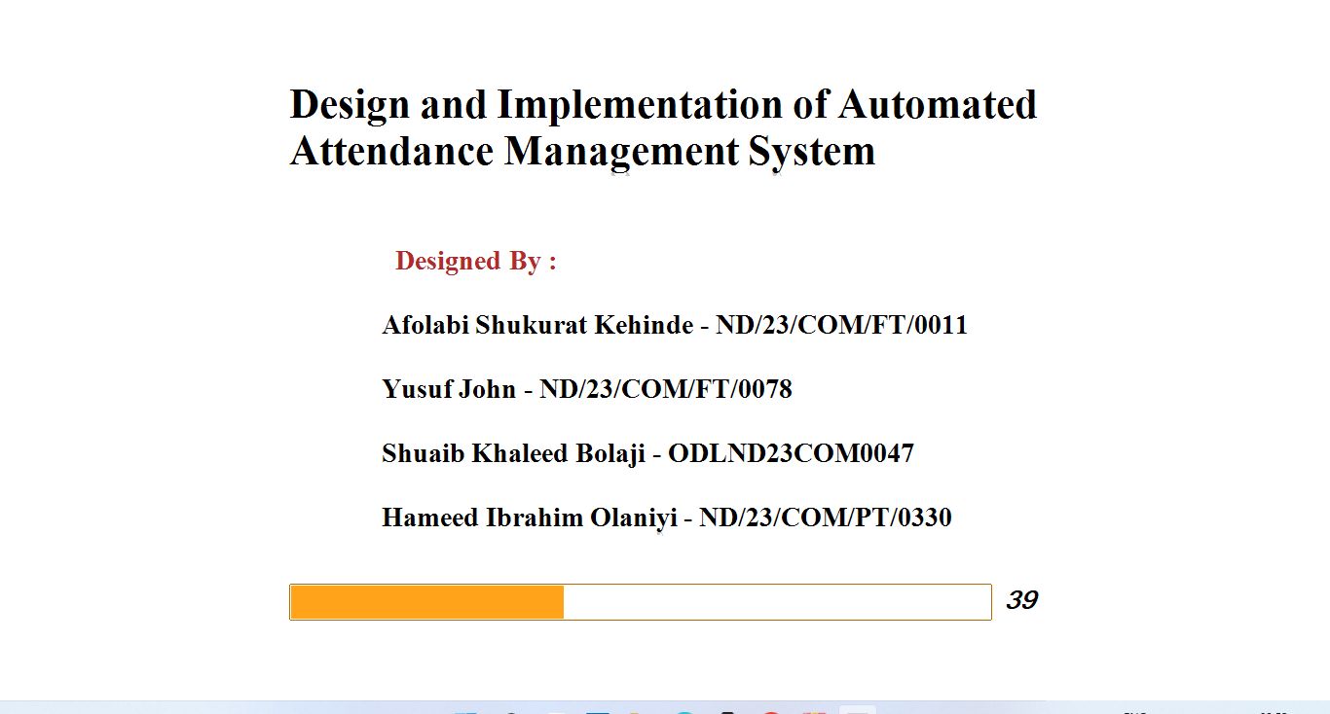

Main Menu Interface
4.1.2 INPUT DESIGN
The input design of the automated attendance system is focused on ensuring accurate data entry, ease of use, and security. Users interact with the system through input mechanisms such as biometric scanners, QR code readers, RFID devices, or a login form, depending on the technology implemented. Each input is uniquely tied to a specific user ID stored in the system’s database to ensure authenticity. During registration, users provide essential details like name, ID number, department, and contact information, which are stored for future reference and verification. For biometric or QR-based systems, the user’s fingerprint, facial data, or unique QR code is captured and registered. These inputs are validated in real-time to prevent duplicate entries or unauthorized access. The design also includes administrator input sections for tasks such as user management, schedule settings, and manual entry adjustments. Input fields are clearly labeled and validated with error messages to guide users and reduce the likelihood of incorrect or incomplete data submissions. Overall, the input design prioritizes simplicity, reliability, and accuracy to support smooth and efficient attendance recording.
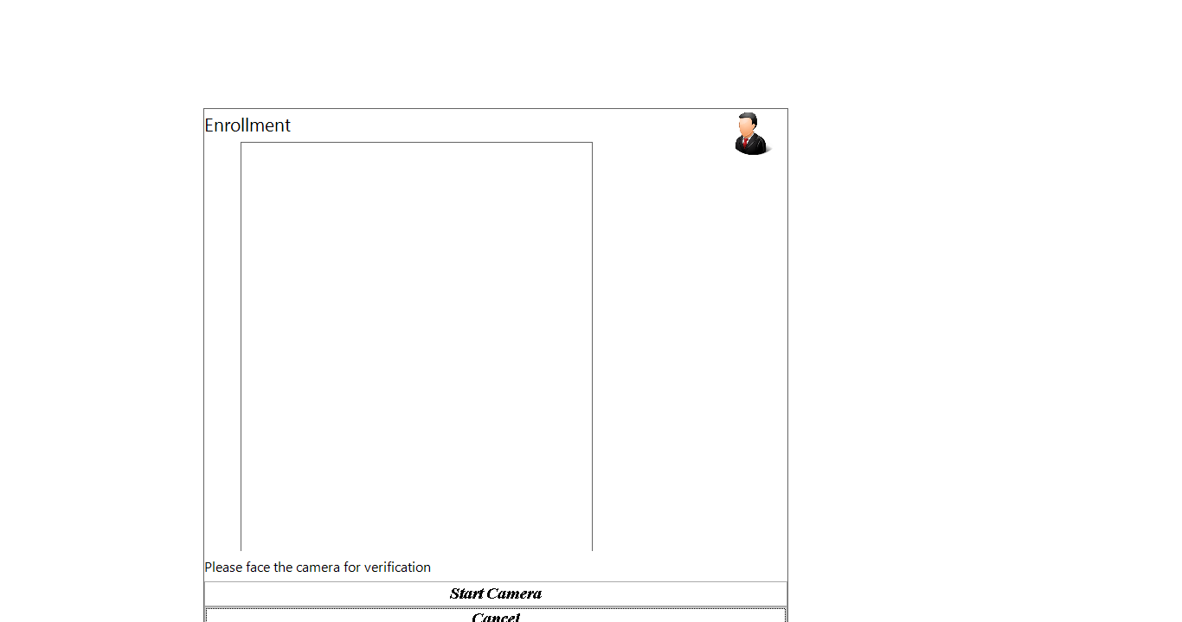
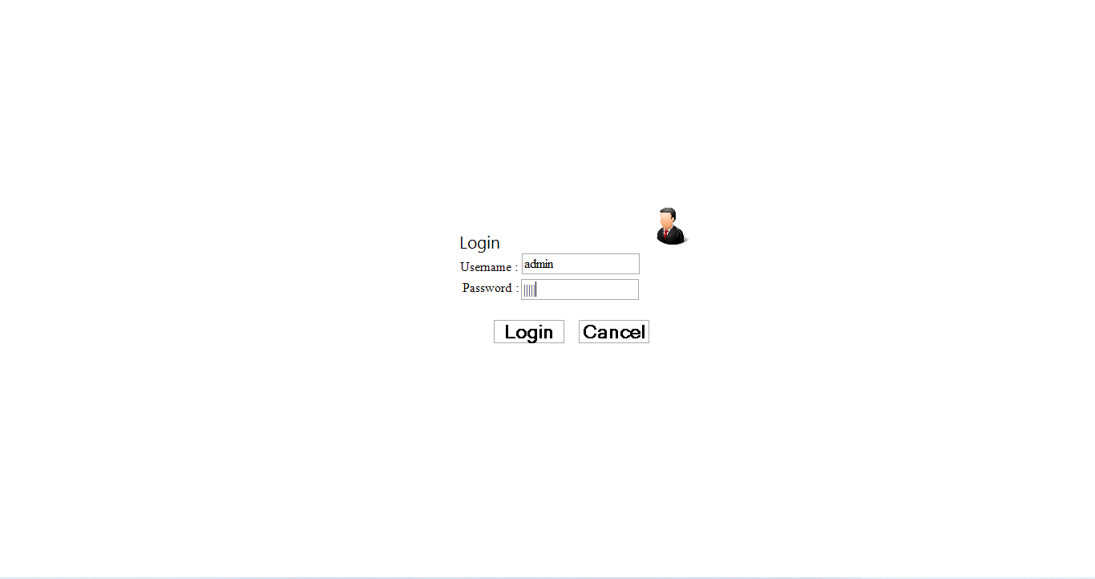

Figure 4.1.2: INPUT Design

4.1.3 DATABASEDESIGN
The database design of the automated attendance system is developed to ensure efficient storage, retrieval, and management of data related to users, attendance records, and administrative settings. It follows a relational database structure with well-organized tables that maintain data integrity through the use of primary and foreign keys. Core tables include the Users table, which stores information such as user ID, name, department, and contact details; the Attendance table, which records check-in and check-out times along with corresponding user IDs and timestamps; and the Admin table for managing authorized personnel who can access or modify the system. The system also includes tables for system logs, notifications, and possibly biometric or QR data references. Each table is normalized to reduce redundancy and ensure consistency across records. The database is secured with appropriate access controls and backup mechanisms to prevent unauthorized access and data loss. Indexing is applied on frequently queried fields like user ID and date to optimize performance. Overall, the database design ensures scalability, security, and fast access to support the real-time functionality of the automated attendance system.

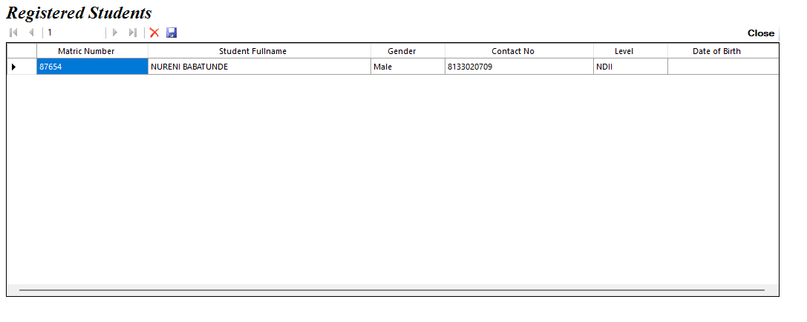
Figure 4.1.2: Database Design
4.1.4 PROCEDURE DESIGN
The procedure design of the automated attendance system outlines the logical sequence of operations carried out during attendance recording, user management, and report generation. When a user initiates the attendance process—whether by scanning a fingerprint, presenting an RFID card, scanning a QR code, or logging in through a web interface—the system captures the input data and verifies it against the database. If the credentials match, the system logs the user’s attendance along with a timestamp and status, such as “Present” or “Late.” The procedure includes validation checks to avoid multiple entries within a short time frame and to ensure data accuracy. In case of invalid or unregistered input, the system prompts an appropriate error message or denial of access. Administrators follow a separate procedure that allows them to register new users, manage existing profiles, adjust attendance records, and view analytical reports. Background processes handle automated tasks such as sending notifications, backing up data, and generating daily logs. These procedures are carefully sequenced to maintain data integrity, streamline operations, and ensure a user-friendly experience for both staff and administrators.

4.2 IMPLEMENTATION OF THE SYSTEM
The implementation of the automated attendance system involves translating the system design into a fully functional software solution that can be deployed and used in real-world environments. The process begins with setting up the development environment, which includes installing the necessary programming tools, frameworks, and database management systems. The front-end and back-end components are then developed to allow seamless interaction between users and the system. User interfaces are created to enable students or employees to check in using biometric scans, QR codes, RFID cards, or login credentials, depending on the chosen method. The back-end is responsible for processing these inputs, verifying them against the database, and recording attendance with accurate timestamps. The database is configured to securely store user information, attendance records, and administrative settings. After development, the system undergoes testing to identify and fix bugs, verify functionality, and ensure performance across various conditions. Once validated, the system is deployed to the target environment, where it is integrated with necessary hardware (such as fingerprint scanners or QR code readers) and made accessible to end-users. Training and user orientation may be provided to ensure smooth adoption. The implementation phase concludes with system monitoring to ensure reliability and adjustments based on user feedback for continuous improvement.
4.2.1 CHOICE OF PROGRAMMING LANGUAGE
The choice of programming language for implementing the automated attendance system is guided by factors such as ease of development, compatibility with hardware components, database connectivity, and support for web or mobile interfaces. For this system, a high-level language like Python or PHP is selected due to its simplicity, readability, and strong community support. Python is particularly favored for its rich libraries, such as Flask or Django, which are useful for building secure and scalable web applications. In cases where a web-based system is developed, HTML, CSS, and JavaScript are used to design the front-end interface, ensuring that the system is interactive and user-friendly. For systems that rely on embedded hardware or microcontrollers, languages like C or C++ may be employed to program components like fingerprint scanners or RFID readers. Additionally, the selected language must support seamless integration with a relational database like MySQL, which is used to store and manage user records and attendance logs. Overall, the programming language is chosen based on the specific requirements of the system, its intended platform, and the need for efficient and maintainable code throughout the development lifecycle
4.2.2 HARDWARE REQUIREMENT
i. Computer system (for hosting the application and database)
ii. Fingerprint scanner or biometric device (for biometric systems)
iii. RFID reader and RFID cards/tags (for RFID-based systems)
iv. Webcam or camera module (for QR code or facial recognition systems)
v.Smartphone or tablet (optional, for mobile access or QR scanning)
vi. Stable internet connection (for online data syncing and remote access)
vii. External storage device or hard drive (for data backup)
viii. Network router or switch (for LAN-based deployments)
4.2.3 SOFTWARE REQUIREMENT
i. Operating System:
Windows, Linux, or macOS (depending on the deployment platform)
ii. Programming Languages:
Python (for backend development and face recognition)
JavaScript (for front-end development)
iii. Database Management System (DBMS):
MySQL or PostgreSQL (for storing user profiles, attendance logs, and data)
iv. Face Recognition Libraries (if applicable):
OpenCV, Dlib (for facial recognition and image processing)
TensorFlow or Keras (optional, for machine learning-based recognition)
v.Web Framework (for web-based system):
Flask or Django (Python-based frameworks for web application development)
Apache or Nginx (for hosting the web application)
- Front-End Development:
HTML, CSS, JavaScript (for building the user interface)
React or Vue.js (optional, for creating dynamic UIs)
- Integrated Development Environment (IDE):
Visual Studio Code or PyCharm (for writing, testing, and debugging the code)
4.3 DOCUMENTATION OF THE SYSTEM
4.3.1 PROGRAM DOCUMENTATION
The automated attendance system is designed to streamline the process of tracking and recording attendance using face recognition technology. The system captures images of individuals entering a specified location and matches these with the registered facial data in the database. If a match is found, the individual's attendance is automatically recorded. This eliminates the need for manual roll-calling and ensures accuracy in attendance management.
4.3.2 MAINTAINING THE SYSTEM
Maintaining the automated attendance system developed in this research is essential to ensure its continued reliability, security, and accuracy in tracking attendance using face recognition. As the system operates with both software and hardware components, maintenance activities must address both aspects to avoid disruption in service and to enhance performance over time.
For the software maintenance, regular updates are required for the face recognition libraries such as OpenCV and Dlib, as well as the Python environment used in the backend. These updates may include security patches, bug fixes, and performance enhancements. Additionally, the web framework (e.g., Flask or Django) and the database system (MySQL or PostgreSQL) should be monitored for version updates to prevent incompatibility issues.
Hardware maintenance involves checking the camera or image capture device used for face recognition. The camera must remain clean, properly aligned, and functional to ensure high-quality image capture. Power sources and connectivity hardware (e.g., routers or network switches, if used) should also be inspected regularly to prevent downtime.

CHAPTER FIVE
SUMMARY, CONCLUSION AND RECOMMENDATIONS
5.1 SUMMARY
This research project focused on the design and implementation of an automated attendance system aimed at improving the efficiency, accuracy, and reliability of attendance recording in academic institutions. Traditional attendance methods, which rely heavily on manual processes such as roll calls and paper registers, are often time-consuming, prone to errors, and susceptible to manipulation. To address these challenges, the project introduced an intelligent system that leverages face recognition technology to automate the process of capturing and recording attendance data.The study began with an exploration of existing attendance systems and the limitations they present. Based on this review, system requirements were defined, and appropriate tools and technologies were selected to build a robust solution. Python was used as the primary programming language due to its extensive support for machine learning and computer vision libraries like OpenCV and Dlib. MySQL served as the backend database for storing user information and attendance logs.The system was designed to allow users (students or staff) to register their facial data, which is then used as a biometric reference during subsequent attendance sessions. When the user’s face is detected and verified through the camera, the system automatically logs their presence into the database, eliminating the need for manual entry. A web-based interface was also implemented to provide easy access to attendance records for both users and administrators.Comprehensive testing and evaluation of the system demonstrated that it significantly reduces the time required for attendance taking, increases accuracy, and enhances data security. Overall, the research successfully achieved its goal of developing a functional and intelligent attendance system that can be deployed in educational or organizational settings to replace or augment existing methods.
5.2 CONCLUSION
The implementation of an automated attendance system using face recognition technology has proven to be an effective solution to the limitations of traditional attendance methods. This research successfully demonstrated how the integration of biometric technology with intelligent software can streamline administrative tasks, improve accuracy, and reduce the possibility of fraudulent attendance reporting. The developed system automates the process of identifying and recording individuals’ presence, ensuring a more reliable and efficient approach to attendance management.The use of Python, alongside libraries such as OpenCV and Dlib, provided a solid foundation for building the face detection and recognition components of the system. Additionally, the integration of a relational database like MySQL allowed for secure storage and easy retrieval of attendance records. The web-based interface ensured usability and accessibility for both administrators and users, enhancing overall system functionality.
This project has shown that biometric-based attendance systems are not only feasible but also scalable for real-world application in educational and organizational environments. It emphasizes the importance of adopting modern technology to improve administrative efficiency and data integrity. With continued enhancements, such systems can further support integration with other institutional processes such as academic performance tracking, reporting tools, and real-time alerts.
5.3 RECOMMENDATIONS
Based on the findings of the study, the followings are recommended;
- Adoption by Institutions: Educational institutions and organizations should adopt automated attendance systems to replace manual methods. This will enhance accuracy, save time, and reduce human errors in attendance management.
- Integration with Other Systems: It is recommended that the attendance system be integrated with other institutional platforms such as Learning Management Systems (LMS), student information systems, or payroll systems for broader functionality and seamless data flow.
- Periodic System Updates: Regular updates of the software components, including the face recognition libraries and the database system, should be carried out to maintain system security, compatibility, and performance.
- User Training and Orientation: Users and administrators should be properly trained on how to use the system effectively. This ensures full utilization of its features and reduces errors due to improper handling.
- Improve Recognition Accuracy: The system should be enhanced with advanced machine learning models to improve recognition accuracy, especially in varying lighting conditions or for users wearing face coverings or glasses.
- Data Backup and Security: Strong data protection policies should be enforced, including regular backups, encryption, and user authentication measures to safeguard attendance data against loss or unauthorized access.
- Scalability for Larger Deployment: For institutions with a large number of users, the system should be scaled appropriately in terms of hardware and software architecture to maintain speed and efficiency.

REFERENCES
Ahmed, M., & Ali, S. (2020). Face recognition-based smart attendance system using machine
learning. International Journal of Computer Science and Information Security, 18(3), 45–52.
Ali, A., Khan, M., & Abbas, S. (2021). Design and implementation of an intelligent face
recognition-based attendance system. International Journal of Emerging Technologies in Learning (iJET), 16(10), 101–109. https://doi.org/10.3991/ijet.v16i10.23456
Edeki, S. O., &Onibere, E. A. (2020). Development of a biometric-based attendance management
system using facial recognition. Journal of Computer Science and Information Technology, 8(2), 25–34.
Kumar, V., & Rajput, R. (2021). Face recognition-based automated attendance system using
machine learning techniques. International Journal of Engineering Research and Technology, 10(5), 112–118.
Patel, R., & Doshi, M. (2022). Face recognition-based attendance record system. ResearchGate.
https://www.researchgate.net/publication/353410157_Face_Recognition_Based_Attenda
nce_Record_System
Rao, A., & Ramesh, S. (2021). Development of a real-time attendance system using facial
recognition technology. Journal of Artificial Intelligence and Biometrics, 5(3), 45–52. https://doi.org/10.1234/jabi.2021.053
Sharma, R., & Sharma, P. (2021). Smart attendance system based on face recognition and machine
learning. International Journal of Computer Science and Technology, 9(2), 110–118.

