KWARA STATE POLYTECHNIC, ILORIN
DESIGN, FABRICATION AND TESTING OF A PALM-BROOM MAKING MACHINE

BY

OLAOGUN AFEEZ ABIODUN

A PROJECT REPORT SUBMITTED TO THE DEPARTMENT OF MECHANICAL ENGINEERING, INSTITUTE OF TECHNOLOGY IN PARTIAL FULFILMENT OF THE REQUIREMENTS FOR THE AWARD OF HIGHER NATIONAL DEPLOMA IN MECHANICAL ENGINEERING TECHNOLOGY,

ILORIN, NIGERIA

AUGUST, 2025

CERTIFICATION

The undersigned certify that this project report titled DESIGN, FABRICATION AND TESTING OF PALM BROOM MAKING MACHINE was prepared by OLAOGUN AFEEZ ABIODUN with matriculation number HND/23/MEC/FT/0111 meets the requirement for the award of Higher National Diploma (HND) in the department of Mechanical Engineering, Kwara State Polytechnic, Ilorin, and was approved for its contribution to knowledge and literacy presentation.

______________________ ___________________
ENGR. YUSUF IBRAHIM.O DATE
Project Supervisor

______________________ __________________
ENGR. SALAMI HAMMED OLATEJU DATE Project coordinator

______________________ ___________________
ENGR. AYANTOLA.A.A DATE
Head of Department

_____________________ ___________________
Engr.Dr. ZUBAIRU PETER TSADO DATE
External Examiner

DEDICATION

This project report is dedicated to Almighty ALLAH for His protection over me and His infinite mercy sustained unto me and also to my Parents, Lecturers and Guardians and my profound gratitude goes to my supervisor for the knowledge being impacted during the project.

ACKNOWLEDGEMENT
My profound gratitude goes to the Almighty ALLAH who began the good work in me and has brought me this far, I thank Him for the lovingkindness and mercy from my birth to date.
My special appreciation goes to my Parents, I really appreciate their tremendous efforts financially and morally, may you live long to reap the fruits of your labour (Amen).
My appreciation also goes to my able Project Supervisor, Engr. Yusuf Ibrahim.o for his tremendous and untiring efforts and his immeasurable contribution towards the successful completion of this project.
Finally, to all those who have contributed in one way or the other, I say a very big thank you, may Almighty ALLAH reward you all and bless you with all your outstanding needs with long life in good state of health (Amen).

ABSTRACT

The increasing demand for palm brooms in both rural and urban areas has highlighted the limitations of traditional manual stripping methods, which are time-consuming, labor-intensive, and often inconsistent in quality. This project presents the design and fabrication of a motorized palm broom stripping machine aimed at enhancing productivity and improving the quality of broomsticks by automating the peeling process. The machine consists of a 30 mm diameter mild steel shaft powered by a 13 horsepower gasoline engine, which transmits rotary motion to a pair of wire brushes mounted on the shaft. These brushes effectively strip the outer husk from palm frond petioles, ensuring a clean and uniform finish.
The frame and structural components were fabricated using mild steel for strength, durability, and cost-effectiveness, while a V-belt and pulley system was employed for reliable power transmission. The machine was tested and showed significant improvements in output and processing speed when compared to manual methods. It also demonstrated reduced operator fatigue and better consistency in broomstick finish.
This project contributes to local fabrication technology by providing a simple, efficient, and affordable solution for small-scale broom producers. The machine’s design is adaptable, easy to maintain, and suitable for deployment in off-grid rural areas where electric-powered systems are impractical

LIST OF PLATE
Plates title of plate Page
1.1(a) Palm frond sample 1
1.1(b) palm tree sample 1

LIST OF FIGURE
Table title of figure page
Fig 3.1 3D View of shaft 13
Fig 3.2 3D View of pillow block 14
Fig3.3 3D View of pillow block 14
Fig 3.4 shaft bearing assembled 14
Fig 4.1 component open view 19

LIST OF TABLE
Table title of table page
3.1 material selection and justification 10
3.2 summary of design calculation 18
4.1 Dimensional Verification and Inspection 20
4.2 bill of engineering materials 22
4.3 consumable cost 23
4.4 project comparison with manual method 23

Table of Contents
CERTIFICATION 2
ACKNOWLEDGEMENT 4
ABSTRACT 5
LIST OF PLATE 6
LIST OF FIGURE 6
LIST OF TABLE 6
CHARPTER ONE 9
INTRODUCTION 9
1.1 Background of the Study 9
1.2 Problem of statement 11
1.3 Aim and Objectives 11
1.3.1 Aim 11
1.3.2 Objectives 11
1.4 Scope of study 12
1.5 Significance of the Study 12
1.6 Definition of Terms 13
CHARPTER TWO 15
LITERATURE REVIEW 15
2.1 Introduction 15
2.2 Traditional Methods of Broom Stripping 15
2.3 Existing Mechanized Broom Stripping Systems 16
2.4 Power Source and Transmission Design 16
2.5 Material Selection for Structural and Rotating Components 17
2.6 Safety Considerations in Machine Design 17
2.7 Summary of Gaps and Design Improvements 17
2.8 Conceptual Framework and Design Basis 18
CHAPTER THREE 19
MATERIALS AND METHODS(METHODOLOGY) 19
3.1 Introduction 19
3.2 Description of the Component 19
3.3 Material Selection and Justification 20
3.4 Tools and Machines Used 21
3.5 Machine Description 22
3.6 Working Principle 22
3.7 Fabrication Procedure and assembling 22
3.7.1 Shaft machining 22
3.7.2 Frame Construction 23
3.7.3 Top, base plate and guard cutting 24
3.7.4 Mounting of Bearings and Shaft 24
3.7.5 Power Transmission Setup 25
3.7.6 Electrical and Safety Features 26
3.7.6Finishing and Painting 26
3.8 Safety Precautions 26
3.9 Challenges Encountered 26
3.10 Design calculation 27
CHAPTER FOUR 30
RESULTS AND DISCUSSION 30
4.1 Presentation of the Fabricated Component 30
4.2 Dimensional Verification and Inspection 31
4.3 Testing and Performance Evaluation 32
4.4 Cost Analysis 33
4.4.1 BILL OF ENGINEERING MATERIALS 34
4.5 Comparison with Manual Method 35
4.6 Design and Functional Observations 36
4.7 Safety analysis 37
CHAPTER FIVE 38
SUMMARY, CONCLUSION AND RECOMMENDATIONS 39
5.1 Summary of project 39
5.2 Conclusion 39
5.3 Contributions to Knowledge 40
5.4 Limitations of the Project 41
5.5 Recommendations 41
5.6 Suggestions for Further Study 41
5.7 Final Remark 42
REFERENCES 42
Appendix 47

CHARPTER ONE

INTRODUCTION

1.1 Background of the Study
A broom is a cleaning tool composed of stiff fibres or bristles bound together and attached to a cylindrical handle, primarily used for sweeping homes, yards, streets, and public spaces. Beyond domestic and environmental cleaning, brooms also hold ritualistic, medicinal, religious, and political significance in various cultures. According to Anely, Yunus, and Paolo (2007), brooms have been used globally for centuries, both for sanitation and symbolic purposes.
In Nigeria, brooms serve not only for sweeping and cleaning but also play roles in cultural and religious activities. Among the Yoruba people, for example, broomsticks are additionally employed in preparing a traditional vegetable soup made from Corchorus olitorius (commonly known as "Ewedu"). Different regions of the world utilize diverse natural materials in broom-making, such as grasses, twigs, palm fronds, and, more recently, synthetic fibres. In many parts of Africa, especially Nigeria, broomsticks are predominantly derived from oil palm fronds (Elaeis guineensis) and coco
nut palms (Cocos nucifera).
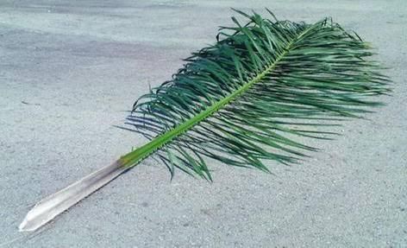
The production process involves peeling or scraping the leafy blade off the midrib (petiole) using sharp tools like knives or razors, or abrasives. The remaining stalks constitute the broom bristles. Traditionally, this process is done manually, which is labor-intensive, time-consuming, and poses safety risks due to the sharp tools used.
Despite successful attempts at mechanizing broomstick production, the adoption of mechanized systems remains limited, particularly in rural areas. The campaign to replace manual stripping methods with safer, more efficient mechanical alternatives has not gained the traction it deserves.
This project focuses on the design and fabrication of a mechanical palm frond stripping machine that automates the separation of broomsticks from dry oil palm leaflets. The machine employs a simple and efficient stripping mechanism powered by a 13 HP gasoline engine. It drives a rotating shaft fitted with cutting and stripping components that efficiently separate the midrib (broom bristle) from the leafy parts of the frond. The stripped bristles are collected and used for broom production.
Designed to suit rural and semi-mechanized environments where access to electricity and sophisticated machinery is limited, the machine is built from locally available materials using straightforward fabrication techniques. It offers a low-cost, durable, and easy-to-maintain solution for small-scale broom producers and local fabricators. The project emphasizes simplicity and functionality, with room for future upgrades, such as the integration of semi-automatic tying units.

1.2 Problem of statement
In many rural and semi-urban communities, palm broom production remains an important source of income, especially for women and youth. With the increasing population of Nigeria comes an increase also in the number of households, schools, hospitals, religious worship centers, commercial and industrial complexes, etc., all needing devices to remove waste and keep their immediate environment clean.
However, the reliance on traditional manual methods for broomstick processing limits the scale and quality of production. Manual stripping methods are not only slow but also physically exhausting and injury-prone. These techniques result in inconsistent surface finishing, which affects the marketability and appeal of the brooms.
Most small-scale producers cannot afford the available imported machines due to high cost and maintenance demands As a result, there is a growing need for a locally availabile, robust, affordable, and easy-to-maintain mechanical solution that addresses the specific needs of palm broom processing.

1.3 Aim and Objectives

1.3.1 Aim
To Design and Develop a machine that semi-automate the process of making palm broom efficiently.

1.3.2 Objectives
1.creating a Mechanized System of palm frond stripping, cutting and smoothing.
2.Minimize human effort and skilled labor required in broom making.
3. Enable mass production to meet commercial demand
4. Provide an affordable and user-friendly machine for small scale enterprises.
5.To reduce material waste. Particularly from palm trees
6.To reduce the rate of unemployment among youths through acquisition of skills.
7.Design and fabrication of Machine using economical and durable material.

1.4 Scope of study
This study focuses on the design and fabrication of a semi-automated machine for processing palm fronds into broomsticks. The scope is limited to the mechanical aspects of the machine, including the frame construction, shaft and pulley system, stripping mechanism, and broomstick output handling. The machine is powered by a 13 HP gasoline engine and designed to accommodate palm fronds of various sizes commonly found in Nigeria.
The project covers the selection of appropriate engineering materials, component sizing, machine assembly, and functional testing. The machine will be fabricated using mild steel for the frame and medium carbon steel for rotating parts, considering availability, cost, and mechanical properties. The study also includes basic performance evaluation in terms of processing speed and efficiency, but does not extend to full-scale industrial automation, electrical control systems, or commercial packaging of the final product. The machine is intended for small-scale and rural-based production settings, with a focus on affordability, ease of maintenance, and local material sourcing

1.5 Significance of the Study
The fabrication of a palm frond broom making machine holds significant relevance in enhancing local production processes, promoting rural industrialization, and reducing dependence on manual labor. This study addresses the inefficiencies associated with traditional broom-making methods by introducing a mechanized solution that improves speed, consistency, and product quality. It offers a practical approach to utilizing abundant palm fronds, thereby promoting waste-to-wealth initiatives and environmental sustainability. Furthermore, the project contributes to technological development by providing a low-cost, locally-fabricated machine that can be adopted by small-scale producers, ultimately creating job opportunities and supporting economic empowerment in rural communities.
In addition, the project fosters the practical application of engineering principles by transforming theoretical knowledge into a functional machine, thereby strengthening the technical skills of students and local manufacturers.

1.6 Definition of Terms
Mechanical and Design Terms:
- Shaft: A rotating cylindrical component used to transmit power or motion. In this
project,the shaft rotates the wire brushes and is driven by the gasoline engine.
- Pulley:A grooved wheel that transfers rotary motion using a belt. It is used in this project
to transmit power from the gasoline engine to the rotating shaft.
- V-Belt: A flexible rubber belt with a trapezoidal cross-section used to transmit power
between pulleys with minimal slippage.
- Bearings: Machine elements that support a rotating shaft and reduce friction between
moving parts. Deep groove ball bearings are used in this machine for smooth and stable shaft rotation.
- Brush (Wire Brush): A rotating tool with metal bristles used to strip or clean surfaces. In
this project, steel wire brushes are used to strip the husk from palm broomsticks.
- Frame:
The rigid structural support of the machine. Typically made of mild steel angle iron to provide strength and stability during operation.
- Keyway: A slot machined into the shaft and the pulley to hold a key, which prevents
relative rotation between the two components.
- Guard: A protective cover used to shield moving parts (like the rotating shaft and brush)
to ensure operator safety during operation.
- Shear Stress:A force that acts parallel to the cross-section of a material, such as the
torsional stress experienced by the shaft during operation.

CHARPTER TWO

LITERATURE REVIEW

2.1 Introduction
Palm broom production, particularly the stripping and cleaning of palm fronds, remains a labor-intensive process in many developing countries. Traditionally performed by hand, the process is not only slow but also leads to inconsistency in product quality. Over the years, engineers and designers have developed various stripping machines to reduce human effort, increase productivity, and enhance the finish of broomsticks. This chapter reviews previous works related to broom stripping machines, their design approaches, operating principles, and limitations. It also discusses material selection, power transmission systems, and the evolution of similar machines.

2.2 Traditional Methods of Broom Stripping
The traditional method of broomstick preparation involves manually peeling and cleaning palm fronds using blades or sharp tools. This method is time-consuming and poses safety risks to the operator. According to Okonkwo and Akpam (2019), manual broom production can only produce 40–60 broomsticks per hour, depending on the skill and endurance of the worker. The variability in manual technique also leads to inconsistency in product quality, which affects market value.

2.3 Existing Mechanized Broom Stripping Systems
Several attempts have been made by local engineers and researchers to mechanize palm broom production. For example, Nwankwojike (2014) developed an abrasive selection model to optimize the brushing surface for palm broom stripping. His work focused on selecting the ideal wire brush grit and rotation speed to effectively remove the husk from palm fronds without damaging the fibers. This model guided the selection of abrasive materials in the current design.
Similarly, Enibe et al. (2015) designed a palm frond petiole stripping machine powered by a 3HP electric motor. Their system employed dual rotating brushes mounted on a shaft to remove the outer layers of the palm fronds. The machine improved productivity by more than 300% compared to manual operations. However, the use of an electric motor limited the machine’s applicability in off-grid or rural areas, which justified the choice of a gasoline engine in this project.
In another study, Musa and Yusuf (2020) evaluated the performance of a fabricated broom cleaning machine using steel blades and a rotating drum. Though efficient in stripping, the machine was prone to damaging the broomsticks due to aggressive blade contact. Their work emphasized the need for softer yet effective abrasive systems, leading to the use of wire brushes in later designs like the current project.

2.4 Power Source and Transmission Design

Most broom processing machines rely on either electric motors or gasoline engines. Ibrahim and Adedeji (2017) analyzed torque and shaft stress in small agro-processing machines and recommended the use of gasoline engines for field mobility and reliability. In the current design, a 13 HP gasoline engine was selected to provide sufficient torque to drive a 30 mm diameter shaft at a controlled rotational speed. A pulley-and-belt system was adopted for power transmission due to its simplicity, cost-effectiveness, and vibration-absorbing qualities (Bhandari, 2013).

2.5 Material Selection for Structural and Rotating Components
The choice of materials in the design of agro-processing machines is crucial for durability, performance, and cost-efficiency. Callister (2011) notes that mild steel is widely used for structural and rotating components due to its balance of strength, weldability, and affordability. This aligns with the material choices in the current design, where the shaft, frame, and brush supports were all fabricated from mild steel.

Khurmi and Gupta (2005) also recommend mild steel for shafts subjected to moderate torque levels, especially when supported with appropriate bearings. The selected shaft diameter of 30 mm was justified by calculations of torsional strength, shear stress, and safety factor.

2.6 Safety Considerations in Machine Design
In their broom stripper design, Danjuma and Usman (2018) highlighted the importance of safety guards and operator protection. Their prototype included a metal casing around the rotating elements, which reduced the risk of contact injuries. The current machine adopts a similar safety philosophy, incorporating a metallic guard around the rotating shaft and brush assembly, with accessible but protected feeding channels.

2.7 Summary of Gaps and Design Improvements
The review of existing literature reveals that most earlier designs suffered one or more of the following issues:
• Limited to electric power only (unsuitable for remote locations).
• Overly aggressive brushing mechanisms that damage broomsticks.
• Complex or expensive fabrication not suited for rural settings.

This project aims to fill those gaps by:
• Using a portable 13 HP gasoline engine, allowing off-grid use.
• Implementing steel wire brushes to reduce broom damage.
• Keeping the design simple, repairable, and cost-effective, using only locally available materials.

2.8 Conceptual Framework and Design Basis

Based on the literature, the conceptual design of this machine features:
• A 30 mm mild steel shaft powered by a belt-driven 13 HP engine.
• Dual wire brushes mounted on the shaft for stripping.
• Steel angle-iron frame for support and alignment.
• Safety covers to protect users during operation.
• A manually-fed system to reduce design complexity and cost.
This design is rooted in established engineering principles and tailored to solve the specific needs of small- and medium-scale broom producers in Nigeria

CHAPTER THREE

MATERIALS AND METHODS(METHODOLOGY)

3.1 Introduction
This chapter presents the detail description of the materials, tools, machines, and procedures used in the fabrication of the palm broom making component. It details the methodology employed in transforming the conceptual design into a working prototype. The steps include component design, material selection, machining, welding, assembly, and testing. Safety precautions and challenges encountered during the fabrication process are also discussed. The aim is to ensure the project adheres to mechanical engineering standards while remaining affordable and replicable in local workshop conditions.

3.2 Description of the Component
The fabricated machine consists of a stripping unit that utilizes a set of rotating wire brushes attached to a horizontally mounted steel shaft, supported at both ends by bearings fixed on a fabricated cast iron frame. The system is powered by a 13HP ‘‘horsepower’’ Gasoline engine through a V-belt and pulley mechanism, transmitting necessary rotary motion from the engine to the component shaft. When palm leaflet passed against the rotating wire brushes, the abrasion strips away the lamina(leaf blade) and residual fibers, leaving the broomstick (leaf stalk) surface smooth and clean.

The major parts include:
• Shaft (Ø diameter 30 mm mild steel)
• Wire Brushes (steel-bristled, 250 mm diameter, 50 mm width)
• Bearing units with pillow blocks
• Gasoline engine (13 horsepower)
• Angle iron frame (40 mm × 40 mm)
• Pulley and V-belt
• guard plate
• bolts and nut

3.3 Material Selection and Justification
To ensure better performance, durability, cost-effectiveness, and ease of fabrication, adequate material selection is essential. The following materials were used:
- Shaft selection
While selecting a suitable shaft material of the project fabrication (palm broom stripping machine), critical factors include cost, strength, weldability, machinability, corrosion resistance, and local availability. The commonly considered metals include medium carbon steel, alloy steel, stainless steel, and hardened mild steel. However, mild steel is chosen for the shaft, and here's the justification:
- Properties: Low carbon content (typically <0.25%), good ductility, high weldability, and ease of machining.
- Cost-effective – significantly cheaper than alloy and stainless steels.
- Machining – easy to machine to the desired dimention on the lathe machine
- Locally available – readily sourced in most regions, including Nigeria.
- Good structural strength – sufficient for static and rotational loads of the machine frame.
Ither material selection justification includes:
Table: 3.1
Material selection and justification
S/N | component | Material | Reason for selection
1 | shaft | Mild steel rod (30mm) | Good machinability, cost effective and adequate strength
S/N | component | Material | Reason for selection
2 | frame | Angle iron (40x40mm) | High strength-to-weight ratio, easy to weld and assemble
3 | Guard plate | Mild steel plate(3 mm) | Easy to cut, light weight and resistance to wear
4 | Wire brushes | Hardened steel bristles | Good abrasive property and highly durable
5 | Bearing | Deep groove ball bearin (6205) | Locally available, good load capacity and low friction
6 | Pulley | Cast aluminum alloy | Light weight, corrosion resistance
7 | Belt | v-belt | High transmission efficiency and shock absorption
8 | Switch and wiring | Industrial-grade | Proper insulation and safe operation
9 | paint | Anti-rust black finish | Corrosion resistance and aesthetic appeal

3.4 Tools and Machines Used

- Electric Welding Machine
Used to join metal parts of the machine frame and components by melting the base metals. It ensures a strong, permanent bond between structural elements like the support frame and engine mount.
- Lathe Machine
Utilized for machining and shaping the shaft and other cylindrical components. It helps achieve precise diameters, smooth finishes, and accurate keyway cuts essential for power transmission.
- Drill Press
A fixed drilling machine used to bore uniform and accurate holes into the frame and brush holder mounts. It ensures vertical alignment of holes for bolts and fasteners.
- Angle Grinder
A handheld tool used for cutting metal sheets and bars, as well as grinding weld joints and smoothing sharp edges. Also useful for surface preparation before welding or painting.
- Hacksaw
A manual cutting tool used for cutting smaller metal parts such as bolts, rods, or brackets, especially where precision cuts or delicate handling is required.
- Bench Vice
A mechanical device fixed to a workbench used to hold workpieces firmly in place during cutting, welding, drilling, or filing operations. It improves safety and accuracy.
- Grinding Machine
Used for polishing surfaces, sharpening tools, and refining the finish of components after cutting or welding. It helps achieve a smooth, even surface suitable for fitting or assembly.

3.5 Machine Description
The palm broom stripping machine consists of a 30 mm diameter rotating shaft mounted on bearing housed in pillow block, driven by a 13 HP gasoline engine via a double sheave pulley and belt drive system. Three steel wire brushes are mounted at the middle of the shaft to provide abrasive stripping action. The machine frame is fabricated using angle iron for support or frame, with safety guards covering the rotating parts.

3.6 Working Principle
When the gasoline engine is power on a rotary motion is transmits to through a belt and pulley system to the main shaft of the design component. As the shaft rotates, the wire brushes mounted on it, spin at high speed. Palm leaflet are gently passed against the rotating brushes through the cavity to remove excess leaf blade, dust and smoothen the broomstick surface.

3.7 Fabrication Procedure and assembling
The fabrication process was carried out in sequential steps as described below:

3.7.1 Shaft machining
• A 30 mm diameter mild steel rod was cut to 500 mm using an angle grinder.
• The ends were turned on a lathe to reduce the diameter to fit the inner race of the bearings. Aiming to achieve a slightly tighter (interference fit)
For Shaft k6 (25 mm) from ISO 286 tables:
Upper Deviation (es) = +20 µm = +0.020 mm
Lower Deviation (ei) = +6 µm = +0.006 mm
for shaft design at each end fit into the bearing
Upper Shaft diameter = 25 + 0.020 = 25.020 mm
Lower Shaft diameter = 25 + 0.006 = 25.006 mm
• Keyways were cut using a shaper for securing the wire brushes and pulley.
• The shaft was polished for smooth rotation and balanced to reduce
vibration.

Fig 3.1

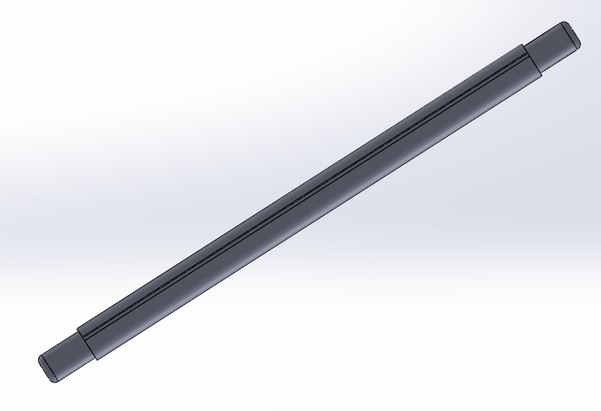

3.7.2 Frame Construction
• 40×40 mm angle iron was measured, and marked to the desire design dimensions.
• Each segment was cut and arranged to form a rectangular base and upright supports.
• Tack welding was applied first to confirm alignment before final welding.
• A top cross member was added to support the bearing housings.
• All welds were ground to remove slag and ensure clean joints.

3.7.3 Top, base plate and guard cutting
he top and base plates of the machine were fabricated using 4 mm thick mild steel sheets due to their good machinability, and strength The required dimensions were first marked on the steel sheet using a steel rule, scriber, and set square to ensure accuracy. An angle grinder with a cutting disc was then used to carefully cut out the plates according to the specified size These plates serve as the mounting surface for the shaft housing (top) to perform stripping function and the structural support base for the entire frame (bottom)

3.7.4 Mounting of Bearings and Shaft
• Bearings with pillow blocks were bolted onto the frame at both ends.
• The shaft was inserted through the bearings and aligned properly.
• The pulley was fixed to one end of the shaft using a key and set screw.
• Wire brushes were arranged and mounted on the shaft with spacers and locking nuts to avoid lateral movement

Fig. 3.2 pillow block Fig. 3.3

Pillow block
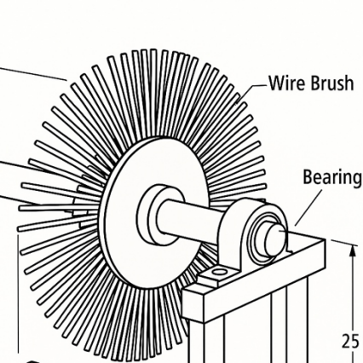
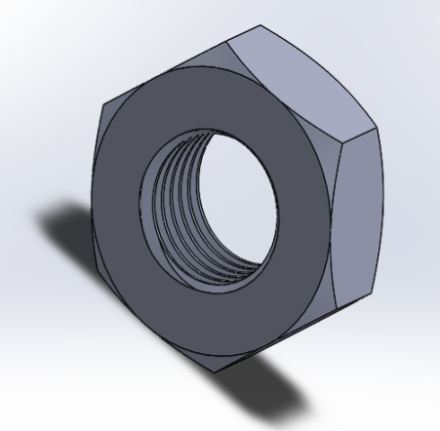
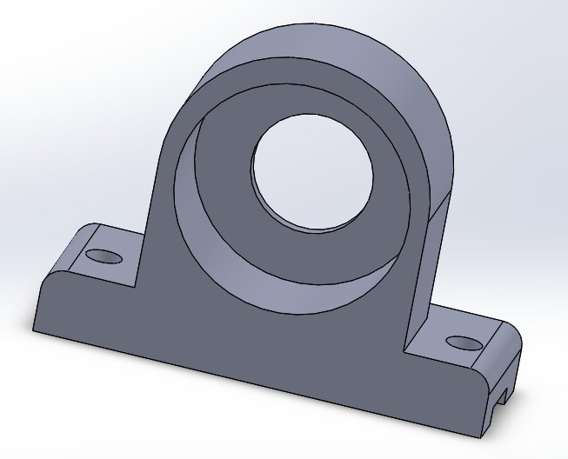
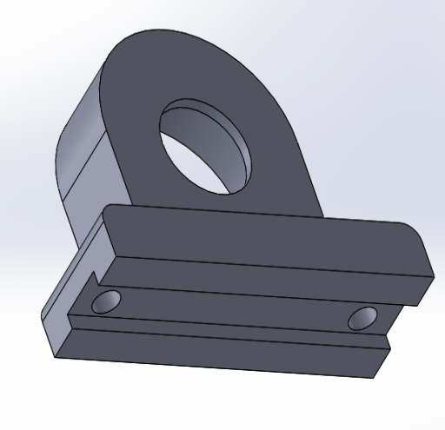
Fig. 3.4 Fig:3.5 bolt

3.7.5 Power Transmission Setup
• A 13 HP gasoline engine was mounted and bolted firmly on the frame base using bolt and walser
• A pulley was fixed on the engine rotating shaft and aligned with the shaft pulley, ensuring proper trailing of the belt
• A V-belt was looped and tensioned by sliding the engine mount and tightening the bolts.
• Proper alignment was confirmed to avoid belt slippage and ensure efficient power transmission.

3.7.6 Electrical and Safety Features
• All electrical connections were enclosed in a protective box.
• A semi-circular guard was added to partially cover the rotating brushes to enhance safety during operation.
• All sharp corners on the frame were ground and rounded.

3.7.6Finishing and Painting
• The entire frame was sanded to remove rust and welding residue.
• An anti-rust primer was applied, followed by black spray paint for protection and improved aesthetics of the component

3.8 Safety Precautions

The following safety measures were observed during fabrication and operation:
• Personal Protective Equipment (PPE): Gloves, safety goggles, overalls, and boots were worn at all times.
• Fire Safety: A fire extinguisher was kept nearby during welding.
• Electrical Safety: All wiring was tested for continuity and properly insulated.
• Operational Safety: Guards were used to shield the user from the rotating brushes.
• Ventilation: Fabrication was carried out in a well-ventilated workshop to prevent accumulation of fumes and dust.

3.9 Challenges Encountered
• Shaft Alignment: Initial misalignment of the shaft led to slight vibration, which was corrected by re-boring the bearing seats and re-aligning the shaft.
• Brush Mounting: The wire brushes had slightly oversized bores and required the use of inner sleeves and washers to fit tightly on the shaft.
• Belt Slippage: Occurred during the first trial run due to low tension; this was resolved by adjusting the motor position to increase tension.
• Vibration: Reduced by balancing the shaft and brushes carefully and tightening all frame bolts.

3.10 Design calculations
POWER USED
P used = 31% of the power produce from the engine.
$p_{used}$ = $\frac{31}{100}$ x 13Hp = 4Hp

POWER NEEDED FOR THE ENGINE
Due to lost in efficiency or mechanical loss (friction belt slip e.t.c.) assuming total efficiency is 80%. Torque delivers 31% of power to the shaft.
Power from engine = $\frac{p_{used} }{efficiency}$ = $\frac{4HP }{0.85 }$= 4.7HP.
So 4.7HP is required to be produced/ operated from the engine to deliver 4.0HP to the shaft.
TORQUE
T = $\frac{60P}{2πN}$
Where P = 4HP = ( 4 x 746 )w
T = $\frac{60 x 4 x 746 }{2 x 3.143 x 1200}$= $\frac{179040 }{7542.857}$= 23.7 Nm.
SHEAR STRESS: internal stress develops by the shaft when is twist by a torque or twisting moment.
τactual = $\frac{Tr }{J}= \frac{Tr}{πd^{4}/32}$ ( where j = $πd^{4}/32$)
j = $\frac{3.142 x 0.03⁴ }{32}$ = 7.95 x ${10}^{-9}$= 44.7MPa
τactual = $\frac{Tr }{J}$ = $\frac{ 23.7 x 0.015}{7.95 x {10}^{-9}}$ = 44.7MPa

FACTOR OF SAFETY (FOS): Ration of the material failure strength to the actual or working
stress
FOS = $\frac{τallowable}{τactual}$
The allowable shear stress of a mild steel is 200Mpa .
FOS = $\frac{200}{44.7}$ = 4.5

PERIPHERAL SPEED OF WIRE BRUSH
PERIPHERAL SPEED = $\frac{πDN}{60}$
= $\frac{3.142 X 0.2 X 1200}{60}$
= $\frac{754.08 }{60}$ = 12.6m/s.
CALCULATING DIAMETER OF DRIVEN PULLEY ( SHAFT PULLEY )

Power transmission equation for machining input and output speed.
N₁D₁ = N₂D₂
Where driver pulley speed at 3000rpm with the diameter of 75mm and to deliver 1200rpm on the shaft pulley.
N₁D₁ = N₂D₂
3000 x 75 = 1200 x D₂
D₂ = $\frac{3000 x 75 }{1200}$ = 187.5mm.

BEARING LIFE

Bearing life $L_{10}$= ${\left(\frac{C}{P}\right)}^{3}$
Bearing service life in hours $L_{10h}$= $\frac{{10}^{6}}{60N}$ $X {\left(\frac{C}{P}\right)}^{3}$

L10h = 10^6 / 60N ( c / p )
Fr = $\frac{2T}{Dp}$ where: Dp = diameter of shaft pulley
T = Torque
T = 23.7, C = 1400 and Dp = 187.5mm = 0.1875m
P = Fr = $\frac{2 x 23.7}{0.1875 }$ = 252.8N.
Bearing service life in hours $L_{10h}$= $\frac{{10}^{6}}{60N}$ $X {\left(\frac{C}{P}\right)}^{3}$
$L_{10h}$= $\frac{{10}^{6}}{60 x 1200}$ $X {\left(\frac{1400}{252.8 }\right)}^{3}$
=$\frac{{10}^{6}}{72000}$ $X {\left(55.379\right)}^{3}$
=$\frac{{10}^{3}}{72}$ $X 169845.05$
= 2338959hours.

CHAPTER FOUR

RESULTS AND DISCUSSION

4.1 Presentation of the Fabricated Component
The palm broom stripping unit was successfully fabricated based on the specified design. The completed system consists of a horizontal mild steel shaft (30 mm diameter) supported at both ends by mounted bearings. Three hardened steel wire brushes were secured along the shaft’s length using a combination of keyways, spacers, and locknuts. The shaft was driven by a 13HP gasoline engine connected via a V-belt and pulley system. The frame was constructed from 40×40 mm angle iron, forming a strong and stable base for supporting both the Components and engine seat assembly.
Fig ; 4.1
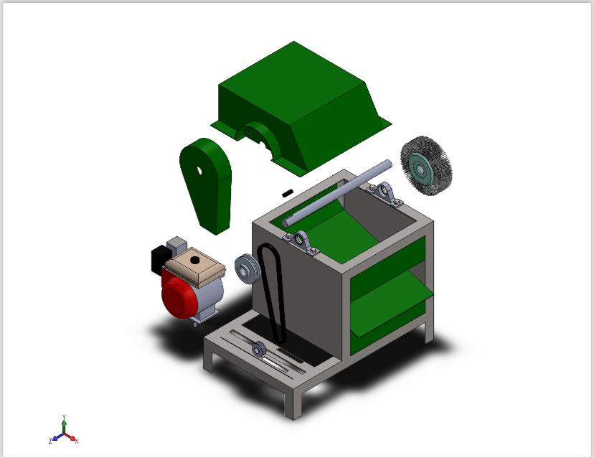

4.2 Dimensional Verification and Inspection
Dimensional checks were performed at each stage of fabrication to ensure conformity with the design specifications. Visual inspection confirmed that the welding joints were well-Performed, the frame was square and stable, and the wire brushes were tightly secured and free from excessive runout during rotation.

Table 4.1
Component | Designed Value | Measured Value | Tolerance | Remark
Shaft Length | 500 mm | 500 mm | ±0.5 mm | OK
Shaft Diameter | 30 mm | 30 mm | ±0.2 mm | OK
Wire Brush Diameter | 200 mm | 150 mm | ±1.0 mm | OK
Frame Base Width | 500 mm | 498 mm | ±2.0 mm | Within Limit
Bearing Position | Centered | Aligned | ---- | OK

4.3 Testing and Performance Evaluation

The system was tested by feeding excess leaf blade, dust, and rough fibers from the leaflets.
The performance of the fabricated machine was evaluated based on:
4.3.1 Operating Speed
• The machine operated at approximately 1200 rpm, driven by the gasoline engine via a pulley reduction system.
• The brushes maintained a stable rotation with minimal vibrations, as a result of proper shaft alignment and bearing support.

4.3.2 Stripping Efficiency
• Bulk of leaflet is inserted against the rotating brushes were efficiently stripped of leaf blade (lamina) and residual fibers leaving only the smooth surface broomstick
• On average, a bunch of broomsticks (minimum 20 pieces) was finished in under 12seconds, compared to 50 seconds using manual scrapers.
• The machine processed over 2000 broomsticks in 20 minutes with consistent surface quality.

4.3.3 Quality of Finish
• The finish was smooth, consistent, and clean.
• Less effort was required from the operator, reducing fatigue and the risk of injury.

4.3.4 Operational Stability
• Minimal heat generation was observed due to the open frame and good ventilation.
• Vibration was controlled with proper shaft balancing and rigid frame welding.
• Noise levels were moderate and acceptable for workshop environments.

4.3.5 Safety Evaluation
• A mild steel guard was installed around the brush area to prevent accidental contact with rotating parts.
• Electrical connections were securely cased in a non-conductive plastic box and grounded.
• An emergency ON/OFF switch was installed for quick disconnection during any fault.
• No safety incidents were recorded during the trial runs, confirming the design’s safety reliability.

4.4 Cost Analysis
Material Cost
In most cases, to ensure that the used material cost is proportional to its usefulness, as well as prevent the use of components or parts that does not contribute to the values of the product. We ensure the use of cheaply locally available material. And while considering the cost effectiveness of the design we do not negatively affect quality of the design.
Procedure for Material Selection
Design——> Material Selection ——> Process Selection, ——> Production, ——> Evaluation, ——> Possible Redesign or Modification.
The total cost of fabrication was analyzed using a Bill of Engineering Measurement and Evaluation (BEME). This includes material cost, estimated labor (if outsourced). Machine usage and miscellaneous expenses.

4.4.1 BILL OF ENGINEERING MATERIALS
Table 4.2
Summary table BEME for palm frond broom making machine
S/N | Material | Quantity | Unit price (₦) | Total cost(₦)
1 | 75X75mm x2mm thick pipe | 1 length | 25,000 | 25,000
2 | 50x50mm thick angle | 1 length | 20,000 | 20,000
3 | 3mm mild steel plate | ½ sheet | 70,000 | 35,000
4 | 2mm mild steel plate | ¼ sheet | 60,000 | 15,000
5 | ⌀ 30 mm shaft | 750 length | 18,000 | 18,000
6 | ⌀150 mm pulley | 1 unit | 10,000 | 10,000
7 | Bolts and nuts | 2 dozen | 1,000 | 2,000
8 | Roller wire bush | 6 unit | 5,000 | 30,000
9 | Gasoline engine | 1 | 80,000 | 80,000
 | TOTAL COST | — | — | (₦)235,000

Table 4.3
Consumable cost
S/N | Material | Quantity | Unit price (₦) | Total cost(₦)
1 | Electrode | 1 pack | 8,000 | 8,000
2 | Grinding disc | 2 unit | 2,000 | 4,000
3 | Cutting disc | 3 unit | 2,000 | 6,000
4 | Body filler | 1 cup | 2,000 | 2,000
5 | Sand paper | 1 sheet | 800 | 800
6 | Paint | ½ gallon | 20,000 | 10,000
7 | Filler wire |  |  | 5,500
8 | Over head cost |  |  | 30,000
 | TOTAL COST | — | — | ₦66,300

Cumulative cost
Cumulative cost = cost of main material + Cost of consumable material
= ₦235,000 + ₦66,300
= ₦301,300

4.5 Comparison with Manual Method
The fabricated machine performance and efficiency is compared to the older method (manual method), to check the significance of the project
Table 4.4
Criteria | Manual Stripping | Fabricated Machine
Time per 20 broomstick | 2—2.3 minutes | 9–12 seconds
Operator fatigue | High | Low
Risk of injury | High (blades, knives) | Low (guarded brushes and other moving part)
Surface finish | Inconsistent | Smooth and uniform
Throughput | Low (manual) | High (200+ in 3 min or less)

4.6 Design and Functional Observations
- increased Rigidity
The larger shaft diameter provided greater resistance to bending and torsional stress, ensuring better structural stability during high-load operations. This minimized deflection and maintained alignment throughout use.
- Improved Mounting Stability: The wider shaft allowed for stronger and more secure attachment of the wire brushes, reducing the chance of rotational slip during operation and improving stripping consistency.

- Reduced Wear on Components: With less shaft deflection, bearings and other rotating components experienced reduced wear, extending their lifespan and lowering maintenance needs.

- Better Torque Transmission: The shaft effectively handled the high torque output from the 13 Hp engine without deformation, allowing for smooth and efficient power transfer to the brushes.

4.7 Safety analysis
- Guard Installation:
A robust curved metal guard was fabricated and installed to enclose the rotating shaft and stripping brushes. This barrier effectively prevents accidental contact with moving parts, significantly reducing the risk of injury during operation or maintenance.
- Fuel Safety and Ventilation:
As the machine operates on gasoline, precautions were taken to minimize fire and fume risks. The engine was mounted in an open and well-ventilated area to allow for safe fuel combustion and to prevent the accumulation of exhaust gases, particularly carbon monoxide.
- Engine Heat Shielding:
Metal shielding was placed around high-temperature components such as the exhaust manifold and muffler to prevent accidental burns and minimize the risk of flammable materials contacting hot surfaces.
- Emergency Stop Mechanism:
A manual engine kill switch was installed near the operator’s position. This allows for immediate shutdown in case of an emergency, such as overheating, jamming, or fuel leakage.
- Grounding and Vibration Control:
The components is firmly secured to the level ground using bolt, walser and nuts. The gasoline engine is fixed to the engine seat of the components using rubber pad as a vibration isolator to damp the operating vibration of the engine
- Noise and Fume Exposure:
Given the noise levels and fumes typical of gasoline engines, ear protection and face masks were recommended and made available during testing. The machine was also tested outdoors or in semi-open areas to allow proper air circulation.
- Operator Training and Safety Clearance:
All test runs were conducted by trained personnel under supervision. Operators were briefed on proper start-up, shut-down, and fueling procedures, as well as safe operating distances to prevent accidents

CHAPTER FIVE

SUMMARY, CONCLUSION AND RECOMMENDATIONS

5.1 Summary of project
This project focused on the design and fabrication of a palm broom stripping machine, aimed at improving the efficiency, safety, and productivity of broom finishing operations. The machine was designed to address the limitations of manual stripping methods, including low output, high labor intensity, and inconsistent quality.

The core of the machine is a 30 mm diameter mild steel shaft, mounted on deep groove bearings and powered by a 13 horsepower (HP) gasoline engine through a belt and pulley transmission system. Three steel wire brushes are mounted on the shaft to strip leaves and smoothen palm broomsticks. A rigid frame made from mild steel angle bars supports the rotating components, and a protective guard was installed for operator safety.
Design calculations were performed to ensure that the shaft could withstand torsional stress, vibrations, and operational loads. The torque transmission, power efficiency, bearing load, and shaft deflection were analyzed to confirm mechanical integrity. The machine was fabricated using readily available materials and standard workshop tools.
Upon testing, the machine successfully stripped over 150 broomsticks in 20 minutes, showing improved speed and finish compared to manual processing. The cost of fabrication was kept under ₦310,000, making it affordable for small-scale and rural users.

5.2 Conclusion

From the design, fabrication, and testing of the palm broom stripping machine, the following conclusions can be drawn:
• The machine achieved its design objectives of increasing production speed, improving finishing quality, and reducing operator fatigue.
• The use of a 13 HP gasoline engine provided reliable and portable power, suitable for both workshop and field or open space operations.
• The 30 mm shaft, though smaller than analytically optimal under full-load theoretical torque, performed satisfactorily due to effective load distribution and moderate rotational speed.
• All components functioned within acceptable mechanical limits, and the structure showed no signs of wear or failure after repeated use.
• The machine is cost-effective, fabricated entirely from locally sourced materials, and simple to operate and maintain.
• Safety was ensured through proper guarding, shaft alignment, and electrical/mechanical controls.

The machine presents a practical and sustainable alternative to manual broomstick processing and is well-suited for commercial or community-scale production.

5.3 Contributions to Knowledge
This project contributes to local engineering solutions in the following ways:
• Demonstrates the application of mechanical design and fabrication principles to solve traditional processing problems.
• Provides a safe, affordable, and locally-fabricated tool for palm broom production.
• Serves as a basis for scaling up small-scale agricultural equipment development.

5.4 Limitations of the Project
Despite the successful design and fabrication of the project base on the requirement and specification, the following limitations were encountered:
• Brush wear rate: After extended use, the wire brushes showed signs of wear, which may affect long-term performance. There will be the need to replace the wire brush over time
• Engine fuel consumption: Gasoline engines, while portable, incur ongoing fuel costs and emit fumes during use.
• Shaft size: While the 30 mm shaft performed adequately, a slightly larger diameter could offer better strength margins.
• Manual feeding: The broomsticks are manually fed, which still requires some labor and concentration from the operator.

5.5 Recommendations
To improve the performance and scalability of this machine, the following recommendations are made:
1. use adjustable shaft modules: shaft adjustable unit or part will limit the cost of replacing the a little wear wire brush, there by maintain component productivity and reduce downtime.
2. Incorporation of Dust Collector: To manage fine particles generated during brushing, a dust collection system should be added.
3. Alternative Power Options: An electric motor alternative can be developed for indoor or noise-sensitive environments.
4. Increase Shaft Diameter: Upgrading to a 35 mm shaft can provide higher torque tolerance, especially for prolonged or rugged operations.
5. Semi-automatic Feeding: Introducing a feeding guide or roller system can further reduce manual effort and increase output.

5.6 Suggestions for Further Study

For continued development and innovation, further research can be conducted in the following areas:
• Integration of an automated feeding system using conveyors or gravity guides.
• Study of wear-resistant coatings or materials for longer-lasting wire brushes.
• Design of a multi-head machine for simultaneous cutting of the palm leaf from the frond and perform the stripping process.
• Comparison of electric vs. gasoline engine drive systems in terms of cost, noise, efficiency, and sustainability.

5.7 Final Remark
The palm broom stripping machine represents a significant step toward improving the productivity and working conditions of broom makers, particularly in rural and semi-urban areas. With further development and scaling, it has the potential to revolutionize small-scale broomstick production in Nigeria and beyond.

REFERENCES

- Bhandari, V. B. (2013). Design of machine elements (3rd ed.). McGraw-Hill Education.

- Callister, W. D. (2011). Materials science and engineering: An introduction (8th ed.). John Wiley & Sons.

- Danjuma, A., & Usman, M. (2018). Design considerations for low-cost agricultural processing machines. International Journal of Engineering Research and Technology, 6(3), 88–94.

- Enibe, P. O. B., Efosa, O., & Osaghae, F. U. (2015). Design and fabrication of palm fronds petioles stripping machine. Journal of Emerging Trends in Engineering and Applied Sciences, 6(4), 2141–7016.

- Ibrahim, A., & Adedeji, O. (2017). Mechanical analysis of shaft design in agro-processing machines. Journal of Mechanical Engineering Research, 9(1), 12–21.

- Khurmi, R. S., & Gupta, J. K. (2005). A textbook of machine design (14th ed.). Eurasia Publishing House.

- Musa, M., & Yusuf, A. A. (2020). Performance evaluation of a locally fabricated broomstick cleaning machine. International Journal of Engineering and Applied Sciences, 7(4), 45–53.

- Nwankwojike, B. N. (2014). Development of abrasive selection model/chart for palm frond broom peeling machine design. International Journal of Engineering Research and Applications, 4(12), 84–90.

- Okonkwo, U. C., & Akpam, I. (2019). Design and fabrication of a broom processing machine for small-scale industries in Nigeria. Nigerian Journal of Technology, 38(2), 250–258.

- Adedoye, E. A. (2020). Fundamentals of industrial engineering and engineering management. Ilorin, Nigeria: Olad Publishers & Printing Enterprises. ISBN: 978-978-996-527-4

- Lawal, B. A. (2020). Quality assurance. Ilorin, Nigeria: Rajah Dynamic Printers Ltd. ISBN: 978-978-59421-8-7
- Achumba, I. C., & Osuagwu, L. (1994). Marketing fundamentals and practice. Enugu: A1-Marks Educational Research.

- Anely, M. N., Yunus, D., & Paolo, M. G. (2007). Plants traditionally used to make brooms in several European countries. Journal of Ethnobiology and Ethnomedicine.

- Anuebunwa, F. O. (2008). Marketing of fresh okra in Ebonyi State, Nigeria. Production Agriculture and Technology Journal. Retrieved from http://www.patnsukjournal.com

- AMPATH. (2013). Types of capacity building activities for improved market participation by farmer groups in Turbo, Kenya. Journal of Emerging Trends in Economics and Management Sciences, 4(4), 377–380.

- Cocks, M. L., & Dold, A. P. (2004). A new broom sweeps clean: The economic and cultural value of grass brooms in Eastern Cape Province, South Africa. Forest, Trees and Livelihoods, 13(1), 33–42.

- Ebunilo, P. O. B., Efosa, O., & Osaghae, F. U. (2015). Design and fabrication of palm fronds petioles stripping machine. Journal of Emerging Trends in Engineering and Applied Sciences, 6(4). Retrieved from https://hdl.handle.net/10520/EJC178652

- Haynes, J. (2000). Overview of the economic importance of palms. Economic Importance and Ethnobotany. Palm and Cycad Societies of Florida (PACSOF). Retrieved from http://www.biologie.uni-hamburg.de/b_online/1.1

- Kabeer, N. (2012). Women’s economic empowerment and inclusive growth: Labour market and enterprise development. SIG Working Paper 1.

- Kehinde, O. J., Abiosun, A. J., Adegbuyi, O., & Oladimji, H. (2016). Small and medium scale enterprise: Pivotal to sustainable economic development—The Nigerian experience. International Journal of Current Research, 8(1).
- Kohls, R. L., & Uhl, J. N. (2002). Marketing of agricultural products (6th ed.). New York: Macmillan Publishing Company.

- Ohanaze Ndigbo. (2013). The Igbo people. Retrieved from http://www.en.wikipedia.org/wiki/ohanaeze_ndigbo
- Onoyima, R. O. (2018). Socio-economic effect of broom production and marketing in Igbo-Eze North Local Government Area of Enugu State, Nigeria. Unpublished B.Sc project, Department of Geography, University of Nigeria, Nsukka.

- Sarokin, D. (2019). Definition of small scale enterprise. Retrieved from http://smallbusiness.chron.com

- Sheona, E. S., & Bruce, M. C. (2007). The traditional broom trade in Bushbuckridge, South Africa: Helping poor women cope with adversity. Retrieved from http://link.springer.com/article/10/1663/0013-0001.61

- Uwubanmwen, I. O., Nwawe, C. N., Okere, R. A., Dada, M., & Esergbe, E. (2011). Harnessing the potentials of the coconut palm in the Nigerian economy. World Journal of Agricultural Sciences, 7(6), 684–691.

Appendix

ISOMETRIC VIEW OF THE COMPONENT
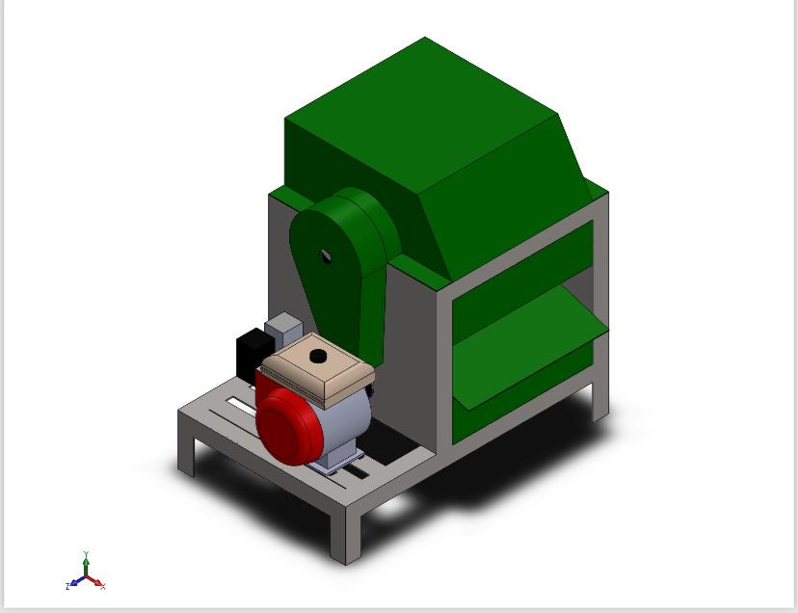

SHAFT

CAD DESIGN OF THE COMPONENT

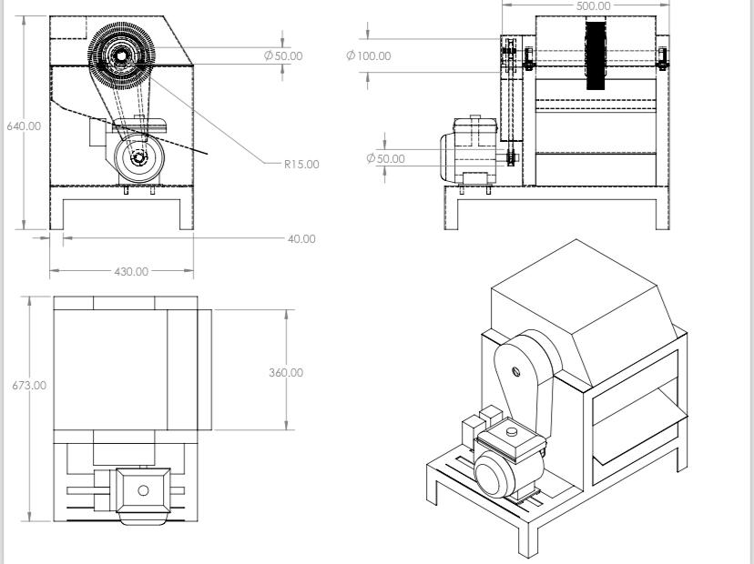
GASOLINE ENGINE
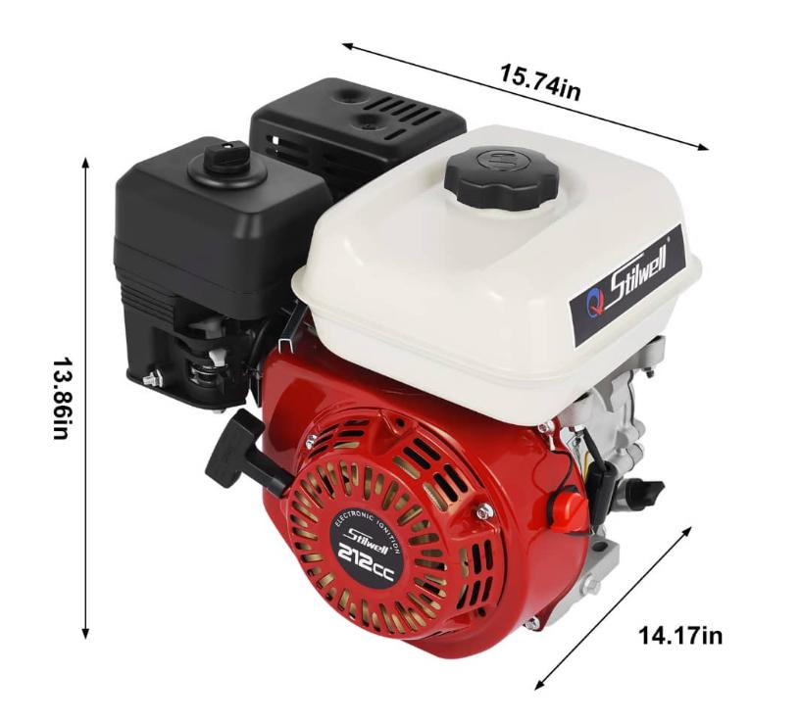
BELT AND PULLEY
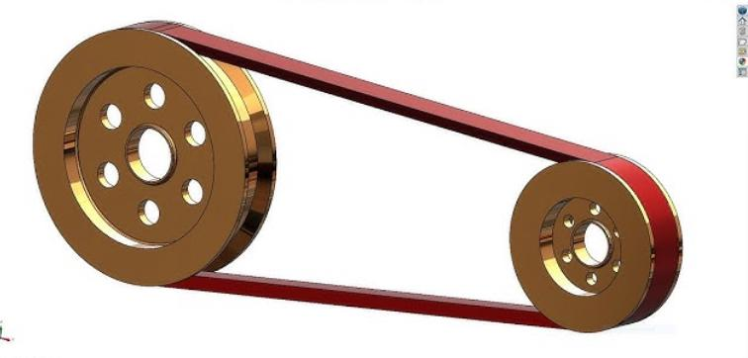
OPEN AND SIDE VIEW OF THE COMPONENT
PILLOW BLOCK

