WEB BASED INVENTORY MANAGEMENT SYSTEM
BY

ADEGOKE ABOSEDE TEMITOPE
HND/23/COM/FT/0387

SUBMITTED TO THE DEPARTMENT OF COMPUTER SCIENCE, INSTITUTE OF INFORMATION AND COMMUNICATION TECHNOLOGY
KWARA STATE POLYTECHNIC, ILORIN

KWARA STATE POLYTECHNIC, ILORIN.
IN PARTIAL FULFILLMENT OF THE REQUIREMENTS FOR THE AWARD OF HIGHER NATIONAL DIPLOMA (HND) IN
COMPUTER SCIENCE

JULY, 2025.

CERTIFICATION
This is to certify that this project was carried out by ADEGOKE ABOSEDE TEMITOPE with matriculation number HND/23/COM/FT/0387 in the Department of Computer Science, Institute of Information Communication Technology, Kwara State Polytechnic, Ilorin, Kwara State.

…………………………………. ….………………………
MR. SADIQ, K. A. Date
Project Supervisor

…………………………………. ….………………………
MR. OYEDEPO, F. S. Date
Head of Department

…………………………………. ….………………………
External Examiner Date

DEDICATION
I dedicate this project work to Almighty God who inspired me and directed my ways during my academic stay in the polytechnic.

ACKNOWLEDGEMENT
All praise is due to Almighty God the Lord of the universe. I praise him and thank him for giving me the strength and knowledge to complete my ND program and also for our continued existence on Earth.
I appreciate the utmost effort of my supervisor, Mr. Sadiq, K. A. whose patience, support, and encouragement have been the driving force behind the success of this research work. He gave useful corrections, constructive criticisms, comments, recommendations, and advice and always ensures that excellent research is done. My sincere gratitude goes to the Head of the Department Mr. Oyedepo F. S., and other members of staff of the Department of Computer Science, Kwara State Polytechnic, Ilorin, for their constant cooperation, constructive criticisms, and encouragement throughout the program.
Special gratitude to my parents, who exhibited immeasurable financial, patience, support, prayers, and understanding during the period in which I was busy tirelessly with my studies, special thanks go to my lovely siblings
My sincere appreciation goes to my friends and classmates.

TABLE OF CONTENTS
Title page i
Certification ii
Dedication iii
Acknowledgments iv
Table of Contents v
Abstract vi
CHAPTER ONE: GENERAL INTRODUCTION
1.1 Background to the Study 1
1.2 Statement of the Problem 2
1.3 Aim and Objectives 2
1.4 Significance of Study 2
1.5 Scope of Study 3
1.6 Organization of the Report 3
CHAPTER TWO: LITERATURE REVIEW
2.1 Review of Related Past works 4
2.2 Review of General Studies 8
2.3 Historical Overview 11
CHAPTER THREE: RESEARCH METHODOLOGY AND
ANALYSIS OF THE SYSTEM
  - Research Methodology 13
  - Analysis of the Existing System 16
  - Problem of the Existing System 17
  - Analysis of the Proposed System 17
  - Advantages of the Propose System 19

CHAPTER FOUR: DESIGN, IMPLEMENTATION AND
DOCUMENTATION OF THE SYSTEM
  - Design of the System 21
    - Output Design 21
    - Input Design 23
    - Database Design 26
    - Procedure Design 28
  - Implementation of the System 28
    - Choice of programming language 28
    - Hardware support 28
    - Software Support 29
    - Changeover Techniques 29
  - System Documentation 29
    - Operating the System 29
    - Maintaining of the System 29
CHAPTER FIVE: SUMMARY CONCLUSION AND
RECOMMENDATIONS
5.1 Summary 31
5.2 Conclusion 31
5.4 Recommendations 32
References 33

ABSTRACT
This project presents the design and implementation of a web-based Sales Inventory Control System aimed at improving the management and tracking of product sales and inventory in real-time. The system was developed using a combination of front-end technologies, HTML, CSS, JavaScript, and Bootstrap and back-end technologies such as PHP and MySQL. It allows businesses to efficiently monitor stock levels, process sales transactions, generate reports, and manage users. The system reduces manual errors, enhances data accuracy, and improves decision-making through timely and automated inventory updates. Development was carried out using XAMPP as the local server environment and Visual Studio Code as the code editor. The system was tested on modern web browsers and includes optional version control integration via Git and GitHub. This solution provides an efficient, scalable, and user-friendly tool for inventory and sales management, suitable for small to medium-sized enterprises.

CHAPTER ONE
INTRODUCTION
  - Background to the Study
Inventory management is a critical component of supply chain operations, ensuring efficient stock tracking, storage, and distribution. Traditional inventory systems often rely on manual processes, leading to errors, inefficiencies, and delays in stock updates. The Web-Based Inventory Management System addresses these challenges by integrating RFID (Radio Frequency Identification) technology, IoT sensors, and cloud computing to enable real-time tracking, automated stock updates, and remote access via a web-based dashboard. (Opeyemi, et al., 2013).
A Sales Inventory Control System (SICS) for a supermarket is a comprehensive software solution designed to streamline and optimize the management of inventory, sales, and related processes in a retail environment. This system represents a critical component of modern retail operations, allowing supermarkets to efficiently track and manage their product inventory, monitor sales trends, enhance customer service, and make data-driven decisions (Smith & Johnson, 2022). Implementing a sales inventory control system can provide numerous benefits to a supermarket. Firstly, it enables real-time inventory tracking, allowing store managers to have up-to-date information about the stock levels of different products (Brown, 2022). This information is vital for decision-making, as it helps prevent stockouts and ensures that popular items are always available for customers.
The Web-Based Inventory Management System is designed to streamline inventory tracking using RFID technology, MQTT communication, and a cloud-based web dashboard. The system consists of three key components: IoT devices (ESP8266 with RFID sensors), a backend server (Node.js with MongoDB), and a frontend dashboard (React.js). The ESP8266 microcontroller reads RFID tags attached to inventory items and sends the data to an MQTT broker (Mosquitto) via Wi-Fi. A Node.js server subscribes to the MQTT topic, processes incoming tag IDs, and stores the inventory records in MongoDB. The React.js dashboard retrieves and displays real-time inventory updates, enabling users to monitor stock levels efficiently. The system can be further enhanced with AI-based predictive analytics for restocking, SMS alerts for low stock notifications, and cloud deployment for remote accessibility.
  - Statement of the Problem
The management of inventory and sales within a supermarket is a complex task, crucial for ensuring efficient operations and customer satisfaction. However, many modern supermarkets still grapple with manual and disjointed inventory control and sales tracking processes, which often result in inaccuracies, inefficiencies, and missed opportunities. These challenges include the need for real-time insights into stock levels, difficulties in recording sales transactions, and security vulnerabilities associated with manual user permissions management.
  - Aim and Objectives of the Study
This aim of the research to develop a Development of SICS for a Supermarket, the specific objectives of the system are as follows;
- Implement RFID and IoT sensors to monitor inventory movements in real time.
- Implement AI-based analytics to predict stock shortages and prevent overstocking.
- Develop a cloud-based dashboard for easy access to inventory records from any location.
- Design the system to integrate with cloud platforms like AWS IoT, Firebase, or Azure for large-scale deployment.

  - Significance of the Study
Leveraging RFID technology, IoT sensors, and cloud computing, the system eliminates the inefficiencies of manual inventory management, reducing human errors, stock discrepancies, and delays This system significantly benefits businesses, by providing real-time stock monitoring, automated alerts for low stock levels, and predictive analytics for demand forecasting. It ensures seamless multi-location inventory tracking .

1.5 Scope of the Study
The Web-Based Inventory Management System automates real-time tracking, stock updates, and remote monitoring using RFID, IoT sensors, and a cloud dashboard. It enhances efficiency, accuracy, and scalability, supporting multi-location tracking and predictive analytics. Though requiring internet connectivity and setup, it is ideal for retail, warehousing, and logistics.

1.6 Organization of the Study
The study is organized as follows:
Chapter One: Introduction, including the background of the study, problem statement, aim and objectives, significance, scope, and organization of the study.
Chapter Two: Literature Review, examining existing research and systems related to sales inventory management.
Chapter Three: Methodology, detailing the design, development process, and tools used for the sales inventory system.
Chapter Four: System Implementation and Testing, describing the implementation phase and results of system testing.
Chapter Five: Summarizing the findings,Conclusion and Recommendations.

CHAPTER TWO
LITERATURE REVIEW
2.2 Review of Related Works
Gokilavani, et al., (2020) opined sales forecasting using a prediction analytics algorithm and planned for providing a complete analysis of sales forecasting. Sales forecasting is an important aspect of different companies engaged in retailing, logistics, manufacturing, marketing, and wholesaling. It allows companies to efficiently allocate resources, estimate achievable sales revenue, and plan a better strategy for future growth of the company. In this project, the prediction of sales of a product from an outlet is performed via a two-level approach that produces better predictive performance compared to any of the popular single-model predictive learning algorithms. The approach is performed in departmental stores. The proposed approach was organized into six stages, first is data collection, which includes collecting data and dataset, second is hypothesis definition, which is used to analyze the problems, third is data exploration which is used to explore the uniqueness of the data, fourth is data cleaning, which is used to detect and correct the inaccurate dataset, fifth is data modeling, which is used to predict the data using machine learning techniques, sixth is feature engineering, which is used to import the data from machine learning algorithm.
Yongchang and Mengyao (2015) designed a Supermarket Management System, the supermarket management system has realized the transmission and control of large goods, to facilitate the management and decision of sales and reduce a big burden for supermarkets and supermarket managers. It also can help to improve the work efficiency of supermarkets. It requires providing the basic information maintenance function of employees, memberships, and products so that managers can through the function add, delete, and modify the basic information of employees and the employees can through it to add, modify and delete the basic information of memberships and goods. The supermarket management system is very convenient for managing, inputting, outputting, and finding the data to make messy supermarket data into specific, visualizations, and rationalizations. In the aspect of the software, the supermarket management system uses Java language and Oracle as the background database. In the aspect of software, various configurations in a computer including input and output capacity, internal memory, and external memory capacity can meet the requirements of users.
Scott (2017) reviewed Sales Forecasting involves predicting the amount people will purchase, given the product features and the conditions of the sale. Sales forecasts help investors decide on investments in new ventures. They are vital to the efficient operation of the firm and can aid managers on such decisions as the size of a plant to build, the amount of inventory to carry, the number of workers, to hire the amount of advertising to place, the proper price to charge, and the salaries to pay sale people.
Bohdan (2018) writes on Machine-Learning Models for Sales Time Series Forecasting using machine-learning models for sales predictive analytics. The main goal of this paper is to consider the main approaches and case studies of using machine learning for sales forecasting. The effect of machine-learning generalization has been considered. This effect can be used to make sales predictions when there is a small amount of historical data for specific sales time series in the case when a new product or store is launched. A stacking approach for building a regression ensemble of single models has been studied. The results show that by using stacking techniques, we can improve the performance of predictive models for sales time series forecasting.
Trapero, Kourentzes & Fildes (2014) writes on the identification of sales forecasting models in the presence of promotions shorter product life cycles, and aggressive marketing, among other factors, have increased the complexity of sales forecasting. Forecasts are often produced using a Forecasting Support System that integrates univariate statistical forecasting with managerial judgment. Forecasting sales under promotional activity is one of the main reasons to use expert judgment. Alternatively, one can replace expert adjustments with regression models whose exogenous inputs are promotion features (price, display, etc.). However, these regression models may have large dimensionality as well as multicollinearity issues. We propose a novel promotional model that overcomes these limitations. It combines Principal Component Analysis to reduce the dimensionality of the problem and automatically identifies the demand dynamics. For items with limited history, the proposed model is capable of providing promotional forecasts by selectively pooling information across established products. The performance of the model is compared against forecasts provided by experts and statistical benchmarks, on weekly data; outperforming both substantially.
Niya & Jasmine, (2021) presented sale prediction using a linear regression model Regression analysis is a machine learning model for sale prediction. For this kind of prediction, a company needs time series of data based on which it also predicts future sales. In this project we will analyze the sale data of the company based on that we predict the sales for a specific product. For this project, we apply multi-variable linear regression using a straight-lined equation.
Giang, et al (2015) presented sales forecasting using regression and artificial neural networks the goal of this paper is to incorporate regression techniques and artificial neural network (ANN) models to predict industry sales, which exhibit a seasonal pattern, by using both historical sales and non-seasonal economic indicators. Both short-term and long-term predictive models were constructed, ranging from one-quarter predictions to twenty-quarter predictions. The step-by-step process was as follows: deseasonalize the data set, choose the relevant economic indicators using various statistical techniques, make predictions with ANNs, deseasonalized the predictions, and compute the errors of the predictions. Marketing practitioners believe that sales forecasting is important. In Darymple, (2010) survey of marketing executives in US companies, 93 percent said that sales forecasting was "one of the most critical” or "a very important aspect of their company's success". Furthermore, formal marketing plans are often supported by forecasts Darymple (2010). Given its importance to the profitability of the firm, it is surprising that basic marketing texts devote so little space to the Armstrong, (2001), in a content analysis of 53 marketing textbooks, found that forecasting was mentioned on less than 1 percent of the pages.
Abisoye, et al. (2013) Designed a Computerized Inventory Management System for Supermarkets, inventory is often the largest-priced asset of a business after the fixed asset. Keeping the inventory also means keeping a tab on the realizable value, the market value of all the stocks, stock in production, and finished stock. This paper explores the challenges of manual inventory management systems for supermarkets and infers solutions to the current challenges by designing a computerized inventory management system to order and update the stocks. The main method used for this research work is interview. Data were collected from 5 heterogeneous supermarkets and used as a tool for obtaining facts. When the goods were supplied the update of the stocks was being taken from time to time. The finding shows the challenges facing the manual system of the inventory management system; the manual system requires everyday counting of items in the inventory, human errors are very prevalent during counting and recording, and in case of disaster like fire or flood or poor communication, all the manual inventory records will be damaged and irretrievable. Based on the findings this paper highlights the possible solutions to the above problems; a computerized inventory management system to order and update the stocks was designed and goods were supplied to implement the possible solutions.
Rahmat (2013) make research on Sales and Inventory Management Systems, the retail business vision is to maximize profit from customer satisfaction and loyalty towards the store by providing more personalized service for the customer. However, retail businesses also easy to lose possible customers if they do not have sufficient stocks in the store. Thus, in this paper, the developer identified a problem related to inventory that exists in one of the oldest retail stores in Taman Majuknown Rahmath Store. The major problem of the store is they do not have a proper inventory control system in guiding and managing their sale and inventory level of the store. By proposing Sale & Inventory Management System to the store as the replacement of old manual ways, the project aims in providing the system with enhanced and more flexible functions to the store. The objective of the system is to provide functions for managing goods in the store more efficiently. To achieve the objectives derived, the scope of the project will focus on the aspects such as database, report generating, quality control (QA), and point of sale of the store. Besides, the development of the system will be based on an offline system or window based. In developing the system, a phase development prototype is chosen. This methodology will perform the development stage according to the modules underlined in the scope of the project. Thus, version by version of the system will be developed before the whole complete system is ready to use. The expected result of the system is that the user interface to be developed will be user-friendly so that it can be handled easily by people with no IT background. Besides, the system is also expected to serve its functions and helps Rahmath Store in reducing time and paperwork in managing their inventory.
2.2 Review of General Studies
The study of inventory management systems has evolved significantly over the years, reflecting the increasing complexity and scale of retail operations. General studies in this field provide a foundation for understanding the principles, challenges, and technological advancements in inventory management. This section reviews key general studies that have contributed to the development of effective sales inventory systems.
2.2.1 Inventory management
Inventory management is a critical organizational process that involves overseeing the entire lifecycle of products or goods within a business. It encompasses a range of activities aimed at optimizing the availability, storage, and movement of inventory, ensuring that a company has the right products in the right quantities at the right time. Efficient inventory management is essential for achieving operational excellence, minimizing costs, and meeting customer demands. At its core, inventory management revolves around maintaining a delicate balance between supply and demand. This entails accurately forecasting customer needs, tracking stock levels, and strategically replenishing inventory to prevent stockouts and overstocking. It requires a keen understanding of market trends, seasonal fluctuations, and customer preferences to ensure that products are available when customers want them, without tying up excessive capital in surplus stock.
An effective inventory management system relies on robust data collection, storage, and analysis. Modern technologies such as barcode scanners, RFID (Radio-Frequency Identification), and advanced software solutions play a pivotal role in automating these processes. These tools provide real-time insights into inventory levels, movement patterns, and sales trends, enabling businesses to make informed decisions and respond quickly to changing market conditions. Inventory management is not limited to the retail sector; it extends across various industries, including manufacturing, healthcare, and logistics. In manufacturing, efficient inventory management ensures that production processes run smoothly by guaranteeing the availability of raw materials and components. In healthcare, it ensures that medical supplies and pharmaceuticals are accessible to provide timely patient care. In logistics, it facilitates the seamless movement of goods through the supply chain, minimizing delays and reducing costs.
However, effective inventory management is not without its challenges. Balancing inventory levels to meet fluctuating demand while avoiding excess stock can be intricate. Poor inventory management can lead to stockouts, missed sales opportunities, increased carrying costs, and ultimately, dissatisfied customers. On the other hand, overstocking ties up valuable resources increases storage costs, and can lead to obsolescence. To overcome these challenges, businesses adopt various inventory management strategies, such as the Just-In-Time (JIT) approach, Economic Order Quantity (EOQ) models, and ABC analysis. JIT aims to minimize carrying costs by receiving goods only as they are needed for production or sales. EOQ models help determine the optimal order quantity to balance ordering and holding costs. ABC analysis categorizes items based on their value and usage, allowing businesses to allocate resources more effectively.
2.2.2 Sales Tracking
Sales tracking is a fundamental component of effective business management, allowing organizations to monitor, analyze, and optimize their sales processes. It involves the systematic collection and evaluation of data related to sales activities, providing valuable insights that drive strategic decisions, improve customer interactions, and enhance overall profitability. At its core, sales tracking captures crucial information about customer interactions and transactions. This encompasses details such as the products sold, quantities, transaction dates, pricing, and customer information. By recording this data, businesses can gain a comprehensive understanding of their sales performance, identify trends, and make informed projections for future sales activities.
Modern sales tracking goes beyond manual record-keeping. With the advent of digital tools and Customer Relationship Management (CRM) systems, businesses can now automate the process, ensuring accurate and real-time data capture. CRM platforms allow for seamless integration of sales data with customer profiles, enabling sales teams to personalize interactions and tailor offerings to individual preferences. The insights derived from sales tracking have far-reaching implications. Organizations can identify their most profitable products, target specific customer segments, and develop effective pricing strategies. By analyzing sales trends, businesses can anticipate market shifts and adjust their strategies accordingly, ensuring that they remain competitive and responsive to changing customer preferences.
Furthermore, sales tracking contributes to the improvement of sales team performance. Managers can evaluate individual sales representatives based on key performance indicators (KPIs) such as conversion rates, deal sizes, and sales cycles. This data-driven approach enables targeted coaching and training, helping sales teams enhance their skills and reach their full potential. In the e-commerce landscape, sales tracking is even more crucial. Online businesses rely heavily on data analytics to understand user behavior, optimize conversion rates, and streamline the user experience. Through the analysis of website traffic, click-through rates, and shopping cart abandonment rates, e-commerce platforms can identify pain points in the customer journey and implement improvements to boost sales.
2.2.3 Database Management
Database management is a cornerstone of modern business operations, encompassing the systematic organization, storage, retrieval, and manipulation of data. In an increasingly data-driven world, effective database management is crucial for businesses to efficiently handle vast volumes of information, make informed decisions, and maintain a competitive edge. At its essence, database management involves the use of specialized software systems, known as Database Management Systems (DBMS), to create, modify, and manage databases. These databases serve as structured repositories that store data in a logical and organized manner, allowing for easy access and retrieval. Businesses utilize databases to store a wide range of information, from customer profiles and sales transactions to inventory levels and employee records.
One of the key benefits of proper database management is data integrity. A well-designed database enforces data validation rules, ensuring that only accurate and consistent information is entered. This reduces the risk of errors and inconsistencies that can arise from manual record-keeping. Data integrity is crucial for making reliable business decisions and building trust with customers, partners, and stakeholders. Database management also enables data security and access control. In a business context, not all users should have equal access to all data. Through user authentication and authorization mechanisms, databases can ensure that only authorized personnel can access sensitive information. This is particularly vital in safeguarding confidential data and complying with data protection regulations.
Efficient data retrieval is another hallmark of effective database management. Businesses often require quick access to specific information for decision-making, analysis, and reporting. Well-structured databases, equipped with efficient query languages like SQL (Structured Query Language), allow users to extract relevant data with ease, improving operational efficiency and responsiveness. Moreover, databases facilitate data analysis and reporting. With the right tools, businesses can transform raw data into actionable insights. Analytical processes can uncover trends, patterns, and correlations, enabling organizations to identify opportunities and make informed strategic decisions. These insights drive innovation, competitive strategies, and enhanced customer experiences.
2.3 Historical Overview
Each day, people all over the world partake in numerous sales transactions across the world, creating a stable flow of significance that forms the strength of character of our economies. Trade of buying and selling things has been going for centuries, so naturally, that way the inventory management system has always been in existence in some manner, at least. In most cases, sales signify a transaction that takes place among two parties where the consumer receives goods (tangible or intangible), services, or assets in exchange for money from the merchant. According to Chase, Jacobs, and Aquilano (2004), inventory is the stock of any item or resource used in an organization. A stock system is a set of policies and controls that monitor levels of stock and determine what levels should be maintained, when stock should be replenished, and how large orders should be. Pycraft et al (2000) defined inventory or stock as “the stored accumulation of material resources in a transformation system. So a manufacturing company will hold stocks of materials, a tax office will hold stocks of information and a theme park will hold stocks of customers (when it is customers who are being processed we normally refer to the stocks of them as queues). During the early ages, there was no technology 300 years ago, and surely no tag or barcode readers, but people have always tried to make things easier in the trading process, adopting innovative technologies within the line. Following the study of Navarro (2012), Sales and Inventory System, the computer is a general-purpose device that can be programmed to carry out the finite set arithmetic or local operation, the computer has a big role in our nation today because of technology. Wherever you go, a computer exists, especially in business, it makes the procedure easy and sourced by programming the manual system into a computerized system. The role of technology in our life today has a big impact. Meanwhile, inventory means the resources, unmanufactured goods, and finished products that are considered to be a part of a business’s resources that are ready for sale. Back then, merchants had to note down purchases and look out for how many items were sold that day, and how many of them were left.

CHAPTER THREE
RESEARCH METHODOLOGY AND ANALYSIS OF THE NEW SYSTEM
3.1 Research Methodology
This chapter presents a comprehensive analysis and design of the proposed Sales Inventory Control System using web technologies. It outlines the system requirements, analyzes the existing system, and introduces the proposed solution using PHP as the primary server-side language. The design process includes system modeling, data flow diagrams, and database structure to ensure an efficient and user-friendly solution suitable for managing sales and inventory in a supermarket environment.
Sim Menu

Inventory Management

Store Orders

Items Ordered
Store Order Details
Deals Query

Item Sales

Figure 3.1. Conceptual Design diagram

3.1.2 Algorithm of the Proposed System
Steps for K-means Algorithms
Step-1: collect the database (cash memo) from the storekeeper and put it into the proper format (excel sheet). Also, collect inventory and put it in a separate Excel sheet.
Step-2: In this data, preprocessing is done by filling in missing values either by global constant or by average.
Step-3: After that aggregation has to perform. Season-wise aggregation (collection) is performed.
Step-4: clustering algorithms have to be performed. 1. K-mean Algorithm or 2.Hierachical Agglomerative. Any one of them has to be performed.
Step-5: after any one clustering algorithm is performed. 3 clusters are generated as small growth clusters, fast growth clusters, and dead stock clusters.
Step-6: perform the Most Frequent Pattern algorithm on 1. Fast growth cluster and 2. Slow growth clusters. Show the result in matrix format.

3.1.3 Choice of Programming Tools.

Choice of Programming Tools
The development of the Sales Inventory Control System was guided by the selection of suitable programming tools that ensure flexibility, scalability, cross-platform support, and ease of maintenance. The system is web-based, requiring both client-side and server-side technologies. Below are the tools chosen for the development:

1. Front-End Tools (Client-Side)
- HTML (HyperText Markup Language):
Used to structure the content of web pages such as forms, tables, and dashboards.
- CSS (Cascading Style Sheets):
Applied for styling and enhancing the appearance of the web pages to provide a user-friendly interface.
- JavaScript:
Used to create interactive elements like form validation, dynamic content loading, and client-side logic.
- Bootstrap (Optional):
A CSS framework used to ensure the application is responsive and mobile-friendly.

2. Back-End Tools (Server-Side)
- PHP (Hypertext Preprocessor):
The main server-side scripting language used for handling business logic, database interactions, session management, and form processing. PHP is widely supported, easy to integrate, and ideal for developing dynamic web applications.

3. Database Management System
- MySQL:
A relational database used to store and manage all system data such as product details, sales records, users, and inventory logs. It is reliable, open-source, and integrates seamlessly with PHP using MySQLi or PDO.

4. Development Environment
- XAMPP (Apache, MySQL, PHP, and Perl):
A local development environment used to simulate a web server on a personal computer. It provides an integrated platform for running and testing PHP scripts and MySQL databases.

5. Code Editor
- Visual Studio Code / Sublime Text / Notepad++:
Lightweight and efficient text editors used for writing and managing code, with syntax highlighting and extensions to improve productivity.

6. Web Browser
- Google Chrome / Mozilla Firefox:
Used for testing and running the web application. These browsers offer developer tools that help in debugging and optimizing the user interface.

7. Version Control (Optional)
- Git & GitHub:
For tracking changes in source code, managing versions, and enabling collaborative development.
  - Analysis of the Existing System
The existing sales and inventory management system in most local supermarkets is either manual or semi-automated. It typically relies on handwritten records, spreadsheets, or outdated standalone applications that do not support real-time data updates or remote accessibility. In the manual approach, stock entries and sales transactions are recorded in ledgers or notebooks, while inventory counts are done physically and periodically. This process is not only time-consuming but also prone to human errors, miscalculations, and data loss due to damage or misplacement of records. Sales are often recorded without direct linkage to inventory, leading to discrepancies between the actual stock and recorded quantities. Furthermore, the absence of automated alerts for low stock levels means restocking is often delayed, resulting in frequent stockouts and customer dissatisfaction. Reporting is also inefficient as generating sales or inventory reports requires combing through volumes of data, which delays business decisions and affects performance analysis.
The lack of proper user access control in the existing system further increases the risk of unauthorized data manipulation, fraud, and errors. Backup and recovery mechanisms are usually non-existent, making the business vulnerable to data loss from unforeseen events like system crashes or physical damage. In summary, the current system is inadequate for meeting the growing operational needs of a modern supermarket. It lacks efficiency, accuracy, speed, and scalability, hence the need for a web-based inventory control system that provides real-time tracking, secure access, and automated processes for managing sales and stock information.
3.3 Problem of the Existing System
Data integration and compatibility are critical aspects of developing a Sales Inventory Control System (SICS) for a supermarket. These issues can significantly impact the system's functionality, efficiency, and effectiveness. Supermarkets often use various data sources and systems, including point-of-sale (POS) systems, accounting software, supplier databases, and e-commerce platforms. These systems may use different data formats and structures.
Integrating data from diverse sources into the SICS can be complex. Mapping and transforming data from various formats and systems into a unified format for inventory management and sales tracking is challenging. Inconsistent or poor-quality data from different sources can lead to errors in inventory management and sales tracking. For example, inaccurate product descriptions or SKU numbers can cause data mismatches. Implementing data cleansing and validation procedures to improve data quality is necessary. Ensuring that data is standardized and consistent across all systems is a continuous effort. Real-time updates of inventory levels and sales data are essential for accurate tracking. Delays in data synchronization can result in stockouts, overstocking, and inaccurate sales records. Achieving real-time data synchronization across all systems and ensuring that updates are seamless and timely requires robust data integration techniques and technologies.
3.4 Description of the Proposed System
The proposed system is a web-based Sales Inventory Control System designed to automate and streamline the processes of sales recording, inventory management, and reporting for a supermarket. Developed using PHP as the server-side scripting language and MySQL as the database management system, the system aims to provide real-time, accurate, and efficient handling of stock and sales transactions through a user-friendly web interface.
This system will allow authorized users such as administrators, store managers, and cashiers to perform operations including adding new products, updating stock quantities, recording sales, generating sales reports, and monitoring inventory levels from any internet-enabled device. Each transaction will automatically update the inventory database, ensuring up-to-date stock information and reducing the chances of human error.
Key features of the system include:
- Real-time inventory tracking to reflect product availability instantly after each sale or stock update.
- User authentication and role-based access, ensuring that only authorized users can perform specific actions.
- Low stock alerts to notify management when products fall below the reorder threshold.
- Dynamic reporting tools to generate daily, weekly, and monthly sales and inventory reports.
- Secure data handling using input validation and encrypted user credentials.
- Responsive web interface designed for ease of use on both desktop and mobile devices.
The proposed system eliminates the limitations of the existing manual or semi-digital methods by increasing efficiency, reducing losses due to errors or stock mismanagement, and improving decision-making through timely and accurate data. It provides a scalable and secure solution that aligns with modern retail management needs.
3.5 Advantages of the New System over the Existing System
The proposed web-based Sales Inventory Control System offers several advantages over the traditional manual or semi-automated systems currently in use in many supermarkets. These advantages include:
1. Real-Time Data Updates:
Unlike manual systems where inventory and sales data are updated periodically, the new system automatically updates records in real-time. This ensures accurate tracking of stock levels and immediate reflection of all transactions.
2. Improved Accuracy and Reduced Errors:
Manual entry often leads to miscalculations and data inconsistencies. The automated system reduces human errors by validating inputs and calculating values such as totals, balances, and stock quantities automatically.
3. Enhanced Efficiency:
The system simplifies and speeds up operations such as sales processing, stock updating, and report generation. Tasks that used to take hours can now be completed within seconds, thereby improving staff productivity.
4. Secure and Controlled Access:
The new system supports user authentication and role-based access control, which prevents unauthorized access and ensures that only permitted users can perform specific functions like modifying data or generating reports.
5. Low Stock Alerts and Notifications:
The system can automatically notify the management when a product’s stock level falls below a preset threshold, helping avoid stockouts and ensuring continuous product availability.
6. Easy Report Generation:
Sales summaries, inventory status, and transaction histories can be generated instantly in various formats (daily, weekly, monthly), helping management make informed decisions quickly.
7. Remote Accessibility:
Being web-based, the system can be accessed from anywhere with an internet connection. This allows for remote monitoring and control, which is especially beneficial for owners and managers who are not always on-site.
8. Better Record Keeping and Data Backup:
All records are stored in a centralized database with regular backups, reducing the risk of data loss due to physical damage or system crashes.

CHAPTER FOUR
IMPLEMENTATION AND DOCUMENTATION OF THE SYSTEM
  - Design of the System
The design of the sales inventory system for the supermarket involves creating a robust and user-friendly framework that integrates various components to ensure efficient inventory management. This includes designing a comprehensive database schema to store and manage product, sales, and supplier information, and developing intuitive user interfaces for data entry and retrieval.
    - Output Design
Output design focuses on how the information generated by the system will be presented to the users. The primary goal is to ensure that outputs are clear, concise, and accessible. This includes designing reports, user interfaces, and dashboards that display inventory levels, sales data, reorder alerts, and analytics. Key components of output design include:

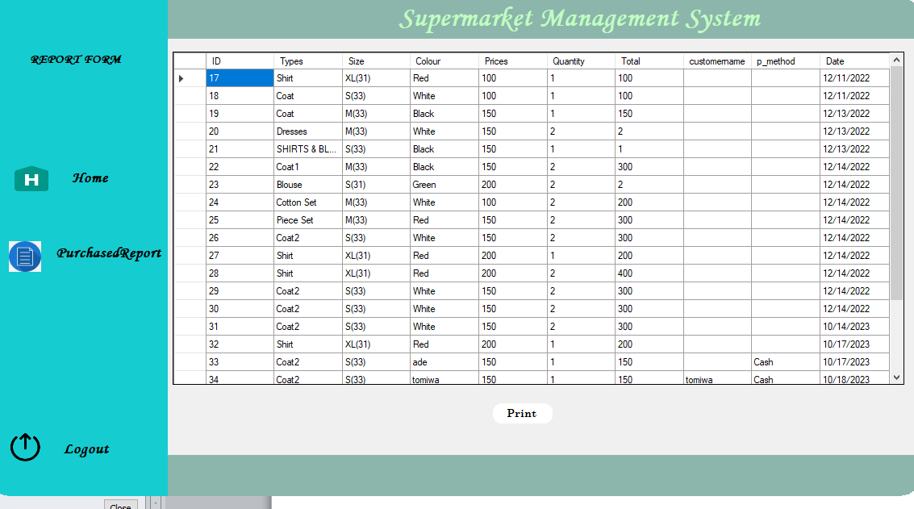
Figure 4.1: All Purchased Report
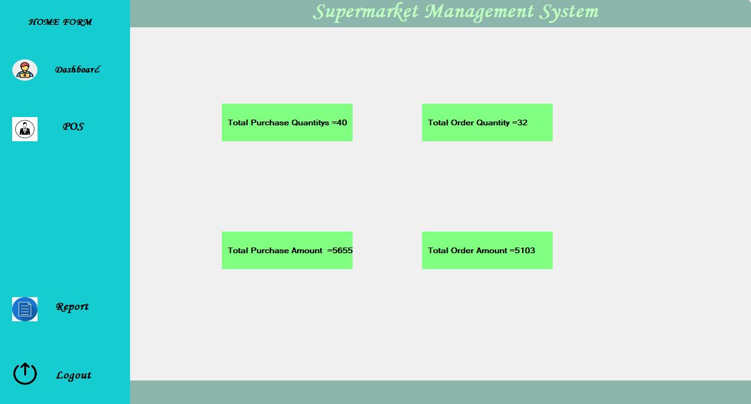
Figure 4.2: Staff Dashboard
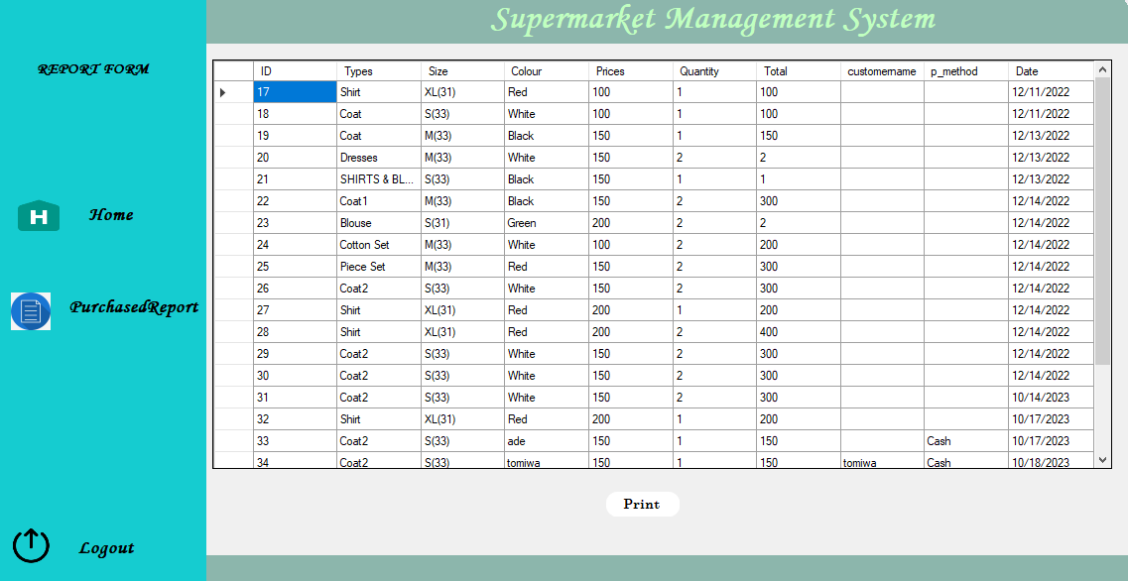
Figure 4.3: Report Page

  - Input Design
In any organization, institution or any system of operation there is always an input into the system which keeps a system going, if the input is wrong definitely the output will be wrong. This design is meant to handle data about a particular product or stock in the Supermarkets.
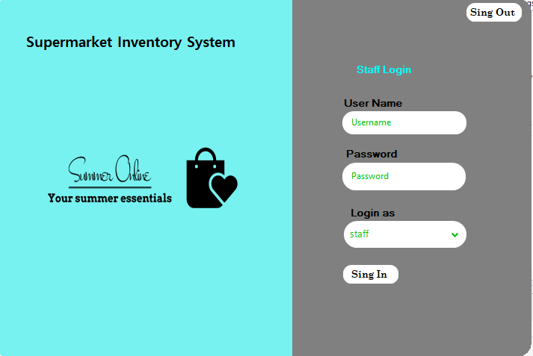
Figure 4.4: Staff Login Page
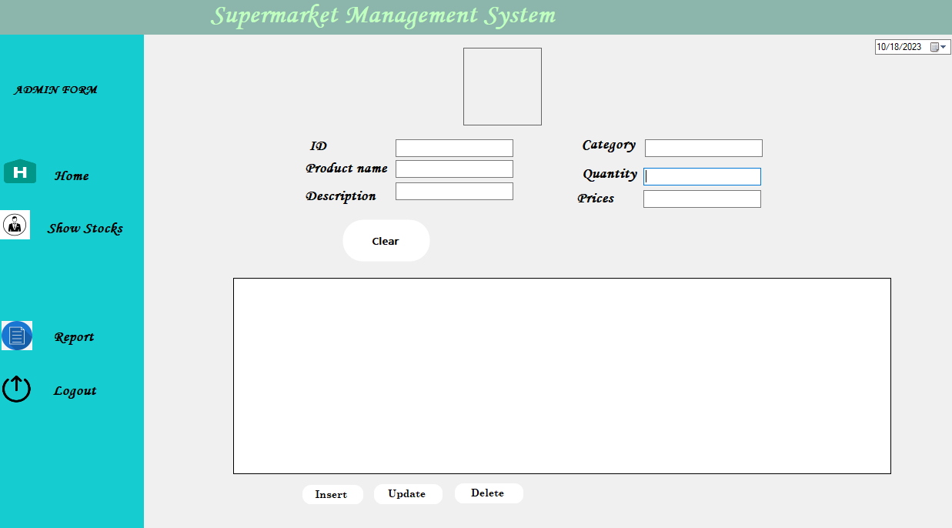
Figure 4.5: Admin Dashboard
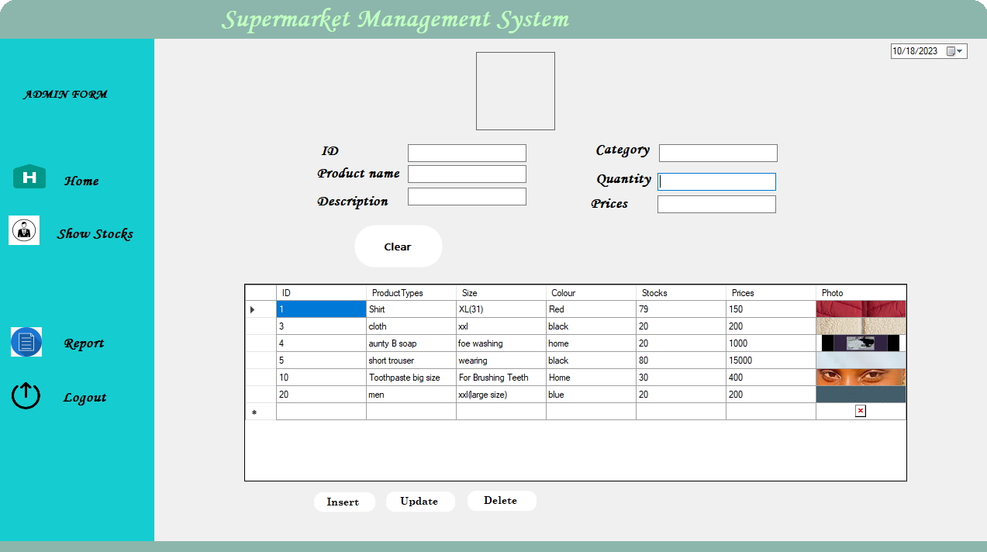
Figure 4.6: Add new Product
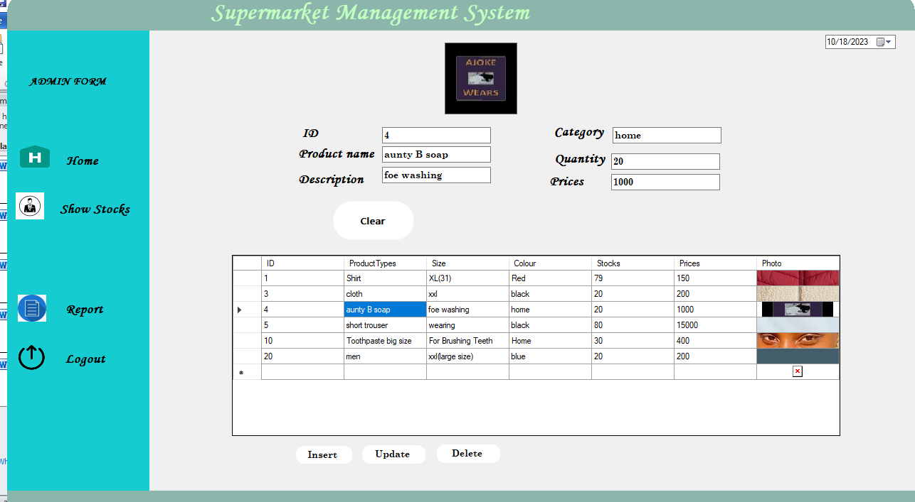
Figure 4.7: Update Existing Product
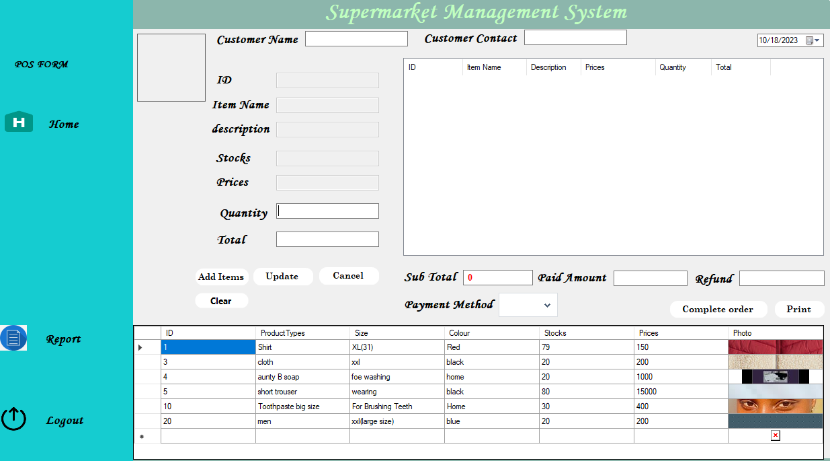
Figure 4.8: Point of Sale Page

    - Database Design
This refers to the back end of the proposed system. The following steps are employed in the development of the database.
- Click on start button and locate Ampp.
- Open any browser and type http://localhost/phpmyadmin
- Type the name of the database i.e Pharmacy and click on create new
- In few seconds the database is created.
- To create table is the next action.
- On a create table menu type the name of the table and click on ok.
Table 4.1: Product Details Table
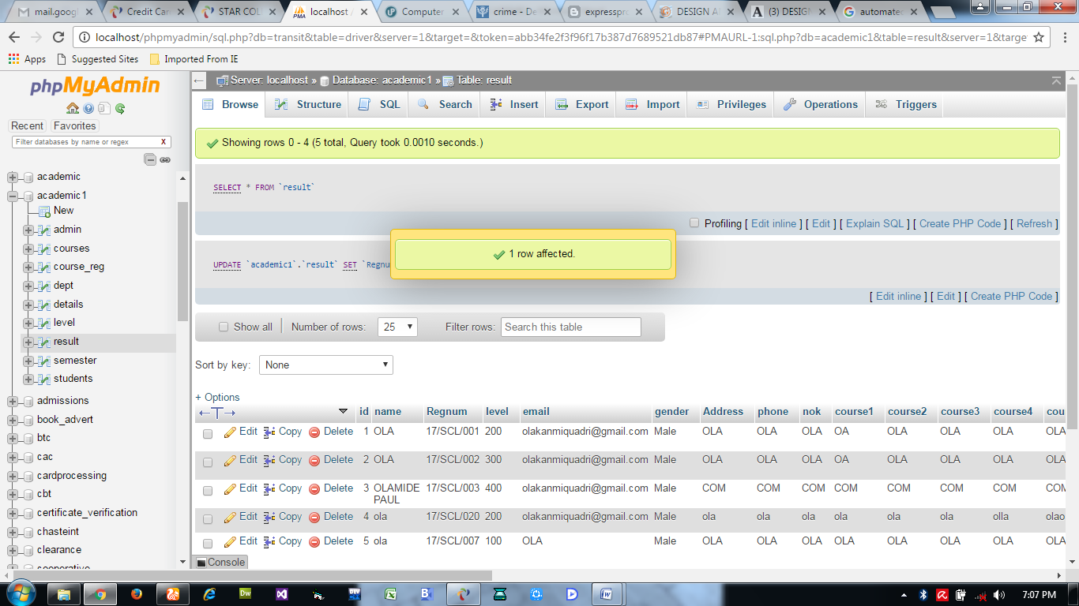

Table 4.2: Users database table
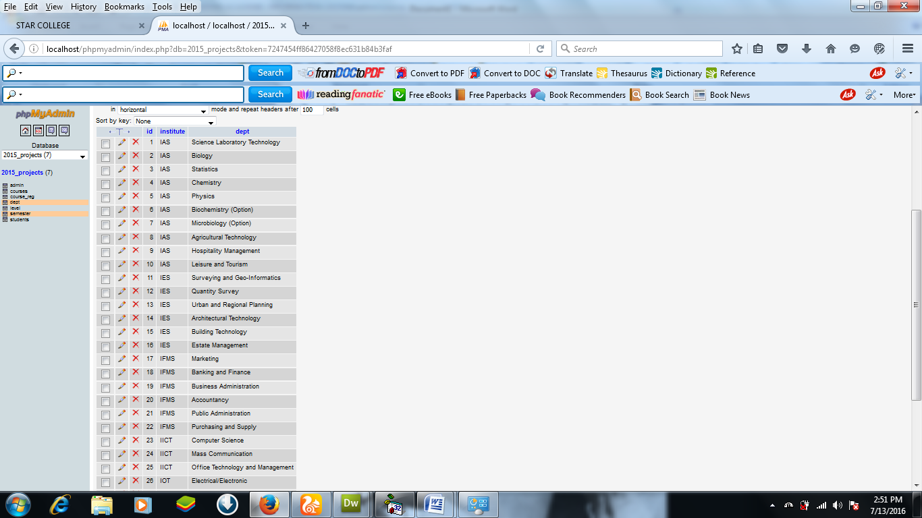

Table 4.3: Purchase Details Database
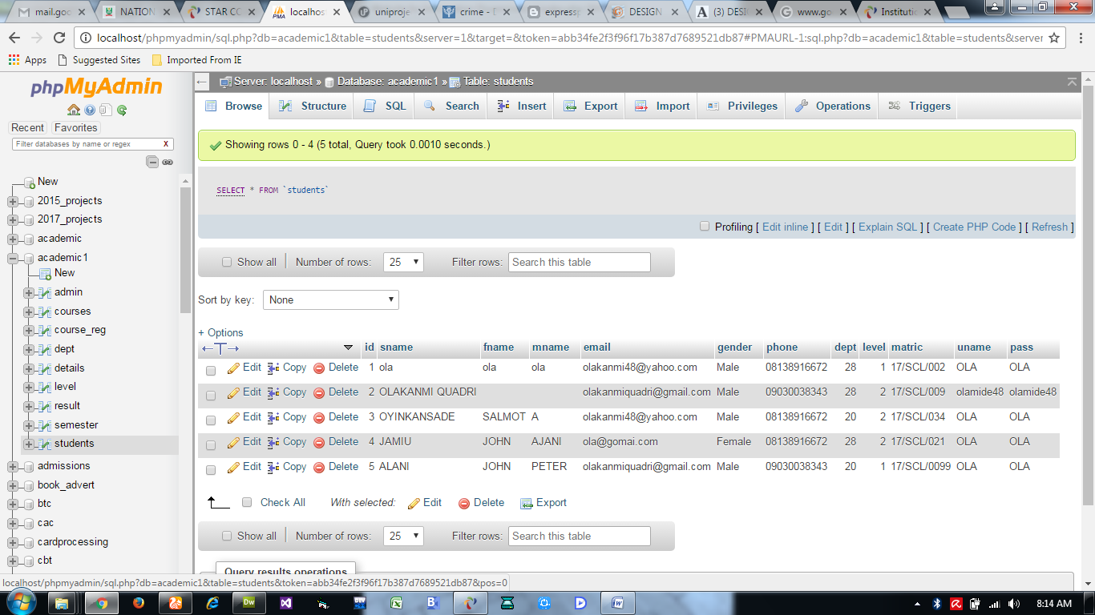

    - Procedure Design
This refers to the step by step method of using the proposed system. The proposed system comprises of Home, Login, Add Record, View Cart, View Mode, Reports, Log out while the administrator is able to add available position as well as its modification.
- On the address bar of any browser type http://localhost/Pharmacy/admin/
- You are prompted to supply the username and password this verifies that you are authorized user and has the privilege to add Product.
- If the username and password supplied are correct as that of the voter you are prompted with the home page with the list of add available position.
- The website has two environments the general user and the administrator environment.
- User you are to type http://localhost/Pharmacy/login.php on the address bar.
  - Implementation of the System
    - Choice of Programming Language
The reason for choosing PHP is that it is among the language of the web and as well it is an open source language in which help is readily available when needed and its level of pedagogy. And also the mysql data base was chosen because of its data integrity and high secured back end. Cascading Style Sheet was used to style the layout of the website while the javascript was used as the server side script in the development of the system
    - Hardware Support
The computer configuration required to run the software is;
Computer/memory processor PC with a 48dx, MHZ or Pentium, Intel or higher processor required.
CPU : PENTIUM IV
PROCESSOR SPEED : 2 GHZ
COPROCESSOR : BUILT IN
TOTAL RAM : 1GB OR HIGHER
HARD DISK : 80 GB
KEYBOARD : 105 KEYS
MOUSE : LOGITECH MOUSE
DISPLAY : SGVA COLOR
    - Software Support
The unapproved made system makes use of macromedia fireworks for graphics work on the images and background used in the system, macromedia Dream weaver (a text editor) while MY SQL is used as the database.
    - Changeover Techniques
The implementation technique to be used in the system is parallels, a system that support the current system along-side with the proposed system. This means that for 7 UP bottling Company Limited Ilorin to adopt the proposed system a paper and pen method that is currently in use will still be in existence so that a failure in the proposed system will not lead to total loss of vital information.
  - Documentation of the System
    - Operating the System
In order for the proposed system to be used on any computer system it takes the following ways
- Boot the system
- Copy the folder to www inside Wamp folder of the drive C: after Wamp server is installed onto the system.
- Open any browser on the system (Microsoft internet Explorer, Mozilla Fire fox, Netscape Navigator, Opera, Flock, Safari e.t.c)
- Type http://localhost/Pharmacy/admin/on the address bar and press the return key/ enter key.

4.3.2 System Maintenance
The system is flexible enough to entertain any future amendment which might be required when the need arises. The system requires regular update which necessitates the function of an administrator for regular information that is needed in the system. The system is also designed in such a way that it will be convenient for any other programmers or system analyst that might want to work on the maintenance of the system if the need arises by documenting each and every part of the modules that made of the system.

CHAPTER FIVE
SUMMARY,CONCLUSION AND RECOMMENDATIONS
5.1 Summary
The development of a Sales Inventory Control System (SICS) for the supermarket represents a significant stride toward optimizing inventory management, sales tracking, and customer service. This comprehensive system offers real-time inventory control, efficient sales tracking, and accurate data reporting. It integrates product identifying for quick and precise product identification and employs robust security measures to protect sensitive data. The user-friendly interface ensures ease of use for various staff roles. However, to maximize the SICS's potential, it's crucial to address data integration and compatibility challenges, which can impact its effectiveness. System requirements encompass core functionalities, scalability, and data quality. Successful evaluation validates the system's performance, compliance with regulations, and user satisfaction.

5.2 Conclusion
The development of a Sales Inventory Control System for the supermarket holds the promise of revolutionizing operations, making them more efficient, secure, and data-driven. By aligning with the defined system requirements, the SICS addresses core challenges in inventory and sales management. Integration and compatibility have been key areas of focus, ensuring seamless data exchange with other systems and hardware. The successful evaluation of the system demonstrates its readiness for deployment, ready to improve inventory control, streamline sales tracking, and contribute to the supermarket's overall success.

5.3 Recommendations
Based on the project's findings and objectives, several recommendations emerge:
- Continuous Monitoring: Implement ongoing monitoring and maintenance procedures to ensure the SICS operates smoothly, remains secure, and adapts to evolving business needs.
- User Training: Provide comprehensive training for supermarket staff to ensure they can effectively use the SICS, maximizing its benefits.
- Data Integration and Compatibility: Regularly assess and optimize data integration processes, ensuring seamless data exchange with other systems and hardware.
- Future Enhancements: Consider integrating additional features such as mobile applications, e-commerce support, and advanced analytics to stay competitive in the retail landscape.
- Cost Control: Continue monitoring project costs to ensure ongoing cost-effectiveness while delivering value for the investment.
- Compliance Maintenance: Regularly review and update the SICS to ensure it remains compliant with industry regulations and standards.
- Feedback Loop: Maintain an open feedback loop with supermarket staff to address issues, suggestions, and evolving operational needs.

REFERENCES
Abisoye O., A., et al., (2015) Design of a Computerized Inventory Management System for Supermarkets. International Journal of Science and Research (IJSR), India Online ISSN: 2319-7064

Armstrong, J. S. (2016). Sales Forecasting. The IEBM Encyclopedia of Marketing, 278 290. Retrieved from https://repository.upenn.edu/marketing_papers/237

Bohdan M. (2019) Machine-Learning Models for Sales Time Series Forecasting. Received: 3 November 2018; Accepted: 14 January 2019; Published: 18 January 2019

Efendigil T, Önüt S, Kahraman C, (2017) A decision support system for demand forecasting with artificial neural networks and neurofuzzy models: A comparative analysis. Expert Syst. Appl.

Gokilavani et al., (2020) Sales Forecasting Using Prediction Analytics Algorithm. International Journal of Research and Innovation in Applied Science (IJRIAS) | Volume V, Issue VII, July 2020|ISSN 2454-6194 www.rsisinternational.

Juan R. et al., (2014) On the identification of sales forecasting models in the presence of Promotions. Article in Journal of the Operational Research Society · January 2014 DOI: 10.1057/jors.2013.1

Mentzer, J.T.; Moon, M.A. (2016) Sales Forecasting Management: A Demand Management Approach; Sage: Thousand Oaks, CA, USA.

Niya, N. J., (2021) Sale prediction using linear regression model. 2021 IJCRT | Volume 9, Issue 3 March 2021 | ISSN: 2320-2882

Rahmat, B, A., (2013) Sales and Inventory Management System. University Technology of PETRONAS. Bandar Seri Iskandar 31750 Tronoh

Yongchang, R., & Mengyao C., (2015) Design and Implementation of Supermarket Management System. College of Information Science and Technology, Bohai University, Jinzhou, 121013.

