COMPARATIVE ASSESSMENT OF ROAD APPARATUS AND THEIR SAFETY IMPLICATIONS ON CAMPUS ROAD USERS
A CASE STUDY OF KWARA STATE POLYTECHNIC AND UNIVERSITY OF ILORIN

BY:
RAHEEM LATEEF OPEYEMI
HND/23/URP/FT/0003

BEING A RESEARCH PROJECT SUBMITTED TO THE DEPARTMENT OF URBAN AND REGIONAL PLANNING,
INSTITUTE OF ENVIRONMENTAL STUDIES (IES)
KWARA STATE POLYTECHNIC, ILORIN

IN PARTIAL FULFILLMENT OF THE REQUIREMENTS FOR THE AWARD OF HIGHER NATIONAL DIPLOMA (HND) IN
URBAN AND REGIONAL PLANNING

JUNE, 2025
CERTIFICATION

This is to certify that this project was an original work carried out by RAHEEM LATEEF OPEYEMI with Matric No. HND/23/URP/FFT/0003 from the Department of Urban and Regional Planning and has been prepared in accordance with the rules and regulations governing the preparation and presentation of project in Kwara State Polytechnic, Ilorin.

________________________ __________________
TPL. M.I. YAHAYA &
MRS. IYIBUSOLA DATE
(Project Supervisor)

________________________ __________________
TPL. M.I. YAHAYA DATE
(Project Coordinator)

________________________ __________________
TPL. ADEKANYE DATE
(Head of Department)

________________________ __________________
EXTERNAL SUPERVISOR DATE

DEDICATION
This project is lovingly dedicated to my family for their unwavering support and encouragement throughout this journey. To my parents, who instilled in me the values of perseverance and curiosity, and to my siblings, whose belief in me has been a constant source of motivation. Their love, patience, and words of encouragement carried me through every challenge and made this accomplishment possible.

ACKNOWLEDGEMENTS
I am profoundly grateful to God Almighty, the source of all knowledge, wisdom, love, mercy, and grace, for His unfailing protection and guidance throughout this programme.
My deepest thanks go to my project supervisors, TPL M. I. YAHAYA and Mrs. Iyibusola, whose expert guidance, insightful feedback, and unwavering support were instrumental in bringing this project to completion. Their encouragement provided clarity and direction at every stage.
I also appreciate the thoughtful criticism and valuable suggestions of our project coordinator, TPL M. I. YAHAYA, which significantly enhanced the quality of this work.
My sincere gratitude is extended to TPL Adekanye, Head of Department, for granting access to vital resources, facilities, and research materials essential for this research and other members of staff and lecturer for their support.
I am thankful to all my colleagues and fellow students for their collaborative spirit, peer reviews, and enriching discussions that added depth to the project.
Special thanks go to my friends, whose support and encouragement were invaluable in making this research possible.
Finally, I would like to express my heartfelt appreciation to my wonderful family and friends for their love, patience, and understanding emotionally and logistically throughout this entire journey.

TABLE OF CONTENTS
Title Page i
Certification ii
Dedication iii
Acknowledgement iv
Title Page v
Abstract viii
CHAPTER ONE: INTRODUCTION
  - Background of the Study 1
  - Statement of Problem 2
  - Research Questions 2
  - Aim and Objectives 2
  - Scope of the Study 3
  - Justification 3
  - Study Areas (Kwarapoly and Unilorin) 3

CHAPTER TWO: LITERATURE REVIEW
2.1 Concept of Road Apparatus 12
2.2 Types and Functions of Road Apparatus 12
2.3 Importance of Road Safety 13
2.4 Comparative Study on Campus Road Safety 13
2.5 Safety Implications of Inadequate Road Apparatus 14
2.6 Theoretical Framework 14
2.7 Empirical Review 15

CHAPTER THREE: RESEARCH METHODOLOGY
  - Introduction 16
  - Method of Data Collection 16
  - Research Instrument 17
  - Sample Frame 17
  - Sample Size 17
  - Sample Techniques 17
  - Definition and Treatment of Variables 17
CHAPTER FOUR: DATA ANALYSIS AND PRESENTATION OF FINDINGS
  - Introduction` 19
  - Data Presentation 19
  - Data Analysis 21
CHAPTER FIVE: SUMMARY OF FINDINGS, CONCLUSION AND RECOMMENDATION
  - Introduction 22
  - Summary of Findings 22
  - Conclusion 22
  - Recommendation (Recommendation for Kwarapoly, Recommendation 23
for Unilorin and General Recommendation)
References
Appendix

ABSTRACT
This study conducts a comparative assessment of road apparatus and their safety implications on campus road users, focusing on two prominent Nigerian tertiary institutions—Kwara State Polytechnic and the University of Ilorin. The research investigates the availability, condition, placement, and functional efficiency of road infrastructure such as speed bumps, road signs, pedestrian crossings, and traffic control devices. Data were collected primarily through direct observation and analyzed to evaluate road user compliance and the overall safety environment of each campus. Findings reveal that both institutions have a comparable number of speed bumps and road signs, but differ significantly in terms of infrastructure quality, placement appropriateness, and the presence of supplementary safety features. Notably, the University of Ilorin demonstrates slightly superior infrastructure and placement standards, yet still reflects critical gaps such as poor zebra crossing conditions and the absence of traffic control devices. The study underscores the importance of strategic planning, regular maintenance, and behavioral sensitization to enhance road safety on campuses. Recommendations include upgrading existing infrastructure, implementing traffic control mechanisms, promoting safety awareness campaigns, and establishing institutional traffic management units. These findings aim to guide policymakers, campus administrators, and urban planners in developing safer and more efficient campus transportation systems.

CHAPTER ONE
INTRODUCTION
  - BACKGROUND OF THE STUDY
The road is there, it will always be there. You just have to decide when to take it.” — Chris Humphrey Road infrastructure is a vital component of urban development, serving as the backbone of socio-economic activities, particularly in institutional environments. Globally, the presence of effective road apparatus—such as traffic signs, road markings, pedestrian crossings, and speed control devices—has been acknowledged as critical to ensuring road safety and reducing accidents (World Health Organization, 2020). These apparatus are designed not only to regulate vehicular movement but also to protect vulnerable road users, including pedestrians and cyclists.

In developed countries, road safety is significantly enhanced through strategic planning, regular maintenance, and enforcement of road usage policies. Institutions of higher learning are no exception, as these areas often experience high traffic volumes due to the movement of students, staff, and visitors. Functional road safety infrastructure in such areas plays a key role in minimizing road accidents, ensuring smooth traffic flow, and promoting a safe learning environment (Bhargava, 2019).

In contrast, many African countries, including Nigeria, face challenges in implementing and maintaining road apparatus in institutional settings. Factors such as poor urban planning, insufficient funding, and limited policy enforcement contribute to the inefficiency of road infrastructure. According to the African Development Bank (2022), road traffic accidents remain a leading cause of death in Africa, often due to inadequate or non-functional road safety features.

Kwara State Polytechnic and the University of Ilorin, both located in Ilorin, Nigeria, serve as major academic hubs with a large population of road users navigating their campuses daily. However, these institutions experience varying levels of road safety implementation. While one may have relatively advanced infrastructure, the other might struggle with poor maintenance or complete absence of key safety features such as pedestrian walkways, warning signs, and traffic lights. This disparity can affect not only the safety of users but also their perceptions and behaviors concerning road usage.
Given these concerns, this study undertakes a comparative assessment of road apparatus and their safety implications for road users within the campuses of Kwara State Polytechnic and the University of Ilorin. The aim is to evaluate the availability, quality, and effectiveness of these infrastructure elements, providing evidence-based insights into how institutional road planning can be improved for the safety of all users.

  - STATEMENT OF THE PROBLEM
Despite the vital role road apparatus play in ensuring safety and order within academic institutions, many Nigerian tertiary campuses still suffer from inadequate, poorly maintained, or completely absent road safety infrastructure. At Kwara State Polytechnic, several internal roads lack basic road signs, speed control measures, and visible pedestrian crossings, leading to frequent near-miss incidents and traffic confusion, particularly during peak school hours. Similarly, at the University of Ilorin, while the main access roads are fairly developed, many inner campus roads experience faded markings, limited signage, and encroachments from roadside parking, increasing the risk of pedestrian-vehicle conflicts. In both institutions, these issues are compounded by rapid population growth, poor maintenance culture, insufficient budgetary allocation, and lack of enforcement of traffic rules within the campuses. These challenges not only endanger lives but also disrupt campus mobility and reflect broader urban infrastructure shortcomings. Despite these realities, limited comparative research exists to assess the extent and implications of these problems in Nigerian tertiary institutions, particularly in Kwara State, which this study seeks to address.

  - RESEARCH QUESTIONS
- What types of road apparatus are available within the campuses of Kwara State Polytechnic and the University of Ilorin?
- To what extent are the available road apparatus visible, accessible, and appropriately positioned on each campus?

  - AIM AND OBJECTIVES
    - AIM
The aim of this study is to compare the types, conditions, and placement of road apparatus in Kwara State Polytechnic and the University of Ilorin, and assess their safety implications on campus road users.

1.5 OBJECTIVES
This study seeks to address road safety challenges within the campuses of Kwara State Polytechnic and the University of Ilorin by focusing on the following specific objectives:
- Identify the available road apparatus within Kwara State Polytechnic and the University of Ilorin
- Examine the physical condition or effectiveness of road apparatus in both campuses
- Evaluate the placement of road safety installations across key areas
- Recommendations

  - SCOPE OF THE STUDY
This study is limited to the assessment of road apparatus within the campuses of Kwara State Polytechnic and the University of Ilorin. It focuses on identifying the types, evaluating the conditions, and examining the placement of road safety features such as speed bumps, road signs, pedestrian crossings, and traffic markings. The study also considers how these apparatus affect the safety of campus road users, including students, staff, and visitors. External roads and areas beyond the campus boundaries are excluded from this study.

1.7 JUSTIFICATION
The increasing movement of vehicles and pedestrians within tertiary institutions presents rising concerns about road safety. Despite the presence of road apparatus, accidents and unsafe road behaviors still occur, suggesting possible issues with their type, condition, or placement. By focusing on Kwara State Polytechnic and the University of Ilorin, this study provides valuable insights into how road infrastructure affects user safety within academic environments. The findings will help school management, safety agencies, and policymakers make informed decisions to enhance road safety and reduce risks on campus.

1.8 STUDY AREA
Ilorin is the capital city of Kwara state in western Nigeria. It is located on the Awun River, a minor tributary of the Niger, founded in the late 18 century by Yoruba people, it became the capital of a kingdom that was a vassal state of the Oyo Empire. Through the 19th century, Ilorin served as a major trade center between the Hausa of the North and the Yoruba of the south, it strongly resisted British rule not until 1897, when the army of the Royal Niger company arrived after conquering Bida (106miles East-North-East), did Ilorin recognize British Supremacy, In 1900 the Ilorin emirate was the only part of Yoruba land to be included to the Northern Nigeria Protectorate, which later in the colonial period, developed into the Northern Province and then the Northern region, with the sub-division of the country administrative regions in 1967, ilorin became part of the west central (later Kwara State).
Modern Ilorin is mainly initiated by Muslim Yoruba people, although its traditional ruler is a Yoruba speaking Fulani Emir. Surrounding the historic central district with its traditional single story mud houses with thatched straw roofs and numerous mosques, all protected by a mud wall, the modern city is an industrial, commercial, and educational central. It is a major market for locally raised crops (yams, cassava) corns, rice, peppers, kola-nuts etc. Local hand crafts include pottery making, wood carving, cloth weaving, mat and basket weaving etc. There are several banks and insurance companies that serve the city and state. The city has a federal university which is university of Ilorin and a state polytechnic which is Kwara state polytechnic, the federal agricultural and rural management training institute which operates a research farm is located near the city. Teacher ‘straining colleges and a vocational trade school. Health services include a number of government, privates and religious hospital and a nursing home for the elderly.

POLITICAL BOUNDARIES
Kwara state is one of the 36 states of Nigeria. Its capital is Ilorin and its Governor is Mallam Abdulrahman Abdulrasak. The primary ethnic group of Kwara state is Yoruba with significant Nupe, Bariba and Fulani minorities.
Kwara state was created on 27 May, 1967 when the Federal Military Government Yakubu Gowon broke the four regions that constituted the federation of Nigeria into 12 state. As its creation, the state was made up of the former Ilorin province of the northern region and was initially named the west central state but later changed to Kwara a local name for the River Niger.
On 27th August 1991, five local governments local area namely, Oyi, vagba, okene, pkehi, and kogi were also exercise to form part of kogi state, while the sixth, Borgu local government area was merged with Niger state.

GEOGRAPHICAL SETTING
It is situated at a strategic point between the density populated south western and sparsely populated middle belt of Nigeria. Ilorin is located in the transitional zone between the deciduous woodland of the south and dry savanna of North Nigeria.

CLIMATE AND VEGETATION
The study area experiences the daily changes in atmospheric condition as a result of its position lying at the transition zone between the semi-arid north and humid coastal belt and share most of the characteristics of both weather. It is usually humid at the day time and then the relatives' humidity is about 70% in the morning and it falls between 10 - 30% in the afternoon. Ilorin has the tropical wet and dry seasons. It has mean annual rainfall of about 1,318mm. Usually the raining season is between April and November. The days are very hot during the dry season which is between February and April.
The average mean temperature is about 30°c while the harmattan ranges between the month of December and January. The nature of soil at the study area is sandy-loamy soil which favours certain species of trees and grasses, couple with the climatic condition to which the sandy area falls made it to fall into Guinea Savannah. This type of vegetation is characterized by deciduous trees of mixed trait e.g. silk, cotton and tall grasses like Elephant grass are noticed at the study area.

URBAN CLIMATE AND ENVIRONMENT
In winter, winds blow mostly from SW, W, NW and N. However, from March onwards, there is a great increase in the frequency of northerly winds (Alcoforado, 1992). Northeast is the most frequent wind direction in December (30%), but the north direction is still a strong component (13%). In January and February, the west direction is persistent and at the end of the winter season the north direction becomes more important. Although the wind blowing from south and southwest directions are not the most frequents directions, they can cause serious damages to urban trees (Lopes, 2003).

Figure 1: Showing map of Nigeria indicating Kwara State as the Case Study Area

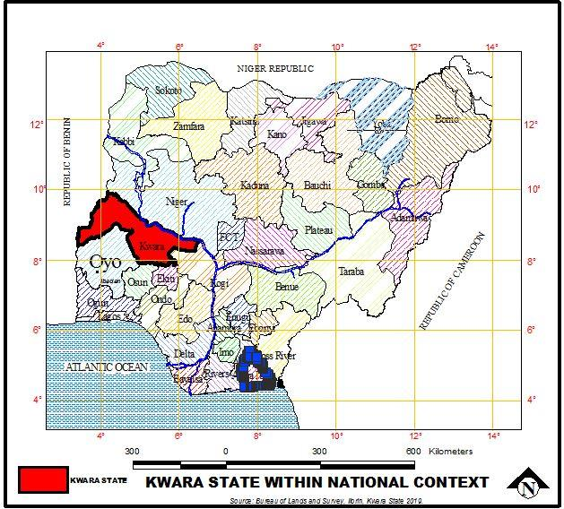
Source: Wikipedia ©2022

Figure 2: Showing Kwara State as the Case Study Area
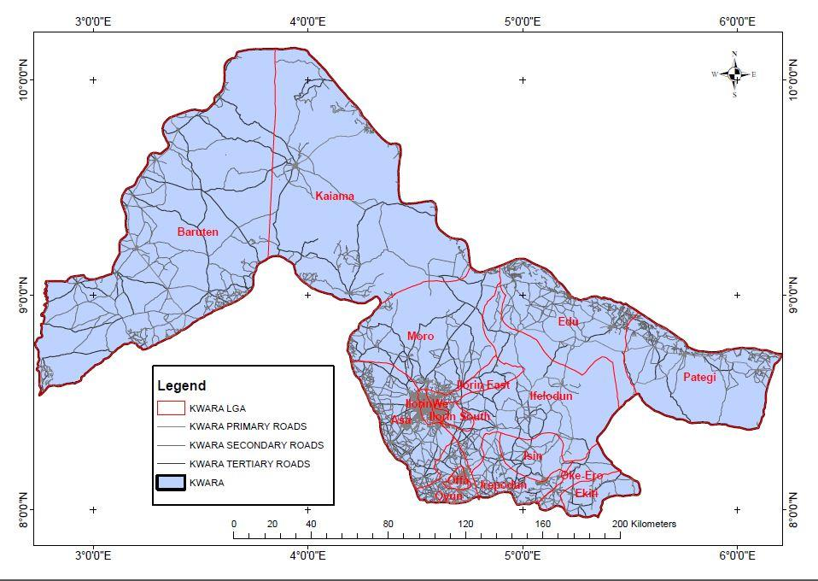
Source: Kwara State Geographical and Information Services (KWGIS)

Figure 3: Showing Map of Kwara State Indicating Moro Local Government as a Study Area.

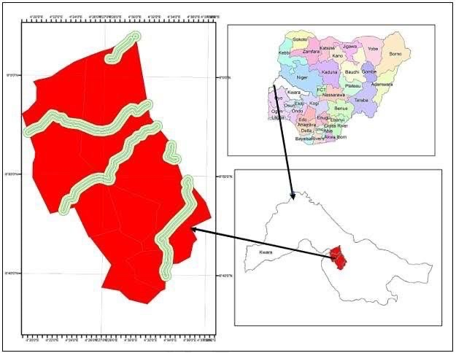
Source: Kwara State Geographical and Information Services (KWGIS)

Figure 4: Ilorin East Local Government Area as the Case Study Area
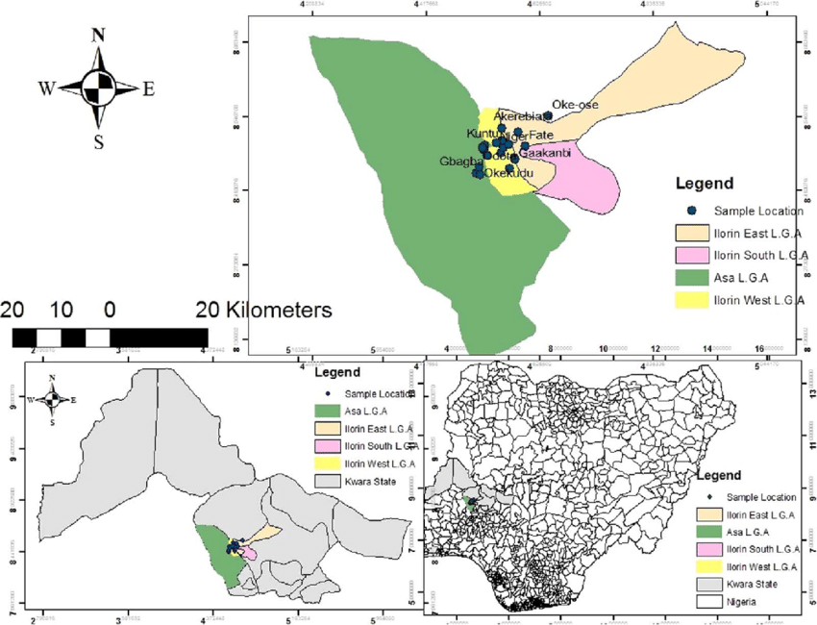
Source: Kwara State Geographical and Information Services (KWGIS)

Figure 5: Showing Kwara State Polytechnic as the Case Study Area
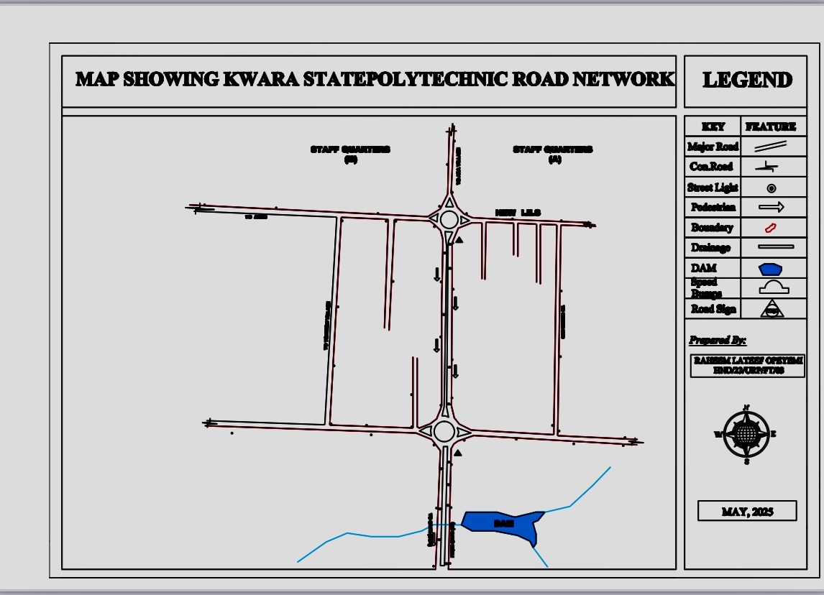
Source: Kwara State Geographical and Information Services (KWGIS)
Figure 5: Showing University of ilorin as the Case Study Area
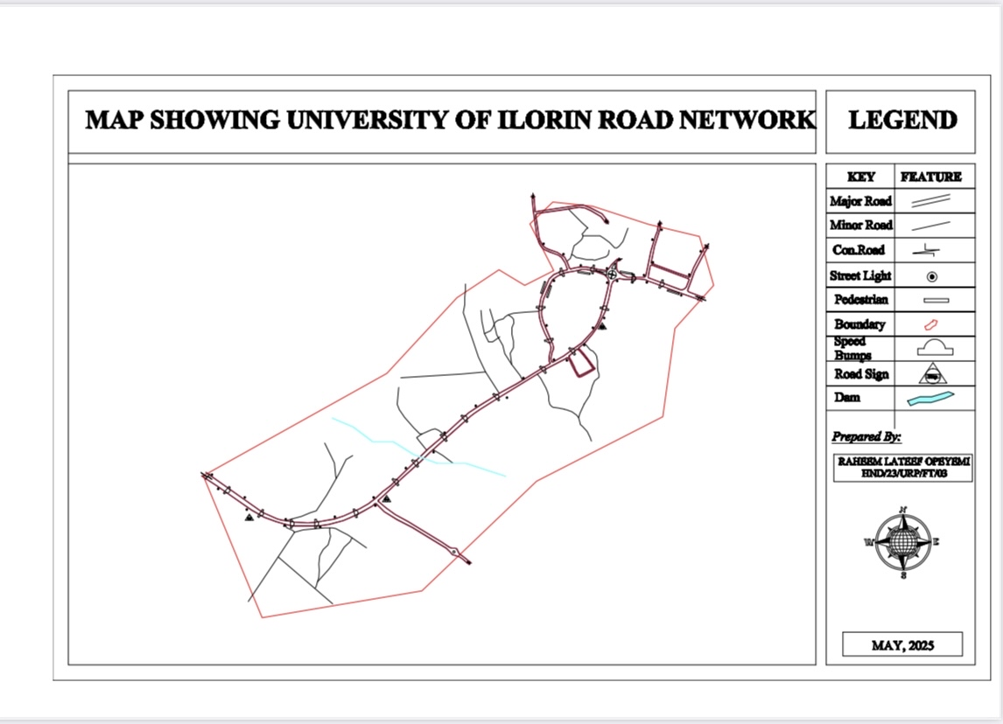
Source: Kwara State Geographical and Information Services (KWGIS)

CHAPTER TWO
LITERATURE REVIEW
2.0 INTRODUCTION
The literature review serves as a foundational segment of this research, offering a critical analysis of scholarly works, theoretical insights, and empirical evidence related to road apparatus and their implications for road safety particularly within campus environments. It provides conceptual clarity by defining road apparatus and explicating their roles in regulating traffic and enhancing pedestrian safety.
This chapter systematically categorizes road infrastructure elements, explores their significance, and examines the consequences of inadequate implementation, especially in institutional settings. Furthermore, it reviews theoretical models that underpin traffic safety studies and presents empirical findings from related research, thereby establishing a comprehensive framework to evaluate the current conditions in Kwara State Polytechnic and the University of Ilorin. The insights gained herein are essential for contextualizing the comparative assessment undertaken in subsequent chapters.
2.1 CONCEPT OF ROAD APPARATUS
Road apparatus refers to the various physical features and installations on roadways that help regulate, direct, and facilitate the safe and efficient movement of traffic and pedestrians. These include traffic signs, signals, road markings, barriers, pedestrian crossings, speed bumps, and other related infrastructure elements. Road apparatus plays a crucial role in ensuring that traffic flows smoothly and that road users are aware of potential hazards, traffic rules, and the surrounding environment. It helps prevent accidents, reduces road congestion, and improves overall road safety (Bhargava, 2019).
Road apparatus can be classified into different categories, such as regulatory devices (e.g., stop signs), warning devices (e.g., yield signs), and informational devices (e.g., road signs showing directions). These tools are essential for managing traffic behavior, guiding drivers, and ensuring pedestrian safety. Inadequate or malfunctioning road apparatus can create confusion, increase the risk of accidents, and hinder the overall effectiveness of the transportation system (Adebayo & Salami, 2021).

2.2 TYPES AND FUNCTIONS OF ROAD APPARATUS
Road apparatus can be categorized into several types, each serving a unique function to promote road safety and efficiency. The primary types of road apparatus include:
- Traffic Signs: These are visual symbols placed on roads to convey instructions or warnings to drivers and pedestrians. Examples include stop signs, speed limit signs, warning signs for sharp turns, and pedestrian crossings. These signs regulate traffic flow and reduce accidents by informing road users about necessary actions (Williams, 2020).
- Traffic Signals: Traffic lights (red, yellow, green) are used to control the flow of traffic at intersections. These signals are crucial for maintaining an orderly traffic flow, preventing accidents, and ensuring the safety of pedestrians crossing busy roads (Ojo, 2019).
- Road Markings: Lines, symbols, and arrows painted on the road serve as visual guides for drivers. These markings define lanes, indicate turning points, and help guide vehicles in the correct direction (Federal Road Safety Corps, 2021).
- Speed Bumps and Rumble Strips: These apparatus are installed to reduce vehicle speed in areas with high pedestrian traffic or sharp bends. Speed bumps are commonly found near schools, hospitals, and residential areas to ensure road users slow down and drive cautiously (Adedeji & Adeyemi, 2020).
- Pedestrian Crossings: Zebra crossings and pedestrian overpasses are designed to provide a safe passage for pedestrians, especially in busy areas. They help minimize accidents involving pedestrians and reduce traffic congestion.

2.3 IMPORTANCE OF ROAD SAFETY
Road safety is essential for reducing accidents, injuries, and fatalities on the road. The importance of road safety cannot be overstated, as it impacts public health, economic stability, and the overall quality of life. According to the World Health Organization (WHO, 2020), road traffic accidents are one of the leading causes of death worldwide, particularly among young people. Effective road safety measures, such as well-maintained road apparatus, are crucial in minimizing these risks.
In addition to saving lives, road safety improves the efficiency of transportation systems. When roads are safe, traffic flows more smoothly, reducing congestion and enhancing productivity. Road safety is also crucial for ensuring equal access to mobility, as it protects vulnerable groups such as children, the elderly, and disabled individuals. Road safety policies and infrastructure investments also play a significant role in economic development by reducing the costs associated with accidents, medical treatments, and loss of workforce (Yusuf, 2019).

2.4 SAFETY IMPLICATIONS OF ROAD APPARATUS
Inadequate or malfunctioning road apparatus can have severe safety implications, leading to accidents, injuries, and fatalities. Studies have shown that poorly maintained or absent road signs, faded road markings, and non-functional traffic signals are major contributors to road traffic accidents (Nwachukwu & Eze, 2020). When road users are not adequately informed about road conditions or required actions, the risk of confusion and misjudgment increases.

For instance, the absence of proper traffic signs or speed bumps in areas with high pedestrian traffic can lead to accidents involving pedestrians, especially in busy environments like educational institutions, markets, and residential areas (Oluwaseun, 2019). Moreover, the absence of clear road markings at intersections and pedestrian crossings can cause drivers to make unsafe maneuvers, resulting in crashes. The consequences of these safety lapses include physical harm to individuals, financial loss, and a general decline in public confidence in the transportation system.

2.5 THEORETICAL FRAMEWORK
The study of road safety and infrastructure is underpinned by several theories related to behavior, safety, and traffic management. One key theory is the Human Factor Theory, which posits that human behavior is a major determinant of road safety outcomes. According to this theory, road users’ decisions—such as speeding, ignoring road signs, or failing to yield to pedestrians—are influenced by both environmental factors (e.g., road apparatus) and individual attitudes (Albright & Beck, 2018).

Another relevant framework is the Traffic Flow Theory, which focuses on the movement of traffic as a system influenced by both physical infrastructure and user behavior. This theory emphasizes that the effective design and maintenance of road apparatus are essential to optimizing traffic flow and reducing accidents (Meyer & Kummer, 2020).

Lastly, the Risk Homeostasis Theory suggests that road users adjust their behavior based on the perceived level of safety. In areas where road apparatus is absent or malfunctioning, drivers may perceive the environment as safer than it is, leading to risky behaviors such as speeding and reduced attention to road conditions (Fuller, 2019).

2.6 EMPIRICAL REVIEW
Numerous studies have investigated the relationship between road apparatus and road safety, emphasizing the importance of functional infrastructure. For example, Adebayo and Salami (2021) explored how inadequate traffic signs and road markings at Nigerian campuses contribute to a high rate of accidents. They found that campuses with well-maintained road apparatus experienced fewer traffic-related injuries. Similarly, studies by Williams (2020) highlight the role of pedestrian crossings and speed bumps in reducing accidents in high-density areas.

In Nigeria, the Federal Road Safety Corps (2021) reported that areas with neglected road apparatus saw a higher incidence of accidents, particularly among pedestrians. Nwachukwu & Eze (2020) noted that in regions where speed bumps were absent or poorly constructed, vehicle speeds were higher, leading to increased accidents.
Empirical findings also support the notion that road users’ behaviors are influenced by their perception of safety. Ojo (2019) found that drivers in urban areas often ignore road signs and speed limits, particularly when road markings are faded or non-existent. This underlines the necessity for regular maintenance and improvement of road apparatus to ensure effective traffic control and safety.

CHAPTER THREE
3. 0 RESEARCH METHODOLOGY

3.1 INTRODUCTION
This chapter outlines the procedures and strategies that will be used to conduct the research. It includes the research design, particularly the use of direct observation, to enable a comprehensive evaluation of the research plan and its findings.

3.2 METHOD OF DATA COLLECTION
Data collection is the process of gathering and measuring information on variables of interest, in an established systematic fashion that enables one to answer stated research questions, test hypotheses, and evaluate outcomes. The data collection component of research is common to all fields of study including physical and social sciences, humanities, business, etc. While methods vary by discipline, the emphasis on ensuring accurate and honest collection remains the same.
In order to get hold of the required information we decided to employ the following method of data collection.

3.2.1 Primary Source
It is a collection of data from the source of origin. It provides the researcher with first-hand quantitative and raw information related to the statistical study. In short, the primary sources of data give the researcher direct access to the subject of research. For example, statistical data, works of art, and interview transcripts. Information is collected from field through:

- Direct observation
This is a research method in which the researcher systematically watches and records behaviors, events, or conditions as they occur in their natural setting, without manipulating or interfering with the environment. This method helps gather firsthand, real-time data, particularly useful for understanding actual practices, patterns, or behaviors related to the study.

3.2.2 Secondary Source
The data already in existence which has been previously collected by someone else for other purposes is known as secondary data. It does not include any real-time data as the research has already been done on that information. However, the cost of collecting secondary data is less. As the data has already been collected in the past, it can be found in refined form. The accuracy and reliability of secondary data are relatively less than the primary data. The chances of finding the exact information or data specific to the researcher’s needs are less. However, the time required to collect secondary data is short and hence is a quick and easy process. Some examples of sources for the collection of secondary data are books, journals, internal records, government records, articles, websites, government publications, etc.

3.3 RESEARCH INSTRUMENTS
Direct Observation and Personal Interview werethe only primary sources research instruments used to collect primary data from the study area, some secondary tools were also implored.

- 3. 3. 1 Direct Observation
This is a research method in which the researcher systematically watches and records behaviors, events, or conditions as they occur in their natural setting, without manipulating or interfering with the environment. This method helps gather firsthand, real-time data, particularly useful for understanding actual practices, patterns, or behaviors related to the study.

3.4. SAMPLING FRAME
The sampling frame for this study includes two key road locations across two institutions: Kwara State Polytechnic and the University of Ilorin. These locations were selected based on the presence of specific road apparatus and high road user activity. Observations will focus on various road users during peak periods, aiming to assess the effectiveness and safety implications of the existing road apparatus.

3.5 SAMPLING SIZE
The sample size for the direct observation was determined based on the number of strategic road points selected on each campus. A total of two observation sites (one from Kwara State Polytechnic and one from the University of Ilorin) were monitored over a period of three consecutive days. Observations were conducted twice daily (morning and afternoon peak hours), focusing on various categories of road users. This resulted in the observation of approximately 100 road users across both campuses.
3.5. SAMPLING TECHNIQUES
This is a method you employ while choosing a sample from a population. It is defined as the selection of a subset (a statistical sample) of individuals from within a statistical population to estimate characteristics of the whole population. In this research project I will be adopting a convenience sampling techniques

3.6.1 Convenience Sampling Techniques
This is a method of collecting samples by taking samples that are conveniently located around a location or internet service, it involves using respondents who are “convenient” to the researcher. There is no pattern whatsoever in acquiring these respondents—they may be recruited merely asking people who are present in the street, in a public building, or in a workplace, for example. The concept is often confused with “random sampling” because of the notion that people are being stopped “at random.
In other words a convenience sampling technique is a non-probability sampling method where units are selected for inclusion in the sample because they are the easiest for the researcher to access.

  - DEFINITION AND TREATMENT OF VARIABLES
- Independent Variables:
These are the road apparatus being assessed across the two institutions:
• Speed bumps
• Road signs (warning and directive)
• Zebra crossings
• Traffic barriers (where present)
These variables are defined by their physical presence and visibility, and will be evaluated based on their design, placement, and functionality.
2. Dependent Variables:
These are the observed safety implications on campus road users, including:
• Rate of compliance by road users
• Number of road users using apparatus correctly (e.g., using zebra crossings)
• Frequency of unsafe practices or near-accidents
• Flow of traffic during peak periods
These will be measured through structured observation at selected sites.

CHAPTER FOUR
PRESENTATION AND ANALYSIS OF DATA
4.1 INTRODUCTION
This chapter presents the data collected through direct observation of road apparatus and their safety implications at Kwara State Polytechnic and the University of Ilorin. The information gathered is systematically organized, displayed using tables, charts, and descriptive summaries to facilitate clear understanding. The data is then analyzed to assess the condition, placement, and effectiveness of the road apparatus and to evaluate their impact on the safety behaviors of campus road users. The findings are discussed in relation to the research objectives and existing literature, providing insights into the comparative safety environment of both campuses.

4.2 Types and Availability of Road Apparatus on Both Campuses
Road Apparatus | Kwara State Polytechnic Gate to Ara Roundabout  (Number) | University of Ilorin UITH to school stadium  (Number)
Speed Bumps | 19 | 18
Road Signs | 2 | 2
Road Marking | 0 | 1
Pedestrian Safety Features | 1 | 2
Traffic Control Devices | 0 | 0
Lighting and Visibility | 101 | 203
 | 123 | 226
Source: Author’s Survey, 2025
As presented in Table 4.2, the segment of road extending from the main gate of Kwara State Polytechnic to the roundabout leading to Ara features a total of 19 speed bumps. In comparison, the University of Ilorin route stretching from the UITH park to the school stadium comprises 18 speed bumps. Both institutions have two road signs within the specified locations. Regarding road markings, Kwara State Polytechnic has none, whereas the University of Ilorin has one. Additionally, only one pedestrian safety feature was observed at Kwara State Polytechnic, while the University of Ilorin has two. Notably, traffic control devices were absent along the surveyed routes in both institutions.

4.3 Physical Conditions of Road Apparatus
Road Apparatus | Campus | Good Condition | Fair Condition | Poor Condition
Speed Bumps | Kwarapoly |  | ✔️
 | Unilorin |  | ✔️
Road Signs | Kwarapoly |  |  | ✔️
 | Unilorin | ✔️
Zebra Crossing | Kwarapoly |  |  | __
 | Unilorin |  |  | ✔️
Traffic Barriers | Kwarapoly |  |  | __
 | Unilorin |  | ✔️
Source: Author’s Survey, 2025
As presented in Table 4.3, the speed bumps at Kwara State Polytechnic were surveyed to be in fair condition, while those at the University of Ilorin were also in fair condition. The road signs at Kwara State Polytechnic were found to be in poor condition, whereas those at the University of Ilorin were in good condition. There is no zebra crossing at Kwara State Polytechnic, while the one at the University of Ilorin is in poor condition. Additionally, there are no traffic barriers at Kwara State Polytechnic, whereas the traffic barriers at the University of Ilorin are in fair condition.

  - Road User Compliance Rates With Road Apparatus
Road Apparatus | Campus | Compliance Rate (%) | Observed Unsafe Behavior (%)
Speed Bumps | Kwarapoly | 85%
 | Unilorin | 85%
Road Signs | Kwarapoly |  | 85%
 | Unilorin |  | 85%
Zebra Crossing | Kwarapoly |  | -
 | Unilorin |  | 60%
Source: Author’s Survey, 2025
As presented in Table 4.4, an 85% rate with speed bumps was recorded at both Kwara State Polytechnic and the University of Ilorin. Additionally, 85% of observed road users exhibited unsafe behavior related to road sign usage at both institutions. Furthermore, 60% of road users were observed to use the zebra crossing unsafely at the University of Ilorin.

  - Appropriatness of Road Apparatus Placement
Road Apparatus | Campus | Location | Placement Rating (Appropriate/Inappropriate) | Remarks
Speed Bump | Kwarapoly | Gate to Ara Roundabout | Inappropriate | Fair
Zebra Crossing | Unilorin | UITH to school stadium | Appropriate | Good
Source: Author’s Survey, 2025
As presented in Table 4.5, the road from the Kwara State Polytechnic gate to Ara Roundabout was surveyed to have an inappropriate placement of road apparatus and was rated as fair. In contrast, the road from UITH to the School Stadium in the University of Ilorin was surveyed to have appropriate placement and was rated as good.
CHAPTER FIVE
5.0 SUMMARY OF FINDINGS, CONCLUSION AND RECOMMMENDATION
5.1 INTRODUCTION
This chapter summarizes the key findings of the study, draws relevant conclusions, and offers recommendations based on the data collected and analyzed.
5.2 SUMMARY OF FINDINGS
The summary below highlights the major outcomes of the research
- The survey revealed that the Kwara State Polytechnic route contains 19 speed bumps, while the University of Ilorin route has 18. Both campuses have two road signs each, but only the University of Ilorin has a road marking. Kwara Polytechnic has one pedestrian safety feature, compared to two at Unilorin. No traffic control devices were found on either route.
- The speed bumps at both Kwara State Polytechnic and the University of Ilorin were rated as fair. Road signs at Kwarapoly were in poor condition, while those at Unilorin were good. Kwarapoly had no zebra crossing or traffic barriers, whereas Unilorin had a poorly rated zebra crossing and traffic barriers in fair condition.
- Both institutions recorded 85% compliance with speed bumps and 85% unsafe behavior in the use of road signs. At the University of Ilorin, 60% of road users were observed to use the zebra crossing unsafely.
- The placement of road apparatus at Kwarapoly was found to be inappropriate with a fair rating, while that of Unilorin was appropriate and rated as good.

5.3 CONCLUSION
The study highlights notable differences and similarities in the condition and effectiveness of road apparatus between Kwara State Polytechnic and the University of Ilorin. While both campuses have a comparable number of speed bumps and road signs, Unilorin shows better overall infrastructure with additional features like road markings and more pedestrian safety elements.
However, challenges persist in both institutions, particularly regarding the poor condition or absence of critical safety features such as zebra crossings and traffic barriers. Unsafe road user behavior remains a concern, despite high compliance with speed bumps. The findings underscore the need for improved planning, placement, and maintenance of road apparatus to enhance campus road safety.

5.4 RECOMMENDATIONS
Based on the findings of this study, the following recommendations are proposed to enhance the safety, effectiveness, and proper management of road apparatus within the campuses.
1. Identify the Available Road Apparatus
Establish a comprehensive digital inventory system across both institutions to document and routinely update the status and location of all road apparatus. This will aid in monitoring coverage and detecting infrastructural gaps.
2. Examine the Physical Condition
Implement a biannual infrastructure audit by the campus facilities management unit to evaluate the condition of existing road apparatus. Repairs and upgrades should follow standardized benchmarks in accordance with FRSC and ISO 39001 guidelines.
3. Evaluate the Placement of Road Safety Installations
Engage professional traffic engineers to redesign the placement strategy of speed bumps, road signs, and pedestrian crossings based on pedestrian flow analysis and vehicle behavior patterns observed on each campus.
4. Institutional Traffic Safety Committees
Committees should be established at both Kwara State Polytechnic and the University of Ilorin. These committees will oversee road safety compliance, enforce regulations, and act as liaisons between student unions, transport officers, and external agencies.

REFERENCE
AASHTO. (2018). A policy on geometric design of highways and streets (7th ed.). American Association of State Highway and Transportation Officials.
Adelakun, O. J. (2016). An evaluation of the effectiveness of traffic control devices in Nigeria. Ibadan University Press.
Adeyemi, O. J., & Omisore, E. O. (2019). Road safety measures and pedestrian behaviour in selected Nigerian universities. Journal of Transport and Road Safety, 5(2), 34–45.
Akintola, A. (2021). Traffic management and road safety in urban campuses. Lagos: Greenfield Publications.
Akinyemi, F. O., & Salami, K. K. (2020). Assessment of road infrastructure and its safety implications in tertiary institutions: A case study of FUTA. Nigerian Journal of Civil Engineering, 14(1), 22–35.
Amuda, T. A., & Bello, M. A. (2018). Evaluating the efficiency of speed bumps in reducing campus traffic speed. International Journal of Transportation Studies, 9(3), 45–53.
Ayodele, M. T., & Lawal, O. A. (2021). An overview of road safety challenges in Nigerian tertiary institutions. International Journal of Safety and Security, 7(2), 70–81.
Federal Road Safety Corps (FRSC). (2016). Road use and safety manual. Abuja: FRSC Publications.
Federal Road Safety Corps (FRSC). (2022). Annual report on road safety and traffic incidents. Retrieved from https://frsc.gov.ng
Gbadamosi, K. T. (2020). Urban transportation planning and road safety management. Ilorin: Adekunle Press.
International Road Assessment Programme (iRAP). (2019). Star ratings and investment plans for safer roads. Retrieved from https://irap.org
International Organization for Standardization (ISO). (2012). ISO 39001: Road traffic safety (RTS) management systems – Requirements with guidance for use. ISO.
Jacob, R., & Ogunlana, S. (2017). Road signage and driver behavior in Nigerian university campuses. Journal of Transport and Urban Development, 3(1), 18–27.
Mamman, J. M., & Ojo, A. A. (2019). Safety implications of inadequate road furniture in Nigerian higher institutions. Journal of Environmental and Urban Studies, 5(4), 60–74.
National Bureau of Statistics (NBS). (2021). Road accident data in Nigeria: Annual summary report. Retrieved from https://nigerianstat.gov.ng
Nnaji, C. C., & Umeghalu, I. C. (2018). An investigation of pedestrian safety in tertiary institutions. Journal of Civil Engineering Research, 8(2), 24–30.
Nwaogbe, O. R., & Aloba, O. (2020). Road markings and their effects on pedestrian behavior in Nigerian universities. Transportation Research Procedia, 3(5), 103–109.
Odewumi, S. G., & Olagunju, S. A. (2021). Enhancing campus mobility through strategic road infrastructure. African Journal of Built Environment, 12(1), 29–40.
Ogunlana, K. A. (2018). Urban road design and safety planning. Abeokuta: Federal Polytechnic Press.
Okafor, B. C. (2022). Road safety awareness and behavior among university students in Nigeria. International Journal of Public Health Studies, 6(3), 92–101.
Olawale, R. A., & Hassan, M. T. (2019). Evaluation of road apparatus and campus traffic control: A Nigerian case study. Nigerian Journal of Highway Engineering, 11(2), 39–52.
Oluwole, D. O. (2017). Design and application of traffic calming measures in Nigerian universities. Lagos: Academic Publishers.
Organisation for Economic Co-operation and Development (OECD). (2019). Safer roads, safer lives: Guidelines for road safety interventions. Paris: OECD Publishing.
Peden, M., Scurfield, R., Sleet, D., Mohan, D., Hyder, A. A., Jarawan, E., & Mathers, C. (2004). World report on road traffic injury prevention. World Health Organization.
United Nations Economic Commission for Africa (UNECA). (2020). Status of road safety in Africa. Retrieved from https://www.uneca.org
University of Ilorin. (2023). Campus master plan and transportation policy report. Unilorin Physical Planning Unit.
World Health Organization (WHO). (2020). Global status report on road safety. Geneva: WHO Press.

APPENDIX
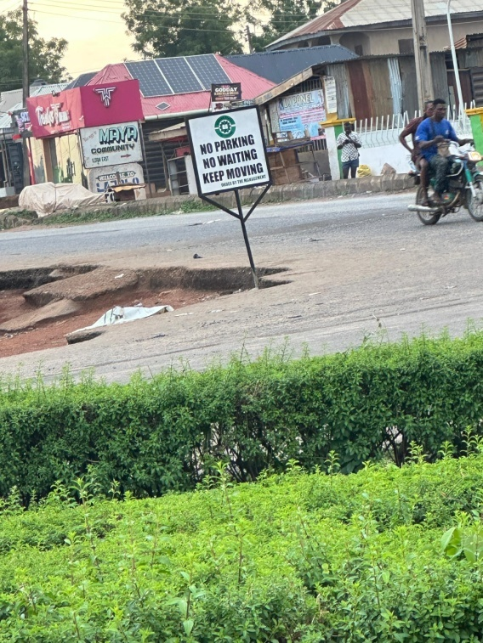
Plate 1: Showing A Road Sign in Kwara State Polytechnic
Source: Field Survey Showing Road Sign in Kwara State Polytechnic, 2025

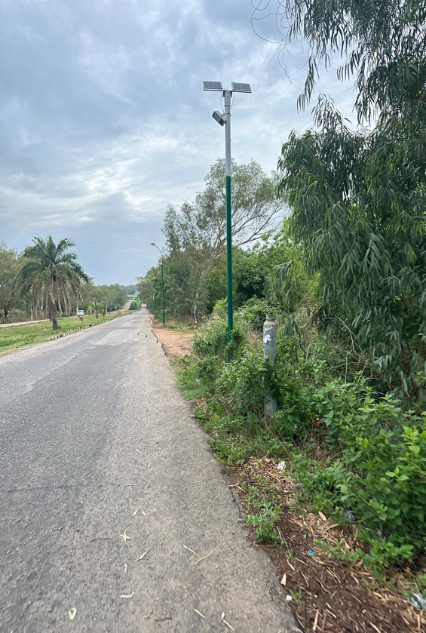
Plate 2: Showing A Traffic Lighting in Kwara State Polytechnic
Source: Field Survey Showing Traffic Lighting in Kwara State Polytechnic, 2025

Plate 3: Showing a Road Sign in Kwara State Polytechnic
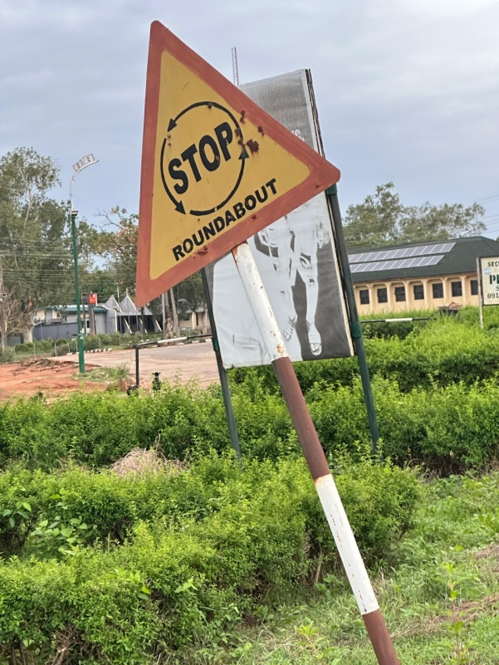
Source: Field Survey Showing Road Sign in Kwara State Polytechnic, 2025

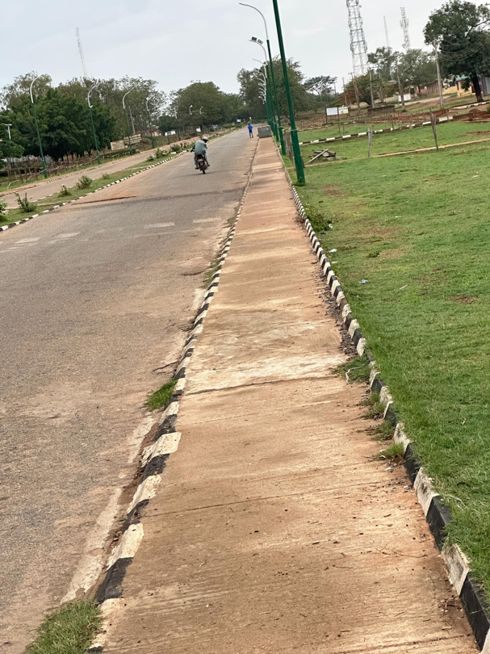
Plate 4: Showing Pedestrian Walkway in Kwara State Polytechnic
Source: Field Survey Showing Pedestrian Walkway in Kwara State Polytechnic, 2025

Plate 5: Showing Speed Bumps in University of Ilorin
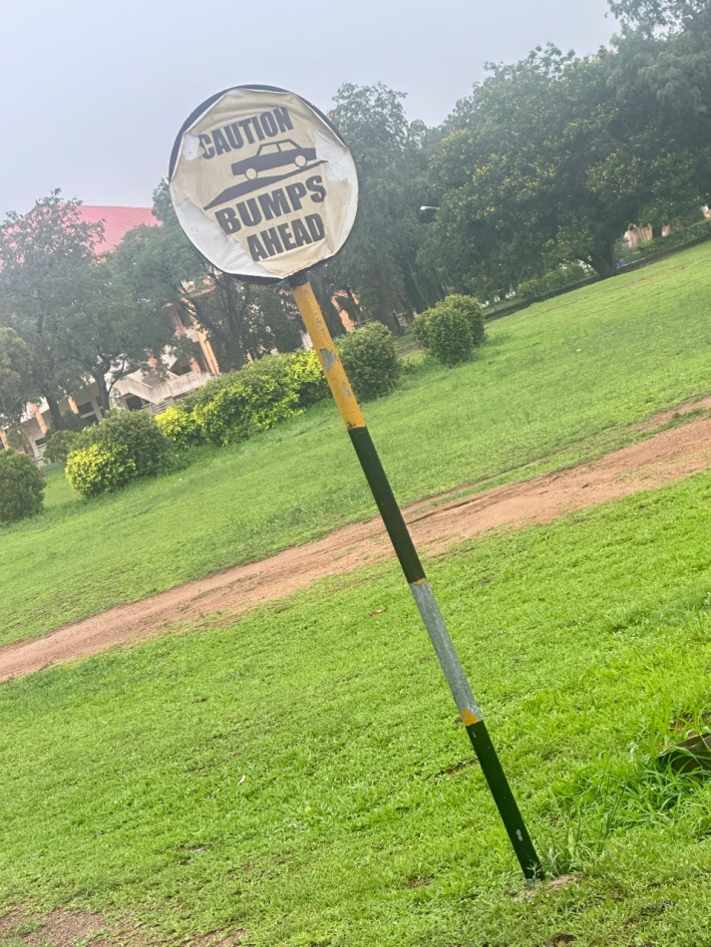

Source: Field Survey Showing Speed Bumps in University of Ilorin, 2025

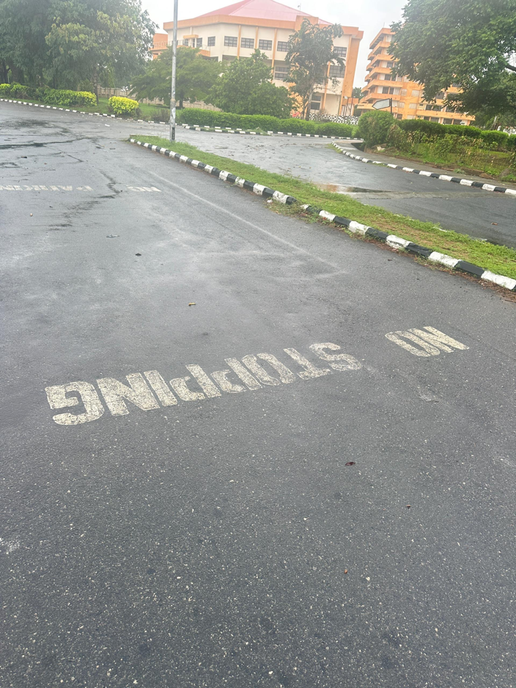
Plate 6: Showing Road Markings in University of Ilorin

Source: Field Survey Showing Road Markings in University of Ilorin, 2025

Plate 7: Showing Speed Limit in University of Ilorin
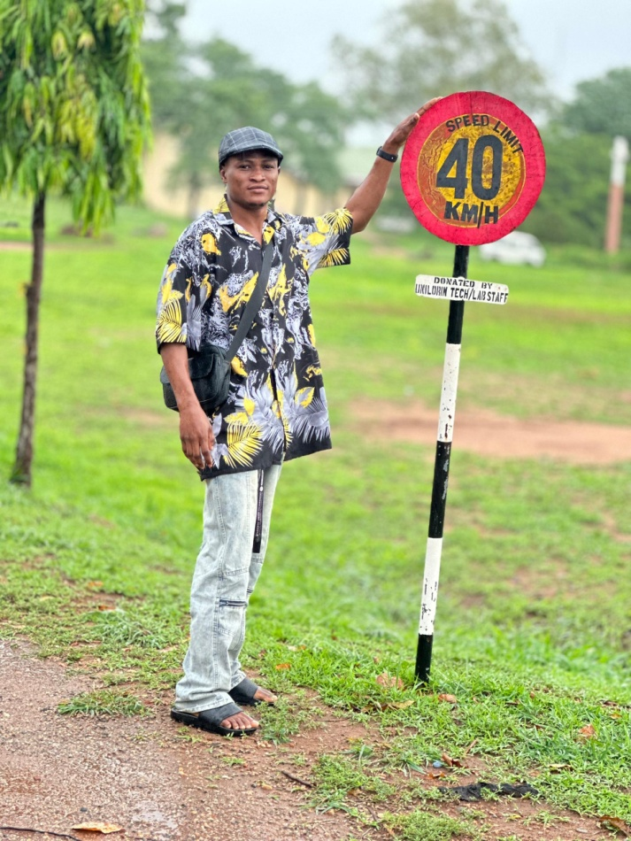

Source: Field Survey Showing Speed Limit in University of Ilorin, 2025
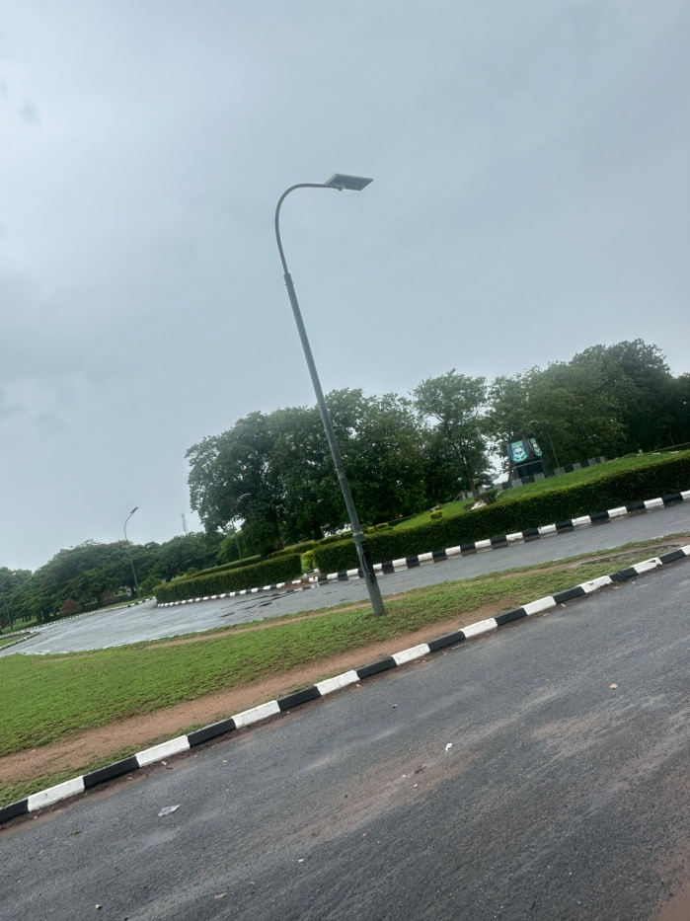
Plate 8: Showing Traffic Lighting in University of Ilorin

Source: Field Survey Showing Traffic Lighting in University of Ilorin, 2025

