DEVELOPMENT OF AN AIRLINE TICKET BOOKING AND REVENUE MANAGEMENT SYSTEM
BY
MUSA KHALID OLAMILEKAN
ND/23/COM/FT/0030

SUBMITTED TO THE DEPARTMENT OF COMPUTER SCIENCE, INSTITUTE OF INFORMATION AND COMMUNICATION TECHNOLOGY,
KWARA STATE POLYTECHNIC, ILORIN

IN PARTIAL FULFILLMENT OF THE REQUIREMENTS FOR THE AWARD OF NATIONAL DIPLOMA (ND) IN
COMPUTER SCIENCE

JUNE, 2025.
CERTIFICATION
This is to certify that this project was carried out by MUSA KHALID OLAMILEKAN of Matriculation Number: ND/23/COM/FT/0030 has been read and approved by the Department of Computer Science, Kwara State Polytechnic Ilorin, in Partial Fulfiment of the requirements for the award of National Diploma (ND) in Computer Science.

…………………………………. ….………………………
MR SADIQ K. A. Date
Project Supervisor

…………………………………. ….………………………
MR. OYEDEPO, F. S. Date
Head of Department

…………………………………. ….………………………
External Examiner Date

DEDICATION
I dedicate this project work to Almighty God who inspired me and directed my ways during my academic stay in the polytechnic.

ACKNOWLEDGEMENT
All praise is due to Almighty God the Lord of the universe. I praise him and thank him for giving me the strength and knowledge to complete my HND program and also for our continued existence on Earth.
I appreciate the utmost effort of my supervisor, Mr. Sadiq, K. A. whose patience, support, and encouragement have been the driving force behind the success of this research work. He gave useful corrections, constructive criticisms, comments, recommendations, and advice and always ensures that excellent research is done. My sincere gratitude goes to the Head of the Department Mr. Oyedepo F. S., and other members of staff of the Department of Computer Science, Kwara State Polytechnic, Ilorin, for their constant cooperation, constructive criticisms, and encouragement throughout the program.
Special gratitude to my parents, who exhibited immeasurable financial, patience, support, prayers, and understanding during the period in which I was busy tirelessly with my studies, special thanks go to my lovely siblings
My sincere appreciation goes to my friends and classmates.

TABLE OF CONTENTS
Title page i
Certification ii
Dedication iii
Acknowledgments iv
Table of Contents v
Abstract vi
CHAPTER ONE: GENERAL INTRODUCTION
1.1 Background to the Study 1
1.2 Statement of the Problem 2
1.3 Aim and Objectives 3
1.4 Significance of Study 3
1.5 Scope of Study 3
1.6 Organization of the Report 4
CHAPTER TWO: LITERATURE REVIEW
2.1 Review of Related Works 5
2.2 Review of General Text 9
2.3 Concept of Human Activity Recognition 9
CHAPTER THREE: RESEARCH METHODOLOGY AND
ANALYSIS OF THE SYSTEM
  - Research Methodology 15
  - Analysis of the Existing System 17
  - Problem of the Existing System 17
  - Analysis of the Proposed System 18
  - Advantages of the Propose System 20
CHAPTER FOUR: DESIGN, IMPLEMENTATION AND
DOCUMENTATION OF THE SYSTEM
  - Design of the System 22
    - Output Design 22
    - Input Design 24
    - Database Design 25
    - Procedure Design 26
  - Implementation of the System 27
    - Choice of programming language 27
    - Hardware support 27
    - Software Support 27
    - Implementation Techniques used in Details 27
  - System Documentation 28
    - Operating the System 28
    - Maintaining of the System 28
CHAPTER FIVE: SUMMARY CONCLUSION AND
RECOMMENDATION
5.1 Summary 29
5.2 Conclusion 29
5.4 Recommendations 30
References 31

ABSTRACT
This study designs a modern flight reservation system to address current system limitations such as outdated technology, lack of personalization, and data security issues. The proposed system uses AI, machine learning, and cloud computing to enhance personalization, security, pricing, and user experience. Key benefits include personalized recommendations, robust security, optimized revenue management, mobile access, and scalability. The study concludes that the new system significantly improves current systems and recommends adopting modern technologies, enhancing data security, focusing on user experience, promoting interoperability, and providing training and support to revolutionize flight reservations for better efficiency and customer satisfaction.

CHAPTER ONE
GENERAL INTRODUCTION
  - Background to the Study
In science and technology, the desire for improvement is a constant subject which triggers advancements. This is visible in every ramification and the airline industry is not an exemption. Airline reservation systems were first introduced in the late 1950s as relatively simple standalone systems to control flight inventory, maintain flight schedules, seat assignments and aircraft loading. Today modern airline reservation systems are comprehensive suites of products to provide systems that assist with a variety of airline management tasks and service customer needs from the time of initial reservation through completion of the flight (Blessing, 2022). The World Wide Web has become tremendously popular over the last four years, and currently most of the airlines have made provision for online reservation of their flights. The Internet has become a major resource for people looking for making reservations online without the hassle of meeting travel agents by implementing an online reservation system this ensures that reservation are not only generated by the airline own staff but also by any travel agent using a Global Distribution system or other airlines that have a multilateral Interline Traffic Agreement with the airline (Nikitha & Adarsh, 2023).
A Computer Reservations System is a computerized system used to store and retrieve information and conduct transactions related to travel. Computer reservation systems are classified as Passenger Service Systems (PSS) which handles a series of critical functions for the airline. For an Airline, the reservation system is a mission critical system that should use the latest state of the art technology to provide for all flight reservations on a robust platform, which is flexible and can be adapted to any style of airline. Secure and stable systems are vital to the airline industry which is why companies spend many years designing an architecture specifically suited to the nature of the airline industry which often requires tens of thousands of users to access and use the system simultaneously (David, 2020). Flight reservation systems play a pivotal role in the modern aviation industry, serving as the backbone of airline operations and customer service. These systems, often built on sophisticated software platforms, facilitate the booking, ticketing, and management of airline seats for millions of passengers worldwide. Currently, most airlines rely on comprehensive reservation systems that integrate various functionalities, including inventory management, fare calculation, and passenger profiling (Smith, 2019).
Efficient flight reservation systems are essential for several reasons. Firstly, they streamline the booking process, allowing passengers to easily find and reserve flights according to their preferences and travel requirements. This convenience enhances the overall customer experience and fosters loyalty to airlines that offer seamless reservation services. Moreover, efficient reservation systems enable airlines to maximize revenue by optimizing seat utilization and pricing strategies. By accurately forecasting demand and adjusting fares dynamically, airlines can achieve higher yields and profitability (Jones & Brown, 2020). Despite their importance, current flight reservation systems face several challenges and limitations. One significant challenge is the complexity of legacy systems, which often rely on outdated technology and infrastructure. These legacy systems may struggle to adapt to evolving industry trends, such as the increasing demand for personalized services and real-time booking capabilities. Additionally, interoperability issues between different reservation systems can hinder seamless communication and data exchange among airlines, travel agencies, and other stakeholders. Furthermore, concerns related to data security and privacy pose ongoing challenges for reservation system providers, particularly in light of regulatory requirements and cyber threats (Johnson, 2020).
Addressing these challenges requires innovative solutions that leverage modern technologies such as cloud computing, artificial intelligence, and blockchain. By modernizing reservation systems and enhancing their capabilities, airlines can improve operational efficiency, enhance customer satisfaction, and stay competitive in an increasingly dynamic market landscape.

  - Statement of the Problem
The Statement of the Problem outlines the challenges and limitations faced by current flight reservation systems. These challenges include complex and outdated infrastructure, interoperability issues between systems, concerns regarding data security and privacy, inflexible pricing and inventory management, and a lack of personalization in services. These issues impact both airlines and passengers, leading to inefficiencies, security risks, and missed revenue opportunities. Addressing these problems is essential for enhancing operational efficiency, improving the customer experience, and ensuring the competitiveness of airlines in the modern aviation industry.
  - Aim and Objectives of the Study
The aim of this study is to design and implement an efficient flight reservation system that addresses the challenges and limitations present in current systems, and the objectives are to:
- Analyze the existing flight reservation systems and identify their strengths, weaknesses, opportunities, and threats (SWOT analysis).
- Design a comprehensive and user-friendly flight reservation system that integrates modern technologies.
- Develop the proposed reservation system, including functionalities such as dynamic pricing, real-time inventory management, and personalized customer services.
- Evaluate the performance and usability of the developed system through testing and user feedback.
  - Significance of the Study
The study's significance lies in its potential to revolutionize the aviation industry through the design and implementation of an advanced flight reservation system. By improving operational efficiency, enhancing the customer experience, maximizing revenue generation, fostering technological innovation, boosting industry competitiveness, and contributing to academic and practical knowledge, this study aims to bring about positive changes and advancements that benefit airlines, passengers, and the aviation sector as a whole.
  - Scope of the Study
The scope of this study encompasses the design and implementation of a flight reservation system with a focus on usability, security, and performance. The system will include features such as flight search, booking, ticketing, and passenger management. The study will primarily focus on domestic flights but will provide insights applicable to international flights as well.
  - Organisation of the Report
For easy study and proper understanding of this project write-up, It is planned and organized into five chapters. The description of what each chapter contains is explained below:
Chapter One: This contains an Introduction to the whole write-up, the problem of the study, aims and objectives of the study, the significant of the study, the scope and limitation of the study, and organization of the report.
Chapter Two: It focuses on the literature review of the study, organization of the board of director, computerization of the current state of the art.
Chapter Three: It presents data collection method employed, analysis of data and existing system, advantages of the proposed system, design and implementation, programming language used with reasons, hardware and software support.
Chapter Four: It deals with the system design implementation and documentation, design of the system, output design, input design, file system, procedural design, and documentation of the new system.
Chapter Five: This centres the summary, experienced gained, recommendation and conclusion.

CHAPTER TWO
LITERATURE REVIEW
2.1 Review of Related Work
David, (2020) Airline Reservation Systems (ARS) used to be standalone systems. Each airline had its own system, disconnected from other airlines or ticket agents, and usable only by a designated number of airline employees. Travel agents in the 1970s pushed for access to the airlines' systems. Today, air travel information is linked, stored, and retrieved by a network of Computer Reservations Systems (CRS), accessible by multiple airlines and travel agents. This report is a summary of the study that was undertaken to design and implement an airline reservation system. The airline reservation system designed in this project was developed using php, java script and html as the programming languages and MySQL as the database Management system. The researcher reviewed the literature of reservation systems in chapter two and explored the advantages and limitations of reservation system in real life situations. The researcher used interviews and questionnaire methods during the data collection phase, these data collection methods helped the researcher to better understand the existing system in use. Case tools and data flow diagram were used during the development process to simulate the process of airline reservation and ticket booking. The outcome of the study was an online airline reservation system tested and implemented in the case study Rwenzori Airlines to book, schedule and reserve flights.
Patil and Deshpande (2021) Airline Reservation System. Automation in various fields is taking this world one step closer to the technical era. This project “Airline Reservation System” is about flight ticket booking and managing flight databases as admin.
Sreenivasachari & Dinakar (2022) presented a paper on “Online Airline Reservation System” Online Airline Reservation System is a Web based application for a particular Airlines company. This application facilitates registering, updating, and utilization of miles for a Frequent Flier of its flights. The frequent flier should be able to login and key in all the details of his travel in their airlines. The application is accessible for the frequent fliers from the existing website of the airlines. Airline reservation System is a computerized system used to store and retrieve information and conduct transactions related to air travel. The project is aimed at exposing the relevance and importance of Airline Reservation Systems. It is projected towards enhancing the relationship between customers and airline agencies through the use of ARSs, and thereby making it convenient for the customers to book the flights as when they require such that they can utilize this software to make reservations.
Nikitha P. & Adarsh K (2024), “Android Bus Ticketing System” The Public transport system is a major source of income in developing countries like India. Earlier to reserve a ticket people had to waste a lot of time by standing in a long queue. As technology proliferated automation is ingrained in our daily life. To book ticket instantly “The Online Bus Ticket Reservation System” came into existence. It is a web-based application that allows visitors to check the bus ticket availability, book the bus tickets and payment transactions are done through online. It provides facilities like reservation; cancellation of seats and various types of information’s regarding buses etc. These types of reservation are suited for longer journeys. When passenger needs to travel within a city, online booking would long hectic procedure to book a ticket online and generate a ticket and show that to a conductor. Ascertaining the same situations in a mall to book movie tickets ‘Bookmyshow’ Android application is used. The QR code will be generated as ticket; this is scanned at the entrance and allowed inside the theater. By this got an idea to develop a system to book tickets for passengers who travel within the city. The app is developed, passenger needs to login by providing necessary credentials. The user must enter the destination place and the number of passengers in the fields provided by the app and then the respective amount is been deducted directly through payment account or bank account which is registered at the time of login and the ticket will be generated that will be unique. This will be scanned at entrance and valid passengers are allowed to get in and IR sensor will count the no of passengers, database is also managed. There are three parts in door opening system in bus. In below fig you are observing a special mechanism door is placed inside the bus, that door is called inlet door. Code scanner is placed at the center, there are 2 code scanners one is while entering the bus and another while alighting the bus.
Blessing (2019) review a journal on “Challenges of Airline Reservation System and Possible Solutions” An Airline Reservation system is very important because it has the strong ability to reduce errors that might have occurred when using a manual system of reservation and helps speed up the boarding process. Overland Airways has an existing Airline Reservation System, but this paper analyzed the problems of the existing system. The problems are: inability of passengers to select their preferred seat(s) from the reservation system, No option of passengers printing their boarding pass from the existing system, non-notification of passengers of flight cancellation or delays and passengers don‘t have access to aircraft maintenance report to ease the fears associated with air travel and its disasters. In this paper, an Improved Airline Reservation System that is convenient for passengers to solve the aforementioned problems was designed. The Improved Airline Reservation system is designed and implemented using data obtained from interviewing airline personnel, passengers, and materials on Airline Reservation Systems. In this regard, the Improved Airline Reservation System will assist Overland Airways in variety of airline administration tasks and service needs from time of initial reservation through completion of the task. The following programming languages were used: PHP, JavaScript, HTML and CSS for designing the interface of the system, and SQL for the database. The designed airline system was tested with 50 passengers
Sameer, Prachi & Loganathan (2020) worked on “Airline Reservation System” Airline reservation System is a computerized system used to store and retrieve information and conduct transactions related to air travel. The project is aimed at exposing the relevance and importance of Airline Reservation Systems. It is projected towards enhancing the relationship between customers and airline agencies through the use of ARSs, and thereby making it convenient for the customers to book the flights as when they require such that they can utilize this software to make reservations.

2.2 Review of General Studies
In addition to specific works focusing on the historical development, functionalities, challenges, and emerging trends of flight reservation systems, there exists a body of general studies that provide broader insights into the field. These studies offer valuable perspectives on various aspects of reservation systems, including their impact on the aviation industry, customer behavior, and technological innovation.
2.2.1 Impact on the Aviation Industry
Flight reservation systems have had a profound impact on the aviation industry, revolutionizing airline operations, revenue management strategies, and customer service practices. Several studies have examined the various ways in which reservation systems have shaped the industry landscape:
- Distribution Channels: Flight reservation systems have transformed the distribution channels through which airlines sell their tickets. Historically, airlines relied heavily on traditional travel agents and ticket counters for bookings. However, the advent of computerized reservation systems enabled the emergence of online travel agencies (OTAs) and airline websites as prominent booking platforms. This shift has empowered airlines to reach a broader audience and reduce dependence on intermediaries.
- Revenue Management: Reservation systems play a crucial role in revenue management strategies employed by airlines. These systems enable dynamic pricing, wherein ticket prices fluctuate based on factors such as demand, time until departure, and competitor pricing. By analyzing booking data and market trends in real-time, airlines can optimize pricing strategies to maximize revenue while ensuring seat occupancy levels.
- Operational Efficiency: The automation and streamlining of booking processes through reservation systems have significantly improved operational efficiency for airlines. By centralizing booking management, seat inventory control, and passenger data, airlines can reduce manual errors and administrative overhead. This efficiency translates into cost savings and enhanced competitiveness in the industry.
- Customer Experience: Reservation systems have reshaped the customer experience in the aviation industry, offering travelers greater convenience, flexibility, and customization options. Passengers can now book flights, select seats, and manage their itineraries online or through mobile apps, eliminating the need for physical tickets and cumbersome paperwork. Additionally, reservation systems facilitate personalized services such as seat upgrades, special meal requests, and loyalty program benefits, enhancing customer satisfaction and loyalty.
- Market Competition: The widespread adoption of reservation systems has intensified competition among airlines, both in terms of pricing and service offerings. Airlines must continuously innovate and differentiate themselves to attract and retain customers in a crowded marketplace. Reservation systems provide valuable insights into consumer preferences and behavior, enabling airlines to tailor their marketing strategies and product offerings to meet evolving demands.
2.3 History of Airline Reservation Information System
In the arena of global competition, organizations all over the world are competing through the use of the most comprehensive and advanced technological features. The most common example of innovation is in the area of information technology and communication. Various industries are using technology and the advancements of software and internet to maintain and monitor their business transactions. In the application of the informative systems, the airline industry is the most commonly used system. This chapter explores the concept of reservation information system, their history, components, types and their applications in real world situation to solve problems
American Airlines was the first to establish an automated booking system in 1946. Using a system to track information and improve efficiency was a highly appealing aim in the industry, and drew the attention of other airlines worldwide. The system endured years of development and alterations. Later, other airlines invested more in research and development to launch improved systems, and through the late 1960s and early 1970s, airlines established their own systems.
United Airlines developed the Apollo Reservation System, and shortly after allowed travel agents access. The Apollo system was the foundation for many further developments, which spread from just US airlines to European airlines as well. The research and development of Airline Reservation System became a significant aspect of the industry and all its air carrier companies, and partnerships between airlines and technology gurus emerged. Winston (1995)
Other airlines soon established their own systems. Delta Air Lines launched the Delta Automated Travel Account System (DATAS) in 1968. United Airlines and Trans World Airlines followed in
1971 with the Apollo Reservation System and Programmed Airline Reservation System (PARS), respectively. Soon, travel agents began pushing for a system that could automate their side of the process by accessing the various Airline Reservation Systems directly to make reservations. Fearful this would place too much power in the hands of agents; American Airlines executive Robert Crandall proposed creating an industry-wide Computer Reservation System to be a central clearing house for United States travels; other airlines demurred, citing fear of antitrust prosecution.
Airline deregulation occurred in 1978, magnifying the importance of computerized airline reservation systems and their accessibility. During the early 1970s, as travel agents pushed for access to reservation systems, and certain airline executives made investments for the sake of accessing the systems of other airlines, antitrust laws came into focus. The purpose of the 1978 Airline Deregulation Act in the United States was to eliminate government control over commercial aviation, and ensure competitive behavior and fair business practices in the airline industry. Passengers could gain knowledge of market forces and new market entry in the industry. Information on specific airlines and the industry as a whole became more widely and readily accessible, evolving the airline reservation systems from "standalone" operations toward GDS. Today, airline reservation systems have developed into computerized reservation systems which are of mission critical to the airline industry, about six major airline reservations systems are used by international airlines. Winston (1995)
2.3.1 Reservation Information Systems
The airline reservations system was one of the earliest changes to improve efficiency in the airline industry. Airline Reservation System eventually evolved into the computer reservations system (CRS). Airline Reservations System (ARS) is a computerized system used to store and retrieve information and conduct transactions related to air travel. The systems were originally designed and operated by airlines, but were later extended for the use of travel agencies. Wikipedia, May (2014).
Major airline reservation system operations that book and sell tickets for multiple airlines are known as Global Distribution Systems (GDS). Airlines have divested most of their direct holdings to dedicated GDS companies, who make their systems accessible to consumers through Internet gateways. Modern Global Distribution Systems typically allow users to book hotel rooms and rental cars as well as airline tickets. Wardell, David (1991).
Global Distribution Systems(GDS) is a worldwide computerized reservation network used as a single point of access for reserving airline seats, hotel rooms, rental cars, and other travel related items by travel agents, online reservation sites, and large corporations. The premier global distribution systems are Amadeus, Galileo, Sabre, and Worldspan. They are owned and operated as joint ventures by major airlines, car rental companies, and hotel groups. Global, May, (2012).


GDS

.

Airline website

Customer booking

IDS internet

Distribution system

Central reservation
system

Travel agent

using GDS
(
)

Airline
Running

Figure 2.1 showing a global distribution system; adapted from Reservation Interfaces, Wikipedia May 2012.
2.3.2 Customer Behavior and Preferences
Understanding customer behavior and preferences in the context of flight reservations is crucial for designing effective booking systems. Research reveals that customers exhibit varied booking patterns influenced by factors such as travel purpose and destination. Payment preferences are shifting towards digital options like mobile wallets, alongside traditional methods. Key factors driving purchasing decisions include price, convenience, brand reputation, and loyalty programs. Providing a seamless user experience, including intuitive interfaces and mobile responsiveness, is pivotal for customer satisfaction and engagement. Additionally, personalization plays a significant role, with travelers valuing customized recommendations and offers based on their preferences and past behaviors. Incorporating insights into customer behavior enables airlines to optimize pricing, enhance user experience, and deliver personalized services, ultimately fostering satisfaction, loyalty, and business success.
2.3.3 Technological Innovation and Adoption
Technological innovation plays a pivotal role in shaping the evolution of flight reservation systems, driving advancements in functionality, performance, and security. Research highlights several key areas of innovation and adoption within the aviation industry:
- Cloud Computing: The adoption of cloud computing technology offers scalability, flexibility, and cost-efficiency for airlines managing reservation systems. Cloud-based solutions enable airlines to offload IT infrastructure, reduce operational costs, and scale resources based on demand fluctuations. Moreover, cloud platforms facilitate seamless integration with other airline systems and third-party services, enhancing system interoperability and agility.
- Artificial Intelligence (AI) and Machine Learning (ML): AI and ML technologies are revolutionizing flight reservation systems by enabling predictive analytics, personalized recommendations, and dynamic pricing strategies. AI-powered algorithms analyze vast amounts of data, including historical booking patterns, market trends, and customer preferences, to optimize pricing and inventory management in real-time (Jones et al., 2021). Additionally, ML models can identify patterns and anomalies in booking data, enabling airlines to proactively address issues and improve decision-making processes.
- Blockchain Technology: Blockchain technology holds promise for enhancing security, transparency, and efficiency in flight reservation systems. By leveraging distributed ledger technology, airlines can secure sensitive data, such as passenger information and transaction records, against unauthorized access and tampering. Blockchain-based solutions also enable transparent and immutable tracking of transactions, reducing disputes and fraud in ticket sales and settlements.
- Mobile Applications: The proliferation of mobile applications has transformed the way customers interact with flight reservation systems. Mobile apps offer travelers convenient access to booking services, itinerary management, and real-time flight updates on their smartphones and tablets. By providing seamless and personalized experiences across multiple devices, mobile apps enhance customer engagement and loyalty.
- Biometric Authentication: Biometric authentication technologies, such as fingerprint and facial recognition, are increasingly being integrated into reservation systems to enhance security and streamline the check-in process. By replacing traditional authentication methods with biometric identifiers, airlines can reduce check-in times, minimize fraud, and enhance the overall travel experience for passengers.
In summary, technological innovation in flight reservation systems is driving significant improvements in efficiency, security, and customer experience. By embracing cloud computing, AI, blockchain, mobile applications, and biometric authentication, airlines can stay ahead of the curve and meet the evolving needs of travelers in an increasingly digital and interconnected world.
2.3.4 Industry Trends and Best Practices
Understanding industry trends and best practices is crucial for airlines aiming to stay competitive and meet evolving customer expectations. Personalization emerges as a key trend, driven by data analytics and AI, allowing airlines to deliver tailored experiences and targeted marketing campaigns. Providing a seamless omni-channel experience across various touchpoints, including online platforms, mobile apps, and social media, ensures consistency and enhances customer satisfaction. Sustainability initiatives are gaining traction, with airlines integrating eco-friendly options into reservation systems to promote environmentally responsible travel. Real-time data analytics empowers airlines to make informed decisions, optimize pricing strategies, and adapt to market changes swiftly. Collaborative partnerships with other airlines, travel agencies, and technology providers enable airlines to expand their reach, enhance service offerings, and drive growth. By embracing these trends and best practices, airlines can differentiate themselves, foster customer loyalty, and achieve sustainable success in the competitive aviation industry.
2.3.5 Future Directions and Research Opportunities
Understanding the future trajectory of flight reservation systems is pivotal for shaping the aviation industry's evolution and addressing emerging challenges. This exploration offers insights into key areas for future research and development:
- Advancements in Artificial Intelligence (AI) and Machine Learning (ML): Future research could delve deeper into leveraging AI and ML algorithms to enhance various aspects of flight reservation systems. This includes developing more accurate demand forecasting models, refining dynamic pricing strategies, and creating personalized recommendation engines. Exploring the intersection of AI with other emerging technologies like natural language processing (NLP) could also unlock new opportunities for improving customer interactions and streamlining booking processes.
- Blockchain Technology Integration: Research on integrating blockchain technology into flight reservation systems can address concerns related to data security, transparency, and trust. Exploring blockchain-based solutions for identity management, ticket validation, and loyalty programs could revolutionize how airlines manage customer information and transactions. Additionally, investigating the potential impact of blockchain on streamlining inter-airline transactions and settlements could lead to more efficient and cost-effective collaboration within the industry.
- Enhanced User Experience Design: Future research should focus on optimizing user experience design for flight reservation systems, particularly in the context of mobile applications and omni-channel experiences. Understanding user preferences, behaviors, and pain points can inform the development of intuitive interfaces, streamlined booking flows, and personalized features. Additionally, exploring innovative ways to incorporate AR, VR, and voice assistants into reservation platforms can create more immersive and engaging experiences for customers.
- Sustainability Initiatives: Research on integrating sustainability initiatives into flight reservation systems can encourage eco-friendly travel choices and support airlines' environmental goals. This includes offering carbon offset options, promoting sustainable transportation alternatives, and incentivizing passengers to choose greener options. Exploring the effectiveness of sustainability messaging and incentives within reservation platforms can raise awareness and drive positive behavior change among travelers.
- Data Privacy and Security: With increasing concerns around data privacy and security, future research should focus on enhancing measures to protect sensitive passenger information in flight reservation systems. This includes exploring advanced encryption techniques, implementing privacy-preserving technologies, and ensuring compliance with evolving regulations such as GDPR and CCPA. Additionally, investigating the potential risks and vulnerabilities associated with emerging technologies like IoT and biometrics can help airlines mitigate security threats and build trust with customers.
- Collaborative Research and Standardization: Research on international collaboration and standardization efforts in the development and adoption of flight reservation systems can facilitate interoperability, data exchange, and regulatory compliance across borders. This includes fostering partnerships between airlines, technology providers, and regulatory bodies to establish industry-wide standards and best practices. Additionally, exploring the challenges and opportunities associated with global reservation systems can inform policy decisions and drive collective action towards a more seamless and interconnected aviation ecosystem.

CHAPTER THREE
RESEARCH METHODOLOGY AND ANALYSIS OF THE NEW SYSTEM
3.1 Research Methodology
The methodology describes the procedures, tools, techniques that were employed to achieve the specific objectives of the airline reservation system for Airlines. The development of the System was based on the model below. It involved requirement determination, requirement analysis, system design, implementation, testing and validation. This approach below describes the sequence of steps involved.

Requirements analysis

System Design

Implementation

Testing

& Validation

Requirement Determination

Figure 3.1 the system study and design model
Source: Wardell, David J.
3.1.1 System Implementation
This involved putting together or building various elements of a system for example MySQL for database Wamp Server for hosting the web pages. This is the stage in which the actual system was recognized. The technical architecture defined in the design stage was the baseline for developing the system. The interface ware designed using HTML and Java script languages. This is because these languages provided tremendous friendly user interfaces; that is easy to learn and affordable. The database was designed in MYSQL basing on Wamp Server software. MYSQL provides a high level of security to the database, that is, authentication which can either be during the logging in to the database or on DML commands such as delete, add or even edit, it also reduces redundancy. In here the researcher achieved his fourth objective.
3.2 Analysis of the Existing System
There are two methods involved; Direct and Call-in reservation. With both reservation methods, the customer must first confirm the financial implications, if there are available seats; the passenger must now choose a seat. All of this requires the staff manually opening and checking documents and books each time to get the required indication while the customer and the other possibly in a queue exercise the virtue of patience same applies to those calling the terminus. Finally the passengers’ data is required in order to issue the ticket and prepare manifest. Basic data contained in the ticket are: Name, Address Seat number, Cost of fare and Next of kin phone number. A ticketing officer handling more than one route repeats this process for every route and passenger. Routinely each day’s operation starts with the ticketing officer drawing circles with numbers and crossing those seat numbers that have been reserved.
The analysis of the existing flight reservation systems reveals a mixed landscape of strengths, weaknesses, opportunities, and threats (SWOT). Existing systems boast established infrastructure, a wide range of features, global reach, and integration capabilities. However, they suffer from drawbacks such as reliance on legacy technology, limited personalization, data security concerns, and interoperability issues. Opportunities lie in technological advancements, improved user experience, enhanced personalization, and sustainability initiatives. Yet, threats emerge from competition, regulatory compliance, cybersecurity risks, and rising customer expectations. Understanding these factors is crucial for identifying areas of improvement and guiding the development of a new and improved reservation system.
3.3 Problems of the Existing System
The analysis of the existing flight reservation systems has identified several significant problems and challenges that need to be addressed:
- Limited Personalization: Existing reservation systems often lack advanced personalization capabilities, offering a one-size-fits-all approach to customer service. This results in a generic booking experience that fails to meet the individual preferences and needs of passengers.
- Data Security Concerns: There are growing concerns about data security and privacy in existing reservation systems, especially with the increasing volume of sensitive passenger information stored in these systems. Instances of data breaches and cyber attacks pose significant risks to both airlines and passengers.
- Interoperability Issues: Interoperability issues between different reservation systems and airlines can lead to data inconsistencies, integration difficulties, and operational inefficiencies. Lack of standardized protocols and communication standards exacerbates these challenges.
- Complex Pricing and Inventory Management: The complexity of pricing and inventory management in existing systems hinders airlines' ability to optimize revenue generation and offer competitive pricing. Manual processes and outdated algorithms limit the effectiveness of dynamic pricing strategies.
- Poor User Experience: Some existing reservation systems suffer from usability issues, cumbersome booking processes, and outdated interfaces, leading to a subpar user experience for both airlines and passengers. This can result in frustration, reduced conversion rates, and customer attrition.
- Limited Mobility and Accessibility: Accessibility features and mobile responsiveness are often lacking in existing reservation systems, making it difficult for passengers to book flights or manage their itineraries on mobile devices or across different platforms.
3.4 Analysis of the Proposed System
The proposed flight reservation system addresses the limitations of existing systems through modern architecture, advanced personalization, enhanced security measures, streamlined pricing and inventory management, improved user experience, integration capabilities, and scalability. It adopts cloud computing infrastructure and micro-services architecture for scalability and flexibility, while leveraging AI and machine learning for advanced personalization and dynamic pricing strategies. Robust security features, including encryption and multi-factor authentication, ensure data privacy and compliance with regulations. The system prioritizes user experience with intuitive interfaces, accessibility features, and mobile optimization. Seamless integration with other systems and standardized APIs facilitate interoperability, while modular design enables customization and extensibility. Overall, the proposed system offers a comprehensive solution to enhance efficiency, security, and user satisfaction in flight reservation processes.
The proposed Airline Ticket Reservation System will have four actors who will interact with application. Firstly, passengers who will book the ticket, application will allow passenger to access, search and check bus ticket availability over the internet 24 hours a day, 7 days a week. In addition passengers can book the bus ticket. Secondly, Admin who will control and check whole the system, admin can add/edit/delete airline, route, destination and soon. However, admin can distribute accounts for the pilot to allow them access to the system and for the guards as well. Thirdly, pilot who will fly the plane, his privilege less than the admin. Pilot can only check his trip, the plane number that it will fly it, beside that he can see the passenger's lists for a specific trip. Lastly, guard his privilege same with the pilot only check the trips and see the passenger's lists. However, the ARS prototype will work for Web platform.

3.5 Advantages of the New System over the Existing System
The proposed flight reservation system offers several distinct advantages over existing systems, enhancing various aspects of functionality, security, and user experience:
- Advanced Personalization: By utilizing AI and machine learning, the new system provides personalized recommendations and customized offers, improving passenger satisfaction and loyalty.
- Enhanced Security: The system incorporates robust encryption, multi-factor authentication, and proactive threat detection to protect sensitive data, ensuring compliance with industry regulations like GDPR and PCI-DSS.
- Optimized Revenue Management: Advanced algorithms and real-time data analytics support dynamic pricing, demand forecasting, and seat inventory control, maximizing revenue potential and seat utilization.
- Improved User Experience: The system features intuitive interfaces, responsive design, and seamless booking processes, with accessibility features for users with disabilities and mobile optimization for booking on any device.
- Seamless Integration: Standardized APIs and communication protocols enable easy integration with other airline systems, third-party services, and distribution channels, enhancing operational efficiency.
- Scalability and Flexibility: The cloud-based infrastructure and modular architecture allow the system to scale according to demand and adapt to evolving business requirements and technological advancements.
- Cost Efficiency: Leveraging cloud computing and automation reduces operational costs related to maintenance, upgrades, and hardware, resulting in overall cost savings for airlines.

CHAPTER FOUR
DESIGN AND IMPLEMENTATION OF THE SYSTEM
4.1 Design of the System
Generally, all efforts are geared toward designing a system program that eliminates all the setbacks of the existing manual method. This new approach is simple, efficient and guaranteed.
The proposed is designed in order to meet the goal and objective of the organization. The design of the system is intended to solve the various problems contributed in the manual method of Airline Reservation System
4.1.1 Output Design
It refers to the report expected to be generated from files in database. The generated reports are lists of view, index page e.t.c. Below are the snapshot of the output designs

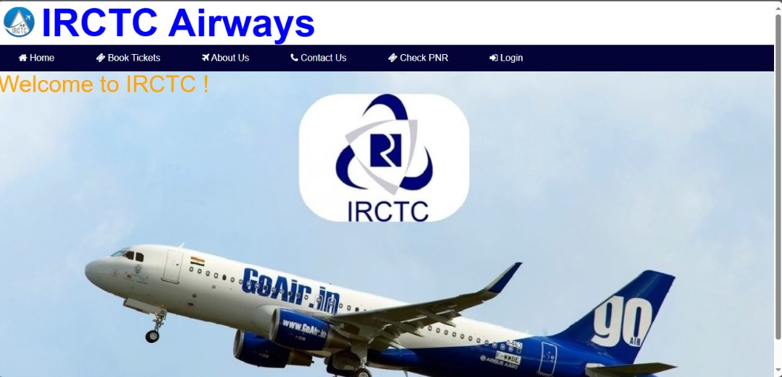
Figure 4.1: Index Screenshot

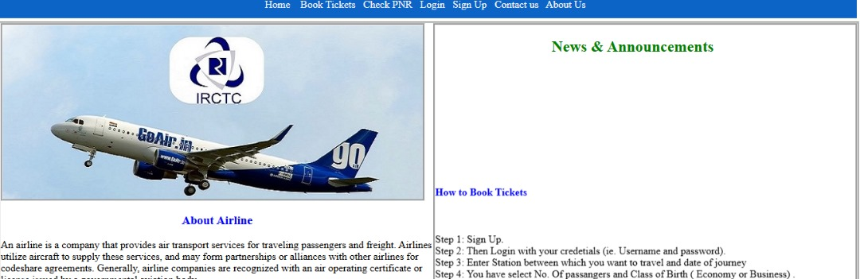
Figure 4.2: News and Announcement page
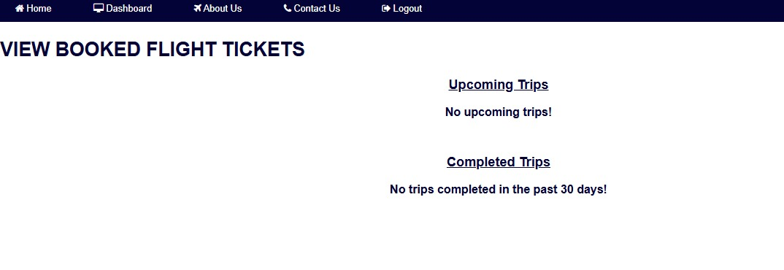
Figure 4.3: View Booked Flight Module

4.1.2 Input Design
Design is a way of mapping and arranging part into a whole, which satisfies the objective involved. The input design refers to the type of all data used to feed information into the database via the program and the format and the input used for the system. Below are the snapshots of the input designs

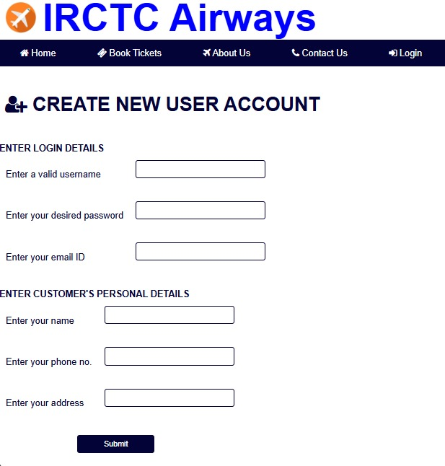
Figure 4.3: Module for Creating account
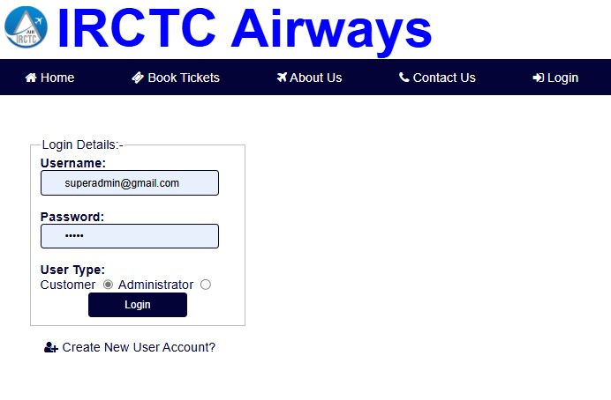
Figure 4.3: Login Page
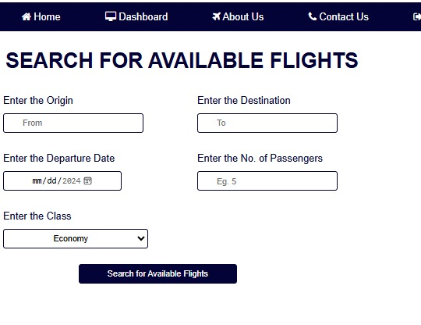
Figure 4.4: Module to search for Available flights
4.1.3 Database Design
Database entails the organization and access mode that are implemented in carrying out our specified operations upon the records of the file.
The files used in this system have records that have been organized randomly (random organization) and for this purpose, it will be more appropriate to access the records of the files randomly (random access mode).

4.1.4 Procedure Design
Procedures are steps which verify the whole process i.e which are everything put together to produce the desired output. This involves the organization of the source document and end with the output result.
Documents are sent to various departments to be filled by the employees and later returned to the personnel department which are analysed to determine which record goes into the computer.
After selecting the necessary data, this serves as input to the computer system.

4.2. System Implementation
It is always good to develop new ideas, to implement them on a computer and eventually to relish the satisfaction of achieving a successful result. The implementation process involves converting the system design into a complete and tested EDP that is fully operational and that can be used by the system users to meet their business needs. During implementation phase, the hardware and the software must be implemented.
Implementation of a system can be explained in six steps:-
1. Review design specification
2. Code, test and document programs
3. Train users
4. Perform system test
5. Convert to new system
6. Evaluate and maintain the new system

4.2.1 Choice of Programming Language
The proposed system is developed with HTML, CSS and JAVASCRIPT while MYSQL is used as the back end with PHP as the server side scripting language
The system will design with HTML, and CSS for interface design, php and javascript as scripting language, SQL for database provision for querying the database and phpMyAdmin as the database management system.
During the analysis of the programming language to be use, various language where examine but Javascript and php were chosen because they are server side programming language.
- For easy workability across all platform
- Building and compiling web app are easy and understandable
- It is easy to understand during designing
- It can be easily manipulate in other to design a user friendly environment
- It can be easily manipulate with MySQL in access for database reference.
4.2.2 Hardware Support
- Minimum of Microcomputer Pentium II- Intel 533 MHZ processor, 128 MB RAM, 3.5GB HDD, 3.5”FDD, 14” VGA Monitor Windows 2000 Enhanced keyboard, mouse and pad.
- Scanner
- Printer
- HP DeskJet 3820c series
4.2.3 Software Support
I. Interface Design Language, windows Notepad for help interface design Hypertext Mark-up Language (HTML)
ii. MY SQL Database Management Software
iii. Programming PHP (Hypertext Pre-processor)
iv. Operating system window 07 professional
v. Graphic software paint shop and choosing these two formats GIF (Graphic Image Format)
vi. Scanner software, Mira scan
- Web browser software MOZILLA
4.2.4 Implementation Technique Used
In preparation for the installation of the new system, the method of changeover is given serious consideration to determine the success of the new system. Suitable changeover technique for this system is pilot changeover. The pilot changeover operates by applying the new system bit-by-bit until it covers the whole of the operations. The result obtained from using the pilot method on a small portion of the operations would be used in determining the suitability of the need system for the rest of the operations. This method is similar to testing small sample of a distribution if the test yields a good result then the whole system because fully operational and the manual/existing system is eliminated.
4.3 System Documentation
4.3.1 Program Documentation
This is the detailed description of the proposed system. It important because it helps to design and implement a system that would allow shopping by getting into the company website on the internet from anywhere. It also helps to design and implement a website that will be more interactive and more information about company activities.
Moreover, it design and implements a system that will create a virtual community, which does not necessitate the use of offices and staff stationed around the world.
4.3.2 System Maintenance
The use of the term maintenance for software is different from other references to maintenance. Unlike the tires on your car, software does not “wear out”. If this is the case, then why does software maintenance account for such a high percentage of the Total Cost of Ownership for software?
The software maintenance definition refers to changes for defect correction, performance improvements, or adaptations to a changed environment (enhancements). According to this definition, if we build software that is defect-free, performs well, and contains user-controlled parameters to adjust processing rules in response to changing requirements then most maintenance would not be necessary.
Why does this happen? There are many reasons but the most common reasons are time constraints and lack of experience. Adding validation logic takes time. So, people make assumptions about the quality of in-bound data. Assumptions are also made about the volume of transactions and the impact on performance and the stability of the automated business processes. Finally, it is common for new software to be developed by younger developers who don’t understand the maintenance impacts of their designs.
The reality is that business requirements change and most of these assumptions are flawed. Transaction volumes increase, changing business processes require new transactions or new validation criteria, and software users will use the software incorrectly. The cost of software maintenance and the total cost of ownership can dramatically be reduced if developers build software that adjusted to changes in transaction volumes; validated all inbound data and provide user-configurable options for decision logic and data validation.

CHAPTER FIVE
SUMMARY, CONCLUSION, AND RECOMMENDATIONS
5.1 Summary
This study has examined the design and implementation of a new flight reservation system, analyzing its potential to address the limitations of existing systems. The research methodology involved a comprehensive review of current reservation systems, identifying key challenges such as legacy infrastructure, limited personalization, data security concerns, interoperability issues, and poor user experience. The proposed system aims to overcome these challenges through modern architecture, advanced personalization, enhanced security measures, streamlined pricing and inventory management, improved user experience, seamless integration capabilities, and scalability. The advantages of the new system include personalized recommendations, robust security, optimized revenue management, intuitive interfaces, accessibility, mobile optimization, cost savings, and flexibility.
5.2 Conclusion
The development of a new flight reservation system represents a significant advancement in the aviation industry, addressing the critical issues faced by existing systems. By incorporating modern technologies such as AI, machine learning, cloud computing, and robust security protocols, the proposed system enhances functionality, usability, and security. This study concludes that the new system offers substantial improvements in personalization, data protection, user experience, integration, and operational efficiency. These enhancements not only meet current industry demands but also position airlines to adapt to future technological advancements and evolving customer expectations. The successful implementation of the proposed system promises to revolutionize flight reservation processes, providing a more efficient, secure, and satisfying experience for both airlines and passengers.

5.3 Recommendations
Based on the findings and conclusions of this study, the following recommendations are proposed:
- Adopt Modern Technologies: Airlines should invest in modern technologies such as AI, machine learning, and cloud computing to enhance the capabilities of their reservation systems. These technologies can drive personalization, optimize revenue management, and improve overall system performance.
- Focus on Data Security: Implementing robust security measures is crucial to protect sensitive passenger data and ensure compliance with industry regulations. Airlines should prioritize encryption, multi-factor authentication, and proactive threat detection to safeguard information.
- Enhance User Experience: Airlines should prioritize user experience by designing intuitive, accessible, and mobile-optimized interfaces. Ensuring a seamless and satisfying booking experience can increase customer satisfaction and loyalty.
- Promote Interoperability: Standardizing APIs and communication protocols can facilitate integration with other systems and third-party services. Airlines should focus on interoperability to streamline operations and enhance collaboration within the aviation ecosystem.
- Scalability and Flexibility: Airlines should adopt scalable and flexible system architectures to accommodate future growth and technological advancements. Cloud-based infrastructure and modular design can ensure the system remains adaptable and cost-effective.
- Continuous Improvement: Ongoing evaluation and improvement of the reservation system are essential. Airlines should regularly update their systems to incorporate new features, address emerging security threats, and respond to changing customer preferences.
REFERENCES
Alaya, S. M. (2014). Development of an Online Bus Ticket Reservation System for a Transportation Service in Nigeria, 5(12), 9–18.
Al-hijaj, A. A., Jabbar, A. M., & Kh, H. N. (2013). Design and Developing Online Iraqi Bus Reservation System By Using Unified Modeling Language, 3(1), 19–28.
Blessing (2017) “Challenges of Airline Reservation System and Possible Solutions” International Journal of Emerging Trends & Technology in Computer Science (IJETTCS) Web Site: www.ijettcs.org Email: editor@ijettcs.org, editorijettcs@gmail.com Volume 3, Issue 3, May-June 2017
Böhmer, M., Hecht, B., Schöning, J., Krüger, A., & Bauer, G. (2011). Falling asleep with Angry Birds, Facebook and Kindle – A Large Scale Study on Mobile Application Usage. Proceedings of the 13th International Conference on Human Computer Interaction with Mobile Devices and Services - MobileHCI ’11, 47. http://doi.org/10.1145/2037373.2037383
Buell, R. W., Campbell, D., & Frei, F. X. (2010). Are self-service customers satisfied or stuck? Production and Operations Management, 19(6), 679–697. http://doi.org/10.1111/j.1937 5956.2010.01151.x
Ceipidor, U. B., Medaglia, C. M., Marino, a., Morena, M., Sposato, S., Moroni, a., … Morgia, M. La. (2013). Mobile ticketing with NFC management for transport companies. Problems and solutions. 2013 5th International Workshop on Near Field Communication, NFC 2013. http://doi.org/10.1109/NFC.2013.6482446
David, A. O., (2016) Design and Implementation of an Online Airline Reservation Information System.
Davis, F. D. (1989). Information Technology Introduction, 13(3), 319–340. Eicher, R. B., Nh, U. S., Eicher, R. B., & Us, M. A. (2012). (19) United States (12), (19).
Fang-Fang, C., (2010) Design and Implementation of Airline Reservation Web Services Using Service-oriented Architecture. Proceedings of the World Congress on Engineering 2010 Vol I WCE 2010, June 30 - July 2, 2010, London, U.K.
Ferreira, J. C., Porfírio, F., Cunha, G., & Silva, J. (2013). Cloud terminals for ticketing systems. SERVICE COMPUTATION 2013 : The Fifth International Conferences on Advanced Service Computing, 7.
I.J. Information Technology and Computer Science, 2017, 1, 34-45 Published Online January 2017 in MECS (http://www.mecs -press.org/) DOI: 10.5815/ijitcs.2017.01.05
Jarad, G. A. (2014). The Potential of developing Iraq smatphone market as an emarging and lucrati market, 2(2), 37–42.
Ketmaneechairat, H. (2014). Searching Application for Southern Thailand Travel Guide on iPhone, 195–200.
Lewis, J. R. (1995). IBM computer usability satisfaction questionnaires: Psychometric evaluation and instructions for use. International Journal of Human-Computer Interaction, 7(1), 57–78. http://doi.org/10.1080/10447319509526110
Lu, W. (2007). An Analysis of Airline E-commerce Strategies in Ticket Distribution, 0–4. Meeker, M. (2015). 2015 Internet Trends — Kleiner Perkins Caufield Byers. Retrieved August 5, 2015, from http://www.kpcb.com/internet-trends Paper, C. (2012). Development of a Mobile Airline Reservation Application, (July 2015).
Nikitha P. & Adarsh K (2017), “Android Bus Ticketing System” Computer Engineering and Intelligent Systems www.iiste.org ISSN 2222-1719 (Paper) ISSN 2222-2863 (Online) Vol.5, No.12, 2014
Oyelade, Fatumo, Azeta & Ayo (2009) “Development of a Mobile Airline Reservation System” International Journal of Scientific Research in Computer Science, Engineering and Information Technology © 2018 IJSRCSEIT | Volume 4 | Issue 2 | ISSN : 2456-3307
Parul & Tarun (2014) “Airline Management Optimization using Genetic Algorithm” Journal of Computer ScienceS Its Application, June 2[][]8, Vol. IS, No. I
Patil, S.T and Deshpande, Y. (2021) Airline Reservation System. International Journal of Innovative Science and Research Technology. Volume 6, Issue 6, June – 2021
Sameer, Prachi & Loganathan (2016) worked on “AIRLINE RESERVATION SYSTEM” European Journal of Computer Science and Information Technology Vol.3, No.5, pp.42 55, November 2015
Skarica, D., Belani, H., & Illes, S. (2009). Implementation and evaluation of mobile ticket validation systems for value-added services. SoftCOM 2009 - 17th International Conference on Software, Telecommunications & Computer Networks.
Smirnov, A., Kashevnik, A., Shilov, N., Teslya, N., & Shabaev, A. (2014). Mobile Application for Guiding Tourist Activities : Tourist Assistant – TAIS.
Sreenivasachari & Dinakar (2018) “Online Airline Reservation System” University Computing, 1993, 15(2) 58{69.c Inter-University Committee on Computing.

