Lecturer Course Allocation System using Ant-Bee Colony and Tabu Search Algorithm

BY

ADEWALE WAHEED OLAMILEKAN
ND/23/COM/PT/0326

A Project Submitted to the Department of Computer Science, Institute of Information and Communication Technology, Kwara State Polytechnic, Ilorin

In Partial Fulfillment of the Requirements for the Award of National Diploma (ND) in Computer Science

July, 2025
CERTIFICATION
This is to certify that this project was carried out by ADEWALE, Waheed Olamilekan with matriculation number ND/23/COM/PT/0326, has been read and approved as meeting part of the requirements for the award of National Diploma (ND) in Computer Science.

_______________________ ___________________
Mr Olajide A.T. Date
(Project Supervisor)

_______________________ ___________________
Mr. Oyedepo F.S Date
(Head of Department)

_________________________ ____________________
External Examiner Date

DEDICATION
This project is dedicated to the creator of the earth and universe, the Almighty God. It is also dedicated to my parents for their moral and financial support.

ACKNOWLEDGEMENT
With a heart full of gratitude, I give all praise to Almighty Allah, whose mercy and guidance have seen me through this academic journey.
I am deeply thankful to my project supervisor, Mr. Olajide A.T., for his patience, insightful feedback, and unwavering support throughout the course of this research.
To my family and loved ones your endless love, encouragement, and prayers have been my greatest strength.
I also appreciate all my lecturers in the Computer Science Department for their knowledge and dedication, and my coursemates for the shared experiences that made this journey worthwhile.

TABLE OF CONTENTS
Title Page i
Certification ii
Dedication iii
Acknowledgements iv
Abstract v
Table of Content vi
CHAPTER ONE: GENERAL INTRODUCTION
  - Background to the Study 1
  - Statement of the Problem 3
  - Aim and Objectives of the Study 3
  - Significance of the Study 4
  - Scope of the Study 4
  - Organization of the Report 5
CHAPTER TWO: LITERATURE REVIEW
2.1 Review of Related Works 6
2.3 Review of General Text 9
CHAPTER THREE: RESEARCH METHODOLOGY AND ANALYSIS
  - Research Methodology 12
  - Analysis of the Existing System 14
  - Problems of the Existing System 14
  - Description of the Proposed System 15
  - Advantages of the proposed system 15
CHAPTER FOUR: DESIGN, IMPLEMENTATION AND DOCUMENTATION OF THE SYSTEM
  - Design of the System 16
    - Output Design 16
    - Input Design 19
    - Database Design 21
    - Procedure Design 23
  - Implementation of the System 23
    - Hardware Support 24
  - Documentation of the System 25
    - Maintaining the System 25
CHAPTER FIVE: SUMMARY, CONCLUSION AND RECOMMENDATION
  - Summary 26
  - Conclusion 26
  - Recommendation 27
References 28
Appendices
Appendix 1 Main Menu Flowchart 30
Appendix 2 Lecturer Registration Flowchart 31
Appendix 3 Course Registration Flowchart 32
Appendix 4 Course Allocation Flowchart 33
Appendix 5 Lecturer Assessment Flowchart 34
Appendix 6 Source Code 35

ABSTRACT
This project aims is to produce an academic course allocation system using Ant Bee colony and Tabu Search algorithm to solve the courses schedule. Factors to consider in course allocation are the lecture to be assign, the lecturers and the time of the lecturer, the suitability of the credits with the time of the lecture, and perhaps also the lecturer area of concentration, and so forth. Ant bee colony and Tabu Search Algorithms can provide the best solution for some solutions in dealing with allocation problems. Based on the test results, the resulting system can automate the allocation of courses to lecturers properly. Determination of parameter values in Tabu search Algorithm also gives effect in producing the solution of Course allocation to lecturers.

CHAPTER ONE
GENERAL INTRODUCTION
  - BACKGROUND OF THE STUDY
Course Allocation involves the scheduling of a certain number of academic staff to teach course(s) over a definite period of time (Virtue, 2016). Lecturer course allocation system using Ant Bee Colony and Tabu search algorithm is a system that use tabu search and Ant Bee Colony to allocate course/courses to lecturer and provided that a particular course that has been allocated to one lecturer is not assigned to another, with the help of tabu search algorithm, the course allocation system for lecturer is being developed to provide ease handling on course given for lecturers (Fairuz, Youagenraj & Zuraidy, 2018).
Adewale, Ibam and Izundu (2018) claimed that over the years allocation of courses and their credit units have been growing from one stage to another and similarly, the procedures and routine embarked on every semester coupled with the departmental growth compounded the problem of manual allocation of course their units and thereby delays the registration procedures because some students paying extra fee as payment that is demanded in addition to the usual charge for registering their course late, as late payment but computerization or automation of course their credit units allocation and departmental time provide the most effective reliable and quickest services required by the students. (Emeka, 2018).
The recent developments in the information and communication technology integrated into the higher education institutions as many universities are using lecture course allocation through software. The educational institutions are using these Software’s to provide effective and hinder free education to the students with the reduction in the administrative staff work. The lecture course allocation system reduces clashes during the preparation of schedule for lecture. (Muraina & Zozu, 2021).The online course allocation management system for academy lecturer is being developed to provide ease handling on courses given for lecturers. A lot of issue has been developed due to the manual allocation method which is been carried out manually using paper and pen from the lecturer in charge of course allocation. All lecturers are having their preferable courses where their expertise field plays the most important role on that issue. The lecturer is the biggest guide for the student lecturing in the courses that students taking on the semester (Aliyu, Kana & Aliyu, 2020).
Institutions across the country are having a constraint on course allocations for the lecturers by using manual allocation process, which is relatively slow and increases delay in academy process. It effects the lecturer’s expertise field which they have done the majoring studies on it. Every lecturer is having their preferable course to be lectured for the student under that course registered by them on the current semester. (Aforlabi, Ibrahim & Kehinde, 2021).
This project is a system that will handles the allocation of the courses for the lecturers using Ant Bee colony and Tabu search algorithm. It also minimizes the courses given to the higher position lecturers.
  - STATEMENT OF THE PROBLEM
The existing way of allocating courses to lecturers is a random methods of allocation in which lecturers are allocate courses without considering their area of specialization. Usually this method has several setbacks such as inadequate allocation of course to a lecturer because their area of specialization was not taken into consideration, the system also lack documentation, it is inefficient and affect both lecturers and students. Because of these setbacks institutions has continued to leave activities unattended to by the department because of volume of work left to be done. The current allocation is inaccurate because some lecturers are allocated more courses than the other. Other than that, lecturers could not get the preferred course according to their expertise. Lastly, the courses are difficult to manage according to the changes. The courses are difficult to manage according to the changes. This project aimed to solve the above mentioned problems.
1.3 AIM AND OBJECTIVES OF THE STUDY
The aim of the research is to develop a course allocation to lecturers using ant-bee colony and tabu search algorithm. The objectives are to:
- design a system that will allocate courses to lecturers
- develop a system that will allocate course to lecturers base on their expertise.
- develop a system that will make sure one course is not allocated to two lecturers.
  - SIGNIFICANCE OF THE STUDY
The system is developed to ease the allocation of academy work for the academy semester. The importance of the system is that, it gives priority for the lecturers on the expertise field courses to be lectured, it provides the student to get the lecturing from the specify lecturers on the related course field. The system also helps on the higher position lecturers to receive on minimum number of courses which can lower their work burden. It also helps on the research lecturers to by giving low amount of courses assign according to the profile created on the system.

1.5 SCOPE OF THE STUDY
An Administrator (probably a Time Table officer) has the full authorization to log in to the system to make any changes on the course adding, dropping and also assigning different lecturers if needed. The administrator has to create a profile and set the expertise field for each lecturer so the system can detect it to assign the correct number of courses according to their expertise field for the lecturers. The lecturers also can view the portal on the courses assigned for them. If they wanted to make any changes regarding the courses assigned for them, they can refer the management office for the changes to be applied.
1.6 ORGANIZATION OF THE REPORT
This is the overall organizational structure of the work as presented in this project. This project is segmented into five distinct chapters. Chapter one is all about the introduction, statement of problem, aim and objectives, significance of the study, scope of the study, definition of terms, as well as the organization of the report. The second chapter deals with the literature review which contains the concept of course allocation management systems, importance of course allocation management system. The third chapter talks about the research methodology that entails introduction, system analysis, and system design. The fourth chapter deals with the design of the system which entails the output, database and procedure design of the system, the implementation comprises of the hardware and support while the documentation comprise of how to use the system and the system maintenance. The last chapter deals with the summary of the experience gained, conclusion and recommendation.

CHAPTER TWO
LITERATURE REVIEW
2.1 REVIEW OF RELATED WORKS
Rauf, Selvan and Adnan (2018) developed a course allocation system for lecturers. The purpose of the system developed is to ease and smoothen the course allocation process. Moreover, a lot of issues have popped up regarding the manually allocation method such as lecturers could not get the expertise courses to be lectured, more courses given to higher position lecturers and also burden their research timing. According, to the problem the developer has come up with a solution which to develop a course allocation system for lecturers. The developer has set the objectives to provide the lecturers their expertise field course to be lectured and also provide the correct number of courses according to the lecturer position and timing. Regarding, this the developer has done a research study on the similarities of the system which has been developed previously.
Virtue (2016) proposed a university course allocation in a department using linear programming techniques. The paper considered a departmental course allocation problem in a university system over a definite period of time. The allocation takes into consideration the constraints imposed by the contact hours per week and the teaching load per week of lecturers as well as the preferences of individual lecturers for courses taught in the department per semester. The aim is to develop a framework that optimally allocates courses to lecturers according to their preferences. The aim is achieved by formulating the course allocation problem as an integer programming problem. The problem formulation provides for instances where the teaching load for lecturers are underutilized and where lecturers are to be outsourced. Solution to the course allocation problem is obtained using the Gomory cutting plane algorithm and this is implemented in MATLAB. An example is provided to demonstrate the utility of the course allocation model.
Meka (2018) proposed an algorithm for efficient allocation of courses to lecturers for effective teaching. The work developed an algorithm that was used to allocate courses efficiently to lecturers for effective teaching. The algorithm incorporates the following factors: lecturer’s rank, years of experience, area of specialization, his/her percentage performance in class, and pairing of two or more lecturers to a course. These factors will definitely introduce dynamism and efficiency in the course allocation process so that the best lecturers for any given course can be determined by calculated values from the above factors, and not merely by face-recognition that is being currently practiced.
Syafie and Lantara (2019) worked on lecture scheduling automation using genetic algorithm. The paper aimed produce an academic scheduling system using Genetic Algorithm (GA) to solve the academic schedule. Factors to consider in academic scheduling are the lecture to be held, the available room, the lecturers and the time of the lecturer, the suitability of the credits with the time of the lecture, and perhaps also the time of Friday prayers, and so forth. Genetic Algorithms can provide the best solution for some solutions in dealing with scheduling problems. Based on the test results, the resulting system can automate the scheduling of lectures properly. Determination of parameter values in Genetic Algorithm also gives effect in producing the solution of lecture schedule.
Bolajia , Khadera , Al-betara and Awadallaha (2011) developed an artificial bee colony algorithm for curriculum-based course timetabling problem. An attempt to solve these problems was made via an approach broken down into two parts; first, Saturation Degree (SD) was used to ensure a feasible solution, where the hard constraints are satisfied. Secondly, Artificial Bee Colony Algorithm was used to further improve the results obtained. The algorithm produced very good results, though they were not comparatively better than those previously reported in the literature due to the fact that the algorithm easily gets stuck in the local optimal solution. With proper modification and hybridizing local search-based algorithms this approach could make the algorithm perform better on timetabling problem in general.
Sheikh (2012) developed a prototype of lecturer course allocation system. This project is an implementation of a lecturer course allocation system (LECAS) which enables every lecturer can register courses by online as well as can view course schedule. The goal of is prototype is to provide the course schedules that would allow lectures to register courses that they plan to teach for the coming semester in the fast and possible ways. The objective of LECAS was to provide lecturers to get a convenient and efficient way during registering the courses. There are four users that can access the system such as; admin, lecturers, coordinator, and head department, each of them have different privileges in which they can access through internet and a web browser anytime and anywhere. Furthermore, the prototype has been developed by using java Servlet page (JSP) with MySQL for database. This prototype was developed based on the proposed requirement of system and was evaluated by using perceived usefulness and ease of use where the respondents are from University Utara Malaysia (UUM) lecturers. The feedbacks from 30 respondents about the system prototype are quite good which are showed with 5.46 grand mean for perceived usefulness factor and 5.37 grand mean for perceived ease of use factor with the scale of 7. Therefore, it can be concluded that the prototype is useful and easy to use. This prototype is expected to facilitate the other university to develop and enhance the system for lecturer registration time.
According to Dasola (2019), course allocation problems should continuously attract the interest of researchers in the quest for the best approach for assigning courses properly to lecturers for improved teaching. The algorithm developed in this work is therefore subject to improvement from other renowned researchers to actualize this objective.
2.2 REVIEW OF RELATED CONCEPTS
2.2.1 EDUCATION MANAGEMENT AND ADVANCEMENT IN WEB APPLICATIONS
The past two decades have witnessed the unprecedented growth of the Internet and an ensuring transformation in the educational landscape. The adoption of a wide variety of web-based tools has given rise to the trend of e-learning in education world-wide. Meanwhile, the increasing availability of wireless and mobile technology makes e learning even more ubiquitous and pervasive. The development of a course management system (CMS) or learning management system can be viewed as both the result and the impetus of this e-learning trend. As a software package, CMS provides “web-based tools, services, and resources to support teaching and learning processes for both online and blended delivery”. Often, CMSs have their presence in the sector of higher education, and their roles have evolved from course authoring tools to enterprise-level systems. CMSs are increasingly used as a solution to promote the quality, efficiency and flexibility of teaching and learning in higher education (McGee, Carmean & Jafari 2016).
As an evolving tool and innovation, CMS is used for a variety of purposes and in various ways and settings. Nevertheless, it remains arguable whether the CMS is an important tool to help transform higher education. McGee, Carmean, and Jafari (2016) summarize issues of CMS in three foci: to understand CMS and make better pedagogical choices, to inform CMS implementation with learning theory and intentional pedagogical design, and to define and design the next generations of CMS software environment.
However, many studies concerning e-learning have focused on practitioner perspective or course design and overlooked students’ voices (Sharpe, Benfield, Lessner & DeCicco, 2015).
2.2.2 THE CONCEPT OF COURSE ALLOCATION MANAGEMENT SYSTEMS
The course allocation Management system for lecturer is being developed to provide ease handling on course given for lecturers. A lot of issue has been developed due to this allocation method which has been conducting manually using software called Microsoft Excel. All lecturers are having their preferable courses where their expertise field plays the most important role on that issue. The lecturer is the biggest guide for the student lecturing in the courses that students taking on the semester. It doesn’t mean that all the lecturer can only teach few courses according to their expertise to be lectured for the students but they also can teach all courses which has not on their expertise field. Due to that doing on manual course allocation they could not get the preferred course, due to that a system has to be developed accordingly. The system also minimizes the usage of paperwork and user friendly for the administrators to log in and edit if any changes required for the course allocation. The system will print out an output of a list stated for lecturers on their preferred course.
In recent years, CMS has become an integral part of infrastructure in higher education, especially with the introduction of enterprise-level CMS (Katz, 2013). According to the survey conducted by Harrington and associates (2004), more than 80 percent of higher education institutions in the US used CMS. CMS is not simply a tool for teaching and learning, but an integral part of education infrastructure in higher education. Educause Center for Applied Research (ECAR) conducted serial studies of undergraduate students’ experience with technology and reported that with CMS, students’ engagement level increased significantly over the past three years (Salaway, Caruso, Nelson, & Dede, 2017).
Course management systems are difficult to define because they can encompass so much. As described by Morgan (2003), the major goal of a CMS is “to integrate a suite of teaching technologies into a powerful set of tools that make it easy for faculty to use technology in instruction”. The genre of CMS technology can trace its roots to the mid- to late-1990s. Many of the early CMSs were created within higher education in direct response to the lack of tools that supported online teaching. For example, Web CT was conceived on the campus of the University of British Columbia, Blackboard at Cornell University, and A Tutor at the University of Toronto. While some of these systems were transferred into the commercial sector, others have remained as homegrown institutional systems (Gibbons, 2005).
In spite of the large array of CMSs available, homegrown or commercial systems, they often have similar functions. Commonly included within the functions of a CMS are synchronous and asynchronous communication tools, such as discussion board, online chat, and email.
Organizational tools, including online calendar and syllabus, announcement board, and digital drop box, assist the instructor in managing the flow of information and content within the class.
Through online exams and quizzes, grading tools, and tracking course site use by individual students, the CMS can also help to streamline student assessment. Within the CMS, students and faculty can share URLs and digital documents, including assigned reserve reading materials (Gibbons, 2015). Dabbagh and Bannan-Ritland (2015) categorized the common CMS features into five groups: communication tools (e.g. discussion board, chat, E-mail); content creation and delivery tools (e.g. assignment, course documents); administrative tools (e.g. calendar, announcements); learning tools (e.g. personal tasks, bookmarks); and assessment tools (e.g. grade book, quiz).
Much of the literature on e-learning has focused on teachers’ experience and perceptions while students’ voices are largely unheard and their experiences undocumented (Alexander, 2011).
2.3 IMPORTANCE OF COURSE ALLOCATION MANAGEMENT SYSTEMS
The Educational sector started with the CCTV technology, which evolved completely into online courses which surprisingly online education has emerged to major form of e-business. (Madan, 2017)The journal provides information of the evolvement of education system from manual methods to automated system. In addition, the course allocation system is more vital important part because it provides the student to get the lecturing from the specify lecturers on the related course field and also the lecturers can get the preferred course on their expertise field of study. Moreover, the online studies have become a part of business profit to a certain part of business industry which managing the education management due to that, all the syllabus has evolve from manual to digital phase to enhance the technology in education industry. Lastly, the enhanced allocation system is beneficial for the futuristic students to develop their education an also sustain the education management handing.

CHAPTER THREE
RESEARCH METHODOLOGY AND ANALYSIS OF THE EXISTING SYSTEM
3.1 RESEARCH METHODOLOGY
In this project, the methodology chosen for the development of the system is Rational Unified Process (RUP). RUP method is an object-oriented methodology which used for software system developing. In addition, the developer rectifies and chose this methodology to help on the developmental stages of the system. RUP method consists of four phases which are inception phase, elaboration phase, construction phase and transition phase. This system will be developed using Visual C# with Microsoft Visual Studio for frontend and MYSQL a relational database management system for the backend.
3.1.1 Algorithm Adopted
The following pseudocode presents a simplified version of the tabu search algorithm
- sBest ← s0
- bestCandidate ← s0
- tabuList ← []
- tabuList.push(s0)
- while (not stoppingCondition())
- sNeighborhood ← getNeighbors(bestCandidate)
- bestCandidate ← sNeighborhood[0]
- for (sCandidate in sNeighborhood)
- if ( (not tabuList.contains(sCandidate)) and (fitness(sCandidate) > fitness(bestCandidate)) )
  - bestCandidate ← sCandidate
- end
- end
- if (fitness(bestCandidate) > fitness(sBest))
- sBest ← bestCandidate
- end
- tabuList.push(bestCandidate)
- if (tabuList.size > maxTabuSize)
- tabuList.removeFirst()
- end
- end
- return sBest
Algorithm 1: Tabu Search algorithm Source: (Aliyu et al, 2020)
Algorithm 2: Ant Bee Colony algorithm Source: (Aliyu et al, 2020)

3.2 ANALYSIS OF THE EXISTING SYSTEM
The existing system of course allocation involves a list of all courses in the department and the available lecturers. Allocation of courses are then done randomly by allocating to a lecturer without considering their area of specialization In the conventional way Head of the Departments go through a list of courses and availability of lecturers to handle courses. This process is sometimes difficult for the lecturers because they are not comfortable with what they are given which later affect the students.
3.3 PROBLEMS OF THE EXISTING SYSTEM
Some of the problems identified in the present or the existing system includes:
- The current allocation is being done manually which cause inaccurate on the number of courses given for the lecturer.
- It is time consuming.
- Lecturers could not get the preferred course according to their expertise.
- The courses are difficult to manage according to the changes.
  - DESCRIPTION OF THE PROPOSED SYSTEM
To overcome the problems of the existing system, the researcher have proposed an improved lecturer course allocation system using ant bee colony and tabu search algorithm. This is an electronic and computerized means of allocating courses to lecturers putting their area of specialization in mind; this system will make sure a single course will not be allocated to different lecturers. The proposed system will collect each lecturers information, stored it on the system and information are used during the allocation of courses.
3.5 ADVANTAGES OF THE PROPOSED SYSTEM
An improved lecturer course allocation has the following advantages:
- It helps the institution and departments to know the area of specialization of every lecturer’s.
- It creates storage of large volume of data on lecturers records
- It assists every department to allocate courses to lecturers easily.

CHAPTER FOUR
DESIGN AND IMPLEMENTATION OF THE SYSTEM
4.1 DESIGN OF THE SYSTEM
This is the computation of the particulars of a new system, the determination of what the new system would be and the function it is to perform. This may involve changing from one system to another or modifying the existing system operation.
The most challenging phase of the system life cycle is the change from manual operation to a faster and more accurate one. System design stage covers the technical specifications that will be employed in the implementation of the new system in order to modify the previous system. Some factors are put in consideration. These factors include input design, output design, definitions file and procedure designs and other documentation.
4.1.1 OUTPUT DESIGN
This incorporates the objectives of solving the existing system problems and challenges. This involves the structuring of the desired information and also to enhance efficient and effective course allocation to lecturers. Things taken into consideration in determining the output are represented below:


HND/20/COM/FT/490
Figure 4.1: Welcome Interface

The image above shows the welcome interface of the system which displays the title of the system as well as the developer.

Figure 4.2: Main Menu Interface
This is the main menu of the system; it contains some other sub-menus which user can be clicked to navigate to other pages such as file, record, course allocation, assessment and so on.
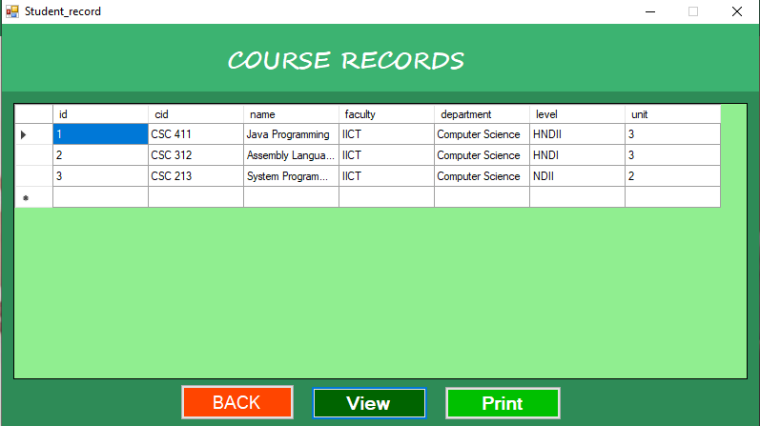
Figure 4.3: Course Records Interface
This is the page that displays all records of the registered courses on the system.
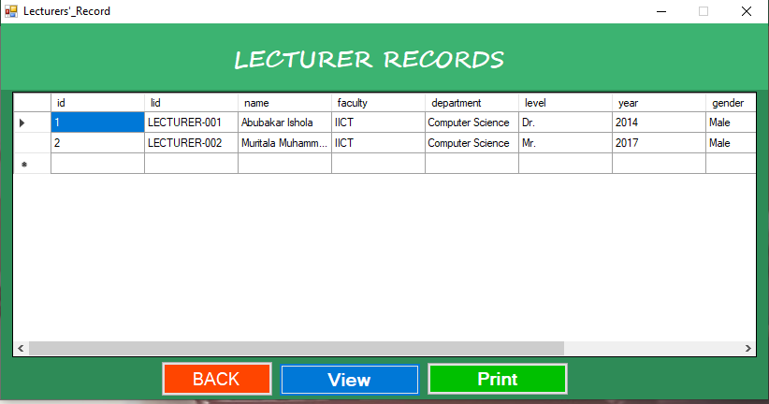
Figure 4.4: Lecturers Record Interface
This is the page that displays all records of the registered Lecturers on the system.

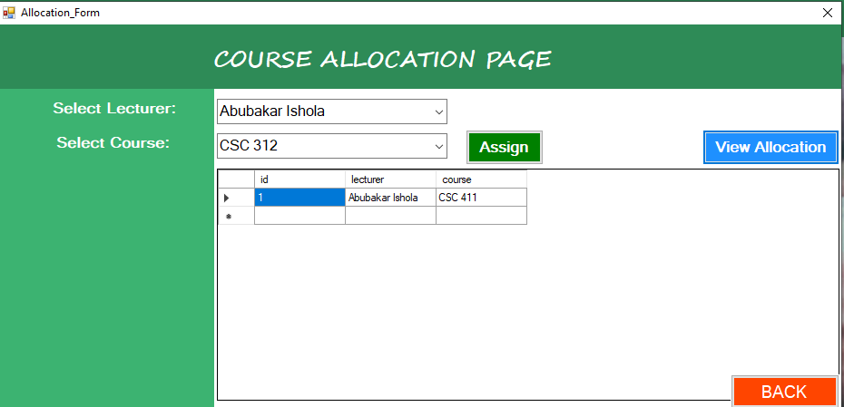
Figure 4.5: Course Allocation Interface
This interface above shows the page where courses are allocated to lecturers.

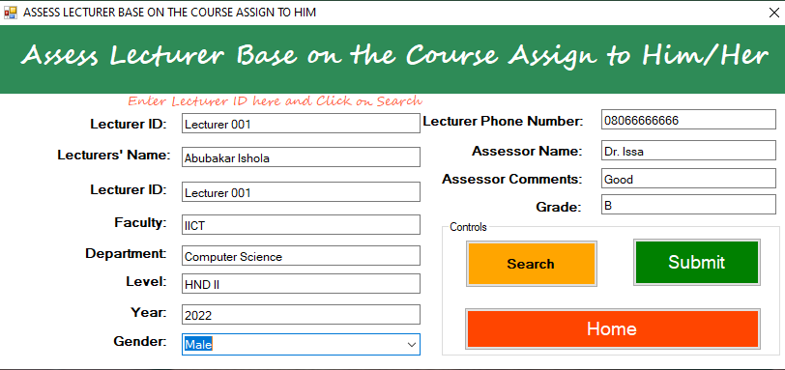
Figure 4.6: Lecturers Assessment Interface
This is the page where the admin can assess the lecturer performance on the course allocated to him base on some gathered information.
4.1.2 INPUT DESIGN
The input to run this software is obtained from course allocation administrator. The administrator is expected to register every course. He can achieve this by typing via the keyboard or loading from the diskette. The input required from the student is their personal data.
To the questions set by the administrator. It can serve as the various input layouts from the various modules first from the collection of data and module then from the assessment module and input from lecturers respectively.
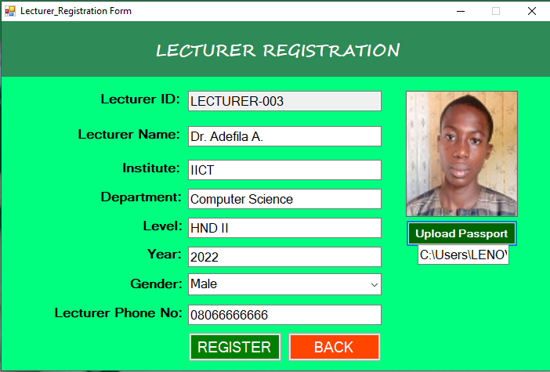

Figure 4.7: Lecturer Registration Interface
This is the page where every lecturer can register on the system by supplying some details such as name, Level, Phone number, Gender and so on.
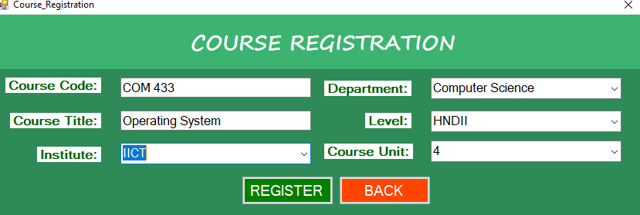
Figure 4.8: Course registration interface
This is the page where the admin can register courses on the system by entering the details of the course such as course title, course code, name, department, unit and so on.
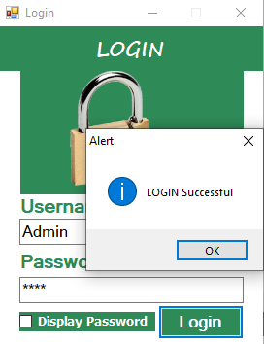
Figure 4.9: Login Interface
This is where the admin can login to the system.
4.1.3 Database Design
This involves the list of tables used in the database design. The tables are listed as follows:
Table 4.1: Course Allocation Table
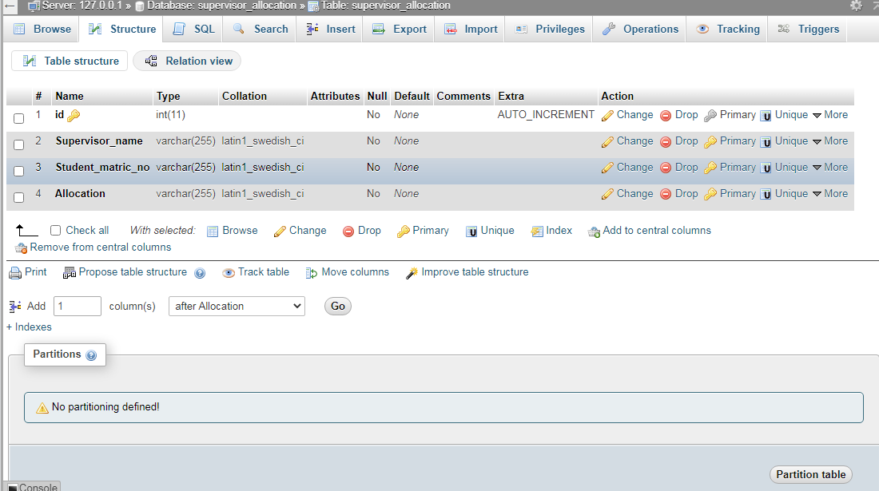

Table 4.2: Lecturer registration table
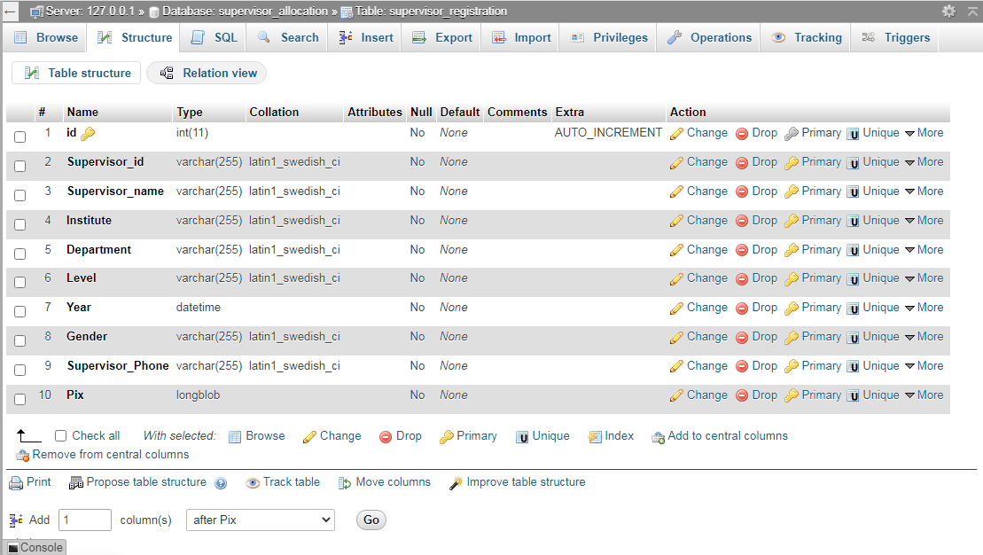
Table 4.3: Course registration table
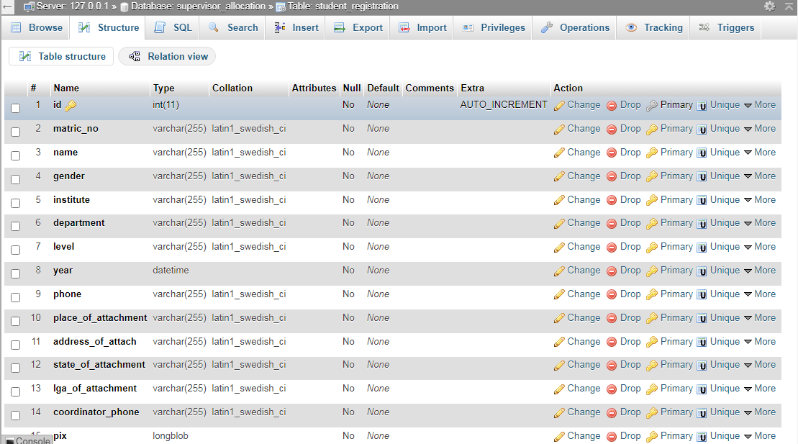

4.1.4 PROCEDURE DESIGN
These are the steps involved in unifying the whole process to produce the desired output. It involves computer procedures which starts from the original input lessons to the output result file. This allows the processing of the information and result to be possible. Menu is provided to aid user in the processing of the output file.
4.2 IMPLEMENTATION OF THE SYSTEM
This entails the choice of the programming language employed to implement the software which should be suitable for course allocation. The software was designed to allocate courses to lecturers.
4.2.1 HARDWARE REQUIREMENT
Minimum of Microcomputer Pentium IV- Intel 1.5 GHZ processor, 1.0 GB RAM, 40GB Hard disk, 14” VGA Monitor Windows XP or higher, Enhanced keyboard, mouse and pad.
4.2.2 SOFTWARE REQUIREMENT
i. Windows Operating system such Windows 7, Windows 8, Windows 10 etc.
ii. Visual Studio 2010 (Enterprise Edition which allows the Programmer to run all the necessary Data, which has been supplied.
4.3 DOCUMENTATION OF THE SYSTEM
After the program has been well tested with input that the output has already been known, the next is to install the software in to the computer system for use.
The process of installing are been stated below
- Insert the CD into the system through the CD-ROM after the computer is switch on
- Locate the CD drive directory in my computer and click it to open
- After open, locate setup.exe, and then click to install the program by following the necessary step in installing the program.
- Ensure full installing of the software for effective operation of the system.
After the program has been fully installed, the next thing is to locate the package installed and put it into operation. To locate the package for expiration purpose the following step are to be taking.
- Click on start menu from task bar. Then select all program
- From the display sub option, select by locating the software installed named Information to load the software.
4.3.1 PROGRAM DOCUMENTATION
The program is packaged for use in any system irrespective of either it runs Visual Studio Application or not. After developing a program in Visual Studio, there is a facility provided in Microsoft Visual Studio suite called “Package and Deployment Wizard” that is used in Visual studio application packaging and deployment.
The course allocation is packaged into an installable setup that can be run from any system.
4.3.2 OPERATING THE SYSTEM
To operate the system, the following algorithm must be followed:-
- Switch the system on
- Allow it to boot
- Click on start menu
- Select the package name “Allocation of Courses to Lecturers” and wait for the application to load.
- From the list of menu that appears on the application main page, user can
- Select any one to navigate and carry the operation of the menu item.
4.3.2 MAINTAINING THE SYSTEM
The system maintenance refers to making modification to an already existing application/program without necessarily re-writing everything from the start. Program maintenance of a program includes modification of the program to meet-up with certain requirements of the users. In this course, additional features can be added, errors corrected, ambiguous interfaces redesigned to eliminate confusions and unnecessary features removed.
Maintaining this program can be done in a Visual Studio environment. Any future modification can be by re-running the program source code in a Visual Studio environment making necessary changes and updates and recompiling the application into an upgrade version of the existing version of the mini word processing application. Further versions of this program can be named following their year of release or it can be given a different version number.
4.3.3 PROCEDURE DESIGN
The procedure design refers to the construct of the whole program i.e. how each section functions individually and collectively as a whole to make up the whole execution of the program work/operate according to specification.
The system contains menus, each menu having different forms and they are control by modules.

CHAPTER FIVE
SUMMARY, CONCLUSION AND RECOMMENDATION
5.1 SUMMARY
In this project, the purpose of system developing is to ease and smoothen the course allocation process. Moreover, a lot of issues have popped up regarding the manually allocation method such as lecturers could not get the expertise courses to be lectured, more courses given to higher position lecturers and also burden their research timing. According, to the problem the researcher has come up with a solution which was the system developed that is a course allocation system for lecturers using ant bee colony and tabu search algorithm. The developer has set the objectives to provide the lecturers their expertise field course to be lectured and also provide the correct number of courses according to the lecturer position and timing. Regarding, this the developer has done a research project on the similarities of the system which has been developed previously. The methodology used is the Rational Unified Process (RUP) because the methodology is the backbone of the system. Moreover, the programming language adopted is Microsoft Visual C Sharp an object oriented programming language and MySQL a relational database system for the backend.
5.2 CONCLUSION
Automation of course allocation is a system that will improve the organization and learning process in the department and even in the school at large. However, user are expected to log into the system to view the course which they are been assign to and the time for a particular course, this is however, notwithstanding the location in which they are, once the application is install in their computer system. This system will enable lecturers not to miss their classes and also help them to organize their schedules. Therefore this application is going to improve the standard of learning and teaching in the department.
5.3 RECOMMENDATIONS
Based on the findings of the study, the researcher recommends the following;
i. User Training: the administrator who works on the system should be trained on how to use the new system.
ii. Higher institutions should adopt this system to enable easy course allocation to lecturers.
iii. More research should be conducted on this research as more technology can be introduced.

REFERENCES
Adewale, O., Ibam, E., & Izundu, E. (2018). A Tabu Search-based University Lectures Timetable Scheduling Model, International Journal of Computer Applications. Vol. 18, Issue: 9. Pp. 116.
Alexander, S. (2011). E-learning developments and experiences. Education + Training, Vol. 4 Issue: 5. Pp. 240-248.
David, J., A , Robert, W., I. & David, F.M (2018). Two Algorithms for the Student-Project Allocation Problem, Pp. 1-2.
Emeka, A., G. (2018). An algorithm for efficient allocation of courses to lecturers for effective teaching, International Journal of Engineering Science Invention (IJESI). Vol. 7, Issue: Pp. 68-74.
Fairuz, R., Youagenraj, K., S. and Zuraidy, A. (2018). Course Allocation System for lecturers, International Journal of Computer Applications. Vol.1, Issue: 2. Pp. 2.
Hambali, A. M., Olasupo, Y. A & Dalhatu, M. (2020). Automated University Lecture Timetable Using Heuristic Approach, Nigerian Journal of Technology (NIJOTECH). Vol. 39, Issue: 1. Pp. 1 – 1.
Herman, L., S & Dirgahayu, L. (2019) Lecture Scheduling Automation Using Genetic Algorithm, International Journal of Engineering and Advanced Technology (IJEAT.) ISSN: 2249 – 8958, Vol. 8, Issue-5. C, India. Pp. 45-46.
Ismail, A. & Salisu, A. (2020). Development of Knowledge Graph for University Courses Management, I. J. Education and Management Engineering, Published Online April 2020 in MECS (http://www.mecs-press.net) DOI: 10.5815/ijeme.2020.02.0
Ismail, O. M. (2013). Artificial Intelligent Rule-Based Optimization for Course Allocation Challenges, International Journal of Applied Physics .http://www.iaras.org/iaras/journals/ijap, Vol. 6. Pp. 43-48.
Kaixiang, Z., Lily, D., L. & Michael, L. (2022). School Timetabling Optimisation Using Artificial Bee Colony Algorithm Based on a Virtual Searching Space Method, https://www.mdpi.com/journal/mathem.
Mohamed, A. S. (2012). A prototype of lecturer course allocation system, international journal of information and communication. Vol. 1. Pp. 3-4.
Uvir, B. and Ritesh, A. (2012). Automatic Venue Allocation for Varying Class Sizes using Scoring and Heuristic Hill-climbing, International Journal of Natural Computing Research, Pp. 1-13.

Appendices: System Flowchart
Appendix 1: System flowchart

START

LOGIN

ADMINISTRATOR
STOP

STAFF

Appendix 2: LOGIN FLOWCHART

START
Is USERNAME AND PASSWORD CORRECT?
STOP
Yes
ENTER USERNAME AND PASSWORD

NO

SHOW ADMIN MAIN MENU
INVALID USERNAME OR PASSWORD

Appendix 3: ADD NEW LECTURER
Start
CLOSE Database
MORE RECORD?
RETURN
Yes
OPEN DATABASE

ENTER STAFF DETAILS

No
YES
DISPLAY STAFF FORM
INCREMENT ID BY 1
SAVE INTO DATABASE

Appendix 4: UPDATE STAFF RECORD

START
DISPLAY RECORD
RETURN
OPEN DATABASE
ACCEPT STAFF ID
IS RECORD FOUND
MODIFY ANOTHER RECORD?
CLOSE DATABASE
DISPLAY RECORD NOT FOUND
No
Yes
No
SEARCH STAFF RECORD
EDIT/DELETE CURRENT RECORD

Yes
UPDATE DATABASE
RECORD

Appendix 5: STAFF LIST

Start
START
Open Database
CLOSE DATABASE
Display

Appendix 6: COURSE ALLOCATION FLOWCHART

START
ALLOCATE COURSE
RETURN
OPEN DATABASE
ENTER STAFF ID
IS COURSE ALREADY ALLOCATED
ALLOCATE ANOTHER RECORD?
CLOSE DATABASE
No
Yes
No
SELECT COURSE TO ALLOCATE
Yes

Appendix 7: Source Code
using System;
using System.Collections.Generic;
using System.ComponentModel;
using System.Data;
using System.Drawing;
using System.Linq;
using System.Text;
using System.Windows.Forms;
using System.IO;
using MySql.Data.MySqlClient;

namespace Fault_detection_in_Cloud
{
public partial class CreateData : Form
{
public void randomareg()
{
String rid = "Rec-001";
MySqlConnection mycon = new MySqlConnection(Class1.connectstring);
mycon.Open();
MySqlCommand cmd = new MySqlCommand("select Count(rid) from recor", mycon);
int i = Convert.ToInt32(cmd.ExecuteScalar());
mycon.Close();
i++;
textBox1.Text = rid + i.ToString();

}
public CreateData()
{
InitializeComponent();
randomareg();
}

private void button4_Click(object sender, EventArgs e)
{
Main_menu mm = new Main_menu();
}

private void button2_Click(object sender, EventArgs e)
{
//checking for empty fields............

try
{
if ((textBox1.Text.Trim().Equals("")) || (textBox2.Text.Trim().Equals("")) ||
(textBox4.Text.Trim().Equals("")) ||textBox4.Text.Trim().Equals("") || pictureBox1.Image.Equals(""))
{
MessageBox.Show("ALL FIELDS ARE MANDATORY!", "ALERT!", MessageBoxButtons.RetryCancel, MessageBoxIcon.Error);
textBox1.Focus();
return;
}
}
catch (FormatException ex)
{
MessageBox.Show(ex.Message);

