CHAPTER ONE
GENERAL INTRODUCTION
1.1BACKGROUND TO THE STUDY
An integrated graph plotting package is a collection of programs designed to draw graphs of mathematical functions in a coordinated system and similar things. Graphs and charts play a major role in professional presentations and reports. This project contains standard Windows program with menus and dialogs. The project is capable of drawing standard functions, parametric functions, polar functions, tangents, point series, shadings and relations. It is also possible to evaluate a function for a given point, trace a graph with the mouse and much more. This project is designed in an interactive format and independent of the user’s manual, but fully appreciating all the research work requires some knowledge of the visual basic programming language.
This project concentrates on the mechanics of producing particular kinds of graphs because the question of what type of graph is best in a given situation. The goal is to provide a powerful package that is capable of drawing various types of graphs, but within the visual basic language. Hence the package is implemented using visual basic powerful macro facility.
1.2 STATEMENT OF THE PROBLEM
Since Babbage developed the first calculating machine, computers have fundamentally influenced the development of mathematics and mathematicians have fundamentally influenced the development of computer applications. As mathematics has developed through the use of computers, so too, has the use of computers altered mathematics. However, in every mathematical presentation and report, the importance of graph cannot be over- emphasized. Therefore, there is a need to develop a computer base package that is capable of drawing various types of graph so as to overcome problems such as inefficiency, accuracy problem, time consuming and ineffectiveness of the existing manual method of plotting graphs.
1.3 AIM AND OBJECTIVES
The major aim of this research work is to produce a package that is capable of drawing various types of graphs with the objectives of designing a graphical package that can perform specific functions like:
1. Automatic scaling.
2. Automatic generation and labeling of tick marks or grid lines
3. Multiple coordinate systems
4. Linear and logarithmic scales
5. Separate data files
6. Ability to handle numbers outside the usual range
1.4 SIGNIFICANCE OF THE STUDY
The significance of this study is to develop an additional approach to plotting graphs. The proposed system uses an innovation method to improve the reliability and accuracy of graphs. Additionally, it can connect to other application packages and transfer data asynchronously.
1.5 SCOPE OF THE STUDY
This research covers the detail explanation of how the computer simplifies the difficult process of plotting graph in the existing manual method. However, the professional linking of graphs and charts are out of the scope of this research work.
1.6 DEFINITION OF TECHNICAL TERMS
Artificial intelligence: is a general term in which expert systems and robotics work like human beings. It result when machines are made to thick The expert system technology has been necessitated by the fact that some human domain experts delay some wonderful skill, which is lost whenever they die thereby leaving the future generation with little or nothing to inherit from their wonderful skill. Hence they need the expert knowledge of a human being in a domain of activity to be stored in the computer such that computer mimic the reasoning of the expert in some way reaching the same decisions or conclusion as the expert himself and effectively replacing him. Because of the reposition of an expert knowledge in the computer memory to enable it think like the expert.
Graph: Graph can be referred to as a diagram showing the relationship between two variable quantities, each measured along one of a pair of axis. It also involves drawing standard functions, parametric functions, polar functions, tangents, point series, shadings and relations. It is possible to evaluate a function for a given point, trace a graph with the mouse and much more.
Axis: This is an imaginary line about which a body rotates. It can also be referred to as a line which divides a regular figure symmetrically.
Linear: This is a straight line with the function f(x) = a*x + b, where a and b are constants calculated so the line is the best fit to the point series. The trend line is calculated so the sum of squares (SSQ)  (yi-f(xi))2 will be as small as possible. If possible the function will cross the points in the series; else the function will be so close to the series that the summation cannot get any smaller.
Complex number: Complex numbers are a superset of real numbers. Complex numbers are two dimensional and is most often written on rectangular form as a+ bi where a is the real part and b is the imaginary part. The imaginary unit i is defined as i^2=-1. Complex numbers can also be shown on polar form as a   where a is the absolute value of the number and  is the angle of the number in radians or degrees. Complex numbers are used in the Evaluate dialog for standard functions and for graphing functions.
Integer: The set of numbers ...,-3,-2,-1, 0,1,2,3... is called integers and is a subset of the real numbers. A given integer n may be negative, zero or positive.
Numeric expression: An expression that can be evaluated as a number is called a numeric expression. The expression can include any combination of numbers, constants, variables, operators and functions.
Real number: A real number is on the form nnn.fff Eeee where nnn is the whole number part that may be negative. Fffis the fraction part that is separated from the integer part with a dot '.'. The fraction part is optional, but either the integer part or the fraction part must be there. E is the exponent separator and must be an 'E' in upper case. eee is the exponent optionally preceded by '-'. The exponent is only needed if the E is there.
1.7 ORGANIZATION OF REPORT
This research work is organized into five (5) chapters. Chapter one is the Introduction section and it contains the general overview of background of the study, statement of problem, objective of the study, significance of the study, scope of the study as well as the definition of technical terms. Chapter Two entails the literature review of the project, which includes: review of past work and review of general texts. Chapter Three comprises the research methodology, analysis of existing system, problem of the existing system, description of the proposed system and the advantages of the proposed system. Chapter Four deals with the details of design and implementation of the propose system which includes: design of the system, implementation of the system and system documentation. Chapter five, is the final chapter which contain: the summary of findings, conclusions and recommendation for further investigation.

CHAPTER TWO
LITERATURE REVIEW
2.1 REVIEW OF PAST WORK ON GRAPHICAL PACKAGES
Various professionals have developed different types of graph, plotting packages in the past using different techniques. One of such package is the SAS/GRAPH software by Jeff Cartier, SAS Institute Inc. SAS/GRAPH data sets containing map data, and other utility procedures and applications that help manage graphical data and output. There are five main procedures that produce specific types of graphs in SAS/GRAPH software:
- GCHART bar, pie, block, donut, star charts
- GPLOT scatter, bubble, line, area, box, regression plots
- G3D 3-D scatter and surface plots
- GCONTOUR contour plots
- GMAP maps with user-defined data
2.2 REVIEW OF GENERAL TEXTS
Human eyes are super at locating edges and color in image at an estimating size of object in a view with known perspective from our first half million years. These functions are necessary for survival but our eye is not particularly good at deciphering a mass of text with a quick glance and yet a table of number is usually the most accurate representation of business and scientific data. Thus, if the table of data can be translated into pictures, the data will be appreciated much more easily. Therefore, the need for the development of a package that can be used to translate data into pictures inform of graphs and charts cannot be over emphasized.
This research work presents two galleries of data: Seeking relationship in a data stack and Scattered plot. The detail of these two galleries is explained in the latter chapter of this research work.

2.3 COORDINATE SYSTEM
Coordinate system is the act of locating the areas or points to be plotted on a graph. The coordinate system can be broadly divided into two; which are:
- Rectangular coordinate system.
- Graphing with polar coordinate system.
2.3.1 RECTANGULAR COORDINATE SYSTEM
This system is the most, popular system for charts and mathematical plots. Typically, a central horizontal line (x axis) divide the plotting area into left and right. The plotting area is further divided into four sectors namely:
- The positive X and Y values; this is drawn in the upper right section of the plotting area, named the first quadrant.
- The negative X and positive Y values: drawn at the upper left of the plotting area, named the second quadrant.
- The positive X and negative Y values; this is drawn on the lower right section of the plotting area and it is called the third quadrant.
- The negative X and Y values; these values are plotted on the lower right section of the plotting area and it is called the fourth quadrant.
2.3.2 GRAPHING WITH POLAR COORDINATE
The first system discussed is not always suitable for all types of curves especially charts. The need to solve this problem gives birth to the graphing with polar system. This system uses an origin at the center of the chart (0).
The extent or distance from this origin represents the length of the radius vector (V). The radius vector has a magnitude (V) and direction (0) measured counter clockwise from the polar axis.

CHAPTER THREE
RESEARCH METHODOLOGY AND ANALYSIS OF EXISTING SYSTEM
3.1 RESEARCH METHODOLOGY
Microsoft visual basic is used to analyze the data gathered using observation method. Been an object oriented programming language and with its graphical user interface functionality (G.U.I), visual basic present a friendly interface for the analysis of the data used in this research work.
3.2 ANALYSIS OF DATA AND THE EXISTING SYSTEM
Basically, the existing graph plotting system involves the use of manual method (the use of pencil, paper ruler and other drawing materials) and other simple computer application packages like Microsoft office tools. These methods have various advantages and provide the needed help in representing data with graphical pictures. However, the problems of this existing system are greater than their advantages, which brought about the need for the development of an automated graphical system that can provide a lasting solution to these problems.
3.3 PROBLEMS OF THE EXISTING SYSTEM
Some of the problems that discourage the use of the existing manual graphical system include:
- The manual system is Time consuming.
- It is prone to errors.
- There is also a problem of efficiency and effectiveness with the manual system.
- Data are not safe in the manual system. That is data can be easily misplaced or misused.
- The manual method cannot be said to be flexible since it is not even successful with the few data that are available now, compare to the nearest future when there will be more data to handle.

3.4 DESCRIPTION OF THE PROPOSED SYSTEM
The proposed system deals mainly on plotting of various types of graphs and charts. It can also perform simple curves fitting to produce smooth lines between plotted points for XY-scatter graphs.
This is achieved by cubic spline interpolation. The cubic spline is a mathematical function widely used in the production of rigid object drawn curves.
To fit Yi (Xi) = aiy(x)
Where input data is Y(X) and point X are the co-efficient that could be used to comput Yi data accurately. At a point which must be between the lowest input X and the highest input X. This point program is a manual driver which allows the user to print out and save with their attributes.
3.5 ADVANTAGES OF THE PROPOSED SYSTEM
The advantages to be derived from the new system can easily be trace to the characteristics of a computer system which include:
- EFFICIENCY: the proposed is will be efficient because there will be an increase at the start of operation since retriever of information is quick and easy.
- RELAIBILITY: the system will be more reliable compare to the manual existing system because the integrity of every data will be maintain.
- ACCURACY: with the introduction of the proposed package to plotting system, graphical errors will surely be reduced if not totally eradicated.
- FLEXIBILITY: the ability of the proposed system to modify data without much difficulty solves the problem flexibility of the existing system.
- The proposed system will also help users to think through and understand important ideas.
- This system also creates a clear vision of pattern and behavior.

CHAPTER FOUR
DESIGN AND IMPLEMENTATION OF THE PROPOSED SYSTEM
4.1 DESIGN OF THE SYSTEM
Design can simply be refers to as the process drawing or presenting a given data in form of a picture. However, in designing a system, there are two aspects involved; that is the input and output design. The design of this system is therefore categorized into two:
4.1.1 OUTPUT DESIGN
The important of the output design in any system cannot be over emphasized because it renders a lot of help in the design of the system itself (in fact it is even refer to as the system in most cases). The format of the output also helps determine the type of data needed to be as the input. With this in mind, the output design generated from this system includes:
4.1.1.1 OUTPUT DESIGN FOR A BAR CHART
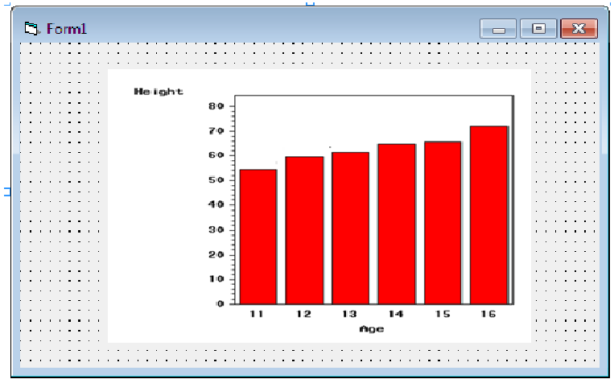
Figure1: Bar Chart

4.1.1.2 OUTPUT DESIGN FOR PIE CHART
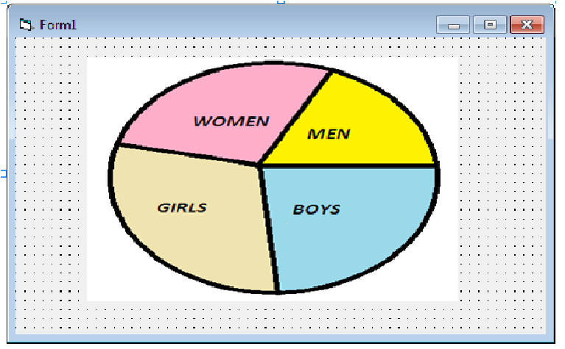
Figure2: Pie Chart

4.1.1.3 OUTPUT DESIGN FOR A LINE GRAPH
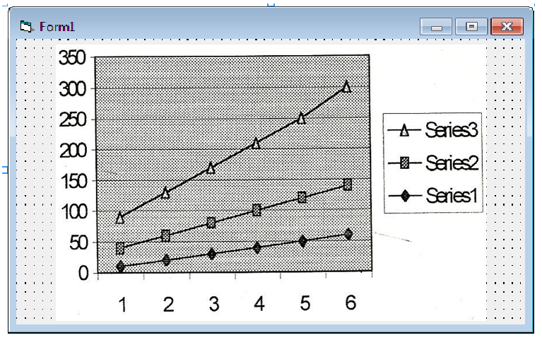
Figure3: Line Graph

4.1.1.4 OUTPUT DESIGN FOR XY- SCATTER GRAPH

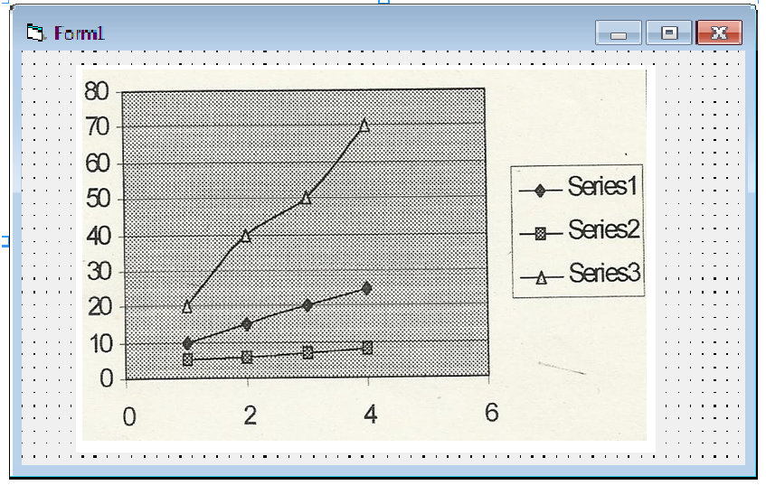
Figure4: Scatter Graph

4.1.2 INPUT DESIGN
At the input state, date or information is supply to the system through the keyboard. The input data for each plot is obtain from a visual basic control known as Microsoft Flexgrid (Msflexgrid) which consist of both rows and columns determined by the user base on the choice of output. However, the following are the input designs that generate the designs in the output section:

4.1.2.1 INPUT DESIGN FOR THE BAR CHART
The Bar chart plotted show the relationship between the height and the age of a given number of students. The information is as follows:
CHART TITLE RELATIONSHIP BETWEEN THE AGE AND HEIGHT OF STUDENTS
NUMBER OF BARS 8

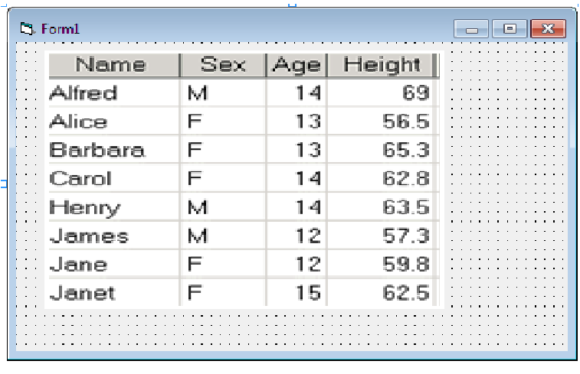
Table1: Data for the Bar Chart

4.1.2.2 INPUT DESIGN FOR THE PIE CHART
The PIE chart shows the percentage number of boys, girls, men and women in a studio at a particular time. The information supply is as follows:
CHART TITLE ANALYSIS PEOPLE IN A STUDIO
NUMBER OF DATA POINT 4
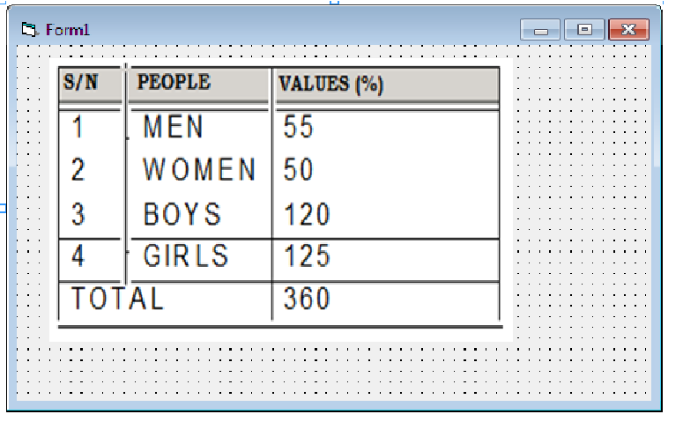
Table2: Data for the Pie Chart

4.1.2.3 INPUT DESIGN FOR THE LINE GRAPH
NUMBER OF DATA POINS 6. CHART TITLE SERIES OF NUMBER
NUMBER OF LINES TO BE PLOTTED 3. GRIDS X – axis, Y – axis.

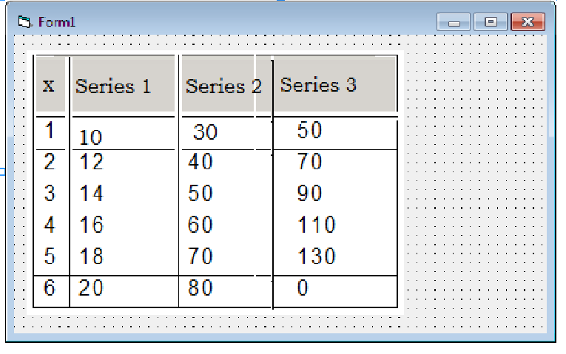
Table3: Data for Line Graph

4.1.2.4 INPUT DESIGN FOR THE XY - SCATTER GRAPH
NUMBER OF DATA POINS 4. CHART TITLE SERIES OF NUMBER
NUMBER OF LINES TO BE PLOTTED 3. GRIDS X – axis, Y – axis.
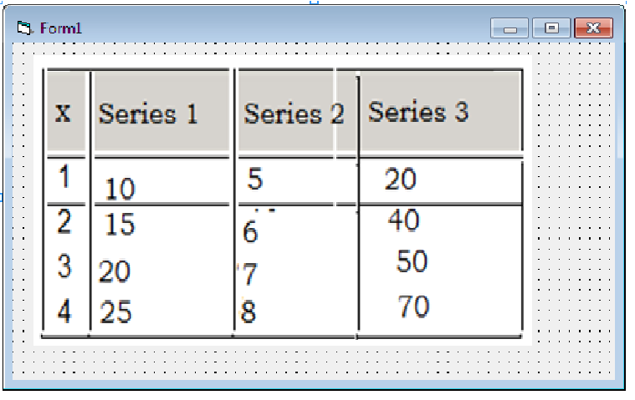
Table4: Data for XY-Scatter Graph

4.1.3PROCEDURE DESIGN
This research work contains nine modular programs. These are:
- PROCESS DATA
- SCALE DATA
- PLOT GRAPHS
- SAVE AS
- PRINT GRAPH
- NEW PLOT
- OPEN DATA
- RETURN
- HELP
PROCESS DATA: This procedure is used to convert strings of numeric data in text boxes and Msflexgrid to actual numbers.
SCALE DATA: The scale data function is use to scale the data to fit the dimension of the chart. This is achieved by first finding the maximum X(ptxmax) and the maximum Y(ptymax) data values in the array called N ARRAY.
PLOT GRAPHS: As the name implies, this procedure performs the main operation. That is, it plots the real graph and immediately after the procedure “PROCESS DATA” is invoked, the data is sent down to the “PLOT GRAPHS” procedure for plotting.
SAVE AS: This function allows the user to save new plotted data and information including the chart itself either on the main memory or secondary storage devices.
PRINT GRAPH: This procedure help to produce a hard copy of the plotted graph.
NEW PLOT: This allows user to plot a new graph or chart.
OPEN DATA: The “OPEN DATA” allows users to retrieve an existing document from any storage devices.
RETURN: This procedure allows the user to go back to the main menu for another type of graph.
HELP: This procedure provide users with more information about any type of graph.

4.2 SYSTEM IMPLEMENTATION
After coding and testing of the system, the next step is implementation. This involves the practical execution of the theoretical analysis and design of the coordinate graphs or charts into the organization where it will be used.
4.2.1 CHOICE OF PROGRAMMING LANGUAGE
The programming language mused in the design of this research work is VISUAL BASIC programming language. Visual basic is an object oriented programming language. The visual part of its name refers to the method used to create the graphical user interface (G.U.I) and the basic part means beginners all-purpose instruction code.
Visual basic is a language used by many programmers in the world of computing today. Rather than writing numerous lines of code to describe the appearance and location of the interface elements, visual basic allows users to simply drag and drop built-in objects that suit their design into the design area of the screen.
4.2.2 HARDWARE SUPPORTS
The hardware requirement is the visible part of the system that supports the implementation of the designed package. The hardware supported by this package includes:
- Pentium (PI) 166 Processor and Above.
- 32MB SDRAM.
- 1.2GB or More Hard Disk space.
- Compact Disk Read Only Memory (CD-ROM 24X).
- Graphics Adapter (VGS) or Super Video Graphics Adapter (SVGA) Colored Monitor.
- Keyboard Full of 7 – Bits ASCII Code.
- Laser Jet Printer (1100 Series). Desk Jet – HP 840 Series.

4.2.3 SOFTWARE SUPPORT
The software requirement has to do with the invisible part of the system that supports the implementation of the package. For this project, the basic software required by the package includes:
- Windows operating system.
- Visual basic programming software.
4.2.4 IMPLEMENTATION TECHNIQUES USED IN DETAIL
The technique used for the implementation of this package includes; creation of user interface by “drawing” controls such as Check Boxes, Combo Boxes, Label Boxes, Frames, Msflexrid, Picture Boxes and Text Boxes on the form using visual basic programming language.
Check Boxes: Check boxes controls are used to select option(s). Check boxes are valid as single controls and single option which is probably counter-intuitive. A check box has three possible settings for the value properties. Check boxes can also be one of three states: that is ON, OFF or GRAY. Gray (dimmed) does not mean the same as disables in this context. A grayed check box is neither on nor off, though the user can change settings if the check box was disabled. A grayed check box is used to signify a neutral position.
Frame Object: Frame control isolation is not particularly useful. It’s just like a container for other controls that comes on their own. Controls are usually placed in a frame or option. in most cases, certain attribute of are frame is achievedby the object it contains because it has effect on grouping the object together.
Label Objects: A label control is similar to a text control in that they both display text. However, the main difference is that the text in a label box can only be altered using code(s). Label boxes are used to provide information on the message shown on the form or prompt.
Text Boxes: This control is commonly used to accept input or enter data into the package. It can also be used to accept data pints to be plot on the graph from the user.
Picture Boxes: Picture boxes are used in this package to accommodate plotted graphs and to also make printing easy for the user.
Combo Boxes: The name combo box comes from “combination of boxes”. The idea is that, combo box combine the feature of both text box and list box “the best of all possible worlds”. A combo box (at least in two of its style available in visual basic) allows you to select a pre-define item from the list of items or enter items not in the list. In this package, it allows user to select legend for each plot.
MsFlexgrid: The Microsoft Flexgrid is been used in this package to accommodate all necessary data to be plotted. This control is very powerful as it allows data to be edited.
4.3 SYSTEM DOCUMENTATION
4.3.1 PROGRAM DOCUMENTATION
Basically, the documentation of this program shows the details of what each procedure in this research work does, each of which has been explained in the previous sections. The program is made up of various procedures that work together as a unit to ensure that the aim and objectives of this project are achieved.
4.3.2 OPERATING THE SYSTEM (GUIDELINES)
In using this package, there is no need of cramming any shortcut before this package can be used. This is because; the programs in this package are as simple and interactive as possible. Besides, the package is menu-driven which displays all the information the user(s) needs for each plot.
4.3.3 MAINTENANCE OF THE SYSTEM
The package is very easy to maintain as long as all the specify hardware and software required are available. Likewise, the package can be modify or upgraded anytime.

CHAPTER FIVE
SUMMARY, CONCLUSION AND RECOMMENDATION
5.1 SUMMARY
In summary, this package is more reliable and efficient in terms of storage and accuracy. The package is menu-driven and has facilities like printing and page setup. Both the input and the output data for the various types of graphs and charts have been tested and preventive measures for any error that may occur during usage have been put in place.
5.2 CONCLUSION
In such a short amount of space, it is not possible to show or explain all the features of this software. Hopefully, you have been able to grab better idea of what the software can do and understand some of its basic programming constructs. Because graphs can be created from programs, you can set up batch jobs that automatically produce graphs from production data sets. This is a major plus for people creating large scale systems with this package. For scientists and statisticians, the analytical capabilities of this package are in high demand. Furthermore, it is important to state here that this package is subjected to future modification as may be required by programmers whenever the need arises.
5.3 RECOMMENDATION
Although graph plotting package and its technology is no longer a new in computing today, however continuous innovations in computer processing power, disk storage, and statistical software increasing the accuracy of analysis of graphical package need much more attention.

REFERENCES
Vance, J. R. (2017). Interactive Mathematics. using Graphing Calculators and Computers .published by CRC press.
Brown, A.D. (2018). Mathematics Education In The Digital Age. Published by Routledge.
Kim, J.M. (2016). E-Graph Plotter:A Tool for Visualizing Mathematical Functions. Published in the International Journal of Mathematical Education in Science and Technology.
Lee, S.H. (2015). Interactive Graph Plotting for Mathematical Education. Published in the Journal of Educational Computing Research.
Y. Zhang (2017). Development of an E-Graph plotter for STEM Education. Published in the journal of science Education.
Olatunji .E.K $ R.T Olusi (Mrs) (2002). computer software packages. Igbagbogbemi publishers: Ilorin.
Oyedepo F.S $ Dada O.M (2009). Introduction to visual basic programming. Ilorin: Rafmik international: Ilorin.

SYSTEMFLOW CHART
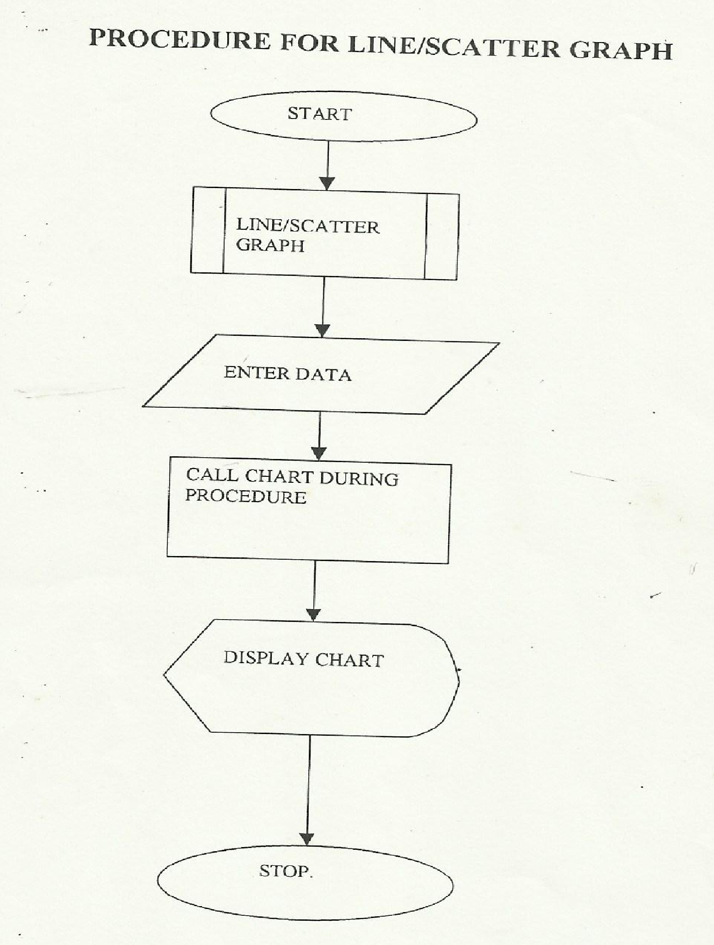
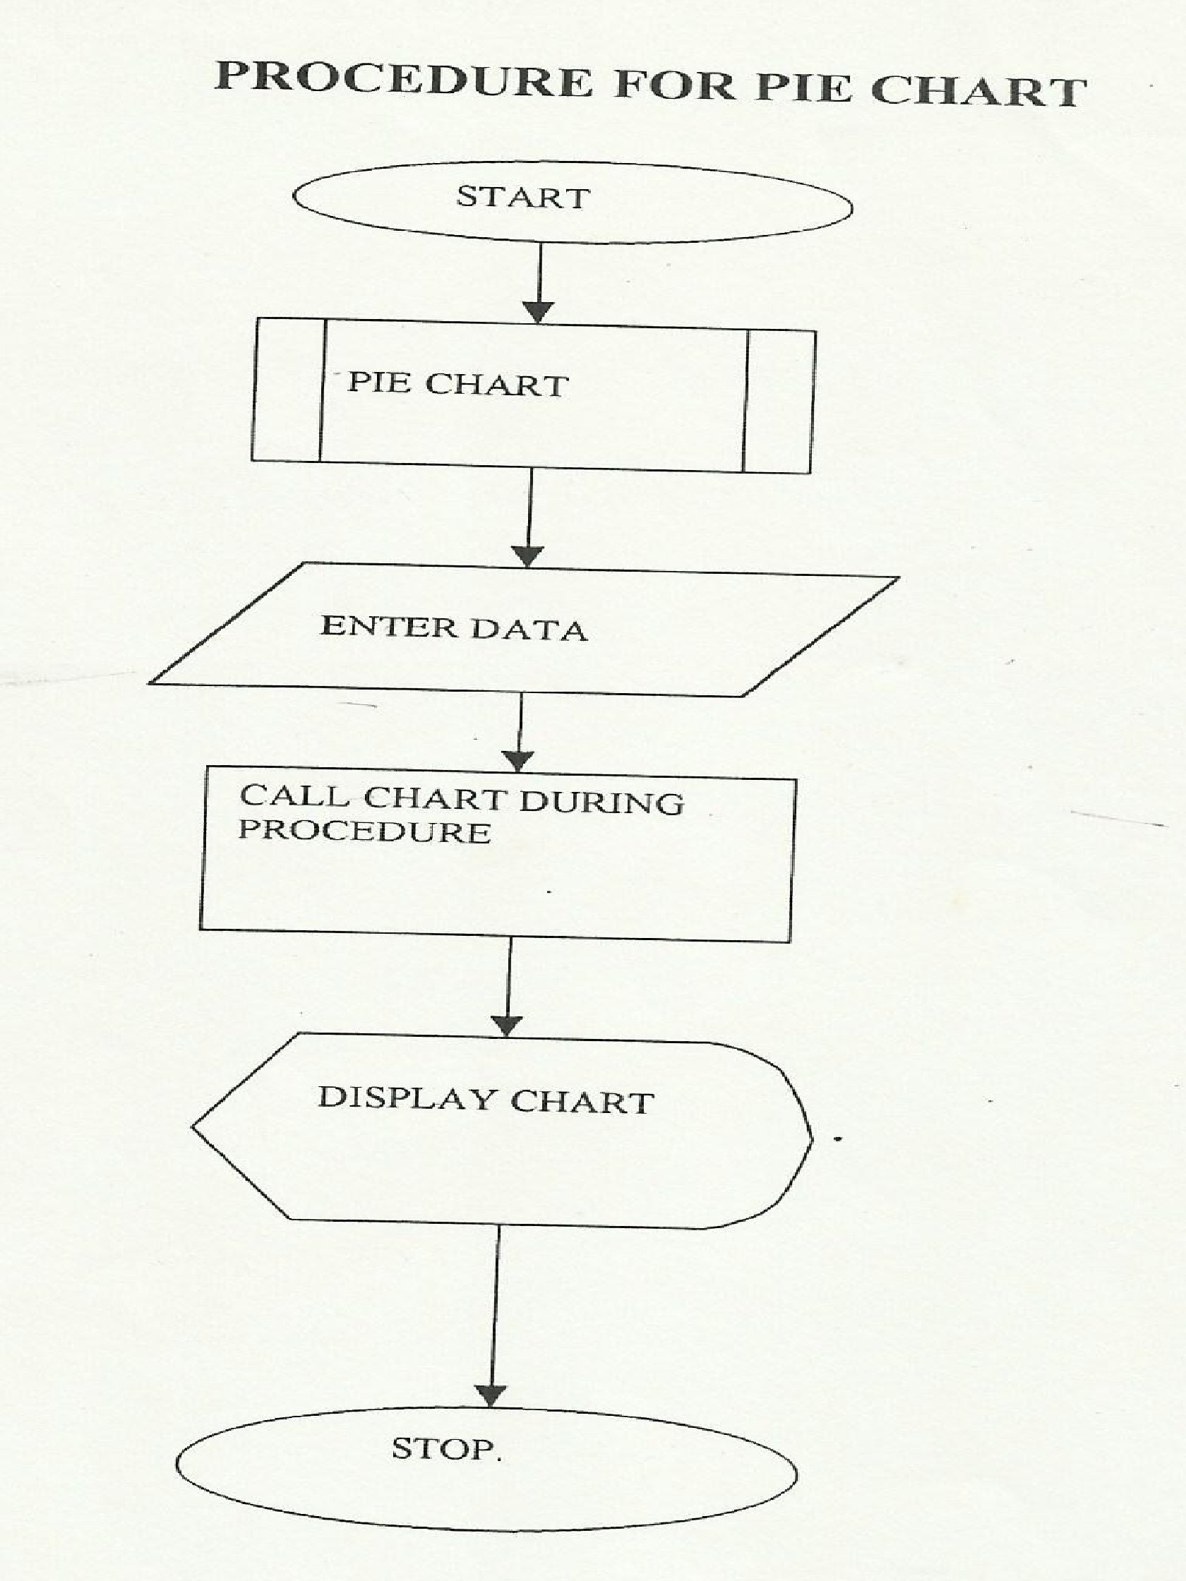
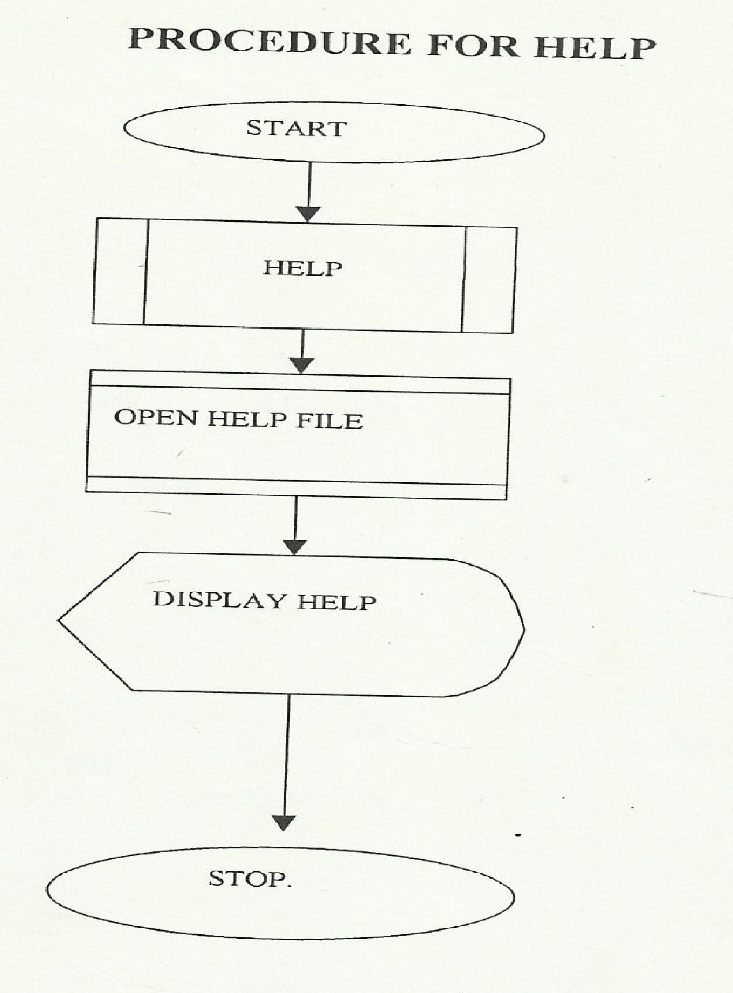

SOURCE CODE
'Coding for the main menu
Private Sub Form_Activate()
Dim intOPNUM As Integer 'Stating the type of operation
'Enter a number to represent your operation(1 for bar chart, 2 for line/scatter graph,
'3 for pie chart, 4 to get help, 5 to print previous work and 6 for Exit.)
intOPNUM = Val(InputBox("Enter the type operation (1-6) as indecated in the manual"))
Select Case intOPNUM
Case 1
Print "Bar chart"
Case 2
Print "Line/scatter graph"
Case 3
Print "Pie chart"
Case 4
Print "Help"
Case 5
Print "Print"
Case 6
Print "Exit"
Case Else
Print "operation not recognized"
End Select
End Sub
Private Sub InitializeComponent()
Me.Label1 = New System.Windows.Forms.Label()
Me.txtGridSpacing = New System.Windows.Forms.TextBox()
Me.picGraph = New System.Windows.Forms.PictureBox()
Me.txtStatus = New System.Windows.Forms.TextBox()
Me.btnGraph = New System.Windows.Forms.Button()
Me.Label2 = New System.Windows.Forms.Label()
Me.Label3 = New System.Windows.Forms.Label()
Me.Label4 = New System.Windows.Forms.Label()
Me.txtMinValue = New System.Windows.Forms.TextBox()
Me.txtMaxValue = New System.Windows.Forms.TextBox()
CType(Me.picGraph, System.ComponentModel.ISupportInitialize).BeginInit()
Me.SuspendLayout()
'Label1
Me.Label1.AutoSize = True
Me.Label1.Font = New System.Drawing.Font("Microsoft Sans Serif", 11.0!, System.Drawing.FontStyle.Regular, System.Drawing.GraphicsUnit.Point, CType(0, Byte))
Me.Label1.Location = New System.Drawing.Point(13, 13)
Me.Label1.Name = "Label1"
Me.Label1.Size = New System.Drawing.Size(329, 18)
Me.Label1.TabIndex = 0
Me.Label1.Text = "Enter The Horrizontal Grid Lines Spacing Value : "
'txtGridSpacing
Me.txtGridSpacing.Font = New System.Drawing.Font("Microsoft Sans Serif", 11.0!, System.Drawing.FontStyle.Regular, System.Drawing.GraphicsUnit.Point, CType(0, Byte))
Me.txtGridSpacing.Location = New System.Drawing.Point(340, 10)
Me.txtGridSpacing.Name = "txtGridSpacing"
Me.txtGridSpacing.Size = New System.Drawing.Size(450, 24)
Me.txtGridSpacing.TabIndex = 0
'picGraph
Me.picGraph.Image = Global.DynamicGraphVBApp.My.Resources.Resources.Whitebackground
Me.picGraph.Location = New System.Drawing.Point(18, 42)
Me.picGraph.Name = "picGraph"
Me.picGraph.Size = New System.Drawing.Size(771, 419)
Me.picGraph.TabIndex = 2
Me.picGraph.TabStop = False
'txtStatus
Me.txtStatus.BorderStyle = System.Windows.Forms.BorderStyle.None
Me.txtStatus.Enabled = False
Me.txtStatus.Font = New System.Drawing.Font("Microsoft Sans Serif", 11.0!, System.Drawing.FontStyle.Regular, System.Drawing.GraphicsUnit.Point, CType(0, Byte))
Me.txtStatus.Location = New System.Drawing.Point(19, 510)
Me.txtStatus.Name = "txtStatus"
Me.txtStatus.Size = New System.Drawing.Size(629, 17)
Me.txtStatus.TabIndex = 3
'btnGraph
Me.btnGraph.Font = New System.Drawing.Font("Microsoft Sans Serif", 11.0!, System.Drawing.FontStyle.Regular, System.Drawing.GraphicsUnit.Point, CType(0, Byte))
Me.btnGraph.Location = New System.Drawing.Point(564, 506)
Me.btnGraph.Name = "btnGraph"
Me.btnGraph.Size = New System.Drawing.Size(133, 29)
Me.btnGraph.TabIndex = 3
Me.btnGraph.Text = "Draw Graph"
Me.btnGraph.UseVisualStyleBackColor = True
'Label2
Me.Label2.AutoSize = True
Me.Label2.Font = New System.Drawing.Font("Microsoft Sans Serif", 11.0!, System.Drawing.FontStyle.Regular, System.Drawing.GraphicsUnit.Point, CType(0, Byte))
Me.Label2.Location = New System.Drawing.Point(200, 475)
Me.Label2.Name = "Label2"
Me.Label2.Size = New System.Drawing.Size(325, 18)
Me.Label2.TabIndex = 5
Me.Label2.Text = "Enter The Range Of Values To Plot The Graph : "
'Label3
Me.Label3.AutoSize = True
Me.Label3.Font = New System.Drawing.Font("Microsoft Sans Serif", 11.0!, System.Drawing.FontStyle.Regular, System.Drawing.GraphicsUnit.Point, CType(0, Byte))
Me.Label3.Location = New System.Drawing.Point(16, 509)
Me.Label3.Name = "Label3"
Me.Label3.Size = New System.Drawing.Size(159, 18)
Me.Label3.TabIndex = 6
Me.Label3.Text = "Min Value : (>-10 &&<0)"
'Label4
Me.Label4.AutoSize = True
Me.Label4.Font = New System.Drawing.Font("Microsoft Sans Serif", 11.0!, System.Drawing.FontStyle.Regular, System.Drawing.GraphicsUnit.Point, CType(0, Byte))
Me.Label4.Location = New System.Drawing.Point(276, 511)
Me.Label4.Name = "Label4"
Me.Label4.Size = New System.Drawing.Size(162, 18)
Me.Label4.TabIndex = 7
Me.Label4.Text = "Max Value : (>0 &&< 10)"
'txtMinValue
Me.txtMinValue.Font = New System.Drawing.Font("Microsoft Sans Serif", 11.0!, System.Drawing.FontStyle.Regular, System.Drawing.GraphicsUnit.Point, CType(0, Byte))
Me.txtMinValue.Location = New System.Drawing.Point(186, 508)
Me.txtMinValue.Name = "txtMinValue"
Me.txtMinValue.Size = New System.Drawing.Size(84, 24)
Me.txtMinValue.TabIndex = 1
'txtMaxValue
Me.txtMaxValue.Font = New System.Drawing.Font("Microsoft Sans Serif", 11.0!, System.Drawing.FontStyle.Regular, System.Drawing.GraphicsUnit.Point, CType(0, Byte))
Me.txtMaxValue.Location = New System.Drawing.Point(444, 508)
Me.txtMaxValue.Name = "txtMaxValue"
Me.txtMaxValue.Size = New System.Drawing.Size(100, 24)
Me.txtMaxValue.TabIndex = 2
'
'frmGraph
'
Me.AutoScaleDimensions = New System.Drawing.SizeF(6.0!, 13.0!)
Me.AutoScaleMode = System.Windows.Forms.AutoScaleMode.Font
Me.BackColor = System.Drawing.Color.White
Me.ClientSize = New System.Drawing.Size(806, 548)
Me.Controls.Add (Me.txtMaxValue)
Me.Controls.Add (Me.txtMinValue)
Me.Controls.Add (Me.Label4)
Me.Controls.Add (Me.Label3)
Me.Controls.Add (Me.Label2)
Me.Controls.Add (Me.btnGraph)
Me.Controls.Add (Me.txtStatus)
Me.Controls.Add (Me.picGraph)
Me.Controls.Add (Me.txtGridSpacing)
Me.Controls.Add (Me.Label1)
Me.MaximizeBox = False
Me.MinimizeBox = False
Me.Name = "frmGraph"
Me.StartPosition = System.Windows.Forms.FormStartPosition.CenterScreen
Me.Text = "Dynamic Graph Plotter"
CType(Me.picGraph, System.ComponentModel.ISupportInitialize).EndInit()
Me.ResumeLayout (False)
Me.PerformLayout()

End Sub
Friend WithEvents Label1 As System.Windows.Forms.Label
Friend WithEvents txtGridSpacing As System.Windows.Forms.TextBox
Friend WithEvents picGraph As System.Windows.Forms.PictureBox
Friend WithEvents txtStatus As System.Windows.Forms.TextBox
Friend WithEvents btnGraph As System.Windows.Forms.Button
Friend WithEvents Label2 As System.Windows.Forms.Label
Friend WithEvents Label3 As System.Windows.Forms.Label
Friend WithEvents Label4 As System.Windows.Forms.Label
Friend WithEvents txtMinValue As System.Windows.Forms.TextBox
Friend WithEvents txtMaxValue As System.Windows.Forms.TextBox
End Class

