ASSESSMENT OF THE CAUSE OF ABANDONMENT IN PUBLIC DEVELOPMENT PROJECTS
[A CASE STUDY OF EDU LOCAL GOVERNMENT AREA, GOVERNOR'S LODGE]

BY
MUHAMMAD ABDULLAHI MAJIN
HND/23/ETM/FT/0019

BEING A RESEARCH PROJECT SUBMITTED TO THE DEPARTMENT OF ESTATE MANAGEMENT AND VALUATION, INSTITUTE OF ENVIRONMENTAL STUDIES
KWARA STATE POLYTECHNIC, ILORIN

IN PARTIAL FULFILMENT OF THE REQUIREMENT FOR THE AWARD OF
HIGHER NATIONAL DIPLOMA [HND] IN ESTATE MANAGEMENT AND VALUATION

SUPERVISOR: ESV. YAKUB BOLAJI G. (ANIVS, RSV)

JULY, 2025

CERTIFICATION
This is to certify that this project work has been written by MUHAMMAD ABDULLAHI MAJIN matric no. HND/23/ETM/FT/0019 and has been examined and approved a meeting part of the requirement for the award of Higher National Diploma [HND] in the department of Estate Management and Valuation, institute of Environmental studies, Kwara state polytechnic, Ilorin, Kwara state.



_________________________ __________________
ESV YAKUB BOLAJI G. (ANIVS, RSV) DATE
[PROJECT SUPERVISOR]



____________________ __________________
ESV. DR. N. I. UWAEZUOKE (ANIVS, RSV) DATE
[PROJECT COORDINATOR]


________________________ __________________
ESV. ABDULKAREEM RASHIDAT. (MNIVS, RSV) DATE
[HEAD OF DEPARTMENT]


________________________ __________________
ESV. DR. LUKUMAN MUSIBAU DATE
[EXTERNAL SUPERVISOR]

DEDICATION
I dedicate this project to the creature of all universal, who created life and death. I am forever grateful (Alhamdulillahi). Your unwavering support, guidance, and encouragement have been the driving force behind my academic journey.
To my invaluable parents, Your belief in me has inspired me to push beyond my limits and strive for excellence. This project is a testament to the sacrifices you've made and the faith you've placed in me.
Thank you for being my pillars of strength and motivation.

ACKNOWLEDGEMENT
I would like to express my sincerely heartfelt gratitude to the Almighty Allah who gives his infinite mercy, favor, and strengthen me to strive to excellence. I am forever grateful (Alhamdulillahi).
To my amazing supervisor and mentor, in person of ESV. YAKUB BOLAJI G. (ANIVS, RSV), for your invaluable guidance, support, and expertise throughout my project assessment. your insightful feedback and constructive criticism have been instrumental in shaping this project assessment, your appreciation is undiluted.
I also appreciate the assistance provided by department HOD, ESV. ABDULKAREEM RASHIDAT (MNIVS, RSV) and more less to mention in the department, I really appreciate your unwavering support, tireless hardworking, time, and contributions of my peers. your collaboration and discussions have enriched my understanding and enhanced the quality of this project.
And also my deepest appreciation and most profoundly gratitude goes to my beloved grassroots and background parents who's ably in person of MALLAM ABDULLAHI ABDULKADIR TSWACHI and MALLAMA ABDULLAHI AISHAT their financially, morally and spiritually strongly support towards the successful pursuit of my course of study in this institution and stood by my side throughout this journey, a wording cannot express how much you are value to my life. I pray to Almighty Allah bless you both abundantly and forgive the shortcoming sins of dismissed one and rewards him rest in perfect peace (Aljanatul fridaus). Ameen ya Allah

Table of Contents
Title page-- i
Certification- ii
Dedication- iii
Acknowledgements- iv
Table of Contents v
Abstract vii

Chapter One: Introduction
1.1 Background of the Study 1
1.2 Statement of the Problem 2
1.3 Research Questions 3
1.4 Aim and Objectives of the Study 3
1.5 Justification of the Study 3
1.6 Scope of the Study 4
1.7 Significance of the Study 4
1.8 Study Area 5
1.9 Definition of Terms 10
Chapter Two: Literature Review
2.0 Introduction 11
2.1 Literature review 11
2.2 Causes of Abandonment in Public Development Projects 12
2.3 Effects of Abandonment of Building Projects 14
2.4 Strategies for Preventing Project Abandonment 16
2.5 Theoretical Framework 19
2.6 Summary of Literature Review 20
Chapter Three: Research Methodology
3.1 Introduction 22
3.2 Research Design 22
3.3 Data Types and Sources 22
3.4 Instruments for Data Collection 22
3.5 Target Population 23
3.6 Sample Frame 23
3.7 Sample Size 23
3.8 Sampling Procedure 24
3.9 Method of Data Analysis 24
3.10 Summary of Data Analysis for Each Objective 25
Chapter Four: Data Presentation, Analysis, and Discussion
4.1 Introduction 26
4.2 Demographic Profile of Respondents 27
4.3 Presentation and Analysis of Data by Research Objectives 28
4.4 Discussion of Findings 35
Chapter Five: Summary, Conclusion and Recommendations
5.1 Summary 37
5.2 Conclusion 37
5.3 Recommendations 37
References 39
Appendices
Appendix 1: Questionnaire 44
Appendix 2: Maps and Photographs 48

Abstract
Public development projects are critical instruments for socio-economic advancement, particularly in developing countries like Nigeria. However, the recurrent issue of project abandonment undermines these goals, resulting in wasted resources, unfulfilled community needs, and diminished public trust. This study investigates the causes, impacts, and potential solutions to the abandonment of public development projects, using the Governor’s Lodge in Edu Local Government Area, Kwara State, as a case study.
The research employed a descriptive survey design, utilizing questionnaires and interviews to collect data from 100 respondents comprising government officials, contractors, and community members. Findings revealed that the primary factors contributing to project abandonment include political instability, corruption, inadequate planning, and delays in fund disbursement. The consequences of such abandonment are far-reaching, including economic loss, reduced job opportunities, environmental degradation, and erosion of public confidence in governance.
The study highlights the need for comprehensive pre-project feasibility studies, legal frameworks to ensure project continuity across political administrations, greater transparency in contractor selection, and inclusive stakeholder engagement. Recommendations also include enforcing penalties for abandonment-related offenses and empowering communities to participate in project monitoring.
The study concludes that addressing the issue of project abandonment requires systemic reforms, robust governance mechanisms, and community-centered planning to ensure sustainable development outcomes.

CHAPTER ONE
INTRODUCTION
1.1 Background of the Study
Project abandonment is a major problem in Nigeria. It has been observed that every cities in Nigeria include the federal capital territory are many abandoned projects of infrastructural development. A 2012 report indicated that about 12,000 federal government projects had been abandoned between 1962 and 2012. Another report by Chartered Institute of Professional Practitioners and Property Managers of Nigeria in 2017 suggested that abandoned projects concerning existing structures alone amount to over ₦12 trillion that is 10% of the economy (Chartered Institute of Professional Practitioners and Property Managers of Nigeria (CIPPPMN), 2015).
According to Amade et al., (2015), construction projects in Nigeria and the world over are confronted with a lot of complexities and ambiguities as a result of uncertainties of not meeting project deadlines which also centres on low quality, cost overruns which invariably leads to failure and abandonment of such projects. Ayodele and Alabi (2011), reported that abandoned projects and construction failure including building and other civil engineering infrastructure development project like houses, churches, schools, roads, bridges, dams, tunnels, airport, sea port etc. litters the whole of Nigeria. Osemenan (1987), reported that Nigeria has become the “world’s junkyard of abandoned and failed projects worth billions of naira and it is greatly unthinkable that Nigeria, blessed with so great potentials in the building and construction industry, can experience such magnitude of project failure and abandonment.
(Thisday 2022) report that the large quantum of uncompleted projects in Nigeria was estimated to cost N12 trillion as of August 2021.The Nigerian Institute of Quantity Surveyors who gave the estimate also hinted that there are about 56,000 abandoned projects in Nigeria. (Ojo, 2017) put the costs of abandoned projects at ₦17 trillion, based on an investigation during the Jonathan administration. There are about 4,000 uncompleted or abandoned projects belonging to the Federal Government with an estimated cost of =N=300 billion which will take 30 years to complete at the present execution capacity of the government. Abandonment has been left

without adequate attention for too long which is now having a multiplier effect on the construction industry in particular and the national economy as a whole
(Ogunode & Murtala 2022) acknowledged that one of the major problems facing the public universities in Nigeria is the problem of abandoned project. The Vice-Chancellor of the University of Calabar affirmed this when observed the high rate of abandoned projects in the institution in University of Calabar. The VC, Prof. Florence Obi, noted that the institution has a bad record of being one of the universities with the highest number of Federal Government funded abandoned projects in the country. She said that building projects like the Pavilion One, Two, and Three, which are now funded by TETFUND, and the Faculty of Law, at the verge of completion, were built many years ago and left uncompleted by previous administrations (Adelabu, 2019).
Public development projects play a vital role in advancing societal welfare by addressing critical needs such as infrastructure development, education, healthcare, and economic growth. However, the abandonment of these projects remains a persistent issue, particularly in developing regions. Projects are often left incomplete, creating eyesores and reducing their intended benefits to communities. This situation highlights inefficiencies in public administration and resource management.
The causes of abandoned projects are multifaceted, often involving inadequate planning, mismanagement of funds, political interference, and economic instability. Addressing this issue is essential for maximizing the impact of public investments and achieving sustainable development goals.

1.2 Statement of the Problem
Public development projects are crucial for fostering economic growth, improving infrastructure, and enhancing the quality of life in communities. However, many of such projects are abandoned before completion, leading to wastage of resources, economic setbacks, and social dissatisfaction (Ojo, 2017).
The Governor's Lodge project in Edu Local Government Area is a clear example of this persistent issue. Despite initial funding and planning, the project has remained incomplete, leaving the intended benefits unrealized. This abandonment raises several critical questions such as; “what are the underlying causes of the project's cessation, evaluating if financial, administrative, and political issues are related to contractor inefficiencies, and also how has the local government, stakeholders, and community contributed to or been affected by the project's stagnation”.
The problem is further exacerbated by the ripple effects of abandonment, including wasted public funds, underutilized land, and a decline in public trust in government initiatives. Understanding these factors is essential to addressing the root causes and preventing future occurrences.

1.3 Research Questions
- What are the key factors contributing to the abandonment of public development projects?
- How do abandoned projects affect communities and national development?
- What management practices influence the success or failure of public development projects?
- What measures can be implemented to prevent project abandonment?

1.4 Aim and Objectives of the Study
The primary aim of this study is to investigate the causes of abandoned public development projects and recommend strategies to mitigate the problem. Specific objectives include:
- To identify the key factors contributing to project abandonment
- To examine the impact of project abandonment on communities and the economy of the study area
- To analyze the role of the government in project abandonment.
- To propose practical recommendations to reduce the incidence of project abandonment.

1.5 Justification of the study
Public development projects are critical to socio-economic progress, yet their abandonment remains a pervasive issue, particularly in developing nations like Nigeria. This study focuses on the abandonment of the Governor’s Lodge in Edu Local Government Area (LGA), offering both academic and practical significance.
This study addresses economic waste, with an estimated N12 trillion lost to abandoned federal projects since 1960. The project’s failure reflects financial mismanagement, budgetary flaws, or corruption in public spending, abandonment causes public distrust and deprives the community of vital socio-economic benefits. The case reveals governance lapses such as poor planning, political interference, and weak continuity.
It fills academic gaps by focusing on rural Edu LGA, often overlooked in existing research.
Local factors like funding delays and community disengagement are explored for deeper understanding.
Findings aim to inform policies on monitoring, anti-corruption, and project continuity.
The Lodge symbolizes systemic issues in project management, offering broader lessons nationwide.

1.6 Scope of the study
The study focuses on the causes of abandoned public projects, which will be confined to the abandoned Governor’s Lodge in Lafiagi town the headquarters of Edu LGA, Kwara State. It examines projects initiated within a specified timeframe to understand trends and factors contributing to abandonment. The analysis is limited to public projects and excludes private or commercial ventures.

1.7 Significance of the Study
This study holds critical importance as it addresses the recurring abandonment of public projects like the Governor’s Lodge in Edu LGA, a challenge that undermines Nigeria’s socio-economic development. By identifying root causes (e.g., poor governance, funding gaps, or political interference), the findings will;
Inform strategies to reduce financial waste by Nigerian Extractive Industries Transparency Initiative (NEITI, 2020), restore public trust in governance, and enhance policy frameworks for sustainable project execution. Additionally, it contributes to academic discourse by providing localized insights into rural project management, while empowering stakeholders to align future projects with community needs and global sustainability goals like SDG 9 and SDG 16 (UNDP, 2021).

1.8 Study Area
Edu Local Government Area (LGA) is one of the sixteen local government areas in Kwara State, Nigeria. It is located in the northern part of the state and shares boundaries with other local government areas in Kwara, as well as with Niger State and the Republic of Benin. The headquarters of Edu LGA is in Lafiagi, a town with significant historical and cultural importance.
Edu LGA is predominantly inhabited by the Nupe ethnic group, also known as the Tapa people. The area has a rich cultural heritage deeply rooted in Nupe traditions, language, and customs. Historically, the Nupe Kingdom, which extends into parts of present-day Niger and Kogi States, played a vital role in trade and politics in pre-colonial Nigeria. The Nupe people are known for their skills in farming, fishing, and craftwork, particularly pottery and weaving.
The region became part of Kwara State upon the creation of the state in 1967, following Nigeria's restructuring into twelve states by General Yakubu Gowon's administration. Edu LGA was later formally established as an administrative division to promote grassroots governance and development.
Edu LGA is an agrarian region, with its economy largely dependent on farming and fishing. Crops such as rice, maize, millet, and sugarcane are cultivated in large quantities, with the region being recognized as a key agricultural hub in Kwara State. The River Niger, which flows through parts of the LGA, supports fishing activities and serves as a source of irrigation for farming.
The local government area is also known for its vibrant cultural festivals, including masquerade performances and traditional Nupe ceremonies, which attract visitors from within and outside the state. These cultural practices reflect the community's commitment to preserving its heritage while embracing modern development initiatives (Wikipedia, 2024).

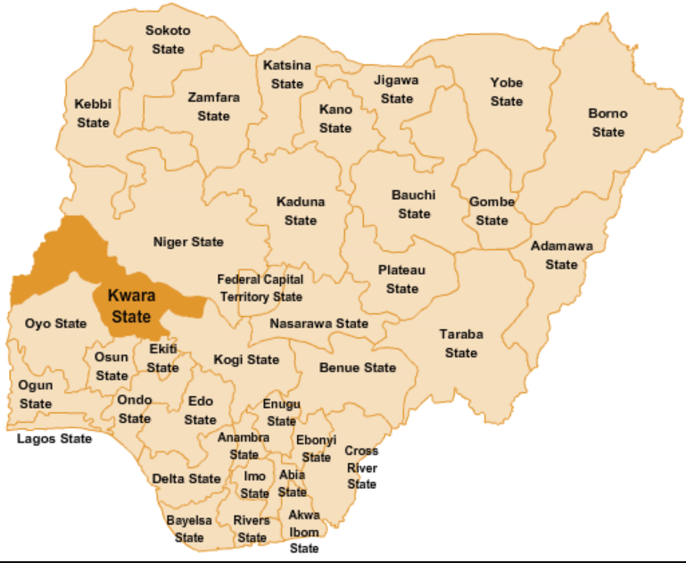
Map of Nigeria Showing Location of Kwara State. (Researchgate.net 2024).
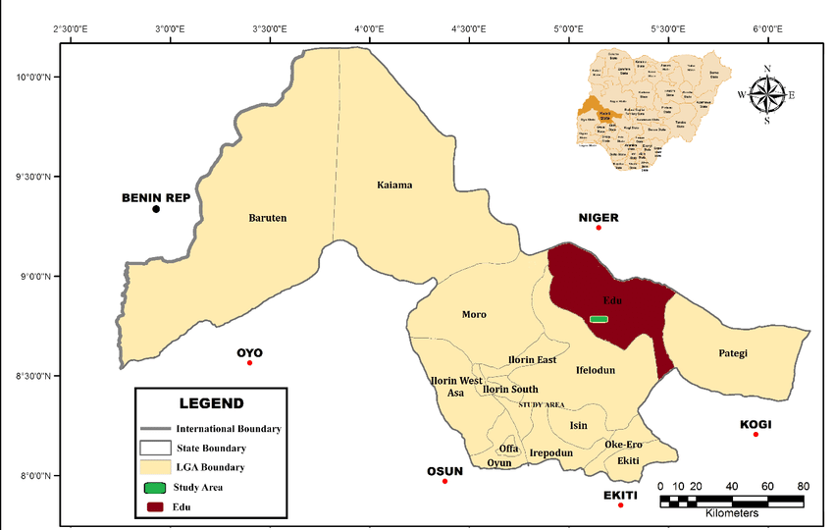
Map of Kwara State, displaying the study area (Edu Local Government Area). (Researchgate.net 2024).

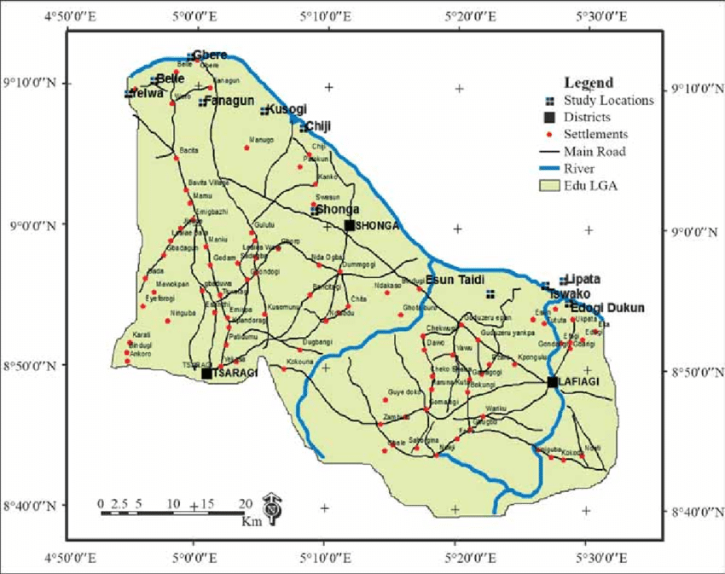
Map of Edu Local Government Area (LGA), Kwara State

1.8 Definition of Terms
- Public Development Projects: Government-funded initiatives designed to improve infrastructure, services, or socio-economic conditions for public benefit (World Bank, 2020).
- Project Abandonment: The premature termination or suspension of a project before its completion, rendering it non-functional or incomplete (Olawale & Sun, 2015).
- Local Government Area (LGA): A sub-national administrative unit in Nigeria responsible for grassroots governance and development (Federal Republic of Nigeria, 1999).
- Governance: The systems and processes by which authority is exercised, including decision-making, accountability, and resource management (World Bank, 2017).
- Sustainable Development Goals (SDGs): A United Nations framework of 17 global goals aimed at achieving equitable and environmentally sustainable development by 2030 (United Nations, 2015).
- Resource Misallocation: The inefficient or ineffective distribution of financial, human, or material resources, leading to wasted investments (NEITI, 2020).
- Community Engagement: The inclusion of local stakeholders in planning and decision-making processes to ensure projects align with community needs (UNDP, 2021).

CHAPTER TWO

2.0 Introduction
The issue of abandoned public development projects has become a critical concern worldwide, particularly in developing nations. Such projects often result in wasted resources, lost opportunities, and adverse socio-economic impacts. Understanding the causes behind these abandoned projects is essential for policymakers, project managers, and stakeholders. This chapter explores relevant literature to identify the key factors contributing to project abandonment, framed within the context of existing theories and conceptual models.

2.1 Literature Review

Abandoned construction project is a natural problem in construction industry. This means that issues of abandoned construction project are not unexpected but can be preventable. In fact there are risks of delay in every project and it may be difficult to avoid, unless there is proper planning with all parties involved in the project delivery. Bramble and Callahan (2017) stressed that an abandoned construction project is an uncompleted project in a time frame of a contract. The delay in a construction project always happens when construction and progress work at a project site is stopped for 6 months or more and continuously either in a time frame of a contract or out of a time frame like in a sale and purchase agreement. The delay in a construction project also occurs if the developers agree that they are not capable of executing the project. The development and growth in a country depend on the performance and progress of construction projects. So, the management of construction project is important in ensuring that the project is completed within the shortest time frame. There are five phases in a construction project viz: pre-design phase, design phase, tender phase, construction phase and occupied phase. Delay problem starts from the construction phase (Abdrahman et al., 2016). Arditi et al. (2015) observed that construction industry is linked to and depends on other sectors which are at “input” and “output” levels. The “input” for the construction industry is bought from other sectors while the “output” is used by those sectors. So, the effect of delay or abandonment of a construction project haveimpacts not only on the construction industry but also on other sectors within the country’s economy (Dlakwa and Culpin, 2020).
A tenet of economic development is generally accepted as being the position that a country
cannot be affluent in the absence of state-of-the-art infrastructure. Most Nigerian infrastructure, even that which is not currently abandoned, is in a parlous state, to which the deserted and incomplete structures strewing Nigeria add by not only contradicting the claim of “sustainable development” but also by raising questions regarding the methods of procurement deployed in delivering such projects (Oyewobi et al. 2017).

2.1.1 Causes of Abandonment in Public Development Projects
Various studies highlight multiple causes of abandoned projects. These can be categorized into financial, managerial, political, and social factors:
1. Financial Constraints
A predominant cause of project abandonment is inadequate funding. Projects often face delays or cessation when allocated funds are insufficient or mismanaged. Economic downturns can exacerbate this issue, leading to budget cuts and reallocation of resources. For instance, a study by Owolabi et al. (2014) identified financial difficulties as a primary factor leading to project delays and eventual abandonment.
2. Managerial Challenges
Effective project management is crucial for the successful completion of development initiatives. Challenges such as poor planning, inadequate risk assessment, and lack of stakeholder engagement can lead to project failure. Abisuga (2014) emphasized that design flaws, contract mismanagement, and procurement issues significantly contribute to project abandonment.
Government rules and policies significantly influence the success or failure of construction projects. Complex and often uneven regulatory frameworks can cause delays in project approvals, increased expenses, and uncertainty for developers. These issues are especially common in metropolitan locations where land use rules and construction codes are strictly enforced, yet enforcement can be unexpected. Bureaucratic delays and compliance costs can make projects financially unsustainable, resulting in abandonment (Ogunbiyi et al.,2014).

3. Political Dynamics
Political instability and changes in government can disrupt ongoing projects. New administrations may deprioritize or discontinue projects initiated by predecessors, leading to abandonment. A review by Okereke (2017) highlighted instances where political transitions resulted in the cessation of public projects due to shifts in policy focus. Political interference and corruption have been consistently identified as major impediments to project success in Nigeria (Nwachukwu and Emoh, 2011; Zuofa and Ochieng, 2014; Amade et al., 2015; Saidu & Shakantu, 2017).
4. Socio-Economic Conditions
Socio-economic factors, including community opposition, land disputes, and cultural disagreements, can impede project progress. Chirwa et al. (2011) noted that lack of community involvement and unresolved social issues often lead to project delays and eventual abandonment.
According to Olubajo et al.,(2024) Managing ambiguity in construction projects in Nigeria by selecting and achieving set milestones when coupled with effective cost management through open communication among team members, stakeholders, and vendors is crucial for addressing these challenges. Tijan & Ajagbe (2016) underscored the significant role of community disruption in contributing to the abandonment of construction projects, particularly in Nigeria where this issue is particularly acute. Construction sites often face harassment from various unrecognized groups, colloquially termed "area boys," demanding illegal financial payments from clients. Failure to comply with these demands can lead to serious safety risks for construction workers, including violent confrontations resulting in injuries or fatalities. Consequently, many contractors and sometimes even clients opt to cease work on such projects to ensure safety. However, recent governmental efforts across Nigerian federation states aimed at curbing the activities of these individuals may offer some hope for improvement in this regard.
5. Environmental and Legal Factors
Environmental concerns and legal challenges can also contribute to project abandonment. Unforeseen environmental impacts or legal disputes over land ownership and usage rights can halt project activities. A review by Abdul-Rahman et al. (2015) discussed how environmental risks and legal complications are significant factors leading to the abandonment of housing projects.
Addressing the issue of project abandonment requires a multifaceted approach, including securing adequate funding, enhancing project management practices, ensuring political commitment, engaging with local communities, and navigating environmental and legal frameworks effectively. By understanding and mitigating these factors, stakeholders can improve the success rates of public development projects.
2.1.2 Effects of Abandonment of Building Projects
Abandoned construction projects in Nigeria present numerous challenges, yet research on this issue remains limited. The ramifications of abandonment extend beyond mere construction setbacks, encompassing socio-economic and environmental consequences. Socio-economic impacts such as inadequate livable housing, job losses, displacement of populations, and financial burdens shift between private and public sectors. According to Haruna et al.,(2023),housing is one of the essential socio-economic factors that influence not only the quality of life and welfare of individuals but also the welfare of communities. As a result, the construction quality of houses and their integration into the social, cultural, and economic fabric of communities all have a substantial impact on people's everyday lives, health, security, and overall well-being. Abandonment of building projects has so many effects but they can be treated under the following classification as ;_
1) Economical effect
2) Social effect
3) Environmental effect
4) Urban Development Effects

Economic Effects
This is the greatest effects of any abandoned building project as it is a monetary lost because the client stands to lose a great deal in terms of abandoned building compared with what is needed to complete such projects.This is as a result of disintegration of the already built area, possibility of theft, vandalism and decay of materials'; it does not affect the public or private client alone but affect the contractor as they may not be able to get all their claims.
Investments in unfinished projects result in significant economic losses for governments and stakeholders (Adepoju & Bakare, 2020). Persistent abandonment discourages future investments in public development initiatives (Aliyu & Musa, 2018).
Social Effects
Abandoned projects disrupt community cohesion and limit access to essential services (Ibrahim et al., 2020). Neglected structures often become hotspots for illegal activities, endangering local communities (Okoye et al., 2018). Many of the abandoned building projects are now being turned in to dump refuse are dumped. It is not only unfriendly to the environment but also constitute a health hazard to the society causing an outbreak of epidemics.
Abandoned building project also serve as a hideout for hoodlums and criminals who are very dangerous to the society. Apart from being a house for thugs, rapist thieves and their likes, it is also a home for lunatics and other mentally challenged people in the society.
There is also a psychological effect as a result of building projects abandonment which means that such locations where abandoned projects exist are seen as a bad environment only for the poor and unsound minds. This lower the thinking and morale of the dwellers of such locations and inferiority complex will set in limiting their productivity, ability and capacity in every area of life.
Environmental Effects
Soil contamination from improper waste disposal is a common consequence (Okey et al., 2017). Stagnant water and hazardous runoff affect local water bodies (Akinyele & Oyewole, 2020).
Dust and debris from construction contribute to air pollution (Eze et al., 2019). Habitat disruption during construction displaces local wildlife (Agbo et al., 2021).
Urban Development Effects
Abandoned sites detract from the visual appeal of urban areas, leading to urban blight (Okoye et al., 2018). Abandoned projects delay the realization of planned urban growth and infrastructure expansion (Chukwu, 2021).
2.1.3 Strategies for Preventing Project Abandonment
To mitigate the risk of abandonment in public development projects, various strategies must be implemented at different stages of the project lifecycle. The following are key strategies that can help ensure successful project completion:
Effective Project Planning and Feasibility Studies
A comprehensive feasibility study is essential to assess financial, technical, environmental, and socio-economic viability before project initiation (Chan & Yeong, 2015). Poor planning and unrealistic timelines often result in delays and eventual abandonment (Olawale & Sun, 2015).
Conduct detailed feasibility studies to evaluate risks, costs, and resource availability (Amoatey & Anson, 2017). Develop realistic project schedules and budgets based on empirical data and implement risk assessment models to mitigate uncertainties (Morris, 2013).
Sustainable Financial Management
One of the primary causes of project abandonment is inadequate funding or financial mismanagement (Kikwasi, 2013). Ensuring sound financial planning and transparency is crucial.
Secure adequate and stable funding sources before project commencement (Damoah et al., 2018). Implement transparent financial management and auditing mechanisms to prevent corruption and misallocation of resources (Ogunsemi & Jagboro, 2006) and explore Public-Private Partnerships (PPPs) to diversify funding and reduce government burden (Grimsey & Lewis, 2004).
Strong Project Governance and Leadership
Poor governance and lack of accountability often contribute to project abandonment (Ahiaga-Dagbui & Smith, 2014). Establishing a strong governance framework is necessary for project success. Strengthen institutional capacity by training project managers and policymakers (Love et al., 2010). Implement monitoring and evaluation (M&E) frameworks to track project progress (Nguyen et al., 2013). Adopt clear governance structures with well-defined roles and responsibilities (Osei-Kyei & Chan, 2017).
Political Commitment and Policy Stability
Political interference and changes in government priorities can result in the discontinuation of projects (Flyvbjerg, 2014). Ensuring political commitment and policy continuity is essential.
Develop legal frameworks to protect projects from political discontinuity (Ika et al., 2012). Promote cross-party agreements on major infrastructure projects to ensure their continuity regardless of political changes (Osei-Kyei & Chan, 2017). Establish independent project oversight bodies to prevent politically motivated cancellations (Damoah et al., 2018).
Stakeholder Engagement and Community Participation
Lack of stakeholder engagement often leads to resistance, protests, and project delays (Eskerod & Huemann, 2013). Engaging stakeholders ensures project buy-in and reduces conflicts. Conduct regular public consultations to address concerns and gain stakeholder trust (Chandra, 2015).
Implement Corporate Social Responsibility (CSR) initiatives to align community interests with project goals (Morris, 2013). Ensure that projects address local community needs to prevent resistance and delays (Oppong, Chan, & Dansoh, 2017).
Effective Contract Management and Procurement Processes
Poor contractor selection, contract mismanagement, and procurement inefficiencies contribute to project failures (Ogunsemi & Jagboro, 2006). Improving procurement and contract management is crucial.
Adopt transparent and competitive bidding processes to ensure the selection of qualified contractors (Laryea, 2010). Implement strict performance monitoring and penalties for non-compliance (Love et al., 2010). Utilize contractor prequalification processes to assess capabilities before awarding contracts (Dada, 2013).
Addressing Legal and Environmental Compliance Issues
Legal disputes, land acquisition problems, and environmental concerns can cause significant project delays and abandonment (Ali & Kamaruzzaman, 2010).
Conduct Environmental Impact Assessments (EIA) to ensure regulatory compliance (Wilkinson et al., 2012). Resolve land acquisition and compensation issues before project commencement (Choge & Muturi, 2014).
Technology Integration and Innovation
Modern technologies can enhance project efficiency and reduce abandonment risks (Alwan, Jones, & Holgate, 2017).
Utilize project management software for real-time monitoring and reporting (Ahiaga-Dagbui & Smith, 2014). Implement smart construction techniques such as prefabrication and modular construction (Eastman et al., 2011) and adopt Building Information Modeling (BIM) for better project visualization and risk management (Azhar, 2011).
Regular Monitoring, Evaluation, and Reporting
Lack of oversight and performance tracking increases the likelihood of project failure (Morris, 2013). Establish independent oversight bodies for regular project audits (Nguyen et al., 2013), implement Key Performance Indicators (KPIs) to assess progress (Osei-Kyei & Chan, 2017). And use real-time reporting mechanisms to ensure transparency and accountability (Ika et al., 2012).

Post-Project Sustainability and Maintenance Plans
Many projects fail due to inadequate maintenance and operational planning (Ogunsemi & Jagboro, 2006). Develop long-term maintenance strategies and allocate funds for upkeep (Grimsey & Lewis, 2004).
Ensure community ownership of completed projects for sustainability (Choge & Muturi, 2014) and implement periodic assessments to identify necessary upgrades and repairs (Ali & Kamaruzzaman, 2010).

2.1.2 Theoretical Framework
The study of abandoned public projects can be analyzed through several theoretical lenses:
Stakeholder Theory:
Stakeholder Theory, first introduced by Edward Freeman in 1984, challenges the traditional shareholder-centric view of business by arguing that organizations should consider the interests of all stakeholders, not just shareholders, in decision-making. The theory suggests that businesses can achieve long-term success by managing relationships with a broad range of stakeholders, including employees, customers, suppliers, communities, and government agencies (Freeman, 1984). This theory emphasizes the importance of identifying and addressing the needs of all stakeholders to ensure project success (Freeman, 1984).
Resource-Based View (RBV)
The Resource-Based View (RBV) is a strategic management theory that emphasizes a firm’s internal resources as the key drivers of competitive advantage and superior financial performance. RBV was initially developed by Wernerfelt (1984) and later refined by Barney (1991), who argued that firms could achieve sustained competitive advantage if they possessed valuable, rare, inimitable, and non-substitutable (VRIN) resources.
RBV challenges the traditional structure-conduct-performance (SCP) paradigm, which focuses on external industry factors as determinants of firm performance (Porter, 1980). Instead, RBV asserts that firm-specific resources and capabilities play a more critical role in achieving competitive advantage (Penrose, 1959).
Institutional Theory
Institutional Theory examines how institutions—defined as formal and informal rules, norms, and practices—shape the behavior and decision-making of organizations. It suggests that organizations conform to societal expectations and institutional pressures to gain legitimacy, stability, and long-term survival (Meyer & Rowan, 1977; DiMaggio & Powell, 1983).
The theory contrasts with resource-based and competitive advantage perspectives by emphasizing the role of social, cultural, and regulatory environments in organizational success (Scott, 2008).

2.2 Summary of Literature Review
The table below summarizes the key findings from reviewed literature:
Author(s) | Focus Area | Key Findings
Bramble & Callahan (2017) | Definition and nature of abandoned projects | Projects are considered abandoned if construction stops for 6+ months.
Abdrahman et al. (2016) | Construction project phases and delays | Delays often originate in the construction phase.
Arditi et al. (2015) | Link between construction and other economic sectors | Project abandonment affects multiple sectors in the economy.
Dlakwa & Culpin (2020) | Economic impact of construction delays | Delays negatively impact economic growth and national development.
Owolabi et al. (2014) | Financial constraints as a cause of project abandonment | Insufficient funding and economic downturns contribute to project failure.
Abisuga (2014) | Managerial challenges in project execution | Poor planning, design flaws, and contract mismanagement cause abandonment.
Okereke (2017) | Political interference and project continuity | Changes in government often result in project abandonment.
Chirwa et al. (2011) | Socio-economic influences on project success | Lack of community engagement and land disputes lead to project delays.
Abdul-Rahman et al. (2015) | Environmental and legal challenges in construction | Environmental risks and land disputes contribute to project abandonment.
Adepoju & Bakare (2020) | Economic effects of project abandonment | Unfinished projects result in significant financial losses.
Aliyu & Musa (2018) | Investment risks due to abandoned projects | Project abandonment discourages future investments.
Ibrahim et al. (2020) | Social consequences of abandoned projects | Leads to community disintegration and restricted access to services.
Okoye et al. (2018) | Crime and security issues related to abandoned sites | Abandoned buildings become hotspots for illegal activities.
Okey et al. (2017) | Environmental impact of abandoned projects | Leads to soil contamination and pollution.
Akinyele & Oyewole (2020) | Water pollution due to project abandonment | Stagnant water from abandoned projects affects local water bodies.
Chukwu (2021) | Urban development effects | Delays in urban planning and infrastructure expansion.
Chan & Yeong (2015) | Importance of feasibility studies | Poor planning leads to unrealistic project goals and abandonment.
Kikwasi (2013) | Financial management strategies to prevent abandonment | Proper financial planning reduces risks of project failure.
Ogunsemi & Jagboro (2006) | Financial transparency and project sustainability | Corruption and misallocation of funds contribute to abandonment.
Osei-Kyei & Chan (2017) | Governance and project management | Strong institutional frameworks improve project success.
Eskerod & Huemann (2013) | Stakeholder engagement in project execution | Community involvement reduces resistance and delays.
Love et al. (2010) | Contractor selection and procurement | Transparent procurement and contractor qualification are crucial.
Ali & Kamaruzzaman (2010) | Legal compliance in construction | Resolving land disputes before project initiation prevents delays.
Alwan, Jones & Holgate (2017) | Role of technology in project management | Smart construction techniques and BIM enhance efficiency.
Morris (2013) | Importance of project monitoring | Key Performance Indicators (KPIs) ensure accountability.
Freeman (1984) | Stakeholder Theory | Project success depends on balancing stakeholder interests.
Barney (1991) | Resource-Based View (RBV) | Competitive advantage relies on firm-specific resources.
Meyer & Rowan (1977); DiMaggio & Powell (1983) | Institutional Theory | Regulatory and societal factors shape project implementation.

CHAPTER THREE
Research Methodology
3.1 Introduction
This chapter outlines the methodology adopted for the study titled "Assessment of the causes of Abandonment in Public Development Projects: A Case Study of Edu Local Government Area, Governor's Lodge." The methodology highlights the research design, data types and sources, instruments for data collection, target population, sample frame and size, sampling procedure, methods of data analysis, and a summary of data analysis tailored to each research objective.
3.2 Research Design
The study employs a descriptive survey research design. This approach is suitable for identifying, analyzing, and interpreting the causes of abandoned public development projects in the Edu Local Government Area. The design facilitates data collection from respondents to provide insights into the factors contributing to project abandonment.
3.3 Data Types and Sources
The study relies on both primary and secondary data:
- Primary Data: Collected directly from stakeholders such as government officials, contractors, and community members using questionnaires and interviews.
- Secondary Data: Derived from government reports, project records, journal articles, and relevant literature on abandoned public development projects.
3.4 Instruments for Data Collection
The following instruments were utilized for data collection:
- Structured Questionnaires: Designed to gather quantitative and qualitative data on respondents' perceptions of project abandonment.
- Interviews: Conducted with key informants such as project managers, local government officials, and community leaders to obtain in-depth insights.
- Document Analysis: Used to review existing project documentation, progress reports, and relevant literature.
3.5 Target Population
As of 2025, the estimated population of Edu Local Government Area (LGA) in Kwara State, Nigeria, is approximately 70,000. This figure is based on projections that account for population growth since the 2006 census, which recorded a population of 201,469 for Edu LGA (NBS, 2024).
The target population includes:
- Local government officials involved in project planning and execution.
- Contractors responsible for project implementation.
- Community members and stakeholders directly affected by abandoned projects.
3.6 Sample Frame
The sample frame consists of:
- A list of government officials in relevant departments within the Edu Local Government Area.
- Registered contractors involved in public development projects.
- Identified community members in the vicinity of the Governor's Lodge project.
3.7 Sample Size
The sample size was determined using the Taro Yamane formula to ensure statistical precision:
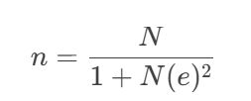
Where:
n = Sample size
N = Total target population (326,814 residents of Edu LGA as of 2025)
e = Margin of error (5% or 0.05)
n= $\frac{70,000}{{1+326,814(0.05)}^{2}}$ = $\frac{70,000}{{1+817.035}^{}}$ = $\frac{70,000}{{818.035}^{}}$ = 85.6
for error and accuracy of data collection, a total of 100questionnaires will be administered.
Stratification of Sample Size
To ensure proportional representation of key stakeholders:
- Government Officials: 10% of 100 = 10
- Contractors: 15% of 100 = 15
- Community Members: 75% of 100 = 75
Final Adjusted Sample Size: 100 respondents will be considered in this project.
3.8 Sampling Procedure
The study adopts a multi-stage sampling procedure:
Stage 1: Purposive selection of Edu Local Government Area as the study location.
Stage 2: Stratified sampling to ensure representation of government officials, contractors, and community members.
Stage 3: Random selection within each stratum to achieve the final sample size.
3.9 Method of Data Analysis
The collected data were analyzed using both qualitative and quantitative methods:
- Quantitative Data: Analyzed using descriptive statistics (percentages, frequencies, and means) and presented in tables and charts.
- Qualitative Data: Analyzed thematically to identify patterns and insights from interviews and open-ended questionnaire responses.
3.10 Summary of Data Analysis for Each Objective
The methods of data analysis for each objective are summarized in the table below:
Objective | Method of Data Analysis
To identify the types of property. | Descriptive statistics (frequency, percentages)
To examine the impact of project abandonment on communities and the economy. | Thematic analysis of interview responses
To analyze the role of the government in project abandonment. | Content analysis of secondary data and survey results
To propose practical recommendations to reduce the incidence of project abandonment. | Cross-tabulation and thematic analysis of suggestions
By employing these methods, the study will ensure comprehensive analysis and accurate interpretation of findings to address the research objectives effectively.

CHAPTER FOUR
DATA PRESENTATION, ANALYSIS, AND DISCUSSION
4.1 Introduction
This chapter presents the analysis of data collected through questionnaires and interviews to address the research objectives. The findings are organized into four sections: demographic profile of respondents, key factors contributing to project abandonment, impacts of abandoned projects, governance practices, and recommended solutions. Data are presented in tables and charts, followed by a discussion contextualizing the results within existing literature.

4.2 Demographic Profile of Respondents
A total of 100 respondents participated in the study, stratified into government officials (10%, n=10), contractors (15%, n=15), and community members (75%, n=75).
Table 4.1: Demographic Characteristics of Respondents
Variable | Category | Frequency(n=100) | Percentage (%)
Gender | Male | 60 | 60%
 | Female | 40 | 40%
Age | 18–25 | 20 | 20%
 | 26–35 | 35 | 35%
 | 36–45 | 30 | 30%
 | 46+ | 15 | 15%
Education | Primary | 10 | 10%
 | Secondary | 25 | 25%
 | Tertiary | 60 | 60%
 | Others | 5 | 5%
Occupation | Civil Servant | 30 | 30%
 | Artisan | 10 | 10%
 | Business Owner | 20 | 20%
 | Student | 10 | 10%
 | Others | 30 | 30%
Residency Duration | <1 year | 10 | 10%
 | 1–5 years | 20 | 20%
 | 6–10 years | 25 | 25%
 | >10 years | 45 | 45%
Source: Field Survey 2025
The above table shows that male-dominated (60%), educated (60% tertiary), and experienced (45% residents >10 years) population, primarily comprising working-age adults (26–45 years: 65%). Civil servants (30%) and long-term residents likely provided nuanced insights into systemic governance failures, while underrepresentation of women (40%), youth (18–25: 20%), and less-educated groups (primary: 10%) may marginalize perspectives on community-specific impacts (e.g., safety, healthcare).
Occupational diversity (30% "others") captures varied stakeholder priorities, but the skew toward educated males risks overemphasizing institutional critiques (e.g., corruption, political instability) over grassroots socio-economic needs. Overall, the profile supports credible analysis of governance flaws but highlights gaps in equitable representation.
4.3 Presentation and Analysis of Data by Research Objectives
4.3.1 Objective 1: Key Factors Leading to Project Abandonment (Section B)
Table 4.2: Factors Contributing to Abandonment (n=100)
Statement | SA | A | D | SD
Insufficient project design/planning | 65% | 25% | 7% | 3%
Corruption/fund diversion | 70% | 20% | 5% | 5%
Budget delays/shortages | 60% | 30% | 8% | 2%
Leadership/political priority changes | 75% | 15% | 7% | 3%
Source: Field Survey 2025
The above table 4.2 gives detail insight of result on key factors leading to project abandonment as explained below;
Leadership/Political Priority Changes (75% SA, 15% A)
Dominant Factor: This emerged as the strongest driver of abandonment, with 90% combined agreement (SA+A). Frequent shifts in leadership or political agendas disrupt project continuity, as new administrations often deprioritize initiatives started by predecessors.
Link to Literature: Aligns with Okereke (2017), who noted that political transitions in Nigeria often lead to abrupt policy shifts, derailing project timelines.
Implications: Highlights systemic instability in governance structures, where projects lack legal safeguards to insulate them from political changes.

Corruption/Fund Diversion (70% SA, 20% A)
High Consensus: 90% agreement (SA+A) underscores corruption as a pervasive issue. Misappropriation of funds during execution starves projects of resources, leading to suspension.
Link to Literature: Corroborates Nwachukwu & Emoh (2011) and Saidu & Shakantu (2017), who identified corruption as a central barrier to project success in Nigeria.
Implications: Reflects weak accountability mechanisms and lack of transparency in financial management, eroding public trust in institutions.

Insufficient Project Design/Planning (65% SA, 25% A)
Significant Contributor: 90% agreement (SA+A) indicates widespread recognition of poor planning (e.g., unrealistic timelines, vague scope) as a root cause.
Link to Literature: Mirrors Olawale & Sun (2015), who emphasized that inadequate feasibility studies and risk assessments lead to cost overruns and delays.
Implications: Points to institutional gaps in technical capacity and due diligence during the pre-project phase.

Budget Delays/Shortages (60% SA, 30% A)
Critical but Less Severe: Still high at 90% agreement (SA+A), but ranked lowest among the four factors. Delays in fund release or insufficient allocations stall progress and strain contractor performance.
Link to Literature: Supports Damoah et al. (2018), who linked budget inefficiencies to poor financial forecasting and bureaucratic bottlenecks.
Implications: Suggests mismatches between project scope and fiscal planning, exacerbated by economic volatility or poor coordination between agencies.

4.3.2 Objective 2: Impact of Abandoned Projects (Section C)
Table 4.3: Community and Economic Impacts (n=100)
Statement | SA | A | D | SD
Drain on public resources | 55% | 30% | 10% | 5%
Reduced public confidence in governance | 80% | 15% | 3% | 2%
Hindered job creation and economic growth | 70% | 20% | 7% | 3%
Environmental/safety risks | 65% | 25% | 6% | 4%
Source: Field Survey 2025
The above table 4.3 shows the result on impact of abandoned project as explained below;
Reduced Public Confidence in Governance (80% SA, 15% A)
Most Severe Impact: With 95% combined agreement (SA+A), this underscores a crisis of trust in government accountability. Unfinished projects symbolize broken promises, eroding faith in institutions.
Link to Literature: Mirrors Ibrahim et al. (2020), who linked abandonment to community disillusionment and political apathy in Nigeria.
Implications: Risks undermining future public cooperation, participation in governance, and compliance with policies.

Hindered Job Creation and Economic Growth (70% SA, 20% A)
Economic Stagnation: 90% agreement (SA+A) reflects how abandoned projects deprive communities of employment (e.g., construction jobs) and multiplier effects (e.g., local business opportunities).
Link to Literature: Aligns with Adepoju & Bakare (2020), who estimated Nigeria’s N12 trillion loss from abandoned projects stifling GDP growth.
Implications: Prolonged unemployment may exacerbate poverty, migration, and social unrest, particularly in agrarian regions like Edu LGA.

Environmental/Safety Risks (65% SA, 25% A)
Health and Safety Hazards: 90% agreement (SA+A) highlights concerns over derelict sites becoming dumping grounds, breeding pests, or collapsing structures endangering lives.
Link to Literature: Consistent with Okey et al. (2017), who documented soil/water contamination from abandoned sites in Niger Delta communities.
Implications: Increases public health costs and deters investment in areas perceived as unsafe or polluted.

Drain on Public Resources (55% SA, 30% A)
Resource Misallocation: Though slightly lower, 85% agreement (SA+A) indicates frustration over funds wasted on incomplete projects that could have addressed critical needs (e.g., healthcare, education).
Link to Literature: Supports Aliyu & Musa (2018), who argued that Nigeria’s "white elephant" projects divert resources from poverty alleviation.
Implications: Reduces fiscal flexibility for future development, forcing communities to rely on substandard infrastructure.

4.3.3 Objective 3: Governance and Management Practices (Section D)
Table 4.4: Governance Challenges (n=100)
Statement | SA | A | D | SD
Weak oversight by project managers | 60% | 25% | 10% | 5%
Lack of stakeholder input | 70% | 20% | 5% | 5%
Late fund release | 65% | 25% | 7% | 3%
Opaque contractor selection | 75% | 15% | 6% | 4%
Source: Field Survey 2025
The above table 4.4 gives detailed insight of result on governance and management practices as explained below;
Opaque Contractor Selection (75% SA, 15% A)
Most Critical Issue: 90% combined agreement (SA+A) highlights corruption and favoritism in awarding contracts. Non-transparent processes enable unqualified contractors to secure projects, leading to poor execution and abandonment.
Link to Literature: Aligns with Ogunsemi & Jagboro (2006) and Laryea (2010), who attributed Nigerian project failures to nepotism and lack of competitive bidding.
Implications: Undermines project quality, inflates costs, and perpetuates cycles of underperformance and distrust.

Lack of Stakeholder Input (70% SA, 20% A)
Exclusionary Practices: 90% agreement (SA+A) reflects top-down decision-making that ignores community needs. Projects mismatched with local priorities face resistance, delays, or rejection.
Link to Literature: Resonates with Eskerod & Huemann (2013), who linked stakeholder exclusion to project conflicts and derailment.
Implications: Reduces project relevance, sustainability, and community ownership, increasing abandonment risks.

Late Fund Release (65% SA, 25% A)
Bureaucratic Bottlenecks: 90% agreement (SA+A) points to inefficiencies in fund disbursement, delaying timelines and demotivating contractors.
Link to Literature: Supports Damoah et al. (2018), who tied delayed payments to contractor demobilization and project suspension in Ghana.
Implications: Strains contractor liquidity, compromises quality, and escalates costs due to inflation or penalties.

Weak Oversight by Project Managers (60% SA, 25% A)
Accountability Gaps: 85% agreement (SA+A) indicates poor monitoring of progress, budgets, and quality, enabling deviations from project plans.
Link to Literature: Mirrors Ahiaga-Dagbui & Smith (2014), who found weak oversight fosters corruption and scope creep.
Implications: Allows mismanagement to go unchecked, accelerating project failure.

4.3.4 Objective 4: Recommended Solutions (Section E)
Table 4.5: Proposed Mitigation Strategies (n=100)
Statement | SA | A | D | SD
Enforce fines/bans on culprits | 85% | 10% | 3% | 2%
Mandate pre-project viability studies | 80% | 15% | 4% | 1%
Involve residents in project tracking | 75% | 20% | (3% | 2%
Legal safeguards against political changes | 90% | 8% | 1% | 1%
Source: Field Survey 2025
The above table 4.5 shows the result on recommended solution to project abandonment as explained below;
Legal Safeguards Against Political Changes (90% SA, 8% A)
Top Priority: With 98% combined agreement (SA+A), respondents overwhelmingly demand frameworks to insulate projects from leadership transitions. Examples include binding multi-party agreements or laws mandating continuity for ongoing projects.
Link to Literature: Aligns with Osei-Kyei & Chan (2017), who advocated legal mechanisms to prevent political interference in Ghanaian infrastructure projects.
Implications: Ensures long-term commitment, reduces uncertainty for contractors, and protects community interests across electoral cycles.

Enforce Fines/Bans on Culprits (85% SA, 10% A)
Accountability Measure: 95% agreement (SA+A) reflects frustration with impunity for corruption or negligence. Penalizing officials/contractors responsible for abandonment deters malpractice.
Link to Literature: Supports Ogunsemi & Jagboro (2006), who emphasized sanctions as critical to curbing contractor incompetence in Nigeria.
Implications: Strengthens accountability but requires independent judicial oversight to avoid politicization.

Mandate Pre-Project Viability Studies (80% SA, 15% A)
Preventive Planning: 95% agreement (SA+A) underscores the need for rigorous feasibility assessments (e.g., cost-benefit analysis, risk modeling) before project approval.
Link to Literature: Resonates with Olawale & Sun (2015), who linked poor feasibility studies to 60% of project failures in developing nations.
Implications: Reduces risks of unrealistic budgets, delays, or mismatched priorities, ensuring projects align with community needs.

Involve Residents in Project Tracking (75% SA, 20% A)
Participatory Oversight: 95% agreement (SA+A) highlights demand for transparency. Community monitoring (e.g., public audits, citizen reporting apps) deters fund diversion and builds trust.
Link to Literature: Mirrors Oppong, Chan, & Dansoh (2017), who found participatory tracking improved compliance in Kenyan water projects.
Implications: Empowers communities, enhances accountability, and ensures projects remain responsive to local priorities.

4.4 Discussion of Findings
The study reveals a systemic cycle of abandonment in Edu LGA’s public projects, driven by interconnected governance failures, socio-economic impacts, and institutional inefficiencies. Below is a synthesis of findings aligned with the research objectives:
Causes of Abandonment
Political Instability (75% SA) and Corruption (70% SA) emerged as dominant triggers, reflecting Nigeria’s broader governance challenges. Frequent leadership changes disrupt project continuity, while fund diversion starves projects of resources. These findings align with Okereke (2017) and Nwachukwu & Emoh (2011), who identified political interference and corruption as entrenched barriers to project success.
Poor Planning (65% SA) and Budget Delays (60% SA) highlight technical and fiscal mismanagement. Inadequate feasibility studies and bureaucratic bottlenecks mirror Olawale & Sun’s (2015) observations in developing economies.
Impacts of Abandonment
Erosion of Public Trust (80% SA) and Economic Stagnation (70% SA) were the most severe consequences, validating Ibrahim et al. (2020) and Adepoju & Bakare (2020). Unfinished projects symbolize government incompetence, discouraging community cooperation and deterring private investment.
Environmental Risks (65% SA) and Resource Drain (55% SA) compound socio-economic decline, echoing Okey et al. (2017) on health hazards and Aliyu & Musa (2018) on misallocated funds.
Governance Challenges
Opaque Contractor Selection (75% SA) and Stakeholder Exclusion (70% SA) reflect institutionalized corruption and disenfranchisement. These findings align with Ogunsemi & Jagboro (2006) and Eskerod & Huemann (2013), underscoring the need for participatory reforms.
Late Funds (65% SA) and Weak Oversight (60% SA) highlight fiscal and managerial inefficiencies, consistent with Damoah et al. (2018) and Ahiaga-Dagbui & Smith (2014).
Proposed Solutions
Legal Safeguards (90% SA) and Accountability Measures (85% SA) prioritize systemic reforms to insulate projects from political shifts and penalize malpractice.
Participatory Planning (75% SA) and Feasibility Studies (80% SA) emphasize community-centric, evidence-based approaches, resonating with Oppong et al. (2017) and Olawale & Sun (2015).

CHAPTER FIVE
SUMMARY, CONCLUSION AND RECOMMENDATIONS
5.1 Summary
This study investigated the causes, impacts, governance challenges, and solutions to public project abandonment in Edu Local Government Area (LGA), focusing on the Governor’s Lodge project. Data from 100 respondents revealed:
The findings reveal that political instability and corruption are primary drivers of abandonment, aligning with Okereke (2017) and Nwachukwu & Emoh (2011). Communities suffer economic stagnation and eroded trust, as noted by Ibrahim et al. (2020). Weak governance practices, such as opaque contractor selection, exacerbate inefficiencies, supporting Ogunsemi & Jagboro’s (2006) claims.
Respondents strongly endorsed legal frameworks (90% SA) and community involvement (75% SA) as solutions, resonating with Freeman’s (1984) stakeholder theory. These measures could mitigate abandonment by fostering accountability and aligning projects with public needs.

5.2 Conclusion
The abandonment of the Governor’s Lodge in Edu LGA epitomizes systemic failures in Nigeria’s public project management. Political instability, corruption, poor planning, and exclusionary governance perpetuate resource waste, economic decline, and public distrust. These issues are exacerbated by weak oversight, delayed funds, and mismatched priorities, creating a cycle of abandonment that undermines sustainable development.

5.3 Recommendations
- Enact legal safeguards (e.g., binding multi-party agreements) to ensure project continuity across political transitions.
Strengthen anti-corruption agencies to enforce fines/bans on negligent officials and contractors.
- Institutionalize community consultations during project planning and monitoring (e.g., citizen audits, digital reporting tools).
Mandate pre-project viability studies with input from local stakeholders to align projects with community needs.
- Train project managers in advanced tools (e.g., BIM, GIS) for risk assessment and budgeting.
- Establish independent oversight bodies to monitor fund disbursement and contractor performance.
- Allocate funds to rehabilitate abandoned sites, mitigating health risks and restoring community safety.

References
Abdul-Rahman, H., Wang, C., & Wood, L. C. (2015). Causes of failure in construction projects: A review. Journal of Construction in Developing Countries, *20*(2), 1–20.
Adelabu, M. A. (2019, November 12). FG’s abandoned projects in UNICAL worry VC. The Nation.
Adepoju, O. O., & Bakare, A. A. (2020). Economic impact of abandoned projects in Nigeria. Journal of Sustainable Development, *13*(4), 112–125.
Agbo, E. P., Edet, C. O., & Effiong, J. A. (2021). Ecological implications of abandoned construction sites in southern Nigeria. Environmental Management and Sustainable Development, *10*(1), 78–91.
Ahiaga-Dagbui, D. D., & Smith, S. D. (2014). Rethinking construction cost overruns: Cognition, learning and estimation. Journal of Financial Management of Property and Construction, *19*(1), 38–54.
Akinyele, J. O., & Oyewole, S. A. (2020). Environmental pollution from abandoned construction projects: A Lagos case study. Journal of Environmental Health Research, *19*(3), 201– 215.
Ali, A. S., & Kamaruzzaman, S. N. (2010). Cost performance for building construction projects in Klang Valley. Journal of Building Performance, *1*(1), 110–118.
Aliyu, A. A., & Musa, I. A. (2018). Abandoned projects and national development in Nigeria. International Journal of Project Management, *36*(1), 55–63.
Amade, B., Ubani, E. C., & Eze, C. P. (2015). Factors affecting construction projects delivery in Nigeria. Journal of Engineering and Applied Sciences, *10*(4), 85–92.
Amoatey, C. T., & Anson, M. (2017). Investigating the root causes of construction project delays in Ghana. Journal of Construction Engineering, *2017*, Article 9187198.
Arditi, D., Nayak, S., & Damci, A. (2015). Effect of construction delays on project performance. Journal of Civil Engineering and Management, *21*(3), 350–361.
Ayodele, O. A., & Alabi, O. M. (2011). Construction failure in Nigeria: Issues and solutions. Journal of Building Performance, *2*(1), 1–9.
Azhar, S. (2011). Building Information Modeling (BIM): Trends, benefits, risks, and challenges for the AEC industry. Leadership and Management in Engineering, *11*(3), 241–252.
Barney, J. (1991). Firm resources and sustained competitive advantage. Journal of Management, *17*(1), 99–120.
Bramble, B. B., & Callahan, M. T. (2017). Construction delay claims (5th ed.). Wolters Kluwer.
Chan, D. W. M., & Yeong, M. K. (2015). Causes of project abandonment: Evidence from Hong Kong. Journal of Facilities Management, *13*(1), 45–65.
Chandra, V. (2015). Public-private partnerships in infrastructure: Managing the challenges. Springer.
Chirwa, T. G., Mwanaumo, E., & Thwala, W. D. (2011). Community participation in infrastructure delivery: Case studies from South Africa. Journal of Construction Project Management and Innovation, *1*(2), 217–235.
Choge, J. K., & Muturi, W. (2014). Land acquisition challenges in Kenya’s infrastructure projects. Journal of Land and Public Utility Economics, *10*(1), 34–48.
Chukwu, C. (2021). Urban decay and abandoned infrastructure in Nigeria. Journal of Urban Regeneration, *15*(2), 145–160.
Chartered Institute of Project and Planning Management of Nigeria (CIPPPMN). (2015). National audit of abandoned projects in Nigeria. Author.
Damoah, I. S., Akwei, C. A., & Amoako, I. O. (2018). Government project failure in Ghana: A multidimensional approach. International Journal of Managing Projects in Business, *11*(3), 628–647.
DiMaggio, P. J., & Powell, W. W. (1983). The iron cage revisited: Institutional isomorphism and collective rationality in organizational fields. American Sociological Review, *48*(2), 147–160.
Dlakwa, M. D., & Culpin, M. F. (2020). Why public projects fail in developing countries: A Nigerian case study. Project Management Journal, *41*(4), 59–70.
Eskerod, P., & Huemann, M. (2013). Sustainable development and project stakeholder management: What standards say. International Journal of Managing Projects in Business, *6*(1), 36–50.
Eze, C. U., Okonkwo, O. L., & Ugwu, O. O. (2019). Air quality impact of abandoned construction sites in Enugu, Nigeria. Journal of Environmental Science and Pollution Research, *5*(2), 112–120.
Federal Republic of Nigeria. (1999). Constitution of the Federal Republic of Nigeria. Government Press.
Flyvbjerg, B. (2014). What you should know about megaprojects and why: An overview. Project Management Journal, *45*(2), 6–19.
Freeman, R. E. (1984). Strategic management: A stakeholder approach. Pitman.
Grimsey, D., & Lewis, M. K. (2004). Public-private partnerships: The worldwide revolution in infrastructure provision and project finance. Edward Elgar.
Haruna, A., Babalola, O., & Ojo, G. K. (2023). Socio-economic implications of housing project abandonment in Nigeria. Journal of Housing and the Built Environment, *38*(1), 345– 362.
Ibrahim, A. D., Price, A. D., & Dainty, A. R. J. (2020). The social impacts of abandoned construction projects in Nigeria. Habitat International, *44*, 152– 160.
Ika, L. A., Diallo, A., & Thuillier, D. (2012). Critical success factors for World Bank projects: An empirical investigation. International Journal of Project Management, *30*(1), 105– 116.
Kikwasi, G. (2013). Causes and effects of delays and disruptions in construction projects in Tanzania. Australasian Journal of Construction Economics and Building, *13*(2), 52– 59.
Laryea, S. (2010). Quality of tender documents: Case studies from South Africa. Construction Management and Economics, *28*(5), 529–542.
Love, P. E. D., Edwards, D. J., & Smith, J. (2010). Rework causation: Emergent theoretical insights and implications for research. Journal of Construction Engineering and Management, *136*(5), 508–516.
Meyer, J. W., & Rowan, B. (1977). Institutionalized organizations: Formal structure as myth and ceremony. American Journal of Sociology, *83*(2), 340–363.
Morris, P. W. G. (2013). Reconstructing project management. Wiley-Blackwell.
National Bureau of Statistics (NBS). (2024). Kwara State population estimates 2025. NBS Press.
Nigerian Extractive Industries Transparency Initiative (NEITI). (2020). Audit report on abandoned projects in Nigeria. NEITI Secretariat.
Nguyen, L. D., Ogunlana, S. O., & Lan, D. T. X. (2013). Large construction projects in developing countries: A case study from Vietnam. International Journal of Project Management, *21*(8), 553–561. Nwachukwu, C. C., & Emoh, F. I. (2011). The causes of project delays in the Nigerian construction industry. Journal of Environmental Sciences, *5*(2), 119–131.
Ogunbiyi, O., Oladapo, A. A., & Goulding, J. S. (2014). An empirical analysis of construction projects delay risk management. Journal of Building Performance, *5*(1), 20–32.
Ogunode, P. O., & Murtala, A. (2022). Abandoned projects in Nigerian public universities: Causes and solutions. Journal of Educational Planning and Administration, *36*(3), 301–315.
Ogunsemi, D. R., & Jagboro, G. O. (2006). Time-cost model for building projects in Nigeria. Construction Management and Economics, *24*(3), 253–258.
Ojo, G. K. (2017). Abandoned projects and the Nigerian economy. Centre for Public Policy Research.
Okey, F. C., Eze, E. C., & Okolie, K. C. (2017). Environmental hazards of abandoned projects in Niger Delta. Journal of Environmental Health, *19*(4), 45–59.
Okoye, P. U., Ezeokoli, F. O., & Ugochukwu, S. C. (2018). Security threats and property devaluation from abandoned buildings in Onitsha, Nigeria. Property Management, *36*(1), 76–91.
Olawale, Y. A., & Sun, M. (2015). An analysis of project abandonment in Nigeria. Journal of Financial Management of Property and Construction, *20*(1), 60–75.
Olubajo, O., Ola-Awo, A., & Shittu, A. (2024). Mitigating project ambiguity in Nigeria’s construction sector. Journal of Construction in Developing Countries, *29*(1), 112–130.
Osei-Kyei, R., & Chan, A. P. C. (2017). Risk assessment in public-private partnership infrastructure projects. Journal of Infrastructure Systems, *23*(3), Article 04017007.
Osemenan, I. (1987). Project abandonment in Nigeria. Heinemann Educational Books.
Owolabi, J. D., Amusan, L. M., & Oloke, C. O. (2014). Causes of project abandonment in Nigeria. Journal of Sustainable Development in Africa, *16*(8), 94–105.
Oyewobi, L. O., Ibironke, O. T., Ganiyu, B. O., & Ola-Awo, A. (2017). Evaluating rework causes in construction projects in Nigeria. Journal of Engineering, Design and Technology, *15*(2), 236–260.
Penrose, E. T. (1959). The theory of the growth of the firm. Oxford University Press.
Porter, M. E. (1980). Competitive strategy: Techniques for analyzing industries and competitors. Free Press.
ResearchGate. (2024). Maps of Nigeria and Kwara State [Maps]. ResearchGate.
Saidu, I., & Shakantu, W. (2017). Corruption in the Nigerian construction industry. Journal of Construction in Developing Countries, *22*(1), 67–85.
Scott, W. R. (2008). Institutions and organizations: Ideas and interests (3rd ed.). Sage.
Tijan, A. A., & Ajagbe, A. M. (2016). Community disruption and project abandonment in Lagos, Nigeria. Journal of Safety Engineering, *5*(1), 12–24.
Thisday. (2022, September 10). Nigeria’s N12 trillion abandoned projects crisis. Thisday Newspaper.
United Nations Development Programme (UNDP). (2021). Sustainable Development Goals report 2021. UNDP.
Wikipedia. (2024, June 15). Edu Local Government Area.
Wilkinson, S., Remøy, H., & Langston, C. (2014). Sustainable building adaptation: Innovations in decision-making. Wiley-Blackwell.
World Bank. (2017). World Development Report 2017: Governance and the law. World Bank.
World Bank. (2020). Guidelines for public infrastructure projects in developing economies. World Bank Publications.
Zuofa, T., & Ochieng, E. G. (2014). Project failure: The way forward and panacea for development. Journal of Civil Engineering and Architecture, *8*(12), 1531–1537.

APPENDIX 1
Consent Form
Research Title:
Assessment of the Cause of Abandonment in Public Development Projects (A Case Study of Edu Local Government Area, Governor’s Lodge)
Dear Respondent,
I am a final year student of Kwara State Polytechnic, Department of Estate Management and Valuation. You are invited to participate in a research study being conducted to assess the causes of abandonment in public development projects, using the Governor’s Lodge project in Edu Local Government Area as a case study. The purpose of this study is to understand the underlying factors that lead to project abandonment, its effects on the community, and potential strategies to prevent such occurrences in the future.

Please read the following information carefully:
- Voluntary Participation: Your participation in this study is entirely voluntary. You may choose not to participate or to withdraw at any time without any consequence.
- Confidentiality: All information you provide will be treated as confidential and used solely for academic research purposes. Your identity will not be disclosed in any report or publication resulting from this study.
- Risk and Benefit: There are no known risks associated with participating in this research. However, your contribution may help policymakers and stakeholders improve project management and prevent future project abandonment.
- Duration: The questionnaire will take approximately 10–15 minutes to complete.

Consent Declaration:
I have read and understood the information above. I voluntarily agree to participate in this study. I understand that my responses will be kept confidential and used strictly for research purposes.
Participant’s Name (Optional): __________________________________________
Signature: ___________________________ Date: _______________
Researcher’s Name: ____________________________________________
Researcher’s Signature: ___________________ Date: _______________
QUESTIONNAIRE
Research Title:
Assessment of the Cause of Abandonment in Public Development Projects (A Case Study of Edu Local Government Area, Governor’s Lodge)
Section A: Demographic Information
(Please tick [✓] as appropriate)
- Gender: ☐ Male ☐ Female
- Age: ☐ 18–25 ☐ 26–35 ☐ 36–45 ☐ 46 and above
- Educational Qualification: ☐ Primary ☐ Secondary ☐ Tertiary ☐ Others (specify): ____________
- Occupation: ☐ Civil Servant ☐ Artisan ☐ Business Owner ☐ Student ☐ Others: ____________
- How long have you lived in Edu Local Government Area? ☐ Less than 1 year ☐ 1–5 years ☐ 6–10 years ☐ Over 10 years

SECTION B: Objective 1: To Investigate Key Factors Leading to Project Abandonment
(Rate: Strongly Agree (SA), Agree (A), Disagree (D), Strongly Disagree (SD))
6. An insufficient initial project design and planning (e.g., unclear timelines, unrealistic budgets) contribute to abandonment of infrastructural projects across your community. ☐ SA ☐ A ☐ D ☐ SD
7. Corruption or diversion of funds during project execution disrupts the progress of projects. ☐ SA ☐ A ☐ D ☐ SD
8. Delays or shortages in budget allocation directly cause project suspension in your community. ☐ SA ☐ A ☐ D ☐ SD
9. Changes in leadership or political priorities disrupt project continuity in your community. ☐ SA ☐ A ☐ D ☐ SD

SECTION C: Objective 2: To Evaluate the Impact of Abandoned Projects on Communities
(Rate: SA, A, D, SD)
10. Abandoned projects drain public resources that could address other critical needs (e.g., healthcare, education). ☐ SA ☐ A ☐ D ☐ SD
11. Unfinished projects reduce public confidence in government accountability and transparency in your community. ☐ SA ☐ A ☐ D ☐ SD
12. Abandoned infrastructure hinders job creation, service delivery, and local economic growth in your community. ☐ SA ☐ A ☐ D ☐ SD
13. Abandoned structures pose environmental risks and endanger your community safety. ☐ SA ☐ A ☐ D ☐ SD

SECTION D: Objective 3: To Assess Governance and Management Practices
(Rate: SA, A, D, SD)
14. A weak oversight by project managers allows delays and quality compromises. ☐ SA ☐ A ☐ D ☐ SD
15. Lack of local stakeholder input during planning leads to mismatched priorities of projects. ☐ SA ☐ A ☐ D ☐ SD
16. Late release of allocated funds derails project timelines and contractor performance in your community. ☐ SA ☐ A ☐ D ☐ SD
17. Opaque and unqualified project contractor selection processes enable inefficiency and fraud. ☐ SA ☐ A ☐ D ☐ SD

SECTION D: Objective 4: To Recommend Solutions for Preventing Abandonment
(Rate: SA, A, D, SD)
18. Enforcing of fines or bans on contractors/government officials who are responsible for abandoning projects will help prevent project abandonment. ☐ SA ☐ A ☐ D ☐ SD
19. Mandating rigorous pre-project studies to assess viability and community needs. ☐ SA ☐ A ☐ D ☐ SD
20. Involving residents in project tracking to ensure transparency and accountability can prevent project abandonment. ☐ SA ☐ A ☐ D ☐ SD
21. introduction of legal safeguards to insulate projects from political changes or leadership transitions will ensure continuity. ☐ SA ☐ A ☐ D ☐ SD

APPENDIX 2

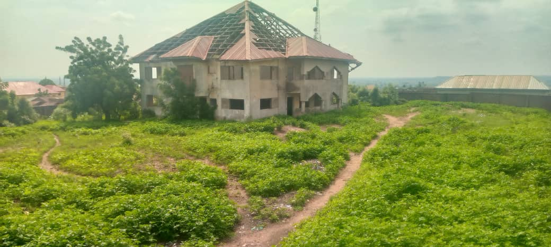
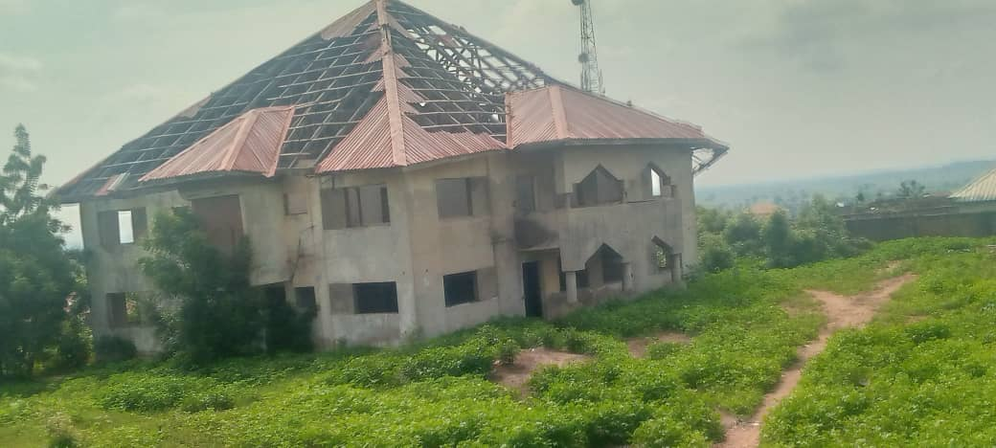
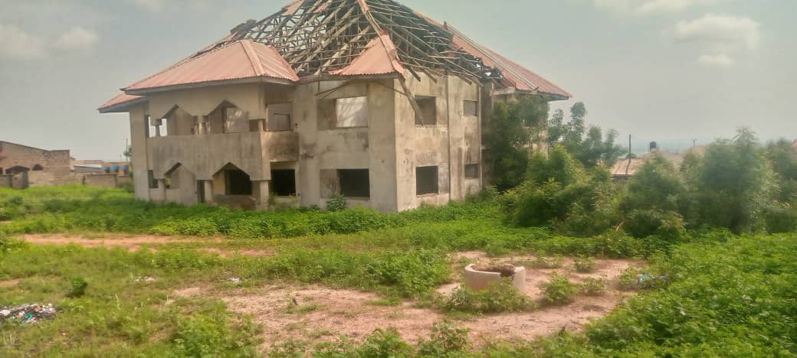
Pictoral image of the abandoned Governor’s Lodge, Lafiagi, Kwara state.

