

A
PROJECT
ON

ESTIMATION OF ULTRAVIOLET RADIATION USING DEW POINT TEMPERATURE DATA AT A LOCATION IN THE TROPICS ILORIN, KWARA STATE, NIGERIA

PREPARED BY

OLANIYAN EMMANUEL OLUWATOSIN
HND/23/SLT/FT/0161

SUBMITTED TO THE
DEPARTMENT OF SCIENCE LABORATORY TECHNOLOGY (PHYSICS AND ELECTRONICS UNIT), INSTITUTE OF APPLIED SCIENCES, KWARA STATE POLYTEHNIC, ILORIN.

IN PARTIAL FULFILMENT FOR THE AWARD OF HIGHER NATIONAL DIPLOMA (HND) IN SCIENCE LABORTORY TECHNOLOGY

SUPERVISED BY:
MR. ABDULKAREEM USMAN

2024/2025 SESSION
CERTIFICATION
This is to certify that this project work has been written by OLANIYAN EMMANUEL OLUWATOSIN with matric number HND/23/SLT/FT/0161 and has been read and approved as meeting the parts of the requirements for the award of Higher National Diploma (HND) in Science Laboratory technology Department, Institute of Applied Sciences, Kwara State Polytechnic.

_____________________________ ___________________
MR. ABDULKAREEM USMAN DATE
(Project Supervisor)

_____________________________ ___________________
MR SALAHU BASHIRU DATE
(Head of Unit)

_____________________________ ___________________
MR. ABULKAREEM USMAN DATE
(Head of Department)

_____________________________ ___________________
EXTERNAL EXAMINER DATE

DEDICATION
This work is dedicated to Almighty God, for his grace, mercy and guidance over me before and during and after the completion of my academic pursuit. All Glory to God and my Supervisor (Mr. Usman A.) also to my parents who has never failed to give me financial and moral support for all my needs during the time I developed my system and for teaching me that even the largest task can be accomplished if it is done one step as a time.

ACKNOWLEDGEMENT
I express my sincere gratitude to God Almighty for the success of this project. I also express my sincere gratitude to our parent (Mr. and Mrs. Olaniyan) and siblings for supporting me through the cause of this project. My gratitude to Mr. Usman A. for his time and supporting in monitoring and supervising me through this project. Thank you for shaping this project and enhancing my learning experience.

TABLE OF CONTENTS
Page
TITLE PAGE I
CERTIFICATION II
DEDICATION III
ACKNOWLEDGEMENT IV
TABLE OF CONTENTS V
ABSTRACT VII
CHAPTER ONE: INTRODUCTION
1.1 GENERAL BACKGROUND 1
1.2 RELEVANCE OF ULTRAVIOLET RADIATION 1
1.3 DEW POINT TEMPERATURE 2
1.4 STATEMENT OF PROBLEM 2
1.5 OBJECTIVES OF RESEARCH 3
1.6 JUSTIFICATION FOR THE RESEARCH 3
1.7 EXPECTED CONTRIBUTION TO KNOWLEDGE 3
CHAPTER TWO: LITERATURE REVIEW 4
CHAPTER THREE: THEORETICAL BACKGROUND
3.1 ULTRAVIOLET RADIATION 9
3.2 DEW POINT TEMPERATURE 11
3.3 ESTIMATION FOR UV_{P}
3.3.1 EQUATION FOR ULTRAVIOLET RADIATION DETERMINATION 13 3.4 14
CHAPTER FOUR: METHODOLOGY
4.1 PRE-FIELD EXPERIMENTAL WORK 15
4.2 SITE DESCRIPTION 16
4.3 FIELD MEASUREMENTS 16
4.4 PHOTOMETER AND PSYCHROMETER 16
4.5 DATA ACQUISITION AND REDUCTION 17
4.5.1 DATA LOGGING OF THE SAMPLE DATA 17
4.5.2 PRE-PROCESSING OF THE RAW DATA 18
CHAPTER FIVE: RESULTS AND DISCUSSION
5.1 DIURNAL OF ULTRAVIOLET RADIATION AND 19
DEW POINT TEMPERATURE
5.2 ESTIMATION OF ULTRAVIOLET RADIATION FROM 27
DEW POINT TEMPERATURE
CHAPTER SIX: SUMMARY AND CONCLUSIONS
6.1 SUMMARY AND CONCLUSIONS 30
REFERENCES 31

ABSTRACT
Radiation generally is the emission or transmission of energywaves or particlesagro–climatological researches. This research was carried out at a tropical location (Kwara state polytechnic) in Ilorin, Kwara state. The instruments used for this research are Photometer and Psychrometer. The measurements were taken for a period of two weeks (10th – 23rd May, 2025). The data were recorded at every 30 minutes and were reduced to hourly measurement. For the period under consideration, the highest value of ultraviolet radiation for this research is 250 Wm⁻². The parametric equation obtain in this research was found to be: UV_{p}= -1.737 (DTp) + 75.686.
CHAPTER ONE
1.0 INTRODUCTION
1.1 GENERAL BACKGROUND
Radiation is the emission or transmission of energy in the form of waves or particles through space or through a material medium. Ultraviolet (UV) radiation is a form of electromagnetic radiation that comes from the sun and man-made sources like tanning beds and welding torches (Weisstein, 2014).
Ultraviolet (UV) radiation is similar to visible light in all physical aspects, except that it does not enable us to see things. The light that enables us to see things is referred to as visible light and is composed of the colors we see in a rainbow. The ultraviolet region starts right after the violet end of the rainbow. In scientific terms, UV radiation is electromagnetic radiation just like visible light, radar signals and radio broadcast signals. Electromagnetic radiation is transmitted in the form of waves. The waves can be described by their wavelength or frequency and their amplitude (the strength or intensity of the wave). Wavelength is the length of one complete wave cycle. For radiation in the UV region of the spectrum, wavelengths are measured in nanometers (nm), where 1 nm = one millionth of a millimeter (Jemal et al., 2010).
Different wavelengths of electromagnetic radiation cause different types of effects on people. For example, gamma rays are used in cancer therapy to kill cancerous cells and infrared light can be used to keep you warm.
UV radiation has shorter wavelengths (higher frequencies) compared to visible light but have longer wavelengths (lower frequencies) compared to X-rays (Bellenir, 2007).
1.2 Relevance of Ultraviolet Radiation
Ultraviolet, of wavelengths from 10 nm to 125 nm, ionizes air molecules, causing it to be strongly absorbed by air and by ozone (O₃) in particular. Ionizing UV therefore does not penetrate Earth's atmosphere to a significant degree, and is sometimes referred to as vacuum ultraviolet. Although present in space, this part of the UV spectrum is not of biological importance, because it does not reach living organisms on Earth (Bellenir, 2007).
There is a zone of the atmosphere in which ozone absorbs some 98% of non-ionizing but dangerous UV-C and UV-B. This so-called ozone layer starts at about 20 miles (32 km) and extends upward. Some of the ultraviolet spectrum that does reach the ground is non-ionizing, but is still biologically hazardous due to the ability of single photons of this energy to cause electronic excitation in biological molecules, and thus damage them by means of unwanted reactions (Bellenir, 2007).
1.3 DEW POINT TEMPERATURE
Dew point temperature (DPT) is a weather condition that happens when the air is fully saturated with water vapor and the number of water molecules evaporating from any surface is in equilibrium with the number of molecules condensing (Ben-Asher et al., 2010). Fluctuations of DPT in combination with other weather parameters have a remarkable potential impact on regional agriculture, water supplies, and human well-being. In addition, it serves as an essential variable to model precipitation and frost processes.
Further, DPT also influences crop yields by the spread of many pathogens through free moisture. Nevertheless, a slow rate of drop in the dew point temperature results in evaporative cooling and, conversely, a rise in DPT intensifies the impacts of heat waves on the environment (Ben-Asher et al., 2010).
1.4 STATEMENT OF PROBLEM
Ultraviolet Radiation is that portion of the electromagnetic spectrum extending from the violet, or short-wavelength, end of the visible light range to the X-ray region.
Ultraviolet (UV) radiation is undetectable by the human eye, although, when it falls on certain materials, it may cause them to fluoresce i.e., emit electromagnetic radiation of lower energy, such as visible light. Many insects, however, are able to see ultraviolet radiation. It is however necessary to obtain the ultraviolet radiation from routine measurement as it involves changes in the dew point temperature. This study, therefore, intends to obtain ultraviolet radiation from values of dew point temperature measured.
1.5 OBJECTIVES OF THE RESEARCH
The Specific objectives of the research are to:
- Measure ultraviolet radiation and dew point temperature
- Observe the diurnal variation of measure ultraviolet radiation and dew point temperature
- Obtain a parametric equation of ultraviolet radiation from dew point temperature
- Validate the parametric equation obtained in (iii) above.
1.6 JUSTIFICATION FOR THE RESEARCH
Estimation of ultraviolet radiation from dew point temperature such as we have in this study is very useful in estimating ultraviolet radiation without necessarily passing through the experimental ways of measuring the ultraviolet radiation.
1.7 EXPECTED CONTRIBUTION TO KNOWLEDGE
The results of this study will provide empirical relationships that can be useful to determine ultraviolet radiation from the routinely measured dew point temperature data. This directly affects evapotranspiration and will be useful to agro-meteorologist, climate modeling and water resources management.

CHAPTER TWO
LITERATURE REVIEW
Exposure to UVR is not always considered bad. In fact, UVR has been found to be particularly helpful in treating vitamin D deficiency, seasonal affective disorders, psoriasis, sarcoidosis, mycosis fungoides, and numerous other cutaneous conditions (Gleeson et al., 2011).
An example is the formation of pyrimidine dimers in DNA, which begins at wavelengths below 365 nm (3.4 eV), which is well below ionization energy. This property gives the ultraviolet spectrum some of the dangers of ionizing radiation in biological systems without actual ionization occurring. In contrast, visible light and longer-wavelength electromagnetic radiation, such as infrared, microwaves, and radio waves, consists of photons with too little energy to cause damaging molecular excitation, and thus this radiation is far less hazardous per unit of energy (Gleesonet al., 2011).
Vitamin D is important for calcium absorption from the intestinal tract to help maintain strong bones. Vitamin D has to go through a series of steps to become activated and useful within the body. Within the epidermis, 7-dehydrocholesterol is converted to vitamin D (cholecalciferol) by UVB light. Then through a series of steps in the liver and kidneys, vitamin D's activated component 1,25dihydroxyvitamin D₃ stimulates intestinal absorption of calcium. Short and limited solar exposure is usually sufficient to maintain adequate vitamin D levels. The elderly and young children are the ones who are particularly susceptible to vitamin D deficiency. Vitamin D deficiency can lead to rickets in children, osteomalacia in adults, osteopenia/osteoporosis, and factures in the elderly. The Institute of Medicine recommends the following vitamin D allowances: 400 IU for 0 to 12 months, 600 IU for 1 to 70 years, and 800 IU for greater than 70 years (IOM, 2011).
Light therapy is an inexpensive treatment and can be beneficial in treating certain diseases. The use of UVR in the treatment of some patients with seasonal affective disorders has been successful. In fact, a meta-analysis of randomized trials found that bright light and dawn stimulation therapies reduce the severity of depression in patients with seasonal affective disorder. Additionally, difficult-to-treat psoriasis patients sometimes find relief with UVR. It is thought that UVR has both ant proliferative and anti-inflammatory effects through down regulation of T-cell response to antigens. Studies have also shown improvement of the cutaneous effects of sarcoidosis with UVA-1 light and topical psoralen plus UVA (PUVA) therapy. PUVA and narrowband UVB has been shown to induce and maintain remissions of mycosis fungoides (Querfeld et al., 2005).
The negative effects of the sun have been documented in the literature. Chronic sun exposure creates premature cutaneous aging, decreases immune response to environmental pathogens, and increases the risk for developing premalignant and malignant neoplasms. On the molecular level, exposure to UV radiation can result in a covalent joining of pyrimidine (usually thymine) dimers. If deoxyribonucleic acid (DNA) repair mechanisms, such as nucleotide excision repair, base excision repair, or mismatch repair genes, do not recognize dimers, the mutations go uncorrected to the cell cycle. When mutated genes reach the cell cycle, if not repaired by the induction of the p53 pathway, a series of changes can result in malignant transformation and immunosuppression (Matsumura, 2004).
UV-induced immunosuppression contributes to skin cancer due to damage to DNA and inhibition of protective mechanism within the skin. A common type of sun-related skin damage is actinic keratosis (AK). Age, Fitzpatrick skin type 1 or 2, and UV light are the major risk factors for developing AK. Most AKs do not progress into invasive squamous cell carcinoma (SCC), but the risk is still present. The risk of malignant transformation of an AK to SCC within one year is approximately 1 in 1,000. However, approximately 60 percent of invasive SCCs of the skin probably arise from AKs. If not treated or protected against additional sun damage, AKs may eventually progress to invasive SCC. Avoiding sun exposure and daily application of sunscreen statistically decreases the number of AKs (Naylor et al., 1995).
The dew point is that temperature below which the water vapor in a body of air cannot all remain vapor. When a body of air is cooled to its dew point or below, some fraction of its water vapor shifts from gaseous to liquid phase to form fog or cloud droplets. If a smooth surface is available, vapor condenses directly onto it as drops of water (dew). The dew point of a body of air depends on its water vapor content and pressure. Increasing the fraction of water vapor in air (i.e., its relative humidity) raises its dew point; the water molecules are more crowded in humid air and thus more likely to coalesce into a liquid even at a relatively warm temperature. Decreasing the pressure of air lowers its dew point; lowering pressure (at constant temperature) increases the average distance between molecules and makes water vapor less likely to coalesce (Ahmad et al., 2017).
If the dew point of a body of air is below 32°F (0°C), its water vapor will precipitate not as liquid water but as ice. In this case, the dew point is termed the frost point.
Air at ground level often deposits dew on objects at night as it cools. In this case, the dew point of the air remains approximately constant while its temperature drops. When the dew point is reached, dew forms. Ground mist and fog may also form under these conditions (Ahmad et al., 2017).
The dew point can be measured using an instrument called a dew-point hygrometer. Invented in 1751, this consists essentially of a glass with a thermometer inserted. The glass is filled with ice water and stirred. As the temperature of the glass drops, the air in contact with it is chilled; when it reaches its dew point, water condenses on the glass. The temperature at which condensation occurs gives the dew point of the surrounding air.
Dew point temperature is the temperature at which water vapor in the air will condense into dew, frost, or water droplets given a constant air pressure. It can be defined alternately as the temperature at which the saturation vapor pressure and actual vapor pressure are equal. Dew point temperature together with relative humidity can be used to determine the moisture content in the air. A dew point temperature below 0°C is referred to as the frost point because frost is produced when the air cools to that temperature.
One of the earliest climatological studies on dew-point temperatures was done by The study was based upon observations throughout the contiguous United States with approximately 200 stations using psychometric summaries available from 1949-1960.
Dew point temperature (DPT) plays an important role in the water cycle between the air and land surface, especially in arid/semi-arid areas, while dew has significant effects on the ecological system (Monteith, 1957). Research has shown that dew point is a major factor that affects vegetation water-use efficiency, with a significant contribution to the plant’s water economy (Ben-Asher et al., 2010). (Wang and Zhang, 2011) have reported that considerable dewfall exists in arid and semi-arid areas; the mean daily dewfall can exceed 0.1 mm. Thus, dewfall is a major water source for vegetation survival (Zhang et al., 2007), and in several cases, the amount of dewfall can exceed that of rainfall during the same time period (Maleket al., 1999).
General aviation pilots use dew point data to calculate the likelihood of carburetor icing and fog
The hydrocarbon dew point is often considered to be the most important factor when performing any type of gas sampling. In the simplest terms, hydrocarbon dew point is the point at which the gas components begin to change phase from gas to liquid. When phase change occurs, certain components of the gas stream drop out and form liquids thereby making an accurate gas sample impossible to obtain (James, 2019).
Dew point temperature is a good estimate of near-surface humidity and can affect the stomata closure in plants, where the productivity of the plants can be reduced by low humidity. Dew can be essential to plant survival, especially in arid regions that infrequently have rainfall (Agam and Berliner, 2006). Many agronomical, ecological, hydrological, and climatological models require dew point temperature as an input to estimate evapotranspiration. Dew point temperature may be used in calculating actual vapor pressure or estimating relative humidity. Dew point temperature coupled with wet-bulb temperature can be used to calculate critical damage air temperature, allowing producers to respond to potential frosts that may damage crops. During a summer heat wave in of 1995 in the Midwestern United States, over 1000 people died due to a combination of high air temperatures and high dew point temperature.
Zhang et al., 2003 suggested that the phenomenon of “water respiration” from surface soil may occur in extremely arid regions, with condensation during the night and evaporation during the day. In arid and semi-arid regions, dew collection functions as a supplementary water source. The amount of dewfall has been reported under different climate conditions. For instance, dewfall of 0.086 mm for a day was obtained with large dew collectors in India (Sharan et al., 2007), and dewfall in tropical and Mediterranean climates was recorded at 0.1mm and 0.17 mm respectively
The earliest recorded careful measurements of the dew point that I could find were made by Dalton (1802), who was interested in understanding the process of evaporation of liquid water into moist air. He suspected that the rate of evaporation depended on the temperature, which determines the equilibrium vapor pressure of the liquid water, as well as the moisture content of the ambient air (which he called the "force of the aqueous atmosphere"). To quantify this moisture content, he filled a glass with cold spring water and watched to see if dew formed on the outside. If so, he poured out the water, let it warm up a bit, dried off the glass, and poured the water back in, repeating this until the first time that dew did not form; measuring the temperature of the water in the glass gave him the dewpoint (Dalton called this the “condensation point").

CHAPTER THREE:
3.0 THEORETICAL BACKGROUND
3.1 ULTRAVIOLET RADIATION
Radiation is often categorized as either ionizingeVionize, electrons or positronsphotons
Other sources include X-raysradiographymuons, mesonsneutronsKricker, 2001).
The word "radiation" arises from the phenomenon of waves radiating (i.e., traveling outward in all directions) from a source. This aspect leads to a system of measurements and physical units that are applicable to all types of radiation. Because such radiation expands as it passes through space, and as its energy is conserved (in vacuum), the intensity of all types of radiation from a point source follows an inverse-square law in relation to the distance from its source. Like any ideal law, the inverse-square law approximates a measured radiation intensity to the extent that the source approximates a geometric point (Armstrong and Kricker, 2001).
Gamma rays, X-rays and the higher energy range of ultraviolet light constitute the ionizing part of the electromagnetic spectrum. The word "ionize" refers to the breaking of one or more electrons away from an atom, an action that requires the relatively high energies that these electromagnetic waves supply. Further down the spectrum, the non-ionizing lower energies of the lower ultraviolet spectrum cannot ionize atoms, but can disrupt the inter-atomic bonds which form molecules, thereby breaking down molecules rather than atoms; a good example of this is sunburnwavelengthheatfrequencies

Sources of ultraviolet radiation
Sunlight is the greatest source of UV radiation. Man-made ultraviolet sources include several types of UV lamps, arc welding, and mercury vapour lamps.
UV radiation is widely used in industrial processes and in medical and dental practices for a variety of purposes, such as killing bacteria, creating fluorescent effects, curing inks and resins, phototherapy and suntanning. Different UV wavelengths and intensities are used for different purposes (Geller et al., 2002).

Health effects of exposure to UV radiation
Some UV exposure is essential for good health. It stimulates vitamin D production in the body. In medical practice, one example is UV lamps can be used for treating psoriasis (a condition causing itchy, scaly red patches on the skin).
Excessive exposure to ultraviolet radiation is associated with different types of skin cancer, sunburn, accelerated skin aging, as well as cataracts and other eye diseases. The severity of the effect depends on the wavelength, intensity, and duration of exposure (Geller et al., 2002).

Effect on the skin
The shortwave UV radiation (UV-C) poses the maximum risk. The sun emits UV-C but it is absorbed in the ozone layer of the atmosphere before reaching the earth. Therefore, UV-C from the sun does not affect people. Some man-made UV sources also emit UV-C. However, the regulations concerning such sources restrict the UV-C intensity to a minimal level and may have requirements to install special guards or shields and interlocks to prevent exposure to the UV (Geller et al., 2002).
The medium wave UV (UV-B) causes skin burns, erythema (reddening of the skin) and darkening of the skin. Prolonged exposures increase the risk of skin cancer (Geller et al., 2002).

Effect on the eyes
The eyes are particularly sensitive to UV radiation. Even a short exposure of a few seconds can result in a painful, but temporary condition known as photokeratitis and conjunctivitis. Photokeratitis is a painful condition caused by the inflammation of the cornea of the eye. The eye waters and vision is blurred. Conjunctivitis is the inflammation of the conjunctiva (the membrane that covers the inside of the eyelids and the sclera, the white part of the eyeball); which becomes swollen and produces a watery discharge. It causes discomfort rather than pain and does not usually affect vision (Jemal et al., 2010).

How do you protect yourself from UV Radiation
UV radiation is invisible and therefore does not stimulate the natural defenses of the eyes. Workers must use eye and skin protection while working with UV radiation sources which present the potential of eye harmful exposure. The selection of eye protection depends on the type and intensity of the UV source. For more information consult CSA Standard (CAN/CSA-Z94.3 2015) Eye and Face Protectors. UV radiation is easily absorbed in a variety of materials. Shielding is usually easy to design. Mercury lamps and metal halide lamps have an outer glass cover to stop UV radiation, and are designed such that if the outer glass is broken, the lamp ceases to function (Jemal et al., 2010).
3.2 DEW POINT TEMPERATURE (DPT)
Dew point is the temperature at which air must be cooled to become saturated with water vapor. Therefore, dew point is the temperature at which the moisture (water vapor) in the air begins to condense. The warmer the air is, the more moisture it can hold (McHugh et al., 2015).
Dew point temperature (DPT) has several characteristics related with atmospheric features. For instance, semi-arid environments sometimes experience negative dew points, when air temperatures are between 50–60⁰Fwith the relative humidity levels dropping below 10% (McHugh et al., 2015). On the other hand, dew point values in the range of 13–20⁰F are critical and lead to cold nights with possible difficulty in keeping room temperatures above critical levels. Air holds very little moisture when the dew point is below zero. In dry seasons, dewfall and direct water vapor adsorption are the main mechanisms that add water to the soil (Agam and Berliner, 2006). Dew recharges the soil moisture in addition to limiting evaporation from soil surface during the time of dewfall.
Increasing the barometric pressure increases the dew point. This means that, if the pressure increases, the mass of water vapor in the air must be reduced in order to maintain the same dew point. For example, consider New York (33 ft or 10 m elevation) and Denver).
The dew point can be measured using a dew-point hygrometer. This instrument, invented in 1751, consists essentially of a glass with a thermometer inserted. The glass is filled with ice water and stirred. As the temperature of the glass drops, the air in contact with it is chilled; when it reaches its dew point, water condenses on the glass. The temperature at which condensation occurs is recorded as the dew point of the surrounding air. Because water vapor is the strongest contribution to the greenhouse effect, any changes in dew-point temperatures would have important implications for climate change. Dew-point temperature was chosen because it appears to be a more accurate parameter for measuring humidity and has been used more often in studies of climate (Robinson, 1998). Data are also more readily available as most weather stations record dew-point temperatures hourly.
Generally, across the United States, Td along with specific humidity have similar spatial and temporal patterns, increasing more overnight than during the daytime (Gaffen and Ross, 1999). However, found that diurnal variations of Td have little hour-to-hour variation overnight and found a slight increase in the hours following sunset then decreasing towards sunset. In fact, it was found that during the warmer seasons the opposite was true and the daytime dew points increased at a greater rate than overnight dew-point temperatures across the United States and Canada (Schwartzman et al., 1998).
In a rural setting there is vertical mixing and morning dew evaporates, which raises the dew points at sunrise. In an urban setting, there is less vertical mixing and the dew-point diurnal minimum occurs at or near sunset (Schwartzman et al., 1998).
It cannot be assumed that the records at the stations are completely uniform. As time goes on, technology changes and so do instruments measuring Td. In the early 1950s, the National Weather Service calculated Td based on dry and wet bulb temperature observations from sling psychrometers. The dial hygrothermometer was introduced in the 60s. An updated version was later introduced, and the most common sensor used by the NWS is the HO-83. It is also plausible that the instrumental effects could have resulted in a 1.8°F increase in dew points over the 44-year period (Robinson, 2000).
Overall, there was a general increase of 0.9°F per 100 years in dew points over most of the country, with the most dramatic increases occurring over the spring and fall (Robinson, 2000). The dew point of a body of air is below 32°F (0°C), its water vapor will precipitate not as liquid water but as ice. In this case, the dew point is termed the frost point.
3.3 ESTIMATION FOR UV_{P}
In this research, estimated is tested against the measured data set. This is subjected to the same input data sets.
3.3.1 EQUATION FOR ULTRAVIOLET RADIATION DETERMINATION
The linear regression equation, which estimates ultraviolet radiation from dew point temperature measurements, is formulated as follow:
UV_{p} = a (DP_{T}) + b.
Where, UV_{P} is the estimated ultraviolet radiation, a is the slope, DT_{P} is the dew point temperature and b is the intercept.
The parameters of the linear regression equation () were obtained from calibration.a and b
3.4 STATISTICAL ANALYSIS
The performance of the parameterized approach was tested statistically by calculating the mean bias error (MBE) and root mean square error (RMSE). These indicators are defined respectively as:
$MBE=\frac{\sum{\left(UVp-UVm\right)}}{n}$
$\sum{UV}$_{P} = 4531.4, $\sum{UV}$_{M} = 4890, n = 96
MBE = $\frac{4531.4-4890}{96}$
MBE = -3.12
$RMSE=\sqrt{\frac{\sum{{\left(\left(UVp-UVm\right)\right)}^{2}}}{n}}$
RMSE = $\sqrt{\frac{\sum{{\left(4531.4-4890\right)}^{2}}}{96}}$
RMSE = 16.8
Where, UV_{p} and UV_{m} are the parameterized and the measured mean values of ultraviolet radiationrespectively, and n is the total number of observations.
In general, a low RMSE and MBE are desirable while positive MBE shows overestimation and a negative MBE indicates underestimation.

CHAPTER FOUR:
METHODOLOGY
This research work was carried out at a tropical location (Kwara state polytechnic) in Ilorin, Kwara State. The instruments used for this research are Photometer and Psychrometer. The measurements were taken for a period of two weeks (10th – 23rd May, 2025). The data were recorded at every 30 minutes and were reduced to hourly measurement.
The reduced data (hourly) was plotted against local standard time to show the diurnal variation of the measured data.
4.1 PRE-FIELD EXPERIMENTAL WORK
INSTALLATION OF THE PHOTOMETER AND THERMOMETER
We installed Photometer and Psychrometer, we adhere to the instructions below to test the Photometer and Psychrometer function
- We inserted the battery
- We connected the Photometer and Psychrometer to the appropriate connector on the junction box.
- We checked their altitude usage, to make sure it works perfectly in the location.
- We mounted it with the Photometer and Psychrometer having a solar panel in it.
- We used an iron rod to mount it, the rod is of 5meter length.
- We mounted the Photometer and Psychrometer which consist of solar panel at the top mounting stage.
- Then we connected the data Weather Smart Data logger to a personal computer (PC).

CHOOSING THE BEST PHOTOMETER AND THERMOMETER LOCATION
We used the following guideline to determine the best location for Photometer and Psychrometer.
- We installed the Photometer and Psychrometer in a location where wind flow is unobstructed by tress and nearby buildings.
- For the most accurate readings the Photometer and Psychrometer should be mounted at least 4 feet (1.2m) above the roof line.
- We did this by mounting the Photometer and Psychrometer on a metal rod of shout 4feet (1.2) above the roof line.
- We make sure the metal rod is properly grounded.
4.2 SITE DESCRIPTION
This research was carried out inside physics laboratory, Kwara State Polytechnic, Ilorin, Kwara State.
Kwara State Polytechnic has been in operation since 1973 with focus on technological and entrepreneurship skills. It is located in Ilorin, the capital of Kwara state. Kwara state polytechnic started with 110 pioneering students and it offer National Diploma and Higher National Diploma in courses at undergraduate levels.
Kwara state polytechnic is a Nigeria Tertiary Institution that was established in 1973 by the military Governor of Kwara state col. David Bamigboye after the decision of establishing a polytechnic in Kwara state was announced in 1971.
The latitude of kwara state is 8.9848⁰N while the longitude is 4.5624⁰E. The latitude and longitude can be mapped to closest address of kwara, Nigeria.
Kwara state is located in sub-locality, locality, district, kwara state of Nigeria country (Federal Republic of Nigeria Population census, 2006).
4.3 FIELD MEASUREMENTS
The Photometer and Psychrometer was mounted. We used measuring tape to measured 5.2m pole above ground levelin Kwara state polytechnic, Ilorin, Kwara state.
4.4 PHOTOMETER AND PSYCHROMETER
The probe or instruments used for this research are Photometer and Psychrometer. The below image represents the probe.
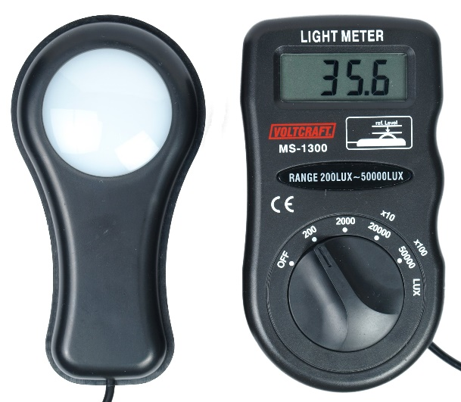
Figure 4.1: Diagram illustration of a Photometer (wikipedia.com).
4.5 DATA ACQUISITION AND REDUCTION
This research was carried out at a tropical location in Ilorin, Kwara State. The measurements were taken for two week (10th – 23rd May, 2025). The data were recorded every 30 minutes and were reduced to hourly measurements.
Custom-built software for the operation, acquisition, and pre-processing of the raw data was used (WeatherSmart, 2017). In this software, the following parameters were configured: sampling time, average time, and data storage.
4.5.1 DATA LOGGING OF THE SAMPLE DATA
In this project, the acquisition of the data was achieved by using Weather Smart data logger systems (measurement and control module). An RS232 connection to the computer for communication purposes was achieved by using a USB cable. The data logger is wirelessly connected to all the sensing elements thereby accepting their respective signals.
The transducers signals were then sampled, digitized and stored in the internal/expanded memory. The data which were collated in ASCII format were then reduced using a data reduction program, MicroCal Origin 7.1 Version. All the sensors used was sampled every 30 minutes but later reduced to hourly data. The radiation measuring instruments were sampled at 10 Hz, and subsequently averaged to produce hourly data statistics for the surface radiation fluxes.

4.5.2 PRE-PROCESSING OF THE RAW DATA
The data processing and presentation package, MicroCal Origin 7.1 Version has been used for necessary computations and data reduction. After elimination of spurious data values and the data to 30 minutes, data were then reduced to hourly data averages. The data thereafter were imported into the MicroCal origin version 7.1 new worksheet and a graphical presentation of the diurnal variability of the measured parameters was produced.

CHAPTER FIVE
RESULTS AND DISCUSSION
This study is aimed at parameterizing Ultraviolet Radiation from Dew Point Temperature. The prediction of Ultraviolet Radiation from Dew Point Temperature at a tropical location was obtained as datasets from the field experimental measurement at Ilorin, the Kwara State capital. The field experiment was carried out from 10th – 23rd May, 2025.
5.1 DIURNAL VARIATION OF ULTRAVIOLET RADIATION AND DEW POINT TEMPERATURE
For day 1, the result shows an increase in the reading of Ultraviolet radiation, about 0 to 100 hours, which is the highest value or reading for Ultraviolet radiation for the day (230mW/m²). It then falls sharply from 600 to 750 hours. There was a constant reading from about 760 to 2300 hours, before it finally increased at about 2400 hours. The diurnal variation of both the Ultraviolet Radiation and Dew Point Temperature on this day was depicted in Figure 5.1.
For day 2, the result shows an increase in the reading of Ultraviolet radiation, about 0 to 200 hours, which is the highest value or reading for Ultraviolet radiation for the day (250mW/m²). It then falls sharply from 550 to 800 hours. There was a constant reading from about 810 to 2200 hours, before it finally increased at about 2450 hours. The diurnal variation of both the Ultraviolet Radiation and Dew Point Temperature on this day was depicted in Figure 5.2.
For day 3, the result shows an increase in the reading of Ultraviolet radiation about 0 to 500 hours, which is the highest value or reading for Ultraviolet radiation for the day (225mW/m²). It then falls sharply from 550 to 750 hours. There was a constant reading from about 750 to 2300 hours, before it finally increases at about 2400 hour. The diurnal variation of both the Ultraviolet Radiation and Dew Point Temperature on this day was depicted in Figure 5.3.
For day 4, the result shows an increase in the reading of Ultraviolet Radiation measured and Ultraviolet Radiation predicted about 0 to 200 hours which is the highest value or reading for Ultraviolet radiation for the day (250mW/m²) for Ultraviolet radiation measured. It then falls sharply from 500 to 850 hours. There was a constant reading from about 850 to 2400 hours, before it finally increases at about 2450 hour. The diurnal variation of both the Ultraviolet Radiation measured and Ultraviolet Radiation predicted on this day was depicted in Figure 5.4.
For day 5, the result shows increase in the reading of Ultraviolet Radiation measured and Ultraviolet Radiation predicted about 0 to 200 hours which is the highest value or reading for Ultraviolet radiation for the day (225mW/m²) for Ultraviolet radiation measured. It then falls sharply from 500 to 850 hours. There was a constant reading from about 850 to 2400 hours, before it finally increases at about 2450 hour. The diurnal variation of both the Ultraviolet Radiation measured and Ultraviolet Radiation predicted on this day was depicted in Figure 5.5.
For day 6, the result shows increase in the reading of Ultraviolet Radiation measured and Ultraviolet Radiation predicted about 0 to 250 hours which is the highest value or reading for Ultraviolet radiation for the day (240mW/m²) for Ultraviolet radiation measured. It then falls sharply from 400 to 600 hours. There was a constant reading from about 650 to 2200 hours, before it finally increases at about 2400 hour. The diurnal variation of both the Ultraviolet Radiation measured and Ultraviolet Radiation predicted on this day was depicted in Figure 5.6.
Some of the decreases and increases in the reading are as a result of the amount of insolation reaching the earth on each day.

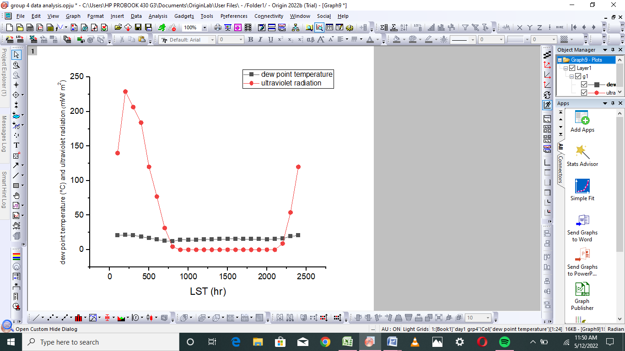

Figure 5.1: Diurnal variation of ultraviolet radiation and dew point temperature for (DOY 130).

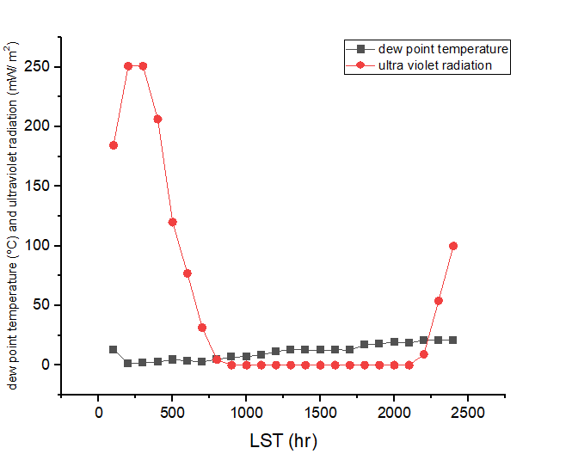
Figure 5.2: Diurnal variation of ultraviolet radiation and dew point temperature for (DOY 131).

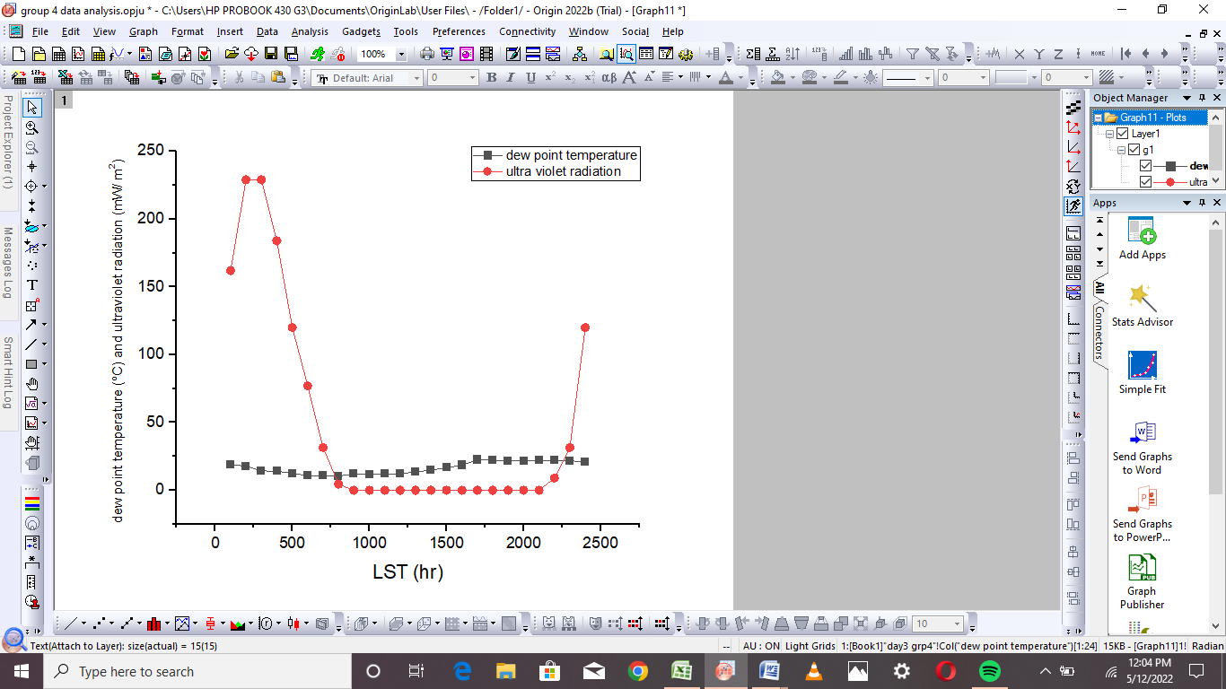
Figure 5.3: Diurnal variation of ultraviolet radiation and dew point temperature for (DOY 132).

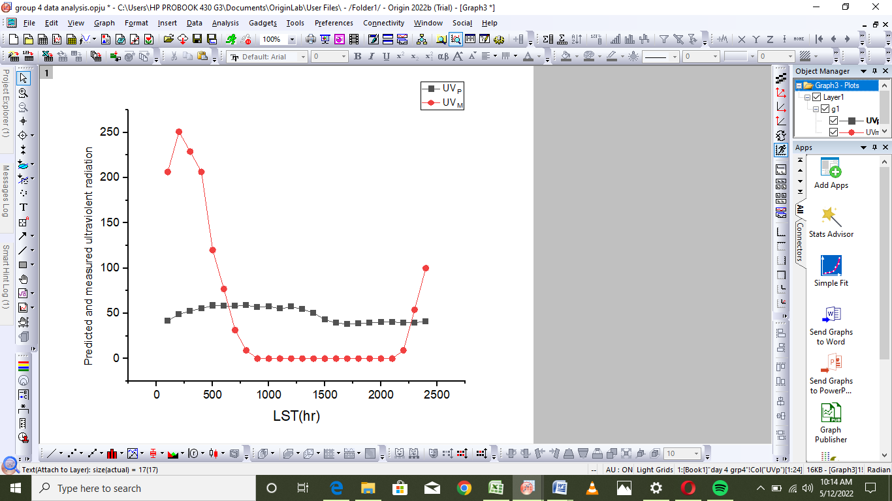
Figure 5.4: Diurnal variation of Predicted and measured Ultraviolent Radiation for (DOY 135).

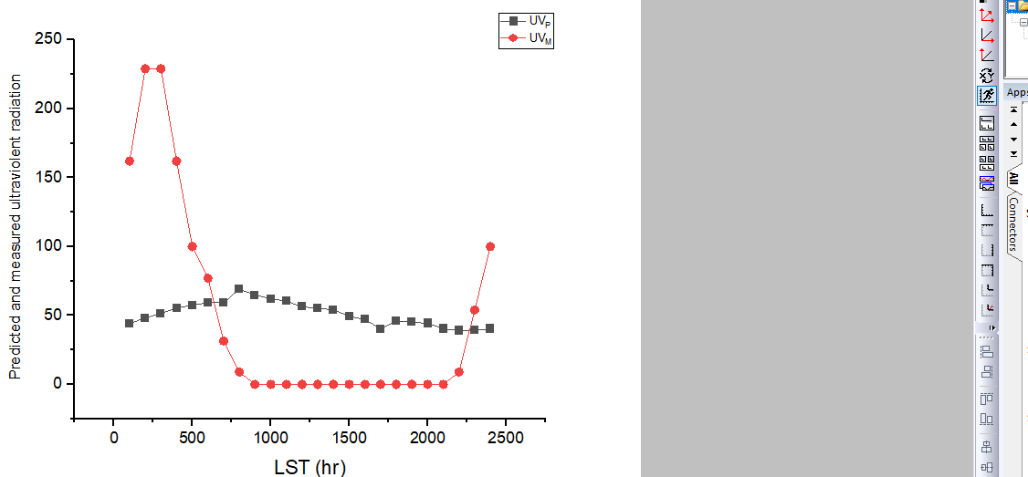
Figure 5.5: Diurnal variation of Predicted and measured Ultraviolent Radiation for (DOY 136).

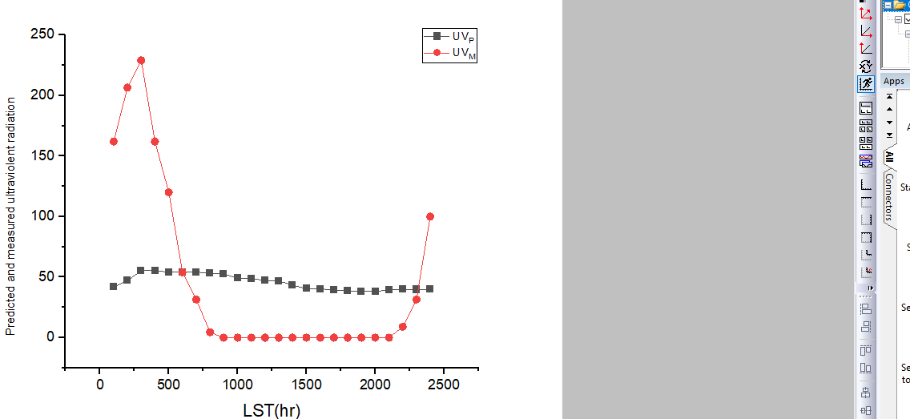
Figure 5.6: Diurnal variation of Predicted and measured Ultraviolent Radiation for (DOY 137).

5.2 ESTIMATION OF ULTRAVIOLET RADIATION AND DEW POINT TEMPERATURE
Data for UVR_{P} are often needed in micrometeorology, hence, there have been many publications on how to measure UVR_{P} with less sensors or how to correlate it from only few measurements.
In order to evaluate the effectiveness of the tested equation, the results were compared to the measured data set considering graphical and statistical means of evaluation.
The linear regression equation, to determine Ultraviolet Radiation and Dew Point Temperature measurements is obtained and given
UVR=a (D_{PT}) + b
Where, $UVR$ is the estimated relative humidity, a is the slope and b is intercept. The values obtained from the calibration in Fig 5.7 are $a=1.737, b=75.686 and r=$-0.112respectively.
Figure 5.8, depicted the graph of the measured and the estimated ultraviolet radiation,
Conclusively, the parameters found from the linear regression of the calibration data set gives a slope of $1.737$and $b=75.686$as the intercept for this research.

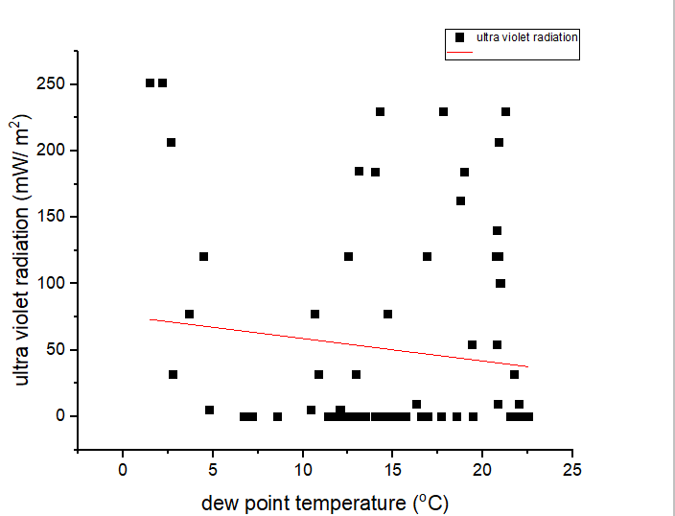

Figure 5.7: Calibration of the data sets for some selected days between 10th – 23rd May, 2025.

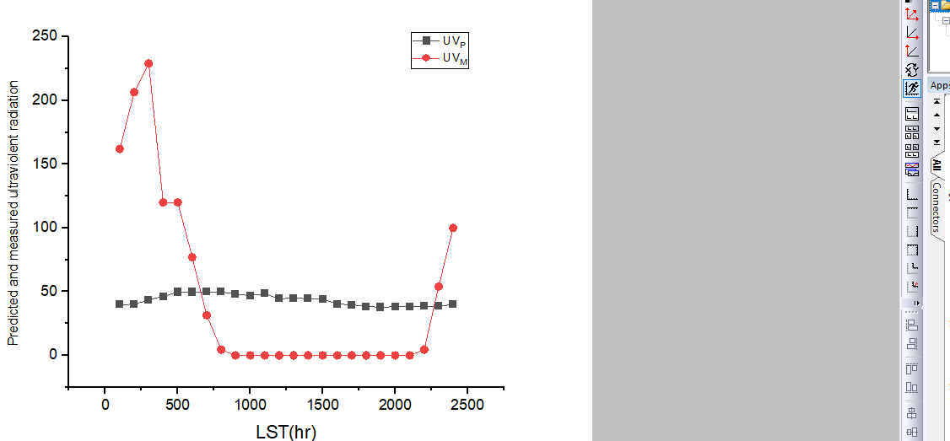
Figure 5.8: Diurnal variation of Predicted and measured Ultraviolent Radiation for (DOY 121).

Table 5.1: Parameters of the linear regression (slope a, intercept b and correlation coefficient r) as well as standard deviation and coefficient of determination for the tested estimated with respect to the measured values for the overall dataset.
Parameterization | a | b | r | SD | r²
Linear equation | -1.737 | 75.686 | -0.112 | 0.334 | 0.013

CHAPTER SIX:
SUMMARY AND CONCLUSIONS
Continuous measurements of Ultraviolet radiation and Dew Point temperature at an experimental site (08⁰ 9’21⁰N, 04⁰30’.50⁰E) located at the Kwara State Polytechnic Ilorin, Nigeria, was carried out between 10th – 23rd May, 2025. Using the direct measurement technique, these datasets were used to investigate the diurnal variation of the Ultraviolet radiation, Dew Point temperature and estimation of ultraviolet radiation from Dew Point temperature using linear regression equation.
From comparison of the simple parametric relationship used for the ultraviolet radiation with the measured data, assessment of the predicted value with the measured value indicated a remarkably fair agreement with the estimation of Ultraviolet radiation from Dew Point temperature.

REFERENCES
Agam, N and Berliner, P.R. (2006). Dew formation and water-vapour adsorption in semi-
arid environments; a review. J Arid Environ 65:572–590.
Ahmad, L; Parvaze, S; Kanth, R. H and Mahdi,S. S. (2017). Experimental
Agrometeorology: A Practical Manual. Springer International Publishing AG. ISBN 978-3-319-69184-8
Armstrong, B.K and Kricker, A. (2001). How much melanoma is caused by sun
exposure? Melanoma Res. 3, 395–401.
Ben-Asher, J; Alpert, P and Ben-Zvi, A. (2010). Dew is a major factor affecting
vegetation water use efficiency rather than a source of water in the eastern Mediterranean area.
Federal Republic of Nigeria Population Census (2006). Description of Kwara state
Polytechnic in the map of Nigeria.
Gaffen, G and Ross, K. (1999). Relationship between dew point temperature and relative
humidity in America.
James, W. (2019). “Wind Power Density Forecasting Using Ensemble Predictions and
Time Series Models”, IEEE Transactions on Energy Conversion, vol.24,no.3,pp.775-782
Naylor, E.C; Watson, R.E and Sherratt, M. J. (1995). Molecular aspects of skin ageing.
Maturitas, 69, 249–256.
Malek, E; McCurdy, G. D and Giles, B. (1999). Dew contribution to the annual water
balance in semi-arid desert valleys. J Arid Environ 42:71–80.
Monteith, J.L. (1957). Dew. Q J R MeteorolSoc 83:322–341.
Robinson, T. (1998). Relationship between dew point and relative humidity.
Robinson, T. (2000). Relationship between dew point and relative humidity.
Sharan, G; Beysens, D and Milimouk, M. I. (2007). A study of dew water yields
on Galvanized iron roofs in Kothara (North-West India). J Arid Environ 69:259–269.
Schwartzman, H. J.P and Jacobs, A.F.G. (1998). Diurnal variation of dew at night, at
near sunset and after sunset.
Wang, S and Zhang, Q. (2011). Atmospheric physical characteristics of dew formation in
semi-arid in Loess Plateau. ActaPhys Sin 60(5):05920
Weisstein, E. W. (2014.). "Radiation". EricWeisstein's World of Physics. Wolfram
Research.
www.wikipedia.com
Zhang, Q; Wei, G.A and Huang, R.H. (2003). Characteristics of hydrologic transfer
between soil and atmosphere over gobi near oasis at the end of summer. AdvAtmosSci 20(3):442–452.
Zhang, S.L; Lars, L and Harald, G. (2007). Modeling the effects of mulching and fallow
cropping on water balance in the Chinese Loess Plateau. Soil Tillage Res 93:283–298.

