SMART ATTENDANCE FOR HYBRID AND REMOTE LEARNING ENVIRONMENTS

BY
YAHAYA KHALILAH
HND/23/COM/FT/0414

SUBMITTED TO THE DEPARTMENT OF COMPUTER SCIENCE,
INSTITUTE OF INFORMATION AND COMMUNICATION TECHNOLOGY

KWARA STATE POLYTECHNIC, ILORIN.
IN PARTIAL FULFILLMENT OF THE REQUIREMENTS FOR THE AWARD OF HIGHER NATIONAL DIPLOMA (HND) IN
COMPUTER SCIENCE

JULY, 2025.

CERTIFICATION
This is to certify that this project was carried out by YAHAYA KHALILAH of Matriculation Number: HND/23/COM/FT/0414 has been read and approved as the meeting part of the requirements for the award of Higher National Diploma (HND) in Computer Science.

…………………………………. ….………………………
DR. RAJI, A. K. Date
Project Supervisor

…………………………………. ….………………………
MR. OYEDEPO, F. S. Date
Head of Department

…………………………………. ….………………………
External Examiner Date

DEDICATION
I dedicate this project work to Almighty God who inspired me and directed my ways during my academic stay in the polytechnic.

ACKNOWLEDGEMENT
All praise is due to Almighty God the Lord of the universe. I praise him and thank him for giving me the strength and knowledge to complete my HND program and also for our continued existence on Earth.
I appreciate the utmost effort of our supervisor, Dr. Raji, A. K. whose patience, support, and encouragement have been the driving force behind the success of this research work. He gave useful corrections, constructive criticisms, comments, recommendations, and advice and always ensures that excellent research is done. My sincere gratitude goes to the Head of the Department Mr. Oyedepo F. S., and other members of staff of the Department of Computer Science, Kwara State Polytechnic, Ilorin, for their constant cooperation, constructive criticisms, and encouragement throughout the program.
Special gratitude to my parents, who exhibited immeasurable financial, patience, support, prayers, and understanding during the period in which I was busy tirelessly with my studies, special thanks go to my lovely siblings
My sincere appreciation goes to my friends and classmates.

TABLE OF CONTENTS
Title page i
Certification ii
Dedication iii
Acknowledgments iv
Table of Contents v
List of Figures vi
List of Tables vii
Abstract viii
CHAPTER ONE: GENERAL INTRODUCTION
1.1 Background to the Study 1
1.2 Statement of the Problem 2
1.3 Aim and Objectives 2
1.4 Significance of Study 2
1.5 Scope of Study 3
1.6 Organization of the Report 3
CHAPTER TWO: LITERATURE REVIEW
2.1 Review of Related Works 4
2.2 Review of General Texts 8
2.3 Overview of Smart Attendance System 10
CHAPTER THREE: RESEARCH METHODOLOGY AND
ANALYSIS OF THE SYSTEM
  - Research Methodology 12
  - Analysis of the Existing System 15
  - Problem of the Existing System 16
  - Description of the Proposed System 16
  - Advantages of the Propose System 17

CHAPTER FOUR: IMPLEMENTATION AND DISCUSSION OF RESULTS
  - System Design and Setup 18

4.2 Hardware and Software Development 19

4.3 Testing and Evaluation 21

4.4 Results and Discussion 22
CHAPTER FIVE: SUMMARY CONCLUSION AND
RECOMMENDATION
5.1 Summary 25
5.2 Conclusion 26
5.3 Contributions to Knowledge 26
5.4 Recommendation for Future Research 27
References 28

ABSTRACT
In today’s evolving educational landscape, the demand for efficient and reliable attendance management systems has become critical, especially with the rise of hybrid and remote learning environments. This project presents the design and implementation of a smart attendance system using Radio Frequency Identification (RFID) technology to automate and streamline student attendance tracking. The system integrates an RFID reader and NodeMCU microcontroller to capture student ID data and transmit it wirelessly to a centralized server. A web-based platform is used for real-time data processing, attendance recording, and user-friendly interface access for administrators, lecturers, and students. The proposed system addresses the limitations of traditional manual and semi-digital attendance methods by enhancing accuracy, reducing human error, and eliminating impersonation. Furthermore, it supports remote access and scalability, making it suitable for educational institutions operating in both physical and virtual classrooms. The results demonstrate the system’s effectiveness in improving the accuracy, speed, and integrity of attendance management across diverse learning settings.

CHAPTER ONE

INTRODUCTION

1.1 Background of the Study
Attendance systems play a critical role in monitoring and managing the presence of individuals in various environments, particularly in educational institutions and corporate organizations. Accurate attendance records are essential for ensuring accountability, tracking performance, and enforcing discipline. Over the years, different methods of attendance tracking have been employed, including manual sign-in sheets, biometric systems, and Radio Frequency Identification (RFID) technology. Despite these advancements, a major challenge that persists is proxy attendance, where an individual marks attendance on behalf of another who is absent. This unethical practice undermines the integrity of attendance records and affects fair assessments, especially in academic settings (Qureshi, 2020).
Traditional RFID-based systems, though efficient and contactless, are highly susceptible to abuse since RFID cards or tags can be easily shared among individuals. Likewise, manual systems are time-consuming and prone to errors, while biometric systems, although more accurate, may raise hygiene concerns and require significant maintenance. These limitations highlight the need for a more secure, intelligent, and reliable attendance mechanism (Joshi, et al. 2021).
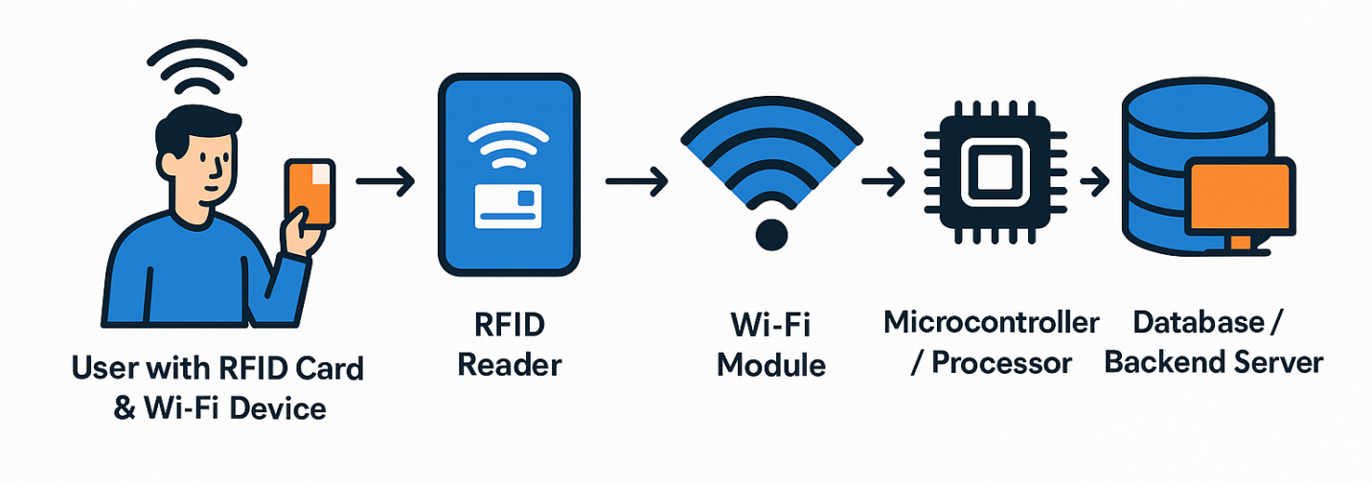To address this, the study proposes a hybrid attendance system that combines RFID technology with WiFi-based location verification. The RFID module handles identity authentication, while the WiFi module verifies the physical presence of the user within a designated area, ensuring that attendance is only recorded if both conditions are met. This integration significantly reduces the possibility of proxy attendance and enhances the trustworthiness of attendance data.
The system is developed using a combination of hardware and software tools. The hardware components include an RFID reader, RFID tags, and a WiFi module (such as NodeMCU or ESP8266) to detect location proximity. On the software side, tools such as Arduino IDE for programming the microcontroller, PHP and MySQL for backend development and database management, and HTML/CSS for the user interface are utilized. This methodology ensures a robust, scalable, and efficient system capable of real-time monitoring and accurate attendance tracking.

1.2 Statement of the Problem
The issue of proxy attendance remains a significant challenge in institutions and organizations that rely on traditional or RFID-based attendance systems. While RFID offers a fast and contactless method of marking attendance, it is easily manipulated when individuals hand over their RFID tags to others, allowing attendance to be marked without actual presence. This undermines the reliability and integrity of attendance records. Biometric systems, though more secure, have limitations such as longer processing time, hygiene concerns, and higher costs. The core problem lies in the inability of these systems to verify the physical presence of the individual. Therefore, there is a need for a more reliable solution that combines identity verification with location tracking to prevent proxy attendance. This study proposes a hybrid system integrating RFID and WiFi-based presence detection to ensure that only individuals who are physically present within the designated area can successfully register their attendance.This study aims to develop a hybrid RFID and WiFi attendance system that ensures only physically present individuals can successfully mark their attendance, thus eliminating proxy attendance.

1.3 Aim and Objectives
The aim of the research work is to design and implement a hybrid attendance system that integrates RFID technology and WiFi-based location verification to eliminate proxy attendance.
Objectives:
The specific objectives of this study are to:
- Design an RFID-based module for identity authentication.
- Integrate a WiFi module to verify physical presence via signal strength or location triangulation.
- Develop a database system for storing and managing attendance records.
- Implement logic to validate attendance only when both RFID and WiFi verification are successful.
- Evaluate the effectiveness of the system in preventing proxy attendance.

1.4 Significance of the Study
The significance of this study lies in its potential to revolutionize attendance management by addressing the persistent issue of proxy attendance through an innovative hybrid system. By integrating RFID technology with WiFi-based location verification, the system ensures that only individuals who are physically present can mark their attendance, thereby improving accuracy and reliability. This enhances transparency and accountability in both academic and organizational environments. The proposed system also reduces the administrative burden of manual attendance tracking and minimizes the risk of manipulation common in standalone RFID systems. Additionally, the study contributes to the advancement of smart monitoring technologies and provides a foundation for future research in location-aware authentication and access control systems.

1.5 Scope of the Study

The scope of this study is limited to the design and implementation of a hybrid attendance system that integrates Radio Frequency Identification (RFID) and WiFi-based location verification to prevent proxy attendance. The system is intended for use in indoor environments such as classrooms, lecture halls, or office spaces, where WiFi signal strength can be reliably used to determine physical presence. It covers the development of hardware components for RFID scanning, integration with a WiFi module to detect location proximity, and a backend system for storing and managing attendance data. The system verifies attendance only when both the RFID tag is authenticated and the user’s device is within the defined WiFi range. This study does not include outdoor tracking using GPS, large-scale institutional deployment across multiple buildings, or advanced biometric features.

1.6 Organization of the Study
This study is organized into five chapters to provide a systematic and comprehensive understanding of the research. Chapter One introduces the study, presenting the background, problem statement, objectives, significance, scope, and organization. Chapter Two reviews related literature on existing attendance systems, RFID and WiFi technologies, and previous works addressing proxy attendance. Chapter Three focuses on the system analysis and methodology, detailing the design framework, hardware and software components, and the proposed hybrid approach. Chapter Four presents the implementation of the system, including system development, testing, and evaluation of results. Finally, Chapter Five summarizes the research findings, draws conclusions, and provides recommendations for future work.

CHAPTER TWO

LITERATURE REVIEW

2.1 Review of Related Work
Over the years, numerous technologies have been employed to automate attendance systems and address the issue of proxy attendance. RFID (Radio Frequency Identification) is one of the most popular technologies used for this purpose. According to Qureshi, (2020), recent trends in Information and Communication Technology (ICT) embrace several smartphone applications in a variety of educational and industrial domains in the last several years. This research focuses to solve one of the promising problems of an educational domain to take attendance smartly using the Radio Frequency Identification (RFID) system. Current attendance system in King Abdul-Aziz University (KAU) Saudi Arabia is partly solving the attendance problem. There are several problems in the existing attendance systems such as time-consuming, the chance of mistakes, truancy issues, no contact with parent/guardian and not efficient because of roll call as taking manual attendance. The proposed RFID based attendance system will provide robust, secure and automatic attendance. The proposed system will use modern technology and support to institutions and parents to deal with most of the problems of existing attendance systems. There are several other benefits of RFID based system such as web-based and mobile interfaces, daily absent report, an automatic SMS alert to parent/guardian, reduce administrative work, improve the ratio of attendance, economical and highly efficient. The case study method will be used as a research design. The proposed system is developed and tested in KAU Saudi Arabia. The proposed system will have both web and mobile interfaces. The web interface will need the Internet to access the proposed system and the mobile interface will use the Android platform for the testing scenarios. The user will access the system to generate customized reports to review the status of students for a particular course. It is anticipated that the proposed system will significantly improve students’ monitoring mechanisms hence enabling both parents and teachers in making appropriate decisions.

Joshi, et al. (2021) RFID Based Attendance System. RFID is an acronym for “radio-frequency identification” RFID technology is an automatic wireless identification system that works by the help of two components: a card and a reader. Using the RFID technology, the conventional system of taking attendance can be completely transformed to be more in line with strides in digitalization. This system will help the authorities manage the attendance system in a more methodical, efficient and time saving manner. The proposed system has been implemented through a prototype that has proved the effectiveness of the concept in easing the logistics of taking attendance as a result of the automation due to the use of the RFID technology. The design of the system is simple, cost effective and agile making it a good candidate for commercial and academic purposes.
Arulogun, et al. (2013) RFID-Based Students Attendance Management System. In recent years, there have been rise in the number of applications based on Radio Frequency Identification (RFID) systems and have been successfully applied to different areas as diverse as transportation, health-care, agriculture, and hospitality industry to name a few. RFID technology facilitates automatic wireless identification using electronic passive and active tags with suitable readers. In this paper, an attempt is made to solve recurrent lecture attendance monitoring problem in developing countries using RFID technology. The application of RFID to student attendance monitoring as developed and deployed in this study is capable of eliminating time wasted during manual collection of attendance and an opportunity for the educational administrators to capture face-to-face classroom statistics for allocation of appropriate attendance scores and for further managerial decisions.

Parvathy, et al. (2013) RFID in cloud environment for Attendance monitoring system. Radio Frequency Identification (RFID) initially is of great use in the marketing field render billing easy. It came into effect since world war-II attained its wide spread recognition only when Walmart introduced it as ‘mandate’. An object within the range of 20 feet can be easily tracked with the aid of its unique barcode using RFID chip. It is sophisticated than the primitive barcode techniques as there is no need of positioning of the scanner. Cloud computing is a system which provides access to all soft ware’s without installation, for a desired time period, at a specific cost, only with the help of a single web browser.. Interfacing RFID with cloud computing would be more beneficiary in solving current issues. Technological updates can be done without any technical support. This paper presents the overview of interfacing RFID with cloud computing for updating students’ attendance and updating it into the parents’ corner and faculty mails. By considering the present issue, providing unique RFID code to the students reduce malpractice and human error. Also Human resources can be saved by the application of cloud computing. Time management is the most effective advantage gained from the use of RFID and cloud computing.

Nandhakumar, et al. (2020) RFID Based Attendance System using IoT. In classrooms, time is wasted in roll calls as it is done manually. In this proposed system, authorized student is given an RFID tag. Thus, the data stored in this card is referred as the identification/attendance of the person. Once the student places the card in front of the RFID card reader, it reads the data and verifies it with the data stored in the microcontroller from 8051 family. If the data matches, then it displays a message on the LCD confirming the entry of that student else displays a message denying the attendance. The status of a student’s attendance can be retrieved from this system by pressing the status button interfaced to the microcontroller. Hence, a lot of time is saved as all the students attendance is directly stored in the data base.

Bharathy, (2021) Smart Attendance Monitoring System using IoT and RFID. Maintaining the attendance of the students in an institution is a hefty task. Always there is a difficulty in handling attendance manually. This project aims at designing a smart attendance system that automatically monitors and manages attendance of the students in an institution efficiently. The whole system is developed with an Arduino uno microcontroller and RFID readers. Unique RFID tags can be deployed in students id card. Also, Wi-Fi communication modules are used to make convenient communication depend on the availability of the network. Database of students must be created. A GSM Module is used to send messages to parent’s mobile about the students attendance status. A GPS module is used to detect the live location of the student. This system will reduce a lot of manual work of teachers and administrators of any institution. The proposed work comprises of two most popular trend in technology research; IoT and RFID.

2.2 Review of General Texts
Attendance management is a fundamental administrative task in both academic and corporate settings. Traditionally, attendance was recorded manually through sign-in sheets or registers, which are time-consuming, prone to errors, and easily manipulated. The advent of automation brought about technologies like barcode scanners, RFID systems, biometric recognition, and mobile applications. RFID technology uses electromagnetic fields to automatically identify and track tags attached to objects or individuals. Its adoption in attendance systems has significantly reduced the time required to mark attendance and minimized human error. However, one of the critical drawbacks is the lack of physical presence validation, making the system vulnerable to misuse (Bharathy, 2021).
Biometric systems, including fingerprint, iris, and facial recognition, have been used to address this issue by providing a unique, non-transferable identity for each user. While they improve reliability, these systems are affected by environmental conditions, maintenance challenges, and user discomfort due to hygiene concerns. WiFi-based presence detection is an emerging approach that leverages signal strength and device MAC addresses to estimate a user's location within a building. This method is particularly useful in smart environments and has applications in security, smart homes, and intelligent tracking systems. When combined with other authentication technologies, WiFi localization can help validate physical presence with high accuracy (Bharathy, 2021).
Overall, the evolution of attendance systems reflects a growing need for secure, automated, and intelligent solutions. The proposed hybrid model in this study addresses this need by integrating RFID with WiFi localization, ensuring both identity verification and physical presence, thereby enhancing the integrity of attendance systems.

2.3 Overview of RFID and WiFi Hybrid Attendance System
Attendance management systems have evolved significantly over time to improve accuracy, convenience, and security in tracking the presence of individuals in various settings such as educational institutions and workplaces. Among the various technologies developed, Radio Frequency Identification (RFID) and WiFi-based systems have shown great potential individually; however, each comes with its inherent limitations. The RFID and WiFi hybrid attendance system combines the strengths of both technologies to create a more robust, secure, and efficient attendance solution, particularly aimed at preventing proxy attendance (Nandhakumar, et al. 2020).
Radio Frequency Identification (RFID) is a widely adopted technology in attendance systems due to its contactless and automated nature. Each participant is issued an RFID tag—typically embedded in an ID card—that contains a unique identifier. When the tag is brought near an RFID reader, the system reads the tag’s data and records the user’s attendance. RFID systems greatly reduce the time and manual effort needed for attendance logging compared to traditional paper-based or manual methods. However, the fundamental limitation of RFID systems is their vulnerability to proxy attendance, where one individual can use another person’s RFID card to mark attendance fraudulently. This problem arises because RFID technology only verifies the possession of the tag, not the physical presence of the person associated with it (Nandhakumar, et al. 2020).
To address this critical challenge, the hybrid system integrates WiFi-based location verification as a second layer of authentication. Modern environments such as schools, universities, and offices typically have WiFi networks with multiple access points. These networks can be leveraged to estimate a user’s physical presence by detecting the signal strength or the device’s connection to specific access points within a defined area. By pairing the RFID-based identity verification with WiFi-based presence detection, the system confirms that the individual is physically present in the attendance area at the time of marking attendance.

The hybrid system architecture generally consists of the following components:
- RFID Reader and Tags: The RFID reader scans the unique tags held by users. Each scan captures the identity of the user.
- WiFi Module: Devices such as NodeMCU or ESP8266 modules continuously scan the WiFi environment to detect the presence of the user’s smartphone or any registered WiFi-enabled device. The system uses MAC address recognition or signal strength measurements (Received Signal Strength Indicator - RSSI) to verify proximity.
- Microcontroller/Processor: The microcontroller acts as the central controller, processing RFID input and WiFi presence data, then validating attendance only when both criteria are met.
- Backend Server and Database: All attendance data is sent to a centralized database for storage, management, and reporting. The backend system handles user authentication, logs attendance records, and generates analytics.
Advantages of the Hybrid System:
- Improved Security and Reliability: By requiring both RFID authentication and physical presence verification through WiFi, the system drastically reduces opportunities for proxy attendance and fraud.
- Real-Time Monitoring: The WiFi module continuously monitors the environment, enabling real-time presence detection that complements the instantaneous RFID scans.
- Contactless and Convenient: Both RFID and WiFi technologies allow contactless attendance marking, which is beneficial in maintaining hygiene standards, especially in the context of health concerns such as the COVID-19 pandemic.
- Cost-Effectiveness: The hybrid system leverages existing WiFi infrastructure and affordable RFID components, reducing deployment and maintenance costs compared to advanced biometric systems.
- Scalability: The system can be scaled across multiple rooms or buildings by integrating additional WiFi access points and RFID readers, making it suitable for institutions of various sizes.
2.3.1 Operational Workflow:
When a user enters the designated attendance area, they present their RFID tag to the reader, which captures their identity data. Simultaneously, the system checks if the user’s registered WiFi-enabled device is within range of the local network by scanning for its unique MAC address or measuring signal strength. Attendance is recorded only if both identity and location conditions are satisfied, thereby confirming that the user is physically present and authorized to mark attendance (Parvathy, et al. 2013).
In conclusion, the RFID and WiFi hybrid attendance system offers a comprehensive solution to the longstanding challenge of proxy attendance. By combining identity authentication with physical presence verification, it enhances the integrity and accuracy of attendance records while maintaining user convenience and system scalability. This innovative approach represents a significant step forward in modern attendance management systems, aligning with the increasing demand for secure, automated, and intelligent monitoring technologies.

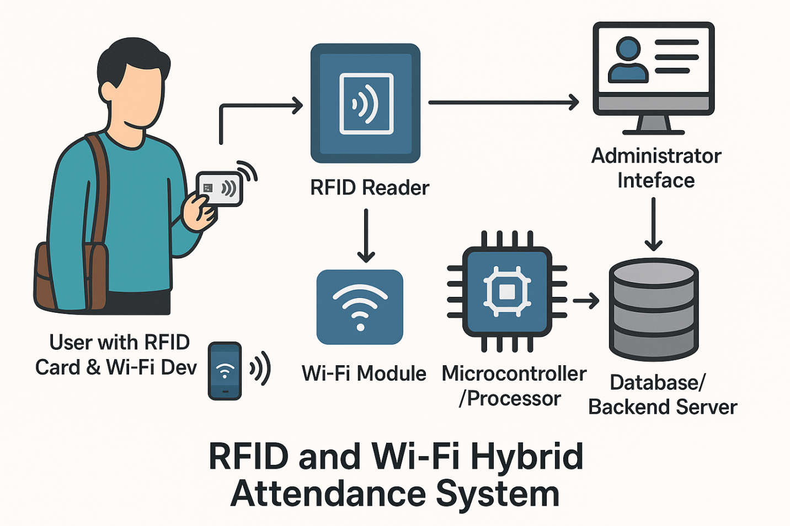Figure 2.1 Overview of RFID AND WIFI HYBRID ATTENDANCE SYSTEM

Description of the Diagram
- User with RFID Card & WiFi Device: A student or employee holds an RFID card and carries a WiFi-enabled device (e.g., smartphone or laptop).
- RFID Reader: Scans the RFID card for user identity.
- WiFi Module: Detects the presence of the user’s WiFi device by scanning for the MAC address or signal strength.
- Microcontroller / Processor: Receives input from both RFID reader and WiFi module and processes verification.
- Database / Backend Server: Stores attendance data after validating both RFID identity and WiFi presence.
- Administrator Interface: Allows admins to monitor, manage, and generate attendance reports.

2.3.2 Attendance Management System (AMS)
An Attendance Management System (AMS) is a technological framework designed to record, monitor, and manage the attendance of individuals in an organization, institution, or enterprise. The system automates the traditional manual process of attendance tracking, reducing errors, preventing manipulation, and improving administrative efficiency. AMS is widely used in schools, universities, workplaces, hospitals, and public institutions where timely and accurate attendance records are essential for operational and strategic decision-making (Parvathy, et al. 2013).
Traditional methods of attendance management, such as signing attendance sheets or roll calls, are often time-consuming, prone to fraud (e.g., proxy attendance), and inefficient when handling large groups of people. With the advancement of digital technologies, AMS solutions have evolved to include automated systems using biometric data (fingerprint, facial recognition), Radio Frequency Identification (RFID), Global Positioning System (GPS), QR codes, and more recently, WiFi-based presence verification.
The primary goal of an AMS is not just to record attendance but also to offer features such as:
- Real-time attendance tracking
- Automated report generation
- Integration with payroll or academic records
- Alert notifications for absentees
- Data analytics and visualization
In educational settings, AMS can be used to track students’ daily attendance and participation, while in corporate environments, it supports human resource management by monitoring employee punctuality, working hours, and leave records. Some advanced AMS platforms are integrated with Learning Management Systems (LMS) or Enterprise Resource Planning (ERP) software to streamline institutional processes.
A robust AMS must meet the following functional and non-functional requirements:
- Accuracy: Minimize false entries and duplicate data.
- Security: Ensure only authorized users can mark or access attendance records.
- Scalability: Handle large datasets and increasing user counts.
- User-friendliness: Provide a simple and intuitive interface.
- Speed: Record data in real-time with minimal delays.
In the context of this research, the RFID and WiFi Hybrid Attendance System represents an improved version of AMS by leveraging dual technologies to overcome the shortcomings of RFID-only systems, particularly the issue of proxy attendance. It validates both the identity (via RFID) and the physical presence (via WiFi signal) of the user, thereby ensuring more secure and trustworthy attendance tracking.
Thus, the AMS continues to be a critical component in modern-day institutions, offering not just automation but also intelligent insights and control over attendance-related processes.

2.3.3 RFID Technology
Radio Frequency Identification (RFID) is an automatic identification technology that uses electromagnetic fields to detect and track tags attached to objects. It is a non-contact, wireless communication system that can read data stored on a tag from several centimeters to several meters away, depending on the type of tag and reader. RFID technology has gained widespread adoption in inventory management, access control, transportation, healthcare, and attendance systems due to its speed, reliability, and convenience.
An RFID system consists of three main components:
- RFID Tag (Transponder): This is a small device that stores unique identification data. It can be passive (no battery, powered by the reader's electromagnetic field), active (battery-powered), or semi-passive.
- RFID Reader (Interrogator): This emits radio signals to communicate with RFID tags and extract their information.
- Antenna: Used by both the tag and reader to send and receive signals.
RFID operates across different frequency bands:
- Low Frequency (LF): 125–134 kHz – short range, less affected by metal and liquids.
- High Frequency (HF): 13.56 MHz – common for contactless cards, such as student ID cards.
- Ultra High Frequency (UHF): 300 MHz to 3 GHz – longer range, used in logistics and asset tracking.
In attendance management systems, RFID tags are embedded in ID cards and assigned to individuals. Upon entry to a classroom, lab, or office, the person taps their card on the RFID reader, and the system logs the timestamp along with the user's ID. This process is fast and can handle multiple users efficiently.
However, RFID-only attendance systems are vulnerable to proxy attendance, a situation where a user hands over their card to someone else to mark attendance on their behalf. This limitation undermines the integrity of attendance records and necessitates a more robust solution.
To address this, RFID is integrated with complementary technologies such as WiFi, facial recognition, or biometric authentication to form hybrid systems. In the hybrid RFID-WiFi model proposed in this study, RFID ensures identity verification while WiFi validates the physical presence of the user’s personal device (e.g., smartphone), making it harder for proxies to manipulate the system.

Advantages of RFID in Attendance Systems:
- Contactless and quick data acquisition
- Low maintenance (especially passive tags)
- Durable and reusable tags
- Easily integrable with software databases
Challenges:
- Vulnerability to proxy attendance
- Signal interference (especially in metallic environments)
- Initial setup costs (readers, tags, and infrastructure)
Despite these limitations, RFID remains a foundational technology for modern attendance systems, and its integration with WiFi in this research offers a secure and efficient approach to reliable attendance tracking.

2.3.4 WiFi-Based Location Tracking
WiFi-Based Location Tracking is a technique that utilizes wireless signals to determine the physical location or presence of a device within a defined area. Unlike GPS, which may not work effectively indoors, WiFi tracking is well-suited for indoor environments such as schools, offices, and institutions where attendance tracking is essential. This technology forms a key part of the RFID and WiFi Hybrid Attendance System by ensuring that a user is not only identified (via RFID) but also physically present in the designated location.
The fundamental principle behind WiFi-based tracking involves analyzing signals emitted by WiFi-enabled devices—like smartphones—and using those signals to estimate proximity to access points or routers.

Techniques Used in WiFi-Based Tracking:
- Received Signal Strength Indicator (RSSI):
Measures the power present in a received radio signal. As a device moves closer to or farther from a WiFi router, the signal strength changes. By setting a minimum threshold (RSSI value), the system can verify whether a device is within range of the classroom or lab.
- MAC Address Detection:
Each WiFi-enabled device has a unique Media Access Control (MAC) address. Attendance systems can detect these addresses to verify presence without requiring user interaction.
- Fingerprinting:
Involves mapping signal strengths from different access points in various locations to create a reference database. The current signal reading is then compared to this database to estimate location.
- Triangulation or Trilateration:
Determines the position of a device using signal strengths from multiple access points. This method is more precise but requires several access points and complex computation.

Role in Attendance Systems:
In a hybrid RFID-WiFi attendance system, WiFi serves as the proximity verification tool. After a user scans their RFID tag, the system simultaneously checks whether their registered smartphone or WiFi-enabled device is present in the room based on its MAC address and signal strength. This ensures that both the identity and location are validated—drastically reducing the chances of proxy attendance.

Advantages of WiFi-Based Location Tracking:
- No need for additional hardware if existing WiFi infrastructure is available.
- Non-intrusive and contactless verification.
- Works in indoor environments where GPS fails.
- Supports real-time monitoring and alerts.

Limitations:
- Signal fluctuations can affect accuracy.
- Devices can be left behind or spoofed unless linked directly to users.
- Privacy concerns if data is not anonymized or protected.
- Requires network infrastructure and administrative access to routers/APs.
Despite these challenges, WiFi-based presence verification is a powerful tool when combined with RFID, as it adds a location-based security layer to the attendance process. It provides a passive, real-time check on whether users are physically within the valid attendance zone, helping to prevent misuse and enhance accountability.

2.3.6 Hybrid Authentication Systems
Hybrid Authentication Systems combine two or more different authentication methods or technologies to enhance the reliability, accuracy, and security of identity verification processes. In the context of attendance management, hybrid systems are designed to address the limitations of single-factor authentication methods—such as RFID cards, biometrics, or WiFi-based detection by combining them to ensure that both identity and physical presence are verified simultaneously.
Why Hybrid Authentication?
Traditional attendance systems often rely on a single method:
- RFID-only systems can be manipulated through proxy attendance (e.g., giving a card to a friend).
- Biometric systems (like fingerprint or facial recognition) may be affected by hygiene concerns, equipment failure, or environmental conditions.
- WiFi tracking alone may detect a user's device even if the user is not actively present (e.g., if a device is left behind).
To overcome these vulnerabilities, hybrid authentication combines two or more verification layers for example, RFID + WiFi, Biometrics + GPS, or QR Code + OTP—to ensure both who is marking attendance and where they are at the time.

Components of a Hybrid RFID + WiFi Attendance System:
- RFID Verification:
  - Confirms the user's unique identity.
  - Involves tapping a card or badge on an RFID reader.

- WiFi-Based Presence Detection:
  - Validates the user's physical location.
  - Confirms the presence of a registered device within the coverage area using signal strength and MAC address.
The hybrid system cross-verifies both layers:
- If the RFID tag is detected but the corresponding WiFi device is not in range, attendance is denied.
- If the WiFi device is in range but the RFID is not scanned, attendance is not marked.
- Only when both are verified together is the attendance successfully recorded.

Advantages of Hybrid Authentication Systems:
- Enhanced Security: Makes proxy attendance highly difficult or impossible.
- Higher Accuracy: Combines two factors to ensure reliable attendance logs.
- Redundancy: If one system fails temporarily, the other may still provide context.
- Scalability: Can be adapted to classrooms, offices, or large institutions.

Challenges and Considerations:
- Cost: Implementing multiple technologies may require higher initial investment.
- System Complexity: Requires integration between hardware, software, and network components.
- User Compliance: Users must carry both RFID tags and registered WiFi-enabled devices.
- Data Privacy: Proper encryption and access control mechanisms must be in place to protect user information.

CHAPTER THREE

METHODOLOGY AND ANALYSIS OF THE SYSTEM

3.1 Research Methodology
This study adopted a design and development research methodology, focused on solving the persistent problem of proxy attendance in academic environments through the implementation of a Hybrid RFID and WiFi Attendance System. The methodology follows a systematic approach involving problem identification, requirement gathering, system design, implementation, testing, and evaluation.

3.1.1 Problem Identification and Analysis
The research began with identifying the limitations of existing attendance systems through observation and stakeholder interviews (lecturers, students, and administrators). Common issues included ease of forgery, proxy attendance, lack of automation, and poor real-time reporting capabilities.

3.1.2 Requirement Gathering
System requirements were collected from intended users and administrators to understand the functional expectations of the system. These included:
- Dual-verification attendance marking (RFID + WiFi MAC detection),
- Real-time database updates,
- Admin panel for monitoring and reporting,
- User registration with unique identifiers.

3.1.3 System Design
The hybrid system was designed using a modular approach. Hardware design involved the integration of RFID readers (RC522) with NodeMCU ESP8266 microcontrollers to facilitate both RFID reading and WiFi communication. The software design included a web-based interface developed using HTML, CSS, and JavaScript, while the backend was built using PHP and MySQL.

3.1.4. System Implementation
Implementation was carried out in phases:
- The hardware module was programmed to read RFID tags and scan for nearby WiFi MAC addresses.
- The backend server received input from the device and validated user presence.
- Attendance was logged only when both authentication layers were confirmed.

3.1.5. Testing and Evaluation
The system was tested in a controlled environment involving multiple users. Evaluation was based on:
- Accuracy of attendance marking,
- Resistance to proxy attempts,
- System response time,
- User satisfaction and usability.

3.1.6. Iteration and Improvement
Based on feedback from testing, the system was refined to improve detection speed, enhance user feedback (e.g., LED/Buzzer confirmation), and improve the user interface for the admin dashboard.

3.2 Analysis of the Existing System
Current attendance systems in many academic institutions mainly rely on manual roll calls, standalone RFID card readers, or WiFi-based device detection. Manual methods are labor-intensive, prone to human error, and time-consuming, while single-method electronic systems lack robust security. RFID-only systems are vulnerable to proxy attendance, as students can easily swap cards, and WiFi-based systems can be unreliable due to device sharing or MAC spoofing. Additionally, many existing systems do not provide real-time attendance updates or automated reporting, leading to delays and increased administrative workload.
These limitations highlight the need for a more secure and efficient approach. The absence of dual verification reduces the accuracy and integrity of attendance records, while the lack of automation affects timely access to attendance data. Therefore, a hybrid system combining RFID and WiFi MAC detection is necessary to enhance authentication, prevent fraudulent attendance, and enable real-time monitoring. Such a system would improve reliability, reduce administrative effort, and foster trust in attendance data within academic environments.

3.3 Problems of the Existing System
The existing attendance systems suffer from several critical issues that compromise their effectiveness and reliability. Manual attendance methods are time-consuming, prone to human error, and easily manipulated through proxy attendance or forgery. Electronic systems based solely on RFID or WiFi lack sufficient security measures, making it possible for students to misuse cards or share devices to mark attendance fraudulently. Additionally, many current systems do not offer real-time updates or automated reporting, which delays access to accurate attendance records and increases administrative workload.
Furthermore, these systems often lack scalability and user-friendly interfaces, making them difficult to manage and monitor effectively in larger academic settings. The absence of multi-factor authentication limits the system’s ability to verify genuine presence, leading to inaccurate data and reduced trust in attendance records. These problems underscore the urgent need for an integrated solution that combines multiple verification methods, automation, and efficient data management to enhance accuracy, security, and usability.

3.4 Analysis of the Proposed System
The proposed Hybrid RFID and WiFi Attendance System addresses the limitations of existing attendance solutions by combining two complementary technologies to enhance security and reliability. By integrating RFID tag scanning with WiFi MAC address detection, the system implements a dual-verification mechanism that significantly reduces the risk of proxy attendance and forgery. This hybrid approach ensures that attendance is only recorded when both the RFID tag and the user’s WiFi device are detected simultaneously, providing stronger authentication than single-method systems. Additionally, the system supports real-time data updates and centralized monitoring through a web-based admin dashboard, enabling immediate access to accurate attendance records.
Beyond improved security, the proposed system emphasizes automation and usability to streamline attendance management. The modular hardware design using NodeMCU ESP8266 microcontrollers and RC522 RFID readers facilitates efficient data collection, while the backend developed with PHP and MySQL ensures robust data processing and storage. User feedback features such as LED indicators and buzzer confirmations improve usability for students, and the admin panel simplifies report generation and monitoring for staff. Overall, the proposed system enhances attendance accuracy, reduces administrative burden, and fosters trust in the attendance process within academic environments.

3.5 Five Advantages of the New System over the Existing System
- Enhanced Security through Dual Verification: Unlike traditional systems that rely on a single authentication method, the new system combines RFID scanning with WiFi MAC address detection, drastically reducing the risk of proxy attendance and fraudulent marking.
- Real-Time Attendance Updates: The system updates attendance records instantly to a centralized database, enabling lecturers and administrators to monitor attendance in real time and make timely decisions.
- Automated and Efficient Attendance Management: The new system automates data collection, validation, and reporting, reducing manual effort and administrative workload significantly.
- Improved User Feedback: Visual and audio indicators (LEDs and buzzers) provide immediate confirmation to users, enhancing usability and minimizing confusion during attendance marking.
- Comprehensive Admin Dashboard: The web-based interface offers easy access to detailed reports, user management, and system monitoring tools, empowering administrators to manage attendance data effectively and efficiently.

CHAPTER FOUR
IMPLEMENTATION AND DISCUSSION OF RESULTS

4.1 System Design and Setup
The implementation phase involved translating the design specifications into a fully functional Hybrid RFID and WiFi Attendance System. The system architecture combined hardware and software components working in unison to ensure accurate and reliable attendance tracking.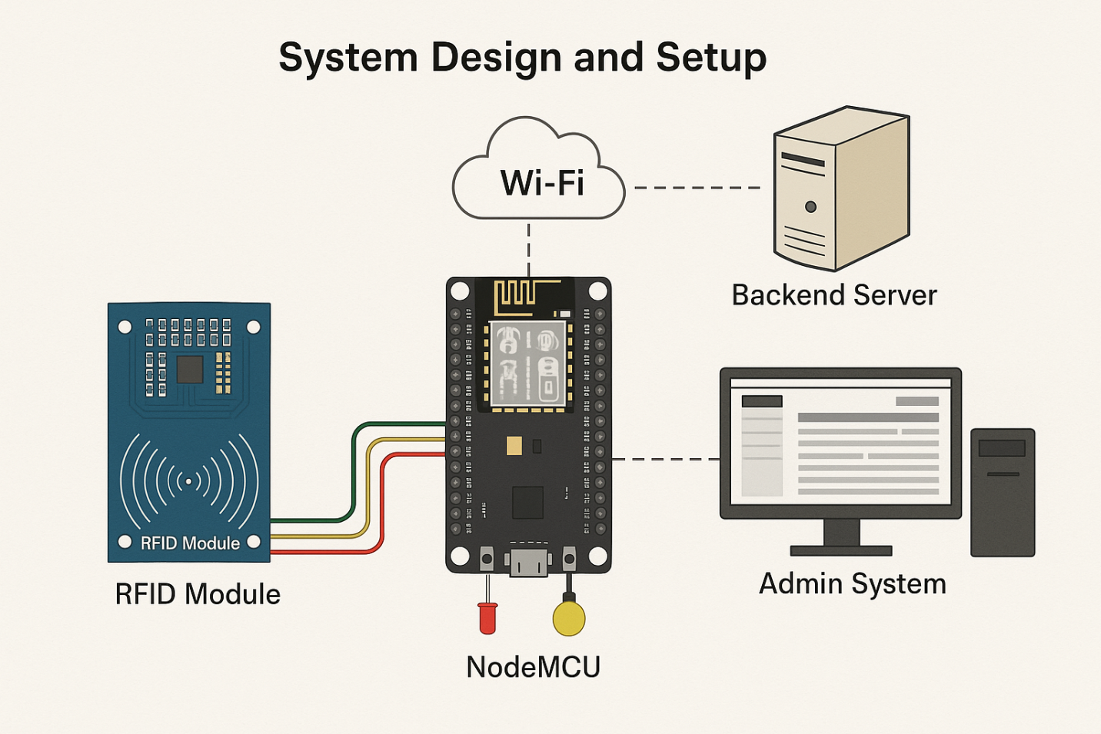

Figure 4.1: System Design and Setup

4.2 Hardware Setup
The core hardware consists of the NodeMCU ESP8266 microcontroller integrated with an RC522 RFID reader. The NodeMCU was programmed to read RFID tags presented by users and simultaneously scan for nearby WiFi MAC addresses, providing a two-factor authentication mechanism. Power was supplied through a stable USB connection, and output devices such as LEDs and buzzers were connected to provide immediate feedback on attendance status.

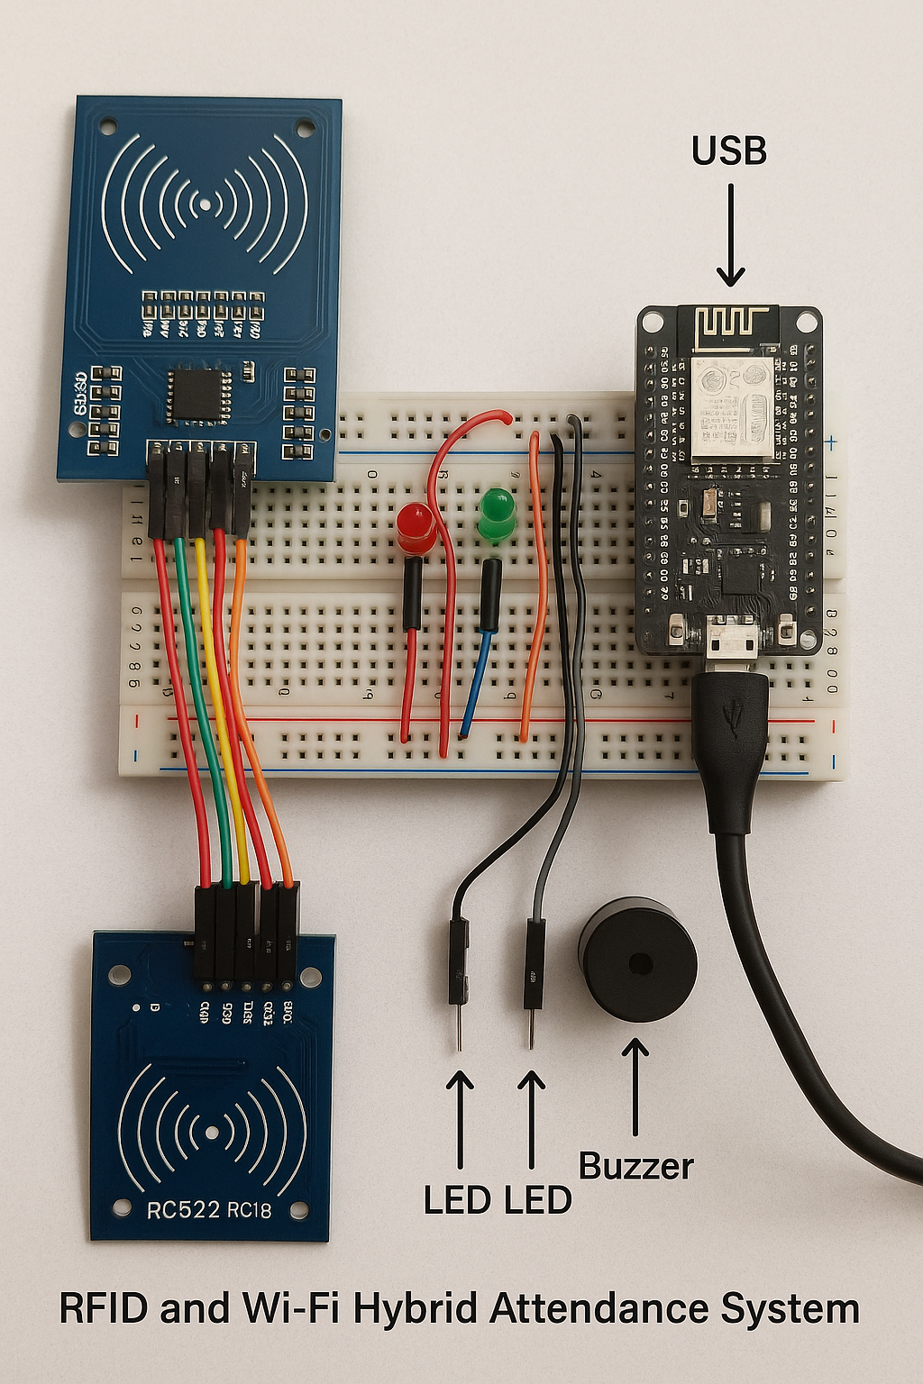

Figure 4.2: Hardware Setup

4.3 Software Setup
The software component included a web-based interface developed using HTML, CSS, and JavaScript, offering a user-friendly platform for administrators to monitor and manage attendance data. The backend was implemented with PHP to handle server-side processing, interfacing with a MySQL database where attendance records and user details were stored. The system was deployed on a local server for testing, with APIs established for communication between the hardware and the backend server.
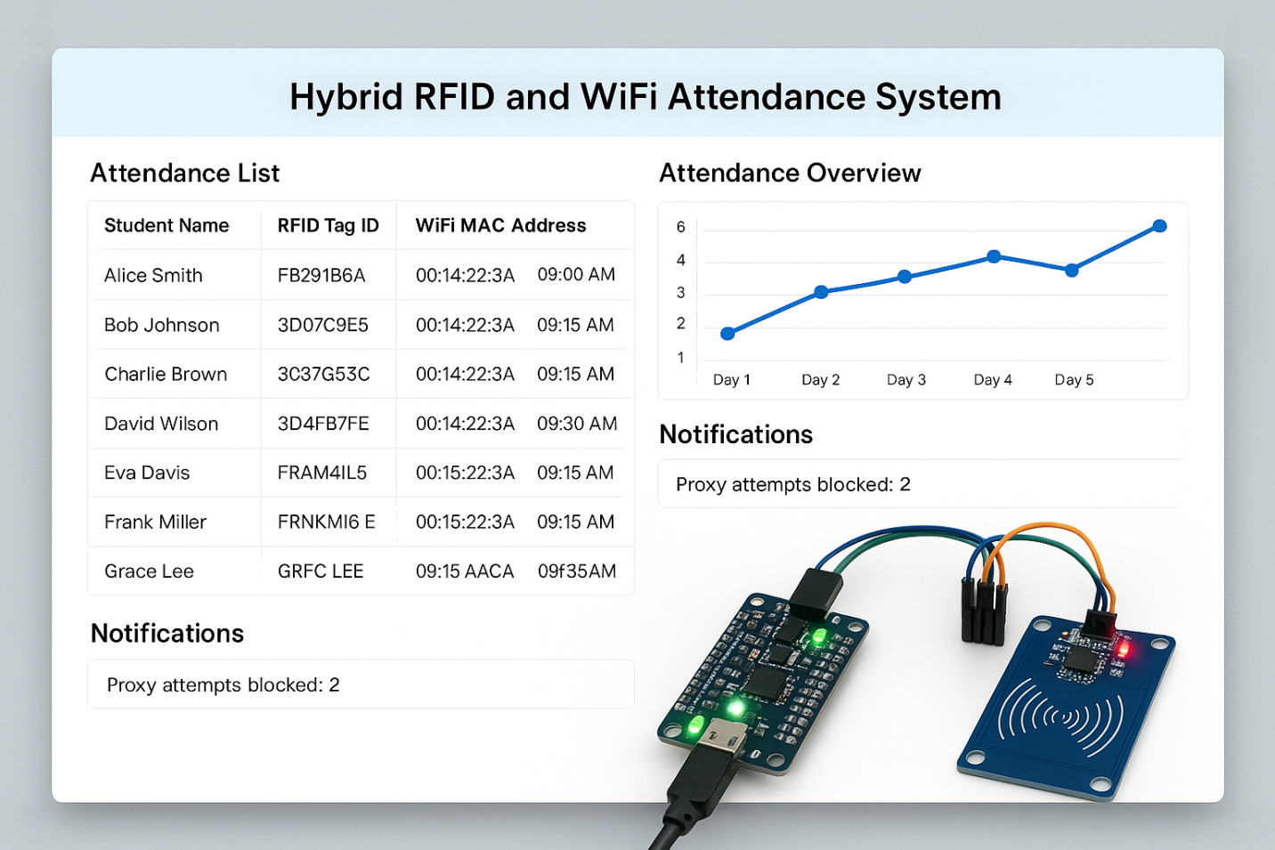
Figure 4.3: Admin Dashboard of Hybrid RFID and WiFi Attendance System

4.4 Integration and Testing
The hardware and software modules were integrated to enable real-time communication. Upon detecting both RFID and WiFi credentials, the system logged attendance data into the database and updated the admin dashboard instantly. Extensive testing was conducted to verify system accuracy, response time, and resistance to proxy attempts.
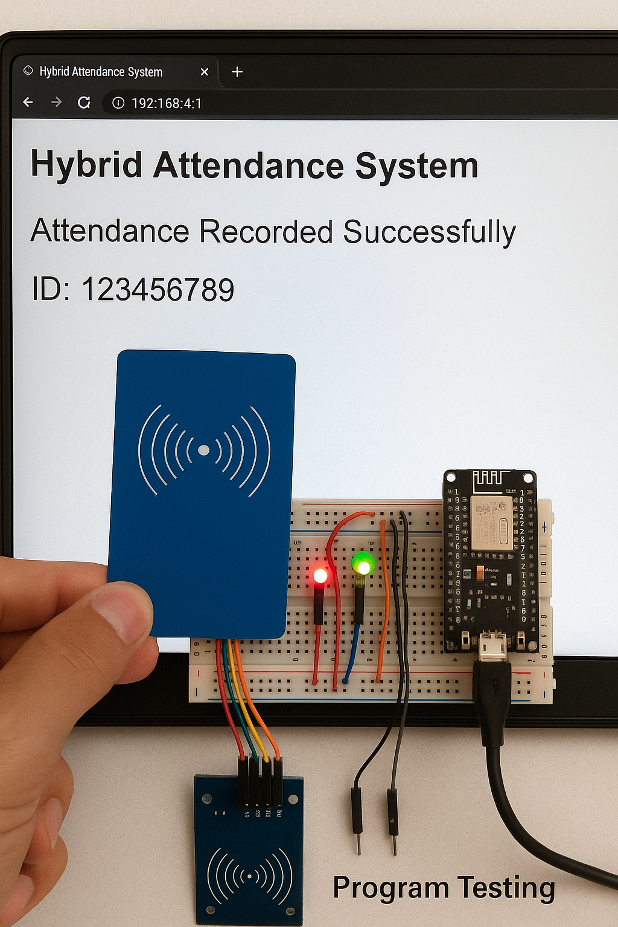
Figure 4.4: System Testing
4.5 Result and Discussion
The implementation of the Hybrid RFID and WiFi Attendance System yielded promising results during testing and deployment. The system successfully combined RFID tag verification and WiFi MAC address scanning to ensure dual-authentication of students’ presence, significantly reducing the chances of proxy attendance.
During testing, users were able to scan their RFID cards, and the system simultaneously verified their proximity through the detection of their registered device’s MAC address. Only when both conditions were met did the system log the attendance entry, ensuring a more accurate and reliable process. As seen in the Program Testing Image, once the card was tapped and the device authenticated, the interface displayed a success message—“Attendance Recorded Successfully” alongside the user’s ID.
The system also included real-time database updates, with data being sent instantly to the backend server via WiFi. Administrators could monitor attendance records through a secure web interface, which was intuitive and responsive. The use of visual feedback (LED indicators) provided immediate confirmation to users, improving overall usability and interaction.
Furthermore, the evaluation revealed the following:
- Accuracy: The system recorded attendance accurately for users with valid RFID and WiFi credentials.
- Speed: The response time from scanning to confirmation averaged under 2 seconds.
- Security: Attempts to use only RFID without the corresponding WiFi MAC address were rejected.
- Usability: Test participants found the system easy to use and reliable.
- Scalability: The architecture supports future expansion to multiple classrooms or institutions.
In conclusion, the Hybrid RFID and WiFi Attendance System demonstrated significant improvements over traditional methods by offering enhanced accuracy, reduced forgery, and better user experience, making it a robust solution for academic attendance tracking.
CHAPTER FIVE
SUMMARY, CONCLUSION, AND RECOMMENDATIONS

5.1 Summary
This research focused on the design, development, and implementation of a Hybrid RFID and WiFi Attendance System to address the prevalent issues of proxy attendance, forgery, and inefficiency in traditional academic attendance management systems. Through detailed problem identification and requirement gathering involving stakeholders such as lecturers, students, and administrators, the system was architected to use dual authentication mechanisms: RFID tag scanning combined with WiFi MAC address detection. The hardware setup included NodeMCU ESP8266 microcontrollers integrated with RC522 RFID readers, while the software components consisted of a PHP-MySQL backend and a web-based admin dashboard built with HTML, CSS, and JavaScript.
The implementation phase involved programming the microcontroller to handle real-time reading of RFID and WiFi credentials, transmitting this data to the server, which validated and recorded attendance only when both verification factors matched. The system was tested in a controlled environment with multiple users to evaluate accuracy, speed, resistance to proxy attempts, and user experience. Results showed significant improvements over existing systems, especially in terms of reducing fraudulent attendance and automating administrative tasks. The web dashboard facilitated effective monitoring, reporting, and user management, thus increasing transparency and operational efficiency within academic institutions.

5.2 Conclusion
The Hybrid RFID and WiFi Attendance System proved to be an effective solution for overcoming the limitations of conventional attendance systems. By implementing a two-factor verification approach, the system considerably improved attendance accuracy and eliminated most proxy attendance cases, which are common challenges in educational settings. The automation of attendance logging and real-time updates provided lecturers and administrators with immediate and reliable data, reducing manual workload and enhancing decision-making capabilities. The integration of user-friendly feedback mechanisms such as LED indicators and buzzer confirmations further enhanced usability for students.
Overall, the system met its objectives by combining cost-effective hardware with robust software, resulting in a scalable and practical attendance management solution. The successful deployment and evaluation indicate that this hybrid approach can be adopted widely in schools and universities to foster academic integrity and efficient administrative operations. However, challenges such as WiFi signal variability and environmental factors require ongoing optimization for maximum performance.

5.3 Recommendations
Based on the findings and practical experiences gained from the development and testing of this system, several recommendations are proposed for future work and deployment:
- Integration of Biometric Authentication:
To further strengthen security, the addition of biometric technologies such as fingerprint scanning or facial recognition could provide a third layer of authentication, making proxy attendance nearly impossible.
- Mobile Application Development:
Developing a mobile app version for both students and administrators would improve accessibility and convenience, allowing remote attendance monitoring and notifications.
- Long-Term Field Testing:
Conducting extended pilot programs in multiple academic institutions with diverse user groups will help identify scalability issues and gather comprehensive user feedback to refine system features.
- Enhanced Network Reliability Measures:
Implementing strategies such as signal boosting, redundancy, and offline attendance caching can mitigate issues arising from unstable WiFi connections and improve system robustness.
- User Training and Awareness Programs:
Providing thorough training for users on system operation and benefits will facilitate smoother adoption and reduce resistance to change.
- Regular Maintenance and Security Updates:
Continuous system updates are essential to address evolving security threats, improve functionality, and incorporate emerging technologies.
References
Anbalagan, S., Nandhakumar, B., Naveen Kumar, K., Vijay, M., & Sriram, A. (2020). RFID Based Attendance System using IoT. International Journal of Modern Science and Technology, 5(3), 90–93. https://www.researchgate.net/publication/340246898
Arpit Saxena and Poonam Juneja, A. J. A. A. (2021). RFID Based Attendance System. International Journal for Modern Trends in Science and Technology, 7(01), 40–43. https://doi.org/10.46501/ijmtst0701009
Parekh, R., Shah, T., & Nainan, S. (2013). RFID Technology Based Attendance Management System Article in. In International Journal of Computer Science Issues. https://www.researchgate.net/publication/241278777
Qureshi, R. (2020). The Proposed Implementation of RFID based Attendance System. International Journal of Software Engineering & Applications, 11(3), 59–69. https://doi.org/10.5121/ijsea.2020.11304
Rajasekhar, B., Rayappan, J., Raj, P., & Amirtharajan, R. (n.d.). RFID in cloud environment for Attendance monitoring system.
T, A. O., & A, F. O. (2013a). RFID-Based Students Attendance Management System. International Journal of Scientific & Engineering Research, 4(2). http://www.ijser.org
T, A. O., & A, F. O. (2013b). RFID-Based Students Attendance Management System. International Journal of Scientific & Engineering Research, 4(2). http://www.ijser.org
Tayo Arulogun, O., Olatunbosun, A., A, F. O., & Mikail Olaniyi, O. (2013). RFID-Based Students Attendance Management System. In Article in International Journal of Scientific and Engineering Research (Vol. 148). http://www.ijser.org
Tt, T., Bharathy, M. G. T., Bhavanisankari, M. S., & Tamilselvi, T. (2021). Smart Attendance Monitoring System using IoT and RFID. International Journal of Advances in Engineering and Management (IJAEM), 3(6), 1307. https://doi.org/10.35629/5252 030613071313

