PETROGRAPHIC STUDIES OF ROCK IN KAM QUARRY, KWARA STATE

By

BELLO, MORUFAH BOLANLE
HND/23/MNE/FT/021

SUBMITTED TO:
THE DEPARTMENT OF MINERALS AND PETROLEUM RESOURCES ENGINEERING TECHNOLOGY INSTITUTE OF TECHNOLOGY, KWARA STATE POLYTECHNIC, ILORIN
IN PARTIAL FULFILLMENT OF THE REQUIREMENT FOR THE AWARD OF HIGHER NATIONAL DIPLOMA (HND) IN MINING ENGINEERING TECHNOLOGY

JULY, 2025

Certification
This is to certify that this project was carried out and submitted by BELLO, MORUFAH BOLANLE of Matric number HND/23/MNE/FT/021 to the Department of Minerals and Petroleum Resources Engineering, Kwara State Polytechnic, Ilorin in partial fulfilment of the Requirement for the Award of Higher National Diploma in Mining Engineering Technology.

DR. OBARO, R.I
(Project Supervisor) Date

DR. OLATUNJI J.A.
(Head Of Department) Date

ENG. (DR.) OLUWASEYI, A.O
External Examiner (Academic) Date

ENGR. JIMBA, J.J
External Examiner (industrial) Date

Dedication
This project is dedicated to almighty Allah for making this project a successful one.

Acknowledgements
I give all glory and adoration to almighty Allah, the giver of knowledge, strength and ability for sustaining and helping me through my project period, and for his grace and protection over me throughout my higher national diploma program.
My appreciation also goes to my supervisor in person of Dr. Reuben Obaro for his total support and fatherly advice during the period of this project. I appreciate you so much Sir.
My appreciation goes to my beloved parent Mr. and Mrs. Bello for their moral, financial, and prayer supports, may you live long to reap the fruit of your labour.
I will be an ingrate if I don’t show my appreciation to my beloved sister Bello Samiat Ajoke, and to all members of my family, my colleagues, friends and everyone that has contributed in one way or the other to the success of this project.

Abstract
Structural components and mineralogical constituents are vital constituents in the study of rocks in Kam quarry. The materials and methods used include desk study, field mapping and laboratory analysis. The desk study involved review of previous reports on the Precambrian Basement complex of North - central Nigeria. The field mapping was carried out using visual survey with detailed investigation on outcrops found in the study area while the laboratory analysis was carried out using modern petrographic microscopes combined with digital cameras connected to the computer for detailed photomicrographs of fresh representative samples of Migmatite Gneiss tagged Sample A, Porphyritic Granite tagged Sample B and Biotite Granite labelled Sample C in an open-cast mine site. The results shows detailed brittle structures such as joints while the ductile structures includes foliations and folds such as assymetrical fold. The petrographic analysis of three (3) samples revealed that the Migmatite Gneiss, Porphyritic Granite and Biotite Granite consist of significant amount of quartz, plagioclase and alkali feldspar, microcline, biotite, hornblende and other accessory minerals. Economically, the sampled rocks (Migmatite Gneiss, Porphyritic Granite and Biotite Granite) in the studied area have good potentials for engineering purposes. The petrographic analysis examined indicate that mineral distribution quality are essentially made up economic minerals quartz, feldspar, biotite, muscovite and other accessory minerals. It is important to reiterates that these minerals are conspicuously present in all the rocks and it is evidenced that the minerals presents are randomly distributed in accordance to their lithological variations. It is noteworthy that the various rock types mapped conform to what has been reported in previous literatures and it evidently supports the geology of both North-central and South-western Basement Complex of Nigeria.

Table of Contents
Title page i
Certification ii
Dedication iii
Acknowledgement iv
Abstract v
Table of content vi
List of Figures ix
List of Tables x
CHAPTER ONE 1
1.0 Introduction 1
1.1 Background of the study 1
1.2 Aim of the study 2
1.3 Objectives of the study 2
1.4 Problem Statement 2
1.5 Justification of the study 3
1.6 Scope of the study 3
CHAPTER TWO 4
2.0 LITERATURE REVIEW 4
2.1 Review of Previous work 4
2.2 Composition of Rock 5
2.3 Physical Properties of Rock 5
2.4 Chemical Properties of Rock 6
2.5 Mineralogical Properties of Rocks 6
2.6 Economic Importance of Rocks 7
CHAPTER THREE 8
3.0 MATERIALS AND METHODS 8
3.1 Geology of Nigeria 8
3.2 Geology of the Study Area 10
3.3 Sample Collection 12
3.4 Sample Preparation 12
CHAPTER FOUR 13
4.0 RESULTS AND DISCUSSION 13
4.1 Structural features 13
4.2 Classification of structures 13
4.2.1 Brittle structures 13
4.2.2 Joints 13
4.3 Ductile Structures 14
4.3.1 Folds 14
4.3.2 Foliation 16
4.4 Results of Petrographic studies of the Thin Sections 17
4.5 Discussion on Petrographic Studies of Migmatite Gneiss 17
4.6 Petrographic Description of some of the Prominent Minerals in the Migmatite 18
4.6.1 Quartz (SiO₂) 18
4.6.2 Plagioclase Feldspar (Na₂AlSi₃O₈.Ca₂Al₂Si₂O₈) 18
4.6.3 Orthoclase Feldspar 18
4.6.4 Microcline Feldspar 19
4.6.5 Muscovite (KF)₂(Al₂O₃)₃(SiO₂)₆ 19
4.6.6 Biotite (Mg,Fe)₃ AlSi₃O₁₀(OH,F)₂ 19
4.6.7 Hornblende (Ca₂(Mg,Fe)₅(AI,Si)₈O₂₂(OH)₂ 19
4.7 Discussion on Petrographic Studies of Porphyritic Granite (Sample B) 22
4.8 Discussion on Petrographic Studies of Biotite Granite (Sample C) 24
4.9 Economic Potential of the Rocks 26
CHAPTER FIVE 27
5.0 Conclusion and Recommendation 27
5.1 Conclusion 27
5.2 Recommendation 27
References 28

List of Figures
Figure 3.1: Geological Map of Nigeria (Modified After Rahaman, 1988) 9
Figure 3.2: Location Map of the Study Area (modified after Olasehinde et al., 1998) 11

List of Plates
Plate 4.1. Joint 14
Plate 4.2. Asymetrical fold 15
Plate 4.3. Foliations 16
Plate 4.4. Photomicrograph of migmatite gneiss under Crossed Polarized Light 21
Plate 4.5. Photomicrograph of migmatite gneiss under Plane Polarized Light 21
Plate 4.6. Photomicrograph of porphyritic granite under Crossed Polarized Light 23
Plate 4.7. Photomicrograph of porphyritic granite under Plane Polarized Light 23
Plate 4.8. Photomicrograph of Biotite granite under Crossed Polarized Light 25
Plate 4.9. Photomicrograph of porphyritic granite under Plane Polarized Light 25

CHAPTER ONE
INTRODUCTION
1.1 Background of the study
Rocks are important sources of construction materials worldwide. Studies has proved that detailed descriptions of rocks with respect to its minerals content and its textural relationship within the rock are very vital to its economic viability. Crushed or blasted quarry aggregate are commonly used as coarse aggregates in civil engineering construction works including road base construction, concrete mix for building and pavement. Nguyen et al. (2023) investigated the relationship between petrographic characteristics and rock quality, presenting innovative approaches for integrating petrographic data into broader geotechnical assessments. The properties of the aggregate depend on the properties of the parent rock, and the petrographic characteristics are a major determinant for proper utilization of the rock aggregate Nevile (2011) also noted that many properties of the aggregate such as, chemical and mineral composition, petrological characteristics, hardness strength, specific gravity pore structure and cotour, depend entirely on properties of parent rock for the reason that all aggregate particles originally formed a part of a larger mass and may have been fragmented by natural process of weathering or artificially by crushing The petrographic analysis of any given rocks sample aid in the classification of that particular rock sample. Some extent various workers have studied the geology stratigraphy, structure paleogeography, petroleum and solid minerals associated with the cretaceous and younger sediment of the upper Benue through (Carter et al., 1963; Idowu and Ekqcozor, 1989; Baba et al., 1995; Zaborski et al., 2004) mineral deposits hosted by sediments in the region include evaporates, diatomites, limestones, clays, coal and sulphides among others. Geological field mapping and petrographic studies of rocks in a locality are used for the description and identification of different rock types and associated mineralogy, which can provide important support information in the exploration and exploitation of any associated economic mineralization. Sajid and Arif (2014) conducted that variations in the mechanical properties of rocks are largely associated with differences in their textures and modal mineralogical compositions. The geology of Nigeria is made up of three major litho - petrological components, namely, the basement complex, the younger granites, and the sedimentary basin. The basement complex which is Precambrian in age, occurs mostly in the south western, northern and eastern parts of the country. Hendron (2004) demonstrated that the compressive strength of granite increase with increasing specific surface area of individual grain. Tugrul (2004) opined that petrographic characteristics of rocks have significant effect of macro mechanical properties.
1.2 Aim of the Study
The aim of this project is to carry out detailed petrographic study of rocks in Kam quarry in Kwara state
1.3 Objective of the Study
The objective of this study includes:
i. to examine the petrographic study of rock.
ii. to determine the mineralogical constituents of rock
iii. to establish its importance for industrial purpose.
1.4 Problem statement
The geology and economic viability of Kam quarry is poorly understood, hindering optimal exploitation and management of its rock resources. Quarrying activities in Kam quarry without proper analysis of structural and mineral constituents may be cause underutilization of rocks. Hence, a petrographic study is needed to assess the structural features and mineralogical content.
1.5 Justification of the Study
Kam Quarry's geological diversity makes it a key resource for both local industries and researchers. A detailed petrographic study will however aid in classifying the rocks based on their mineralogical composition and texture, enhance the quality control measures for construction materials, provide baseline data for future studies and support sustainable exploitation and management of quarry resources.
1.6 Scope of the Study
The scope of this project will be restricted to collection of different rock samples from Kam quarry, Kwara State. The project is limited to field work and laboratory analysis. The global positioning system will be used to take the coordinate.

CHAPTER TWO
LITERATURE REVIEW
2.1 Review of previous works
Many researchers has reported petrographic study of rocks in Nigeria. Neville (2011) reported that many properties such as chemical and mineral composition, and petrological characteristics, depend entirely on properties of parent rock. Sajid and Arif (2014) concluded that variations in the properties of rocks are largely associated with difference in their textural compositions. Akinwumi (2022) worked Geology and Petrographic Studies of Rocks around Ogale, Ijumu in southwestern Nigerian Basement Complex, as a geologically rich region requiring in-depth petrographic and structural analysis. The study concluded with the identification of key lithological units including granite gneiss, biotite granite, and pegmatite. Petrographic analysis showed the presence of minerals like plagioclase, quartz, biotite, and hornblende, with most mineral grains exhibiting subhedral textures. Structural analysis revealed a dominant NE–SW foliation trend, along with joints and fractures, which have significant implications for hydrogeological studies.
Adekeye (2024) reported Petrographic and Structural Analysis of Exposed Rocks of Bishini Sheet and revealed the minerals and textures characteristic of high-grade metamorphic conditions, while structural analysis recorded significant deformation events evidenced by folding and faulting. These findings provided a clearer understanding of the tectonic forces that have acted upon the Nigerian Basement Complex and served as a foundation for further regional geological investigations and resource evaluations. Mohammed (2024) studied the Geologic and Petrographic Studies of the Rocks in Dumne Area, Northeastern Nigeria and stressed that the granitic rocks in the Dumne area are coarse-grained and of magmatic origin. Petrographic analysis revealed quartz, orthoclase, biotite, microcline, hornblende, muscovite, iron oxide, zircon, and ilmenite. The quartz exhibited low relief and weak birefringence, while accessory minerals such as zircon and ilmenite indicated a complex magmatic evolution. These findings enhanced the geological understanding of the region, suggesting potential for economic mineralization and aiding in future mineral exploration projects in Northeastern Nigeria.
2.2 Composition of Rock
Igneous rocks are commonly classified by their composition and texture. Most are composed of the eight abundant elements in the earth because of the dominance of oxygen and silicon in the crust. Igneous rocks are mostly made up of silicates. The dark silicate is also called ferromagnesian because of the presence of iron and ferromagnesian in them. They include olivine, pyroxene, amphibole and biotite. The higher coloured silicates include quartz, muscovite and feldspar. Solidification from magma produces great diversity in the mineral composition which makes up the rock there are general categories which are keyed to the amount of the light and dark silicates in the rocks. At the light coloured are rocks made of mainly quartz and the feldspars, with about 70% silica. Such rocks are called granitic rock.
2.3 Physical Properties of Rock
These are used to identify the type of rocks to discover more about them. There are various physical properties of granite like Hardness, grain size, fracture, streak, porosity, luster, strength etc. which defines it. The physical properties of granite rock are vital determine its texture and uses. The physical properties of Granite depend on its formation. Physical properties of rocks play an important role in determining its applications in various fields. Rocks are rated on the on the Moh's Hardness Scale which rates the rocks on the scale from 1 to 10. Rocks with hardness 1-3 are soft rocks from 3-6 are medium hardness rocks and 6-10 are hard rocks. The hardness of Granite is 6-7 whereas its compressive strength is 175.00 N/mm². Streak is the color of rock when it is crushed or powdered. The streak of Granite is white whereas its fracture is not available. Luster of Granite is the interaction of light with the surface of Granite. Luster of Granite is dull to grainy with sporadic parts pearly and vitreous. Granite cleavage is not available. The specific gravity of Granite is 2.6 - 2.7. Granite is opaque in nature whereas its toughness is not available. You can also know all the list of rocks in opaque rocks, translucent rocks and transparent Rocks.
2.4 Chemical Properties of Rock
The chemical composition of granite is typically 70-77% silica, 11-13% alumina, 3-5 %potassium oxide, 3-5% soda, 1% lime, 3-4% total iron, and less than 1% magnesia.The resulting granite will likely have been made primarily from quartz, different feldspars and biotite. However, it can also have a variety of other minerals and oxides present. Quartz content can range from 65-95% and biotite content is around 10-15% in most granite. The chemical composition as well as the formation of granite inside the earth’s surface produces an incredible material that is valued for its look and physical properties. It has started replacing marble because of its more durable qualities and resistance to weather and acid rain, through a very common rock, granite is far from ordinary (Tugrul and Zarif, 1999)
2.5 Mineralogical Properties of Rock
Rock is classified according to the QAPF diagram for coarse grained plutonic rocks and is named according to the percentage of quartz, alkali feldspar (orthoclase or microcline) and plagioclase feldspar on the A – Q - P half of the diagram. True granite (according to modern petrologic convention) contains both plagioclase and alkali feldspars. When a granitoid is devoid or nearly devoid of plagioclase, the rock is referred to as alkali feldspar granite. When a granitoid contains less than 10% orthoclase, it is called tonalite; pyroxene and amphibole are common in tonalite. A granite containing both muscovite and biotite micas is called a binary or two-mica granite. Two-mica granites are typically high in potassium and low in plagioclase, and are usually S-type granites or A-type granites.
2.6 Economic Importance of Rocks
Rocks serve as an essential natural resource in Nigeria, forming the backbone of several economic sectors including construction, energy, mineral resources, ceramics, agriculture, and geotourism. The petrographic characteristics of these rocks comprising their mineralogical, chemical, and physical properties determine their industrial applications and economic value. Igneous and metamorphic rocks in Nigeria, especially granites, gneisses, and quartzite, are widely used as dimension stones, aggregates, and building materials. Petrographic studies on granitic rocks has confirmed high quartz and feldspar content with minimal microfractures, making them ideal for high strength aggregates in road and bridge construction. The economic relevance of charnockites in Akure area, demonstrating that their mineralogical toughness and resistance to weathering make them suitable for heavy-duty construction and railway ballast. Their work also emphasized the textural compactness derived from fine- to medium-grained minerals, which enhances the durability and compressive strength of these rocks.

CHAPTER THREE
MATERIALS AND METHODS
3.1 Geology of Nigeria
Nigeria lies within the mobile belt of Africa and is bordered at the Western part by West Africa craton, and Congo craton at the Southeastern part and Atlantic Ocean at the South. Geologically, the Basement Complex covers about 50% of the total surface of Nigeria (Fig. 2.1). It composed of the following lithostructural units. The Migmatite-Gneiss complex (MGC) has for long been regarded as basement sensu stricto (S.S.) and it is the most widespread of the main rock units in both northwestern and southwestern Nigeria. The various rock types in this complex are exposed in the north central, north eastern, southwestern and a narrow zone parallel to the eastern boundary of the country, east of River Benue. Kogbe, (1989). The Younger Granite Complexes occupies about 5% of the total surface area of Nigeria. It covers an area of about 8600sq km in central Nigeria and located in N-S rectangular province 400km long and 160 km wide. The complexes concentrated on the Jos Plateau area with few numbers scattered in the north and south of the Plateau extending to Bauchi, Kaduna, Kano, Gombe and Nassarawa states. Nigeria is underlain by seven major sedimentary Basin (from the oldest) the Calabar flank, the Benue trough, the Chad, Lullemenden (Sokoto), Dahomey and Niger Delta. Sedimentary succession in this area is of middle Mesozoic to Paleozoic age. Older sedimentary deposit was not preserved, probably because during the Paleozoic (Oyawoye, 1959).

Figure 3.1: Geological Map of Nigeria (Modified After Rahaman, 1988)

3.2 Geology of the Study Area
The study area is Kam Quarry, Ilorin South in Kwara State. It is located within latitude N08⁰ 33¹.18.2¹¹ and longitude E004⁰ 45¹33. 011. Geologically, the area (Fig. 2.2) lies in the Precambrian Basement complex of north central Nigeria and is underlain by rock of metamorphic and igneous type (Figure2.1). However, migmatite predominantly underlies the rocks in the area while other principal rocks include granites and gneisses which are emplaced by Precambrian time and have overtime subjected to tectonic activities characterized by large changes on temperature and resulting in folding and fractures such as joints, faults and fractures within the basement complex rock. (Ibrahim et al., 2012). The mineralogical composition in these rocks include quartz, feldspar, mica (muscovite and biotite), hornblende.

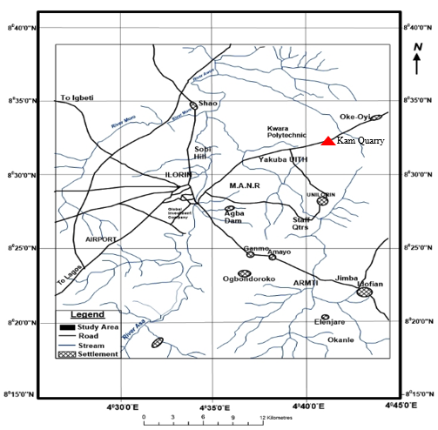
Figure 3.2: Location Map of the Study Area (modified after Olasehinde et al., 1998)

3.3 Sample Collection
Fresh representative samples of Migmatite Gneiss tagged Sample A, Porphyritic Granite tagged Sample B and Biotite Granite (Sample C) were collected on the open-cast mine site on outcrops. Structural features were observed based on tectonic activities and visual studies were also carried out to identify the different types of rocks. The Global Positioning System was used to take the coordinate of the different locations where the samples are taken. Other equipment used includes hammer, chisel, sampling bags, paper tape and marker. The three sample were separated in different sample bags and transported to University of Ilorin, Geology and Mineral Sciences Laboratory for detailed analysis.
3.4 Sample Preparation
The laboratory analysis was carried out on three different types of rocks labeled Sample A (Migmatite Gneiss), Sample B (Porphyritic Granite) and Sample C (Biotite Granite). The petrographical analysis carried out include thin section analysis and optical observations. During the preparation of thin sections analysis for all the samples, a thickness of 1.0 cm of a square shape of each of the rock sample was cut with the cutting machine. Applying emery cloth and caborundum powder, the specimen is further flattening to a thickness of about 0.04 mm. This flattened specimen is overlaid by the boiled Canada basalm and it is covered with a cover slip and left for about a day, then it is washed, rinsed with spirit and later with water. A total of six (6) thin sections (2 slides from each rock sample) were prepared from the samples for effective analysis and control. The analyses were subjected to microscopic examinations. Petrographic studies of the selected samples were made with the aid of a polarizing microscope. Some of the major minerals were observed under the microscopic examinations.

CHAPTER FOUR
RESULTS AND DISCUSSION
4.1 Structural features
This chapter is concerned with the description, spatial representation and analysis of structural features produced by the displacement or deformation of rocks. Structural features are formed as a result of rock resistance to stress. It reflects extent of tectonic events that have affected the area.
The structural features may be primary that is formed during the formation of rocks such as horizontal layering or secondary which is formed after primary structures or after the rock has being formed, this include folding, fracturing etc.
4.2 Classification of structures
The structural features observed in the area are classified into two main groups. These are:
i. Brittle structures
ii. Ductile structures
4.2.1 Brittle structures
These are structures that are formed from breaking of rocks in response to stresses higher than their elastic limit. They are developed when the rocks loses its cohesion in response to application of stress resulting in marked discontinuities called fractures and may be seen as joint or faults.
4.2.2 Joints
This is a fracture without apparent movement or displacement parallel to the plane of the surface (Plate 4.1). Joints were seen on the field trending in different directions. Joints occur in virtually all the mapped areas and some of the veins observed were believed to have been formed as minerals precipitate within these joints to form veins.
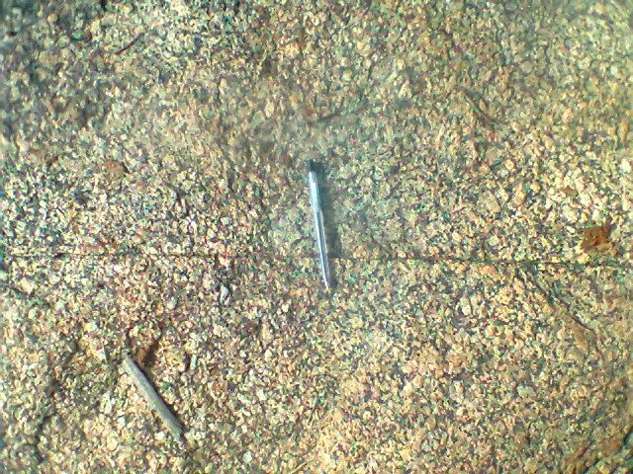
Plate 4.1: Joint
4.3 Ductile Structures
Ductility is the ability of a rock to undergo large strains without resulting in marked discontinuities of the entire rock mass. Ductile behavior of rocks is a function of temperature and strain rate. The ductile features observed in the mapped area are folds, foliation, and lineation.
4.3.1 Folds
Fold is a bend in planar surface as a result of compressional force. It is said to be a ductile structure due to its resistance to breakage during the application of stress (Plate 4.2). They occur as folded veins and folded alignment of minerals segregated into light and dark bands. Observable fold on the field is Asymmetrical fold.

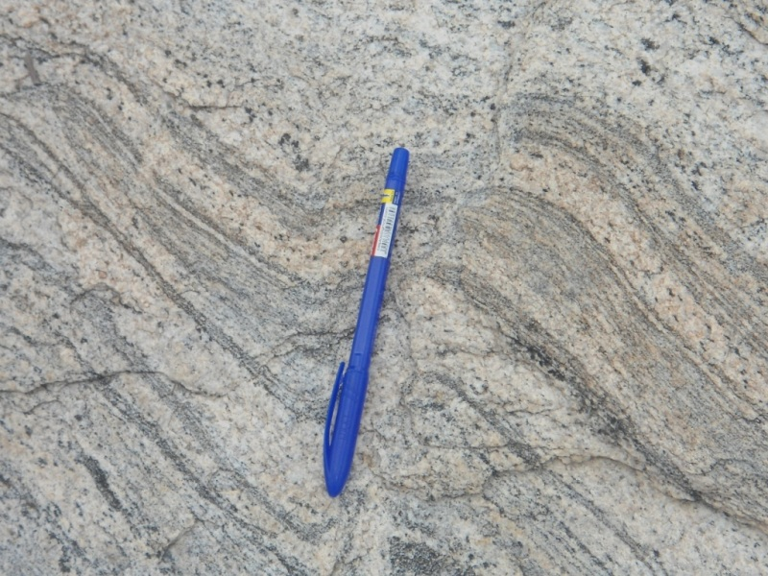
Plate 4.2. Asymetrical fold

4.3.2 Foliation
This is a repeated or penetrative planar feature in a rock which may be defined by fabric, compositional layering or pervasive fracture (Plate 4.3). They are mostly common in metamorphic rocks. They are also parallel alignment of textural and structural features of rock.
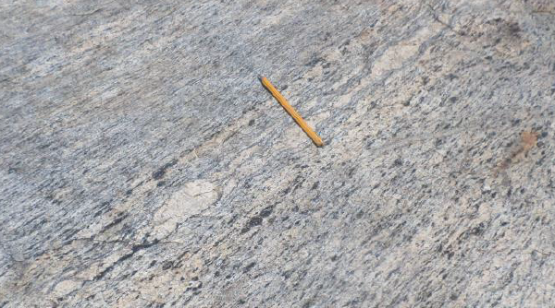
Plate 4.3. Foliations

4.4 Results of Petrographic studies of the Thin Sections
The results based on petrographic studies of the thin sections revealed the various mineral distributions such as quartz, biotite, hornblende and feldspar (orthoclase, plagioclase and microcline). The quartz and feldspar constitute almost 88% of the thin section with other accessory minerals in both plane polarized and cross polarized light.
4.5 Discussion on Petrographic Studies of Migmatite Gneiss
The migmatite gneiss is the oldest type of rock in the study area. According to Abba (1983) gneiss occurs as the most widespread lithological unit in basement terrains and the imprints of the Pan – African deformation were evident by regional metamorphism, migmatization, extensive granitization and gneissification which produce syntectonic granites and homogeneous gneisses. It is common and appears to demonstrate undifferientiated pattern within the area. They are depicted generally by alternating light and dark coloured bands. The felsic bands of the rock consist of quartz, plagioclase and orthoclase feldspar with large percentage composition while the hornblende, muscovite or biotite constitutes smaller percentage of minerals in mafic bands. Based on mineral assemblages, quartz is however a dominant minerals while others such as feldspar and biotite are also making up a vital part. It has textural classification of fine to medium grained. In addition, the rock has undergo numerous orogenic cycles which has essentially lead to large scale deformation (Obaje, 2009). The imprints has been widely reported in the Precambrian rocks of Nigeria (Rahaman, 1989). The macro and micro structures is as a result of fracturing (Olayinka, 1992) such as folding, jointing, veins, intrusions, foliations and mineral lineations which were found in the study area.

4.6 Petrographic Description of some of the Prominent Minerals in the Migmatite Gneiss
The studied thin section with the aid of petrological microscope and slides were analyzed under plane polarized light and crossed nicol. The studied minerals include quartz, feldspar, biotite and hornblende.
4.6.1 Quartz (SiO₂)
The quartz is colourless in plane polarized light and shaped in euhedal. In coss polarized light, the quartz is colourless, reddish and conchoidal fracture with anhedral shape (Plate 4.4 and 4.5). It also display pleinchoism crystal of quartz that exhibit low relief and sometimes exhibit undulose extinction indicative of deformation or straining (Obini and Omietimi, 2020).
4.6.2 Plagioclase Feldspar (Na₂AlSi₃O₈.Ca₂Al₂Si₂O₈)
The feldspar mineral observed are plagioclase feldspar which is clearly from Albite twining characteristics (Ojelokun and Fawole, 2019) which is as a result of angle parallel to the large crystals in plane polarized light is colourless (Plate 4.4) but it demonstrate first order grey colour when the polar is crossed. It can be characterized from other types of feldspar because of its polysynthetic twining visible in the crystal. Some of the plagioclase in the slides occur as phenocryst (Plate 4.5).
4.6.3 Orthoclase Feldspar
The orthoclase feldspar under plane polarized light and crossed polarized light (XPL) appears cloudy and colourless (Plate 4.4 and 4.5). The crystals have low relief and are anhedral in shape. It is often colourless crystals with grey and reddish. The darker portion in the thin section suggest weathered feldspar with no definite cleavage.

4.6.4 Microcline Feldspar
The microcline feldspar exhibit a crystal system known as triclinic. This mineral is colourless under plane polarized light (PPL) and appears milky white under cross polarized light (XPL) with higher relief to quartz and orthoclase plate (Plate 4.4 and 4.5). The physical and chemical composition of microcline feldspar can be compare with the orthoclase feldspar. A thin section study implies large anhedral to subhedral microperthitic microcline with good polysynthetic crosshatched crystals with elongated crystals that exhibit subhedral habit.
4.6.5 Muscovite (KF)₂ (Al₂O₃)₃ (SiO₂)₆
The muscovite appears colourless under plane polarized light (PPL) (Plate 4.4) and has a pale green appearance under cross polarized light (XPL) (Plate 4.5) which makes it pleochroic. It exhibit parallel extinction with high relief and perfect cleavage in all direction. However, many of the crystals has twining and those near to the extinction shows position display appearance which is characteristics of mica family.
4.6.6 Biotite (Mg,Fe)₃ AlSi₃O₁₀(OH,F)₂
The colour of the biotite is between grey to brown colouration with subhedral to anhedral shape and has no twining. It has a directional cleavage. The mineral plate does not have extinction angles but form interstitial lamellae which may occur as linear aggregates with alteration to chlorite. It exhibits different pleonchoic orientation. The biotite has some inclusion of accessory minerals like zicon, rutile and apatite (Plate 4.4 and 4.5). It has strong birefringence under crossed polarised light, interference colour of dark green with symmetrical extinction and polysynthetic twinning.
4.6.7 Hornblende (Ca₂(MgFe)₅(AI₂Si)₈O₂₂(OH)₂
The colour of hornblende under plane polarized light is greenish black and it also displays pleochroism from green to brown. Under plane polarized light, a few of the hornblende crystals showed the characteristics shape and two cleavages. Under crossed nicol, twinning was seen in a few hornblende crystals and the highest interference colour seen is a second-order blue.

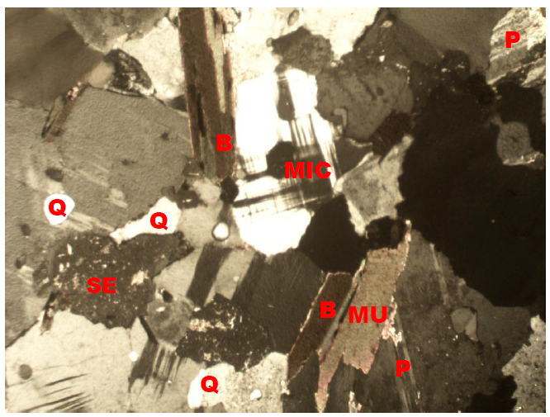
Plate 4.4: Photomicrograph of migmatite gneiss under Crossed Polarized Light (XPL), showing quartz (Q), biotite (B), plagioclase feldspar (P).
Plate 4.5: Photomicrograph of migmatite gneiss under Plane Polarized Light (PPL) showing the various shades of colours of mineral grains, Quartz (Q), Biotite (B), Plagioclase feldspar.

4.7 Discussion on Petrographic Studies of Porphyritic Granite (Sample B)
Porphyritic granite is the second most abundant rock type in the study area and it exhibits the characteristics of both slow and rapid rates of cooling magma. This has resulted to large or giant crystals of minerals (Phenocrysts) due to slow cooling, nevertheless, it has been subjected to further rapid cooling as the magma eventually move to the surface to form finer groundmass in which the Phenocryst are embedded to form porphyritic texture (Saad and Baba, 2017). The major mineral constituents that occur include quartz, biotite, hornblende and plagioclase feldspar. The quartz in the porphyritic granite is euhedral in shape and it displays undulose extinction. The biotite exhibits different pleonchronic orientation. The biotite has some inclusion of accessory minerals like zircon, rutile and apatite. The plagioclase feldspar occurs as phenocrysts with lamellar twinning within the groundmass. Accessory minerals in the rock include zircon, apathite, magnetite and titanite (Plate 4.6 and 4.7)

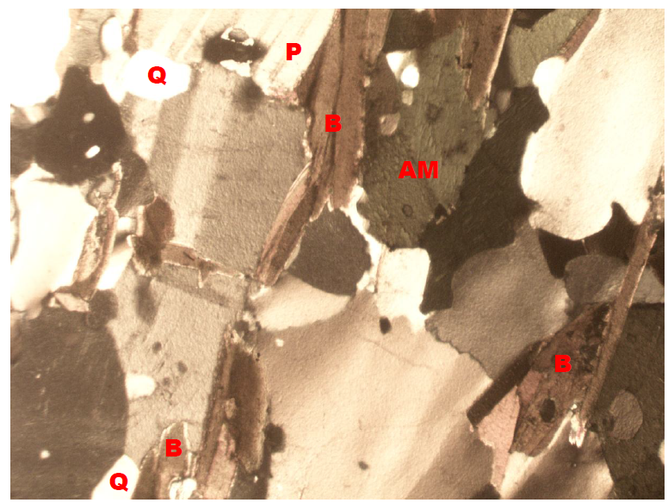
Plate 4.6: Photomicrograph of porphyritic granite under Crossed Polarized Light (XPL), showing quartz (Q), biotite (B), plagioclase feldspar (P).
Plate 4.7: Photomicrograph of porphyritic granite under Plane Polarized Light (PPL) showing the various shades of colours of mineral grains, Quartz (Q), Biotite (B), Plagioclase feldspar.

4.8 Discussion on Petrographic Studies of Biotite Granite (Sample C)
The biotite granite is a medium to coarse grained rock. The colour has resulted from the disintegration of biotite to fom chlorite (Aga and Haruna, 2019). Biotite is pleochroic form green to brown and are subhedral in shape (Plate 4.8). The chlorite that occurs within the fractures has light green colouration and occurs mainly in cracks present within mineral matrixes. The crystal form of the chlorite is anhedral and occurs as a different product. However, the quartz in the biotite granite is euhedral to crystal in shape with crypto crystalline inclusions. It displays undulose extinction. This essentially proves that the rocks were highly deformed. The huge tectonic activities that took place or occur might have led to the exposure of the rocks to the surface of the study area. The occurrence of feldspar in the biotite granite is known as plagioclase feldspar and it is an irregular formed perthite with patches of it formed at the surface. The iron oxide occurs as tiny black patches in some biotite crystals and it is less abundant in the sample (Plate 4.9).

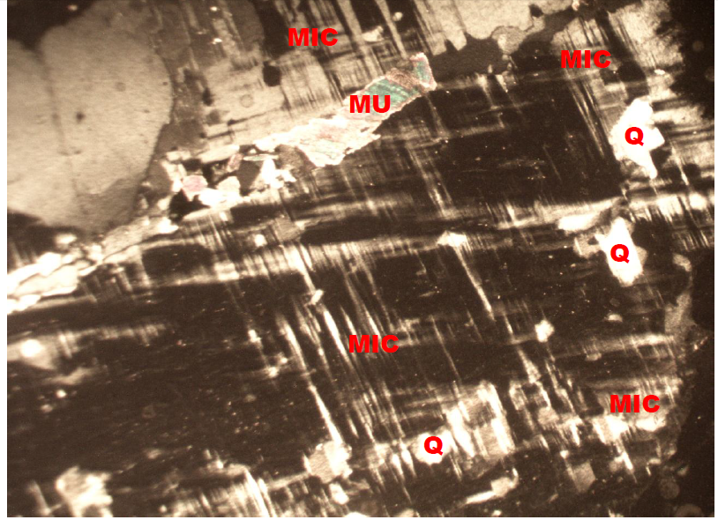
Plate 4.8: Photomicrograph of Biotite granite under Crossed Polarized Light (XPL), showing quartz (Q), biotite (B), plagioclase feldspar (P).
Plate 4.9: Photomicrograph of porphyritic granite under Plane Polarized Light (PPL) showing the various shades of colours of mineral grains, Quartz (Q), Biotite (B), Plagioclase feldspar.
4.9 Economic Potential of the Rocks
Economically, the sampled rocks (Migmatite Gneiss, Porphyritic Granite and Biotite Granite) in the studied area have good potentials for engineering purposes. Industrially, the quartzite can be used as industrial silica sand, silicon and silicon carbide. It can also be used as decorative stone used to cover walls. It is also useful in flooring, star steps and as roofing tiles. It is sometimes used as railway ballast and also in road construction purposes such as bridges, building houses, road pavement etc. The petrographic analysis examined indicate that mineral distribution quality are essentially made up economic minerals quartz, feldspar, biotite, muscovite and other accessory minerals. It is important to reiterates that these minerals are conspicuously present in all the rocks and it is evidenced that the minerals presents are randomly distributed in accordance to their lithological variations (Ajali, 1997). Feldspar can be mined as profit by ceramics and glass industries for making product. The feldspar (plagioclase and orthoclase) can also be mined for fertilizers and cements.

CHAPTER FIVE
Conclusion and Recommendation
5.1 Conclusion
Petrographic studies and geochemical analysis of two different rock samples were carried out in the study area. Petrographically, the granitic rocks in the study area are composed of major rock forming silicate minerals such as quartz, biotite mica, and feldspars. The photomicrographs in the study area shows that the rocks are mineralogically composed of quartz, orthoclase and plagioclase feldspar, albite, microcline and other minor constituents such as hornblende and biotite. Economically, the various rocks in the area have good potentials for engineering purposes. The petrographic analysis examined indicate that mineral distribution quality are essentially made up economic minerals quartz, feldspar, biotite, muscovite and other accessory minerals.
5.2 Recommendation
The federal government should establish and equip the existing laboratories to carry out detailed analysis particularly on petrographic analysis of rocks for engineering construction purposes.
Measures should also be put in place to exploit and explore solid mineral resources in order to enhance industrialization and boost the economy of the country.

References
Amuda, A. G., Uche O. A. U. and Amuda A. K. (2014). Physicomechanical characterization of basement rocks for construction aggregate: A case study of Kajuru area, Kaduna, Nigeria. IOSR Journal of Mechanical and Civil Engineering, 11(6), 46 - 51.
Ayfer, O. (2018). Geology for civil engineering, [on-line:] (https://aybu.edu.tr/muhendislik/insaat/contents/files/GEOLOGY%20FOR%20CIV IL%20 Engineering. (2).
Kosmatka, S. H., Kerkhoff, B. and Panarese, W. C. (2003). Design and control of concrete mixtures Skokie, IL: Portland Cement Association.
Lindqvist J. E., Akesson U. and Malaga K. (2007). Microstructure and functional properties of rock materials. Materials characterization, 58(11-12), 1183-1188
Muhammad, J. M., Safeer, A., Syed, M. S. K., Anwar, K., Syed Z. A. and Muhammad T. A. (2017). “Engineering characteristics of widely used coarse aggregates in Pakistan: a comparative study." Pakistan Journal of Engineering and Applied Sciences, Vol; 20, pp.85- 93.
Neville, A. M. (2011). Properties of Concrete (Vol. 4) London: Longman. Adubok A. S, Imoekparia EG (2008). Trace elements distribution and enrichment in soils overlying barytes vein deposits in the Paya district, middle Benue Trough, Nigeria. Continental J. Earth Sci. 3:22-27.
Nguyen, T. P., Chen, Y. L., & Garcia, H. M. (2023). Integrating petrographic characteristics into geotechnical assessments: Innovations and applications. Rock Mechanics and Mining Sciences, 67, 128–140.
Ojeifo, J. Akhimien, M. O. and Francis, O. (2013). Pattern of Fencing and Impacts in Urban Auchi, Edo State, Nigeria; International Journal of Physical and Human Geography, Vol. 1(1), Pp. 26-34.
Jethro, M. A., Shehu, S. A. and Olaleye, B. M. (2014). The Suitability of some selected granite deposits for aggregate stone production in road construction. The International Journal of Engineering and Sciences, 3, 75-81.

