ROUTE SURVEY

OF

MICHEAL IMODU WAY TO KANGU OSHIN OLATUNJI ROAD
IFELODUN TO ILORIN WEST LOCAL GOVERNMENT AREA,
ILORIN KWARA STATE.

BY
ADEFABI ABIODUN BENJAMEN
HND/23/SGI/FT/0124

SUBMITTED TO:
THE DEPARTMENT OF SURVEYING AND GEOINFORMATICS,
STATE POLYTECHNIC ILORIN, KWARA STATE.

IN PARTIAL FULFILMENT OF THE REQUIREMENTS FOR THE
AWARD OF HIGHER NATIONAL DIPLOMA IN
SURVEYING AND GEOINFORMATICS.

MAY, 2025

CERTIFICATE
I hereby certify that all the field work and information combined in this project write up were obtained as a result of observation and measurements made by me ADEFABI ABIODUN BENJAMEN with matriculation number HND/20/SGI/FT/0124 and that the survey was carried out in accordance with survey rules and regulations and departmental instructions.

______________________ ______________________
Student's Signature Date of Completion

CERTIFICATION
This is to certify that ADEFABI ABIODUN BENJAMEN with matriculation number HND/20/SGI/FT/0124 has successfully carried out the survey duties contained therein in this project write up under my instruction and direct supervision.
I hereby declare that he has conducted himself with due diligence, honestly and on the project

______________________ ______________________
SURV. A.O. AKINYEDE DATE
(PROJECT SUPERVISOR)

______________________ ______________________
SURV. S.A. AWOLEYE DATE
(PROJECT COORDINATOR)

______________________ ______________________
SURV.I.I. ISAU DATE
(HEAD OF DEPARTMENT)

______________________ ______________________
EXTERNAL MODERATOR DATE
(SURV. B.A. JIMOH [MNIS])

DEDICATION
This project write up is dedicated to the Almighty God, the lord of the universe and my loving and wonderful family.

ACKNOWLEDGEMENT
All glory, Honor and Adoration to God Almighty, the gracious one who has given me the opportunity to complete my HND programme.
My appreciation goes to my supervisor Surv. A. O. Akinyede, for his encouragement and motivation as regard the writing of this project thank you and God bless you. And to all lecturers in the Department of Surveying and Geoinformatics, Surv. I .I.Abimbola (HOD). Surv. A. G. Aremu, Surv. R. S. Awoleye, Surv. R. O. Asonibare, Surv. Ayuba Abdulsalam, Surv. Babatunde Kabir, Surv. Bello F.D and others. May God bless you all (Amen).

ABSTRACT
The Route Survey from Micheal Imodu way to kangu oshin Olatunji Was carried out by carried out recce survey, planning at the office. The Total Station (series) was used for the traversing and detailing while the controls establishment and benchmarks was done by DGPS all across the route line at every 1km and the data was processed using CivilCAD2014 with the AutoCAD 2007. Series of engineering plans was produces like horizontal alignment plan, vertical alignment plan, cross section and calculating volumes of earth works were also produce to show cut and fill quantities material.

TABLE OF CONTENTS
TITLE PAGE……………………………………………………………………………..i
CERTIFICATE…………………………………………………………………………...ii
CERTIFICATION………………………………………………………………………..iii
DEDICATION…………………………………………………………………………....iv
ACKNOWLEDGEMENT………………………………………………………………...v
ABSRACT………………………………………………………………………………...vi
TABLE OF CONTENT…………………………………………………………………...vii
LIST OF TABLES………………………………………………………………………...viii
LIST OF FIGURES……………………………………………………………………….ix

CHAPTER ONE:
1.0 INTRODUCTION 1-4
1.1 STATEMENT OF THE PROBLEM 4
1.2 AIM OF THE PROJECT 5
1.3 OBJECTIVES OF THE PROJECT 5
1.4 SCOPE OF THE PROJECT 5
1.5 PROJECT LOCATION 6
1.6 SPECIFICATION OF THE PROJECT 6
1.7 PERSONNEL INVOLVES 7
CHAPTER TWO:
2.0 LITERATURE REVIEW 8-11
CHAPTER THREE:
3.0 METHODOLOGY 12
3.1 PRELIMINARY PLANNING AND PREPARATION 12
3.2 RECCONAISANCE PLANNING 13
3.3 OFFICE PLANNING 14
3.4 SELECTION OF THE EQUIPMENT AND SOFTWARE 14
3.5 BENCH MARKS ESTABLISHMENT, CAPPING AND LABEL 15
3.6 INSTRUMENT TEST 16
3.7 DATA ACQUISITION 17-21
CHAPTER FOUR:
4.0 DATA PROCESSING 23
4.1 DATA DOWNLOADING AND EDITING 23-24
4.2 DATA PROCESSING PROCEDURE 24-27
4.3 RESULT AND ANALYSIS 27-28
4.4 LINEAR ACCURACY 28-29
4.5 HEIGHT ACCURACY 30
4.6 PLAN PRODUCTION 30-34
4.7 PROJECT COSTING 35-37
FIG 4.1 SHOWING HORIZONTAL ALIGNMENT 31
FIG 4.2 SHOWING VERTICAL ALIGNMENT 32
FIG 4.3 SHOWING CROSS SECTION 33
FIG 4.4 DIAGRAM SHOWING GENERATED VOLUME COMPUTATION 34
CHAPTER FIVE:
5.0 SUMMARY, PROBLEM ENCOUNTERED, RECOMMENDATION AND COCLUSION
5.1 SUMMARY 38
5.2 PROBLEM ENCOUNTERED 39
5.3 RECOMMENDATION 39
5.4 CONCLUSION 39
5.5 REFRENCES 40
5.6 APPENDICES 41

CHAPTER ONE
- INTRODUCTION
Surveying plays a key role in the development of engineering project such as hydroelectric schemes irrigation, alignment of roads, and transmission lines, locations and construction of dams, aqueduct (a structure like bridge that takes water across valley), development of cities, flood controls and development and maintenance of harbour’s. In all these projects, the role of surveyors is to render services to the design engineers to provide information relevant to the design and construction of roads. (Roy, 2008). Surveying include the determination of the measuring data, reduction and interpretation of the data to useable form and conversely the establishment of relative position and size according to the given measurement requirements. There are many operations in surveying which are boundary surveys, topographic survey, hydrographic surveying mine surveying, construction surveys, photogrammetry and remote sensing, route surveying.
Engineering surveying is the survey carried out to provide special information for construction projects which are usually drawn to large scale. Engineering surveying has assumed the goal of dimensioning the physical environment. Greater part of its responsibility is seen from the various type of surveying, which are geared towards promoting accessibility route ways, convenience, economy and spatial delineation of both natural and social environment. Route surveying which is the main focus of this project is define as the topographic and constructional survey that are necessary for the location and construction of communication lines, transportation, roads, canals, highway, pipelines etc. generally route survey can be applied to the survey required to establish the horizontal and vertical alignment for transportation facilities. In most cases the transportation facilities comprise a network that includes the transport of people or goods by way of highways, railways, canal, pipelines, and transmission lines.
A route survey is defined as being the required service and product that adequately locates the planned path of a linear project or right of way which crosses a prescribed area of real estate, extending from a least one known point and turning or terminating at another known point. Adequate location shall mean substantial compliance with the conditions and tolerances expressed in this standard. A route surveying defines new or proposed boundaries shall be conducted as a boundary survey and must adhere to the rules and regulations of the Texas board of professional land surveying (TBPLS).
Various means of transportation exist; they are transportation by air, by land and transportation by water. Land transportations involves by rails, and roads. Road accounts for about 95% of all surface transportation in Nigeria. Road make possible socio-economic and cultural relationship among communities and create avenue for the good and management of the environment. Good transportation, in and of itself, will not assure success in the marketplace, as the availability of transportation is a necessary but insufficient condition for economic growth. However, the absence of supportive transportation services will serve to limit or hinder the potential for a nation or region to achieve its economic potential. Thus, if a society expects to develop and grow, it must have a strong internal transportation system consisting of good roads, rail systems, as well as excellent linkages to the rest of the world by sea and air. Thus, transportation demand is a by-product derived from the needs and desires of people to travel or to transfer their goods from one place to another. It is a necessary condition for human interaction and economic competitiveness. (Garber 2009)
Transportation has contributed immensely to the economy development of the world in terms of:
- Migration of people
- Movement of goods and services
- National integrations
- Division of ideas and technology.

Route surveying is such a survey exercise that requires all field works and calculations made for the purpose of locating and constructing a cross country social utilities such as highways, railways, canals, transmission lines and pipeline. This involve the determination of the ground configuration and location of physical features (naturals and manmade) along the route, establishing the line on the ground and computing the volume of earthwork.
The main purpose of any route survey is to:
- Select one or more tentative general route for the road way or utility gather enough information about the general route to make it possible for the route designers.
To select the final location selected from the available options. With these purpose, route survey usually entails reconnaissance, preliminary and final location survey phases that satisfy respectively, each of the purposes given above. Sometimes the prevailing circumstances may preclude the requirement to perform all three phases, for example if a new road or utility be constructed on a military installation, having a well-marked vertical and horizontal control networks and up to date topographic maps and utility maps, then the reconnaissance and preliminary survey phases may not necessarily be required .
Road which is the most common mode of transportation facilities our movement from one location to another, also to delivered manufactured and farm produce from the production points to the end users. Roads in Nigeria can be classified in Nigeria can be classified in to three major groups which are:
Federal roads (interstate roads)
State roads (intra state roads)
Local roads (rural roads)
Each class of roads differ in the sense that it control access to different degree, also the amount of traffic that can be safely supported and the speed at which traffic can safely travel. The federal government is responsible for the construction and maintenance of federal roads through its agencies like federal ministry of works; federal ministry of Niger delta affairs, or federal roads maintenance agency (FERMA) state governments are responsible for the construction and maintenance of intra state roads e.g. roads that falls within a state capital or roads that traverse between towns in a state. This is done through their different states ministry of works and transportation or any other agencies established by the state government for this purpose. While local government councils are responsible for the construction and maintenance of rural and street roads. The road under the subject matter here falls within the third category mentioned above i.e. local government road.
1.1 STATEMENT OF THE PROBLEM
Although the road is an existing road, but it was not tarred and it has been damaged because of erosion which shows the roads needs construction. This necessitated the need for route survey to enhance proper planning and designing of the road which can be used by corporate bodies and government agencies for decision making.
  - AIM OF THE PROJECT
The aim of this project is to carry out engineering survey from Micheal Imodu to Kongu toward OshinOlatunji. Which entails the productions of both horizontal and vertical alignment plans of the route which will be used in computing the volume and also in designing of the road.
1.3 OBJECTIVES OF THE PROJECT
In order to achieve the above mentioned aim, the objectives listed below were pursued,
- Traverse was commence on three coordinated (known) controls and closed on another set of three coordinated controls which must be confirmed undisturbed by necessary measurement (control checks)
- Close third order traverse is to be run along the route observing angular measurements on one zero
- Linear measurement.
- Levelling operations should commence from a bench mark and close on same or another bench mark
- Points should be created at every 25 meters interval of longitudinal profile and cross section
- Fixing of relevant details for good interpretation of plan
- Reduction and computation of the acquired data
- Presentation of the processed data.
1.4 SCOPE OF THE PROJECT
The scopes of the project are the activities carried out which includes the following:
- Reconnaissance survey (both field reconnaissance and office planning).
- Data Acquisition includes both controls and Bench marks Establishment
- Data Processing
- Presentation and Plan production
- Analysis and Project Costing
- Project Report Writing
1.6 PROJECT AREA
The location of the project site is the route from Micheal Imodu area to Kangu toward Oshin Olatunji axis. The distance covered was approximately 4.5km and the site is situated in Ifelodun to Ilorin West Local Government area Kwara State, Nigeria. With geographical coordinates of: Long. 004° 35’ 28.089’’, Lat. 008° 25’ 52.667’’, Long. 004° 34’ 19.879’’, Lat. 008° 26’ 22.548’’
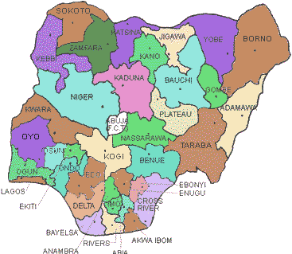
MAP OF NIGERIA

MAP OF KWARA
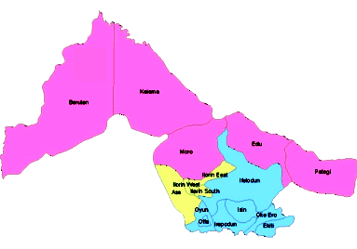

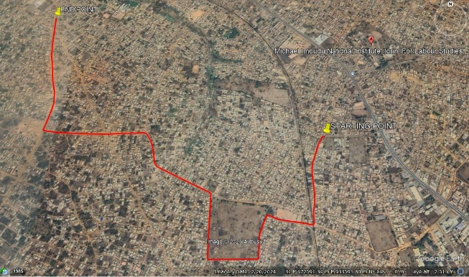
Google Earth imagery of The Study Area.
1.7 PERSONNEL INVOLVED
All the under-listed names are members of group 5C that participated in the successful execution of this project.
NAME MATRIC NUMBER ROLE
- ADEFABI ABIODUN BENJAMEN HND/23/SGI/FT/0124 Writer
- SOLADOYE AMIDAT OLABISI HND/23/SGI/FT/0109 Member
- AINA JOSEPH OLASUNKANMI HND/23/SGI/FT/0116 Member
- SODIQ AYUBA ADEBAYO HND/23/SGI/FT/0110 Member
- OJO SIMON ABAYOMI HND/23/SGI/FT/0114 Member
- ROTIMI IYANUOLUWA ANU HND/23/SGI/FT/0104 Member
- OKUNOYE NAFISAT ADEYEMI HND/23/SGI/FT/0111 Member
- BABATUNDE SIDIKAT J. HND/22/SGI/FT/0113 Member

CHAPTER TWO
2.0 Literature Review
Local planning handbook (2015) defined routes that follow simple patterns with few turns are easier to understand for transit riders. A network of simple routes makes the whole system easier to use spontaneously with little planning. Routes that do not make a lot of deviations also provide a faster trip for riders and are less expensive to operate for the provider meaning more service can be provided for the same resources. Communities can support this principle by encouraging development along denser, linear corridors and connecting gaps in the street grid to allow transit to have simple and direct routes in their communities.
Route survey is type of engineering surveying, which provides height along a proposed route with offsets at the both sides of the centerline of the route. This serves the purpose of location, design and construction of the route networks. Route survey, therefore, can be explained as a survey made along a line or narrow belt or strip for location, design, and construction of any route of transportation such as highways, railways sewage and oil; it is also very useful in surveys which require the establishment of both vertical and horizontal alignment for cross-country development of utilities. Apart from the general scope of surveying which include: Planning and Decision making: That is, knowing the purpose of survey, deciding on survey methods, equipment scale, costing etc. Data acquisition or Field work: This involves actual making of measurement and recording of data in the field. Data processing or Computations: This involves preparing calculations based on the recorded data from the field to determine the locations, areas, volumes, directions, and so on. Data representation or Mapping: this involves plotting measurement as processed to produce a map, plan, or chat. Stake-out: That is, setting monuments and stakes to delineate boundaries, or guide construction operation.
Scope of Route survey as an aspect of engineering survey includes:
- Geometric Design of Routes.
- Setting-out of Routes.
- Longitudinal and Cross-section.
- Area calculation
- Setting-out of Structures (As-Built Survey).
Surveying is indispensable to the engineer when planning, designing and constructing a project, so all engineers should have a thorough understanding of the limits of accuracy possible in the construction processes, This knowledge, combined with an equal understanding of the limits and capabilities of surveying instrumentation and techniques, will enable the engineer to complete the project successfully in the most economical manner and in the shortest possible time.
Engineering surveying, which was the main task in this project, was defined by M. Seedat (2012), as the type of survey which is associated with the engineering design (topographic, layout and as built) often requiring geodetic computations beyond normal civil engineering practice. It is required in planning and execution of nearly every form of construction. The equipment commonly used for this are theodolites, GNSS (GPS) and leveling instruments.
Engineering survey has assumed the goal of dimensioning the physical environment. Greater part of its responsibility is seen from the various types of
Surveying which are - geared towards promoting accessibility, route ways, convenience, economy and spatial delineation of both natural and social environment. He also stated that engineers and surveyors involves in site, surveying are responsible for all aspect of dimensional control on such schemes. According to him, the main purposes of engineering surveying are:
Surveying which are - geared towards promoting accessibility, route ways, convenience, economy and spatial delineation of both natural and social environment. He also stated that engineers and surveyors involves in site, surveying are responsible for all aspect of dimensional control on such schemes. According to him, the main purposes of engineering surveying are:
Surveying which are - geared towards promoting accessibility, route ways, convenience, economy and spatial delineation of both natural and social environment. He also stated that engineers and surveyors involves in site, surveying are responsible for all aspect of dimensional control on such schemes. According to him, the main purposes of engineering surveying are:
To provide large scale topographical map/ plan and other measurement at the concept and design stage. Since this data forms the basis for an entire project, the reliability of the design depends to a great extent on the precision and thoroughness with which the original site survey is carried out. To provide precise framework at the construction stage control from which it is possible to position the works and, most importantly, to ensure that engineering project are built in their correct relative and absolute position (this is known as setting out). In addition to these, data for the measurement of the work is also collected to enable volumes of the material to be estimated during construction. To monitor structural movement on major retaining structure at the post construction stage. History testifies that transportation is necessary to draw a country, state town or settlement to civilization by making communication among neighbors easier.

Modern methods of road construction were first developed in the 18 century. Innovations of the time included waterproof surfaces and better drainage systems. The modern engineers make use of variety of materials and construction techniques to build roads that can handle the high volumes and stresses of modern automobile and truck traffic. One of the stages in construction of modern roads is to carrying out route surveying which is discussed below.
Encarta Encyclopedia (2008) defined route surveying as the type of survey carried out in establishing the horizontal and vertical alignment of a particular area needed for social utilities like roads, railways, bridges, transmission lines, pipelines, canals etc. It is one of the first and last tasks performed on a project before a preliminary route map is prepared. 4
- Detailing is defined as the process of fixing topographical features to the survey line. Any of these under listed methods could be used:
- Chain survey method (tie line and offset).
- Plane table survey method.
- Compass survey method.
- Tachometric method.
- By the use of total station.
- By the use of DGPS

CHAPTER THREE

3.0. METHODOLOGY

Methodology is the set of methods and principles and instructions used to perform a particular activities or task. Its show the stages involved during the execution phase of the project research work. The methods involved in the execution of this project are includes traversing, detailing and contouring, processing and presentation. According to Oloyede et al. (2017), Total stations and GPS equipment are commonly used in Nigerian route surveys, providing precise measurements of distance, angles, and elevations. These tools allow surveyors to collect data on the terrain, which is essential for designing roads and other infrastructure projects
3.1 Preliminary Planning and Preparation:
- Route Selection: Based on preliminary maps and project requirements, a set of possible routes was identified and later the route from Michael Imodu to Oshin Olatunji was chosen.
- Site Visit: All the team member of Surveyors crew and Engineers visited the potential sites to familiarize themselves with the terrain and environment.
- Other: other preliminary activities was done in the office by the surveyor team. These activities are check the condition of the surveying equipment for the project execution and son costing activities.

3.2. RECONNAISSAINCE SURVEY

Reconnaissance Survey was carried out by the members of Group 5C, were the necessary information about the project area were gathered which are paramount to the successful execution of this project work. It is pre-requisite for any survey project to be carried out. During the Recce. Survey the group member visited the site in order to have a good view of the site location with other relevant information, the selection of the bench marks point, the tracking of the existing route using handheld GPS (Garmin 72) to know the length of the road, and checking of the available with. This was continue from the starting chainage to the end and at the end of the Recce. Survey activities the reconnaissance diagram was drawn as show on the figure below.

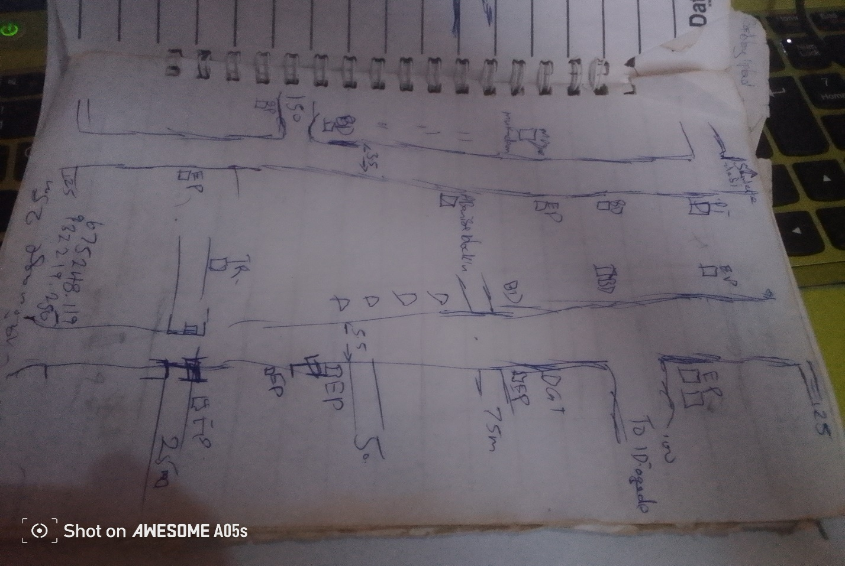Fig.3.1: Recce Diagram of the project location (Not drawn to scale)

3.3 OFFICE PLANNING

Having completed the field recce survey, then office planning was followed on the next day. It involves chosen the type of instruments, purpose and accuracy required of the survey be carried out. The collection of equipment needed for the project and also test of the instrument, mission planning, assembling and studying of all available data project of the relevant to the project, the costing of the operation was also done in the office. In executing the project, necessary information related to the project given such as the coordinates of the control. The prefix number of the controls used and the bench marks.
Table 3.1 shows the list of coordinates of existing control points
BEACON NO. | NORTHING(m) | EASTING(m) | HEIGHT(m) | LOCATION
BM.01 | 932229.902 | 675261.302 | 312.39 | Ilorin
BM.02 | 932225.637 | 675284.873 | 313.04 | Ilorin
BM.03 | 932207.160 | 675272.022 | 312.97 | Ilorin
Source: Author, 2025.
3.4. SELECTION OF THE EQUIPMENT AND SOFTWARE
The equipment, tools and software used for this project were grouped into two categories and they are:
- Hardware
- Software
3.4.1 Hardware Used
- Sokkia (CX105) Total Station 1 No.
- Hand held GPS receiver 1 No.
- HP Design jet 7100 series 1 No.
- HP Gateway laptop 1 No.
- Tracking rod 1No.
- Tripod 1 No.
- Linear tape (50m) 1 No.
3.4.2 Software Used
- Ts-link for (CX105) Total Station downloading software
- AutoCAD 2007
- CivilCAD 2014
- Note pad
- Microsoft Office package (Word and Excel)
3.5. BENCH MARKS ESTABLISHMENT, CAPPING AND LABEL
- Temporary bench marks (TBM) were established and coordinated along the entire route of the project, which were meant to serve as a check for data acquisition and controls for establishing centerlines chainages, setting out of curves and other road features during the actual construction.
- The positions of these beacons (TBMs) were selected and established at certain distances part not above 500m interval in such a way that they are inter-visible to each other, not too far from the proposed road and considerable number of centerline chainages can be set out from them.
- The property beacons used were precast with dimensions 18cm x 18cm x 75cm in length. Sixty five centimeters (65cm) of the precast beacon was buried beneath the surface and ten centimeters (10cm) above as shown in fig. 2.3.
- The numbering was done serially from the beginning to the end of the proposed road and was prefixed with identification number BM01, BM02, BM03 and so on. The values of those TBMs were shown on appendix
10cm
65cm
Ground level
18cm
BM
01
18cm
18cm
B
M

01

Figure 3.2: Show the Description Typical Bench Mark.
3.6. INSTRUMENT TEST
3.6.1. COLLIMATION TEST
The procedure undergone to perform instrument test is as explained thus:
The instrument (CX105 Total Station) was set up on TBM.01 and all temporary adjustments (centering, leveling and parallax elimination) were performed. A reflector prism was set-up at a distance of about 100m to the line of sight and bisected on both face left and face right. The instrument was switched on and program which is on-board of the micro-computer of the instrument was switched to the columniation program. Then horizontal columniation and vertical index were in sequence recorded and stored in the memory of the instrument. The telescope was transited and the same target was bisected. Both the new vertical index and columniation error were recorded and stored accordingly. It was transited to the same target with both horizontal and vertical readings recorded to check the instruments accuracy. The readings obtained were shown in the table below.

Table 3.2 Show the Horizontal Circle Readings
Station | Sights | Face | Horizontal Circle Readings | Diff. Between (FL & FR)
A | C  C | L  R | 204⁰ 36’ 42’’  024⁰ 36’ 36’’ | 180⁰00’ 06’’

Table 3.3 Show the result of the adjustment made.
 | OLD READING | NEW READING
Horizontal Columniation | 00° 00’ 18’’ | 00° 00’ 06’’
Vertical Index | 00° 00’ 11’’ | 00° 00’ 04’’

3.7 DATA ACQUISITION
3.7.1 IN-SITU CHECK
The in-situ check was carried out on the control TBM.01, TBM.02, and TBM.03, the result showed that the pillars were reliable enough to be used for the project. An analytical comparison of the measured data obtained from the check and the calculated values is as shown below.
Table 2.3 Show the observed coordinates of TBM.01 from TBM.02
STATION | NORTHING(m) | EASTING (m) | HEIGHT(m) | REMARK
TBM.01 | 932229.902 | 675261.302 | 312.39 | Observed
TBM.01 | 932229.896 | 675261.311 | 312.37 | GPS Given
Discrepancy | -0.006 | 0.009 | -0.017

Table 2.4: Show the observed coordinates of TBM.03 from TBM.02
STATION | NORTHING(m) | EASTING (m) | HEIGHT(m) | REMARK
TBM.03 | 932207.160 | 675272.022 | 312.97 | Observed
TBM.03 | 932207.164 | 675271.996 | 312.98 | GPS Given
Discrepancy | 0.004 | -0.006 | 0.006
Table 2.5: Result of the computed control check (from given GPS coordinates).
STATION FROM | BEARING | DISTANCE | DN | DE | NORTHING | EASTING | STATION  TO
 |  |  |  |  | 932229.896 | 675261.311 | TBM.01
TBM.01 | 349ᴼ59’59” | 23.953 | -4.255 | 23.478 | 932225.637 | 675284.873 | TBM.02
TBM.02 | 234ᴼ59’56” | 22.507 | -18.482 | -12.858 | 932207.164 | 675271.996 | TBM.03

The result was used to obtain the inclusive angle between TBM.01, TBM.02, and TBM.03 by finding the difference between the bearings of two lines.
TBM.02 TBM.01 => 169ᴼ59’59”
TBM.02 TBM.03 => 234ᴼ59’56”
Therefore (234ᴼ59’56”-169ᴼ59’59”)
Check angle 64⁰ 59’ 57’’

64⁰ 59’ 57’’

Fig.2.5 Show sketch of the check angle from three Given data
Table 2.6: Show result of the computed control check angle (from observed coordinate).
STATION FROM | BEARING | DISTANCE | DN | DE | NORTHING | EASTING | STATION  TO
 |  |  |  |  | 932229.902 | 675261.302 | TBM.01
TBM.01 | 350ᴼ01’01” | 23.954 | -4.264 | 23.570 | 932225.637 | 675284.873 | TBM.02
TBM.02 | 234ᴼ59’59” | 22.508 | -18.477 | -12.851 | 932207.160 | 675272.022 | TBM.03

The result was used to obtain the included angle between TBM.01, TBM.02 and TBM.03 by finding the difference between the bearings of two lines.
TBM.02 TBM.01 => 170ᴼ01’01”
TBM.02 TBM.03 => 234ᴼ59’59”
Therefore (234ᴼ59’58”-170ᴼ01’01”)
Check angle 64⁰ 59’ 58’’
TBM.02TBM.02
TBM.01TBM.01
TBM.03TBM.03
64⁰ 59’ 58’’

Fig.2.6 show the sketch of check angle from the observed data
The difference between the Observed check angle and the computed from given check angle was 00⁰ 00’ 01’’
- Computed distance from the given data (TBM.02 TBM.01) = 23.953m
- Computed distance from the observed data (TBM.02 TBM.01) = 23.954m
Difference obtained with the two result was compared as = 0.001m
- Computed distance from the given data (TBM.02 TBM.03) = 22.507m
- Computed distance from the observed data (TBM.02 TBM.03) = 22.508m
Difference of the two results = 0.001m
3.7.2 GEOMETRIC DATA ACQUISITION
3.7.3 TRAVERSE OF BM POINTS
Traverse was run round the established eleven (11) BM points. The CX105Total Station was set up on BM.02, a back sight was taken to BM.01 after the instrument is switched on and all temporary adjustments were carried out. The stations parameters (N, E and H) were enter into the memory of instrument for both occupied and reflector target station at back sight station (BM.02 and BM.01) respectively. Fore sight was taken to the first BM.03 and measurement stored, the instrument was then moved to the BM.01 as instrument station and reflectors were positioned at BM.02 and BM.03 as back sight and fore sight respectively. The occupied station (BM.01) parameter was entered into the Total Station and measurement was taken to CL-Road Centerline. This whole process continues and the traverse was closed back at BM.02. The numbers of BM are eleven (11) in total. The table below show the list of the benchmarks observed.
3.7.4 DATA ACQUISITION
The CX Total Station was set-up on BM.02, switched on and all temporary adjustments were carried out. The instrument was set on coordinates mode and the instrument parameters (Station name, Height of instrument, and N, E, H) as well as the target station parameters (Back sight station name, Height of reflector, and N, E H) were keyed into the Total Station. Then orientation was made to the reflector at station BM.01, and the measurement between the two stations was stored in the memory of the instrument. Foresight was made to 0+000m chainage centerline and then to the cross-sections at 20m away from the center line on both side and stored on the Total Station. Then the reflectors were now moved to the next chainage 0+025 and the same measurement performed for the first chainage is repeated here i.e. the centerline and the cross-section. Also details were fixed alongside traversing; IP points was also coordinated by moving the reflectors to the desired point of interest and denoted using a different code (CL, BLD, E.P, RT, LT, W.F, and DR. CV. Where CL means Centerline, BLD means Buildings, E.P. means Electric Poles, RT means Road Right Side, LT means Road Left Side, W.F. means Wall Fenced, DR mean Drainage line, CV mean Culvert ). This whole process continues until the reflector is no longer visible from the instrument. Then the instrument station was changed and the above process of data acquisition was repeated for the marked chainages and BM points till the end of the route was reached. The traverse was closed on BM11. The discrepancy between the observed and the given coordinates for the easting and northing is -0.099m and +0.102 respectively was used to compute for linear accuracy and found to be 1: 63,000, compare with the permissible accuracy of 1:5000.

TP2
TP1
CL
TP3

CH 0+000 CH 0+100 CH 0+200 CH 0+300

CHAPTER FOUR
4.0 DATA PROCESSING
The data processing follows immediately after the completion of the data acquisition and the selected software from the chapter three. This involved the methods used in downloading / retrieving, sorting and analysing of acquired data (field data). Here the data downloaded was processed into information using appropriate methods and software. The steps involved are as follows;
4.1 DATA DOWNLOADING (CX- TOTAL STATION)
4.1.1 DOWNLOADING PROCEDURE
The data were transferred from the Total station to the SD Card via the SD card Slotted in into Total Station and later downloaded into the computer using Ts-Link Sokkia (CX105) Total Station software.
The following procedure was followed during the downloading from the Total Station to the computer;
The SD card was Slot in into the Total Station and the instrument was powered on. The job “Route” was selected from the list of JOBS to be downloaded then transfer to the SD Card following the steps below
- click on F4 which means transfer
- The following option displayed on the total station screen
- Comm. sends data
- Comm. receive data
- Comm. setting
- Memory to S.D card
- S.D card to memory
- S.D card to file manager
- Then the fourth (4th) option is selected since we are moving the job “Route” from Instrument memory to SD card
- Then press ok
- Click on F1 to create a new file
- Input the file name and press F5 (ok)
- Search for the file name then press enter and the data was successfully moved from instrument memory to SD card
4.1.2 DOWNLOAD FROM SD CARD TO COMPUTER SYSTEM
The Sokkia-link software was installed on the computer system and was used to download from the SD card to system.
The following procedures were followed
- Insert the memory card at the appropriate slot on the Computer system.
- Sokkia-link software was launched from the desktop screen.
- Click on the SD card on the software
- Scroll on import data
- Click on the file name
- Click on yes
The coordinates will display in the format
PT | N/X | E/Y | Z | CODE
- Then save the file as text file.
4.2 DATA PROCESSING PROCEDURE
The file was opened and point data were displayed. This was then copied to a notepad and Microsoft excel environment for further processing.
On notepad, data were well spaced to differentiate one column from the other and unwanted information deleted.
On Microsoft excel, data were prepared for scripting purpose in AutoCAD. A small programme was written to prepare point and text scripts files.
4.2.1 PLOTTING PROCEDURE IN CIVILCAD 2014
    - CIVILCAD 2014 was lunched and NEW PROJECT was clicked index FILE MENU and named e.g. Route Survey, the OPEN button was clicked.
    - CONFIGURATION was then clicked under file menu to carry out General settings (Language, System units, Angles units, and Printout font size etc.), drawing environment settings, and Coordinate format settings and File settings.
    - Having completed the configuration, TOPOGRAPHY MENU was clicked and COORDINATES was chosen in the pull down menu.
    - In the dialogue box, ‘Load menu from text file’ button was clicked to load raw data coordinates that was arranged in the format; Point ID, Easting, Northing, and Height.
    - After selecting the raw data file and clicked Open, REFRESH ALL button was clicked and the software automatically run the script and plot the whole data just exactly the way it was surveyed. Also layers were automatically created for all the point Ids, Heights and Symbols used. But layers for each feature that was fixed along the route were manually created, e.g. buildings, Electric poles, Drainages, Culverts etc.
    - Line, Polyline, points and Splines tools were used to join all the features that were fixed along the route path into its appropriate layers.

4.2.2 PROFILE / VERTICAL ALIGNMENT PLOTTING USING CIVILCAD
- In CivilCAD2014 environment, ROAD MENU was clicked and VERTICAL ALIGNMENT submenu under Road selected.
- The Options Button was clicked in the dialogue box to set the Slope format, Vertical curves’ factor, Data precision and super elevation maximum slope. After the settings of these parameters, OK button was clicked.
- Having done this, ‘Load sections from a text file’ button was clicked to load sections of the centerline data, which was prepared in notepad in this format;
Station Chainage leveling height
  - 0 312.870
  - 25 312.710
  - 50 312.540
  - 75 312.390......
- Zoom Extent was opted for under view menu to view the whole profile drawing.
- A design was carried out on the profile by selecting a polyline tool to pick points along the profile, and when this was completed, APPLY button was clicked and the software automatically generates design levels for the whole profile.
- The design level was then used to calculate the volume of CUT and FILL on each section of the centerline
4.2.3 LOGITUDINAL / HORIZONTAL ALIGNMENT PLOTTING USING CIVILCAD
- In CivilCAD2014 environment, Road Menu was clicked and HORIZONTAL ALIGNMENT chosen.
- Options button was clicked in the appeared dialogue box and Define Section was then clicked to choose the section format and the distance between the sections. Format 2 was chosen and the distance between sections was taken to be 25m
- Having chosen these options, OK was clicked twice.
- Pick tool was selected from the right pane dialogue box to pick all the intersection points (IPs), and appropriate radius values of curve was given to each IP as specified by the client.
- Apply button was then clicked to effect all the given parameters on the drawing. On each IP position, information about the IP is been displayed. Such information are; IP number, X coordinate, Y coordinate, Radius of curve, Length of curve, Deflection angle and so on.
4.2.4 PLOTTING OF CROSS-SECTIONS USING CIVILCAD
- In CivilCAD2014 environment, Road menu was clicked and CROSS SECTION selected. Then ‘Load sections from text file’ button was clicked to load the existing ground level data.
- Having uploaded the data file, Existing Ground Level was chosen to specify that the data coming in is for existing ground level.
- The same format of data was uploaded next but for Designed Level by choosing Designed Ground Level button. The design level data was calculated using 2.5% slope for cambering and 3% slope for the shoulder.
- The software then superimposed the two drawing together to calculate the volume of CUT and FILL at each cross sections.
- Then frame division was clicked and the Output scale, Paper size and range was chosen for the final output of the cross sections.

4.2.5 GENERATING EARTHWORK TABLE USING CIVILCAD 2014
- Under Road menu, EARTHWORK button was clicked and the Apply button to generate the volume of earthwork table.
- Having done this, a geometry report dialogue box appears on the screen showing the accumulated volume of Cut and Fill, which can be directly printed or exported to Microsoft Excel for further editing.
  - RESULT AND ANALYSIS
This is a systematic examination and evaluation of data obtained and processed as a result of my field observation. This was achieved by taking into consideration all the necessary survey procedures and adhering to survey rules and regulations while on field and during processing.
The final results were tabulated in appendix
The route survey traverse started from TBM.01, TBM.02 andTBM.03 but closed back on TBM.02.
Table 4.7: Abstract of BM coordinates
TBM.01 | 932229.902 | 675261.302 | 312.39
TBM.02 | 932225.637 | 675284.873 | 313.04
TBM.03 | 932207.160 | 675272.022 | 312.97
TBM.04 | 931583.654 | 674839.222 | 310.21
TBM.05 | 931589.824 | 674818.166 | 309.58
TBM.06 | 674441.073 | 931811.975 | 310.13
TBM.07 | 931823.719 | 674448.987 | 309.46
TBM.08 | 932238.880 | 673657.641 | 322.56
TBM.09 | 932216.454 | 673658.547 | 323.87
TBM.10 | 933121.878 | 673159.463 | 303.71
TBM.11 | 933124.483 | 673178.850 | 303.56

Finally the observed coordinates and the given coordinates were compared and the computation shows that the traverse closed.
4.4 LINEAR ACCURACY
The accuracy was computed with the formula below:
For the boundary traverse;
_____1_____
√(ΔE)² + (ΔN)²
Total Length

Starting Coordinate (TBM.02) 932225.637mN; 675284.873mE, Ht = 313.040m
Closed Coordinate (TBM.02) 932225.739mN; 675284.774mE, Ht = 312.068.m
Misclosure in Easting (E) = -0.099m
Misclosure in Northing (N) = + 0.102m
Total Length = 9000m

_____1_ _____
√ (0.099)² + (0.102)²
= 9000m
_1_ __
√ 0.020205
= 9000m
_____1_ _ _
0.1421443
= 9000m
____1_ _
= 0.00001579381
= 63,315

The computed accuracy is 1/63,000
The permissible accuracy is 1/5,000
4.5 HEIGHT ACCURACY
Obtained error in leveling traverse (Misclosure) = -0.028m
Minimum allowable error in leveling (Permissible) = 24mm√k
Where k = distance covered in kilometers is 9.0km
Allowable error over in height over km =
24mm√k = 24mm√9.0km = - 0.0026m
Therefore, it means that the job met the required specification.
From the above computations, the linear accuracy obtained was better than the allowable limits of 1:5000 according to SURCON specifications for third order engineering job.
4.6 PLAN PRODUCTION
The adjusted coordinates were plotted in AutoCAD 2007 and CivilCAD 2013 Environment to generate the centerline of the road, longitudinal profile and cross section. The details were also plotted.The essence of obtaining a detail plan is to provide a platform for horizontal curve and alignment design for the road expansion /rehabilitation. Information shown on the detail plan provides a vivid representation of the land mass for easy understanding of the route.

    - HORIZONTAL ALIGNMENT PLAN
AutoCAD Land Development software 2009 was used to transform the collected and already processed data into a plan for visual presentation. A hard copy of the plan was printed using the AutoCAD visual display graphical information. Plots of the cross-section, profile, and longitudinal section were made which was attached to this project.
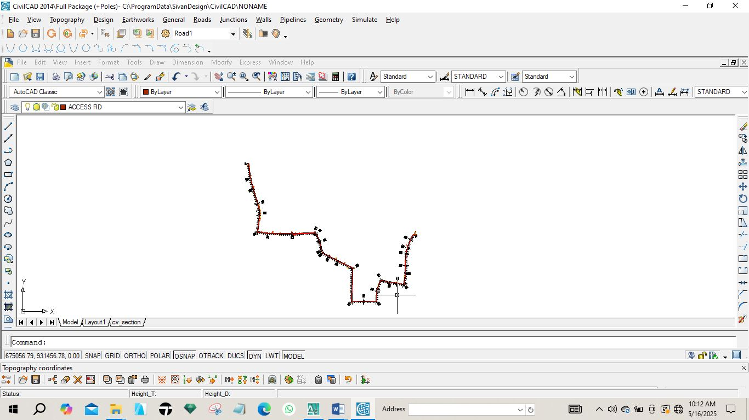
Fig 4.1: Horizontal plan of the route
4.6.2 VERTICAL ALIGNMENT PLAN
In order to give vertical height and terrain information along a route for vertical alignment and curve design, a profile was created. It gives a clear view of the terrain and helps decide where to fill or cut. It offers details like the existing level, formation level, tangent points, and slope.
The design of the route was done after the creation of the longitudinal profile. The longitudinal profile was created using AutoCAD Civil 3D 2022. The steps in the creation of the longitudinal profile shown in fig 4.2 are as follows:
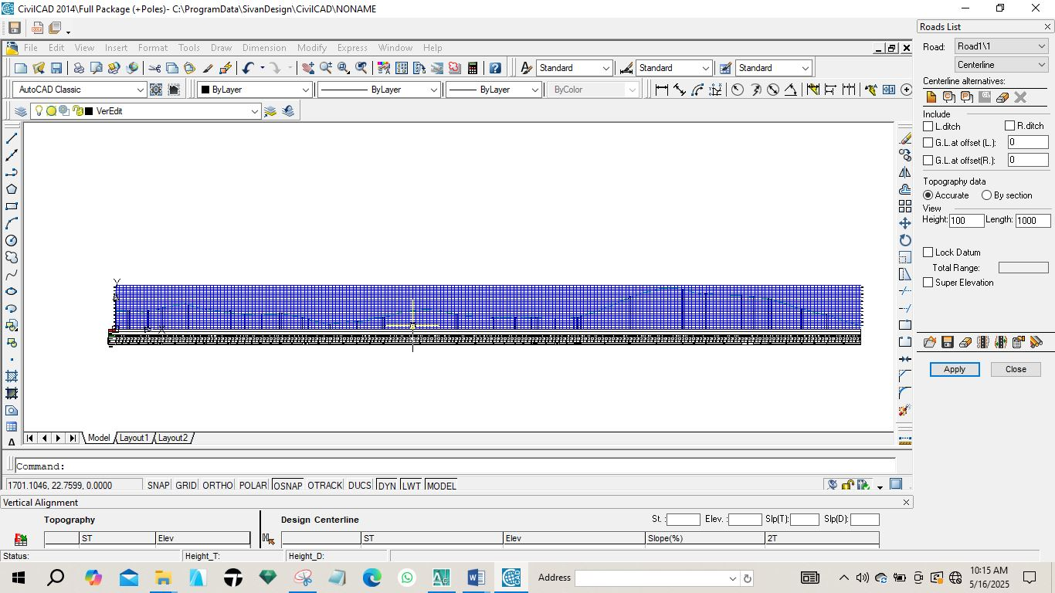
Fig 4.2: Vertical Profile of the route.
    - CROSS SECTION PLAN
The terrain information across the road chainage is shown in the cross-section. Details were displayed, including the height of the proposed and current center line and embankments. In cut and fill analysis, the area and, consequently, the volumes of earthwork were generated using the cross-section parameters.
The following process was carried out on the currently plotting on Auto CAD Civil CAD for generating cross section. The Cross Section icon was used to sample the sections from the existing ground, edit the values of the tangents, curves, and spirals, and create a current surface by clicking on surfaces and setting current surface. A template was created for the section and it was also edited under design control. Then, by clicking on section plot, all was selected, and all sections were created.
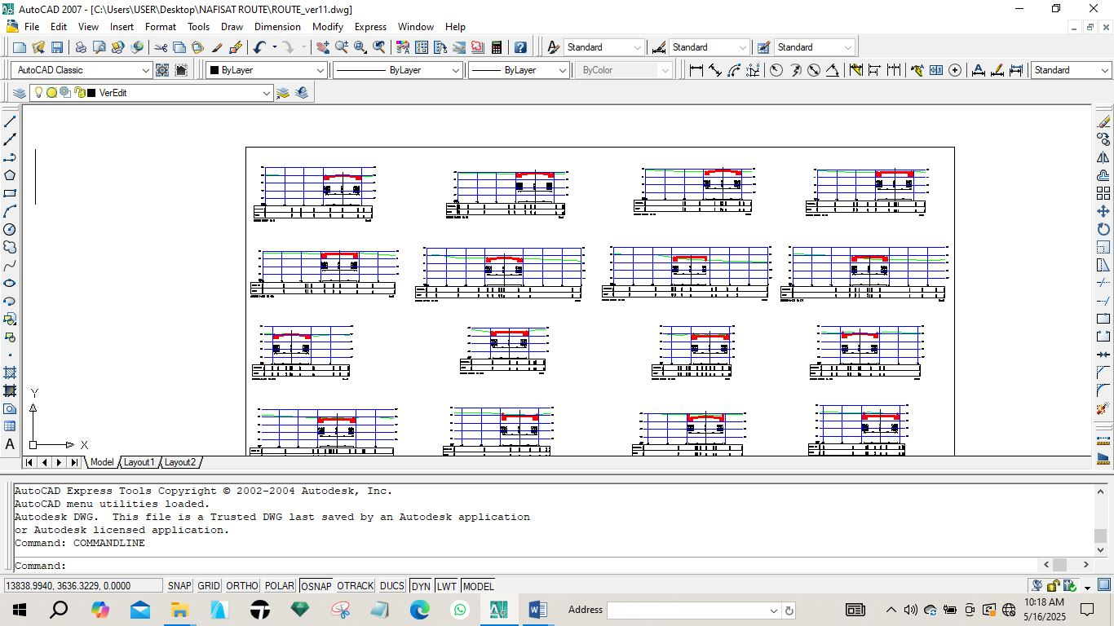
Fig. 4.3: Diagram showing generated cross section
4.6.4 VOLUME OF EARTWORKS
Volume computation in route surveying is a fundamental process used to estimate the quantity of earthwork required for road construction projects. Accurate volume calculations help engineers plan excavation and embankment activities efficiently, ensuring cost-effective and sustainable infrastructure development.
The software used for volume of earth work calculation is AutoCAD 2007and Civil CAD 2014, the process involves selecting specific areas for calculation and defining initial and final surfaces, which can be particularly useful in monitoring changes over time, such as material removal or deposition.
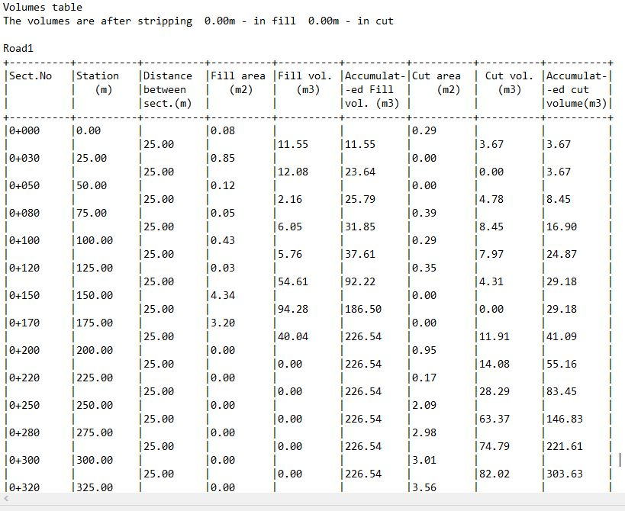
Fig. 4.4: Diagram showing generated volume computation

  - PROJECT COSTING
Table 4.4.1: shows the worked out cost of the project
OPERATION | RATE / DAY | NO OF DAYS | UNIT COST (#) | AMOUNT (#)
RECCONNAISSANCE (DAY)
1 Senior Surveyor | 10,000 | 1 | 10,000 | 10,000
8 Technical officer | 5,000 | 1 | 40,000 | 40,000
1 skilled labour | 5,000 | 1 | 5,000 | 5,000
Transportation (Field vehicle + Driver/ Mechanic + fuel) | 20,000 | 1 | 20,000 | 20,000
Basic Equipment (Hand held GPS, Field Book etc.) | 5,000 | 1 | 5,000 | 5,000
SUB TOTAL |  |  |  | #83,000
DETAILING AND SPOT HEIGHTING 4DAYS
1 Senior Surveyor | 10,000 | 4 | 40,000 | 40,000
8 Technical officer | 5,000 | 4 | 20,000 x 8 | 160,000
Basic Equipment (Total Station, Reflector) | 20,000 | 4 | 80,000 | 80,000
Transportation (Field vehicle + Driver/ Mechanic + fuel) | 20,000 | 4 | 80,000 | 80,000
SUB TOTAL |  |  |  | #360,000
DATA PROCESSING 1WKS
1 Principal surveyor | 10,000 | 5 | 50,000 | 50,000
1 surveyor | 8,000 | 5 | 40,000 | 40,000
1 assistant technical officer | 5,000 | 5 | 25,000 | 25,000
Computer accessories (printer, internet, generator, fuelling etc.) | 15,000 | 5 | 75,000 | 75,000
SUB TOTAL |  |  |  | #190,000
INFORMATION PRESENTATION
1 Senior surveyor | 10,000 | 1 | 10,000 | 10,000
1 technical officer (CAD) | 8,000 | 1 | 8,000 | 8,000
Standard set (computer, plotter, Generator etc.) | 15,000 | 1 | 15,000 | 15,000
SUB TOTAL |  |  |  | #33,000
TECHNICAL REPORT
1 Chief surveyor | 30,000 | 1 | 30,000 | 30,000
2 Surveyors | 20,000 | 1 | 20,000 x 2 | 40,000
SUB TOTAL |  |  |  | 70,000

COST OF THE PROJECT | #736,000
MOBILIZATION / DEMOBILIZATION (10% of the project) | #73,600
CONTIGENCY (5% of the project) | #36,800
TOTAL COST OF THE PROJECT | #846,400
VAT) (5% of the project) | #42,320
GRAND TOTAL | #888,720

CHAPTER FIVE
5.0 SUMMARY, CONCLUSION AND RECOMMENDATAION.
5.1 SUMMARY
The project covered a total length of 3.7km. The field work however involved the following processes; Reconnaissance, Documentation, Traversing, and Detailing. Tersus Differential GPS was used for the data acquisition and its software for downloading and transforming the acquired data respectively. The adjusted coordinates were used for the production of the final plans.

5.2 PROBLEMS ENCOUNTERED
During the execution of this project, the under listed problems were encountered:
When the project and its specification were given, there were no sufficient instruments (Total Station in particular) for all the groups available which was solved by consistency and unity.
5.2.1 SOLUTION TO THE PROBLEMS
The problems above were solved by consistency and unit. At the initial stage when the instrument were not given to us, we as a group never relent in disturbing the store keeper in order to get one which was later resolved. The poor calibration ad poor stiff legs were resolved by returning the bad one to the store and the good one were collected.

5.3 RECOMMENDATIONS
For the sake of the experience gained during the course of this project. I wish to make the following recommendations:
For the sake of the experience gained during the course of this project. I wish to make the following recommendations:
- This project should be available to any survey work as a baseline data of the project site in which necessary information necessary may be referenced.
- Also, this particular project should be done continually on all roads that have the same problem (as encountered in this project) in order to enhance the accessibility of various places.
5.4 CONCLUSION
The field work, processing and presentation was a success and this was due to proper planning and precaution taken at every stage of the project, and the entire information for the design and construction of the road was obtained within a short period.
The aim of this project was achieved at the end of the exercise whereby a vertical, horizontal alignment and cross section plan was produced.

REFRENCES
(Roy, 2008).
(Garber 2009)
Local planning handbook (2015) defined routes
Encarta Encyclopedia (2008) defined route surveying
M. Seedat (2012)
Oloyede et al. (2017),

APPENDIX
i. Recci diagram
ii. Field book
- Computation sheet
- Plotting: Analogue and Digital plans

