DESIGN AND IMPLEMENTATION OF A WEB BASED PLACEMENT OF PRIMARY ASSIGNMENT (PPA) FOR NYSC

BY

ADEJARE AZEEZAT TOLULOPE
ND/23/COM/FT/0127

A PROJECT SUBMITTED TO THE
DEPARTMENT OF COMPUTER SCIENCE,
INSTITUTE OF INFORMATION AND COMMUNICATION TECHNOLOGY KWARA STATE POLYTECHNIC, ILORIN

IN PARTIAL FULFILLMENT OF THE REQUIREMENTS FOR THE AWARD OF NATIONAL DIPLOMA (ND) IN COMPUTER SCIENCE

JULY, 2025.
CERTIFICATION
This is to certify that this project research was written by, ADEJARE AZEEZAT TOLULOPE with Matriculation Number ND/23/COM/FT/0127. The project has been read and approved as meeting part of the requirements for the award of National Diploma in Computer Science.

_________________________ __________________
MR. BOLAJI-ADETORO D.F. Date
Project Supervisor

_________________________ __________________
MR. OYEDEPO F.S. Date
Head of Department

_________________________ __________________
External Examiner Date

DEDICATION
I dedicate this project work to Almighty God who inspired me and directed my ways during my academic stay in the polytechnic.

ACKNOWLEDGEMENTS
The journey through this academic program has been both challenging and rewarding. Through all the trials and triumphs, I give all glory, honor, and adoration to the Almighty God for His unending grace, divine protection, and sustenance from the very first day I stepped into the academic world until this present moment. Without His mercy, I would not have come this far.
I wish to express my heartfelt gratitude to the Head of the Computer Science Department, Mr. Oyedepo F.S., for his unwavering support, fatherly guidance, and consistent encouragement throughout the course of my academic journey.
My profound appreciation goes to my project supervisor, Mr. Bolaji-Adetoro D.F., for the invaluable role he played in the successful completion of this research project. His intellectual input, timely corrections, encouragement, and professional mentorship were instrumental in shaping the quality of this work.
I also wish to extend my sincere appreciation to all the lecturers in the Department of Computer Science for their dedication to academic excellence and for imparting knowledge and discipline throughout my course of study. Each of you contributed uniquely to my academic and personal growth.
To my family, friends, and colleagues who stood by me in prayers, words of encouragement, and support during trying times, I say thank you.
Above all, I am grateful to everyone who, in one way or the other, contributed to the successful completion of this project.

TABLE OF CONTENTS
Title page
Certification
Dedication
Acknowledgement
Table of contents
List of Tables
List of Figures
Abstract
CHAPTER ONE: GENERAL INTRODUCTION
1.1 Background of the Study
1.2 Statement of the Problem
1.3 Aim and Objectives of the Study
1.4 Significance of the Study
1.5 Scope of the Study
1.6 Organization of the Study
CHAPTER TWO: LITERATURE REVIEW
2.1 Review of Related Work
2.2 Review of General Text
2.3 Overview of E-PPA
CHAPTER THREE: METHODOLOGY AND ANALYSIS OF THE SYSTEM
  - Research Methodology
  - Analysis of the Existing System
  - Problem of the Existing System
  - Analysis of the Proposed System
  - Advantage of the New System Over the Existing System
CHAPTER FOUR: IMPLEMENTATION AND DOCUMENTATION OF THE SYSTEM
  - Design of the System
  - System Implementation
  - System Documentation
CHAPTER FIVE: SUMMARY, CONCLUSION AND RECOMMENDATION
5.1 Summary
5.2 Conclusion
5.4 Recommendation
References
APPENDICES
Program Flowchart of the existing system
Program Flowchart of the proposed system
Source program listing
Computer output listing

ABSTRACT
This project work is aimed at studying the procedure for NYSC posting system for the purpose of automating the system for effectiveness and efficiency with SMS. Nigerian University students are sent on a one year National youth service corps after their graduation from the institutions. The list forwarded by universities to NYSC Headquarter is registered for the purpose of sending call-up letter to the students and for posting of qualified students. So, this research is to design and implement an automated system for NYSC posting. This will be of immense benefit to the administrators of the NYSC program as it will be easier to sort out list from a particular institutions. Also, the system will enable proper documentation of graduates that participated in NYSC program in a given year. The implementation of the automated system was carried out using PHP and MySQL as the database

CHAPTER ONE
GENERAL INTRODUCTION
1.1 INTRODUCTION
Every year more than 5,000 corps members are deployed to each state for one year service. This deployment is in three (3) batches namely batches A, B and C. Batches A and B corps members are usually more in number while batch C corps members are fewer. Out of this number some will relocate from the state they are deployed to another state because of certain reasons like marital status and health condition. The result of the interview from some NYSC official states that there are two types of NYSC deployment of corps members. The first type is National level deployment where qualified graduates from institutions of higher learning are deployed to the various states they will serve. The list of the graduates is gotten through the student affairs officer of the institutions that is responsible for the preparation of eligible students for service. In this type of deployment, corps members’ state of origin, marital status and health conditions are considered before posting the corps members. (Anujeonye, 2020)
The time lag, paper work and rigors involved in manual method of posting of Corps members to states of the country makes it more desirable but imperative that computerized approach be used to the facilitate in National Youth Service Corps (NYSC) members postings. The manual method suffers a number of setbacks which includes large volume of requests for redeployments at the National Youth Service Corps (NYSC) headquarters from corps members who have peculiar cases warranting redeployment. The manual process is time consuming and prone to errors. It has led to corps members posting procedure to remain cumbersome over a long period of time and the result of this is that corps members getting their postings at the last minutes. Corps members have just few hours to a day before getting to their various states of postings. Therefore, the problem that arises is to find a method of processing intending corps members’ personal information while making use of the NYSC scheme criteria for posting that would be sufficiently accurate in posting intending NYSC and within a reasonably time and reducing cost in the long run. (Akpan, Obe & Vincent-Akpan, 2020)
There is an "Orientation" period of approximately three weeks spent in a camp away from family and friends in their respective posted state before being deployed to their various place of assignment. This follows by a "passing out ceremony" at the end of the year and primary assignment followed by one month of vacation. From Nigeria point of view however, NYSC was created to foster unity among Nigeria’s about 250 ethnic groups and to create a sense of nationhood and selfless service among young people. The software application in this research is intended to bring relieve by providing for timely, accurate and cost-effective process of posting NYSC Corps members using the processing power of the computer software as well as information and communication technologies (ICT). The NYSC Scheme was created in a bid to reconstruct, reconcile and rebuild the country after the Nigerian Civil war. NYSC was established in 22nd May 1973 with a view to proper encourage and develop of common ties among the Nigerian youths and the promotion of national unity. At present the National Youth Service This study attempts to develop a database driven website that can post corps members to states in Nigeria using the NYSC Scheme criteria to replace the manual method of posting of corps members. The database driven website proposed in this study is such that posting of corps members will be done automatically by database driven website thereby reducing time, cost and more accurate posting will be achieved. The requests for redeployments will be reduced. The main focus of this study is on the design, development and implementation of a dynamic database driven web-based system for the posting of prospective NYSC corp members. (Sunday & et al., 2021).
1.2 STATEMENT OF THE PROBLEMS
The Place of Primary Assignment is meant to be a place where corps members are sent to dispatch to the environment what they have up-step or what they gat to offer related to their field of study, but all of a sudden, it is no longer the way it used to be, corps members are posted to a Place of Primary Assignment that do not relate by any means to what he/she have studied in school. And the posting section do not place a request to what field the need or can accommodate in their place, due to lack of access to the places of Place of Primary Assignment in the area.
1.3 AIM AND OBJECTIVES
The primary aim of this project is to design and implement E-PPA posting via SMS and the objectives are as follows
- Design and implement a central database system that would serve as NYSC database, which will contain information of all the graduates that are waiting for national youth service corps.
- To generate students call up letters.
- To efficiently and effectively post qualified students via SMS.
1.4 SIGNIFICANCE OF THE STUDY
The study will shed more light on how to use computer as posting procedure which can help in completing complex tasks using network analysis. It will also serve as guidelines in choosing of the operations to be done earlier and which is to be abandoned in order to get option solution.
1.5 SCOPE AND LIMITATION OF THE STUDY
The scope of this project will cover the design of development of manual method of posting corp members across the nation using SMS and distribution of their call up letters concurrently.

1.6 ORGANISATION OF THE REPORT
This is the overall organizational structure of the work as presented in this project write-up. Chapter one of this project deals with the introduction to the general work in the project. It also entails the statement of the problem, aims and objectives of this project, the significance of the study, the scope and limitation of the study and organization of the report.
Chapter two focuses on the review related journals and books, historical background of the study, as well as computerization current state of the art.
Chapter three covers the methods used for data collection, description of the current procedure, problems of existing system, description of the proposed system and the basic advantages of the proposed web based application.
Chapter four entails design, implementation and documentation of the system. The design involves the system design, output design form, input design form, database structure and the procedure of the system. The implementation involves the implementation techniques used in details, choice of programming language used and the hardware and software support. The documentation of the system involves the operation of the system and the maintenance of the system.
Chapter five contains with the summary, experience gained, conclusion, recommendation and references.

1.7 DEFINITION OF TERMS

DEPLOYMENT: the movement of troops or equipment to a place or position for military action.

INTERVIEW: is essentially a structured conversation where one participant asks questions, and the other provides answers. In common parlance, the word "interview" refers to a one-on-one conversation between an interviewer and an interviewee.

RELOCATE: move to a new place and establish one's home or business there.

MANAGEMENT: the process or practice of managing.
APPLICATIONS: is any program, or group of programs, that is designed for the end user. Applications software (also called end-user programs)
MySQL: Database application, mainly for the storage of information.

CHAPTER TWO
LITERATURE REVIEW
2.1 REVIEW OF RELATED WORKS
Akpan, Obe & Vincent (2020) Proposed a Dynamic Database-Driven Web-Based Automatic NYSC Posting System. This paper presents comprehensive techniques for the development, implementation and deployment of an automatic dynamic database driven web-based system for posting national youth service corps (NYSC) members based on three major criteria, namely: 1) prospective corp members above the age of 30 years are exempted from the NYSC service programme; 2) prospective corp members who are below the age of 30 years and married are posted to the state where their spouse is located; and 3) prospective corp members below the age of 30 years and single are posted to a state and to a region different from their state of origin and state of residence. The design of the database driven web-based NYSC posting system has been accomplished with the aid of five major software tools, namely: 1) Apache web server for hosting the application, 2) Adobe Dreamweaver for writing HTML for the web-based application, 3) PHP for writing scripts required for the application, 4) MySQL as the database server for writing SQL, 5) Google Chrome browser for reading and displaying information developed using the first four tools. Significant instructions on the installation, setting-up and configuring these five software tools have also been presented which enables these tools to work interactively. The results obtained from the implementation of the proposed dynamic database driven web-based NYSC posting system show the validity and efficiency of the NYSC posting system. Finally, it has been recommended that the proposed NYSC posting system can be deployed to NYSC headquarters for the posting of NYSC corp members to replace and speed up the manual method of posting NYSC corp members.

Olowookere, et al (2021) writes and presented a paper on “Design and Implementation of NYSC Orientation Posting scheme in Nigeria” NYSC Posting Information system is designed to overcome the problems encountered with the existing system in terms of insecurity, data redundancy, Information time management and data protection, misplacement and mismanagement of files etc. The new system is designed in such a way that information about each corps member is effectively managed within the database for easy retrieval of information. The Top-down design approach model was used in the course of this research and data collected were implemented using Visual Basic 6 for the front end design and Microsoft Access for the Back end.
Olusola et al., (2020) also writes and presented a journal on “GRADUANT POSTING DECISION SUPPORT SYSTEM (GPDSS): A DEFLATOR OF GODFATHERISM IN GRADUANTS’ POSTING FOR NYSC” The development of any decision support system (DSS) is complex. It depends on the task being supported and the organization that is going to use it including its present design practices. This research work critically analyses the nature and state of DSS in combating godfatherism in graduants’ posting. Graduant Posting Decision Support System (GPDSS) is a decision process that deals with posting of fresh graduate for National Youth Service Corp taking into cognizance the age, state of origin, and other logical parameters. The study demonstrates and agitates full deployment of DSS in reducing or eliminating godfatherism in the posting of fresh graduates for NYSC. To provide context for the study, a history of DSS is presented which focuses on the evolution of a number of sub-groupings of research and practice. Documents and sampled data of previous NYSC postings were taking from the Student Affairs arm of Adekunle Ajasin University, Akungba-Akoko, Ondo State. MySQL and PHP were used to design the system.

Ifeanyichukwu & Apine (2020) review a report on The Problems and Negative Effects of the Use of National Youths Service Corp (NYSC) Members as Ad-hoc Teaching Staff in Nigeria: A Case Study of Kalgo Local Government Area of Kebbi State. This research study was undertaken to identify problems and negative effects of the use of National Youths Service Corp (NYSC) members as ad-hoc teaching staff in Nigeria with particular reference to Kalgo Local Government Area of Kebbi State. A descriptive research design was adopted. Four secondary schools exist in Kalgo Local Government Area, all of which were sampled. Data collection was mainly through the use of inventory, oral interviews and questionnaires. Ineffective curriculum implementation, superficial knowledge of subject matter, lack of commitment, as well as inadequate knowledge of the culture and traditions of the host communities have been identified as the problems and negative effects of the use of corp members as ad-hoc teaching staff in Nigeria. The study recommends the employment of qualified teaching staff, strengthening of the Teachers’ Registration Council of Nigeria (TRCN) and effective inspection and supervision of schools as the panacea for stemming the falling standard of education in Nigeria.
Linda (2020) Design and Implementation of NYSC Orientation Camp Information System. This Project Design and Implementation of Orientation Camp Information System (A Case Study of NYSC Orientation Camp Awgu ) was designed to eliminate the problems associated with manual handling of information at the Orientation Camp such as: data redundancy, time wastage etc. The Design and Implementation was carried out using the top down software development approach. The tools used to implement this project are VB.Net and SQL Server.

Vancouver Island University (2019) Job Posting System What is the VIU Job Posting System? What are the benefits? The VIU Job Posting System replaces the Internal Posting/Advertising Form. The system operates using job description templates allowing for jobs to be posted quickly, easily, and consistently. Electronic approval workflows notify approvers of a pending job posting; prompting them to comment and approve the job posting in the system. Users can monitor the job posting at each step in the approval process.
Wara & Singh (2020) writes a report on Academic institutions worldwide embrace communication network and Internet services for their academic activities and collaboration. Communication network enable members of institutions to collaborate with each other and as well access Internet. Therefore, sophisticated cyber-attack emanating from one segment of the network or from the greater Internet can undoubtedly trigger crisis that can affect various stakeholders both within and outside the academic institutions. Consequently, a coordinated concerted effort is required for a more protected network and safe internet. This joint effort is mostly referred to as CERT (Computer Emergency Response Team) or CSIRT (Computer Security Incident Response Team). This paper provides the guides on establishing Computer Security Incident Response Teams (CSIRTs) for securing the National Research and Education Network (NREN) in Nigeria. Focused synthesis method using published articles and archival data has been collected and analysed in this study. Finally, the proposed guide would improve the management of cyber security issues in NREN.

2.2 REVIEW OF GENERAL TEXT
The study established a multicriteria decision system for deploying corps members to their place of primary assignments thereby reducing/eliminating the errors, stress and time wastage in the manual deployment of the corps members. Decisions on deploying corps members to the places of primary assignment are made by committee constituted by NYSC zonal inspectors and mobilisation officer by considering some factors such as organisations requests, corps discipline and qualifications, gender, tribes and marital status. Faced with the multiple criteria (organisations requests, corps discipline and qualifications, gender, tribes and marital status), the deployment committee annually evaluates every corps member against the requirement before deploying the corps members. This process is cumbersome and time consuming. Moreover, the corps members are deployed to places that are not relevant to their disciplines. This, for most of the time, renders their one year service wasted. With manual processing, the deployment is bound to be tedious, time wasting, inaccurate due to human error and at times deliberate manipulation to achieve personal aim or to favour some friends like deploying corps from influential people to urban centers or better places and others to rural areas.

Every year more than 5,000 corps members are deployed to each state for one year service. This deployment is in three (3) batches namely batches A, B and C. Batches A and B corps members are usually more in number while batch C corps members are fewer. Out of this number some will relocate from the state they are deployed to another state because of certain reasons like marital status and health condition. The result of the interview from some NYSC official states that there are two types of NYSC deployment of corps members. The first type is National level deployment where qualified graduates from institutions of higher learning are deployed to the various states they will serve. The list of the graduates is gotten through the student affairs officer of the institutions that is responsible for the preparation of eligible students for service. In this type of deployment, corps members’ state of origin, marital status and health conditions are considered before posting the corps members. The second type is done at state level which involves deploying corps members that are posted to the state after orientation to the places of primary assignment. To process this second type of deployment, organisation requests, marital status and health condition are considered.

Deployment Policy and requirements
The ultimate objective of the NYSC Scheme is to achieve national unity through mobilisation of the Youths of this country for service in the NYSC Scheme. Corps members are to be exposed to life in other parts of the country and to learn many similarities and diversities of culture and traditions of the various ethnic groups in the country with a view to eliminating any inherent prejudices. Corps members therefore have no choice as to where they would like to serve. They are discouraged from lobbying for choice stations. A deployment is the movement of an employee from one position to another within the same period and unlike assignments or secondments, an employee gains incumbency in the position to which he or she is deployed and therefore assumes the classification level and any terms and conditions of employment of the new position. A deployment cannot result in a promotion or a change of tenure. A deployment requires the consent of the employee concerned except in those situations where a willingness to be deployed is a condition of employment of his or her current position. To promote the efficient and timely movement of employees to new job responsibilities, either operational or individual needs or both is to be met. It is government policy to deploy employees to meet operational needs; to fulfil career development and individual needs of employees; to develop the skills and abilities required by organisations in the long term, and to foster the achievement of employment equity goals. Deployments are to be made in a reasonable and transparent manner, taking into account the needs of the organisation and the legitimate career interests and aspirations of employees. Departments must establish deployment policies and procedures that respect the directives made by the Treasury Board pursuant to sections 34.2(1), 34.3(1), and 34.3(3) of the public service “Employment Act”, or any regulations made under section 37.1(1) of that Act. It is also to; i) take into consideration the needs and rights of employees subject to workforce adjustment; ii) include criteria for determining which positions, if any, in the organisation shall require an arrangement to be deployed as a condition of employment; iii) provide instructions for departmental complaint processes and procedure; and iv) take into account the policy requirements for developments in the executive group. Departments must consult with their bargaining agents on the establishment of their deployment policies and procedures. A signed letter of offer will act as the certificate of appointment for pay and deployment purposes.
Recruitment
The effective management of human resources is a key component to the success of the business. Recruitment is just one element of human resource management; however, it is of significant importance to its success as it is the method used to acquire the human capital for the organisation. Barber (1998) defines recruitment as those practices and activities carried on by the organisation with the primary purpose of identifying and attracting potential employees. Recruitment and selection are necessary human resource processes initiated by organisations where the constant balancing act is to find and retain quality staff that meets the needs of the position and the company while minimizing the expenditure in the process. This refers to the process of screening and selecting qualified people for a job in an organisation or firm, or for a vacancy. In a volunteer-based on some components of the recruitment process, medium and large size organisation and companies often 23 retain professional recruiters or outsource some of the processes to recruitment agencies. External recruitment is the process of attracting and selecting employees from outside the organisation.
2.3 HISTORY OF NATIONAL YOUTH SERVICE CORPS (NYSC)
The National Youth Service Corps was established by degree 24 of May 1973. However, the founding decree has been replaced with decree 51 of 16th June, 1993. It is also important to mention that the scheme is established to promote the ideals of national unity and a sense of common destiny among Nigerians and eliminate mutual suspicion and mistrust that has been engendered by the civil war. The objectives of NYSC are to: (a) promote unity and national integration; (b) raise the moral tone of the youths by exposing them to higher ideals of nation building; (c) promote national economic, development/mobility of labour into less developed areas; and (d) encourage employers to employ Nigerians irrespective of their background or ethnic origin. Nigerians graduates from universities, polytechnics (at HND level) and other degree awarding institutions that are not more than 30 years of age whether locally or foreign trained are eligible to serve. The people who are exempted from service include; graduates who are above 30 years on graduation, those who have served in any of the armed forces or national security agencies for at least nine months, and those conferred with national honours. Graduates with national honours are to submit copies of their identity card, relevant enlistment/award letters. Graduates of part-time programmes, and diploma programmes in universities and polytechnics are also excluded from the service. In preparation for NYSC service, there is a stage of mobilisation and deployment. This stage includes briefing of prospective corps members, collation and processing of data on them by the NYSC, display of the data in all institutions to identify/correct errors before deployment is carried out. In line with federal government determination to stamp out corrupt practices, the NYSC is now introducing new security measures. These include the embossing of passport photographs on call-up letters and all NYSC certificates among others. Some of the intended corps members are given concessional deployment based on marital ground or those with life threatening diseases on submission of relevant documents. Documents that support the application should be submitted to schools and NYSC secretariats in the State where the school is located.
The NYSC service is stipulated to last for continuous period of 12 calendar months less terminal leaves of 21 days. Doctors/Pharmacists could defer their service to carry out housemanship/internship, while lawyers serve before or after law school. In accordance with the decree 51 of June 1993, only successfully graduated candidates in the various certificate/diploma or degree examinations are qualified to be called up for services in the NYSC scheme. Only such candidates are qualified to collect their CALL-UP letters from students Affairs Offices of the respective institutions. All prospective corps members are issued with call-up letters on graduation from their respective institutions. The letter informs them of their states of deployment, the orientation venues and the date they should report to the NYSC Orientation camps.
OPERATION OF THE NYSC SCHEME
The decree set up a National Directorate comprising a chairman, the Director-General, representatives of committees of vice chancellors, rectors, the armed forces, police, the Nigeria employers’ consultative association and time special members. The Directorate is the governing and policy making body of the National Youth Services Corps. The Director General is the chief Executive of the scheme while the coordinator is in charge of the state secretariat. The Decree also provides for the establishment of a Governing Board in each state of the federation. The state Governing Board has a statutory responsibility to assist the Directorate in the smooth operation of the scheme in the state. The Decree also established local governing committees and State Zonal Officers to assist in the operation of the scheme at the grassroots levels.
MOBILIZATION
This entails collections and collation of data on all prospective corps members from the various corps producing institution nation-wide whose graduates qualify for enlistment into the scheme. Nigeria graduates from foreign institution report directly to the directorate headquarters Abuja, for the evaluation of their certificate preparatory to deployment. Foreign- trained graduates should note that only national who graduated before they turned 30 are eligible to serve irrespective of their age on arrival in Nigeria, it is age at graduation for the first degree that matters.
ORIENTATION PROGRAMME
The orientation programme provides the first venue for affecting the desired change of attitude, as participants receive training in preparation for their next assignment of selfless and patriotic service to their fatherland. The purpose of the course is also to introduce corps members to and familiarize them with the ideas of the youth corps scheme. It is compulsory for every participant to be inducted through orientation training before service; nobody joins the orientation prior to service.
PRIMARY ASSIGNMENT
POSTING
The national youth service corps takes care to avoid posting that result in wastage of human resources. Corps members are therefore, as much as possible; posted to areas relevant to their discipline although sometimes national need may override this consideration.
REPOSTING
Wrong posting or under utilization of corps members, when established is corrected through reposting by the state NYSC secretariat.
PROCEDURE FOR RELOCATION
A corps members seeking relocation away from his state of service shall address an application to the director-general through the state through the state of service attaching necessary documentary evidence to support or aid the request. The state coordinator will forward the application to the director-general with his comments. He is not to suppress the application either recommended or not .A corps member who has applied for relocation and except under unusual circumstances shall continue to serve at his duty station if until necessary approved relocation is received from directorate.
COMMUNITY DEVELOPMENT SERIVCE (CDS)
A. In identifying with the current national objectives, the NYSC CDS has ventured into agriculture thus several corps members who specialize in agriculture and allied disciplines and who are same posted within the same locality are organized to work in rotational schedules on the farms.
Furthermore, the generality of corps members are expected to undertake a year round basis in addition to their primary assignment, at least one community development project in their neighborhood, in groups. After the consultation with the community people. Some suggested projects under the year round community development programmes are as follows:
i. Mass literacy: each one teaches one or funds the teaching one.
ii. Technologies/scientific inventions and fabrications.
iii. Organizing local people to take more interest in indigenous art, drama, and music and dances.
iv. Public health education, immunization and health care delivery preventive and curative horticulture, tree planting-landscaping environmental beautification.
Encourage by the success of the infrastructural construction. The management of NYSC scheme has diversified into some commercial ventures such as; tailoring, printing, food production and processing. Cottage Industries, Using Local Raw materials and Corps Manpower Resources.

CHAPTER THREE
METHODOLOGY AND ANALYSIS OF THE SYSTEM
3.1 RESEARCH METHODOLOGY
Method of data collection refers to the practices and techniques in research used to gather, process, and manipulate information that can then be used to test ideas and theories about social life. Types of methodologies include interview, textbooks and internet research. The main type of method employed in this system is observation on the ways in which message is been sent and not known may be it delivered or not.
This is a description of methods chosen to achieve the objectives of the proposed system. It will go on to describe the techniques of data collection that will be employed in the research study of the proposed systems. In order to achieve the aim and the objectives in chapter 1.
- The System Development Life Cycle (SDLC) we chose to use the iterative waterfall model. In this model, the system follows a series of events from the requirement definition, system and software design, implementation and unit testing, integration and system testing and operational maintenance.
- During each phase of the lifecycle, a set of well defined activities are carried out for instance at the Analysis stage (Structured Analysis of Requirement) was specifically carried out in focus of the functionality of dataflow of the system. The system and structured analysis was then transformed into software design (software architecture to decompose the system into modules and representation of relationships among the modules, data structures and algorithms for the modules to be designed.
- The approach used in designing the system is the structured design approach. It consists of starting with the “Big picture” of the proposed system that is gradually decomposed into more and more detail until it is fully understood.
- The system was carefully study and understood before the development of the system and the tools which was used in design the system is PHP, HTML and MYSQL as the database.
  - ANALYSIS OF THE EXISTING SYSTEM
System analysis is the procedure by which activities in an organization (NYSC orientation information system camp) are studied with the aim of determining how to operate it most efficiently. It is essential for a thorough analysis of the present system. However the level of success achieved in carrying out a work of this dimension depends on the methodology adopted. From the analysis of the current system the following conclusions are drawn:
(i) The staff allocates registration form manually.
(ii) Registration forms are stored as hard copies.
(iii) Difficulties are experienced in getting information about the corps members.
(iv) Difficulties are experienced in getting in touch with the NYSC director.
(v) Difficulties are experienced in during renewing and updating of corps members profile and NYSC policies.
  - PROBLEMS OF THE EXISTING SYSTEM
The problem of the existing system are:
(i ) Poor filling system.
(ii) Poor storing, processing and accessibility of data/information.
(iii) Data redundancy.
(iv) Poor database management.
(v ) Lack of data integrity.

  - ANALYSIS OF THE PROPOSED SYSTEM
The proposed system will be developed using the recent web technologies. It will be developed in such a way that there will be room for the addition of Graduate, and staff and the modification of the inserted information. There will be room for report of all the information inserted into the system and also to posting appointment. It will be developed to increase the efficiency of NYSC on web based system.
3.5 ADVANTAGE OF THE NEW SYSTEM OVER THE EXISTING SYSTEM
The proposed system has the following advantages:
- It is fast, efficient and reliable
- Avoids data redundancy and inconsistency
- Very user-friendly
- Easy accessibility of data
- Number of personnel required is considerably less
- Provides more security and integrity to data

CHAPTER FOUR

  - Design of the System
Some factors are considered when designing the new system so as to achieve a good design standard:, among them are:
- Designing a system that will capture data faster than the old system thus improves efficiency.
- Designing a system that will minimize time-wastage which as a case will lead to quick processing of data collection from various Graduates.
- Designing a system that will eliminate unnecessary long queues of Graduates at the NYSC Head office.
    - Output Design
This window is specifically designed for corps members that have already gotten their registration number to access to the information in the software system.

Fig: 4.1 Home pages
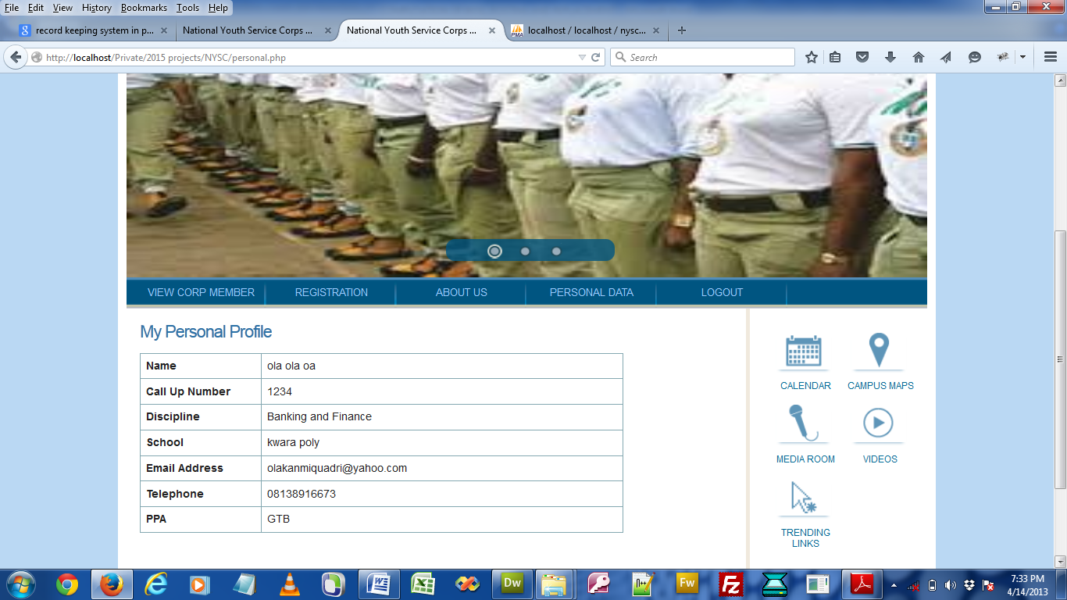
Fig: 4.2 Shows posted Corps member
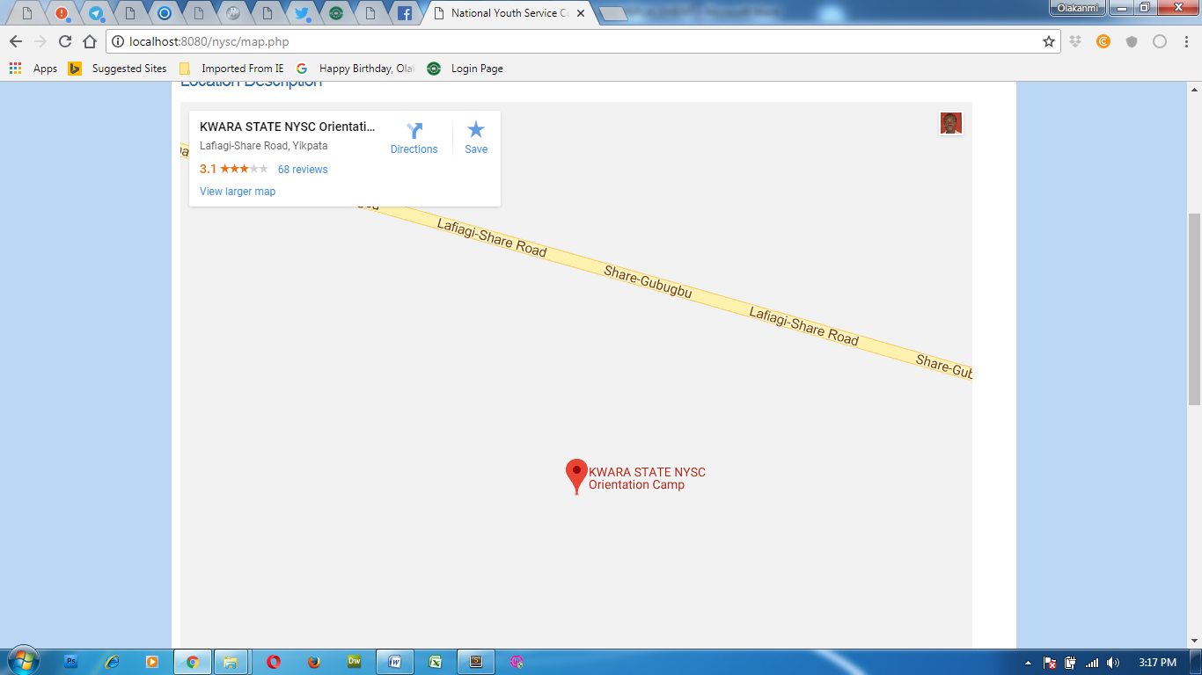
Figure 4.3: Its shows the NYSC camp Travel guide in Kwara State
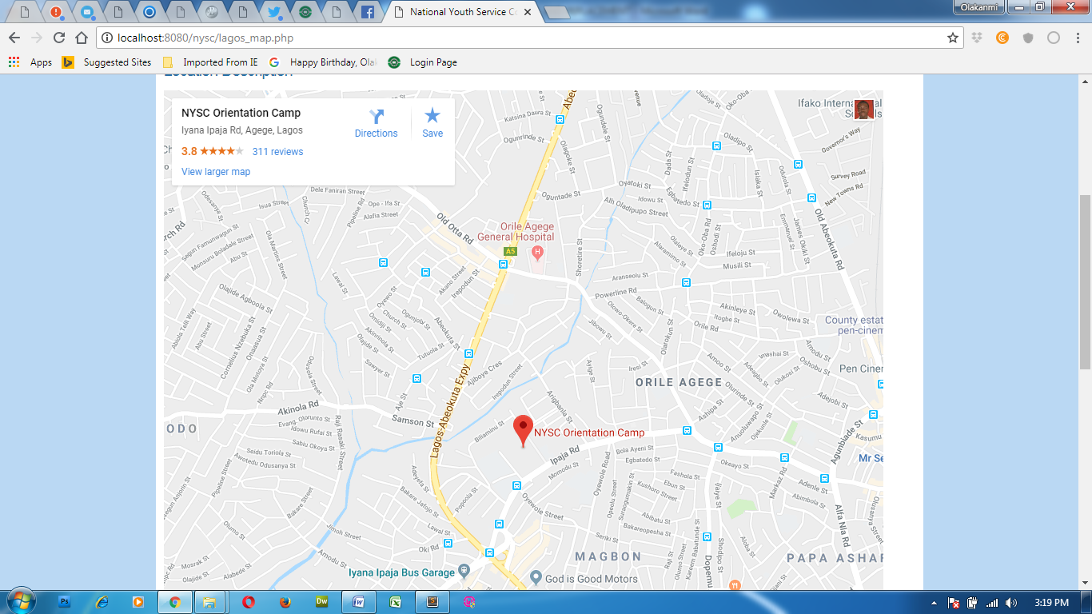
Figure 4.4: Its shows the NYSC camp guide Travel in Lagos State
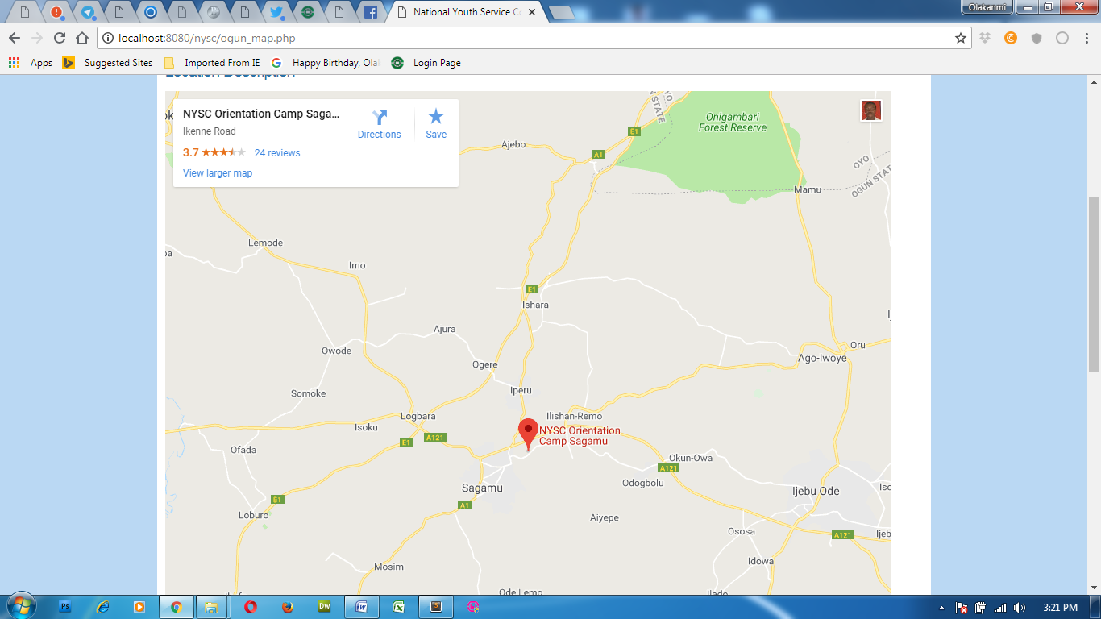
Figure 4.5: Its shows the NYSC camp Travel guide in Ogun State
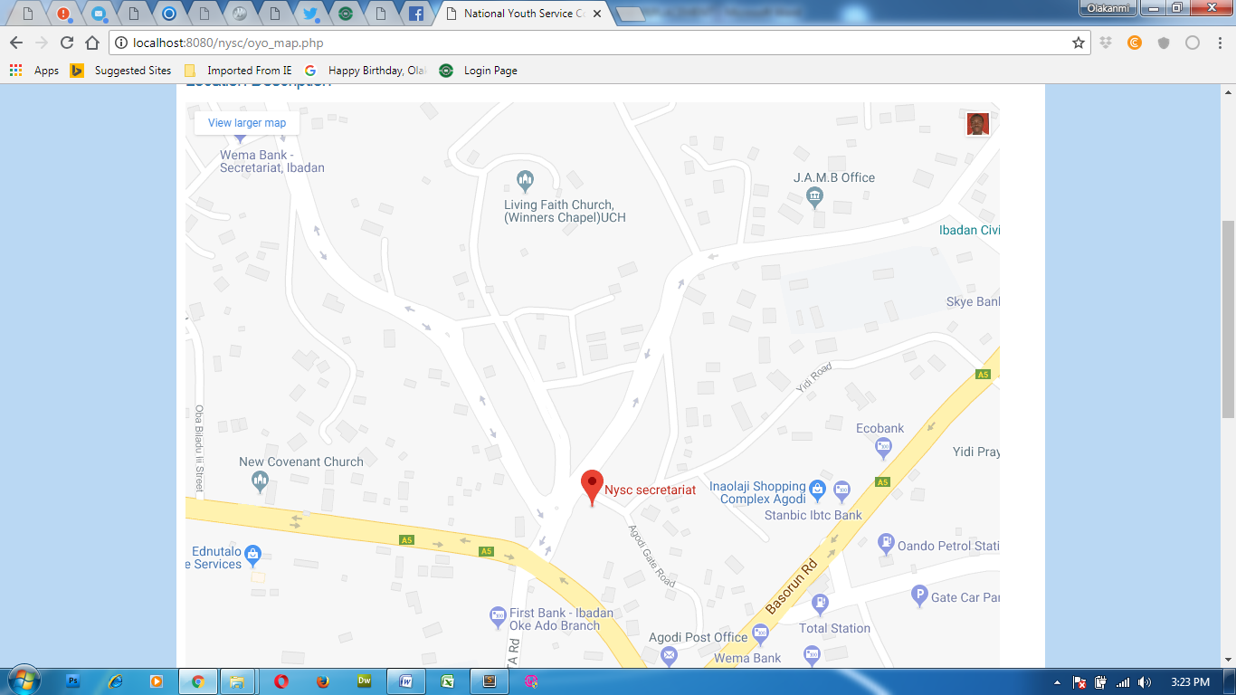
Figure 4.6: Its shows the NYSC camp Travel guide in Oyo State
    - Input Design
The input to be extracted from the proposed system are
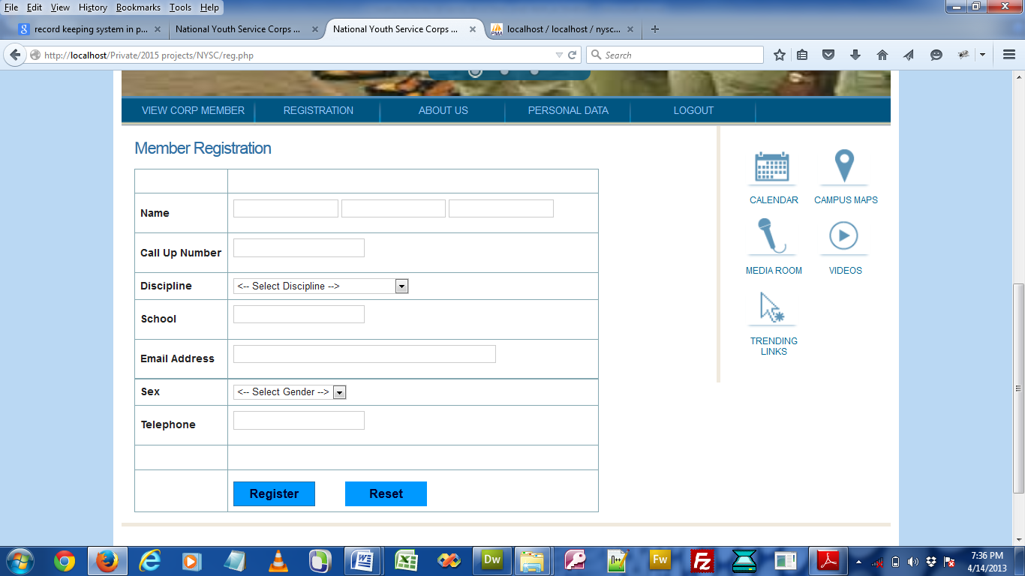
Fig: 4.3 Corps Member Registration page
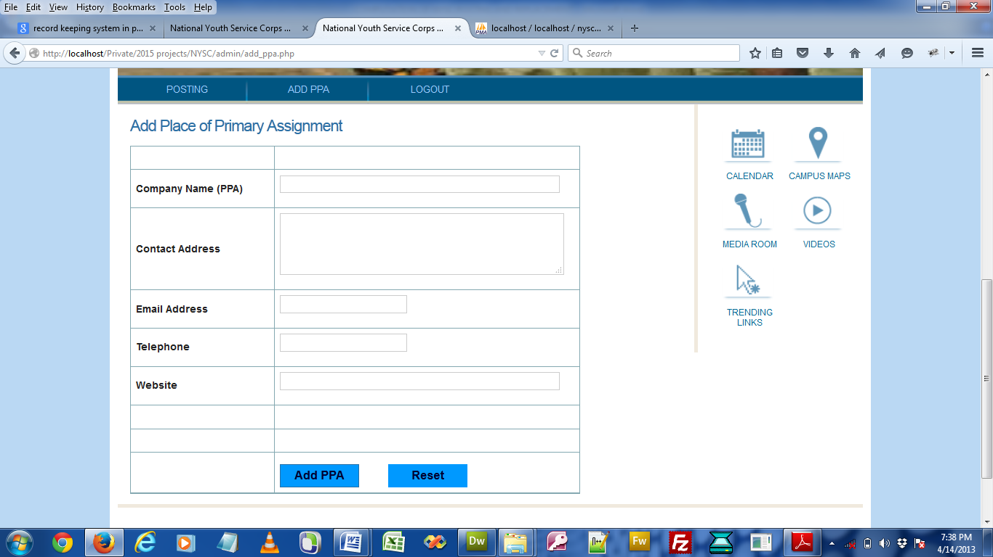
Fig: 4.4 Add PPA page

    - Database Design
This refers to the back end of the proposed system. The following steps is employed in the development of the database.
- Click on start button and locate wampserver.
- Open any browser and type http://localhost/phpmyadmin
- Type the name of the database i.e recruitment and click on create new
- In few seconds the database is created.
- To create table is the next action.
- On a create table menu type the name of the table and click on ok.

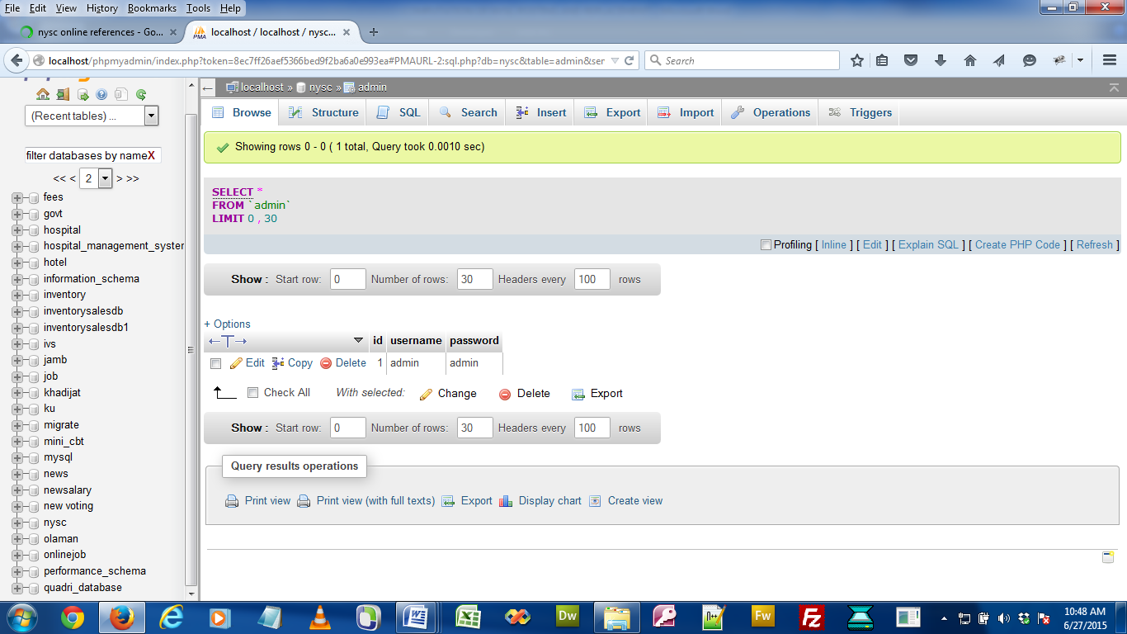
Fig: 4.5 Admin table
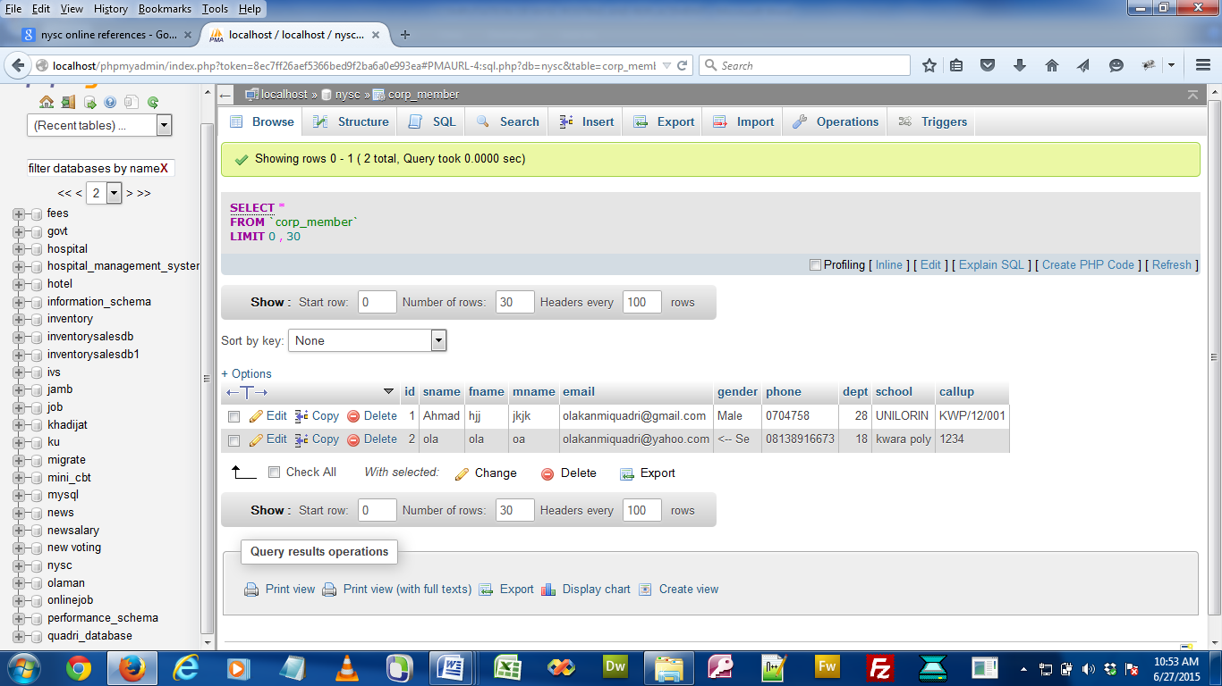
Fig: 4.6 Corps member table
    - Procedure Design
This refers to the step by step method of using the proposed system. The proposed system comprises of About, Register, Login, Modify Details while the administrator is able to add available PPA as well as its modification.
- On the address bar of any browser type http://localhost/nyscposting/admin/index.php
- You are prompted to supply the username and password this verifies that you are authorized user.
- If the username and password supplied are correct as that of the voter you are prompted with the home page..
- The website has two environments the general user and the administrator environment.
- As a corps memebr you are to type http://localhost/nycsposting/index.php on the address bar.
4.2 System Implementation
    - Choice of Programming Language
The new system is implemented using PHP programming language. This is because the programming language has the advantage of easy development. Flexibility and it has the ability of providing the developer/programmer with possible hints.
    - Hardware Support
The program for this project is written in PHP Programming Language. it is designed to run on an IBM personal computer. The following minimum hardware specification is needed
- Intel Pentium 1.MMX technology
- 14” VGA or SVGA Monitor
- 16 MB RAM
- 3.5 Floppy Drive
- 24 x CD ROM Drive
- 2.1 GB Hard Drive
- Keyboard
- Printer
    - Software Support
The proposed system makes use of macromedia fireworks for graphics work on the images and background used in the system, Macromedia Dreamweaver (a text editor) while MYSQL is used as the database.
    - Implementation Techniques Used In Detail
System conversion examines the pros and cons of various approaches to system change over from the old to the new system and recommends which is the most suitable for the present study. It also goes further to plan a course of action for the conversion. In this project work, the researcher adopted the parallel change over procedures. It is a situation where the old system processes data alongside with the new system.
  - Documentation of the System
    - Program Documentation
In order for the proposed system to be used on any computer system it takes the following ways
- Boot the system
- Put the software in the CD or flash drive into its appropriate drive.
- Open the content from “my computer” icon on the desktop or clicking the start button.
- Double click the set up icon from the content of the package folder in the device (flash, CD).
- Follow the instruction and click on the appropriate button and the installation will be completed in a few moments.
    - Operating The System
- Click on start button on the desktop.
- Point to all programs
- Select wampserver and launch it
- On the address bar of any browser type http://localhost/Nysc/index.php
- As an administrator you are to type http://localhost/Nysc/admin/index.php on the address bar.

    - Maintaining The System
Maintenance this program can be done in PHP environment. Any future modification can be done by re-compiling the source program in development environment making necessary changes versions of the existing version of the mini word processing applications

CHAPTER FIVE
Summary, Recommendation and Conclusion
5.1 Summary
NYSC computation system is designed to overcome the problems encountered with the existing system (i.e manual) such as prone to attack, data redundancy, time wastage in searching for information, poor security and protection, misplacement and mismanagement of files etc. The new system is designed in such a way that information about each corps member is stored in a database for easy retrieval of information.
5.2 Conclusion
This project covers the introduction, literature review, system analysis and design of computation NYSC System. After the system testing, it was observed that the Design and Implementation of the Project was achieved because of its effectiveness and mode of operation.
5.3 Recommendation
Regarding the problem being faced with the existing system adopted in. There is need for them to improve on their existing system.
It is important that NYSC personnel should always maintain an adequate and constant backup of data in order to prevent the loss of data and information and also to guide against fraudulent act when the proposed system is in operation.
We therefore wish to recommend that institutions, industries and companies should Endeavour to computerize their operation using the design of the study so as to facilitate the sharing of common resources as well as to encourage smooth running of the organization.

REFERENCES
Automation. (2020). Encyclopaedia Britannica. Encyclopaedia Britannica Student and Home edition. Chicago: Encyclopaedia Britannica.
Adibe, M.O. (2020).Computer Literacy, Lagos: Brillace Nigeria limited.
Aneke, (2019). Concepts and Application Technology in Information Technology.
Enugu:Macmillian Nigeria plc.
French, C.S. (2021). Data processing and information technology (10th ed.). London:
Continuum.
National Youth Service Corps (2019). National Youth Service Corps Orientation
Programme/ Service Guide: for corps members deployed to Ebonyi state (Batch “B”) [Orientation programme/service guide]. Ebonyi, Nigeria: Author.
Ogunsola, L. A., & Aboyade, W. A. (2020). Information and Communication Technologyin
Rob, G. R.& Coronel.(2019), Scientific Method in Database Systems. London: Oxford
University Press.
Remi, M. O. (2020). Academic research: Developing skills in project writing. Yola, Nigeria: RECH publishing house.
Stephen, M. (2019). Software development cycle [Electronic version]. Abingdon, England:
Tessella Support Services.
Tsai,A.A & Sarah,W. C.,(2020),Providing Efficient Web services. NewYork:Prentice
publications.

APPENDIX A: FLOWCHART
Start
Select menu
General user Area
Admin user Area
Return

ADMIN LOGIN
START
OPEN DATABASE
ACCEPT USERNAME AND PASSWORD
IS USERNAME AND PASSWORD
DEFAULT PAGE MENU
CLOSE DATABASE
STOP

YES
NO
GENERAL USER FLOWCHART
Is menu = registration ?
Is menu = About us?
Return
Start
Select menu
Is menu = view corp member?
View corp SSmember
About us
Registration

Yes

NO
Yes
No

NO

Yes
No
NO
Admin user Environment
Start

Select menu
Is menu = posting
Is menu = Add PPA?
Return

Posting
Add PPA

Yes
Yes
No
POSTING
START
OPEN DATABASE
SUPPLY POSTING DETAILS
ADD TO DATABASE
ADD MORE POSTING ?
CLOSE DATABASE
RETURN

YES
ADD PPA
NO
START
OPEN DATABASE
ADD PPA DETAILS
ADD TO DATABASE
ADD MORE PPA?
CLOSE DATABASE
RETURN

YES

NO
NO

REGISTRATION
START
OPEN DATABASE
SUPPLY CORPER DETAILS
ADD TO DATABASE
ADD MORE CORPER?
CLOSE DATABASE
RETURN

YES
NO

VIEW CORPS MEMBER
OPEN DATABASE
Start
SUPPLY CORPS DETAILS
IS DETAILS CORRECT?
DISPLAY CORPS MEMEBER
CLOSE DATABASE
RETURN

YES
ABOUT US
Start
Select menu
Display About
Return

