DESIGN AND IMPLEMENTATION OF A COMPUTERIZED CRIME REPORTING SYSTEM

BY

MUHAMMED ABDULLAHI MAYOWA
ND/23/COM/PT/0383

SUBMITTED TO:
DEPARTMENT OF COMPUTER SCIENCE
INSTITUTE OF INFORMATION AND COMMUNICATION TECHOLOGY

KWARA STATE POLYTECHNIC, ILORIN

IN PARTIAL FULFILMENT OF THE REQUIREMENTS FOR THE

AWARD OF NATIONAL DIPLOMA (ND) IN COMPUTER
SCIENCE

JUNE, 2025

CERTIFICATION

This is to certify that this project was carried out by MUHAMMED ABDULLAHI MAYOWA, Matric No: ND/23/COM/PT/0383, in the Department of Computer Science, Institute of Information Communication Technology, Kwara State Polytechnic, Ilorin, Kwara State.

….…………………………… ….……………………………
MR. SADIQ, K. A. Date
Project Supervisor

….…………………………… ….……………………………
MR. OYEDEPO Date
Head of Department

….…………………………… ….……………………………
External Examiner Date

DEDICATION

This project work was dedicated to Almighty God who inspired us and directed our ways our academic stay in polytechnic.

ACKNOWLEDGMENT
I wish to express my profound thanks and appreciation to God Almighty for His guidance and protection throughout this program. I acknowledge my supervisor, Mr. Sadiq K. A, who carefully read this work in detail. His kindness and encouragement were indispensable; without them, this study would not have been a success. May God reward and bless his family generously.
My gratitude also goes to the Head of the Department Mr. Oyedepo F. S., and others lecturers who imparted knowledge to me, directly and indirectly. May God reward you all abundantly.
Sincere thanks to my parents, Mr. & Mrs. Muhammed, whose sacrifices, understanding, and support encouraged me throughout this journey and ensured its success. God bless you both.

OF CONTENTS
Title Page i
Certification ii
Dedication iii
Acknowledement iv
Table of contents v
Abstract vi
CHAPTER ONE: INTRODUCTION
  - Chapter Overview 8
  - Background of the Study 8
1.2.1 Historical Perspectives 9
1.2.2 Theoretical Perspective 9
1.2.3 Conceptual Perspective 9
  - Problem Statement 9
  - Aims and Objectives of the Study 10
  - Scope of the Study 11
  - Limitation of the Study 11
  - Definitions of Terms 11
  - Chapters Layout 12

CHAPTER TWO: LITERATURE REVIEW
Brief History Of The Nigeria Police Force 13
2.1.1 Organization Structure Of The Nigeria Police 14
Concept Of Crime 15
2.2.1 Types Of Crime 17
Electronic Crime Reporting System 18

CHAPTER THREE: SYSTEM ANALYSIS AND DESIGN METHODOLOY
Chapter Overview 22
Analysis of the existing system 22
3.2.1 Problems Of The Existing System 22
Analysis Of The Proposed System 23
3.3.1 Vantages of the Proposed System 23
Methodology Adopted 24
3.4.1 Reasons For Choosing The Agile Methodology 25
3.4.2 Advantages Of The Agile Methodology 25
Logical Design 26
Use case Diagram 26
Data Flow Diagram 27
Activity Diagram 27
Physical Design 28
3.10 Database design 29

CHAPTER FOUR: SYSTEM IMPLEMENTATION
4.1 Chapter Overview 31
4.2 Features and Choice of Implementation 31
4.3 System Testing 34
4.3.1 Unit Test 34
4.3.2 Integration Test 35
4.4 Target Computer System Requirements 35

CHAPTER FIVE: SUMMARY, CONCLUSION AND RECOMMENDATIONS
5.1 Summary 40
5.2 Conclusion 40
5.3 Recommendations 40
5.4 Reference

ABSTRACT
The persistent use of paper-based crime reporting system has presented considerable challenges for police services globally, with the Nigeria Police Force in Ilorin being no exception. The reliance on antiquated paper systems has led to issues such as delayed dissemination of crime reports, misplacement or loss of recorded files, and inconsistencies in suspect documentation due to manipulation or alteration within police offices. Despite numerous studies emphasizing the critical role of the police force in the crime reporting and investigation process, limited research has been directed towards improving crime reporting methods, causing significant hurdles for law enforcement agencies in Kwara.
This research specifically targets the Nigeria Police Force in Kwara, focusing on the development of a tailored web-based application to enhance crime reporting and investigation processes. Employing a qualitative and quantitative approach with a cross- sectional design, the study utilized structured questionnaires and interviews with police personnel. The application was implemented using PHP, HTML, and JavaScript programming languages, with a database system utilizing MYSQL programming language. Rigorous testing and validation were conducted to ensure the application met the specific requirements of the Nigeria Police Force in Ilorin.

CHAPTER ONE

GENERAL INTRODUCTION

1.1 BACKGROUND OF THE STUDY
Computers have become an integral part of contemporary society, playing a crucial role in various sectors, especially in developing countries like Nigeria. The significance of computer applications extends to the enhancement of management processes and increased efficiency in service delivery. This project focuses on the development and implementation of a Computerized Crime Reporting System, with a specific emphasis on the Nigeria Police, Kwara.

1.2 HISTORICAL PERSPECTIVES
Crime report handling is a fundamental responsibility of law enforcement agencies, and the Nigeria Police is no exception. Efficient handling of crime reports is crucial for satisfying victims' needs and enhancing credibility in crime prevention. The current reliance on paper-based information systems has proven inadequate in meeting the demands for efficiency, leading to a call for technological solutions.
However, the transition to technology has presented challenges, affecting police performance and fostering mistrust between the public and law enforcement personnel. Literature emphasizes the potential of information systems and communication technologies in improving productivity and service delivery. Web-based applications, in particular, are recognized for their trustworthiness, cost-effectiveness, speed, and effectiveness in enhancing police service delivery.
The adoption of technological solutions, especially web-based applications, has transformed policing globally. These applications have become integral to effective crime management and response to the needs of victims and the public. While developed countries embraced this innovation earlier in the 21st century, developing nations, including Nigeria, are gradually recognizing the importance of such systems in modern policing.

1.2.1 THEORETICAL PERSPECTIVE
This study is guided by the hybrid evidence investigations theory, emphasizing the examination of crime scenes through both physical and digital evidence. The theory recognizes the coexistence of physical objects with hidden digital characteristics, shaping how crime reports and investigations are approached.
Digital evidence includes various forms of data like text, images, audio, and video stored, processed, and transmitted using digital devices and networks, complementing traditional physical evidence gathered from crime scenes (Guy, 2022).

1.2.2 CONCEPTUAL PERSPECTIVE
Crime report handling involves managing recorded crime files to make informed decisions. In the context of this study, a crime report is the process of notifying the police of a crime incident, facilitated through communication services or by visiting a police station. The study examines different crime scene details, suspect identity, victim- witness surveys, and both physical and digital evidence. The proposed computerized crime reporting system is conceptualized as a web-based application, providing a platform accessible through web browsers, web-application servers, and a back-end information system with crime databases.

1.2.3 CONTEXTUAL PERSPECTIVE
In the Nigerian context, the reliance on paper-based systems persists within the Nigeria Police. Despite some manual processes being conducted by the immigration department, the majority of tasks within the police force are still paper-based. This has resulted in the loss of reported information and potential manipulation of suspect records. The inefficiencies in the current system have hindered the rapid dissemination and sharing of crime information. This research seeks to address these challenges through the development of a computerized crime reporting system, specifically designed for the Nigeria Police, with a focus on enhancing accountability in law enforcement agencies.

1.3 PROBLEM STATEMENT
The Nigeria Police currently relies on a traditional, paper-based system for the management of crime-related information, involving the use of hard copies for documentation. This conventional approach has given rise to several challenges within the Nigeria Police. A key issue is the significant delay in disseminating crime information reported by victims or witnesses, resulting in a failure in the swift administration of justice. Additionally, challenges such as the misplacement of recorded evidence files by responsible Police Officers and the loss of crucial crime details from Police archives persist. Another pressing concern is the inconsistency of criminal records, often arising from incorrect manipulation or alterations by individuals within the Police offices.
To address these challenges and usher in a more professional and efficient approach to policing, a web-based application system has been developed specifically for the Nigeria Police. The primary objectives of this system are to streamline the handling of crime cases, expedite the dissemination of criminal information reports, facilitate efficient records searching and retrieval of complainants' and offenders' information, enable the real-time monitoring of case statuses, generate comprehensive reports, and maintain accurate records of crime cases within the Nigeria Police. The implementation of this web-based system aims to mitigate issues of data loss and inconsistency of criminal information by enhancing data integrity and transparency while ensuring authorized access for registered Police Officers only, prioritizing security measures.
The impetus behind delving into this topic lies in the evident challenges faced by the Nigeria Police in developing a secure and effective method to counteract data loss and manipulation of criminal information. The introduction of a web-based approach is tailored to enhance the efficiency of the crime reporting system within the Nigeria Police, emphasizing the need for a modernized and technology-driven approach to law enforcement. It is crucial to note that access to this web-based application is restricted solely to registered Police Officers, ensuring a secure and controlled environment.

1.4 AIM AND OBJECTIVES OF THE STUDY
1. User-Friendly Framework: The systems aims to provide a framework that caters to users of various categories, ranging from those proficient with computers to those with little to no computer knowledge.
2. Error-Free System: The product aims to establish a framework that is error-free, recognizing the critical nature of a crime management system and the potential consequences of errors.
3. Effectiveness: The software is designed to operate efficiently and effectively. It also ensure regular and timely actions against reported crimes, indicating a focus on responsiveness and accuracy.

1.5 SCOPE OF THE STUDY
This study focuses on researching and addressing the factors affecting the crime reporting, investigation, and correction roles within the Nigeria Police. The scope of this project is defined by the implementation of an online crime reporting application. The emphasis is on leveraging technology to enhance and streamline the processes associated with reporting crimes, conducting investigations, and implementing corrective measures within the Nigeria Police framework. The online crime reporting application will be a pivotal component in facilitating efficient, transparent, and user- friendly interactions between law enforcement and the public.

1.6 LIMITATIONS OF THE STUDY
1. Technological Literacy Variation: The effectiveness of the system can be influenced by variations in technological literacy among users. While efforts are made to create a user-friendly interface, users with limited computer proficiency may still face challenges.

2. Dependency on Reporting Accuracy: The success of the system relies heavily on accurate and timely reporting of crimes. Factors such as underreporting or delayed reporting by individuals or law enforcement agencies could impact the overall efficiency and effectiveness of the system.
3. Resource Constraints: Limitations in resources, both financial and technological, impact the system's scalability and the ability to implement advanced features. This could affect the overall robustness of the crime management system.
4. Dynamic Nature of Crime: The dynamic nature of criminal activities and emerging trends may pose challenges in anticipating and accommodating new types of crimes within the system. Regular updates and adaptability are essential to address evolving security concerns.

1.7 DEFINITIONS OF TERMS
Crime Report Handling: Crime Report Handling refers to the systematic procedures and methods employed by the Nigeria Police to manage and address various crime activities. It involves the utilization of a computerized crime reporting system to enhance work performance and community service delivery.
Crime Details: Crime Details specifically pertain to information related to various types of crimes that are crucial for Nigeria Police Officers to investigate.
Physical and Digital Evidences: Refers to information obtained during an investigation, encompassing both physical evidence (tangible items) and digital evidence (information stored electronically).
Suspect Identity Suspect Identity pertains to the reliable collection and storage of information related to potential offenders. This data is crucial for decision-making within law enforcement activities.
Victim-Witness Survey/Testimony: Victim-Witness Survey/Testimony involves the systematic collection of historical information from both victims and witnesses. This information aids in making informed decisions during the investigation process.
Police Services: Refers specifically to the Nigeria Police Services responsible for delivering effective community services.
Law Enforcement Agencies: Represents the various law enforcement agencies in Nigeria empowered by the constitution to enforce the law.

1.8 CHAPTER LAYOUT
This research work is organized into five chapters, each chapter gives the exposition of the fundamental concepts, procedures, ad implementation of the project.
Chapter one introduces the background of the study with the statement of the problem, objectives of the project, its significance, scope and constraints while previous literature in the understudied topic were reviewed in chapter two. Chapter three focuses on system investigation, system analysis and design. It details with detailed investigation and analysis of the existing system and problem identification. It also proposes the new system. Chapter four covers the system implementation, results and system integration test. Finally the chapter five discuss the summary, recommendation and the conclusion of the project.

CHAPTER TWO
LITERATURE REVIEW

2.1 BRIEF HISTORY OF THE NIGERIA POLICE FORCE
The Nigerian Police Force’s origins can be traced to the colonial period, when Nigeria was governed by the British. In order to uphold peace and order in the colony of Lagos, the British government founded the first police force in Nigeria in 1861, known as the Lagos Police. The Lagos Police, which was in charge of maintaining law and order in the Lagos Colony, was primarily made up of British officers. As the British colonial rule expanded to other parts of Nigeria, the need for a more organized police force arose. In 1894, the Royal Niger Company established the Niger Coast Constabulary, which was later merged with the Lagos Police to form the Southern Nigeria Police in 1906. The Southern Nigeria Police was responsible for policing the southern region of Nigeria, which comprised the present-day states of Lagos, Ogun, Ondo, Edo, Delta, Bayelsa, Rivers, and Akwa Ibom. To preserve peace and order in the northern region of Nigeria, which included the modern-day states of Sokoto, Kebbi, Zamfara, Kaduna, Katsina, Kano, Jigawa, Bauchi, Yobe, and Borno, the British administration founded the Northern Nigeria Police in 1900. (Chukwuemeka 2023).
The Nigerian Police Force’s principal responsibilities during the colonial era included upholding law and order, defending British interests, and quelling local uprisings against colonial control. Nigerians were mostly used as constables or other lower-ranking officials, while British officers held senior posts in the police force. With the passage of time, the Nigerian Police Force underwent several significant changes in its structure, functions, and responsibilities. One of the key developments was the enactment of the Police Act of 1943, which established a unified police force for the entire country, bringing together the Southern Nigeria Police and the Northern Nigeria Police under a single command. (Chukwuemeka 2023).
The Nigerian Police Force made progress in terms of capacity-building, modernization, and professionalization. In 1964, the Police College was established in Ikeja, Lagos, to provide training to police officers and improve their skills and knowledge. The police force also started to recruit more Nigerians into higher-ranking positions, and the Nigerian Police Force gradually became more representative of the diverse population of Nigeria. (Chukwuemeka 2023).

2.1.1 ORGANIZATIONAL STRUCTURE OF NIGERIA POLICE

MAKURDI ZONE
DEPUTY INSPECTOR GENERAL OF POLICE
LAGOS ZONE
YOLA ZONE
‘E’, ‘F)
Department (‘A’, ‘B’, ‘C’, ‘D’,
INSPECTOR
BENIN ZONE
ILORIN
ZONE
ABUJA ZONE
LOKOJA ZONE
UMUAHIA ZONE
KWARA
ZONE
STATE POLICE COMMANDS
DIVISIONAL POLICE COMMANDS

fig. 1: Organizational Structure of the Nigerian Police.

The organizational structure of Nigeria police which is fig 2.1 shows the various departments the police in Nigeria has starting from the rank of the inspector general of police down to the rank of the divisional police command and also their various zone which in total is nine zones.

2.2 CONCEPT OF CRIME

Well, meaningful societies in the world frown upon crime and any social vices that undermine the collective safety and values adopted in that society. Crime persists as long as human society exists, therefore there is a continuous effort and legitimacy to report, investigate, and provide convincing evidence to prosecute individuals who perpetrate any criminal activity. The word "Crime" originated from the Latin word "Crimen," dubbed charge or offense. Zuiderveen et al. (2020) projected crime as a function of the adoption of standards by the society rather than individualistic standards; that is, the society gradually determines what is perceived as good value and bad acts and prescribes possible consequences. Kaur (2020) defined crime as an intentional act in violation of criminal law without an excuse. Kahan (2019) expressed a holistic definition of crime as an act that is not just harmful to some individuals but also to the state or the general public.

The determination of what is obnoxious or sane is determined through long and continuous complex interactions and reactions among members of a society. As society varies, so does what is considered as crime vary from people to people. Wilson et al. (2018) argued that there cannot be a general theory to define crime for all societies because of the diversity of human society and culture. More so, Eisenstadt, et al. (2018) had a different view, stating that differences in cultures and societies do not really matter but the common characteristics in cultures can be identified, and a general theory can be formulated to prescribe what the society should adopt as a crime. That is, criminologists should not isolate crimes but look for the commonality in crimes so as to propose a general rule to determining crime for all societies. The dynamism of culture and unpredictability of humans make it unlikely to have a general set of rules for all human societies.
No continent is left out; Ukoji et al. (2019) reported that Africa is considered a flashpoint for high crime. He noted that giants of Africa like Nigeria and South Africa now have high records of violent crimes in recent times. America also has a high crime index while some places in Europe have been able to reduce crime index by few digits.
Another important component of the justice system is crime investigation and prosecution. The general knowledge of what crime constitutes is not enough without ultimately punishing the offender to serve as a deterrent and freeing the falsely accused persons in such occasions.

The general justice system constitutes the laws, which indicate what crime is, the law apparatuses like security agencies, people, and processes that are followed to implement justice. The people who are to be served by the justice system may soon begin to lose confidence and underreport or resort to jungle justice to redress their anger if the existing justice system continues to fail over time. The criminal justice system also constitutes the system of practices and institutions of government directed at ensuring social control, deterring and mitigating crime or sanctioning individuals who violate laws with criminal penalties and rehabilitation efforts.
However, the perception of the criminal justice system in Nigeria is usually put in poor light because of rapid and failing structures of the justice system. EHIGIATOR, B. O. (2023) reported that Amnesty International has always rated Nigeria's justice system poorly, representing it as a conduit for injustice from start to end. The actors in the justice system have also not helped the situation by not acting as expected by the lofty positions they hold and the important role they play in the process of dispensing justice. There is a sentiment about lawmakers having vested interests, thereby making inadequate laws that do not really serve the interest of the general public. The judicial system is also almost compromised as judges are bribed to pervert justice and dash the hope of the common man. Components of the justice system vary for different societies.
The process of the justice system is very important as it determines if the people who are served will accept the outcome of the process and continue to support the system. An important aspect of the justice system is being able to report cases, investigate and prosecute based on laws and get sentencing. Until recently, most communities reported crime incidences on papers, making the process vulnerable to alteration, theft, mutilation, and erasure of evidence that could have made the system apportion justice appropriately. With the advent of information technology, crime reporting has taken a new turn, as many cases can be reported independently and security agencies can easily access them and act promptly. There are state and individual-sponsored ICT platforms for reporting, investigating crime, and giving feedback to the people. The manual and old process do not engage the people as anticipated, which has generated all sorts of perceptions about how professionally and sincerely reported cases have been investigated. The United States of America has a common database for reporting crime incidences which has improved policing in the US.

There is a need to increase awareness of an encompassing electronic platform that will accommodate all crime incidences, open to all and provide feedback to the members of the public. This strengthens our legal infrastructure and justice system.
2.2.1 TYPES OF CRIME:
Crime statistics on reported offenses reflect that a total of 134,663 cases were reported in 2017. Offenses against property had the highest number of cases reported, with 68,579 such cases. Offenses against persons recorded 53,641 cases, while offenses against lawful authority recorded the least, with 12,443 cases (NBS 2017). The National Bureau of Statistics (NBS) in 2017 categorized crime rates in each state of Nigeria as follows:
- CRIME AGAINST PERSON
- Child Stealing
ii Slave Dealing
iii Rape & Indecent Assault
iv Kidnapping Unnatural Offence
v Other Offence Offences
vi Murder Man Slaughter
- CRIME AGAINST PROPERTY
- Armed Robbery
- Wounding With Menace
- Theft / Stealing
- Burglary House
- Breaking Store Breaking
- CRIME AGAINST LAWFUL AUTHORITY
  - forgery Of Currency
  - Coining Offence
  - Gambling

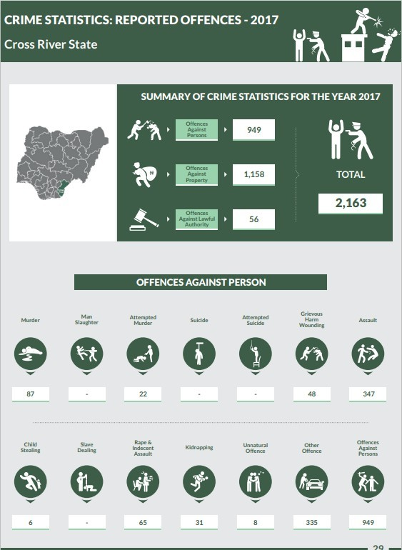

Fig. 2: Statistics of crime in Ilorin State

2.3 ELECTRONIC CRIME REPORTING PLATFORMS
Aswini .G, Dhivya .N, Jayanthi .R, and Ambikapathy R ( 2019) - Fall Detection and Reporting Using Smartphone" . This innovative application sought to harness the capabilities of smartphone technology for fall detection, providing users with a streamlined method to seek assistance during hazardous situations by simply shaking their smartphones.

Strengths:
The application boasted several strengths that contributed to its potential efficacy. Firstly, its intuitive help mechanism stood out as a notable feature. By enabling users to trigger assistance through a simple action – shaking their smartphones – the application offered a user-friendly and accessible means for individuals to request aid in emergency situations. This intuitive approach addressed the need for a quick and straightforward method of seeking help, especially in moments of distress.
Additionally, the integration of GPS technology for location reporting was a commendable strength. This feature enhanced the responsiveness of emergency services by providing precise location information when a fall was detected. The inclusion of GPS data ensured that responders could swiftly locate and reach individuals in need, thereby optimizing the efficiency of emergency response efforts.

Limitations:
However, the application was not without its challenges. One notable limitation was the potential for unintentional activation of the fall detection mechanism. The sensitivity of the system to smartphone shaking posed a risk of false alarms, leading to misunderstandings and confusion among users and those in close proximity. This limitation emphasized the importance of fine-tuning the fall detection algorithm to strike a balance between sensitivity and specificity, thereby minimizing the occurrence of false positives.
Huaqun Wang, Debiao He, Zhe Liu, and Rui Guo- Blockchain-Based Anonymous Reporting Scheme With Anonymous Rewarding This innovative concept aimed to redefine anonymous reporting mechanisms by seamlessly integrating blockchain technology and introducing the revolutionary concept of BB2AR (Blockchain-Based Anonymous Reporting with Anonymous Rewarding).

Strengths:
The scheme brought forth a multifaceted set of strengths designed to elevate the efficacy and user experience:
- Anonymous Reporting Mechanism: A pivotal strength lay in the incorporation of an anonymous reporting mechanism. This feature empowered users to report incidents without the necessity of revealing their identity, fostering a secure environment conducive to individuals sharing information that might otherwise remain undisclosed.

- Anonymous Rewarding: The conceptualization of BB2AR introduced the groundbreaking concept of anonymous rewarding. This unique approach not only acknowledged the importance of incentivizing individuals to actively participate in reporting but also ensured that rewards were distributed without compromising the anonymity of those providing valuable information.
- Web-Based Application: Another notable strength was the utilization of a web- based application. This platform choice enhanced accessibility for users, allowing seamless engagement with the reporting system through standard web browsers. The decision to adopt a web-based approach aimed to streamline user interactions, potentially fostering increased participation and engagement in the reporting process.

Limitations:
While the scheme showcased promising features, it is crucial to recognize and address potential limitations:
- Technology Adoption Challenges: The incorporation of blockchain technology, while innovative, could pose challenges related to technology adoption. Users unfamiliar with blockchain concepts might face a learning curve, potentially hindering the widespread adoption of the anonymous reporting scheme. Educating users and providing user-friendly interfaces may be crucial to overcoming these challenges.
- Scalability Concerns: The scalability of the chosen blockchain network becomes a critical consideration. As the number of users and reported incidents increases, scalability challenges may arise, potentially impacting the efficiency and responsiveness of the anonymous reporting platform. Addressing these concerns is vital to ensuring the system's ability to accommodate growth while maintaining optimal performance.
Gunawan et al. (2021) - Factors Influencing Citizens' Intentions in Indonesia: Gunawan and colleagues conducted a study in Indonesia in 2021, exploring the factors influencing citizens' intentions to use online crime reporting systems. The findings revealed that perceived usefulness, ease of use, and trust in the system emerged as significant predictors for the intention to use such systems. Additionally, the study underscored the critical role of system design and security in fostering users' trust, emphasizing the importance of these factors in shaping the public's willingness to adopt and engage with online crime reporting systems.

Al-Shammari and Al-Sherbaz (2020) - Evaluation of Online Crime Reporting System in Iraq: In 2020, Al-Shammari and Al-Sherbaz conducted an evaluation of an online crime reporting system implemented in Iraq. The study demonstrated a positive impact on crime reporting and management, showcasing a reduction in police response time and an overall enhancement in the efficiency of the justice system. Notably, the study emphasized the imperative of heightened awareness and promotion among the public to boost system usage. Recognizing the need for increased public engagement became a key takeaway for the successful implementation of online crime reporting systems.
Nguyen and Pham (2020) - Impact Evaluation in Vietnam: Similarly, in Vietnam, Nguyen and Pham carried out a study in 2020 to evaluate the impact of an online crime reporting system on the efficiency of the justice system. The study identified a significant positive impact on crime reporting, management, and prevention. Furthermore, it stressed the pivotal role played by system security and a user-friendly interface design in promoting the adoption and success of the online crime reporting system. These elements were recognized as crucial contributors to the overall effectiveness of the system in improving the efficiency of justice-related processes.

CHAPTER THREE
SYSTEM ANALYSIS, DESIGN AND METHODOLOGY

3.1 OVERVIEW
In the pursuit of modernizing crime reporting and enhancing law enforcement capabilities in Nigeria, the "Design and Implementation of a Computerized Crime Reporting System" project enters a pivotal phase. Chapter Three delves into the intricacies of system analysis, design, and methodology, providing a comprehensive insight into the meticulous crafting of this computerized crime reporting system to effectively meet the needs of the Nigeria Police.

3.2 ANALYSIS OF THE EXISTING SYSTEM
The current crime reporting system within the Nigeria Police relies heavily on manual processes and paperwork. Incidents are recorded using a traditional, paper-based approach. When an individual wishes to report a crime, their information is manually documented, leading to delays and potential inefficiencies.
3.2.1 PROBLEMS OF THE EXISTING SYSTEM
Upon a thorough examination of the current system, several issues have been identified:
i. Data Discrepancies: The reliance on paper records increases the risk of data discrepancies and loss. Managing crime reports necessitates extensive paperwork, making it susceptible to errors and inaccuracies.
ii. Delay in Processing: Users often experience delays in the processing of crime reports as they navigate through manual records. This can lead to slower response times from law enforcement.
iii. Error-Prone: The manual nature of the existing system makes it prone to errors. The risk of inaccuracies in recording and maintaining crime data is high, impacting the overall effectiveness of law enforcement efforts.
iv. Resource-Intensive: The current system is labor-intensive and requires significant human resources, contributing to potential inefficiencies in the overall crime reporting process.
v. Limited Accessibility: The manual system limits the accessibility of crime data, hindering the timely sharing of crucial information among law enforcement agencies.

,
3.3 ANALYSIS OF THE PROPOSED SYSTEM
The design of the proposed computerized crime reporting system stems from a meticulous analysis of the shortcomings of the existing system. The objective is to create a technologically advanced and efficient solution that addresses the identified issues and enhances the overall capabilities of the Nigeria Police in managing and responding to criminal incidents.
3.3.1 ADVANTAGES OF THE PROPOSED SYSTEM
The design and implementation of the computerized crime reporting system offer a myriad of advantages over the existing manual system, addressing critical limitations and enhancing the overall effectiveness of law enforcement efforts in Nigeria.
      - Enhanced Data Accuracy: One of the primary benefits of the proposed system is the significant improvement in data accuracy. By replacing manual record- keeping with automated processes, the system minimizes the risk of errors associated with handwritten reports. This heightened accuracy ensures that law enforcement agencies can rely on precise and trustworthy information when making decisions and allocating resources.
      - Improved Efficiency and Timeliness: The transition to a computerized system introduces real-time data processing capabilities, reducing delays in crime reporting and response times. Law enforcement personnel can swiftly access and act upon reported incidents, leading to a more efficient allocation of resources and a proactive approach to crime prevention.
iii. Streamlined User Experience: The user-friendly interface of the proposed system enhances the overall experience for both law enforcement personnel and the public. Intuitive forms and simplified processes make it easy for users to submit and retrieve information, encouraging greater participation in the crime reporting process. This streamlined user experience contributes to increased engagement and a more comprehensive database of reported incidents.
iv. Enhanced Security Measures: The implementation of robust security measures, including encryption protocols and access controls, ensures the integrity and confidentiality of crime data. This not only protects sensitive information from unauthorized access but also instills trust in the system among users. Strengthened data security is a fundamental advantage of the proposed system in safeguarding critical information.

v. Resource Optimization: The automation of processes in the proposed system reduces the manual workload on law enforcement personnel. This optimization of resources allows for a more strategic allocation of human capital, enabling personnel to focus on higher-priority tasks such as investigations and community engagement. As a result, the system contributes to the overall efficiency of law enforcement operations.

3.4 METHODOLOGY ADOPTED
In the development of the computerized crime reporting system tailored for the Nigeria Police Ilorin, the chosen methodology is the Agile Software Development Model. This selection is driven by the agility of Agile in addressing the limitations of traditional waterfall methodologies. In contrast to a rigid sequential design process, Agile embraces an incremental approach, fostering flexibility and adaptability throughout the system's development lifecycle.
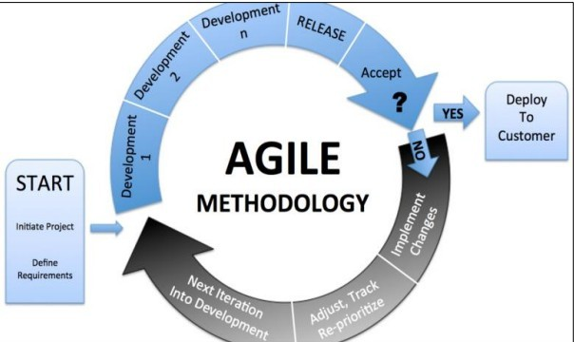
Agile, unlike the rigid structure of the Waterfall model, allows for revisiting and adapting previous stages even after the initial planning. The methodology involves breaking down the project into manageable components, such as design, coding, and testing, and assembling them as needed. Agile practices emphasize incremental development with small, frequent releases—typically every two or three weeks. This frequent release cycle enables rapid feedback from end-users, facilitating the incorporation of changing requirements in real-time.

Fig 3: Agile methodology

3.4.1 REASONS FOR CHOOSING THE AGILE METHODOLOGY
The selection of the Agile Software Development Model for the development of the Computerized Crime Reporting System for the Nigeria Police is based on several key reasons:
- Flexibility and Adaptability: Agile's incremental approach allows for flexibility and adaptability throughout the development lifecycle, crucial in addressing the evolving needs and requirements of the Nigeria Police.
- Active User Involvement: The active involvement of end-users in the development process aligns with the dynamic nature of law enforcement, ensuring that the system is tailored to the specific operational requirements of the Nigeria Police.
- Iterative Development: The iterative nature of Agile enables developers to receive early and continuous feedback from users, guiding ongoing adjustments and improvements, and accommodating changes even after the initial stages of development.
3.4.2 ADVANTAGES OF THE AGILE METHODOLOGY
The Agile Software Development Model offers several advantages for the design and implementation of the Computerized Crime Reporting System for the Nigeria Police:
- Rapid Response to Changing Requirements: Agile's incremental and iterative approach allows for quick adjustments to changing requirements, ensuring that the system remains responsive to the evolving needs of law enforcement.
- Early and Frequent User Feedback: By involving end-users throughout the development process, Agile facilitates early and frequent feedback, allowing developers to address user concerns promptly and improve the system iteratively.
- Reduced Documentation Overhead: Agile minimizes the need for extensive documentation, emphasizing informal communication. This streamlines the development process, allowing teams to focus on delivering functional components efficiently.
- Improved Collaboration: The collaborative nature of Agile promotes effective communication and collaboration among development teams and stakeholders, fostering a shared understanding of project goals and priorities.

- Continuous Improvement: Agile's iterative cycles support continuous improvement, enabling developers to refine the system based on user input and emerging requirements, leading to a more robust and user-centric final product.

3.5 LOGICAL DESIGN
Logical design stands as a pivotal phase in the development of the Computerized Crime Reporting System. This phase is dedicated to delineating the structure and functionality of the system without delving into the specifics of implementation. The emphasis here is on creating a blueprint that ensures the system aligns seamlessly with the operational needs of the Nigeria Police, fostering a robust and efficient crime reporting process.

3.6 USE CASE DIAGRAM
The use case diagram is a pivotal visual tool employed to illustrate the scenarios of users' instantaneous interactions with the designed components within the Computerized Crime Reporting System. This diagram encapsulates a set of scenarios that vividly describe how users, including law enforcement personnel and the public, interact with the proposed application system, offering a comprehensive overview of the system's functionality from the perspective of end-users. Below is the use case diagram
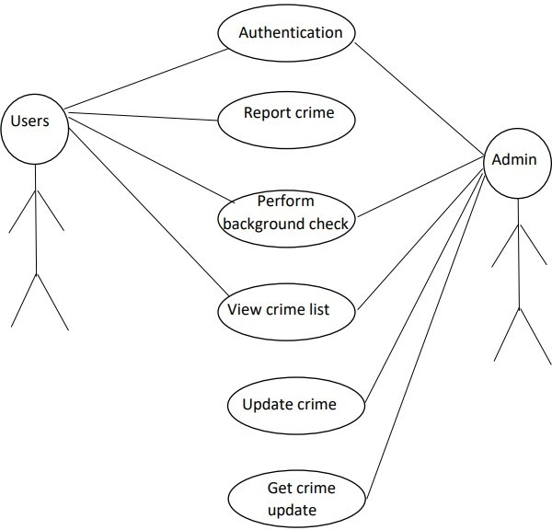

Fig 4: Use Case Diagram

3.7 DATA FLOW DIAGRAM
Data Flow Diagram (DFD) is a visual representation of the flow of data within a system. It illustrates how data moves between processes, data stores, and external entities. Below is a graphical description of a simplified Data Flow Diagram for a computerized crime reporting system.

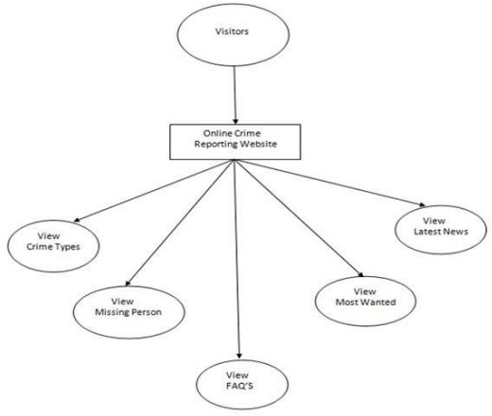

Fig 5: Data Flow Diagram

3.8 ACTIVITY DIAGRAM
The activity diagram describe the sequential flow of activities and actions within a system or process. It is a powerful tool for modelling and analyzing complex workflow and can be used to depict both high level processes and detailed low-level activities.
Below is the activity diagram for crime reporting system

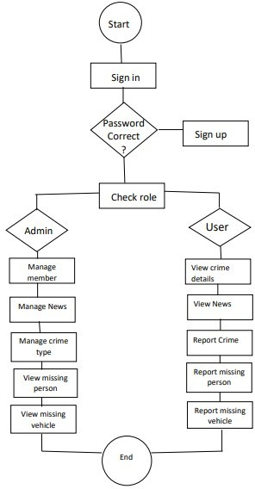

Fig 6: Activity diagram

3.9 PHYSICAL DESIGN
In the physical design for this system, the logical specifications are transformed into a detailed description of the system in terms of both hardware and software components. This phase also encompasses the mapping of the logical data structure to the physical architecture, involving the creation of database structures.

3.10 DATABASE DESIGN
The database was designed using MySQL database system. MYSQL was chosen since it is very fast in information retrieval, advanced features from authentication/authorization to storage through the database management information system and its ability to easily access and be accessed by network facility using windows operating system. The tables that was used to design crime reporting system is shown below.

Table 1: Users table of the database
S/N | NAME | TYPE | DESCRIPTION
1 | Users_id | Int(12) | Primary key for user
2 | User_Name | Varchar(25) | Name of user
3 | User email | Varchar(20) | E-mail of user
4 | User pwd | Varchar(10) | Password of user

Tab
T

Table 2: Crime table of the database

S/N | NAME | TYPE | DESCRIPTION
1 | Crime_id | Int(12) | Primary key for crime
2 | Crime_status | Varchar(100) | Status of crime
3 | Crime_Descr | Varchar(100) | Crime description
4 | Crime_scene | Varchar(10) | Scene of crime
5 | Crime_suspects | Varchar(100) | Suspects in a crime
6 | Crime_Address | VarChar(50) | Location where crime occured
7 | Crime_evidence | Varchar(50) | Evidence retrieved from crime

Table 3: M

S/N | NAME | TYPE | DESCRIPTION
1 | Person_id | Int(12) | Primary key for missing person

2 | Person_fullName | Varchar(100) | Name of missing person
3 | Person_Address | Varchar(100) | Missing person address
4 | Person_phone | Varchar(10) | Password of user
5 | Person_Desc | Varchar(100) | Description of the missing person
6 | Person_image | Blob | Image of the missing person
7 | Person_alert | Varchar(50) | Who to alert when missing person is found

Table 4: Missing vehicle table of the database
S/N | NAME | TYPE | DESCRIPTION
1 | Vehicle_id | Int(12) | Primary key for missing vehicle
2 | Number_plate | Varchar(8) | Plate number of the missing vehicle
3 | Model | Varchar(20) | Missing vehicle plate number
4 | Owner | Varchar(50) | Owner’s name
5 | phoneNumber | Varchar(11) | vehicle owner’s phone number
6 | National_id | Varchar(12) | Owners’s National ID
7 | Vehicle_desc | Varchar(1000) | Missing vehicle description
8 | Vehicle_image | Blob | Image of the missing vehicle

CHAPTER FOUR
SYSTEM IMPLEMENTATION

4.1 CHAPTER OVERVIEW
This chapter details the implementation process of a computerized crime reporting system designed for the Nigeria Police in Ilorin. The development and execution of this system address crucial issues inherent in traditional crime reporting methods. The tools employed during the development and implementation phases are highlighted, playing a pivotal role in shaping and realizing the core functionalities required to achieve the system's objectives.
The chapter provides insights into specific functionalities within each module, outlining their respective outcomes. The central theme revolves around the seamless integration of components to create an interconnected mechanism tailored to enhance crime reporting and analysis for the Nigeria Police in Ilorin. The system comprises interacting and interdependent elements that collectively contribute to its overall effectiveness.

4.2 FEATURES AND CHOICE OF IMPLEMENTATION
In the development of the computerized crime reporting system for the Nigeria Police in Ilori, careful consideration was given to selecting technologies and languages to ensure the delivery of a robust and user-friendly solution. This section provides a comprehensive overview of the features and the rationale behind the choice of implementation technologies.

Programming Languages and Technologies:

HTML (Hypertext Markup Language):
HTML serves as the foundation of the crime reporting system, responsible for structuring the content and presenting it in a web-based format. It defines the layout, headings, paragraphs, forms, and hyperlinks that constitute the user interface. HTML is instrumental in creating an intuitive and consistent platform for reporting crimes, facilitating easy navigation for users.

CSS (Cascading Style Sheets):
CSS plays a crucial role in enhancing the visual appeal and user experience of the system. By governing the style and layout, CSS ensures that the crime reporting interface is not only functional but also aesthetically pleasing. It enables customization of fonts, colors, spacing, and responsiveness, ensuring accessibility across various devices and screen sizes.

JavaScript:
JavaScript introduces dynamism to the system, providing interactivity and responsiveness. It empowers the web pages with features such as real-time updates, user validation, and dynamic content loading. JavaScript ensures that users can seamlessly interact with the crime reporting system, improving overall user engagement and satisfaction.

PHP (Hypertext Preprocessor):
PHP is the chosen server-side scripting language for this implementation. It excels in processing user requests, managing data from the front-end, and interfacing with the database. PHP is essential for implementing user authentication, handling crime report submissions, processing data, and generating dynamic content based on user interactions. Its versatility and efficiency make it a crucial component in ensuring smooth system operations.

MySQL (Structured Query Language):
MySQL serves as the relational database management system (RDBMS) for the crime reporting system. It is a robust and widely adopted choice for storing and managing data efficiently. MySQL stores critical information, including crime records, user details, incident history, and more. Its ability to handle complex queries, ensure data integrity, and scale with the system's growing data make it an ideal choice for data storage.

Advantages of the Chosen Technologies:
- User-Centric Interface: In the context of a computerized crime reporting system for the Nigeria Police in Ilorin, the collaboration of HTML, CSS, and JavaScript plays a pivotal role in creating a user-centric interface. HTML, as the markup language, structures the content, ensuring that the crime reporting platform is well-organized and easily navigable. CSS, through cascading styles, enhances the visual aesthetics of the interface, making it not only functional but also appealing to users.
JavaScript introduces dynamic elements, allowing for real-time validation, interactive forms, and seamless content loading. Together, these technologies contribute to the development of a highly engaging and user- friendly system, ensuring that individuals can easily and intuitively report crimes.
- Efficient Server-Side Processing: PHP, as the chosen server-side scripting language, brings efficiency to server-side tasks within the crime reporting system. It excels in managing user registration, authentication processes, and interactions with the underlying MySQL database. In the context of law enforcement, where data security and efficiency are paramount, PHP ensures that user data is handled securely, and interactions with the database are optimized. This efficiency guarantees that individuals reporting crimes experience a responsive and reliable platform, reinforcing the trust in the system's ability to process and manage critical information.
- Reliable Data Management: MySQL, functioning as the relational database management system (RDBMS), provides a robust and scalable solution for storing and managing extensive crime records, user data, and transaction details. The reliability of MySQL ensures data integrity, essential in maintaining the accuracy and trustworthiness of crime-related information. The scalability of the database system is particularly crucial as the volume of reported crimes grows over time. MySQL's ability to handle complex queries and quick data retrieval contributes to the overall reliability and effectiveness of the crime reporting system.
- Interactivity and Real-Time Updates: JavaScript, as the dynamic scripting language, enriches the crime reporting system with interactive features, fostering user engagement. Real-time search capabilities empower users to quickly find relevant information, enhancing the efficiency of the reporting process. Interactive forms streamline the submission of crime reports, making the system more user- friendly. Content loading without page refreshes ensures a seamless and dynamic user experience, allowing individuals to stay informed about the status of their reported crimes in real time. This interactivity not only improves the overall user experience but also contributes to the effectiveness and responsiveness of the crime reporting platform.

Use Cases:
The strategic selection of technologies for the computerized crime reporting system enables it to address a diverse range of use cases:
- Intuitive Crime Reporting Interface: The HTML and CSS collaboration ensures the creation of an intuitive and visually appealing interface for users to effortlessly report and explore crime-related information. The user-friendly design enhances the accessibility of the crime reporting system, allowing individuals to navigate and submit reports seamlessly.
- Effortless User Management: PHP, as the server-side scripting language, facilitates user registration, authentication, and profile management. This functionality ensures a streamlined experience for individuals using the crime reporting system, promoting efficient user management and maintaining the security and integrity of user data.
- Effective Incident Management: The synergy between PHP and MySQL supports the efficient addition, editing, and removal of reported incidents from the system. Real-time updates on incident availability and status ensure that law enforcement personnel can manage and respond to incidents promptly, enhancing the overall effectiveness of incident management.
- Transaction Handling: PHP excels in handling various transactions within the crime reporting system, including the submission of crime reports, updates on incident status, and fine calculations where applicable. This ensures the accuracy and reliability of transactions, contributing to the system's credibility and trustworthiness.
- Dynamic and Interactive Features: JavaScript introduces dynamic features such as real-time search, auto-suggestions, and interactive forms. These features enrich the crime reporting system, providing users with a dynamic and engaging platform. Real-time search capabilities empower law enforcement personnel to quickly access relevant information, while interactive forms simplify the process of submitting detailed incident reports.

4.3 SYSTEM TESTING
The primary objective of the system testing process was to meticulously identify and address any defects within my project. This involved subjecting the program to a series of test inputs, systematically observing its behavior, and determining whether it aligned with our expectations. My comprehensive testing strategy encompassed two crucial levels:

4.3.1 UNIT TESTING
Unit testing was initiated once a module had been created and successfully reviewed. This phase involved testing individual modules in isolation to ensure their functionality and reliability. To conduct unit testing effectively, I established a complete test on:

Admin module

Users login module

Users and police login module
Unit testing was systematically performed on each module outlined in the module description provided in Chapter 4. This meticulous approach allowed me to validate the individual functionalities of every module, ensuring that they met the specified requirements.

2) Integration Testing
Integration testing was the next crucial step in my testing process. This phase involved testing the interaction and integration of multiple modules to ensure they functioned seamlessly as a cohesive system. The objective was to identify and address any issues that might arise when integrating different components of the project.

4.4 TARGET COMPUTER SYSTEM REQUIREMENTS
For the successful operation of this project, specific hardware and software prerequisites are essential. These requirements encompass:
HARDWARE DETAILS
The following hardware components are required for the developing and implementing the system. Some of these requirements are as follows.
- System running: Pentium or Intel.
- Random access memory (RAM): A minimum of 512MB RAM and above.
- Hard disk: 1.0GB and above
- Internet Connectivity: Access to 3G/EDGE/Wi-Fi internet connectivity is necessary.
- Compatible Devices: The software should run on personal computers (PCs), smartphones, and other web-compatible devices.

SOFTWARE DETAILS
The following software components are required for the development and implementation of the system:
- Windows xp, windows 7 and above
- MYSQL database
- XAMPP server
- Google chrome or updated Mozilla Firefox web browser

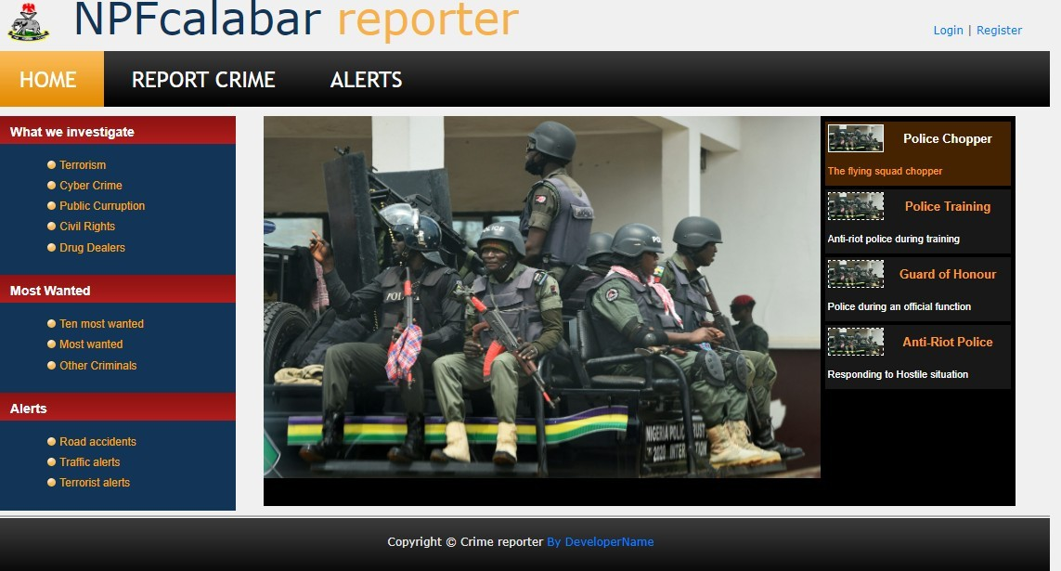
4

Fig 7: Hompage

Home Page
This is the main or initial page of a website that serves as the starting point for users when they visit the site. It the first page that loads when the web browser is opened or when a user enters the website's domain name. The homepage provides an overview of the website's content and navigation options.

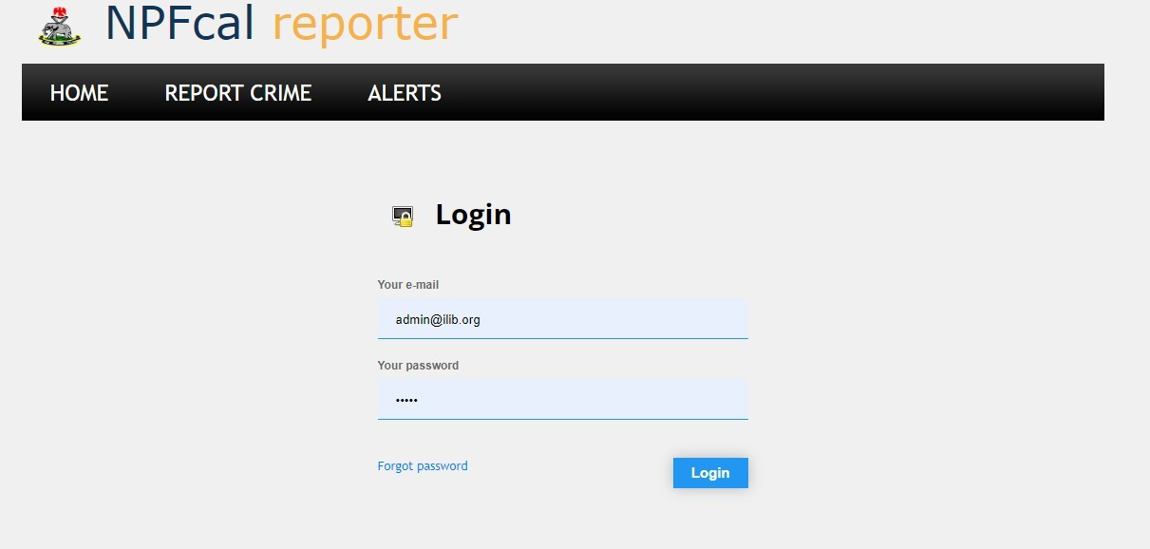

Fig 8: Admin Login Admin Login
This is the admin Login the admin manages user accounts, oversees incident details, configures system settings, ensures security and access control, generates crime reports and analytics, coordinates communication, provides training and support.
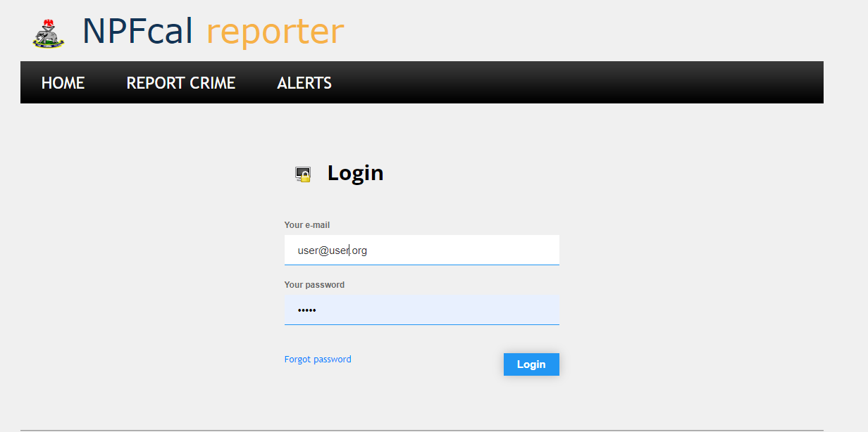

Fig 9: User Login User Login
This is the user login page, each user registers with a unique email address and a password. The user can report incidents, provide details on crimes, upload relevant documents or evidence, track the status of reported incidents, receive updates on investigations, communicate with law enforcement, and access relevant information or resources provided by the system.

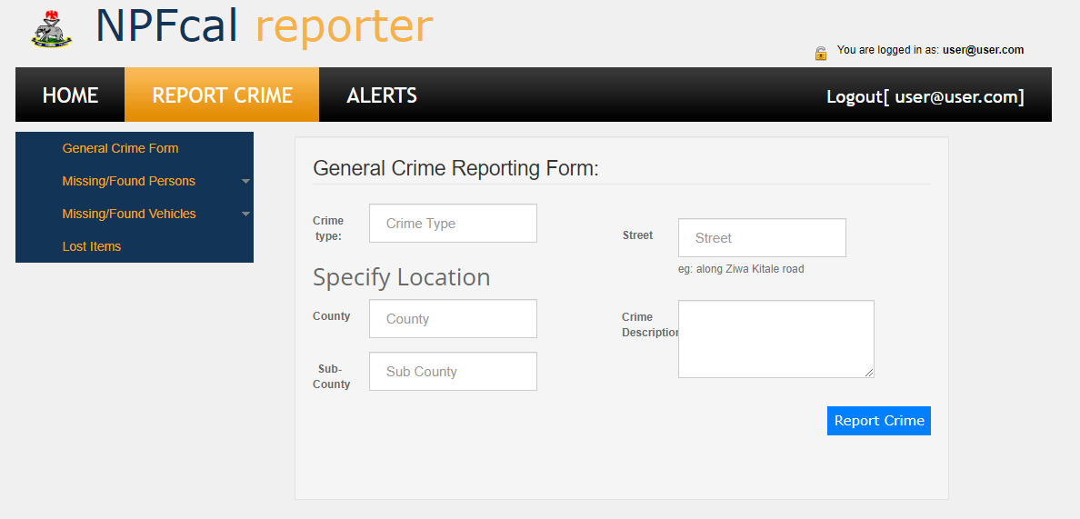

Fig 10: Report Crime Page

REPORT CRIME PAGE
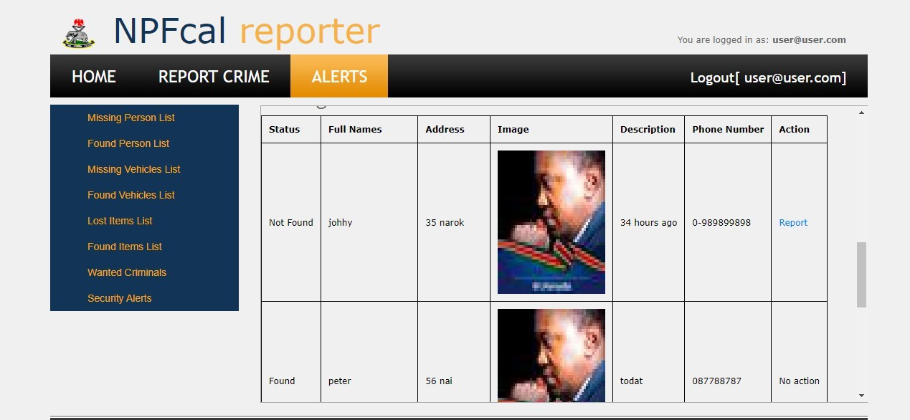
Upon successful login, users are presented with a reporting screen where they can submit information including their full name, the location of the crime, upload images depicting the type of crime, and provide a written description.

Fig 11: Alert Page

ALERT PAGE
This screen displays the current cases to the admin, showcasing their status along with detailed information about the reporters.

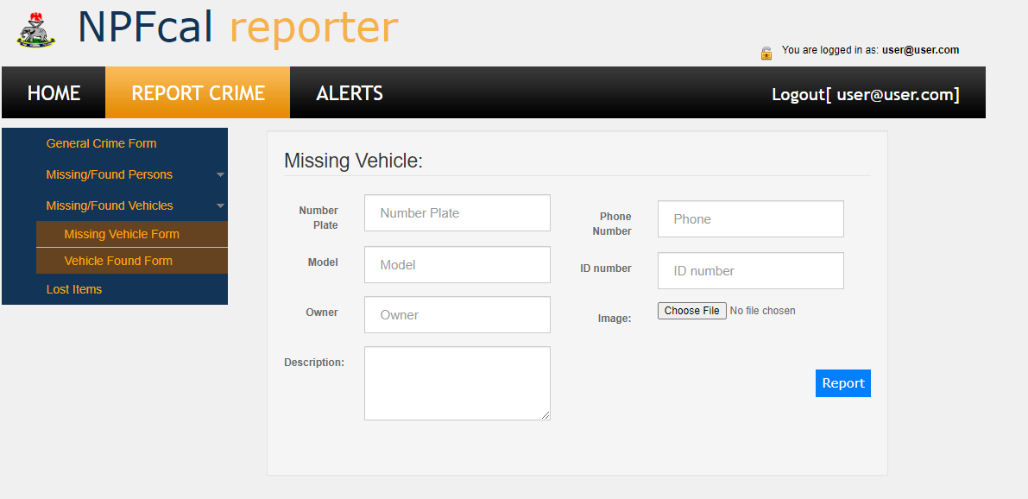

Fig 12: Missing Vehicle Form MISSING VEHICLE FORM
After a successful login the user can also use the Vehicle Report Form to make a report about a stolen vehicle adding the vehicle details, description and image.

CHAPTER FIVE
SUMMARY, CONCLUSION, AND RECOMMENDATION

5.1 SUMMARY
The "Design and Implementation of a Computerized Crime Reporting System" for the Nigeria Police in Ilorin represents a pivotal shift from manual, paper-based crime reporting to a modernized, technologically advanced solution. This project encapsulates the key findings and outcomes of the entire system, highlighting the transformation of law enforcement capabilities through the adoption of the computerized crime reporting system.
The system addresses critical issues in the existing manual process, offering advantages such as enhanced data accuracy, improved efficiency and timeliness, streamlined user experience, and resource optimization.
5.2 CONCLUSION
In conclusion, the computerized crime reporting system stands as a testament to the commitment to modernize law enforcement practices in Ilorin and Nigeria at large. The shift from manual to automated processes has mitigated challenges associated with data discrepancies, processing delays, errors, resource-intensive operations, and limited accessibility. The introduction of this system marks a significant step toward efficient crime reporting, management, and response. It addresses the shortcomings of the manual system and provides a robust platform for accurate, timely, and secure crime data handling.

5.3 RECOMMENDATION

We look forward to a time when names and identity of the offenders will be maintained on the application and some artificial intelligence techniques will be harnessed to predict the possibility of offenders committing the crime again or map hot spot locations and the frequency of committing a particular crime. These features will further make the application better and strengthen our security and justice system in Nigeria. Adopting our approach should bring us at par with best democracies and societies that have proper justice systems in the world.

REFERENCES
Adeolu, A. (2019). Analysis of Police Station and Crime spot in Ikeja, Lagos Nigeria. Researcher World.
Amankwah‐Amoah, J. (2019). Technological revolution, sustainability, and development in Africa: Overview, emerging issues, and challenges. Sustainable Development, 27(5), 910-922.
Barrow, F. J. (2019, May 2). Criminal Record Management System In the Perspective.
Corsaro, N., & Wilson, J. M. (2018). The effects of police contracting on crime: An examination of Compton, California. Journal of Experimental Criminology, 14, 59- 81.
Creately. (2021, July 16). UML Diagram Types Guide: Learn About All Types of UML Diagrams with Examples. Retrieved from Creately.

Ehigiator, B. O. (2023). Newspaper coverage of kidnapping in Nigeria.
Eisenstadt, S. N., & Schluchter, W. (2018). Introduction: Paths to early modernities
—A comparative view. In Public Spheres and Collective Identities (pp. 1-18). Routledge.
Government, F. (2021). Nigerian Communication Commission. Retrieved from [Nigerian Communication Commission]
Guy, E. L. (2022). Analysis of Law Enforcement's Use of Internet of Things for Digital Evidence Collection in Metropolitan Atlanta (Doctoral dissertation, University of the Cumberlands).
Jr., T. U. (2019, June 23). Development of an Online Crime Management & Reporting System.
Kaur, S. (2020). Revisiting Intention and Motive in Criminal Law. Issue 6 Int'l JL Mgmt. & Human., 3, 907.
Mroczkowska, A. (2021, January 20). Flutter Pros & Cons for Mobile App Owners. Retrieved from [The Droids Roids]

Sathish, A., Prathyusha, M., and Priyanka, M. (2018). Crime Detection and Criminal Identification Using IOT. Austin Journal of Robotics & Automation, November 10, 2018.
Schmaling, R. (2022). Crime. In R. J. Sampson (Ed.), SAGE Encyclopedia of Criminology and Criminal Justice (pp. 1-2). Thousand Oaks, CA: SAGE Publications.

V. I. Jennifer. (2019). Community Policing. ResearchGate Publication.
Z. R. Xinyi. (2019). Fake News: A Survey of Research, detection methods and opportunities.
Zuiderveen Borgesius, F. J. (2020). Strengthening legal protection against discrimination by algorithms and artificial intelligence. The International Journal of Human Rights, 24(10), 1572-1593.

