
DEPARTMENT OF SCIENCE LABORATORY TECHNOLOGY

EXTRACTION, PHYSIOCOCHEMICAL ANALYSIS AND ELUCIDATION OF THE CHEMICAL COMPOSITION OF LOCALLY PRODUCED COW GHEE

By

KEHINDE MARIAM OLUWATOSIN
HND/23/SLT/FT/0645

BEING A THESIS SUBMITTED TO
THE DEPARTMENT OF SCIENCE LABORATORY TECHNOLOGY (BIOCHEMISTRY UNIT),
INSTITUTE OF APPLIED SCIENCES, KWARA STATE POLYTECHNIC ILORIN, KWARA STATE.
IN PARTIAL FULFILLMENT OF THE REQUIREMENT FOR THE AWARD OF HIGHER NATIONAL DIPLOMA (HND) IN SCIENCE LABORATORY TECHNOLOGY, KWARA STATE POLYTECHNIC ILORIN,
KWARA STATE

SUPERVISED BY: MR. O. E. ADEYEMO
2022/2023 SESSION
CERTIFICATION
This is to certify that this project work presented by KEHINDE MARIAM OLUWATOSIN with Matriculation Number HND/23/SLT/FT/0645 has been read, approved and submitted to the Department of Science Laboratory Technology (Chemistry/Biochemistry Unit), Institute of Applied Sciences, Kwara State Polytechnic, Ilorin.

____________________ ________________
MR. O. E. ADEYEMO DATE
Supervisor

____________________ __________________
MRS. K. A. SALAUDEEN DATE
HEAD OF UNIT

____________________ __________________
DR. USMAN ABDULKAREEM DATE
HEAD OF DEPT

____________________ __________________
EXTERNAL EXAMINER DATE
DEDICATION
I dedicate this project to those who believed in me even when I doubted myself, your unwavering support, encouragement and inspiration made this work possible.

ACKNOWLEDGEMENT
All praise and thanks be to God Almighty for His countless blessings, wisdom, and strength that guided us throughout this project. Without His grace, this work would not have been possible.
A special thanks to my parent,Mr and Mrs KEHINDE for their moral, unwavering support, patience and motivation during this journey, their prayer and belief in me kept me going.
Our profound gratitude goes to our amiable supervisor Mr Adeyemo. O. Elijah,for his invaluable guidance, expert advice despite his tight official schedules. I pray Almighty continue to bless you.
We give our vast and weighty gratitude to our Head of department,my HOU and all the lecturers in the department of Science Laboratory Technology.
A special thanks to my family and friends for their support throughout the period of my program and we acknowledge the contributions of authors, researchers and online sources that helped us gather relevant information.
We are truly grateful to everyone who played a part, directly or indirectly, in the completion of this project. I appreciate you all. May God bless you all.

Contents
Title page
Certification
Dedication
Acknowledgements
Table of Content
Abstract
Table of Content
CHAPTER ONE
- Introduction
1.1 Problem Statement
1.2 Aim and Objective of the Study
1.3 Justification of the Study
1.4 Scope of the Study
1.5 Relevance of the Study
CHAPTER TWO
2.0 Literature Review
2.1 Gross Composition of Ghee
2.2 Chemical Nature of Ghee
2.3 Nutrient Composition of Ghee
2.3.1 Vitamins
2.3.2 Lipids
2.3.3 Sensory Aspects
2.4 Physico-Chemical Properties of Ghee
2.5 Biological Importance of Ghee
2.5.1 Wound Healing Properties
2.5.2 Cow ghee intake and its relation with Diabetes
2.5.3 Ghee helps in Digestion
2.5.4 Cardioprotective Activity
2.5.5 Anticancer Activity
2.5.6 Hepatoprotective Activity
2.5.7 Eye Lubricant Activity
2.5.8 Antistress activity
2.6 Utilization of Ghee
2.7 Oxidation of Ghee oil and its prevention
2.7.1 Oxidation imperfections in Ghee
2.7.2 Prevention of Oxidative process in Ghee
CHAPTER THIREE
3.0 Experimental
3.1 Apparatus and Reagents
3.1.1 Apparatus and Equipment
3.1.2 Recagents
3.2 Collection and Preparation
3.3 Preparation of Reagent
3.3.1 Preparation of Ether: Ethanol Mixture
3.3.2 Preparation of Glacia of Acetic Acid Chloroform (3:2)
3.3.3 Preparation of 5% potassium lodide
3.3,4 Preparation of saturated potassium iodide
3.3.5 Preparation of n-hexane acetone mixture (1:1)
3.4 Dctermination of physical properties GAPFAttER
3.4.1 Delermination of odor
3.4.2 Determination of color
3.4.3 Determination of sample density
3.4,4 Determination of specific gravity
35Determination gf Chemical properties
3.5.1 Determination of Acid value
3.5.2 Determination of peroxide value
3.5.3 Determination of Iodine value
3.5.4 Determination of saponification value
3.5.5 Determination of Ester value
3.5.6 Determination of B-carotene and lycopene in sample
CHAPTER FOUR
4.0 Results and Discussion
4.1 Results
4.1.1 Physical Parameters result
4.1.2 Chemical Parameters Result
4.2 Discussion
4.3 Conclusion
References as footnotes
Appendix

Abstract
A sample of locally produced cow ghee sold in a Nigerian market was analysed for its physicochemical and biochemical constituents to assess the product’s quality. This dairy product is the least popular in most other part of the country except in the northern part. The results of the physicochemical analysis showed that the locally produced cow ghee, a semi-solid, had a characteristic smell of cheese, pale-yellow or cream colored, density of 0.911g/ml, and a specific gravity 0.984 of the molten form at ambient temperature. Other properties analysed for included; acid value (36.13g of oil/mg KOH), peroxide value (11.5 meq I₂/Kg oil), saponification value (195.6937 mg KOH/g ghee), iodine value (38.704 g I₂/100/g ghee), ester value (159.5637cm³M/g ghee), and free fatty acid (FFA) content (18.07 wt% oleic acid). The two biochemical parameters analysed for were β-carotene and lycopene. The result indicated that the β-carotene content was 6.28mg/ml of the molten sample while lycopene was not detected in the cow ghee sample. Some of these results showed agreement with literature values for cow ghee while others showed discrepancies. The ghee oil methyl ester (GOME) analysed by GC-MS revealed over hundred substances in the sample, mostly fatty acids and other carboxylic acids.
Keywords: Cow ghee, physicochemical properties, β-carotene, lycopene

CHAPTER ONE
1.0 INTRODUCTION
Ghee is one of the major dairy products that has played an important role in the diet of the people of the Indian subcontinent due to its good flavor, and its aroma¹. The ghee is evolved from Sanskrit word ghruta, it is known by its various names in various languages however its common Indian name is represented as clarified butter fat. Ghee is one of the good sources of energy, lipid nutrients including fat soluble vitamins and essential fatty acid and contains butyric acid, conjugated linoleic acid and phospholipids etc, it has been recognized to possess several therapeutic properties. It increases the digestive fire and improves absorption and assimilation develops memory and strengthen the brain and nervous system¹.
Ghee is a purified form of fat derived solely from milk or curd and chemically defined as complex lipids of triacylglycerol consists of
1. Sundaresan Bhavaniramya et al. “A review on understanding the subterranean insights in nature of South Indian ghee with its biological and physiochemical properties”. International Journal of Food Science and Nutrition. 2018, 3, 6; 257-262
small number of sterols, hydrocarbons, carbonyl compounds, fat soluble vitamins (A,D,E and K), carotenoids pigments, moisture and trace elements like copper and iron²
Ghee is one of important cooking medium, because the taste it adds to food is absolutely pleasant and also promotes good health³. Ghee is nutritionally more reliable to other oils/fats due to the fact of its medium chain fatty acids content which are absorbed directly by the liver and burned to supply energy³.
It is fairly shelf stable due to low moisture and nature antioxidants contents⁴. Lactose or casein intolerant have no difficulty with ghee because of removal of milk solids and impurities most human⁵.

2. D. B. Kapadiya, and K. D. Aparnathi. Comparison of physicochemical, nutritional and sensory aspects of ghee obtained from different species. International journal of trend in scientific research and development (IJTSRD). 2016, 1,1231-1236
3. Anil Kumar. “Ghee : Its Properties, Importance and Health Benefits”. Lipid Universe. 2018, 6, 6-14
4. J. C. T. Van den Berg. Dairy technology in the tropics. Pudoc, Wageningen, Netherlands. Marcel Dekker Inc., New York; 1988. p. 360–90.
5. K. T. Achaya, “Ghee. Vanaspati and special fats in India”. In: Gunstone FD, Padley FB, editors. Lipid Technologies and Applications. New York: Marcel Dekker Inc; 1997. p. 369–390.
1.1 PROBLEM STATEMENT
Research shows that Ghee is rich in saturated fats, which may contribute to high cholesterol levels and an increased risk of heart disease if consumed in excess Ghee has low moisture content, exposure to fluctuating temperature can causes the fats in ghee to oxidize, leading to rancidity and an unpleasant odor.
Improper temperature control in storage can encourage microbial contamination. Storing ghee at high temperatures for extended periods can degrade its quality, flavor and shelf life. Exposure to high temperature can destroy fat soluble vitamins (A,D,E and K) reducing its nutritional benefits if stored in warm conditions, plastic containers may release harmful chemicals into the ghee.
Ghee is highly flammable at extreme temperature and an catch fire if overheated, especially when left unattended on an stove.
Improper storage conditions can cause ghee to turn rancid quickly, leading to financial losses. Excessive consumption of ghee can contribute to weight gain due to is high calorie content.
Ghee contains antioxidants that help neutralize free radicals but excessive heat destroy these beneficial compounds which makes it loss the antioxidants and high heat temperature oxidize fat and generate acrolein, toxic compound linked to respiratory issues and irritation.
The limited research on the chemical composition and medicinal properties of Coleus amboinicus hinders a comprehensive understanding of its potential health benefits and applications in traditional medicine.
The absence of Comprehensive research on the phytochemical composition and potential Pharmacological properties Coleus amboinicus hinders its exploration for therapeutic applications in modern medicine.
1.2 AIM AND OBJECTIVE OF THE STUDY
The aim of this research is to study the physicochemical properties and some of the biochemical constituents of Cow ghee. And also to analyze the composition of the ghee oil, especially the fatty acid components and the possible health outcomes of ghee.
The specific objectives are:
(i) To obtain a freshly produced ghee from a local dealer or market
(ii) To determine the physical properties such as color, odor, density and specific gravity,
(iii)To determine the chemical properties such as free fatty acid (FFA) content of Cow ghee, acid value, peroxide value, ester value, iodine value, and saponification value of the Cow ghee.
(iv) To determine two biochemical constituents namely; lycopene and β-carotene in the ghee sample.
(v) To analyze the sample for fatty acid composition and other components in the ghee oil using GC-MS.

1.3 JUSTIFICATION OF THE STUDY
The study of ghee is justified based on its nutritional, health, economic and environmental significance. Understanding its properties benefits and potential drawback can help consumers, producers and policymakers make informed decisions. This study is essential for understanding ghee’s nutritional value, ensuring quality control, supporting sustainable production, and guiding consumers towards healthy consumption habits.
1.4 SCOPE OF THE STUDY
The scope of this project research work extents from the collection of the sample, extraction of the oil, purification and analysis of the oil.
The research intends to provide a comprehensive understanding of ghee from multiple perspective, benefiting consumers, produces from a nutritional and health perspective, it focus on analyzing the composition of ghee including its fat contents, essential vitamins (A,D,E and K) and antioxidant properties.

1.5 RELEVANCE OF THE STUDY
The relevance of studying ghee lives in its impact on health, nutrition industry, economy and the environment. Ghee has been a staple in various cultures for centuries valued for its rich flavor, medicinal properties and high nutritional content. Understanding the consequences of excessive consumption such as its role in obesity, cholesterol levels and cardiovascular diseases is crucial for promoting balanced dietary intake.
The study highlights how heating and storage conditions effect the nutritional integrity of ghee, ensuring consumers use it safety and effectively. The rise of organic and artisanal ghee also creates new opportunities in the market, making this study relevant for business growth and economic development.

CHAPTER TWO
2.0 LITERATURES REVIEW
Ghee is recognized as an important food product in India-diet due to its high nutritive values, pleasant aroma, taste and unique texture India products 900,000 tones of marketed ghee with a value of 85000 million, in tropical country like India spoilage of ghee is mainly due to oxidative rancidity¹. Ghee is manufactured by different method namely, desi method, direct creamery method, creamery butter method, pre-stratification method and continuous method. Fact methods pertains to quality and flavor imparting strategy in ghee¹. Ghee is produced mainly by indigenous methods in Asia, the middle-east and Africa and the methods of manufacture and characteristics vary. Some ambiguity in the definition of ghee occurs mainly due to regional differences and preferences for the product, commonly used for culinary purpose but also for particular social functions and therapeutic purposes⁶.
6. Mohammed L. Serunjogi, Roger K. Abrahamsen, and Judith Narvhus. “ A review paper: current knowledge of ghee and related products”. Int. Dairy Journal. 1998, 8, 677-688.

Ghee is a type of clarified butter fat that has been produced and utilized in India from antiquity. It is used in Ayuveda as a therapeutic agent and also for religious rituals. It is popular in India because of its nutritional attribute and characteristics flavor and aroma and is considered as sacred food it is made from milk, cream, or butter of several animal species. Ghee processing may be activated by drawing fat form milk, cream or butter using direct heat with or without fermetation³. Ghee is identified as valuable natural sources of food which has several health benefits entirely beneficial to the human population it is one of the popular ingredient in the India and takes prevalent position in the dairy industry market. Consumption of ghee in an adequate amount, impart various health benefits such as binds toxins, enhance complexion and glow of the face and body an amazing rejuvenator for the eyes, increases physical and intellectual stamina etc. in addition to imparting sustaining energy⁷.

7. S. Sindhuja, et al, “Health benefits of ghee (clarified butter) - A review from ayurvedic perspective”. IP Journal of Nutrition, Metabolism and Health Science 2020, 3(3), 64–72
2.1 GROSS COMPOSITION OF GHEE
Bulk of ghee is mainly made up of triglyceride (∞ 98%), derived whether from cow or buffalo milk. The other classes of lipids which are present in minor quantities in ghee are diglyceride, (1.2%), monoglycerides (0.1- 0.2%), free fatty acids (1-10 mg/100g), phospholipids (0 to 80 mg/100), sterols (mainly cholesterol), fat soluble vitamins carbonyl 4.6 ug/g, glyceryl ethers (0.8µm/g) and alcohols (1.8-2.3µm/g)³.
Table 1.1: Gross composition of ghee
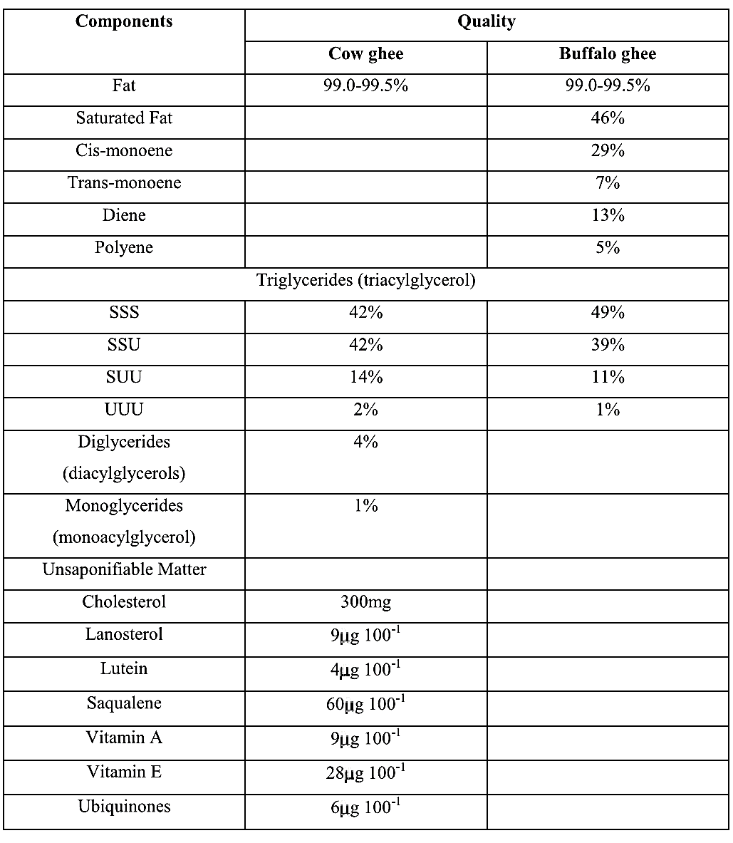
2.2 CHEMICAL NATURE OF GHEE
The chemical composition of ghee varies on the preparation method. The chemical composition of cow and buffalo ghee varies slightly. The fatty acid composition is represents in the table 1.1 above¹.
2.3 NUTRIENT COMPOSITION OF GHEE
Ramesh carried out to analyze the chemical and nutritive value of the ghee residues and the entire analysis revealed the moisture, crude protein, crude fiber, ether cataract, nitrogen free extract and total ash contents of ghee residue have been 12.10, 19.86, 3.49. 47.12, 85.63 and 3.90 percent, respectively fatty acid profile of ghee residue revealed that the palmitic acid registered the highest (38.88) among saturated fatty acid and the oleic acid accounted for the highest proportion (25.15) among unsaturated fatty acids. Linoleic, linolenic, eicosapen to enoic and decosahexaenoic acid content of ghee resident were 2.02, 0.79, 0.36 and 0.25 percent respectively. Amine acid profile of ghee residue revealed that the lysine and methionine, content where 0.99 and 0.61 percent, respectively. Thrponine and argine levels are observed to be at 1.44 and 0.76 precent, respectively. The glutamic acid recorded the absolute best proportion (5.26), while cystine registered the lowest share (0.35) among amino acids in ghee residue. He concluded that ghee residue is a weathy source of fats, protein, unsaturated fatty acids and amino acid⁸.
2.3.1 Vitamins
Ghee is an importance source off at soluble vitamins like vitamin A,D,F and K^{9,10}. In that vitamin A and F which are antioxidant. Vitamin A is

8. P. Ramesh,et al. “Nutrient composition of ghee residue”. J Pharm Phytochemistry. 2018, 7(5), 3316–9.
9. K. S. Rangappa, and K. T. Achaya. “Indian Dairy Products”. Mysore City, India: Asia Publishing House; 1974.
10. R. Chand, et al. “Inflfluence of lactic acid bacteria on oxidative stability of ghee”. Milchwissenschaft. 1986, 41, 335–6.
known to be present in two forms; one is an ester and carotene which is concerted in to vitamin A in the body Vitamin A keeps epithelial tissue at the studies shows that vitamin E is essential for normal pregnancy, birth and breast milk production. Vitamin D is known to play an important role both in lying down of calcium and phosphorous¹¹.
Nahveed Ahmad utilized the fluorescence spectroscopy for the characterization of buffalo and cow ghee along with the detection of their adulteration spectroscope analysis confirmed the presence of vitamin A, B₁₂, D, E, K and CLA in buffalo and cow ghee. The emission bands at 380 and 390nm represent spectral signatures of vitamins B12, D, and K at 525nm characteristics beta-carotene, and at 440 and 490nm depict (IA and Vitamin A. the spectral signatures of vitamins reveal that cow ghee contains relatively higher concentration of vitamin B12, D and K as compared to buffalo ghee similarly, buffalo ghee has relatively higher concentration of CLA and vitamin A. The consequently, the presence and absence of beta-carotene, CLA

11. N. Ahmad, M. Saleem. “Characterisation of cow and buffalo ghee using fluorescence spectroscopy”. Int J Dairy Technol. 2020, 73(1), 191–201.
and vitamin A can be used biomarker to differentiate buffalo and cow ghee. Spectroscopic analysis and PCA model have successfully demonstrated the detenction of adulteration of 6 blind samples¹².
2.3.2 Lipids
Lipids are considered as the total lower chain fatty acids C4 to C12 (5.3%) with total saturated fatty acids 10.1% and more of unsaturated fatty acid (66.8%) in comparisa to those of ghee. Basically, fatty acid are made up of phospholipids, shows that is has no fatty acids are made up of phospholipids show that it has no fatty acids lower than 12 carbon atoms. The higher number of phospholipids present in ghee decreases the heating period rehulred to the transfer of phospholipids from ghee residues to ghee. While heating cream/butter, only a small fraction at the phospholipase get transferred to ghee, most of the phospholipids remain with the residue because of their polar character. The difference observed in the physic chemical constant, fatty acid and PUTA contents between lipids of ghee residue and ghee are due to the high phospholipid content of ghee residue¹.
12. Ahmad N, Saleem M. Characterisation of cow and buffalo ghee using fluorescence spectroscopy. Int J Dairy Technol. 2020, 73(1), 191–201.
2.3.3 Sensory Aspects
In India ghee is greatly assed by its characteristic flavor the flavor of the ghee is highly dependent on the method of preparation. The high score of flavors of ghee prepared from camel, cow and buffalo milk was 33.73, 44.78 and 41.97 (out of 50) respectively compared to this goat milk does not have flavor hence it is not suitable for manufacture of ghee¹³. However, the pleasant flavor only present in cow and buffalo milk, it shows unpleasant flavor and salty in camels milk¹³⁻¹⁶ next to flavor color plays key roles, in quality of ghee the colour of cow ghee varies from deep yellow to straw tallow while that of buffalo¹⁷. The physical nature of camel ghee consists of a mixture of higher

13. Parmar N. Characterization of ghee prepared from camel milk and evaluation of its shelf life during storage. M. Tech thesis, Department of Dairy chemistry, Anand Agricultural University, Anand, 2013.
14. Mal G, Pathak KML. Camel milk and milk products. SMVS’ Dairy year book. National Research Centre on Camel, Bikaner, Rajasthan, India, 2010, 97-103.
15. Hamid AD. The Indigenous Fermented Foods of the Sudan: A Study in African Food and Nutrition. CAB International, Wallinford, UK, 1993.
16. Park YW, Haenlein GFW. Handbook of Milk of Non-Bovine Mammals. Blackwell Publishing Ltd, Iowa, USA, 2006.
17. Bharwade M, Balakrishnan S, Chaudhary N, Jain AK. Fatty Acid Profile and Physico-Chemical Characteristics of Milk Lipids of Kankrej Cow. Int. J Curr. Microbiol. App. Sci. 2017; 6(8):3035-3047.
softening point fats in crystalline from dispersed in the liquid lower softening points fats and his give the ghee a somewhat granular appearance the texture or granularity of the ghee is also quality parameter which are identified by the presence of uniform size grains with very liquid fat is desirable characteristic of food quality¹.
2.4 PHYSICO-CHEMICAL PROPERTIES OF GHEE
Milk fat is one of the complex forms of lipids existing in nature. Ghee is processed milk fat and basically known as clarified butter fat or anhydrous milk fat. It is mainly composed of glyceride (usually mixed) and of minor constituent found, are free fatty acids, phospholipids, sterols, sterolester, fat soluble vitamins, carbonyls, hydrocarbons, carotenoids (only in milk fat derived from cow). It also contains small amount of charred casein and traces of calcium, phosphorus, iron and so ion. The moisture contents in ghee is vary negligible (0.3%) and the major part composed of glycerides (98% of the total matter) of the remaining constituents about 2% sterol (mostly cholesterol) occurs to the extent of 0.5%. ghee may also contain good amount of conjugated linoleic acids, a reported anticancer agent (20). It also has possible antioxidative properties, responsible for its stability by preventing oxidation. Therefore, it is more convenient product than butter and cream in the tropics regions, because it remains stable under warm condition. Basically, the low moisture and milk. Solid nonfat content in ghee are responsible for the restricted bacterial growth in it¹⁸. The other fact in ghee may be because of its phospholipids content (Ca. 400 mg/kg), low acidity and the presence of natural antioxidant, which are also believed to contribute to the extension of Hg shelf life⁶.
2.5 BIOLOGICAL IMPORTANCE OF GHEE
Ghee has been process to have varies biological importance through varies studies which some of it is wound healing, eye lubricant, antistress, anticancer, candioprolective, hepatoprotectice, helps in digestion etc.
2.5.1 Wound Healing Properties
Hema Sharma have studied the impact of selected formulated five variants of topical application forms materials (Flax, seed oil, cow ghee,
18. F. O'Mahony. “Rural dairy technolog: Experiences in Ethiopia; International Livestock Centre for Africa, Addis Ababa, Ethiopia. ILCA Manual No. 4, Dairy Technology Unit:1989, 3- 8.
amalakifriat extract, shoreanobusta resin and tashadabhasma) on functional status of skin and tissues regeneration capacity in wound healing models by measuring collagen estimation, wound contraction and breaking strength of the skin which had been chosen primary based on the leads from Ayuvadic literature and concluded that can be beneficial in wound contraction enhancement of tensile strength and augumentation in hydroxyproline content or collagen content. These properties together make this combination for anti-aging activities which is particularity good for skin health¹⁹.
A study on wound healing activity Aegle marmelos leaves and cow ghee confirmed recovery in buffalo. The effects produced by using cow ghee and topical application of a combination of Aegle marmelos leaves extracts in wound and tissue regeneration at the wound site have been studied and the wound healing activity was found substantial and was healed completely in 8 days²⁰

19. Datta HS, Mitra SK, Patwardhan B. Wound Healing Activity of Topical Application Forms Based on Ayurveda. Hindawi Publishing Corporation Evidence-Based Complementary and Alternative Medicine; 2011.
20. Gupta A, Gupta SK. Wound healing activity of topical application of A. marmelos and cow ghee. Int J Drug Discov Herbal Res. 2014;4(2/3):741–5.
Nandanwar et al, consider the cow ghee containing formulation of Aleo vera for wound healing potential, showed that desirable keratinization, epithelization, tibrosis and collagenation indicative of good healing process in histogical examination²¹.
2.5.2 Cow Ghee Intake and Its relation with Diabetes
The function of cow ghee in prevention and treatment of diabetes as a dilatory complement was reviewed by Kumar Rav. In that overview it suggest that specific components of cow ghee are inversely associated with diabetes and its use in application quality may be beneficial in preventing and treatment diabetes and its associated complication potential defensive constituents in cow ghee includes carotenoids, vitamin A, D, E (antioxidants), mg and ca, all these substance have shown antidiabetic activity²². Animal studies have varied many helpful results of ghee, inclusive of dose-dependent decrease in serum total cholesterol, low density lipoprotein, very low, and triglycerides,

21. R. Nandanwar, et al. “Studies on wound healing activity of gel formulation containing cow ghee and Aloe ver”a. Int J Pharm Sci Res. 2010;1(3):50–4.
22. Ravi K. Critical review of cow ghee intake and its relation with prameha or diabetes. World J Pharm. 2018;7:459–66.
decrease liver total cholesterol triglycerides and cholesterol esters, and a lower level on non-enzymative included lipid per oxidation in liver homogenaxe²³.
Cow ghee is a very good source of conjugated linoleic acid (CLA). CLA has antidiabetic effects in animal research due to complex regulation of the gene vital transduction in skeletal muscles²⁴.
2.5.3 Ghee helps in Digestion
Cow ghee is recognized to be digested 96% compared to all distinctive vegetable or animal source fats. Dispersion of fat glybules in the aauous phase of milk forming an emulsion in the reason behind the excellent digestibility of milk fat. Due to digestibility the milk fat act as a valuable dietary constituent for the treatment of many diseases²⁵⁻²⁷.
23. Dwivedi C, Crosser AE, Mistry VV, Sharma HM. Effects of dietary ghee (clarified butter) on serum lipids in rats). J Appl Nutr. 2002, 52, 65–8.
24. J. W. Ryder et al. Isomer-Specific Antidiabetic properties of Conjugated Linoleic Acid Improved Glucose Tolerance, Skeletal Muscle Insulin Action, and UCP-2 Gene Expression). Diabetes. 2001;50:1149–57
25. Haug A, Høstmark AT, Harstad OM. Bovine milk in human nutrition – a review. Lipids Health Dis. 2007, 6, 25–40.
26. Kumar A, Upadhyay N, Padghan PV, Gandhi K, Lal D, Sharma V. Detection of vegetable oil and animal depot fat adulteration in anhydrous milk fat (ghee) using fatty acid composition. MOJ Food Processing Technol. 2015, 1(3), 13.
27. Kansal VK. Milk fat and human health. Indian Dairyman. 1994, 46, 345–50.
Kumar et al., determined unlike other oils ghee contains butyric acid, a short chain fatty acid which gives distinct flavour and help in digestion²⁸.
2.5.4 Cardio-protective Activity
Harl Sharma et al, investigated the impact of 10% dietary ghee on microsomal lipid peroxldation, as well as serum lipid levels in Fischer inbred rats to investigate the impact of ghee on free radical mediated technetates that are implicated in many chronic illnesses such as cardiovascular disease. Result confirmed that 10% dietary ghee fed of serum total cholesterol, but triglyceride levels increase in Fischer inbred rats²⁹.
Research on Maharishl Amrit Kalash-4 (MAK-U), an Ayurvedic herbal mixture containing ghee ingested MAK-4 for hyperlipidemic patients up to 18 weeks confirmed on impacting on level of serum cholesterol high density

28. G. D. Miller, J. K. Jarvie, L. D. McBean. “Handbook of Dairy Foods and Nutrition”. Boca Raton, Florida: CRC Press, Inc; 1995.
29. H. Sharma, X. Zhang, and C. Dwivedi. “The effect of ghee (clarified butter) on serum lipid levels and microsomal lipid peroxidation”. Ayujournal. 2020;.
lipoprotein, LDL, or tryglycerides. Research finding, support commended effect of ghee outlined in the historic Ayurvedic texts and the therapeutic use of ghee for hundred of years in the ayurvedic system, of medicine³⁰⁻³¹.
2.5.5 Anticancer Activity
Rita rani and Vinod investigated the impact of feeding mixture of cow and soyabean oil, 7,12- dimethylbenz as anthracene (DxnBA) induced carcinogenesis and expression of cox-2, and peroxisome proliferatons activated receptors – γ (PPARY) in rat mammary gland to check anticancer potential of cow ghee. In the DMBA ( a carcinogen) treated groups, the animals fed on soyabean oil exhibited higher tumor incidence (65.4%) tumor weight (96.18g) and tumor volume (6285 mmg) than the rat entirely fed an cow ghee was used as feed as compared to feeding with soyabean oil, which exhibited a latency period of 23 weeks. They concluded that diatery cow ghee

30. Sundaram V, Hanna AN, Lubow GP, Koneru L, Falko JM, Sharma HM, et al. Inhibition of low-density lipoprotein oxidation by oral herbal mixtures Maharishi Amrit Kalash-4 and Maharishi Amrit Kalash-5 in hyperlipidemic patients. Am J Med Sci. 1997, 14, 303–10.
31. Hanna AN, Sundaram V, Falko JM, Stephens RE, Sharma HM. Effect of herbal mixtures MAK-4 and MAK-5 on susceptibility of human LDL to oxidation. Complement Med Int. 1996, 3, 28–36.
opposed to soyabean oil attenvates mammary carcinogenesis induced by DMBAP; and the impact is mediated by decrease expression of cyclooxygenase-2 and improved expression of cyclooxygenase-2 and increased expression of PPAR-γ in the former group³².
2.5.6 Hepato-protective Activity
Achliya et al., investigate the hepaprotective activity of panchangavya Ghrita in albion rats to wounds CCL4 brought about hepatoxicity with the help of serum marken enzymes the degree of protection was measured panchagavyaghrita @ 150-300 mg/kg/dpo recommended prenvention of CCL4 induced elevation levels of serum glutamate pyruvate transaminase, serum glutamate oxalogcetate transsanuse, acid phosphates, and alkaline phosphates. The outcome had been compared with standard drug silymarin. A histological study compared and verified the hepatoprotectetive activity of panchagavya Ghrita of liver from different group³³.

32. Rita R, Vinod K. Effects of cow ghee (clarified butter oil) & soybean oil on carcinogen-metabolizing enzymes in rats. Indian J Med Res. 2012;136:460–5.
33. Achliya GS, Kotagale NR, Wadodkar SG, Dorle AK. Hepatoprotective Activity of Panchgavya Ghrita against Carbontetrachloride Induced Hepatotoxicity in Rats. Indian J Pharmacol. 2003;35:308–11.
2.5.7 Eye lubricant Activity
Cow ghee is very useful for computer vision syndrome (CUS). The Goghrita contain 98% glucerides and some fatty acids which has lubrication property beneficial for reduction of the symptoms of CVS. It contain vitamin A 3500/100gm. Vitamin A is accountable for the moistening of the outer lining of the eyeball and can prevent blindness. It also contains beta-carotene and vitamin E which has antioxidant activity. So Goghrita eye drops (aschgotan) may become effective treatment for computer vision syndrome³⁴.
2.5.8 Antistress Activity
Antistress activity was evaluated with panchagauga ghrita, along with ethanolic extract of Aleo babadens using tail suspension model in mice Alprazolam as standard. The combination found significant antistress potential as compared with control and standard which was revealed by GC-MS studies. The combined action of panchagavya ghrita and aleo extract was trait to the increase in the levels of gamma amino butyric acid and decrease plasma cortisconsterone level and dopamine ³⁵.
34.S antosh S, Dilip PM, Bhusari. Conceptual study of Goghrita Eye drops (Aschyotana) in Computer Vision Syndrome. Asian J Multidiscip Stud. 2013;1:2321–8819.
35. A. Kumaret al . Antistress activity of different compositions of Panchgavya and Aloe barbadensis Mill by using tail suspension method. Int J Innovations Biol Chem Sci. 2013;7:17–9.
2.6 UTILIZATION OF GHEE
A major portion of ghee is utilized for culinary purpose, e.g. as a dressing for varies foods and for cooking and frying of different foods. In India, ghee is considerd as a sacred article and used also in religious rites³⁶. Uses of varies products related to ghee have been documented from different part of the word. Mestitho, a traditionally Assyrian product, is added to dishes mainly as a garnish³⁷. In Sudan, Samin is mainly used as a topping for Mullah, a type of sauce normally made from a variety of ingredient among the nomads who produce it Samin is also drunk on its own, usually in small quantities, such as coffee cupful every morning other uses of Samin include feeding children in a pure form or mixed with food, as a relish and as a topping for coffee or tea, or for therapeutic purpose. A mixture of honey and Samin is believed to be used nutritional and an effective aphprodiciac³⁸. In uganda, Samuli ghee is basically used for cooking and frying various foods. It is

36. G. S. Rajorhia. Ghee. Im Encyclopaedia of Food Science, Food Technology and Nutrition. 1993, Vol. 4. Eds R. Nactae, R. K. Robinson and M. J. Sadler. Academic Press Ltd. London. Pp. 2186-2192.
37. M. Abdalla. “Milk in the rural culture of contemporary Assyrians in the Middle-East. In Milk and Milk Products from Medieval to Modern Times, ed. P. Lysaght. Canongate Press, Edinburgh. Pp, 27-39.
38. A. D. Hamid. The indigenous fermented foods of the Sudan: A study in African Food and Nutrition. CAB International, Wallinford, U. K. 1993.

especially liked for its convenience since it can be added to hot food and served without further cooking⁶.
A Considerable amount of ghee is consumed in many part of the word. In India an annual production amounts to 800,000t, the buk of which is produced by the indigenous method (40). It has been estimated that an average Assyrian family eats about 60kg of ghee (meshho) every year. The consumption figures for most other regions of the world, where ghee and related indigeneous products are popular, are not readily available⁶.
2.7 OXIDATION OF GHEE OIL AND ITS PREVENTION
The chemical composition of ghee revealed that lipid is the major constituents and this oxidation process play a role in availability of ghee. The oxidation of fat differs from that of bulk lipids because it highly interacts between ingredients and the partitioning of ingredients between the oil, equeous and the interfacial region due to the presence of hydrophobic and hydrophilic groups.
During this process, free radicals are produced which are unstable and readily react with oxygen, moisture or fat during processing or storage. Fat oxidation mainly depends on the several steps such as selection, storage, refining and manufacture. Fatty acids a basically long aliphatic chain consist of carbon and hydrogen. In food products fatty acid are found in lipid complexes such as triglycerides. Among them some fatty acids are saturated while others have different types of unsaturated fatty acids. Polyunsaturated fatty acids mainly involved in oxidation due to the presence of two or more number of double bonds, risk of oxidation increase with the number of double present in the fatty acids¹.
2.7.1 Main Imperfections in Ghee to Oxidation
Rancidity is the most serious defects of ghee. There are two types of rancidity namely hydrolytic and oxidative rancidity. Basically, it develops in ghee during storage and due to overheating in the freshly prepared ghee, mainly it caused by the formulation of violate compounds which exhibit. Unpleasant odors and adversely affect the nutritive value of ghee. Hydrolytic rancidity is mostly occurring in butter oil fat splitting enzyme, lipoprotein lipase is responsible for hydrolysis of milk fat and responsible to produce lower molecular weight fatty acids such as butyric caproic and caprylic acids responsible for unpleasant odor in ghee. However, hydrolytic rancidity is not of much problem in ghee because during manufacturing of ghee it is subjected to high heat treatment which in activities the lipase enzyme⁴⁰.
2.7.2 Preventive Methods
Autoxidation is one of the most common defects may produce adverse effect in serum lipid profile and toxic biochemical reaction at subcellular and vascular endothelia levels. Hence there is need an alternative strategy for reduce the4 toxic effect of thermally oxidized dietary lipids⁴¹. Several workers have studied to improve the stability of ghee against autoxidation⁴² or altering the processing parameters⁴³ and using proper packaging material and storage condition⁴⁴.
40. H. C. Deeth, C. H. Fitz-Gerald. “Lipolytic enzymes and hydrolytic rancidity in milk and milk products. In Developments in dairy chemistry-2. Springer Netherlands, 1983, 195-239.
41. Alam Zeb, and Islam Uddin. “The Coadministration of Unoxidized and Oxidized Desi -Ghee Ameliorates the Toxic Effects of Thermally Oxidized Ghee in Rabbits”. Journal of Nutrition and Metabolism. 2017. 1-7.
42. R. N. Tandon. “Effect of feeding cotton seed to milch animals on the opacity pattern of ghee and changes in its physicochemical constants on storage. Indian Journal of Dairy Science. 1977, 30:341.
43. S. Singh, B. P. Ram, S. K. Mittal. “Effect of phospholipids and methods of manufacture on flavor and keeping quality of ghee”. Indian Journal of Dairy Science. 1979, 32:161.
44. Amit Kumar, et al. “Study on physico-chemical analysis of ghee. South Asian J. Food Technol. Environ. 2016; 2:448-451.
Addition of synthetic antioxidants also significantly reduces the oxidation in ghee by incorporation natural antioxidants from edible in plant material, species and condition aromatic herbs inn India BHA is legally approved as an antioxidant to improve the quality of ghee. Natural antioxidant have significant effects to prevent rancidity in ghee, but no commercial trial has been tried till date to evaluate the natural antioxidant in ghee¹. Nilakkanth (2012)⁴⁵ reported that the addition of fehtonolic extract of Shatavari (0.5%) in ghee significantly reduce the formation of peroxides free fatty acids, conjugated dines and thiobarbituric acid value as compare to control sample of ghee during accelerated storage of 80±1℃. The study concludes that the main antioxidative compounds gave the maximum stabilizing effect to ghee against oxidative deterioration⁴⁶. The active component of turmeric volatile and curcumin showed moderate pro-oxidant activity and exhibited slight pro-oxigenic activity. Studie shows that the addition of curcumin powder at 0.4%

45. Nilkanth P, Gandhi K, Purohit A, Arora S, Singh RRB. Effect of added herb extracts on oxidative stability of ghee (butter oil) during accelerated oxidation condition. Journal of Food Science and Technology. 2012; 65(2):293-299.
gave ghee higher favor value and lower peroxide value as compare to control sample during accelerate storage and reported that addition of curcumin had not create any color detect in ghee¹.

46. Dinesh P, Boghra VR, Sharma RS. Effect of antioxidant principles isolated from Mango (Mangiferaindica L.) seed kernels on oxidative stability of ghee (Butter fat). Journal of Food Science and Technology. 2000; 37:6.
CHAPTER THREE
3.0 EXPERIMENTAL
3.1 APPARATUS AND REAGENT
3.1.1 Apparatus and Equipment
Measuring cylinders, Round-bottom flasks, electronic digital weighing-balance, conical flasks, Dropping pipette, Erlenmeyer flask, funnel, filter paper, Retort stand and clamp, test-tube rack, burrette, Hand dryer, ultraviolet/visible (UV/Vis) spectrophotometer, thermometer, magnetic stirrer, heating mantle.
3.1.2 Reagents
Distilled water, Ether: Ethanol, potassium hydroxide, potassium iodide, acetic acid chloroform, saturated potassium iodide, n-hexane Acetone, hydrochloric acid, phenolphthalein.

3.2 COLLECTION OF SAMPLE
The Ghee fat sample was purchased from a group of local producers/sellers at the Emirs palace in Samaru area of Kaduna State, Nigeria.
3.3. PREPARATION OF REAGENTS
3.3.1 Preparation of Ether: Ethanol Mixture
1L solution of diethyl ether: ethanol (1:1) was prepared by measuring 500mL of diethyl ether and 500mL of ethanol into a 1L beaker. The mixture was carefully stirred and transferred into a 2.5L amber bottle and kept. This mixture was used to determine the acid value (A.V) of the sample.
3.3.2 Preparation of Glacia Acid Chloroform (3:2)
Glacia acetic acid chloroform (3:2) was prepared by measuring 900ml of acetic acid and 600ml of chloroform into a beaker. The mixture was carefully stirred and transferred into an amber bottle and kept away from direct sun. This mixture is used to determine peroxide value.

3.3.3 Preparation of 5% Potassium Iodide
5% (w/v) Potassium Iodide solution was prepared by weighing 5g of potassium iodide into a clean beaker containing small amount of distilled water to dissolve it, the solution was carefully and quantitatively transferred into a 100mL standard flask and topped off with more distilled water. The solution was poured into a clean amber reagent bottle and was labeled. The solution used in determination of Iodine value.
3.3.4 Preparation of Saturated Potassium Iodide
Saturated crystal Potassium Iodide was prepared by weighing about 145g of potassium iodide into a clean beaker and 100ml of distilled water was added and stirred vigorously this give a saturated potassium iodide solution as undissolved crystal is still observed at the bottom of the solution. This solution is used in determination of peroxide value.
3.3.5 Preparation of n-hexane Acetone mixture 1:1
To prepare ratio 1:1 mixtrue of n-hexane and acetone. 200mL of n-hexane was measured using an appropriate measuring cylinder and similarly 200mL of acetone. The two solvents were carefully and quantitatively transferred into a beaker and mixed. The mixture was then finally transferred into a 500mL capacity amber bottle and stoppered.
3.4 DETERMINATION OF PHYSICAL PROPERTIES
3.4.1 Determination of odor
The odor of the sample was detected by simply wafting towards the nostril.
3.4.2 Determination of colour
The colour of the sample was determined organoleptically.
3.4.3 Determination of Sample density
The sample (solide form) was melted to liquid oil by blowing hot air and the temperature was determined. 10ml of the liquid was carefully measured and weighed. The density of the sample was calculated using the expression below.
Density of sample (g/ml) = $\frac{weight of 10ml of liquid sample}{10ml of liquid sample}$
3.4.4 Determination of Specific gravity
To determine the specific gravity of the sample, the density of the melted sample is divided by density of distilled water sample, its calculated using the expression below.
Density of melted sample = $\frac{Mass of melted sample}{volume}$
Density of distilled water sample = $\frac{mass of distilled water}{volume}$
3.5 DETERMINATION OF CHEMICAL PROPERTIES
3.5.1 Determination of Acid value
To determine the acid value of the oil sample the below procedure was follow.
Procedure: 1.00g of the oil sample was weigh into a clean dry erlermeyer flask, and 25ml of Ethanol: Ether (1:1) mixture was measure and added into the oil sample in the flask, 0.5ml of phenolphthalein was added and the titration was done by titrating against 0.08M potassium hydroxide solution to gives a faint pink end point which only persist for 15 sec. the procedure was repeated to obtain at least two concordant titer value.
To calculate Acid value the below expression is used
Acid value = $\frac{56.1 x v x M_{KOH}}{W}$
Where
V = Volume of Kott solution
M_{KOH} = Exact molarity of Kott solution
W = weight of oil sample used
3.5.2 Determination of peroxide value
To determine the peroxide value of the oil sample the below procedure was follow.
Procedure: 1.00g of sample was weigh into a clean dry Erlenmeyer flask, and 30ml of Acetic acid (AcOH) : chloroform mixture was measured and added into the 1g of oil sample, swirl to mix and obtain homogenous solutions, 0.5ml of saturated KI solution was added and the mixture was shake carefully for two minutes and 0.5ml of starch solution was added to the mixture and the solution was titrate against 0.01M Na₂S₂O₃ solution until a blue-black or brownish end point is observed. The titration was repeat to atleast get two concordant titre value.
The procedure was repeated for blank but the oil sample will not be included.
To calculate peroxide value the below expression is used
Peroxide value = $\frac{1000 x (V_{T}-V_{B} x molarity of {Na}_{2}S_{2}O_{3}}{weight of sample}$
V_{T} = Average titre value
V_{B} = Blank titre value
3.5.3 Determination of Iodine value
To determine the Iodine value of the oil sample the below procedure was follow.
Procedure: 1.00g of oil sample was weigh into a clean and dry 250ml Erlenmeyer flask, and 10ml of chloroform was added and swirl to mix, 25ml of Wij’s solution was also added and it was swirl to mix and the solution was kept in the dark for an hour.
A previously cleaned and rinsed burette with 0.1M of Na₂S₂O₃ solution was then filled with the same0.1M of Na₂S₂O₃ solution and adjust to initial level and record the volume, 20ml of 5% KI solution was added to the solution kept in the dark after an hour and swirl to mix, then titrate against 0.1M Na₂S₂O₃ to give a faint yellow then add 0.5ml of starch and titrate to colourless and record the volume of the solution consumed and repeat to obtain atleast two concordant titres.
The procedure was repeated for Blank but oil sample will not be included.
To calculate Iodine value the below expression is used.
Iodine value (I.V) = $\frac{126.90 x \left(V_{B}{-V}_{S}\right) x molarity of thiosulphate}{10 x W}$
3.5.4 Determination of Saponification value
To determine the saponification value of the oil sample the below procedure was follow.
Procedure: 1.00g of oil sample was weigh into a clean and dry 250ml round bottom flask and then measure 25ml of 0.5M ethanolic potassium hydroxide and add it to the oil sample, A reflux was set up and heat to saponify the oil until the mixture turns homogenous, a clean and rinsed burette was filled with 0.5M HCL solution and the solution was removed from the reflux set-up, while hot quickly 0.5ml of phenolphthalein solution was added and titrate against the HCl to give a colourless end point from deep pink and repeat to obtain atleast two concordant titres value.
The procedure was repeated for Blank but the oil sample will not be included.
Saponification value = $\frac{56.11 x \left(V_{B}-V_{T}\right)x Molarity of HCL}{W}$
3.5.5 Determination of Ester value
To determine the ester value of the sample, the saponification value will be substracted from Acid value
Ester value = Saponification value – Acid value
3.5.6 Determination of free fatty acid in sample
The FFA of the locally produced ghee sample was calculataed from the sample’s acid value based on oleic acid. This was done by multiplying a factor with the a id value/ The factor is equal to the molecular weight of the fatty acid of interest (oleic acid, MW = 282.4/mol) divided by ten times the molecular weight of potassium hydroxide (56.11 g/mol) i.e.
$$FFA content (wt\%)=\frac{Acid value ×282.4g/mol}{56.11g/mol × 10}$$
The factor ten (10) is due to the fact that the acid value is in mg/g while FFA content is expressed as ‘wt% oleic acid’. This factor is thus 0.503 $\sim 0.50$. Therefore, the FFA equation is simplified to:
$$FFA content \left(wt\%\right)=Acid value ×0.50$$
3.5.7 Determination of β-carotene and Lycopene in sample
0.20g of oil sample is weigh into a boiling tube, and 12.5ml of acetone-hexane mixture (1:1), and it was shake carefully for atleast 2min and then filter into another boiling tube. Absorbance was measure at three (3) different wavelengths of (453,505 and 663nm).
Β-carotene (mg/ml) = $\frac{0.126 x A_{663}-0.30 x A_{505} +0.452 x A_{455}}{5}$
Lucopene (mg/ml) = $\frac{0.0458 x A_{663}-0.372 x A_{505} +0.0806 x A_{453}}{5}$

CHAPTER FOUR
4.0 RESULT & DISCUSSION
4.1 RESULTS
4.1.1 Physical properties
The results of the physical parameters analysed for are presented in Table 4.1 below.
Table 4.1: Result of physical parameters
Physical parameter | Results
Odor | Characteristics odor of cheese
Color | Cream colour
Density | 0.911g/ml
Specific gravity | 0.9849

4.1.2 Chemical parameters results
The result of the chemical parameters analysed for are presented in Table 4.2 below.
Table 4.2: Results of chemical parameters
Chemical parameters | Results
Acid value | 36.13g of oil/mg KOH
Peroxide value | 11.5 meq I₂/Kg oil
Saponification value | 195.6937 mg KOH/g ghee
Iodine value | 38.704 g I₂/100/g ghee
Ester value | 159.5637cm³M/g ghee
FFA content | 18.07 wt% oleic acid
Table 4.3: Result of two selected Biochemical components
Biochemical components | Result
Β-carotene value | 6.284mg/mL
Lycopene value | -7.992mg/mL

Table 4.4: Results of GC-MS analysis of Ghee oil methyl ester (GOME)
S/N | Elucidated compound
1
2 | 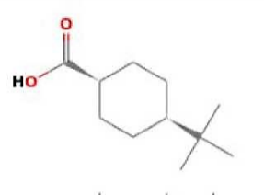 | Cyclohexanecarboxylic acid,4,1,1,1-dimethylethyl-cis
3 | 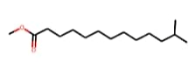 | 12-methyltridecanoic acid, methyl ester
4 | 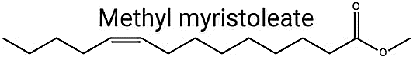 | Methyl myristoleate
5 | 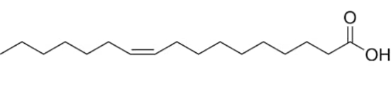 | Cis-10-Heptadecenoic acid
6 | 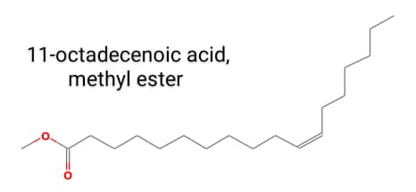 | 11-octadecenoic acid, methyl ester
 | 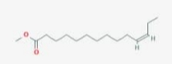 | Methyl z-11-tetradenoate
7 | 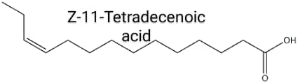 | Z-11-Tetradecenoic acid
8 | 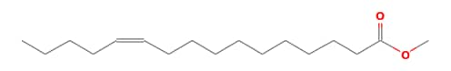 | Z-methyl hexadec-11-enoate
9 |  | Methyl Tetradecenoate
10 | 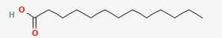 | Tridecanoic acid
11 | 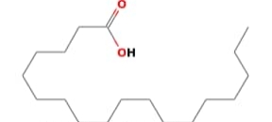 | Octadecanoic acid
12 | 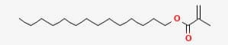 | Methacrylic acid,tetradecyl ester
13 | 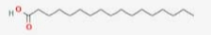 | Heptadecanoic acid
14 | 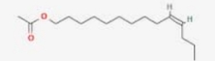 | z-10-Tetradecen-1-ol acetate
15 | 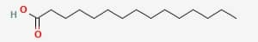 | Pentadecanoic acid
16 | 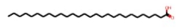 | n-Hexadecanoic acid
17 | 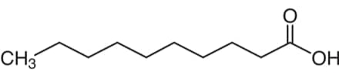 | n-Decanoic acid
18 | 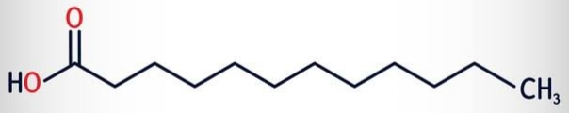 | Lauric acid
19 | 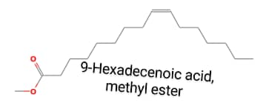 | 9-Hexadecenoic acid, methyl ester
20 | 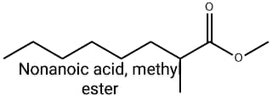 | nonanoic acide, methy ester
21 | 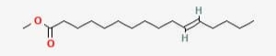 | 11-Hexadecenoic acid, methyl eater
22 | 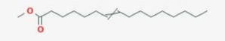 | 7-hexadecenoic acid, methyl ester
23 | 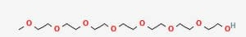 | Heptaethylene glycol
24 | 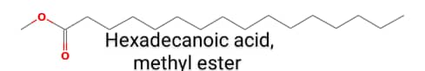 | Hexadecanoic acid, methy ester
25 | 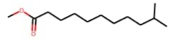 | Undecanoic acid, 10-methyl-,methyl ester
26 | 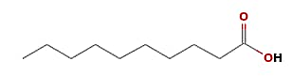 | n-decanoid acid
27 | 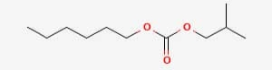 | Carbonic acid,heptadecyl isobutyl ester
28 |  | Methyl stearate
29 | 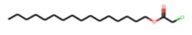 | Acetic acid,chloro,tridecyl ester
30 | 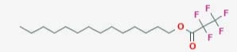 | Tridecyl ester, pentadecanoic acid
31 | 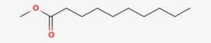 | Methyl ester,decanoic acid
32 | 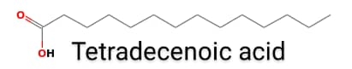 | Tetradecenoic acid
33 | 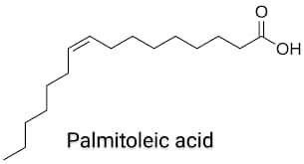 | Palmitoleic acid
34 |  | Tetradecenoic acid
35 |  | Palmitoleic acid
36 | 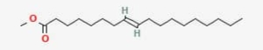 | 8-octadenoic acid, methyl ester
37 | 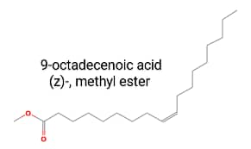 | 9-octadecenoic acid (2)-, methyl ester
38 | 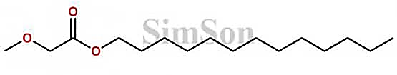 | 9-octadecenoic acid, methyl ester
39 | 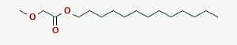 | Tridecyl ester Methoxyacetic acid
40 | 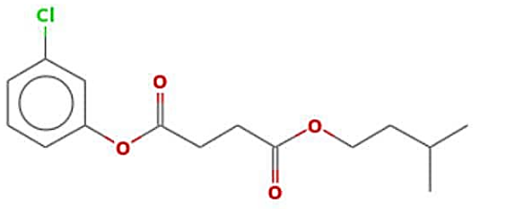 | 3-chlorophenyl 3-methylbutyl ester succinic acid
41 | 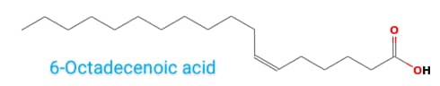 | 6-Octadecenoic acid
42 | 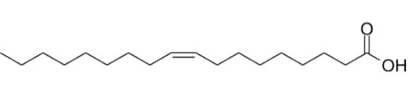 | Oleic Acid
43 |  | 9- hexadecenoic acid, methy ester
44 | 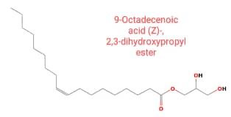 | 9-octadecenoic (Z)-,2,3- dehydroxypropyl ester
45 |  | Sebacic acid, tetrahydrofurfuryl tridecyl ester
46 | 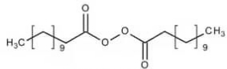 | Lauroyl peroxide
47 | 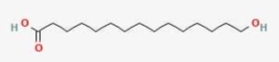 | 15-Hydroxyp entadecanoic acid
48 | 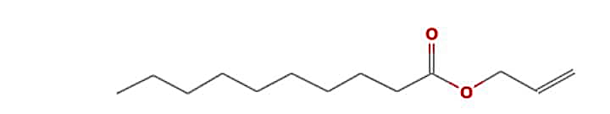 | Decanoic acid, 2-propenyl ester
49 | 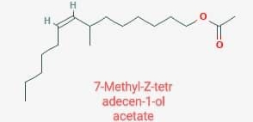 | 7-Methyl-Z-tetr adecen-1-ol acetate
50 | 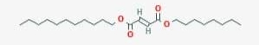 | Furamic acid, octyl undecyl ester
51 | 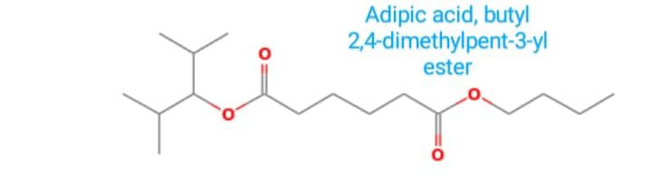 | Adipic acid, butyl 2,4-dimethylpent-3-yl ester
52 | 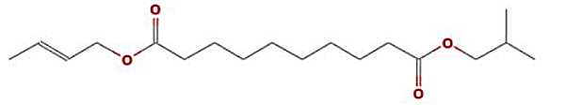 | Sebacic acid, but-2-enyl isobutyl ester
53 | 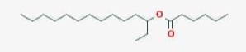 | Hexanoie acid, 3-tetradecyl ester
54 | 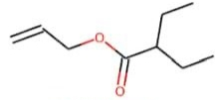 | Allyl 2-ethyl butyrate
55 | 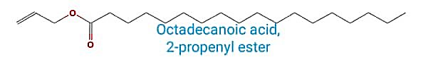 | Octadecanoic acid, 2-propenyl ester
56 | 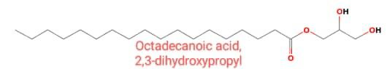 | Octadecanoic acid, 2,3-dihydroxypropyl
57 | 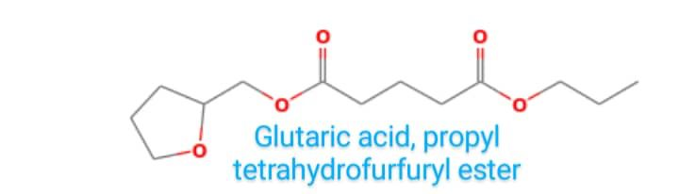 | Glutaric acid, propyl tetrahydrofurfuryl ester
58 | 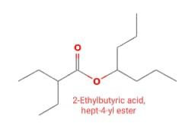 | 2-Ethylbutyric acid, hept-4-yl ester
59 | 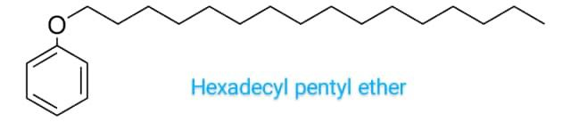 | Hexadecyl pentyl ether
60 | 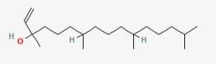 | Isophytol
61 |  | n-Butyric acid tetrahydrofurfuryl ester
62 | 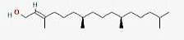 | Phytol
63 | 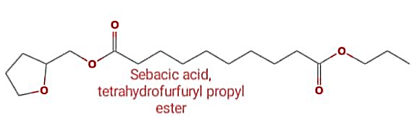 | Sebacic acid, tetrahydrofurfuryl propyl ester
64 |  | Octanoic acid, heptadecyl ester
65 | 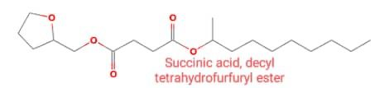 | Succinic acid, decyl tetrahydrofurfuryl ester
66 | 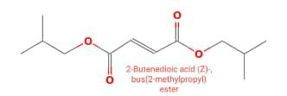 | 2-Butenedioic acid (Z).bus(2-methylpropyl)ester
67 | 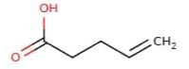 | Pent-4-enoic-acid
68 | 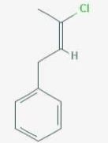 | 2-butene, 3-chloro-1-phenyl. (Z)-
69 |  | 9-Octadecenoic acid (2) 2,3-dihydroxypropylester
70 | 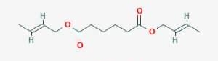 | Adipic acid, di(but-2-en-1-yl) ester

4.2 DISCUSSION
From table 4.1, the density of the cow ghee sample is 0.911g/ml at 30⁰C which also correlate with the standard density of cow ghee of 0.91g/mL in literatures at a temperature of 30⁰C.
Surprisingly from table 4.2, the ghee sample has a high amount of acid value (36.13 mg KOH/g ghee) compared to common fats and oils’. The nonfat milk component may be responsible for this observed high acidity and hence FFA content, since milk is readily fermentable producing acid of lactose (lactic acid). This may contribute to the high acid content of ghee. Another indication is that the local production process may not be efficient enough to remove the residual acids from the ghee product.
In furtherance, the saponification value of the ghee sample is 195.6937 mg KOH/g ghee indicating that the local product contains basically short triglyceride chains. The principle is that shorter chain gives higher saponification value, while longer chain gives lower saponification values. This assertion is further buttressed by the ester value showing the appreciable amount of free ester chain in the ghee sample.
Also from table 4.2, the peroxide value which is used to determine the oxidation of the fat is 11.5 meq I₂/Kg oil and the standard peroxide value range from 1.8 – 2.70 so the value of the peroxide of cow ghee is high indicating that the ghee sample is less stable, can become readily oxidized and be prone to rancidity. This shows that ghee may have shorter shelf life than normal oils and fats. Ghee with high peroxide value have an off flavor and may be harmful to consume. The presence of components of milk may have contributed to it more oxidizable characteristic and the off flavour.
Iodine value from table 4.2 is 38.7045 g I₂/100/g ghee which correlate with the standard value of iodine of 38.69cm³m/g. iodine value indicate the degree of unsaturation agrees well with literature value of fat or oil. The fact that ghee exist in semi-solid form shows its fatty nature and may contain more unsaturated fatty acid chains unlike common fats with more saturated fatty acid components.
From Table 4.1.3, negative lycopene value of -7.992mg/ml indicate absence of lycopene in the cow ghee sample.

4.3 CONCLUSION
The results from this study has shown the locally produced cow ghee to possess quality parameters has expected of ghee to establish it has a lipid from cow milk. However, the local production process could not remove the odor. The importance of the consumption of cow ghee is to the health of an individual is due to the presence of certain biochemical components one of which is believed to be β-carotene. This may be traced to plant consumed by the cow.
This β-carotene in the body is converted into vitamin A which is needed for immune enhancement in the biological system, as well as for healthy skin, mucus membrane and good eye health and vision. This cow ghee hence can be believed to contain vitamin A.
It is therefore necessary to carry out further studies on this material such as fatty acids composition, cholesterol content and the type of cholesterol, presence and quantification of vitamins, and finally assess the efficiency of the local production process as regard retention of beneficial components in final product which were present in the starting material.
Though some research work emphasize that ghee contain essential fatty acid and fat soluble vitamin which can not be synthesized in our body are supplied by ghee.
Although high content or consumption of fat ghee is bad for health, but fat is something which is one of the major nutrient that required by our body for proper functioning.
From Table 4.4 above, the GC-MS analysis revealed over hundred compounds identified in the GOME. These compounds are from various organic homologous series such as carbonyls, lactones, esters, fatty acids, and miscellaneous substances agreeing with information in literatures, especially by Mohammed L and co⁶. About eighty of them are acids (fatty acids especially), and these are believed to play vital role in the pharmacological activity of the ghee oil as well as its possible toxicity.
4.4 CONCLUSION
This work has shown that ghee oil is rich in both common fatty acids and uncommon ones, in addition to several other substances. Some of these substances may have resulted from oxidation of the lipids in ghee oil during production and storage. However, the ghee oil has been a popular part of Asian, Arabian and African foods.

