

GREEN SYNTHESIS OF SILVER NANOPARTICLES USING BRYOPHYLLUM PINNATHUM LEAVES AND IT’S ANTIMICROBIAL EFFECT OF SOME FUNGAL AND BACTERIA ISOLATES
BY
AYANDA OLUWADAMILOLA DORCAS
HND/23/SLT/FT/00 84
A PROJECT SUBMITTED TO THE DEPARTMENT OF SCIENCE LABORATORY TECHNOLOGY, INSTITUTE OF APPLIED SCIENCES (IAS),
KWARA STATE POLYTECHNIC, ILORIN,
IN PARTIAL FULFILMENT OF THE REQUIREMENTS FOR THE AWARD OF HIGHER NATIONAL DIPLOMA (HND) DEGREE IN SCIENCE LABORATORY TECHNOLOGY INSTITUTE OF APPLIED SCIENCES (IAS),MICROBIOLOGY UNIT.
SUBMITTED TO :MRS. E.O OYAGBOLA
JULY, 2025

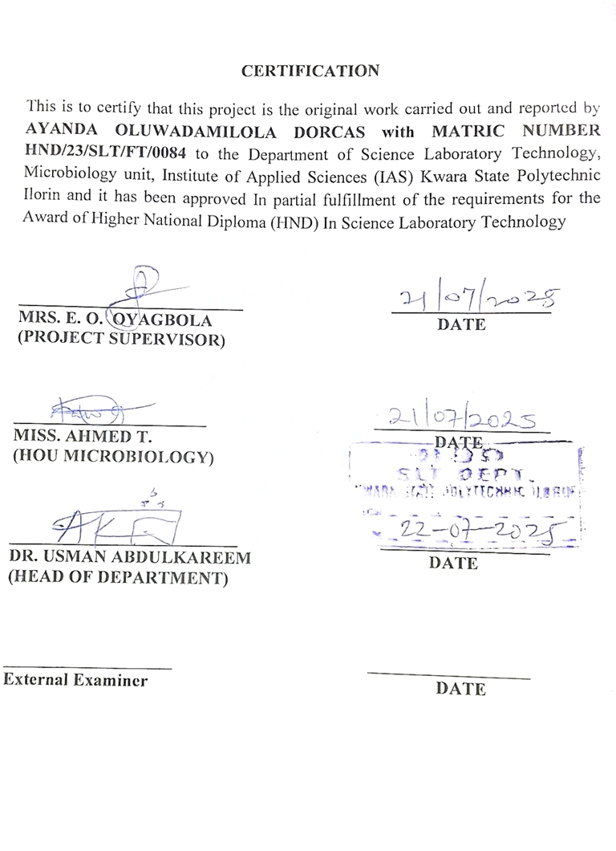

DEDICATION
I dedicate this project work to almighty God the most high, merciful and the giver of life for the success of this project ,may his only name be praised. And to my beloved parents chief / MRS AYANDA for their support, may God grant them long life and eat the fruit of their labor.

ACKNOWLEDGMENT
When I look up to the sky ,I see that all sky are not blue, the lord that bring me from the grass and take my to the grace .Blessed be your holy name ,the God that have been my refuge and my supporter everlasting God ,the lord of host I say thank you lord
My gratitude goes to my able parents, (late) chief olayinka James Ayanda and to my mummy Mrs Janet abiodun Ayanda thanks for all you do till this moment I pray you shall live long and eat the fruit of your labor (mummy). Blessed is the one that carried me,and to my beloved dad continue rest in peace
My gratitude goes to my able and incomparable supervisor mrs E.O ooyagbola who has demonstrated his motherly love upon me who stood by me of the success of my project.
To my amiable siblings Mr Moses Ayanda ,Bro Stephen olayemi Ayanda ,mrs alabi abosede Roseline ,bro Solomon oluwasegunfunmi Ayanda ,bro adeymi oladiran david thank you all for the success of my education I pray whenever you need a help thousand's of helps will rise for you.
Lastly my sincere appreciation goes to my co executive peace tenure from CACSF I love you guys thanks for your prayer and advises I pray we shall all meet in greater places ijn....to my amiable friend ogundele oluwatobiloba Israel thank u so much dear for always been there for me ,you never get tired of me, you're always there for me am grateful .the will grant you all your hear desires

ABSTARCT
This study explores the green synthesis of silver nanoparticles (AgNPs) using the ethanol extract of Bryophyllum pinnatum leaves and evaluates their antimicrobial activity against selected bacterial and fungal isolates. Green synthesis offers a sustainable alternative to conventional chemical methods, utilizing the plant’s rich phytochemical content—including flavonoids, alkaloids, and phenolic compounds—as reducing and capping agents. The synthesized nanoparticles were characterized using UV-Visible spectrophotometry, FTIR, and SEM-EDX. Results indicated a successful synthesis of AgNPs, evidenced by a characteristic color change and surface plasmon resonance. Phytochemical screening confirmed the presence of key bioactive compounds, while antimicrobial assays revealed significant inhibitory effects against pathogens such as Escherichia coli, Salmonella, and Candida albicans. The findings underscore the potential of Bryophyllum pinnatum-mediated silver nanoparticles as effective antimicrobial agents, contributing to the development of eco-friendly nanotechnology solutions in the fight against resistant microbial infections.

TABLE OF CONTENT
TITLE PAGE
CERTIFICATION
DEDICATION
ACKNOWLEDGEMENT
ABSTRACT
TABLE OF CONTENT
CHAPTER ONE
- INTRODUCTION
  - Problem statement
  - Research gap
  - Aims and Objectives
CHAPTER TWO
- LITERATURE REVIEW
  - Green synthesis
  - Metal ion solution
  - Biological reducing agent
  - Botanical description
  - Phytochemical studies
  - Separation of AgNPs
  - Monitoring of AgNPs
  - Mechanism of silver nanoparticle synthesis
  - Application of silver nanoparticle
  - Antimicrobial activity
    - Antifungal activity
    - Antibacterial activity

CHAPTER THREE
3.0. Materials and methods
3.1 Collection And Identification Of Plant Extract And Bacterial And Fungal Isolates
3.2. Preparation of Bryophyllum pinnathum leaves
3.3. Preparation of 1mm silver nitrate solution
3.4. Synthesis of silver nanoparticles
3.5. Water bath assisted biosynthesis of AgNPs
3.6. UV-visible spectrophotometry
3.7. Fourier transform infra-red (FTIR) analysis
3.8. SEM-EDX
3.9. Antimicrobial assay
CHAPTER FOUR
4.0. Result
4.1. UV-visible spectrometry analysis
44.1. UV-visible spectrometry analysis
4.2. Phytochemical analysis (Qualitative and Quantitative)
4.3. Anti-bacterial analysis
4.4. Synthesis of silver nanoparticles
CHAPTER FIVE
5.0. Discussion
5.1. Mechanism of green synthesis
5.2. Antimicrobial efficacy
5.2.1. Antibacterial activity
5.2.2. Membrane disruption
5.2.3. Protein inactivation
5.2.4. Biofilm inhibition
5.3. Antifungal activity
5.4. Factors influencing antimicrobial activity
CHAPTER SIX
6.0. CONCLUSION
REFERENCES

CHAPTER ONE
INTRODUCTION
- BACKGROUND
The emergence of nanotechnology has revolutionalized medical research, particularly through the development of eco-friendly synthesis methods for nanoparticles. Green synthesis, which utilizes natural resources such as plant extract offers a sustainable and biocompatible approach to producing nanoparticles with minimal environmental impact. This method leverages the bioactive compound present in plants to reduce metal ions into nanoparticles, eliminating the need for toxic chemical ( mittal et al; 2013 ). The relevance of green synthesis in medical research lies in its potentials to create safe, effective nanomaterials for applications such as drug delivery, diagnostics and antimicrobial therapies ( Ahmed et al; 2016).
Bryophyllum pinnatum, commonly known as the ‘miracle leaf ’, is a medical plant widely recognized for its rich phytochemical profile , including plavonoids, alkaloid and phenolic compounds. The bioactive constituent posses anti oxidants , anti-inflammatory and antimicrobial properties, making the plant an ideal candidate for green nanoparticles synthesis (ojha et al; 2018). The ethanol extract of bryophyllum pinnatum leaves are particularly promising due to there ability to stabilize and reduce metal ions , facilitating the formation of nanoparticles with enhance therapeutic potential ( patil et al; 2020).
Nanoparticles, especially those derived from metal like silver, gold and zinc, have demonstrated remarkable anti microbial activity against a wide range of pathogens including fungi and bacteria. This is attributed to their high surface area to volume ratio, which enhances their interaction with microbials cell membranes leading to cell disruption and inhibition of growth (Rai et al; 2012). With the global rise in antimicrobial resistance, nanoparticles offer a promising alternative to conventional antibiotic and antifungal, addressing the urgent need for novel therapeutic agent ( Huh & kwon, 2011).

  - PROBLEM STATEMENT
Despite the advantages of green synthesis , most studies on bryophyllum pinnatum have focus on aqueous extraction method , leaving ethanol-based extraction relatively unexplored moreover, while the antibacterial properties of these nanoparticles have been documented , there remain a lack of comprehensive research into their antifungal activity , a critical gap given the rising prevalence of drug resistance fungal infection . Traditional nanoparticles synthesis method also continue to pose challenges in terms of toxicity, cost and environmental impact , necessitating more sustainable alternative.

  - RESEARCH GAP
Despite the growing interest in plant-based nanoparticle synthesis, there is a notable research gap concerning the use of bryophyllum pinnatum-derived for antimicrobial application. Limited studies have explored the potential of this plants ethanol extracts in producing stable bioactive nanoparticle and evaluating there efficacy against fungal and bacterial pathogen. This research aims to bridge this gap by focusing on the green synthesis of nanoparticles using ethanol extract of bryophyllum pinnatum leaves and assessing their antifungal and antimicrobial activities.

  - AIMS AND OBJECTIVES

AIMS
This study aims to explore potential application of the synthesized silver nanoparticles such as their use in antibacterial, anti-fungi, activity in other areas where silver nanoparticles are beneficial

OBJECTIVES
The objectives of the study is as follows :
- To synthesize silver nanoparticles Brophyllum pinnatum leaves
- To characterize the synthesized silver nanoparticles
- To the antibacterial effect of the synthesized silver nanoparticles
- To test the antifungal effect of the synthesized silver nanoparticles.

CHAPTER TWO
LITERATURE REVIEW
2.1. GREEN SYNTHESIS
The primary requirement of green synthesis of AgNps of silver metal ion solution and reducing biological agents in most of the case reducing agents or other constituents presents in the cell act as stabilizing and caping agents from outside
2.2. METAL ION SOLUTION
The silver Ag+ ions are primarily requirement for the synthesis of AgNPs which can be obtained from various water soluble salt of silver. However the aqueous AgNO3 solution with Ag+ ion. Concentration range between 0.1 – 10mm ( most commonly 1mm ) has been used by the majority of researchers

2.3. BIOLOGICAL REDUCING AGENTS
The reducing agents are widely distributed in the biological system. The AgNPs have been synthesized using different organism belonging to four kingdom out of five kingdom of living organisms i.e monera (prokaryotic organisms without true nucleus), protista (unicellular organism with true nucleus), fungi (eukaryotic, saprophyte/parasite), plantae ( eukaryotic, autotrophs) and animalia (eukaryotic,heterotrophs). Data are not available regarding use of animal material for the synthesis of AgNP till date to the best of our knowledge . Due to this limitation, green synthesis of AgNPs has been discussed under heading microorganism, plant and bio-polymers.
Green synthesis of AgNPs have been performed using plant extract ,microbial cell biomass or cell free growth medium and bio-polymers. The plant used for AgNOPs synthesis range from algae to angiosperm; however, limited reports are available for lower plants and the most suitable choice are the angiosperm plants, parts like leaf, bark, root, and stem have been used for the AgNPs synthesis . The medicinally important plant like Boerhaavia diffusa (Vijarkumar et al; 2014), Tinospora cordifolia (Anuj et al; 2013), Aloe vera (Chandran et al; 2006), catharanthus rose (mukuntha et al; 2011) growing in uncontrolled manner due to lack of natural enemies and causing health problem have also been used for AgNPs synthesis. All the plant extract played duel role of potential reducing amd stabilized agents exception in few case where external chemical agents like sodium –do-decyl sulphate were used for stabilization the AgNPs (Rao, p. et al; 2014), methabolites protein (elumalal, et al; 2014) and chlorophyll (Shakar, et al; 2003) present in the plant extract were found to be acting as capping agent for synthesized AgNPs
The AgNPs synthesis by microbes is strenuous compared to the use of plant extract and biopolymers as reducing agents and capping agents mainly due to the difficulty in growth, culture, maintenance, and inoculums size standardization. Several fungal and bacterial species have been successfully used in the synthesis. The AgNPs synthesis mainly followed one of the two distinct route , one utilizing extracellular material secreted in the growth medium whereas the others utilizing microbial cell biomass directly. The microbes synthesize AgNPs intracellular synthesis of AgNPs was observed by few researchers (Mukherjee, et al; 2001).
AgNPs synthesis support better control on size and shape of AgNPs, due to easy down streaming and larger adaptability to nano system.However, extracellular AgNP synthesis is been widely reported (Ajitha et al; 2014) (Bhainsa, et al; 2006).one of the commonly used fungal general for synthesizing AgNPs is fussarium (Ajitha et al; 2014), (Ahmad,A et al; 2003) and (ingle et al; 2009).

2.4 BOTANICAL DESCRIPTION
Bryophyllum pimmathum is a perennial herb of genius Bryophyllum belongsto family Crassulaceae. The family comprises of 25 genera and 450 species.It is erect and grows about 1.5m length. It belongs to crassula tribe, the leaves and stem of which are fleshy and succulent (Neigaratna and Hedgd, 2015) leaves arealternate/ opposite,simple,less commonly pinnately divided and ex stipulate. Flower are usually cymose,hermarphrodite/rarely unisexual and regular. Calyx is free, 4-5 fid/4-5 particle flowers are pendent in large spreading particle with opposite stout brancher, pedicels slender. Habibat is found naturally in hot and humid tropical region of the world. It is a native herbs of Madagascar.

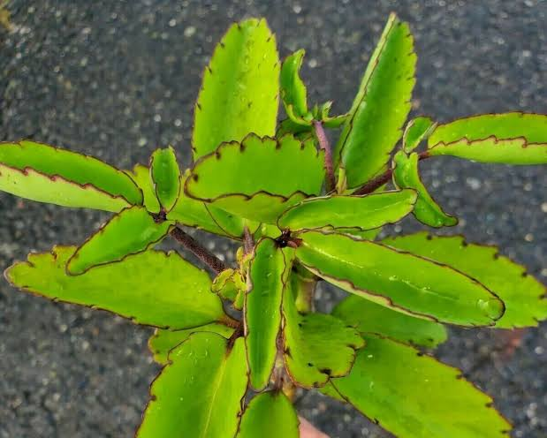

Fig.1BRYOPHYLLUM PINNATHUM LEAF

VERNACULLAR NAME OF BRYOPHYLLUM PINNATHUM

ENGLISH | MIRACLE LEAF,LIFE PLANT,CATHEDRAL BELLS
NEPALI | PATHARCHHATA
URDU | ZAKHM-AYAT, KOPATA, KOTAK, HAEM SAGAR
ARABIC | KUSHNULHAYAT
YORUBA | EWE ABAMODA
IGBO | ODAA OPUO
HAUSA | MASSALLACHI OR SHUKA HAMLIN KA

PLANT PROFILE TAXONOMY
Kingdom plantae- plant
Sub-kingdom Tracheobionta
Division Spermatophyta
Sub-division Magnoliophyta
Class Magnoliopsida
Sub-class Rosidae
Order Rosales
Family Crassulaceae
Genus Bryophyllum
Species Bryophyllum pinnathum Kurz

The part used for herbs have been utilized in the folklore system for the treatment of various ailments. Traditional use as medicine for treating urinary stone in different part of the world. It has been used in numerous conditions like hypertension, skin disorder, asthma, cold, insect stings ,abscesses etc (Nagarathma and Hedge, 2015)
Ethanobotanical used in the treatment of various disease including diabetes and heart disease ( ogbonnia et al; 2008). Leaves of the plant have much higher therapeutic application than the other parts. The juice of the leafs has traditionally been used for the treatment of ear infection, dysentery and cough. In southeastern Nigeria, this herb is used to facilitate the dropping of the placenta of newly born body (Dalziel 1955). In south west Nigeria Yoruba tribe, tie and rub the crushed leaves their head to bring relief for headache ( sofowora, 1982 ). Igbos of Nigeria , uses decoction of the leaf or the raw leaves itself for the treatment of hypertension ( Ghasi et al; 2009). It has been used with palm oil and shear butter in abscesses and swelling ( okwu and Josiah, 2006). In India the leaves are used as hepatroprotective herb to treat jaundice ( Yadav and Dixit,2003). In Africa, Latin America and Asia leaves are used as an anti pyretic and for treatment of malaria ( willcox and Bodeker, 2004). The plant has always been used as an antipsychotic agent since 1921.
In traditional medicine , the leaves of this plants have been reported to posses anti microbial activity, antifungal (salaudeen and yemiten 2006) anti-ulcer (pal and chauduri 1991). The aerial parts of the bryophyllum pinnatum has been used against guinea worm. In case of abdominal pain it has been used as decoction (Agyare et al; 2014).

2.5. PHYTOCHEMICAL STUDIES
Phytochemical shows that the plant contains, plavonoids, tannins, anthocyanins, glycosides, alkaloids, phenols, bufadienotides, saponins, coumarin, carotenoid sitosterols, quinines, tocopherol and lectins (Devbhuto et al; 2008). It also contains lipids carbohydrate, protein vitamins and minerals. The plants is reported to contain alkaloids (1.24 – 1.48mg/100g), flavonoids (1.46 – 1.86mg/100g) tannins (0.04 – 0.5mg/100g), saponins (1.46 – 1.72mg/100g) and phenols (0.06mg/100g). The vitamins reported in the plants include ascorbic acid (26.42 – 44..03mg/100g),riboflavin (0.20 – 0.42mg/100g), thamine ( 0.11 – 0.18mg/100g) and niacin (0.02 – 0.09mg/100g) (okwu and Josiah,2006).

2.6. SEPERATION OF AgNPs
Centrifugation a technique is mostly used by researchers to obtain the pellet or powder form of synthesizes silver nanoparticles. The AgNPs suspension were also oven dried to obtain the product in powder form ( sadeghi,B and Gholamhoseinpoor, 2015)
Some common characterization of AgNPs includes UV-visible spectra, SEM, TEM, FTIR, XRD, and EDAX. DLS study is mostly used for AgNPs synthesized from bio-polymers rather than plant extract and microorganism. Inductive coupled plasma (ICP) analysis was performed to analyze the concentration and conversion of AgNPs (song and Kim, 2009).

2.7. MONITORING OF AgNPs
The appearance of yellow to slight brownish yellow color in the colorless solution has been taken in indicative of AgNPs, synthesis by almost all the researcher. The spr peak of the synthesized AgNPs was witnessed in the range of(400-450mm,the significant range for AgNPs (sastry, et al; 1997). The UV-Viisible spectral analysis have been used to analyze the dependency of PH, metal ion concentration, extract contents on the formation of AgNPs and reveal the size stability of synthesized AgNPs by exhibiting red shift in the SPR peak with increase in size of nanoparticles and blue shift for decrease in size.

2.8. MECHANISM OF SILVER NANOPARTICLES SYNTHESIS
The synthesis of silver nanoparticles by biological entities is due to the presence of large numbers of organic chemical like carbohydrate, fat, protein, enzymes and co-enzymes, phenol plavanoid , terpenoids, alkaloids, gum e.t.c. capable of donating electron for the reduction of Ag+ ions to Ag.

2.9. APPLICATION OF SILVER NANOPARTICLE
The recent research result have shown that the silver nanoparticles due to their specials characteristics have immense potential for application as anti-microbial, anti-parasitic and anti-fungal agent

2.2.0 ANTIMICROBIAL ACTIVITY
The 60% ethanolic extract of the leave was found to be effective against different microorganism. These include Escherichia coli, Bacillus substillis, Staphyloccus aureus, at concentration of 25mg/ml, candida albican, pseudomonas aeruginosa klebsiella pneumonia were found to be resistant to the extract (Akinpelu; 2000).

2.2.1 ANTI FUNGAL ACTIVITY
The silver nanoparticles exhibited antifungal activities against various fungi (Banka.A et al; 2010) (Raut, Rin et al; 2014) actual mechanism behind the antifungal activity is not fully. The disrupting the structure of the cell membrane by destructing the membrane integrity,thereby the inhibition of the budding process has been attributed to be responsible for the antifungal activity of silver nanoparticles against C. albanicans species (Kim J.k et al; 2009). The shape of the silver nanoparticles has a significant effect on the anti microbial activity ( Rai, M.k et al; 2012).

2.2.2 ANTI BACTERIAL ACTIVITY
The silver nanoparticles have potent antibacterial action against gram positive bacterial, Bacillus aereus (Deepak V. et al; 2011) S, aureus (Nanda A. saravananm 2009) and gram negative bacteria E.coli, (Perni et al; 2014) Entrobacteria ( Shahverdi et al; 2007) The antibacterial activity of silver nanoparticles on gram positive and gram negative strain is not the same but competes one over another.

CHAPTER 3

MATERIALS AND METHOD

3.1 COLLECTION AND IDENTIFICATION OF PLANT EXTRACT AND BACTERIAL AND FUNGAL ISOLATES.
Bryophyllum pinnathum leaves were obtained from Kwara State Polytechnic student at basin, Kwara State, Nigeria authenticated at the Department Of Botany, University Of Ilorin, Ilorin. Clinical isolates: Staphylococcus aureus, Salmonella sp., Escherichia coli and, Klebsiella pneumoniae, Penicillium sp., Aspergillius niger, Trichoderma sp., Rhizopus sp., were collected.

3.2. PREPARATION OF BRYOPHYLLUM PINNATHUM LEAVES
Sixty gram (60g) of bryophyllum pinnathum leaves were washed thrice with distilled water to remove the surface impurities. The leave was chopped pinely and macerated with the help of mortal and pestle. After macerating 250ml of distilled water is added and mixed well. The mixture is incubated at 60°c up to 1 hour. The extract thus obtained was cooled and filtered with whatman filter paper -1 and used freshly.

3.3. PREPARATION OF 1mm SILVER NITRATE (AgNO3) SOLUTION
To prepare 1mm AgNO3 solution, 0.1698g of AgNO3 is added to 100ml of distilled water which is kept in dark to avoid photochemical reaction and for further use
3.4. SYNTHESIS OF SILVER NANOPARTICLES
Bryophylum pinnathum leaf extract of 5ml was added to 45ml of 1mm of AgNO3 solution for bioreduction action at room temperature and changes in color was observed.
3.5. WATER BATH ASSISTED BIOSYNTHESIS OF AgNPs
The biosynthesis of AgNPs was carried out using a water bath which was supported with 80°c temperature till the reaction mixture changes to brownish-red color and the ultraviolet (UV). Visible spectrum was recorded
3.6. UV-VISIBLE SPECTROPHOTOMETRY
The reduction of AgNO3 to AgNPs using aqueous Bryophyllum pinnathum leaves extract were observed by measuring the UV-Visible spectrum of the resultant mixture after diluting the small aliquot of the Bryophyllum pinnathum particle with deionized water twice . The measurement are recorded on CORBET UV-Visible spectrophotometer operated at a resolution of 1mm
3.7. FOURIER TRASFORM INFARED (FTIR) ANALYSIS
Fourier transform Infrared was carried out for tooth the extract and AgNPs to observe and identify the Possible bioactive Molecules which is responsible for the reduction of the Ag + ions and the capping of the bio reduced AgNPs by the Bryophyllum pinnathum Leaves extract, in the diffuse raplectanie made at a resolution of 4cm^-1 using potassium bromide (KBR) pellets and the wave length was recorded at Interval of 400 to 40сm^-1
3.8. SEM
A drop of colloidial Solution of AgNPs was placed on carbon-coated coppers grid and later it is dried in air, before the Bryophyllum pinnattum extract Is transferred to the microscope which is operated at an accelerated voltage of 6KV .

3.9 ANTIMICROBIAL ASSAY
Antimicrobial activity of biosynthesized AgNPs is carried out against these Salmonella, kleb, Pseudomonas, EScherichia coli, and staphylococcus with different concentration of AgNPs by well- diffusion method and Zone of inhibition is observed.

CHAPTER 4

RESULTS

  - UV-VISIBLE SPECTROPHOTOMETRY ANALYSIS
The Bryophyllum pinnathum aqueous were observed under UV-Visible spectrophotometry for its maximum absorbance and wavelength to confirm the reduction of silver nitrate
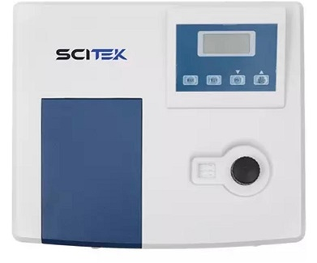
Fig.2 DIAGRAM OF UV SPECTROPHOTOTMETER
THE TABLE IS SHOWN BELOW

WAVELENGTH | ABSORBANCE
300 | 2.443
350 | 2.406
400 | 2.370
450 | 2.356
500 | 2.357
550 | 2.359
600 | 2.269

Fig.3 Wavelength scanning UV-Visible spectrophotometry

  - PHYTOCHEMICAL ANALYSIS
The Bryophyllum pinnathum aqueous were observed under phytochemical for its quantitative, qualitative to conform flavonoids, alkaloids, sapanins Tespenoids , glycosides, tannins, steroids of silver nitrate

Results of quantitative phytochemical analysis of Bryophyllum pinnathum leaves extract
Flavanoids | $±$ 2.435
Alkaloids | ± 2.193`
Saponins | ± 2.501
Tespenoids | ± 3.861
Glycosides | ± 1.574
Tennis | ± 2.582
Stenoids | ± 0.355

Results of qualitative phytochemical analysis of Bryophyllum pinnathum leaves extract
Flavonoids test | +
Alkaloids test | +
Saponins test | +
Tespenoids test | +
Glycosides test | +
Tannin test | +
Stenoids test | +

Key
+ > present in trace form
++ > moderately present
+++ > highly presents
The qualitative phytochemical analysis of bryophyllum pinnathum leaves extract is present in trace form.

  - . ANTIBACTERIAL ANALYSIS
BACTERIA SPECIES | 250ppm | 500ppm | 1000ppm
Klebsiella | - | - | -
Staphyloccocus | - | - | -
Pseudomonas | - | - | -
Escherichia coli | - | - | 24mm
Salmonella | - | - | 21mm

4.4. ANTIFUNGAL ANALYSIS
FUNGAL | 0.1ml | 0.2ml | 0.3ml | 0.4ml
Penicillum spp | 12mm | - | - | -
Aspergillus spp | - | 16mm | 12mm | -
Trichoderma spp | - | - | - | 8mm
Fusarium | 15mm | 12mm | - | -
Rhizopus | - | 19mm | 13mm | 18mm

4.5 FOURIER TRANSFORM INFRARED SPECTROPHOTOMETER
The FTIR spectroscopy was carried out to identify the chemical composition
and nano silver particles of the test sample. The spectra were taken from
resulting disk over the frequency range at 4400-250cm-1.

Fig 5. FTIR spectrum of silver nanoparticle synthesized by Calotropis
procera leaf extracts

4.6 SCANNING ELECTRON MICROSCOPY
A Scanning electron microscope was used to evaluate the morphology of
samples containing AgNPs of Calotropis procera on a copper grid before
being dried at room temperature giving a magnification both in 8000x and 9000x.
Fig 6 SEM images of magnification 8000x and 9000x of the silver
nanoparticles synthesized by Calotropis procera leaf extracts

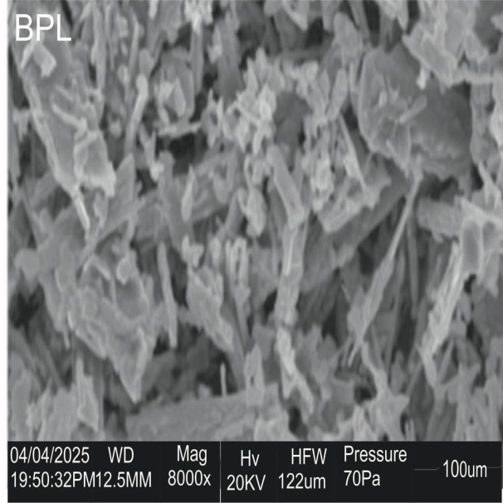

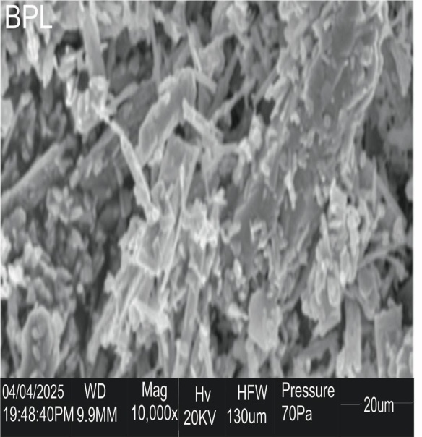

CHAPTER FIVE

5.0 DISCUSSION

The green synthesis of silver nanopartices using Bryophyllum pinnathum leaf extract represents a significant advancement is Sustainable nanotechnology, offering and eco-friendly and cost effective alternative to traditional chemical and physical method. This approach leverages the rich phytochemical profile of BryoPhyllum pinnathum, a medicinal plant widely recognized for its therapeutic properties, to act as both reducing and capping agents for silver ions.
( Sinha; N, & Priya 2025), khan & perumal (2024),Kumarmath et al; (2021))

5.1 MECHANISM Of GREEN SYNTHESIS
The aqueous extract of Bryophyllum pinnathum Leaves Contain Various bioactive Compound, Including flavonoid, phenolic compounds, alkaloids, sapaponins, triterpenos, glycosides Steroid, lipids and organic acids ( Khan and Parumal (2024), Kumarmath et al; (2021), Olaiya & Olarinoye (2024)) • These phytochemicals play a Crucial role in the bioreduction of silver nitrate to elemental Silver and subsequent formation to stable AgNPs. Specifically, the hydroxyl groups in polyphenols and the carbonyl groups op amino acid residues in protein are believed to be Instrumental in reducing ions. The biomolecules also act as capping agents, forming a layer around the synthesized nanoparticle, which prevent agglomeration and imparts stability ( Sinha & priya (2025), Kumarmath et al; (2021) , Olaiya & olarinoye (2024), ). The characteristic brown color observed In the solution and the Surface plasmon (SPR) peak typically around 300-600 nm in UV- Visible spectroscopy confirm the Successful formation of AgNPs ( Sinha and Priya 2025), Khanan and Perumal (2024), Ramakrishna et al; 2021).

5.2 ANTIMICROBIAL EFFICACY
Numerous Studies have consistently demonstrated the potent antimicrobial activity of Bryophyllum pinnathum mediated AgNPs against a broad spectrum of bacterial and fungal isolates ( Sinha and Priya (2025), Khan and parumal (2024), Ramakrishna et al; 2021).

5.2.1 ANTIBACTERIAL ACTIVITY
Silver nanoparticles exhibits strong bactericidal effects against both Gram-positive (e.g staphylococcus aureus, Bacillus subtillis, Micrococcus (uteus) and Gram-negatuve (eg Escherichia Coli, Pseudomonas aeruginosa, salmonella setubal, Enterobacter aerogenes) bacteria (Sinha and Priya (2025), Khan and perumal
(2024) , Ramakrishna et al; (2021) • while some Studies suggest AgNPs are more effective against Gram - negative bacteria due to their thinner peptydoglycan layer, others report varying sensitivities depending on the bacterial strain and nanoparticle Characteristics (Sinha and Priya (2025), khan and perumal (2024), Ramatrishra et al; (2021)) . The antimicrobial mechanism of AgNPs is multifaceted and involved

5.2.2 MEMBRANE DISRUPTION
Silver nanoparticle can adhere to and penetrate microbial cell membrane, leading to Structural damage, Increased permeability and leakage of intracellular Component (Sinha and priya (2025), Abbasi et al, (2024), Dakal et al (2016)) .

5.2.3 PROTEIN INACTIVATION
Silver ions released from AgNPs can interact with sulfur-containing proteins in the bacterial Cell wall and Cytoplasm disrupting Vital Enzyme functions and metabolic pathways (Abbasi et al, (2024), Dakal et al; (2016))

5.2.3 BIOFILM INHIBITION
Silver nanoparticle have been shown to inhibit the formation of bacteria biofilms, which are a major Contributor to antibiotic resistance (Dakal et al; 2016).

5.3 ANTIFUNGAL ACTIVITY
The silver nanopartcle Synthesized using Bryophyllum Pinnathum extract also display significant antifungal activity against various fungal Strains, Including Penicillum spp and Aspergillus niger (Khan & Perumal (2024), Ramakrishna et al; (2021)). The mechanism against fungi is similar to that against bacteria, Involving membrane disruption, oxidative stress and Interference with Cellular processess ( Dakal et al, 2016)

5.4 FACTORS INFLUENCING ANTIMICROBIAL ANCTIVITY
The effectiveness of silver nanoparticles is influenced by several factors, Including their size, Shapes, surface charges, concentration, and colloidal stability ( Dakal et al; 2016). Green Synthesized AgNPs often have a Small size and large Surface area, Which enhances their interaction with microbial cells, contributing to their superior antimicrobial properties ( Sinha & Priya (2025), Khan & perumal (2024) ).The capping agents derived from Bryophyllum pinnathum also contribute to the nanoparticle, which is Crucial for potential biomedial applications (Sinha d Priya (2025), Dahiya et al,2022)).

CHAPTER SIX
CONCIUSION
The utilization Of Bryophyllum Pinnathum for the green Synthesis of Silver nanoparticle offers a powerful and Sustainable Platform for developing nover antimicrobial Solution to combat infectious diseases caused by both bacterial and fungal pathogens or Isolates.

REFERENCES
Abbasi, M., et al. (2024). Advances in silver nanoparticles: a comprehensive review on their potential as antimicrobial agents and their mechanisms of action elucidated by proteomics. Frontiers in Microbiology, 15, 1440065.
Agyare, C., Spiegler, V., Sarkodie, H., Asase, A., Liebau, E., and Hensel, A. (2014). An ethnopharmacological survey and in vitro confirmation of the ethnopharmacological use of medicinal plants as anthelmintic remedies in the Ashanti region, in the central part of Ghana. Journal of Ethnopharmacology, 158, 255-263.
Ahmed, S., Ahmad, M., Swami, B. L., & Ikram, S. (2016). A review on plants extract mediated synthesis of silver nanoparticles for antimicrobial applications: A green expertise. Journal of Advanced Research, 7(1), 17- 28.
Ahmad, A., Mukherjee, P., Senapati, S., Mandal, D., Kham, M.I., Kumar, R. and Sastry, M. (2003) Extracellular Biosynthesis of Silver Nanoparticles Using the Fungus Fusarium oxysporum. Colloids and Surfaces B: Biointerfaces, 28, 313-318. http://dx.doi.org/10.1016/S0927- 7765(02)00174-1
Ajitha, B., Redd, Y.A.K. and Reddy, P.S. (2014) Biosynthesis of Silver Nanoparticles Using Plectranthus amboinicus Leaf Extract and Its Antimicrobial Activity. Spectrochimica Acta Part A: Molecular and Biomolecular Spectroscopy, 128, 257- 262. http://dx.doi.org/10.1016/j.saa.2014.02.105
Akinpelu, D. A. (2000). Antimicrobial activity of Bryophyllum pinnatum leaves. Fitoterapia, 71(2), 193-194.
Anuj, S.A. and Ishnava, K.B. (2013) Plant Mediated Synthesis of Silver Nanoparticles Using Dried Stem Powder of Tinospora cordifolia, Its Antibacterial Activity and Its Comparison with Antibiotics. International Journal of Pharmacy and Biological Sciences, 4, 849-863.
Bankar, A., Joshi, B., Kumar, A.R. and Zinjarde, S. (2010) Banana Peel Extract Mediated Novel Route or the Synthesis of Silver Nanoparticles. Colloids and Surfaces A: Physicochemical and Engineering Aspects, 368, 58- 63. http://dx.doi.org/10.1016/j.colsurfa.2010.07.024
Bhainsa, K.C. and D’souza, S.F. (2006) Extracellular Biosynthesis of Silver Nanoparticles Using the Fungus Aspergillus fumigates. Colloids and Surfaces B: Biointerfaces, 47, 160-164. http://dx.doi.org/10.1016/j.colsurfb.2005.11.026
Chandran, S.P., Chaudhary, M., Pasricha, R., Ahmad, A. and Sastry, M. (2006) Synthesis of Gold Nanotriangles and Silver Nanoparticles Using Aloe vera Plant Extract. Biotechnology Progress, 22, 577- 583. http://dx.doi.org/10.1021/bp0501423
Dahiya, S., et al. (2022). Investigation of Antimicrobial Activity and Biocompatibility of Biogenic Silver Nanoparticles Synthesized using Syzygium cymosum Extract. ACS Omega, 7(31), 27361-27372.
Dakal, T. C., et al. (2016). Mechanistic Basis of Antimicrobial Actions of Silver Nanoparticles. Frontiers in Microbiology, 7, 1831.
Dalziel, J. M. (1955). The useful plants of west tropical Africa.
Deepak, V., Umamaheshwaran, P.S., Guhan, K., Nanthini, R.A., Krithiga, B., Jaithoon, N.M.H. and Gurunathan, S. (2011) Synthesis of Gold and Silver Nanoparticles Using Purified URAK. Colloids and Surfaces B: Biointerfaces, 86, 353- 358.http://dx.doi.org/10.1016/j.colsurfb.2011.04.019 [
Devbhuti, D., Gupta, J. K., Devbhuti, P., and Bose, A. (2008). Phytochemical and acute toxicity study on Bryophyllum calycinum SALISB. Acta Poloniae Pharmaceutica-Drug Research, 65(4), 501-504.
Elumalai, E.K., Kayalvizhi, K. and Silvan, S. (2014) Coconut Water Assisted Green Synthesis of Silver Nanoparticles. Journal of Pharmacy & Bioallied Sciences, 6, 241-245. http://dx.doi.org/10.4103/0975- 7406.142953
Ghasi, S., Egwuibe, C., Achukwu, P., and Onyeanusi, J. (2009). Assessment of the medical benefit in the folkloric use of Bryophyllum Pinnatum leaf among the Igbos of Nigeria for the treatment of hypertension. African journal of pharmacy and pharmacology, 5(1), 83-92
Huh, A. J., & Kwon, Y. J. (2011). "Nanoantibiotics": A new paradigm for treating infectious diseases using nanomaterials in the antibiotics resistant era. Journal of Controlled Release, 156(2), 128- 145. https://doi.org/10.1016/j.jconrel.2011.07.002
Ingle, A., Rai, M., Gade, A. and Bawaskar, M. (2009) Fusarium solani: A Novel Biological Agent for the Extracellular Synthesis of Silver Nanoparticles. Journal of Nanoparticle Research, 11, 2079- 2085. http://dx.doi.org/10.1007/s11051-008-9573-y
Khan, R., & Perumal, K. (2024). Assessment of Bryophyllum pinnatum mediated Ag and ZnO nanoparticles as efficient antimicrobial and cytotoxic agent. Journal of Basic and Clinical Physiology and Pharmacology, 35(5), 515-523.
Kim, K.J., Sung, W.S., Suh, B.K., Moon, S.K., Choi, J.S., Kim, J.G. and Lee, D.G. (2009) Antifungal Activity and Mode of Action of Silver Nanoparticles on Candida albicans. Biometals, 22, 235- 242. http://dx.doi.org/10.1007/s10534-008-9159-2
Kumarmath, G. R., Hazarika, H., & Bhattacharyya, S. K. (2021). Green approach for the synthesis of silver nanoparticles using Bryophyllum pinnatum. International Journal of Green Pharmacy, 15(4).
Mittal, A. K., Chisti, Y., & Banerjee, U. C. (2013). Synthesis of metallic nanoparticles using plant extracts. Biotechnology Advances, 31(2), 346- 356. https://doi.org/10.1016/j.biotechadv.2013.01.003
Mukherjee, P., Ahmad, A., Mandal, D.D., Senapati, S., Sainkar, S.R., Khan, M.I., Parishcha, R., Ajaykumar, P.V., Alam, M., Kumar, R. and Sastry, M. (2001) Fungus-Mediated Synthesis of Silver Nanoparticles and Their Immobilization in the Mycelial Matrix: A Novel Biological Approach to Nanoparticle Synthesis. Nano Letters, 1, 515- 519. http://dx.doi.org/10.1021/nl0155274
Mukunthan, K.S., Elumalai, E.K., Patel, E.N. and Murty, V.R. (2011) Catharanthus roseus: A Natural Source for Synthesis of Silver Nanoparticles. Asian Pacific Journal of Tropical Biomedicine, 1, 270- 274. http://dx.doi.org/10.1016/S2221-1691(11)60041-5
Nagaratna, A., and Hedge, P. (2015). Comprehensive review on Parnabeeja [Bryophyllum pinnatum (Lam.) Oken]. J Med Plants Stud, 3(5), 166171.
Nanda, A. and Saravanan, M. (2009) Biosynthesis of Silver Nanoparticles from Staphylococcus aureus and Its Antimicrobial Activity against MRSA and MRSE. Nanomedicine: Nanotechnology, Biology and Medicine, 5, 452- 456. http://dx.doi.org/10.1016/j.nano.2009.01.012
Ogbonnia, S. O., Odimegwu, J. I., and Enwuru, V. N. (2008). Evaluation of hypoglycaemic and hypolipidaemic effects of aqueous ethanolic extracts of Treculia africana Decne and Bryophyllum pinnatum,/i> Lam. and their mixture on streptozotocin (STZ)-induced diabetic rats. African Journal of Biotechnology, 7(15).
Ojha, P. K., Karad, M., & Purohit, H. J. (2018). Phytochemical and pharmacological potential of Bryophyllum pinnatum. International Journal of Pharmaceutical Sciences and Research, 9(5), 1747- 1754. https://doi.org/10.13040/IJPSR.0975-8232.9(5).1747-54
Okwu, D. E., and Josiah, C. (2006). Evaluation of the chemical composition of two Nigerian
Olaiya, B. O., & Olarinoye, A. O. (2024). Phytochemical analysis and antibacterial activity of Bryophyllum pinnatum (Africa Never Die) leaf extract on bacterial organisms. GSC Biological and Pharmaceutical Sciences, 26(02), 067-074.
Pal, S., and Chaudhuri, A. N. (1991). Studies on the anti-ulcer activity of a Bryophyllum pinnatum leaf extract in experimental animals. Journal of Ethnopharmacology, 33(1), 97-102.
Patil, S. A., Patil, S. S., & Patil, S. V. (2020). Green synthesis of silver nanoparticles using Bryophyllum pinnatum leaf extract and their antimicrobial activity. Journal of Nanostructure in Chemistry, 10(3), 209- 216. https://doi.org/10.1007/s40097-020-00345-8
Perni, S., Hakala, V. and Prokopovich, K. (2014) Biogenic Synthesis of Antimicrobial Silver Nanoparticles Caped with L-Cystine. Colloids and Surfaces A: Physicochemical and Engineering Aspects, 460, 219-224.
Rai, M.K., Deshmukh, S.D., Ingle, A.P. and Gade, A.K. (2012) Silver Nanoparticles: The Powerful Nanoweapon against Multidrug-Resistant Bacteria. Journal of Applied Microbiology, 112, 841- 852. http://dx.doi.org/10.1111/j.1365-2672.2012.05253.x
Rai, M., Yadav, A., & Gade, A. (2012). Silver nanoparticles as a new generation of antimicrobials. Biotechnology Advances, 27(1), 76- 83. https://doi.org/10.1016/j.biotechadv.2008.09.002
Ramakrishna, K., Ravichandrudu, C., & Rajkumar, T. (2021). Green synthesis and characterization of silver nanoparticles by using Bryophyllum pinnatum and the evaluation of its power generation activities on bio- electrochemical cell. ResearchGate. Retrieved from https://www.researchgate.net/publication/358936241_Green_synthesis_and_characterization_of_silver_nanoparticles_by_using_Bryophyllum_pinnatum_and_the_evaluation_of_its_power_generation_activities_on_bio-electrochemical_cell
Rao, P., Chandraprasad, M.S., Lakshmi, Y.N., Rao, J., Aishwarya, P. and Shetty, S. (2014) Biosynthesis of Silver Nanoparticles Using Lemon Extract and Its Antibacterial Activity. International Journal of Multidisciplinary and Current Research, 2, 165-169.
Raut, R.W., Mendhulkar, V.D. and Kashid, S.B. (2014) Photosensitized Synthesis of Silver Nanoparticles Using Withania somnifera Leaf Powder and Silver Nitrate. Journal of Photochemistry and Photobiology B: Biology, 132, 45-55. http://dx.doi.org/10.1016/j.jphotobiol.2014.02.001
Sadeghi, B. and Gholamhoseinpoor, F. (2015) A Study on Stability and Green Synthesis of Silver Nanoparticles Using Ziziphora tenuior (Zt) Extract at Room Temperature. Spectrochimica Acta Part A: Molecular and Biomolecular Spectroscopy, 134, 310- 315. http://dx.doi.org/10.1016/j.saa.2014.06.046
Sadeghi, B., Rostami, A. and Momei, S.S. (2015) Facile Green Synthesis of Silver Nanoparticles Using Seed Aqueous Extract of Pistacia atlantica and Its Antibacterial Activity.Spectrochimica Acta Part A: Molecular and Biomolecular Spectroscopy, 134, 326- 332. http://dx.doi.org/10.1016/j.saa.2014.05.078
Salahdeen, H., and Yemitan, O. (2006). Neuropharmacological effects of aqueous leaf extract of Bryophyllum pinnatum in mice.
Sastry, M., Mayyaa, K.S. and Bandyopadhyay, K. (1997) pH Dependent Changes in the Optical Properties of Carboxylic Acid Derivatized Silver Colloid Particles. Colloids and Surfaces A: Physicochemical and Engineering Aspects, 127, 221-228. http://dx.doi.org/10.1016/S0927- 7757(97)00087-3
Shahverdi, A.R., Minaeian, S., Shahverdi, H.R., Jamalifar, H. and Nohi, A.-A. (2007) Rapid Synthesis of Silver Nanoparticles Using Cultural Supernatants of Enterobacteria: A Novel Biological Approach. Process Biochemistry, 42, 919- 923. http://dx.doi.org/10.1016/j.procbio.2007.02.005
Shankar, S.S., Ahmad, A. and Sastry, M. (2003) Geranium Leaf Assisted Biosynthesis of Silver Nanoparticles. Biotechnology Progress, 19, 1627- 1631. http://dx.doi.org/10.1021/bp034070w
Sinha, N., & Priya, S. S. (2025). Studies on Anti-Bacterial Activity of Silver Nanoparticles Synthesised Using Bryophyllum pinnatum Leaves. International Journal of Pharmaceutical Practice Research, 4(2), 46-51.
Sofowora, A. (1982). Medicinal plants and traditional medicine in Africa.
Vijaykumar, P.P.N., Pammi, S.V.N., Kollu, P., Satyanarayana, K.V.V. and Shameem, U. (2014) Green Synthesis and Characterization of Silver Nanoparticles Using Boerhaavia diffusa Plant Extract and Their Antibacterial Activity. Industrial Crops and Products, 52, 562- 566. http://dx.doi.org/10.1016/j.indcrop.2013.10.050
Willcox, M. L., and Bodeker, G. (2004). Traditional herbal medicines for malaria. BMJ: British Medical Journal, 329(7475), 1156.
Yadav, N., and Dixit, V. (2003). Hepatoprotective activity of leaves of Kalanchoe pinnata Pers. Journal of Ethnopharmacology, 86(2), 197-202.

