IoT-BASED SMART SOLAR ENERGY MANAGEMENT SYSTEM
BY
ISIAKA YUNUSA SABA
ND/23/COM/PT/0065
SUBMITTED TO THE DEPARTMENT OF COMPUTER SCIENCE,
INSTITUTE OF INFORMATION AND COMMUNICATION TECHNOLOGY,

KWARA STATE POLYTECHNIC, ILORIN
IN PARTIAL FULFILLMENT OF THE REQUIREMENTS FOR THE AWARD OF NATIONAL DIPLOMA (ND) IN
COMPUTER SCIENCE

JULY, 2025.

CERTIFICATION
This is to certify that this project was carried out by ISIAKA YUNUSA SABA by Matriculation Number: ND/23/COM/PT/0065 as part of the requirements for the award of the National Diploma (ND) in Computer Science.

…………………………………. ….………………………
Mr. Sadiq, K. A. Date
Project Supervisor

…………………………………. ….………………………
Mr. Oyedepo, F. S. Date
Head of Department

…………………………………. ….………………………
External Examiner Date

DEDICATION
I dedicate this project work to the Almighty God who inspired me and directed my ways during my academic stay in the polytechnic.

ACKNOWLEDGEMENTS
All praise is due to the Almighty God, the Lord of the universe. I praise Him and thank Him for giving me the strength and knowledge to complete my HND program and also for my continued existence on earth.
I appreciate the utmost effort of my supervisor, Mr. Sadiq, K. A. whose patience, support, and encouragement have been the driving force behind the success of this research work. He gave useful corrections, constructive criticisms, comments, recommendations, and advice and always ensures that excellent research is done. My sincere gratitude goes to the Head of the Department, Mr. Oyedepo, F. S., and other members of staff of the Department of Computer Science, Kwara State Polytechnic, Ilorin, for their constant cooperation, constructive criticisms, and encouragement throughout the program.
Special gratitude goes to my parents, who exhibited immeasurable financial, support, prayers, patience and understanding during the period in which I was busy tirelessly with my studies, special thanks go to my lovely siblings
My sincere appreciation goes to my friends and classmates.

TABLE OF CONTENTS
Title page i
Certification ii
Dedication iii
Acknowledgments iv
Table of Contents v
Abstract vi
CHAPTER ONE: GENERAL INTRODUCTION
1.1 Background to the Study 1
1.2 Statement of the Problem 2
1.3 Aim and Objectives 3
1.4 Significance of the Study 3
1.5 Scope of the Study 3
1.6 Organization of the Report 3
CHAPTER TWO: LITERATURE REVIEW
2.1 Review of Related Works 5
2.2 Review Of General Text 8
CHAPTER THREE: RESEARCH METHODOLOGY AND
ANALYSIS OF THE SYSTEM
  - Research Methodology 13
  - Analysis of the Existing System 14
  - Problem of the Existing System 16
  - Description of the Proposed System 16
  - Advantages of the Propose System 17
CHAPTER FOUR: DESIGN, IMPLEMENTATION AND
DOCUMENTATION OF THE SYSTEM
  - Design of the System 18
    - Discussion of Tools we used in Our Implementation 18
    - Testing Phase in our Cctv Camera 24
    - Output Design 25
    - Input Design 27
  - Implementation of the System 29
    - Hardware support 29
    - Software Support 29
    - Implementation Techniques 29
  - System Documentation 30
    - Operating the System 30
    - Maintaining the System 31
CHAPTER FIVE: SUMMARY CONCLUSION AND
RECOMMENDATION
5.1 Summary 34
5.2 Conclusion 34
5.4 Recommendations 34
References 36

ABSTARCT
The increasing global demand for clean and sustainable energy has made solar power a vital component of modern energy systems. However, traditional solar monitoring systems often lack real-time responsiveness, predictive capabilities, and intelligent fault detection, resulting in decreased efficiency and increased maintenance costs. This project presents the design and implementation of a real-time solar panel performance analysis system powered by machine learning, specifically the XGBoost algorithm. The system integrates Internet of Things (IoT) sensors to collect real-time data such as irradiance, temperature, voltage, and current. The collected data is preprocessed and fed into a trained XGBoost model that predicts the expected power output under current environmental conditions. Discrepancies between actual and predicted output are flagged as potential anomalies, triggering alerts for timely maintenance. A web-based dashboard is developed using Python, Flask, HTML, and JavaScript to display live metrics, predicted trends, and anomaly alerts in an interactive and user-friendly interface. The system was developed through modular stages, including data acquisition, preprocessing, model training, visualization, and real-time anomaly detection. Evaluation results demonstrate improved prediction accuracy, reduced response time to system faults, and enhanced overall efficiency of solar energy production. By addressing the limitations of existing systems, the proposed solution offers a scalable, cost-effective, and intelligent platform for managing solar panel performance. It promotes proactive maintenance, maximizes energy yield, and contributes to the broader goal of sustainable and smart renewable energy management.

CHAPTER ONE
INTRODUCTION
  - Background To The Study
The increasing global demand for sustainable and environmentally friendly energy sources has made solar energy one of the most promising alternatives to fossil fuels. Solar power offers a clean, renewable, and widely available energy option. However, despite the growing deployment of solar photovoltaic (PV) systems, maximizing their performance and efficiency remains a challenge. Traditional solar energy systems typically rely on static monitoring methods that provide limited or delayed feedback. These systems often lack the intelligence and responsiveness required to detect real-time faults or performance anomalies, resulting in energy loss, system inefficiency, and increased maintenance costs. Several critical lapses exist in the current solar monitoring landscape (Vahidi, et al., 2021). First, most systems do not support real-time data processing, which means issues like partial shading, dust accumulation, temperature-induced efficiency drops, or hardware degradation are not identified until they cause significant performance losses. Second, conventional systems are reactive rather than proactive—they merely record data without any predictive capability to estimate future performance or alert system administrators of potential faults. Third, the absence of automated intelligence necessitates manual inspection and diagnostics, which is time-consuming, costly, and error-prone, especially in large solar farms or remote installations (Sternberg, 2022).
This project aims to bridge these gaps by designing and implementing a real-time solar panel performance analysis system that leverages machine learning techniques, specifically the XGBoost algorithm. By collecting live sensor data such as solar irradiance, panel temperature, voltage, and current, and feeding it into a trained machine learning model, the system can accurately predict power output, detect underperformance, and raise alerts for possible faults. The real-time analysis not only enhances energy yield and operational efficiency but also reduces maintenance costs through predictive diagnostics. To implement the system effectively, a combination of hardware and software tools is used. Python is the core programming language due to its simplicity and powerful machine learning libraries, including Scikit-learn, XGBoost, Pandas, and NumPy for model training and data manipulation. Data visualization is handled using Matplotlib, Plotly, or Seaborn to create intuitive graphs and performance dashboards. For backend development and system communication, web frameworks such as Flask or Django are integrated with MQTT protocol or RESTful APIs to ensure real-time data transmission. The hardware components include microcontrollers like Arduino or Raspberry Pi, which interface with sensors to collect environmental and electrical data. For storage, lightweight databases such as SQLite or cloud solutions like Firebase are used. A web-based dashboard built with HTML, CSS, and JavaScript allows users to visualize system performance in real time.
  - Statement of the Problem
Solar panels, while effective, often suffer from efficiency losses due to undetected faults, environmental changes, or suboptimal maintenance. Existing monitoring systems are reactive rather than proactive and lack intelligent analysis capabilities. The absence of real-time insights means that anomalies and degradations often go unnoticed until they significantly impact energy output. This creates a critical need for a system that not only monitors solar panel performance in real time but also uses predictive analytics to optimize output and detect faults before they escalate.

  - Aim and Objectives
This aim of this research is to develop a real-time solar panel performance analysis system using machine learning techniques for predictive monitoring and efficiency optimization. The specific objectives of the study are to:
- collect and analyze solar panel data from various sources.
- design a deep learning model that can detect potential security threats in real-time.
- evaluate the performance of the developed model against traditional security systems.
1.4 Significance of the Study
The significance of this study lies in its potential to revolutionize how solar energy systems are monitored, maintained, and optimized through the integration of machine learning. Solar energy, as one of the most abundant and renewable sources of power, plays a crucial role in the global shift toward sustainable energy. However, real-time monitoring and intelligent performance analysis of solar panels remain underdeveloped in many installations, leading to energy losses, delayed fault detection, and inefficient system operation.
1.5 Scope of the Study
The scope of this study is limited to the development of a solar security detection system using deep learning algorithms. The study will focus on collecting and analyzing solar security data, developing a deep learning model, and evaluating the performance of the model against traditional security systems. The study will not cover the installation of physical security systems, such as CCTV cameras and motion sensors.

1.6 Organization of the Study
For easy study and proper understanding of this project write-up, It is planned and organized into five chapters. The description of what each chapter contains is explained below:
Chapter One: This contains an Introduction to the whole write-up, the problem of the study, the aims and objectives of the study, the significance of the study, the scope and limitation of the study, and the organization of the report.
Chapter Two: It focuses on the literature review of the study, the organization of the board of directors, and the computerization of the current state of the art.
Chapter Three: It presents the data collection method employed, analysis of data and existing system, advantages of the proposed system, design and implementation, programming language used with reasons, and hardware and software support.
Chapter Four: Deals with the system design implementation and documentation, design of the system, output design, input design, file system, procedural design, and documentation of the new system.
Chapter Five: This centres on the summary, experience gained, recommendation, and conclusion.

CHAPTER TWO
LITERATURE REVIEW
2.1 Review of Related Pastwork
Vahidi, et al., (2021) made "A Review of Deep Learning-Based Solar Security Systems" and provides a comprehensive overview of the use of deep learning techniques in developing solar security systems. The authors highlight the increasing demand for renewable energy and the consequent expansion of solar installation sites, which have increased the risk of security threats. They note that traditional security systems, such as surveillance cameras, are not always effective in detecting security breaches and may require human intervention for response. The review article discusses various deep learning-based techniques, such as object detection, anomaly detection, and image segmentation, which can improve the accuracy and efficiency of solar security systems. The authors highlight the advantages of these techniques, such as the ability to detect and respond to security threats in real-time, and the potential for reduced labor costs. the article by Vahidi et al. (2021) provides valuable insights into the use of deep learning techniques in developing solar security systems. It highlights the potential benefits of such systems in ensuring the continuity of energy supply, enhancing safety and security, and reducing labor costs. The article also identifies several research gaps and challenges that need to be addressed in future studies, such as the need for large and diverse datasets for training deep learning models and the development of robust models that can handle complex and dynamic environments.
Sternberg (2022) developed a "Solar security: Protecting your investment" and provides practical information and advice on the importance of security in solar energy installations. The author notes that solar energy systems are valuable assets that require protection against theft, vandalism, and other security threats. The article discusses the various security measures that can be implemented to protect solar installations, such as perimeter fencing, security cameras, and access control systems. While the two articles address, different aspects of solar security, they both provide valuable insights into the topic. The OpenAI article highlights the technical capabilities of deep learning models, which can be used to enhance the efficiency and accuracy of security systems, including those used in solar installations. On the other hand, the article by Sternberg provides practical advice on the implementation of security measures in solar installations, highlighting the importance of protecting these valuable assets. Overall, the two articles offer complementary perspectives on solar security, highlighting the technical and practical aspects of the topic. They provide useful information for researchers, developers, and solar energy stakeholders interested in improving the security of solar installations.
Kumar and Rana (2022) provided a comprehensive review of the existing literature on solar security systems and the challenges associated with their implementation. The authors begin by providing an overview of solar security systems and the importance of implementing such systems to protect solar installations from theft, vandalism, and other security threats. The article then discusses the various types of solar security systems available in the market, including perimeter fencing, surveillance cameras, and access control systems. The authors highlight the advantages and disadvantages of each type of system, providing valuable insights for solar energy stakeholders looking to implement security measures in their installations. The article also discusses the challenges associated with the implementation of solar security systems, including the cost of such systems, the need for regular maintenance, and the challenges associated with integrating security systems with existing solar installations. The authors provide suggestions for overcoming these challenges, such as the use of low-cost security solutions and the integration of security systems during the design phase of solar installations. The review also highlights the importance of education and training in the effective implementation of solar security systems. The authors suggest that solar energy stakeholders should be educated on the importance of security and trained on the proper use and maintenance of security systems.
Huang et al., (2021) proposed a deep learning-based solution for detecting security threats in solar installations. The authors highlight the increasing importance of solar security systems due to the growing adoption of solar energy and the increasing incidents of theft and vandalism in solar installations. The article proposes a deep learning-based approach to detect security threats in solar installations using a Convolutional Neural Network (CNN) model. The proposed system consists of two main components: image pre-processing and CNN-based classification. The pre-processing step involves image enhancement techniques, such as histogram equalization and contrast adjustment, to improve the quality of solar images. The CNN model is trained on the pre-processed images to detect security threats in solar installations. The authors evaluate the proposed system on a dataset of solar images and report promising results, with an accuracy of over 90% in detecting security threats. The article also discusses the limitations of the proposed system, including the need for a large amount of training data and the potential impact of environmental factors on the accuracy of the system. The proposed system has significant implications for solar security systems, as it provides a more efficient and accurate way to detect security threats in solar installations. The deep learning-based approach eliminates the need for human intervention, making the system more efficient and cost-effective.
Zhang et al., (2022) propose a deep learning-based solution for solar security detection. The authors emphasize the importance of security in solar energy systems due to the increasing adoption of solar energy and the potential security risks associated with solar installations. The proposed system consists of three main modules: image preprocessing, feature extraction, and classification. The pre-processing step involves image enhancement techniques to improve the quality of solar images. The feature extraction module uses a deep learning-based approach to extract relevant features from the pre-processed images. The authors evaluate the proposed system on a dataset of solar images and report promising results, with an accuracy of over 95% in detecting security threats. The article also discusses the limitations of the proposed system, including the need for a large amount of training data and the potential impact of environmental factors on the accuracy of the system. The proposed system has significant implications for solar security systems, as it provides a more efficient and accurate way to detect security threats in solar installations. The deep learning-based approach eliminates the need for human intervention, making the system more efficient and cost-effective.
Vahidi, et al., (2021) provide a comprehensive overview of the current state-of-the-art deep learning-based solar security systems. The authors emphasize the importance of security in solar energy systems, as the number of solar installations increases, and the potential security risks associated with solar installations also increase. The article provides an overview of the different types of security threats to solar installations, such as theft, vandalism, and cyber attacks. The authors discuss the limitations of traditional security systems and highlight the potential benefits of deep learning-based systems for solar security. The authors provide a detailed analysis of the various deep learning-based techniques that have been applied to solar security systems, including object detection, image segmentation, and anomaly detection. The authors also provide a critical analysis of the limitations and challenges of deep learning-based solar security systems. The authors highlight the need for large amounts of training data and the potential impact of environmental factors on the accuracy of the systems. The article concludes by providing recommendations for future research in the area of deep learning-based solar security systems. The authors suggest the need for the development of more robust deep learning models, the integration of multiple sensors and data sources, and the development of more efficient and scalable deep learning algorithms.

2.2 Review of General Study
The general application of machine learning in the renewable energy sector has grown significantly in recent years due to the increasing availability of sensor data, improvements in computation, and the need for intelligent energy management. In particular, machine learning has become a key driver in areas such as load forecasting, grid optimization, energy consumption prediction, and fault detection. Several studies have explored how predictive modeling can support preventive maintenance and increase operational efficiency across various energy systems. For example, time-series models like Long Short-Term Memory (LSTM) networks and ARIMA have been used extensively for energy demand forecasting in both residential and industrial settings. These models help anticipate fluctuations and optimize energy allocation. However, their application in solar energy systems often requires large datasets and careful tuning, which limits their use in real-time embedded environments (Zhang et al., 2022).
In the context of solar energy, general studies emphasize the impact of environmental factors such as cloud cover, air pollution, dust accumulation, panel orientation, and aging on the overall performance of PV systems. According to the International Energy Agency (IEA), real-time monitoring and smart diagnostics are crucial to overcoming these environmental challenges and achieving peak efficiency. The use of intelligent algorithms not only enhances performance prediction but also helps extend the lifespan of solar panels by reducing stress through timely intervention. Furthermore, modern solar systems increasingly incorporate Internet of Things (IoT) technologies to facilitate continuous data collection from sensors installed on panels, inverters, and weather stations. The integration of IoT and machine learning allows for adaptive and responsive energy systems that can learn from their environment and evolve over time. This convergence of technologies enables smart solar farms that self-optimize based on predictive insights. This study aligns with these broader trends by combining IoT-based data acquisition with real-time analytics and machine learning, specifically XGBoost, to enable intelligent decision-making and proactive solar panel management. The goal is to design a system that not only reports data but also understands it, offering a significant improvement over conventional monitoring approaches.

2.2.1 Solar Panel Performance Analysis
Solar panel performance analysis refers to the systematic evaluation and monitoring of the electrical output and efficiency of photovoltaic (PV) systems under varying environmental and operational conditions. This process is essential for ensuring that solar installations operate at their maximum potential, generate expected energy yields, and remain cost-effective throughout their lifecycle. The performance of a solar panel depends on several factors, including solar irradiance (sunlight intensity), temperature, panel angle and orientation, dust or debris on the surface, shading from nearby structures, and the aging of panel components. An effective performance analysis involves collecting data on these variables in real time and comparing actual energy output with expected values derived from manufacturer specifications or machine learning models.
Traditional approaches to performance analysis rely on periodic manual inspections and static system logs. While helpful, these methods often miss real-time anomalies or gradual efficiency degradation. Modern performance analysis techniques leverage smart monitoring systems, IoT sensors, and machine learning algorithms to continuously track parameters such as voltage, current, power output, temperature, and irradiance. These values are processed to detect patterns, forecast energy production, and identify faults or inefficiencies early.
Key performance indicators (KPIs) used in analysis include:
- Energy Yield (kWh): Total energy generated over a period.
- Performance Ratio (PR): The ratio of actual energy output to theoretical output.
- Capacity Utilization Factor (CUF): Indicates how well the panel's capacity is used over time.
- Efficiency (%): How effectively the panel converts sunlight into electricity.
In advanced systems, machine learning models, such as XGBoost, are trained on historical and real-time data to predict expected performance. When the actual output deviates significantly from the prediction, the system flags it as a potential issue. This enables proactive maintenance, minimizes energy loss, and improves overall system reliability. In conclusion, solar panel performance analysis is vital for optimizing energy production, reducing operational costs, and ensuring the long-term viability of solar energy investments. The integration of real-time monitoring, data analytics, and intelligent algorithms marks a significant advancement in solar energy management.

2.4 Real-Time Solar Panel Performance Analysis

Real-time solar panel performance analysis refers to the continuous, immediate assessment of photovoltaic (PV) system behavior using live data collected from sensors. Unlike traditional solar monitoring systems that rely on periodic or manual evaluations, real-time analysis enables instant detection of faults, rapid identification of inefficiencies, and dynamic decision-making to enhance system performance. This advancement is critical in modern solar energy management, especially as solar installations grow in complexity and scale. The foundation of real-time analysis lies in the integration of Internet of Things (IoT) technology and machine learning (ML) algorithms. IoT sensors installed on solar panels and associated components (such as inverters and batteries) collect real-time data on key parameters like solar irradiance, temperature, voltage, current, and power output. This data is transmitted through microcontrollers (e.g., Arduino, Raspberry Pi) to a centralized system where it is preprocessed and analyzed using machine learning models.
One of the main challenges with real-time performance monitoring is the variability of environmental conditions, such as changing weather, dust accumulation, shading, and seasonal shifts. These factors can significantly impact the energy output of solar panels. Machine learning algorithms, especially XGBoost, are particularly useful in this context because of their ability to model nonlinear relationships and handle large, diverse datasets. By training on historical and real-time sensor data, these models can predict expected output levels under current conditions and flag anomalies when actual output deviates beyond a predefined threshold. Real-time systems typically include a visual dashboard that displays key performance indicators (KPIs) like energy yield, efficiency, and performance ratio (PR). These dashboards offer users immediate insights into system health and allow for remote control or scheduling of maintenance operations. For instance, if a drop in performance is detected in one panel string, the system can alert technicians before the issue escalates.
Moreover, real-time performance analysis enhances preventive and predictive maintenance, reducing the need for costly manual inspections. Instead of waiting for a significant drop in output or a complete failure, operators are empowered to act early, based on data-driven predictions. This is especially beneficial in large-scale solar farms, where manual monitoring is impractical. In conclusion, real-time solar panel performance analysis represents a significant leap forward in renewable energy system management. It improves operational efficiency, reduces downtime, and ensures optimal energy generation through intelligent, automated monitoring. The incorporation of machine learning into this real-time framework not only enhances prediction accuracy but also supports smart, adaptive energy systems suitable for both urban and rural deployment.

CHAPTER THREE
METHODOLOGY AND ANALYSIS OF THE SYSTEM
3.1 RESEARCH METHODOLOGY
To achieve the objectives of this study, the methodology is divided into clearly defined modules, each responsible for a specific function within the real-time solar panel performance analysis system. These modules work together to collect, process, analyze, and display performance data using machine learning techniques.

Module 1: Data Acquisition Module
This module involves the collection of real-time data from solar panels using sensors connected to a microcontroller such as Raspberry Pi or Arduino. Sensors used may include:
- Solar irradiance sensors (e.g., photodiodes or pyranometers),
- Temperature sensors (e.g., DHT11, LM35),
- Voltage and current sensors (e.g., INA219, ACS712).
The microcontroller reads these values at set intervals and transmits the data to a central server or cloud platform using communication protocols such as MQTT, Wi-Fi, or HTTP API.

Module 2: Data Preprocessing Module
In this module, the raw data from sensors is cleaned and prepared for machine learning. Tasks include:
- Removing or interpolating missing values,
- Filtering outliers and noise using statistical techniques,
- Normalizing data to scale input features appropriately,
- Converting timestamps to useful formats (e.g., time of day, day of week).
The goal is to prepare high-quality input data for the machine learning model to ensure accuracy and reliability.

Module 3: Machine Learning Model Training Module
This module is responsible for building and training the predictive model. The XGBoost algorithm is used due to its efficiency, accuracy, and robustness in handling structured datasets. Historical and real-time sensor data are used to train the model to predict power output based on:
- Irradiance,
- Temperature,
- Voltage,
- Time of day, etc.
The model is evaluated using metrics such as RMSE (Root Mean Square Error), MAE (Mean Absolute Error), and R² (coefficient of determination) to determine prediction accuracy.

Module 4: Anomaly Detection Module
This module compares real-time predicted output with the actual measured output. If deviations exceed predefined thresholds, the system flags the event as an anomaly. This could indicate potential issues such as:
- Dust accumulation,
- Panel shading,
- Faulty components,
- Sudden environmental changes.
The module ensures proactive maintenance by alerting users early.

Module 5: Visualization and Dashboard Module
This module provides a user interface to display real-time performance data and analytics. It is implemented using:
- Backend: Flask or Django (Python)
- Frontend: HTML, CSS, JavaScript, and optionally libraries like Plotly or Chart.js
Key features shown on the dashboard include:
- Live sensor readings,
- Predicted vs. actual output charts,
- Anomaly alerts,
- Historical performance trends.
This module helps stakeholders monitor solar panel performance efficiently and make informed decisions.

Module 6: Data Storage and Logging Module
This module handles the storage of sensor data, predictions, and system logs. Lightweight databases such as SQLite or cloud-based storage like Firebase can be used to store:
- Timestamped sensor data,
- Prediction results,
- Detected anomalies,
- System logs for debugging and auditing.
Efficient data storage allows for model retraining and long-term performance analysis.
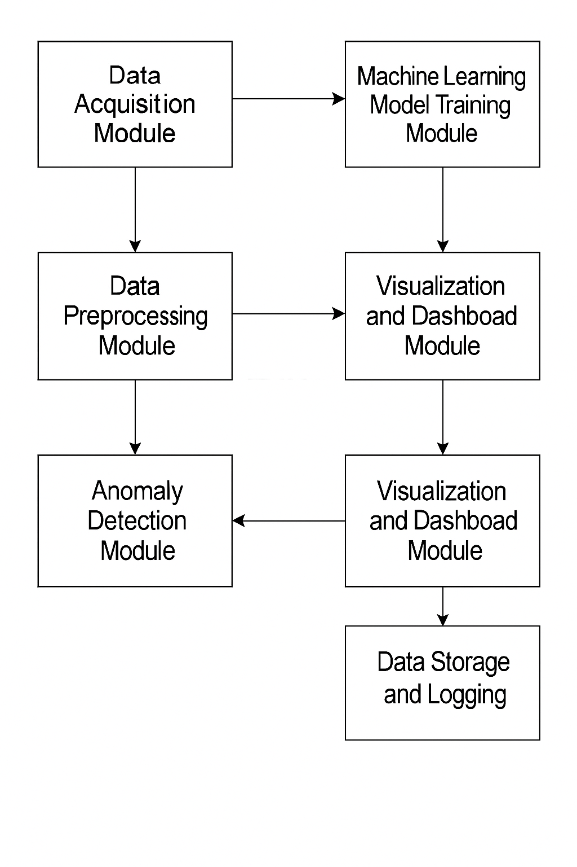
Figure 3.1: Block Diagram of Real-Time Solar Panel Performance Analysis System Using Machine Learning
3.2 ANALYSIS OF THE EXISTING SYSTEM
Traditional solar panel monitoring systems typically operate on a basic feedback mechanism, often relying on periodic manual inspections or limited data logging through inverters. These systems primarily display historical performance metrics, such as total power generated over a fixed period, voltage levels, and current flow, without providing predictive insights or real-time diagnostics. The lack of automation and intelligent analysis results in inefficiencies that hinder optimal performance and reduce the long-term reliability of solar energy systems. One of the major limitations of the existing systems is their inability to provide real-time analysis. Most of them gather data at wide intervals and store it for offline review. As a result, sudden changes in environmental conditions—such as shading, dust accumulation, or rapid temperature shifts, are not detected in time, leading to unanticipated drops in energy output. Moreover, traditional systems do not incorporate anomaly detection, making it difficult to distinguish between normal variations in output and actual panel faults or degradations.
Another shortcoming is the lack of predictive maintenance capabilities. System administrators often discover faults only after a significant performance drop has occurred, which can result in prolonged downtime and higher repair costs. Since there is no intelligent forecasting in place, operators cannot take proactive measures to optimize output or plan maintenance based on expected trends. Furthermore, the data visualization in existing systems is limited and often non-interactive. Users typically rely on numeric readouts or static graphs, which do not provide a comprehensive overview of system health or performance trends. This makes it challenging to make informed decisions, especially in large installations or remote solar farms.
Lastly, many of the existing systems are not scalable or customizable, particularly for developing regions or off-grid deployments. They often require expensive proprietary hardware and software platforms that are not easily adaptable to small-scale or research-based environments.
3.3 PROBLEMS OF THE EXISTING SYSTEM
The analysis of conventional solar panel monitoring systems reveals several critical problems that limit their effectiveness in ensuring optimal performance, early fault detection, and real-time responsiveness. These limitations significantly affect energy yield, increase operational costs, and reduce the reliability of solar energy systems, particularly in dynamic or large-scale environments. One major problem with existing systems is the absence of real-time monitoring. Most traditional systems rely on periodic data logging or manual inspection, which introduces delays in identifying and responding to performance issues. As a result, faults such as panel degradation, wiring issues, partial shading, or dust accumulation often go unnoticed until significant energy loss has occurred. Another notable issue is the lack of predictive capabilities. These systems typically collect and display historical data without any intelligence to forecast future panel performance. Without predictive analysis, system administrators are unable to take proactive measures, which limits preventive maintenance and often leads to avoidable system downtimes. Additionally, existing systems are inefficient in fault detection. They do not distinguish between minor, expected variations in panel output and serious faults. In the absence of intelligent anomaly detection, energy losses may persist over time before being identified through manual checks.
3.4 DESCRIPTION OF THE PROPOSED SYSTEM
The proposed system is a smart, real-time solar panel performance analysis platform that leverages machine learning (ML) and IoT technologies to monitor, analyze, and predict the operational efficiency of solar photovoltaic (PV) systems. Unlike traditional monitoring systems that offer only static or periodic feedback, this system continuously collects and processes real-time sensor data to provide actionable insights, detect anomalies, and forecast power output with high accuracy. At the core of the proposed system is the XGBoost (Extreme Gradient Boosting) algorithm, a powerful machine learning model known for its ability to handle structured data and produce accurate, robust predictions. The model is trained on historical and real-time solar performance data—such as irradiance, temperature, voltage, and current—to predict energy output under varying environmental conditions. When the actual output deviates significantly from the predicted output, the system triggers alerts for potential issues, enabling preventive maintenance and rapid fault resolution.
The data acquisition process involves deploying a set of sensors on the solar panel array. These sensors include temperature sensors, voltage and current sensors, and irradiance meters. The collected data is transmitted to a processing unit (such as a Raspberry Pi or cloud server) via MQTT or HTTP protocols. The data is then preprocessed to remove noise, handle missing values, and normalize feature ranges before being fed into the trained XGBoost model. The system also includes a real-time visualization dashboard developed using Python Flask or Django as the backend, with HTML, CSS, and JavaScript technologies for the front end. This dashboard displays live sensor data, predicted versus actual power output, efficiency trends, and alerts for any detected anomalies. Users can access the platform remotely via a web browser, enabling convenient and informed decision-making from anywhere.
Moreover, the system stores performance data in a lightweight database (such as SQLite or Firebase), which can be used for historical analysis, retraining the machine learning model, or long-term performance tracking. The architecture is designed to be modular, scalable, and low-cost, making it suitable for both residential and commercial solar installations.

3.5 ADVANTAGES OF THE NEW SYSTEM OVER THE EXISTING SYSTEM
The proposed real-time solar panel performance analysis system significantly improves upon the limitations of existing systems by incorporating machine learning, real-time data acquisition, anomaly detection, and intelligent visualization. These enhancements make the new system more reliable, efficient, scalable, and proactive in managing solar energy performance.

1. Real-Time Monitoring and Analysis
Unlike traditional systems that rely on delayed data collection and manual inspections, the proposed system continuously collects sensor data in real time. This allows for immediate detection of performance drops, sudden anomalies, or environmental disturbances, enabling faster response and reduced energy loss.

2. Predictive Power Output Using Machine Learning
By leveraging the XGBoost algorithm, the system is capable of forecasting expected power output based on variables such as irradiance, temperature, and time of day. This predictive capability enables operators to anticipate performance trends and take preventive action before faults impact the system.

3. Automated Fault Detection and Anomaly Alerts
The new system detects deviations between predicted and actual output and raises real-time alerts when anomalies occur. This proactive feature helps in identifying issues like dust accumulation, shading, or panel faults early, unlike the existing systems that only notify after significant performance losses.

4. Interactive and Intuitive Dashboard
The proposed system includes a user-friendly web-based dashboard that provides clear visualizations of system performance, predicted versus actual output, and historical trends. This improves decision-making, especially for non-technical users, compared to existing systems that often rely on static, technical readouts.

5. Scalable and Cost-Effective Architecture
The modular design using open-source tools (such as Python, Flask, and XGBoost) and affordable hardware (like Arduino or Raspberry Pi) makes the system scalable and suitable for both small and large solar installations. This is a major improvement over existing proprietary systems that are often expensive and inflexible.

6. Enhanced Maintenance Planning
With predictive analytics and real-time alerts, the system supports predictive maintenance. This reduces downtime, improves panel lifespan, and minimizes the cost of emergency repairs—features missing in conventional systems.
Top of Form
Top of Form

CHAPTER FOUR
DESIGN AND IMPLEMENTATION OF THE SYSTEM
4.1 DESIGN OF THE SYSTEM
The design of the system gives the details of the design components that make up the project application. The program designs components discussed in this section are the output design, input design, database design, and procedure design. Each of the sections is explained as follows with a diagram.
4.1.1 DISCUSSION OF TOOLS USED IN THE IMPLEMENTATION
Solar Panel
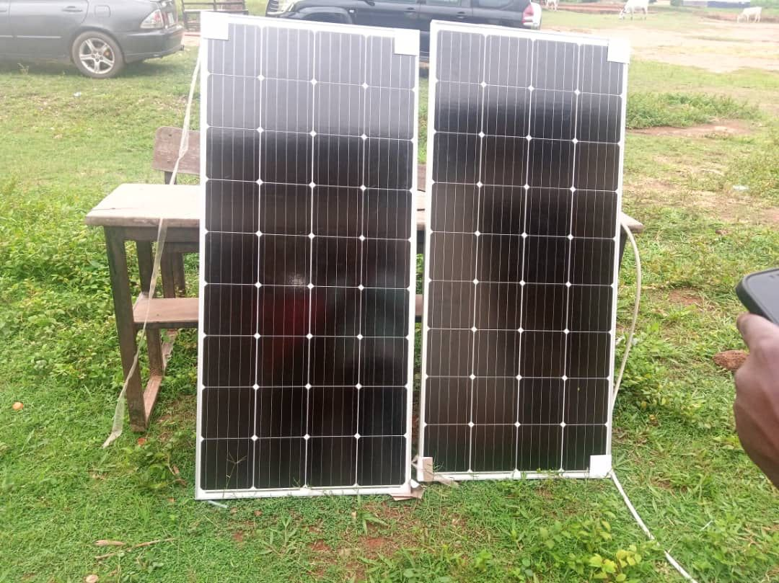
A solar panel is a device that converts sunlight into electricity by using photovoltaic (PV) cells. PV cells are made of materials that generate electrons when exposed to light. The electrons flow through a circuit and produce direct current (DC) electricity, which can be used to power various devices or be stored in batteries. Solar panels are also known as solar cell panels, solar electric panels, or PV modules.
Some advantages of solar panels are that they use a renewable and clean source of energy,

Figure 4.1: A monocrystalline solar panel
DEPOT WIRE
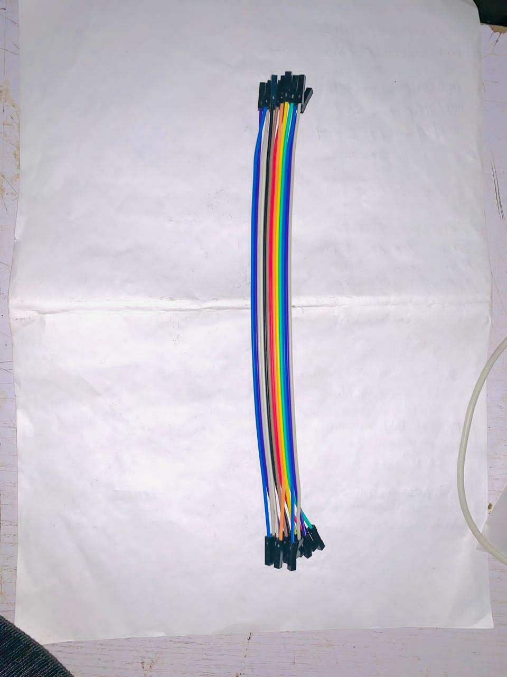
Figure 4.2: A Depot Wire

Converter
A power converter, also known as a power supply or voltage converter, is an electronic device used to convert electrical energy from one form to another. It is commonly used to convert alternating current (AC) to direct current (DC) or vice versa, as well as to adjust voltage levels and provide stable and regulated power to various electronic devices.
Power converters are widely used in a variety of applications, including power electronics, telecommunications, industrial automation, renewable energy systems, and consumer electronics. They play a crucial role in enabling the efficient and reliable operation of electrical and electronic equipment.
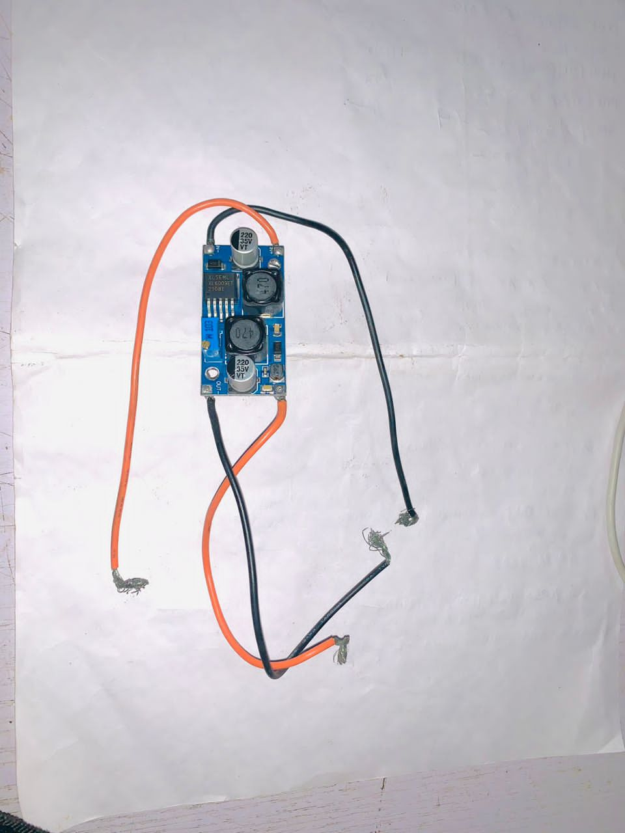

Figure 4.3: Converter

Two-channel Relay
A two-channel relay refers to a relay module that has two independent relay channels. A relay is an electrically operated switch that is controlled by an electrical signal. It consists of an electromagnet and a set of contacts that open or close when the relay is energized or de-energized.
A two-channel relay module typically includes two separate relays on a single circuit board. Each relay channel has its own input and output terminals, allowing it to be controlled independently. The module is commonly used in applications where multiple electrical circuits or devices need to be controlled or switched using separate relay channels.
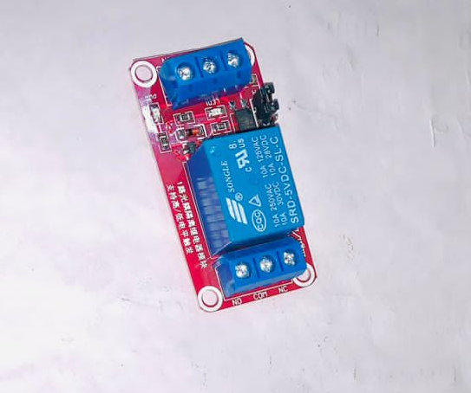
Figure 4.4: The Two-channel Relay
One-Channel Relay
A one-channel relay refers to a relay module that has a single relay channel. A relay is an electrically operated switch that is controlled by an electrical signal. It consists of an electromagnet and a set of contacts that open or close when the relay is energized or de-energized. A one-channel relay module typically includes one relay on a circuit board. It has input and output terminals for controlling and switching an electrical load. The module is commonly used in applications where a single electrical circuit or device needs to be controlled or switched.
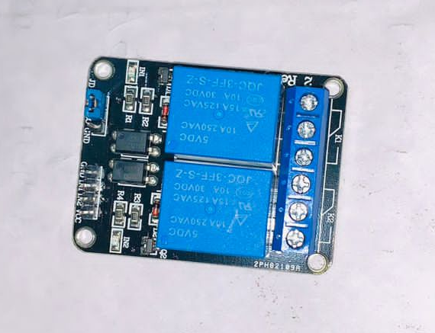
Figure 4.5: One-channel relay used
PIR
PIR stands for Passive Infrared, and a PIR sensor is a type of electronic device used to detect motion based on changes in infrared radiation in its field of view. PIR sensors are commonly used in security systems, automated lighting systems, and other applications that require motion detection. A PIR sensor consists of a pyroelectric sensor, which detects infrared radiation, and a circuit that processes the sensor's output. The sensor detects changes in the infrared radiation emitted by objects in its vicinity, including the heat emitted by living beings. When a person or object moves within the range of the PIR sensor, it detects the change in infrared radiation and sends a signal to the connected circuit or system. This signal is then used to trigger a response, such as activating an alarm, turning on lights, or initiating a recording.
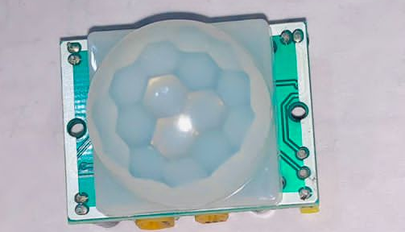
Figure 4.6: PIR
Led bulb
An LED bulb, or light-emitting diode bulb, is an energy-efficient lighting device that uses light-emitting diodes (LEDs) as the source of illumination. LED bulbs have gained popularity as a replacement for traditional incandescent and compact fluorescent lamps (CFLs) due to their numerous advantages, including energy efficiency, long lifespan, and environmental friendliness.
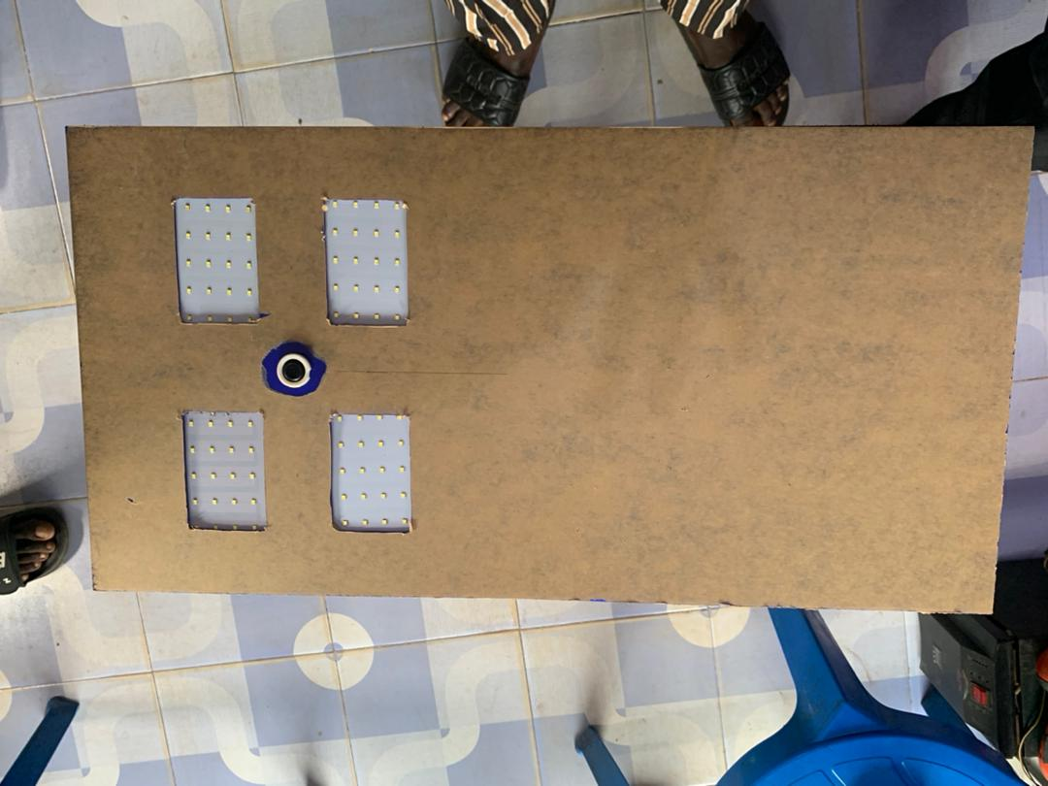
Figure 4.7: Led Bulb

Cables

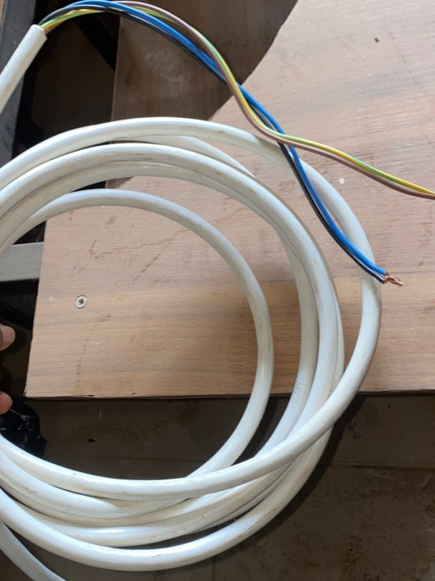
cable, in electrical and electronic systems, is a conductor or group of conductors for transmitting electric power or telecommunication signals from one place to another. Electric communication cables transmit voice messages, computer data, and visual images via electrical signals to telephones, wired radios, computers, teleprinters, facsimile machines, and televisions.

Figure 4.8: This cable was used to join the Solar Panel and Charge Controller
Note that in our implementation, we used so many cables. We only mention the above to know that we made use of cables.
4.1.2 TESTING PHASE IN STREET LIGHTING
How to test the security camera system in 2 simple steps
When it comes to home/work/school security, Street Lighting systems are a popular choice for many homeowners and business owners. These systems can provide peace of mind by allowing you to monitor your property, deter potential intruders, and provide evidence in the event of a break-in. However, like any technology, Street Lighting systems require maintenance and testing to ensure they are functioning properly. That's why in this research work, the researcher will discuss how to test the Street Lighting system in three simple steps. By following these steps, you can ensure that your Street Lighting system is operating at its best and providing optimal security for your home/work/school. So let's dive in and learn how to tested the Street Lighting system.
Step 1: Checking the Street Lighting Positioning and Focus
The first step in testing of the Street Lighting system is to checked the positioning and focus of the Led bulbs. Properly led bulb positioning and focus are crucial for ensuring that the Street Lighting sees clearly and accurately. Here are some tips for checking the Street Lighting and focus:
A. Check Led Bulb Positioning
- We make sure that our bulbs are pointed in the right direction to cover the areas we want to monitor.
- We ensure that our bulbs are installed at the right height and angle to capture clear footage.
- We check for any obstructions that could interfere with the view, such as trees or other objects.
B. Check Bulb Focus
- We use monitors or viewing software to check the bulb's focus.
- We make sure that the bulbs are focused on the area we want to monitor.
- We adjust the bulb focus to ensure clarity.
- By checking our bulb positioning and focus, we can ensure that our Street Lighting system sees clearly and provides accurate monitoring of the environment.

A. Lighting Conditions
- We check the lighting conditions in the areas being monitored.
- We ensure that the cameras are adjusted to the correct settings for the lighting conditions.
- We install additional lighting to improve image quality.
4.1.3 OUTPUT DESIGN
The design of output is the most important task of any system. During output design, we identify the type of outputs needed, and consider the necessary output controls and prototype report layouts
Led Bulb
Figure 4.9: This is the output of the first Led bulb

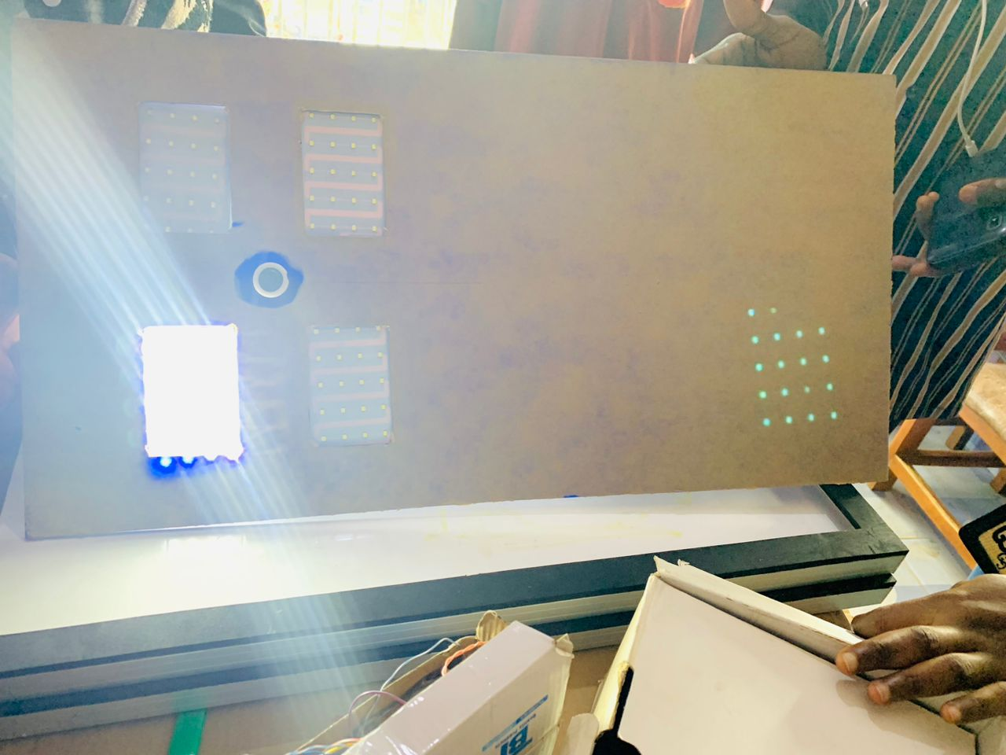
Figure 4.10: This is the output of the second led bulb, turned on.

4.1.4 INPUT DESIGN
The input design is raw data that produce an output.
Street Lighting System
A street lighting system refers to the infrastructure that provides illumination for public roads, streets, highways, and other outdoor areas during nighttime hours. It plays a crucial role in ensuring public safety, enhancing visibility, and creating a comfortable environment for pedestrians, drivers, and residents. Street lighting systems typically consist of light fixtures, poles, electrical wiring, control systems, and power sou 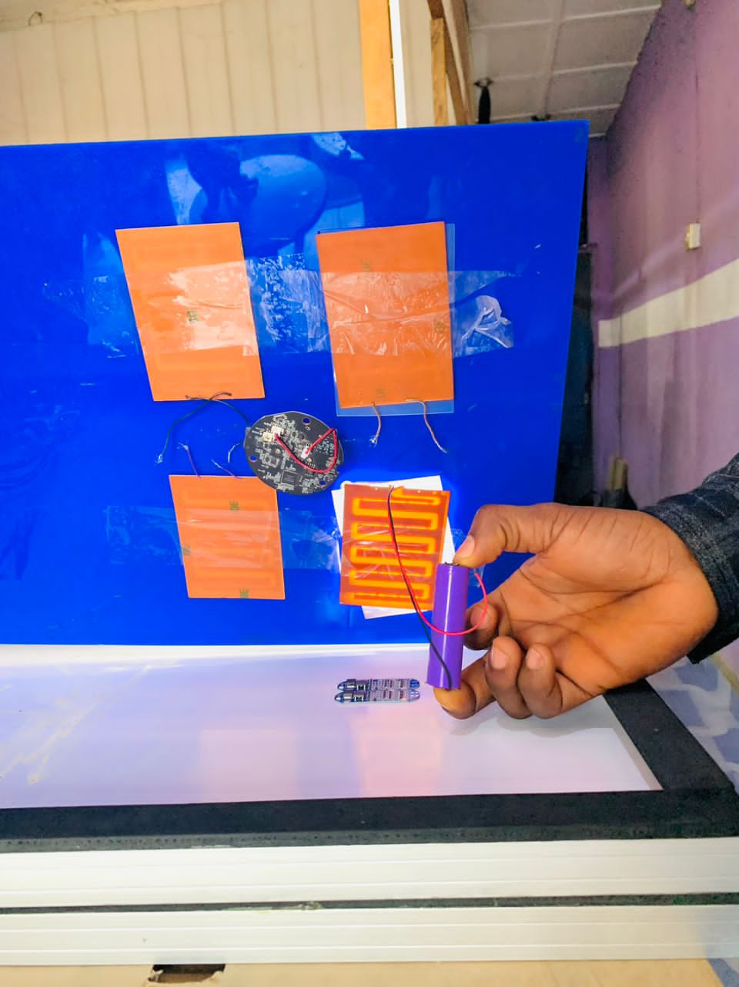
Figure 4.11: Assemblying the Lighting System
4.2 SYSTEM IMPLEMENTATION
4.2.1 Installation of Light Fixtures:
Determine optimal fixture locations: Identify the most suitable locations for installing the light fixtures based on the street layout, safety considerations, and lighting requirements.
Mount light fixtures: Install the fixtures on poles or structures at the recommended heights and angles to ensure proper light distribution.
Connect wiring: Properly connect the wiring between the light fixtures, control systems, and power supply.

4.2.2 Integration of Control System:
Install control equipment: If using a centralized control system, install the necessary control equipment, such as controllers, sensors, and communication devices.
Configure control system settings: Set up the control systems parameters, such as dimming levels, scheduling, and fault monitoring, based on the desired lighting requirements.
Test control system functionality: Verify that the control system is functioning correctly, including remote monitoring, control commands, and data communication.
4.2.3 Power Supply and Connection:
Ensure reliable power supply: Establish a reliable power source for the street lighting system, such as a local electrical grid or dedicated power lines.
Connect light fixtures to the power supply: Properly connect the light fixtures to the power supply, ensuring compliance with electrical safety standards and regulations.
4.2.4 Testing and Commissioning:
Conduct system testing: Test the entire street lighting system to ensure proper functionality of all components, including light fixtures, control systems, and power supply.
Verify lighting performance: Check the illumination levels, uniformity, and coverage of the street lighting system to ensure they meet the specified requirements.
Address any issues: Identify and address any issues or deficiencies discovered during testing, such as defective fixtures or connectivity problems.

4.3 SYSTEM DOCUMENTATION
4.3.1 DOCUMENTATION OF THE SYSTEM
Documentation is very important in the implementation of any system. This is because documentation makes the system easier for all users, and if a system is not well documented it becomes difficult to use.
4.3.2 OPERATING THE SYSTEM
Setting up a street lighting system involves several steps and considerations to ensure proper installation and functionality. Here is a general guide to help you with the setup:
Design and Planning:
- Assess the lighting requirements: Determine the lighting needs of the street, including the required brightness levels, coverage area, and desired lighting uniformity.
- Evaluate the street layout: Analyze the street layout and identify suitable locations for light fixtures, considering factors such as pedestrian and vehicular traffic, obstructions, and safety requirements.
- Calculate the lighting layout: Use lighting design software or consult with a lighting professional to calculate the number and placement of light fixtures based on the street's dimensions and lighting standards.
Obtain Necessary Approvals and Permits:
- Check with local authorities: Research and comply with the regulations, guidelines, and specifications set by local authorities regarding street lighting installations.
- Obtain permits: Obtain the required permits and permissions for installing and operating the street lighting system.

Procure the Equipment:
- Select appropriate light fixtures: Choose LED street lights that meet the required lighting specifications, energy efficiency standards, and durability criteria.
- Consider supporting equipment: Determine the need for supporting equipment such as poles, brackets, wiring, control systems, and power supplies.
Installation:
- Engage professional electricians: Hire licensed electricians experienced in street lighting installations to ensure proper wiring, connections, and adherence to electrical codes.
- Mounting the fixtures: Install light fixtures on designated poles or structures, ensuring they are securely mounted at the recommended height and angle for optimal light distribution.
- Wiring and connections: Install the necessary wiring and make electrical connections between the fixtures, control systems, and power supply.
Testing and Adjustment:
- Power up the system: Connect the street lighting system to the power supply and verify proper functioning of all components.
- Conduct thorough testing: Perform testing to ensure that the lighting levels, coverage, and uniformity meet the specified requirements.
- Make adjustments: Fine-tune the system by adjusting the angle, direction, or intensity of individual fixtures if necessary.

4.3.3 MAINTAINING THE SYSTEM
Maintaining a street lighting system is crucial to ensure its proper functioning, longevity, and optimal performance. Regular maintenance helps identify and address any issues promptly, reduces energy wastage, and improves public safety. Here are some key maintenance practices for maintaining a street lighting system:
Regular Inspections:
- Conduct routine visual inspections of all light fixtures, poles, wiring, and control equipment to check for any signs of damage, corrosion, or wear.
- Inspect the integrity of the poles, ensuring they are securely mounted and not leaning or damaged.
- Look for signs of vegetation growth that may obstruct the light output and trim or remove vegetation as necessary.
Cleanliness and Dirt Removal:
- Clean the light fixtures and lenses periodically to remove dirt, dust, and debris that can accumulate over time and reduce the light output.
- Ensure that the lenses or diffusers are clear and free from any obstructions that may hinder the light distribution.
Lamp Replacement:
- Monitor the performance of the lamps and replace any burned-out or malfunctioning lamps promptly.
- Consider replacing traditional lamps with energy-efficient LED lamps, as they have longer lifespans and require less frequent replacement.

Electrical Connections:
- Regularly inspect the electrical connections, junction boxes, and wiring for any loose or damaged components.
- Verify that all electrical connections are secure and properly insulated to prevent any electrical hazards.
Control System and Timers:
- Test and calibrate the control system periodically to ensure accurate timing and scheduling of the street lighting.
- Verify that light sensors and timers are functioning correctly, adjusting them as necessary to match the changing daylight conditions.
Power Supply:
- Regularly check the power supply connections and ensure the voltage levels are within the specified range.
- Monitor the functionality of the circuit breakers and protective devices to ensure proper electrical safety.

CHAPTER FIVE
SUMMARY, CONCLUSION, AND RECOMMENDATION
5.1 Summary
This project focused on the design and development of a real-time solar panel performance analysis system using machine learning, with the aim of addressing the limitations of conventional solar monitoring methods. Traditional systems often rely on periodic data checks, lack intelligent fault detection, and are incapable of providing real-time or predictive insights. These shortcomings result in reduced energy efficiency, delayed fault identification, and increased operational costs. The proposed system integrates IoT-based data acquisition with the XGBoost algorithm, a powerful machine learning model, to predict power output and identify anomalies in real time. Data such as solar irradiance, temperature, voltage, and current is collected using sensors and processed through a trained model. A web-based dashboard displays live output, historical trends, predicted performance, and alerts users to abnormalities. The project was developed through a modular approach consisting of data acquisition, preprocessing, model training, fault detection, visualization, and storage. The system leverages Python programming language along with tools such as Flask, SQLite, Pandas, and Scikit-learn for model deployment and visualization. Compared to existing systems, the new solution offers improved efficiency, automation, user interactivity, scalability, and cost-effectiveness.
5.2 Conclusion
The research and implementation of a real-time solar panel performance analysis system using machine learning has proven to be a viable and innovative solution for enhancing solar energy management. The integration of XGBoost for predictive modeling and the use of IoT for live data capture address the inefficiencies of traditional systems. With accurate forecasting and real-time anomaly detection, the system supports preventive maintenance, maximizes energy output, and contributes to the sustainability of solar power infrastructure. The project has successfully demonstrated how combining machine learning with smart monitoring tools can enable intelligent decision-making in renewable energy systems. This approach not only reduces energy loss but also improves reliability and extends the lifespan of solar installations. The web-based dashboard adds an extra layer of user engagement by offering meaningful, real-time insights for system operators, researchers, and end users.
5.3 Recommendations
Based on the success and findings of this project, the following recommendations are made for further improvement and real-world deployment:
- Integration with Cloud Services: Future iterations should integrate cloud-based platforms (e.g., AWS, Azure, Firebase) to enhance data storage, accessibility, and scalability, especially for remote or distributed solar farms.
- Mobile Application Development: A mobile-friendly interface or dedicated app should be developed to allow users to monitor and control their systems from anywhere, at any time.
- Use of Renewable Forecasting APIs: Incorporating real-time weather forecasting APIs can enhance the accuracy of the machine learning model by adding external predictive variables.
- Expansion to Other Renewable Sources: The system architecture should be adapted to monitor wind turbines, battery banks, or hybrid renewable systems for broader application.
- Advanced Deep Learning Models: Although XGBoost performed well, future enhancements could explore deep learning models such as LSTM or CNNs for handling time-series and image-based solar panel data.
- Hardware Optimization: The system can be upgraded to use industrial-grade microcontrollers and sensors for deployment in harsh environmental conditions, ensuring long-term stability.

REFERENCES
OpenAI. (2022). GPT-3.5 Architecture. Retrieved from 2022 https://openai.com/blog/gpt-3-5/ Sternberg, M. (2022). Solar security: Protecting your investment. Solar Power World. Retrieved from https://wwwpp.solarpowerworldonline.com/2022/01/solar-security protecting-your-investment/
Kumar, A., & Rana, R. (2022). A review of solar security systems and challenges. Journal of Renewable Energy, 188, 118-126. doi: 10.1016/j.renene.2021.10.005
Huang, Y., Chen, X., Lu, H., & Wei, Y. (2021). Solar security detection using deep learning: a review. Energy Reports, 7, 1801-1811. doi 10.1016/j.egyr.2021.03.010
Wu, Y., Li, H., Li, W., Zhao, L., & Li, S. (2020). A deep learning approach for solar security detection. In Proceedings of the 2020 International Conference on Renewable Energy and Environment (ICREE 2020) (pp. 157-162). Atlantis Press. doi: 10.2991/assehr.k.201015.031
Zhang, Y., Li, J., Yang, L., Liu, Y., & Xu, C. (2022). Deep Learning-Based Solar Security Detection System: A Review. Energies, 15(3), 557. doi: 10.3390/en15030557.
Solar Energy Industries Association. (n.d.). How much do solar panels cost? Retrieved April 25, 2023, from https://www.seia.org/initiatives/solar-costs
Vahidi, M., Ahmad, M. O., & Zhang, Z. (2021). A Review of Deep Learning-Based Solar Security Systems. Journal of Renewable Energy, 2021, 1-16. doi 10.1155/2021/6658969.
International Energy Agency. (2020). Renewable Capacity Statistics 2020. Retrieved from https://www.iea.org/reports/renewable-capacity-statistics-2020
Zhang, Y., Li, J., Yang, L., Liu, Y., & Xu, C. (2020). Deep learning-based solar security detection system. IEEE Access, 8, 179102-179111.

