CHAPTER ONE
1.1 INTRODUCTION
It is generally accepted as a common saying that every work and no play makes jack a dull boy (Drucker, 2011). Thus, this is a phenomenon that occasion the need for work leave. Human is said to be only functioning resources that pushes the activities of other management resources into action. The proper functioning of the element of management such as planning, organizing, coordinating, staffing, recruiting, and directing calls for keen and meticulous implementation of workable administrative plan. The administrative resources of the management are not under-used or over-used. It is apparently a known fact that men are finite and this have elastic limit. The human body functions at its best for adequate and effective discharge of duties when adequate refreshing plan is put in order. Hence, this gives rise to the need for a work leave. Work leave therefore is a deliberate system that is put in place by the management to formally absent members of staff from work on order to certain and increase their level of effectiveness. Additionally, the work leave plan it also regarded as a temporal absence of an employee from his or her primary job while maintaining the status of employee (Drucker, 2011). There are dimensions of work leave such as garden leave, annual leave, sabbatical leave, medical leave, exam leave, etc. According to the U. S Department on Management,work leave enables employees to take time off from work for various reasons. This act is ubiquitous among the nations of the world. Urbycoz in his words asserts that the term “work leave” originated in the British civil service where employees had the right to request special leave for exceptional purpose. According to the MANILA DOCTORS HOSPITAL guideline, work leave is carried out to attain the employees highest working efficiency as far as performance and compliance to duties are concerned. The information also pinpoints that many employees commit general leave of absence but the these leaves are subject to prior computation and meticulous monitoring in order to give what should be vested to an employee. Thus, this indicates that the work leave is designed and implemented in such a way that the scheduling has zero negative effect on the functioning of the management system as due, priority scheduling techniques is keenly contracted. This scheduling design in line with the management system monitors the number of leaves and employee commits and proper computations of such absence. The priority scheduling techniques considers proper arrangement in an organized and systematic way. This will in turn retain and improve the work efficiency and quality of service. The design and implementation of work leave scheduling and management system, using priority scheduling techniques. Ultimately, the scheduling is aimed at enabling the employee to be refreshed for quality service. Performance and delivery and secondly to ensure that the scheduling plan has a positive effective on the growth and development of the managerial system in the organization. HriditaAfsana adequately informs that the human resources are the valuable resources an organization depends on for it success because of the potential to manage the most note worthy and valuable resources of an organization (Porter & Kramer, 2011). This, therefore, indicates that the proper design and implementation of work leave scheduling in the managerial system would succeed a breast the human resources of the managerial consequently since the human resource equally needs adequate rest to function at its best in order to avoid personal and managerial collapse, a proper work leave scheduling system must be put in place buy using priority scheduling techniques.
1.2 STATEMENT OF THE PROBLEMS
The strength of team work is said to be embattled if an organization fails to properly fractionalize the decisions that surround the work leave prioritization. This however has been the order of the day in most organization in the sense that proper prioritization is neglected and not brought to book. This in turn reflects a negative effect on hesole aim of the establishment which is the maximizations only approve work leave respectively without prioritizing the need for the later to want the former the need for the later to want for the former and vice versa.
HriditaAfsana (2013), comments in his works the major part of Human Resource department is to keep all the records of personal information and managing leave data of all the employees, most importantly paid leaves taken by employees, up to date and readily available in times of need. He stress that “the maintenance of these become apparently difficult for the Human Resource department when all the is done manually”
Thus, Hridita stress the computation of the employees work leave in order to by pass the huddle created by the manual approach system. But this research emphasizes the priority scheduling techniques for the employees work leave.
1.3 AIM AND OBJECTIVES
The aim of this project is to develop a work leave scheduling and management system with the following objectives:
- Adaption of priority scheduling techniques to work leave scheduling
- Implementation of the adapted algorithm
1.4 SIGNIFICANCE OF THE STUDY
This project is beneficial to organizations, entrepreneurs and functioning companies because it will aid a clearer understanding of administering work leave in the ways and manner that it does not affect the growth and development of the management. It will be of immense benefits to private firm owners, who quite for a purposeful, yielding and success oriented establishments.
This work equally unravels literatures capable of helping a management to tune to an updated options is far as work leave smooth running. This project will be an eye opener to the human resource manager as he sits meticulously on his decisions making, regarding the leaves to approve or not. On a final not this project will recommend ways by which an organization could be well managed work title or no interference stemming form the work leave management plan through priority scheduling techniques
1.5 SCOPE OF THE STUDY
This project is focused on the design and implementation of work leave scheduling and management system using priority scheduling techniques. It uses the practice of work leave management in WANDEL INTERNATIONAL LIMITED. To get hold of relevant information for his project, the company to located at 77/79 Eric Moore Road, Surulere, Lagos, Nigeria. The company is into importing and distributing the TVs motors company, India and Luminous inverters.

1.6 DEFINITIONS OF TERMS
Term that are germane to this project are defined and they are as follows:
Work: Is the activity involving in mental or physical effort done in order to achieve a purpose or it is also the place where one is employed.
Leave: Is a period of time that one must be away from one’s primary job while maintaining the status of employee.
Work Leave: This can be defined as the time off work to much on employee may be entitled depend on the organization leave plan schedule through a formal process prior to approval.
Management: This can be defined as the process of the administration of an organization through principle relating to the functions of planning, organizing, directing, staffing, leading and controlling (a group of one or more people or entitle) or effort for the purpose of accomplishing a goal.
Management System: This can be defined as a set of policies, process and procedure used by an organization to ensure that it can fulfill the tasks required to achieve its objectives.
Priority: This can be defined as the fact or condition of being regarded or treated as more importance than others, it also refers to the important to be dealt with first. In this work, it is used to consider what leave request should be given priority.
Priority Scheduling: This can be defined as the method or techniques of scheduling processes based on priority. In this project, it is used to consider the work leave priority scheduling so as not to affect the work flow of the organization.
1.7 ORGANISATION OF THE STUDY
This is the overall organizational structure of the work as presented in this project writeup.
Chapter one of this project deals with the introduction to the general work in the project. It also entails the statement of the problem, aim and objectives of the project, the significance of the study, the scope and limitation of the study and organization of the report.
Chapter two deals with the review of related journals and books, historical background of the study, as well as computerization of current state of the art.
Chapter three covers the methods used for data collection, description of the current procedure, problems of existing system, description of the proposed system and the basic advantages of the proposed is system based application.
Chapter four entails design, implementation and documentation of the system. The design involves the system design, output design form, input design form, database structure and the procedure of the system. The implementation involves the implementation techniques used in details, choice of programming language used and the hardware and software support. The documentation of the system involves the operation of the system and the maintenance of the system.
Chapter five deals with the summary, experience gained, conclusion, recommendation and references.

CHAPTER TWO
2.1 LITERATURE REVIEW
Leave Management System by Pratik (2011),stated that leaves are maintained using the attendance register for staff. The staff needs to submit their leaves manually to their respective authorities. This increases the paperwork and maintaining the records becomes tedious. Maintaining notices in the records also increases the paperwork. The main objective of the proposed system is to decrease the paperwork and help in easier record maintenance by having particular centralized Database System, where Leaves and Notices are maintained. The proposed system automates the existing system. It decreases the paperwork and enables easier record maintenance. It also reduces chances of Data loss. He also stated that Leave Management System is the important system in administration department in all company. However, the management is different for each company. Some company still comfort with the manual system and the other make change the system from manual to computerize to make the management more effective. Leave time is a comprehensive and flexible leave management system enabling us to enter and manage leave requests according to company rules. This time of the year, many employers face a formidable task of juggling and approving leaves applications. Employer need to ensure they are keeping staff happy but retaining the right workforce to do the job for themselves and customers over Eid-New Year, traditionally a time with high priorities on maintenance and preparations for the year ahead. This company develop an automated payroll and leave management systems which offers an on-line leave management system designed to radically simplify for employees and employers alike the process of planning, applying for and approving leave. This system eliminates paperwork and cuts delay by enabling employees and supervisors to action time-off applications simply by entering the dates and type of leave being sought after the employee has viewed his or her entitlements online. Employees used a personal ID code to get immediate access to their entitlements, while managers can at a glance see all employees' leave history, leave balances, pending leave applications and approved. The benefit of the system is that it saves time by eliminating paperwork, enhances employee satisfaction by speeding up the process and helps managers by ensuring compliance with company policies. Their system is a web-based, there is no software to install or support and no additional hardware required to operate the system.
Student leave management system by Jyotirmay and Solanki (2011), discussed about scheduling policies of central processing unit (CPU) for computer system. A number of problems were solved to find the appropriate among them. Therefore, based on performance, the shortest job first (SJF) algorithm is suggested for the CPU scheduling problem to decrease either the average waiting time or average turnaround time. Also, the first come first serve (FCFS) algorithm is suggested for the CPU scheduling problems to reduce either the average CPU utilization or average throughput.
Employee Leave Management System by Jain (2014) affirms that the success of any organization widely depends on human resources. Managing human resources strategically has become very important for the companies in today world HR manager’s role and skills have developed significantly because of the adoption and use of new technologies. He reveal that In the existing system, leaves are maintained using the attendance register for staff. The staff needs to submit their leaves manually to their respective authorities. This increases the paperwork & maintaining the records becomes tedious. Maintaining notices in the records also increases the paperwork. The main objective of the proposed system is to reduce the paperwork and help in easier record maintenance by having a particular centralized Database System, where Leaves and Notices are maintained. The proposed system modernizes and automates the existing system. It decreases the paperwork and enables easier record maintenance. It also reduces chances of Data loss. This module intelligently adapts to HR policy of the management & allows easy leave handling for better scheduling of workload.
The Leave Management System (LMS)byMehdi (2010), stated that leave management is an Intranet based application that can be accessed throughout the organisation or a specified group/Dept. This system can be used to automate the workflow of leave applications and their approvals. The periodic crediting of leave is also automated. There are features like email notifications, automatic approval of leave, report generators in this system.
Leave Management System byNeshat, Mehdi Sargolzali, Adel Najaran, Aliadeli (2012), The new method of adoptive CPU scheduling using Fonseca and Fleming’s genetic algorithm, proposed a new CPU scheduling. This algorithm based on three parameters of CPU burst time, VO service time and priority of processes. The proposed FFGA multi objective optimization algorithm is used. It selects and runs the desired process through adaptation. In this algorithm, the priority of processes increases with time. The proposal algorithm is analyzed with the other method showed that the average waiting time and average response time are reduced.

2.2 REVIEW OF RELATED WORKS
Student leave management system by Ghanadarko-Asumadu et al (2010) in their works inform that the influence of work-life balance on employee commitment and this should be of interest to social workers. In the banking sector where employees work interferes with their social life, it is crucial to examine their commitment.
The objectives of the study were to explore employee’s perception on work-life balance and the relationship between work-life balance and commitment. In other words the concept of work leave makes the acquisition of the best working ability from an employee obtainable. Work leave is regarded as a break from work for the refreshing of the mental reasoning of a worker in order to bring out the best from them. Bridget Miller notes that the work leaves are legally mandated to be available and others are voluntarily offered by employers. According to Adekola, work leave is defined as formal period of absence from work place based on the contractual agreement of employment. He adds that it assists to boost the morale of the employees.
Leave can also be defined as a period of time that an employee must be away from his primary job, while maintaining the status of employee. Thus, it can further be seen as the hours or days employee of an organization is permitted to be away from their employment. This implies that the times. Taken off is paid by the company or organization and the employees are allowed to request the time for any reason they wish to be off from work. Ultimately, it is supposed that work leave enables the employee to bring out the best in him when he returns back to the office. This time off is important to maintaining a positive a work/life balance.
2.2.1 TYPES OF WORK LEAVE
Employees need time to leave work for many different types of situation and they will need to request this time from their supervisor. The employee of any organization are entitled to certain types of leaves during their work tenures help them maintain adequacy and skillfulness for higher performance in the discharge of their duties.
There are different types of work leave, some are official authorized to be offered, and others are voluntary presented by employers.
According to the policy of MetLife, there are types of leave that all employees of the organization can avail.
- Earned leave (Annual / privilege leave)
- Casual leave
- Sick leave
- Maternity leave
- Volunteering leave
- Study leave
- Leave without pay (LWP)
2.2.2 DESCRIPTION OF DIFFERENT TYPES OF LEAVE
1. EARNED LEAVE (ANNUAL / PRIVILEGE LEAVE)
This type of leave is completed one year of permanent employee who has completed one year of continuous service at MetLife. He/she will be able to avail earned leave of eighteen working days. It is counted of in year an employee will be able to request for leave fare assistance (LFA) with an application of minimum 3days of earned leave which must be submitted within two months before the date of availing. Un–availed annual earned leave(s) shall be accumulated or carried forward to next year which shall not exceed 6 working days.
2. CASUAL LEAVE
This can be applied by an employee when he/she is unable to attend office due to situation of an emergency nature. It is counted in working days. Casual leave is granted for maximum (3) days at a stretch and cannot be prefixed with annual leave or holiday. It cannot be carried forward to next year. The company have right to disallow any casual leave if it is not satisfied with the reasons for absence of the employees for which casual leave has been applied for.
3. SICK LEAVE
All employees are entitled to sick leave from the date of joining at MetLife. Sick leaves are counted in calendar days and are not carried forward to next year. If an employee remain sick for more than two consecutive working days then the employee must provide a medical certificate issued by a licensed medical practitioner after joining.
4. MATERNITY LEAVE
At MetLife, a female employee is entitled to avail maternity leave for 180days with full payment. After completion of (6) six months service in the company will be entitled to avail maternity leave. This type of leave is not be admissible more than twice during her tenure of service in MetLife.
5. VOLUNTARY LEAVE
This type of leave is provided to employees to encourage them to contribute to social activities and help people in need. All permanent employees of MetLife can apply for up to 1 working day or (2 half days) of each calendar year and this leave is not carried forward or accumulated in next year.
6. STUDY LEAVE
This type of leave is guided by the policies developed by MetLife Bangladesh for different study programs.
7. LEAVE WITHOUT PAY (LWP)
Leave without pay may be granted to an employee in special circumstances when no other leave is under this policy permissible or if all other applicable leave has been availed. LWP is measured in calendar days.
Other forms of work leave are also listed below:
- Bereavement
- Administrative
- Voting
- Compassionate leave
- Career break leave

CHAPTER THREE
3.0 METHODOLOGY AND ANALYSIS OF THE SYSTEM
3.1 RESEARCH METHODOLOGY
Research methodology refers to the methods or tools that is used during the research work. The proposed system is developed with C# programming language and MYSQL as the database. They are as follows;
- For Data Gathering: the method I used in gathering of data is direct. Due to the importance attached to collection of accurate information from the right, authentic and reliable source.
- Technique Used: the technique that I used in the proposed system is the parallel method of implementation simply because parallel supports the use of a system with the existing one in case of system failure so that it will not be back to square one for the user of such system.
- Tools: The system frontend was implemented using C# while Microsoft SQL Server was used for the backend.
Other method that can be employed for the system aside the ones i used are;
  - Use of internet: this is the medium of gathering information through searching on the internet.
3.1.1 PRIORITY SCHEDULING TECHNIQUE
Scheduling forms the basis of multi-programmed operating systems. It is because scheduling determines which processes run when there are multiple runnable processes. For the system of single processor, when multiple process comes, then one process can be execute at a time and other process remain in waiting state until the CPU becomes ideal or can be schedule again. To expand the CPU usage, the goal of multiprogramming is to have some procedure running at all times. CPU scheduling manages the issue of choosing which of the procedures in the ready queue is to be assigned the CPU. Operating System usually performs scheduling of processes which is major task of a system. Different number of algorithms is used to schedule processes such as First Come First Serve (FCFS), Shortest Job First (SJF), round robin and priority scheduling algorithm. In FCFS, the process that arrives first is executed first. The SJF works on shortest burst time it means the job that has lowest burst time is executed first and then another process and so on. In the round robin scheduling, processes are executed in First In First Out (FIFO) manner but are given a small amount of CPU time called a time-slice or a quantum. The CPU is preempted, if a process does not complete before its CPU-time expires and given to the next process waiting in a queue. In priority Scheduling algorithm, a priority is assigned to each process, and priority is allowed to run. Each process have their different priorities, according to the priority the processes are executed. Higher priority process will executed first and then the lower priority and so on. Generally, we use the lowest integer as highest priority. If the two or more process has equal priorities then they executed in FCFS manner such that the process which enters first will executed first. The decision of priority can be internally or externally. Internal priority uses some factors these are available to calculate the priority of a process. External priorities are set by criteria outside the operating system.

3.2 ANALYSIS OF THE EXISTING SYSTEM
Before the use of computer for work leave management system the existing paper work related to leave management, leaves are maintained using the attendance register for staff. The staff needs to submit their leaves manually to their respective authorities. This increases the paperwork & maintaining the records becomes tedious. Maintaining notices in the records also increases the paperwork.
3.3 PROBLEMS OF THE EXISTING SYSTEM
The use of paper work for work leave does not ensures security of every record. It increases the redundancy of data and gives various facilities. It leads to loss of data. The employee has to write a letter to its superior for leave which makes it a tedious work for the employee.
The following problems are faced with the existing system:
- Lack of Security
Paper document filing can be less secure than electronic filing systems. Misplaced documents can easily be placed in the wrong hands. Clients expect their information to be secure in your hands. If you can’t keep this safe, you are at risk for losing them. A cabinet filled with files is way easier to access than a computer which requires a password and credentials to get into.
- Access Time
Manual leave document filing is very time consuming. Not only do you have to organize and store the files, hunting down the information when it is need can take time. It can take anywhere from minutes to hours to hunt down a file, depending on how well your organization is. This can cause annoyance for management as well as for employees. Their productivity is lowered by having to spend excessive time dealing with a paper filing system.
- Higher Cost
When you use paper documents for your work leave your costs are going to be higher because you are paying for ink and paper. Your office supply bill will be higher if you are using a manual document filing process. While you might think this is insignificant, overtime it’s a lot of money that can be used in better ways.

CHAPTER FOUR
IMPLEMENTATION AND DOCUMENTATION OF THE SYSTEM
4.1 DESIGN OF THE SYSTEM
Generally, all efforts are geared toward designing a system program that eliminates all the setbacks of the existing manual method. This new approach is simple, efficient and guaranteed.
The proposed is designed in order to meet the goal and objective of the organization. The design of the system is intended to solve the various problems contributed in the manual method of work leave request and approval method.
4.1.1 OUTPUT DESIGN
In the below figure, it is Admin dashboard page screen which contain the all module of the project like add employee, Requested leave, Show allowed leave and show employee.
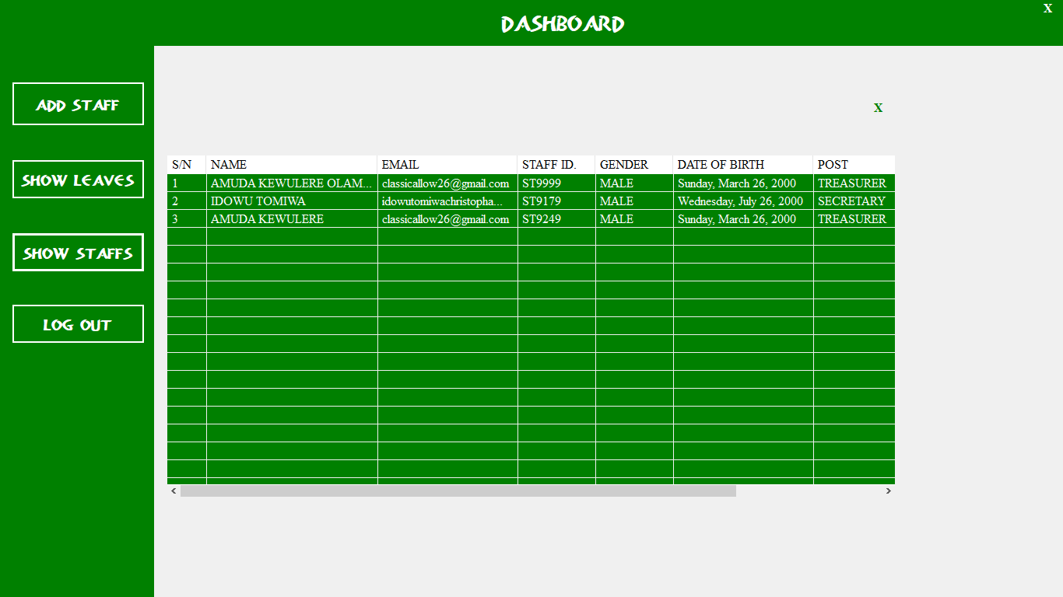
Figure 1:Work Leave requestAdmin Home Page Screenshot
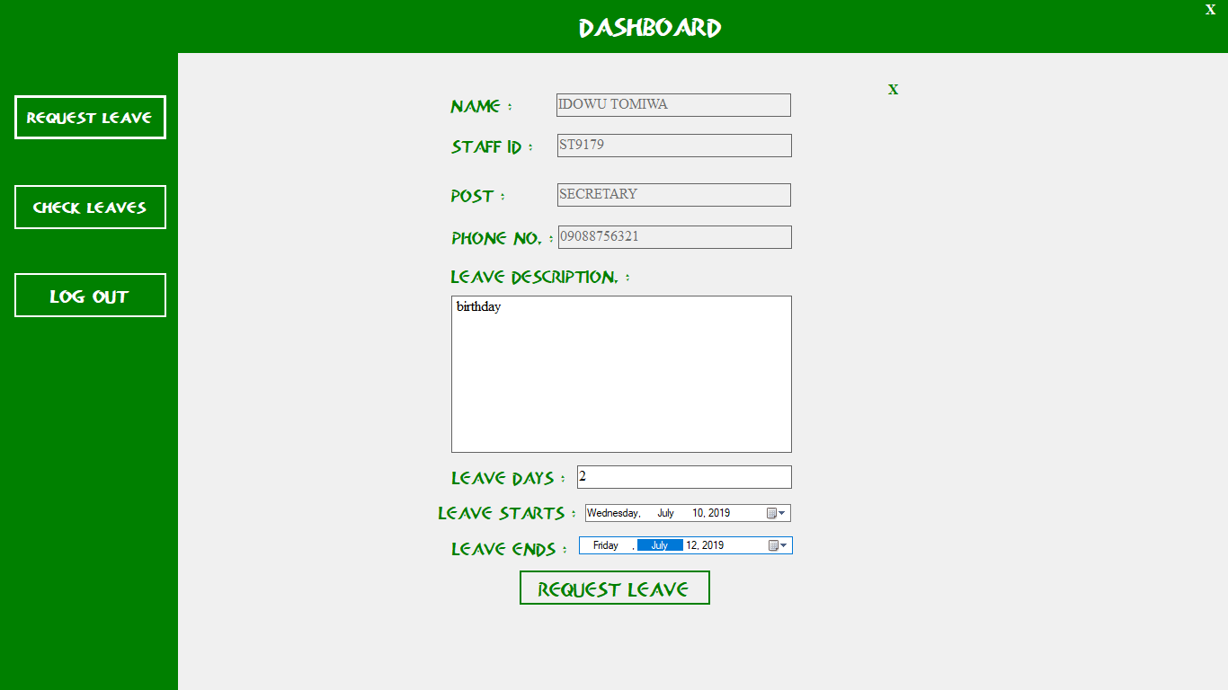
Figure 2: Employee Leave Request Page Screenshot
4.1.2 INPUT DESIGN
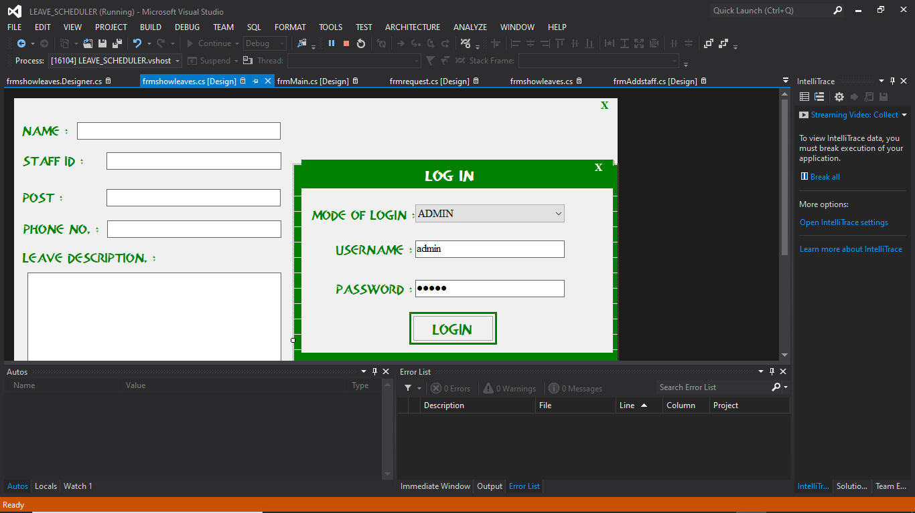
In the below figure management can log-in with there unique Id and password and redirect to the Admin Home Page.

Figure 3: Adminlogin Page Screenshot

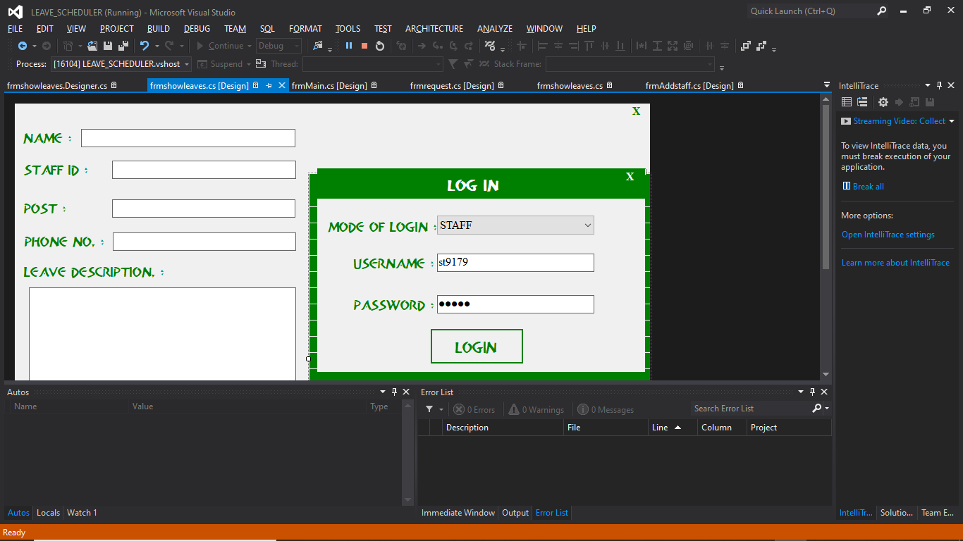

Figure 4: Staff login Page Screenshot
This form will add new employee where fills all necessary details.
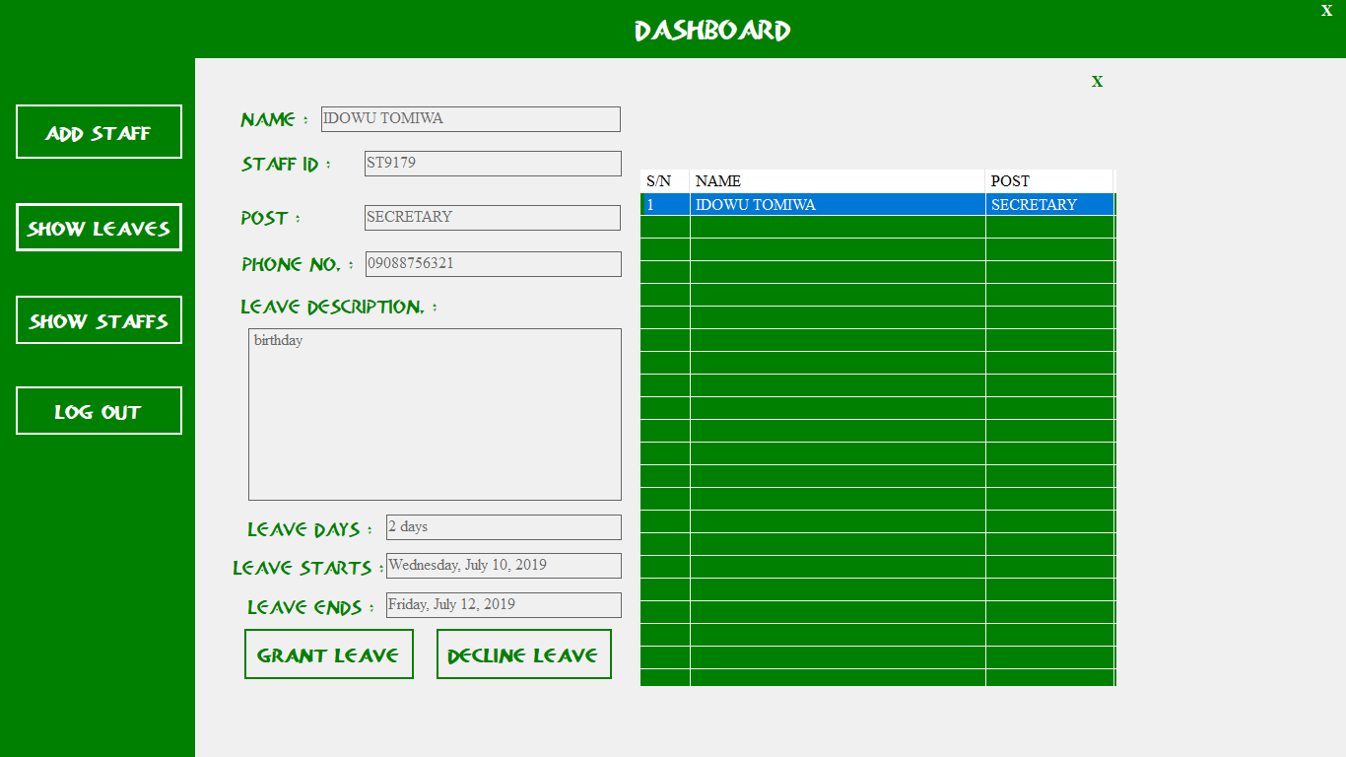
Figure 5: Add Employee Page Screenshot

4.1.3 PRIORITY INPUT DATA AND RESULT
Input :
process no-> 1 2 3 4 5
arrival time-> 0 1 3 2 4
burst time-> 3 6 1 2 4
priority-> 3 4 9 7 8
Output :
Process_noStart_timeComplete_timeTurn_Around_TimeWating_Time
1 0 3 3 0
2 3 9 8 2
4 9 11 9 7
3 11 12 9 8
5 12 16 12 8
Average Wating Time is : 5.0
Average Trun Around time is : 8.2

4.1.4 DATABASE
Database entails the organization and access mode that are implemented in carrying out our specified operations upon the records of the file.
The files used in this system have records that have been organized randomly (random organization) and for this purpose, it will be more appropriate to access the records of the files randomly (random access mode).

Table1: Employees Table Structure
FIELD DESCRIPTION | DATA TYPE
ID | BIGINT
FIRST NAME | VARCHAR
LAST NAME | VARCHAR
GENDER | VARCHAR
PHONE_NO | VARCHAR
ADDRESS | VARCHAR
DEPARTMENT | VARCHAR
POSITION | VARCHAR

    - PROCEDURE DESIGN
This refers to the step by step method of using the proposed system. The proposed system comprises of management Login, Employee Login, add different Leave, Request for leave, Approve leave request, Report. The steps to use the proposed system are as follows
Installed the Application
- You are prompted to supply the username and password this verifies that you are an administrator and has the privileged to view this page.
- If the username and password supplied are correct as that of an administrator you are prompted with the home page for the administrator and if the supplied details is that of aemployee you are redirected to the employee page where you can apply for leave and review your leave status.
- The username and password are in two formats as an administrator as well as aemployee.
- As an administrator you are directed to page containing all the facilities of the system.
- As anemployee supply the details given to you by the administrator then you will be prompted with your Home page to apply for leave.
4.2 IMPLEMENTATION OF THE SYSTEM
System implementation entails the requirements of the system that will run the new application considering the hardware and software needed for effective performance of the program.
Implementation of a system can be explained in six steps: -
1. Review design specification
2. Code, test and document programs
3. Train employees
4. Perform system test
5. Convert to new system
6. Evaluate and maintain the new system
4.2.1 CHOICE OF PROGRAMMING LANGUAGE
Microsoft Visual Studio 2012
It is an integrated development environment from Microsoft. It is used to develop console and graphical user interface application along with Windows Forms or WPF application, web sites, web application and web services in both native code together with managed code for all platforms. It includes a code editor supporting intelligence as well as code refactoring. In this project Microsoft Visual Studio 2012 has been used. Microsoft Visual C# It’s an implementation of the c sharp (C#) language, targets the .NET framework, along with the language services that lets the visual studio IDE support C# projects. While the languages are a part of visual studio, the compiler is available separately as a part of the .NET framework.
Microsoft SQL Server (MYSQL)
It is a RDBMS developed by Microsoft. As a database it is a software product whose primary function is to store and retrieve data as requested by other applications, be it those on another computer across a network. I have used Microsoft SQL Server 2010 during the completion of my project.
In preparation for the installation of the new system, the method of changeover is given serious consideration to determine the success of the new system. Suitable changeover technique for this system is pilot changeover. The pilot changeover operates by applying the new system bit-by-bit until it covers the whole of the operations. The result obtained from using the pilot method on a small portion of the operations would be used in determining the suitability of the need system for the rest of the operations. This method is similar to testing small sample of a distribution if the test yields a good result then the whole system become fully operational and the manual/existing system is eliminated.
4.2.2 HARDWARE SUPPORT
i. Minimum of Microcomputer 1.50GHZ processor, 2 GB RAM, 350GB HDD, 3.5 “FDD, 14” VGA Monitor Windows 2000 Enhanced keyboard, and mouse.
ii. Scanner
4.2.3 SOFTWARE
I. Microsoft visual studio as chosen compiler
ii. C# (C Sharp) as chosen programing language
iii. MY SQL Database Management Software
4.3 PROGRAM DOCUMENTATION
4.3.1 DOCUMENTATION OF THE SYSTEM
This is the detailed description of the proposed system. It important because it helps to design and implement a system that would allow shopping by getting into the company website on the internet from anywhere. It also helps to design and implement a website that will be more interactive and more information about company activities.
Moreover, it designs and implements a system that will create a virtual community, which does not necessitate the use of offices and staff stationed around the world.
4.3.2 OPERATING THE SYSTEM
Step 1: Boot your computer and click on start button on task bar
Step 2: Launch the install application
Step 3: Press any key to continue
Step 4:Supply your username and password to access the system
Step 5: Select any operation of your choice
Step 6: Logout

CHAPTER FIVE
SUMMARY, CONCLUSION AND RECOMMENDATION
5.1 SUMMARY
The implementation of Work Leave Scheduling Management System is aimed at developing a Leave scheduling management system that is of importance to either an organization. The Work Leave Scheduling Management System (WLSMS) is a standalone application (Desktop Application) that can only be accessed throughout the organization system or a specified group/Dept. This system can be used to automate the workflow of leave applications and their approvals. The periodic crediting of leave is also automated. There are features like Scheduling leave request, approval of leave, report generators etc. in this system. Work Leave Scheduling Management application will reduce paper work and maintains record in more efficient way.
5.2 CONCLUSION
This chapter officially completes this study on work leave scheduling administration in the Public Service. In this the whole study was summarized and the findings were analysed. From the findings in this study the recommendations were made which can be implemented to ensure that what has been discovered as challenges or areas of non-compliance can be addressed. Perhaps when these recommendations are implemented there can be change in how leave as benefit is perceived, managed and utilized.
5.3RECOMMENDATION
Emanating from the findings, the following are the recommendations that can be implemented.
- Training and Development
Training and development should be provided on a continuous basis. There are always changes and amendments on the leave policy, as the result training will provide an opportunity to close that skill gap.
- Electronic System and Leave Management
Employee leave management is a basic HR task and one that affects all employees. It was discovered that the public sector is still using the manual system to apply and record leave. A lot of challenges can be encountered during the leave processing. Sharma (2009) highlights the importance of the electronic system and leave management as follows:
- Accurate information about leave data.
- Conveying policy rules.
- Compliance to leave policy.
- Instant information about employee’s leave history.
- Saves HR’s Time.
- Improves discipline.
- Multi-location holiday management (Sharma, 2009).
- Leave Planning
The departments indicated that leave planning is happening in their departments. Some of the cases may not be controlled such as the family responsibility leave. The researcher suggests that the public sector must plan and manage leave carefully within each directorate to ensure that:
  - It is programmed and spread evenly throughout the year, to secure utilizationand allow for the better management of workloads; and
  - It is not left to accumulate towards the end of the calendar year. Leave scheduling should be done in January as soon as the leave credits are given to the staff members. This will ensure that leave is well managed and further that the officials will know their leave days.

SOURCE CODE
using MySql.Data.MySqlClient;
using System;
using System.Collections.Generic;
using System.ComponentModel;
using System.Data;
using System.Drawing;
using System.Linq;
using System.Text;
using System.Threading.Tasks;
using System.Windows.Forms;

namespace LEAVE_SCHEDULER
{
public partial class frmLogin : Form
{
public frmLogin()
{
InitializeComponent();
}

private void textBox1_TextChanged(object sender, EventArgs e)
{

}

private void frmLogin_Load(object sender, EventArgs e)
{
cmbmode.Items.Add("--SELECT MODE OF LOGIN--");
cmbmode.Items.Add("ADMIN");
cmbmode.Items.Add("STAFF");
cmbmode.SelectedIndex = 0;
}

private void btnlogin_Click(object sender, EventArgs e)
{
if (cmbmode.SelectedIndex == 1 &&txtuser.Text == "admin" &&txtpass.Text == "admin")
{
this.Hide();
frmMain m = new frmMain();
m.lbldont.Text = txtuser.Text;
m.btnrequest.Visible = false;
m.btncheck.Visible = false;
m.ShowDialog();
this.Close();
}
else if (cmbmode.SelectedIndex == 2)
{
try
{
leave.OpenMe();
MySqlDataReadermyreader;
string sql = "SELECT * FROM user_table WHERE staff_id ='" + txtuser.Text + "' AND password ='" + txtpass.Text + "'";
MySqlCommandcmd = new MySqlCommand(sql, leave.mycon);
myreader = cmd.ExecuteReader();
int i = 0;
while (myreader.Read())
{
i = i + 1;
}
if (i> 0)
{
MessageBox.Show("Access Granted>>>>");
this.Hide();
frmMain g = new frmMain();
g.lbldont.Text = txtuser.Text;
g.btnrequest.Location = new Point (16, 47);
g.btncheck.Location = new Point (16, 147);
g.btnlogout.Location = new Point(16, 245);
g.btncheck.Visible = true;
g.btnrequest.Visible = true;
g.btnshowleave.Visible = false;
g.btngrant.Visible = false;
g.btnAddstaff.Visible = false;
g.ShowDialog();
this.Close();
leave.CloseMe();
}
else
{
MessageBox.Show("YOU'RE NOT A REGISTERED STAFF!");
}
leave.CloseMe();
}
catch (Exception ex)
{
leave.CloseMe();
MessageBox.Show(ex.Message);
}
}
else
{
MessageBox.Show("MODE OF LOGIN NOT ACCEPTED");
}
}

private void button1_Click(object sender, EventArgs e)
{
Application.Exit();
}

private void button1_Click_1(object sender, EventArgs e)
{
Application.Exit();
}
}
}

using MySql.Data.MySqlClient;
using System;
using System.Collections.Generic;
using System.ComponentModel;
using System.Data;
using System.Drawing;
using System.Linq;
using System.Text;
using System.Threading.Tasks;
using System.Windows.Forms;

namespace LEAVE_SCHEDULER
{
public partial class frmAddstaff : Form
{
public frmAddstaff()
{
InitializeComponent();
}

private void button1_Click(object sender, EventArgs e)
{
this.Dispose();
}

private void frmAddstaff_Load(object sender, EventArgs e)
{
Random rnd = new Random();
int a = rnd.Next(9000, 10000);
txtid.Text = "ST" + a.ToString();
cmbgender.Items.Add("--SELECT YOUR GENDER--");
cmbgender.Items.Add("MALE");
cmbgender.Items.Add("FEMALE");
cmbgender.SelectedIndex = 0;
txtname.Focus();
}

private void btnsave_Click(object sender, EventArgs e)
{
if (txtmail.Text == "" || txtname.Text == "" || txtpass.Text == "" || txtphone.Text == "" || txtpost.Text == "" || cmbgender.SelectedIndex == 0)
{
MessageBox.Show("ALL FIELDS ARE REQUIRED TO BE FILLED CORRECTLY");
txtname.Focus();
}
else
{
try
{
leave.OpenMe();
string sql = "INSERT INTO user_table (name,email,staff_id,gender,dob,post,phone_no,password) values (@name,@email,@staff_id,@gender,@dob,@post,@phone_no,@password)";
MySqlCommandcmd = new MySqlCommand(sql, leave.mycon);
cmd.Parameters.AddWithValue("name", txtname.Text.Trim());
cmd.Parameters.AddWithValue("email", txtmail.Text.Trim());
cmd.Parameters.AddWithValue("staff_id", txtid.Text.Trim());
cmd.Parameters.AddWithValue("gender", cmbgender.Text.Trim());
cmd.Parameters.AddWithValue("dob", dateTimePicker1.Text.Trim());
cmd.Parameters.AddWithValue("post", txtpost.Text.Trim());
cmd.Parameters.AddWithValue("phone_no", txtphone.Text.Trim());
cmd.Parameters.AddWithValue("password", txtpass.Text.Trim());
cmd.ExecuteNonQuery();
leave.CloseMe();
txtpost.Text = "";
txtname.Text = "";
txtpass.Text = "";
txtphone.Text = "";
txtmail.Text = "";
cmbgender.SelectedIndex = 0;
Random rnd = new Random();
int a = rnd.Next(9000, 10000);
txtid.Text = "ST" + a.ToString();
MessageBox.Show("STAFF ADDED SUCCESSFULLY");
txtname.Focus();
}
catch (Exception ab)
{
leave.CloseMe();
MessageBox.Show(ab.Message);
}
}
}
}
}

using MySql.Data.MySqlClient;
using System;
using System.Collections.Generic;
using System.ComponentModel;
using System.Data;
using System.Drawing;
using System.Linq;
using System.Text;
using System.Threading.Tasks;
using System.Windows.Forms;

namespace LEAVE_SCHEDULER
{
public partial class frmrequest : Form
{
public frmrequest()
{
InitializeComponent();
}

private void button1_Click(object sender, EventArgs e)
{
this.Dispose();
}

private void btnrequest_Click(object sender, EventArgs e)
{
if (txtdays.Text == "" || txtdescription.Text == "")
{
MessageBox.Show("FILL ALL FIELDS TO COMPLETE REQUEST");
txtdescription.Focus();
}
else
{
try
{
leave.OpenMe();
string sql = "INSERT INTO request_table (name,staff_id,post,phone,description,days,start,end) values (@name,@staff_id,@post,@phone,@description,@days,@start,@end)";
MySqlCommandcmd = new MySqlCommand(sql, leave.mycon);
cmd.Parameters.AddWithValue("name", txtname.Text.Trim());
cmd.Parameters.AddWithValue("staff_id", txtid.Text.Trim());
cmd.Parameters.AddWithValue("post", txtpost.Text.Trim());
cmd.Parameters.AddWithValue("phone", txtphone.Text.Trim());
cmd.Parameters.AddWithValue("description", txtdescription.Text.Trim());
cmd.Parameters.AddWithValue("days", txtdays.Text.Trim());
cmd.Parameters.AddWithValue("start", dateTimePicker1.Text.Trim());
cmd.Parameters.AddWithValue("end", dateTimePicker2.Text.Trim());
cmd.ExecuteNonQuery();
leave.CloseMe();
txtdescription.Text = "";
txtdays.Text = "";
MessageBox.Show("REQUEST MADE SUCCESSFULLY");
txtdescription.Focus();
}
catch (Exception ab)
{
leave.CloseMe();
MessageBox.Show(ab.Message);
}
}
}

private void frmrequest_Load(object sender, EventArgs e)
{
leave.CloseMe();
try
{
leave.OpenMe();
MySqlDataReader reader;
string sql = "SELECT * FROM user_table WHERE staff_id ='" + lblhide.Text + "'";
MySqlCommandcmd = new MySqlCommand(sql, leave.mycon);
reader = cmd.ExecuteReader();
while (reader.Read())
{
txtname.Text = reader["name"].ToString();
txtphone.Text = reader["phone_no"].ToString();
txtpost.Text = reader["post"].ToString();
txtid.Text = reader["staff_id"].ToString();
}
leave.CloseMe();
}
catch (Exception ex)
{
//leave.CloseMe();
MessageBox.Show(ex.Message);
}
}
}
}

using MySql.Data.MySqlClient;
using System;
using System.Collections.Generic;
using System.ComponentModel;
using System.Data;
using System.Drawing;
using System.Linq;
using System.Text;
using System.Threading.Tasks;
using System.Windows.Forms;

namespace LEAVE_SCHEDULER
{
public partial class frmshowleaves : Form
{
public frmshowleaves()
{
InitializeComponent();
}

private void button1_Click(object sender, EventArgs e)
{
this.Dispose();
}

private void frmshowleaves_Load(object sender, EventArgs e)
{
//leave.CloseMe();
this.Location = new Point(300, 100);
try
{
leave.OpenMe();
MySqlDataReadermyreader;
string sql = "SELECT * FROM request_table WHERE state = '" + " " + "'";
MySqlCommandcmd = new MySqlCommand(sql, leave.mycon);
myreader = cmd.ExecuteReader();
int sn = 1;
lst1.Columns.Add("S/N", 50);
lst1.Columns.Add("NAME", 300);
lst1.Columns.Add("POST", 130);
while (myreader.Read())
{
ListViewItem LV1 = lst1.Items.Add(sn.ToString());
LV1.SubItems.Add(myreader["name"].ToString());
LV1.SubItems.Add(myreader["post"].ToString());
sn++;
}
leave.CloseMe();
}
catch (Exception ex)
{
leave.CloseMe();
MessageBox.Show(ex.Message);
}

}

private void lst1_SelectedIndexChanged(object sender, EventArgs e)
{

}

private void btngrant_Click(object sender, EventArgs e)
{
try
{
leave.OpenMe();
string sql = "UPDATE request_table SET state ='" + "GRANTED" + "' WHERE description ='" + txtdescription.Text + "' AND staff_id ='" + txtid.Text + "'";
MySqlCommandcmd = new MySqlCommand(sql, leave.mycon);
cmd.ExecuteNonQuery();
leave.CloseMe();
MessageBox.Show("LEAVE GRANTED!");
}
catch (Exception ab)
{
leave.CloseMe();
MessageBox.Show(ab.Message);
}
}

private void btnreject_Click(object sender, EventArgs e)
{
try
{
leave.OpenMe();
string sql = "UPDATE request_table SET state ='" + "DECLINED" + "' WHERE description ='" + txtdescription.Text + "' AND staff_id ='" + txtid.Text + "'";
MySqlCommandcmd = new MySqlCommand(sql, leave.mycon);
cmd.ExecuteNonQuery();
leave.CloseMe();
MessageBox.Show("LEAVE DECLINED!");
}
catch (Exception ab)
{
leave.CloseMe();
MessageBox.Show(ab.Message);
}
}

private void lst1_DoubleClick(object sender, EventArgs e)
{
int a = int.Parse(lst1.SelectedItems[0].Text);
try
{
leave.OpenMe();
MySqlDataReader reader;
string sql = "SELECT * FROM request_table WHERE id ='" + a + "'";
MySqlCommandcmd = new MySqlCommand(sql, leave.mycon);
reader = cmd.ExecuteReader();
while (reader.Read())
{
txtname.Text = reader["name"].ToString();
txtphone.Text = reader["phone"].ToString();
txtpost.Text = reader["post"].ToString();
txtid.Text = reader["staff_id"].ToString();
txtdays.Text = reader["days"].ToString();
txtdescription.Text = reader["description"].ToString();
txtend.Text = reader["end"].ToString();
txtstart.Text = reader["start"].ToString();
}
leave.CloseMe();
}
catch (Exception ex)
{
leave.CloseMe();
MessageBox.Show(ex.Message);
}
}

}
}

