DESIGN AND IMPLEMENT OF AN EMPLOYEE ATTENDANCE TRACKING SYSTEM

BY
BALOGUN, FIRDAWS OMOTOLA
ND/23/COM/PT/0245

SUBMITTED TO THE DEPARTMENT OF COMPUTER SCIENCE,
INSTITUTE OF INFORMATION AND COMMUNICATION TECHNOLOGY
KWARA STATE POLYTECHNIC, ILORIN

IN PARTIAL FULFILLMENT OF THE REQUIREMENTS FOR THE AWARD OF NATIONAL DIPLOMA (ND) IN
COMPUTER SCIENCE

JULY, 2025.

CERTIFICATION
This is to certify that this project was carried out by BALOGUN, FIRDAWS OMOTOLA with matriculation number ND/23/COM/PT/0245 in the Department of Computer Science, Institute of Information and Communication Technology, Kwara State Polytechnic, Ilorin, Kwara State.

…………………………………. ….………………………
MR. BOLAJI-ADETORO D.F Date
Project Supervisor

…………………………………. ….………………………
MR. OYEDEPO, F. S. Date
Head of Department

…………………………………. ….………………………
External Examiner Date

DEDICATION
I dedicate this project work to Almighty God who inspired me and directed my ways during my academic stay in the polytechnic.

ACKNOWLEDGEMENT
All praise is due to Almighty God the Lord of the universe. I praise him and thank him for giving me the strength and knowledge to complete my ND program and also for our continued existence on Earth.
I appreciate the utmost effort of my supervisor, Mrs Bolaji-Adetoro D.F whose patience, support, and encouragement have been the driving force behind the success of this research work. She gave useful corrections, constructive criticisms, comments, recommendations, and advice and always ensures that excellent research is done. My sincere gratitude goes to the Head of the Department Mr. Oyedepo F. S., and other members of staff of the Department of Computer Science, Kwara State Polytechnic, Ilorin, for their constant cooperation, constructive criticisms, and encouragement throughout the program.
Special gratitude to my parents, who exhibited immeasurable financial, patience, support, prayers, and understanding during the period in which I was busy tirelessly with my studies, special thanks go to my lovely siblings
My sincere appreciation goes to my friends and classmates.

TABLE OF CONTENTS
Title page i
Certification ii
Dedication iii
Acknowledgements iv
Table of contents v
Abstract viii
CHAPTER ONE: GENERAL INTRODUCTION
1.1 Introduction 1
1.2 Statement of the Problem 3
1.3 Aim and Objectives 3
1.4 Significance of the Study 3
1.5 Scope of the Study 4
1.6 Organization of the Report 4
CHAPTER TWO: LITERATURE REVIEW
2.1 Review of Related Past Works 6
2.2 Overview to E-Learning Services 11
2.3 Computer Based Learning 12
2.4 Strategic Importance of E-Learning 12
2.5 Computer Supported Collaborative Learning (CSCL) 12
2.6 Technology Enhanced Learning (TEL) 13
2.7 Communication Technologies used in E-Learning 15
CHAPTER THREE: RESEARCH METHODOLOGY AND ANALYSIS OF THE SYSTEM
  - Research Methodology 17
  - Analysis of the Existing System 18
  - Problem of the Existing System 19
  - Analysis of the Proposed System 19
  - Advantage of the Propose System 19
CHAPTER FOUR: DESIGN, IMPLEMENTATION AND DOCUMENTATION OF THE SYSTEM
  - Design of the System 21
    - Output Design 21
    - Input Design 22
    - Database Design 24
    - Procedure Design 26
  - Implementation of the System 26
    - Choice of programming language 26
    - Hardware support 27
    - Software Support 28
  - System Documentation 28
    - Operating the System 28
    - Maintaining of the System 28
CHAPTER FIVE: SUMMARY CONCLUSION AND RECOMMENDATION
5.1 Summary 30
5.2 Conclusion 30
5.4 Recommendations 31
References 32

ABTRACTS
Nowadays, the Information and Communication Technology (ICT) made deep effects in the human life. But still the communication style in most educational sectors is still at the beginning steps. So, the trend is to move towards the E-learning system in order to overcome the problems of traditional style. E-learning is a field belongs to the E-government. Hence, electronic learning is an important direction within E-education. This direction treats with learning-style and the communications between the academic-staff in one side and students in other side at the institution and keep-tracking their activities during studying-year. The current style of communication needs to be improved by benefiting from the new technology capabilities. However, the institutions suffer from lack of using new technology and building the E-learning system will push other whole sectors towards the E-government system. As an important direction within Electronic, this project work produces an efficient proposed learning system called Electronic Learning System (ELS). The proposed system consists of modules that provide four groups of services. First group relates with student services: Lecturers Feedback, Discussion Forums and Course materials that include: Lectures, Assignments, Schedules, Marks and Objections. The proposed system is implemented and tested practically. The proposed system has been designed and implemented using the tools: (MySQL, HTML, CSS, PHP, JavaScript, JQuery, Ajax and Bootstrap).

CHAPTER ONE
GENERAL INTRODUCTION
  - Background to the Study
In today's dynamic work environment, effective management of employee attendance is crucial for organizational productivity and efficiency. Traditional attendance tracking methods, such as manual time keeping or punch cards, are not only time-consuming but also prone to errors like signing in and signining out and manipulation. With the advent of technology, there has been a shift towards automated attendance systems, leveraging advancements in biometrics, RFID (Radio Frequency Identification), and computer vision. These systems offer real-time tracking, accuracy, and accountability, thus addressing the limitations of conventional methods (Kumar & Kaur, 2020).
Employee attendance and management is an aspect widely practiced in all workplaces. Day by day, security breaches and transaction fraud increase, and the need for secure identification and personal verification technologies is becoming a great concern to the organization. Therefore, this resource present an efficient management of attendance using fingerprint identification for that area, where the biometric device is not available and attendance of Employees is calculated at the end of the month. The first step is to enroll the Employee. Store all the necessary information including ID, image, and fingerprint into the database. When attendance is calculated, the daily fingerprints are matched with the stored fingerprint by using the scanner. If the fingerprint is matched then attendance is accepted; otherwise, it is rejected (Hemlata & Pallavi, 2020).
The rise of remote work and flexible schedules further emphasizes the need for a robust attendance system that can accommodate diverse work arrangements. Employers require a solution that allows them to monitor attendance regardless of employees' physical location, ensuring fairness and transparency in workforce management (Mishra et al., 2020).
In these technologies, fingerprint has become the most mature and popular biometrics technology used in automatic personal identification. The reason for the popularity of fingerprint verification is that fingerprints satisfy uniqueness, stability, and permanency and are taken easily (Sangeetha, et al., 2015). Skin on human fingertips contains ridges and valleys which together form distinctive patterns. These patterns are fully developed during pregnancy and are permanent throughout the whole lifetime. Prints of those patterns are called fingerprints. Injuries like cuts, burns, and bruises can temporarily damage the quality of fingerprints but when fully healed patterns will be restored. Fingerprints have remarkable permanency and individuality over time (Olagunju, 2021).
Moreover, regulatory requirements and compliance standards necessitate accurate record-keeping of employee attendance for payroll processing, labor law adherence, and auditing purposes. Organizations must align their attendance management practices with legal frameworks to avoid penalties and maintain organizational integrity. Paperwork will be reduced and the company Employees spend more time monitoring the progress. The system is user-friendly and easy to use. All the important data will be stored in a database and it avoids miscalculations. Admin has the authority to add Employee details. And he also has the right to edit or delete Employee information to/from the list. Admin provides a unique username and password for each Employee through which he can log in and all the information is stored in the database .
1.2 Statement of the Problem
Traditionally, the Employee attendance and management system is done by signing in and out in a register which leaves a gap for impersonation and Employees sometimes record earlier times when they are late. Despite the recognized importance of attendance management, many organizations still rely on outdated methods that are inefficient and prone to inaccuracies. Manual attendance tracking is labor-intensive, susceptible to errors, and lacks real-time monitoring capabilities.
  - Aim and Objectives of the Study
This research work aim to develop a window application for Employee attendance and management system and the objectives are as follows:
- Design an Employee attendance and management system using a minutiae algorithm for fingerprint recognition to avoid impersonation.
- Develop a prototype of the proposed attendance system and evaluate its functionality, accuracy, and usability.
- Develop an application that will receive and store daily Employee attendance reports.

  - Significance of the Study
This study holds significant implications for both organizations and employees. By providing a reliable and efficient attendance management solution, organizations can streamline their HR processes, reduce administrative burden, and enhance productivity. Moreover, accurate attendance tracking fosters a culture of accountability and transparency, improving employee morale and organizational trust. From an employee perspective, the implementation of an automated attendance system ensures fair and equitable treatment, irrespective of work location or schedule. Employees can benefit from streamlined timekeeping processes, reduced errors in payroll calculations, and timely resolution of attendance-related issues.
  - Scope of the Study
This study focuses on the design and implementation of an employee attendance system within the context of medium to large-scale organizations. The scope encompasses the analysis of existing attendance tracking methods, the development of a prototype system, and the evaluation of its effectiveness in real-world settings.
1.6 Organisation of the Report
The study is organized into five chapters. Chapter One provides an introduction to the research topic, including background information, problem statement, objectives, significance, and scope of the study. Chapter Two reviews relevant literature on attendance management systems and related technologies. Chapter Three outlines the methodology employed in designing and implementing the employee attendance system. Chapter Four presents the findings of the study, including the prototype development and evaluation results. Finally, Chapter Five offers conclusions, implications, and recommendations for future research.
  - Definition of Technical Terms
Attendance System: A system used by organizations to monitor and record the presence or absence of employees during scheduled work hours.
Biometrics: Authentication techniques based on unique biological characteristics such as fingerprints, iris patterns, or facial features.
RFID (Radio Frequency Identification): A technology that uses radio waves to identify and track objects or individuals.
Computer Vision: A field of artificial intelligence that enables computers to interpret and analyze visual information from digital images or videos.

CHAPTER TWO
LITERATURE REVIEW
2.1 Review of Related Work
Mishra et al., (2020) One common approach in the literature is the utilization of biometric authentication for employee identification and attendance tracking. Biometric systems, such as fingerprint scanners, facial recognition, and iris recognition, offer advantages in terms of accuracy and security (Kumar & Kaur, 2019). Studies have demonstrated the effectiveness of biometric attendance systems in reducing instances of buddy punching and fraudulent timekeeping, thus enhancing overall accountability and trustworthiness
Josef (2022) researched on an “Minutiae Extraction from Fingerprint with Neural Network and Minutiae based Fingerprint Verification”, Human fingerprints are rich in details called minutiae, which can be used as identification marks for fingerprint verification. The goal of this thesis is to develop a complete system for fingerprint verification through extracting and matching minutiae. A neural network is trained using the back-propagation algorithm and will work as a classifier to locate various minutiae. To achieve good minutiae extraction in fingerprints with varying quality, pre-processing in form of binarization and skeletonization is first applied on fingerprints before they are evaluated by the neural network. Extracted minutiae are then considered as a 2D point pattern problem and an algorithm is used to determine the number of matching points between two point patterns. Performance of the developed system is evaluated on a database with fingerprints from different people and experimental results are presented.
Madya & et al (2020) presented a journal titled “Employee Management System”, in any organisation such as schools, colleges, companies, industry, etc certain number of employee’s are employed. Managing this type information by just simply noting them in a diary is a tedious task to do. So in order to manage employee’s details some automation is required. Employee Management which includes automated management of an employee’s attendance payroll activities based on attendance, gratuity, provident fund and generates Salary slip, thus reducing large amount of paper work. This software is built using php, AJAX, CSS and MySQL for database. Key words: payroll, attendance, gratuity, provident fund, employee.
Chiwa & Musa (2019) argued that all organizations and institutions are established to achieve specific objectives or goals. The identification and authentication of employee is very necessary for achieving any objective or goal. To identify and authenticate the identity of an individual employee by their names, ID numbers and signatures only are not enough, because any one can misuse other's identity and this type of problem occur very often. Fingerprint can be applied for recognizing any person, because human fingerprints are unique to each person and can be regarded as some sort of signature, certifying the person's identity. This method of employee identification and authentication will improve the attendance of employees thereby improving security, productivity and skill which will in turn improve the progress of organizations.
Shrinivas, Samadhan & Jogdand (2021) developed an “Android Based Attendance Management System”. Android Based Attendance Management System is based on Android, which can be implemented on any Android Phone. In This application, PHP is server side language, MySQL and PHP is used as back-end design and HTML, CSS and JavaScript are used as front-end tools. The system communicates with database residing on a remote server. It calculates automatically, the attendance percentage of students without any manual paper-based work. Managing the attendance using traditional approach is really a cumbersome process. The person has to be maintain the attendance record in registers and file using pen and paper. The problem with this approach is that it requires lots of paper which are the part of our non-renewable natural resources. We are in the age, where we have to think about sustainable development. Managing the attendance using mobile phones, provide an alternative way in this direction. Communication between teachers and the parent is also an important issue that should also be considered, because parent can only get the information about their ward after the interaction with teachers. So, we also tried to bring the system which enables parent to receive the information of their ward of regularity on daily basis.
Sangeetha, Sivaranjani & Shalini (2020) opined that In recent time, there has been high level of impersonation experienced on a daily basis in both private and public sectors, the ghost worker syndrome which has become a menace across all tiers of government, employers concerns over the levels of employee absence in their workforce and the difficulty in managing student attendance during lecture periods. Fingerprints are a form of biometric identification which is unique and does not change in one’s entire lifetime. This paper presents the attendance management system using fingerprint technology in a university environment. It consists of two processes namely; enrolment and authentication. During enrolment, the fingerprint of the user is captured and its unique features extracted and stored in a database along with the users identity as a template for the subject. The unique features called minutiae points were extracted using the Crossing Number (CN) method which extracts the ridge endings and bifurcations from the skeleton image by examining the local neighborhoods of each ridge pixel using a 3 x 3 window. During authentication, the fingerprint of the user is captured again and the extracted features compared with the template in the database to determine a match before attendance is made. The fingerprint-based attendance management system was implemented with Microsoft’s C# on the. NET framework and Microsoft’s Structured Query Language (SQL) Server 2005 as the backend. The experimental result shows that the developed system is highly efficient in the verification of users fingerprint with an accuracy level of 97.4%. The average execution time for the developed system was 4.29 seconds as against 18.48 seconds for the existing system. Moreover, the result shows a well secured and reliable system capable of preventing impersonation.
Olagunju, Adeniyi & Oladele (2020) Staff Attendance System is a simple windows based attendance system that was specifically developed for small and medium scale companies. This software helps to manage the workforce and track employee time and attendance in an easier way. This software application can manage the recordings, control and monitoring of staff absence and lateness. The significance of this application is to make sure that the staff member are punctual and do their jobs on time. Currently, there is no proper system to monitor the staff attendance at some companies. Some companies still use the paper based system to store the records of the employees. With the implementation of this system, paper based system will be eliminated. This research will help the Administrator to manage recordings, monitoring and tracking the attendance of the employees. It provides an accurate time management for the employees in order to sign in and sign out their attendance. In this paper, the biometrics based Staff Attendance Monitoring System was developed using Visual Basic Programming Language as front end while Microsoft Access was used as the Database to the backend users.
Miguel & et al (2022) Improving fingerprint matching algorithms is an active and important research area in fingerprint recognition. Algorithms based on minutia triplets, an important matcher family, present some drawbacks that impact their accuracy, such as dependency to the order of minutiae in the feature, insensitivity to the reflection of minutiae triplets, and insensitivity to the directions of the minutiae relative to the sides of the triangle. To alleviate these drawbacks, we introduce in this paper a novel fingerprint matching algorithm, named M3gl. This algorithm contains three components: a new feature representation containing clockwise-arranged minutiae without a central minutia, a new similarity measure that shifts the triplets to find the best minutiae correspondence, and a global matching procedure that selects the alignment by maximizing the amount of global matching minutiae. To make M3gl faster, it includes some optimizations to discard non-matching minutia triplets without comparing the whole representation. In comparison with six verification algorithms, M3gl achieves the highest accuracy in the lowest matching time, using FVC2002 and FVC2004 databases.
Seema & Satoa (2019) Concluded that biometric technology that involves the identification and verification of individuals by analyzing the human fingerprint characteristics has been widely used in various aspect of life for different purposes, most importantly as regards this study the issue of employee attendance. The main aim of this paper is to develop an accurate , fast and very efficient automatic attendance system using fingerprint verification technique. We propose a system in which fingerprint verification is done by using extraction of minutiae technique and the system that automates the whole process of taking attendance, The study was conducted using a quantitative approach by designing a questionnaire as the data collection instrument based on fingerprint matching biometric technologies. The survey involved 6 employees based on stratified random sampling technique. The results however show that fingerprint biometric identifier was found suitable for the employee attendance management system of the organization.
In Ravi, Raja & Venugopal (2019) the authors concluded that the popular Biometric used to authenticate a person is Fingerprint which is unique and permanent throughout a person’s life. A minutia matching is widely used for fingerprint recognition and can be classified as ridge ending and ridge bifurcation. In this paper we projected Fingerprint Recognition using Minutia Score Matching method (FRMSM). For Fingerprint thinning, the Block Filter is used, which scans the image at the boundary to preserves the quality of the image and extract the minutiae from the thinned image. The false matching ratio is better compared to the existing algorithm.

2.2 Review of General Study
In addition to specific studies focusing on the development and implementation of employee attendance systems, there exists a body of literature that provides a broader perspective on attendance management practices and challenges in organizational contexts.
General studies on attendance management often emphasize the significance of effective timekeeping in achieving organizational objectives. Attendance is considered a fundamental aspect of workforce management, directly impacting productivity, operational costs, and employee morale. Therefore, organizations strive to implement efficient attendance tracking systems to monitor employee presence, ensure compliance with work schedules, and facilitate accurate payroll processing.
Moreover, research in this area explores the relationship between attendance patterns and various organizational outcomes, such as performance, absenteeism rates, and employee turnover. Studies have found correlations between attendance behavior and job satisfaction, with consistent attendance linked to higher levels of engagement and job commitment (Kumar & Kaur, 2019). Conversely, frequent absenteeism or tardiness may indicate underlying issues related to job dissatisfaction, workplace culture, or personal factors.
Furthermore, the literature highlights the role of technology in transforming traditional attendance management practices. With advancements in digital tools and automation, organizations have the opportunity to streamline their timekeeping processes, minimize administrative burdens, and improve data accuracy (Mishra et al., 2020). From biometric scanners to cloud-based software solutions, technological innovations offer diverse options for enhancing the efficiency and effectiveness of attendance tracking systems.
Overall, the literature on general attendance management provides valuable insights into the complexities of tracking employee presence in organizational settings. By examining best practices, challenges, and emerging trends, researchers and practitioners can inform decision-making processes and drive improvements in attendance management practices.
2.3 Overview of Staff Attendance and Management System
Attendance management is the act of managing attendance or presence in a work setting to minimize loss due to employee downtime. Attendance control has traditionally been approached using time clocks and timesheets, but attendance management goes beyond this to provide a working environment which maximizes and motivates employee attendance. Attendance management is a major part of today’s human resource systems; take organization towards better human resource practice, systems and excellence, hence regular attendance and punctuality are expected of all employees or candidates in a work setting. Unsatisfactory attendance caused by unscheduled absences and tardiness cause a disruption in work, affects productivity, and creates morale problems when workloads are shifted to other employees.
Moreover, in many institutions, and academic organizations, attendance is also a very important criteria which is used for various purposes. These purposes include record keeping, assessment of students, and promotion of optimal and consistent attendance in class. In developing countries, a minimum percentage of class attendance is required in most institutions and this policy has not been adhered to, because of the various challenges the present method of taking attendance presents. This traditional method involves the use of sheets of paper or books in taking student attendance. This method could easily allow for impersonation and the attendance sheet could be stolen or lost. Taking of attendance is time consuming and it is difficult to ascertain the number of students that have made the minimum percentage and thus eligible for exam. Thus, there is a need for a system that would eliminate all of these trouble spots.
2.4 Types of Attendance Management System
Attendance Management falls into two categories namely: Conventional and Automated methods.
Conventional methods: include time sheet, attendance register and time clock. Time sheets are documents, electronic or otherwise that record what time was spent by the employee on what tasks. Attendance register is an official list of people who are present at an institution or organization. Time clock which is a mechanical (or electronic) time piece used to assist in tracking the hour worked by an employee of a company.
Automated methods: include Barcode system attendance system, magnetic stripe attendance system, Radio Frequency Identification (RFID) and the biometric attendance system. The barcode attendance system requires that every employee is issued a badge/card in which there is a barcode. In order to check into or out of the company, the badge/card is swapped on the time clock, and the data is captured by the clock. In the magnetic stripe attendance system, data is encoded in the magnetic stripe of the employee card. When the card, is swiped through the employee time clock, the information in the card’s magnetic stripe is recorded by the time clock. This system reads one card at a time and also requires contact with the reader. Radio-frequency identification (RFID) is a technology that uses radio waves to transfer data from an electronic tag, called RFID tag or label, attached to an object, through a reader for the purpose of identifying and tracking the object. The ID cards of the employees is embedded with RFID tag which is read by a reader. This RFID system is interfaced to a database through a computer. Each employee uses an RFID card and the reader records the data when the employee enters or exits. In biometric Attendance system, there is attendance Software that is paired with a time clock for employees which uses biometric technology for authentication purposes. When these systems are in use, the employees can use their biometric data such as finger prints for clocking in and clocking out. This method has the great benefit that the entire process is easy as well as quick. Other advantages include elimination of the cost previously incurred in getting the employees cards.
2.4 Concept of Minutae Algorithm
Minutiae matching essentially consist of finding the best alignment between the template (set of minutiae in the database) and a subset of minutiae in the input fingerprint, through a geometric transformation. This is the most popular and widely used technique, being the basis of the fingerprint comparison made by fingerprint examiners. Minutiae are extracted from the two fingerprints and stored as sets of points in the two- dimensional plane. Minutiae-based matching essentially consists of finding the alignment between the template and the input minutiae sets that results in the maximum number of minutiae pairings A more effective and faster minutiae extraction realization can be achieved by minimizing data that represents minutiae without corrupting it. Since minutiae are determined only by discontinuities in ridges, they are totally independent of ridges thickness. Thinning of the ridges to only 1-pixel wide lines also called skeletons, not only preserves minutiae but it does it with minimum possible data usage. The thinning method is often called skeletonization.
2.4.1 Adaptation Minutiea Algorith Steps
Ridge ending is the point where the ridge ends suddenly.
Ridge bifurcation is the point where a single ridge branches out into two or more ridges.
Ridge dots are very small ridges.
Ridge islands are slightly longer than dots and occupy a middle space between two diverging ridges.
Ponds or Lakes are the empty space between two diverging ridges.
Spurs is a notch protruding from a ridge.
Bridges are the small ridges that join two longer adjacent ridges.
Crossovers are formed when two ridges cross each other.
CHAPTER THREE
RESEARCH METHODOLOGY AND ANALYSIS OF THE SYSTEM
3.1 Research Methodology
The research design for this study is structured to encompass both the development of the fingerprint attendance monitoring system and the evaluation of its effectiveness. The study employs a mixed-method approach, integrating both qualitative and quantitative methods to provide a comprehensive analysis of the system's performance and user perceptions.
3.2 Fingerprint Capture
Fingerprint capture is the initial step in the biometric identification process. It involves acquiring a digital image of the fingerprint using a fingerprint reader. This study utilizes an optical fingerprint reader due to its high resolution and reliability.
- Procedure: Participants are instructed to place their finger on the scanner, which captures the fingerprint image. Multiple images may be taken to ensure clarity and quality.
- Considerations: The quality of the captured fingerprint is critical. Factors such as finger pressure, cleanliness, and environmental conditions are controlled to obtain high-quality images.
3.3 Binarization
Binarization is the process of converting the grayscale fingerprint image into a binary image, where the ridges are represented by black pixels and the valleys by white pixels. This step simplifies the image, making it easier to process in subsequent steps.
- Procedure: The captured grayscale fingerprint image is processed using a thresholding technique. A global threshold value is determined to distinguish between the ridges and valleys.
- Tools: Image processing software and algorithms are used to perform binarization. MATLAB or Python libraries such as OpenCV can be utilized for this purpose.
3.4 Thinning
Thinning, also known as skeletonization, reduces the binary fingerprint image to a one-pixel-wide representation of the ridges. This step is essential for accurately extracting minutiae points.
- Procedure: The binary image undergoes morphological operations to iteratively remove pixels from the edges of the ridges while preserving the ridge structure.
- Tools: Thinning algorithms such as Zhang-Suen or Guo-Hall are commonly used. These can be implemented using image processing libraries in MATLAB or Python.
3.5 Minutia Extraction
Minutia extraction involves identifying and locating the unique features of the fingerprint, such as ridge endings and bifurcations. These features are used to create a template for each fingerprint, which is stored in the system's database.
- Procedure: The thinned fingerprint image is analyzed to detect minutiae points. The coordinates and orientation of each minutia point are recorded.
- Tools: Minutia extraction algorithms are applied to the thinned image. Software libraries like VeriFinger or custom algorithms in MATLAB or Python can be used.
3.6 System Implementation
The fingerprint attendance monitoring system is implemented by integrating the fingerprint reader with software that performs the aforementioned image processing steps. The system is designed with a user-friendly interface for ease of use by students and faculty.
- Software Development: The system's software is developed using a programming language such as Python, incorporating image processing libraries and database management systems for storing fingerprint templates and attendance records.
- Hardware Integration: The fingerprint reader is connected to the system, and drivers are installed to facilitate communication between the hardware and software.
3.7 Evaluation
The effectiveness of the fingerprint attendance monitoring system is evaluated based on its accuracy, usability, and user acceptance.
- Accuracy: The system's accuracy is measured by comparing its performance to traditional attendance methods. Metrics such as false acceptance rate (FAR) and false rejection rate (FRR) are calculated.
- Usability: User feedback is collected through surveys and interviews to assess the system's ease of use and overall satisfaction.
- User Acceptance: The perceptions and attitudes of students, faculty, and administrators towards the system are analyzed to determine its acceptance and potential areas for improvement.

Finger Print Capture

Binarization

Thinning

Minutia Extraction

Figure 1. The proposed system workflow
Finger Print Template: In biometrics, a fingerprint template is the name used to describe a stored file in a fingerprint scanning system. A fingerprint template is smaller than the actual fingerprint image and using the template instead of an image makes for faster processing time.
Binarization: Is the process of transforming data features of any entity into vectors of binary numbers to make classifier algorithms more efficient. In a simple example, transforming an image's gray-scale from the 0-255 spectrum to a 0-1 spectrum is binarization.
Thinning: Is the transformation of a digital image into a simplified, but topologically equivalent image. It is a type of topological skeleton, but computed using mathematical morphology operators.
Minutia Algorithm: is the most popular approach in fingerprint matching. Then the transformation parameters are calculated using phase correlation between two MDMs to align two fingerprints to be matched.

3.2 Analysis of the Existing System
Before designing and implementing the proposed employee attendance system, it is essential to conduct a thorough analysis of existing attendance management practices and systems within organizational contexts. This analysis provides valuable insights into the strengths, weaknesses, and opportunities for improvement, serving as a foundation for the development of the new system.
The analysis begins with an evaluation of the current methods used for attendance tracking within the organization. This includes reviewing manual processes, such as paper-based timesheets or punch cards, as well as the existing automated systems, such as biometric scanners or RFID readers. The strengths and limitations of each method are identified, considering factors such as accuracy, reliability, ease of use, and scalability. The existing technology infrastructure supporting attendance management is assessed to determine its compatibility, reliability, and capacity to support a new system. This involves reviewing hardware components, such as computers, servers, and networking devices, as well as software applications used for timekeeping, payroll processing, and HR management. Any gaps or deficiencies in the technology infrastructure are identified, along with potential integration challenges.
Compliance requirements related to attendance management, including labor laws, regulations, and industry standards, are examined to ensure that the proposed system aligns with legal and regulatory obligations. This includes considerations such as data privacy, confidentiality, and record-keeping requirements, as well as any specific industry guidelines or certifications relevant to attendance tracking systems.

  - Problems of the Existing System
The analysis of the existing employee attendance system reveals several significant problems and challenges that hinder its effectiveness and efficiency. Identifying these issues is crucial for understanding the shortcomings of the current system and informing the development of solutions in the proposed attendance system.
- Manual Data Entry Errors: One of the primary problems with the existing system is the reliance on manual data entry for recording employee attendance. This manual process is prone to errors, including typos, incorrect timestamps, and data duplication, leading to inaccuracies in attendance records and payroll calculations.
- Lack of Real-Time Monitoring: The existing system lacks real-time monitoring capabilities, making it difficult for supervisors and HR personnel to track employee attendance promptly. As a result, instances of tardiness, absenteeism, or unauthorized leave may go unnoticed until after the fact, limiting the organization's ability to address attendance issues proactively.
- Vulnerability to Time Theft and Buddy Punching: The absence of robust authentication mechanisms in the existing system makes it susceptible to time theft and buddy punching. Employees can manipulate attendance records by clocking in or out on behalf of their colleagues, leading to inaccuracies in hours worked and payroll costs.
- Inefficient Reporting and Analytics: The existing system may lack robust reporting and analytics capabilities, making it challenging for managers and HR professionals to derive insights from attendance data. Without comprehensive reporting tools, identifying attendance trends, monitoring employee performance, and making data-driven decisions becomes difficult.

3.4 Analysis of the Proposed System
The proposed system is a staff attendance system where every staff finger will be stored in the database for recognition. This proposed system was accomplished with the help of minutea algorithm where finger are transformed into a small set of essential characteristics, eigenfingers, which are the main components of the initial set of learning images (training set). Recognition is done by projecting a new image in the eigenfinger subspace, after which the person is classified by comparing its position in eigenfinger space with the position of known individuals.
Robust authentication mechanisms, such as biometric recognition or multi-factor authentication, are integrated into the proposed system to prevent time theft and buddy punching. These features enhance security and accountability by ensuring that only authorized individuals can access and record attendance data, thereby reducing the risk of fraudulent activities. Seamless integration with existing HR systems, such as payroll, scheduling, and performance management platforms, is a key component of the proposed system. By synchronizing attendance data across multiple systems, the proposed system streamlines workflow processes, eliminates redundant data entry, and ensures data consistency and accuracy.
The proposed system features an intuitive user interface and provides comprehensive training and support resources to ensure user adoption and satisfaction. User-friendly dashboards, tooltips, and interactive tutorials guide employees and supervisors through the attendance tracking process, minimizing the learning curve and maximizing productivity.
3.5 Advantages of the New System over the Existing System
The proposed employee attendance system offers several distinct advantages over the existing system, addressing the limitations and shortcomings identified through the analysis of the current practices. These advantages contribute to improved efficiency, accuracy, compliance, and user experience in attendance management within organizational contexts.
- Automation and Accuracy: The new system automates attendance tracking processes, reducing reliance on manual data entry and minimizing the risk of errors. By leveraging advanced technologies such as biometrics or RFID, the system ensures accurate and reliable recording of employee attendance, eliminating discrepancies and discrepancies associated with manual methods.
- Real-Time Monitoring and Alerts: With the new system, supervisors and HR personnel have access to real-time monitoring of employee attendance, enabling proactive intervention in case of tardiness, absenteeism, or unauthorized leave. Automated alerts and notifications notify stakeholders of any deviations from established attendance policies, facilitating timely responses and corrective actions.
- Enhanced Security and Compliance: The new system incorporates robust authentication mechanisms and data encryption protocols to enhance security and compliance with regulatory requirements. By preventing unauthorized access to attendance data and ensuring data privacy, the system mitigates compliance risks and protects sensitive employee information from potential breaches or misuse.
- Remote Accessibility and Flexibility: Unlike the existing system, the new system offers remote accessibility and mobility features, allowing employees to clock in and out from off-site locations using mobile devices or web-based applications. This flexibility accommodates remote work arrangements and decentralized operations, enhancing workforce productivity and flexibility.
- Integration with HR Systems: Seamless integration with existing HR systems, such as payroll, scheduling, and performance management platforms, streamlines workflow processes and eliminates redundant data entry. By synchronizing attendance data across multiple systems, the new system ensures data consistency, accuracy, and accessibility, facilitating more informed decision-making.

CHAPTER FOUR
4.0 DESIGN AND IMPLEMENTATION OF THE SYSTEM
4.1 Design of the System
System design and specification is very important in every software development. At this stage, the developer puts every factor into consideration while making this design. In the course of the design, the system has to be designed in a way that there will be a close relationship between the inputs and outputs. Also, the design format must be made in a way that it will be acceptable to the end users.
4.1.1 Output Design
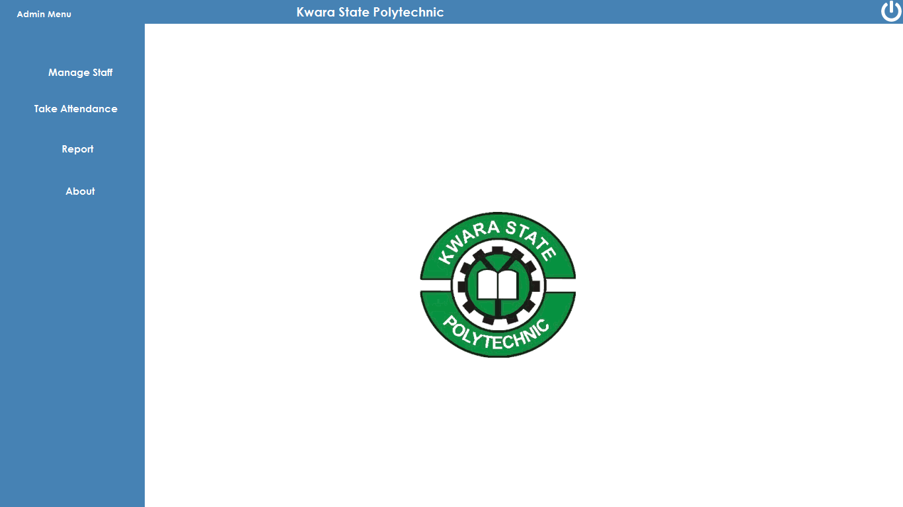
Figure 4.1: Main Menu: This is the menu page where every module directory is displayed.
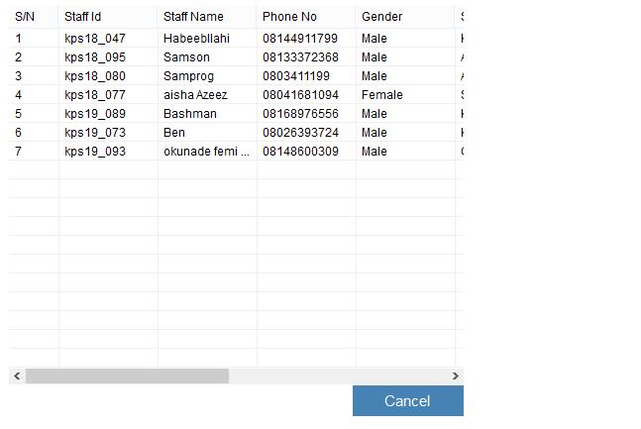
Figure 4.3: Staff Report Page: This is where staff details are displayed
4.1.2 Input Design
It is also necessary to denote that data inputted in the computer for processing determines what the output will be. The inputs are use in collecting information the student through the keyboard. Inputs are necessary information needed for processing so as to produce the expected outputs; which are supplied through the keyboard.
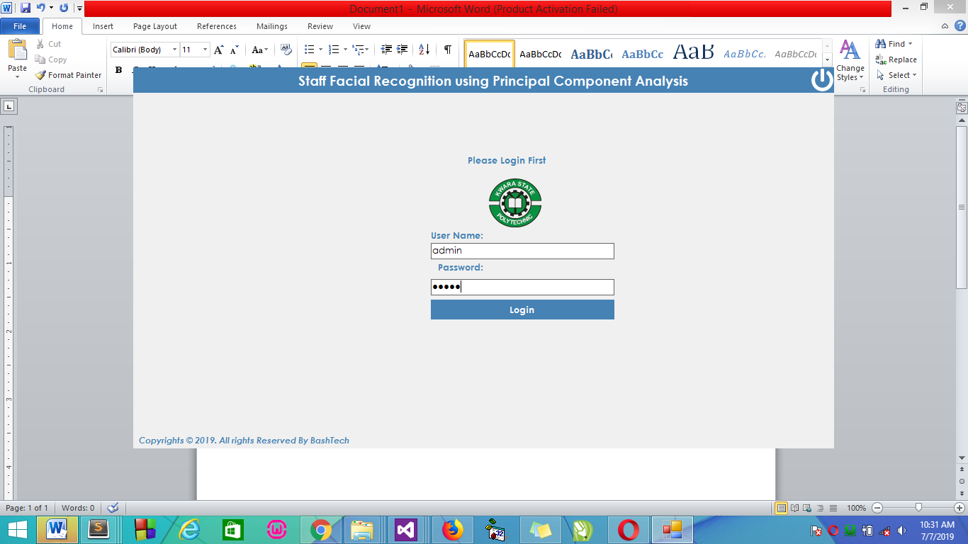
Figure 4.4: Login Page: The login environment for admin
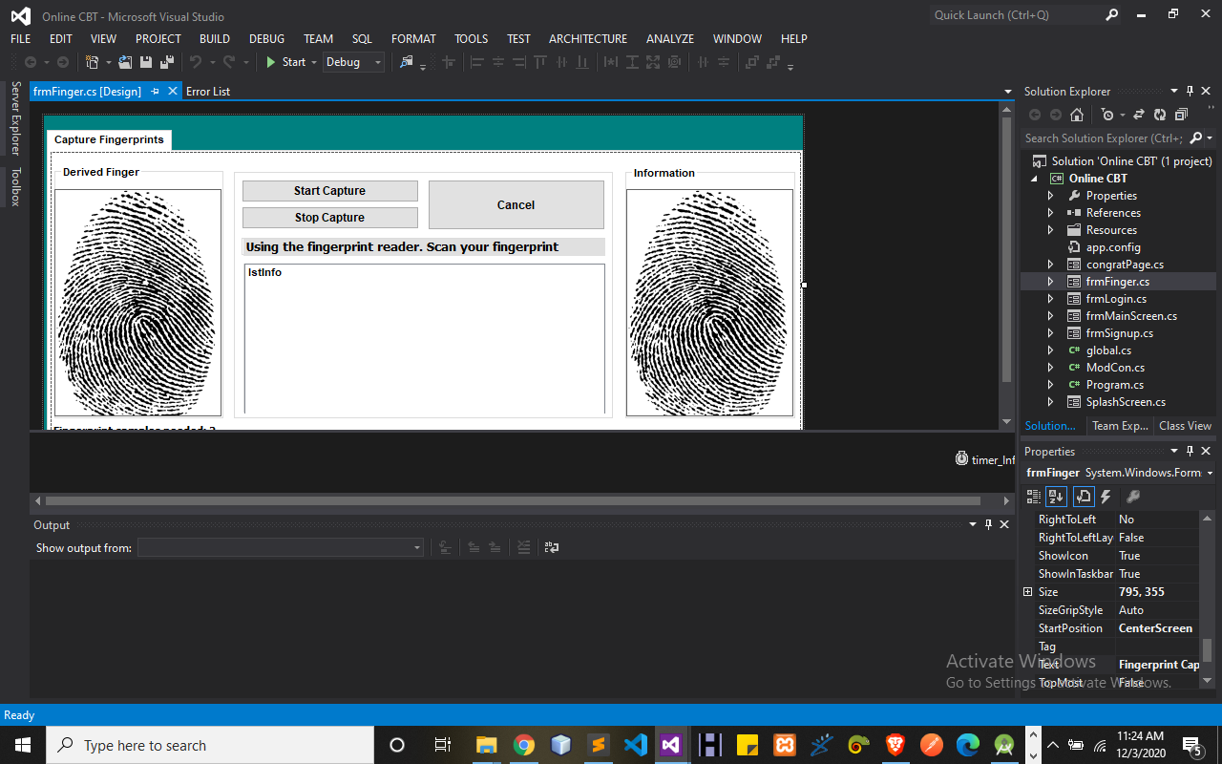
Figure 4.5: Finger Print Page: This is where Admin Add Staff Fingerprint Details

4.1.3 Database Design
A database table is used for storing information about the files. The database use for this application is mysql database. The files and their respective modes of access as well as information they hold are given below;
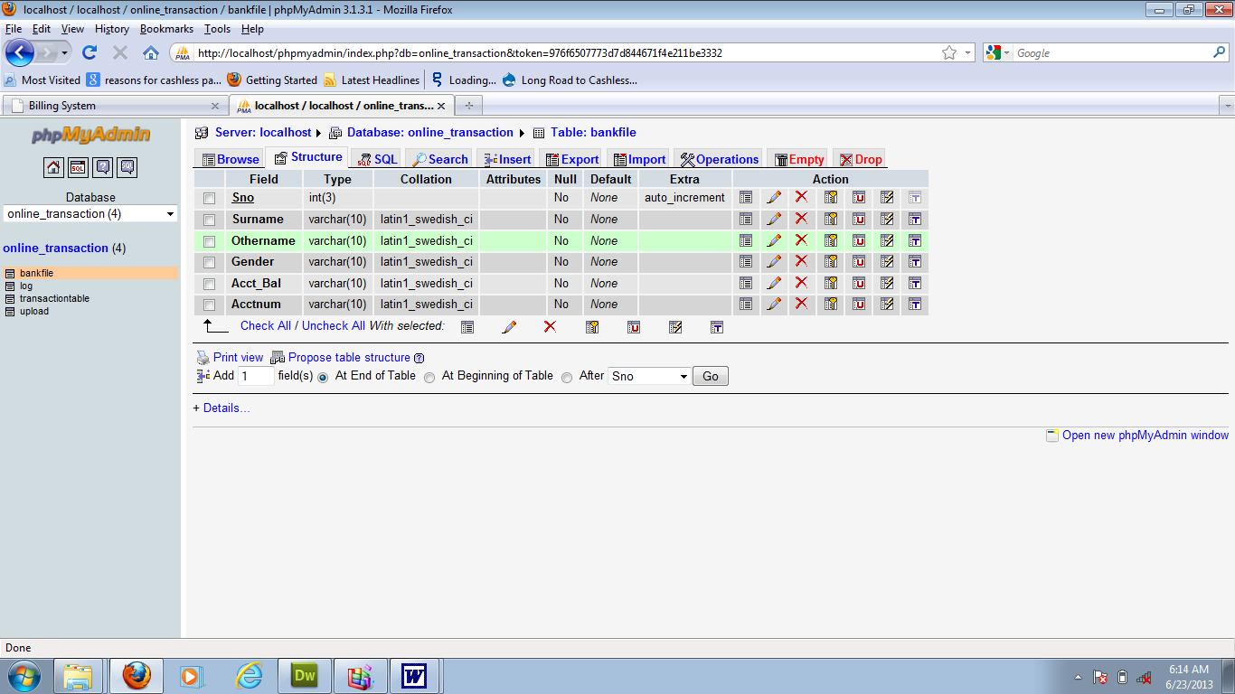
Table 4.6: Admin Datatable: This is admin datatable where data are stored and retrieved
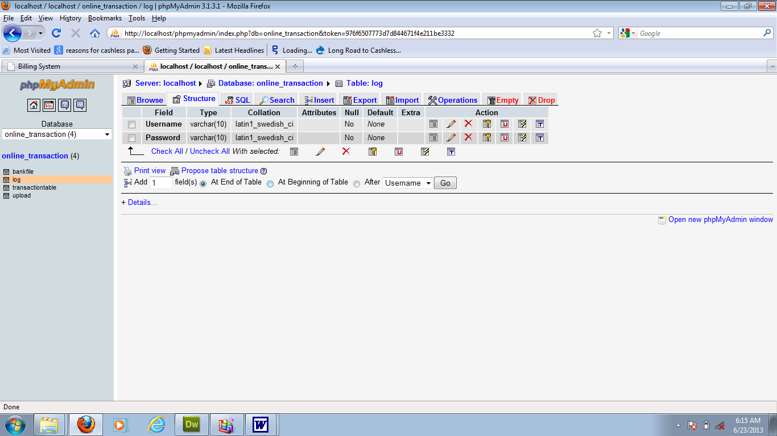

Table 4.2: Staff Details Datatable: This is where staff’s data are stored and retrieved

4.1.4 Procedure Designs
Procedures are steps which verify the whole process i.e which are everything put together to produce the desired output. This involves the organization of the source document and end with the output result.
Documents are sent to various departments to be filled by the employees and later returned to the personnel departments which are analyzed to determine which record goes into the computer.
After selecting the necessary data, this serves as input to the computer system.
4.2 Implementation of the System
It is always good to develop new ideas, to implement them on a computer and eventually to relish the satisfaction of achieving a successful result. The implementation process involves converting the system design into a complete and tested EDP that is fully operational and that can be used by the system users to meet their business needs. During implementation phase, the hardware and the software must be implemented.
Implementation of a system can be explained in six steps:-
1. Review design specification
2. Code, test and document programs
3. Train users
4. Perform system test
5. Convert to new system
6. Evaluate and maintain the new system
4.2.1 Choice of Programming Language
The application is designed using C# as the programming language and MYSQL for database management. Hence, the database testing simply involves running it directly from a Mozilla Firefox web browser on local host server provided by Apache 2.0 in WampServer 2.0 application.
In preparation for the installation of the new system, the method of changeover is given serious consideration to determine the success of the new system. Suitable changeover technique for this system is pilot changeover. The pilot changeover operates by applying the new system bit-by-bit until it covers the whole of the operations. The result obtained from using the pilot method on a small portion of the operations would be used in determining the suitability of the need system for the rest of the operations. This method is similar to testing small sample of a distribution if the test yields a good result then the whole system because fully operational and the manual/existing system is eliminated.
4.2.2 Hardware Support
The computer configuration required to run the software is;
Computer/memory processor PC with a 48dx, MHZ or Pentium, Intel or higher processor required.
Memory: 2GB of RAM
Cache memory: 512KB
Hard disk Minimum size 500GB
Recommended 200GB
Virtual Memory 32Bits
Cache memory 512KB
4.2.3 Software
I. Microsoft Visual Studio
ii. MY SQL Database Management Software
iii. Operating system window 07 professional
v. Graphic software paint shop and choosing these two formats GIF (Graphic Image Format)
vi. Scanner software, Mira scans
vii. Web browser software MOZILLA
4.3 Program Documentation
4.3.1 Operating the System
Step 1: Boot your computer and click on the C# application to load
Step 2: Enter your username and password
Step 3: Click on Options
3.1 Click on Manage Staff (to manage staff)
3.2 Click on Take Attendance (to take attendance)
3.3 Click on Report (to view report)
3.4 Click on About (to view the about page)
Step 4: Logout
4.3.2 Maintaining the System
The use of the term maintenance for software is different from other references to maintenance. Unlike the tires on your car, software does not “wear out”. If this is the case, then why does software maintenance account for such a high percentage of the Total Cost of Ownership for software?
The software maintenance definition refers to changes for defect correction, performance improvements, or adaptations to a changed environment (enhancements). According to this definition, if we build software that is defect-free, performs well, and contains user-controlled parameters to adjust processing rules in response to changing requirements then most maintenance would not be necessary.
Why does this happen? There are many reasons but the most common reasons are time constraints and lack of experience. Adding validation logic takes time. So, people make assumptions about the quality of in-bound data. Assumptions are also made about the volume of transactions and the impact on performance and the stability of the automated business processes. Finally, it is common for new software to be developed by younger developers who don’t understand the maintenance impacts of their designs.
The reality is that business requirements change and most of these assumptions are flawed. Transaction volumes increase, changing business processes require new transactions or new validation criteria, and software users will use the software incorrectly. The cost of software maintenance and the total cost of ownership can dramatically be reduced if developers build software that adjusted to changes in transaction volumes; validated all inbound data and provide user-configurable options for decision logic and data validation.

CHAPTER FIVE
SUMMARY, CONCLUSION AND RECOMMENDATIONS
5.1 Summary
This study set out to design, implement, and evaluate a fingerprint attendance monitoring system for educational institutions. The research involved several key steps, including the capture of fingerprint images, their binarization, thinning, and the extraction of minutiae points to ensure accurate identification. The system was developed to enhance the efficiency and reliability of attendance tracking, addressing the limitations of traditional methods such as manual roll calls and barcode scanning. The study adopted a mixed-method approach, integrating both qualitative and quantitative methods to provide a comprehensive analysis of the system's performance and user perceptions. The system was implemented using an optical fingerprint reader, and the software was developed using Python, incorporating image processing libraries and database management systems.
Evaluation of the system focused on its accuracy, usability, and user acceptance. Metrics such as the false acceptance rate (FAR) and false rejection rate (FRR) were calculated to assess accuracy. User feedback was collected through surveys and interviews to gauge usability and overall satisfaction. The perceptions and attitudes of students, faculty, and administrators were analyzed to determine the system's acceptance and identify potential areas for improvement.

5.2 CONCLUSION
In this work we aim to optimize the fingerprint recognition using minutea algorithm by increasing the number of images in the training set and then reduce the computation time that may occur of this enhanced algorithm. Our enhanced algorithm reduces the participated eigenvectors in the algorithm to reduce the computation time. The enhanced algorithm gives the same performance results in less time of recognition as 35% of the recognition time of the original algorithm. Our experiments are conducted using the MYSQL database and the algorithm is coded using C#.
The research methodology is based on exercising the proposed modified Minutea algorithm to decide the minimum number of images in the training set for individual that fulfill 100% of recognition, i.e., zero FAR. This experiment aims to neutralize the factor of the number of images in the training set while as this high training set number of images is best exercise our proposed algorithm for computational time.

5.3 RECCOMENDATIONS
Based on the findings of this study, the following recommendations are proposed:
- Further Research and Development: Continue to refine the fingerprint recognition algorithms to further reduce false acceptance and rejection rates. Explore the integration of other biometric technologies, such as facial recognition or iris scanning, to complement fingerprint recognition and provide multi-modal authentication options.
- Privacy and Data Security: Implement robust data security measures to protect the biometric data of students and staff, ensuring compliance with relevant privacy regulations. Educate stakeholders about the importance of data security and the measures in place to protect their biometric information.
- Scalability and Integration: Scale the system to accommodate larger institutions or multiple campuses, ensuring that it can handle a high volume of users and transactions. Integrate the fingerprint attendance system with existing school management systems to provide a seamless experience and enhance overall administrative efficiency.
- User Training and Support: Provide comprehensive training for users, including students, faculty, and administrative staff, to ensure they are comfortable with using the system. Establish a support system to address any technical issues or user concerns promptly.

Reference
Chiwa, F. & Musa, D. (2020): Secured Employee Attendance Management System Using Fingerprint, IOSR Journal of Computer Engineering (IOSR-JCE).
Hemlata, P. & Pallavi, A. (2021): Employee Attendance Management System Using Fingerprint Recognition, International Journal of Electrical, Electronics and Computer Engineering, Vol. 1, pp.37-40.
Josef, S. B. (2019): Minutiae Extraction from Fingerprint with Neural Network and Minutiae based Fingerprint Verification.
Łukasz, W. (2020): A Minutiae-Based Matching Algorithms in Fingerprint Recognition Systems, Journal of Medical Informatics & Technologies, Vol. 13, pp. 65-72.
Madya, A., et al (2019): Employee Management System, International Journal of Scientific & Engineering Research, Vol. 9, pp. 47-49.
Olagunju, M., et al. (2018): Staff Attendance Monitoring System using Fingerprint Biometrics, International Journal of Computer Applications, Vol. 179, pp. 8 15.
Ravi, J., et al (2020): Fingerprint Recognition Using Minutia Score Matching, International Journal of Engineering Science and Technology, Vol. 2, pp. 35 42.
Shrinivas, K., et al (2021): Android Based Attendance Management System, International Journal of Advanced Research in Computer and Communication Engineering, Vol. 7, pp. 190-193.
Sangeetha, J., et al (2020): Fingerprint-Based Attendance Management System, International Journal of Engineering Development and Research (IJEDR), Vol. 7, pp. 1-7.
Seema, R. & Satoa, K. J. (2020): An Attendance Monitoring System Using Biometrics Authentication, International Journal of Advanced Research in Computer Science and Software Engineering Vol. 3, pp. 379-383.
Kumar, A., & Kaur, R. (2019). Review on Automated Employee Attendance System. International Journal of Innovative Technology and Exploring Engineering, 8(10).
Mishra, S., Shaikh, M. Z., & Vora, J. (2020). Attendance Monitoring System Using Face Recognition. International Journal of Scientific & Technology Research, 9(03),
Nithya, K., & Rajalakshmi, P. (2018). Development of RFID based Attendance System for Educational Institutions. International Journal of Scientific Research in Computer Science, Engineering and Information Technology, 3(5), 79-83.

