

A PROJECT REPORT

ON

LAND INFOFMATION SYSTEM OF GORVERNMENT

SECONDARY SCHOOL MARABA , ILORIN EAST LOCAL

GONERNMENT AREA, ILORIN, KWARA STATE.

PRESENT BY:

AJEORUN JAMIU OLUWADAMILOLA

HND/23/SGI/FT/0099

SUBMITTED TO:

THE DEPARTMENT OF SURVEYING AND GEOINFORMATICS

INSTITUTE OF ENVIRONME NTAL STUDIES

KWARA STATE POLYTECHNIC P.M.B 1340

ILORIN,KWARA STATE.

IN PARTIAL FULFILLMENT OF THE REQUIREMENT FOR

THE AWARD OF HIGHER NATIONAL DIPLOMA IN SURVEYING

AND GEO-INFORMATICS

SUPERVISOR:

MR ABIMBOLA IBRAHIM ISAU

DECLARATION
I hereby certify that all the information given in this project was obtain as result of field observation and measurement made by me and that the survey was carried out in accordance with survey rules and regulation and department instructions.

NAME: AJEORUN JAMIU OLUWADAMILOLA

MATRIC NO: HND/23/SGI/FT/0099

DATE:

SIGNATURE:

CERTIFICATION
This is to certify that this project report was prepared and submitted by AJEORUN JAMIU OLUWADAMILOLA of Matric No: HND/20/SGI/FT/0099 to the Department of Surveying and Geo-Informatics, Institute of Environmental Studies Kwara State Polytechnic Ilorin, as a result of field observation and measurement using appropriate instrument and equipment to carry out the task.

---------------------------------------- --------------------------
SURV. ABIMBOLA IBRAHIM ISAU DATE
Project Supervisor

---------------------------------------- --------------------------
SURV. ABIMBOLA IBRAHIM ISAU DATE
Head of Department

---------------------------------------- --------------------------
SURV. R.S AWOLEYE DATE
Project Coordinator

DEDICATION
This project is dedicated to Almighty Allah and to my loving parents whose continuous effort, support and encouragement made it possible for me to participate in this project.

ACKNOWLEDGEMENT
My sincere gratitude goes to all who made this project a reality. SURV. ABIMBOLA IBRAHIM ISAU, your guidance was invaluable. I appreciate the dedication of my Teammates and Colleagues, whose Collaborative efforts brought our project to fruition. Our institution’s support was crucial in ensuring a smooth execution.
Lastly, my family, friends, and loved ones provided unwavering support and Motivation. Their belief in my abilities kept me focused on our project’s objectives. Together, your collective contributions have been the driving force behind this project’s success, and for that, I’m profoundly thankful.

TABLE OF CONTENTS
Title Page________________________________________________________________1
Declaration_______________________________________________________________2
Certification______________________________________________________________3
Dedication________________________________________________________________4
Acknowledgements__________________________________________________________5
Table of Contents ___________________________________________________________6
Abstract
CHAPTER ONE
  - Background Of The Study___________________________________________________8
  - Statement Of The Problem___________________________________________________9
  - Aim Of The Study_________________________________________________________10
  - Objectives Of The Study____________________________________________________10
  - Scope Of The Project_______________________________________________________11
  - Project Specifications_______________________________________________________11
  - Study Area________________________________________________________________12
  - Personnel Involved__________________________________________________________13
CHAPTER TWO
2.0 Literature Review___________________________________________________________14
2.1 Importance Of Land Information System_________________________________________17
2.2 Benefits Of Land Information System____________________________________________18
2.3 Applications Of Land Information System_______________________________________21

CHAPTER THREE
3.0 Methodology_______________________________________________________________23
3.1 Reconnaissance______________________________________________________________21
3.1.1 Office Reconnaissance_______________________________________________________24
3.1.2 Field Reconnaissance________________________________________________________24
3.2 Equipment Used And System Selection____________________________________________28
3.3 Hardware And Software Used____________________________________________________28
3.3.1 Hardware Used______________________________________________________________29
3.3.2 Software Used_______________________________________________________________29
3.4 Test Of Instruments (Total Station)_________________________________________________31
3.5 Control Check_________________________________________________________________32
3.6 Data Source___________________________________________________________________39
3.7 Geometric Data Acquisition______________________________________________________39
3.7.1 Perimeter Traversing__________________________________________________________39
3.7.2 Detailing___________________________________________________________________42
3.7.3 Attribute/ Social Survey_______________________________________________________44
3.8 Data Creation_________________________________________________________________53
3.8.1 Database Management System__________________________________________________53
3.8.2 Data Quality________________________________________________________________54
3.8.3 Data Integrity_______________________________________________________________55
3.8.4 Data Security_______________________________________________________________55
3.9.1 Drafting And Plotting_________________________________________________________55
3.9.2 Database Creation Procedures__________________________________________________55

CHAPTER FOUR
4.0 Introduction_________________________________________________________________56
4.1 Spatial Data Result_________________________________________________________57
4.2 Topographical Analysis Results_______________________________________________61
4.2.1 Digital Elevation Model (Dem)_______________________________________________61
4.2.2 Contour Mapping__________________________________________________________64
4.2.3 Slope And Terrain Analysis__________________________________________________68
4.2.4 Significance Of Topographical Analysis Result__________________________________68
4.3 Non-Spatial Data Results____________________________________________________68
4.3.1 Linking Non-Spatial Data With Gis____________________________________________70
4.4 Query Execution And Result_________________________________________________72

CHAPTER FIVE
5.0 Costing_________________________________________________________________74
5.1 Summary________________________________________________________________77
5.2 Conclusion_______________________________________________________________78
5.3 Recommendation_________________________________________________________78
Reference_______________________________________________________________80
Appendix

ABSTRACT
Land is one of the most valuable natural resources, and its effective management is essential for sustainable development. This project focuses on the design and implementation of a Land Information System (LIS) for government Secondary School Maraba , located in Ilorin East Local Government Area of Kwara State. The system was developed to provide an organized and digital means of storing, analyzing, and managing both spatial and attribute data related to land parcels, roads, buildings, and ownership information within the estate. Data were collected through field surveys using GNSS equipment and total station.

CHAPTER ONE
INTRODUCTION
  - BACKGROUND OF STUDY
A Land Information System (LIS) is a system that integrates data related to land and property management, typically including geographic, legal, and administrative data. It supports decision-making and management by providing information about land use, ownership, tenure, and boundaries. These systems are widely used by governments, municipalities, urban planners, real estate developers, and others involved in land management.

The project involves the acquisition of geometric data in X, Y, and Z. System the linear accuracy of the traverse lines will be computed and the area of the project site will be calculated using the plane coordinates (the X, Y coordinates). Also the height (Z coordinates) will be used for Digital Terrain Model (DTM) generation

AutoCAD land development will be used for plotting geometric data. The attribute data will be obtained through social survey (oral interview). The attribute data type pertaining to parvel of land, and building such as name uses, status, office, area etc. Will be linked with the geometric data type to allow for spatial analyses and queries. ArcView 3.2a Version will be used for the spatial analysis and queries. The information presentation of the result will be in form of tables, maps and report.

A Land Information System (LIS) is a sophisticated tool designed to collect, store, manage, and analyze data related to land resources. It integrates geographic (spatial) data with land-related information, such as ownership, land use, and legal or administrative data, into a cohesive system. LIS plays a critical role in modern land administration, urban planning, environmental management, and resource allocation.

As populations grow, urban areas expand, and environmental concerns increase, managing land resources efficiently and effectively has become increasingly important. This is where LIS comes into play, providing the infrastructure to support informed decision-making and sustainable land management practices.

A Land Information System is a powerful tool that supports the efficient management of land resources by providing accurate, up-to-date, and spatially referenced data. With the increasing need for sustainable development, urban planning, and environmental protection, the role of LIS has never been more critical. By integrating geospatial data with land administration, an LIS helps streamline decision-making processes and ensures that land is used and managed in a transparent, equitable, and sustainable manner.

In today’s rapidly urbanizing world, the importance of Land Information Systems cannot be overstated—they serve as the backbone for land governance, urban planning, resource management, and environmental protection efforts.

  - STATEMENT OF PROBLEM
Land administration and management in Government Secondary School Maraba continues to form critical inefficiencies, lack of coordination, and outdated systems in the study area. These problems underscore a deeper need, the urgent implementation of a digital solution that can integrate spatial data, and land use details into a unified platform.

Therefore, this project seeks to address these challenges by designing and implementing a Land Information System that is intelligent, accessible, and tailored to support effective land administration and sustainable development in Government Secondary School Maraba.
1.3 AIM OF THE STUDY
The primary aim of this study is to design and implement a functional Land Information System (LIS) that enhances the efficiency, accuracy, and transparency of land management processes within Government Secondary School Maraba, Ilorin East Local Government, Ilorin Kwara State. The system will serve as a digital platform for organizing, storing, retrieving, and managing land-related data, with the ultimate goal of supporting effective decision-making, reducing land disputes, improving access to land records, and promoting sustainable land administration at the institutional level.

  - OBJECTIVE OF THE STUDY
The specific objectives of this study are
- Design a user-friendly Land Information System capable of managing land and usage data in a centralized digital format.
- Geometric and attribute data acquisition
- Implement core features of the system including data entry, spatial mapping, search and retrieval functions, and secure access control.
- Integrate Geographic Information System (GIS) tools to visualize and enable location-based analysis and decision-making.
- Evaluate the performance of the developed system in terms of accuracy, usability, responsiveness, and reliability.
- To produce plans as graphical representation

1.5 SCOPE OF THE PROJECT
The scope of this project covers the following major phases and activities:
- Reconnaissance Survey: Preliminary field inspection to understand the area of study, identify existing features and determine control points needed for mapping.
- Office Planning: Preparation of necessary materials, equipment checks, defining the workflow, and gathering existing maps or records for the project area.
- Data Acquisition: Collection of spatial and non-spatial data through total station.
- System Design and Implementation: Development of a functional Land Information System to address land management and decision making.
- Documentation and Reporting: Compilation of project activities, methodologies, system features, and outcomes into a final technical report.

  - PROJECT SPECIFICATION
This project is aimed at building a Land Information System (LIS) to support effective land management. The system will combine both spatial (map-related) and non-spatial (text-based) information to help users register, retrieve, and visualize land records

STUDY AEEA
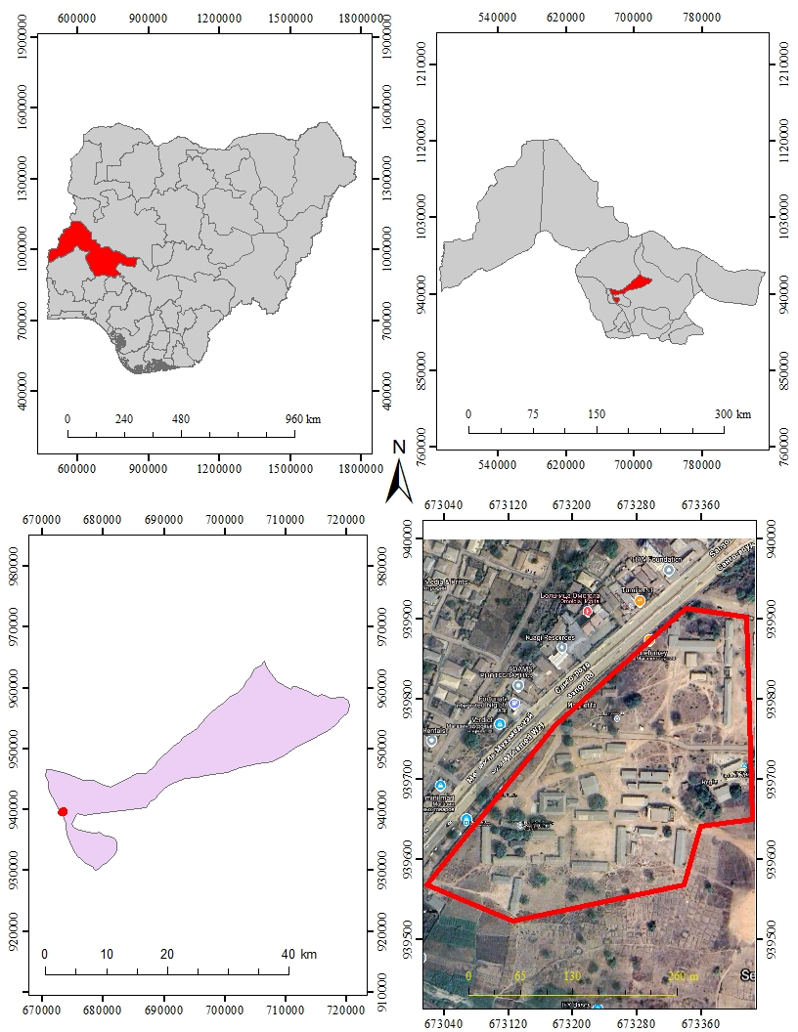

Source : Goggle Earth April, 2025
Fig 1 ;1 Study Area Image

1.5 PERSONNEL INVOLVED

NAME MATRIC NUMBER
AJEORUN JAMIU OLUWADAMILOLA HND/23/SGI/FT/0099 (AUTHORS
YUNUSA RUAYAT HND/23/SGI/FT/0090
OLADITI ABDULMUHEEZ OLAYEMI HND/23/SGI/FT/0092
AREMU OLUWAFEMI VICTOR HND/23/SGI/FT/0093
FATOYINBO THERESA HND/23/SGI/FT/0091
AGBALAYA OLAIDE MARGARET HND/23/SGI/FT/0097
AJIDE ALICE OLUWATOYIN HND/23/SGI/FT/0113
SAMSON DANIEL OLUWATOBILOBA HND/22/SGI/FT/0121

CHAPTER TWO
2.0 LITERATURE REVIEW
Land is man’s most valuable resources, which is neither inexhaustible and its acquisition in controlled by law in many communities both the private and public sectors and information is a pre-requisite for making decisions related to land Investment, development and managment. Policy makers, resources planners and administrators due to technological advancement needed more detailed information than the once acquired by the traditional method which should include population growth, social hazards and environmental degradation (Akinroye, 2008) Land is the essence of human civilization. It has been one of the most sought after posession in developing countries such exist, where the survivability, status etc is linked to the extent of an individual’s landed property.

The importance of land information cannot be overemphasized, land records provide the basis for;
  - Recognition of owner’s title, boundaries and usage,
  - Collection of all land and property related levies such as property tax, vacant land tax, water tax etc.
  - Planning by government for developmental and welfare purposes,
  - Database for various governmental and non-governmental users.
The wastage and destruction of land resources have continued worldwide which necessitated the need for accurate knowledge of natural resources, description and proper recording for their conservation. The cadastre is often the principal sources of information about ownership or rights on land, even when compiled for fiscal purposes.

A Land Information System (LIS) is a tool for legal, administrative, and economic decision-making as well as an aid for planning and development. It consists of a database containing spatially referenced land-related data and procedures and techniques for the systematic collection, updating, processing, and distribution of this data. LIS is critical in urban planning, property valuation, land tenure, and environmental management.

A Land Information System (LIS) is a comprehensive, integrated system for managing land-related information, typically used by local governments for cadastral and land-use mapping. It combines databases, mapping, and spatial analysis tools to collect, store, retrieve, and analyze data about land, including ownership, use, and location. LIS is a key tool for legal, administrative, and economic decision-making, as well as for planning and development.

Geographic Information System is a system that allows the capture, updating and display of manber of previously unconnected data set, bringing them into a common reference system for spatial analysis from which relationship can be identified and decision made.

The use of geographic information is satisfying a given need among GIS application.

Land Information System for Development
The general land use may be available for planning but the concept of carrying capacity base land use plan is still a dream for any planner. To obtain sustainability for any development plan, such carrying capacity plays a vital role. Starting from a new area development plan for housing or industrial complex to a flood control district level mitigation policy, the land information becomes a primary criterion. The information will vary from legal status of a plot number to a cadastral map needed for acquisition or construction of a highway or industry relocation area to geo-hydrological or geotechnical information for the construction of a reservoir or locating a hazard waste disposal ground. Some of the stipulated rules are so stringent at present that if we are not equipped with such information, we cannot obtain any clearance from the authority.

Any development project essentially requires clearance from various departments which need to be based on information on a developing land. The rehabilitation strategy has almost become a regular part of any development project and therefore the information of presently occupying and to be occupied land, both become essential criteria of the project

The demand for land for any development will always be the primary requirement and to establish utility oriented information system about such land must be important criteria in our policy.

Geographic information plays an increasingly important role both nationally and internationally. It is useful in environment monitoring and management essential to the survival of future generations.

In developing countries, efforts so far has focused to satisfy on short-time acute needs investment that have yielded immediate tangible results, as in food production, infrastructure and health, have taken precedence over other investments which have been downgraded and neglected. The regrettable result in most developing countries is that overviews of natural resources and environmental states are meager. The information requisite to planning and prodent management of renewable and other resources if inadequate. There are not reliable overviews of the extent of environmental damage caused by human activities.

Having dealt so much on what land information system, GIS, L.IS, Database and Dutabase Management System (DBMS) are, a step will be taken further into the methodology. Which include the database design, data acquisition, data processing etc, in chapter three of this report

Importance of Land Information Systems
- Land Administration and Management: An efficient LIS simplifies land administration tasks, such as registering ownership, resolving boundary disputes, and managing property taxation. It provides a centralized database for all land-related information, which can be accessed by landowners, government agencies, and developers.
- Urban Planning and Development: Urban planning is highly dependent on land data to design zoning regulations, infrastructure, and public services. By integrating land use data and demographic information, LIS helps planners make informed decisions on urban expansion, housing, transportation, and utilities.
- Environmental Protection: An LIS can support environmental management by providing insights into land use changes, deforestation, soil erosion, or pollution. This data can be used to monitor and protect ecosystems, track natural resources, and mitigate environmental degradation.
- Disaster Management and Risk Assessment: With spatially accurate land data, LIS can help in disaster preparedness and risk management. For instance, in flood-prone areas, LIS can identify flood plains, vulnerable populations, and infrastructure to support mitigation strategies.
- Agricultural Land Use: For agriculture, LIS helps in identifying land suitability for specific crops, monitoring soil health, and managing irrigation and land reclamation projects. This can improve land productivity and sustainability in rural areas.
- Supporting Government Policies: Governments rely on accurate, up-to-date land data to implement policies, issue permits, enforce zoning laws, and protect public land. LIS supports transparency and accountability by making land data accessible and easy to update.
Benefits of Land Information Systems
  - Efficiency: By automating data collection, processing, and analysis, LIS streamlines land-related processes, reducing the time and resources needed for manual tasks.

  - Accuracy: The integration of spatial and non-spatial data ensures that land records are accurate and up-to-date, which is crucial for decision-making and legal purposes.

  - Accessibility: A well-designed LIS makes land data accessible to a wide range of stakeholders, including government authorities, developers, landowners, and the general public.

  - Transparency and Accountability: An LIS allows for better tracking of land ownership, land-use changes, and zoning compliance, fostering transparency and accountability in land management.

  - Support for Sustainable Development: By providing the necessary tools to assess land use and environmental conditions, LIS supports sustainable land use practices, helping to balance development with environmental conservation.

The Role of Land Information Systems in Land Administration
Land administration is one of the primary functions of an LIS. In land governance, LIS supports the management of land ownership, transactions, land tenure, and rights, providing a comprehensive framework for managing land and resolving disputes. According to Enemark et al. (2005), a well-functioning land administration system is crucial for economic growth, as it provides clear property rights, reduces land disputes, and encourages investment.

An LIS typically includes land registration, property valuation, and cadastral mapping. Cadastral systems that use LIS technologies ensure that accurate and up-to-date land records are maintained, reducing the risk of conflicts, fraud, and illegal land transactions. Studies, such as those by Williamson et al. (2010), have highlighted the importance of secure land tenure in promoting sustainable development, especially in developing countries where land ownership is often informal and poorly documented.

Technological Advancements in LIS
The development of Geographic Information Systems (GIS) has greatly enhanced the capabilities of LIS by providing tools for spatial data analysis and mapping. GIS allows for the integration of spatial and non-spatial data, which is a critical feature of modern LIS. Brovelli et al. (2012) discuss how GIS-based systems provide precise mapping of property boundaries, supporting efficient urban planning, land valuation, and land-use zoning.

Furthermore, the advent of remote sensing technologies and satellite imagery has expanded the scope of LIS. According to Miller (2007), the integration of satellite-based imagery into LIS enables the monitoring of land use changes, environmental degradation, and urban sprawl. Google Earth Engine and Sentinel Hub, for example, are widely used platforms for analyzing time-series satellite imagery, making it easier to detect land cover changes over time, and to support policy decisions related to environmental conservation and urban planning.

Cloud computing has also emerged as a transformative technology for LIS. Cloud-based GIS platforms allow for the storage and analysis of vast amounts of geospatial data, making LIS more scalable, accessible, and cost-effective. Tomlinson et al. (2016) argue that cloud-based solutions enhance collaboration between various stakeholders, including government agencies, landowners, and developers, by providing real-time access to land data.

Challenges in Implementing and Managing LIS
Despite the technological advancements, the implementation of an LIS faces several challenges. One of the primary obstacles is the data availability and quality issue. Many countries, particularly in developing regions, lack accurate and up-to-date land data. Deininger et al. (2011) note that poor data quality, inconsistent land records, and inadequate cadastral surveys are significant barriers to establishing effective LIS systems. In many cases, land information is fragmented across multiple agencies, leading to inefficiencies and inconsistencies.

Another significant challenge is data standardization. Minghua et al. (2019) discuss how the lack of common standards for data collection and management often complicates the integration of land data from different sources. Inconsistent formats and classifications across agencies and regions can lead to significant discrepancies in land records, making it difficult to conduct reliable spatial analysis.

Financial constraints are another hurdle in establishing an LIS. Robinson et al. (2004) emphasize the high costs associated with implementing LIS, especially in developing countries. These costs include investments in infrastructure, software, personnel training, and data collection. However, the authors argue that the benefits of LIS—such as reduced land disputes, improved land management, and increased transparency—far outweigh the initial investment.

Additionally, institutional and legal barriers can impede the effective functioning of LIS. Amedzro and Ayee (2014) highlight how issues like lack of political will, corruption, and poor governance can undermine efforts to implement an LIS. The authors suggest that political support and public trust are essential for the successful implementation and long-term sustainability of land information systems.

Applications of Land Information Systems
Land Information Systems are applied in various sectors, and the literature shows a diverse range of applications across different contexts:

  - Urban Planning and Development: LIS is instrumental in urban planning and zoning decisions. According to Zhang and Wu (2008), cities can use LIS to analyze land-use patterns, plan infrastructure, and optimize the allocation of resources. By analyzing land data, planners can make informed decisions about where to build residential, commercial, and industrial zones, as well as where to invest in infrastructure such as roads and public services.

  - Environmental Management: Remote sensing and spatial analysis capabilities in LIS allow for the monitoring of environmental changes. Dewan et al. (2012) use an LIS to study land use changes and deforestation in the Amazon, showing that such systems can track changes in vegetation cover over time, enabling governments and conservationists to take proactive measures in protecting natural habitats.

  - Agricultural Land Management: In agriculture, LIS is used for land suitability analysis, determining which areas are best suited for specific crops. Ruth et al. (2014) demonstrate how an LIS can optimize land-use efficiency, ensuring that agricultural land is used sustainably, with optimal yields and minimal environmental impact.

  - Disaster Management: An LIS can play a significant role in disaster risk assessment and management. Bhattacharya et al. (2011) show how spatial data and GIS tools are used to assess vulnerability in flood-prone areas. By integrating hazard maps with land-use data, governments can better prepare for disasters and manage risk zones effectively.

  - Property Valuation and Taxation: Kassim et al. (2017) discuss how LIS enhances the efficiency of property valuation and taxation systems. By maintaining accurate land records and integrating property data with market trends, governments can generate fair and up-to-date property valuations, improving tax revenue generation.

CHAPTER THREE

3.0 METHODOLOGY
This explained the method and techniques used to pursue the objectives and to realize the aims of this project work, the execution of this project was based on the following basic principle of surveying
- Working from whole to the part.
- The principle of choosing the method of survey most appropriate to meet the desired result.
- The principle of provision for adequate checks to meet the required accuracy
3.1 PROJECT PLANNING
Effective planning is essential before initiating any survey project. This process begins with a thorough inspection of the project area, allowing the researchers to gain a clear understanding of the site prior to commencing fieldwork, known as “RECONNAISSANCE”. Reconnaissance typically consists of two main components: (i) Office Planning (ii) Field Reconnaissance
Effective surveying begins with comprehensive project planning, a systematic process that establishes the foundation for accurate data collection. This preparatory stage involves:
- Thorough research on the targeted land parcel
- Clear definition of survey objectives and deliverables
- Precision assessment to determine methodology and equipment.
3.1.1 OFFICE PLANNING
Office planning which could be termed as office reconnaissance involved knowing the type of instruments, purpose, specification and accuracy require of the survey to be carried out. These led to the choosing of appropriate equipment and method to be employed, also costing of the survey operation was done in the office. Information related to the project was collected from various sources, the coordinate (x, y, and z) of the initial and that of the three choosing controls used for orientation were all obtained from survey department office (KWGIS).
3.1.2 FIELD RECONNAISSANCE
The project site was visited by all the group members to have the true picture of the site for the better planning. The recce diagram was drawn alongside the carrying out and the reasonable artificial features were fixed along and within the traverse lines, the traverse was fixed to maintain perfect indivisibility.
3.2 DATA BASE DESIGN
The design of any database involves three stages namely;
- Conceptual design
- Logical design
- Physical design
VIEWOF REALITY
In database design, there is need for reality which is referred to as the phenomenon that actually exists, including all aspects which may or may not be perceived by individuals. The view of reality however, is the mental abstraction of the reality for a particular application or group of applications.
For this application, the view of reality is made of the topography of the project. Since it is not possible to represent the real world, the only option is to conceptualize and model it in a specified manner to represent the real world. The area of interest to use in this project includes; Green Reserve, Roads, Electric poles, Trees, Water Facilities, Buildings, Football pitch, Streams.

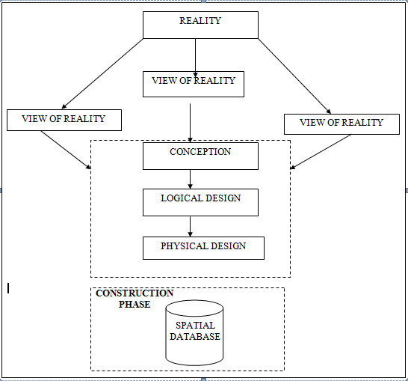

Fig.3.1Design and Construction Phases in Spatial Database (R Sobh, C Perry,. 2006)
    - LOGICAL DESIGN

This is the design aspect of the database refers to the process of creating a conceptual framework or model that represents the structure and organization of spatial data within the system. It involves defining the data element, their relationship, and the rules for data manipulation and analysis. In this phase, the entities, their attributes and their relationships are represented in a single uniform manner in form of relation in such a way that would be no information loss and at the same time no unnecessary duplication of data. In this study, the logical database design is employed to generate a geo-relation database structure. Each entity has unique identifier in bold type. An attribute type or combination of attribute types that serves to identify an entity type is termed an identifier.
- Building (B_ID,B_Area, B_Name, B_Easting, B_Northing)

- Roads (R_ID,R_Width, R_Type, R-Condition, R_Easting, R_Northing)

- Vegetation (V_ID,GR_Area,)

- Tree (TR_ID,TR_spp,TR_Importance,TR_Easting,TR_Northing)

- Electric Pole (EP_No,EP_Type,EP_Height,EP_Easting,EP_Northing)

- Football Pitch FP_ID, FP_Area,FP_Status)

3.3 EQUIPMENT USED
3.3.1 HARD WARE
- Total Station (South
- Reflector Pole
- Hand-held GPS
- Steel tape
- Nails and bottle cover
- Field book
- 1 cutlass

3.3.2 SOFTWARE
- AutoCAD 2007
- Arc-GIS 10.2
- Google Earth
- Note pad
- Excel

3.4 INSTRUMENT TEST
To ensure data quality, the Total Station used for this project was tested for both vertical index and horizontal collimation errors. It was also to ascertain the efficiency and reliability of the instrument. The procedure used is described below.

3.4.1 HORIZONTAL COLLIMATION TEST

This test was conducted to ensure that the line of sight was perpendicular to the trunnion axis. The Total Station was positioned over a specific point, and initial adjustments were made to ensure proper alignment, leveling, and focus (to eliminate parallax in the telescope). A vertical target was placed at a distance of 100 meters from the Total Station. To access the configuration menu of the Total Station, the menu key was pressed and held for approximately 2 seconds. From the

main menu, the calibration sub-menu was selected, and within that, the horizontal collimation test option was chosen. The target was then observed and divided into two halves, with horizontal readings recorded for Face left and Face right. The readings are shown in Table 3.4.1 below.

Total Station Reflector (Target)
100m

Station A Fairly Level Ground Station B

Fig3.4.1.1; Horizontal Collimation and Vertical Index error test

Table3.4.1.1: Horizontal Collimation Data

Station | Target | Face | Horz. Reading | Difference | Error
A | B | L | 025˚ 32‟ 32”
 |  | R | 205˚ 32‟ 35” | 180˚ 00’ 03” | 00˚ 00’ 03”

3.4.2 VERTICAL INDEX ERROR TEST

This test was conducted to verify the accuracy of the vertical reading when the line of sight is horizontal. The desired measurement for this test is exactly ninety degrees (90˚), any deviation from this value is referred to as the vertical index error.
The Total Station was positioned over a specific point, and necessary temporary adjustments were made to ensure proper alignment and functionality. A target was placed approximately100 meters away from the Total Station, and the instrument
was aimed at the target. The target was bisected by aligning the instrument on the face left, and the corresponding reading was recorded. Similarly, the target was then bisected on the face right and the respective reading were also recorded. The recorded readings are provided below:

Table3.4.2.1: Vertical Index Data

Instrument Station | Target Station | Face | Vertical | Sum | Error
A | B | L | 95˚ 00‟ 00”
 |  | R | 275˚ 00‟ 02” | 360˚ 00‟ 02” | 02”

3.4.3 ANALYSIS OF COLLIMATION AND VERTICAL INDEX DATA

The readings obtained during calibration were reduced to obtain new collimation and vertical errors.
Horizontal collimation = {(FR–FL) –180} /2 ={(00˚00‟03”} /2 =1.5”

Vertical collimation = {(FL+FR) –360} = (95˚00‟00” + 275˚00‟02” ) -360} = 02” The result shows that the instrument is still in good working condition.

3.5 CONTROL CHECK
3.5.1 Control Check Procedure Using Total Station
To ensure the accuracy and reliability of the Total Station observations used for spatial data acquisition, control checks were carried out before and during the main survey. The procedure involved setting up the instrument over a known control point, performing temporary adjustments, executing angular and distance observations (back sight and foresight), and validating the computed coordinates against known values.
Step 1: Instrument Setup and Centering.
The Total Station was mounted securely on a tripod placed directly over the first known control point.
Centering was done using the built-in optical plummet to align the vertical axis of the instrument precisely over the ground mark.
Fine adjustments were made by shifting the tripod legs or using the sliding base plate to achieve perfect alignment.
Step 2: Temporary Adjustments (Leveling and Elimination of Instrumental Error)
Leveling: The circular bubble was first centered using the tripod legs. Then, the tubular (or electronic) level was used with the foot screws to achieve fine leveling in two perpendicular directions.
Collimation Check: An internal calibration (collimation) check was performed using the instrument’s self-diagnosis function to ensure the vertical and horizontal axes were perpendicular.
The horizontal circle was then set to zero after selecting the backsight direction.

Step 3: Back sight Observation
The telescope was rotated to face a second known control point (backsight).
The instrument was focused accurately on the backsight prism, and both horizontal and vertical coordinates (XYZ) were measured.
Step 4: Foresight Observation and Coordinate Validation
The telescope was then turned to observe a third point (foresight). The horizontal and vertical coordinates (XYZ) were measured. The observed coordinates were then compared to the known coordinates of the foresight control point already established.
Coordinate difference (ΔX, ΔY, ΔZ) was calculated to assess positional accuracy. The difference was within the allowable tolerance (typically ±2cm for X/Y and ±3cm for Z), the instrument was considered properly calibrated.
Step 5: Repeat Check at another Station
The same procedure was repeated for every station setup across the site to ensure uniform accuracy across the network.
All three control stations showed closure errors and coordinate differences well within the accepted tolerance for third-order survey work. This control check procedure ensured that the Total Station data used for plotting school boundaries, buildings, and topography in the Land Information System were precise and trustworthy.
Once the control points were verified and validated, they were used as reference locations for the detailed survey of the sc

ordinate of the observed and the original values of K654AD
PILLAR | NORTHING | EASTING | STATUS | REMARKS
SC/KW K654AD | 939792.896 | 673354.040 |  | ORIGINAL
SC/KW K654AD | 939792.886 | 673354.020 | FIXED | OBSERVED
DISCREPANCY | 0.010 | 0.020

Table 3.4.2: Coordinate of the observed and the original values of K656AD
PILLAR | NORTHING(m) | EASTING(m) | STATUS | REMARKS
SC/KW K656AD | 939837.818 | 673334.688 |  | ORIGINAL
SC/KW K656AD | 939837.797 | 673334.666 | FIXED | OBSERVED
DISCREPANCY | 0.021 | 0.022

Table 3.4.3: Coordinate of the observed and the original values of K657AD
PILLAR | NORTHING(m) | EASTING(m) | STATUS | REMARKS
SC/KW K657AD | 939803.143 | 673366.311 |  | ORIGINAL
SC/KW K657AD | 939803.132 | 673366.291 | FIXED | OBSERVED
DISCREPANCY | 0.011 | 0.020

3.7 GEOMETRIC DATA ACQUISITION
The total station instrument was set carefully on control point SC/KW K6546AD back sight taken to K SC/KW K654AD after necessary station adjustments has been carried out on it. The adjustments include; centering, leveling and focusing. The following procedures were then followed to determine the position of the next point (NL1) and the same procedure were repeated until all we come close to the site. The method used in acquiring data on site was radiation method where two or more points are coordinated from one instrument station.
- Having setup the instrument and temporary adjustment carried out, the instrument was powered „on‟ and a job file was created under job menu in the internal memory of the instrument. The job file created was named GSSGR4C.
- On the job, the coordinates of the three (3) control points were keyed in to the memory of the instrument and some codes were also saved. The codes include
„RD‟ for road, SP‟ for spot height, BD for buildings, etc.

- The height of the instrument was measured and saved on the memory of the instrument as well as their reflector height.
- On coordinate menu, orientation was set by inputting the coordinates of the instrument station and back sight. The reflector at the back station was perfectly bisected before the orientation was confirmed by clicking yes.
Having done the orientation, the reflector at the next station was bisected and observe option was clicked. The three-dimensional coordinate of the point (E N, H) were displayed on the display unit of the instrument and record button was clicked to save the data into the memory of the instrument. For subsequent observation after this, all options were used instead of pressing observation (“obs”) and pressing record later.

- It was ensured that the center of the prism of the reflector was bisected and that it was set perfectly on the tripod in order to minimize the error on height determination.
- The instrument is been shifted to another station after all details, spot height and boundary point visible from the instrument station have been picked, The instrument was set over new station and temporary adjustments carried out.

However, the above operations were repeated until all the boundary points with heights were coordinated.

In this project all spot height were not in grid intervals but randomly acquired. At the end of data acquisition process all details were observed and properly recorded to be shown in their respective positions on the plan.

Detailed Survey:
The detailed survey focused on mapping the internal structures and facilities within the school, including:
- Classrooms
- Staff rooms and administrative offices
- Laboratories and libraries
- Playgrounds and sports fields
- Roads, parking lots, and walkways
Geometric data for every feature were acquired using Total Station, and the collected spatial data were stored in a structured format. Screenshots of the Total Station data interface were captured to illustrate the data collection process. The observations were carried out systematically to ensure complete coverage of all features within the project area.

Non-Spatial Data Collection
In addition to spatial data, non-spatial data (attribute data) were collected to provide descriptive information about each observed feature. These data were gathered through field observations, school administrative records, and structured interviews with key personnel.
Types of Non-Spatial Data Collected
- Building Information: Name, number of floors, year of construction, type of usage (classroom, staff office, laboratory, etc.).
- Staff Room and Office Details: Departmental functions, number of staff, office occupants.
- Infrastructure Information: Type of roads (paved or unpaved), water supply, power supply.
A field book was used to record the collected data, ensuring uniformity and easy integration into the LIS database. The completed forms were reviewed for accuracy before entering the data into a spreadsheet for GIS processing. Screenshots of the attribute data collection forms were taken and included in the documentation.

3.3.4 Data Download and Storage
Once the field surveyed was completed, all collected data were transferred to a computer system for further processing and storage. The following steps were taken to ensure proper data management:
- Downloading Total Station Data: The surveyed X, Y, Z coordinates were extracted from the Total Station’s internal memory using instrument software. The data were saved in a CSV (comma-separated values) file format for compatibility with GIS and AutoCAD software.
- Organizing Non-Spatial Data: The collected attribute data were entered into an Excel spreadsheet, ensuring proper formatting for easy integration with spatial data. The file structure was reviewed to ensure consistency and completeness.
- Data Backup: Copies of all data files were stored in an external flash drive to prevent data loss. File versions were properly labelled to maintain organization.
The downloaded spatial and non-spatial datasets were prepared for further processing and integration into the LIS.

3.3.5 Data Validation and Accuracy Assessment
To ensure the accuracy and reliability of the collected data, a rigorous validation process was conducted. This involved cross-checking the surveyed coordinates, attribute data, and instrument readings to identify and correct any errors.
Validation of Spatial Data
- Coordinate Cross-Check: The surveyed points were compared with known control points to verify accuracy.
- Boundary Accuracy Check: The surveyed boundary was overlaid on an existing satellite image in Arc=GIS to detect any misalignment.
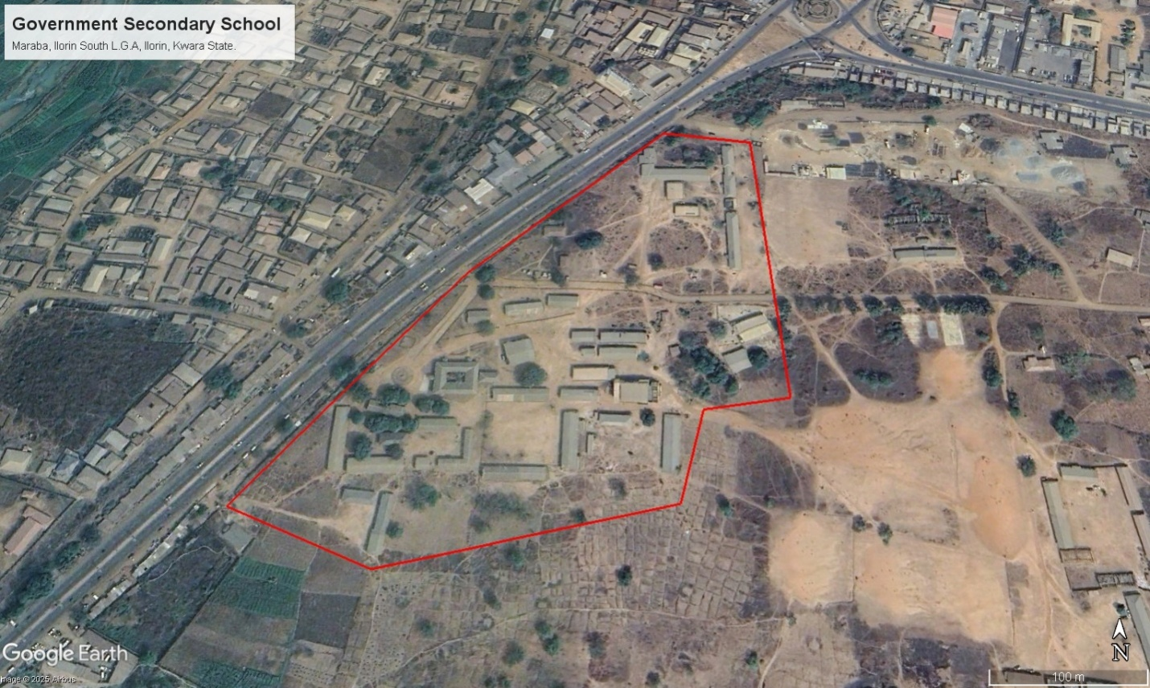
Figure 3.3: Satellite Imagery of the study area
Validation of Non-Spatial Data
- Attribute Consistency Check: The recorded building and facility details were compared with official school records.
- Correction of Data Entry Errors: Any discrepancies or incorrect attribute entries were identified and corrected before finalizing the dataset.

3.4 DATA PROCESSING AND INTEGRATION
The data processing and integration phase is a critical step in transforming the raw data collected from the field survey into a structured Land Information System (LIS). This stage involves cleaning, organizing, and integrating both spatial and non-spatial data into a geodatabase, ensuring seamless access, analysis, and visualization.
The processing workflow consists of multiple steps, including spatial data processing in AutoCAD and Surfer, non-spatial data structuring in Excel, geodatabase creation in ArcGIS, and data integration for LIS development. The structured integration of these datasets enables effective querying, mapping, and decision-making for the secondary school management system.
3.4.1 Spatial Data Processing in AutoCAD
AutoCAD was used to plot the observed coordinates, (Geometric data) ensuring accurate representation of school facilities such as classrooms, staff rooms, administrative offices, roads, and playgrounds. The following steps were carried out:
- Importing Surveyed Points:
  - The CSV file containing surveyed coordinates was imported into AutoCAD.
  - The points were plotted based on their real-world X and Y coordinates, while the Z values were retained for elevation analysis.
- Plotting of Boundaries and Features:
  - The boundary points were connected using polyline tools, forming a closed polygon to define the extent of the school premises.
  - Each school building was mapped as a separate layer, and unique identifiers were assigned to distinguish classrooms, staff rooms, laboratories, and other structures.
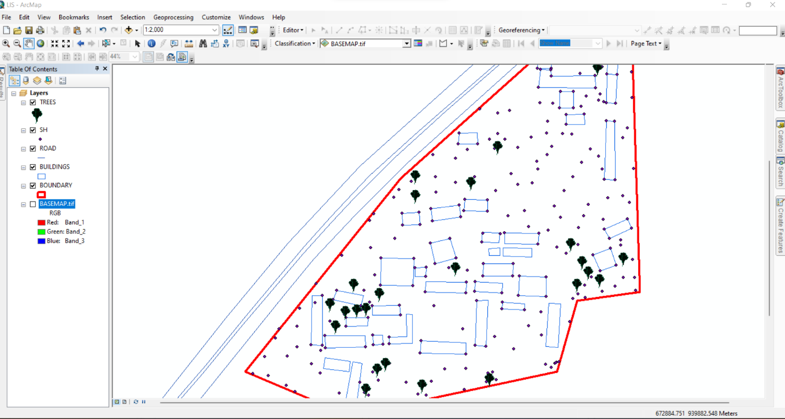
Figure 3.5 Screenshot of boundary digitization and features
3.4.2 TOPOGRAPHIC DATA PROCESSING IN SURFER
Surfer software was used for topographic analysis and terrain modelling based on the surveyed elevation data (Z values). The following procedures were followed:
- Importing Surveyed Data:
  - The X, Y, and Z coordinates were loaded into Surfer as a point dataset.
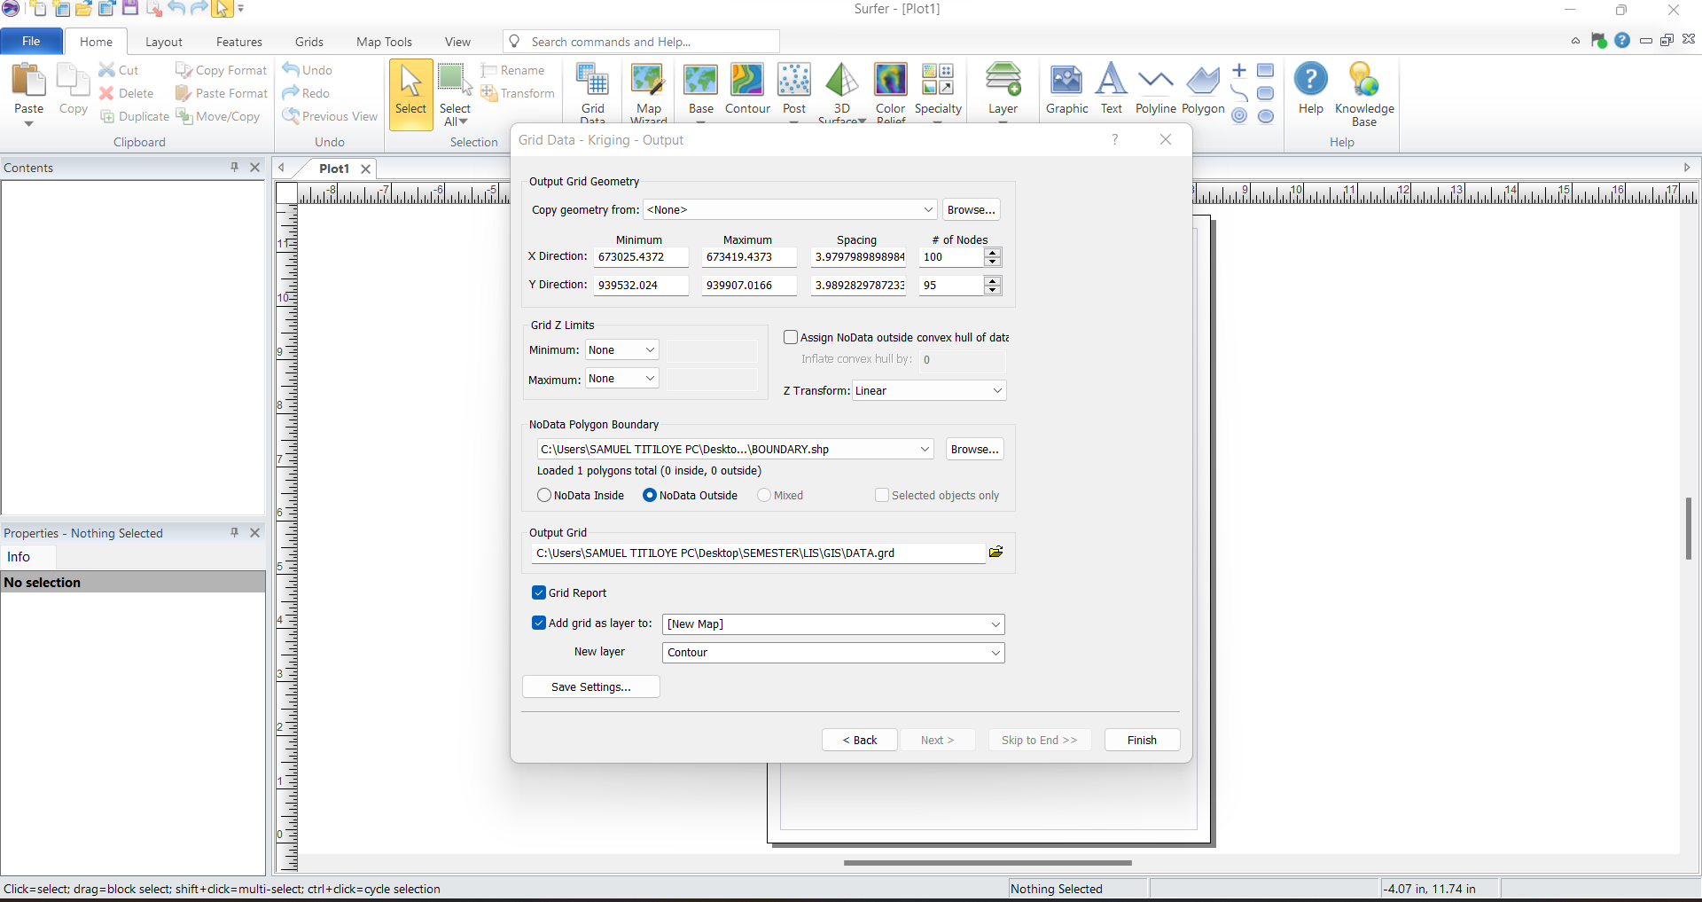
Figure 3.6: Screenshot of the imported dataset.
- Generation of Digital Elevation Model (DEM):
  - A grid-based interpolation technique was applied to generate a Digital Elevation Model (DEM) of the school area.
  - The DEM provided insight into the elevation variations across the school premises, assisting in drainage and flood risk assessment.
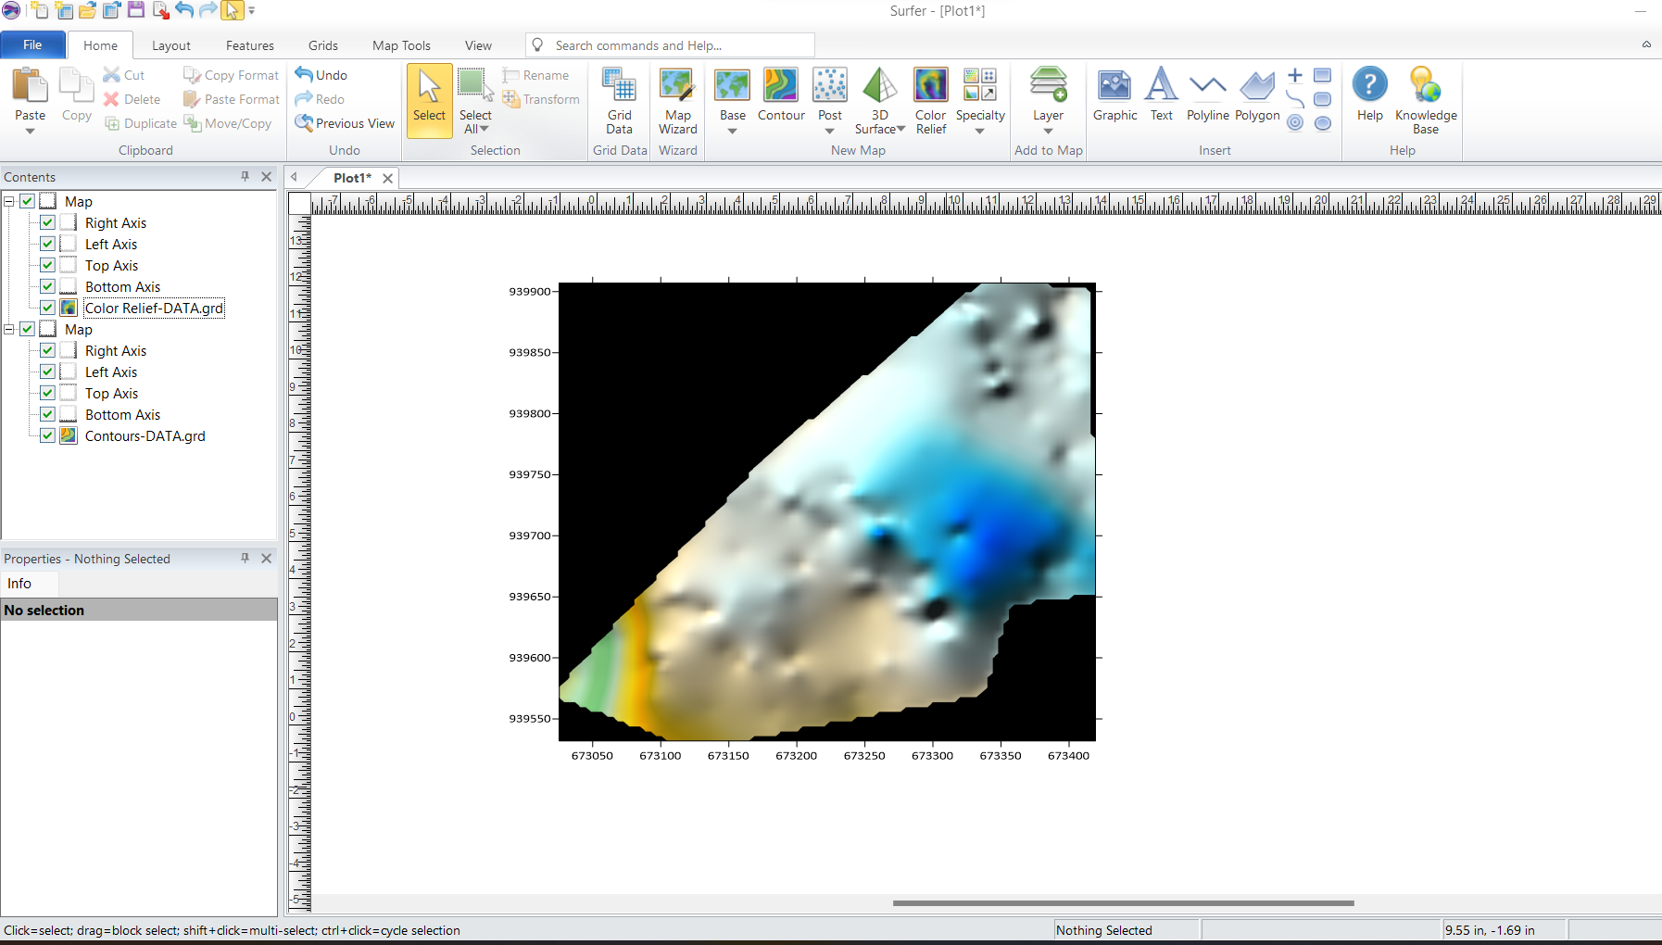Figure 3.7: Screenshot of the generated DEM.
- Creation of Contour Maps:
  - Contour lines were generated at specific intervals to visualize terrain variations.
  - The contour map was exported in Geo-TIFF format for integration into Arc-GIS.
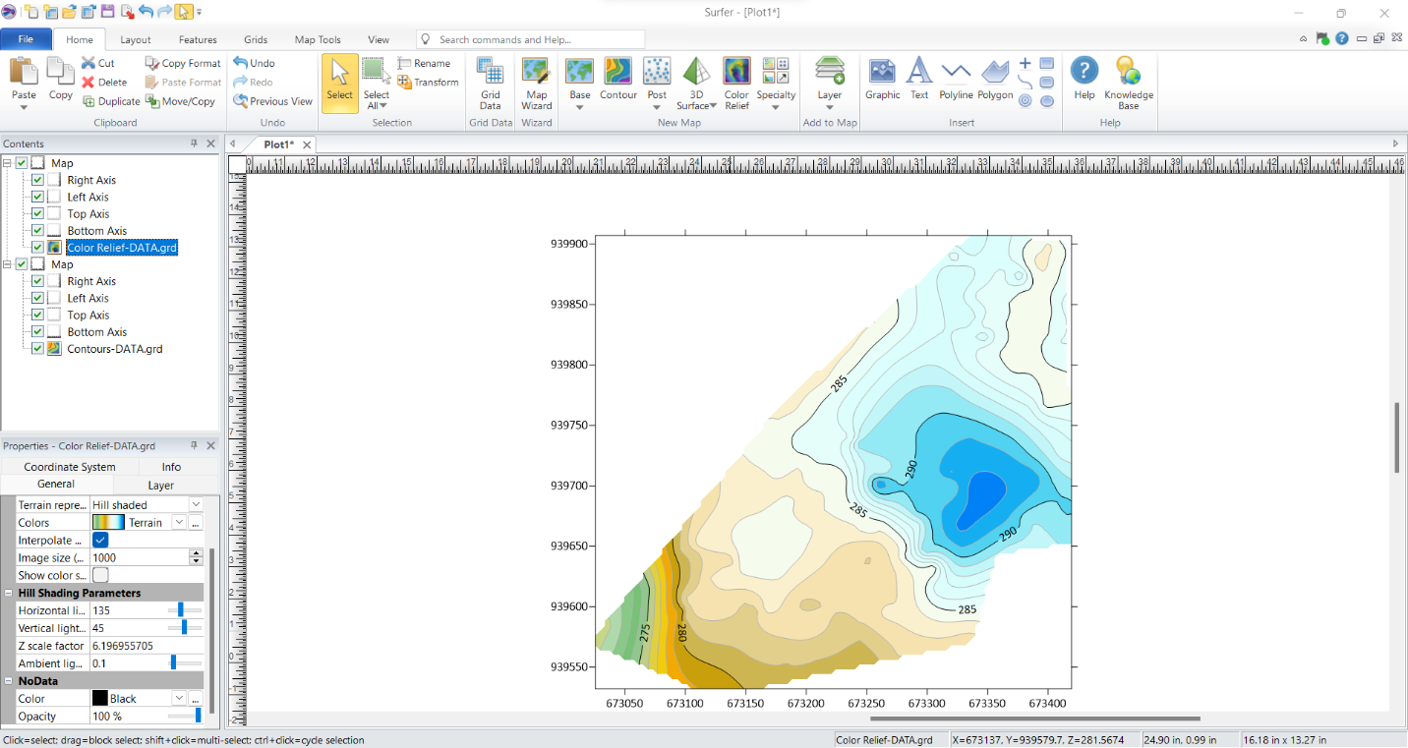Figure 3.8: Screenshots of the contour generation process.
3.4.3 NON-SPATIAL DATA PROCESSING IN EXCEL
Non-spatial data collected through field observations and school administrative records were structured and formatted in Excel to ensure consistency and ease of integration into Arc-GIS.
- Data Entry and Formatting:
  - Each facility was assigned a unique ID corresponding to its spatial location.
  - Attributes such as building type, year of construction, and available amenities were recorded.
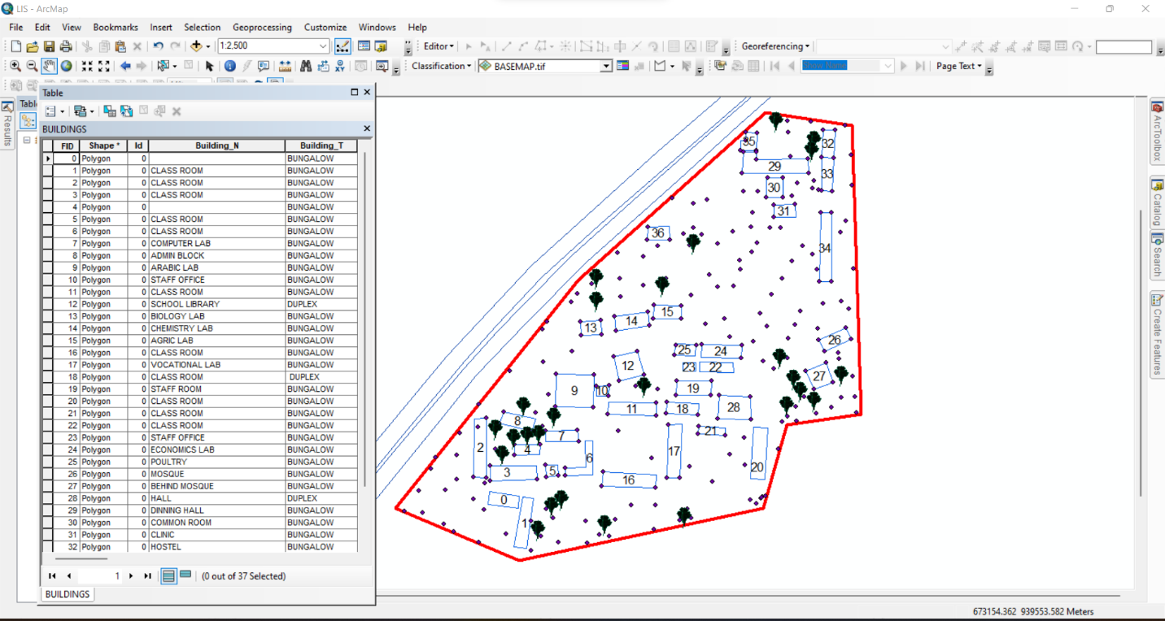Figure 3.9: Screenshot of the structured attribute table.
3.4.4 GEO-DATABASE CREATION IN ARC-GIS
A geo-database was created in Arc-GIS to integrate both spatial and non-spatial data, allowing efficient storage, retrieval, and analysis of school infrastructure data. The following steps were taken:
- Creating a New Geo-database:
  - A file geo-database was created in Arc-GIS to store all spatial data layers and attribute tables.
- Importing Spatial Data:
  - The DXF file from Auto-CAD (containing school boundaries and building layouts) was imported into Arc-GIS.
  - The Geo TIFF file from Surfer (containing the DEM and contour data) was also loaded.
- Defining Feature Classes:
  - Separate feature classes were created for classrooms, staff rooms, offices, laboratories, roads, and other infrastructure.
  - Each feature class was assigned relevant spatial properties (e.g., polygon for buildings, polyline for roads).
- Importing Non-Spatial Data and Linking to Spatial Features:
  - The CSV file containing attribute data was imported into ArcGIS.
  - A one-to-one relationship was established between the spatial features and their corresponding attribute records using the unique ID field.
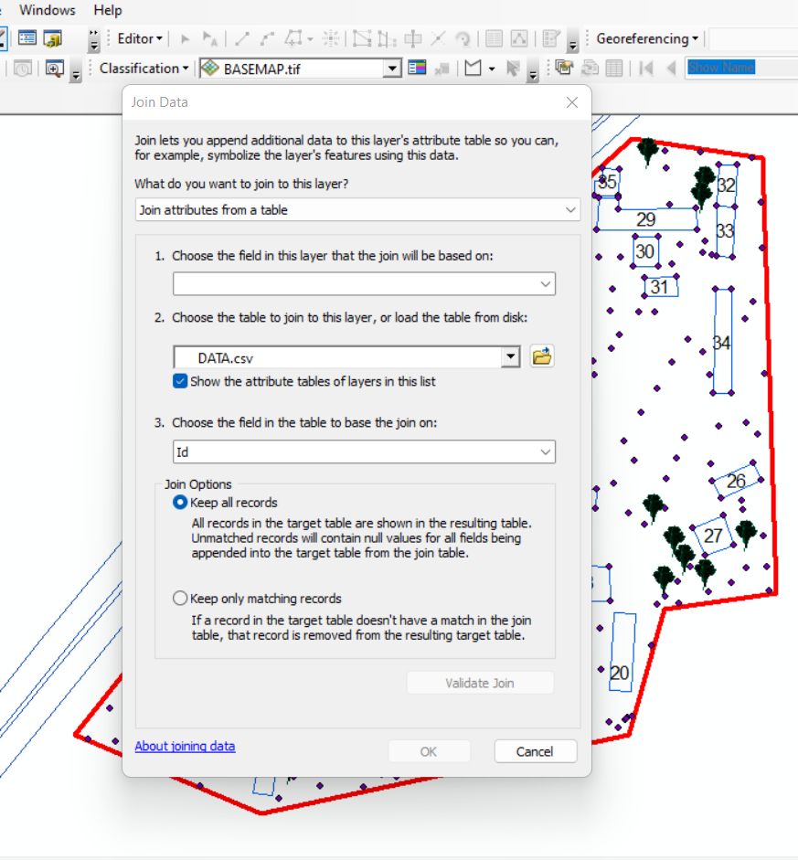
Figure 3.11: Screenshot of the data join process.
3.4.5 DATA INTEGRATION AND FINALIZATION FOR LIS
The final stage involved ensuring seamless integration between spatial and non-spatial data within the LIS environment.
- Verification of Data Integrity
  - The attribute data were cross-checked to ensure they matched their respective spatial locations.
  - Any mis-linked records were corrected, and missing attributes were updated.
- Symbolization and Visualization:
  - Each feature class was assigned unique symbols and colors for better visualization in Arc-GIS.
  - Thematic maps were created to represent building categories, classroom capacities, and road networks.

3.7.1 Perimeter Plan of the Project Area
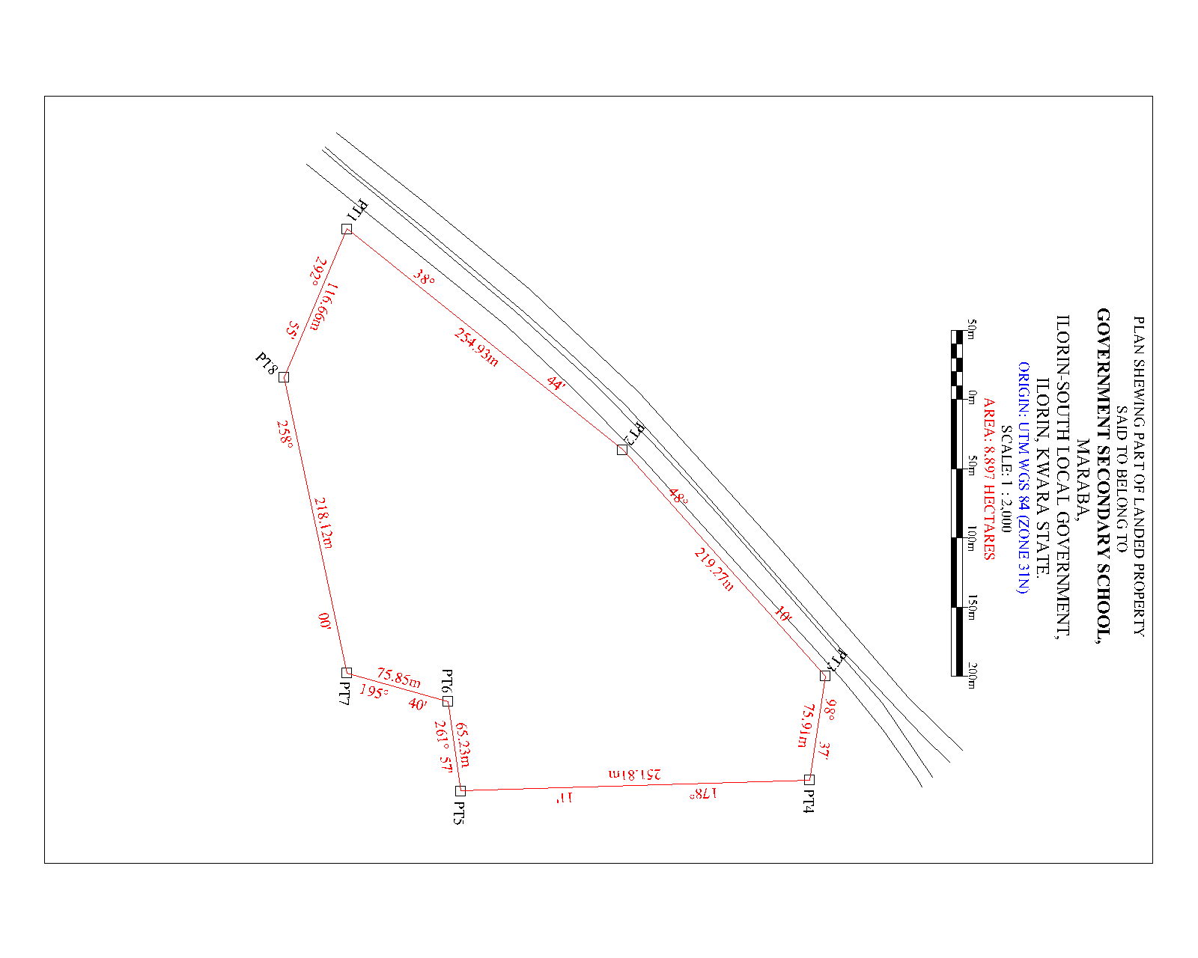
Figure 3.7.1: A screenshot of the boundary in AutoCAD.
- Boundary Digitization and Feature Mapping:
  - The boundary points were connected using polyline tools, forming a closed polygon to define the extent of the school premises.
  - Each school building was mapped as a separate layer, and unique identifiers were assigned to distinguish classrooms, staff rooms, laboratories, and other structures

3.7.2 Detailing
Figure 3.7.2 Screenshot showing the digitization process and layer management.
3.7.2 Topographic Data Processing in Surfer
Surfer software was used for topographic analysis and terrain modelling based on the surveyed elevation data (Z values). The following procedures were followed:
- Importing Surveyed Data:
  - The X, Y, and Z coordinates were loaded into Surfer as a point dataset.

3.7.3 ATTRIBUTE DATA ACQUISITION
Attribute data is information about spatial features. They provide the characteristics, description and nomenclature about spatial objects. Thus, the attributes data acquired includes names of buildings and their uses such as classrooms, roads, water facilities and prominent natural features Likes River and trees found and vegetation were properly identified within and around the

3.8 DATABASE CREATION / IMPLEMENTATION
This is the database creation phase. Having completed the three stages of design phase (i.e Reality, Conceptual and Logical design), the data base was created using ArcGIS10.2 software. It involves the combination and storage of acquired graphic data and attributes data in creating the database for the purpose of spatial analysis and query.
Database is an organized integrated collection of data stored so as to be capable of use by revenant application with data being accessed by different logical part. After the Attribute table was populated via the keyboard, some attributes such as areas of settlements were automatically displayed by special command in the ArcGIS 10.2 version. The ArcGIS software was used to link the graphic data and table for query generation.

3.8.1 DATABASE MANAGEMENT SYSTEM (DBMS)
Data base management is a collection of software for creating, storing, manipulating, updating, organizing and querying of information in a database (Kufoniyi, 1998). It is a software package whose function is to manipulate a data base on behalf of the user.
A good DBMS must provide the following functions:

      - Storage and retrieval of data.

      - Access to by several users at a time.

      - A standardized interface between data base and application programmed.

      - Standardized access to data and separation of data storage and retrieval functions from the program using the data.

      - Maintenance of data security and integrity.

3.8.2 Data Quality
Having created the database, proper maintenance practice was made to meet its stated objectives. The ability to include more data and remove irrelevant data was possible by way of maintenance. There is every need for the data to be updated regularly because of the physical changes that may occur on the landscape with time. Both security and integrity were also exercised to ensure maintenance and to meet its stated objectives.
Proper observance, updating and management of database ensure its currency and quality to stand a profound chance in Spatial Decision Support System (SDSS). The quality of any database depends on the currency and fitness for use as a decision support system (SDSS). The quality of database depends on its ability to generally fit and use as a decision system(DSS). The storage media should be from time to time justified if otherwise could necessitate data inaccessibility or physical deterioration of the storage media. Also, care must be taken during populating any database system, as a database is only good as the data supplied. In archiving stable media should be used. Examples of these are
- Computer compatible tape reader

- Magnetic tape

- Optical disc and compact disc.

CHAPTER FOUR

ANALYSIS AND RESULTS

4.1 Introduction
This chapter presents the results obtained from the data acquisition, processing, and integration procedures described in the previous chapter. The findings provide a comprehensive spatial and non-spatial representation of the school environment, including the layout of buildings, topographical features, and attribute information related to school facilities. The results are structured to demonstrate how the Land Information System (LIS) can enhance school management by providing accurate, well-organized, and easily accessible data.
The results are categorized into different sections for clarity. The spatial data results include mapped school boundaries, building footprints, and access networks, all of which were digitized using GIS tools. The topographical results analyze elevation variations using Digital Elevation Models (DEM) and contour maps, which are crucial for site planning and infrastructure development. The non-spatial data results contain attribute information such as classroom capacity, staff room assignments, and building conditions, all integrated into the LIS database. The data integration and query results demonstrate how the LIS functions as an interactive tool for retrieving, analyzing, and visualizing school-related data.
This chapter also includes analyses that reveal important insights into building distribution, infrastructure conditions, environmental constraints, and potential areas for school expansion. The results are presented using maps, tables, and screenshots from GIS and related software to illustrate how data were processed and visualized. The goal of this chapter is to demonstrate the practical application of an LIS in school facility management and to highlight the benefits of integrating spatial and non-spatial data for decision-making.

4.2 SPATIAL DATA RESULTS
The spatial data results provide a detailed representation of the school’s geographical layout, including its boundaries, buildings, access roads, and pathways. These results were derived from Total Station survey data, processed in AutoCAD and ArcGIS to create an accurate Land Information System (LIS) for the school. This section highlights the steps taken to map the school boundary, digitize building footprints, and visualize access routes.
The spatial data results are essential for effective school management, as they provide a georeferenced framework that helps in planning expansions, monitoring infrastructure, and optimizing resource allocation. The outputs presented in this section form the foundation for further topographical, non-spatial, and LIS-based analysis discussed in subsequent sections.
4.2.1 School Boundary and Building Layout
The school boundary and building layout were mapped using surveyed coordinates (X, Y, Z) collected with the Total Station. The acquired data were processed in AutoCAD to generate a structured boundary map and building footprints, which were then imported into ArcGIS for further spatial analysis and integration into the LIS database.
Figure 4.2.1: As built Plan of Government Secondary School Maraba, Ilorin South East Local Government. using GIS software
Visualization of Spatial Data Results
The final processed spatial data were visualized in ArcGIS, where the school boundary, building footprints, and access roads were symbolized appropriately to enhance readability.
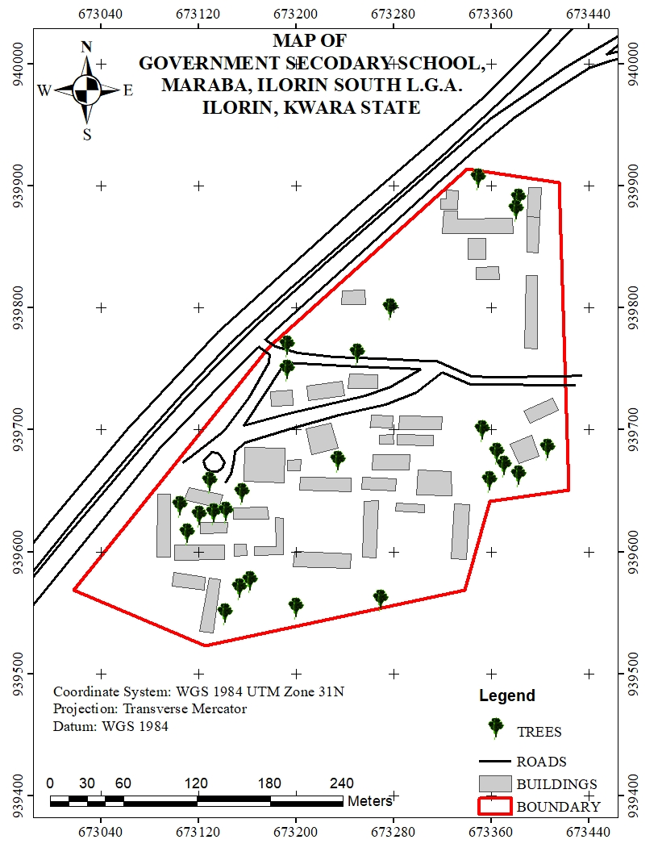
Figure 4.2.1: Mapped School Boundary and Buildings in ArcGIS
- The school boundary is represented as a bold polygon to define the outer limits of the school.
- Buildings are shown in different colors based on their usage (e.g., classrooms in blue, administrative offices in green, laboratories in red).
- Roads are displayed as lines, with roads marked in black.
This spatial data representation serves as the primary framework for the LIS database, allowing users to visualize, analyze, and manage school infrastructure efficiently.
Significance of the Spatial Data Results
The school boundary and building layout play a crucial role in:
- Infrastructure Planning: Ensuring optimal land use by identifying available spaces for future construction and expansion.
- Facility Management: Helping administrators monitor the condition, usage, and location of various school buildings.
- Navigation and Accessibility: Enhancing movement planning for students, staff, and visitors by identifying clear pathways and access points.
- Disaster Management: Providing accurate spatial information to plan for emergency exits, assembly points, and safety zones.
The spatial data results form the foundation for further analysis, including topographical evaluation, attribute data integration, and advanced GIS-based queries, which will be presented in the subsequent sections of this chapter.

4.3 TOPOGRAPHICAL ANALYSIS RESULTS
Topographical analysis provides crucial information about the elevation, slope, and terrain variations within the school environment. Understanding these features is essential for site planning, infrastructure development, drainage design, and environmental management. This section presents the results of topographical data processing and analysis, including the creation of Digital Elevation Models (DEM), contour maps, and slope analysis.
The topographical data were obtained using Total Station measurements, which captured X, Y, and Z coordinates of various points within the school premises. These data were processed in Surfer to generate elevation models and later integrated into ArcGIS for spatial analysis.
4.3.1 DIGITAL ELEVATION MODEL (DEM)
The Digital Elevation Model (DEM) was created to provide a 3D representation of the school’s terrain. Using Z-coordinates from the Total Station survey, a gridded elevation surface was generated in Surfer and later exported to ArcGIS for further analysis.

Key Features of the DEM:
- The DEM visually represents variations in land elevation within the school compound.
- Areas of higher elevation are highlighted, aiding in infrastructure planning and water drainage management.
- The DEM serves as the base for further slope, aspect, and contour analysis.
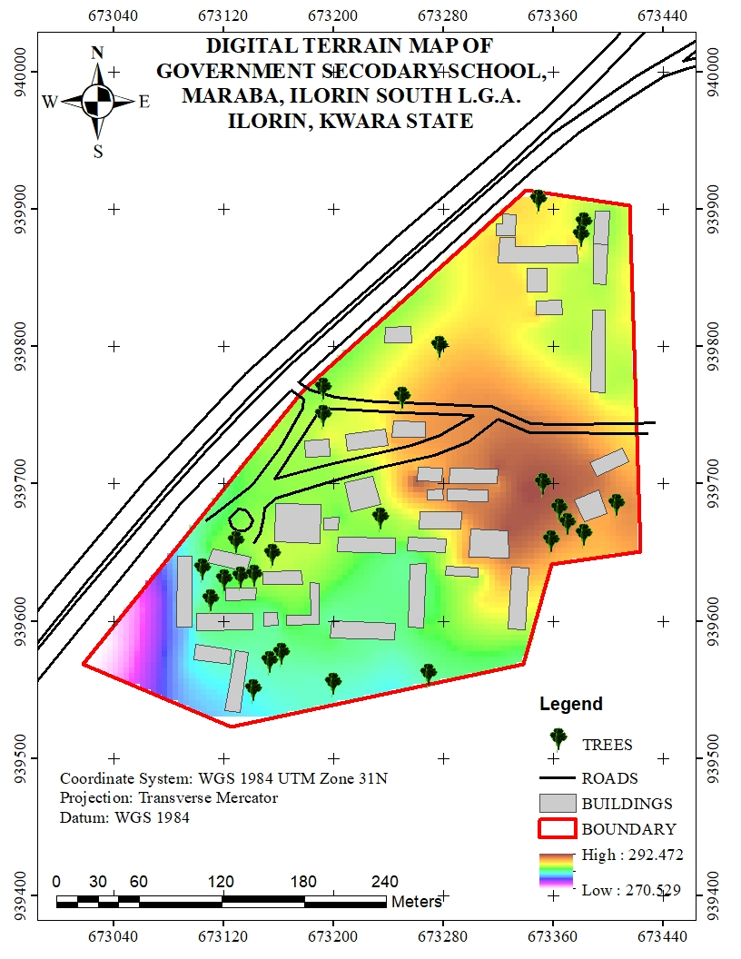
Figure 4.3.1: Digital Elevation Model (DEM) of the School Premise
s
4.3.2 CONTOUR MAPPING
Contour mapping was conducted to visualize elevation changes and terrain gradients within the school environment. The surveyed elevation data were processed in Surfer to generate contour lines, which were later imported into Arc-GIS for spatial overlay and analysis.
Key Results from Contour Analysis:
- The contour interval was set based on the range of elevation variations in the study area.
- Closely spaced contour lines indicate steep slopes, while widely spaced lines represent gentler slopes.
- The contour map helps in identifying low-lying areas that may be prone to water logging or flooding.
- The results assist in drainage planning by identifying natural water flow paths.
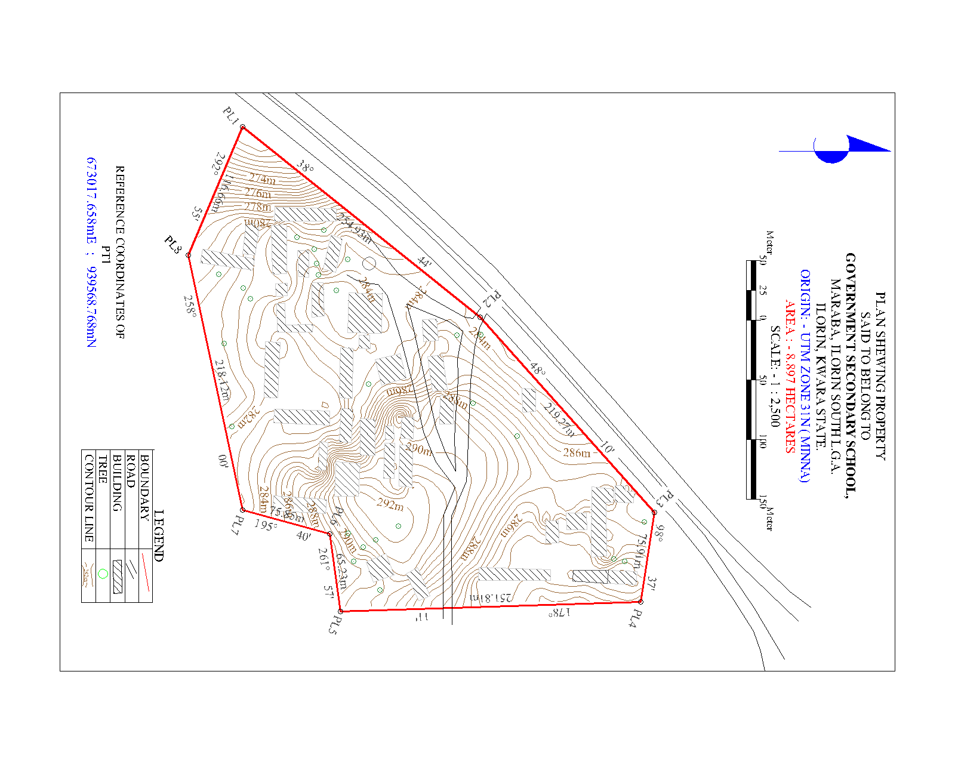
Figure 4.3.2: Contour Map of the School Premises
4.3.3 SLOPE AND TERRAIN ANALYSIS
A slope analysis was conducted to determine variations in land steepness across the school environment. The slope was computed using the DEM in ArcGIS, with results classified into different slope categories to assess terrain usability.
Key Findings from Slope Analysis:
- Flat areas (0-5 degrees) are suitable for classroom blocks, play areas, and other infrastructure.
- Moderate slopes (5-15 degrees) are manageable for footpaths and minor construction projects.
- Steeper slopes (above 15 degrees) may require erosion control measures or retaining walls to prevent land degradation.
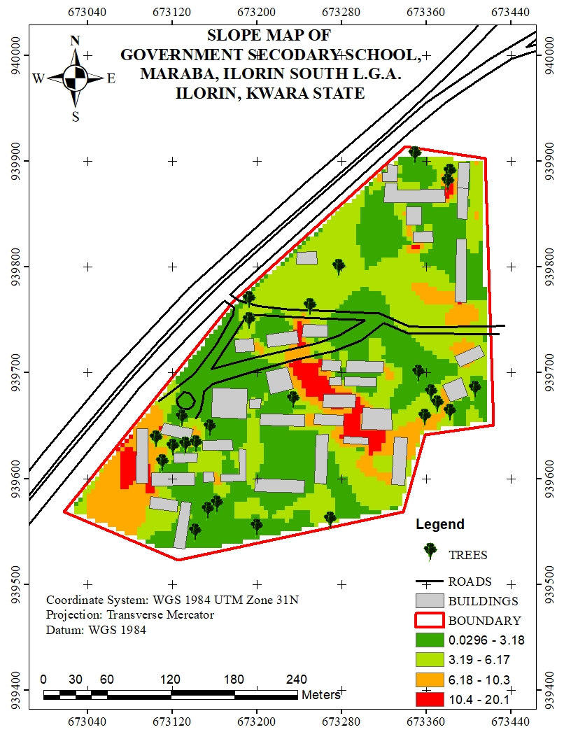
Figure 4.3.3: Slope Analysis Map of the School Premises

4.3.4 SIGNIFICANCE OF TOPOGRAPHICAL ANALYSIS RESULTS
The results of the topographical analysis provide essential insights for school management, infrastructure development, and environmental sustainability. These findings contribute to:
- Better infrastructure planning: Ensuring that new buildings and roads are constructed on stable ground.
- Improved drainage management: Reducing the risk of flooding and water stagnation within the school premises.
- Enhanced safety measures: Identifying steep areas that may require protective barriers or adjustments in land use planning.
- Sustainable land use: Helping decision-makers optimize space utilization while considering terrain constraints.
The topographical analysis results form an integral part of the Land Information System (LIS), ensuring that spatial data is not only stored but also analyzed for informed decision-making in school infrastructure management.
4.4 NON-SPATIAL DATA RESULTS
Non-spatial data results refer to the descriptive information associated with various school facilities, buildings, and infrastructure. Unlike spatial data, which provides geometric representations of features (such as school boundaries, buildings, and roads), non-spatial data includes textual and numerical attributes that help in facility management and decision-making.
The non-spatial data collected in this study were integrated into the Land Information System (LIS) to enhance school administration, infrastructure monitoring, and resource planning. The data were structured in tabular format and linked to corresponding spatial features in ArcGIS using unique identifiers.
4.4.1 ATTRIBUTE DATA FOR SCHOOL BUILDINGS
The non-spatial attributes for classrooms, staff rooms, laboratories, and administrative offices were recorded and organized in a database. Each building was assigned a unique identifier (Building ID), allowing for easy retrieval of information in GIS.
Key Attributes for Buildings:
- Building Name/ID (e.g., Classroom Block A, Staff Room 1)
- Building Type (Classroom, Laboratory, Office, Library, Hall)
- Primary Use (Teaching, Administration, Storage, Utility)
This information was stored in ArcGIS attribute tables and linked to the digitized building footprints, allowing users to perform queries such as identifying underutilized classrooms or buildings in need of maintenance.
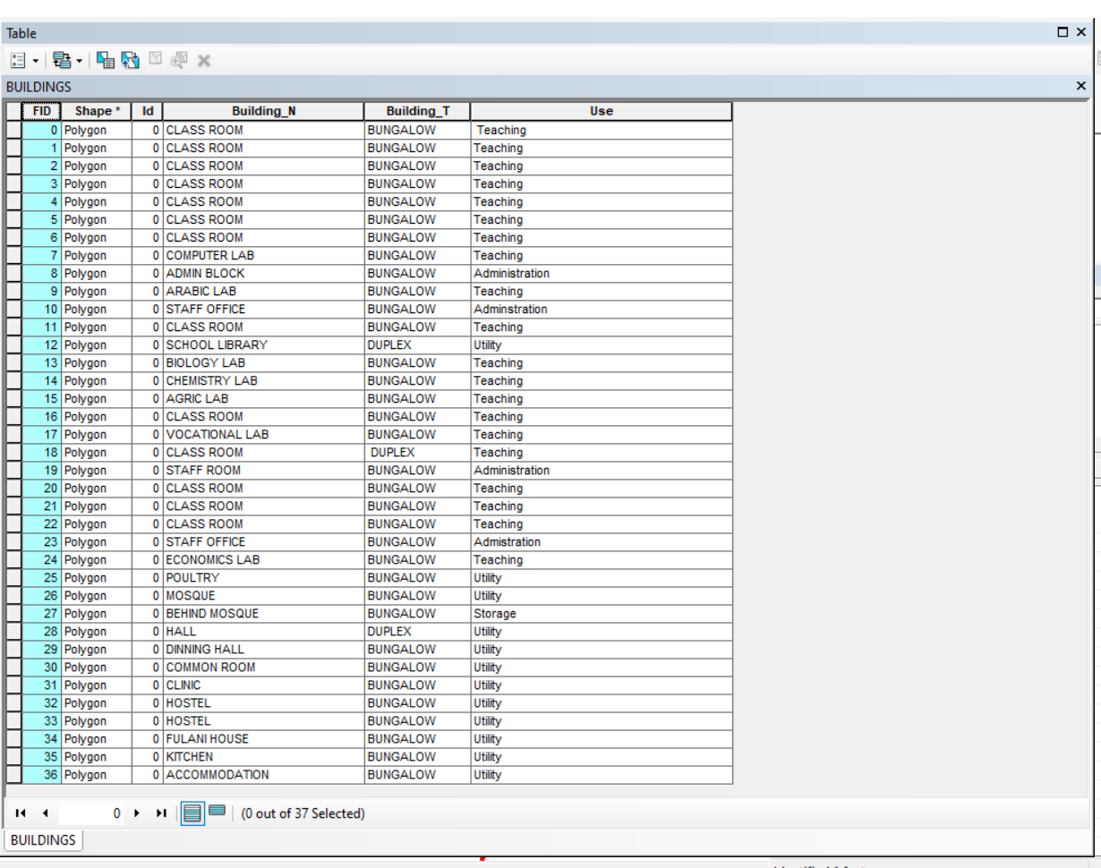
Figure 4.4.2: Sample Attribute Table for School Buildings

4.4.3 LINKING NON-SPATIAL DATA WITH GIS
All non-spatial datasets were linked to their corresponding spatial features in ArcGIS. This integration allows for interactive queries and visual analysis of school facilities. Some of the key functionalities include:
- Clicking on a building footprint to view its attributes (e.g., building name, building type, & use).
- Running queries to find classrooms that exceed their maximum student capacity.
- Generating reports on the maintenance history of infrastructure.
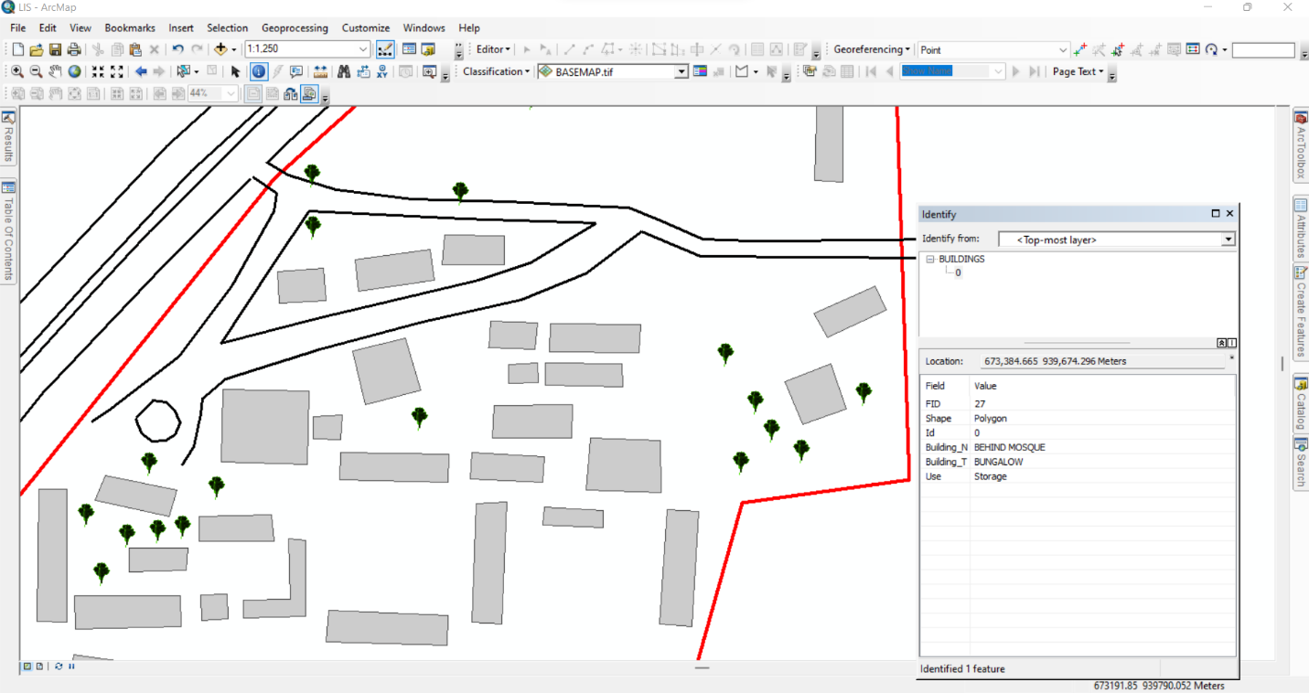Figure 4.4.3: Linking Non-Spatial Data to Spatial Features in ArcGIS
4.4.4: SIGNIFICANCE OF NON-SPATIAL DATA IN LIS
The integration of non-spatial data into the LIS enhances decision-making by providing comprehensive attribute information for school management. These results contribute to:
- Effective Resource Allocation: Ensuring that classrooms, offices, and other facilities are optimally utilized.
- Infrastructure Maintenance Planning: Monitoring facility conditions and scheduling necessary repairs.
- Improved School Administration: Tracking staff distribution, student population trends, and room assignments.
- Emergency Preparedness: Identifying critical infrastructure that requires regular inspections and safety measures.
The non-spatial data results demonstrate how a Land Information System (LIS) can support school facility management by combining spatial visualization with detailed attribute data. This information is essential for long-term planning, policy-making, and efficient school operations.

4.5 QUERY EXECUTION AND RESULTS
With the integrated database, queries were performed in ArcGIS to extract specific information about the school environment. These queries help in analyzing building usage, staff distribution, facility conditions, and space utilization.
Example Query Results:
- Mapping Distribution of Staff Offices:
Query: "Show all staff offices"
Result: A spatial representation of staff office locations was displayed, ensuring adequate office space allocation.
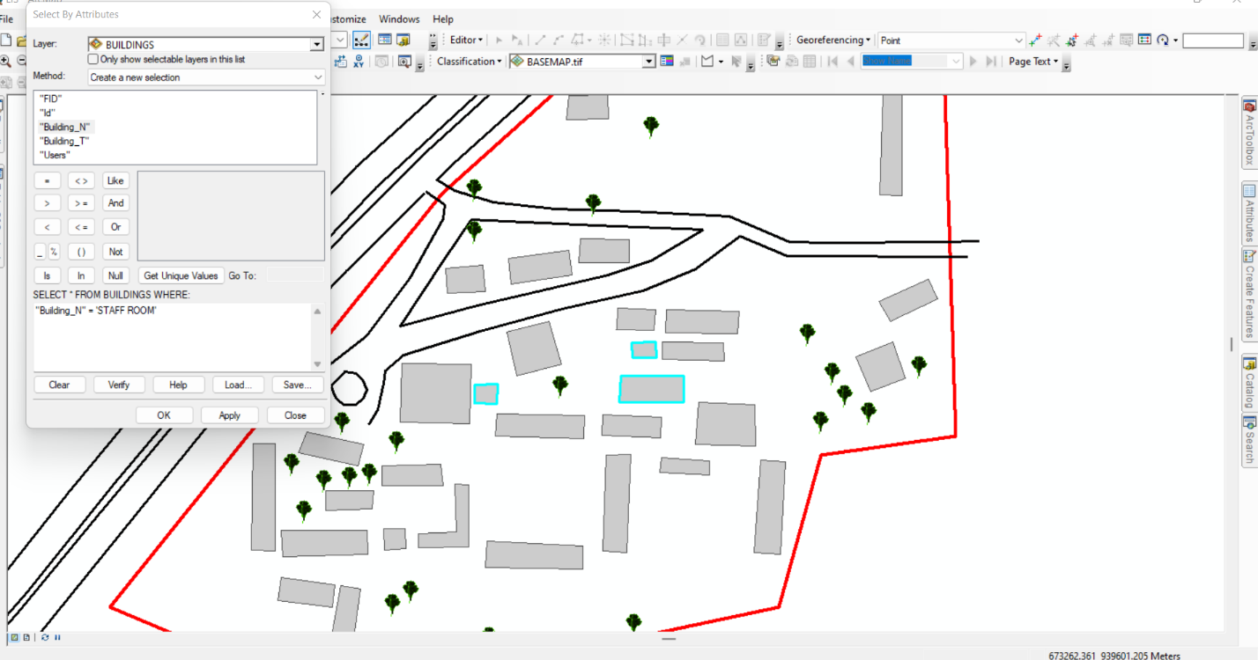
Figure 4.5.1: Sample Staff room Query Results in Arc-GIS
- Mapping Distribution of Class rooms:
Query: "Show all Class rooms"
Result: A spatial representation of class room locations was displayed, ensuring adequate office space allocation.
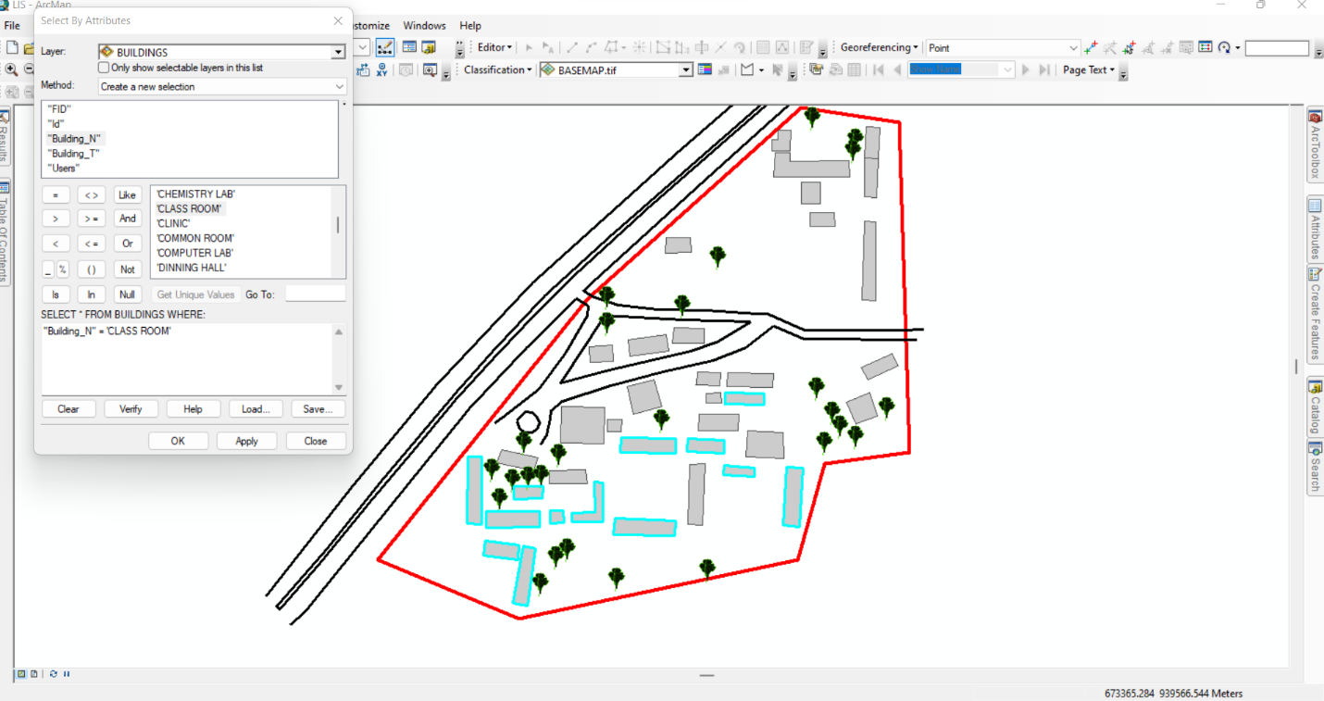
Figure 4.5.2: Sample Class room Query Results in ArcGIS

CHAPTER FIVE

5.0 COSTING, SUMMARY, PROBLEMS ENCOUNTERED, CONCLUSION AND RECOMMENDATION
5.1 COSTING
The costing of this project was done using the Nigeria Institution of Surveyor's (NIS) professional scale of fees for consultant in the construction industry. This stage shows the total cost that was spent on the project from day one to the final stage.
RECCI
PERSONAL/QUALITY | DAY(S) | UNITRATE(N) | TOTAL AMOUNT(N)
1 Senior Surveyor | 1 | 20,000.00 | 20,000.000
Assistant Surveyor | 1 | 8,000.00 | 8,000.00
Transportation | 1 | 7,000.00 | 7,000.00
Basic Equipment | 1 | 8,000.00 | 7,000.00
TOTAL |  |  | #42,000.00

BEACON= 2,100 × 5
= #10,500

BEACONING
PERSONAL/QUALITY | DAY(S) | UNITRATE(N) | TOTALAMOUNT(N)
1Assistant Surveyor | 1 | 8,000.00 | 8,000.00
Basic Equipment(6) | 1 | 8,000.00 | 8,000.00
Transportation | 1 | 7,000.00 | 7,000.00
TOTAL |  |  | #23,000.00

TRAVERSING
PERSONAL/QUALITY | DAY(S) | UNITRATE(N) | TOTALAMOUNT(N)
1 Assistant Surveyor | 2 | 8,000.00 | 16,000.00
Basic Equipment | 2 | 8,000.00 | 16,000.00
Transportation | 2 | 7,000.00 | 14,000.00
TOTAL |  |  | #46,000.00

DOWNLOADING DATA AND PLOTTING
PERSONAL/QUALITY | DAY(S) | UNITRATE(N) | TOTALAMOUNT(N)
1Senior Surveyor | 2 | 15,000.00 | 30,000.00
1AssistantSurveyor | 2 | 8,000.00 | 16,000.00
Transportation | 2 | 7,000.00 | 14,000.00
Consumables | 2 | 7,000.00 | 14,000.00
TOTAL |  |  | #74,000.00

INFORMATION PRESENTATION
PERSONAL/QUALITY | DAY(S) | UNITRATE(N) | TOTALAMOUNT(N)
1Assistant Surveyor | 1 | 8,000.00 | 8,000.00
Transportation | 1 | 7,000.00 | 7,000.00
TOTAL |  |  | #15,000.00

(1) # 42,000.00
(2) # 10,500.00
(3) # 23,000.00
(4) # 46,000.00
5) #74,000.00
(6) # 15,000.00
TOTAL # 210,500.00
CONSTIGENCIES=5%
210,500.00×5%÷ 100
= #10,525.00

V. A. T = 7.5%
210,500.00×7.5%÷100
= #15,787.50

MOBILIZATION AND DEMOBILIZATION =10%
2o10, 500.00 × 10%. ÷ 100
= #21,050.00
ACCOMODATION = 1.5%
210,500.00 ×1.5%÷100
= 3,157.50
TOTAL = 210,500.00
10,525.00
15,787.50
21,050.00
3,157.50
GRAND TOTAL = 261,020.00

GRAND TOTAL

5.1 SUMMARY OF FINDINGS
This study focused on the design and implementation of a Land Information System (LIS) for Government Secondary School, Maraba, situated in Ilorin East Local Government Area of Kwara State. The objective was to develop a reliable system for managing land-related data such as parcel boundaries, structures, ownership, and land use within the school premises. The study adopted surveying techniques, GIS technologies, and database development to capture, process, and present land information digitally.

The fieldwork involved ground control surveys using GPS and total stations, acquisition of satellite imagery, data digitization, and integration into a GIS platform. The spatial database created includes detailed maps of the school buildings, open fields, access roads, drainage, and other infrastructure. Attribute data such as land use types, structure conditions, and measurement details were also embedded into the system.
The LIS produced in this study allows users to easily:
- View and query spatial data of the school property
- Retrieve detailed records of different land parcels and features
- Generate maps for administrative and planning purposes
- Monitor changes and ensure effective land management within the school
The system developed is user-friendly and can be updated over time to accommodate new developments, changes in land use, or expansion projects.

5.2 CONCLUSION
The study successfully demonstrated that Land Information Systems are essential tools for efficient and sustainable land management, even at the institutional level such as public schools. Through the integration of spatial and attribute data, the developed LIS for Government Secondary School, Maraba, provides a reliable framework for:

- Decision-making related to land use
- Infrastructure planning
- Resource allocation
- Land monitoring and documentation
By digitally capturing and organizing spatial data, the system addresses common challenges like poor record-keeping, encroachment, and land disputes. The project confirms that even smaller public institutions can benefit from LIS to enhance transparency, accountability, and long-term planning.

5.3 RECOMMENDATIONS
Based on the findings of this project, the following recommendations are made:
- Adoption by Kwara State Ministry of Education and Urban Development
Government agencies should promote the integration of LIS in all public secondary schools to monitor and manage school lands effectively. This could prevent encroachment, mismanagement, or unauthorized use of public land assets.

- Regular Updates and Maintenance
The LIS developed should be regularly updated to reflect any structural changes, land use modifications, or new developments within the school. A trained staff or GIS consultant should be appointed for periodic updates.
- Capacity Building
There is a need for training of school administrators and staff on the use and benefits of LIS. Basic knowledge of how to interpret digital maps, query databases, and use the system will encourage its optimal use.
- Integration with State-wide LIS Platforms
This project can serve as a pilot for developing a larger-scale LIS for public properties across Kwara State. The state government should integrate school land databases with platforms like KWAGIS to build a comprehensive land administration framework.
- Security and Data Backup
To avoid data loss, the LIS should be backed up on external servers or cloud platforms. Password protection and access controls should also be implemented to ensure data security.

- Use in Planning and Budgeting
School authorities and the Ministry of Education should use LIS outputs (maps, statistics, and reports) in future planning and budgeting for land development, classroom expansion, fencing, and infrastructure upgrades.

REFERENCES
Abdulkadir, A. (2020). An assessment of the Kwara Geographic Information System (KWAGIS). Journal of African Geo-Information Systems, 12(3), 45–59.
Cowen, D. J. (1988). GIS versus LIS: Comparative review. Photogrammetric Engineering & Remote Sensing, 54(11), 1551–1555.
Dale, P., & McLaughlin, J. (1999). Land administration. Oxford University Press.
Enemark, S. (2005). Understanding the land management paradigm. In FIG Working Week 2005 (pp. 1–12). Cairo, Egypt.
Magel, H., & Friedrich, R. (2000). The role of LIS in sustainable land management. GIS Development Journal, 7(4), 21–25.
Molen, P. Van der. (2003). Some observations on the relationship between land administration and land tenure security. In UN/FIG Conference Proceedings, Nairobi, Kenya.
Rajabifard, A., Williamson, I. P., Holland, P., & Johnston, G. (2002). From SDI to GSDI: Developing the capacity. Journal of Spatial Science, 47(1), 15–29. https://doi.org/10.1080/14498596.2002.9635010
Stoter, J., van Oosterom, P., & Ploeger, H. (2011). 3D cadastre in the Netherlands: Developments and international applicability. Computers, Environment and Urban Systems, 35(1), 9–18. https://doi.org/10.1016/j.compenvurbsys.2010.05.002
Williamson, I., Enemark, S., Wallace, J., & Rajabifard, A. (2010). Land administration for sustainable development. ESRI Press.
Zevenbergen, J. (2002). Systems of land registration: Aspects and effects. Delft University Press.
Zlatanova, S., Sithole, G., & Nakagawa, M. (2016). Towards sustainable land information infrastructure. International Journal of Geo-Information, 5(2), 23–39. https://doi.org/10.3390/ijgi5020023

APPENDIX
 | EASTINGS | NORTHINGS | ELEVATION
PT1 | 673384.7215 | 939882.4456 | 284.324
PT2 | 673368.3346 | 939852.5804 | 284.974
PT3 | 673405.9883 | 939809.5429 | 285.418
PT4 | 673328.7865 | 939826.643 | 286.878
PT5 | 673277.1787 | 939834.9943 | 285.121
PT6 | 673258.6622 | 939839.0555 | 283.911
PT7 | 673298.2823 | 939799.4299 | 288.005
PT8 | 673328.172 | 939792.2934 | 287.552
PT9 | 673312.6354 | 939762.8023 | 289.926
PT0 | 673210.9532 | 939791.8953 | 283.435
PT11 | 673176.0265 | 939756.1512 | 283.922
PT12 | 673192.603 | 939752.8734 | 284.652
PT13 | 673304.6739 | 939734.3437 | 290.222
PT14 | 673416.2718 | 939684.1855 | 290.247
PT15 | 673262.0306 | 939711.3252 | 288.105
PT16 | 673149.9921 | 939731.4451 | 284.378
PT17 | 673146.6577 | 939696.4113 | 283.653
PT18 | 673227.3225 | 939675.5951 | 284.134
PT19 | 673246.0674 | 939672.8165 | 284.316
PT20 | 673321.673 | 939630.1681 | 288.378
PT21 | 673117.1536 | 939688.396 | 282.391
PT22 | 673294.0261 | 939591.9552 | 283.783
PT23 | 673337.8286 | 939578.4527 | 283.019
PT24 | 673271.9858 | 939568.4352 | 282.117
PT25 | 673104.7472 | 939620.371 | 281.182
PT26 | 673073.4392 | 939634.0653 | 276.58
PT27 | 673071.2371 | 939615.2187 | 275.123
PT28 | 673242.9053 | 939550.3469 | 280.075
PT29 | 673203.9413 | 939544.2854 | 280.735
PT30 | 673148.8427 | 939568.436 | 281.263
PT31 | 673052.708 | 939612.8861 | 272.448
PT32 | 673140.3028 | 939546.8119 | 280.215
PT33 | 673159.3407 | 939539.2528 | 280.517
PT34 | 673135.9737 | 939532.024 | 279.591
PT35 | 673114.231 | 939546.4438 | 279.556
PT36 | 673037.8605 | 939584.0792 | 270.915
PT37 | 673025.4372 | 939566.4692 | 270.677
PT38 | 673037.8605 | 939584.0792 | 270.915
PT39 | 673048.7103 | 939603.1658 | 272.177
PT40 | 673145.4432 | 939724.5862 | 283.813
PT41 | 673170.6938 | 939748.3946 | 284.45
PT42 | 673188.627 | 939764.5666 | 283.773
PT43 | 673320.9003 | 939845.4578 | 287.18
PT44 | 673362.1948 | 939875.4125 | 285.746
PT45 | 673385.9494 | 939892.7828 | 284.152
PT46 | 673372.8074 | 939797.935 | 284.644
PT47 | 673363.6725 | 939784.3633 | 286.123
PT48 | 673354.6165 | 939769.3984 | 288.129
PT49 | 673345.6938 | 939755.1428 | 289.742
PT50 | 673090.2289 | 939538.8492 | 278.481
PT51 | 673341.702 | 939727.2912 | 291.403
PT52 | 673417.181 | 939777.7687 | 284.558
PT53 | 673403.693 | 939704.2105 | 289.927
PT54 | 673373.8018 | 939666.3041 | 290.383
PT55 | 673366.7365 | 939657.6599 | 289.8
PT56 | 673359.693 | 939648.863 | 289.387
PT57 | 673354.665 | 939644.1429 | 289.178
PT58 | 673322.5007 | 939606.3774 | 286.048
PT59 | 673144.5627 | 939544.431 | 280.276
PT60 | 673154.7819 | 939560.0081 | 281.098
PT61 | 673166.3101 | 939576.9963 | 281.907
PT62 | 673335.5904 | 939738.9727 | 291.06
PT63 | 673409.6768 | 939902.881 | 285.097
PT64 | 673343.9989 | 939813.6289 | 285.841
PT65 | 673332.9823 | 939800.4245 | 286.532
PT66 | 673317.4768 | 939785.3667 | 288.656
PT67 | 673275.4552 | 939754.9254 | 289.562
PT68 | 673155.4283 | 939649.2573 | 284.999
PT69 | 673153.0985 | 939647.8698 | 284.914
PT70 | 673145.872 | 939640.2191 | 284.266
PT71 | 673136.9341 | 939632.0235 | 283.646
PT72 | 673095.4975 | 939590.4612 | 279.358
PT73 | 673085.8895 | 939576.7588 | 278.209
PT74 | 673068.6625 | 939547.998 | 275.907
PT75 | 673041.5594 | 939564.6487 | 272.021
PT76 | 673061.0455 | 939584.5291 | 273.936
PT77 | 673071.1215 | 939593.8976 | 275.368
PT78 | 673171.3443 | 939705.5928 | 284
PT79 | 673234.0205 | 939763.4674 | 286.572
PT80 | 673274.2492 | 939798.5538 | 287.23
PT81 | 673284.8663 | 939807.7859 | 287.065
PT82 | 673360.1973 | 939896.9251 | 286.454
PT83 | 673379.5924 | 939906.2515 | 285.363
PT84 | 673415.0684 | 939877.3203 | 285.558
PT85 | 673384.9695 | 939776.993 | 285.683
PT86 | 673370.35 | 939740.6932 | 289.914
PT87 | 673365.9627 | 939728.855 | 290.9
PT88 | 673360.3944 | 939716.777 | 291.697
PT89 | 673347.5661 | 939690.5155 | 292.448
PT90 | 673267.3527 | 939567.245 | 281.818
PT91 | 673249.8414 | 939761.4528 | 287.673
PT92 | 673253.5943 | 939769.0759 | 287.673
PT93 | 673289.4358 | 939837.6854 | 285.923
PT94 | 673359.1224 | 939907.0166 | 286.683
PT95 | 673309.0537 | 939718.1688 | 290.864
PT96 | 673386.4728 | 939846.5499 | 284.751
PT97 | 673381.1222 | 939847.9086 | 284.798
PT98 | 673311.7239 | 939810.1819 | 287.49
PT99 | 673214.1183 | 939753.5767 | 285.594
PT100 | 673151.1501 | 939668.0286 | 284.273
PT101 | 673298.2596 | 939761.629 | 289.834
PT102 | 673410.6168 | 939819.4782 | 286.064
PT103 | 673412.8398 | 939743.0719 | 286.98
PT104 | 673386.0424 | 939725.4241 | 289.89
PT105 | 673338.3902 | 939696.8038 | 292.455
PT106 | 673094.8002 | 939567.3012 | 279.722
PT107 | 673060.0972 | 939554.7259 | 274.721
PT108 | 673308.9272 | 939615.9023 | 286.747
PT109 | 673367.422 | 939644.724 | 288.332
PT110 | 673384.691 | 939651.1906 | 288.549
PT111 | 673397.7855 | 939656.608 | 288.644
PT112 | 673418.0052 | 939665.7253 | 289.824
PT113 | 673222.9371 | 939571.6333 | 281.678
PT114 | 673208.9905 | 939558.954 | 281.109
PT115 | 673195.205 | 939545.5706 | 280.87
PT116 | 673184.7054 | 939538.5535 | 280.999
PT117 | 673419.4373 | 939652.4321 | 289.44
PT118 | 673406.323 | 939665.6577 | 289.634
PT119 | 673135.7762 | 939557.6619 | 280.436
PT120 | 673183.4375 | 939557.5805 | 281.026
PL121 | 673265.7897 | 939558.0713 | 281.327
PT122 | 673275.585 | 939560.4378 | 282.041
PT123 | 673326.709 | 939576.0595 | 282.93
PT124 | 673336.051 | 939577.2225 | 282.915
PT125 | 673337.2307 | 939577.8349 | 282.96
PT126 | 673340.1753 | 939579.0557 | 283.101
PT127 | 673332.4629 | 939572.9081 | 282.561
PT128 | 673244.5043 | 939571.7683 | 280.976
PT129 | 673279.8337 | 939710.7086 | 289.235
PT130 | 673329.327 | 939714.1065 | 291.661
PT131 | 673291.0307 | 939772.5217 | 289.507
PT132 | 673213.3844 | 939769.2161 | 285.037
PT133 | 673363.0785 | 939841.574 | 285.29
PT134 | 673415.3765 | 939850.5814 | 286.503
PT135 | 673382.7967 | 939854.74 | 284.659
PT136 | 673268.7507 | 939807.9178 | 286.262
PT137 | 673381.0649 | 939790.3494 | 285.169
PT138 | 673404.0828 | 939698.8956 | 290.112
PT139 | 673359.7209 | 939699.5474 | 292.101
PT140 | 673211.8851 | 939636.4391 | 283.159
PT141 | 673241.3311 | 939612.7449 | 282.141
PT142 | 673274.3892 | 939604.8506 | 282.939
PT143 | 673119.7542 | 939627.4855 | 282.657
PT144 | 673089.4511 | 939639.6237 | 279.492
PT145 | 673351.4368 | 939620.0598 | 286.705
PT146 | 673139.7017 | 939652.3184 | 284.027
PT147 | 673090.4839 | 939659.3809 | 280.094
PT148 | 673287.9755 | 939729.3201 | 289.918
PT149 | 673390.6326 | 939747.4299 | 287.987
PT150 | 673406.2127 | 939749.4954 | 286.834
PT151 | 673318.698 | 939777.2251 | 289.241
PT152 | 673353.3829 | 939813.4117 | 285.219
PT153 | 673327.8948 | 939814.0516 | 286.716
PT154 | 673276.8713 | 939802.7248 | 287.085
PT155 | 673233.785 | 939788.3116 | 285.237
PT156 | 673246.1943 | 939797.5355 | 285.454
PT157 | 673277.4142 | 939813.7851 | 286.407
PT158 | 673333.8765 | 939845.0464 | 287.321
PT159 | 673121.233 | 939624.4639 | 283.071
PT160 | 673121.0743 | 939615.0976 | 282.792
PT161 | 673143.9343 | 939624.4639 | 283.815
PT162 | 673100.278 | 939592.8726 | 281.442
PT163 | 673085.3555 | 939596.0476 | 278.194
PT164 | 673096.7855 | 939595.5713 | 279.372
PT165 | 673149.1731 | 939596.2063 | 281.843
PT166 | 673159.4919 | 939597.0001 | 281.78
PT167 | 673141.2356 | 939593.9838 | 282.01
PT168 | 673099.8017 | 939605.7314 | 282.096
PT169 | 673148.6968 | 939606.2076 | 282.084
PT170 | 673165.5244 | 939604.1439 | 283.126
PT171 | 673096.7855 | 939647.3239 | 281.218
PT172 | 673107.9774 | 939642.8657 | 281.375
PT173 | 673136.5524 | 939636.5157 | 282.179
PT174 | 673111.7874 | 939652.6024 | 283.596
PT175 | 673148.1941 | 939636.5157 | 284.471
PT176 | 673176.3458 | 939637.1507 | 284.381
PT177 | 673177.4042 | 939626.9907 | 284.25
PT178 | 673165.5244 | 939597.3176 | 283.212
PT179 | 673197.5935 | 939587.8543 | 282.967
PT180 | 673244.4249 | 939586.796 | 282.022
PT181 | 673198.3873 | 939600.2898 | 281.592
PT182 | 673254.0557 | 939595.5802 | 282.376
PT183 | 673265.4857 | 939594.9452 | 283.309
PT184 | 673255.802 | 939641.6178 | 282.017
PT185 | 673281.4313 | 939633.4209 | 283.739
PT186 | 673305.1116 | 939632.2303 | 284.123
PT187 | 673282.0928 | 939640.3001 | 285.194
PT188 | 673327.3865 | 939645.9658 | 290.763
PT189 | 673298.4353 | 939646.9641 | 289.971
PT190 | 673327.1219 | 939666.0741 | 292.244
PT191 | 673254.0028 | 939661.2816 | 284.252
PT192 | 673281.6254 | 939649.8516 | 284.438
PT193 | 673244.8482 | 939649.7184 | 282.435
PT194 | 673253.5265 | 939651.2804 | 282.443
PT195 | 673245.1657 | 939660.831 | 283.997
PT196 | 673262.0991 | 939667.1554 | 284.253
PT197 | 673262.5753 | 939679.6967 | 286.756
PT198 | 673292.7379 | 939667.1554 | 287.534
PT199 | 673156.8328 | 939657.7089 | 284.797
PT200 | 673190.0645 | 939656.8622 | 284.931
PT201 | 673190.9112 | 939685.2256 | 284.021
PT202 | 673207.8461 | 939700.8096 | 284.134
PT203 | 673212.6572 | 939679.8325 | 283.992
PT204 | 673234.3045 | 939685.4637 | 284.829
PT205 | 673157.4678 | 939685.8606 | 283.582
PT206 | 673203.2556 | 939666.3872 | 284.044
PT207 | 673192.4606 | 939675.436 | 283.893
PT208 | 673203.7319 | 939675.9122 | 283.133
PT209 | 673202.6206 | 939650.8297 | 283.871
PT210 | 673228.2191 | 939705.8367 | 284
PT211 | 673178.7419 | 939731.5013 | 284.127
PT212 | 673197.5274 | 939720.1242 | 284
PT213 | 673179.2711 | 939719.3304 | 284.169
PT214 | 673208.6399 | 939736.2638 | 285.441
PT215 | 673210.0113 | 939723.8857 | 285.565
PT216 | 673239.3316 | 939728.0617 | 287.38
PT217 | 673196.469 | 939732.8242 | 285.965
PT218 | 673237.7441 | 939740.2326 | 285.981
PT219 | 673243.3004 | 939745.7888 | 287.908
PT220 | 673266.6455 | 939745.3188 | 289.626
PT221 | 673260.7952 | 939702.1712 | 292.324
PT222 | 673293.0554 | 939679.8554 | 290.403
PT223 | 673299.8697 | 939667.1325 | 289.403
PT224 | 673399.1328 | 939678.4214 | 289.269
PT225 | 673382.464 | 939672.3359 | 289.093
PT226 | 673391.989 | 939705.9381 | 291.205
PT227 | 673375.3202 | 939688.7401 | 291.609
PT228 | 673393.3119 | 939695.8839 | 290.854
PT229 | 673414.7432 | 939716.5214 | 288.314
PT230 | 673386.6973 | 939715.4631 | 290.931
PT231 | 673410.5099 | 939726.0465 | 287.665
PT232 | 673319.6306 | 939710.8646 | 292.093
PT233 | 673318.8744 | 939700.0749 | 289.855
PT234 | 673284.4939 | 939711.4996 | 289.939
PT235 | 673266.6058 | 939734.0519 | 289.765
PT236 | 673236.7533 | 939802.9493 | 284.509
PT237 | 673237.8116 | 939814.3793 | 283.996
PT238 | 673256.65 | 939803.161 | 285.935
PT239 | 673347.6196 | 939823.0727 | 287.83
PT240 | 673242.5066 | 939734.1471 | 289.519
PT241 | 673386.9377 | 939766.8486 | 286.751
PT242 | 673397.7856 | 939766.3194 | 284.723
PT243 | 673388.7898 | 939826.9091 | 284.968
PT244 | 673397.521 | 939826.6446 | 284.746
PT245 | 673347.6073 | 939833.5502 | 285.377
PT246 | 673366.1811 | 939833.8677 | 284.881
PT247 | 673341.0985 | 939840.059 | 286.99
PT248 | 673355.386 | 939840.2338 | 285.718
PT249 | 673355.386 | 939857.204 | 285.598
PT250 | 673341.973 | 939856.9723 | 285.635
PT251 | 673319.4093 | 939861.2091 | 287.356
PT252 | 673321.0629 | 939879.73 | 287.56
PT253 | 673331.977 | 939879.3993 | 287.867
PT254 | 673332.3077 | 939873.1154 | 287.697
PT255 | 673377.287 | 939873.7769 | 287.932
PT256 | 673378.0787 | 939860.846 | 284.921
PT257 | 673332.3752 | 939880.9239 | 286.766
PT258 | 673332.6927 | 939896.3227 | 287.526
PT259 | 673389.3851 | 939875.3015 | 284.306
PT260 | 673399.9684 | 939874.5078 | 284.067
PT261 | 673389.1205 | 939845.6681 | 284.362
PT262 | 673398.45 | 939845.1514 | 284.514
PT263 | 673390.4434 | 939899.1141 | 284.735
PT264 | 673401.0268 | 939898.5849 | 283.725
PT265 | 673318.167 | 939880.8446 | 287.29
PT266 | 673323.0089 | 939896.6402 | 286.94
PT267 | 673322.8502 | 939889.4965 | 285.163

