DEVELOPMENT OF HEALTH MONITORING SYSTEMTO MEASURE HUMAN VITAL SIGNS AND RECOGNIZE HUMAN ACTIVITY

BY
ESHO, OLAOLUWA DAVID
ND/23/COM/PT/0009

SUBMITTED TO THE DEPARTMENT OF COMPUTER SCIENCE, INSTITUTE OF INFORMATION AND COMMUNICATION TECHNOLOGY,
KWARA STATE POLYTECHNIC, ILORIN.

IN PARTIAL FULFILLMENT OF THE REQUIREMENTS FOR THE AWARD OF NATIONAL DIPLOMA (ND) IN
COMPUTER SCIENCE

JUNE, 2025.

CERTIFICATION
This is to certify that this project was carried out by ESHO, Olaoluwa David with matriculation number ND/23/COM/PT/0009 in the Department of Computer Science, Institute of Information Communication Technology, Kwara State Polytechnic, Ilorin, Kwara State.

…………………………………. ….………………………
MR. BOLAJI-ADETORO, D. F. Date
Project Supervisor

…………………………………. ….………………………
MR. OYEDEPO F. S. Date
Head of Department

…………………………………. ….………………………
External Examiner Date

DEDICATION
I dedicate this project work to Almighty God who inspired me and directed my ways during my academic stay in the polytechnic.

ACKNOWLEDGEMENT
All praise is due to Almighty God the Lord of the universe. I praise him and thank him for giving me the strength and knowledge to complete my ND program and also for my continued existence on Earth.
I appreciate the utmost effort of my supervisor, Mr. Bolaji-Adetoro, D.F. whose patience, support, and encouragement have been the driving force behind the success of this research work. He gave useful corrections, constructive criticisms, comments, recommendations, and advice and always ensures that excellent research is done. My sincere gratitude goes to the Head of the Department Mr. Oyedepo F. S., and other members of staff of the Department of Computer Science, Kwara State Polytechnic, Ilorin, for their constant cooperation, constructive criticisms, and encouragement throughout the program.
Special gratitude to my parents, who exhibited immeasurable financial, patience, support, prayers, and understanding during the period in which I was busy tirelessly with my studies, special thanks go to my lovely siblings
My sincere appreciation goes to my friends and classmates.

TABLE OF CONTENTS
Title page i
Certification ii
Dedication iii
Acknowledgements iv
Table of contents v
Abstract vi
CHAPTER ONE: GENERAL INTRODUCTION
1.1 Background to the Study 1
1.2 Statement of the Problem 3
1.3 Aim and Objectives 3
1.4 Significance of the Study 3
1.5 Scope of the Study 4
1.6 Organisation of the Report 4
CHAPTER TWO: LITERATURE REVIEW
2.1 Review of Related Works 5
2.2 Review of Related Concepts 11
2.3 Internet of Things 11
2.4 Machine Learning 13
CHAPTER THREE: METHODOLOGY AND ANALYSIS OF
THE SYSTEM
  - Research Methodology 15
  - Analysis of the Existing System 16
  - Problem of the Existing System 16
  - Analysis of the Proposed System 17
  - Advantage of the Propose System 17

CHAPTER FOUR: DESIGN AND IMPLEMENTATION OF
THE SYSTEM
  - Design of the System 18
    - Output Design 18
    - Input Design 20
    - Database Design 21
    - Procedure Design 21
  - Implementation of the System 22
    - Choice of programming language 22
    - Hardware support 22
    - Software Support 23
  - System Documentation 23
    - Operating the System 23
    - Maintaining of the System 23
CHAPTER FIVE: SUMMARY CONCLUSION
AND RECOMMENDATION
5.1 Summary 24
5.2 Conclusion 24
5.4 Recommendations 25
References 26

Abstract
Monitoring of vital signs of hospitalized patients is of paramount importance to deliver timely and adequate care. Numerous studies that focus on analyzing vital signs hypothesize that many adverse events are preceded with a disruption in the vital signs. Monitoring is conventionally achieved via expensive and cumbersome devices. In hospitals, early warning score (EWS) systems are used to indicate deterioration of the vital signs heart rate, respiration rate, systolic blood pressure, oxygen saturation, and temperature. One limitation of this EWS is that it evaluates the current instantaneous measurement of the vital sign but provides no past trends or future predictions of vital signs. Another limitation is the low frequency of observations in clinical practice which is typically between two to three time a day. Chronic diseases caused by abnormalities in vital signs are major reasons of deaths throughout the world. The long-term effects of the irregularities in multiple vitals can result serious chronic illness. A clinical decision support system (CDSS) with early prediction capability can mitigate such problems. The first challenge comes while establishing the communication phase. There are a lot of smart devices which enables data flow from the sensor device attached a patient to the mobile phone. However, in some of these devices there is no provision by which data can flow from the device to a medical practitioner for monitoring or examination. The second challenge that needs to be addressed arises in the data processing and usage phase. In the data processing phase, it must be ensured that the collected data is reliable. To check if the data is reliable, ML will be used in anomaly detection algorithms.

CHAPTER ONE
GENERAL INTRODUCTION
  - BACKGROUND TO THE STUDY
Monitoring of vital signs especially for patients with chronic conditions such as diabetes, hypertension, cardiovascular diseases, asthma e.t.c. of hospitalized patients is of paramount importance to deliver timely and adequate care. Numerous studies that focus on analyzing vital signs hypothesize that many adverse events are preceded with a disruption in the vital signs. Monitoring is conventionally achieved via expensive and cumbersome devices. In addition, these conventional monitoring devices have limited mobility and portability. In hospitals, Early Warning Score (EWS) systems are used to indicate deterioration of the vital signs heart rate, respiration rate, systolic blood pressure, oxygen saturation, and temperature. One limitation of this EWS is that it evaluates the current instantaneous measurement of the vital sign but provides no past trends or future predictions of vital signs. Another limitation is the low frequency of observations in clinical practice which is typically between two to three times a day. This relatively low frequency results from monitoring vital signs with cumbersome devices in combination with manual recording of the EWS by the nurses e.g., respiration rate (Varun, 2019).
However, advancements in digital health technologies, particularly the widespread adoption of Electronic Health Records (EHR), present an opportunity to revolutionize how vital signs are monitored and utilized. EHR systems capture a wealth of patient data, including demographic information, medical history, medications, and importantly, longitudinal records of vital signs. This wealth of data holds promise for leveraging predictive analytics and machine learning algorithms to anticipate changes in vital signs before they manifest clinically. The integration of machine learning with EHR data offers several advantages over conventional methods. Machine learning models can analyze vast amounts of data to identify patterns and relationships that may not be apparent through traditional statistical approaches. By learning from historical patient data, these models can predict future trends in vital signs, thereby enabling healthcare providers to proactively manage patient care (Wajid, et al., 2021).
"The methodology for developing the application revolves around rigorous data collection and preprocessing from electronic health records (EHR), ensuring compliance with privacy regulations. We employ Python and its libraries such as scikit-learn and TensorFlow for data preprocessing, model development, and integration. Following data preparation, we select and optimize machine learning algorithms suitable for predicting vital signs, focusing on regression models due to the continuous nature of vital sign predictions. Model performance is evaluated using standard metrics and cross-validation techniques to ensure robustness. The application architecture utilizes Flask for developing a web-based interface, enabling real-time data input and prediction capabilities. Validation includes comparing model predictions against clinical guidelines, while deployment considerations encompass regulatory compliance and user acceptance testing to facilitate seamless integration into healthcare workflows. Trong, et al. (2021).
1.2 STATEMENT OF THE PROBLEM
Traditional approaches rely on periodic measurements during clinical visits or continuous monitoring in intensive care units, which may not capture subtle changes in a patient's condition early enough to prevent deterioration. Moreover, these methods often require significant human resources and may not be scalable across large populations. Electronic Health Records (EHR) offer a promising alternative by providing longitudinal data on patients' vital signs, but the full potential of this data remains underutilized. There is a critical need for an efficient and accurate method to leverage EHR data through machine learning techniques to predict vital signs in real-time or near real-time.
  - AIM AND OBJECTIVES
The aim of this study is to develop an application for predicting vital signs using machine learning algorithms based on electronic health records (EHR) and objectives are to;
- Confogure the heart rate sensor to capture patient heart rate
- Sychronize the configured sensor in (1) with a backend-end program
- Analyzed the data provided by (2) in real-time

1.4 SIGNIFICANCE OF THE STUDY
From the motivations of these works, in this study we mainly focus on vital sign correlations and utilize these contexts to produce a useful tool for the healthcare professionals by estimating patient-specific future trends of various vitals in advance. Our developed methodology will assist the doctors to make better decisions, diagnosis and treatment, resulting in improved healthcare service quality and less chronic disease-related deaths.

1.5 SCOPE OF THE STUDY
Several Techniques were used to develop a Vital Signs Monitoring System. It also aims to increase the accuracy and precision with which vital signs can be monitored. High level process takes attributes as the input and generates the final understanding as the final result of analysis, and this research those not go beyond this.
1.6 ORGANIZATION OF THE STUDY
For easy study and proper understanding of this project write-up, It is planned and organized into five chapters. The description of what each chapter contains is explained below:
Chapter One: This contains an Introduction to the whole write-up, the problem of the study, aims and objectives of the study, the significant of the study, the scope and limitation of the study, and organization of the report.
Chapter Two: It focuses on the literature review of the study, organization of the board of director, computerization of the current state of the art.
Chapter Three: It presents data collection method employed, analysis of data and existing system, advantages of the proposed system, design and implementation, programming language used with reasons, hardware and software support.
Chapter Four: It deals with the system design implementation and documentation, design of the system, output design, input design, file system, procedural design, and documentation of the new system.
Chapter Five: This centres the summary, experienced gained, recommendation and conclusion.

CHAPTER TWO
LITERATURE REVIEW
2.1 REVIEW OF RELATED WORK
rong, et al. (2021) writes and present a journal titled “Machine learning based classification model for screening of infected patients using vital signs” The classification of healthy versus infected persons, and the early detection of disease sources, plays an important role in preventing spread of disease and in curing the disease. The current traditional quarantine methods using remote body thermometers as well as questionnaires have not been highly effective due environment and subjective human factors. The use of Machine Learning algorithms may be more objective and optimal for this purpose. In this paper, a non-contact measuring system using medical radar is proposed to acquire data. Then, data captured from this radar is passed through filters to both eliminate interference and to provide vital parameters such as heart and respiration rate. Finally, the classification between healthy and infected people is executed by using five Machine learning algorithms. With the measured dataset, the classification models are built through training and test steps. The classification results of the algorithms are evaluated based on the f1-score parameter with accuracy greater than 80%. In particular, the Deep Learning algorithms gives the highest result of 98%. Conclusion: This study implements patient classification algorithms, which achieved good performance. This might be beneficial for rapid screening of infected patients at public health centers in underdeveloped areas, where people have little access to healthcare. The classification of healthy and infected people can help prevent the spread of disease in a community. With such relatively accurate results, in the future, the system can be directly applied in practice.
Norberto, et al. (2021) writes on “Patient Classification Algorithm at Urgency Care Area of a Hospital Based on the Triage System” The time passed in the urgency zone of a hospital is really important, and the quick evaluation and selection of the patients who arrive to this area is essential to avoid waste of time and help the patients in a higher emergency level. The triage, an evaluation and classification structured system, allows to manage the urgency level of the patient; it is based on the vital signs measures and clinical data of the patient. The goal is making the classification in the shortest possible time and with a minimal error percentage. Levels are allocated according to the concept that what is urgent is not always serious and that what is serious is not always urgent. In this work, we present a computational algorithm that evaluates the patients within the fever symptomatic category, we use fuzzy logic and decision trees to collect and analyze simultaneously the vital signs and the clinical data of the patient through a graphical interface; so that the classification can be more intuitive and faster. Fuzzy logic allows us to process data and take a decision based on incomplete information or uncertain values, decision trees are structures or rules sets that classify the data when we have several variables.
Wajid, et al. (2021) presented a journal titled “A Machine-Learning-Based System for Prediction of Cardiovascular and Chronic Respiratory Diseases” Cardiovascular and chronic respiratory diseases are global threats to public health and cause approximately 19 million deaths worldwide annually. -is high mortality rate can be reduced with the use of technological advancements in medical science that can facilitate continuous monitoring of physiological parameters blood pressure, cholesterol levels, blood glucose, etc. E futuristic values of these critical physiological or vital sign parameters not only enable in-time assistance from medical experts and caregivers but also help patients manage their health status by receiving relevant regular alerts/advice from healthcare practitioners. In this study, we propose a machine-learning-based prediction and classification system to determine futuristic values of related vital signs for both cardiovascular and chronic respiratory diseases. Based on the prediction of futuristic values, the proposed system can classify patients’ health status to alarm the caregivers and medical experts. In this machine-learning-based prediction and classification model, we have used a real vital sign dataset. To predict the next 1–3 minutes of vital sign values, several regression techniques (i.e., linear regression and polynomial regression of degrees 2, 3, and 4) have been tested. For caregivers, a 60-second prediction and to facilitate emergency medical assistance, a 3-minute prediction of vital signs is used. Based on the predicted vital signs values, the patient’s overall health is assessed using three machine learning classifiers, i.e., Support Vector Machine (SVM), Naive Bayes, and Decision Tree. Our results show that the Decision Tree can correctly classify a patient’s health status based on abnormal vital sign values and is helpful in timely medical care to the patients.
Abdur Rahim and Ibrahim (2020) writes a journal titled “A clinical decision-making mechanism for context-aware and patient-specific remote monitoring systems using the correlations of multiple vital signs” In home-based context-aware monitoring patient's real-time data of multiple vital signs (e.g. heart rate, blood pressure) are continuously generated from wearable sensors. The changes in such vital parameters are highly correlated. They are also patient-centric and can be either recurrent or fluctuate. The objective of this study is to develop an intelligent method for personalized monitoring and clinical decision support through early estimation of patient-specific vital sign values, and prediction of anomalies using the interrelation among multiple vital signs. In this paper, multi-label classification algorithms are applied in classifier design to forecast these values and related abnormalities. We proposed a completely new approach of patient-specific vital sign prediction system using their correlations. The developed technique can guide healthcare professionals to make accurate clinical decisions. Moreover, our model can support many patients with various clinical conditions concurrently by utilizing the power of cloud computing technology. The developed method also reduces the rate of false predictions in remote monitoring centres. In the experimental settings, the statistical features and correlations of six vital signs are formulated as multi-label classification problem. Eight multi-label classification algorithms along with three fundamental machine learning algorithms are used and tested on a public dataset of 85 patients. Different multi-label classification evaluation measures such as hamming score, F1-micro average, and accuracy are used for interpreting the prediction performance of patient-specific situation classifications.
Cong and Sen (2020) presented a journal on “A system of human vital signs monitoring and activity recognition based on body sensor network” The purpose of this paper is to develop a health monitoring system that can measure human vital signs and recognize human activity based on body sensor network (BSN). The system is mainly composed of electrocardiogram (ECG) signal collection node, blood oxygen signal collection node, inertial sensor node, receiving node and upper computer software. The three collection nodes collect ECG signals, blood oxygen signals and motion signals. And then collected signals are transmitted wirelessly to receiving node and analyzed by software in upper computer in real-time. Experiment results show that the system can simultaneously monitor human ECG, heart rate, pulse rate, SpO2 and recognize human activity. A classifier based on coupled hidden Markov model (CHMM) is adopted to recognize human activity. The average recognition accuracy of CHMM classifier is 94.8 percent, which is higher than some existent methods, such as supported vector machine (SVM), C4.5 decision tree and naïve Bayes classifier (NBC). The monitoring system may be used for falling detection, elderly care, postoperative care, rehabilitation training, sports training and other fields in the future. Originality/value First, the system can measure human vital signs (ECG, blood pressure, pulse rate, SpO2, temperature, heart rate) and recognizes some specific simple or complex activities (sitting, lying, go boating, bicycle riding). Second, the researches of using CHMM for activity recognition based on BSN are extremely few. Consequently, the classifier based on CHMM is adopted to recognize activity with ideal recognition accuracies in this paper.
Bing, et al. (2019) writes and presented a journal titled “Health Data Driven on Continuous Blood Pressure Prediction Based on Gradient Boosting Decision Tree Algorithm” Diseases related to issues with blood pressure are becoming a major threat to human health. With the development of telemedicine monitoring applications, a growing number of corresponding devices are being marketed, such as the usage of remote monitoring for the purposes of increasing the autonomy of the elderly and thus encouraging a healthier and longer health span. Using the machine learning algorithms to measure blood pressure at a continuous rate is a feasible way to provide models and analysis for telemedicine monitoring data and predicting blood pressure. For this paper, we applied the gradient boosting decision tree (GBDT) whilst predicting blood pressure rates based on the human physiological data collected by the EIMO device. EIMO equipment specific signal acquisition includes: ECG, PPG. In order to avoid over-fitting, the optimal parameters are selected via the cross-validation method. Consequently, our method has displayed a higher accuracy rate and better performance in calculating the mean absolute error evaluation index than methods such as: the traditional Least squares method, Ridge regression, Lasso regression, ElasticNet, SVR and KNN algorithm. When predicting the blood pressure of a single individual, calculating the systolic pressure displays an accuracy rate of above 70% and above 64% for calculating diastolic pressure with GBDT, with the prediction time being less than 0.1s. In conclusion, applying the GBDT is the best method for predicting the blood pressure of multiple individuals: with the inclusion of data such as age, body fat, ratio and height, algorithm accuracy improves, which in turn indicates that the inclusion of new features aids prediction performance.
Varun (2020) presented a journal titled “Machine Learning Enabled Vital Sign Monitoring System” Internet of Things (IoT) based remote health monitoring systems have an enormous potential of becoming an integral part of the future medical system. In particular, these systems can play life-saving roles for treating or monitoring patients with critical health issues. On the other hand, it can also reduce pressure on the health-care system by reducing unnecessary hospital visits of patients. Any health care monitoring system must be free from erroneous data, which may arise because of instrument failure or communication errors. In this thesis, machine-learning techniques are implemented to detect reliability and accuracy of data obtained by the IoT-based remote health monitoring. A system is a set-up where vital health signs, namely, blood pressure, respiratory rate, and pulse rate, are collected by using Spire Stone and iHealth Sense devices. This data is then sent to the intermediate device and then to the cloud. In this system, it is assumed that the channel for transmission of data (vital signs) from users to cloud server is error-free. Afterward, the information is extracted from the cloud, and two machine learning techniques, i.e., Support Vector Machines and K-Nearest Neighbor are applied to compare their accuracy in distinguishing correct and erroneous data. The thesis undertakes two different approaches of erroneous data detection. In the first approach, an unsupervised classifier called Auto Encoder (AE) is used for labeling data by using the latent features. Then the labeled data from AE is used as ground truth for comparing the accuracy of supervised learning models. In the second approach, the raw data is labeled based on the correlation between various features. The accuracy comparison is performed between strongly correlated features and weakly correlated features. Finally, the accuracy comparison between two approaches is performed to check which method is performing better for detecting erroneous data for the given dataset.

Mohamed, et al. (2019) makes a research on “Prospects of Machine and Deep Learning in Analysis of Vital Signs for the Improvement of Healthcare Services” The advent of E-Health and the need for real-time patient monitoring and assessment has prompted interest in understanding people behavior for improving care services. In this paper, the application of machine learning algorithms in clustering and predicting vital signs was pursued. In the context of big data and the debate surrounding vital signs data is fast becoming more relevant and applicable in predictive medicine. This paper assesses the applicability of k-Means and x-Means in clustering signals and used deep learning, Naïve Bayes, Random Forests, Decision Trees, and Generalized Linear Models to predict human dynamic motion-based vital signal patterns.
Ahmed, et al. (2020) writes on “Vital Signs Prediction and Early Warning Score Calculation Based on Continuous Monitoring of Hospitalised Patients Using Wearable Technology” In this prospective, interventional, international study, we investigate continuous monitoring of hospitalised patients’ vital signs using wearable technology as a basis for real-time early warning scores (EWS) estimation and vital signs time-series prediction. The collected continuous monitored vital signs are heart rate, blood pressure, respiration rate, and oxygen saturation of a heterogeneous patient population hospitalised in cardiology, postsurgical, and dialysis wards. Two aspects are elaborated in this study. The first is the high-rate (every minute) estimation of the statistical values (e.g., minimum and mean) of the vital signs components of the EWS for one-minute segments in contrast with the conventional routine of 2 to 3 times per day. The second aspect explores the use of a hybrid machine learning algorithm of kNN-LS-SVM for predicting future values of monitored vital signs. It is demonstrated that a real-time implementation of EWS in clinical practice is possible. Furthermore, we showed a promising prediction performance of vital signs compared to the most recent state of the art of a boosted approach of LSTM. The reported mean absolute percentage errors of predicting one-hour averaged heart rate are 4.1, 4.5, and 5% for the upcoming one, two, and three hours respectively for cardiology patients. The obtained results in this study show the potential of using wearable technology to continuously monitor the vital signs of hospitalised patients as the real-time estimation of EWS in addition to a reliable prediction of the future values of these vital signs is presented. Ultimately, both approaches of high-rate EWS computation and vital signs time-series prediction is promising to provide efficient cost-utility, ease of mobility and portability, streaming analytics, and early warning for vital signs deterioration.
Sandeep, et al. (2021) makes a review on “Vital signs to monitor hospital patients: a systematic Review” Vital signs are an important component of monitoring the adult or child patient’s progress during hospitalisation, as they allow for the prompt detection of delayed recovery or adverse events.1 Vital signs are measured to obtain basic indicators of a patient’s health status. If outside of a normal range of values they may point to dysfunction or a disease state. The most common intervention performed in hospital medicine is measurement of vital signs and these traditionally consist of blood pressure, temperature, pulse rate and respiratory rate. In relation to vital sign collection and post-operative monitoring, the literature provides little guidance as to what constitutes best practice. Finally, the issue of accuracy of measurement will be considered in the light of advanced medical technologies being developed for the purpose of determining vital signs. For example, although vital sign measurement is quicker using automated techniques, the accuracy of these measurements in many cases is unknown. A study found in the original systematic review compared vital sign measurements by conventional methods versus automated measurements and found that the latter saved 20 seconds per person, which according to the researchers represented a significant saving when viewed in terms of all hospital patients over a 1-year period.

2.2 REVIEW OF RELATED CONCEPTS
Remote Health Monitoring (RHM) is a system in which patients are monitored outside the current clinical environment. This technique is helpful in saving time and reducing healthcare delivery cost. In the case of chronic diseases, RHM is useful in improving the quality of life of a patient. The application areas of RHM includes body temperature monitoring, diabetes monitoring, congestive heart failure detection, infertility, heart rate variability, etc. In modern days, RHM is implemented using wearable devices, smartphone apps, communication systems such as Radio Frequency Identification, Lora/Bluetooth, ZigBee, etc.
Present day state of RHM notwithstanding, IoT and ML have helped further revolutionize RHM where doctors can monitor multiple patients and provide medication simultaneously, regardless of the type of medication needed or place inhabited. Hence, the combination of ML with IoT is useful not only for monitoring but also for ensuring efficient diagnosing illnesses.
There is a significant growth in the RHM devices market and various surveys have been conducted in the past. The Grand View Research Company conducted a study showing increasing demand for RHM devices from 2012-2022. Their study showed that in 2012 the market of RHM was around 5.00 billion USD. In 2016 the market of RHM was 10.00 billion USD, it is expected to reach 40 billion USD in 2022. RHM devices are used in various industries such as m-health, remote patient monitoring, wearable sensor technology, wearable devices and telehealth.
2.3 INTERNET OF THINGS
IoT is defined as a system of interconnected devices each having unique identifiers (UID). Sharing of information between interconnected devices over the network does not require human-to-human or machine-to-machine communication. Applications of IoT includes smart cities, smart environment, smart agriculture-health, etc. However, this thesis focuses on role of IoT for healthcare industry. Thus, IoT in healthcare industry is broadly classified into three main categories namely, clinical care, remote monitoring, and context awareness discussed widely in.
- Clinical Care
Clinical care requires IoT devices for monitoring physiological condition of patients. Collection and analyzation of patient’s data is performed using body connected sensors and transmission of sensor data to processing centers provides suitable actions. Recently, IBM took an initiative to design hand washing monitoring system using Radio Frequency Identification (RFID). Main aim of this design is to avoid infections in hospitals after patient’s treatment. Thus, preventing 90,000 deaths as well as saving $30 million yearly.

- Remote monitoring
Remote monitoring is a method which uses IoT for providing medical facilities. In case of an emergency, remote monitoring plays an important role by providing medical facilities remotely; thereby, saving time by avoiding unnecessary hospital visits. In order to provide medical facilities to elderly people a connected e-health system is proposed. Sensors in this system are used for sending signals to doctors who can then continuously monitor the patient’s data while also providing the latest information and data insights to emergency healthcare services in real time. By using a twin device (health-kits) arrangement wherein one of the devices (attached to the patient’s body) synchronizes with the other (inside the ambulance) facilitating sound communication via Message Queuing Telemetry Transport (MQTT) sessions over the Transmission Control Protocol (TCP) protocol, the exact location of the ambulance can be determined in real time.
- Context Awareness
Context awareness is an important method of determining a patient’s condition where the patient’s environment proves to be a vital consideration. In the event of a certain change in the patient’s environment, healthcare professionals can now actively monitor these changes relative to the physical state of the patient. Studies have shown that the variations in physical being of a patient due to environmental changes can influence his/ her ability to endure adverse effects of various diseases that he/ she may have been inadvertently exposed to, in the past. Thus, using IoT in the form of sensors to monitor the physical state of the patient during various activities (walking, running, sleeping, etc.) which can then be directly relayed to healthcare professionals for real time monitoring proves to be an important aspect of making vital healthcare facilities available to the patient at the most appropriate point in time possible.
2.4 MACHINE LEARNING
2.4.1 Overview
ML arises from Artificial intelligence (AI) where computer systems learn without being explicitly programmed. This process of learning begins with observations or data such as training examples and direct experiences to look for patterns in those examples and make predictions in the feature based on those examples.
There are various applications of ML, such as email spam detection, credit card fraud detection, speech recognition, etc.
2.4.2 Types of Machine Learning
There are two broad categories of ML algorithms. These algorithms are discussed briefly in the following sections.
2.4.2.1 Supervised Learning
The supervised learning algorithms are based on labeled data. The SL algorithms focus on the training of these labeled data. Each labeled data consists of the input value and the desired output value. These SL algorithms analyze the training data and make an inferred function, which is used for mapping new values. The SL algorithms are preferred for data analyses.
2.4.2.2 Unsupervised Learning
The Unsupervised Learning algorithms contains data that has not been labeled, classified, or categorized. These algorithms focus on detecting commonalities in the data and react based on the presence or absence of such commonalities. The USL algorithms are also used for data analyses.
2.4.3. Applications of Machine Learning for Healthcare
Healthcare industry has various benefits such as providing value-based care. Moreover, this industry has helped various countries in earning revenue. Technology in healthcare is useful not only in providing patient care, billing, and medical records but also for medical practioners in developing staffing models, providing smart care, reducing administrative and supply costs. ML is useful in healthcare industry for various purposes such as analyzing data points and providing outcomes, precise resource allocation, etc. Thus, some of the applications of ML in healthcare industry are discussed widely.
A. Predictive Analytics
Predictive analytics is defined as the branch of analytics which is used to make predictions about unknown future events. This method uses various techniques such as data mining, ML and AI to make predictions about the future. ML devices are used by clinicians of Beacon Health operations to extract actionable insights from structured and unstructured patient data. Determining the most appropriate treatment with minimum recovery time for people afflicted with second- or third-degree burns is recommended by using ML techniques.
B. Personalized Medicine
Rapidly advancing field of healthcare i.e., personalized medicine comprises of an individual’s unique clinical, genetic and environmental information. Factors that enable personalized medication include phenotype categories, population size and statistical analysis. Phenotype categories consider knowledge about human disease, including their subtypes. Statistical Analysis considers mechanism to classify, predict, or diagnose on the basis of statistical method. Statistical analysis uses ML to develop models from dataset for obtaining quantitative results.
However, certain advancements are required for practical implementation of personalized healthcare. In case of population size, more enrolment of patients is required for improving visibility. Phenotype categorization is achieved by improved sharing of published/ unpublished data and efficient use of biotechnologies with improved collaboration. Advance in statistical data is currently being hindered by two factors; namely, computational genomics and voluntary negligence by clinicians towards statistical analysis.

CHAPTER THREE
RESEARCH METHODOLOGY AND ANALYSIS OF THE NEW SYSTEM
3.1 RESEARCH METHODOLOGY
This chapter outlines the research methodology employed to develop and evaluate the application for predicting vital signs using machine learning with electronic health records (EHR). The methodology encompasses several key steps aimed at achieving the project objectives effectively.
3.1.3 Data Preprocessing
Data preprocessing is crucial to ensure that the electronic health records (EHR) data is clean, structured, and suitable for machine learning model development. The following steps are undertaken:
- Data Cleaning: Handle missing values, outliers, and inconsistencies in the EHR data. This involves techniques such as imputation for missing data and removing or correcting outliers.
- Feature Selection: Identify relevant features (vital signs such as heart rate, blood pressure, etc., demographics, medical history) that will contribute to the predictive models.
- Normalization and Standardization: Scale numerical features to a standard range to ensure fairness in model training. Techniques like Min-Max scaling or standardization (Z-score normalization) are applied.
- Handling Categorical Variables: Encode categorical variables into numerical representations suitable for machine learning algorithms. Techniques such as one-hot encoding or label encoding may be used depending on the nature of the data.
- Time-Series Data Preparation: If vital signs are recorded over time, ensure the data is structured appropriately for sequential analysis. Techniques like windowing or lagging may be applied to create time-series datasets.

3.1.4 Machine Learning Model Development
The development of machine learning models involves selecting appropriate algorithms and optimizing them for predicting vital signs from EHR data:
- Model Selection: Choose suitable machine learning algorithms based on the nature of the prediction task (e.g., regression for continuous vital signs prediction). Commonly used algorithms include linear regression, decision trees, random forests, support vector machines (SVM), and neural networks.
- Model Training: Split the preprocessed data into training and validation sets. Train the selected models using the training set, optimizing hyperparameters through techniques like grid search or randomized search.
- Model Evaluation: Evaluate model performance using metrics such as Mean Absolute Error (MAE), Mean Squared Error (MSE), Root Mean Squared Error (RMSE), and coefficient of determination (R-squared). Perform cross-validation to assess model robustness and generalizability.

3.1.5 Application Development
Development of the application involves creating a user-friendly interface for healthcare professionals to input patient data and receive predictions:
- Architecture Design: Choose appropriate programming languages and frameworks (e.g., Python for backend, Flask or Django for web development) for building the application.
- Integration of Models: Integrate the trained machine learning models into the application backend, allowing real-time or near real-time predictions based on user input.
- User Interface Design: Design a responsive and intuitive user interface (UI) that facilitates easy data input and visualization of predicted vital signs. Consider usability principles and feedback from healthcare professionals during the design phase.
- Testing and Validation: Conduct rigorous testing to ensure the application functions as intended, including unit testing, integration testing, and usability testing. Validate predictions against known clinical data or guidelines to assess accuracy and reliability.
3.2 ANALYSIS OF THE EXISTING SYSTEM
In many healthcare settings, the current approach to monitoring and predicting vital signs involves manual methods that, despite their foundational role in patient care, present several challenges and limitations. Typically, healthcare professionals periodically measure key physiological parameters such as heart rate, blood pressure, respiratory rate, and temperature using standard medical equipment like sphygmomanometers, thermometers, and pulse oximeters. These measurements are recorded in patient charts or electronic health records (EHR) during clinical visits or hospital stays. However, these manual methods suffer from significant drawbacks, including intermittent monitoring that can miss critical fluctuations in vital signs, a high demand on healthcare staff resources leading to inefficiencies, and potential human errors in recording and transcription that affect data accuracy and clinical decisions. Additionally, the time lag between measurement, recording, and interpretation delays necessary interventions, impacting patient outcomes. Manual methods primarily offer a snapshot of the patient's current condition without predictive capabilities to forecast future trends based on historical data and complex interactions among variables. Consequently, these limitations can lead to delayed diagnosis and intervention, suboptimal resource allocation, and inconsistent monitoring, which collectively hinder effective patient care. These challenges underscore the need for an automated system that leverages machine learning and EHR data to predict vital signs, providing continuous, accurate, and real-time predictions. Such a system could enhance early detection of health risks, improve clinical outcomes, and optimize healthcare delivery by addressing the shortcomings of manual monitoring methods.

3.3 PROBLEMS OF THE EXISTING SYSTEM
The existing manual methods for monitoring and predicting vital signs in healthcare settings exhibit several critical problems that limit their effectiveness and efficiency. These issues highlight the need for an improved system capable of leveraging advanced technologies for better patient outcomes.

3.3.1 Intermittent Monitoring
Manual monitoring of vital signs typically occurs at periodic intervals, often during scheduled clinical visits or hospital rounds. This intermittent approach can miss significant fluctuations and early signs of patient deterioration that occur between measurements, potentially delaying crucial interventions.

3.3.2 Resource Intensive
Manual vital signs monitoring is labor-intensive, requiring substantial time and effort from healthcare professionals. This demand on human resources can lead to inefficiencies, especially in high-demand environments such as emergency rooms or intensive care units, where timely monitoring is critical.

3.3.3 Susceptibility to Human Error
The process of manually recording and transcribing vital signs is prone to human error. Mistakes in measurement, data entry, or transcription can compromise the accuracy of patient records, which can subsequently affect clinical decisions and patient outcomes.

3.3.4 Delayed Response
There is often a time lag between the measurement of vital signs, their recording, and the clinical interpretation of this data. This delay can result in slower response times to emerging health issues, potentially worsening patient conditions and outcomes.

3.3.5 Limited Predictive Capability
Manual methods primarily provide a current snapshot of a patient's health status without the capability to predict future trends based on historical data. The lack of predictive analytics limits the ability to anticipate and prevent potential health issues before they become critical.

3.3.6 Inconsistent Monitoring
Variability in the frequency and technique of manual monitoring can result in inconsistent data collection. This inconsistency complicates the longitudinal assessment of a patient's health, making it difficult to track changes and trends over time accurately.
  - ANALYSIS OF THE PROPOSED SYSTEM
The proposed system leverages machine learning algorithms and electronic health records (EHR) to predict vital signs, addressing the limitations of existing manual methods. The process begins with the collection of comprehensive EHR data from healthcare institutions. These records include historical data on patients' vital signs, demographic information, medical history, and other relevant clinical data. Ensuring compliance with data privacy and security regulations is critical during this phase.
Once collected, the data undergoes rigorous preprocessing to ensure it is clean, consistent, and suitable for machine learning. Data cleaning involves handling missing values through imputation, correcting or removing outliers, and resolving inconsistencies. Feature selection identifies relevant features that influence vital sign predictions, such as current and past vital signs, demographic details, and medical history. Numerical features are then scaled to a standard range through normalization and standardization. Categorical data is converted into numerical format using techniques like one-hot encoding or label encoding. For time-series data, the data is structured appropriately for analysis, using techniques like windowing and lagging to capture temporal dependencies.
The core of the proposed system involves the development of machine learning models capable of predicting future vital signs based on the preprocessed EHR data. Appropriate machine learning algorithms, such as linear regression, decision trees, random forests, support vector machines (SVM), and neural networks, are selected based on the nature of the prediction task. The preprocessed data is split into training, validation, and test sets. The models are trained on the training set, with hyperparameters optimized using techniques like grid search or randomized search to enhance performance. The models are evaluated on the validation set using performance metrics such as Mean Absolute Error (MAE), Mean Squared Error (MSE), and Root Mean Squared Error (RMSE), with cross-validation techniques employed to ensure robustness and generalizability.
Once trained, the machine learning models are integrated into a user-friendly application designed for healthcare professionals. The application is developed using suitable programming languages and frameworks, such as Python for backend processing and Flask or Django for web development. The trained models are embedded within the application backend, allowing real-time or near real-time predictions based on user input. A responsive and intuitive user interface (UI) is designed to facilitate easy data input and visualization of predicted vital signs, developed with input from healthcare professionals to ensure it meets clinical needs and usability standards. The application supports real-time data input from various sources, such as wearable devices, to continuously monitor and predict vital signs.
The application continuously analyzes the input data using the integrated machine learning models to provide real-time predictions of vital signs. It continuously monitors incoming data and updates predictions in real-time, ensuring timely detection of significant changes in vital signs. The application can generate alerts and notifications for healthcare professionals if predicted vital signs indicate potential health risks, enabling proactive intervention. A dashboard provides a comprehensive view of patient status, trends, and predictions, aiding in clinical decision-making and patient management.
Finally, the proposed system undergoes rigorous testing and validation to ensure its accuracy, reliability, and effectiveness in a clinical setting. The accuracy and reliability of the predictions are evaluated against clinical guidelines and existing methods. Feedback from healthcare professionals is gathered to assess the usability and practicality of the application in real-world scenarios. Additionally, the feasibility of deploying the application in healthcare settings is analyzed, along with its potential impact on patient outcomes and healthcare efficiency. This comprehensive approach ensures the proposed system not only improves the prediction of vital signs but also enhances overall patient care.
  - ADVANTAGES OF THE NEW SYSTEM OVER THE EXISTING SYSTEM
The proposed system for predicting vital signs using machine learning and electronic health records (EHR) offers several significant advantages over the existing manual methods. These benefits highlight the potential for improved patient care, efficiency, and overall healthcare outcomes.
- Continuous Monitoring: Unlike manual methods that rely on periodic measurements, the new system enables continuous monitoring of vital signs. This real-time data collection ensures that no critical fluctuations are missed, providing a more comprehensive and accurate picture of a patient's health status.
- Enhanced Accuracy and Reliability: By leveraging machine learning algorithms, the new system reduces the likelihood of human error in recording and interpreting vital signs. Automated data collection and analysis ensure that measurements are consistently accurate, leading to more reliable clinical decisions and improved patient outcomes.
- Predictive Capabilities: One of the most significant advantages of the new system is its ability to predict future trends in vital signs. Machine learning models analyze historical and real-time data to forecast potential health issues before they become critical. This predictive capability allows for proactive interventions, potentially preventing adverse events and improving patient care.
- Resource Efficiency: The new system reduces the labor-intensive nature of manual monitoring, freeing up healthcare professionals to focus on more complex tasks that require their expertise. This efficient use of resources can lead to better patient management and a reduction in operational costs.

Real-Time Alerts and Notifications: The system's ability to generate real-time alerts and notifications ensures that healthcare providers are immediately informed of any significant changes in a patient's vital signs. This prompt alert system enhances the speed of response to emerging health issues, improving patient safety and outcomes.

Better Patient Engagement: The user-friendly interface of the new system can enhance patient engagement by providing easy access to their health data and predictions. Patients can be more involved in their own care, leading to better adherence to treatment plans and improved health outcomes.

CHAPTER FOUR
DESIGN AND IMPLEMENTATION OF THE SYSTEM
4.1 DESIGN OF THE SYSTEM
System designs calls for the creativity of the analyst. Therefore, creating an acceptable design, the system analyst must exclude all prejudice.
The design of the system is the approach of work out how best computers together with other resources may be applied to perform data storage, management and retrieval for decision making.
4.1.1 OUTPUT DESIGN

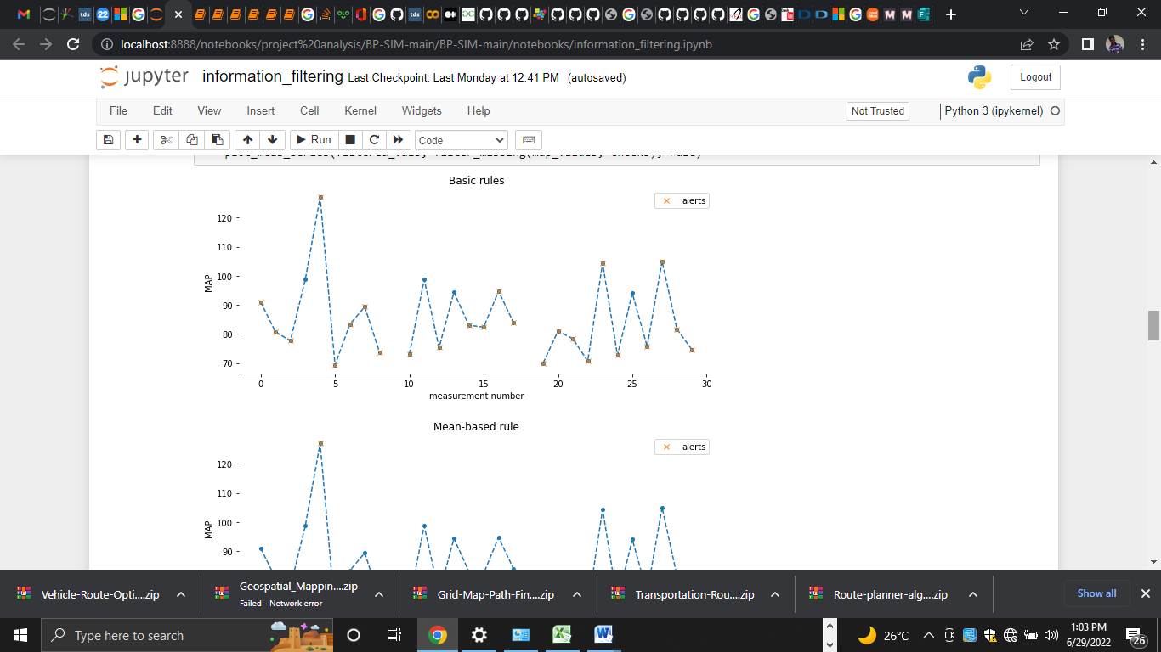

Figure 4.1: Basic Rules Graph Display
Figure 4.2: Signs Graph Plot

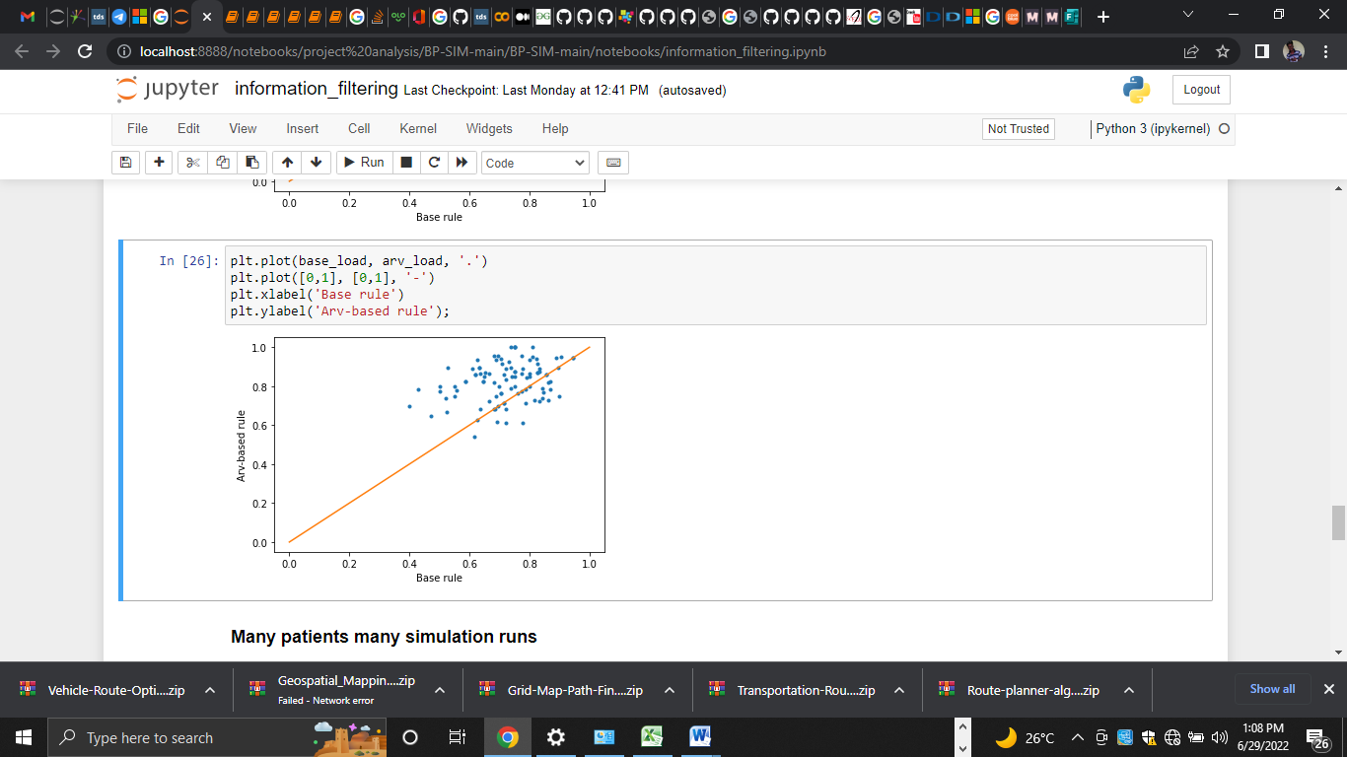

Figure 4.3: data load with plot dot

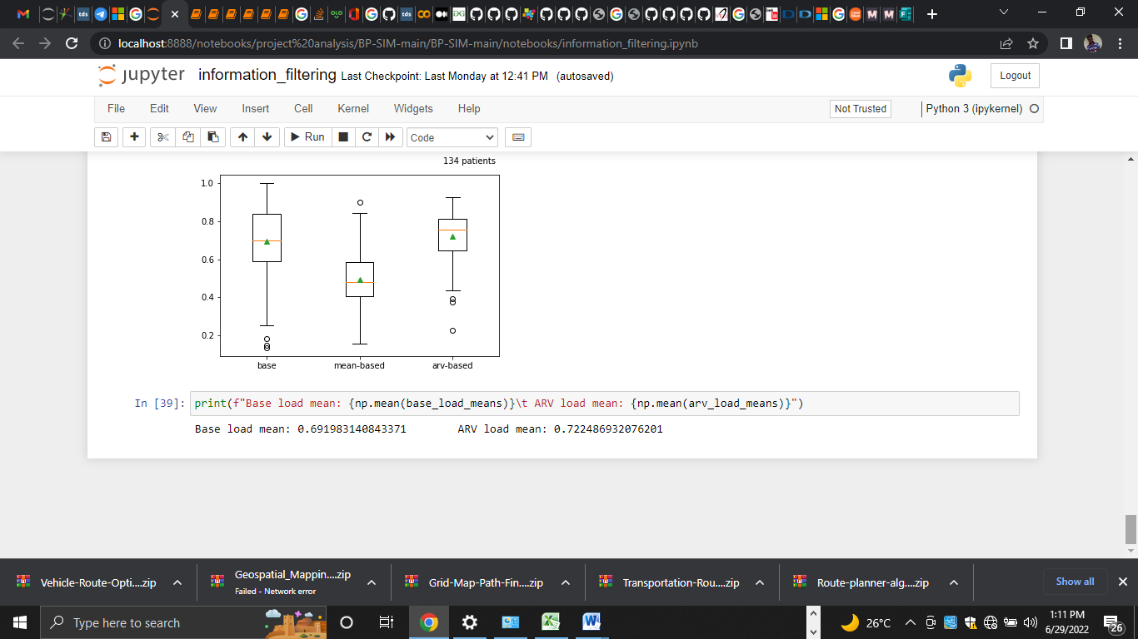
Figure 4.4: Patient Rate Display

4.1.2 INPUT DESIGN
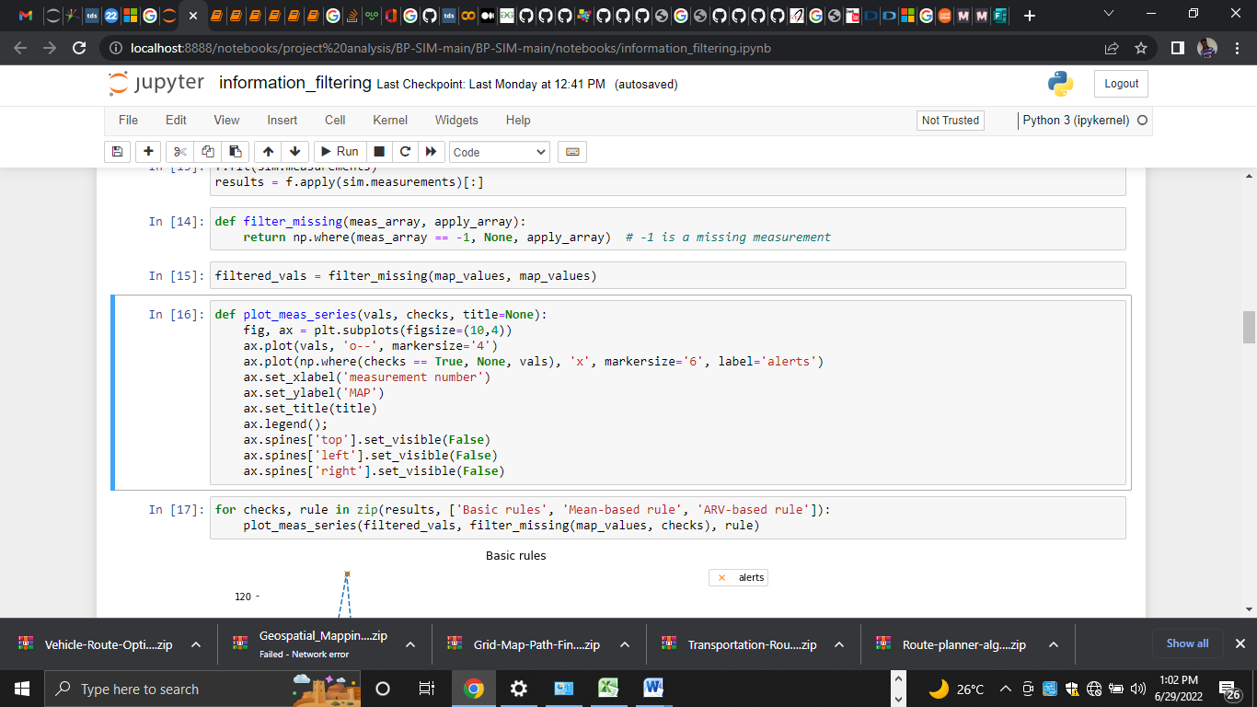

Figure 4.5: Heading Data input

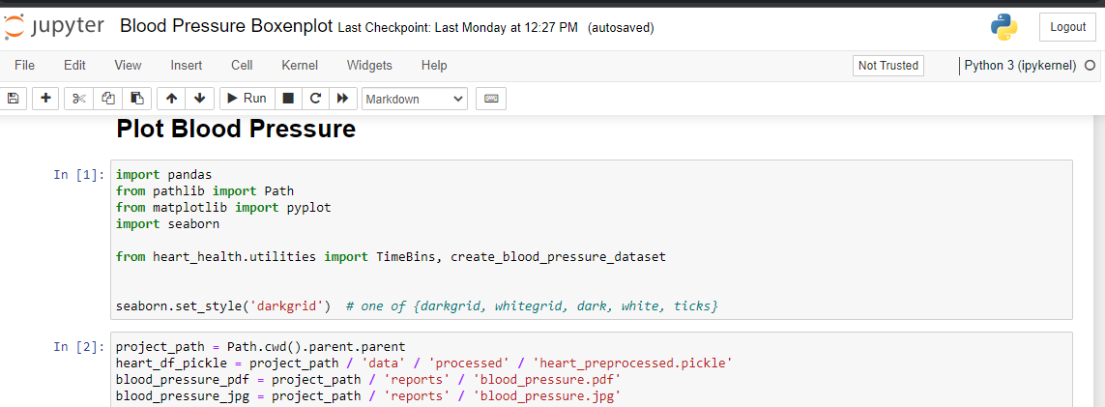

Figure 4.8: Blood Pressure Rate Data Input Path

4.1.3 DATABASE DESIGN

Table 4.1: Patient Dataset Table

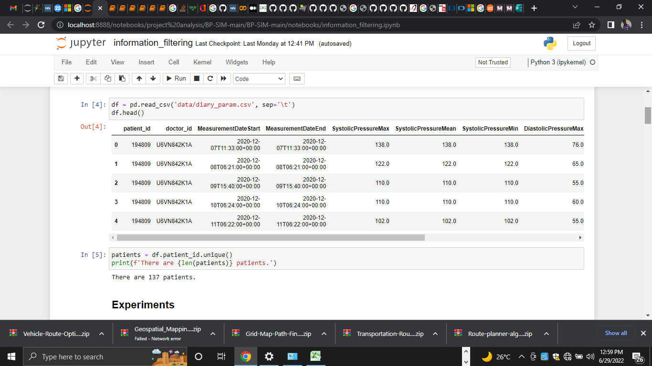

Table 4.2: Symptoms dataset table
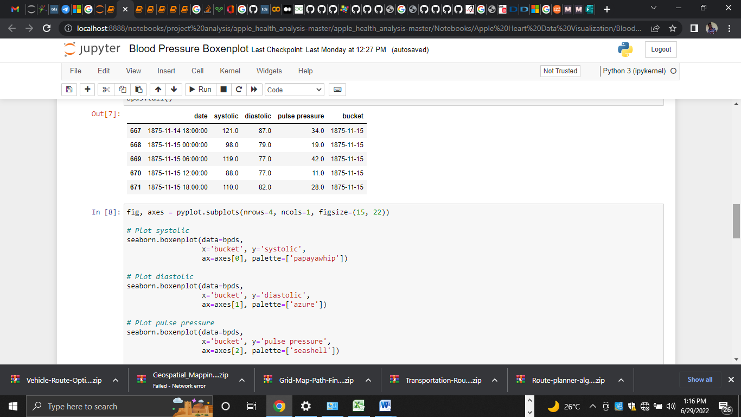

4.1.4 PROCEDURE DESIGN
The procedural design describes the system generally. It describes the various main programs in the system as well as the relationship that exist between all subprograms included. The procedural designs in this new system are of 5 menus of which each menu has it sub menu.
The application also contains several modules of which each module has its own specific function. The purpose of dividing the program into modules is because it enhances maintainability, readability and easy debugging.
4.2 SYSTEM IMPLEMENTATION
4.2.1 CHOICE OF PROGRAMMING LANGUAGE
After researching the benefits and advantages of Django it usually comes back to one thing, and that's not that it's an advantage to use Django, but it is an advantage that Django is built using Python. Python is considered an easy language to program with. This is because you can create more functions with fewer lines of code.
The main advantage of Django is that it delivers a pre-made ORM, which allows you to concentrate on the user interface and less on the backend code, which comes in installable packages. It creates a light model, view, and controller. Unlike other frameworks that add a lot of bloated syntax, that will not be used in your final application. It lets you choose the exact requirements and plugins you want to use in the app. Because Django produces so little unused code, web applications assembled with the framework usually have cleaner code and are more human readable, which makes it easier to understand and edit for the developer.

4.2.2 HARDWARE SUPPORT
The computer configuration required to run the software is;
Computer/memory processor PC with a 48dx, MHZ or Pentium, Intel or higher processor required.
Memory : 512MB of RAM
Cache memory : 512KB
Hard disk Minimum size : 10.2GB
Recommended : 40GB
Virtual Memory : 32Bits
Cache memory : 512KB
Floppy disk drive : 1.44MB
4.2.3 SOFTWARE SUPPORT
The software support for the design of the proposed system involves operating system, Python IDE, Anaconda NoteBook Text,CSV Package as well as an anti-virus software which prevents the system from being infected by virus.

4.2.4 IMPLEMENTATION TECHNIQUES USED IN DETAILS
The system will be implemented using the parallel approach. This approach is considered because it ensure that the new system is tested alongside with the old system to ensure the effectiveness and efficiency of the system.

4.3 SYSTEM DOCUMENTATION
4.3.1 PROGRAM DOCUMENTATION
The system must be used as instructed according to the hardware and software supports so as to make optimal use of it.

4.3.2 OPERATING THE SYSTEM
- Click start on the computer desktop
- Select all programs
- Launch Anaconda application
- Select the File NoteBook (localhost)
4.3.3 MAINTAINING THE SYSTEM
The following instructions must be strictly adhere to in other to make efficient use of the system. Install an anti-virus and always make sure it is usually updated to.

CHAPTER FIVE
SUMMARY, CONCLUSION AND RECOMMENDATIONS
5.1 SUMMARY
Diseases are some of the issues faced by health care. Due to the time-independent lifestyle, both diseases affect mortality across the globe. Disease attack occurs without any apparent symptoms. An intelligent method is utilized to forecast the vital signs that might help save the patient with disease. The computer-aided system may prevent or mitigate heart attacks and help in reducing the mortality rate. The effective identification of the machine-learning model concerning data is a challenging task. In this paper, i have discussed the details of predicted models for the forecasting of vital sign values that are ultimately helpful for the realization of a machine-learning-based system for the prediction of chronic diseases. -is study also aims to facilitate caregivers and medical experts to provide in-time medical assistance to the patients to reduce the fatality rate due to chronic respiratory complications in indoor patients, particularly after surgical procedures. It is necessary to assess the appropriateness of the prediction model according to the nature of the data. In summary key findings from this work include evidence of the effectiveness of polynomial regression for the prediction of the vital signs that shows the curvilinear nature of the vital signs used in this study. We have fulfilled the requirement of employing a sizeable comprehensive dataset to build confidence in the polynomial regression prediction model. In addition, the prediction outcomes are used to train the classifiers to identify the state of the patient. Our results show that the Decision Tree can correctly classify the condition of the patient. Decision-Tree-based classifiers are generally considered intuitive. They do not require an accumulation of multiple variables; however, their use under the practical restraints of missing data must be critically analyzed.
5.2 CONCLUSION
This study presented a Machine Learning algorithm for classifying controls (N = 140) versus dengue fever infected persons (N = 360) based on the vital signs: (HR,RR,T) measured by medical Radar, with high accuracy. The algorithm used and compared is the Decision Tree, this is foundational for application in practical systems. The major contribution of this research is the investigation of multi-label classification methods to forecast the future value of multiple vital signs at the same time using their correlated features. Therefore, the outcome of multi-label classification can assist the healthcare professionals in decision making through and thus help to detect instances when patient would be in serious clinical danger. The model is extendible for other vital signs (e.g. body temperature) and in future, we want to include more bio-signals and clinical data and their correlation in the investigations.

5.3 RECCOMENDATIONS
From the growing interest of IoT-based remote health monitoring, it is evident that there is a massive scope of future research and study. As a path of future work, we can point out three different perspectives of future work from this thesis.
Security:
Another, perspective is concerned with providing security to the data. In this thesis, the data taken into account is health-related data. Therefore, it is required to make ensure that this data flows through a highly secured pathway. The various security related methods can be implemented, and there is also a possibility of providing protection using standard machine learning algorithms.
Data Processing:
Finally, considering data processing phase in this thesis. This work only concentrates a few machine learning methods such as Decision Tree. This work focuses on basically four parameters for analysis but using online source dataset can be obtained with more features. Therefore, if features in the dataset are more than more advanced machine learning can be implemented to deal with a massive amount of dataset.

REFERENCES
Bing, Z., (2020) Health Data Driven on Continuous Blood Pressure Prediction Based on Gradient Boosting Decision Tree Algorithm. Content may change prior to final publication. Citation information: DOI 10.1109/ACCESS.2019.2902217, IEEE Access
Rashidi, et al (2022)“Arti- ficial intelligence and machine learning in pathology: the present landscape of supervised methods,” Academic pathology, vol. 6, pp. 23–74.
Rose et al (2020)., "THE INTERNET OF THINGS: AN OVERVIEW Understanding the Issues and Challenges of a More Connected World," [Online]. Available:https://www.internetsociety.org/wp-content/uploads/2017/08/ISOC-IoT-Overview 20151221-en.pdf. [Accessed 25 May 2020].
Fatima and Pasha, (2020) “Survey of machine learning algorithms for disease diagnostic,” Journal of Intelligent Learning Systems and Applications, no. 1, pp. 1–16.
Japan radio Co., (2020) ’’NJR4262 series’’, available:. https://w.w.w.njr. com/ download/ datasheet/sensor/NJR4262-rev00-02.pdf,. [Accessed 5 January 2020].Accessed.
Nguyen Cuong (2020) non-contact infection screening system using medical radar and Linux embedded FPGA: implementation and preliminary validation", Nr. Informatics in medicine unlocked, vol. 16; 2020. p. 100225.
Norberto, (2021) Patient classification algorithm at urgency care area of a hospital based on the triage system. JOURNAL OF MEDICAL INFORMATICS & TECHNOLOGIES Vol. 22/2021, ISSN 1642-6037
Kennely, (2021) "The IEEE 1073 Standard for Medical Device Communication," in IEEE AUTOTESCON Proceedings, Meredith, NH.
Weng, et al (2020), “Can machine-learning improve cardiovascular risk prediction using routine clinical data?” PloS one, vol. 12, no. 4, Article ID e0174944.
Sun Guanghao, et al. (2019) Design an easy-to-use infection screening system for non-contact monitoring of vitalsigns to prevent the spread of pandemic diseases. Nr. 36th annual international conference of the IEEE engineering in medicine and biology society, IEEE. p. 4811–4.
Trong, et al. (2021) Machine learning based classification model for screening of infected patients using vital signs. Informatics in Medicine Unlocked journal homepage: www.elsevier.com/locate/imu
Wajid, S., (2021) A Machine-Learning-Based System for Prediction of Cardiovascular and Chronic Respiratory Diseases. Journal of Healthcare Engineering Volume 2021, Article ID 2621655, 17 pages https://doi.org/10.1155/2021/2621655

