RESULTS
Phytochemical Analysis
Freshly prepared Cucuma Longa extract were subjected to preliminary phytochemical screening for various constituents.
Table 1: Phytochemical Analysis of Cucuma Longa extract
QUALITATIVE PHYTOCHEMICAL ANALYSIS | ETHANOLIC EXTRACT
TANNIN | +
SAPONIN | -
TERPENOID | +
GLYCOSIDE | +
STERIOD | +
ALKALOID | +
FLAVONOID | +
PHENOLICS | +
AMINO. ACID | -
PHLABOTANIN | +
Note: + = Present
‘ - = Absent

Table 2: The Effect Of Cucuma Longa Extract On Body Weight in Paracetamol Induced Chronic Hepatotoxicity Rats
Body weight (g)
Groups Day 0 Day1 Day 7 Day 14
Control 140±0.25ª 155.0±0.15^{b} 156±0.12 ^{b} 165.5±0.23^{c}
PCM Control (4000mg/kg) 152.8±0.41ª 141.6±0.16^{b} 114±0.15^{c} 105±0.24^{d}
VIT C (200 mg/kg) 132.8±0.7ª 128.4±0.61ª 112±0.21^{c} 155±0.14^{d}
CLE D1 (200mg/kg) 123.4±0.14ª 121.8±0.72ª 125.2±0.11ª 154±0.24^{b}
CLE D2 (400mg/kg) 115.6±0.24ª 113±0.21ª 123.4±0.54^{b} 132±0.41^{c}
Values are expressed as Mean ± SEM (n=5)
Means with different superscript in a Column differ significantly (P<0.05
Table 3: The Effect Of Cucuma Longa Extract On Hepatic Marker Enzyme in Paracetamol Induced Chronic Hepatotoxicity Rats

Specific Activity (U/L/mg protein)
Groups ALT AST ALP
Control 10.35±0.23ª 19.70±0.33ª 14.95±0.54ª
PCM Control (4000mg/kg) 25.20±1.31^{b} 30.82±2.21^{b} 28.10±0.23^{b}
VIT C (200 mg/kg) 15.36±0.95ª 20.97±0.47ª 19.24±0.67ª
CLE D1 (200mg/kg) 14.41±0.88 ª 19.48±2.27ª 20.96±1.96ª
CLE D2 (400mg/kg) 13.64±0.98ª 18.20±1.48ª 18.26±1.16ª
Values are expressed as Mean ± SEM (n=5)
Means with different superscript in a row differ significantly (P<0.05)

Figure1 : Effect Of Treatment On Liver Total Proteins Concentration (mg/ml)
Results Are Presented As Mean ± SEM (n=5).
Bars With Different Letters Are Significantly Different At P<0.05
Figure 2: The Effect Of Cucuma Longa Extract On GSH Concentration (µg/ml)in Paracetamol Induced Chronic Hepatotoxicity Rats
Results Are Presented As Mean ± SEM (n=5).
Bars With Different Letters Are Significantly Different At P<0.05

Figure 3: The Effect Of Cucuma Longa Extract On Superoxide Dismutase Enzyme Activity (mmol/min/mg protein) in Paracetamol Induced Chronic Hepatotoxicity Rats
Results Are Presented As Mean ± SEM (n=5).
Bars With Different Letters Are Significantly Different At P<0.05

Figure 4: The Effect Of Cucuma Longa Extract On Catalase Enzyme Activity (mmol/min/mg protein) in Paracetamol Induced Chronic Hepatotoxicity Rats
Results Are Presented As Mean ± SEM (n=5).
Bars With Different Letters Are Significantly Different At P<0.05

Figure 5: The Effect Of Cucuma Longa Extract On MDA concentration (nmol MDA/mg protein) in Paracetamol Induced Chronic Hepatotoxicity Rats
Results Are Presented As Mean ± SEM (n=5).
Bars With Different Letters Are Significantly Different At P<0.05

LIVER HISTOPATHOLOGY
A
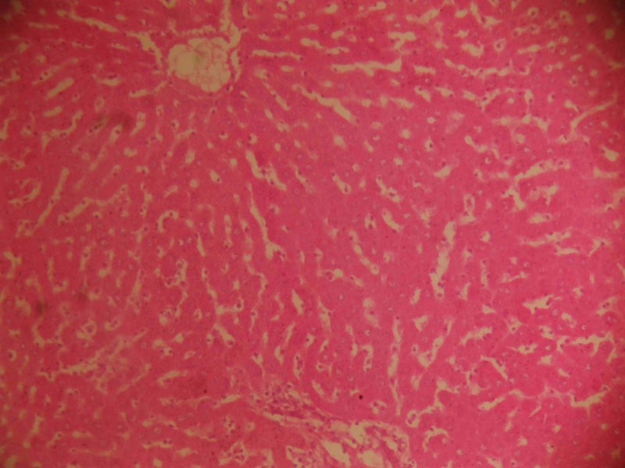
Showing hepatocytes nests and cords (yellow arrows) mostly within normal limits, interspersed with sinusoids which have more numbers of phagocytic macrophages (black arrows)
INTERPRETATION : The increased Macrophages suggest an active clean up process, likely responding to bile accumulation or cell debris. Haematoxyin and eosin stain. X100
B
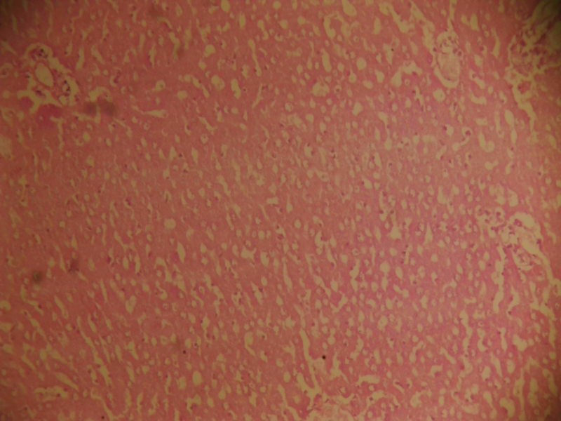
Showing hepatocyte plates with necrotic beds (yellow arrow), numerous vacuoles and sinusoids (red arrows) with many inflammatory cells (black arrows).
INTERPRETATION: This suggest severe liver injury withNecrosis, possibly due to toxic or infectious insult. The combination of Necrosis, vacuoles and inflammation is typically acute or chronic hepatitis. Haematoxylin and eosin stain. X100.

C

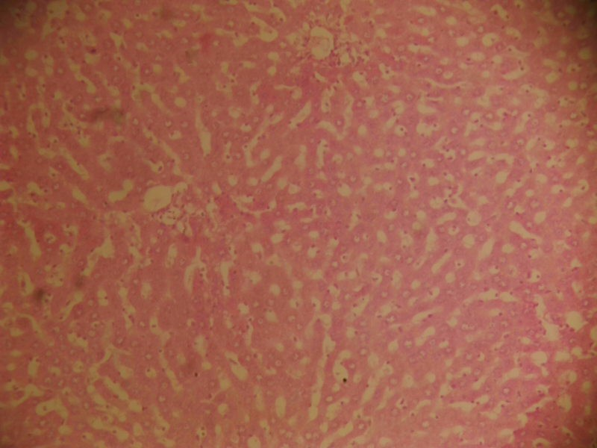
Showing hepatocytes cords and nests (yellow arrows), interspersed with more numbers of sinusoid channels in which also are many inflammatory cells (black arrows). Features are in keeping with cholestasis with inflammation.
INTERPRETATION : The infiltration of inflammatory cells into the sinusoid points to active or inflammatory response to bile retention or injury . Haematoxylin and eosin stain. X100.

D
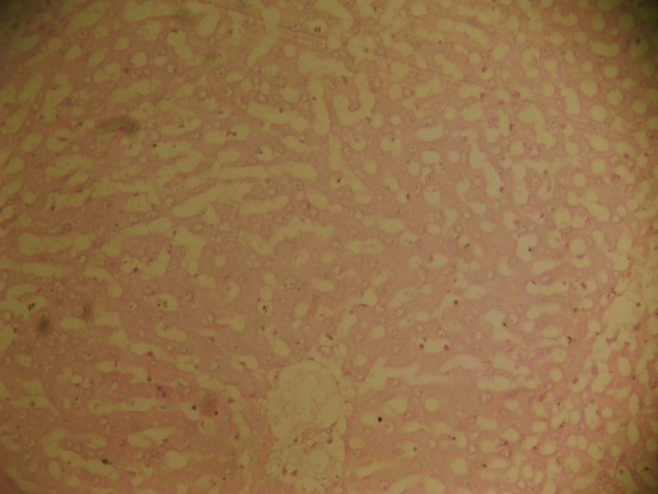
Showing hepatocytes cords and nests (yellow arrows) being interspersed with wider sinusoids (black arrows) margins, which is suggestive of odema.
INTERPRETATION : The sinusoidal widening is indictative of hepatic edema, likely due tofluid accumulation. This may suggest early liver damage or inflammation resulting in vascular leakage. Heamatoxylin and eosin stain. X100.

E
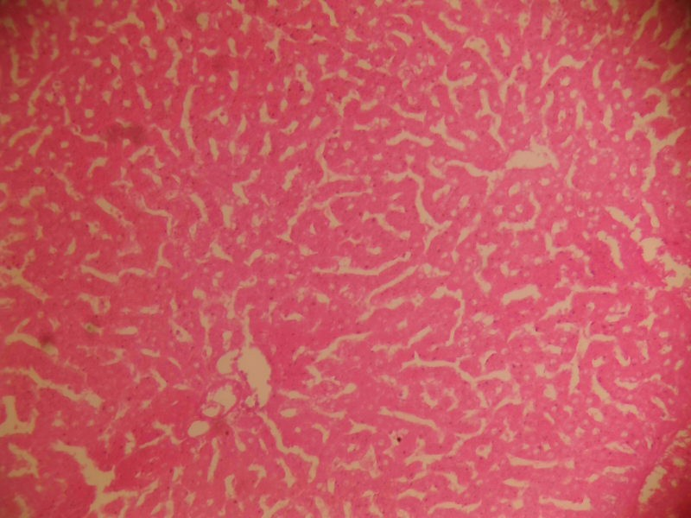
Showing hepatocytes cords and nests (yellow arrows) within moderate limits, separated by numerous sinusoid channels, inside of which are some resident inflammatory cells (black arrows).
INTERPRETATION : This shows Mild to Moderate inflammation. It may represent an early stage of liver inflammation or a relatively preserved liver with minimal reactive changes. Haematoxylin and eosin stain. X100.

