EFFECT OF RENTAL VARIATION IN RESIDENTIAL AND COMMERCIAL PROPERTIES
(A CASE STUDY OF IKEJA LAGOS STATE)

BY
AMUSA RASAQ ENIOLA
HND/23/ETM/FT/0039

SUBMITTED TO THE DEPARTMENT OF ESTATE MANAGEMENT AND VALUATION,
INSTITUTE OF ENVIRONMENTAL STUDIES,
KWARA STATE POLYTECHNIC, ILORIN, KWARA STATE

IN PARTIAL FULFILLMENT OF PART OF THE REQUIREMENTS FOR THE AWARD OF HIGHER NATIONAL DIPLOMA (HND) IN ESTATE MANAGEMENT AND VALUATION

CERTIFICATION

This is to certify that this project work has been written by AMUSA RASAQ ENIOLA with Matriculation No: HND/ETM/FT/0039 and has been read and approved as meeting parts of the requirement for the award of Higher National Diploma (HND) in the Department of ESTATE MANAGEMENT AND VALUATION, Institute of Environmental Studies (IES), Kwara State Polytechnic, Ilorin, Kwara State.


ESV. OLADOJA ISMAIL OLAWALE (ANIVS, RSV) DATE

(Project Supervisor)




ESV. DR. (MRS.) UWAEZUOKE, N.I (Ph.D, RSV) DATE

(Project Coordinator)


ESV. ABDULKAREEM RASHEEDAT (ANIVS, RSV) DATE

(Head of Department)



ESV. DR. LUKMAN MUSIBAU (Ph.D, RSV) DATE

(External Exaaminer)

DEDICATION
This Project is dedicated to Almighty Allah (SWT) and my parent Mr. and Mrs. Amusa.

ACKNOWLEDGEMENTS
All thanks to Almighty Allah(SWT) the most beneficient and the most merciful.
My sincere appreciation goes to my supervisor Esv Oladoja Olawale Ismail for his advice, correction, commitment and encouragement towards the success of this project.
I also appreciate Esv Abdulkareem Rasheedat my H.O.D,Esv.Dr.Mrs N.I Uwaezuoke Project Coordinator,Esv Abdul Olarenwaju Hassan,Esv Lawal Simiat,Esv Bolaji,Esv Barakat,Mr Abdulmumeen,Mr Akewula,Mr Ismail,Mr kamil for the knowledge they impacted on me during my course of study.
I am indebted to my ever supportive parent Mr and Mrs Amusa for their Financial,Moral and Spiritual support all through my academic journey.I pray you both live long to reap the fruit of your labour.
Also,i want to extend my gratitude to my family, Daddy mariam,Wiseman,Olamummy,Bro sheriff, Rofiat, Mummy fridaus,Sis Ashiat and others for the support you all give all through this journey.
To my ever-supportive gf,Miss Akeem Mariam Omoyeni(Ajoke) thanks for the constant word of encouragement and immense love all through the journey.
To my EMVSA family,ESSA family,SRC family, Transportation committee family,NAOSS(Ogun) family.You all are wonderful and the time spent with you guys is forever cherish
Lastly, i express my heartfelt gratitude to my friends who have been there through thick and thorn.Oni Micheal Joseph(SUG Speaker),Ishaka Elvis Onoriode(EMVSA President),Nta Opeyemi Esther(EMVSA Social),Isaka Jelilat Tiwa(Asst Rep),Kajola Samiat Ayomiposi(QS Speaker) and others.I really appreciate the love and support you all showered me and you guys are the real MVPs.

TABLE OF CONTENTS
Title page i
Certification ii
Dedication iii
Acknowledgements iv
Table of Contents v
Abstract vii
CHAPTER ONE
1.0 Introduction 1
1.1 Background 2
1.2 Statement of the Problem 3

1.3 Research Questions 3

1.4 Aim and Objectives 4

1.5 Scope of the Study 4

1.6 Justification of the Study 4
1.7 Historical Background of the Case Study 6
1.8 Definition of Terms 6

CHAPTER TWO: LITERATURE REVIEW

2.0 Introduction 7

2.1 Conceptual Review 7

2.1.1 Concept of Rental Variation 7

2.1.2 Types of Rental Properties 9

2.1.3 Factors Influencing Rental Values 10

2.1.4 Residential Properties: Concepts and Characteristics 12

2.1.5 Commercial Properties – Concepts and Characteristics 13

2.1.6 Urbanization and Its Impact on Rental Values 15

2.1.7 Additional Economic Influences on Rental Values 16

2.1.8 Infrastructure, Urban Clusters, and Rental Dynamics 17

2.1.9 Public-Private Partnerships and Infrastructure as a Predictor of Rental Value 18
2.2 Summary of Reviewed Literature 20
CHAPTER THREE: RESEARCH METHODOLOGY

3.0 Introduction 23

3.1 Research Design 23

3.2 Sources of Data 23

3.3 Target Population 23

3.4 Sampling Frame 24

3.5 Sample Size 24
3.6 Sampling Procedure 24
3.7 Method of Data collection 25
3.8 Methods of Data Analysis 25
CHAPTER FOUR: DATA PRESENTATION, ANALYSIS AND INTERPRETATION
4.0 Introduction 26
4.1 Data Presentation 26
4.2 Discussion of Findings 42
CHAPTER FIVE: SUMMARY OF FINDINGS, CONCLUSION AND RECOMMENDATIONS
5.1 Summary of Findings 45
5.2 Conclusion 45
5.3 Recommendations 45
References 47

ABSTRACT
This study examined the influence of infrastructural development and other contributing factors on rental variation in Ikeja, Lagos State. Data were collected from a range of stakeholders including tenants, landlords, estate agents, and business operators. The findings revealed that rental variation was primarily influenced by factors such as location, accessibility, security, demand and supply, and infrastructural development, with location emerging as the most critical factor. The majority of respondents reported that inflation and infrastructure improvements significantly contributed to rent increases, with rental prices most commonly changing on a yearly or quarterly basis. Tenants, who constituted the majority of respondents, were the most affected by rent variations, often experiencing negative impacts on their standard of living or business performance. Infrastructure components such as road networks and electricity were identified as having a strong influence on rental pricing, despite being rated as fair or poor in quality. Furthermore, over half of the respondents confirmed that rent increases within the past year ranged between 10–20%. The study concluded that while infrastructural development has the potential to boost property values and attract investments, it also contributes to rising rents that strain residents and small business operators. The study recommended policy interventions such as rent control, equitable infrastructure development, housing subsidies, and regulatory oversight of landlords and estate agents to ensure fair and affordable access to housing and commercial properties.

CHAPTER ONE
1.0 Introduction
The real estate sector is an essential component of the Nigerian economy, contributing significantly to the GDP and job creation in urban areas like Lagos State, where population density is high. The demand for both residential and commercial properties is influenced by several economic, social, and infrastructural factors. Ikeja, a key commercial and residential district in Lagos, serves as a focal point for this study. It houses numerous businesses, government institutions, and residential complexes, making it an ideal location to explore rental variation and the implications of urban development.
However, despite the extensive literature on real estate in Nigeria, a gap remains in understanding how these variations specifically affect different property types in Ikeja—especially with the increasing demand for both residential and commercial spaces. Rental variation in Ikeja has been influenced by several factors, such as rapid urbanization, infrastructural development, and changing economic trends. The area has experienced significant growth over the past few decades, with a steady rise in commercial activities—like those in the Computer Village—and a corresponding increase in residential developments.
While these factors have enhanced the area's economic vibrancy, they have also led to rising prices, with commercial properties often commanding significantly higher rates compared to residential properties in prime locations. This disparity creates affordability challenges, especially for businesses and low- to middle-income residents, making it essential to understand the causes and consequences of rental fluctuations in this area (Ekanem, 2021).
Existing studies have largely focused on the broader Lagos real estate market, with very few offering in-depth analyses of specific locations like Ikeja. For instance, research by Umeh and Ogunde (2019) discussed the relationship between urbanization and property prices in Lagos but did not address the trends experienced differently in the residential and commercial sectors. Additionally, studies have explored property valuation in Nigeria (2023), but often overlook the nuanced effects in mixed-use areas like Ikeja, where both property types coexist and interact in complex ways.
Thus, while there is recognition of the broader trends affecting Lagos real estate, there is a need for a study that specifically investigates how these forces operate within Ikeja—with particular focus on the factors contributing to rental variation. This study aims to bridge that gap by examining the specific causes of rental variation in Ikeja, focusing on both residential and commercial properties.
The research will explore economic, infrastructural, and social factors that drive rental price fluctuation and assess their impact on tenants and landlords. By using methods that include surveys, interviews, and property analysis, the study will offer a more comprehensive understanding of rental dynamics in Ikeja.
These findings will provide valuable insights to real estate developers, policymakers, and urban planners in developing strategies for promoting sustainable and equitable rental pricing in the area (Obasi, 2021). Through this approach, the development of fair and effective policies that address the challenges of rental variation and support balanced urban growth in Ikeja will be encouraged.
  - Background
The real estate sector plays a pivotal role in the socio-economic development of any country. In Nigeria, the demand for residential and commercial properties continues to rise due to urbanization, population growth, and the increasing need for business spaces in Ikeja. The variation in rental values between residential and commercial properties in Ikeja is largely determined by location, property type, and economic factors.
As Lagos remains Nigeria's economic nerve center, areas such as Ikeja—which hosts commercial districts like the Computer Village and the Lagos State Government Secretariat—experience unique rental patterns. These factors underscore the need to examine the reasons behind this variation and their broader implications, as observed in May and August 2019. Rapid urbanization in Lagos has created pressure on the available housing and commercial spaces due to competitive rental prices in Ikeja.
The development of infrastructure, such as road networks and power supply, has further impacted rental values. In Ikeja, proximity to key facilities like Murtala Muhammed International Airport and major markets significantly increases rental demand, making the area attractive for both residential and commercial purposes. Economic fluctuations, including inflation, exchange rates, and instability, also contribute to rental value variation. As landlords adjust rental prices to mitigate economic challenges, tenants face affordability issues, especially for commercial purposes.
This trend is more pronounced in high-demand areas like Ikeja, where businesses are willing to pay premium rates for strategic locations. Additionally, zoning laws and government policy influence rental trends in Ikeja. Residential properties in certain parts of the area are being converted to commercial use, increasing rental values in such locations. The Lagos State government’s urban planning initiatives have further shaped property development and pricing dynamics (Adeleja, 2023).
Cultural and social factors are also contributing to rental value variations. Ikeja’s diverse population and its status as a melting pot for individuals from different parts of the country create dynamic real estate management challenges. The preferences of tenants and their willingness to pay for specific property types in desirable neighborhoods play a crucial role in rental determination.
The economic activities in Ikeja, such as the presence of shopping malls, hotels, and entertainment centers, drive up rental values for commercial properties. Businesses aiming to capitalize on the area’s economic vibrancy often outbid residential tenants, creating a disparity in rental pricing (Obasi, 2021). Moreover, the demand for affordable housing in Ikeja highlights the challenges faced by low- and middle-income earners. As landlords prioritize commercial tenants who can afford higher rents, residential tenants often relocate to suburban areas, resulting in socio-economic implications for urban planning and development (Okonkwo, 2019).
Technological advancement and smart property management systems have also impacted rental value trends in Ikeja. Modern buildings equipped with advanced facilities and security features command higher rental prices compared to older structures. This shift in tenant preference has contributed to a dynamic rental market (Dada & Shokunbi, 2021).
The importance of understanding the factors influencing rental variation cannot be overstated. For real estate investors and policymakers, analyzing these trends provides valuable insight into market dynamics and helps formulate strategies for sustainable development in Ikeja (Oyetunji, 2022). Moreover, rental variation in residential and commercial properties in Ikeja is shaped by economic, social, and policy factors. This study seeks to explore these variations in depth, providing a foundation for improved real estate practices and effective urban planning policies (Oluwole, 2023).
1.2 Statement of the Problem
The real estate sector in Nigeria, particularly in Lagos State, has witnessed significant rental variations over the years, creating socio-economic challenges for residents and businesses alike. In Ikeja, these variations are influenced by factors such as rapid urbanization, economic instability, and infrastructural disparities.
Residential tenants face affordability challenges, often leading to displacement to suburban areas. On the other hand, commercial tenants are burdened with exorbitant rent trends, which impact their profitability and sustainability. Despite numerous studies on property valuation and urban development, limited research has addressed the specific factors contributing to rental variation in Ikeja and its implications for stakeholders.
This gap in knowledge has hindered the development of sustainable policies and practices that could effectively address rental disparities. This study aims to bridge that gap by analyzing the underlying causes of rental variations in residential and commercial properties in Ikeja, Lagos State.
Using a mixed-method approach, the research will investigate factors such as economic trends, infrastructural development, and tenant preferences. Data collection will include surveys, interviews, and property value analysis to provide a comprehensive understanding of the issue.
The findings will not only highlight the challenges faced by tenants but also offer practical recommendations for real estate developers, policymakers, and urban planners. By addressing these issues, the study seeks to contribute to sustainable property management practices and equitable rental pricing in Ikeja.

1.3 Research Questions
The following research questions are raised to guide the study:
- What are the primary factors contributing to rental variations in residential and commercial properties in Ikeja?
- How do economic trends such as inflation and market demand influence rental values in Ikeja
- What role does infrastructural development play in determining rental prices in Ikeja?
- How do tenant preferences and location dynamics impact rental variations between residential and commercial properties?
- What are the socio-economic implications of rental disparities on residents and businesses in Ikeja?

1.4 Aim and Objectives
The aim of this study is to examine the factors influencing rental variations in residential and commercial properties in Ikeja, Lagos State.
- To achieve this aim, the study sets out the following specific objectives:
- To identify the primary factors contributing to rental variations in residential and commercial properties in Ikeja.
- To analyze the influence of economic trends such as inflation and market demand on rental values in Ikeja.
- To evaluate the impact of infrastructural development on rental pricing in the study area.
- To examine the role of tenant preferences and location dynamics in determining rental variations.
- To assess the socio-economic implications of rental disparities on residents and businesses in Ikeja.

1.5 Scope of the Study
This study focuses on the effect of rental variations in residential and commercial properties in Ikeja, Lagos State, Nigeria. Specifically, it examines factors such as economic trends, infrastructural developments, tenant preferences, and location dynamics that contribute to disparities in rental values.
The study covers key areas within Ikeja, including commercial hubs like the Computer Village and residential neighborhoods, to provide a balanced analysis of both property types. The research is limited to rental variation trends between 2015 and 2024, allowing for an evaluation of recent economic and urban development impacts on rental values.
Data will be collected from property owners, tenants, real estate agents, and policymakers within Ikeja through surveys, interviews, and document analysis. The geographical scope of the study is confined to Ikeja in Lagos State, specifically focusing on the Computer Village and Allen Avenue for proper and accurate representation of the issue.

1.6 Justification of the Study
Previously, studies have extensively examined real estate trends and property valuation in Ikeja, with many focusing on urban centers like Lagos State. Research by Umeh and Ogundele (2019) highlighted the role of rapid urbanization and economic instability in shaping property prices in Ikeja. Similarly, Ekane (2021) explored the relationship between infrastructural development and rental values, concluding that areas with better infrastructure command higher rental incomes.
However, these studies often generalize findings without providing in-depth analysis specific to Ikeja—a unique area with its mix of residential and commercial properties. This lack of localized insight has left critical gaps in understanding how rental variation manifests in Ikeja.
While Obasi (2021) investigated commercial property rental trends in Ikeja, the study neglected the impact of these trends on residential properties and the socio-economic balance within urban centers. Furthermore, Okonkwo (2019) emphasized the challenges of affordable housing but did not address how the increased demand for commercial space contributes to rental disparities.
These gaps underscore the need for a focused study that examines both residential and commercial rental variations in Ikeja. A study of this nature would provide a holistic understanding of the factors at play and their broader implications for urban planning and property management.
This study is poised to bridge these gaps by offering a detailed analysis of rental variation in Ikeja, using a mixed-method approach to gather both quantitative and qualitative data. By focusing on both residential and commercial properties, it aims to uncover the interplay of economic trends, infrastructural factors, and tenant preferences in driving rental disparities.
The findings will not only fill existing knowledge gaps but also provide actionable recommendations for policymakers, real estate developers, and urban planners to foster equitable rental practices. Ultimately, this will contribute to sustainable urban development in Ikeja.
1.7 Historical Background of the Case Study (Ikeja)
Ikeja, the capital of Lagos State, Nigeria, lies at approximately latitude 6.6018° N and longitude 3.3515° E. Historically, it began as a modest rural settlement inhabited by the Awori, a subgroup of the Yoruba ethnic group. The name “Ikeja” is believed to have originated from “Akeja,” a local deity once worshipped in the area. Situated inland from the Atlantic coast, the town’s favorable location made it ideal for agriculture and trade among early settlers, who cultivated crops like yam and cassava and engaged in local commerce and traditional practices that reflected their deep-rooted Yoruba heritage.
During the British colonial period, Ikeja's location — just about 10 kilometers northwest of Lagos Island — gave it strategic importance. Its accessibility was enhanced by the construction of major roads and a railway line that linked it to other parts of Lagos and southwestern Nigeria. This development gradually shifted Ikeja from a quiet farming village to a growing semi-urban community. By the mid-20th century, the British colonial administration began considering Ikeja as a suitable location for future expansion and urban planning due to its flat topography and room for growth.
In 1967, when Lagos State was officially created, Ikeja was designated as the new state capital. This shift aimed to reduce the administrative pressure on Lagos Island and provide a more organized space for government operations. As a result, the Lagos State Government Secretariat, Government House, and several ministries and parastatals were established there. Modern infrastructure such as residential estates, schools, and hospitals began to spring up, transforming Ikeja into a bustling administrative and residential area. The city’s elevation, which averages around 39 meters (128 feet) above sea level, provided a good foundation for urban development.
The economic growth of Ikeja accelerated in the 1980s and 1990s with the establishment of the Ikeja Industrial Estate and the emergence of Computer Village, now one of the largest markets for ICT products in West Africa. The presence of Murtala Muhammed International Airport, located just a few kilometers away at latitude 6.5774° N and longitude 3.3216° E, further cemented Ikeja’s role as a major economic and transport hub. These developments attracted businesses, investors, and a diverse population, making the area a magnet for both commerce and innovation.
Today, Ikeja is a thriving urban center that blends tradition with modernity. Despite its rapid development, it still holds onto its cultural roots through local festivals, chieftaincy institutions, and historical landmarks. With its strategic coordinates and steady infrastructural expansion, Ikeja stands as a key player in Nigeria’s economic, political, and social landscape, reflecting the dynamic spirit of Lagos State and the resilience of its people.
LOCATIONAL MAPS


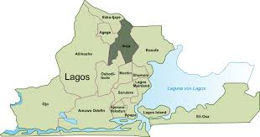
Fig 1: Map of Nigeria Showing Lagos State

Fig 1: Map of Lagos State showing Ikeja
1.8 Definition of Terms
Rental Variation:This refers to the difference in the rental value of properties, which is influenced by factors such as location, demand, and level of development (Adelake, 2023).
Residential Property:A type of property designed primarily for housing purposes, including apartments, houses, and duplexes (Ekanem, 2021).
Commercial Property:This refers to properties used for business activities, such as offices, shops, and warehouses (Obasi, 2021).
Real Estate:Land and buildings, including the natural resources found within and on the land, collectively constitute real estate (Umeh & Ogunleye, 2019).
Urbanization:
The increasing shift of population from rural areas to urban centers, often driven by economic opportunities and better living conditions (Onyeka, 2020).
Infrastructure Development:The enhancement and expansion of essential facilities such as roads, electricity, water supply, and waste management systems to support urban living (Adewale & Olorunfemi, 2022).
Tenants:Individuals or businesses who pay rent to occupy residential or commercial properties owned by another party (Okonkwo, 2019).
Landlord:A property owner who rents out residential or commercial spaces in exchange for financial returns (Oluwole, 2023).
Market Demand:The level of desire and financial ability of individuals or organizations to rent properties in a particular location (Dada & Shokunbi, 2021).
Affordable Housing:Residential properties that are priced to be within the financial capacity of low- and middle-income earners (Adelaja, 2023).
Property Valuation:The process of assessing the monetary worth of a property, typically for purposes such as rental pricing or investment analysis (Obasi, 2021).
Policy Intervention:Government actions or regulations aimed at managing rental markets and guiding urban development for the benefit of the general public (Oyebanji, 2022).

CHAPTER TWO

LITERATURE REVIEW

2.0 Introduction
The real estate market, particularly the rental sector, is a complex field influenced by various dynamic and interrelated factors. Understanding the concept of rental variation in residential and commercial properties requires a comprehensive examination of variables such as economic trends, urbanization, infrastructure development, and market dynamics.
This chapter delves into both theoretical and empirical studies surrounding rental variation, with a focus on identifying the primary factors that drive changes in rental prices. The objective is to explore existing literature that highlights the key elements influencing rental variation, particularly within urban environments like Lagos.
The chapter is structured to provide a detailed conceptual review, beginning with the definition and understanding of rental variation. It proceeds to examine the different types of rental properties, followed by an in-depth analysis of the core factors influencing rental values. These include economic conditions, tenant and landlord behaviors, and policy influences.
Additionally, this section discusses the unique characteristics that distinguish residential from commercial properties, as well as the role of urbanization in shaping rental market dynamics. Special attention is given to economic forces that influence pricing decisions, and the impact of infrastructure — which remains a major determinant of rental values, especially in rapidly growing cities like Lagos.
The literature reviewed in this chapter is instrumental in providing a broader context for understanding the trends and underlying factors shaping rental variation in Ikeja. By exploring previous studies and their findings, this chapter identifies existing research gaps and lays a solid foundation for the present study.
Ultimately, this review serves as a bridge to the subsequent chapters by contextualizing the factors influencing rental pricing within the Nigerian real estate landscape. It aims to address the research questions and objectives outlined earlier, offering insights into how rental variation can be critically and effectively analyzed.

2.1 Conceptual Review

2.1.1 Concept of Rental Variation
Rental variation refers to the differences in function and rental prices of properties within a specific geographical location or between different locations. This variation is commonly observed across residential and commercial properties due to several influencing factors such as demand and supply, economic conditions, and infrastructure development.
Rental variation is a critical concept in real estate studies as it reflects the socio-economic dynamics of an area and the level of urban development (Ademiluyi & Raji, 2008). One of the primary factors contributing to rental variation is location. Properties situated in prime areas—such as central business districts or locations with excellent infrastructure—typically attract higher rental prices compared to those in less developed or remote locations. For instance, in cities like Lagos, properties in Ikeja and Victoria Island command significantly higher rents than those in less urbanized areas due to their proximity to commercial hubs and better facilities (Olayiwola et al., 2006).
Another key determinant of rental variation is the type and quality of property. Modern and well-maintained buildings, especially those equipped with features such as security systems, ample parking spaces, and access to basic utilities, tend to have higher rental values. Businesses, in particular, prioritize high-quality spaces to attract customers and maintain their brand image (Oyebanji, 2013).
Economic conditions also play a vital role in influencing rental variation. Periods of economic growth often lead to increased demand for properties, which causes rental prices to rise. Conversely, during economic downturns, rental values may decline as individuals’ purchasing power decreases. The impact of inflation—especially in developing economies like Nigeria—further complicates these dynamics by affecting both construction costs and property demand (Ukoje & Kanu, 2014).
Lastly, infrastructure development is another critical driver of rental variation. Areas with access to good roads, efficient public transportation, and essential amenities such as schools and hospitals generally command higher rental prices. The provision of modern infrastructure enhances the livability and commercial viability of an area, attracting more residents and businesses, which in turn increases demand for properties and pushes rental prices upward (Agboola, 1998).
Government policies and regulations also contribute significantly to rent aberration. For instance, land use policies and restrictions in urban centers can either hinder or discourage investment in the real estate sector, thereby influencing rental prices. Rent control measures, as an example, may limit the extent to which landlords can increase rent, helping to stabilize rental fluctuations in certain areas (Oni et al., 2017).
Demand and supply dynamics are fundamental in understanding rent aberration. High demand for properties in urban centers often leads to intense competition among prospective tenants, thereby driving up rental prices. On the supply side, an increase in the construction of properties can help stabilize or even reduce rental prices—provided that supply keeps pace with or exceeds demand (Aluko, 2011).
Sociocultural factors also play a role in shaping rent aberration in certain communities. Cultural preferences or social status may affect demand for particular types of properties, leading to variations in rent. For instance, affluent neighborhoods tend to attract high-income tenants who are willing to pay premium prices for exclusivity, security, and social prestige (Fabi, 2006).
The impact of rent aberration extends beyond property owners and tenants; it also affects the broader economy. High rents can strain household incomes, reducing disposable income for other essential expenditures. For businesses, elevated rental costs can affect profitability and hinder growth. These economic implications underscore the importance of understanding and addressing the factors contributing to rental variation (Ajanlekoko, 2001).
In conclusion, rent aberration is a complex phenomenon influenced by multiple interrelated factors—including location, property type, economic conditions, infrastructure, and government policies. A comprehensive understanding of these factors is essential for stakeholders in the real estate sector—such as policymakers, developers, and tenants—to make informed decisions that promote sustainable urban development (Oni & Ajibola, 2010).

2.1.2 Types of Rental Properties
Rental properties are broadly categorized into residential and commercial properties, each serving distinct purposes and meeting specific market demands. Understanding the types of rental properties is crucial for analyzing rental variations and their determinants. These categories reflect the different priorities of tenants—ranging from personal living needs to business operations (Oyebanji, 2003).

Residential Rental Properties
Residential rental properties refer to housing units rented out to individuals or families for residential purposes. These include single-family houses, apartments, townhouses, and duplexes. The rental value of residential properties is influenced by factors such as location, size, amenities, and proximity to essential services like schools, healthcare centers, and public transportation. For instance, in high-demand areas such as Ikeja GRA in Lagos, residential rents are significantly higher due to the availability of modern amenities and a serene environment (Olayiwola et al., 2006).

Commercial Rental Properties
Commercial rental properties are spaces leased for business purposes. These include offices, retail shops, warehouses, and industrial facilities. The rental value of commercial properties is typically determined by foot traffic, accessibility, visibility, and proximity to business hubs. In Ikeja, Lagos, areas like Computer Village and Alausa are considered prime locations for commercial rentals due to their vibrant economic activities and strategic location near the Lagos State Secretariat (Ukoje & Kanu, 2014).

Mixed-Use Rental Properties
Mixed-use rental properties combine both residential and commercial functions within the same structure or complex. These properties are increasingly popular in urban centers where land is limited and developers aim to maximize usage. For example, a building that features shops on the ground floor and apartments on the upper floors provides dual income opportunities while catering to a diverse range of tenants (Fabi, 2006).

Specialized Rental Properties
Specialized rental properties include facilities such as hotels, resorts, and serviced apartments, which cater mainly to short-term stays. These are often situated in areas frequented by tourists or business travelers, particularly around transit hubs like Murtala Muhammed International Airport (Agboola, 1998).
Industrial rental properties—such as warehouses, factories, and distribution centers—are designed for manufacturing, storage, and logistics. These are typically located on the outskirts of urban centers to minimize disruptions, reduce operational costs, and benefit from lower land values. In areas like the Ikeja Industrial Estate, such properties are highly sought after by businesses looking for affordable and accessible spaces.
In conclusion, rental properties are diverse and serve a variety of residential and business needs. The type, location, and features of a property significantly influence its rental value and determine its place in the broader real estate market. A clear understanding of these categories is essential for effective real estate planning and management.

2.1.3 Factors Influencing Rental Values
Rental values are shaped by a variety of interrelated factors that differ based on location, property type, market dynamics, and socio-economic variables. These factors not only determine the affordability and appeal of rental properties for tenants but also influence the investment decisions of property owners. A comprehensive understanding of these determinants is crucial for evaluating rental valuations and market behavior (Agboola, 1998).

1. Location
Location is a fundamental determinant of rental values. Properties located in urban centers, commercial zones, or areas with strong economic activity tend to command higher rents than those in rural or underdeveloped regions. For example, in Ikeja, Lagos—particularly areas like Ikeja GRA and Alausa—rental prices are elevated due to proximity to business districts and major infrastructure (Agboola, 2008; Olayiwola et al., 2006).

2. Infrastructure and Amenities
The presence of quality infrastructure such as good roads, steady electricity, water supply, and public transportation greatly impacts rental value. Properties near essential amenities like schools, hospitals, and recreational centers are more attractive to potential tenants and, therefore, demand higher rents (Fabi, 2006).

3. Economic Conditions
Economic trends influence rental prices significantly. During periods of economic growth, higher purchasing power and increased demand for housing drive rents upward. Conversely, economic downturns often lead to a drop in rental values due to decreased disposable income (Ukoje & Kanu, 2014).

4. Demand and Supply Dynamics
The balance between rental property demand and supply is a key determinant of rental values. In areas where demand outpaces supply, competition among tenants typically drives prices up. For example, high demand in Ikeja, due to its economic significance, often results in competitive rental rates (Aluko, 2011).

5. Property Type and Quality
The type and condition of a property significantly affect its rental value. Modern, well-maintained properties featuring amenities like security systems, green spaces, and adequate parking tend to attract higher rents. In contrast, poorly maintained or outdated properties typically command lower rents (Ebenji, 2003).

6. Government Policies and Regulations
Regulations such as rent control laws, property taxes, and zoning laws can either constrain or enhance rental values. For instance, restrictive rent control can limit landlords' ability to adjust rental prices, while investor-friendly policies can boost rental income (Oni et al., 2017).

7. Urbanization and Population Growth
Increasing urbanization and population growth lead to rising demand for rental properties, especially in rapidly growing cities like Lagos. As more people migrate to urban centers for economic opportunities, competition for housing increases, pushing rental prices upward (Ademiluyi & Raji, 2008).

8. Accessibility and Connectivity
Proximity to major roads, transportation hubs, and airports can enhance property desirability. Well-connected properties—such as those near Murtala Muhammed International Airport—generally command premium rents due to ease of movement (Agboola, 2008).

9. Socio-Cultural Preferences
Cultural and social factors can also play a role in shaping rental values. For instance, some high-income individuals prefer exclusive neighborhoods that offer prestige and privacy, which drives up rental prices in such areas (Fabi, 2006).

2.1.4 Residential Properties: Concepts and Characteristics
Residential properties refer to buildings or structures designed primarily for habitation by individuals or families. These properties are central to fulfilling the basic human need for shelter and contribute significantly to both social welfare and economic stability. Understanding their concept and features is essential for analyzing rental patterns and real estate market behavior (Agboola, 1998).

Concept of Residential Properties
Residential properties encompass a range of housing types including single-family houses, apartments, condominiums, duplexes, and townhouses. These properties are typically classified based on ownership (rental or owner-occupied), structure (detached, semi-detached, or multi-unit), and service level (serviced or unserviced). In urban areas like Ikeja, Lagos, residential property demand varies depending on affordability, location, and access to public amenities (Fabi, 2006).

Characteristics of Residential Properties
1. Purpose of Use:
Residential properties are primarily used for living purposes. They provide safe and comfortable accommodation and are not typically intended for business operations—though some areas permit mixed-use developments (Olayiwola et al., 2006).
2. Design and Layout:
These properties are constructed to meet the needs of their occupants, with layouts that prioritize comfort and privacy. Common features include bedrooms, living rooms, kitchens, and bathrooms, and some may include additional amenities like balconies, gardens, or storage spaces (Olayiwola et al., 2006).
Living areas, kitchens, and bathrooms are standard components of residential properties. However, additional features such as balconies, gardens, and parking spaces often vary depending on the type of property and the preferences of the target market.
Tenure and Ownership:
Residential properties may be owned outright, leased, or rented. In Nigeria, a significant proportion of urban dwellers—particularly in cities like Lagos—reside in rental housing due to affordability issues and the high cost of property ownership. In areas like Ikeja, rental apartments and flats are common and cater primarily to middle- and high-income earners (Ademiluyi & Raji, 2008).
Location and Accessibility:
The location of a residential property plays a critical role in its value and attractiveness. Properties situated near schools, healthcare facilities, shopping centers, and public transportation hubs are typically in higher demand. For instance, residential properties located close to Alausa and other commercial centers in Ikeja command premium rents due to their convenience and ease of access (Olayiwola et al., 2006).
Infrastructure and Amenities:
The availability and quality of infrastructure such as well-paved roads, steady electricity, reliable water supply, and efficient waste management systems enhance the appeal of residential properties. Additional features like recreational facilities, security systems, and emergency services further contribute to property desirability (Agboola, 1998).
Affordability and Market Segmentation:
The residential property market is segmented to accommodate various income levels—from low-cost housing for low-income earners to luxurious apartments for affluent individuals. While this segmentation promotes inclusivity, affordability remains a persistent challenge in urban areas like Lagos (Ademiluyi & Raji, 2008).
Environmental Factors:
Environmental conditions such as air quality, noise pollution, and aesthetic appeal also influence rental value. Clean, quiet, and visually pleasing neighborhoods are more desirable and tend to attract higher rents or sale prices (Ajanlekoko, 2001).

2.1.5 Commercial Properties – Concepts and Characteristics
Commercial properties refer to buildings or spaces primarily used for income-generating business activities. These properties represent a significant segment of the real estate market and serve various sectors, including retail, hospitality, manufacturing, and services. Understanding their unique characteristics is vital for analyzing rental trends and property valuations.

Concept of Commercial Properties
Commercial properties encompass structures designed specifically for business operations, such as office buildings, shopping malls, warehouses, restaurants, and hotels. These properties differ widely in size, design, and location depending on the nature of the business they are intended to support. In urban commercial hubs like Ikeja, the demand for commercial properties is high due to the area's economic vibrancy and status as an administrative and commercial center (Olayiwola et al., 2006).

Characteristics of Commercial Properties
1. Purpose and Functionality:
The core function of commercial properties is to facilitate profit-oriented activities. Unlike residential properties, they are tailored to support businesses such as retail shops, corporate offices, and logistics operations. For instance, Computer Village in Ikeja hosts numerous shops and offices dedicated to electronics and IT services (Fabi, 2006).
2. Location and Accessibility:
Location is a critical success factor for commercial properties. Proximity to major roads, transportation terminals, and densely populated neighborhoods significantly enhances customer access and visibility. In Ikeja, areas such as Alausa and Opebi are prime zones for commercial real estate due to their closeness to administrative centers and commercial hubs (Ukoje & Kanu, 2014).
3. Infrastructure and Amenities:
Infrastructure quality—such as access to uninterrupted power supply, water, internet connectivity, and parking—is essential in determining the appeal and rental value of commercial properties. Facilities equipped with modern features like elevators, air conditioning systems, and advanced security installations tend to command premium rents (Oni & Ajibola, 2010).
Commercial properties are governed by zoning laws and regulations that specify permissible activities in designated areas. This promotes orderly development of commercial zones. In Ikeja, Lagos, areas have been specifically allocated for retail, office, and industrial functions, enabling efficient urban planning (Ademiluyi, Luigi, & Raji, 2008).
Design and Layout
The design of commercial properties caters to specific business needs. Retail outlets focus on accessibility and foot traffic; office buildings emphasize efficiency with features such as open-plan layouts and conference rooms, while industrial properties prioritize storage capacity and operational logistics (Hachanle Koko, 2001).
Market Segmentation and Target Users
Commercial properties cater to a variety of industries, including retail, hospitality, manufacturing, and technology. The type and location of the property often influence the target users. In Ikeja, premium office spaces appeal to multinational firms, while warehouses in industrial zones support logistics and manufacturing (Fabi, 2006).
Revenue Potential
The valuation of commercial property often hinges on its income-generating potential. Key factors include foot traffic, economic stability in the area, market-based rental income, and broader property valuation metrics. Ikeja's robust urban economy significantly enhances commercial revenue outcomes (Olayiwola, Adeleye, & Ogunshakin, 2006).
Security and Risk Management
Security features such as surveillance systems, controlled access, and physical guards are crucial. Businesses seek secure environments to protect investments, staff, and clients. Ikeja’s relative safety and effective policing infrastructure make it attractive to commercial investors (Olayiwola et al., 2017).

2.1.6 Urbanization and Its Impact on Rental Values
Concept of Urbanization
Urbanization is defined by rapid city growth and population concentration in urban centers. It is primarily driven by industrialization, improved infrastructure, and better economic opportunities. Lagos, particularly Ikeja, has experienced intense urbanization, evolving into a hub for commerce, education, and governance (Ademiluyi & Raji, 2008).
Demand and Supply Dynamics
Urbanization typically increases the demand for housing and commercial properties due to population growth and migration. In Ikeja, rental values have surged because property supply has not kept pace with demand (Olayiwola et al., 2006).
Infrastructure Development
Urban expansion is closely linked with infrastructure development such as roads, power supply, telecommunications, education, and healthcare facilities. Areas near key infrastructures—like the Murtala Muhammed International Airport and Alausa Business District—attract higher rents due to accessibility and service availability (Fabi, 2006).
Economic Opportunities
The clustering of businesses and industries in urban centers like Ikeja leads to greater employment and business activities, which in turn raises demand for both residential and commercial rental spaces (Ukoje & Kanu, 2014).
Housing Affordability Challenges
Urbanization often escalates rental costs, making housing unaffordable for lower-income earners. This challenge is pronounced in high-demand areas like Ikeja, where the surge in demand has led to overcrowding and informal settlements (Kola, 1998).
Zoning and Land Use Changes
Urbanization results in changes in land use. Agricultural lands and low-density zones are often rezoned for high-density commercial or mixed uses. This transition tends to raise rental values in newly zoned areas, as seen in Ikeja’s evolution into a commercial hotspot (Aluko, 2011).
Socio-Cultural Shifts
Urbanization introduces cultural diversity that influences housing preferences and demand. In Ikeja, the influx of expatriates and affluent individuals has boosted the market for high-end rentals (Ademiluyi, Louis, & Raji, 2008).
Environmental Impact
Unchecked urban growth can lead to environmental issues such as pollution, poor drainage, and waste management failures, which may adversely affect rental values. Conversely, eco-friendly planning enhances property values (Ajande, 2001).
Rental Market Segmentation
Urban migration often results in distinct market segments. High-income earners gravitate toward luxury areas, while middle and lower-income earners settle in affordable neighborhoods. This segmentation reflects the socio-economic diversity of urban populations (Fabi, 2006).

2.1.7 Additional Economic Influences on Rental Values
Employment Rates and Tenant Affordability
Employment rates play a critical role in determining tenants’ capacity to pay rent. Higher employment levels generally increase tenant purchasing power, which supports higher rental prices. In contrast, low employment rates may reduce rental demand and exert downward pressure on rental values. In Ikeja, the concentration of industries and companies contributes to a strong labor market, thereby enhancing rental demand across both residential and commercial sectors.
Cost of Construction and Development
Economic fluctuations directly affect the cost of construction, including building materials, labor, and land acquisition. Rising costs of development often translate into increased rental prices as landlords pass these expenses onto tenants. For instance, in 2006, Nigeria experienced significant inflationary pressure on construction costs, which led to an upsurge in property values and rental rates.
Government Policies and Economic Stability
Government policies on taxation, monetary regulation, and property investment play a pivotal role in shaping rental pricing. Supportive policies that enhance economic stability encourage investment in real estate and moderate rent volatility. Conversely, unstable economic conditions and adverse policies can widen disparities in rent affordability (UN-Habitat & IG Polar, 2010). In Ikeja, favorable government intervention and infrastructure expansion have helped stabilize and boost the property market.
Foreign Exchange Rates and Investment Patterns
Fluctuations in foreign exchange rates affect rental pricing, especially in areas popular with expatriates and foreign investors. A devalued local currency increases the cost of importing construction materials, which inflates property development costs. In locations like Ikeja, properties targeting foreign tenants often have rental rates pegged in foreign currencies, making them more susceptible to exchange rate dynamics.
Economic Inequality and Market Segmentation
Economic inequality leads to rental market segmentation. High-income earners are drawn to premium property offerings, while low-income earners seek more affordable alternatives. This segmentation results in varying rental values across neighborhoods. In Ikeja, this dynamic is evident as property values differ significantly between luxury residential zones and more modest areas (Ademiluyi, Louis, & Raji, 2008).

2.1.8 Infrastructure, Urban Clusters, and Rental Dynamics
Economic Clusters and Property Pricing
The presence of economic clusters such as retail centers, business districts, and industrial zones significantly influences property values. Areas located near these hubs command higher rents due to their proximity to jobs, commercial activities, and a broad customer base. In cities like Ikeja, property values rise in areas close to central business districts and industrial centers, largely because of strategic advantages and economic activity density.
Transportation and Accessibility
Efficient transportation systems enhance property accessibility and attract both residential and commercial tenants. Proximity to major roads, expressways, and public transit reduces commuting costs and travel time. For example, areas around the Lagos–Ibadan Expressway enjoy higher rental demand due to improved accessibility (Aluko, 2011). Well-connected zones in Ikeja experience sustained rental growth.
Utility Infrastructure and Rental Value
Basic utilities—such as constant electricity, potable water, and effective waste management—are crucial in determining rental value. Reliable infrastructure increases tenant satisfaction and property desirability. On the other hand, areas lacking in essential utilities tend to have suppressed rental prices. Districts in Ikeja with dependable services attract higher rental premiums (Fabiyi, 2006).
Healthcare and Educational Infrastructure
The presence of quality hospitals, clinics, and educational institutions boosts the appeal of nearby residential areas. Families, in particular, prioritize proximity to schools and healthcare services. Ikeja, with institutions such as Lagos State University and numerous private schools, benefits from heightened rental demand in surrounding neighborhoods.
Social Amenities and Public Services
Social amenities such as parks, shopping malls, and entertainment centers positively influence rental values. They enhance the quality of life and attract a diverse range of tenants. In Ikeja, facilities like the Ikeja City Mall and other lifestyle hubs make the area highly desirable, contributing to escalating rental prices.
Economic Impact of Infrastructure Development
Investments in infrastructure by government or private stakeholders often lead to area revitalization and rental appreciation. Projects such as road expansions and flyover constructions in Ikeja have transformed previously less-accessible areas into real estate hotspots. These infrastructural advancements signal long-term investment potential and drive rental price surges (Alagola, 1990s).
Centrification and Rental Value Appreciation
Centrification refers to the transformation of low-income or underdeveloped neighborhoods through increased investment and infrastructure improvements. As these areas become attractive to wealthier individuals and businesses, rental prices typically increase. In Ikeja, this trend is evident as upgraded roads, utilities, and commercial facilities have led to rapid rental appreciation (Ajande & Kukuku, 2001).

2.1.9 Public-Private Partnerships and Infrastructure as a Predictor of Rental Value
Public-Private Partnerships in Infrastructure Development
Public-Private Partnerships (PPPs) have increasingly become a strategic model for funding and implementing infrastructure projects, particularly in urban settings. These collaborations allow governments to leverage private sector efficiency, innovation, and capital to accelerate the development of essential infrastructure. PPPs help address infrastructural deficits and ensure that critical projects—such as road reconstruction, utility upgrades, and public facilities—are delivered more efficiently and sustainably. In Ikeja, for instance, partnerships between government agencies and private developers have facilitated several infrastructure initiatives, including road expansions and power supply enhancements. These developments have significantly improved the area’s livability and commercial viability, contributing to increased rental demand and higher property values.
Infrastructure as a Predictor of Future Property Values
Infrastructure development is widely recognized as a strong predictor of future property values and rental growth. Areas with planned or ongoing infrastructural projects often witness an increase in rental prices as they become more accessible and better suited to meet the needs of residents and businesses. Tenants and investors are attracted to such areas with the expectation of long-term value appreciation. This trend is evident in Ikeja, where consistent infrastructural improvements—such as road upgrades, water supply enhancements, and transportation hubs—have made the area increasingly desirable. As a result, property values and rental prices have experienced steady growth, driven by the anticipation of further development and improved living standards (Olayiwola et al., 2006).

2.2 Summary of Reviewed Literature
Study | Methodology | Findings
Olayiwola et al., (2006) | Empirical analysis using regression models and market data analysis | The study found that economic factors including inflation, income levels and employment rates, significantly influence rental prices in urban centres like Lagos. Areas with higher income populations tend to experience higher rental prices due to affordability
Ademiluyi & Raji (2008) | Qualitative research through interviews and survey with property developers, landlords and tenants | The research highlighted the role of urbanization in driving rental variations. If found that as cities expand, rental values increase due to higher demand for housing and commercial spaces in urban centres, particularly in business districts
Aluko (2011) | Case study approach focusing on Ikeja, Lagos | The study indicated that infrastructural development particularly road networks, water supply and electricity is a significant determinant of rental price. Well developed infrastructure area attract higher rents as seen in Ikeja where proximity to major roads and amenities led to increased demand for rental properties
Oni et al. (2017) | Qualitative approach using property value data and demand supply analysis | The study demonstrated a direct relationship between economic growth and rental pricing. It found that areas experiencing economic growth due to industrial development and business opportunities saw an increased in both residential and commercial rental prices, particularly in Lagos
Ajanlekoko (2001) | Literature review and analysis of property development trends | The study identified the role of public private partnerships in infrastructure development which positively affect property values and rental prices, it showed that areas undergoing infrastructural development saw significant increase in rental price, driven by improved accessibility and services.
Ukoje & Kanu (2014) | Survey research targeting tenants and property management | The findings revealed that factors such as security, availability of social amenities and quality of the build environment influenced rental variation. They concluded that location with more amenities and better security experienced higher rental demand and consequently higher rents
Agboola (1998) | Analysis of urban housing market using primary and secondary data | The study highlighted that rapid urbanization leads to increased housing demand which result in higher rental values. It found that in areas more likely to rise, particularly as more people migrate to urban areas for job opportunities
Olayiwola et al (2006) | Market analysis with focus on urban real estate trends | The findings highlighted the impact of infrastructure development on property rental values, in particular, they observed that the development of new transport routes and amenities in Lagos led to higher demand for rental properties causing prices to increase in the areas.
Aluko (2011) | Survey and interviews with real estate professional | This study noted that rental prices are often directly correlated with proximity to economic hubs and well maintain infrastructure. In Ikeja rental value increased due to the availability of commercial spaces and proximity to transportation network.

CHAPTER THREE

RESEARCH METHODOLOGY

3.0 Introduction
This chapter presents the methodology employed in collecting and analyzing data to address the research objectives. It outlines the research design, sources of data, target population, sampling frame, sample size, sampling procedure, methods of data collection, and techniques for data analysis. These components form the framework used to investigate the effect of rental variation in residential and commercial properties, with a specific focus on Ikeja, Lagos State.

3.1 Research Design
This study adopts a descriptive case study design, which is appropriate for examining the effect of rental variation in a real-world context. The descriptive nature of the study allows for the identification and analysis of patterns, trends, and factors contributing to rental changes in Ikeja. The case study approach enables an in-depth exploration of rental dynamics in both residential and commercial sectors. It provides rich insights into how factors such as infrastructure, economic conditions, and urbanization influence rental pricing within the specific environment of Ikeja.

3.2 Sources of Data
This research relies on both primary and secondary data sources:
Primary Data:
Primary data will be collected through structured surveys and interviews. The surveys will target key stakeholders in the Ikeja rental market, including property owners, tenants, real estate agents, and local government officials. These tools will help gather firsthand information on rental prices, property demand, and influencing factors. Interviews with real estate professionals will provide deeper qualitative insights into pricing mechanisms and market dynamics.
Secondary Data:
Secondary data will be sourced from academic journals, industry reports, government publications, and other credible sources. These materials will provide contextual support for the primary data, offering established perspectives on how infrastructure development, economic shifts, and urbanization impact rental markets, particularly in Lagos State.

3.3 Target Population
The target population comprises individuals and organizations actively engaged in the rental property market in Ikeja, Lagos. These include residential and commercial property owners, tenants, real estate agents, and relevant personnel in local government and planning authorities. The study focuses on participants who can provide valuable insights into rental variation and influencing factors in the area. The estimated target population includes:
- 50 Property Owners
- 40 Tenants
- 30 Real Estate Agents
- 20 Government Officials
This results in a total estimated population of 140 respondents.

3.4 Sampling Frame
The sampling frame will be drawn from a comprehensive list of residential and commercial property stakeholders in Ikeja. It will include:
- Publicly available records of property owners
- Industry directories listing real estate agents
- Local government registries for relevant officials
- Community and tenancy listings
This ensures that all relevant groups are adequately represented and allows for a well-rounded understanding of rental dynamics from diverse stakeholders.

3.5 Sample Size
The sample size will be determined using a combination of purposive and random sampling techniques, aiming for both depth and representativeness. The breakdown is as follows:
30 Property Owners (purposive)
25 Tenants (random)
20 Real Estate Agents (purposive)
15 Government Officials (random)
This results in a total sample size of 90 respondents.
3.6 Sampling Procedure
The sampling procedure will involve a mix of purposive and random sampling methods:
Purposive Sampling: This will be used to select participants with specific knowledge and experience, such as seasoned property owners, real estate agents, and government officials involved in housing and planning.
Random Sampling: This will be employed for tenant selection to ensure a diversity of income levels, rental experiences, and types of properties (e.g., flats, duplexes, commercial spaces) are represented.

3.7 Method of Data collection
Data will be collected using structured surveys and semi-structured interviews. The surveys will be distributed to tenants, property owners and real estate agents in Ikeja. The surveys will included both closed ended questions (for quantitative analysis) and open ended questions (for qualitative insights). interview will be conducted with key stakeholders such as real estate professional and government officials, to gather indepth information on their perception of rental pricing, influencing factors and trend in the Ikeja rental market. The data collection process will be conducted over a period of four weeks, ensuring that all relevant stakeholders are adequately represented.
3.8 Methods of Data Analysis
The collected data will be analysed using a combination of quantitative and qualitative methods. Qualitative data obtained from the survey will be analzyed using descriptive statistics including frequencies distributions, percentages and mean scores to identify the trends and pattern in rental pricing and the factors influencing rental variation. Qualitative data from the interview will be analyzed using thematic analysis, where key themes and insight will be identified and categorized to provide a deeper understanding of the factor driving rental variation in Ikeja. The combination of both methods will allow for a comprehensive analysis of the research questions and objectives providing a holistic view of the factors influencing rental variation in the study area.
The findings will be presented in the next chapter where the data will be interpreted and discussed in relation to existing literature and research. Based on the findings, recommendations will be made to address the challenges and opportunities in the ikeja rental market.

CHAPTER FOUR
DATA PRESENTATION, ANALYSIS AND INTERPRETATION
4.0 Introduction
This chapter presents the data collected from the field survey and analyzes it in relation to the objectives of the study. The analysis is aimed at understanding the factors influencing rental variation in Ikeja, Lagos State, as well as the effects of such variations on residents and business operators. The responses obtained through the administered questionnaires are organized into tables, with each table followed by a detailed interpretation of the results. This process provides a clear picture of the demographic characteristics of the respondents, the current rental trends in the area, and the key determinants driving changes in rent.
4.1 Data Presentation
Table 4.1.1: Gender distribution of the Respondents
Gender | Frequency | Percentage
Male | 54 | 60.0%
Female | 36 | 40.0%
Total | 90 | 100.0%
Source: Field Survey, 2025
The above table shows that 60% of the respondents were male, while 40% were female. This suggests that male participants are more involved or accessible in matters related to property occupation and rental activities in Ikeja. The higher male representation could indicate a male-dominated business environment or household leadership role within the study area. However, the female representation, although lower, still contributes significantly to the study, ensuring a balanced perspective across gender lines.
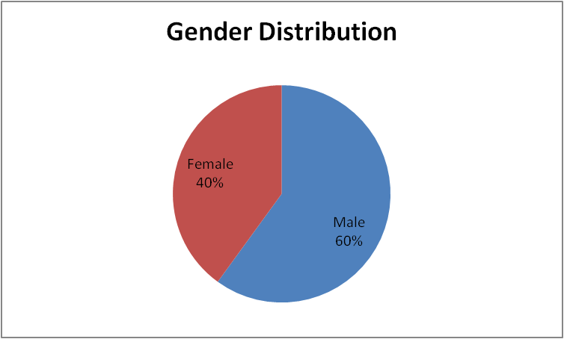
Fig 1: Gender distribution
Table 4.2.2: Age Group of Respondents
Age Group | Frequency | Percentage
18-25 | 20 | 22.2%
26-35 | 35 | 38.9%
36-45 | 25 | 27.8%
46 and above | 10 | 11.1%
Total | 90 | 100.0%
Source: Field Survey, 2025
The age distribution reveals that the majority of respondents fall within the 26–35 age group (38.9%), followed by those aged 36–45 (27.8%). Respondents within the 18–25 age bracket make up 22.2%, while only 11.1% are aged 46 and above. This shows that rental issues and property engagements are largely dealt with by a youthful to middle-aged population in Ikeja. The dominance of the economically active age group (26–45) highlights that this demographic is most affected by rental variations in both residential and commercial properties.
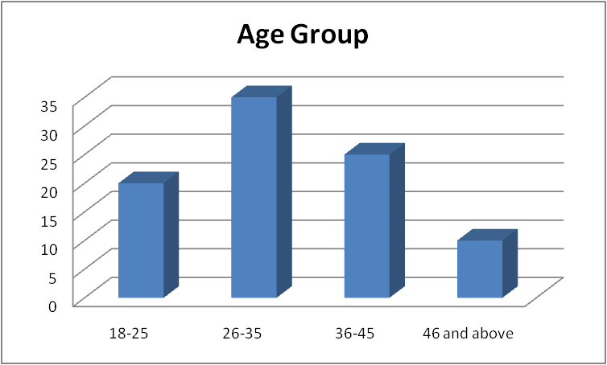
Fig 2: Age group
Table 4.2.3: Type of Property Occupied/Managed
Property Type | Frequency | Percentage
Residential | 50 | 55.6%
Commercial | 30 | 33.3%
Both | 10 | 11.1%
Total | 90 | 100.0%
Source: Field Survey, 2025
According to Table 4.2.3, 55.6% of respondents occupy or manage residential properties, while 33.3% are involved with commercial spaces. Only 11.1% reported engaging in both residential and commercial property usage. This suggests that the issue of rental variation is more prevalent or observable in the residential sector within Ikeja. The presence of commercial property respondents, however, confirms that business operators are also significantly impacted by fluctuating rental rates.
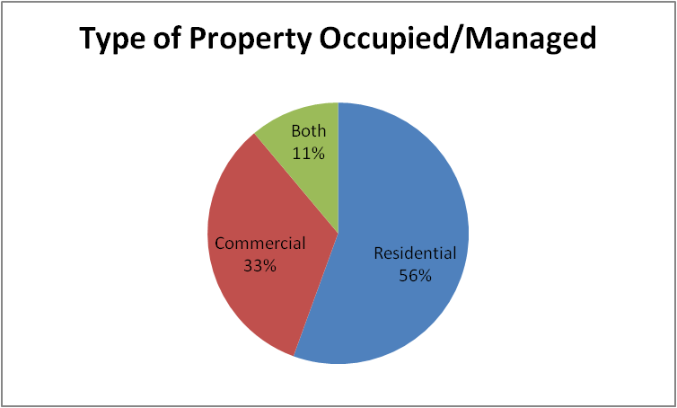
Fig 3: Type of property occupied
Table 4.2.4: Status of Respondents
Respondent type | Frequency | Percentage
Tenant | 45 | 50.0%
Landlord/property owner | 20 | 22.2%
Estate agent | 10 | 11.1%
Business operator | 15 | 16.7%
Total | 90 | 100.0%
Source: Field Survey, 2025
From the data, tenants make up the largest group of respondents (50%), followed by landlords/property owners (22.2%), business operators (16.7%), and estate agents (11.1%). This composition indicates that the study captures a balanced view from different stakeholders in the rental market. Tenants’ majority status emphasizes that the study is grounded in the experiences of those directly bearing the impact of rental variations. Estate agents and landlords, although fewer, provide crucial insights into the determinants of rental pricing, while business operators give a commercial perspective.
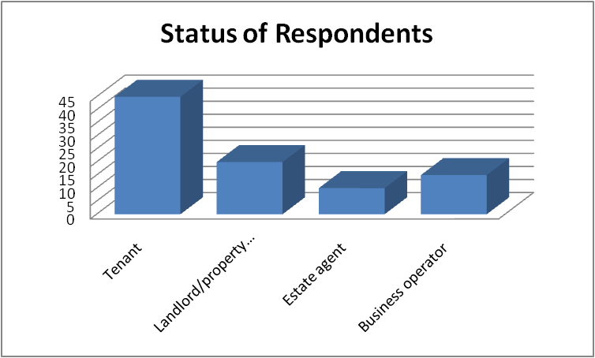
Fig 4: Status of Respondent
Table 4.2.5: Duration of Stay/Operation in Ikeja
Duration | Frequency | Percentage
Less than 1 year | 10 | 11.1%
1-3years | 30 | 33.3%
4-6 years | 25 | 27.8%
More than 6 years | 25 | 27.8%
Total | 90 | 100.0%
Source: Field Survey, 2025
A significant number of respondents have resided or operated in Ikeja for between 1–3 years (33.3%), followed by equal proportions who have stayed for 4–6 years and more than 6 years (27.8% each). Only 11.1% have lived or operated there for less than one year. This spread indicates that most respondents have had long enough exposure to accurately report on rental trends and their implications in the area. The high representation of long-term residents/business operators strengthens the credibility of insights gathered regarding infrastructural changes and rent variations over time.
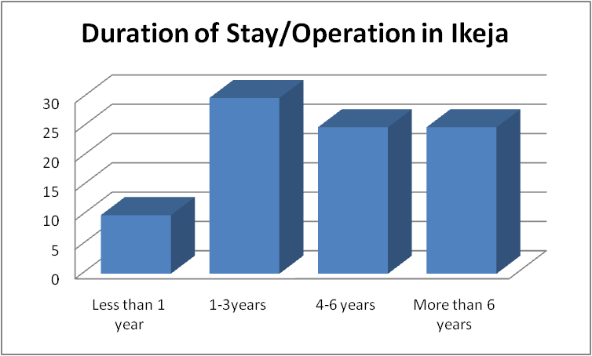
Fig 5: Duration of stay
Table 4.2.6: Factors Affecting Rent Levels in Ikeja
Factors | Frequency | Percentage
Location | 30 | 33.3%
Property type | 10 | 11.1%
Accessibility/road network | 20 | 22.2%
Security | 15 | 16.7%
Demand and supply | 15 | 16.7%
Total | 90 | 100.0%
Source: Field Survey, 2025
This table shows that locationis the most significant factor contributing to rent variation in Ikeja, with 33.3% of respondents agreeing. Accessibility/road network follows at 22.2%, showing how infrastructural ease affects rent decisions. Security and demand/supply dynamics each received 16.7%, indicating moderate influence. Surprisingly, property type was the least important factor (11.1%), suggesting that where a property is located is more influential than its physical features.
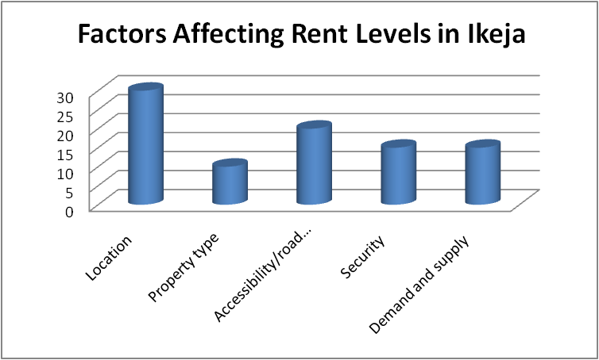
Fig 6: Factors affecting rent level
Table 4.2.7: Frequency of Rental Price Changes
Change Frequency | Frequency | Percentage
Monthly | 15 | 16.7%
Quarterly | 25 | 27.8%
Yearly | 30 | 33.3%
Rarely | 20 | 22.2%
Total | 90 | 100.0%
Source: Field Survey, 2025
The majority of respondents (33.3%) noted that rental prices change on a yearly basis, suggesting periodic adjustments by landlords. Quarterly changes (27.8%) indicate relatively frequent reviews in some areas, possibly commercial zones. A small number (16.7%) observe monthly changes, which may reflect volatile areas or properties under flexible lease agreements. 22.2% claimed that rent rarely changes, indicating stability in certain neighborhoods or long-standing tenancy agreements.
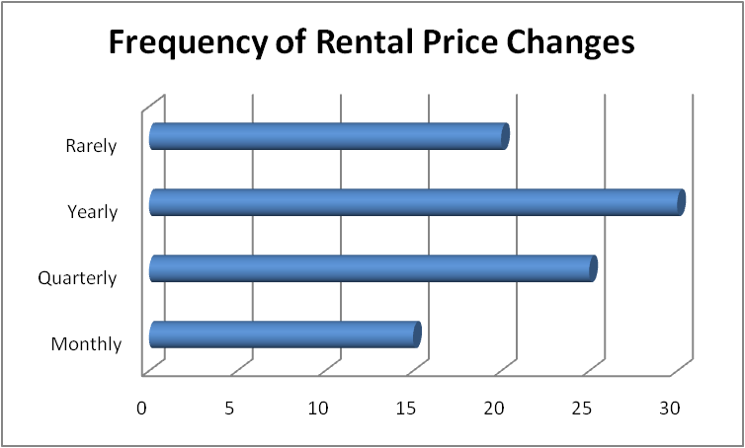
Fig 8: Perception of inflation
Table 4.2.8: Perception of Inflation’s Effect on Rental Prices
Response | Frequency | Percentage
Yes | 60 | 66.7%
No | 10 | 11.1%
Not sure | 20 | 22.2%
Total | 90 | 100.0%
Source: Field Survey, 2025
A significant 66.7% of respondents believe that inflation impacts rental prices, confirming that macroeconomic factors trickle down to property values. Only 11.1% disagree, while 22.2% remain uncertain, suggesting a knowledge gap among some respondents. This result supports the idea that economic trends like inflation are key drivers of rent hikes. It also aligns with the study objective analyzing economic influence on rent variation.
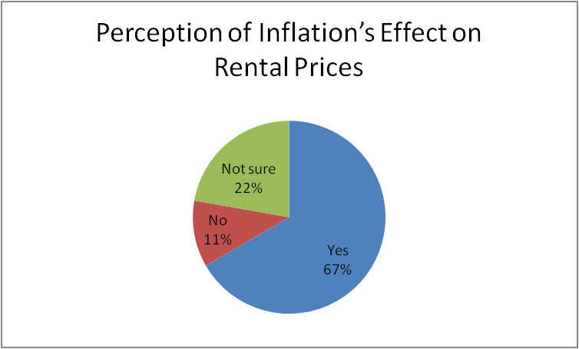
Fig 8: perception of inflation’s effect on rental prices
Table 4.2.9: Influence of Market Demand on Rent
Rating | Frequency | Percentage
Very high | 25 | 27.8%
High | 30 | 33.3%
Moderate | 20 | 22.2%
Low | 10 | 11.1%
Very low | 5 | 5.6%
Total | 90 | 100.0%
Source: Field Survey, 2025
A combined 61.1% of respondents believe market demand has either a high or very high impact on rent, reinforcing demand as a strong influencer. 22.2% rated it as moderate, suggesting varied experiences depending on neighborhood or property type. Those who rated it low or very low (16.7%) may be in low-traffic or economically depressed areas. The data underscores market demand as a relevant factor in determining rental pricing in Ikeja.
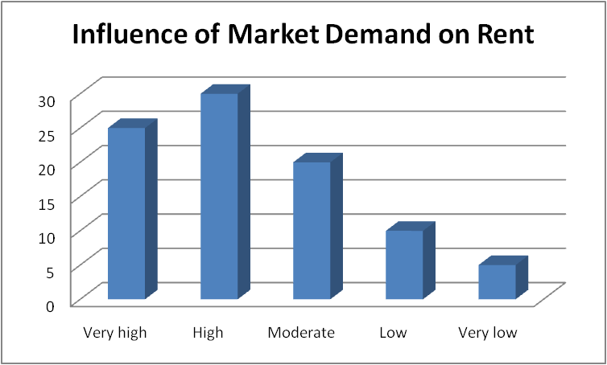
Fig 10: influence of market demand on rent
Table 4.2.10: Experience of Rent Increase in the Past Year
Response | Frequency | Percentage
Yes | 70 | 77.8%
No | 20 | 22.2%
Total | 90 | 100.0%
Source: Field Survey, 2025
An overwhelming 77.8%of respondents experienced a rent increase in the past year, highlighting a widespread trend in rising property costs. Only 22.2% did not experience such changes, showing that rent hikes are more of a norm than an exception. This further confirms concerns about rental affordability in the study area. It also suggests economic or infrastructural triggers driving rent up.
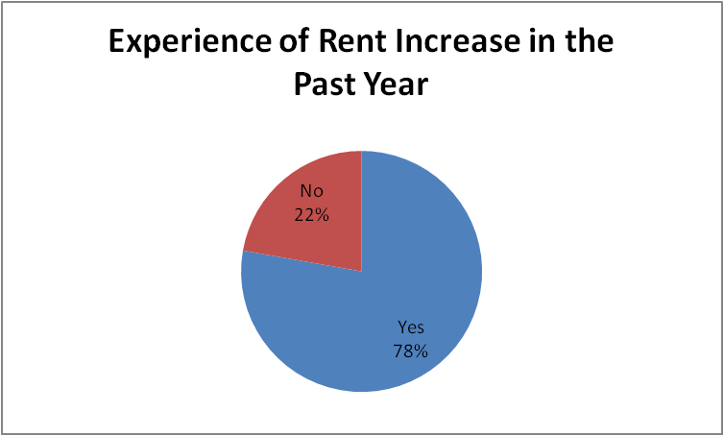
Fig 11: Experience of rent increase in the past year

Table 4.2.11: Percentage increase in Rent
Increase Range | Frequency | Percentage
Less than 0% | 20 | 22.2%
10-20% | 30 | 33.3%
21-30% | 10 | 11.1%
Over 30% | 10 | 11.1%
Total | 90 | 100.0%
Source: Field Survey, 2025
Among those affected by rent hikes, the most common increase range was 10–20%, affecting one-third of respondents. Increases below 10% were reported by 22.2%, while 11.1% each experienced sharp rises between 21–30% and over 30%. These results reveal that while moderate hikes are common, some tenants face significant increases. The findings point to economic strain, especially for lower-income renters or small businesses.
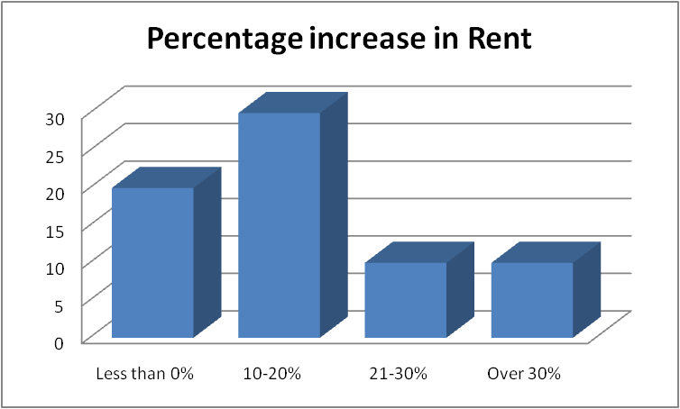
Fig 11: Percentage increase in rent
Table 4.2.12: Rating of Infrastructure Quality
Rating | Frequency | Percentage
Excellent | 5 | 5.6%
Good | 25 | 27.8%
Fair | 35 | 38.9%
Poor | 25 | 27.8%
Total | 90 | 100.0%
Source: Field Survey, 2025
A majority of respondents (38.9%) rated the infrastructure in their area as "fair," while an equal percentage (27.8%) believed it to be "good" or "poor." Only a small fraction (5.6%) rated the infrastructure as excellent. This distribution suggests that while some improvements may have occurred, much of Ikeja still struggles with inadequate infrastructure. The prevalence of "fair" and "poor" ratings highlights the need for targeted infrastructural upgrades to improve living and business conditions and potentially stabilize rental prices.
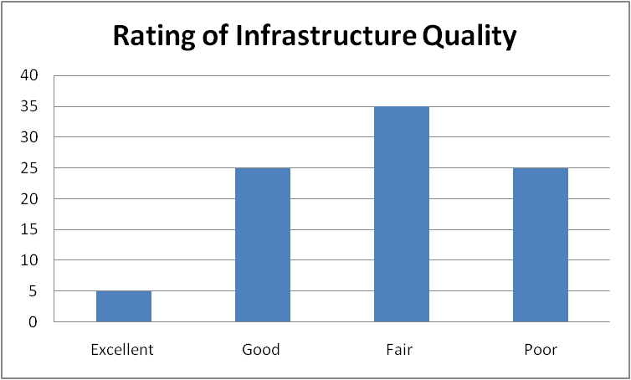
Fig 13: Rating of infrastrucure quality
Table 4.2.13: Effect of Infrastructure on Rent
Response | Frequency | Percentage
Yes | 55 | 61.1%
No | 15 | 16.7%
Not sure | 20 | 22.2%
Total | 90 | 100.0%
Source: Field Survey, 2025
A large percentage of respondents (61.1%) agree that infrastructural developments have led to rental increases in Ikeja. This confirms the role of public and private investment in enhancing property value and influencing rent. The 22.2% who are unsure may reflect tenants not directly aware of policy or infrastructural changes. Meanwhile, the 16.7% who believe infrastructure does not impact rent may reside in areas where development has been minimal or stagnant.
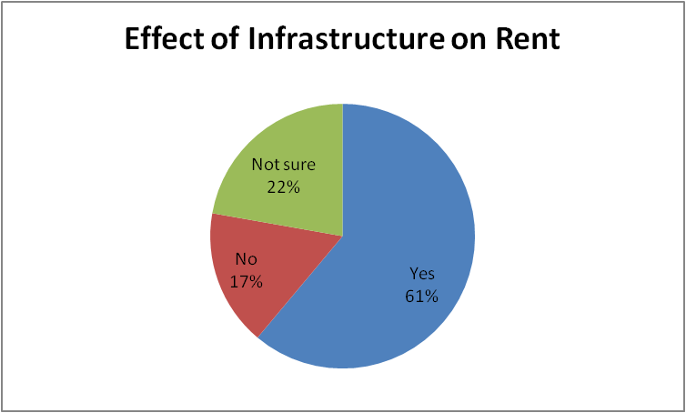
Fig 13: Effect of infrastructure rent
Table 4.2.14: Most Influential Infrastructure
Facility | Frequency | Percentage
Road network | 30 | 33.3%
Electricity | 20 | 22.2%
Drainage system | 10 | 11.1%
Security infrastructure | 15 | 16.7%
Proximity to public transport | 15 | 16.7%
Total | 90 | 100.0%
Source: Field Survey, 2025
"Road network" emerged as the most influential infrastructure factor, as reported by 33.3% of respondents. This is consistent with the understanding that well-paved, accessible roads attract higher rents due to convenience and connectivity. Electricity ranked next at 22.2%, emphasizing its critical role in both residential comfort and business operations. Security and proximity to transport each accounted for 16.7%, indicating their shared influence on rental value, especially in commercial settings. Drainage systems, though important, ranked lowest, possibly due to their less visible impact on daily living unless flooding occurs.
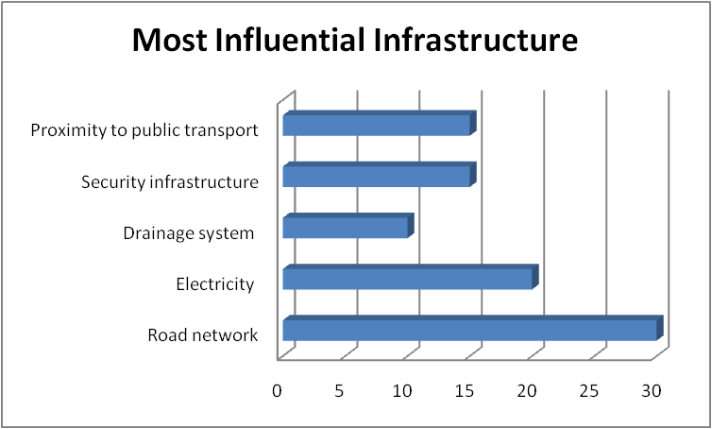
Fig 15:Most influential infrastructure
Table 4.2.15: Top Considerations When Choosing Property
Consideration | Frequency | Percentage
Rent price | 25 | 27.8%
Location | 30 | 33.3%
Security | 15 | 16.7%
Proximity to work/school | 10 | 11.1%
Parking space | 10 | 11.1%
Total | 90 | 100.0%
Source: Field Survey, 2025
Locationis the top priority for 33.3% of respondents when selecting a property, reaffirming its role as a major determinant of rent variation in Ikeja. Rent price is next (27.8%), indicating that affordability is still a critical concern. Security also ranks notably (16.7%), highlighting growing awareness of personal and property safety. The lower emphasis on proximity to work/school and parking space may indicate that while desirable, they are secondary to broader concerns like cost and location.
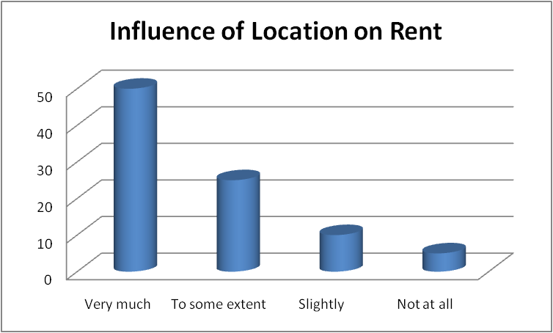
Fig 16: Influence of location on rent
Table 4.2.16: Influence of Location on Rent
Influence Level | Frequency | Percentage
Very much | 50 | 55.6%
To some extent | 25 | 27.8%
Slightly | 10 | 11.1%
Not at all | 5 | 5.6%
Total | 90 | 100.0%
Source: Field Survey, 2025
A strong majority of respondents (55.6%) stated that location influences rental prices very much, reinforcing the earlier findings that link desirable locations to higher rents. Another 27.8% agreed to a moderate extent, which shows widespread acknowledgment of the location-rent connection. Only a small percentage (5.6%) said location has no impact at all, suggesting they may reside in uniform areas where prices are standard regardless of place. This supports the objective examining the role of location dynamics in rent disparities.

Fig 18: Effect of rent variation on living/business
Table 4.2.17: Effect of Rent Variation on Living/Business
Effect | Frequency | Percentage
Positively | 20 | 22.2%
Negatively | 50 | 55.6%
No effect | 20 | 22.2%
Total | 90 | 100.0%
Source: Field Survey, 2025
A majority (55.6%) report that rent variation has had a negative effect on their living or business conditions, showing that rising rents are putting pressure on households and businesses alike. Only 22.2% report no effect, possibly due to stable lease terms or subsidies. Another 22.2% claim a positive effect, which may stem from increased property values benefiting landlords. The results indicate rent increases can lead to significant socio-economic challenges for residents and small business operators.
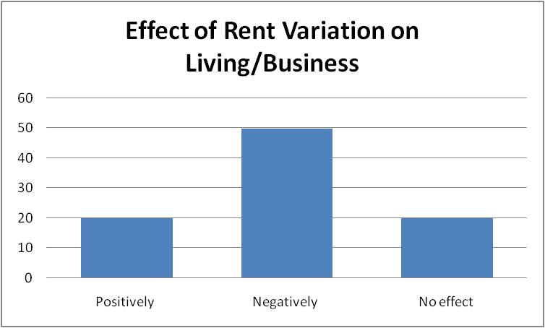
Fig 18: effect of rent/variation on living/business
4.2 Discussion of Findings
The findings from the field survey provide comprehensive insights into the dynamics of rental variation in Ikeja and its multifaceted impacts. One key observation is the dominance of male respondents (60%), which may reflect broader societal structures where males are more likely to be landlords, agents, or business decision-makers. However, the female representation (40%) ensures the inclusion of diverse perspectives in understanding the rental landscape.
The age distribution highlights that the economically active age groups (26–45 years) dominate property rental and management in Ikeja. This underscores that rental market concerns are mostly borne by individuals in their prime working years, which directly ties rental issues to economic productivity and household stability. Furthermore, the prominence of residential property involvement (55.6%) suggests that rental variation is more pressing for private households than commercial entities, although commercial respondents (33.3%) still present notable influence.
The distribution of respondent roles—tenants (50%), landlords (22.2%), business operators (16.7%), and estate agents (11.1%)—demonstrates that the rental market in Ikeja is largely tenant-driven, and thus, any rental variation directly affects a significant portion of the population. Most respondents (61.1%) have resided or operated in Ikeja for over three years, lending credibility to their responses and ensuring that observed changes in rent are based on lived experiences rather than short-term fluctuations.
In examining factors affecting rental levels, location (33.3%) and accessibility/road network (22.2%) emerged as the most critical determinants. This aligns with established real estate principles where proximity to central infrastructure and amenities significantly influences property value. Interestingly, property type had minimal influence (11.1%), suggesting that demand is driven more by where the property is than what it is. This is further confirmed by the finding that location was also the top consideration for tenants when choosing a property and that 55.6% of respondents rated its influence on rent as “very much.”
The frequency of rent changes shows that a majority of respondents (33.3%) experienced annual rent reviews, while others reported quarterly (27.8%) and even monthly (16.7%) changes. This suggests a moderately volatile rental environment, particularly for commercial property users. Additionally, a significant number (77.8%) reported rent increases in the past year, with most facing hikes between 10–20%, though some experienced increases above 30%, reflecting inflationary pressures and economic instability.
The role of inflation and market demand in driving rent increases was affirmed by 66.7% and 61.1% of respondents respectively. This aligns with macroeconomic expectations where rising costs of living and increased demand for urban housing drive property prices upward. Similarly, the data revealed that infrastructure—particularly road networks (33.3%) and electricity (22.2%)—significantly influences rent. Respondents overwhelmingly agreed (61.1%) that infrastructure developments have led to higher rental prices, further highlighting the link between public investment and property market behavior.
Moreover, the majority of respondents (55.6%) believed that rent variation has negatively affected their living or business conditions. This underscores the socio-economic consequences of inconsistent or excessive rental pricing, including potential displacement, financial strain, and reduced business competitiveness. Although a small group (22.2%) noted positive effects, likely landlords benefiting from increased returns, the data suggest that the overall effect on residents and small business operators is largely adverse.

CHAPTER FIVE
SUMMARY OF FINDINGS, CONCLUSION AND RECOMMENDATIONS
5.1 Summary of Findings
This study investigated the influence of infrastructural development and other contributing factors on rental variation in Ikeja, Lagos State. The findings are based on data collected from tenants, landlords, estate agents, and business operators.
Gender and Age Distribution: The study revealed that 60% of the respondents were male and 40% were female. Most respondents fell within the economically active age brackets of 26–45 years, suggesting that rental concerns in Ikeja predominantly affect the youth and middle-aged population who are either renting for residential or business purposes.
Property Types and Respondent Status: A significant proportion of respondents (55.6%) occupied residential properties, followed by commercial property users (33.3%). Tenants made up the majority (50%), showing that rent variations directly affect the renting population more than other stakeholder groups.
Duration of Stay: The majority of respondents had lived or operated in Ikeja for over one year, with 33.3% staying 1–3 years and 27.8% each staying 4–6 years and above 6 years. This indicates that most respondents were experienced enough to provide informed responses regarding rental changes
Key Factors Affecting Rent: Location emerged as the most critical factor influencing rent (33.3%), followed by accessibility/road network (22.2%), security (16.7%), and demand and supply (16.7%). Surprisingly, property type had the least impact (11.1%)
Rental Price Trends: The study found that rental prices mostly change yearly (33.3%) or quarterly (27.8%), while 22.2% observed rare changes. Monthly changes were less common (16.7%), indicating relatively moderate but regular adjustments in rent.
Economic Influence on Rent: A majority (66.7%) of respondents believed inflation significantly impacts rental prices, and 61.1% confirmed that infrastructure developments have caused rental increases. This emphasizes the role of macroeconomic conditions and physical infrastructure in determining rent levels.
Market Demand and Rent Hike Experience: Over 60% of respondents rated the influence of market demand on rent as high or very high, and 77.8% experienced a rent increase in the past year. The most common rent hike was in the 10–20% range.
Infrastructure and Its Impact: Most respondents rated infrastructure in Ikeja as either fair (38.9%) or poor (27.8%), yet they still acknowledged its strong influence on rent, especially road networks (33.3%) and electricity (22.2%).
Tenants' Considerations and Location Influence: Location (33.3%) and rent price (27.8%) were top considerations for choosing property. Furthermore, 55.6% stated that location influences rent "very much."
Impact of Rent Variation: More than half (55.6%) indicated that rent variation negatively affected their standard of living or business performance, suggesting socioeconomic strain due to rising property costs.
5.2 Conclusion
The findings of this study conclude that rental variations in Ikeja, Lagos State, are primarily driven by infrastructural development, location, inflation, and market demand. A significant number of respondents agreed that the quality and availability of infrastructure such as road networks, electricity, and proximity to public transport play a key role in determining rental rates. Similarly, the influence of economic factors like inflation and high market demand has led to consistent rental increases, especially in well-connected and commercially vibrant areas. These increases are more commonly felt by tenants who make up the majority of the rental market and are directly affected by changes in rent policies and property values.
Moreover, the study reveals that rent hikes have had largely negative effects on both residents and business operators in the area, contributing to financial strain, relocation challenges, and in some cases, disruption in business operations. Although a few respondents viewed the rent increase positively, especially property owners who benefit from rising values, the broader implication shows that affordability is a growing concern. Therefore, while infrastructural development can raise property value and attract investments, there is a pressing need for policy interventions that ensure equitable access to housing and commercial spaces, especially for low- and middle-income earners.
5.3 Recommendations
At the end of this study, following recommendations are made:
- Government should implement rent control policies to reduce excessive rental increases in Ikeja.
- Infrastructure development should be evenly distributed to reduce rent disparities across different areas.
- Landlords should be regulated to ensure fair and periodic rental increment practices.
- Housing authorities should monitor inflation effects on rent and adjust policies accordingly.
- Government should subsidize housing projects to make accommodation more affordable for low-income earners.
- Stakeholders should educate tenants on their rights concerning rent increments and tenancy agreements.
- Estate agents should operate under a registered body to ensure transparency in rent negotiations.

References
Adelaja, M. O. (2023). Affordable housing and income segmentation in Lagos property markets. Lagos Real Estate Journal, 8(2), 71–85.
Adelake, T. A. (2023). Rental value dynamics in Nigerian urban real estate: A case of Ikeja, Lagos. Journal of Housing Economics and Policy, 11(1), 45–60.
Ademiluyi, I. A., & Raji, B. A. (2008). Public and private developers as agents in urban housing delivery in Sub-Saharan Africa: The situation in Lagos State. Human Geography Journal, 3(2), 75–92.
Ademiluyi, I. A., & Raji, B. A. (2008). Urbanization and housing development in Nigeria: Issues and challenges. Journal of Geography and Regional Planning, 1(1), 1–8.
Ademiluyi, I. A., Louis, M. O., & Raji, B. A. (2008). Urban growth and housing problems in Nigeria. Journal of Human Ecology, 23(3), 193–200.
Adewale, O. J., & Olorunfemi, T. A. (2022). Infrastructure development and urban transformation in Lagos: A planning perspective. Journal of Urban and Regional Studies, 10(1), 33–49.
Agboola, T. (1998). Urban housing policy and its relationship with housing development in Nigeria. Urban and Regional Planning Review, 1(1), 40–52.
Agboola, T. (1998). Urban housing policy and its relationship with housing production in Nigeria. Nigerian Journal of Housing, 5(1), 15–24.
Agboola, T. (2008). Housing and sustainable urban development in Nigeria: The policy challenge. Journal of Environmental Studies, 4(2), 1–17.
Ajanlekoko, J. S. (2001). Sustainable housing development in Nigeria – The financial and infrastructural implication. International Conference on Spatial Information for Sustainable Development, Nairobi, Kenya.
Ajande, S. B. (2001). Environmental issues and property values in Nigerian cities. Journal of Environmental Studies, 2(1), 58–66.
Ajande, S. B., & Kukuku, D. A. (2001). Gentrification and rental price escalation in Nigerian urban centers. Nigerian Journal of Urban Development, 3(2), 44–55.
Alagola, T. (1990s). Infrastructural development and property values in Lagos. Journal of Property Research, 5(1), 25–38.
Aluko, B. T. (2011). The dynamics of rental values in commercial properties in Lagos Metropolis. Journal of African Real Estate Research, 3(1), 28–41.
Aluko, B. T. (2011). The effects of location and neighbourhood attributes on housing values in metropolitan Lagos. Ethiopian Journal of Environmental Studies and Management, 4(2), 69–82.
Aluko, B. T. (2011). The effects of location and neighbourhood attributes on rental values of residential properties in Lagos Metropolis. Ethiopian Journal of Environmental Studies and Management, 4(2), 87–96.
Dada, S. A., & Shokunbi, T. A. (2021). Smart housing systems and rental market response in urban Lagos. Nigerian Journal of Built Environment, 9(3), 102–117.
Ebenji, F. E. (2003). Real estate valuation: Principles and practice. Ibadan: Spectrum Books Ltd.
Ekanem, V. I. (2021). Residential property pricing and tenant behavior in Lagos State. African Journal of Urban Development, 12(4), 87–99.
Fabi, A. (2006). Cultural perceptions and property preferences in urban Nigeria. Journal of Sociology and Urban Planning, 6(2), 55–68.
Fabi, R. A. (2006). Commercial property development in Lagos: The case of Computer Village, Ikeja. Nigerian Journal of Real Estate Research, 1(2), 45–56.
Fabiyi, O. (2006). Infrastructure and urban development in Nigeria: The impact on rental values. Urban Studies Review, 3(1), 91–104.
Hachanle Koko, P. (2001). Commercial property layout and business efficiency. Nigerian Journal of Architecture and Design, 4(1), 33–42.
Kola, A. M. (1998). Urbanization and low-income housing in Nigeria. Journal of Environmental and Urban Studies, 2(1), 73–81.
Obasi, R. C. (2021). Commercial property rental trends in Ikeja: Drivers and implications. Nigerian Journal of Real Estate Research, 7(2), 44–60.
Okonkwo, P. J. (2019). The tenant-landlord relationship and rent control policies in Lagos State. Journal of African Housing Studies, 6(1), 33–48.
Olayiwola, L. M., Adeleye, O. A., & Ogunshakin, L. (2006). Effects of housing policy on residential property development in metropolitan Lagos. International Journal of Housing Policy, 6(3), 275–292.
Olayiwola, L. M., Adeleye, O. A., & Ogunshakin, L. O. (2006). Public housing delivery in Nigeria: Problems and challenges. World Congress on Housing Transforming Housing Environments through the Design, 1(1), 1–8.
Olayiwola, L. M., Akinbamijo, O. B., & Olaleye, A. O. (2017). Determinants of commercial property values in Nigerian cities. Journal of Sustainable Development in Africa, 19(4), 115–127.
Oluwole, A. T. (2023). Landlord behavior and rental pricing in Nigerian cities: A policy outlook. Journal of Urban Economics and Housing, 13(1), 60–75.
Oni, A. O., & Ajibola, M. O. (2010). Effects of property investment on residential property values in Nigeria: An empirical study. Journal of Property Investment & Finance, 28(3), 254–272.
Oni, A. O., & Ajibola, M. O. (2010). Effects of accessibility and neighborhood characteristics on the rental values of residential properties in Lagos Metropolis. Journal of Sustainable Development, 3(2), 210–220.
Oni, A. O., & Ajibola, M. O. (2010). Effects of tenants’ protection laws on rental values in Lagos Metropolis, Nigeria. Journal of African Real Estate Research, 2(1), 39–53.
Oni, A. O., & Olayinka, I. A., & Yusuf, O. A. (2017). Urban land use regulations and residential rental values in Lagos State. International Journal of Law and Built Environment, 9(2), 112–130.
Oni, A. O., Otegbulu, A. C., & Alabi, A. O. (2017). An empirical study of the impact of government policies on rental housing affordability in Nigeria. International Journal of Housing Policy, 17(2), 265–284.
Onyeka, F. C. (2020). Urbanization and its impact on land use in South-West Nigeria. Journal of African Development Studies, 8(3), 109–123.
Oyebanji, A. O. (2003). Principles of land use economics. Ibadan: Integrity Publishers.
Oyebanji, A. O. (2013). Real estate investment and development in Nigeria: Challenges and prospects. Lagos Journal of Housing and Urban Studies, 4(1), 24–37.
Oyebanji, A. O. (2022). Policy interventions and the stabilization of rental markets in Nigeria. Nigerian Journal of Economic and Real Estate Policy, 11(2), 95–108.
Ukoje, J. E., & Kanu, K. C. (2014). Urban expansion and land use change in the Federal Capital Territory of Nigeria. Journal of Geography and Regional Planning, 7(1), 18–24.
Ukoje, J. E., & Kanu, K. C. (2014). Urbanization and housing challenges in Nigeria: A case study of Abuja Metropolis. Journal of Geography and Regional Planning, 7(4), 76–84.
Ukoje, J. E., & Kanu, K. I. (2014). The effects of inflation and income disparity on housing demand in Abuja, Nigeria. Journal of Contemporary Urban Research, 5(3), 87–101.

QUESTIONNAIRE
KWARA STATE POLYTECHNIC, ILORIN
INSTITUTE OF ENVIRONMENTAL STUDIES
DEPARTMENT OF ESTATE MANAGEMENT AND VALUATION
This questionnaire is designed to collect data for a research study titled “The Effect of Rental Variation in Residential and Commercial Property in Nigeria: A Case Study of Ikeja Local Government Area, Lagos State.” The purpose of this study is to examine the factors influencing rental changes, the impact of economic and infrastructural developments, and how rental disparities affect residents and businesses in Ikeja.
Your honest and accurate responses will be treated with the utmost confidentiality and used strictly for academic purposes. Kindly take a few minutes to complete this questionnaire. There are no right or wrong answers—your personal experiences and opinions are what matter most.
Thank you for your valuable time and contribution.
Section A: Respondent’s Personal Information
- Gender: (a) Male () (b) Female ()
- Age: (a) 18-25 () (b) 26-35 () () 36-45 () (d) 46 and above ()
- Type of property occupied/managed: (a) Residential () (b) Commercial () (c) Both ()
- Are you a: (a) Tenant () (b) Landlord/Property Owner () (c) Estate Agent () (d) Business Operator ()
- Duration of stay or operation in Ikeja: (a) Less than 1 year () (b) 1-3 year () (c) 4-6 years () (d) more than 6 years ()
Section B: Factors contributing to rental Variation
- In your opinion, what are the major factors affecting rent levels in Ikeja? (a) Location () (b) Property Type () (c) Accessibility/Road Network () (d) Security () (e) Demand and Supply ()
- How often do you notice changes in rental prices in your area? (a) Monthly () (b) Quarterly () (c) Yearly () (d) Rarely ()
Section C: Economic Trends and Market Demand
- Do you believe inflation has an effect on rental prices in Ikeja? (a) Yes () (b) No (c) Not sure ()
- How significant is market demand in driving rental increases in Ikeja? (a) very high () (b) High () © Moderate () (d) Low () (e) very low ()
- In the past year, have you experienced an increase in your rent? (a) Yes () (b) No ()
- If yes, by what percentage? (a) Less than 10% () (b) 10-20% () (c) 21-30% () (d) over 30% ()
Section D: Infrastructure and Rental Pricing
12. how would you rate the quality of infrastructure (e.g roads, electricity, water) in your area? (a) Excellent () (b) Good () (c) Fair () (d) Poor ()
13. do you think recent infrastructural developments (e.g new roads, drainage, power supply) have led to a rise in rental prices? (a) Yes () (b) No () (c) Not sure ()
14. Which infrastructural facility do you think most influences rent prices in Ikeja? (a) Road network () (b) Electricity () (c) Drainage system () (d) Secrutiy infrastructure () (e) Proximity to public transportation ()
Section E: Tenant Preferences and Location Dynamics
- What are your top three considerations when choosing a residential or commercial property? (a) Rent price () (b) Location () (c) Security () (d) Proximity to work/school () (e)Parkign Space ()
- How much do you think location influences rental prices in Ikeja? (a) very much () (b) to some extent ()(c) Slightly () (d) Not at all ()
Section F: Socio-Economic Implications of Rental Disparities
- How has rent variation affected your living or business conditions? (a) Positively () (b) Negatively () (c) No effect
- Have rental hikes ever forced you to relocate your home or business within Ikeja? (a) Yes () (b) No
- What challenges do you face due to high rent in Ikeja? (a) Financial Burden () (b) Limited Savings () (c) Reduced Business Profit () (d) Difficulty in maintaining standard living () others ()

