

KWARASTATEPOLYTECHNIC,ILORIN.
INSTITUTEOFTECHNOLOGY

CONSTRUCTIONOFAWOODENSUSPENDEDGROUNDFLOORFOR
EDUCATIONAL PURPOSES

SAHEED MARIAM ENIOLA
ND/23/CEC/PT/0259

A PROJECT SUBMITTED IN PARTIAL FULFILMENT OF THE REQUIREMENTFORTHEAWARDOFNATIONALDIPLOMA(ND)

INDEPARTMENTOFCIVILENGINEERING,SCHOOLOFENGINEERING STUDIES. KWARA STATE POLYTECHNIC,
INSTITUTE OF TECNONOGY, ILORIN,KWARASTATE,NIGERIA

2025.

CERTIFICATION
ThisistocertifythatthisprojectreportwrittenbySAHEEDMARYAMENIOLA,presentedto the department of Civil Engineering, The Kwara State Polytechnic Ilorin was supervised and approved to have met the condition necessary for the award of national diploma in civil engineering of the polytechnic.

…………………………………………….. ………………………. ENGR. M.F RAJI DATE
SUPERVISOR

…………………………………………….. ………………………. ENGR.SANNI ABUBAKAR DATE
HEADOFDEPARTMENT

DEDICATION
This project is dedicated to Almighty God for his goodness and kindness and who through his merciesat all times madeall things possiblegranted. This projectis also dedicated toour parents, MR and MRS SAHEED for their immeasurable, moral, financial and educational support in all aspect within human capacity throughout my educational career. Many thanks to my able supervisor MRS M.F RAJI for her endless assistance and support, May Almighty God be with you and grant you every of your heart desires.

ACKNOWLEDGEMENT
With total reverence, I return all the glory, honor and adoration to ALMIGHTY GOD, the beginning and the end of whatever I make out of life, the giver of knowledge, wisdom and understanding, for his loving kindness in all the spheres of my live. More so, I am eternally grateful to my parents especially my irreplaceable mum for the care and support, even in the hardest time of my life. It is only ALMIGHTY GOD that can reward you.
My sincere appreciation goes to my supervisor Mrs. RAJI MUJIDAT for her guidance, patience, corrections, advises and unwavering supports and efforts. I shall ever remain in debt to him for his painstaking guidance, constructive approach, clear philosophy, forbearance and frequent encouragement right from the commencement of this research to its end. I wish to express my sincerethankstomyHODENGR SANNIABUBAKAR,forhisfatherlyadviceserve aswordof encouragement during my stay in campus, i appreciate the kindness.
My deepest gratitude goes to all other academic and non-academic staff of thedepartment of Civil Engineering, ENGR MRS MARIAM, ENGR LABAEKA, ENGR ADAM. ENGR VICTOR, ENGR DANIEL, ENGR SANNI and my school mother IYA IBEJI CIVIL for their continuous support throughout my undergraduate academic sojourn.

Abstract
This project report encapsulates the meticulous design, construction, and assessment of a560mm by 915mm suspended ground floor (SGF), specifically engineered as a teaching aid. Implemented within the precincts of the Concrete Laboratory in the Civil Engineering Department of Kwara State Polytechnic, Ilorin, this SGF serves as an educational model for students to comprehend the principles and applications of structural engineering. The development process of this SGF was underpinned by stringent standards and thorough evaluations of materials. The sand used in the concrete mix underwent a sieve analysis,revealing a fineness modulus of 2.69, signifying its particle size distribution and suitability for the intended purpose. Moreover, the work ability of the concrete mix was assessed via the slump test,conductedtwice,resultinginvalues of35mm and38mm,indicatingoptimalconsistency and structural integrity. The construction of the SGF was carried out with precision, adhering to the designated dimensions and structural requirements. Supported by two main supports strategically positioned to ensure stability and load-bearing capacity, this suspended floor epitomizes the practical application of theoretical concepts in civil engineering. The project report delves into a comprehensive exploration of the methodologies employed, emphasizing the significance of the sieve analysis and slump tests in ascertaining material quality and the work ability of the concrete mixture. It elucidates the engineering specifications and design considerations that governed the SGF's development, detailing the rationale behind the chosen dimensions and support placements. Additionally, the report not only highlights the success of the project but also underscores challenges encountered and their solutions, offering a robust foundation for potential improvements in future similar endeavors. The construction of SGF stands as a testament to the synergy of theoretical knowledge and practical application, serving as an invaluable educational resource for the Civil Engineering Department, fostering a deeper understanding of structural principles among students.

TABLEOFCONTENT
Page No
Titlepage i

Coverpage ii
Certification iii
Dedication iv
Acknowledgment v
Abstract vi
Tableof Contents vii
Listof Figures viii
Listof Plates ix
CHAPTERONE
Introduction 1
Primarybenefitsof asuspendedgroundfloor 1
Thechoice ofmaterialsfora suspended groundfloor 2
Aimandobjectivesofthestudy 3
Scopeofthestudy 3
Significanceofthe study 4
Operationaldefinition 4
CHAPTERTWO
literaturereview 5
HistoricalBackground 5
MaterialSelection 6
VentilationandMoisture Control: 11
hermalInsulation 14
UsableSpaceand DesignFlexibility 14
EnvironmentalImpact 15
ResearchGap 16
CHAPTERTHREE:
Methodology 18
Introduction 18
ConstructionProcurement 18
Materials 20
DesignandLayout 21
ConstructionProcedure 24
CHAPTERFOUR
ResultsandDiscussion 26
SuspendedGround Floor 26
CHAPTERFIVE
Conclusionsandrecommendations 27
Conclusions 27
: Recommendations 27
References 28

LISTOF PLATE
Page no
Plate3.1:Softwoodused forformwork 19
Plate3.2:Plywoodforsuspendedfloor 20
Plate4.1:Suspendedgroundfloorwithtwosupports 26

LISTOF FIGURES
Page no
Figure3.1:Designofthesuspendedgroundfloor 21
Figure3.2:ParacotforTreatment 25

CHAPTERONE

INTRODUCTION

In a building, the surfaces which divide a building into different levels or storey are known as floors. The floor above the ground level is called ground floor, whereas the floor constructed below ground level is known as basement floor.Any floor above the ground level, except the terrace or roof of a building is known as upper or suspended floor. The ground floor is laidover the joists, with floorboards the most widely used in houses built (Daerga et al; 2012)
A suspended floor is a ground floor construction method used widely in houses built intheearly-mid20thcentury.Suspendedfloorswerepopularintheearlytomid-1900sbecause theyrequiredfewerfoundationsandwerewellsuitedtobuildingmanyhousesquickly. Suspendedfloorsareconstructedusingsupportedjoistsbelowthefloorcovering(e.g. floorboards),withavoidbetweenthegroundbelowandthegroundfloor.Thistypeof constructionallowsbuilderstolaylevelfloorsevenwhenthegroundbelowisuneven.When properly constructed, the void stops damp becoming a problem by ventilating the space belowthefloor (Bernieretal; 2010).Thereareseveraldifferenttypes ofsuspendedfloors.Themost common are timber joists supported below by short loading-bearing walls (aka ‘Sleeper walls’)Asuspendedfloorletsgivesroomforadry,levelfloorwithoutpouringaconcretebase.The ground floor is always the floor at ground level, no matter the construction. A suspended floor is agroundfloorconstructedbyfittingjoists(usuallysupportedonsmall,lowwallsbeneaththe floor) and then installing the floor on top (Birchall et al; 2011)
Suspended ground floor construction is a widely utilized technique in modern civil engineering, architectureandbuildingdesign.Itinvolvescreatingafloorstructurethatappearstofloatabove

the ground, supported by columns, beams, or other load-bearing elements. This method offers several advantages in terms of aesthetics, functionality, and structural integrity.

Primary BenefitsofaSuspendedGroundFloor

One of the primary benefits of a suspended ground floor is its ability to create a sense of openness and lightness in a space. By elevating the floor, architects can incorporate various design elements, such as large windows or skylights, to maximize natural light penetration. This not only enhances the visual appeal of the interior but also contributes to energy efficiency by reducing the need for artificial lighting during the daytime (Beaumont 2007).
Structurally, a suspended ground floor offers advantages as well. This construction technique allows for better utilization of space beneath the floor, making it possible to incorporate services like plumbing and electrical systems without encroaching on valuable interior space. It also facilitates easier maintenance and repairs of these systems.

TheChoiceofMaterialsforaSuspendedGround Floor

The choice of materials for a suspended ground floor is crucial to ensure both durability and safety. Commonly used materials include reinforced concrete, steel, and composite materials. Reinforced concrete is often preferred due to its excellent load-bearing capabilities and fire resistance. Steel, on the other hand, offers the advantage of being lightweight yet strong, making it suitable for creating large open spans without excessive columns.
To design an effective suspended ground floor, structural engineers consider factors such as load distribution, deflection, and vibration control. The loads exerted on the floor, including deadloads(permanentloadsliketheflooritself)andliveloads(temporaryloadslikefurniture

and occupants), must be carefully calculated to determine the appropriate size and spacing of supporting elements.
Proper construction methodsare essentialto ensure the stability and safetyof a suspended ground floor. Skilled professionals follow precise procedures to erect load-bearing elements, such as columnsand beams,ensuring that theyaresecurely anchored to thefoundation. Quality control measures during construction play a vital role in preventing issues like uneven settling, which could lead to structural instability over time.
While the advantages of suspended ground floors are numerous, there are also considerations that need to be taken into account. Adequate insulation and soundproofing mustbe addressed to prevent heat loss and noise transmission, especially if the space below the flooris used for habitation. Additionally, the cost of materials, construction, and maintenance should becarefullyevaluated,assuspendedgroundfloorconstructioncansometimesbemoreexpensive than traditional methods.
Suspendedgroundfloorconstructionoffersablendofaestheticappeal,functionaladvantages, and structural integrity. Its ability to create open, well-lit spaces while accommodating services and systems below the floor makes it a popular choice in modern architecture. When properly designed and constructed, suspended ground floors can contribute to the overall efficiency,safety, and visual impact of a building. As the architectural landscape continues to evolve, this construction technique is likely to remain a valuable tool in the handsof innovative designersand engineers.

AIMAND OBJECTIVESOFTHESTUDY

The aim of this project is to construct a wooden suspended ground floor for an educational facility. The objectives are:

- To construct a prototype suspended ground level with admixture of plastic in concrete mixture
- Toensure the wooden floor serve as educational activities, such as workshops, lectures, and collaborative learning.

SCOPEOFTHESTUDY

- Material Selection: Source high-quality, sustainable, and durable wood materials suitable forconstructingthesuspendedfloor.Materialsthatareenvironmentallyfriendlyandhave a long lifespan are prioritize
- Construction: Execute the construction process, ensuring proper installation of the wooden floor system, including joists, and sub flooring. Attentions were given to safety measures and quality control throughout the construction phase.
- Environmental Considerations: Implementation of sustainable construction practices,such as recycling materials (Plastic) and exploring energy-efficient design options.

SIGNIFICANCEOFTHESTUDY
There are several reasons why using suspended ground levels made of timber in educational contexts is justified. The wooden suspended ground floor will provide a unique and dynamic space for educational activities, fostering creativity, collaboration, and engagement among studentsandeducators.Theconstructionofawoodensuspendedgroundfloorforeducational purposes presents an exciting opportunity to create a functional, safe, and sustainable space thatsupportstheeducationalgoalsoftheinstitution.Thisprojectalignswithmodern

construction practices, environmental responsibility, and a focus on enhancing the learningexperience for students and educators.

OPERATIONALDEFINITION

Theseterminologies provideasolidfoundationforunderstandingandeffectivelycommunicating the concepts and processes involved in the construction of a wooden suspended ground floor in an educational project write-up
- Suspended Ground Floor: A floor construction technique where the floor appears to "float" above the ground, supported by columns, beams, or other load-bearing elements, creating space underneath for utilities and services.
- Subfloor: The base layer of the suspended wooden floor system, often made of plywood or oriented strand board (OSB), providing a stable foundation for the finished flooring.
- Timber:Thisisatermusedtodescribethewoodencomponentsusedinbuilding,frequently in the shape of beams, joists, or planks.
- Floorcovering:Thesubstancethatprovidesthewalkingsurfaceandcoversthejoists.This could be wood planks, plywood, or other materials inthe case of a suspended ground floor made of timber.

CHAPTERTWO

LITERATUREREVIEW

The construction of suspended ground levels, also known as raised floors or elevated platforms, is a technique used in various building applications to create a higher floor level above the ground or existing foundation. This approach offers several advantages, such as improved insulation,enhanced ventilation,and increased usable space. In this literaturereview, we explore the key aspects and considerations associated with the construction of suspended ground levels.

HistoricalBackground:

The historical background of suspended ground floors showcases the ingenuity and adaptability of different civilizations in addressing practical challenges related to flooding, moisture, and environmental conditions. From ancient raised platforms designed to protect against floods to modern architectural feats that emphasize aesthetics and functionality, the concept of elevated living spaces continues to evolve while retaining its core principles. Suspended ground floors remain a testament to the enduring human ability to innovate in response to the ever-changing demands of the built environment. The concept of suspended ground levels dates back to ancient architecture where raised platforms were constructed for various purposes, including protection againstflooding,improvedventilation,andenhancedthermal insulation.In modernconstruction, this technique is applied across residential, commercial, and industrial settings to address similar concerns and achieve functional and aesthetic benefits. The historical background of suspended ground floors, also referred to as raised floors or elevated platforms, can be traced back toancientcivilizationswhereinnovativeconstructiontechniques weredevelopedtoaddressvarious practical and environmental challenges. The concept of raising living spaces above the ground levelhasbeenusedforcenturiesindifferentculturesaroundtheworld.Whilethespecific

methodsandmaterialsvaried,theunderlyingprinciplesofcreatingelevatedspacesremain consistent.
AncientCivilizations:

- Mesopotamia: In Mesopotamia, one of the earliest known civilizations, people builtraised platforms using sun-dried mudbricks toelevate their dwellings above flood levels. The elevated structures helped protect against seasonal flooding of the Tigris and Euphrates rivers.
- Egypt: Ancient Egyptians constructed elevated platforms known as "tumuli" or "tell" to protect their structures from the Nile River's annual inundation. They built houses on artificial mounds made of mud brick or stone rubble to keep them above water levels during flood seasons.
AncientAsia:

- China: In ancient China, homes were often built on raised wooden platforms to protect them from dampness and pests. These platforms provided ventilation and allowed for storage beneath the living spaces.
- Japan: Traditional Japanese architecture incorporated raised wooden floors known as "tatami" platforms. These platforms served multiple purposes, including thermal insulation, protection from moisture, and a distinct separation between indoor andoutdoor spaces.
IndigenousArchitecture:
1.Stilt Houses: Indigenous cultures in various parts of the world, such as Southeast AsiaandtheAmericas,havehistoricallybuiltstilthouses.Thesestructuresaresupportedby

wooden stilts or pillars, keeping the living spaces elevated above the ground to mitigate flooding and pests.
MedievalEurope:

1.CastleKeeps:MedievalEuropeancastlesoftenfeaturedelevatedfloorstoserve defensive and practical purposes. Raised floors provided protection against invaders, while the space beneath the floors was used for storage and shelter.
Modern Applications:

- Industrial Revolution: With the advent of modern construction materials and techniques, the use of suspended ground floors evolved. Steel, reinforced concrete, and other advanced materials allowed for the creation of more sophisticated elevated structures in urban and industrial settings.
- Contemporary Architecture: In modern architecture, elevated floors are used for various purposes beyond practicality, including aesthetic design, optimizing views, and integrating sustainable features. Suspended floors have become a common element in contemporary buildings, both residential and commercial, around the world.
- Suspended Ground Floors in Modern Construction: In modern construction, suspended ground floors are used to address issues such as flooding, moisture, and ventilation. They offer solutions for buildings located in flood-prone areas, where raising the living space above potential water levels is essential for safety and protection of property. Additionally, elevated floors can enhance energy efficiency by providing improved thermal insulation and reducing heat transfer between the interior and the ground.

StructuralConsiderations

The construction of suspended ground levels requires careful attention to structural integrity and load-bearing capacity. Research by Ahmed et al. (2018) emphasizes the importance of analyzing the load distribution, using appropriate materials, and ensuring proper foundation support to prevent structural failures. The construction of suspended ground floors, also known as elevated platforms or raised floors, requires careful attention to various structural considerations toensure safety, stability, and long-term performance. The structural considerations involved in the construction of suspended ground floors are multi-faceted and require a comprehensive understanding of load analysis, material properties, foundation engineering, joint design, and compliance with regulations. The integration of advanced analysis tools, such as computer simulationsandfinite elementanalysis,enhances theprecisionof design.The reviewedliterature underscores the significance of these considerations in ensuring the safety, stability, and durability of buildings with suspended ground floors (Ahmed et al. (2018)

LoadDistributionandAnalysis:

Load distribution is a critical factor in the design of suspended ground floors. Research by Ahmed et al. (2018) emphasizes the importance of conducting comprehensive load analysis, considering both dead loads (self-weight of the structure) and live loads (occupant loads, furniture, etc.). Finite element analysis (FEA) and computer simulations are commonly usedtoolsto assess load distribution and predict structural behavior under different loading scenarios.

FoundationSupport:

Thefoundationsystem plays acrucialroleinprovidingadequatesupportfor suspended ground floors.StudiesbyJohnsonandWilliams(2018)emphasizethatthefoundationmustbe

designed to withstand vertical and lateral loads while preventing settlement and instability. Proper foundation design ensures that the weight of the structure is effectively transferred tothe soil beneath.

Material Selection

The choice of materials significantly impacts the durability and performance of suspendedground levels. According to studies by Shipworth et al. (2019), the selection of materials such as steel, concrete, and engineered wood plays acrucial role inproviding adequate strength, stability, and resistance to environmental factors like moisture and pests.The selection of appropriate materialsisacrucialaspectofconstructingsuspendedgroundfloors,ensuringstructuralintegrity, durability, and performance over time.

Concrete:

Concrete is a widely used material in the construction of suspended ground floors due to its high compressive strength and versatility. Research by Shipworth et al. (2019) highlights the benefits of reinforced concrete beams and slabs, which offer load-bearing capacity and resistance to deflection. Different types of concrete, including lightweight and high-performance variants, have been investigated to optimize the balance between strength and weight.

StructuralSteel:

Structural steel is favoured for its high tensile strength and flexibility in construction. Studies by Ahmed et al. (2018) emphasize the suitability of steel beams and columns in creating open floor plans and providing long spans. Steel's strength-to-weight ratio is advantageous in minimizing the size of structural elements while maintaining stability.

EngineeredWood Products:

Engineered wood products, such as laminated veneer lumber (LVL) and glulam beams, offer an environmentally friendly alternative with consistent strength properties. Research by Pelsmakers etal. (2017)discusses howengineered wood canbeused effectively forsuspended groundfloors, providing strength and stability while contributing to sustainability goals.

MasonryandMasonryBlocks:

In specific applications, masonry materials like concreteblocks or bricks areused tocreate walls and support structures for suspended ground floors. Studies by Green Building Council (2021) emphasize the importance of proper bonding and grouting techniques to ensure load transfer and stability in masonry-based designs.

Composite Materials:

Compositematerials, which combinetheadvantages of different materials, have gained attention for suspended ground floor construction.Johnson and Williams (2018) discuss the use of composite materials like fiber-reinforced polymers (FRPs) for added strength, durability, and resistance to corrosion.

MoistureandPest Resistance:

One critical consideration in material selection is resistance to moisture and pests. Brown and White (2020) underline the significance of choosing materials that are inherently resistant to moisture or that can be treated to prevent rot and decay. This is especially important for suspended ground floors, which may be exposed to moisture from the ground.

EnvironmentalImpactandSustainability:

Sustainable material selection is gaining prominence in modern construction. Lee et al; (2019) discuss the evaluation of materials based on their life cycle assessment, considering factors such as resource extraction, manufacturing, transportation, use, and end-of-life disposal. Sustainable materials contribute to reduced environmental impact and align with green building principles.

Cost Considerations:

Cost-effectiveness is a significant aspect of material selection. Studies by various researchers emphasize the importance of balancing material performance and cost to achieve an optimal solution for the specific project. Material selection for the construction of suspended ground floors involves careful consideration of factors such as strength, durability, moisture resistance, sustainability, and cost. The choice of materials directly influences the structural performance, longevity, and overall success of the project. Research in this field underscores the need for a holistic approach to material selection, integrating engineering principles, environmental concerns,andeconomicfactorstocreatesafeanddurablesuspendedgroundfloorstructures(Lee et al;2019).

VentilationandMoistureControl:

Suspended ground levels can offer improved ventilation and moisture control compared to traditional ground-level construction. Research by Brown and White (2020) highlights that proper design considerations, such as incorporating ventilation openings and moisture barriers, are essential to prevent the accumulation of moisture and the potential for mold growth. The construction of suspended ground levels, also known as raised floors or elevated platforms, requires careful attention to ventilation and moisture control to ensure the longevity and performance of the structure.

VentilationStrategies:

Ventilation is crucial in suspended ground level construction to prevent moisture accumulation, mitigate mold growth, and maintain indoor air quality. Research by Ahmed et al. (2018) highlightsthesignificanceof designingappropriateventilationopenings,such asventsandcrawl space vents, to allow air circulation beneath the raised floor. Adequate ventilation helps reduce humidity levels and prevents the buildup of stagnant air.

MoistureBarriersandVapor Retarders:

To control moisture from the ground, moisture barriers and vapor retarders are essential components. Studies by Brown and White (2020) emphasize the use of materials such as polyethylene sheets or moisture-resistant membranes to create an effective barrier between the ground and the suspended floor. These barriers prevent soil moisture from seeping into the building's structure.

CrawlSpaceEncapsulation:

Crawl space encapsulation involves sealing and conditioning the space beneath suspended ground levels to prevent moisture intrusion. Research by Shipworth et al. (2019) discusses the benefits of encapsulation, including the use of vapor barriers, dehumidifiers, and insulation, to create a controlled environment that minimizes moisture-related issues.

ElevatedFlooringMaterials:

The choice of flooring materials can impact moisture control. Lee et al;(2019) point out that using materials like ceramic tiles, concrete, or engineered wood with moisture-resistant properties can help prevent water absorption and subsequent damage.

Raised Subfloors:

In some cases, raised subfloors or air gaps between the ground and the flooring are incorporated to enhance ventilation and moisture control. Chen et al. (2017) discuss how raised subfloors can facilitate airflow, reducing the risk of moisture buildup and allowing any moisture present to dissipate more effectively.

IntegratedDrainageSystems:

Effective drainage systems are essential to channel rainwater and prevent water from pooling beneath suspended ground levels. Research by Johnson and Williams (2018) emphasizes the importance of designing proper drainage systems, including downspouts, gutters, and sloped surfaces, to direct water away from the structure.

ComprehensiveDesign:

Moisture control and ventilation strategies should be integrated into the overall design of suspended ground levels. Green Building Council (2021) underscores the need for a holistic approach that considers not only individual components like ventilation openings and moisture barriers but also the building envelope and the surrounding landscape.

MitigatingHealth Risks

Effective moisture control and ventilation have direct implications for indoor air quality and occupanthealth.Ensuring thatsuspendedground levelsareproperly ventilated andmoisture-free reducesthepotentialformoldgrowthandassociatedrespiratoryissues.Theseconsiderationsare

essential for preventing moisture-related problems, ensuring indoor air quality, and maintaining the structural integrity of the building. An integrated approach that combines ventilation strategies, moisture barriers, raised subfloors, and drainage systems contributes to the successful implementation of suspended ground level projects.

ThermalInsulation:

Elevated platforms can contribute to enhanced thermal insulation, leading to energy efficiency benefits. Studies by Chen et al. (2017) indicate that suspended ground levels can reduce heat transfer between the interior and the ground, thus helping maintain a more stable indoor temperature.

UsableSpaceandDesignFlexibility:

Suspended ground levels provide additional usable space that can be utilized for various purposes. Research by Johnson and Williams (2018) suggests that this approach offers design flexibility, enabling architects and builders to create unique spatial configurations while optimizing the functionality of the constructed area.

EnvironmentalImpact:

Sustainableconstruction practices are a growing concern, and suspended ground levels can align with these principles. Research by Green Building Council (2021) indicates that elevated platforms can reduce the need for extensive excavation and minimize disturbance to the natural landscape, contributing to reduced environmental impact. Case studies have demonstrated the successfulimplementationof suspendedground levelsindifferentcontexts.For instance, astudy by Lee and et al;(2019) showcases how suspended ground levels were employed in flood-prone areastomitigatewaterdamageandenhancebuildingresilience.Whilethebenefitsofsuspended

ground levels are evident, challenges remain, including proper drainage design, addressing potential vibration issues, and complying with local buildingcodes. Further research could focus on advanced construction techniques, innovative materials, and the integration of smart technologies to optimize the design and construction processes.

CHAPTERTHREE

MATERIALSAND METHODS

INTRODUCTION:

Constructing a wooden suspended ground level involves several steps to ensure stability, safety, and durability. This methodology outlines the key steps to follow when building a wooden suspended ground level

MATERIALS

Thematerialsusedwereprocuredatilorin The material include;
- Timber: soft wood as shown in Plate 3.1 was used to make the prepare the form work (as shown in plate 3.2) for the suspended ground floor. It was cut in 22 x 36 inches or 560mm x 915mm

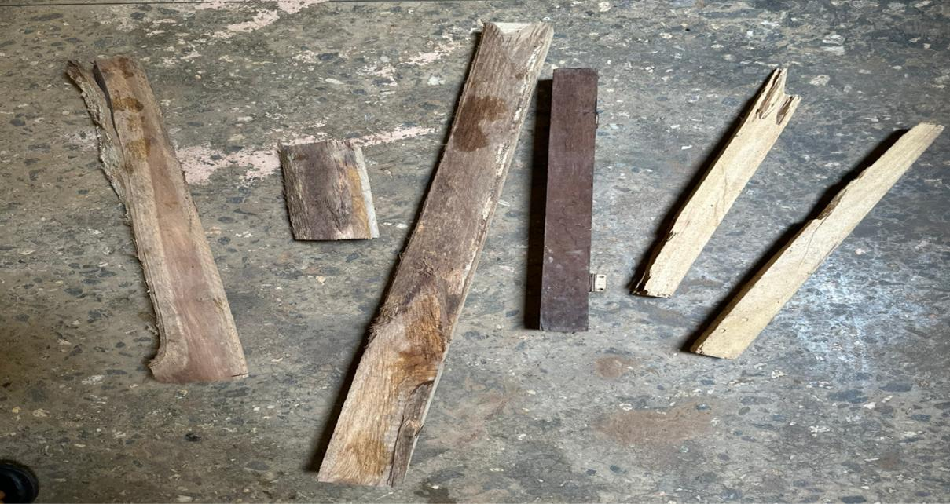

THEIMAGEOFTIMBER(SOFTWOOD)

Fasteners:Nailswereusedforjoiningand securingthewoodencomponents.


THEIMAGEOFNAIL.

- FlooringMaterial:plywoodorcompositeboardsasshowninplate3.3wasusedasthe material that served as walking surface of the suspended ground level
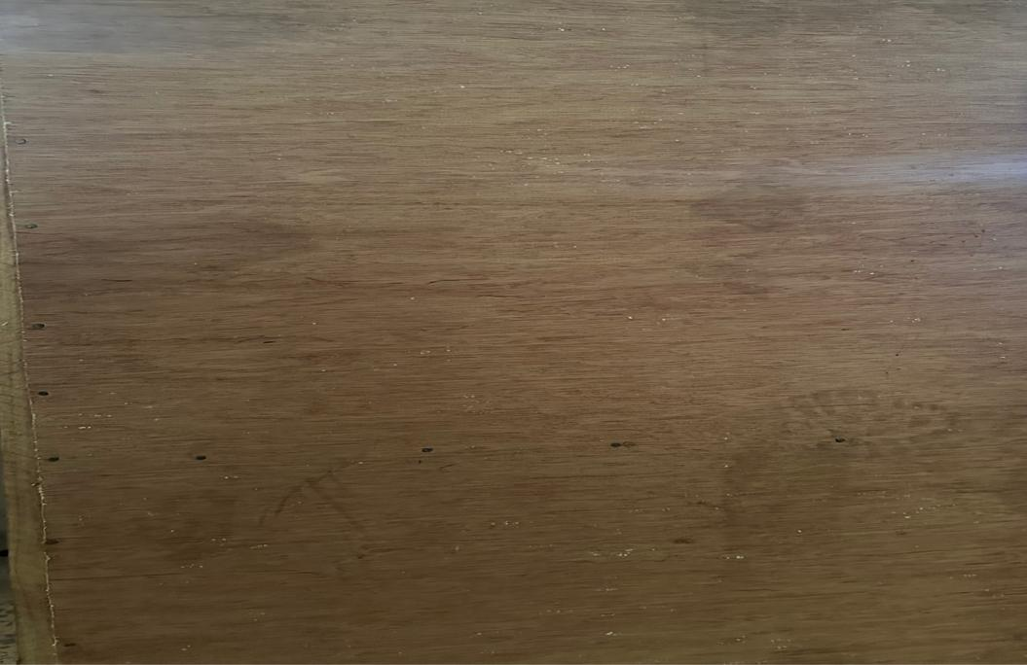

Plate3.2: Plywoodforsuspendedfloor

- SafetyEquipment:Includeanypersonalprotectiveequipment(PPE)necessaryfortheconstruction process, such as helmets, safety glasses, gloves, and harnesses.
- Tools:Thesearethetoolsrequiredfortheconstruction,suchassaws,nail,hammers,measuring tapes.


THEIMAGEOFHAMMER,SAW,MENSURING TAPE.

DESIGNANDCONSTRUCTIONPROCESS

DesignandPlanning:

ThedesignofthesuspendedgroundfloorisdrawnupasShowninFigure3.1,takinginto account the dimensions required (560mm by 915mm)
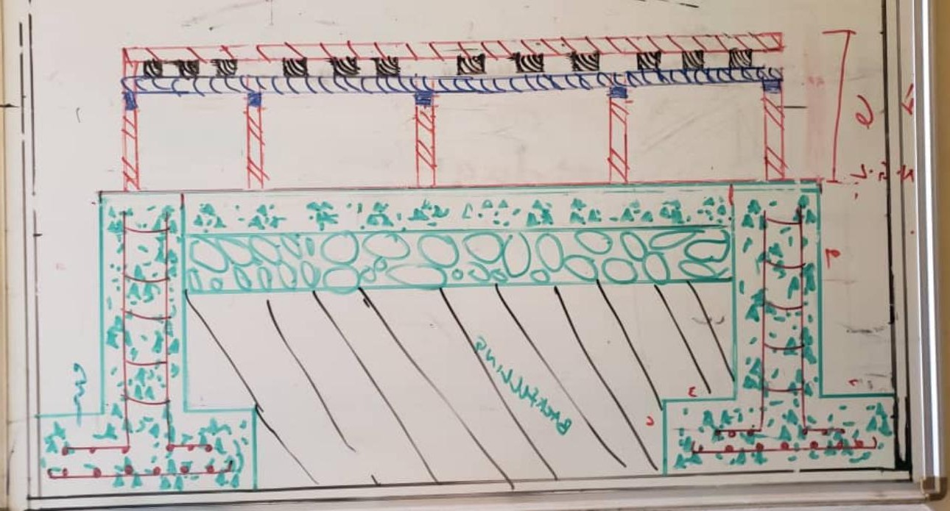

Figure3.1:Designofthesuspendedgroundfloor 3.5.CONSTRUCTION PROCEDURE

Thefollowingprocedureweredeployedtoachievethestatedobjective
      - Theprototype boxwas constructedwithdimensionof36mmby22mm.
      - Beforethemixingof materialsfoundationfootingwasconstructed.
      - Blockfoundationwaserected usingconcrete(batching,mixing, curing)

      - Casting&Compactionwascarriedoutimmediatelyafterthemixingof the material.
      - Theblockwork wasdemoulded after 48hours.
      - Thedemolded foundationswasplaced carefullyintotheprototypebox

      - Backfillingtookplace withtheusage offine aggregate(sand)
      - Hardcorewasplacedimmediatelyafterbackfilling
      - Oversiteconcretewasconstructedabovethehardcorewhichservesasthesolid ground floor.
      - Sleeper wall was constructed immidiately after the groundfloor to support the flloorjoist, floor board and wall plate
      - DPCwas laidimmediatelyafterthesleeperwalltoprevent moisture rising.
      - Wallplateis usedtoprepareastable basefor thefloorjoist
      - Floorjoistitwas usedtocreate alayerthatthefloorboardwillreston

      - Thenfloor boardis laid
      - Thefinishingtoucheswere made(polish,brush,thinner,etc..)
      - Treatment;Thisisusedtopreventthegrowthofvegetativematter.

CHAPTERFOUR
RESULTSANDDISCUSSIONS

SUSPENDEDGROUNDFLOOR
As shown in plate 4.1, the suspended was constructed with two supports and it was done in 560mmby915mm.itwasplacedatConcreteLaboratoryatcivilengineeringdepartment.The parts of the Suspended Ground floor are labelled from 1-10.

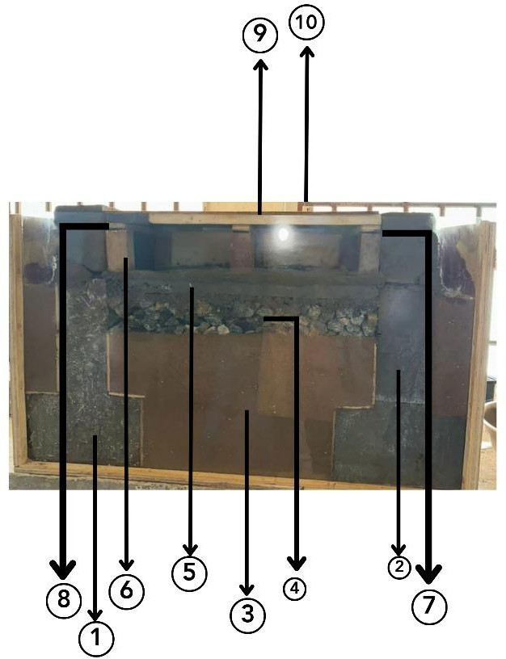

Plate 4.1: Suspended ground floor with two supports Thesearetherepresentationsof1-10labelledinPlate4.1
I
- Foundationfooting;
- block wall: Blockwall are structures containing standard concrete blocks that can ta shapes and sizes .
kevarious
- Backfilling:Thisisaprocessofreplacingorreusingthesoilthatisremoveduringbuilding construction to strengthen and support the structure foundation.
- Hardcore:Thisreferstothemassofsolidmaterial usedasabaseforheavyloadbearingstone and concrete floors.
- OversiteConcrete: This is amass ofconcretewhichhelp tosustain weight oflive anddead load in the building.
- Sleeper’s wall :This is a shortwall usedto supportjoists , beam and blockorhollowcore slabsat ground floor .
- DPC : This is a barrier through the structure designed to prevent moisture rising by capillary action such as through a phenomenon known as rising damp .
- FloorJoist:Thisarehorizontalstructuralmemberthatspanandopenspaceoftenbetween beams which transfer the load to vertical structural members.
- wall Plate :This is a horizontal member built into or laid along the top of the wall to support and distribute the pressure from joist .
- FloorBoard:Thisaresupportanddistributionofloadsonbeams.

CHAPTERFIVE
CONCLUSIONSANDRECOMMENDATIONS
CONCLUSION

The construction of the 560mm by 915mm suspended ground floor (SGF) at the Concrete LaboratoryoftheCivilEngineeringDepartment,KwaraStatePolytechnic,Ilorin,istheevidence of the careful design,implementation,and quality control procedures used in its realization.This kind of construction has several benefits such as being very inexpensive,light weight,and having excellent acoustic and thermal insulation qualities. However it is crucial to guarantee that the floor is protected from moisture and pest and that the joist are correctly treated and placed.

5.2. RECOMMENDATIONS

By incorporatingthefollowingrecommendationsintothisreport, willoffer a comprehensive and insightful document detailing the construction process, materials' quality, structural design, and the educational significance of the suspended ground floor within the context of Civil Engineering studies at Kwara State Polytechnic, Ilorin .

REFERENCES
Anderson, B., Chapman, P.F., Cutland, N.G., Dickson, C.M.,Henderson, G., Henderson, J. H., Shorrock, L. D. (2001). BREDEM-12 Model description. Watford: BRE.
Ahned et al (2018) highlights the significance of designing appropriate ventilation openings, such as vents and crawl space vents, to allow air circulation beneath the raised floor.
Beaumont, A. A (2007). W07 – “Housing regeneration and maintenance – Hard to treat homes in England. International conference – Sustainable urban areas, Rotterdam, the Netherlands”pp 24-25
Bernier, P.,Ainger, C.,&Fenner, R.A. (2010). Assessingthe sustainabilitymerits ofretrofitting existing homes. Proceedings of the Institution of Civil Engineers – Engineering Sustainability, 163, 197–207.
Birchall,S.,Pearson,C.,&Brown,R.(2011).SolidWallInsulationFieldTrials–Report BaselinePerformance of the Property Sample. London
Brown&White(2020)emphasistheuseofmaterialssuchpolyethylenesheetsormoisture- resistant membranes to create an effective barrier between the ground and the suspended floor. Chenetal(2017)indicatethatsuspendedgroundlevelscanreduceheattransferbetweenthe interior and the ground, thus helping maintain a more stable indoor temperature.
Daerga P.A., Girhammar U. A.,Källsner B. (2012): “TheMasonite Flexible BuildingSystem for Multi-Storey Timber Buildings. In: 12th World Conference on Timber Engineering.
Green Building Council (2021) indicate that elevated platform can reduce the need for extensive excavation and minimize disturbance to the natural landscape,contributing to reduced environmental impart..

Jonhson&Williams(2018) suggest that this approach offers design flexibility,enabling architects andbuilders to create unique spatial configurations while optimizing the functionality of the constructed area.
Lee, P., Lam, P. T. I., Yik, F. W. H., & Chan, E. H. W. (2019). Probabilistic risk assessment of the energy saving shortfall in energy performance contracting projects – A case study. Energy and Buildings, 66, 353–363.
Pelsmakers,S.,Fitton,R.,Biddulph,P.,Swan,W.,Croxford,B.,Stamp,S.,Elwell,C.A.(2017).
“Heat-flowvariabilityofsuspendedtimbergroundfloors:Implicationsforin-situ heatflux measuring. Energy and Buildings, 138, 396–405.
Shipworth,M.,Firth,S.K.,Gentry,M.I.,Wright,A.J.,Shipworth,D.T.,&Lomas,K.J.(2010). Centralheatingthermostatsettingsandtiming:Buildingdemographics.Building
Research &Information,38,50–69.

