THE CHALLENGES OF STATUTORY VALUATION AMONG REGISTERED ESTATE FIRMS
(A CASE STUDY OF ILORIN METROPOLIS )

BY
ISIAKA JAMIU OLAMILEKAN
HND/23/ETM/FT/0065
SUBMITTED TO
THE DEPARTMENT OF ESTATE MANAGEMENT AND VALUATION INSTITUTE OF ENVIRONMENTAL STUDIES

IN PARTIAL FULFILLMENT OF THE REQUIREMENT FOR THE AWARD OF HIGHER NATIONAL
DIPLOMA (HND) IN ESTATE MANAGEMENT AND VALUATION, KWARA STATE POLYTECHNIC, ILORIN

JUNE, 2025.

CERTIFICATION
This is to certify that the project was an original work carried out by Isiaka Jamiu Olamilekan with matriculation number HND/23/ETM/FT/0065 in estate management & Valuation and has been prepared in accordance with the regulation governing the preparation and presentation of project in Kwara state polytechnic.
______________________________ ______________
ALH. ESV ABDULKAREEM RASHIDAT A. DATE
PROJECT SUPERVISOR


______________________ ______________
ESV. (DR) MRS. N.I UWAEZUOKE DATE
PRPJECT CO-ORDINATOR)

______________________ ______________
ALH. ESV. ABDULKAREEM RASHIDAT A. DATE
HEAD OF THE DEPARTMENT (HOD)


________________________ ________________
ESV. (DR) LUKMAN MUSIBAU DATE
EXTERNAL EXAMINER

ii

DEDICATION
This project is dedicated to Almighty Allah for his love kindness, protection and provision over my life particularly for impacting knowledge in me during the period of my study. All praises and honour unto you.

ACKNOWLEDGEMENT

I give thanks and honour to Almighty Allah for his infinity mercy and protection upon my life.

I really appreciate the motherly advice and guidance of my supervisor Alh ESV AbdulKareem Rashidat A. for her support guidance and encouragement throughout this project work and I also appreciate the staffs and lecturers of estate management and valuation department. i pray that God will grant you length of days and shower this abundance on you all.

My gratitude appreciation also goes to my parent MR& MRS Isiaka for moral and financial support throughout my academic. May Almighty Allah bless you and may you continue to eat the fruit of your labour Insha Allah (Amin).

ABSTRACT
Statutory valuation is defined as the type of valuation where estimate of value of property is guided by the provision of an enabling law, statutes, edicts, decrees and by-law. Hence this project centers and aims to look at what is statutory valuation, its legal implications, challenges faced by Estate surveyors and Valuers in practice, its methods, laws, enactments and statutes governing the practice. It has also been observed that the challenges faced in carrying out statutory valuation includes: improper administration of rates and taxes, inadequate review of rates applied to economic trees and crops, lack of awareness. Lastly, the need to tackle all this problems needed to be address by the Nigerian institution of Estate surveyors and Valuers.
The Government should show concern and provide favourable laws that will guide the practice in Ilorin and beyond. It is also recommended that government should amend the laws and make it to be flexible so as to accommodate the personal opinion of estate surveyors so as for them to give their own personal judgement whenever carrying out the practice of statutory valuation. Statutory valuation, a critical aspect of property management and real estate practice, involves determining the value of properties for specific legal purposes, such as taxation, compensation, rating, and acquisition. Despite its importance, estate firms face numerous challenges in conducting statutory valuations, particularly in dynamic urban centers like Ilorin This study investigates the challenges of statutory valuation among registered estate firms in Ilorin Metropolis. Using a combination of primary and secondary data, the research explores key issues such as inadequate access to accurate property data, inconsistent valuation standards, limited professional expertise, and regulatory bottlenecks. Additionally, the study examines the impact of these challenges on the reliability of statutory valuations and the confidence of stakeholders in the valuation process.
The findings reveal that challenges such as poor record-keeping systems, lack of modern valuation tools, and limited enforcement of professional standards significantly hinder the performance of estate firms. Furthermore, inadequate collaboration between firms and regulatory authorities exacerbates the difficulties faced in achieving uniformity and consistency in statutory valuations.
The study concludes by providing recommendations to address these challenges, including the need for improved training programs, adoption of advanced valuation technologies, and stronger regulatory oversight. These measures aim to enhance the efficiency and accuracy of statutory valuation practices, thereby promoting transparency and professionalism in the real estate sector in Ilorin Metropolis.

CHAPTER ONE
  - INTRODUCTION
  - BACKGROUND TO THE STUDY
This chapter contains the statement of problems, research questions, aim and objectives, significance of study, scope of the study and historical background, According to (Kuye, 2020), Valuation is the major discipline of estate surveying profession. It is a recurring decimal on other areas of his specialization such as property management, real estate appraisal, rating and taxation, estate agency and project management. (Ighodalo, 2020), sees statutory valuation as the type of valuation where estimate of value of property is guided by the provision of an enabling laws, statutes, edicts, decrees and by-laws. In this type of valuation, the value depends on his professional judgment in selecting appropriate method of valuation and his input into the valuation is restricted. This include valuation based on rent control edict, compensation code, draw act or taxation laws. Although, all professional in all part of the world are regulated by one of the legislation or the other profession of estates and valuation could therefore not be an exception by still have a great effect on valuation practice in Nigerian most especially the issue of statutory valuation where the valuers are restricted to give their personal judgment.
One major challenge faced by estate surveyors and valuers in Ilorin metropolis specifies the method that should be adopted in determining the value. Section 29 of the land use act of (1979) specify in carrying out valuation for compensation. The Valuer have no right to give his personal judgment without following the various statutes regulating the practice of statutory valuation in Nigeria.
For this reason, the study tried to as much as possible to study all the activities concerning statutory valuation as well as other challenges faced by estate surveyors and valuers in Ilorin metropolis and finding solution for the amendment of the legislation affecting the estate surveyor and valuers in general.
1.2 STATEMENT OF PROBLEM
Statutory valuation is a fundamental aspect of the real estate profession, involving the assessment of property values for legal purposes such as taxation, compensation, compulsory acquisition, and rating. Accurate and reliable statutory valuation is essential for ensuring transparency, fairness, and equity in property-related transactions. However, registered estate firms in Ilorin Metropolis face significant challenges in carrying out these valuations effectively.
One of the major issues is the lack of access to accurate and up-to-date property data, which hampers the precision and reliability of valuations. Inconsistent valuation standards and practices across firms further complicate the process, leading to variations in property values and disputes among stakeholders. Moreover, many estate firms struggle with inadequate professional expertise and limited adoption of modern valuation technologies, which are critical for conducting efficient and accurate assessments.
Regulatory bottlenecks, including weak enforcement of existing laws and policies, also pose significant challenges. These issues undermine the credibility of statutory valuations, leading to delays, disputes, and a lack of confidence among property owners, government agencies, and other stakeholders. Additionally, poor collaboration between estate firms and regulatory authorities exacerbates the problem, making it difficult to achieve consistency and transparency in the valuation process.
Despite the critical role of statutory valuation in property-related decision-making, limited research has been conducted to identify and address these challenges in Ilorin Metropolis. This gap in knowledge has hindered the development of effective solutions to improve valuation practices. Therefore, this study seeks to investigate the challenges faced by registered estate firms in Ilorin Metropolis and provide recommendations to enhance the accuracy, efficiency, and reliability of statutory valuations.
1.3 RESEARCH QUESTION
- What are the perception of stakeholders on statutory valuation?
- What are various methods of carrying out valuation in study area?
- What are the challenges faced in carrying out valuation?

1.4 AIM AND OBJECTIVES
Aim
The aim of this research is to examine the challenges faced in statutory valuation among registered firms with a view to improve on the quality of the valuation practice..

Objectives
The objective s of this study are to:
- Examine the various methods of carrying out valuation in study area
- To ascertain the perception of stakeholders on statutory valuation
- Assess the challenges faced in carrying out valuation
- Make recommendation.
1.5 RESEARCH HYPOTHESIS
H1: There is no method involved in statutory valuation
H1: There is no challenges associated with statutory valuation
1.6 JUSTIFICATION OF THE STUDY OF THE STUDY
The jutification of the study is to examine the challenges associated with statutory valuation among registered Estate Surveyors and Valuers in Ilorin metropolis. The reason for carrying out this research is to help educate Estate Surveyors and Valuers, students and other persons that will go for more research. The usefulness of this research cannot be overemphasized for it will open an avenue through which further research will be carried out.

1.7 SCOPE OF THE STUDY
The scope of this study concentrate on the challenges of statutory valuation among some elected registered estate firms in Ilorin metropolis.
The study is limited to registered estate firms operating within Ilorin Metropolis, which includes major areas such as GRA, Tanke, Post Office, Fate, and Sango. These areas are chosen due to their high concentration of commercial,

Fig 1: Map of Ilorin Metropolis
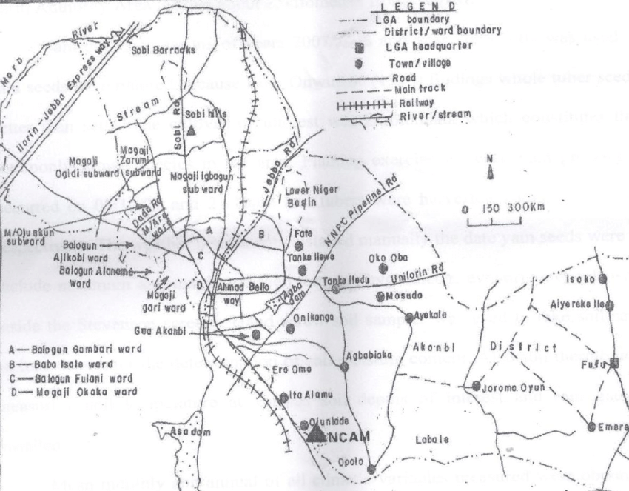
Source:https://www.google.com/search?q=map+of+ilorin+metropolis&rlz=1C1IBEF_enNG972NG972&oq=Map+of+Ilorin+Metropolis&aqs=chrome.0.0i355i512j46i512j0i390i512i650l4j0i512i546l4.15443j0j7&sourceid=chrome&ie=UTF-8#vhid=6q0jOn3b4XBUPM&vssid=l

1.9 LIMITATION OF THE STUDY
The limitations encountered in course of the study includes:
Uncooperative attitude of the respondents in answering certain question which they considered confidential. The difficulty in retrieving questionnaires However, these limitations did not affect the quality of data obtained from the field.

CHAPTER TWO
LITERATURE REVIEW, CONCEPTUAL FRAMEWORK AND THEORETICAL FRAMEWORK
2.0 INTRODUCTION
2.1 LITERATURE REVIEW
(Nwakaji, 2016), Opined that valuers special expertise is to assess the capital or market value of any property at as certain time. Valuation is the basis and attribute discipline of the valuer because the ability to place a monetary values on any interest on land properties.
Valuation is the process of making an estimate or worth of real properties of other assets for a particular purpose. Differently, it is the determination in monetary terms the worth or value at specified date and for special purpose of the property right encompassed in ownership. (Ighodalo, 2013) says valuation is divided into four parts which are as follows:
- Subjective valuation
- Objective valuation
- Statutory valuation
- Non-Statutory valuation
Objective Valuation:This may be defined as an estimate of values of properties based market recent evidence. It entails analyzing recent and relevant transactions of comparable properties to determine the price of rent achieved and then applying the information to estimate the value of subject properties.
This type of valuation has been reasoned to be an objective standard of measuring the standard of properties.
Non-Statutory Valuation:In this type of valuation estimate of property is not tied to any national, state or local laws; the valuer is at liberty to use his professional judgment to estimate the value of the property. This type of valuation includes the following;
- Valuation of purchase
- Valuation for sales
- Insurance valuation
- Mortgage valuation
- Development valuation
- Plan and machinery valuation
Statutory Valuation: is determine by statutes, i.e law e.g valuation for compensation is stated in the LUA.
2.1.1 TYPES OF STATUTORY VALUATION
Definition of statutory valuation
A statutory valuation is made under the provisions of enabling legislation and sets out the requirements under which the valuation is made and includes the purposes for which it may be used. Statutory valuations are used for revenue generation purposes by applicable authorities (e.g. local governments or the Office of State Revenue).
Acquisition And Compensation
Barbier (2019), valuation of compensation for compulsory acquisition of landed properties: the government has under various statutes acquired land and building compulsorily.
The public authority whose acquired the land and building is oblique to pay just compensation the person has been acquired. the amount of the compensation may agreed by the person and the authority. however, if there is agreement ,the valuer generally determines

