EVALUATION OF THE EFFECTIVENESS OF RADIO ADVERTISEMENTS ON FAMILY PLANNING PROGRAMMES (A CASE STUDY OF KWARA STATE POLYTECHNIC, ILORIN)

BY

ORIOWO AYOMIDE EZEKIEL
HND/23/MAC/FT/0466

BEING A RESEARCH SUBMITTED TO THE DEPARTMENT OF MASS COMMUNICATION,INSTITUTE OF INFORMATION AND COMMUNICATION TECHNOLOGY, KWARA STATE POLYTECHNIC

IN PARTIAL FULFILLMENT OF THE REQUIREMENT FOR THE AWARD OF HIGHER NATIONAL DIPLOMA IN MASS COMMUNICATION.

MAY, 2025.

CERTIFICATION
This is to certify that this research work has been completed by Oriowo Ayomide Ezekiel with matric number, HND/23/MAC/FT/0466, read through and approved as meeting the requirement of the Department of Mass Communication, Institute of Information and Communication Technology, Kwara State Polytechnic, Ilorin in fulfillment of the award of Higher National Diploma (HND) in Mass Communication.

_____________________ __________________
MR. OPALEKE E. A. DATE
(Project Supervisor)

_____________________ __________________
MR. OLUFADI AYUBA B. DATE
(Project Coordinator)

_____________________ __________________
MR. OLOHUNGBEBE F.T DATE
(Head of Department)

_____________________ __________________
EXTERNAL SUPERVISOR DATE

DEDICATION
This project work is dedicated to Almighty God for his kindness and mercy over me for sparing my life throughout my academic program and also to my lovely parents for their guidance morally, financially and their spiritual support throughout my studies in Kwara State Polytechnic, Ilorin.

ACKNOWLEDGEMENT
If God does not build the house, the builder build in vain. All thanks and gratitude to Almighty God, the alpha and omega, for he has been so good to me. I also appreciate my wonderful guardian EGNR, DR & MRS. KUDABO for their love and support, they really mean a lot to me.
I also appreciate my H.O.D Mr Fatai Oloungbebe for his guardian and support, he brought out the best in me and he made me know everything about the department of mass communication.
Also to my project supervisor Mr Opaleke E. A, he is indeed a man of integrity. He is brave and intelligent. He frustrated my life from the start not knowing that he intentionally did it because he knew it is something I could do, and today I am so proud of him. May Almighty God should reward him abundantly.(Amen)
I also want to appreciate my friends and colleagues for been their for me.God bless you all. AMEN. and other lecturers in my department in person of Mr. Olufadi, Mr Ibrahim and others, I pray that God will continue to bless you and your family (Amen).

TABLE OF CONTENT
Title page i
Certification ii
Dedication iii
Acknowledgment iv-v
Table of content vi-viii
CHAPTER ONE

1.0 Introduction 1

1.1 Background of the Study 1

1.2 Statement of the Problem 2-3

1.3 Objectives of the Study 4

1.4 Research Questions 4-5

1.5 Significance of the Study 5

1.6 Scope of the Study 5

1.7 Limitations of the Study 6
CHAPTER TWO: LITERATURE REVIEW
2.1 Conceptual Review 11
2.2 Theoretical Framework 11-14
2.3 Empirical Framework 14-15

CHAPTER THREE

3.0 Research Methodology 16

3.1 Research Design 16
3.2 Area of Study 16
3.3 Population of the Study 17
3.4 Sampling Technique and Sample Size 17-18
3.5 Instrument used for Data Collection 18
3.6 Validity of the Instrument 19
3.7 Method of data Collection 19
3.8 Method of Data Analysis 19

3.9 Ethical Considerations 19
CHAPTER FOUR: RESULTS AND DISCUSSION
4.0 Data Analysis 20
4.1 Analysis of research instrument 20
4.2 Analysis of Respondents Demographic 20-28

CHAPTER FIVE: SUMMARY, CONCLUSION AND RECOMMENDATIONS
5.1 Summary 29-31
5.2 Conclusion 31-32
5.3 Recommendation 32-33
Questionnaire 34-35
References 36

CHAPTER ONE

1.0 Introduction

1.1 Background of the Study
Advertising can be traced back to the origin of man. Therefore, it is a phenomenon that has been with the society for a very long time.
Although advertising is so popular, it is difficult to come up with a single and an all embracing definition. However some scholars have proffered some definitions, which will be highlighted in this study.
According to academic’s dictionary of mass communication, compiled by Michael Hoffmann (2007, p.9) “Advertising is a paid form of communication from an identifiable source, designed to persuade the receiver to take some action, now or in the future”.
Throwing more light on this, the dictionary of business and finance captures it as any form of paid public announcement or presentation, which is aimed at the promotion for the sake of goods and services, or at gaining acceptance for any idea or point of view. Okunna (2002, P.99) Jonathan E. Aliede, says in their more recent and widely accepted definition states that, advertising is the non- personal communication of information, usually paid for and usually persuasive in nature about products (goods and services) or ideas by identified sponsors through various media. From the above running background, it is obvious that advertising from all indication is usually the easiest means to reach the target consumer directly. Therefore, advertising enables sponsor to reach a substantial segment of their target audience through various media especially print and electronic.
Family planning is a vital component of public health initiatives, aimed at enhancing maternal and child health, reducing unintended pregnancies, and enabling couples to determine the size and timing of their families. The role of family planning in controlling population growth and improving overall quality of life is especially significant in developing countries like Nigeria, where rapid population growth poses substantial economic and social challenges (Nwachukwu et al., 2020).
In Nigeria, radio has emerged as one of the most accessible and cost-effective media for public health campaigns, particularly in areas where literacy rates are low, and internet access is limited (Akinmoladun et al., 2017). Given its wide reach and relatively low cost, radio advertisements are often used to promote family planning programs in urban and rural settings. However, there has been insufficient research on how effective these radio campaigns are in influencing public awareness, attitudes, and behaviors regarding family planning.
This study seeks to evaluate the effectiveness of radio advertisements in promoting family planning programs in Ilorin Metropolis, Kwara State, Nigeria. The focus will be on understanding how radio advertisements impact knowledge, attitudes, and practices related to family planning among residents of Ilorin.

1.2 Statement of the Problem
Despite the widespread dissemination of family planning messages via radio, the level of impact these messages have on public attitudes and behaviors in Ilorin remains unclear. While some studies suggest that media campaigns, including radio, can influence health behaviors (Lembo et al., 2012), the specific effectiveness of family planning advertisements on radio in Ilorin has not been sufficiently explored. This gap in research hinders a full understanding of how to optimize radio campaigns for better results in the promotion of family planning.
The problem this study addresses is the lack of detailed research on the effectiveness of radio advertisements in Ilorin and how they contribute to awareness, attitude changes, and the use of family planning services.For a very long time, Nigerians have been indifferent to family planning. In some cultures, people’s dignity, prestige and power were reflected on the number of wives and children they had. Nigerian government in the past was also unconcerned about family planning as their basic amenities for their citizenry.
According to Nwankwo (1999, P.15). The major factor resulting in rapid population growth is the fact that many couples who would have wanted to limit the size of their family were discouraged by religious or cultural constraints. There are some religious beliefs that discourage any physical or material interference with the laws of nature or God, as children are believed to be gift from God. Furthermore, culturally Nigerians often say that “it is only God that knows the child that will succeed one”. This saying was as a result of the precarious nature of the health facilities in the past. Then infant mortality rate was high so, in order not to lose the few children one has to measles, cholera, kwashiorkor and other health hazards prevalent then they resulted to having many children thereby throwing the social and economic implication over board. This belief is still in existence till now.

1.3 Objectives of the Study
The objectives of this study are:
- To evaluate the effectiveness of radio advertisements in raising awareness about family planning programs in Ilorin.
- To examine how radio advertisements influence attitudes towards family planning among Ilorin residents.
- To assess whether exposure to radio advertisements leads to increased utilization of family planning services in Ilorin.
- To identify the demographic factors (age, gender, education level, etc.) that may affect the effectiveness of radio advertisements in promoting family planning programs.

1.4 Research Questions
This study will seek to answer the following research questions:
- How effective are radio advertisements in raising awareness about family planning programs in Ilorin?
- What is the impact of radio advertisements on the attitudes of Ilorin residents toward family planning?
- Does exposure to radio advertisements result in increased use of family planning services in Ilorin?
- How do demographic factors (e.g., age, gender, education) affect the effectiveness of radio advertisements in promoting family planning?

1.5 Significance of the Study
This study is significant because it will provide empirical evidence on the effectiveness of radio advertisements in promoting family planning programs in Nigeria, specifically in Ilorin. Findings from this study will be useful for policymakers, health communication experts, and organizations involved in public health campaigns, particularly those targeting family planning. The results could inform strategies for improving the design, content, and frequency of radio advertisements to increase their effectiveness in promoting family planning services.

1.6 Scope of the Study
This research will focus on Ilorin Metropolis, Kwara State, Nigeria, and will involve adults aged 18 years and above, who are the primary audience for family planning campaigns. The study will evaluate the impact of radio advertisements aired on local radio stations in Ilorin, specifically targeting their effects on awareness, attitudes, and utilization of family planning services.

1.7 Limitations of the Study
The study may face several limitations which includes
- Limited access to detailed data from radio stations regarding the frequency, timing, and content of family planning advertisements.
- Potential biases in self-reported data from survey respondents.
- Geographical limitation: The research focuses solely on Ilorin, and findings may not be directly applicable to other regions of Nigeria or other countries.

CHAPTER TWO
LITERATURE REVIEW
2.1 Conceptual Review
An unmet need for family planning results in unintended pregnancies and illegal abortions. This has major health and social implications and is often the leading cause of maternal and child mortality in low income countries. An estimated 214 million women of reproductive age lack access to contraception resulting in an estimated 67 million unintended pregnancies, 36 million induced abortions, and 76,000 maternal deaths each year. Family planning (FP) is a key intervention to limit these adverse health outcomes. Such interventions can prevent 90% of abortions, 32% of maternal deaths, and 20% of pregnancy related morbidity globally, and reduce 44% of maternal mortality in low-income countries. FP reduces adolescent pregnancies, prevents pregnancy-related health risks, and helps to prevent HIV/AIDS. Access to contraception promotes education, raises the economic status of women, and gradually empowers them, resulting in improved health outcomes and better quality of life. Global data show that only 32% of married women from low-income countries currently use modern contraceptives (Bhatt, Bhatt, Neupane, Karki, Bhatta, Thapa, Basnet & Budhathoki, 2021).
Family planning is a practice which allows married people to attain their desired number of children and determine the spacing of pregnancies and usually achieved through use of contraceptive methods and the treatment of infertility (WHO, 2016). With a population of 206 million people, Nigeria has been identified as the most populous country in Africa and the seventh largest country in the world (Worldometer, 2020). Despite high knowledge of family planning modern methods among women in Nigeria, low practice of family planning persist for the past three decades. An approximated 7.3 million women of reproductive age who do not wish to get pregnant now or ever again are not currently using modern contraceptives, resulting in 84% unmet family planning needs. Unmet family planning needs on the other hand results in increased maternal and infant mortality and morbidity thereby slowing down the attainment of SDG 3.7.
There is a growing interest with the intense efforts of the government to popularise the use of modern family planning methods by integrating it into maternal and child health in Nigeria, it seems many people still do not apply family planning methods. Nigeria is a country where some people, cultures and belief system are not in tune with modern family planning usage. This may be due to lack of useful information to those who really need the information as a majority of the Nigerian populace still live in the rural areas where there is poor access to modern means of communication including the mass media. Family planning offers the society with some socio-economic and health benefits. Awareness of such profits can significantly boost the use of contraceptives, which in turn, will decrease population growth and overtime have constructive effects on national development. The primary motives of family planning programmes are to prevent unwanted pregnancies, help achieve birth spacing and help couples limit family size so as to reduce maternal/infant mortality (Omoera, 2010). Generally speaking, family planning campaigns aired on radio are meant to serve as cues for action to couples to remind them of the need to space children for the health and wellbeing of mother and child as well as to enhance family goal attainment. While a couple of family planning oriented programmes have been aired and are currently being aired on radio waves, listenership of such programmes may be hard to determine, giving the availability of other traditional news media and social media. Listenership demography, availability and personal preferences, determine the success of these programmes while depending on the generational affiliation with technological gadget, radio listenership varies significantly.
Family planning methods include the use of safe period, calendar or rhythm, oral pills, condoms, injectables, intrauterine devices (IUDs), Norplant and sterilisation. Communication and decision making are of great importance in ensuring informed choices of family planning and reproductive health behaviour. Effective communication gives room for people to seek what is paramount for their own health and to exercise their right to good quality health care. In the same vein, it has been argued that the mass media, especially radio and television, have been quite effective in creating family planning awareness in urban Nigeria. People living in urban areas would readily have access to family planning information transmitted through radio and television media. But to make this level of family planning awareness effective among the generality of Nigerians, the news media should have a hold in the rural areas where a larger number of the people live. The spread of television and radio, the rise of an independent press, and increasing literacy rates in many countries offer new opportunities for family planners and other health care organisations, to inform the public and reach opinion leaders. Making the most of these opportunities requires skill in helping the news media cover family planning (Omoera, 2010).
Mass Media and Family Planning (Health Programmes)
Mass media play an invaluable role in the development of a nation in all aspects of their engagements. Thus, well-designed mass-media campaigns have proved their ability to increase the use of family planning in Nigeria. Happenstance and Programmes have shown this. Between 1985 and 1988, television promotion of family planning in the cities of Ilorin, Ibadan, and Enugu helped increase the numbers of new and continuing contraceptive users (Bayol, 2014). After the campaign, the number of new clients had almost quintupled in Ilorin, tripled in Ibadan, and more than doubled in Enugu. About half of respondents surveyed reported having seen the family planning messages on television; of these viewers, more than two-thirds recalled the specific clinics promoted.
Meanwhile, in Borno State, in the Capital city of Maiduguri, a mass-media campaign involving radio, television, print materials, and an advocacy forum with religious leaders showed similar results. The number of first-time users in sentinel clinics rose by 24 percent over pre-campaign levels, and the number of continuing users rose 37 percent (Bajos, et al, 2014). As well, research based on nationally representative surveys supports a strong association between family planning mass media campaigns and contraceptive use, even after social and demographic variables are controlled for. The 1989 Kenya Demographic and Health Survey found half of the women who recalled hearing or seeing family planning messages in radio, print, and television consequently used contraception, compared with 14% who did not recall family planning messages in the media, even after age, residence and socioeconomic status were taken into account. (Guttmacher Institute, 2018).
The Health Education Division of the Ministry of Health in Tanzania conducted the Tanzanian Family Planning Communication Project from January 1991 through December 1994, a project funded by the U.S. Agency for International Development (USAID) (Guttmacher Institute, 2018). The program intended to educate both men and men of reproductive age about modern contraception methods. The major media channels and products included radio spots, radio series drama, Green Star logo promotional activities (identifies sites where family planning services are available), posters, leaflets, newspapers, and audio cassettes. In conjunction with other non-project interventions sponsored by other Tanzanian and international agencies from 1992–1994, contraception use among women ages 15–49 increased from 5.9% to 11.3%. The total fertility rate dropped from 6.3 lifetime births per individual in 1991–1992 to 5.8 in 1994 (Guttmacher Institute, 2018). Nigeria is a well-recognized economic and political force in Africa, and, with a population of 98.1 million people, it is the most populous nation on the African continent (PRB, 1994). Because the mass media are fairly widespread in Nigeria, they are an important vehicle for disseminating information about family planning to this large population.
2.2 Theoretical Framework
This theory was use to examine how people use the messages from radio campaigns on family planning, and the benefits they derived from such programmes.
Uses and Gratification
Theory Uses and gratification theory was propounded by Katz (1974). This theory centres on interactive relationship between the media and its audience. It places prominence on what people do with the media; and this draws attention to the need for functional uses and gratification approach to understanding media effects. According to this theory, uses and gratification theory is concerned with the social and psychological origins of needs, which generate expectations of the mass media. However, this can lead to different patterns of media exposure, resulting in need gratification and other consequences. This theory is purely audience centred and addresses needs like surveillance functions, excitement, social integration, entertainment, guidance, relaxation, tension release, escape, identity, socialisation and information acquisition.
Uses and Gratifications (U&G) approach is generally recognised to be a sub-tradition of media effects research. Early in the history of communications research, an approach was developed to study the gratifications that fascinate and hold audiences to the kinds of media and the types of content that please their social and psychological needs. Much early effects research adopted the experimental or quasiexperimental approach, in which communication conditions were manipulated in search of general lessons about how better to communicate, or about the unintended consequences of messages (Ruggiero, 2000).
The relevance of the theory to the study is that radio advertisements is used to understand mass communication, and people use the media in fulfilling their needs. It also helps to create a big impact on the public. The audience also has a choice on what to view or listen to, even though it has influence on them. Therefore, the theory motivates the consumer for mass use. Thus, audience plays a powerful role in the communication process. It also reveals that the public choose the media source to listen to that best fulfils or satisfies their needs.
Elaboration Likelihood Model (ELM)
The Elaboration Likelihood Model (ELM), proposed by Richard E. Petty and John Cacioppo, provides a useful framework for understanding how persuasive messages are received and processed by residents of Ilorin metropolis, particularly in relation to media communication, advertising, and public campaigns. The model outlines two main routes to persuasion: the central route, which requires critical thinking and active engagement, and the peripheral route, which relies on external cues such as popularity, emotions, or source credibility.
In Ilorin metropolis, which comprises a diverse population with varying levels of education, exposure, and socioeconomic background, both routes of persuasion are actively at play. For example, when health campaigns or government policies are communicated via radio or social media, educated and more engaged residents such as university students or professionals may process these messages through the central route. They evaluate the logical strength of the argument, research the topic further, and form attitudes that are more enduring and informed.
On the other hand, a significant portion of the population in Ilorin, especially those with lower literacy levels or less interest in the subject matter, may be more influenced through the peripheral route. For instance, they may accept a message based on the perceived authority of the speaker (e.g., religious leaders, celebrities, or community influencers), jingles, or the repetition of catchy slogans in advertisements or political campaigns. This explains the effectiveness of visually appealing posters, persuasive radio jingles, and endorsements from respected figures in driving public behavior and opinions, even if the audience does not engage deeply with the content.
Understanding ELM in the Ilorin helps communicators, marketers, and public policy makers to design messages that are appropriately targeted. For issues that require long-term attitude change, like public health or education, encouraging central route processing through informative and relatable content is vital. For broader reach and short-term impact, peripheral cues such as trusted spokespersons and emotional storytelling can be highly effective. Ultimately, ELM offers a strategic approach to influencing diverse audiences within Ilorin metropolis.
2.3 Empirical Framework
This study adopts an empirical framework to evaluate the effectiveness of radio advertisements on family planning programs in Ilorin Metropolis. The framework is grounded in the Uses and Gratifications Theory, which posits that audiences actively seek out media to satisfy specific needs such as information, personal identity, social interaction, and decision-making support. In this context, individuals may turn to radio programs to gain knowledge about reproductive health and family planning options. The framework is further supported by the Elaboration Likelihood Model (ELM), which explains how people process persuasive messages either through a central route (critical evaluation) or a peripheral route (superficial cues), influencing their attitudes and behavioral outcomes.
The study employs a mixed-methods research design comprising both quantitative and qualitative approaches. The quantitative aspect involves structured questionnaires administered to a stratified random sample of men and women of reproductive age (15–49 years) across Ilorin East, West, and South Local Government Areas. The qualitative component includes focus group discussions (FGDs) and key informant interviews (KIIs) with selected community members, health workers, and radio broadcasters. Key variables include exposure to radio advertisements (measured by frequency and duration), awareness, attitude, message comprehension, and adoption of family planning methods. Demographic variables such as age, gender, education, marital status, and religious beliefs are considered as potential moderators.
Data will be analyzed using descriptive statistics (frequencies, percentages) and inferential statistics (correlation and regression analysis) for the quantitative data, while thematic content analysis will be applied to qualitative responses. The reliability of instruments will be ensured using Cronbach’s alpha, while content validity will be established through expert reviews. Ethical considerations such as informed consent and confidentiality will be strictly observed. This framework seeks to assess how radio satisfies informational needs and motivates action in family planning awareness and adoption.

CHAPTER THREE

3.0 Research Methodology

3.1 Research Design
The research design used in this research work was survey method. This involved the study of the sampled population in their natural habitat without inducing any artificial conditions. The kind of study involves the selection of a scientific sample from the population, construction and administration of a well structured questionnaire, to the sample to measure what the study intends to measure, that is “usually the audience in Ilorin metropolis to evaluate the effectiveness of radio advertisement of family planning programmes. The sample used was a full representation of the larger population. Jones (1971) observed that surveys provide an important means of gathering information especially when the necessary data cannot be found in statistical records”. Osuala (1982) states that “survey research method a suitable scientific method for ascertaining the views of the public on any contemporary issue”. Sanford and Rebert (1976) states that “A research design is essentially a set of plans for collecting information”. It is also a very important empirical method of establishing and validating facts based on observations and data collected.
3.2 Area of Study
For the purpose of this study, the researcher used the audience who reside in Ilorin Metropolis to evaluate the effectiveness of Radio Advertisement of Family Planning Programmes. The population in Ilorin was too much, that the researcher has to choose a sample of 100 people. Ilorin was divided into three L.G.A or sections.
SECTION A ILORIN NORTH- 50 (G.R.A.)
SECTION B ILORIN EAST - 25 (OKE-OYI)
SECTION C ILORIN SOUTH - 25 (IPATA)
From these samples, the researcher was able to get the view of the whole population.
3.3 Population of the Study
Population as the name implies, simply refers to the totality of items or persons from whom data necessary to study will be collect. Though the researcher found it difficult to state the current overall population of both male and female, but as projected by National Population Commission in 2006, this population of the study which is Ilorin town was 717,291 and the annual growth rate was put at 2.8%. A sample of 100 respondents was chosen randomly. It was then divided into three L.G.A and 50 respondents each were selected from each of the sections randomly.
3.4 Sampling Technique and Sample Size
A total of 100 sampled respondents will be use in this study involving randomly selected Ilorin town dwellers and the sample again will divided into three sections. In the selection of the sample, the researcher was sensitive to the two important qualities of research information, validity and reliability. To ensure that valid and reliable information will be get, the sample size generalized the result to get to the larger population. The sampling technique will use the simple random sampling. However while sampling, the researcher considered the personal differences such as age, sex, marital status, occupation and academic qualification.
3.5 Instrument used for Data Collection
The measuring instrument employed in the study was the questionnaire which was constructed and structured. The questionnaire was administered by the researcher. It contained about 18 questions. The questionnaire will be divide into three sections. Section A dealt with demographic variables such as age, sex, marital status, occupation and academic qualification, the second section dealt specifically with their opinions with all the questions relating to the hypothesis. While section C will be in tabular form.
Some major reasons why the researcher chooses the questionnaire are as follows:
1. It standardizes the researcher’s questions.
2. It guarantees as much as practicable, uniformity of answers from the respondents.
3. It makes the questions to relate to one another, since one question leads to the next; and
4. It facilitates data processing through easy coding.
According to Uzoagulu (1998), a questionnaire is a carefully designed instrument for collecting data in accordance with the specification of the research questions and hypothesis. The questionnaire approaches is considered a very reliable way of getting primary data from respondents because respondents are allowed to answer the questions contained in the questionnaire out of their own perusal experience and knowledge.

3.6 Validity of the Instrument
The instrument used which is the questionnaire will be distributed carefully. To ensure maximum accuracy, the researcher administered the questionnaire personally to the respondents and collected it back without any external help. With this careful exercise, the researcher believes strongly that the views of the respondents were not manipulated by anybody.
3.7 Method of data Collection
Apart from secondary data which will be collect through books, it was evident from the nature of this study that primary data was predominantly required.
Hence, the use of questionnaire as the method of collecting primary data was adopted. To this effect, the researcher distributed 100 well constructed 20 itemed questionnaires to the 100 randomly selected respondents.
3.8 Method of Data Analysis
For easy credibility and accuracy, the researcher used the simple percentage statistical method of data analysis in the interpretation of the variables in the questionnaires while chi-square for analyzing the hypothesis.

3.9 Ethical Considerations
Ethical approval will be sought from relevant authorities, and informed consent will be obtained from all participants. Participants will be assured of the confidentiality and anonymity of their responses, and they will be free to withdraw from the study at any point.`

CHAPTER FOUR
RESULTS AND DISCUSSION
4.0 DATA ANALYSIS
Data analysis is the most crucial part of any research. It summarizes collected data. Data analysis is the process of inspecting, cleansing, transforming and modeling data with goal of discovering useful information, informing conclusions and supporting decision making. In this chapter, data are organized into table so that statistics and logical conclusion can be gotten from the collected data. In this research work,
4.1 ANALYSIS OF RESEARCH INSTRUMENT
Data presentation is defined as the process of using various graphical formats to visually represent the relationship between two or more data sets so that an informed decision can be made based on them. It also refers to the organization and presentation of data into tables, graph, charts etc. However, the organization and presentation of data shall be according to questionnaire items and responses in the one hundred questionnaire items developed from the framed research question, the researcher aimed at using them to provide and answer to his topic problems. A total of 100 copies of the questionnaire were produced and distributed to the respondents and all were restricted.
4.2 ANALYSIS OF RESPONDENTS DEMOGRAPHIC
Table 4.1: Gender of Respondents
OPTION | FREQUENCY | PERCENTAGE (%)
Male | 52 | 52%
Female | 48 | 48%
TOTAL | 100 | 100%
Table 4.1: shows that relatively balanced gender representation, with a slight male majority. The 4% difference suggests that both male and female perspectives are well-represented in the study, allowing for a fair and inclusive analysis of how radio advertisements on family planning are perceived by different genders.
Table 4.2: Age of Respondents
OPTION | FREQUENCY | PERCENTAGE (%)
18 -25 YEARS | 64 | 64%
26–35 YEARS | 29 | 29%
36–45 YEARS | 5 | 5%
46–60 YEARS | 2 | 2%
60 and ABOVE | 0 | 0%
TOTAL | 100 | 100%

Table 4.2: Shows that 64% of respondents are aged 18–25 years, while 29% are between 26–35 years. This suggests that the majority of participants are young adults, a target group for reproductive health education. Minimal representation from older age groups (36 and above) implies the findings are more reflective of youth perceptions and experiences.
Table 4.3: Highest Level of Education
OPTION | FREQUENCY | PERCENTAGE (%)
Primary | 4 | 4%
Secondary | 5 | 5%
Tertiary | 62 | 62%
Others | 29 | 29%
TOTAL | 100 | 100%

Table 4.3: shows that 62% of respondents have tertiary education, with 29% under “Others” (possibly vocational or informal education). This high educational attainment suggests that most respondents are capable of understanding and interpreting radio content accurately. It also indicates that family planning messages via radio can be effectively received and processed by an educated audience.

Table 4.4: Occupation
OPTION | FREQUENCY | PERCENTAGE (%)
Student | 37 | 37%
Employed | 20 | 20%
Unemployed | 9 | 9%
Self-employed | 28 | 28%
Others | 6 | 6%
TOTAL | 100 | 100%

Table 4.4: shows that Students (37%) and self-employed individuals (28%) make up the majority, followed by employed respondents (20%). The high student population reflects the youthful nature of the sample, while self-employed and employed groups may be in decision-making stages regarding family life and planning.
Table 4.5: How often do you listen to the radio?
OPTION | FREQUENCY | PERCENTAGE (%)
Daily | 22 | 22%
Weekly | 11 | 11%
Occasionally | 33 | 33%
Rarely | 31 | 31%
Never | 3 | 3%
TOTAL | 100 | 100%

Table 4.5: shows that Only 22% listen to the radio daily, while 33% listen occasionally and 31% rarely. This implies moderate radio exposure among respondents, which may affect the level of awareness and influence Despite the relatively low daily listenership, radio remains impactful due to content quality and memorability.
Table 4.6: Have you ever heard radio advertisements on family planning programmes?
OPTION | FREQUENCY | PERCENTAGE (%)
Yes | 75 | 75%
No | 25 | 25%
TOTAL | 100 | 100%
Table 4.6: shows that significant 75% of respondents have heard radio advertisements on family planning. This reflects a high level of awareness and shows that radio campaigns are reaching their intended audience.
Table 4.7: Which radio stations do you mostly hear family planning messages on?
OPTION | FREQUENCY | PERCENTAGE (%)
Radio Kwara | 21 | 21%
Sobi FM | 32 | 32%
Harmony FM | 9 | 9%
Option 4 | 4 | 4%
Others | 34 | 34%
TOTAL | 100 | 100%

Table 4.7: shows that Sobi FM (32%) and "Others" (34%) are the most commonly cited stations. This suggests that both mainstream and alternative/community radio platforms are playing vital roles in dissemination.
Table 4.8: What is your general opinion about radio advertisements on family planning?
OPTION | FREQUENCY | PERCENTAGE (%)
Informative | 70 | 70%
Confusing | 6 | 6%
Irrelevant | 4 | 4%
Encouraging | 20 | 20%
TOTAL | 100 | 100%

Table 4.8: shows that 70% find the adverts informative and 20% find them encouraging. Only a small fraction view them as confusing (6%) or irrelevant (4%), indicating a generally positive reception.

Table 4.9: Which of the following messages do you remember hearing in radio family planning advertisements
OPTION | FREQUENCY | PERCENTAGE (%)
Use of contraceptives | 19 | 19%
Birth spacing benefits | 23 | 23%
Counselling availability | 20 | 20%
All of the above | 38 | 38%
TOTAL | 100 | 100%

Table 4.9: shows that 38% recall all key messages (contraceptives, spacing, counselling), showing strong message retention. This demonstrates the effectiveness of radio in delivering clear, multi-dimensional family planning information.
OPTION | FREQUENCY | PERCENTAGE (%)
To reduce population growth | 19 | 19%
To promote reproductive health | 12 | 12%
To educate people on child spacing | 29 | 29%
All of the above | 40 | 40%
TOTAL | 100 | 100%
Table 4.10: What do you think is the main goal of radio advertisements on family planning?

Table 4.10: shows that 40% believe the goal includes reducing population growth, promoting reproductive health, and educating on child spacing. The high percentage reflects a comprehensive understanding of the campaign’s purpose by the audience.
Table 4.11: Radio advertisements have increased my awareness of family planning methods.
OPTION | FREQUENCY | PERCENTAGE (%)
STRONGLY AGREED | 39 | 39%
AGREED | 34 | 34%
NEUTRAL | 22 | 22%
DISAGREED | 2 | 2%
STRONGLY DISAGREED | 3 | 3%
TOTAL | 100 | 100%

Table 4.11: show that73% (Strongly Agreed + Agreed) acknowledge increased awareness due to the adverts. This highlights the success of radio in driving awareness about family planning options and benefits.
Table 4.12: I have discussed family planning with someone after hearing a radio advert.
OPTION | FREQUENCY | PERCENTAGE (%)
STRONGLY AGREED | 30 | 30%
AGREED | 26 | 26%
NEUTRAL | 23 | 23%
DISAGREED | 18 | 18%
STRONGLY DISAGREED | 3 | 3%
TOTAL | 100 | 100%

Table 4.12: shows that 56% of respondents (SA + A) have discussed family planning after hearing ads, while 18% disagreed. This suggests radio campaigns have a stimulating effect, encouraging dialogue, which is crucial for public health education.
Table 4.13: The language used in radio family planning ads is easy to understand.100 responses
OPTION | FREQUENCY | PERCENTAGE (%)
STRONGLY AGREED | 30 | 30%
AGREED | 49 | 49%
NEUTRAL | 14 | 14%
DISAGREED | 6 | 6%
STRONGLY DISAGREED | 1 | 1%
TOTAL | 100 | 100%

Table 4.13: shows that Language Clarity79% of respondents agree that the language used in ads is easy to understand. This ensures message accessibility across different literacy levels and supports wider audience comprehension.
Table 4.14: Radio adverts have changed my perception positively towards family planning.
OPTION | FREQUENCY | PERCENTAGE (%)
STRONGLY AGREED | 33 | 33%
AGREED | 45 | 45%
NEUTRAL | 18 | 18%
DISAGREED | 3 | 3%
STRONGLY DISAGREED | 1 | 1%
TOTAL | 100 | 100%

Table 4.14: shows that 78% say their perception of family planning has changed positively due to radio messages. This underscores the persuasive impact of radio advertisements on public opinion.
Table 4.15: Family planning messages on radio are consistent and regular.
OPTION | FREQUENCY | PERCENTAGE (%)
STRONGLY AGREED | 30 | 30%
AGREED | 32 | 32%
NEUTRAL | 31 | 31%
DISAGREED | 5 | 5%
STRONGLY DISAGREED | 2 | 2%
TOTAL | 100 | 100%

Table 4.15: shows that 62% agree the messages are consistent, with 31% neutral. This points to possible gaps in frequency or regularity, indicating a need for more sustained programming.
Table 4.16: I trust the information on family planning shared through radio.
OPTION | FREQUENCY | PERCENTAGE (%)
STRONGLY AGREED | 30 | 30%
AGREED | 45 | 45%
NEUTRAL | 20 | 20%
DISAGREED | 4 | 4%
STRONGLY DISAGREED | 1 | 1%
TOTAL | 100 | 100%

Table 4.16: shows that 75% of respondents trust the information from radio advertisements. Trust is critical for behavior change and adoption of health services, affirming radio's credibility as an educational tool.
Table 4.17: The ads address both men and women effectively.
OPTION | FREQUENCY | PERCENTAGE (%)
STRONGLY AGREED | 32 | 32%
AGREED | 50 | 50%
NEUTRAL | 9 | 9%
DISAGREED | 7 | 7%
STRONGLY DISAGREED | 2 | 2%
TOAL | 100 | 100%

Table 4.17: shows that A strong 82% agree the ads effectively address both men and women. This inclusiveness ensures broader relevance, which is essential for shared responsibility in reproductive decisions.
Table 4.18: Radio is an effective medium for educating the public about family planning.

OPTION | FREQUENCY | PERCENTAGE (%)
STRONGLY AGREED | 40 | 40%
AGREED | 42 | 42%
NEUTRAL | 14 | 14%
DISAGREED | 1 | 1%
STRONGLY DISAGREED | 3 | 3%
TOTAL | 100 | 100%

Table 4.18: shows that 82% believe radio is effective for family planning education. This validates the continued relevance of radio in public health communication, especially in regions with limited internet access.
Table 4.19: I have taken action (e.g., sought information or services) based on a radio
OPTION | FREQUENCY | PERCENTAGE (%)
STRONGLY AGREED | 33 | 33%
AGREED | 25 | 25%
NEUTRAL | 28 | 28%
DISAGREED | 10 | 10%
STRONGLY DISAGREED | 4 | 4%
TOTAL | 100 | 100%

Table 4.19: shows that 58% of respondents have taken action (e.g., sought services/information) after listening to the ads. This demonstrates real-world impact of the campaigns in influencing health-seeking behavior.
Table 4.20: Radio advertisements have contributed to improving attitudes toward family planning in Ilorin.
OPTION | FREQUENCY | PERCENTAGE (%)
STRONGLY AGREED | 30 | 30%
AGREED | 41 | 41%
NEUTRAL | 23 | 23%
DISAGREED | 6 | 6%
STRONGLY DISAGREED | 0 | 0%
TOTAL | 100 | 100%

Table 4.20: shows that 71% say the advertisements have improved public attitudes toward family planning in Ilorin. This marks a positive societal shift potentially influenced by well-designed and well-broadcasted radio messages

CHAPTER FIVE

SUMMARY, CONCLUSION AND RECOMMENDATIONS

5.1 Summary
This study set out to evaluate the effectiveness of radio advertisements on family planning programmes within Ilorin Metropolis, with the intent of examining how radio functions as a strategic platform for disseminating reproductive health messages. The research was guided by objectives such as identifying the extent of audience exposure to radio adverts, assessing message clarity and reception, and determining how such messages influence individual and communal attitudes and behaviors toward family planning.
Based on the data collected through questionnaires and analyzed in the preceding chapter, The following findings emerged:

1. High Exposure to Family Planning Radio Campaigns: A large percentage of respondents reported frequent exposure to family planning campaigns through popular radio stations such as Radio Kwara, Harmony FM, and Midland FM. The majority of respondents listened to radio either daily or several times a week, demonstrating that radio remains a dominant channel of communication, especially among middle and lower-income households in the metropolis. This high exposure suggests that efforts by health agencies and non-governmental organizations to disseminate family planning messages through radio are yielding some level of outreach. The study also found that jingles, health talk programmes, and drama skits were among the most effective formats for drawing listener attention.

2. Clarity, Relevance, and Comprehension of Messages: Respondents overwhelmingly agreed that the radio messages on family planning were clear, well-structured, and easy to understand. This was largely attributed to the use of simple language, local dialects such as Yoruba, and the inclusion of culturally relatable scenarios. Programmes that featured testimonies or real-life narratives resonated deeply with the audience, increasing message retention and recall.

3. Influence on Awareness, Attitudes, and Behavior: The study discovered a strong correlation between exposure to radio adverts and increased awareness of family planning options. Many participants admitted that radio programmes helped dispel myths and misinformation they had previously believed, while some were motivated to seek further information or visit health centers. A good number of married women and young adults acknowledged that they had adopted modern contraceptive methods as a direct result of information received via radio.

4. Demographic Factors Influence Reception: Younger individuals (particularly those aged 18–35), tertiary-level graduates, and married respondents were more likely to positively engage with radio content on family planning. This highlights the role of age, education, and marital status in influencing the degree of receptivity and responsiveness to health communication messages. It also points to the necessity of customizing content to meet the unique needs of each demographic group.

5. Persistent Sociocultural and Religious Barriers: Despite the effectiveness of radio in reaching and educating the public, several challenges still limit the full adoption of family planning practices. The most frequently mentioned barriers were religious prohibitions, societal norms favoring large families, gender inequality, fear of side effects, and lack of spousal support. These obstacles, though external to the radio medium itself, significantly influence how messages are received and acted upon.

5.2 Conclusion
This study reaffirms that radio remains a vital and effective tool in health communication, particularly in promoting family planning programmes within Ilorin Metropolis. Its accessibility, affordability, and penetration across diverse segments of the population make it a preferred medium for delivering reproductive health information. Findings from the research indicate that radio advertisements and programmes are largely successful in creating awareness, clarifying misconceptions, and encouraging positive behavioral change regarding family planning. The use of indigenous languages and community-specific content plays a crucial role in enhancing listener understanding and trust in the information being disseminated.
However, despite the wide reach and apparent success of these messages, entrenched sociocultural and religious factors still act as significant inhibitors to full adoption of family planning methods. Therefore, while radio communication is effective, its impact is maximized when integrated with broader community engagement strategies that involve local leaders, religious authorities, healthcare workers, and both male and female stakeholders. Radio has proven to be an indispensable tool for public health advocacy, and with sustained effort, strategic content development, and stakeholder collaboration, it can continue to influence reproductive health outcomes positively in Ilorin Metropolis and similar settings.

5.3 Recommendations

1. Strengthen and Sustain Family Planning Broadcast Campaigns: Health organizations and media planners should collaborate to maintain and expand radio family planning campaigns. Regular scheduling, repetition, and consistency in messaging will help reinforce information and improve listener retention.

2. Incorporate Indigenous Languages and Local Contexts: Producing programmes in Yoruba and other local dialects familiar to the target audience enhances comprehension and cultural acceptance. Stories, interviews, and skits should reflect real-life challenges and success stories from within the community.

3. Collaborate with Religious and Traditional Leaders: To overcome sociocultural resistance, key influencers such as religious clerics, traditional rulers, and respected elders should be included in the planning and broadcasting process. Their endorsement can help validate family planning within the bounds of cultural and religious expectations.

4. Develop Targeted Content for Men and Youths: Since men often play a decision-making role in reproductive health matters, tailored content that appeals to men’s sense of responsibility and partnership in family planning should be developed. Similarly, engaging youths through interactive formats will help build informed future parents.

5. Encourage Dialogue and Couple Communication: Radio programmes should include content that encourages open communication between spouses. Call-in segments, testimonials from couples, and expert interviews can help normalize discussions around contraception and reproductive health.

6. Address Misinformation and Fears Proactively: Specific broadcasts should be dedicated to correcting myths and misinformation about contraceptives, including fears about infertility, side effects, or religious implications. Testimonials from satisfied users and medical professionals can help demystify these concerns.

7. Monitor and Evaluate Communication Impact: Government agencies and NGOs should establish mechanisms for evaluating the reach and effectiveness of radio campaigns. Listener surveys, focus group discussions, and feedback mechanisms can guide continuous improvement.

QUESTIONNAIRE
Department of Mass Communication
Kwara State Polytechnic, Ilorin.
Kwara State.
Dear Respondent, I am a student of the Department of Mass Communication, conducting research on "Evaluation of the Effectiveness of Radio Advertisements on Family Planning Programmes (A Case Study of Ilorin Metropolis)", as part of the requirements for the award of the Higher National Diploma in Mass Communication. I would appreciate it if you could kindly fill out the following questionnaire to the best of your understanding. All responses will be treated with confidentiality and used for academic purposes only.

Section A: Demographic Information
- Female ( ) Male ( )
- Age: 60 and above ( ) 46–60 ( ) 36–45 ( ) 26–35 ( ) 18–25 ( )
- Highest Level of Education: Others ( ) Tertiary ( ) Secondary ( ) Primary ( )
- Occupation: Others ( ) Self-employed ( ) Unemployed ( ) Employed ( ) Student ( )
- How often do you listen to the radio?
Never ( ) Rarely ( ) Occasionally ( ) Weekly ( ) Daily ( )

Section B: Awareness and Perception of Radio Advertisements on Family Planning
- Have you ever heard radio advertisements on family planning programmes?
a. Yes b. No
- Which radio stations do you mostly hear family planning messages on?
a. Radio Kwara b. Sobi FM c. Harmony FM d. Others
- What is your general opinion about radio advertisements on family planning?
a. Informative b. Confusing c. Irrelevant d. Encouraging
- Which of the following messages do you remember hearing in radio family planning advertisements?
a. Use of contraceptives b. Birth spacing benefits c. Counselling availability d. All of the above
- What do you think is the main goal of radio advertisements on family planning?
a. To reduce population growth b. To promote reproductive health c. To educate people on child spacing d. All of the above

Section C: Effectiveness of Radio Advertisements on Family Planning
(Please rate each statement according to the following scale: Strongly Agree (SA), Agree (A), Neutral (N), Disagree (D), Strongly Disagree (SD))
No. | Statement | SA | A | N | D | SD
11 | Radio advertisements have increased my awareness of family planning methods.
12 | I have discussed family planning with someone after hearing a radio advert.
13 | The language used in radio family planning ads is easy to understand.
14 | Radio adverts have changed my perception positively towards family planning.
15 | Family planning messages on radio are consistent and regular.
16 | I trust the information on family planning shared through radio
17 | The ads address both men and women effectively.
18 | Radio is an effective medium for educating the public about family planning.
19 | I have taken action (e.g., sought information or services) based on a radio
20 | Radio advertisements have contributed to improving attitudes toward family planning in Ilorin.

References
Akinmoladun, F. O., Akinyemi, O. O., & Adediran, A. S. (2017). Media exposure and use of family planning among women of reproductive age in Nigeria. African Journal of Reproductive Health, 21(3), 51–60.
Bajos, N., Ferrand, M., Jaspard, M., & Leridon, H. (2014). Contraception and family planning: Global perspectives. Population Studies Journal, 68(3), 205–216.
Bayol, R. (2014). Impact of media messages on family planning acceptance in Nigeria. Lagos: Population Communication Africa Press.
Bhatt, N., Bhatt, B., Neupane, D., Karki, A., Bhatta, S., Thapa, P., Basnet, B., & Budhathoki, S. (2021). The effects of family planning on maternal health outcomes: A global systematic review. Reproductive Health, 18(1), 1–9. https://doi.org/10.1186/s12978-021-01115-1
Guttmacher Institute. (2018). Family planning and reproductive health indicators. Retrieved from https://www.guttmacher.org
Hoffmann, M. (2007). Academic’s dictionary of mass communication. Academic Publishers.
Jones, W. H. (1971). Research methods in the social sciences. New York: Holt, Rinehart and Winston.
Katz, E., Blumler, J. G., & Gurevitch, M. (1974). Utilization of mass communication by the individual. In J.G. Blumler & E. Katz (Eds.), The Uses of Mass Communications: Current Perspectives on Gratifications Research (pp. 19–32). Beverly Hills, CA: Sage Publications.
Lembo, A., Baume, C., & Smith, K. (2012). Family planning media campaigns: an effective tool for behavior change. USAID Communication and Health Review, 18(2), 44–52.
National Population Commission (NPC). (2006). Population Census of the Federal Republic of Nigeria: Analytical Report at the National Level. Abuja: NPC.
Nwachukwu, I., Ezeh, O., & Okafor, E. (2020). The role of family planning in population control in Nigeria: A review of strategies and challenges. Nigerian Journal of Public Health, 14(1), 67–75.
Nwankwo, A. (1999). Population and family planning in Nigeria: Issues and challenges. Lagos: University Press.
Okunna, C. S. (2002). Teaching mass communication: A multi-dimensional approach. Enugu: New Generation Books.
Omoera, O. S. (2010). Broadcast media in family planning programmes in rural Nigeria: The Ebelle scenario. Journal of Communication, 1(2), 77–85.
Osuala, E. C. (1982). Introduction to Research Methodology. Onitsha: Africana-FEP Publishers Ltd.
PRB – Population Reference Bureau. (1994). Family planning communication strategies in sub-Saharan Africa. Washington, DC: PRB.
Ruggiero, T. E. (2000). Uses and gratifications theory in the 21st century. Mass Communication & Society, 3(1), 3–37. https://doi.org/10.1207/S15327825MCS0301_02
Sanford, F. H., & Rebert, W. L. (1976). Research methods: Principles, practice, and theory. New York: The Macmillan Company.
Uzoagulu, A. E. (1998). Practical Guide to Writing Research Project Reports in Tertiary Institutions. Enugu: John Jacob's Classic Publishers Ltd.
World Health Organization. (2016). Family planning/Contraception: Key facts. Geneva: WHO. Retrieved from https://www.who.int/news-room/fact-sheets/detail/family-planning-contraception
Worldometer. (2020). Population of Nigeria (2020). Retrieved from https://www.worldometers.info/world-population/nigeria-population

Google Form Questionnaire

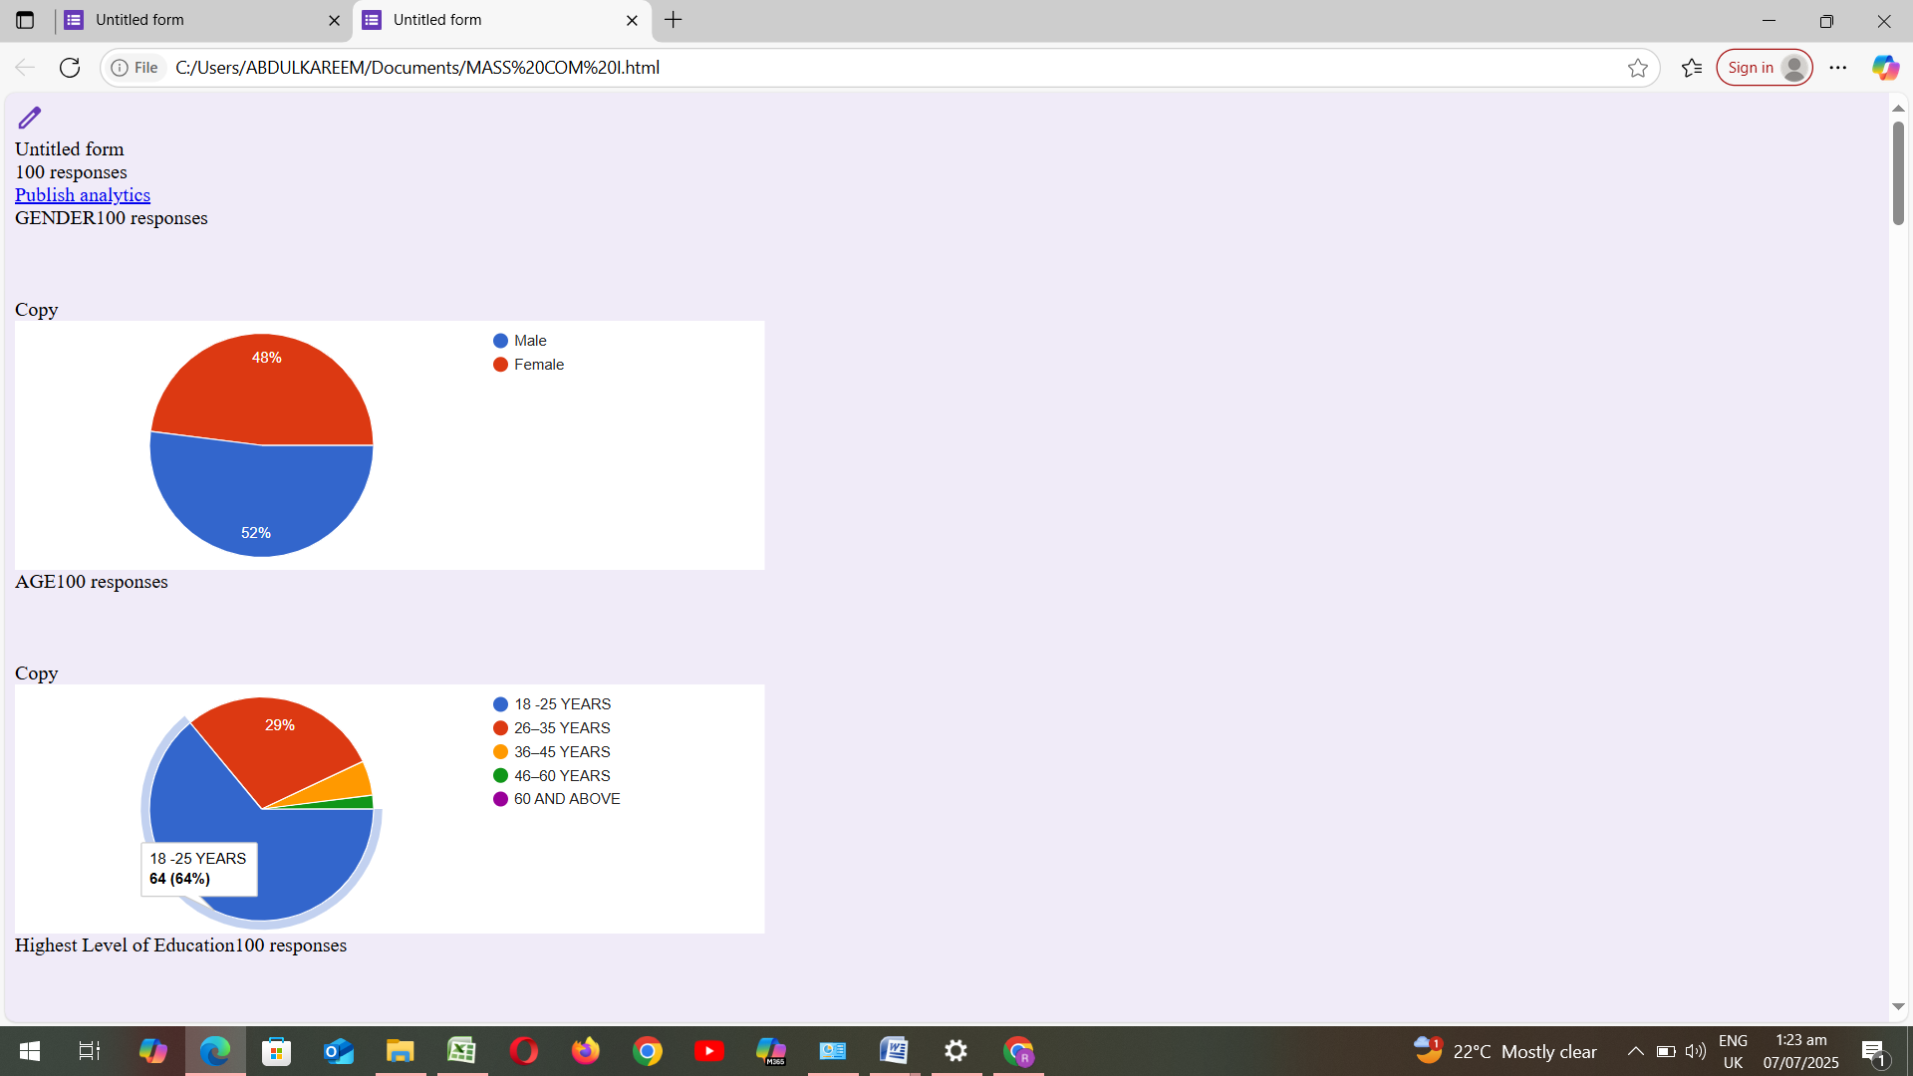

Figure4.1: Gender of Respondents
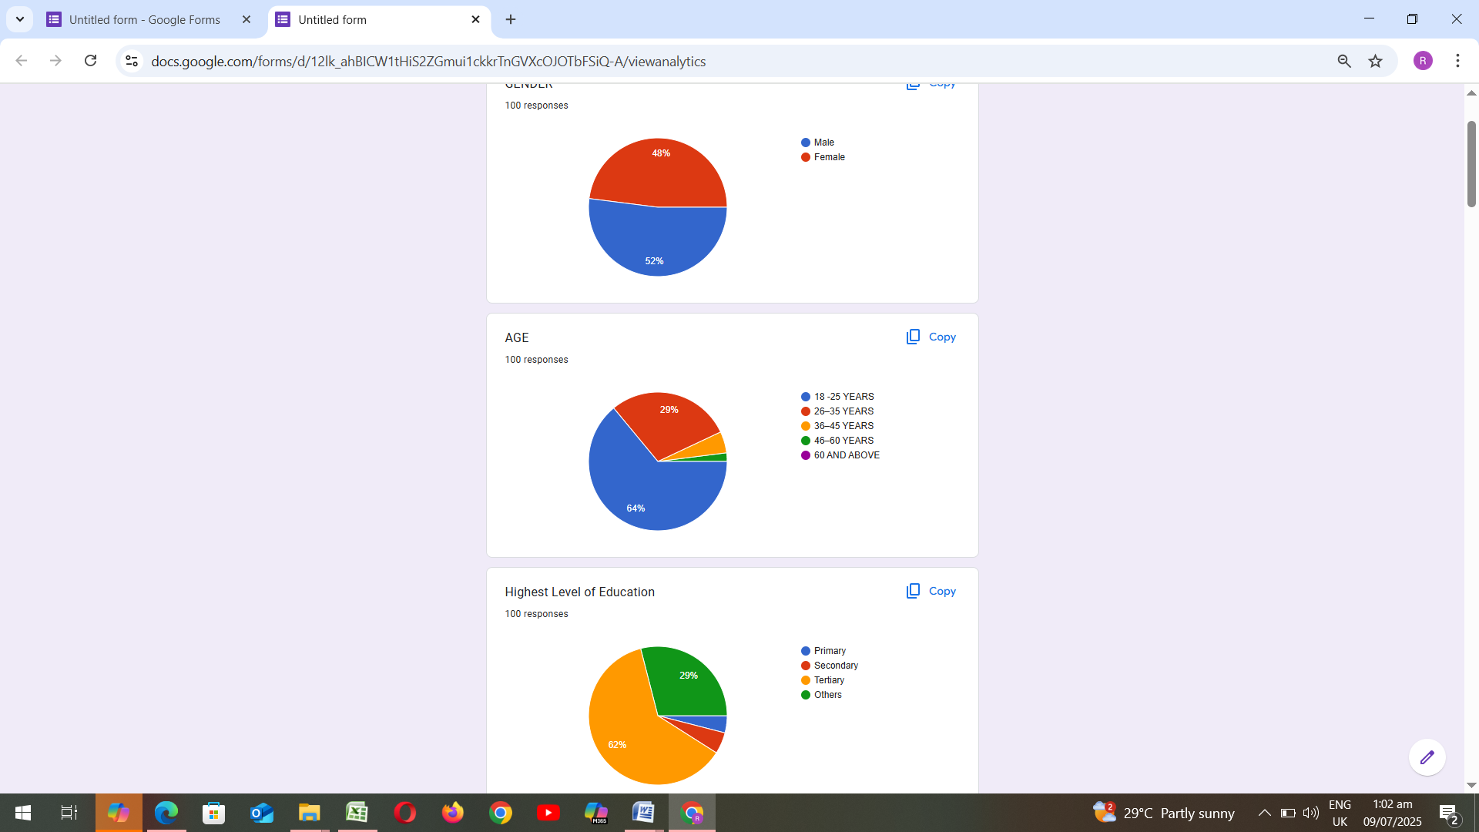

Figure4.2: Age of Respondents
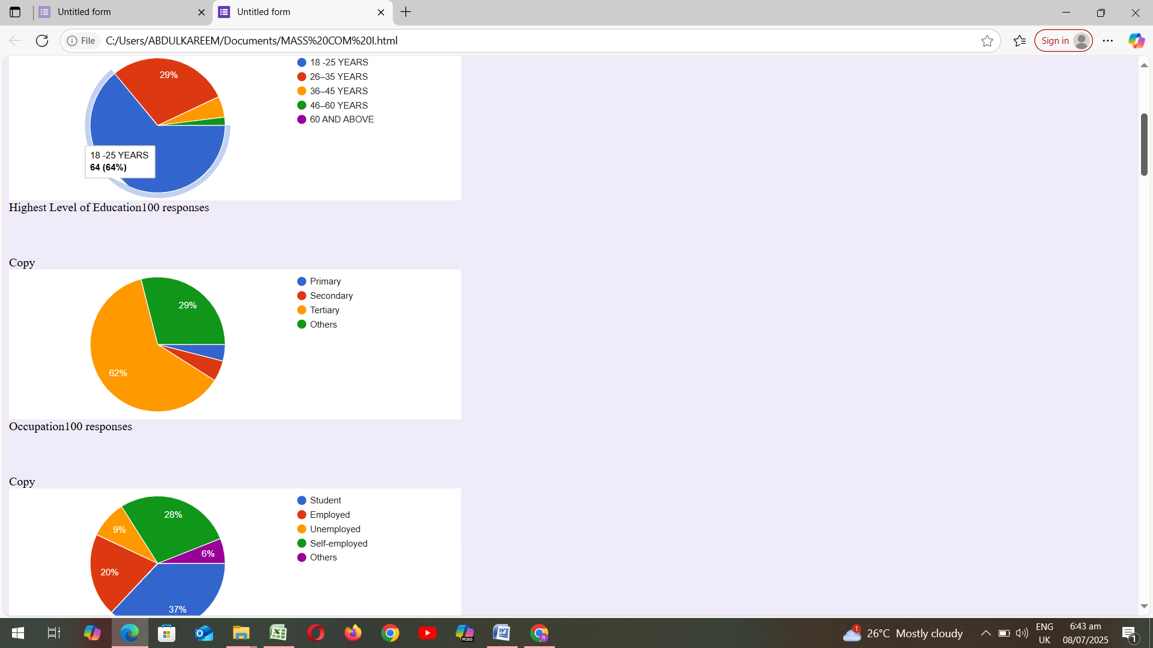

Figure4.3: Highest Level of Education
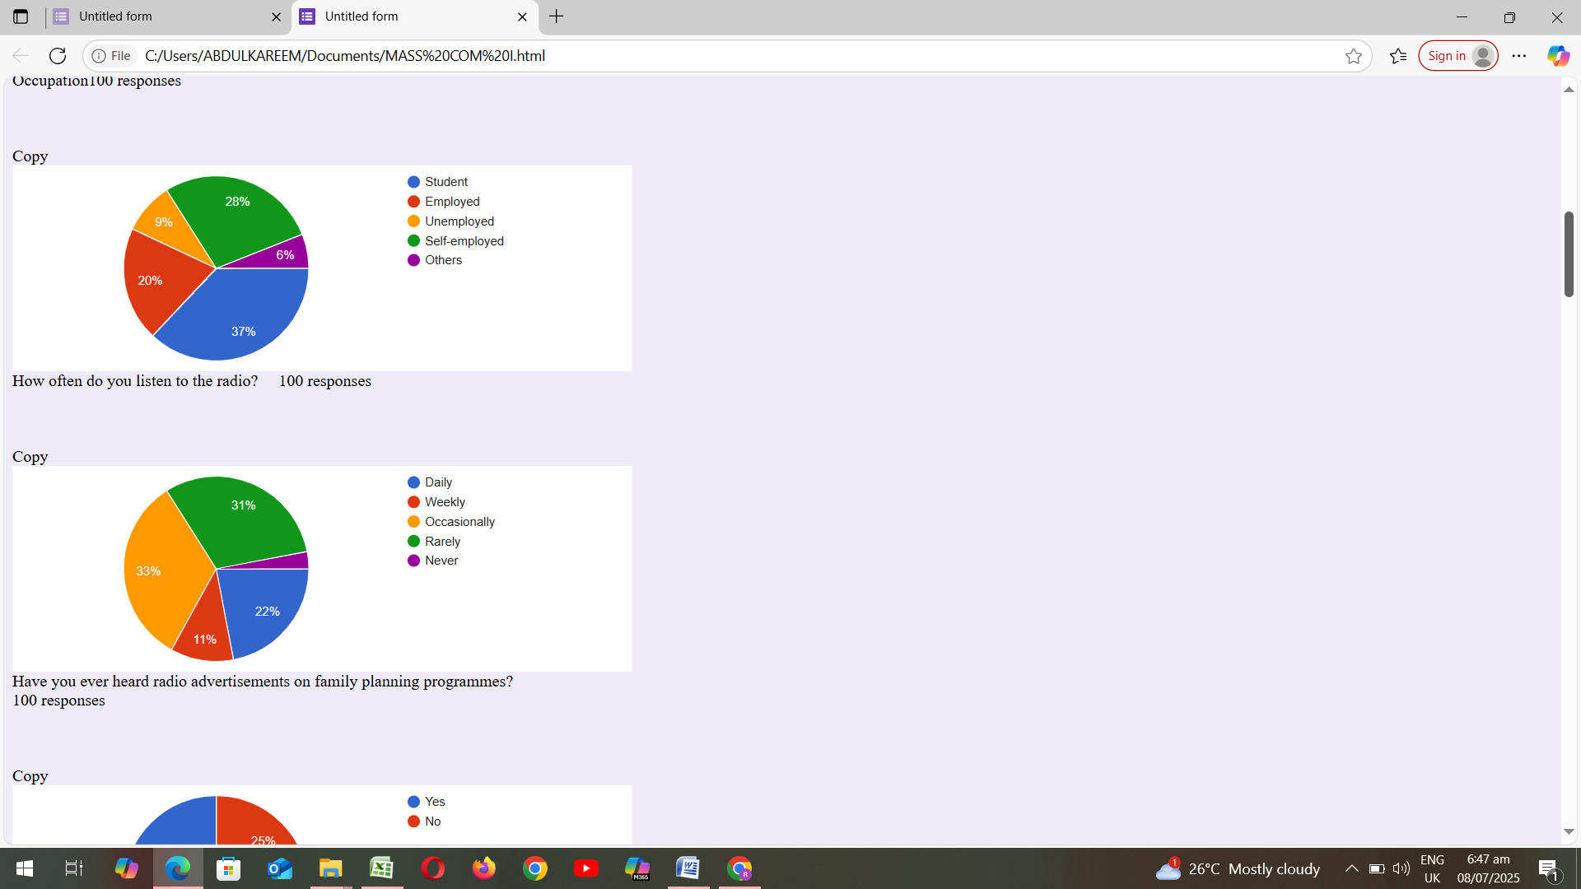

Figure 4.4: Occupation

Figure4.5: How often do you listen to the radio?

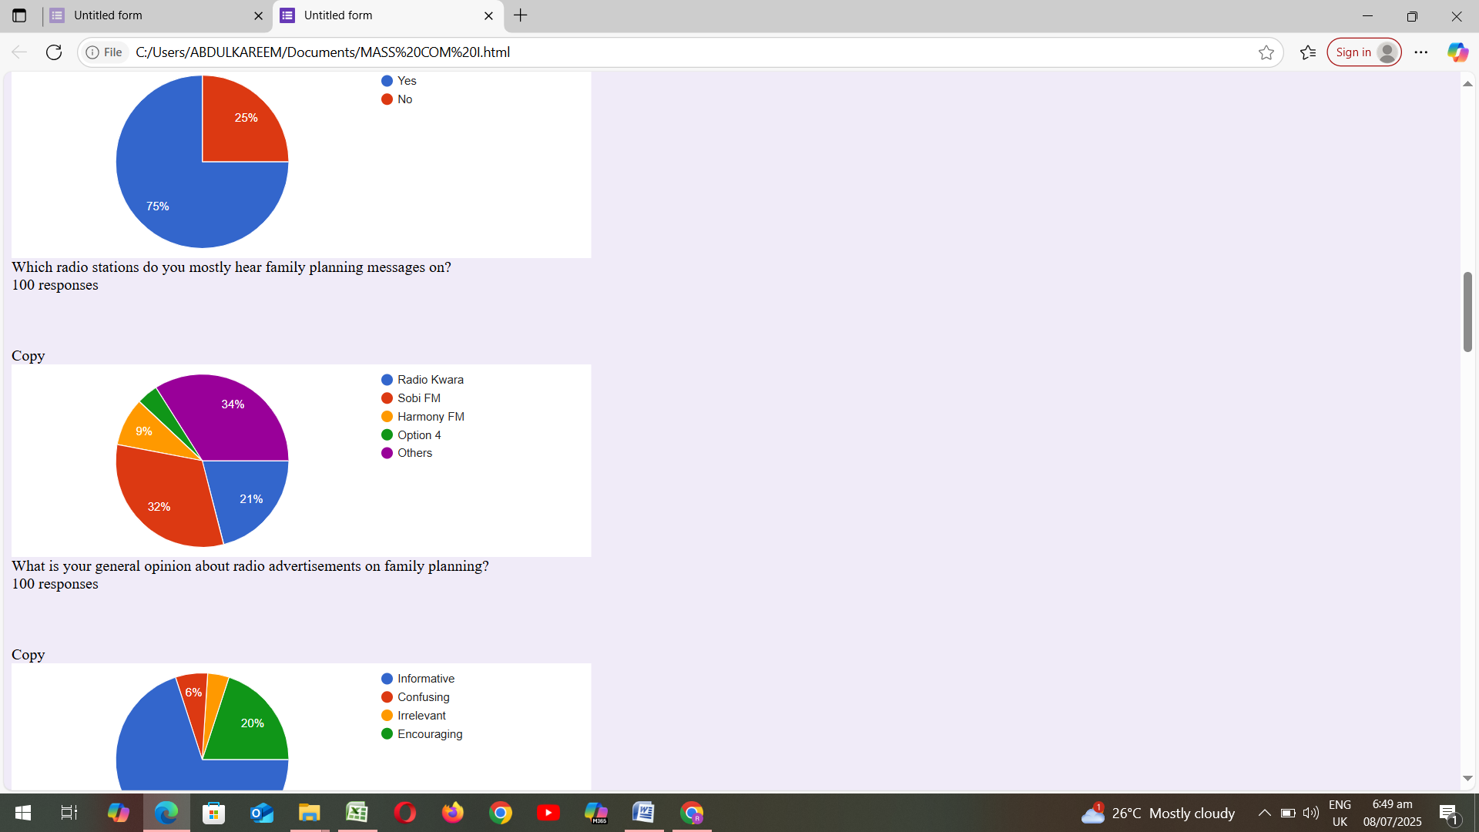

Figure 4.6: Have you ever heard radio advertisements on family planning programmes?

Figure 4.7: Which radio stations do you mostly hear family planning messages on?

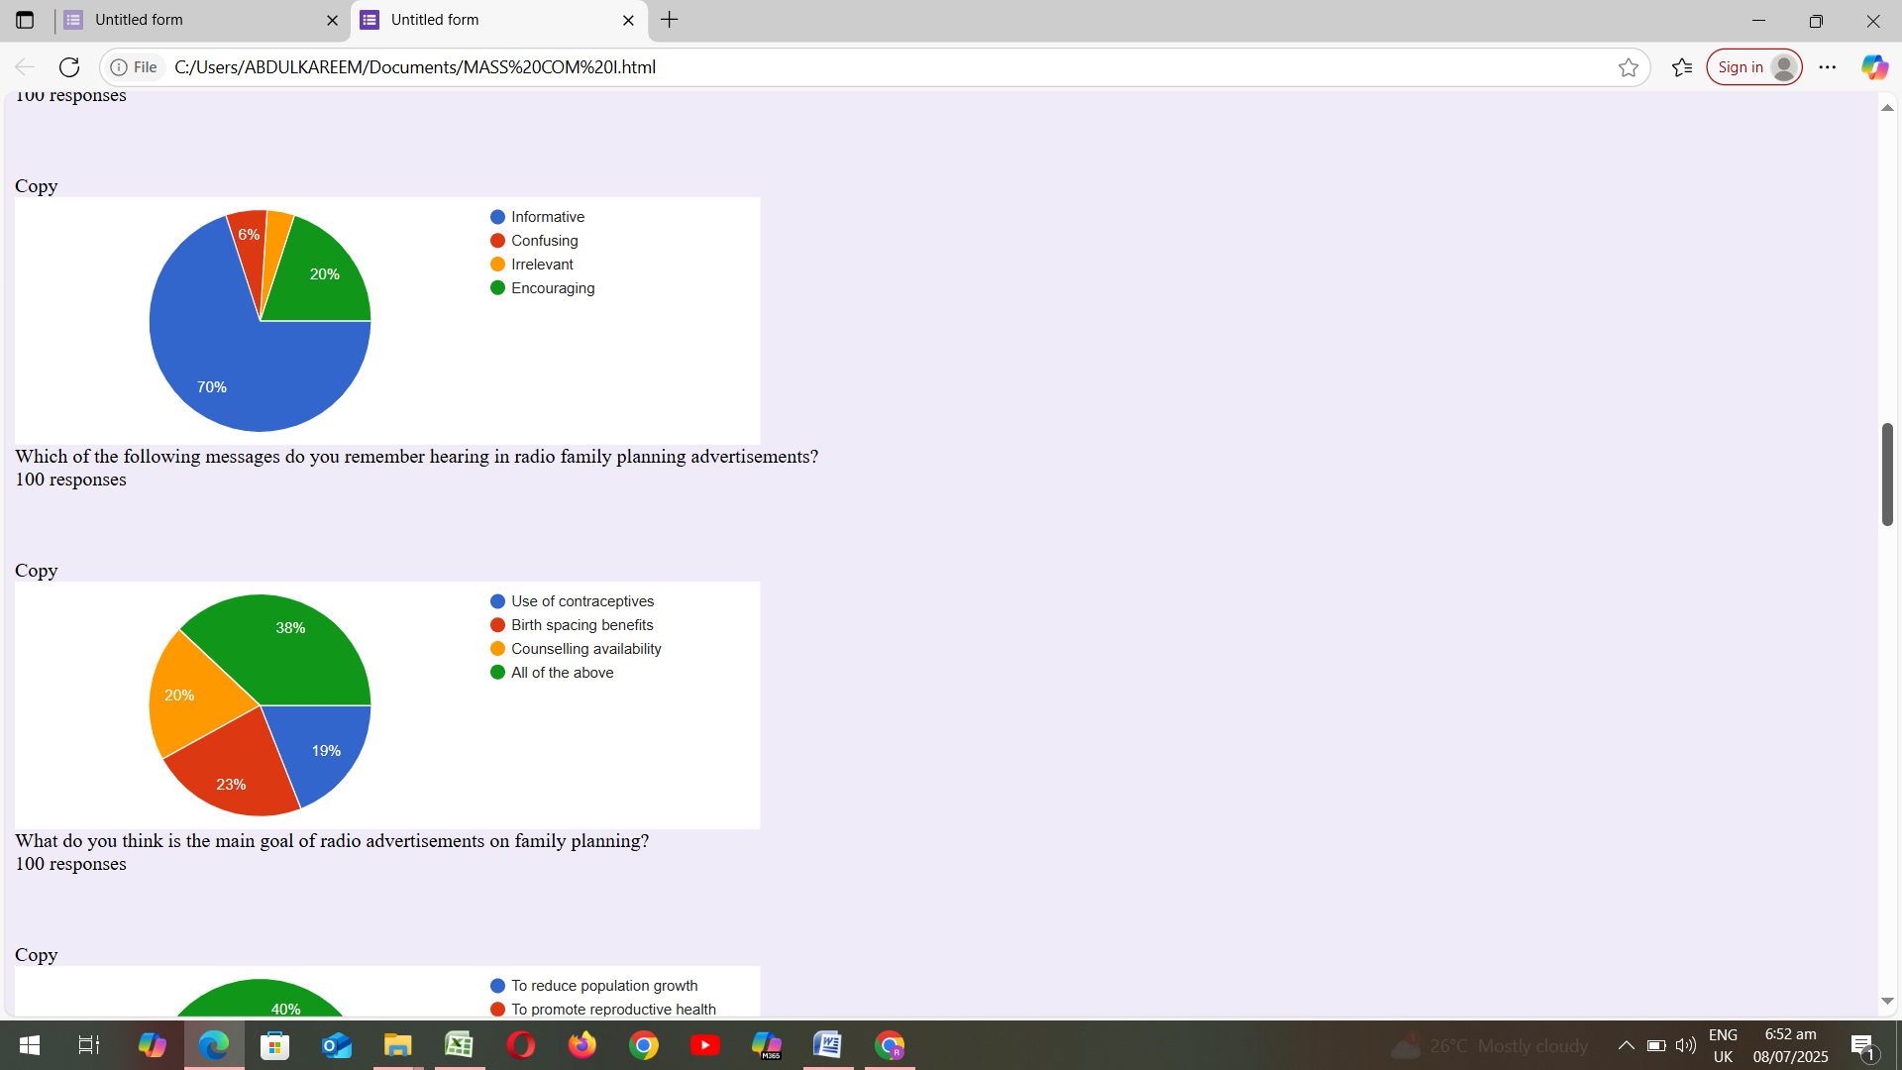

Figure 4.8: What is your general opinion about radio advertisements on family planning?

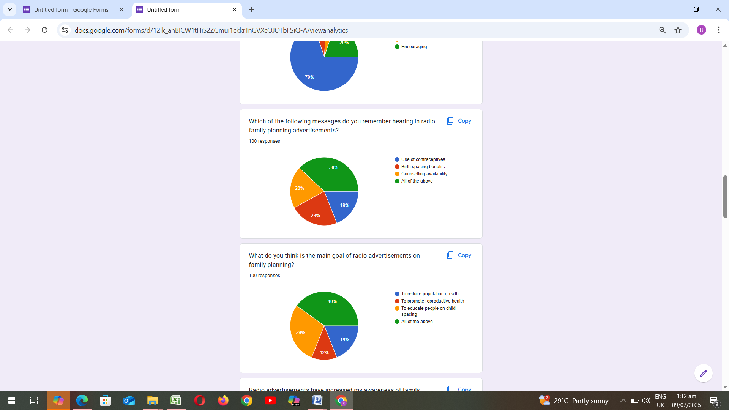

Figure4.9: Which of the following messages do you remember hearing in radio family planning advertisements
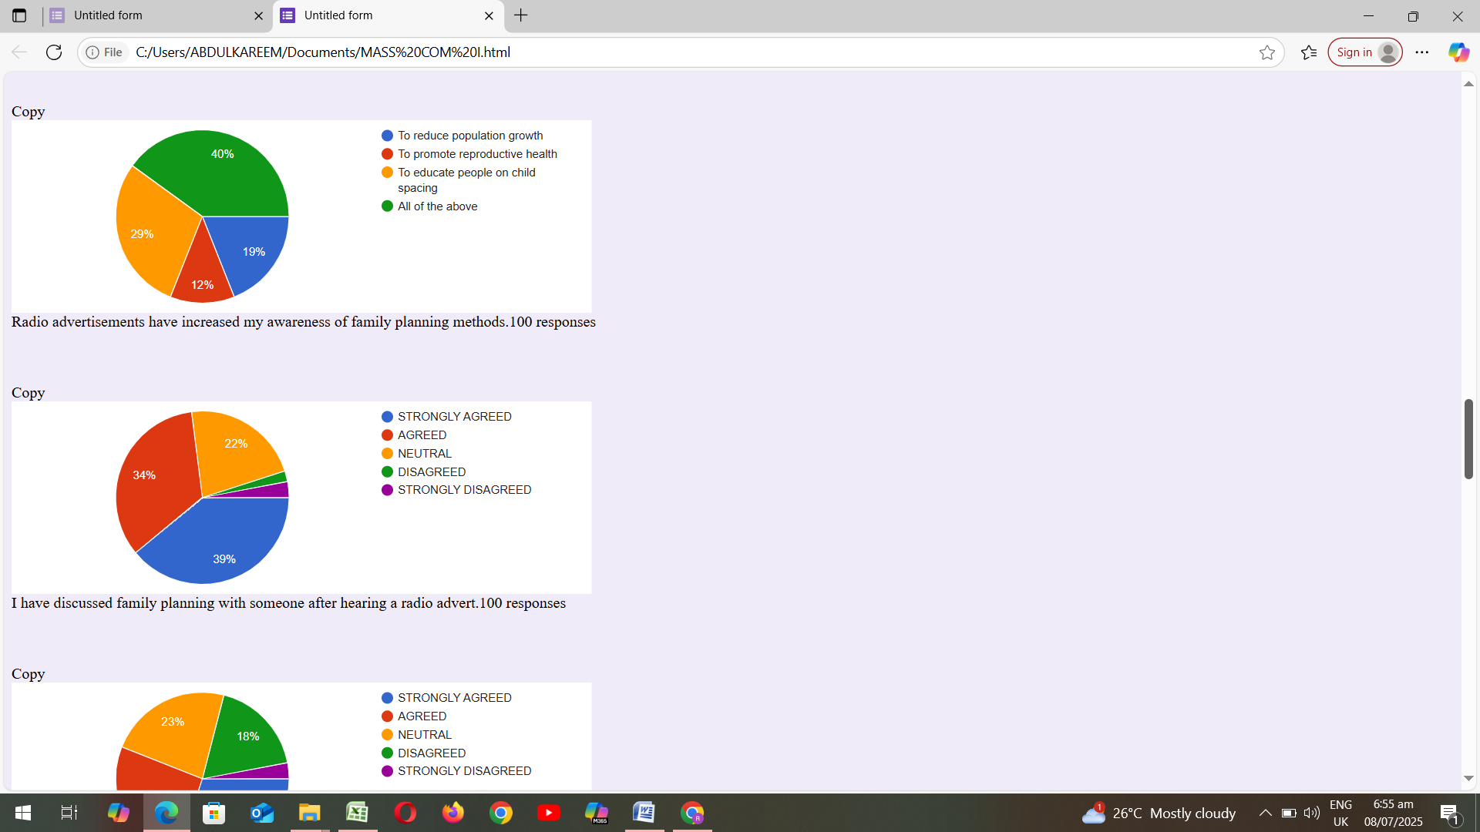

Figure4.10: What do you think is the main goal of radio advertisements on family planning?

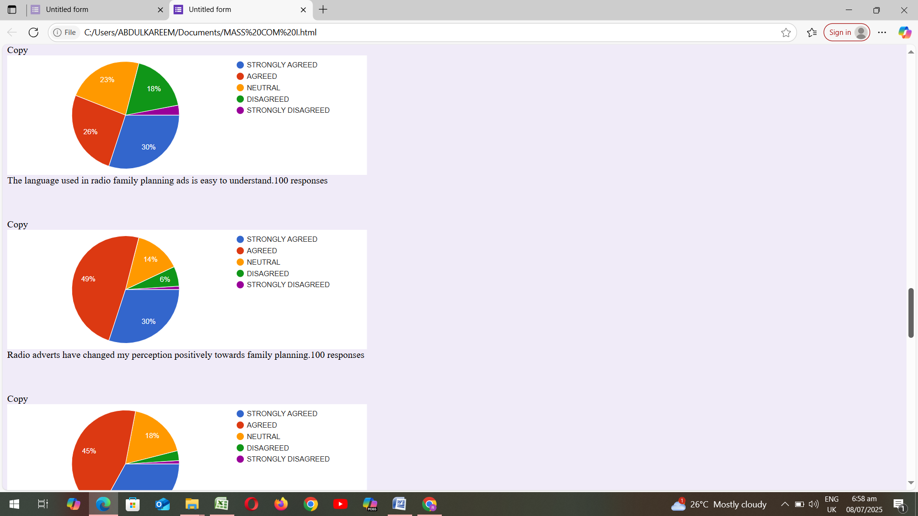
Figure4.11: Radio advertisements have increased my awareness of family planning methods.

Figure4.12: I have discussed family planning with someone after hearing a radio advert.
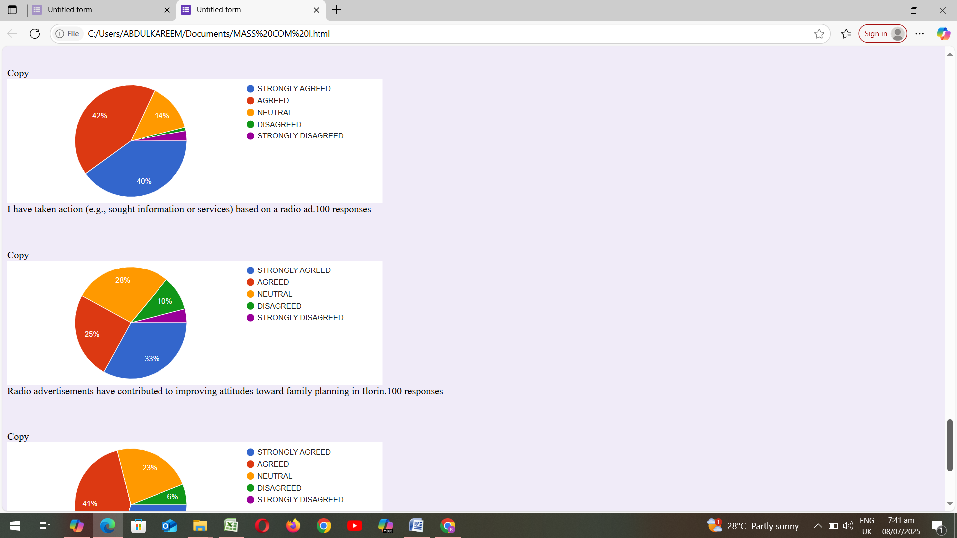

Figure4.13: The language used in radio family planning ads is easy to understand.100 responses
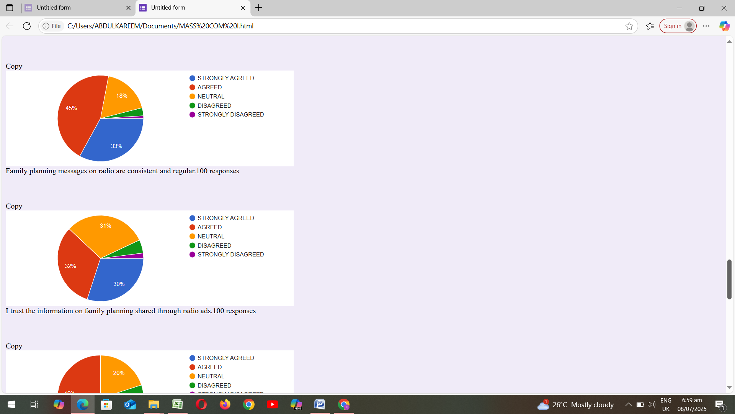

Figure 4.14: Radio adverts have changed my perception positively towards family planning.

Figure4.15: Family planning messages on radio are consistent and regular.
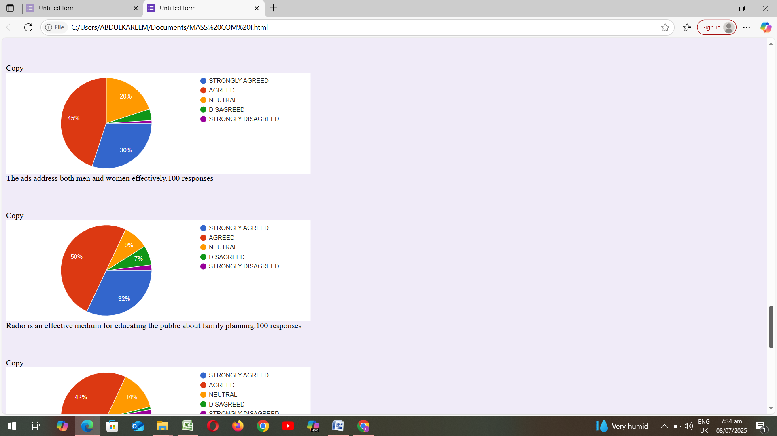

Figure4.16: I trust the information on family planning shared through radio.

Figure 4.17: The ads address both men and women effectively.
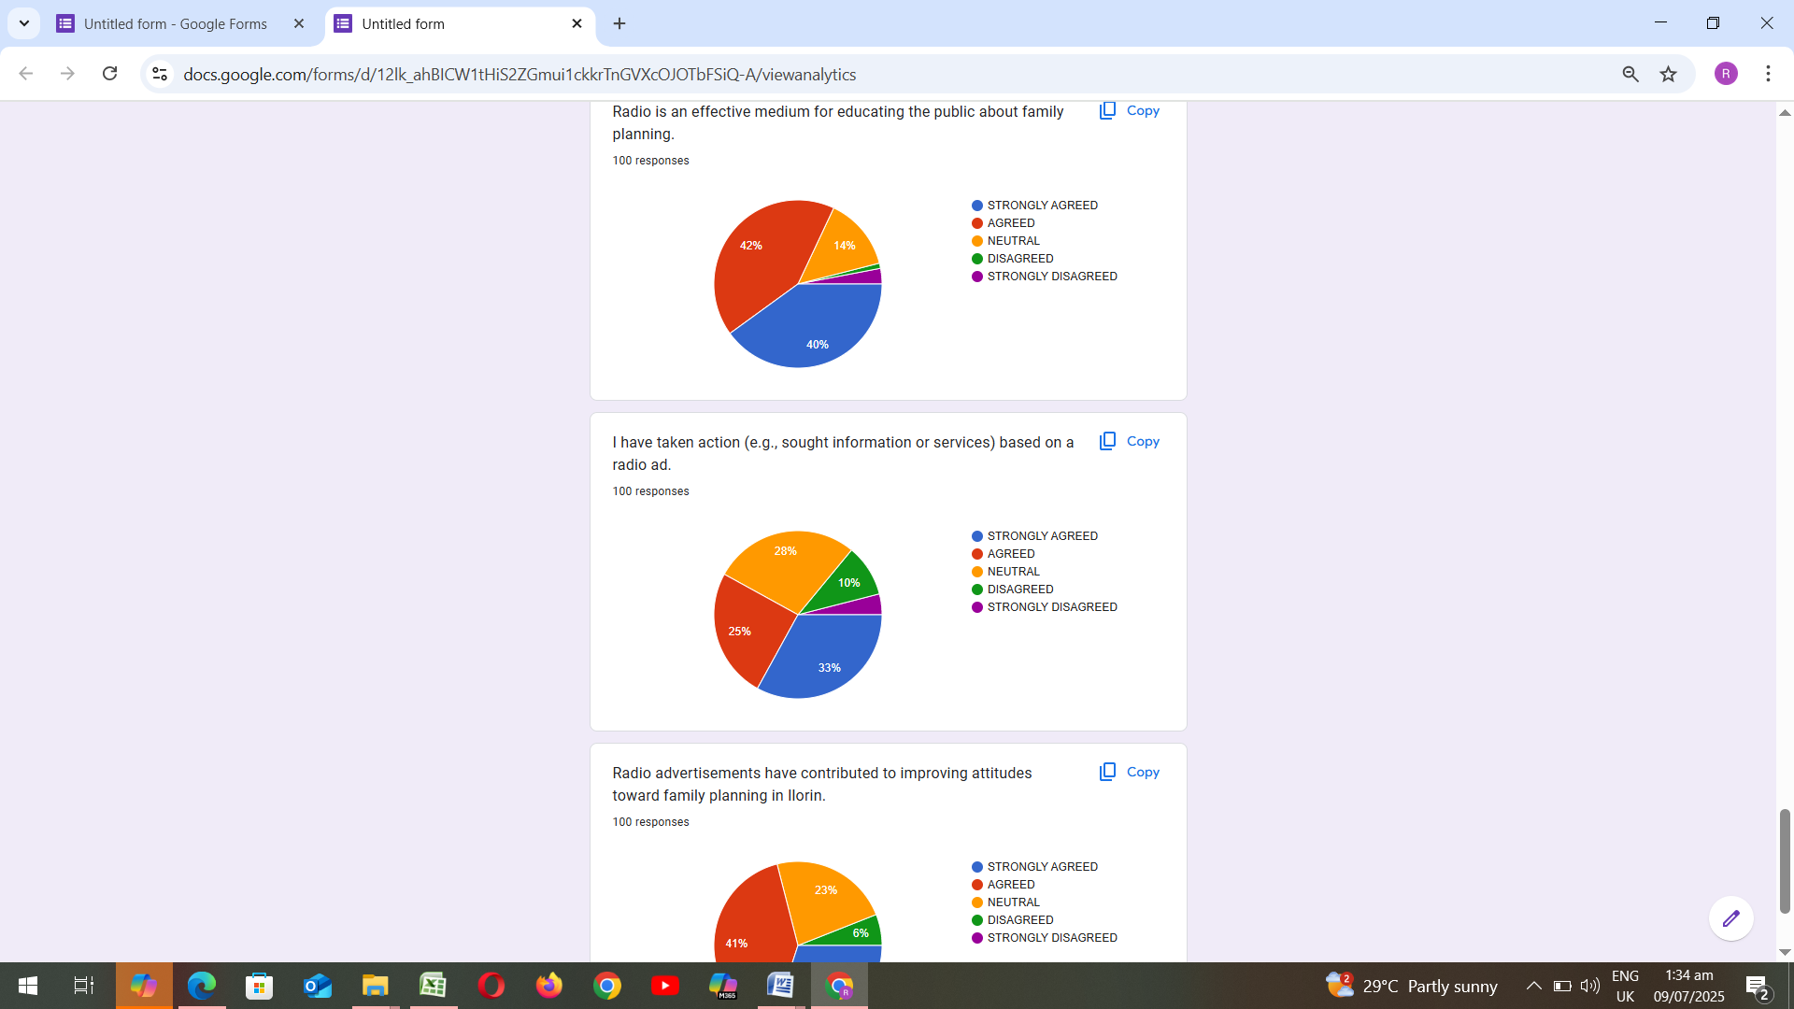

Figure4.18: Radio is an effective medium for educating the public about family plannin

Figure4.19: I have taken action (e.g., sought information or services) based on a radio
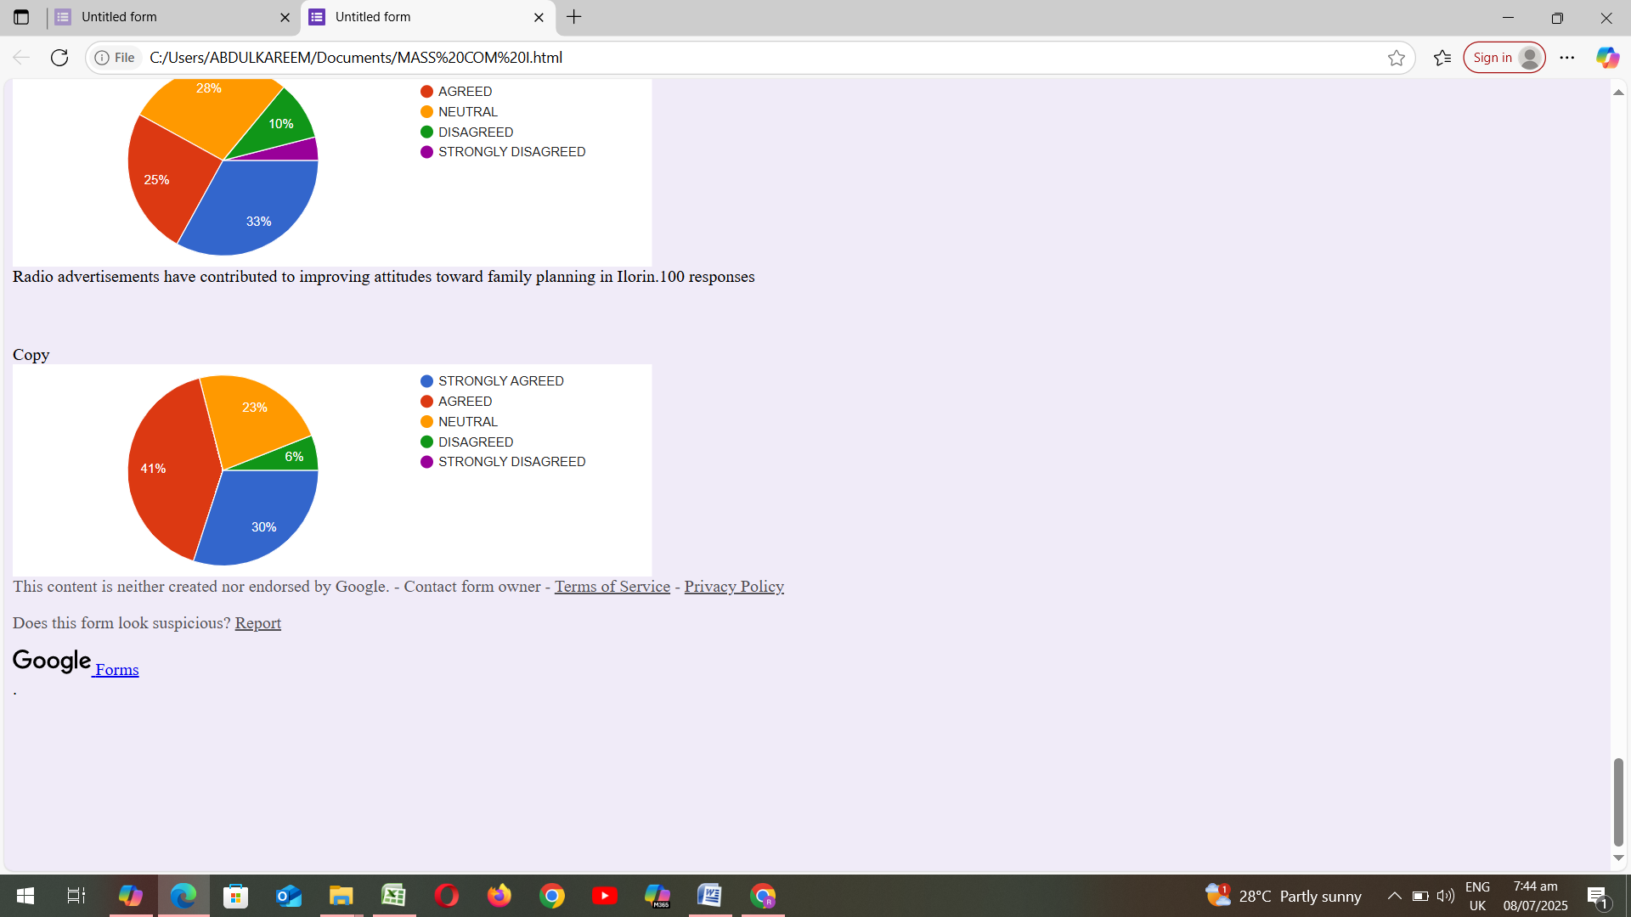

Figure 4.20: Radio advertisements have contributed to improving attitudes toward family planning in Ilorin.

